Fairness
Bias (Ethics/Fairness) - 1. Stereotyping, prejudice or favoritism towards some things, people, or groups over others.
Model - In general, any mathematical construct that processes input data and returns output.
Types of Bias
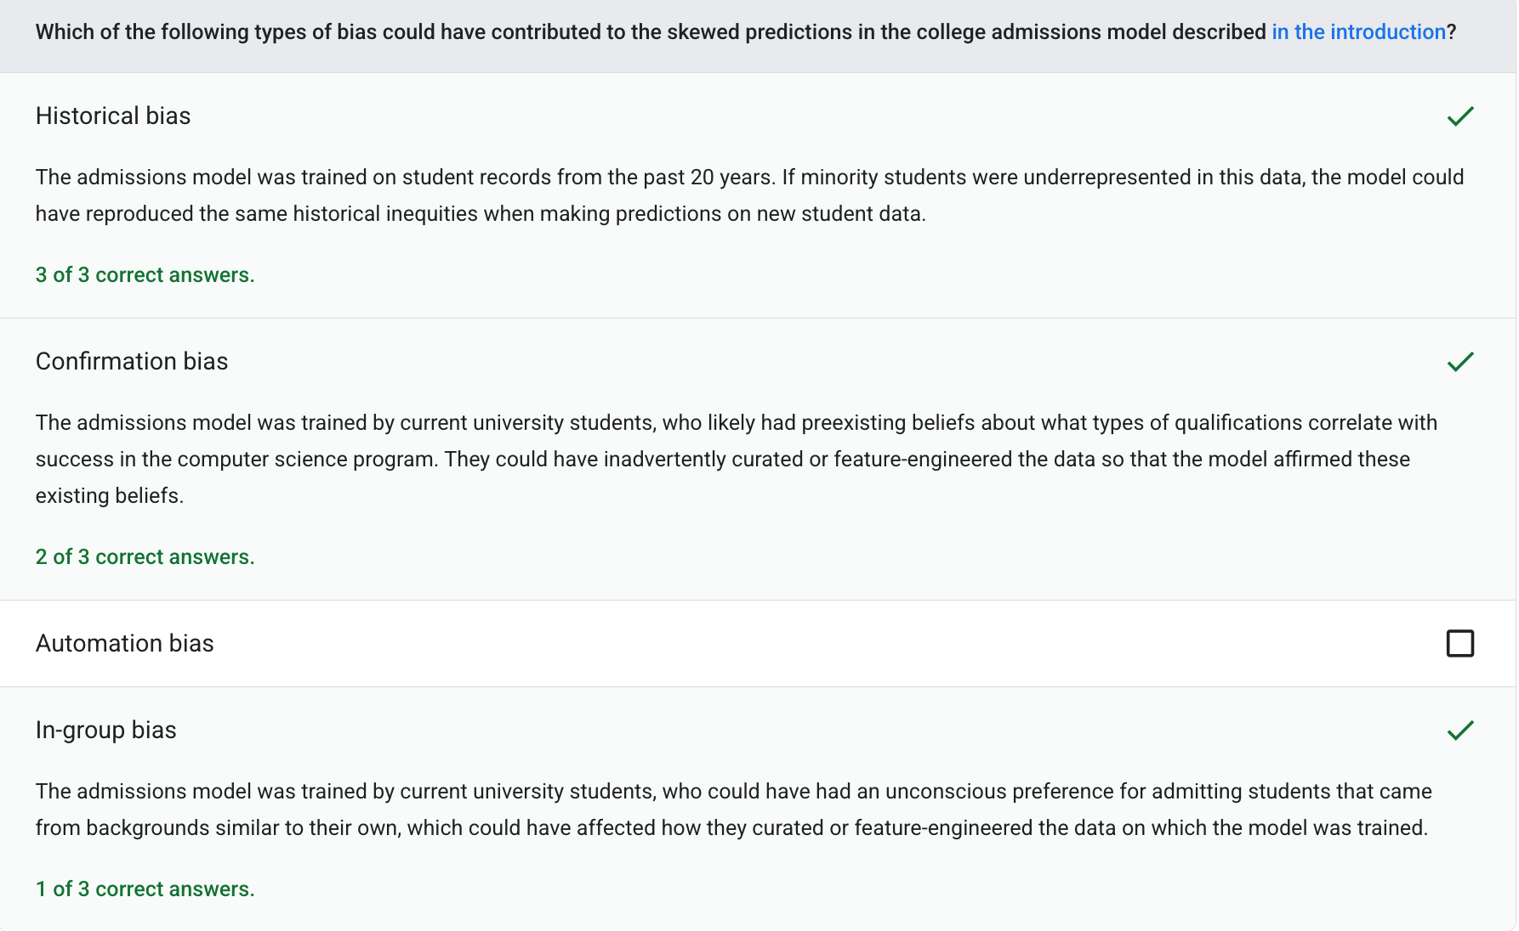
Automation Bias - When a human decision maker favors recommendations made by an automated decision-making system over information made without automation, even when the automated decision-making system makes errors.
Confirmation Bias - The tendency to search for, interpret, favor, and recall information in a way that confirms one's pre-existing beliefs or hypotheses.
Coverage Bias - Errors in conclusions drawn from sampled data due to a selection process that generates systematic differences between samples observed in the data and those not observed.
Experimenter's Bias - The tendency to search for, interpret, favor, and recall information in a way that confirms one's pre-existing beliefs or hypotheses.
Group Attribution Bias - Assuming that what is true for an individual is also true for everyone in that group.
Historical Bias - A type of bias that already exists in the world and has made its way into a dataset.
Implicit Bias - Automatically making an association or assumption based on one's mind models and memories.
In-Group Bias - Showing partiality to one's own group or own characteristics.
Out-Group Homogeneity Bias - The tendency to see out-group members as more alike than in-group members when comparing attitudes, values, personality traits, and other characteristics.
Non-Response Bias - Errors in conclusions drawn from sampled data due to a selection process that generates systematic differences between samples observed in the data and those not observed.
Participation Bias - Synonym for non-response bias. See selection bias.
Reporting Bias - The fact that the frequency with which people write about actions, outcomes, or properties is not a reflection of their real-world frequencies or the degree to which a property is characteristic of a class of individuals.
Sampling Bias - Errors in conclusions drawn from sampled data due to a selection process that generates systematic differences between samples observed in the data and those not observed.
Selection Bias - Errors in conclusions drawn from sampled data due to a selection process that generates systematic differences between samples observed in the data and those not observed.
Identifying Bias
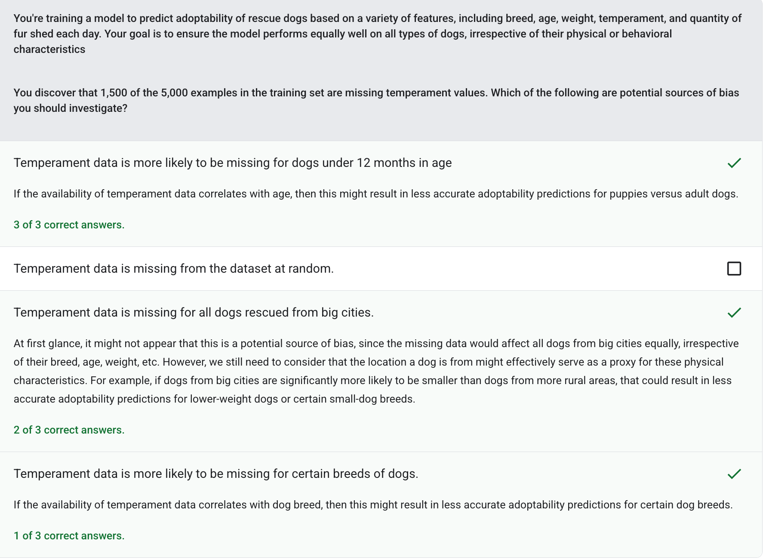
Mitigating Bias
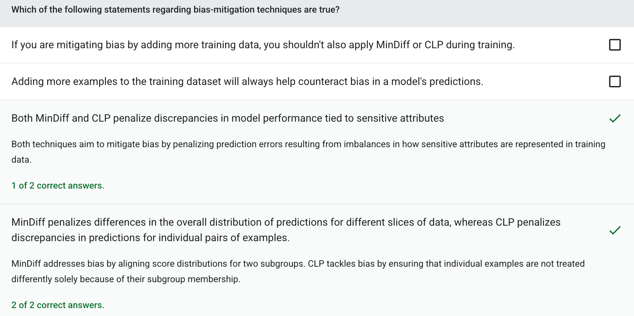
Evaluating for Bias
Log Loss - The loss function used in binary logistic regression.
Accuracy - The number of correct classification predictions divided by the total number of predictions.
Bias (Ethics/Fairness) - 1. Stereotyping, prejudice or favoritism towards some things, people, or groups over others.
Precision - A metric for classification models that answers the following question:
Recall - A metric for classification models that answers the following question:
Demographic Parity
Demographic Parity - A fairness metric that is satisfied if the results of a model's classification are not dependent on a given sensitive attribute.
Equality of Opportunity
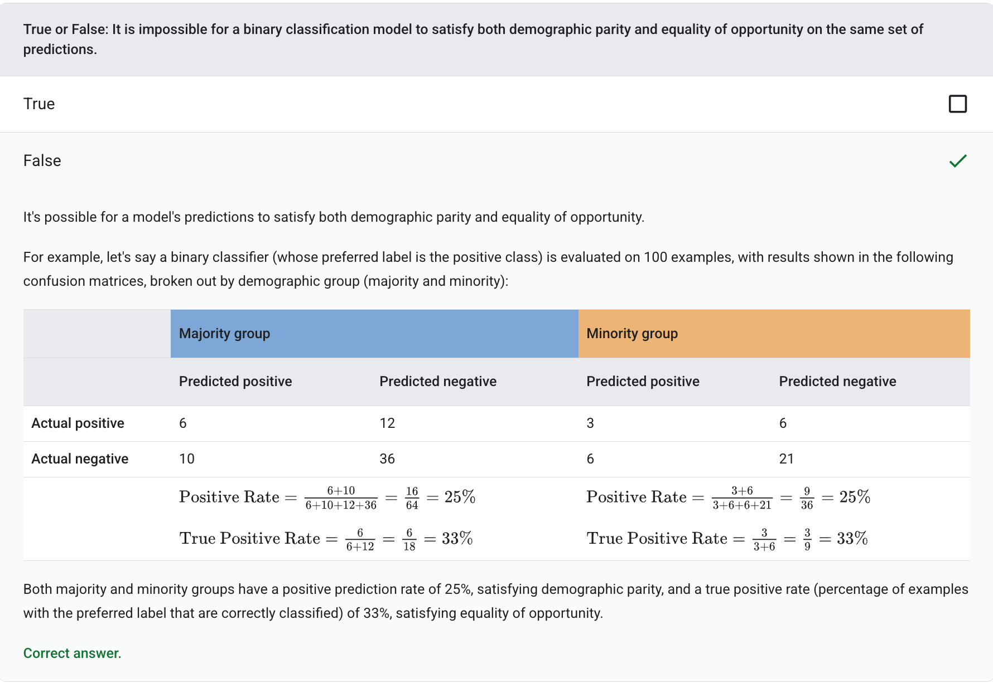
Equality of Opportunity - A fairness metric to assess whether a model is predicting the desirable outcome equally well for all values of a sensitive attribute. In other words, if the desirable outcome for a model is the positive class, the goal would be to have the true positive rate be the same for all groups.
Equalized Odds - A fairness metric to assess whether a model is predicting outcomes equally well for all values of a sensitive attribute with respect to both the positive class and negative class—not just one class or the other exclusively. In other words, both the true positive rate and false negative rate should be the same for all groups.
Counterfactual Fairness
Mutually Incompatible - A definition of fairness meaning it may be impossible to satisfy them simultaneously for a given model's predictions
Programming Exercise
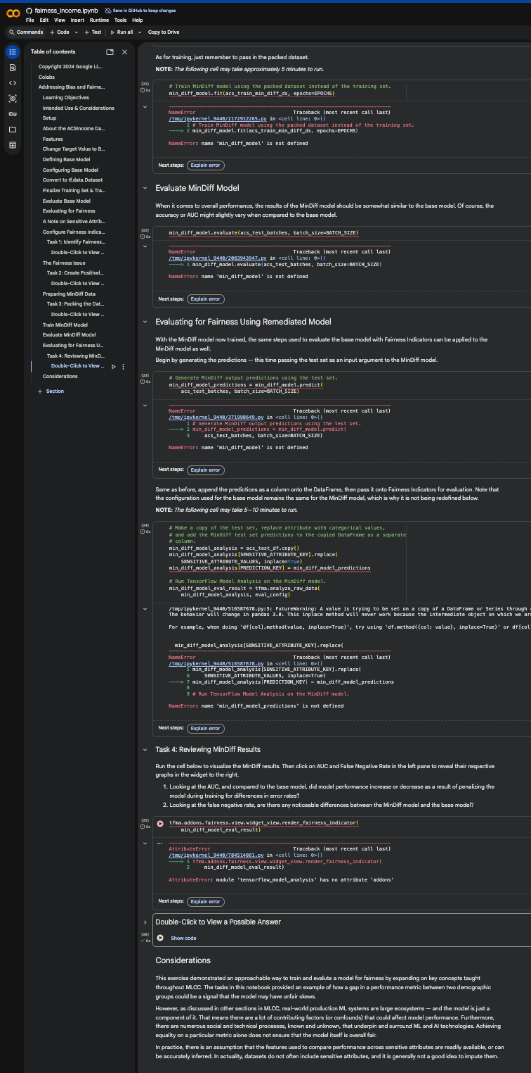
Test Your Knowledge


