Classification
Binary Classification - A type of classification task that predicts one of two mutually exclusive classes:
- the positive class
- the negative class
Class - A category that a label can belong to
Classification (model) - A model whose prediction is a class
Multi-class Classification - In supervised learning, a classification problem in which the dataset contains more than two classes of labels
Sigmoid Function - A mathematical function that "squishes" an input value into a constrained range
Thresholds & the Classification Matrix
Watched the Video
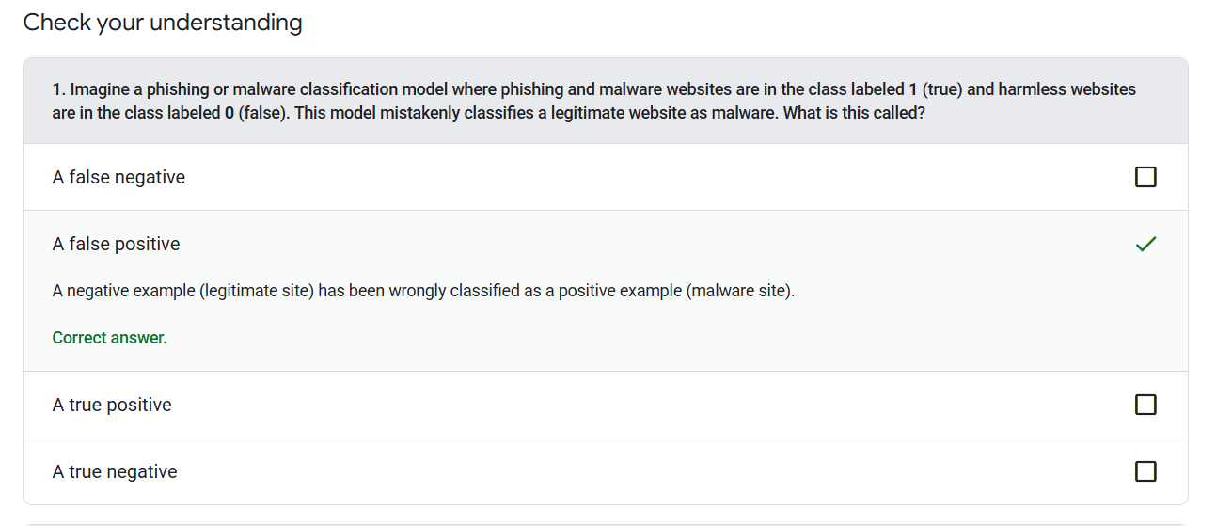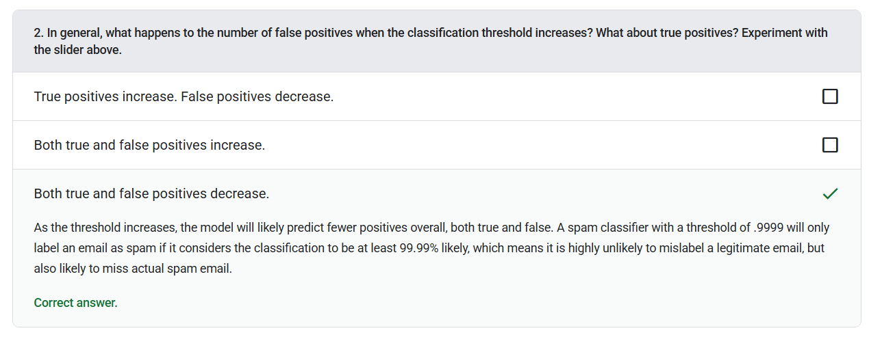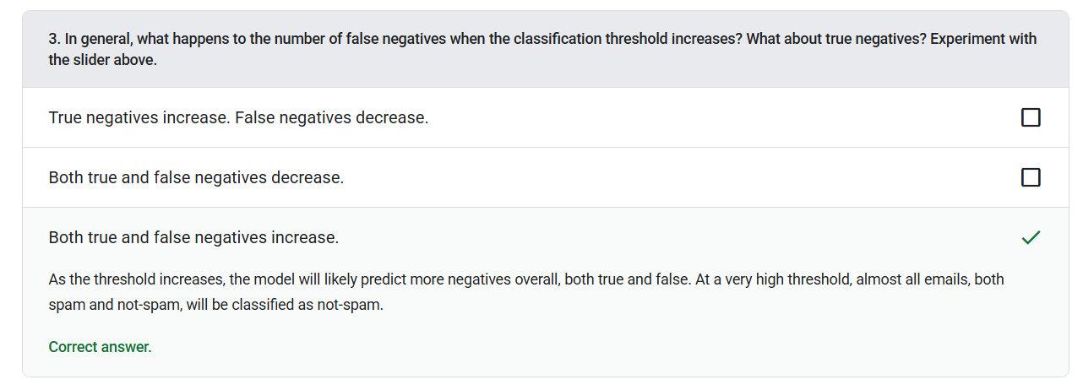
Binary Classification - A type of classification task that predicts one of two mutually exclusive classes:
- the positive class
- the negative class
Class-imbalanced Dataset - A dataset for a classification in which the total number of labels of each class differs significantly
Classification Threshold - In a binary classification, a number between 0 and 1 that converts the raw output of a logistic regression model into a prediction of either the positive class or the negative class
Confusion Matrix - An NxN table that summarizes the number of correct and incorrect predictions that a classification model made
Ground Truth – Reality; The thing that actually happened
Negative Class - In binary classification, one class is termed positive and the other is termed negative. The positive class is the thing or event that the model is testing for and the negative class is the other possibility
Positive Class - The class you are testing for.
Accuracy, Recall, Precision, & Related Metrics
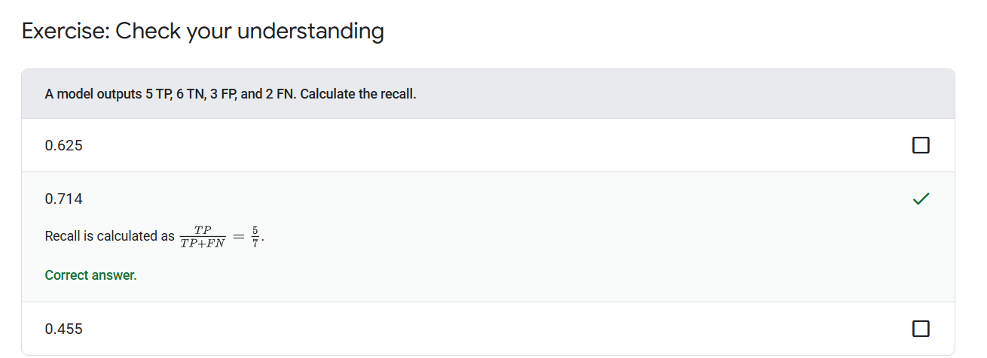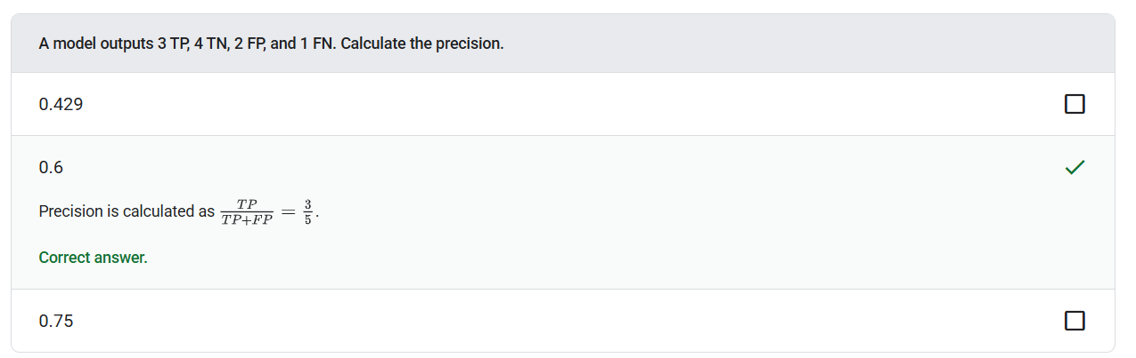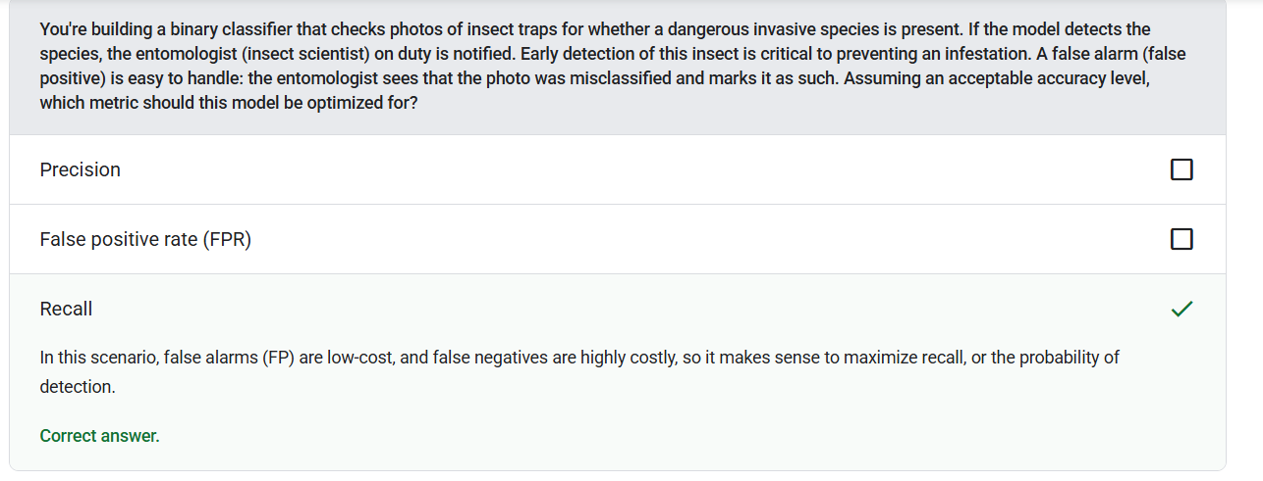
Accuracy - The number of correct classification predictions divided by the total number of predictions
False Positive Rate (FPR) - The proportion of actual negative examples for which the model mistakenly predicted the positive class
Precision - A metric for classification models that answers when the model predicted the positive class, and what percentage of the predictions were correct
Recall - Recall measures what percentage of the real positive cases the model managed to find
ROC & AUC
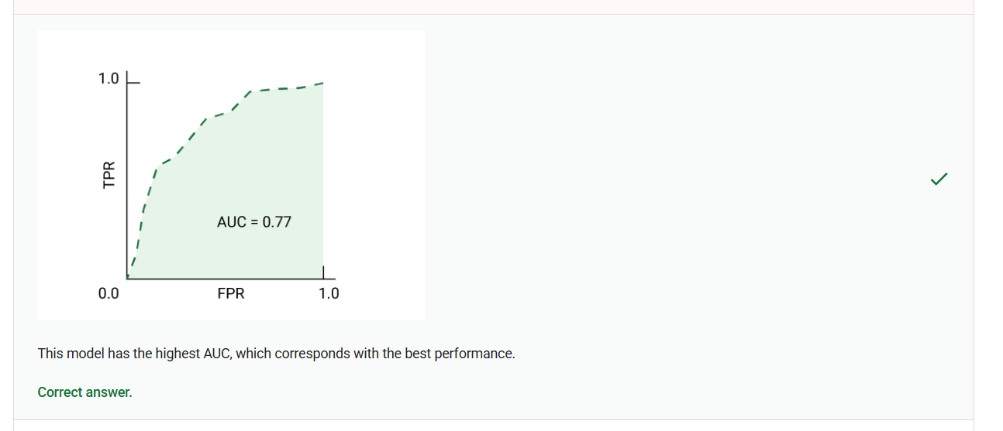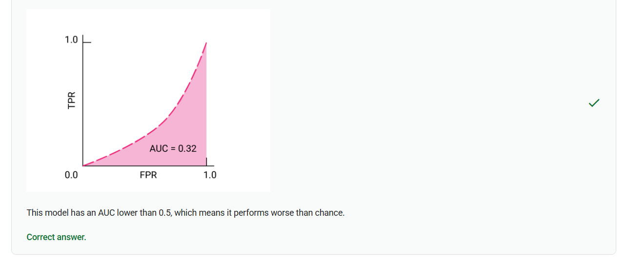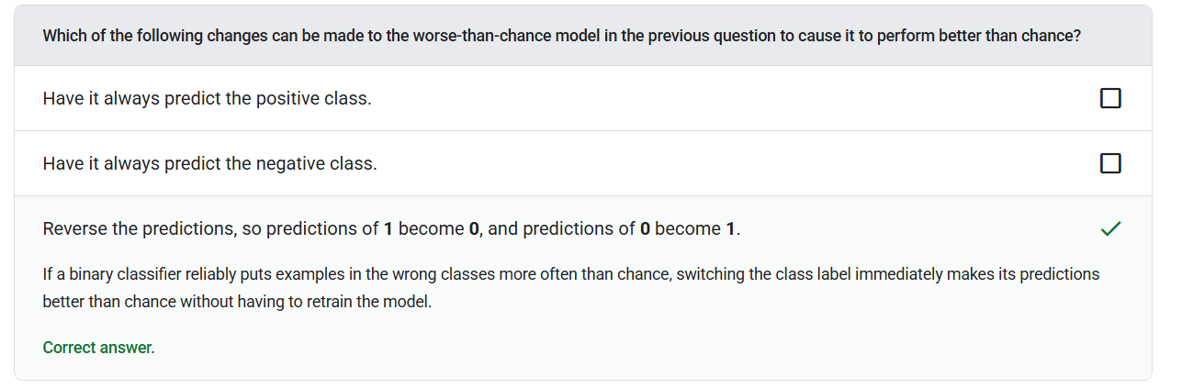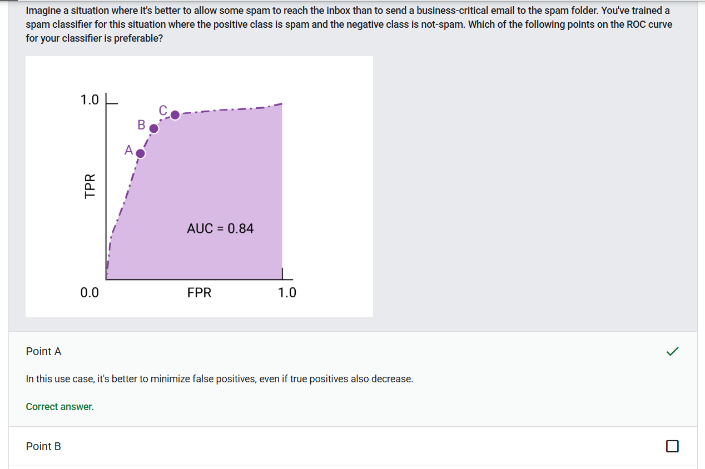
Area Under the ROC Curve (AUC) - A number between 0.0 and 1.0 representing a binary classification model's ability to separate positive classes from negative classes
ROC Curve - A graph of true positive rate versus false positive rate for different classification thresholds in binary classification
Prediction Bias
Ground Truth – Reality; The thing that actually happened
Prediction - A model's output
Prediction Bias - A value indicating how far apart the average of predictions is from the average of labels in the dataset
Multi-Class Classification
Binary Classification - A type of classification task that predicts one of two mutually exclusive classes:
- the positive class
- the negative class

Test Your Knowledge



