Linear Regression
Bias -
Feature -
Label -
Linear Regression -
Parameter –
Weight –

Loss
Mean Absolute Error (MAE)-
Mean Squared Error (MSE)-
L1 –
L2 –
Loss –
Outlier –
Prediction –

Parameters
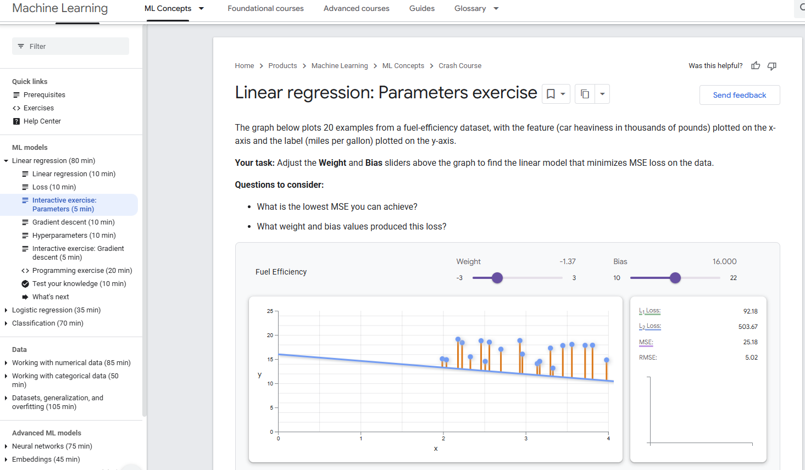
Gradient Descent
-Watched video
Convergence -
Convex Function -
Gradient Descent -
Iteration -
Loss Curve -

Hyperparameters
Batch Size -
Epoch -
Generalize -
Hyperparameter –
Iteration -
Learning Rate -
Mini-batch –
Mini-batch Stochastic Gradient Descent-
Neural Network -
Parameter -
Stochastic Gradient Descent –

Gradient Descent
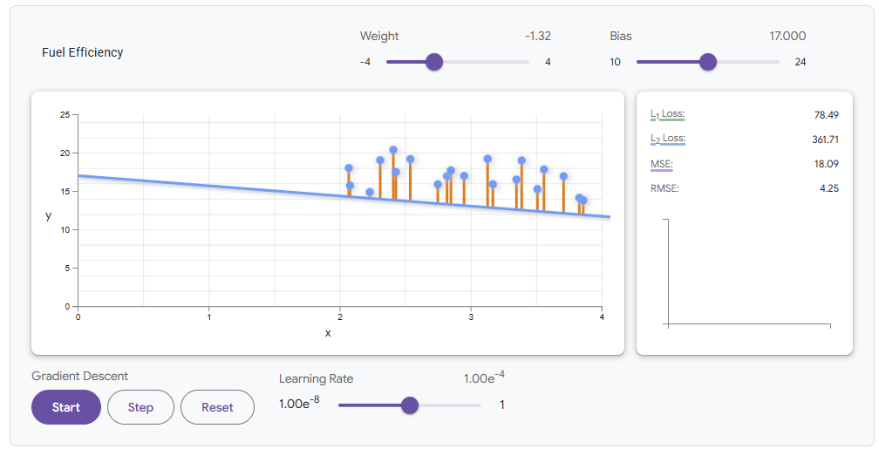
Programming Exercise


Test Your Knowledge


