Report: Networks
By: Emi Neuwalder, Elaine Demetrion and Liberty Lehr

Introduction
The Bank of Money, one of the largest banks on the planet, is experiencing a breach of security. In an effort to understand the weak points of the Bank of Money’s Firewalls our team has led an investigation into their networks. The evidence we have found supports the following inferences.
- There are breaches of security where unknown IP addresses are communicating with websites.
- There was an intrusion related to a potential privacy breach on 4/6/2012 at 17:27-17:28

Hypothesis 1: There are IP addresses not specified by BOM interacting with the BOM network.
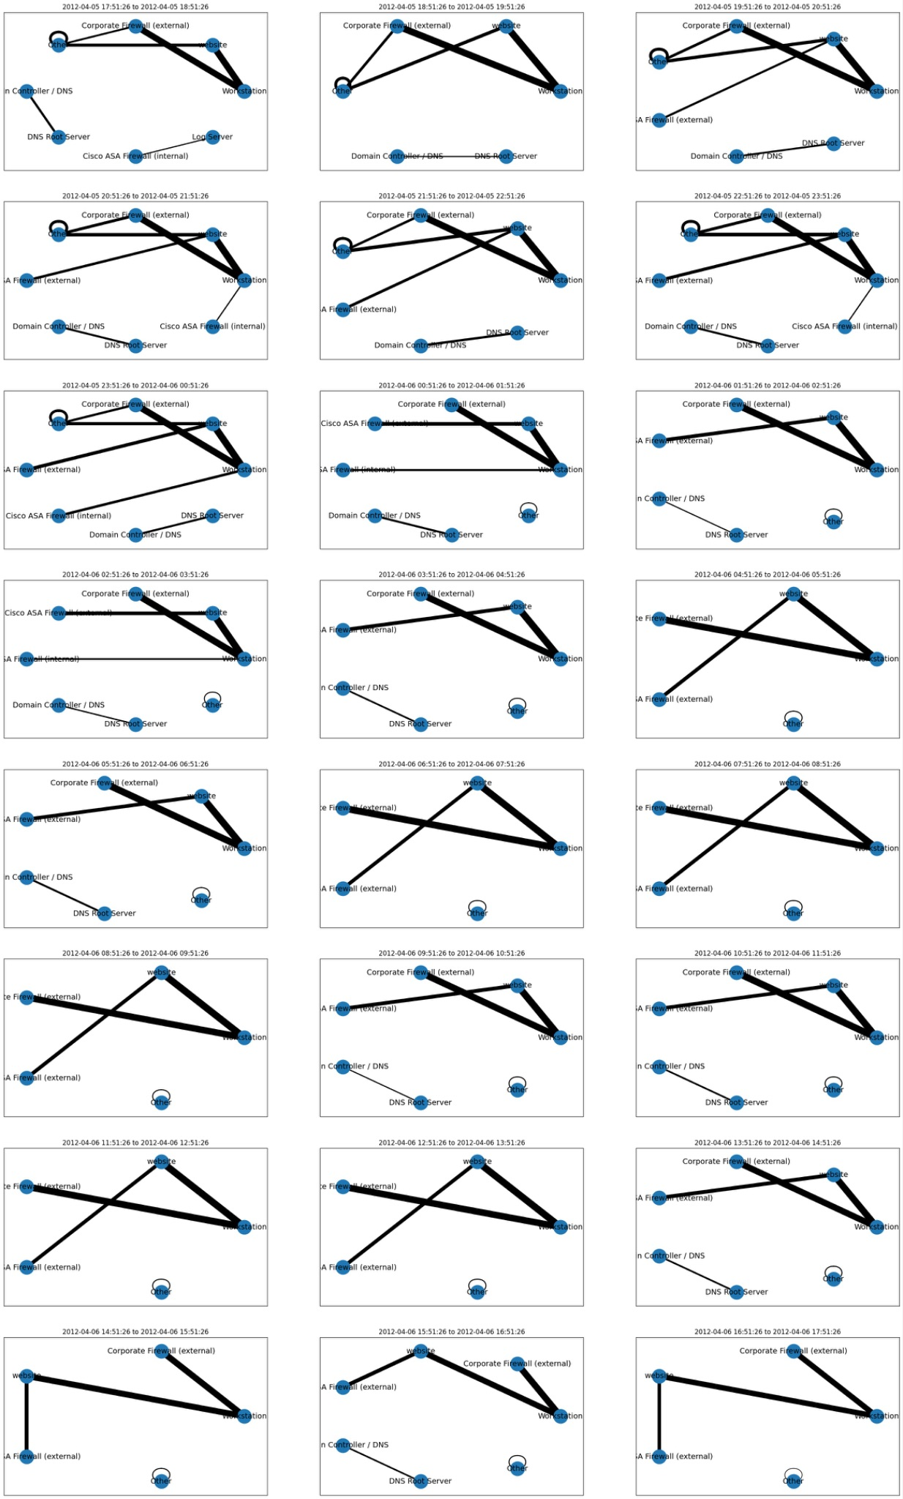
[Fig. 1] Multiple views of network traffic per hour between Corporate Firewall (external), Cisco ASA Firewall (internal), DNS Root Server Websites, SNAT, Financial Server, Domain Controller-DNS, Workstations and other IP addresses unspecified by BOM. Vector strength represents the amount of traffic.

On a given day, 2012-04-06, we can see that “other” IP addresses which are unknown to the BOM system are indirectly communicating with workstations through websites and possibly evading Firewalls.
Hypothesis 2:
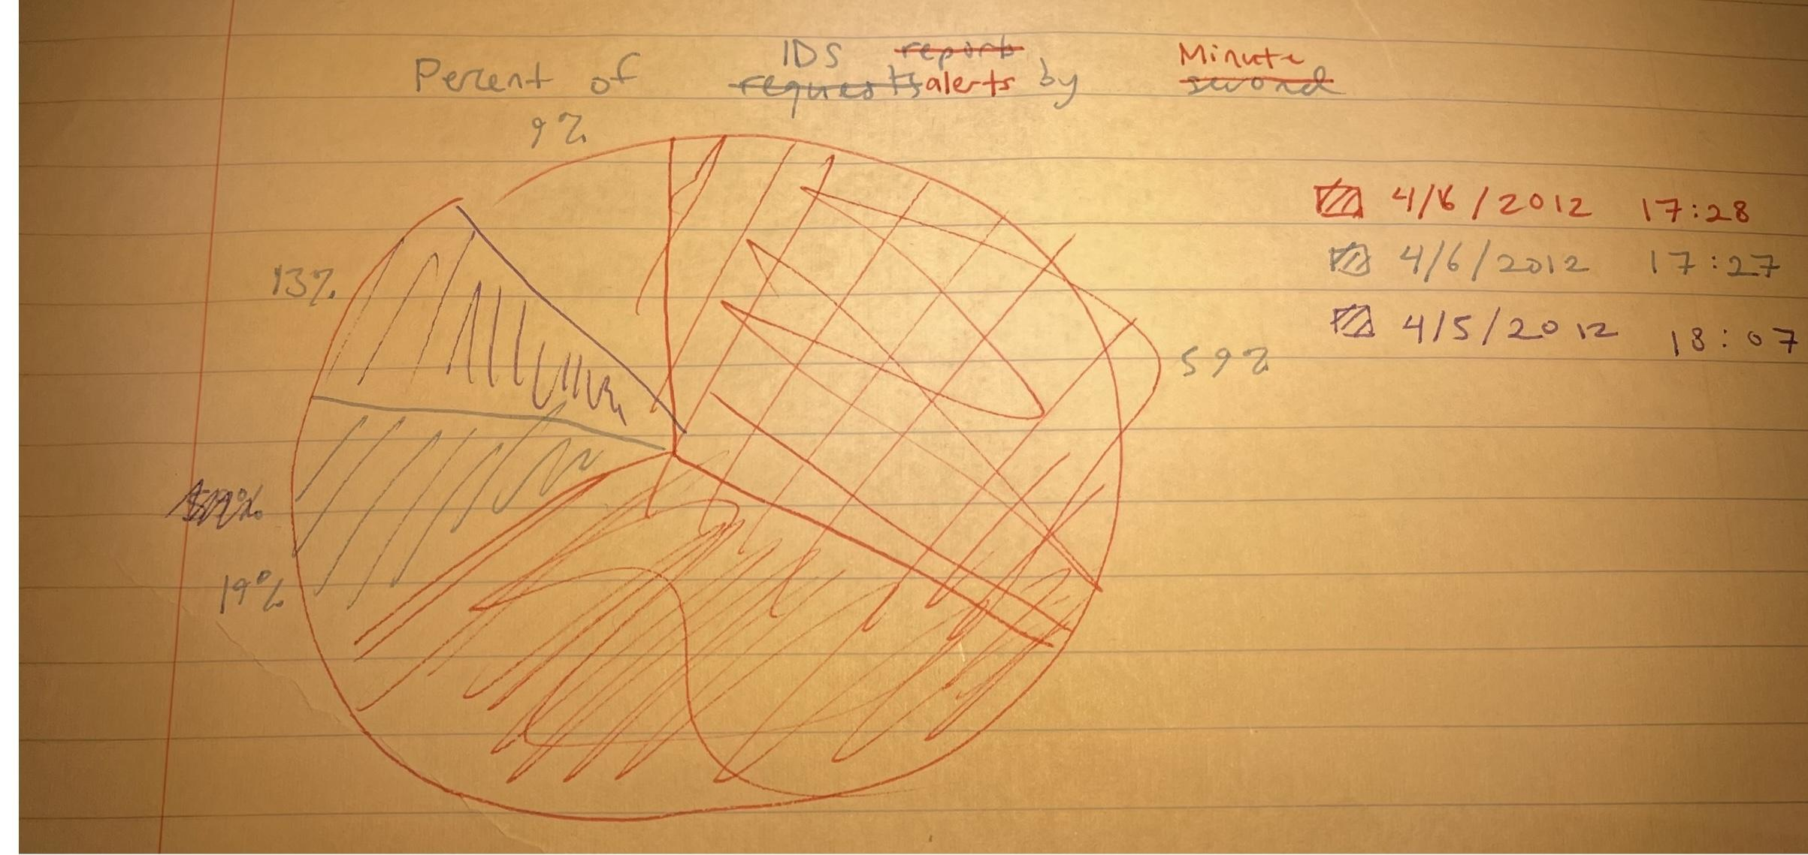

[Fig 2] Pie chart showing percentage of “Potential Corporate Privacy Breach” classified IDS alerts by second, with the last category being “other”

Filtering specifically for intrusions in the IDS logs classified as “Potential Corporate Privacy Breach” since that seems like the sort of issue we are looking for, we can see that the majority of this type of intrusion occurred at either 17:27 or 17:28 on 4/6/2012. Notably (and not clear from this) there were a few hundred requests in just 2 minutes. This is definitely unusual activity. The code to complete this visualization would not work.

Recommendations
- Create a directional version of Fig. 1 to see which IP address is trying to contact which. This would give us a better understanding of the structure of communications within the BOM network.
- Research the IP addresses in the “Other” designation to learn more about the suspicious IP addresses.

