**MY GIT WORKFLOW**

* Initialized local repository in the TaskApp directory with the command

*git init*

* Connected the local repository to my remote repository on GitHub with the command

*git remote set-url origin* [*https://github.com/CelestialSteel/IAP-TaskApp.git*](https://github.com/CelestialSteel/IAP-TaskApp.git)

* Staged all my files for commit using the command *git add for simplicity instead of individually committing files.*
* Used *git status* to check the status of the files on the local repository.
* Used *git commit -m “”* to commit my files(indicating I’m ready to send changes) before pushing to the remote repository.
* Used *git push -u origin master* to push my changes to the master branch of my repository.
* Used *git log* to track the state of my repository and the commit history e.g

**commit c6c90b67a4685e7777acdbf8424bbf4d388da7b3 (HEAD -> master, origin/master, origin/HEAD)**

**Author: Griffin Sitati <sitatigriffin71@gmail.com>**

**Date: Fri Sep 12 22:31:09 2025 +0300**

**Mailing functionality for successful registration and connection to database recording users.Along with catalogue page for courses**

* The schema to my database file is located in the database directory.
* The picture to my database view of registered users is demonstrated below: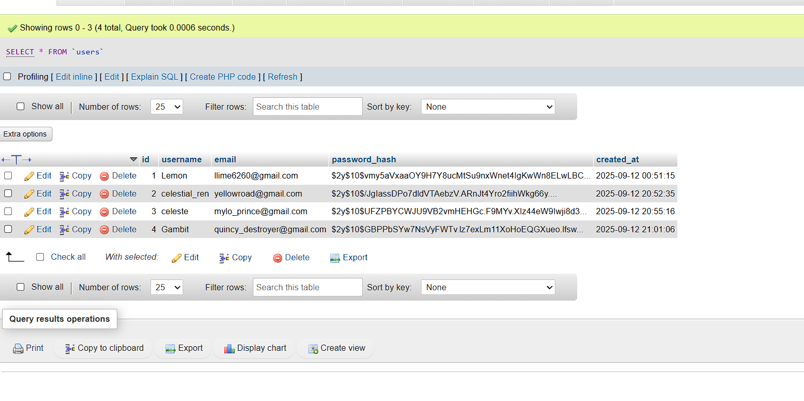

Figure : User's database