***Celestial Intranet Application***

**Asset Tracking Management System [AMS]**

**Software Design Specification**

**Revision History**

|  |  |  |  |
| --- | --- | --- | --- |
| **Date** | **Description** | **Author** | **Comments** |
| 22/06/2020 | Asset tracking management system design documentation | Ashwini T Kumar | Initial draft |
| 25/06/2020 | * Modifications to flowchart and sequence diagrams as per inputs from IT Team. * Architecture and workflow diagram | Ashwini T Kumar | Changes to section 1.4.4 |
| 29/06/2020 | * Modifications to flowchart and sequence diagrams as per inputs from IT Team. * Architecture and workflow diagram | Ashwini T Kumar | Changes to section 1.8 and 1.9 . |

Contents

1. AMS Introduction
2. AMS Use Cases
3. AMS Sequence Diagrams
4. AMS Flowchart
5. **AMS Introduction**
   1. **Description and Purpose**

The IT asset management application on an organizational basis is developed to monitor activities and business practices relating to the management of software, hardware, and workstation warranty. Assets include Servers, Routers, Switches, Cables, Computers, and Peripherals etc.

The purpose of the IT Asset Management Function is to provide resources and expertise to support the acquisition, in-service support and disposal of the physical assets required by the organization.

This application is supposed to minimize the human effort by providing an electronically manageable application which keeps track of several assets that can be borrowed by the borrower and provide various functions.

* 1. **Goal**

The IT asset management project has three main modules :

* Hardware resources management: to reduce the process time and needed manpower for the delivery of e.g. PCs, monitors, switches, cables etc.
* Software Licenses management: To manage used and available licenses, subscriptions on computers.
* Common central repository for IT devices: to track and configure all IT devices within one information system.
  1. **Scope**:

AMS System that is to be developed provides the users and the administrator with assets information.

Main features below:

* Management of physical components form acquisition through disposal including desktop, laptop, servers, LAN and WLAN electronics, wireless voice, and communications equipment.
* Software license management.
* Assets availability.
* Asset current location.
* Current asset’s user.
* Asset history/Details.
* Authenticate the user/administration.
* Administration can generate a unique id for every asset.
* Administrator adds details of the new asset into the database, remove details of the asset that are obsolete from the database and moved to the asset history database.
* Identify the user who failed to comply assets policy (damage or loss). Send a message to the user.
* Assets can be returned/transferred.
* Updating the database tables accordingly for every transaction.
  1. **AMS Overview**
     1. **System overview**

• Asset database management.

• Report on the state of IT assets at given point in time.

• Track IT assets throughout the asset’s life cycle.

• Ensure software license renewal management.

* + 1. **Users Overview:**
* Employee- Can be all level employees within a company
* IT Admin /Asset Manager.
  + 1. **Functional Overview:**

Employee can perform the below operations:

* Request New Asset
* Replace Asset
* View Asset

IT Admin has the following functionalities:

* Add and Update Asset
* Search Asset
* Delete Asset
* Update Asset
* Assign Asset
* License Renewal
* Import/Export Asset data
  + 1. **AMS Module Architecture Overview:**

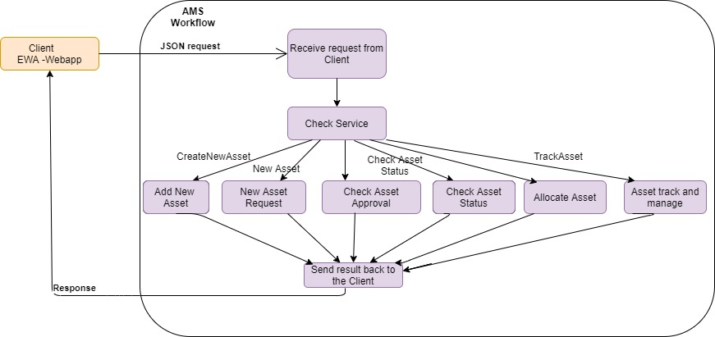

**Fig1 : AMS Workflow**

**Ex:** <http://localhost:8080/AMSservice/NewAssetRequest>"

<http://localhost:8080/AMSservice/AddNewAssetRequest>**"**

**….**

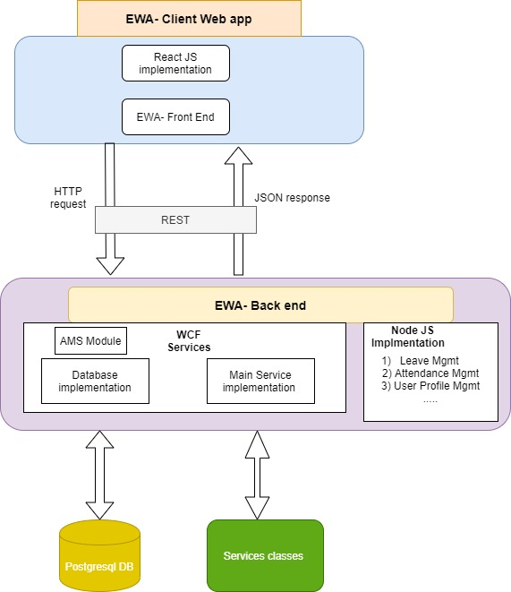

**Fig 2: AMS Architecture overview**

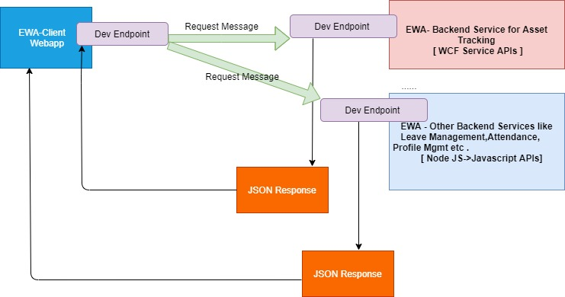

**Fig 3: Client consuming Backend service[WPF service API]**

* + 1. **Database Overview:**

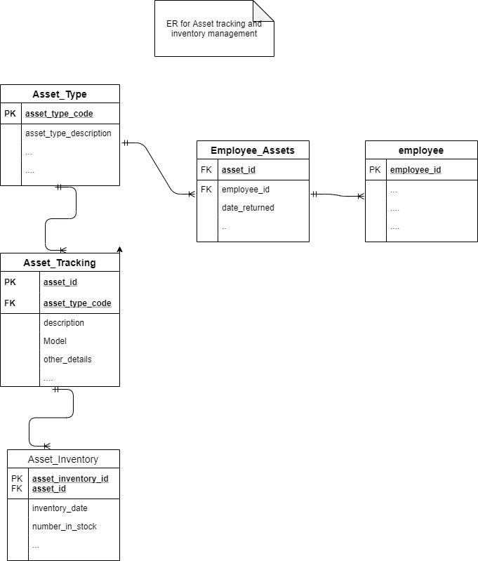

**Fig: Database Entity relation of AMS**

* 1. **Constraints on AMS**
* The information of all the users must be stored in a database that is accessible by the IT-Asset Management System.
* The IT-Asset Management System is connected to the server and is running all time.
* The users access AMS from any computer that has internet browsing capabilities and an internet connection.
* The users must have their correct usernames and passwords to enter the ITAM.
* Once user logs in , the AMS page expires after 3-4 minutes i.e. ,A time out mechanism should be there.
* The system must have data backup facility in case of data loss. If data loss occurs, the system can recover from the data backup.

1. **AMS Use cases:**

The use cases diagrams of different users involved in AMS :

1. **IT Admin :**

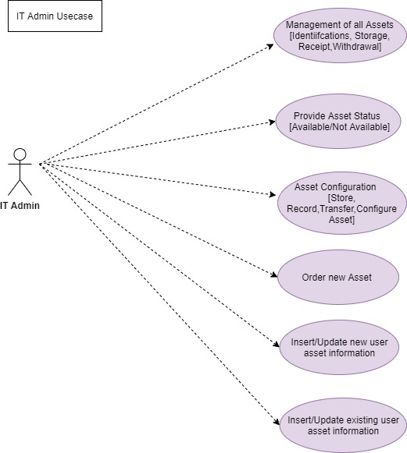

**Fig: Use case for IT Admin operations**

1. **Asset Manager:**

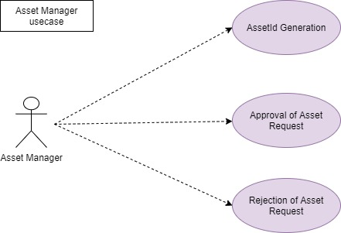

**Fig: Use case for ‘’Asset Manager’’ operations**

1. **Employee/User:**

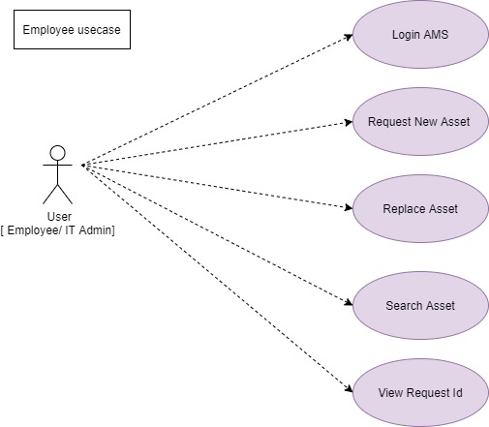

**Fig: Use case for ‘Employee” operations**

1. **All Entities:**

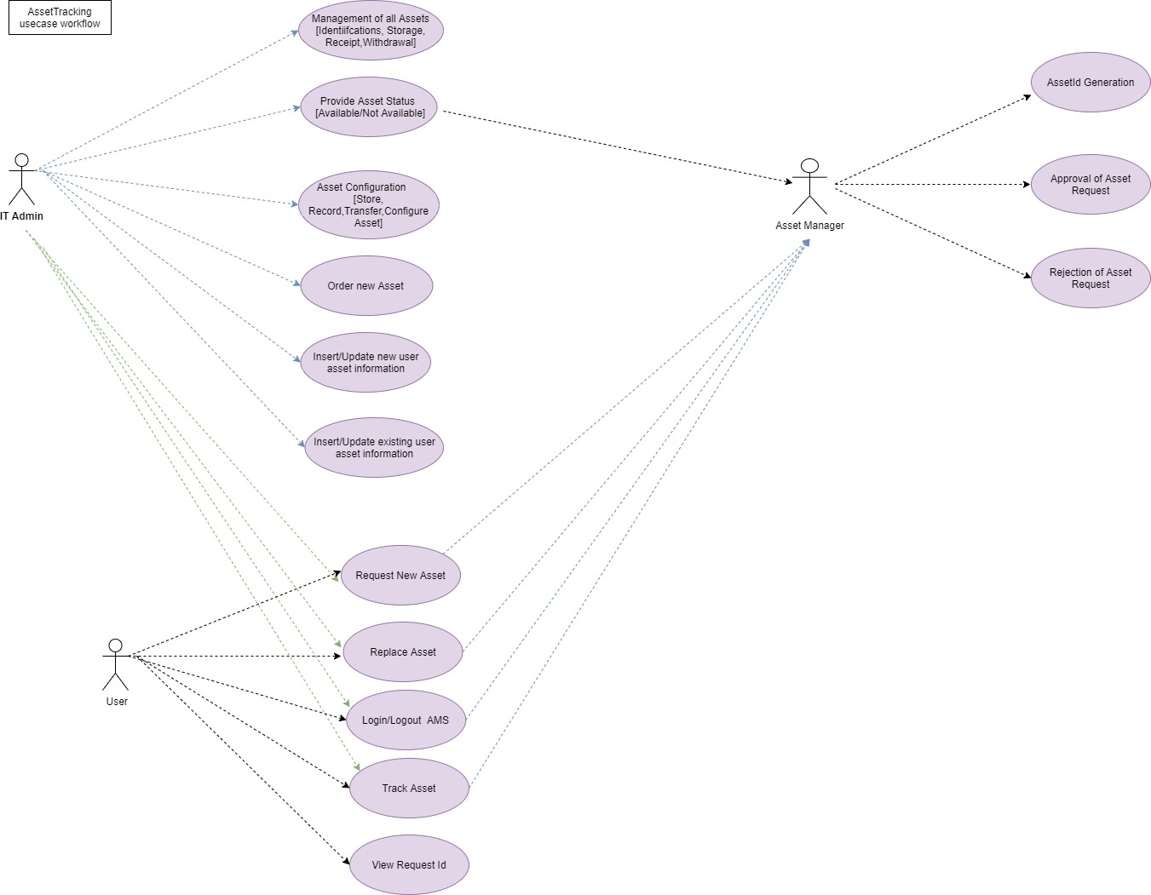

**Fig : Use case diagram for all entities within AMS**

* 1. **Use case description**

|  |  |  |  |
| --- | --- | --- | --- |
| **SL No** | **Entity** | **Use case scenarios** | **Description** |
| 1 | User | Request New Asset | When a new /existing employee requires an asset ,or any updation of an asset, user can raise the new request and the corresponding unique request id will be generated |
| 2 | User | Track a request | After raising an asset request, user can track the status of the request using the unique request id or user can consult IT Admin |
|  |  |  |  |
| 3 | IT Admin | Order new asset/item | Based on the asset non-availability, admin can order the asset any item and maintain record. |
| 4 | IT Admin | Add and Update asset | Once the new asset is ordered, the asset can be added into database and update the asset information. |
| 5 | IT Admin | Asset tracking | IT Admin can view ad track all asset requests with the request Id based on the approval by RM. |
| 6 | IT Admin | Provide Information on Assets | Admin is responsible for providing information on assets to users. |
|  |  |  |  |
| 7 | Admin - Asset manager | Approval/Rejection of an asset | Asset Manager can approve or reject the request |
| 8 | Admin - Asset manager | Asset Id generation | For every new asset ordered , unique Asset Id is generated |
| 9 | Admin - Asset manager | Request Id generation | For every new asset/replace asset request , request Id is generated. |

1. **AMS** **Sequence Diagrams :**
2. **Raise new Asset request :**

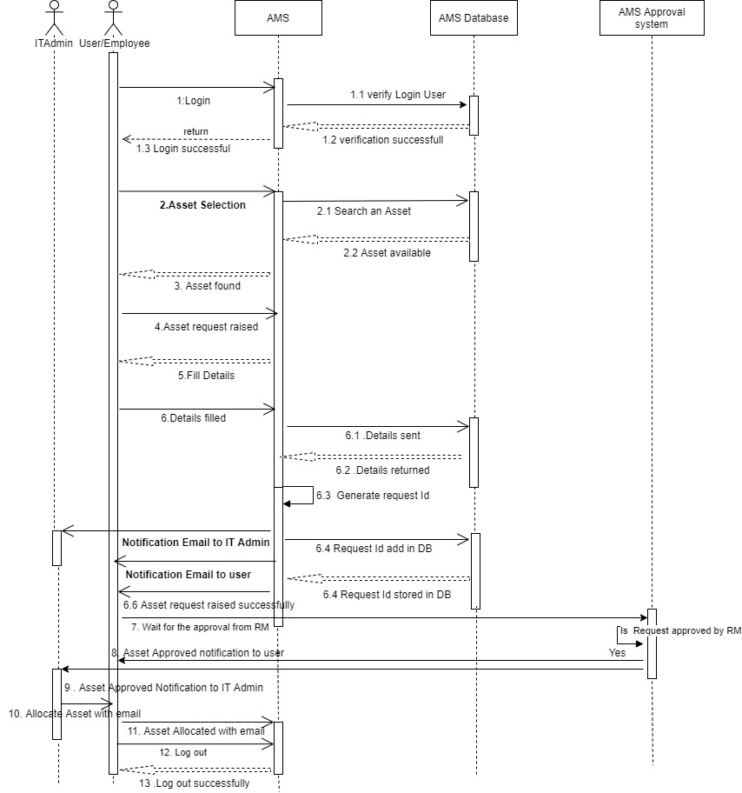

**Fig: Raise New Asset Request**

1. **New Asset Approval**

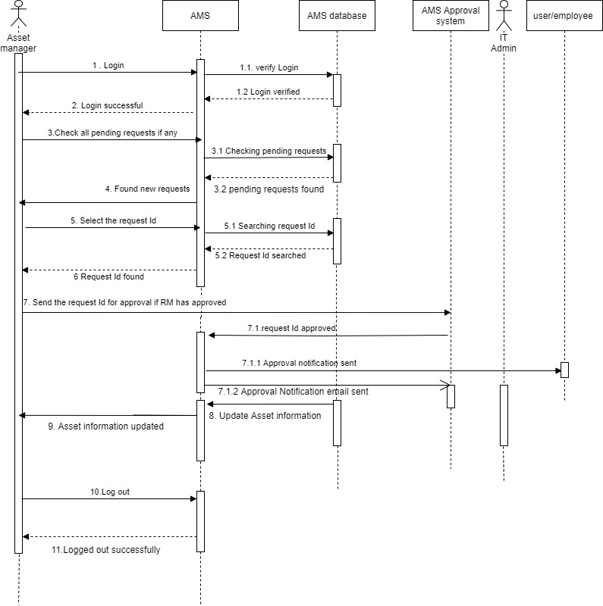

**Fig: New Asset Request approval**

1. **Employee- Asset Track**

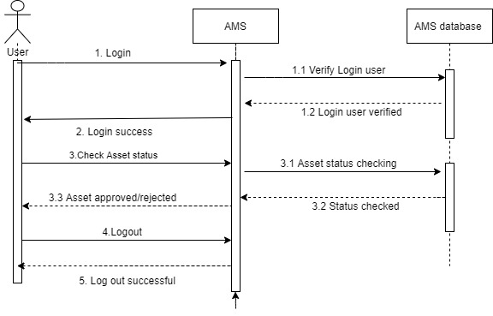

**Fig : Asset Tracking workflow**

1. **AMS Flowchart**

* Raise New Asset request
* Add New Asset
* Create and Update Asset
* Delete Asset
* License Renewal Request
* Import/Export Asset
* View Asset Details[Asset History, Search etc]

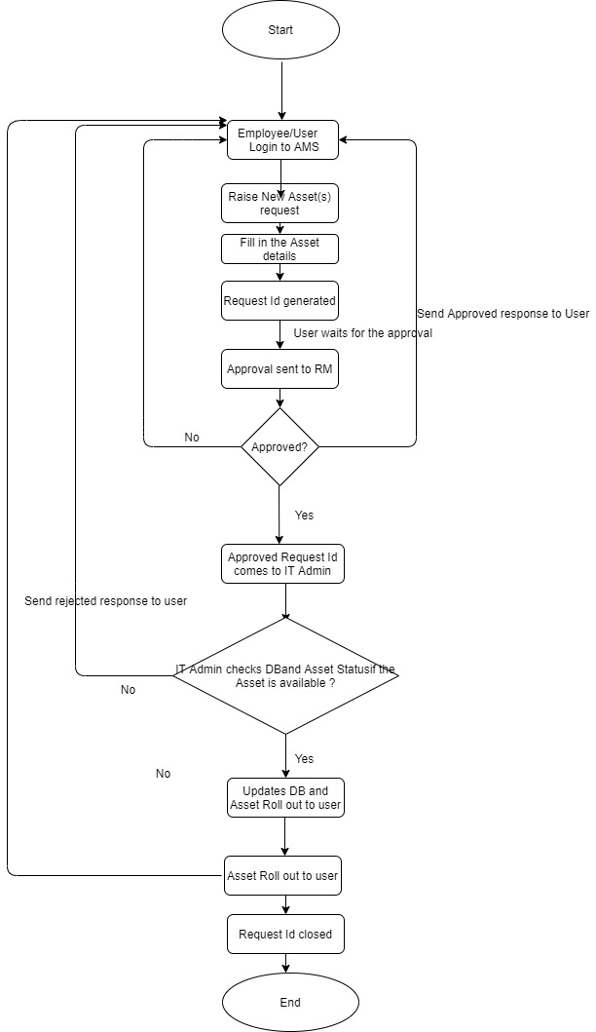 **Fig 1: Raise New Request and track request Id**

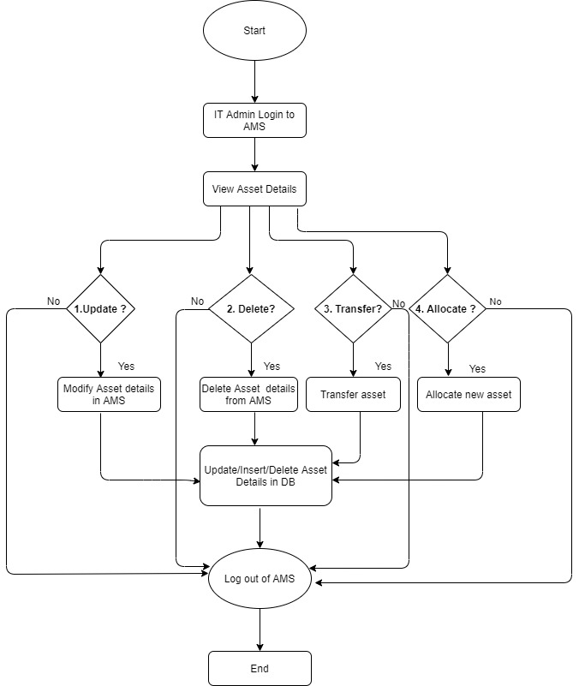

**Fig 2: IT Admin Operations**

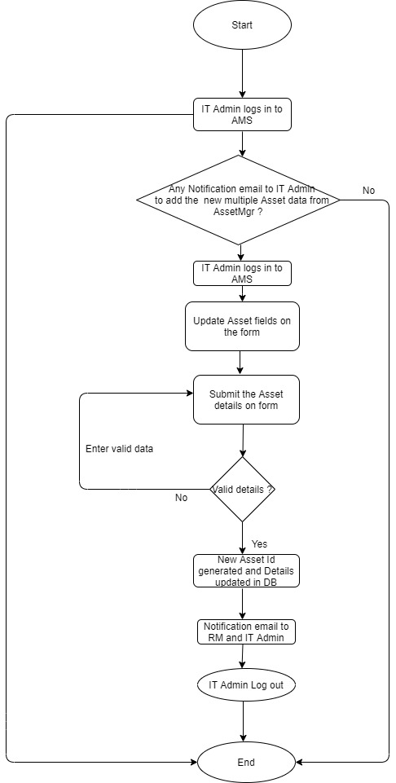

**Fig 3: IT Admin “Add New Asset” and “Update Asset” details**

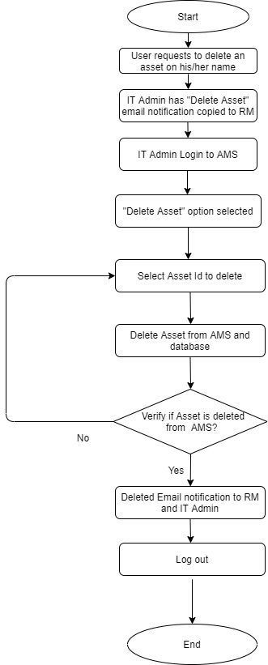

**Fig 4: IT Admin “Delete Asset”**

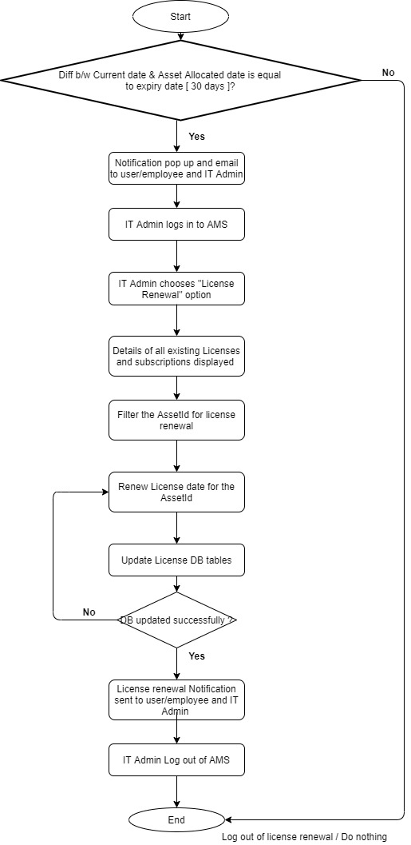

**Fig 5: IT Admin- “License Renewal” request**

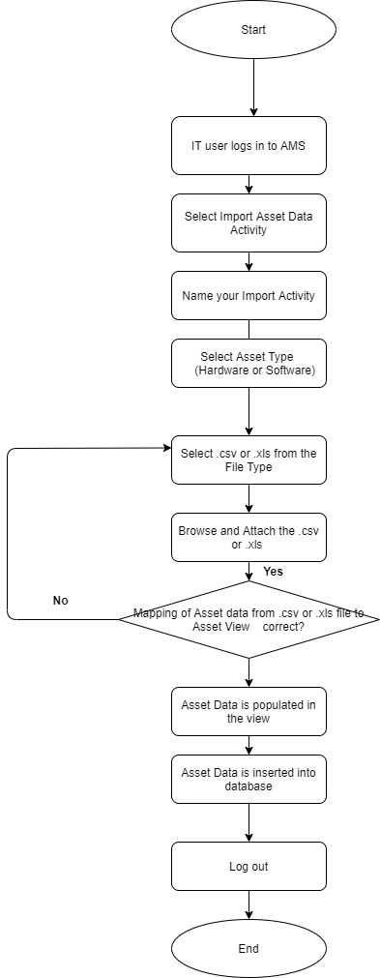

**Fig 6: IT Admin- “Import Asset” data**

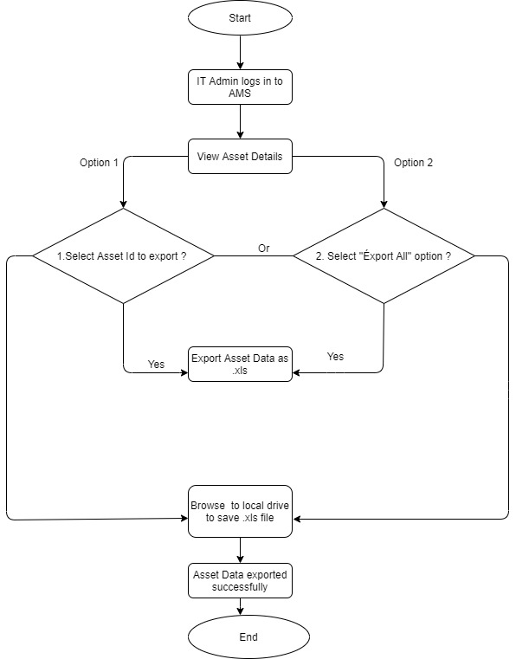

**Fig 7: IT Admin – “Export Asset” data**

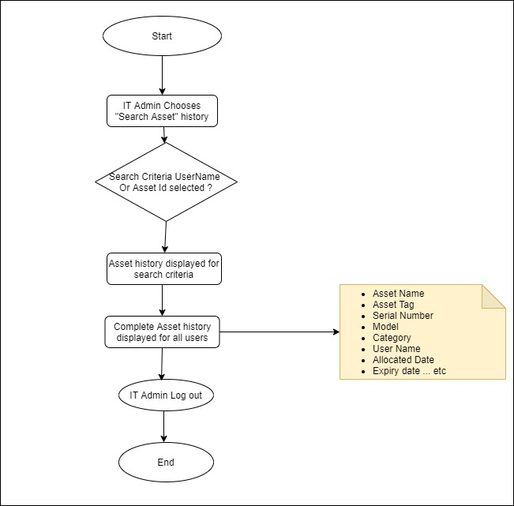

**Fig 8: Asset History**