Answer these questions based on your results.
Searching and Sorting:
- Do the projected (theoretical) values for n and the Big-O efficiencies match your actual results? Which ones match and which ones are different?

- Do they match for anything consistently, no matter the size of the array?

- Where do the theoretical efficiencies differ the most from the actual results? Can you figure out why they differ based on the code for that sort or search?

- What do you notice about insertion sort and selection sort compared to their theoretical efficiency?

- Is there a best method to do a single search no matter the size of the array? What is it?

- Go back to the very top of the spreadsheet and scroll over to the right so that column M is the first column showing on the left. See which search or search + sort is the minimum.
At what point does the linear search cease to be the best way to find something? Which search or search + sort is the minimum at that point? Scroll down looking at that minimum for each N. Fill out the table below with what thing is the minimum for each. Use ls for linear search, is + bs for insertion sort + binary search and ms + bs for merge sort + binary search.
 | 1 | 2 | 3 | 4 | 5 | 6 | 7 | 8 | 9 | 10
32
64
128
256
512
1024
2048
4096
8192
16384

Is there anywhere that Insertion Sort with Binary Search is the best choice?

Make a statement about what is best to use under what circumstances based on what you have observed and the data you have gathered.

Matrix Multiplication
- Your processor is a:
- The size of cache memory on your processor:
- The amount of RAM (available) on your machine:
- What is being calculated:
Loop Order | i, j, k | i, k, j | j, I, k | j, k, i | k, I, j | k, j, i
c = a * b | - = - * |

- Which loop orders do you predict will run the fastest based on having to swap data in and out of memory?
- Which loop order will run the slowest?
- Time to run the experiment. Close all open applications on your machine. Run MatrixMultiplication.java and go do something else for 15 minutes. Then fill out this table :
Loop Order | I, J, K | I, K, J | J, I, K | J, K, I | K, I, J | K, J, I
The size of N: 64
n^3 = 262,144
size in memory is 0.05 GB.
The size of N: 128
n^3 = 2,097,152
size in memory is 0.2 GB.
The size of N: 256
n^3 = 16,777,216
size in memory is 0.8 GB.
The size of N: 512
n^3 = 134,217,728
size in memory is 3.1 GB.
The size of N: 1024
n^3 = 1,073,741,824
size in memory is 12.6 GB.
The size of N: 2048
n^3 = 8,589,934,592
size in memory is 50.3 GB

- Highlight the lowest running times. (Put your cursor in the cell with the low time and then click on the table tool and choose the last menu item borders and shading, click on the shading tab, click where is says No Color and click the bright yellow square. Feel free to delete everything in the parentheses and the pictures below)

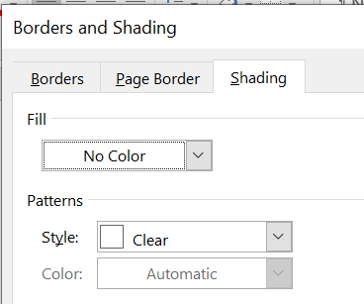

Now look at your predictions. Were you right?
If you weren’t right, it may be that you didn’t understand how to do question 4 and that’s OK.
Save this document and upload it.

