AMP 210 CONDITION MONITORING OF ELECTRICAL AND I&C CABLES SUBJECT TO EQUIPMENT QUALIFICATION REQUIREMENTS (VERSION 2021)

Programme Description
Cables are one of the major components of NPPs and provide multiple functions including transmission of instrumentation and control signals and supply of electrical power to electric components of NPPs [1].
The main objective of this AMP is to provide methodologies to assess that the cables subject to equipment qualification (EQ) requirement, located in harsh plant environments (that is, those areas of the plant that could be subject to the harsh environmental effects of a loss of coolant accident (LOCA), high energy line breaks (HELB), post-LOCA environment, and/or other environments as defined in accordance with national regulatory requirements for EQ) remain in qualified condition after the effects of in-service ageing. The effects of significant ageing mechanisms in the qualification are addressed as a part of initial EQ and subsequently by cable condition monitoring during service life [2-4]. This AMP focused on condition monitoring and needs to be coordinated with other relevant plant´s programmes [5].
- Programme constitutes powerful tool for ([6-13] as well as AMP 221):
- assessment in-service ageing
- confirming that assumptions used in initial qualification are conservative
- reducing uncertainties derived from accelerated ageing performed during the initial cables EQ
- reevaluation of qualified life and / or assessment of qualified condition based on the actual rate of cable degradation in plant operation
This AMP is considered for implementation for those NPPs where a baseline of condition monitoring techniques could be easily established and a set of cable samples in plant could be also easily accessible for periodic testing. This AMP also requires the preparation of a qualification documentation that includes but is not limited to:
- Cables characteristics such as mechanical and electrical properties, chemical composition;
- Cables performance expectations;
- Qualification reports: this report includes test procedure, ageing parameters, result record, environmental conditions to which the cables could be subjected.

Evaluation and Technical Basis
- Scope of the ageing management programme based on understanding ageing:
This AMP applies to the cables subject to EQ requirement,located in harsh plant environments (that is, those areas of the plant that could be subject to the harsh environmental effects of LOCA, HELB, post-LOCA environment, and/or other environments as defined in accordance with national regulatory requirements for EQ).
Condition monitoring of cables may be limited to a representative sample of cables and its frequency may be adjusted based on demonstrated plant specific cable test results and operating experience [9]

- Preventive actions to minimize and control ageing degradation:
This programme is a condition monitoring programme and has no preventive actions.

- Detection of ageing effects:
Within the scope of this AMP, detection of ageing effects consists of periodic measurement of selected measurable condition indicators that are linked to the functional degradation of the cables, detect changes caused by significant ageing mechanisms and have a consistent trend through the cable lifetime [4]. Cables condition can be evaluated through different condition monitoring techniques that can be divided in four main types [9,14]:
- visual / tactile – e.g. visual inspection, infrared thermography
- electrical – e.g. reflectometry [15], tan delta, insulation resistance
- mechanical – e.g. indenter modulus [16], tensile testing [17]
- chemical – e.g. oxidation induction time / temperature [18], density
Relevant information on cable condition monitoring methods is provided in USNRC RG-1.218 [9], NUREG CR/7000 [12] and IAEA-NP-T.3.6 [7].
Some of techniques are destructive and require cable samples. For this purpose, useful sources of cable samples are:
- cable deposit located in “hot spot” areas, where the degradation is slightly accelerated comparing to normal service environment [19],
- operational cables removed from plant,
- cables obtained from decommissioned plants.
Selection of condition monitoring techniques is made based on the operating parameters, cable insulation and jacket materials, cable construction and environmental and operating stressors [9].
More explanations and considerations related to testing methods to be used and the respective acceptance criteria can be found in Appendix 1.

- Monitoring and trending of ageing effects:
Trending of ageing effects is carried out through the in-service inspection and evaluation of condition monitoring test results on cable samples in order to determine residual lifetime. Cable samples subjected to slightly accelerated ageing condition provide information of future ageing condition with fewer uncertainties that those results derived from accelerated ageing during the initial qualification.

- Mitigating ageing effects:
This programme is a condition monitoring programme. This programme has no specific operations, maintenance, repair or replacement regarding mitigation of ageing. However, when higher degradation than expected is detected, additional actions to mitigate ageing effects could be applied (for example using additional shielding, rerouting, improved ventilation in “hot spot” locations) [7].

- Acceptance criteria:
The acceptance criteria for determining the end of lifetime of installed EQ cables are plant specific and directly connected with the condition monitoring techniques selected in this AMP. The acceptance criteria ensure that cables are able to successfully perform their safety related demands during accident condition at the ageing level determined by the selected condition monitoring techniques.
For example, if cable insulation elongation at break (EAB) is selected as one of the condition monitoring technique used for determining the ageing level of cable, the acceptance criteria would refer to a certain value of EAB [19-20]. In this line, the acceptance criteria of a qualified cable would be the value of EAB tested after accelerated ageing (simulating service condition operation during the entire lifetime) performed during initial qualification plus a safety margin. If cables are subject to EQ requirements, these tests are performed prior to test the cable in accident conditions and post-accident conditions (for example LOCA and post-LOCA conditions). As long as the calculated EAB, derived from condition monitoring results and appropriated theoretical model for ageing mechanism, doesn’t reach the acceptance criteria, the cable would remain qualified.
Condition indicators are measured on aged cable samples (naturally aged, accelerated aged or a combination of both) until the expected lifetime, and prior to subjecting the samples to accident and post-accident conditions. For each cable insulation material, a qualified level of degradation (QLD), based on selected condition indicators, is defined [7].

- Corrective actions:
When the qualified life or QLD of the cable is exhausted (or very close to be exhausted) or cable does not meet specified acceptance criterion, a report about qualified life is issued with specification of corrective actions which may include, but are not limited to, replacement or requalification of the installed cable.

- Operating experience feedback and feedback of research and development results:
This AMP addresses the industry-wide generic experience. Relevant plant-specific operating experience is considered in the development of the plant AMP to ensure the AMP is adequate for the plant. The plant implements a feedback process to periodically evaluate plant and industry-wide operating experience and research and development (R&D) results, and, as necessary, either modifies the plant AMP or takes additional actions (e.g. develop a new plant-specific AMP) to ensure the continued effectiveness of the ageing management.
Failure of cable as a result of the accelerated degradation from the water at the site was also identified [22].
Specific visual inspection of cables located in the close vicinity of hot pipelines (e.g. steam isolation valves) is performed as a results of operating experience feedback.
Cable degradation as result of conduits/cables routed in close proximity to reactor coolant system (RCS) hot leg piping with limited heat dissipation capability was registered [22].
The environmental conditions in area of evaluated cables and loading of the cable are essential input for the AMP. Experience and data from other plants utilizing same cable/isolation materials can be used.
Relevant information on condition based qualification methodology based on industry experience, applicable to electric equipment (cables) is provided in IEC/IEEE-60780-323 [4].
Reference [14] identifies condition monitoring methods with potential for degradation monitoring and ageing assessment of various cable insulation and jacket materials. Some techniques indicated a trend in the early stages of degradation such as the oxidation induction time (OIT) test. The oxidation induction temperature (OITP) test continued to trend throughout the ageing process on the ethylene propylene rubber (EPR) and ethylene vinyl acetate (EVA) polymer materials. Other chemical condition monitoring techniques such as thermogravimetric analysis (TGA) did not provide useful trending of degradation for any of the tested materials. Others such as density, ultrasonic velocity, and Fourier transform infrared spectroscopy (FTIR) indicated either promising results for early degradation detection or some trending capability for specific materials. Traditional condition monitoring techniques such as tensile testing or elongation at break and indenter modulus provided useful trending data for most of the polymers tested.
The Cable Polymer Aging Database [23]: contains thermal and radiation data that may be used to evaluate the effects of ageing and determine acceptance criteria. Electric Power Research Institute (EPRI) report 1008211 [24] provides initial acceptance criteria for continued use of cable in safety-related applications and guidance on generating additional acceptance criteria.
The Halden Reactor Project has developed a high-frequency, low-voltage test that assesses reflected impedance of the cable. The test can identify local damage and bulk thermal ageing occurring in polymer insulation. Testing in conjunction with EPRI in 2005 showed that the system could identify significant localized ageing before the ageing exceeded the ageing limits of EQ for cross-linked polyethylene (XLPE) and EPR cables [25].
The processes and phenomena of cable insulation ageing exposed to multiple stress environments in NPPs requires cable polymer ageing and condition monitoring research as described in [26].

- Quality management:
Site quality assurance procedures, review and approval processes, and administrative controls are implemented in accordance with the different national regulatory requirements, (e.g. 10 CFR 50, Appendix B [27]).

Appendix
Examples of Diagnostic Methods with Acceptance Criteria Development for Typical Electrical Cables

Disclaimer
The examples in the appendix are provided to demonstrate criteria for each test discussed. The values should not be considered applicable to all materials and it is the responsibility of the member state / user to perform a technical evaluation to confirm applicability for their polymers.

Table of Contents of Appendix
1. Description 5
2. Scope 6
3. Evaluation and Technical Basis+ 6
3.1 Elongation at Break 6
3.2 Arrhenius Law 14
4. Examples of Acceptance Criteria for non-electrical and electrical tests 19
4.1 Indenter modulus (IM) 19
4.2 Visual inspection 22
4.3 Infrared thermography 24
4.4 Insulation Resistance (IR) 25
4.5 Shield Resistance 29
4.6 Dielectric Losses (tan δ) for MV cables (TD) 31
4.7 Partial discharge (PD) 32
4.8 AC Withstand Test (HiPot) 36
4.9 Time Domain Reflectometry (TDR) 36
4.10 Frequency Domain Reflectometry (FDR-LIRA) 37
4.11 Dielectric Spectroscopy (DS) 41
5. Conclusion 42

- Description
The purpose of this appendix 1 is to collect available testing methods with acceptance criteria that can be used as recommended in AMPs for Low Voltage and Medium Voltage Electrical Cables and could be used in the AMP201, AMP203, AMP223 and AMP206 for connections. It should fit best as attachment to AM210 and referenced in others.
Some of the described diagnostic methods and techniques could be used for both low voltage (LV) and medium voltage (MV) cables if not specifically referenced.
For assessing cable degradation some NPPs are currently using a set of electrical tests and visual inspections with indenter modulus testing (AMP201), and Electrical tests for insulation resistance and connections AMP202 (insulation resistance) and AMP203 (insulation resistance, dielectric losses, partial discharges, shield resistance, resistance of connection, infrared thermography), AMP206 (connections measurement of connection resistance, infrared thermography). To assess the state of the cable one should consider, evaluate and compare results of all tests implemented. Sometimes modifying an acceptance criterion is advised based on the engineering evaluations and judgement.
- Scope
Based on mechanical tests, such as laboratory test of Elongation at Break (EAB) and field test Indenter Modulus (IM), some testing methods are recognized as appropriate for field use including non-electrical and electrical with acceptance criteria included for typical cables used in nuclear power plant with insulation (e.g.EPR/XLPE) and Jacket (e.g. CSPE) [14].
The main objective is to describe some available testing methods for ageing degradation detection and trending with the acceptance criteria based on standardized tensile test for which the Elongation at Break (EAB) is measured [24]. Furthermore, detailed description of development of the Indenter Modulus (IM) with 3 level acceptance criteria (GOOD-TREND-ACTION) is presented.
Additional non-electrical and electrical methods are described with the same 3 level acceptance criteria for 11 field available diagnostic methods such as: Indenter Modulus (IM), Visual Inspection (VI), Arrhenius Temperature model evaluation, InfraRed Thermography (IRT), Insulation Resistance (IR), Connection Resistance, Shield Resistance (R), Dielectric Losses (tan δ, TD), Partial Discharge (PD), Withstand (HiPot), Time Domain Reflectometry (TDR), Frequency Domain Reflectometry (FDR-LIRA) and Dielectric Spectroscopy (DS).

List of abbreviations
CSPE - Chlorosulphonated Polyethylene
EPR - Ethylene Propylene Rubber
EOL - End of Life
PDEV - Partial Discharge Extinction Voltage
XLPE, XLPO - Cross-Linked Polyethylene/ Polyolefin

- Evaluation and Technical Basis+

  - Elongation at Break
Elongation at Break (EAB) is commonly accepted standard for determining the state of the cable insulation. EPRI report 1008211 with initial Acceptance Criteria Concepts also defines the subject of EAB and indenter modules [24] with some of the most common types of cables from various manufacturers. The typical insulation materials for nuclear qualified cables used in safety related electrical circuits (1E) in nuclear power plants (NPPs) e.g. EPR, XLPE. [14]
Correlation charts compare Indenter Modulus (IM) with EAB results as a commonly accepted standard for determining the state of the cable insulation. EPRI Report [24] is associated with indenter elaborating generic types of few materials and some commonly used cables. Since the same materials from different manufacturers, due to various additives can have significant variations in their properties, the values of IM listed in the report are approximate to demonstrate possible available methods of approach. To gain insight into changing IM for cable insulation used in specific NPPs, some additional researches are advised to be carried out. Some research institutes and nuclear plants (NPPs) selected samples from stock and from plant representing most used cables by manufacturers and the typical nuclear qualified materials and aged them to get acceptance criteria for specific materials [14, 34].
In the EPRI report [24], EAB (elongation at break) acceptance criteria with conservative value for the "end of life" cable is retention of 50% absolute. It should be noted that all the cables from the report [14] that had EAB greater than 10% have passed the LOCA test (even some with EAB <5%). In some countries cable does not meet qualification requirements with EAB lower than 50 % despite the fact it passed LOCA test.
Figure 1 shows a comparison of material behaviour under 110°C thermal ageing. XLPO/XLPE has an exceedingly long life at this temperature. The plot shows that XLPO/E has a limited change in EAB for 10,000 hours of exposure and then gradually loses EAB, reaching 50% at approximately 50,000 hours. In comparison to XLPO/E, neoprene, CSPE and EPR age much quicker with sudden drops in EAB.
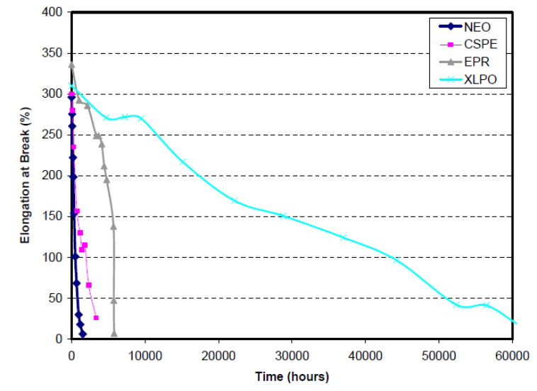
Figure 1: Nature of degradation of different cable materials at 110°C. To a limited extend XLPE and XLPO are interchangeable [24]
Figure 2 focuses on the first 6000 hours of ageing. In this figure, XLPE seems not to degrade at all. Neoprene degrades gradually, but fastest. CSPE degrades more slowly than neoprene. The EPR degrades slowest of these three, but after a gradual decay sees a sudden drop in EAB occurs after 5700 hours, it drops from 150% to essentially zero extremely rapidly.
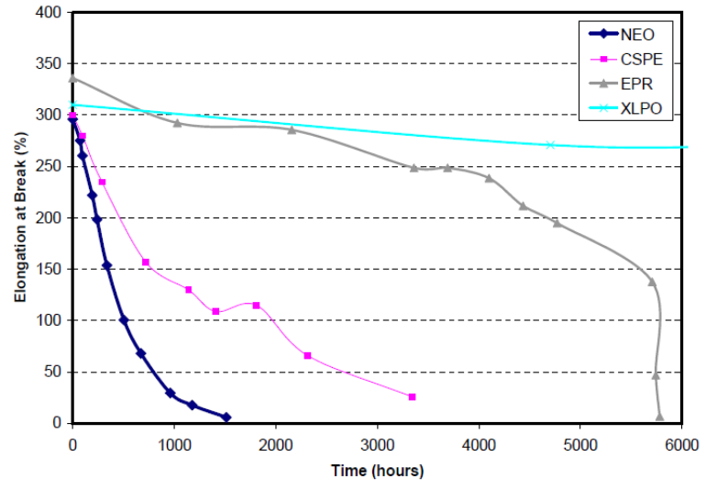
Figure 2: Nature of degradation of different cable materials at 110°C (first 6000 hours) [24]
Note: Elongation trend of CSPE is similar to PE (some specific material might differ, i.e. EPR).
The following graphs show the EAB and remaining life for Neoprene, CSPE, EPR and XLPE:
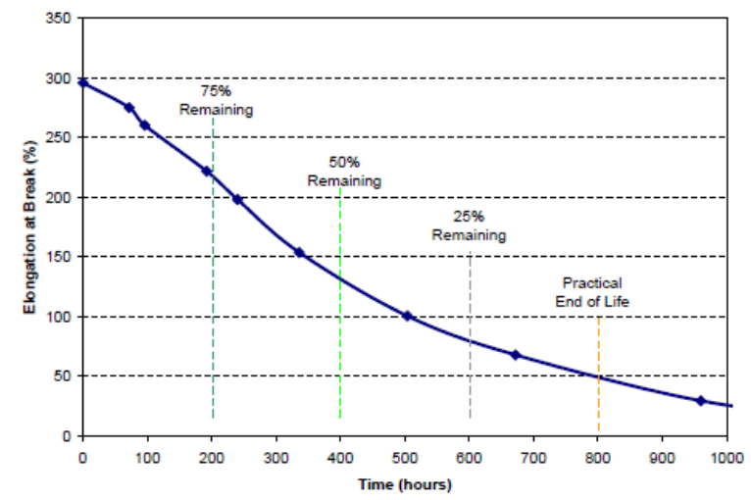
Figure 3: Remaining life curve for Neoprene, 110°C ageing [24]
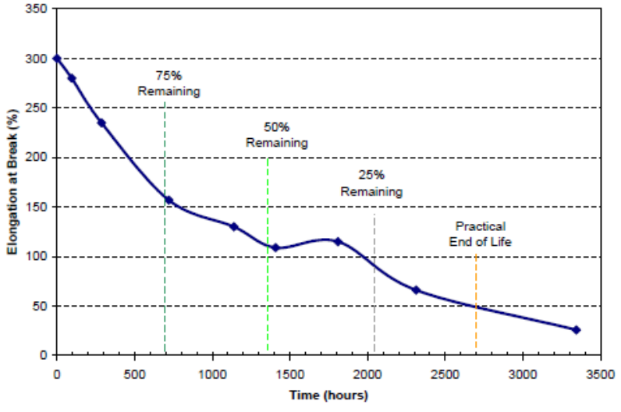
Figure 4: Remaining life curve for CSPE, 110°C ageing [24]

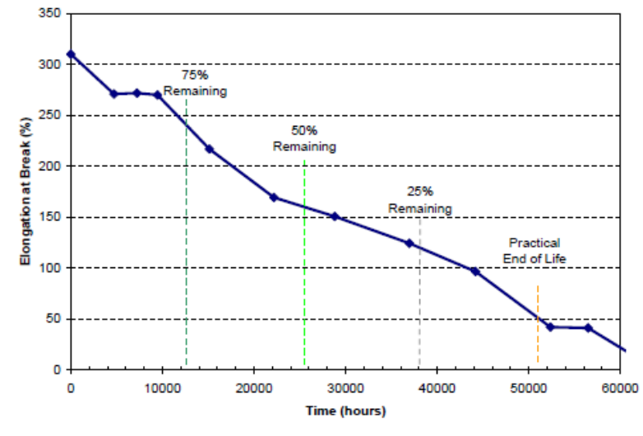
Figure 5: Remaining life curve for XLPE, 110°C ageing [24]
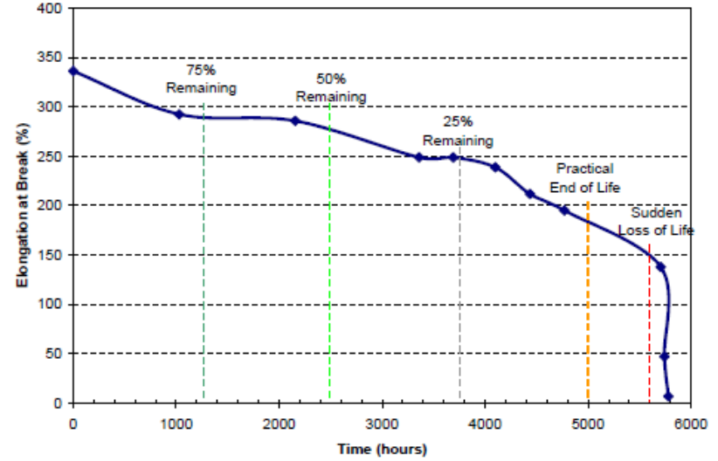
Figure 6: Remaining life curve for specific EPR formulation, 110°C ageing [24]
Figure 6 shows rapid change for specific manufacturer of EPR near the end of its life. Specific manufacturers and material types are described in the end of this chapter and 4.1. Accordingly, the practical end of life has been chosen at a point where the EAB is quite high (170%). A sudden loss of life occurs below 150% EAB. For this kind of EPR, but not necessary for all, the proposed remaining life system is somewhat less than satisfactory. Nevertheless, it is advised to verify specific type of EPR. Since there are other types with different behaviour, specific to each formulation as it is demonstrated in Figure 6a, where the blue line illustrates EPR without sudden loss of life at 150% at same aging 110°C.

However, EPR is only used for insulation and will always have a neoprene or CSPE jacket that may be used as an early indicator of degradation at visual inspection or test. For lightly loaded power, control and instrumentation cables, if the neoprene or CSPE jacket has a significant remaining life, there is no concern for the EPR insulation. However, if an EPR power cable is heavily loaded, ohmic heating may increase the rate of ageing of the EPR and the condition of the neoprene or CSPE jacket may not be fully indicative of the degree of ageing.
Power LOCA cables in nuclear plants are typically not loaded to full design ampacity due to design considerations that tend to oversize cables.

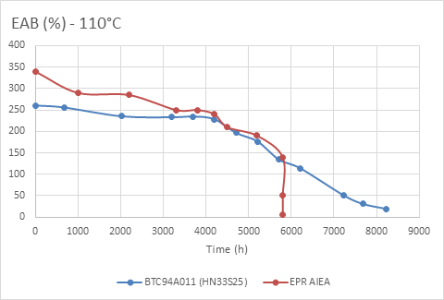

Figure 6a: Demonstration of different EPR types, without sudden drop at 150% in blue line

With the Arrhenius equation, it is possible to compare the results of the EPRI study with artificial aged cable samples in specific material research. Following graphs on Figures 7 to 9 are representing EAB versus IM for specific materials. The Arrhenius equation is a formula for the temperature dependence of reaction rates and its use will be demonstrated at the end of this paragraph as a one of available evaluation methods.
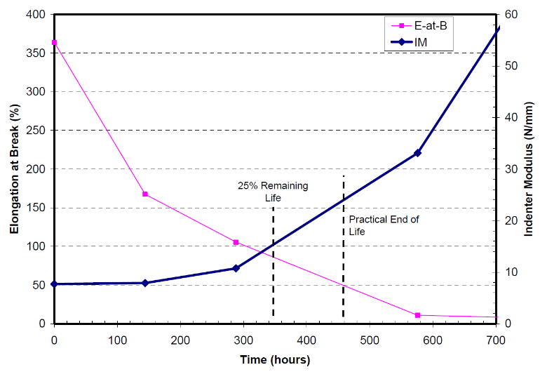
Figure 7: Rockbestos CSPE Jacket EAB versus Indenter Modulus, 142°C Thermal ageing [24]

Figure 7 shows indenter modulus versus ageing at 142°C. At 50% EAB, the IM increases to 24 N/mm from 8 N/mm when sample is new. According to Arrhenius equitation, 460 hours at 142°C for CSPE is equal to 2300 hours at 120°C. Comparing IM testing results in similar ageing time for 6 samples of ROCKBESTOS Cable with CSPE Jacket with results range from 10 N/mm for new cable to above 50 N/mm (sample ageing time was 1872 hours at 120°C) [34].

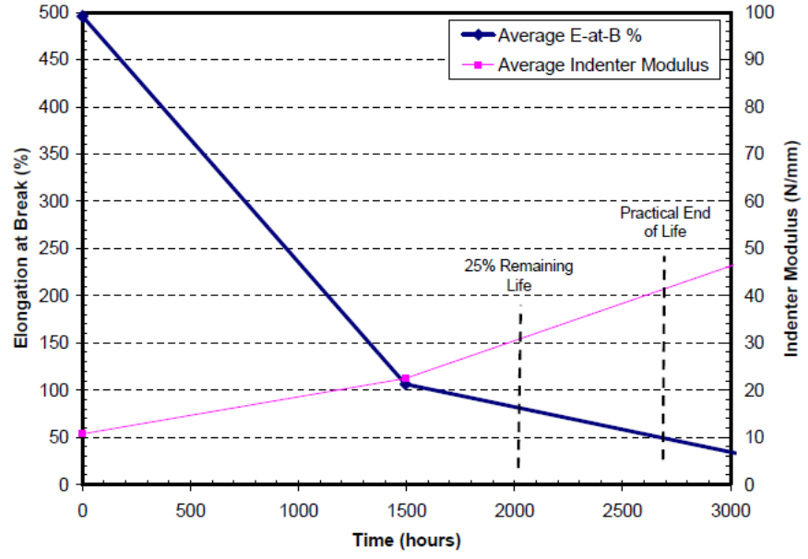
Figure 8: BIW Bostrad 7E Bonded CSPE/EPR EAB versus Indenter Modulus, 110°C ageing [24]

Figure 8 shows the comparison of EAB and indenter modulus for Bostrad 7E composite insulation when aged at 110°C. At 2700 hours, 50% EAB occurs, the corresponding IM is 42 N/mm. At 160% EAB and 32 N/mm IM, 25% remaining life occurs. According to Arrhenius equitation, 2700 hours at 110°C for bonded CSPE/EPR is equal to 1100 hours at 120°C.
Comparing tested 11 different cable samples of Bostrad 7E (BIW CSPE/EPR) aged for 1032 hours at 120°C and measured IM in range from 18 N/mm for new cable to above 100 N/mm (average from all 1032 hours aged samples 70N/mm).
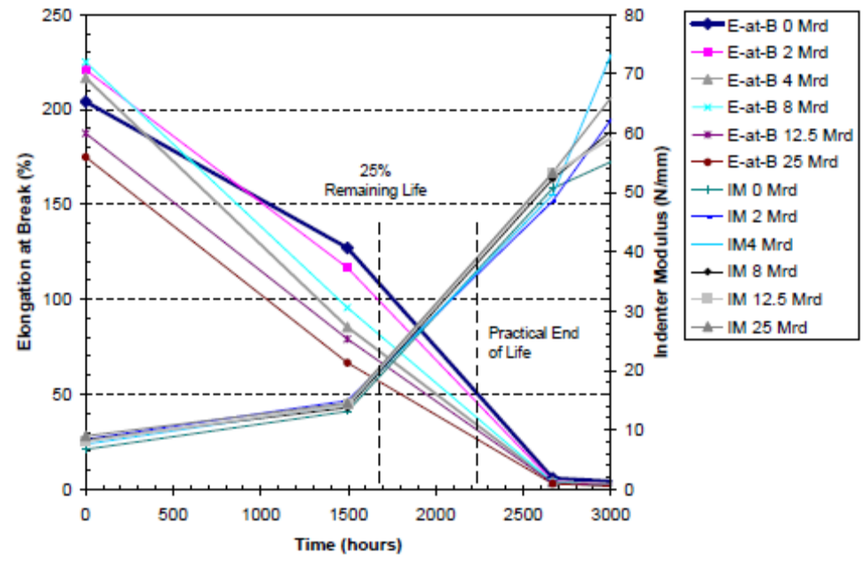
Figure 9: Okonite Okolon Single EAB versus Indenter Modulus, 110°C Various Doses [24]

Figure 9 shows EAB versus IM for Okonite Okolon bonded CSPE/EPR composite insulation used in MV cable applications. The IM related to 50% EAB is 38 N/mm (0 rd dose condition). At 25% remaining life, the EAB is 120% and the IM is 20 N/mm. The plot provides information on unirradiated cables and up to five degrees of irradiation. With 2-Mrd irradiation, there is little effect on EAB. At mid-life, the effects of irradiation are noticeable. However, the plots reconverge at higher ageing levels. According to Arrhenius equation, 2200 hours at 110°C for bonded CSPE/EPR is equal to 910 hours at 120°C. The measured IM in the range of ageing from 0 to 1032 hours for Okonite bonded CSPE/EPR insulation (sample 3) is in the range from 13 N/mm for new cable to 18 N/mm. The reason for different results between the EPRI’s and this study [34], during the ageing, bonded CSPE/EPR insulation was protected with CSPE jacket.

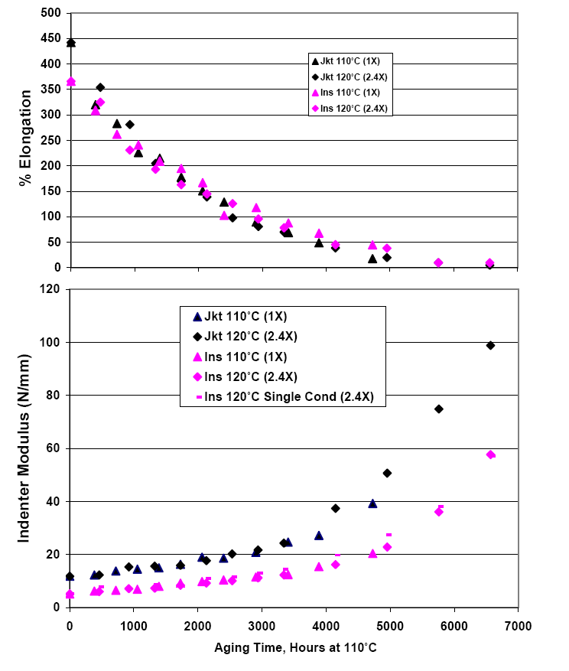 | 50% absolute elongation reached ~ 5000 hours Cable  Jacket Modulus increased to 40 N/mm at 50% elongation
Figure 10: Indenter and EAB results for CSPE outer jacket and EPR/CSPE composite insulation (Ref.: IEEE Trans. Diel & Elect Ins 2007;14:2)

Typical polymer material used in electrical cables, the manufacturer (in brackets), and specific voltage acceptance criteria development are:
- EPR/CSPE insulation (BIW) for LV Cables
- XLPE insulation (Rockbestos) for LV Cables
- Pink EPR insulation (Okonite) for MV Cables
- Jacket CSPE/Hypalone All three manufacturer (BIW, Rockbestos, Okonite) for LV and MV cables
Ageing of jacket material (CSPE) is much faster than ageing of primary insulation; in the stage of ageing where jacket is beyond its end-of-life, primary insulation is still functional. Although the jacket is only mechanical protection of primary insulation, its damage can cause damage to the primary insulation during cable manipulation. The scope of AMPs states that the scope of the program only contains the primary insulation, but conservative approach would advise actions (i.e. cable replacement), even when the jacket is age degraded.
As exposed, 50°C is a conservative threshold temperature, if no assessment of the installed cable materials was done, above which it is necessary to monitor the condition of cable insulation, and a higher temperature should be considered as Adverse Localized Environment (Hot Spot).
All acceptance criteria are set to basic and standardized 50% EAB as end-of-life and according to it, the percentages of remaining life are as follows:
75%-100% of Remaining life Good Condition Green
25%-75% of Remaining life Aged Condition to be Trended Yellow
0-25% of Remaining Life Severely Aged – Action needed Red

  - Arrhenius Law
The Arrhenius equation, as presented in equation 1, is the most widely used method for estimating the influence of temperature on the ageing of materials.
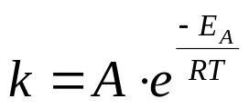 [Eq. 1]
where
R - rate constant (appropriate units)
A - preexponential factor (appropriate units)
R - gas constant (8.314 J⋅K⁻1⋅mol⁻¹)
E_{A} - activation energy (eV, J / mol)
The Arrhenius law is often used as well during qualification programs of cables and equipment for nuclear power plants. Qualification programs include a thermal ageing step which should be representative for the thermal deterioration of the equipment during its service life at a specific operating temperature. An adapted Arrhenius equation, see equation 2, for the determination of the accelerated ageing is therefore used.
The thermal aging step can be done, by maintaining the equipment during a time t_{a} (shorter than t_{s}) at a temperature T_{a} (larger than T_{s}).
$C=\frac{t_{s}}{t_{a}}=e^{\frac{E_{A}}{B}(\frac{1}{T_{s}}-\frac{1}{T_{a}})}$ [Eq. 2]
where
T_{s} - Operating Service temperature (K) (ambient temperature + Ohmic heating)
T_{a} - Accelerated aging temperature (K)
t_{s} - Operating time at operating temperature Ts
t_{a} - Time of accelerated aging at temperature Ta
E_{A} - activation energy (eV), typical values 0.8 to 1.8 eV
C - Acceleration factor
B - Boltzmann constant (8,62 x 10⁻⁵ eV/K)
The Arrhenius methodology can be used as well to recalculate the lifetime a material when operating at different service temperatures. However, when making use of the Arrhenius equation, the user should be aware of the limitations as well.
Physico-chemical aspects need to be considered during fast aging and are related to the limitations of the model of the Arrhenius equation. The accelerated thermal aging performed using Arrhenius equation uses the hypothesis that, for a given material, the rate of deterioration is dependent on only one variable (the temperature). In practice, the thermal degradation of any polymer materials often involves a variety of mechanisms that interact with one another, sometimes in a sequence. These mechanisms often involve the generation of free radicals, oxygen diffusion inside the materials, oxidation, chain scission, crosslinking, termination and many others. Each mechanism possesses its own kinetics (its own speed). The kinetics of each of these mechanisms can be affected by various environmental parameters including (but not limited to) temperature (T), relative humidity, exposure to light or to radiation, partial pressure of oxygen (pO2), equilibrium oxygen concentration inside the material ([O]),… This sequence of mechanisms involved in the degradation process implies that:
- The kinetics of the global thermal degradation process of a polymer material is not necessarily constant over time while Arrhenius uses a linear approach.
- The thermal degradation process is not necessarily uniform trough the cross section of the material.
If the acceleration factor is high, the risk is higher to have different degradation mechanisms to occur in the material. In some countries acceleration factor should not be higher than 250.
In the tables of this section, few demonstrations with examples of approaches and use of the Arrhenius Model for different materials at ageing time steps in electrical furnace at 120°C are provided [34]. According to Table 1, each sample nine ageing time is described with equivalent time in years for specific materials CSPE/EPR/XLPE calculated with Arrhenius equation at 50°C as follows.
Step | Description of Ageing time step | Calculated Equivalent time [Years]
1. | NO AGEING – Material | CSPE | EPR | XLPE
 | SECOND STEP OF AGEING 72 HOURS (3 days) at 120°C | 12.1 | 17.8 | 23.0
 | THIRD STEP OF AGEING 144 HOURS (6 days) at 120°C | 24.2 | 35.6 | 45.9
 | FOURTH STEP OF AGEING 240 HOURS (10 days) at 120°C | 40.4 | 59.3 | 76.6
 | FIFTH STEP OF AGEING 360 HOURS (15 days) at 120°C | 60.6 | 88.9 | 114.8
 | SIXTH STEP OF AGEING 528 HOURS (22 days) at 120°C | 88.8 | 130.4 | 168.4
 | SEVENTH STEP OF AGEING1032HOURS (43days) at120°C | 173.6 | 254.9 | 329.2
 | EIGHTH STEP OF AGEING 1872HOURS (78days) at 120°C | 314.9 | 462.3 | 597.2
 | NINTH STEP OF AGEING 3264HOURS (136days) at 120°C | 549.1 | 806.1 | 1041.2
Table 1. Duration of samples ageing with equivalent time in [Years] with an ambient operating temperature of 50°C for different material CSPE/EPR/XLPE according to Arrhenius Equation. (Ea = 1.14 for CSPE, 1.2 eV for EPR, 1.24eV for XLPE)

Demonstration of its use for the temperature impact on typical cable insulation materials, equivalent ageing time are calculated as examples. Data are used from SAND96-3044 Appendix G4 [44].
These calculations are valid for the instrumentation and control cables that are burdened with very small currents (averaging less than 1% of its ampacity). For power cables, ohmic heating due to current flow through the cable should be considered. Lifespan for cables with constant current flow near max. ampacity can be significantly lower than the time listed in Tables 2 to 6.
- CSPE (used in jacket material for LV and MV cables)
Working Temp.  T_{s} (°C) | Temp.  T_{a} (°C) | Time ta  (Year) | Activation Energy  Ea (eV) | Time t_{s}  (Year)
50 | 80 | 13.5 | 1.14 | 437.25
60 | 80 | 13.5 | 1.14 | 127.95
66 | 80 | 13.5 | 1.14 | 63.38
70 | 80 | 13.5 | 1.14 | 40.22
80 | 80 | 13.5 | 1.14 | 13.50
90 | 80 | 13.5 | 1.14 | 4.81
100 | 80 | 13.5 | 1.14 | 1.81
Table 2. Calculated Equivalent Lifetime for CSPE at various temperatures [44]

- EPR (SAND96-3044) (used for insulation of LV and MV cable insulation)
Working Temp.  T_{s} (°C) | Temp.  T_{a} (°C) | Time ta  (Y) | Activation Energy  Ea (eV) | Time t_{s}  (Y)
50 | 135 | 0.2 | 1.2 | 1580.14
60 | 135 | 0.2 | 1.2 | 433.43
70 | 135 | 0.2 | 1.2 | 128.20
76 | 135 | 0.2 | 1.2 | 63.83
80 | 135 | 0.2 | 1.2 | 40.63
90 | 135 | 0.2 | 1.2 | 13.72
100 | 135 | 0.2 | 1.2 | 4.91
Table 3. Calculated Equivalent Lifetime for EPR at various temperatures [44]

- EPR (BIW) (used for insulation of LV cables)
Working Temp.  T_{s} (°C) | Temp.  T_{a} (°C) | Time ta  (Y) | Activation Energy  Ea (eV) | Time t_{s}  (Y)
50 | 135 | 0.2 | 1.15 | 1087.16
60 | 135 | 0.2 | 1.15 | 314.72
70 | 135 | 0.2 | 1.15 | 97.93
74 | 135 | 0.2 | 1.15 | 62.56
80 | 135 | 0.2 | 1.15 | 32.56
90 | 135 | 0.2 | 1.15 | 11.50
100 | 135 | 0.2 | 1.15 | 4.30
Table 4. Calculated Equivalent Lifetime for BIW EPR insulation at various Temperatures [44]

- XLPE (used for insulation for LV cables)
Working Temp.  T_{s} (°C) | Temp.  T_{a} (°C) | Time ta  (Y) | Activation Energy  (eV) | Time t_{s}  (Y)
50 | 150 | 0.1 | 1.24 | 3718.52
60 | 150 | 0.1 | 1.24 | 976.93
70 | 150 | 0.1 | 1.24 | 277.46
80 | 150 | 0.1 | 1.24 | 84.62
83 | 150 | 0.1 | 1.24 | 60.04
90 | 150 | 0.1 | 1.24 | 27.55
100 | 150 | 0.1 | 1.24 | 9.53
Table 5. Calculated Equivalent Lifetime for XLPE at various temperatures [44]

Primary insulation can withstand 40-60 years at normal ambient temperatures below 50°C without failure. For specific insulation materials, more calculations are advised due to different activation energy (Ea) of the material in the references and qualification report for cables lower values are more conservative and should be considered when doubt.
According to theoretical generally represented numbers and values some nuclear power plants should have no troubles with the aging of cable insulation in area with normal ambient temperature. But there are operating experiences (OE) with hot spots where the situation is different. According to one of the limitations of use the Arrhenius's equation, at the end of lifetime of insulation, the curve becomes very steep, so only a few degrees difference in temperature of the cable makes a significant difference in life expectancy of insulation. In Table 6, these calculations are for EPR insulation (manufacturer BIW) for a temperature of 70-80°C. It is evident that the difference of 10°C reduce the lifetime of the cable for 1 / 3, or only 4 ° C differences (between 74 and 78 ° C) means the difference between 40y and 60y of cable. It is therefore necessary to monitor the condition of the cable insulation at elevated temperatures, for 10 days recording movements temperature cable can provide approximate data, but we cannot be absolutely certain that these data can be referred to 30-year cable temperature.
- EPR (BIW)
Working Temp.  Ts (°C) | Temp.  Ta (°C) | Time ta  (Y) | Activation Energy  (eV) | Time ts  (Y)
70 | 135 | 0.2 | 1.15 | 97.93
72 | 135 | 0.2 | 1.15 | 78.17
74 | 135 | 0.2 | 1.15 | 62.56
76 | 135 | 0.2 | 1.15 | 50.20
78 | 135 | 0.2 | 1.15 | 40.38
80 | 135 | 0.2 | 1.15 | 32.56
Table 6. Differences in calculated equivalent lifetime for BIW EPR for small differences in temperature [44]

- Examples of Acceptance Criteria for non-electrical and electrical tests
Following chapters will provide some examples of acceptance criteria which could be used for cable assessment. Following techniques will be discussed:
  - Indenter Modulus
  - Visual Inspection
  - Infrared Thermography
  - Insulation Resistance
  - Shield Resistance
  - Dielectric Losses tan δ (TD)
  - Partial Discharge (PD)
  - Withstand Test (Hi Pot)
  - Time Domain Reflectometry (TDR),
  - Frequency Domain Reflectometry (FDR-LIRA)
  - Dielectric Spectroscopy (DS)

  - Indenter modulus (IM)
This chapter is demonstration of Acceptance Criteria development for Indenter Modulus for cables with CSPE (Hypalon) jacket with specific insulation materials (EPR/XLPE).
Some specific types of insulations and jacket materials according to the manufacturers and type of cable were used:
    - EPR/CSPE insulation (Boston Insulation Wire – BIW) used in LV cables
    - XLPE insulation (Rockbestos – RB) used in LV Cables
    - Pink EPR insulation (Okonite-Okolone) used in MV cables
    - Jacket CSPE (Hypalon), all three manufacturers (BIW, Rockbestos, Okonite)
For cables from the same manufacturer and the same qualified materials measured at particular level of ageing, the mean value of IM was calculated to get reasonable values. Hardened material is difficult to firmly squeeze by the indenter clamp if the wire is not completely flat or not in the centre of the clamp and so the measurement can give incorrect values. Furthermore, with the induration of the cable, cracks appear in the insulation, and if the probe hits the hole the result of such measurements is lower. The testing procedure requires 10 measurements to be performed on each sample, and with higher degrees of ageing it is difficult to perform 10 measurements without such "deviations" we can often expected in field test results. Also, such large discrepancies appear only on the samples where the IM is greater than 100 N/mm, and a high value suggests the cable might be damaged and need to be replaced.
The eligibility criteria in [34] were made according to EPRI 1008211 [24], 1001391 [31] and IEC/IEEE 62582 [11, 15-18].

    - BIW Bostrad 7E (EPR/CSPE Bonded insulation, CSPE Jacket) LV Cables
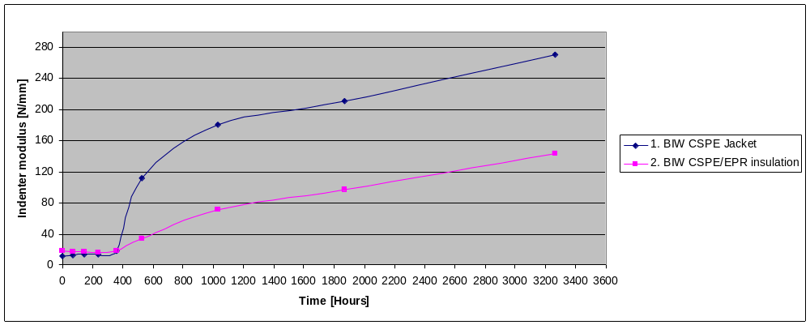
Figure 11: Indenter modulus ageing time at ageing at 120 °C, without radiation for LV cable BIW Bostrad 7E (EPR/CSPE Bonded insulation, CSPE Jacket) [34]

According to the EPRI report 1008211 [24] (Fig. 7-52), the end of life (EOL) value of IM for Bostrad 7E insulation is 42 N/mm and at 25% remaining life IM is 32 N/mm. If we look at the above Figure 11, the value is also near 25% of remaining life. At the point 500 hours, IM of CSPE jacket is 112N/mm that is beyond EOL value for CSPE. Depending on the manufacturer, the values for 25% of remaining life ranging from 14 to 33 N / mm and EOL values from 22 to 41N/mm. It is demonstrated when the outer jacket is in an unacceptable condition, primary insulation is still functional and in good condition. At the point when EPR insulation reaches his EOL value, CSPE IM is above 130N/mm. Recommendations for IM acceptance criteria for BIW CSPE are as follows:
IM< 25 N/mm OK
IM 25-70 N/mm TREND (analyse)
IM > 70 N/mm ACTION (repair/replace).

    - Rockbestos Ferewall III (XLPE insulation, CSPE Jacket) LV Cables
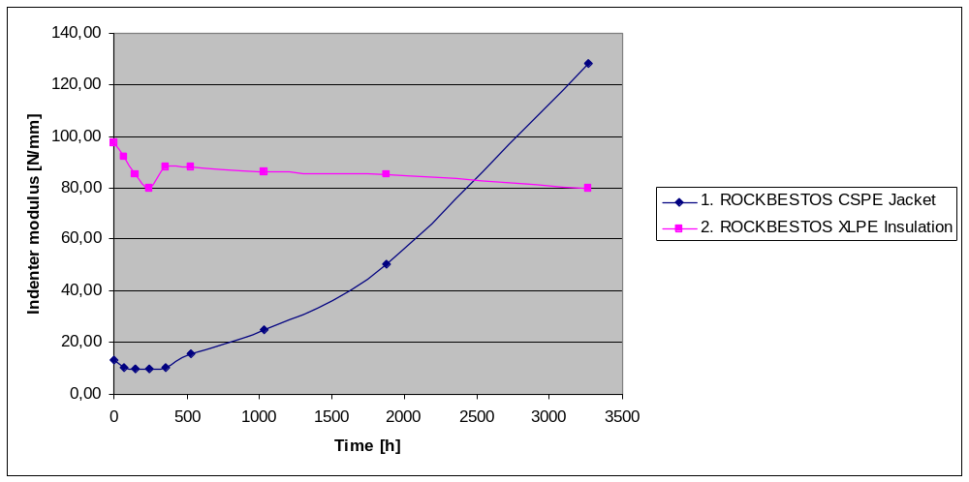
Figure 12: Rockbestos Firewall LV cable (XLPE insulation, CSPE Jacket) – ageing at 120°C, without radiation [34]
According to EPRI report 1008211 [24] (Fig. 7-16) EOL value appear after 1350 hours at 151°C. It is equal to 19600 hours on 120°C that is 6 times more than insulation was aged in this study. For CSPE jacket it will be severely damaged. Fig. 7-16 also describes why IM for XLPE is decreasing unlike other materials and why EAB for XLPE is increasing in the first stage of aging, and how IM is inversely proportional to the EAB, it is normal to decrease.
It is clearly visible in Figure 12 that, at the point when the CSPE jacket is in an unacceptable condition, primary insulation is still in very good condition. Recommended acceptance criteria for Rockbestos Firewall III XLPE would be (even if the CSPE jacket is beyond the EOL):
IM of CSPE jacket < 25 N/mm OK
IM of CSPE jacket 25-70 N/mm TREND (analyse)
IM of CSPE jacket > 70 N/mm ACTION (repair/replace).
NOTE: Although XLPE insulation is the most resistant to thermal effects, it should be noted that this only applies to temperatures up to 160°C. Higher temperatures lead to decomposition of crossed links and melting (and circuit failure) of the XLPE material, unlike bonded CSPE / EPR insulation, which at high temperatures hardens but retains insulating properties.

    - Okonite Okolone (pink EPR, CSPE Jacket) MV Cables
According to the EPRI report 1008211 [24] (Fig. 7-53), the EOL value for bonded CSPE/EPR insulation appears after 2250 hours at 110°C. It is equal to 870 hours at 120°C. At that point IM is around 40N/mm, 25% remaining life is around 20N/mm. From that point IM for EPR is changed from 13N/mm to 15. According to figure 13 (EPRI CPAD [23]) EOL for Okonite EPR insulation (50% EAB) occurs after 6000h at 124°C (equals 8500h at 120°C). It shows that even at the final ageing stage, when the CSPE jacket is aged beyond EOL (IM ~320N/mm) EPR is still functional as insulation.
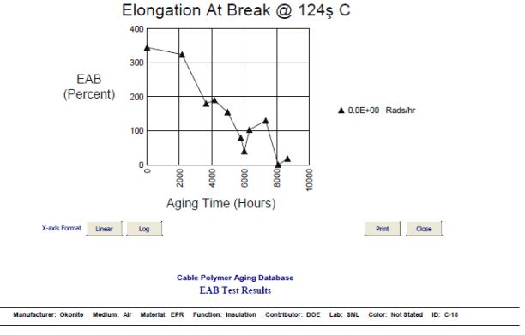
Figure 13: Elongation at Break for Okonite EPR Insulation (EPRI Cable Polymer Ageing Database) [23]
    - Recommendations for IM acceptance criteria: for CSPE Okonite cable jacket
IM< 25 N/mm OK
IM 25-70 N/mm TREND (analyse)
IM > 70 N/mm ACTION (repair/replace).

Conclusion: For different manufacturers with typical material used at specific plant, acceptance criteria IM for cables with CSPE Jacket could be used uniform values:
IM< 25 N/mm OK
IM 25-70 N/mm TREND (analyse)
IM > 70 N/mm ACTION (repair/replace).

Other non-electrical and electrical techniques with acceptance criteria test results based on Referenced Standards are demonstrated in the following descriptions.

  - Visual inspection
Cable jacket or insulation visual indications can be surface anomalies such as embrittlement, discoloration, cracking, melting, swelling, or surface contamination due to the ageing mechanism and effects of high-temperature and/or high-radiation ambient, wear, chemical or surface contamination or significant moisture. If the one or more of the above indications are present, additional testing may be warranted to verify that the cable electric insulation is adequately managed.
Normal operating conditions are not expected to significantly affect the aging of polymer materials used for jacket and insulation of typical nuclear cables. However, care must be taken in adverse localized environments exceeding 40° - 50°C of ambient temperature for cables with limited ohmic heating and for cables operating near their ampacity limit in ambient environments of 30°- 40°C or more because any combination of ambient temperature or ohmic heating can cause higher rates of thermal aging. Also, localized hot spots such as next to or above steam generators, pressurizers, or hot process pipes, such as feedwater lines, main steam lines etc. are a key concern, especially if the cable is adjacent to hot process piping. With respect to high-radiation ambient environments, assuming a 60-year desired life for a polymer material used in typical nuclear cables, no appreciable effect would be expected for average dose rates up to10 rd/hr (0.1 Gy/hr), EPRI 1011873 [9]. Although minimal effects are expected at 10 rd/hr (0.1 Gy/hr), the effects could be appreciable if the cables are simultaneously exposed to high temperature (for example, greater than 50°C with conductor temperatures reaching ampacity limits). For different Jacket material and discoloration and hardening/cracking shall be considered as follows [34, 31] for Dark or Light jacket materials in Figures 14 and 15:
- Dark (Black) material discoloration example on Figure 14 are BIW cable samples with CSPE (Hypalone) jacket [34]
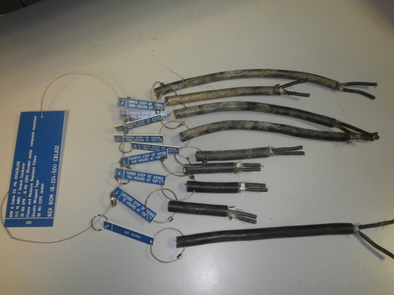 | 136 days at 120°C  78 days at 120°C  43 days at 120°C  22 days at 120°C  15 days at 120°C  10 days at 120°C  6 days at 120°C  3 days at 120°C  New
Figure 14: Samples of BIW cable type aged, tagged, and used for IM testing and visual inspection acceptance criteria [34]
Black and soft OK
Gray, white and hardened Study
Brown White, hardened and cracked Action

- Light (White/Yellow) material discoloration example on Figure 15 with PVC /XLPE jacket
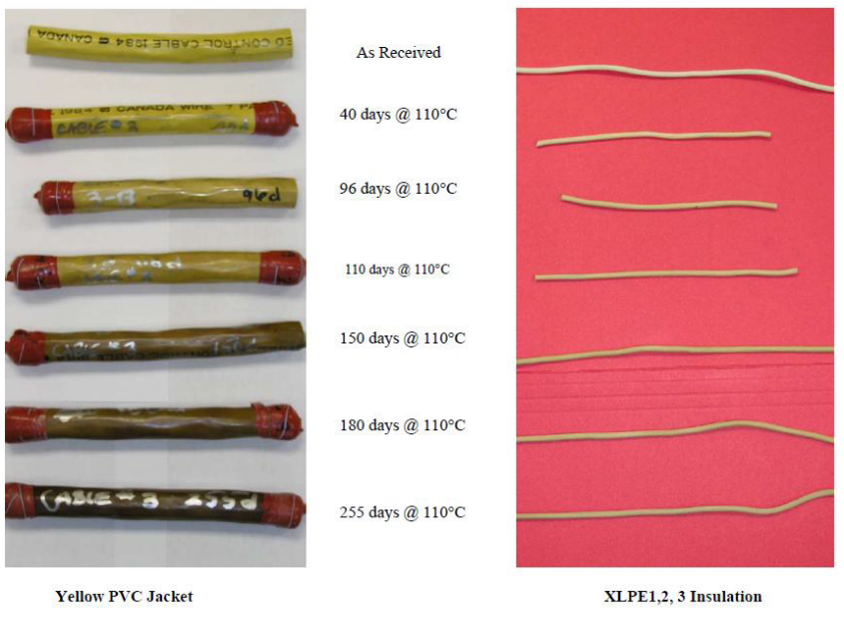
Figure 15: Samples of PVC and XLPE cable type aged, tagged, and used for IM testing and visual inspection acceptance criteria
Light and soft OK
Cream and Light Glow Softer, Study
Dark, Glow, Plasticizer on Surface Action

  - Infrared thermography
Infrared thermography; thermographic inspections should be performed on accessible LV and MV cable connections, terminations and splices when load is applied on system[35]. When infrared thermography indicates that connections are overheating (as compared to baseline readings for reference), the degree of damage should be assessed, and the connection repaired or replaced as appropriate (same as for high conductor temperature from ohmic heating). Also useful for detecting hot spots and high conductor temperature from ohmic heating. Provide a report which includes the following:
1. Description of equipment to be tested.
2. Discrepancies.
3. Temperature difference between the area of concern and the reference area.
4. Probable cause of temperature difference.
5. Areas inspected. Identify inaccessible and unobservable areas and equipment.
6. Identify load conditions at time of inspection.
7. Provide photographs and/or thermograms of the deficient area.
8. Recommended action.
Test Parameters:
1. Inspect distribution systems with imaging equipment capable of detecting a minimum
temperature difference of 1° C at 30° C.
2. Equipment shall detect emitted radiation and convert detected radiation to visual signal.
3. Thermographic surveys should be performed during periods of maximum possible loading.
Suggested actions based on temperature rise can be found in Tables 7 and 8.

Status | Range
Advisory | Up to 8ºC Rise Above Reference
Intermediate | 9ºC to 25ºC Rise Above Reference
Serious | 25ºC to 40ºC Rise Above Reference
Critical | > 40ºC Rise Above Reference
Table 7: EPRI Suggested Severity Ranges for Indoor Electrical Power Connections used in LV or MV systems [35]

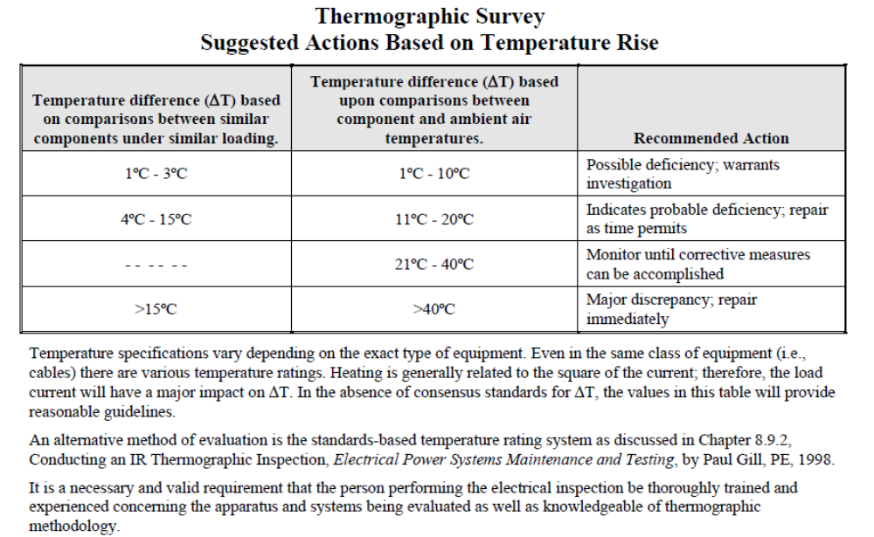
Table 8: Recommendations of ANSI/NETA ATS-2009 Standard for acceptance testing specifications for Electrical Power Equipment and Systems [37]

  - Insulation Resistance (IR)
Insulation resistance measurements and acceptance criteria are treated in many references (i.e. the EPRI cable ageing management program implementation guides [10,11,21,22] and the medium-voltage cable ageing management guide [29]). However, confusion still exists on when insulation resistance is useful for ageing management and what acceptance criteria should be used.
Many plants use 1 megohm plus 1 megohm per 1000 ft per kV of applied voltage as the criteria for acceptance of cables for return to service. This criterion is discussed in IEEE Std 43 [45] and IEEE Std 422 [50]. Although this criterion might be useful to verify that major cable insulation damage did not occur during storage and installation, it is not useful for ageing management purposes or predicting whether cable will provide satisfactory service for a foreseeable period. IEEE Std 690 on design and installation of cable in nuclear plants references IEEE Std 336 for acceptance testing. However, IEEE Std 336 provides no acceptance criteria. The IEEE Std 43 discussion relates to the energization of rotating electrical equipment [45]. The value applies to motors with winding systems that pre-date 1970 that were relatively porous and could have very low insulation resistances when damp. The acceptance value was related to whether it was safe to test the winding at elevated voltages and was never meant to be used as a cable condition acceptance criterion. It should be noted that IEEE Std 43-2000 requires 100 megohms for modern form-wound systems [45].
The discussion in IEEE Std 422-1986, which has been withdrawn by IEEE even though a revision is in place, does apply to cable. For low-voltage power cable, the minimum acceptable insulation resistance using a 500-Vdc insulation resistance (IR) meter is as follows:
IR_{min} in MΩ = (rated voltage in kV + 1) x 1000 / length in ft
This criterion is useful to verify that major cable insulation damage did not occur during storage and installation.
Users are directed to IEEE Std 400 for testing of medium-voltage cable [40, 41]. There is no doubt that a low-voltage power cable will function with a 2-megohm insulation resistance. However, if such a low value is found on test, there is something grossly wrong with the insulation system for the cable. IEEE Std 422 does require that the insulation resistance for a low-voltage power cable be related to cable length. IEEE Std 43, which relates to rotating electrical equipment, naturally does not have a criterion related to cable length. There are two problems with the 1-megohm plus 1-megohm per kV approach without correcting for length. First, the value is much too low and represents an essentially failed cable insulation system; second, it does not account for cable length. Insulation resistance of cable insulation is inversely proportional to length. A low insulation resistance in a short length is much worse than a low insulation resistance in a long length if the results are not compensated for length. Common practice is to provide insulation resistance in terms of 1000-ft or 1-km lengths. The reading is multiplied by 1000 and divided by length in ft or 1 km to give the corrected value to compare to the acceptance criteria.
Insulation resistance test might indicate the need for a more sophisticated test if it indicates that the insulation resistance is low. For medium-voltage cable, insulation resistances that are less than 100 MΩ-1000 ft (30.5 MΩ-km) should be considered inadequate. However, an insulation resistance test should not solely be relied on for determining serviceability even if the cable has greater resistance. A thin layer of good insulation in series with a near-through-wall degradation or defect will mask the problem and result in a high insulation resistance. [36]. For Power Cables (Length dependent) insulation resistance is calculated as follows:
IR_{min}= 100MΩ*(1000/ L [ft]) [37]
Insulation resistance is recommended as a condition monitoring technique for cables exposed to wet conditions for LV and MV. However, if a value of less than 100 megohms-1000 ft (30,5 megohms-km) is measured on medium-voltage cable between the shield and the conductor or on low-voltage cable between conductors or conductors and ground, it is a strong indication that the insulation is flawed, deteriorated, or failed—and the cause of the low measurement should be investigated and dispositioned. The insulation resistance of a cable must be adjusted for the circuit length to be of any practical use. Insulation resistance is a valuable troubleshooting tool when cable insulation failure has occurred. For wet, low-voltage power and control cable, insulation resistance from a conductor to all other conductors grounded is the recommended test for determining if water-related degradation has occurred. [28, 38]
For dry, low-voltage power and control cable, insulation resistance is not expected to be a useful condition assessment technique with respect to thermal or radiation ageing. The types of insulation in use maintain their insulating properties even when highly thermally aged. Shorting can occur only upon complete physical breakdown of the materials, where the insulation powders or cracks. Even then, if no moisture or chemical contamination exists, electrical failure might not occur.
Caution: Hypalon insulation systems have lower insulation resistances than XLPE and EPR insulation systems. The as-manufactured insulation resistance of these Hypalon systems is on the order of 50 megohms1000 ft (15 megohms-km). The action point for such Hypalon insulations should be 5 megohms-1000 ft (1.5 megohms-km). Kerite “FR” insulation used in 600-V applications is a Hypalon insulation having this characteristic. Note: Kerite“FR2,”“FR3,” and “FR4” are EPR based insulations, and the 100 megohms-1000 ft (30.5 megohms-km) action point applies to them.
Insulation Resistance test values for Electrical Apparatus and systems could also be used for LV and MV cables with appropriate length adjustment as represented in Table 9 [37].
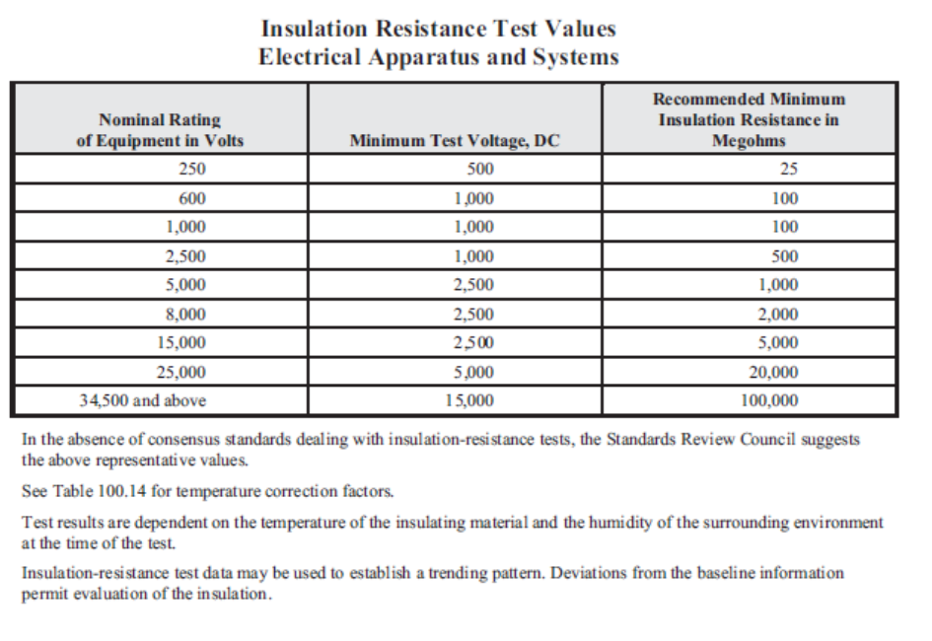
Table 9: Insulation Resistance test values for Electrical Apparatus and systems could be used for LV/MV cables with appropriate length adjustment [37].

Example of acceptance criteria for LV/MV Power Cables:
>100 MΩ -1000ft or >30 MΩ-km OK
25-100 MΩ - 1000ft or 8-30 MΩ-km Study
< 25 MΩ - 1000ft or <8Mohm-km: Action

Guide for Polarisation Index (IP)
Polarisation Index is referenced to equipment but for cables should work as well and it might be used together with the other information obtained as indications of degradation to be contrasted with other electrical, visual and indenter tests.
The polarisation Index for diagnostic insulation testing could be used as a guide with insulation resistance testing in different time window i.e. 1 min – 10 min.
Polarisation Index | Insulation Condition
< 1 | Poor
1 – 2 | Questionable
2 – 4 | OK
> 4 | Good
Table 10: Example of Polarisation Index acceptance criteria values

Values in Table 10 above 4 indicate excellent cable insulation for which no action is likely to be necessary within the immediate maintenance schedule. The operator may be called upon to make critical judgments, however. Some high values of IP (above 5) could indicate brittle or cracked insulation; this should be fairly obvious. A sudden increase in IP greater than 20%, without any maintenance having been performed, should serve as a warning; insulation may hold its value for long periods, but is not likely to dramatically improve all by itself.
If a very high initial insulation resistance (IR) reading >5GΩ is found then further IP tests are not needed.
In all instances a value of 2 or higher is considered adequate or better, and below 1 always inacceptable, the discrepancies are between 1 and 2 and some guides indicates could be addressed as Questionable (Obviously more in the 1-1,5 range).
Polarization Index | Insulation Condition
< 1,5 | Bad
1,5 – 2 | Fair
> 2,5 | Good
Table 11: Another example of Polarisation Index acceptance criteria values

It also option for IP > 1 to avoid false non-acceptances and using the values obtained (1< IP<2) as indications of degradation to be contrasted with the rest of values obtained by other electrical, visual and indenter tests.

  - Shield Resistance
To identify potential degradation of connections (accessible or inaccessible) there are few available techniques [37]:
- Ohmic Resistance or line impedance of one or more connections a circuit with more cable connections for intended function from supply to end device including all connections (start-splice-penetration-splice-end).
- Line or loop impedance (power supply needed).
- Results of the thermographic survey shall be in accordance with Section 4.
- Compare bolted connection resistance values to values of similar connections. Investigate values which deviate from those of similar bolted connections by more than 50 percent of the lowest value.
- Bolt-torque levels shall be in accordance with manufacturer’s published data. In the absence of manufacturer’s published data, tables for specific connection materials can be used
- TDR will show the location of connections. Recurrent assessment by TDR can highlight impedance variations due to bad connections.
If the shield of the cable is damaged, this can have an effect on results of following measurement techniques:
- Insulation Resistance (tens of mega ohms can occur in a failed phase because the failures often blow the shield, leaving a high surface resistance between the conductor and the rest of the shield).
- Dielectric losses (PDE); the current return to the measurement equipment through the shield, if the shield is in bad condition, the test results will be unreliable.
- Partial Discharge (PD); damage to the shield will cause noise interference.
- Reflectometry (TDR); damage to the shield will cause signal attenuation which may invalidate the test.
According to Okonite Engineering Handbook 2019 (Pg.19) there are examples of formulations for calculating shield resistance as follows:
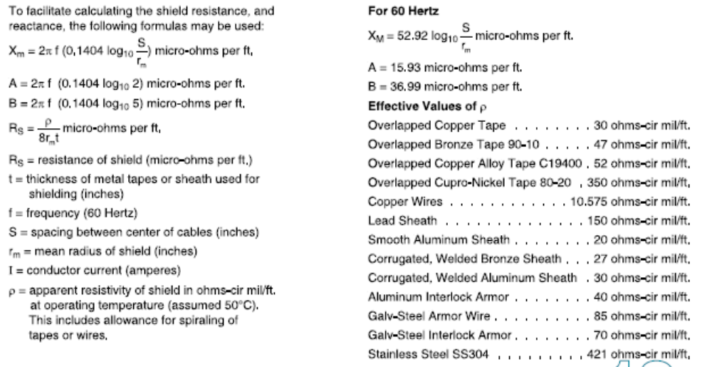
Guide for Measurement of shield continuity:
Connecting the screens of the 3 cables to each other at one end being disconnected from ground and connecting a megohmmeter between 2 screens checking the 3 possible loops (phases 1-2, 2-3 and 3-1). The test is considered accepted, when the results of measuring screens 2 to 2 show low impedance values (close to 0 Ω).

Guide for Shield ohmic resistance:
Without modifying the operating method for measuring the continuity of screens and connecting an ohmmeter with resolution of at least hundredths of ohm, ohmic resistance measurements are made between screens two to two, A, B, C, being:
A= Value measured between phases 1 and 2.
B= Value measured between phases 2 and 3.
C= Measured value between phases 3 and 1.
The results of the resistances corresponding to each phase will be obtained from the expressions.
R1 = (A+C-B)/2
R2 = (B+A-C)/2
R3 = (C+B-A)/2
The shield resistance will be considered correct when the values of the resistance referenced at 20 ºC do not differ significantly from Table 12.
Cross section (mm2) | Resistance (Ω.km) | Tolerance (Ω.km)
16 | 1.24 | ±0.010
25 | 0.779 | ±0.010
75 | 0.259 | ±0.010
Table 12: Examples of ohmic shield resistance for specific cable cross-sections
Recommended values are used by several electrical companies and could be used also for pre-commissioning testing of electrical lines.
This test is planned in case the shield is perceived to be compromised, and results are needed with valid criteria to ensure cables in service.

  - Dielectric Losses (tan δ) for MV cables (TD)
Dielectric Loss testing of MV cables (also called dissipation factor testing, TanDelta-TD, tan δ); is used for the detection of the effects of severe thermal degradation in adverse localized environments, whether caused by unbalanced magnetic circuits in multi-conductor per phase circuits or by high continuous currents. However, a very localized effect may be difficult to detect with tan δ. This test can also identify insulation systems with distributed water-related degradation. However, if a cable insulation system has only a single but significant flaw; tan δ may not necessarily detect it since the results are average value for whole distance of cable. Also note that it does not provide specific location information for identified degradation [14].
Very high TD values may be the result of high humidity at the terminal of MV cables. The use of a guard at the termination can suppress the effect of the termination on the measurements (if the results are good it means that the humidity is localized on the termination).
Some laboratories [46] has studied the influence of terminations in wet environment on the condition of MV cables with XLPE insulation. The condition of a single termination and to be more specific, the condition of the outer sheath of the termination, even installed on long cable lengths (450m is observed), dominates the result of the Riso and TD measured for the complete cable system. This phenomenon makes it impossible to assess the condition of the cable insulation. The results of the measurement depend on the weather conditions, rainy weather leads to poor measurement results. If poor results are measured, no correct monitoring can be given to the cable itself since the termination dominates the measurement.
Laboratory tests were performed to investigate the behaviour of aged and new terminations under varying relative humidity. It can be concluded that the insulation resistance of both terminations drops when the relative humidity rises. A variation of 7 to 9 times lower values was noticed on terminations at relative humidity of 95% compared to 60%. During the tests, the terminations were able to return to their best condition. However, it is observed that an aged termination always results in a lower isolation resistance. Fig 16 shows the influence on a new termination.
During the TD measurements performed on the cable set-up at specific laboratory [46], a guard connection was tested. This guard connection is theoretically designed to eliminate the losses caused by the condition of the termination surface and therefore only measures the actual cable insulation condition. The result of the measurements performed, confirmed that a measurement on a cable with dry termination showed good results, measurements on a cable with wet terminations without guard connection showed poor results and measurements on a cable with wet terminations and guard connected, showed good results.
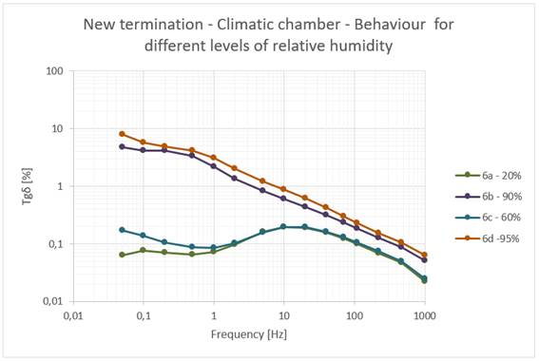
Figure 16: Tan delta [%] in function of frequency for different levels of relative humidity of a new termination

Table 13 show examples of assessment criteria for tan delta testing for specific materials as described in 4.1 and collected from different sources. More information related the differences and explanation of Standard Deviation (STDEV) versus Percent STDEV (%STDEV) can be found in the discussion in EPRI TR 3002000557 Section 5 and Appendix A [29].

Criterion | Std Dev TD at U₀  [E-3] |  | Diff TD 2U₀-U₀  [E-3] |  | Mean TD at 2U0  [E-3]
Insulation | EPR | XLPE | EPR | XLPE | EPR | XLPE
A-OK | < 0.1 | < 0.1 | < 3 | < 0.6 | < 15 | < 1.2
B-Study | 0.1-1 | 0.1-0,5 | 3-8 | 0.6-1 | 15-30 | 1.2-2
C-Action | >1 | > 0.5 | > 8 | > 1 | > 30 | > 2
Table 13: Tan delta assessment criteria for MV cables with specific pink EPR and XLPE insulation and nominal voltage up to 15kV (in terms of 10⁻³; 0.1Hz test frequency. [29]

  - Partial discharge (PD)
Partial Discharge (PD) test is an electrical method of assessing the quality of the insulation of power MV cable systems, particularly for extruded insulation materials. It is a good method in detecting termination and splice problems, especially on off-site cable. Useful also to detect the effects of severe thermal degradation in adverse localized environments. However, water related degradation, such as water treeing, does not produce partial discharge signals. In addition, in the case of helical tapes, corrosion of the tapes from long term wetting is likely to severely attenuate partial discharge signals and impede their detection [41]. For PD occurring in cavities, the electrical field internal to the cavity should typically exceed 3 kV/mm. Partial discharge degradation typically occurs at: Voids, Delamination’s at interfaces, Protrusions (Electrical trees). In laboratory environment testing methods acceptance criteria set much lower values for new cables (up to 5 pC) but in field industry environment with operating large equipment such as MV motors and generators, switchgears and HV switchyard. No partial discharge activity should be detected at 1.5U0. Should be performed after the AC withstand test. Detail guidance in IEEE Guide for Partial Discharge Testing of Shielded Power Cable Systems in a Field Environment [41] as examples in Tables 14 and 15.
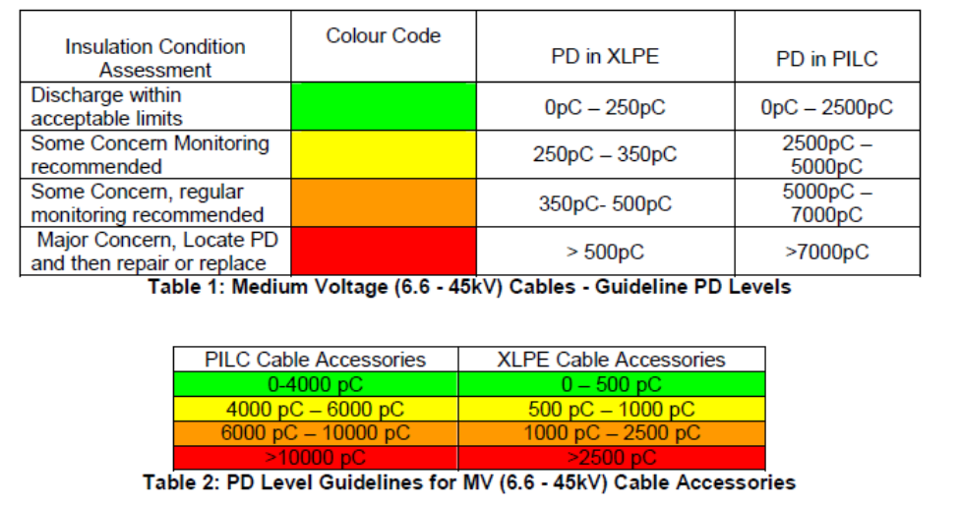
Tables 14: PD assessment criteria for MV cables with pink XLPE and PILC insulation [41]

Ref.: HVPD Technical Guide for PD Levels in MV and HV Cables and Joints, May 2009
Criterion | PD [pC] |  |  | PDEV  [kV]
 | Cable | Connection | Splice | PDEV
A-OK | 250 | 750 | 2500 | >6.3
B-Study | 250-500 | 750-2500 | 2500-5000 | 3.6-6.3
C-Action | 500 | 2500 | 5000 | <3.6kv
Table 15: PD assessment criteria for specific MV cables with pink EPR and XLPE insulation and operation voltage 6,3 kV [41]

Figure 17 shows an example of a partial discharge measurement on an 6kV XLPE cable connected with a 6kV PVC cable which have lead to the replacement of the cable. Figure 18 illustrates the partial discharges who could be detected visually on the insulation of the PVC cable. [47]
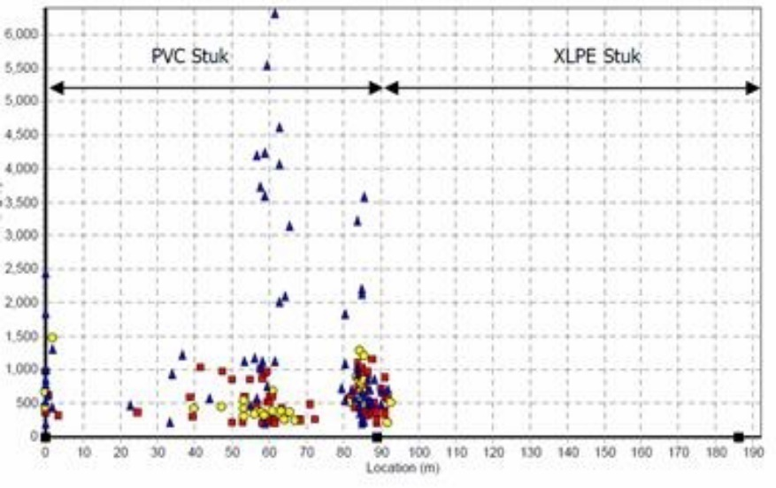
Figure 17: Partial discharge measurement on PVC cable connected to a XLPE cable [47].
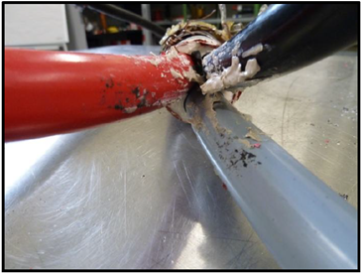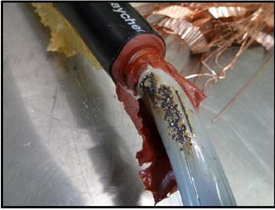
Figure 18: Analyses of the PVC cable with the visual indication of the partial discharges [47]

Examples of typical Partial Discharge patterns are represented and could be used for recognition of different test cable and termination configuration as presented in Figure 19.
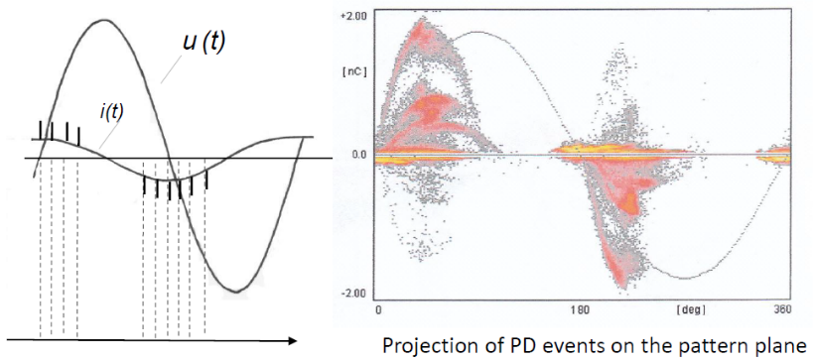
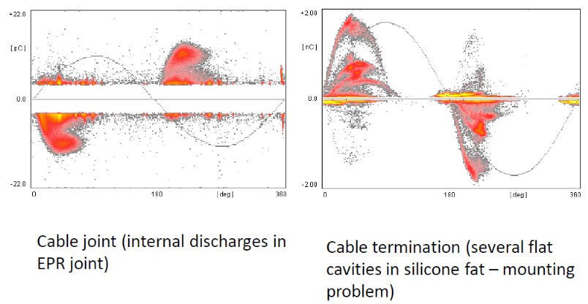
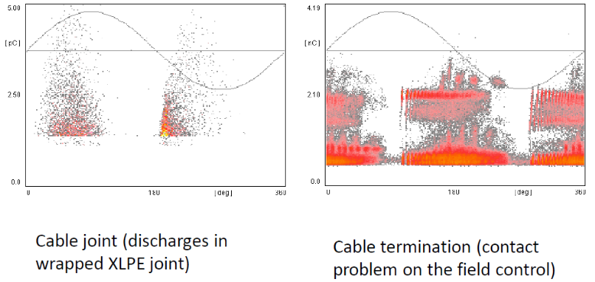
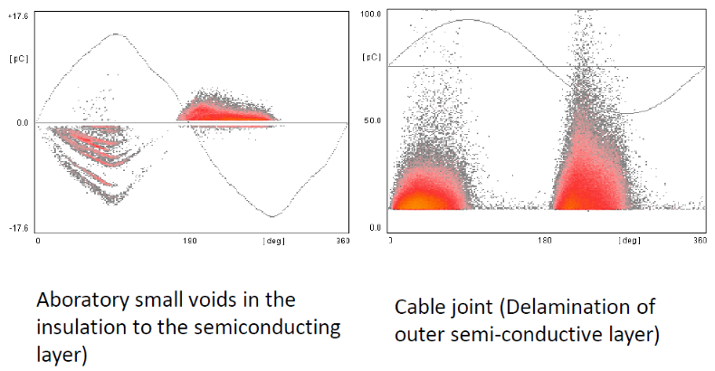
Figure 19: Typical Partial Discharge patterns of different test cable configurations

  - AC Withstand Test (HiPot)
AC withstand testing is generally a go/no-go test for MV cables. According to IEEE 400.2 Standard [40], the Maintenance test called Withstand test throughout is a field test made during the operating life of a cable system. The purpose of test is to verify cable integrity with detection of localized, significant degradations, deterioration and to check the serviceability of the system. Test provides no information concerning widespread, low-level water degradation [29]. Although it provides assurance for continued service (as it is a purposely destructive test) for some period of time, this test provides no information regarding the amount of cable degradation [33]. Testing at power frequency from 20 Hz to 300 Hz or VLF [42]. It is intended to recommend high potential test level ranges from 1.7U0 to 2.5U0. High voltage applied for periods ranging from one to 60 minutes. May be coupled with partial discharge test.
Example:
HiPot Instrument:________________ t (min)________ U(kV) ________ Result: PASS /FAILED/ NA

  - Time Domain Reflectometry (TDR)
Evaluation of the results of TDR is to determine if the cable is fit for service will require an engineering evaluation. The results should be compared with the historical results of previous tests performed on the same cable or a reference reflectogram. The comparison between the TDR test performed and its historical data will allow observing the position of a punctual change in the cable condition due to circuit opening, short circuit or variation of the circuit characteristic impedance. Therefore, in order to facilitate the following inspections, such reference information shall be obtained during the first inspection round.
It shall be considered as a general acceptance criterion:
- Absence of sudden increases in the voltage trace, indicative of an increase in the characteristic impedance or open circuit.
- Absence of sudden decreases in the voltage trace, indicative of a decrease in characteristic impedance or short circuit.
The results allow comparison with a base reflectogram of the cable to facilitate the monitoring of degradation. Useful for detecting deviation and its location along the cable as well as cable damage or connection problems [15].
One of possible judgement guide might also be as comparison between wires in same cable, signal deviations, values, etc.
Experience Comparison based guide:
A: <25-50%; B: 25-50-100% C: > 100-150%

Some laboratories [48] uses TDR measurements to check the connections along cable route. Figure 20 shows an example of TDR measurements near the end of triax & coax cables with different connectors along the route and a speed sensor at the end. For cable 362, an impedance increase instead of decrease was detected which was due to the connection of the speed sensor. Reconnection of the sensor solved this issue.
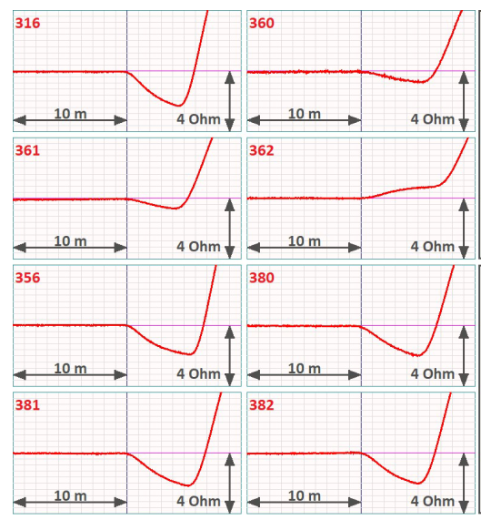
Figure 20: Example of TDR measurements of cable connectors to the pump speed sensors [48].

  - Frequency Domain Reflectometry (FDR-LIRA)
One of available non-destructive test and condition assessment method based on Frequency Dielectric Response (FDR) is Line Resonance Analysis (LIRA). LIRA technology is based on the transmission line theory, through the estimation and analysis of the complex line impedance as a function of the applied signal frequency. We can monitor the global, progressive degradation of the cable insulation due to harsh environment conditions (high temperature, humidity, radiation) and detect local degradation of the insulation material due to mechanical impacts or local abnormal environmental conditions. [43]
The applied frequency band is a 5V signal, and is harmless to the cable. LIRA will detect and locate local degradations in the cable, which is specific to certain sections of the cable and caused by mechanical stress and damages, or by heat-induced oxidation and radiation. It will also detect global degradation in the cable, which is applicable for the entire cable, and is caused by general aging, influenced by external and internal environmental conditions.
LIRA relies on the correlation between insulation’s condition and its dielectric constant (mainly capacitance) and calculates the impedance spectrum (amplitude and phase) as a function of the applied signal over a wide frequency band. The capacitance of a cable changes as a function of changes in the permittivity and changes in the radius, as shown in Figure 21.
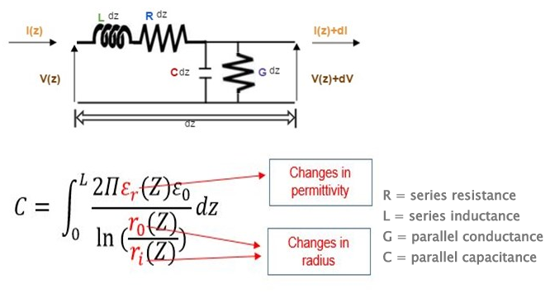
Figure 21: Schematic representation of transmission line model
For a complete cable analysis, LIRA provides the following tools:
- Input impedance spectrum check (Imp) - The spectrum is used to adjust the used bandwidth so that the high frequency part of the spectrum still contains useful information, or, in other words, it does not completely fade out because of the cable attenuation. Figure 22. represents impedance spectrum of 47 m of EPR insulated test cable.
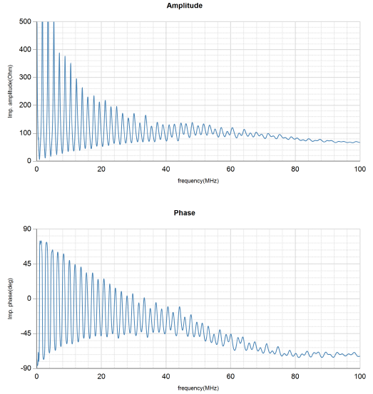
Figure 22: EPR insulation based test cable impedance spectrum

- DNORM view (DNORM) - This is the severity assessment tool in LIRA. Any feature, visible in the signature, is tagged as green, orange or red, according to the estimated severity. The DNORM tab shows a normalized graphical interpretation of the finding along the measured cables length, without the start and end terminations shown. Bars are shown in red when they exceed the double of the threshold (default: 10), orange from 80% of the threshold to the red threshold, otherwise in green. Test cable with cut insulation at approximately 20m, is visible as green bar (Figure 23). Cable also had two splices (22 m and 28 m) visible as red bars in Figure 3.
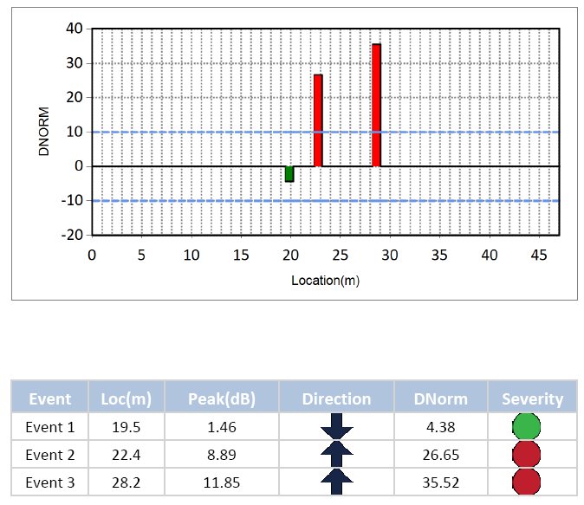
Figure 23: DNORM view of test cable
- Global parameters - The estimated cable parameters (Figure 24.) are dielectric capacitance(C), cable inductance (L), cable attenuation (Att), characteristic impedance (Zo) and phase velocity ratio (Vr) can be compared to the expected values to increase the measurement reliability.
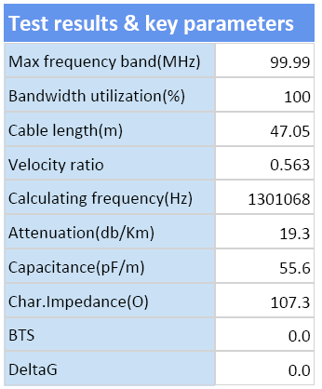
Figure 24: Test cable global parameters

- Cable trend graphs - The frequency trends (Figure 25.) are provided for the following parameters: Characteristic impedance (Z0), Velocity Ratio (Vr), Attenuation Resistance, Dielectric capacitance, Cable inductance.
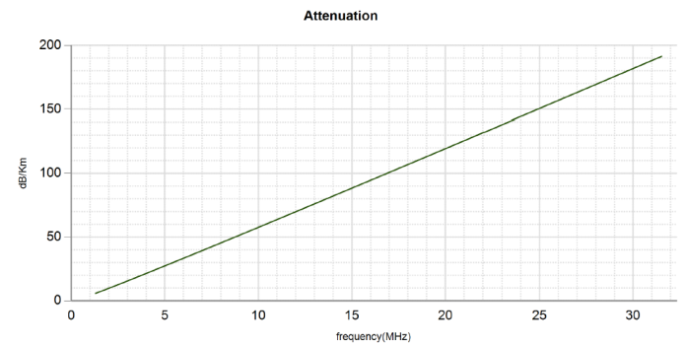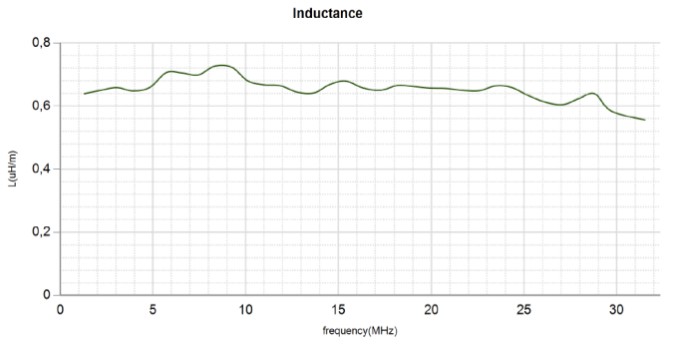

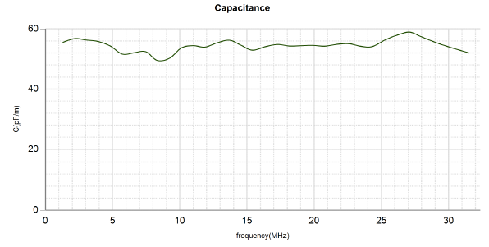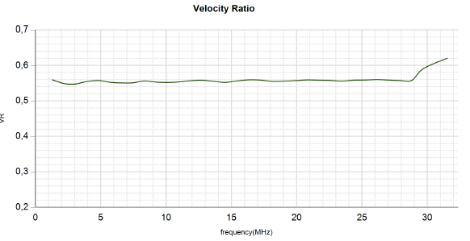
Figure 25: Test Cable trend graphs

- Termination assessment (BTS) - is based on the Fourier transform of the cable impedance spectrum, at the maximum bandwidth allowed by the applied maximum frequency. While the output of the Fourier analysis for the LIRA signature is a power spectrum, for the BTS analysis the complex output is preserved. The ratio between the difference of the imaginary and real component of the transformation function (also called the BTS signature function) has a significant diagnostic value and it is bounded between +$\sqrt{2}$ and –$\sqrt{2}$. Figure 26. shows resulting BTS graph of tested cable with a good termination. The largest peak in Figure 26a. is the cable termination. Any change in the insulation properties at or near the termination (inside the shadow area), would cause an undershoot below zero. In other tested cable with bad termination due to moisture. Figure 26b. shows degraded cable termination with characteristic undershoot.

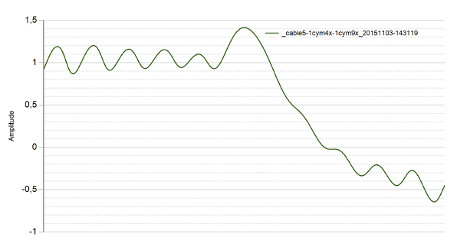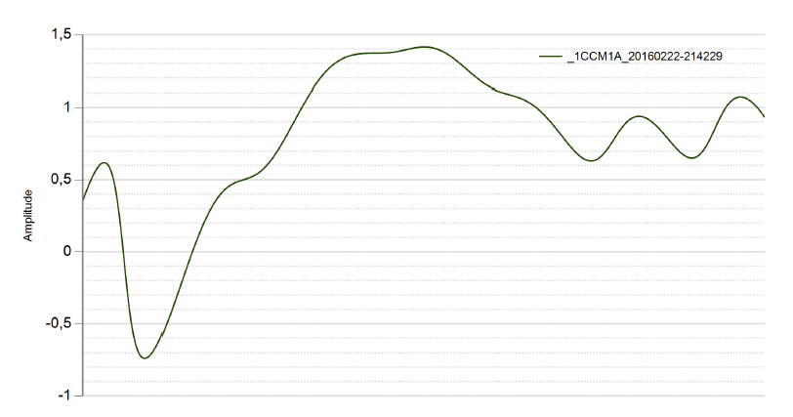 Figure 26a: BTS graph for a normal Figure 26b: BTS graph for degraded
termination condition termination condition

Example of testing form:
Cable Length=______/_____  Calculated / Measured | Test frequency:  100, 50, 10 MHz | Velocity rate=____________  EPR / XLPE

Measurement | Units / Wire: | A-B | A-C | B-C
Length | l [m]
Impedance | Zo [Ω]
Attenuation | Att[dB/km]
BTS
DNORM max
Location [m] | l [m]

Experience Comparison based guide:
A: <25-50%; B: 25-50-100% C: > 100-150%

  - Dielectric Spectroscopy (DS)
Dielectric Spectroscopy is diagnostic test which allows detection of water trees or moisture intrusion in insulation or terminals. Reasonably reliable test –but expert needed to operate equipment and interpret data. Experience gained by a number of service companies and utilities has been published and thus allowed for a reference database to be developed. Sensitive equipment is needed and, thus, in the field, noise may be an issue.
Example of testing form:
Instrument: _____________  Test MODE CR ___________ | Stop frequency: __________  1mHZ, 2mHZ, 5mHZ, 10mHZ, | Voltage Uo [V]

Measurement | Unit | A-B | A-C | B-C
TD (70 Hz) | [%]
C (70 Hz) | [nF]
TD (40 Hz) | [%]
C (40 Hz) | [nF]
TD (0,1 Hz) | [%]
C (0,1 Hz) | [nF]
Experience Comparison based guide:
A: <25-50%; B: 25-50-100% C: > 100-150%

Some laboratories investigated the effect of humidity on the dielectric spectroscopy of LV and I&C cables. The samples used for this test were 1.5m and first aged for 5376h at 135°C. Consequently, the cables were placed in a furnace where temperature and humidity were controlled. The temperature was maintained at 25°C for all tests. The humidity varied between 15% and 90%. Figure 27 shows the dielectric spectroscopy of the Eupen instrumentation cable TXCR/2 with XLPE insulation at different humidity levels. At low frequencies, there is a strong increase in tg delta values when the humidity increases.

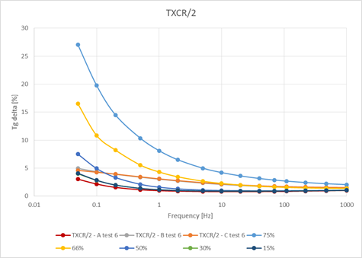
Figure 27: Dielectric spectroscopy of Eupen TXCR/2 cables at different humidity levels [49]

- Conclusion
This appendix 1 assembles information on available testing methods with examples of acceptance criteria for electrical cables. Some of the described diagnostic methods and techniques could be used for both LV and MV cables if not specifically referenced. The third chapter of the appendix 1 gives more information on the use of elongation at break and indenter modulus and also possible use of the Arrhenius law in the assessment of cables.
Based on standardized mechanical test EAB definition of EOL some basic acceptance criteria are recommended in three levels (Good/Trend/Action) for LOCA qualified cables with EPR/XLPE insulation and CSPE jacket.
In chapter four of this appendix 11 methods were elaborated and could be used in relevant AMPs for LV/MV cables as follows:
- Indenter Modulus (IM)
- Visual Inspection
- Infrared Thermography
- Insulation Resistance (IR)
- Shield Resistance
- Dielectric Losses tan δ (TD)
- Partial Discharge (PD)
- Withstand Test (HiPot)
- Reflectometry (Time Domain (TDR)
- Frequency Domain (FDR-LIRA)
- Dielectric Spectroscopy (DS)
Some of the methods are still under development phase and have to be considered by user (TDR, LIRA, DS).

References
- INTERNATIONAL ATOMIC ENERGY AGENCY, Design of Electrical Power Systems for Nuclear Power Plants, Specific Safety Guide No. SSG-34, IAEA, Vienna, March 2016.
- INTERNATIONAL ATOMIC ENERGY AGENCY, Ageing Management and Development of a Programme for Long Term Operation of Nuclear Power Plants, Specific Safety Guide No. SSG-48, IAEA, Vienna, November 2018.
- INTERNATIONAL ATOMIC ENERGY AGENCY, Equipment Qualification in Operational Nuclear Power Plants: Upgrading, Preserving and Reviewing, Safety Reports Series No. 3, IAEA, Vienna, April 1998.
- IEC/IEEE 60780-323:2016, Nuclear facilities - Electrical equipment important to safety – Qualification, 2016.
- INTERNATIONAL ATOMIC ENERGY AGENCY, Implementation and Review of a Nuclear Power Plant Ageing Management Programme, Safety Reports Series No. 15, IAEA, Vienna, April 1999.
- INTERNATIONAL ATOMIC ENERGY AGENCY, Assessment and management of ageing of major nuclear power plant components important to safety: In-containment instrumentation and control cables Volume I and II, IAEA-TECDOC-1188, IAEA, Vienna, December 2000.
- INTERNATIONAL ATOMIC ENERGY AGENCY, Assessing and Managing Cable Ageing in Nuclear Power Plants, IAEA Nuclear Energy Series NP-T-3.6, IAEA, Vienna, May 2012.
- NUCLEAR ENERGY AGENCY, Technical Basis for Commendable Practices on Ageing Management, SCC and Cable Ageing Project (SCAP) Final Report, NEA/CSNI/R(2010)15, Paris, 13-Apr-2011.
- UNITED STATES NUCLEAR REGULATORY COMMISSION, NRC Regulatory Guide 1.218, Rev. 0, Condition Monitoring Techniques for Electric Cables Used in Nuclear Power Plants, USNRC, 2012.
- ELECTRIC POWER RESEARCH INSTITUTE, Plant Support Engineering: Nuclear Power Plant Equipment Qualification Reference Manual, Revision 1, EPRI, Palo Alto, CA: 2010, 1021067.
- IEC/IEEE 62582-1:2011, Nuclear power plants - Instrumentation and control important to safety - Electrical equipment condition monitoring methods - Part 1: General, 2011.
- UNITED STATES NUCLEAR REGULATORY COMMISSION, NUREG CR/7000, Essential Elements of an Electric Cable Condition Monitoring Program, USNRC, January 2010.
- SANDIA NATIONAL LABORATORIES, Nuclear Power Plant Cable Materials: Review of Qualification and Currently Available Ageing Data for Margin Assessment in Cable Performance, SAND2013-2388, 2013.
- INTERNATIONAL ATOMIC ENERGY AGENCY, Benchmark Analysis for Condition Monitoring Test Techniques of Aged Low Voltage Cables in Nuclear Power Plants, TECDOC No. 1825, Vienna, 2017.
- IEC/IEEE 62582-5:2015, Nuclear power plants - Instrumentation and control important to safety - Electrical equipment condition monitoring methods - Part 5: Optical time domain reflectometry, 2015.
- IEC/IEEE 62582-2:2011+AMD1:2016 CSV Consolidated version, Nuclear power plants - Instrumentation and control important to safety - Electrical equipment condition monitoring methods - Part 2: Indenter modulus, 2016.
- IEC/IEEE 62582-3:2012, Nuclear power plants - Instrumentation and control important to safety - Electrical equipment condition monitoring methods - Part 3: Elongation at break, 2012.
- IEC/IEEE 62582-4:2011, Nuclear power plants - Instrumentation and control important to safety - Electrical equipment condition monitoring methods - Part 4: Oxidation induction techniques, 2011.
- INTERNATIONAL ATOMIC ENERGY AGENCY, Pilot study on the management of ageing of instrumentation and control cables, Results of a coordinated research programme 1993-1995, IAEA-TECDOC 932, IAEA, Vienna, March 1997.
- JAPAN NUCLEAR ENERGY SAFETY ORGANIZATION, The final report of the project of assessment of cable ageing for nuclear power plants (p.254), JNES-SS-0903, JNES, 2009.
- UNITED STATES NUCLEAR REGULATORY COMMISSION, Licensee Event Report 2192003002 - Completion of Reactor Shutdown Required by Tech Specs Due to a Cable Fault, 2003.
- UNITED STATES NUCLEAR REGULATORY COMMISSION, Licensee Event Report 2502004005 - Heat-Damaged Cables Cause Potential Inoperability of 2 of 3 Pressurizer Water Level Monitoring Channels, 2004.
- Cable Polymer Aging Database, Version 2.0. EPRI, Palo Alto, CA: 2005, 1011874.
- ELECTRIC POWER RESEARCH INSTITUTE, Plant Support Engineering: Initial Acceptance Criteria Concepts and Data for Assessing Longevity of Low-Voltage Cable Insulations and Jackets. EPRI, Palo Alto, CA: 2005, 1008211.
- ELECTRIC POWER RESEARCH INSTITUTE, Plant Support Engineering: Line Impedance Resonance Analysis for the Detection of Cable Damage and Degradation, EPRI, Palo Alto, CA: 2007, 1015209.
- SANDIA NATIONAL LABORATORIES, EPRI, Cable Polymer Aging and Condition Monitoring Research at Sandia National Laboratories Under the Nuclear Energy Plant Optimization (NEPO) Program, SAND2005-7331, Washington, USA: 2005.
- UNITED STATES NUCLEAR REGULATORY COMMISSION, 10 CFR Part 50, Appendix B, Quality Assurance Criteria for Nuclear Power Plants, Office of the Federal Register, National Archives and Records Administration, USNRC, 2015.
- ELECTRIC POWER RESEARCH INSTITUTE, Low-Voltage and Instrumentation and Control Cable Aging Management Guide, Revision 1. EPRI, Palo Alto, CA: 2017. 3002010641.
- ELECTRIC POWER RESEARCH INSTITUTE, Plant Engineering, Aging Management Program Guidance for Medium-Voltage Cable Systems for Nuclear Power Plants, Revision 1. EPRI, Palo Alto, CA: 2013. 3002000557.
- ELECTRIC POWER RESEARCH INSTITUTE, Plant Engineering: Electrical Cable Test Applicability Matrix for Nuclear Power Plants. EPRI, Palo Alto, CA: 2011. 1022969.
- ELECTRIC POWER RESEARCH INSTITUTE, Training Aids for Visual/Tactile Inspection of Electrical Cables for Detection of Aging. EPRI, Palo Alto, CA: 2002. 1001391.
- ELECTRIC POWER RESEARCH INSTITUTE, Cable Aging Management Program for D.C. Cook Nuclear Plant Units 1 and 2. EPRI, Palo Alto, CA: 1996, TR- 106687.
- ELECTRIC POWER RESEARCH INSTITUTE, Medium Voltage Cable Aging Management Guide, Revision 1. EPRI, Palo Alto, CA: 2010. 1021070.
- HS-2011-02-T-IM Rev.0 Development of acceptance criteria for indenter modulus, NEK - Krsko NPP, 2011
- ELECTRIC POWER RESEARCH INSTITUTE, Infrared Thermography Guide, EPRI, Palo Alto, CA: 1006524, 2002
- ELECTRIC POWER RESEARCH INSTITUTE, Ageing Power Cable Maintenance Guideline, Medium-Voltage Cables, 5 to 35 kV, EPRI, Palo Alto, CA: 1024044, 2012
- American National Standards Institute ANSI/InterNational Electrical Testing Association (ANSI/NETA) ATS-2009 Standard for acceptance testing specification for electrical power equipment testing
- ELECTRIC POWER RESEARCH INSTITUTE, Plant Engineering: Cable Aging Management Program Implementation Guidance, EPRI, Palo Alto, CA: TR-1022968, 2011
- ELECTRIC POWER RESEARCH INSTITUTE, Cable Polymer Handbook - Medium Voltage Insulations, EPRI, Palo Alto, CA: 3002005322, 2015
- Institute of Electrical and Electronics Engineers, Guide for Field Testing of Shielded Power Cable Systems Using Very Low Frequency (VLF) (less than 1 Hz), 400.2-2013, IEEE, 2013
- Institute of Electrical and Electronics Engineers, Guide for Partial Discharge Testing of Shielded Power Cable Systems in a Field Environment, 400.3-2006, IEEE, 2006
- ELECTRIC POWER RESEARCH INSTITUTE, Effects of 0.1 Hertz Withstand Testing on Medium-Voltage Cable Insulation, EPRI, Palo Alto, CA 3002010591 (2017)
- ELECTRIC POWER RESEARCH INSTITUTE, Plant Support Engineering: Line Impedance Resonance Analysis for the Detection of Cable Damage and Degradation, EPRI, Palo Alto, CA: 1015209, 2007
- SANDIA NATIONAL LABORATORIES, Ageing Management Guideline for Commercial Nuclear Power Plants - Electrical Cable and Terminations, SAND96-0344, Appendix G4, prepared by Sandia National Laboratories for the U.S. Department of Energy, 1996.
- Institute of Electrical and Electronics Engineers, Recommended Practice for Testing Insulation Resistance of Rotating Machinery, Institute of Electrical and Electronic Engineers, IEEE, Std 43-2000
- Moisture intrusion in MV cable terminations, Engie Laborelec, 2019
- Visual inspection of cables with partial discharges, Engie Laborelec, 2016
- TDR measurement to check quality of connections, Engie Laborelec, 2019
- CMP – Development of measurement techniques for LV cables, Engie Laborelec, 2020
- Institute of Electrical and Electronics Engineers, Guide for the Design of Cable Raceway Systems for Electric Generating Facilities, IEEE Std 422-2012, 2012
- ELECTRIC POWER RESEARCH INSTITUTE, A Review of Equipment Aging Theory and Technology: Revision 1 of NP-1558, EPRI, Palo Alto, CA: 3002018283, 2020

