## AMP 116 STEAM GENERATORS (VERSION 2020)

### Programme Description

The steam generator programme manages the ageing of recirculating vertical U-tube steam generators (SGs) and once-through SGs (OTSG) used in PWRs and CANDU PHWRs, and horizontal/collector boiling steam generators used in WWER reactors [1-5]. The management scope of this programme includes steam generators tubes, plugs, sleeves, tube sheets or collectors, divider plates, tube-to-tube sheet welds, and secondary side components that are contained within the steam generator (i.e., secondary side internals); the scope of this programme may also include the steam generator shell, channel head, nozzles, and associated welds, when these are not addressed in AMP 102.

The steam generator programme is developed and implemented to achieve timely detection and mitigation of ageing degradation of steam generators in conformance with the guidelines, codes and standards applicable to the Member States of the IAEA, to ensure the steam generator’s integrity and functional capability throughout its service life. The programme requires tube integrity to be maintained, and specifies performance criteria, condition monitoring requirements, inspection scope and frequency, acceptance criteria for the plugging or repair of flawed tubes, acceptable tube repair methods, and leakage monitoring requirements. The non-destructive examination techniques used to inspect tubes, plugs, sleeves, and secondary side internals are intended to identify components (e.g., tubes, plugs) with degradation that may need to be removed from service or repaired.

IAEA-TECDOC-1668, “Assessment and Management of Ageing of Major Nuclear Power Plant Components Important to Safety: Steam Generators, update,” [5] documents the current practices for the assessment and management of the ageing of nuclear power plant (NPP) steam generators, emphasizes safety and engineering aspects, and provides information on current inspection, monitoring and maintenance practices for managing ageing of steam generators, which are available for each Member State to develop a specific SG AMP.

In the U.S, the Steam Generator programme at PWRs is modelled after Nuclear Energy Institute (NEI) 97-06, Revision 3, “Steam Generator Program Guidelines” [6]. This programme references a number of industry guidelines (e.g., the EPRI PWR Steam Generator Examination Guidelines, PWR Primary-to-Secondary Leak Guidelines, PWR Primary Water Chemistry Guidelines, PWR Secondary Water Chemistry Guidelines, Steam Generator Integrity Assessment Guidelines, Steam Generator In Situ Pressure Test Guidelines ([7-11]) and incorporates a balance of prevention, mitigation, inspection, evaluation, repair, and leakage monitoring measures. The NEI 97-06 [6] document (a) includes performance criteria that are intended to provide assurance that tube integrity is being maintained consistent with the plant’s licensing basis and (b) provides guidance for monitoring and maintaining the tubes to provide assurance that the performance criteria are met at all times between scheduled inspections of the tubes. Steam generator tube integrity can be affected by degradation of steam generator plugs, sleeves, the divider plate, tube-to-tube sheet welds, and secondary side internals. Therefore, all of these components are addressed by this AMP.

According to the ageing management review items in NUREG-1801 [2] (e.g., IV.D1.R-17) and the AM practice of several Member States, the boric acid corrosion cannot be excluded for non stainless steel parts of SG in case of leakages from the primary circuit.

Examples of critical locations with potential degradation mechanisms are summarized in Table 1 and Figure 1.

| **Loc. ID** | ***Degradation mechanism*** | ***Fatigue*** | ***General corrosion*** | ***Boric acid corrosion*** | ***Local corr.***  ***(incl. SCC)*** | ***Wear*** | ***Loss of preload*** | ***Fouling*** | ***Thermal Ageing*** |
| --- | --- | --- | --- | --- | --- | --- | --- | --- | --- |
| **Critical location** |
| **1** | **Steam-generator casing / welds / nozzle areas** |  | **+** | **+** | **+** |  |  | **+** |  |
| **2** | **Heat-exchanging tubes** |  |  |  | **+** |  |  | **+** |  |
| **3** | **Connections of the collector covers / other flanged joints / bolted connections** | **+** | **+** |  | **+** | **+** | **+** |  | **+** |
| **4** | **Primary circuit collectors** | **+** |  |  | **+** |  |  |  |  |
| **5** | **Feed-water inlet nozzle** | **+** | **+** |  | **+** |  |  |  |  |
| **6** | **Connection areas of the NA 500 main circulation pipe-line nozzles with dissimilar welds** |  |  |  | **+** |  |  | **+** |  |
| **7** | **Emergency feed-water inlet nozzle** |  | **+** |  | **+** |  |  |  |  |
| **8** | **Connected support structures and earthquake protection components** |  | **+** | **+** | **+** | **+** | **+** |  |  |
| **9** | **Heat exchanger pipe plugs and welds** |  |  |  | **+** |  |  |  |  |
| **10** | **Feed-water collector** |  |  |  | **+** |  | **+** |  |  |
| **11** | **Blow-down nozzles, cleaning nozzles** |  | **+** |  | **+** |  |  | **+** |  |
| **12** | **Carbon steel tube supports** |  | **+** |  | **+** |  |  | **+** |  |
| **13** | **U-bend tubes fatigue** | **+** |  |  |  | **+** |  |  |  |
| **14** | **Support Fretting in Integrated preheaters** |  |  |  |  | **+** |  |  |  |
| **15** | **Under Deposit Pitting**  **At Tubesheet and tube supports** |  | **+** |  | **+** |  |  |  |  |
| **16** | **ODSCC / PWSCC**  **Intergranular Attack**  **at Tubesheet** |  | **+** |  | **+** |  |  |  |  |
| **17** | **Anti-vibration bars** | **+** |  |  |  | **+** |  |  |  |
| **18** | **Dryer frames** |  | **+** |  |  | **+** |  |  |  |
| **19** | **Swirl vane separators** |  | **+** |  |  | **+** |  |  |  |
| **20** | **Fedwater ring/emergency feed water ring** | **+** | **+** |  |  | **+** |  |  |  |

**Table 1.** Example of steam generator critical locations and degradation mechanisms



**Figure 1:** WWER-440steam-generator with the critical locations

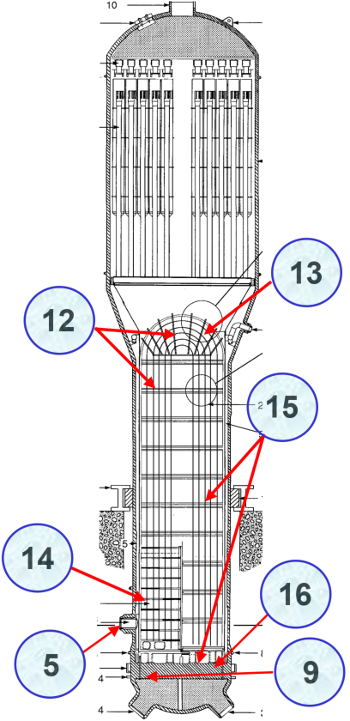

**Figure 2:** CANDU typevertical steam-generator with the critical locations

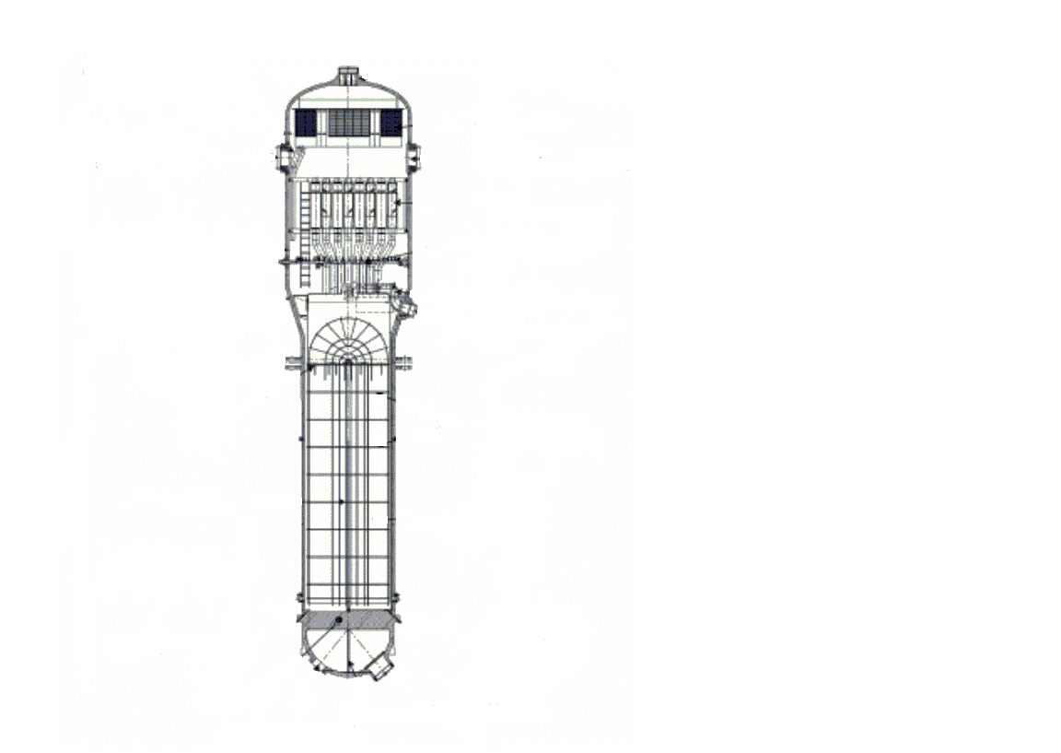

5

7

1

9

20

193

18

3

3

163

7

1553

20

Figure 3. : PWR steam-generator with the critical locations (e.g. typical Areva EPR).

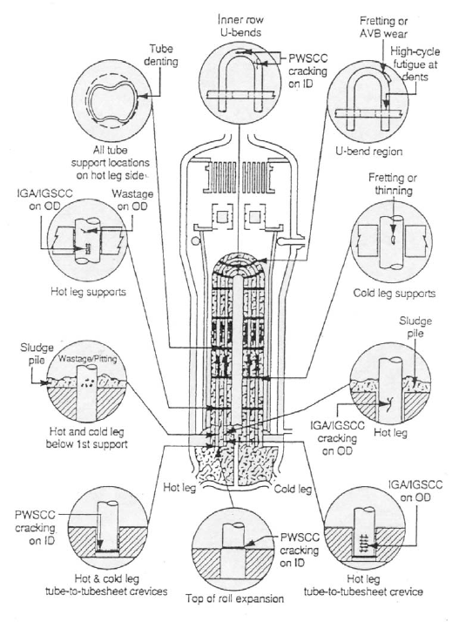

Figure 4. : PWR-type vertical steam-generator with the critical location

**Evaluation and Technical Basis**

1. ***Scope of the ageing management programme based on understanding ageing:***

This programme is applicable to the managing the ageing of recirculating vertical U-tube SGs and OTSGs used in PWRs and CANDU PHWRs, and horizontal/collector boiling steam generators used in WWER reactors. This programme addresses degradation associated with steam generator tubes, plugs, sleeves, tube sheets, support plates and collectors, divider plates, tube-to-tube sheet welds, and secondary side components that are contained within the steam generator (i.e., secondary side internals). This programme does not cover degradation associated with the steam generator shell, channel head, nozzles, or welds associated with these components, which are addressed by AMP 102.

The following degradation mechanisms are considered in this AMP, although not every mechanism applies to each item in the scope of this AMP [4]:

* Fatigue;
* Stress corrosion cracking;
* Thermal ageing;
* Wear;
* Fouling;
* Loss of preload;
* Boric acid corrosion;
* General corrosion.

1. ***Preventive actions to minimize and control ageing degradation:***

This programme includes preventive and mitigation actions for addressing degradation. Preventive and mitigation measures include foreign material exclusion activities, and other primary and secondary side maintenance activities. The programme includes foreign material exclusion as a means to inhibit wear degradation and secondary side maintenance activities, such as sludge lancing and chemical cleaning, as a means to remove deposits that may contribute to degradation. In addition, roto-peening, shot peening, and stress relieving of the U-bend region of the tube may be used to reduce tensile stresses and thereby limit the likelihood of primary water stress corrosion cracking (PWSCC). IAEA-TECDOC-1668 [5] is referred on extensive deposit build-up, foreign objects (material) exclusion in the steam generators. In the U.S., guidance on foreign material exclusion is provided, for example, in NEI 97-06 [6]. Guidance on maintenance of secondary side integrity is provided, for example, in the EPRI Steam Generator Integrity Assessment Guidelines [8]. Primary side preventive maintenance activities include replacing plugs made with corrosion susceptible materials with more corrosion resistant materials and preventively plugging tubes susceptible to degradation.

Extensive deposit build-up in the steam generators could affect tube integrity. For example, the EPRI Steam Generator Integrity Assessment Guidelines [8], which are referenced in NEI 97-06 [6], provide guidance on maintenance of the secondary side of the steam generator, including secondary side cleaning. Secondary side water chemistry plays an important role in controlling the introduction of impurities into the steam generator and potentially limiting their deposition on the tubes. Maintaining high water purity reduces susceptibility to stress corrosion cracking (SCC) or intergranular stress corrosion cracking (IGSCC). Water chemistry is monitored and maintained in accordance with AMP 103.

Implementation of a high alkaline regime (increasing the pH of the feed water to 9.4 - 9.7) results in reduction of mass transfer of corrosion products in the secondary circuit. In particular, that impacts fitness-for-service condition of steam generator tubes, tube supports and collectors. It is possible to implement this after replacement of the copper containing alloys of the equipment of secondary circuit (e.g. turbine condensers of WWER reactors).

To prevent the erosion of the piping of the blow-down water of the steam generators, a replacement of the carbon steel piping with austenitic steal piping can be carried out. That impacts and improves the characteristics of the blow-down water rate regulation as well. Similarly, most of newly built steam generators replaced carbon steel tube supports and antivibration bars with austenitic steel. Recently published book on “Steam Generators for Nuclear Power Plants” [12] extensively describes modern strategies developed by industry to mitigate, monitor and control ageing degradations.

1. ***Detection of ageing effects:***

This programme includes detection of any ageing effects of concern for the steam generator components within its scope to ensure that the integrity of these components is maintained. The inspections are intended to detect degradation (i.e., ageing effects), if they occur. This programme attribute is also intended to ensure that components that could compromise tube integrity are properly evaluated or monitored (e.g., degradation of a secondary side component that could result in a loss of tube integrity is managed by this programme).

In particular, for the steam generator tubes, the inspection requirements may be performance-based, and the actual scope of the inspection and the expansion of sample inspections are justified based on the results of prior inspections. The goal is to perform inspections at a frequency sufficient to provide reasonable assurance of steam generator tube integrity until the next inspection.

The general condition of some components (e.g., plugs, divider plate assemblies, tube sheet, tube-to-tube sheet welds, heads and secondary side components) may be monitored visually, and, subsequently, more detailed inspections may be performed if degradation is detected. To manage cracking due to PWSCC in nickel alloy steam generator tube-to-tube sheet welds and nickel alloy divider plate assemblies, plant-specific AMPs could be required [13]. The criteria to determine the necessity of these plant-specific AMPs are described in [14-16].

In the U.S., NEI 97-06 [6] provides additional guidance on inspection programmes to detect degradation of tubes, sleeves, plugs, and secondary side internals. The frequencies of the inspections are based on technical assessments. Guidance on performing these technical assessments is contained in NEI 97-06 [6] and the associated industry guidelines.

The inspections and monitoring are performed by qualified personnel using qualified techniques in accordance with approved licensee procedures. For example, the EPRI PWR Steam Generator Examination Guidelines [9], Canada CSA N285.4-05, [17] ‘Periodic inspection of CANDU nuclear power plant components’, and India AERB/NPP/SG/O-2 ‘In-service Inspection of Nuclear Power Plants’ [18] contain guidance on steam generator tube inspection techniques, inspection frequency and sampling requirements. CSA N285.4-05 [17] also contains unique requirement on steam generator integrated tube material surveillance programme where a minimum of one removed tube segment is subjected to metallurgical surveillance examination for specified inspection interval. In France, the preventive maintenance standard programme addressed for each degradation type refers to qualified procedures according to the ordinance of November 1999 [19] related to operating management of the main primary and secondary systems.

The primary-to-secondary leakage monitoring programme provides a potential indicator of a loss of steam generator tube integrity. NEI 97-06 [6] and the associated EPRI guidelines provide information pertaining to an effective leakage monitoring programme [20].

The programme includes an assessment of the forms of degradation to which a component is susceptible and implementation of inspection techniques capable of detecting those forms of degradation. The parameter monitored is specific to the component and the acceptance criteria for the inspection. For example, the severity of tube degradation may be evaluated in terms of the depth of degradation or measured voltage, dependent on whether a depth-based or voltage-based tube repair criteria (acceptance criteria) is being implemented for that specific degradation mechanism. Other parameters monitored include signals of excessive deposit build up (e.g., steam generator water level oscillations), which may result in fatigue failure of tubes or corrosion of the tubes; water chemistry parameters, which may indicate unacceptable levels of impurities; primary-to-secondary leakage, which may indicate excessive tube, plug, or sleeve degradation; and the presence of loose parts or foreign objects on the primary and secondary side of the steam generator, which may result in tube damage.

For the dissimilar welds of horizontal steam generators for WWERs, it is important to establish a qualified volumetric inspection (for example with Phased Array UT probes) to detect the stress corrosion cracks. Inspection of weld joints and overlays can be carried out according to [21, 22].

Water chemistry parameters are also monitored as discussed in AMP 103. For example, EPRI PWR Steam Generator Primary and Secondary Water Chemistry Guidelines [9, 10] provide guidance on monitoring chemistry parameters. EPRI Steam Generator Integrity Assessment Guidelines [8] and IAEA-TECDOC-1577, “Strategy for Assessment of WWER Steam Generator Tube Integrity” [23] provide guidance on secondary side activities. In France, guidance for water chemistry is also up-dated according to the operating experience and process development to enhance the secondary system cleanliness.

The boric acid corrosion can be monitored as discussed in AMP 110.

1. ***Monitoring and trending of ageing effects:***

The goal of the inspection programme for all components covered by this AMP is to ensure that the components continue to function consistent with the design and licensing basis of the facility (including regulatory safety margins).

Condition monitoring assessments are performed to determine whether the structural- and accident-induced leakage performance criteria were satisfied during the prior operating interval. Operational assessments are performed to verify that structural and leakage integrity will be maintained for the planned operating interval before the next inspection. If tube integrity cannot be maintained for the planned operating interval before the next inspection, corrective actions are taken in accordance with the plant’s corrective action programme. Comparisons of the results of the condition monitoring assessment to the predictions of the previous operational assessment are performed to evaluate the adequacy of the previous operational assessment methodology. If the operational assessment was not conservative in terms of the number and/or severity of the condition, corrective actions are taken in accordance with the plant’s corrective action programme.

In the U.S. for example, the technical specifications require condition monitoring and operational assessments to be performed (although the technical specifications do not explicitly require operational assessments, these assessments are necessary to ensure that the tube integrity will be maintained until the next inspection). Condition monitoring and operational assessments are done in accordance with the technical specification requirements and guidance in NEI 97-06 [6] and the EPRI Steam Generator Integrity Assessment Guidelines.

Assessments of the degradation of steam generator secondary side internals are performed in accordance with IAEA documents and the applicable member state guidance documents such as IAEA-TECDOC-1577 [23], “Strategy for Assessment of WWER Steam Generator Tube Integrity”, “EPRI Steam Generator Integrity Assessment Guidelines” [8], JSME S NA1 -2008, “Code for Nuclear Power Generation Facilities - Rule on Fitness-for-Service for Nuclear Power Plants” [24],COG-07-4089, “Fitness-for-Service Guidelines for Steam Generator and Preheater Tubes” [25, 26], RD EO-0552-2004 “Guideline for Application of System Approach to Integrity Control of SG Tubes at Operating NPPs with WWER-1000 and WWER-440 Type Reactors” [27] and PNAE G-7-002-86 [28] to ensure the component continues to function consistent with the design and licensing basis and to ensure technical specification requirements are satisfied.

For WWER type of reactors it’s important to monitor the hide out return phenomena. The monitoring activities is performed according to a programme or procedure approved by the Regulatory body.

For the dissimilar welds of horizontal steam generators, it is important to perform the ISI programme according to AMP 102.

1. ***Mitigating ageing effects:***

Methods to mitigate ageing effects are discussed in Attribute 2.

1. ***Acceptance criteria:***

Acceptance criteria for steam generator integrity are consistent with the pertinent governing requirements or guidance documents for the plant.

Plugging criteria is established according with national regulatory requirements and/or manufacturer specifications. The criteria for plugging or repairing steam generator tubes and sleeves can for example be based on U.S. Nuclear Regulatory Commission (NRC) Regulatory Guide 1.121 [29] or other references [27, 28, 30], and are incorporated into plant technical specifications. Guidance on assessing the acceptability of flaws is also provided in NEI 97-06 [6] and the associated EPRI guidelines, including the EPRI Steam Generator In-Situ Pressure Test Guidelines and EPRI Steam Generator Integrity Assessment Guidelines.

Degraded plugs, degraded secondary side internals, and leaving a loose part or a foreign object in the steam generator are evaluated for continued acceptability on a case-by-case basis. NEI 97-06 [6] and the associated EPRI guidelines provide guidance on the performance of these evaluations. The intent of these evaluations is to ensure that the components affected by parts or objects have adequate integrity consistent with the design and licensing basis of the facility.

Guidance on the acceptability of primary-to-secondary leakage and water chemistry parameters also are discussed in NEI 97-06 [6] and the associated EPRI guidelines.

1. ***Corrective actions:***

Corrective actions are consistent with the pertinent governing requirements or guidance documents for the plant.

Examples of corrective actions are provided in IAEA-TECDOC-1668 [6]. In case of the U.S., technical specifications provide requirements on the actions to be taken when the acceptance criteria are not met, for degradation of steam generator tubes and sleeves (if applicable). For degradation of other components, the appropriate corrective action is evaluated per NEI 97-06 [6] and the associated EPRI guidelines, the American Society of Mechanical Engineers (ASME) Code Section XI, 10 CFR Part 50.55a, 10 CFR 50.65, and 10 CFR Part 50, Appendix B, as appropriate [31-33].

In France, the assessment of the SG integrity is based on in-service inspection rules RSE-M [34] that describes the modalities used for detection and characterization of defects.

1. ***Operating experience feedback and feedback of research and development results:***

This AMP addresses the industry-wide generic experience. Relevant plant-specific operating experience is considered in the development of the plant AMP to ensure the AMP is adequate for the plant. The plant implements a feedback process to periodically evaluate plant and industry-wide operating experience and research and development (R&D) results, and, as necessary, either modifies the plant AMP or takes additional actions (e.g. develop a new plant-specific AMP) to ensure the continued effectiveness of the ageing management.

There are currently six types of steam generator tubes used in the world: mill annealed Alloy 600, thermally treated Alloy 600, thermally treated Alloy 690, Monel 400, Alloy 800 NG, and titanium-stabilized austenitic stainless steel 08Ch18N10T used in WWER SGs. Mill annealed Alloy 600 steam generator tubes have experienced degradation due to corrosion (e.g., primary water stress corrosion cracking, outside diameter stress corrosion cracking, intergranular attack, pitting, and wastage) and mechanically-induced phenomena (e.g., denting, wear, impingement damage, and fatigue). Thermally treated Alloy 600 steam generator tubes have experienced degradation due to corrosion (primary water stress corrosion cracking, outside diameter stress corrosion cracking), but minor compared to Alloy 600MA and mechanically-induced phenomena (primarily wear or vibration fatigue near the U-bend section). Thermally treated Alloy 690 tubes have only experienced tube degradation due to mechanically-induced phenomena (primarily wear). Alloy 800NG tubes have experienced tube degradation due to mechanically-induced phenomena (primarily wear and fretting) and limited stress corrosion cracking in deep tubesheet crevices, at tube supports, and at the top of the tubesheet. In the 1980s, there were a limited number of occurrences of pitting/wastage reported. CANDU PWHR SG Monel 400 tubes have experienced degradation due to corrosion (e.g., primary water stress corrosion cracking, intergranular attack, pitting, wastage, and most recently of dealloying) and mechanically induced phenomena (e.g. denting, wear, impingement damage, etc.). WWER 440 and WWER-1000 SGs with austenitic stainless steel tubes have experienced degradation due to corrosion (e.g., outside diameter stress corrosion cracking, intergranular attack, pitting) and mechanically-induced phenomena (e.g., wear). The stress corrosion cracking of dissimilar weld (shell to nozzle) is a specific issue for the WWER-440 and WWER-1000 reactor types. In several cases the repair of these welds is the only solution.

Several generic communications have been issued by the NRC related to the steam generator programmes implemented at plants. The reference section lists many of these generic communications. In addition, NEI 97-06 [6] provides guidance to the industry for routinely sharing pertinent steam generator operating experience and for incorporating lessons learned from plant operation into guidelines referenced in [6]. The latter includes providing interim guidance to the industry, when needed.

The NEI 97-06 [6] programme has been effective at managing the ageing effects associated with steam generator tubes, plugs, sleeves, and secondary side components that are contained within the steam generator (i.e., secondary side internals), such that the steam generators can perform their intended safety function.

In addition, the adequacy of the preventive measures in this AMP is confirmed through periodic inspections. Degradation of tube plugs, sleeves, collectors, divider plates, tube-to-tube-sheet welds, and secondary side internals have also been observed, depending, in part, on the material of construction of the specific component.

This programme includes provisions for continuing review of plant-specific and industry-wide operating experience, and research and development results, such that impact on the programme is evaluated and any necessary actions or modifications to the programme are performed.

In Canada, utilities established action plans for continued assessment of SG tube degradation. One of the key elements of action plans is development of comprehensive fitness-for-service guidelines (FFSG) and a Life Cycle Management Plans (LCMP). These guidelines provide data to determine the life of existing steam generator tubes and supports. Information generated through the LCMP’s application provides a good base on which to assess continued fitness for service for steam generators throughout the industry in Canada.

The conventional eddy current (EC) bobbin coil probe is currently the principal tool used to detect flaws in steam generator tubing. Bobbin coils permit fast inspection rates and have been reasonably reliable for the types of flaws generally seen in the past. However, their effectiveness for some flaw types, such as cracks in dents, is questionable, and it is now generally recognized that they are relatively ineffective for circumferential IGSCC. Supplemental probes of varying design (rotating pancake coils, pancake arrays, ultrasonic probes, etc.) are employed to help resolve questionable bobbin-coil indications or generally improve inspection results. Canadian utilities have developed a specialized NDE probe (known as C-3 probe) for tight circumferential cracks, and Canadian developed X-probe as the need arises which has increased sensitivity and sizing accuracy when compared to the bobbin coil probe for many degradation mechanisms and it is now being used extensively for the inspection of steam generator tubes.

At the time when this AMP was produced, no relevant R&D was identified.

1. ***Quality management:***

Site quality assurance procedures, review and approval processes, and administrative controls are implemented in accordance with different regulatory regulations (e.g., 10 CFR Part 50, Appendix B [33]).

### References

1. UNITED STATES NUCLEAR REGULATORY COMMISSION, NUREG-1801, Generic Aging Lessons Learned (GALL) Report, USNRC, Revision 2, December 2010
2. ATOMIC ENERGY REGULATORY BOARD, Life management of Nuclear Power Plants, AERB/NPP/SG/O-14, AERB, Mumbai, India, 2005
3. Hungarian Atomic Energy Agency: Guideline 4.12, Ageing management during the operation of NPPs, Hungary, 2016
4. STATE OFFICE FOR NUCLEAR SAFETY OF CZECH REPUBLIC, Aging management of NPP, National safety guide BN-JB-2.1, SUJB, 2015
5. INTERNATIONAL ATOMIC ENERGY AGENCY, Assessment and Management of Ageing of Major Nuclear Power Plant Components Important to Safety: Steam Generators, update, IAEA-TECDOC-1668, IAEA, Vienna, November 2011
6. NUCLEAR ENERGY INSTITUTE, Steam Generator Program Guidelines, NEI 97-06, Rev. 3, NEI, January 2011
7. ELECTRIC POWER RESEARCH INSTITUTE, Steam Generator Management Program: Steam Generator Integrity Assessment Guidelines: Revision 4. EPRI, Palo Alto, CA: 2016. 3002007571
8. ELECTRIC POWER RESEARCH INSTITUTE, Steam Generator Management Program: Pressurized Water Reactor Steam Generator Examination Guidelines: Revision 8. EPRI, Palo Alto, CA: 2016. 3002007572
9. ELECTRIC POWER RESEARCH INSTITUTE, Steam Generator Management Program: Steam Generator In-Situ Pressure Test Guidelines, Revision 4. EPRI, Palo Alto, CA: 2012. 1025132
10. ELECTRIC POWER RESEARCH INSTITUTE, Pressurized Water Reactor Primary Water Chemistry Guidelines: Volume 1 and Volume 2, Revision 8. EPRI, Palo Alto, CA: 2014. 3002000505
11. ELECTRIC POWER RESEARCH INSTITUTE, Pressurized Water Reactor Secondary Water Chemistry Guidelines: Revision 8, EPRI 3002010645, EPRI, Palo Alto, CA, February 2017
12. Riznic, J., Ed., Steam Generators for Nuclear Power Plants, Woodhead Publishing, 2017
13. UNITED STATES REGULATORY COMMISSION, Information Notice 2013-20, “Steam Generator Channel Head and Tubesheet Degradation.” Washington, DC, July 2013
14. UNITED STATES NUCLEAR REGULATORY COMMISSION, NUREG-2192, Standard Review Plan For Review Of Subsequent License Renewal Applications For Nuclear Power Plants, USNRC, July 2017
15. ELECTRIC POWER RESEARCH INSTITUTE, SGMP-IL-16-02 “Changes to Aging Management Guidance for Steam Generator Chanel Head Components”
16. ELECTRIC POWER RESEARCH INSTITUTE, Steam Generator Management Program: Investigation of Crack Initiation and Propagation in the Steam Generator Channel Head Assembly, EPRI, Palo Alto, CA: 2014. 3002002850
17. CANADIAN STANDARDS ASSOCIATION, Periodic inspection of CANDU nuclear power plant components, CSA Standard N285.4-05, CSA, 2005
18. ATOMIC ENERGY REGULATORY BOARD, Inservice Inspection of Nuclear Power Plants, AERB/NPP/SG/O-2, AERB, Mumbai, India, March 2004
19. French Ministerial Order of 10 November 1999, main primary circuit and the main secondary circuits of pressurised water nuclear reactors
20. ELECTRIC POWER RESEARCH INSTITUTE, Steam Generator Management Program: PWR Primary-to-Secondary Leak Guidelines — Revision 4. EPRI, Palo Alto, CA: 2011. 1022832
21. PNAE G -7-010-89 Equipment and Piping of Nuclear Power Installations. Weld Joints and Cladding. Overlays. Rules of inspection. Moscow 2000
22. FEDERAL ENVIRONMENTAL, INDUSTRIAL AND NUCLEAR SUPERVISION SERVICE order of 502 07 December 2017, NP-084-15 Unified Inspection Procedures for Base Materials, Weld Joints and Build-Ups in the Course of Operation of Equipment, Pipelines and Other Elements of Nuclear Power Plants
23. INTERNATIONAL ATOMIC ENERGY AGENCY, Strategy for Assessment of WWER Steam Generator Tube Integrity, IAEA-TECDOC-1577, IAEA, Vienna, 2007
24. JAPAN SOCIETY OF MECHANICAL ENGINEERS, IA, IB Code for Nuclear Power Generation Facilities - Rule on Fitness-for-Service for Nuclear Power Plants, JSME S NA1, JSME
25. Kozluk, M., Scarth, D., & Graham, D. (2002). Technical Basis for the CANDU Steam Generator Tube Fitness-for-Service Guidelines. 4th CNS International Steam Generator Conference. Toronto: Canadian Nuclear Society
26. Scarth, D., Kozluk, M., Cartar, E., Mirzai, M., Maruska, C., Nickerson, J. N., & Graham, D. (1998). CANDU Steam Generator Fitness-for-Service Guidelines. 3rd International Conference on Steam Generators and Heat Exchangers. Canadian Nuclear Society
27. GOSATOMENERGONADZOR, Guideline for Application of System Approach to Integrity Control of SG Tubes at Operating NPPs with WWER-1000 and WWER-440 Type Reactors, RD EO-0552-2004, Moscow
28. PNAE G-7-002-86 Standards on Strength Analysis of Equipment and Pipelines of Nuclear Power Installations
29. UNITED STATES REGULATORY COMMISSION, Regulatory Guide 1.121, Bases for Plugging Degraded PWR Steam Generator Tubes, USNRC, Latest Edition.
30. Normative Technical Documentation of Association of Mechanical Engineers of Czech Republic for Design and Life Time Assessment of Components and Piping in VVER NPPs During Operation, 2017
31. UNITED STATES REGULATORY COMMISSION, 10 CFR Part 50.55a, Codes and Standards, Office of the Federal Register, National Archives and Records Administration USNRC, Latest Edition
32. UNITED STATES REGULATORY COMMISSION, 10 CFR 50.65, Requirements for Monitoring the Effectiveness of Maintenance at Nuclear Power Plants, Office of the Federal Register, National Archives and Records Administration, USNRC, Latest Edition
33. UNITED STATES REGULATORY COMMISSION, 10 CFR Part 50, Appendix B, Quality Assurance Criteria for Nuclear Power Plants, Office of the Federal Register, National Archives and Records Administration USNRC, Latest Edition
34. AFCEN (French Association for the rules governing the Design, Construction and Operating Supervision of the Equipment Items for Electro Nuclear Boilers), RSE-M Code, In-Service Inspection Rules for Mechanical Components of PWR Nuclear Islands, 2018 Edition