### AMP 138 REACTOR COOLANT pump (VERSION 2020)

### Programme Description

Approach of some operators (e.g. WWER, CANDU) to AMPs development is focused on components (such RCP, RPV, SG, Pressurizer, etc.), not on individual degradation mechanisms. These “umbrella type” programmes are based on understanding all degradation mechanisms related to the specific component and describing all activities necessary to manage ageing. The main advantage of such an approach is knowledge of the overall state of the components.

This ageing management programme is a component-specific AMP for the reactor coolant pump (RCP) that covers multiple degradation mechanisms the RCP may be subjected to and the activities necessary to manage the ageing mechanisms as such, this AMP refers to other degradation-specific and/or monitoring type of AMPs that deal with particular degradation mechanisms and degradation ageing effects.

The body of the pump including its sealing parts is safety class 1, the internals of the pumps performing the active function of the pump (circulation of primary water) are safety class 2 and they are included in the scope for LTO in accordance with the IAEA Safety Report No. 57 [1].

The fulfillment of the active function of a safety related SSCs may be monitored in the framework of an AMP, or in a separate active function monitoring system. For instance, in the USA it is covered by the Maintenance Rule, in other member states with Maintenance Effectiveness Monitoring Systems out of the scope of AMP.

### Evaluation and Technical Basis

1. ***Scope of the ageing management programme based on understanding ageing:***

The programme controls ageing of the reactor coolant pumps. The following ageing degradation mechanisms are considered in this AMP (see Table 1 and Figure 1):

* Fatigue;
* Stress corrosion cracking;
* Thermal ageing of stainless steels (where necessary, e.g. WWER 1000);
* Wear;
* Erosion;
* Growth of manufacturing defects (if existing);
* Boric acid corrosion (applicable to bolting);
* General corrosion (applicable to the RCP support system).

Fatigue (cumulative effect of fatigue)

Fatigue is caused by cyclic loading of system, structures and components (SSC) during operation. The critical locations for fatigue of RCP are the body and the flanged joints.

Stress corrosion cracking

Stress corrosion cracking is a complex phenomenon driven by the synergistic interaction of mechanical, electrochemical and metallurgical factors.

Thermal ageing of stainless steels (where necessary, e.g. WWER 1000)

Thermal ageing causes loss of fracture toughness and a change of mechanical properties of susceptible CASS materials.

Wear

Wearing is characterized by loss of material due to contact between two moving surfaces, such as sliding, rolling, pushing or streaming. Degradation due to wear or stress relaxation could be applicable to fitted connections such as bolts and keys.

Erosion

Erosion effects on wall thickness of hydraulic components of RCP.

Growth of manufacturing defects

This type of ageing effects is managed by in-service inspections.

Boric acid corrosion

Bolting used on RCP could be in carbon steel or nickel alloy and thus boric acid corrosion is a potential degradation mechanism.

Examples of critical locations with potential degradation mechanisms are summarized in Table 1.

|  |  |  |  |  |  |  |  |  |  |
| --- | --- | --- | --- | --- | --- | --- | --- | --- | --- |
| **Location ID** |  | ***Degradation mechanism*** | ***Fatigue*** | ***General corrosion*** | ***Boric acid corrosion*** | ***Local corr. (incl. SCC)*** | ***Erosion*** | ***Wear*** | ***Loss of preload*** |
|  | **Critical location** |
| **1** |  | **Pump casing, welds** |  |  |  | **+** | **+** | **+** |  |
| **2** |  | **Pressure cover** | **+** |  |  | **+** |  | **+** |  |
| **3** |  | **Nozzles** |  |  |  |  | **+** |  |  |
| **4** |  | **Main flange bolted connections and its location** |  |  |  | **+** |  | **+** | **+** |
| **5** |  | **Main flange sealing surfaces** | **+** |  |  | **+** |  | **+** | **+** |
| **6** |  | **Driving wheel** | **+** |  |  | **+** | **+** |  |  |
| **7** |  | **Sealing-block casing components** |  |  |  | **+** |  |  |  |
| **8** |  | **Supporting frames and structures** |  | **+** | **+** |  |  |  |  |

**Table 1.** Example of reactor coolant pump critical locations and degradation mechanisms

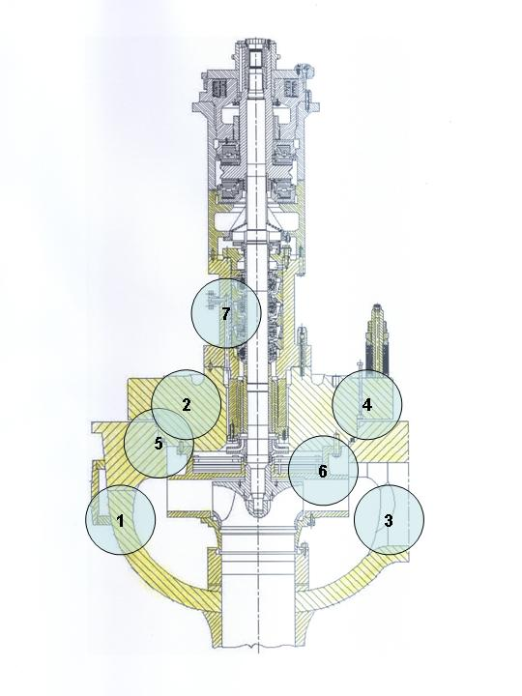

**Figure 1.** WWER-440 main circulating pump with the critical locations

1. ***Preventive actions to minimize and control ageing degradation:***

The preventive actions are carried out during normal operation by established control and monitor any adverse effects of the water chemistry conditions on the ageing mechanisms. The programme description and evaluation and technical basis of monitoring and maintaining reactor coolant chemistry are addressed in AMP 103.

Other preventive action is regular maintenance according to approved schedule (such as general repair, inspection of sealing screw tightness and examination of pure condensate piping throughput, etc.).

1. ***Detection of ageing effects:***

The reactor coolant pumps are inspected and tested according to requirements of the in-service inspection programme. Nondestructive methods such as visual examination, capillary test to detect surface cracks, dimensional control, ultrasonic examination and He bubble test may be used. Furthermore, ageing effects are monitored by a pressure test and a tightness test. It is expected that visual, surface or volumetric inspection performed in AMP 102 will detect cracking due to SCC, or fatigue, growth of manufacturing defects, erosion by wall thickness measurement or common wear by inspecting for loose connections or missing parts. The impact of boric acid leakage on bolting materials is addressed by IGALL AMP 110. The cumulative effect of fatigue is addressed by AMP 101. The development of thermal ageing is indicated by hardness measurements.

The active safety functions of the reactor coolant pump may be monitored by on line diagnostics.

1. ***Monitoring and trending of ageing effects:***

Timely and reliable detection of ageing degradation is provided by implementation of inspection and testing schedules in accordance with the referred AMPs in attribute 3, reliable examination methods, and qualified inspection personnel. Monitoring and trending is performed as per the specific AMPs identified in attribute 3. In connection with the possibility of wear of rotating parts due to vibration and/or precession, which is manifested in periodic сhanges of temperatures, it is necessary to ensure continuous monitoring of the rotation parameters (speed, vibration) for the possible detection of abnormalities in the early stages and the prevention of deterioration related to the issues of rotation.

1. ***Mitigating ageing effects:***

Recommendations for mitigation of ageing effects are based on referred AMPs, and on results from performed analyses of possible degradation developments. Condition-based maintenance (recommendation from on-line diagnostic) is also carried out.

1. ***Acceptance criteria:***

Acceptance criteria are part of referred AMPs, on-line diagnostic programme (for active components, if existing) and maintenance procedures. Any indication or relevant conditions of degradation may be evaluated for acceptance in accordance with the pertinent governing requirements or guidance documents as for example [2-6]. Examination results and flaws that exceed the acceptance criteria in the pertinent governing requirements or guidance documents may require repair or replacement activities, or further evaluation to demonstrate fitness-for-service of the component, to the satisfaction of the regulatory authority, until the end of the next periodic inspection interval.

1. ***Corrective actions:***

For each acceptance criterion which is not satisfied, the procedure for resolution is defined or elaborated and consequently implemented, according to the referred AMPs. At the end of the process the criterion is fulfilled and the requested state of the component is restored. Repair and replacement according to requirement of technical documentation of the components and according to guiding documents of the plant are part of possible corrective actions. When suitable in some cases, changes to operational regimes could be applied.

1. ***Operating experience feedback and feedback of research and development results:***

This AMP addresses the industry-wide generic experience. Relevant plant-specific operating experience is considered in the development of the plant AMP to ensure the AMP is adequate for the plant. The plant implements a feedback process to periodically evaluate plant and industry-wide operating experience and research and development (R&D) results, and, as necessary, either modifies the plant AMP or takes additional actions (e.g. develop a new plant-specific AMP) to ensure the continued effectiveness of the ageing management.

The values of ageing management parameters and corresponding analysis (in case that they were performed) are evaluated according to the relevant AMP. The operational history of the component is analyzed once per inspection or test cycle.

After nearly 30 years of operation of RCP at some WWER NPPs (RCP type: GCN-317 and GCN-195), cracks on the surface (in certain locations) which are caused by the stress corrosion cracking, begin to appear.

The cracks appear on the pressure flange and the guide wheel, always on the diameter of 840 mm. Thermal-stress analysis [7] shows that the guide wheel is stressed with a high temperature gradient in the material (the temperature of seal water on the inner side and the temperature of primary medium on the outside). The impossibility of guide wheel expansion leads to the rise of a stress peak, which is also transmitted to the pressure flange.

Amendment of the guide wheel and the pressure flange is done by the precisely defined removal of material and inserting of the heat shield. Heat shield is set between the inner wall of the guide wheel and the outlet water from the seals. This procedure guarantees that the cracks are eliminated and occurrence of a degradation mechanism is prevented.

At the time when this AMP was produced, no relevant R&D was identified.

1. ***Quality management:***

The AMP is carried out in agreement with site QA procedures, review and approval processes, and administrative controls, which are implemented in accordance with the different national regulatory requirements for example [8-9] or the different national standards.

### References

1. INTERNATIONAL ATOMIC ENERGY AGENCY, Safe long term operation of nuclear power plants, Safety Report Series No. 57, IAEA, Vienna, 2008.
2. Unified Procedure for Lifetime Assessment of Components and Piping in WWER NPPs during Operation, European Commission, COVERS – WP-D4.10, project VERLIFE, 2008.
3. NUCLEAR REGULATORY AUTHORITY OF THE SLOVAK REPUBLIC, Aging management of NPP, 2001National safety guide BNS1.9.2/2001, UJD-SR.
4. STATE OFFICE FOR NUCLEAR SAFETY OF CZECH REPUBLIC, Aging management of NPP, National safety guide BN-JB-2.1, SUJB, 2015.
5. Hungarian Atomic Energy Agency: Guideline 4.12. Ageing management during the operation of NPPs, April 2013.
6. PNAE G -7-010-89 Equipment and Piping of Nuclear Power Installations. Weld Joints and Weld. Overlays. Rules of inspection. Moscow 2000
7. UJV Rez, Analysis of guide wheel of RCP, DITI 2301/359, December 2013
8. STATE OFFICE FOR NUCLEAR SAFETY OF CZECH REPUBLIC, [Decree No.132/2008](http://www.sujb.cz/fileadmin/sujb/docs/legislativa/V1322008.doc) on Quality Assurance System in carrying out activities connected with utilization of nuclear energy and radiation protection, SUJB, 2008.
9. NUCLEAR REGULATORY AUTHORITY OF THE SLOVAK REPUBLIC, Regulation No. 431/2011 on a quality management system, 2011, UJD-SR.