### AMP 153 WWER Main gate valves (VERSION 2020)

### Programme Description

This ageing management programme is a component-specific AMP for the main gate valves (MGV). It covers multiple degradation mechanisms that MGV may be subjected to and the activities necessary to manage the ageing mechanisms. This AMP also refers to other degradation-specific and/or monitoring type of AMPs which deal with particular degradation mechanisms and degradation ageing effects.

Main gate valves are part of WWER 440 design and some version of WWER 1000. MGV original purpose was to enable isolation of specific loop during operation or for maintenance purposes.

An MGV is a horizontally oriented valve with vertical movement of the closing gate. The closing gate is controlled by a vertical shaft passing through the sealing system. The normal operating position of an MGV is open. Actuation is provided by an electric drive with back-up manual control. Operational conditions are given and operation of this component is managed by the operational procedures for primary circuit. The MGV is welded to the main circulation pipe. It is placed on spherical supports with freedom of movement in all directions.

The body of the valve, including, sealing belongs to safety class 1, the internals of the valve performing the active function (shutdown of primary loop) belong to safety class 2 and they are included in the scope for LTO in accordance with the IAEA Safety Report Series No. 57 [1].

### Evaluation and Technical Basis

1. ***Scope of the ageing management programme based on understanding ageing:***

In the frame of the ageing management programme for the main gate valves of WWER 440 and WWER 1000 NPPs (with installed MGV), the following ageing degradation mechanisms are considered (see Table 1 and Figure 1):

* Fatigue;
* Wear;
* General corrosion;
* Stress corrosion cracking;
* Thermal ageing;
* Loss of preload;
* Boric acid corrosion.

Critical fatigue locations of MGV are the housing and the flange sealing surfaces.

Degradation due to wear could be applicable to shaft, flange sealing surfaces, closing surfaces and bolting connections.

The critical location for general corrosion of MGV is the support structures.

Critical locations for stress corrosion cracking may be shaft, flange sealing surfaces, closing surfaces and bolting connections of MGV.

The critical locations for thermal ageing of the MGV is the valve body.

Degradation due to loss of preload could be applicable to fitted connections such as bolts.

Bolting and support structures used on MGV could be in carbon steel thus boric acid corrosion is a potential degradation mechanism.

Examples of critical locations with potential degradation mechanisms are summarized in Table 1.

|  |  |  |  |  |  |  |  |  |  |
| --- | --- | --- | --- | --- | --- | --- | --- | --- | --- |
| **Loc. ID** | ***Degradation mechanism*** | ***Fatigue*** | ***Gen. corr.*** | ***Boric acid corr.*** | ***Local corr. (incl. SCC)*** | ***Wear*** | ***Thermal ageing*** | ***Loss of preload*** | ***Erosion*** |
| **Critical location** |
| **1** | **Casted valve housing** | **+** |  |  |  |  | **+** |  | + |
| **2** | **Cover** (no degr. mech. assigned) |  |  |  |  |  |  |  |  |
| **3** | **Location of the connection of the closing mechanism and the casing** |  |  |  | **+** | **+** |  |  | + |
| **4** | **Main flange sealing surfaces** | **+** |  |  | **+** | **+** |  |  |  |
| **5** | **Main flange bolted connections and its location** | **+** |  |  | **+** | **+** |  | **+** |  |
| **6** | **Location of connection of the spindle and the cover** |  |  |  | **+** | **+** |  | **+** |  |
| **7** | **Sealing-block casing components** |  |  |  | **+** |  |  |  |  |
| **8** | **Supporting structures** |  | **+** | **+** |  | **+** |  |  |  |

**Table 1.** Example of main gate valves critical locations and degradation mechanisms

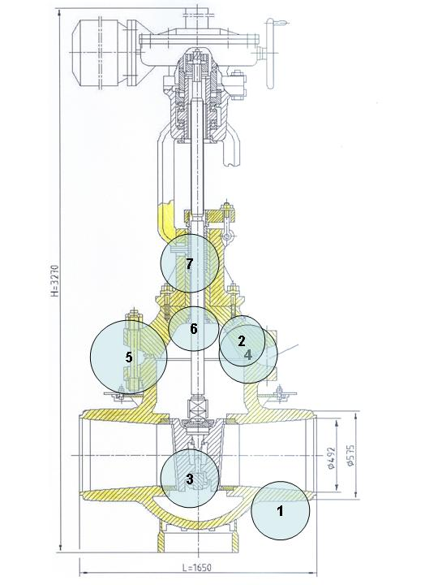

**Figure 1.** WWER-440 main gate valve with the critical locations

1. ***Preventive actions to minimize and control ageing degradation:***

Preventive actions include regular maintenance according to approved documented maintenance instructions.

The preventive actions are carried out during normal operation by established control and monitor of any adverse effects of the water chemistry conditions on the related ageing mechanisms. The programme description, evaluation and technical basis of reactor coolant chemistry monitoring and maintaining are addressed in AMP 103.

Preventive actions for low cycle fatigue include reduction of transients and keeping limits and conditions.

1. ***Detection of ageing effects:***

The main gate valves are inspected and tested according to requirements of the in-service inspection programme. Nondestructive methods such as visual examination, dye penetrant tests for detect of surface cracks, dimensional control and ultrasonic examination may be used. Furthermore, ageing effects are monitored by pressure and tightness test. It is expected that visual, surface or volumetric inspection performed within the AMP 102 will detect cracking due to SCC, fatigue, growth of manufacturing defects or common wear.

The cumulative effect of fatigue is addressed by AMP 101.

The development of thermal ageing can be indicated by periodic hardness measurements or thermoelectric power measurement.

1. ***Monitoring and trending of ageing effects:***

Timely and reliable detection of ageing degradation is provided by implementation of inspection and testing schedules in accordance with the referred AMPs in attribute 3, reliable examination methods, and qualified inspection personnel. Monitoring and trending is performed as per the specific AMPs identified in attribute 3.

1. ***Mitigating ageing effects:***

Recommendations for mitigation of ageing effects are based on the referred AMPs and results from performed analyses of possible degradation developments. Condition-based maintenance (recommendation from on-line diagnostic) is also carried out.

Improving of operational procedures can mitigate the effect of fatigue. In some cases, component replacement is necessary.

For stress corrosion cracking actions are defined in attribute 2.

1. ***Acceptance criteria:***

Acceptance criteria are part of referred AMPs, on-line diagnostic programme (for active components, if existing) and maintenance procedures. Some indication or relevant conditions of degradation may be evaluated for acceptance in accordance with the governing requirements or guidance documents, as for example [2-5].

1. ***Corrective actions:***

Examination results and flaws that exceed the acceptance criteria in the governing requirements or guidance documents may require repair or replacement activities performed on the base of a properly approved documentation.

For each acceptance criterion which is not satisfied, the procedure for resolution is defined or elaborated and consequently implemented, according to the referred AMPs. At the end of the process the criterion is fulfilled and the requested state of the component is restored. Repair and replacement according to requirement of technical documentation of the components and according to guiding documents of the plant are part of possible corrective actions.

When suitable in some cases, changes to operational regimes could be applied.

1. ***Operating experience feedback and feedback of research and development results:***

This AMP addresses the industry-wide generic experience. Relevant plant-specific operating experience is considered in the development of the plant AMP to ensure the AMP is adequate for the plant. The plant implements a feedback process to periodically evaluate plant and industry-wide operating experience and research and development (R&D) results, and, as necessary, either modifies the plant AMP or takes additional actions (e.g. develop a new plant-specific AMP) to ensure the continued effectiveness of the ageing management.

Appropriate sources of external operating experience are WANO Operating Experience Programme, IAEA IGALL Programme, etc.

The operational history of the component is analyzed once per inspection or test cycle according to the member states practice. There is a system in place to incorporate feedback from internal and external operating experiences.

The values of ageing management parameters and corresponding analysis (in case that they were performed) are evaluated according to the referred AMPs in attribute 3.

Observations of degradation of WWER-440 main gate valves include cracks due to stress corrosion cracking at closure bolting components. It has been managed primarily through improved ISI control, repair of sealing surfaces, or replacement of bolts and/or sealing components. Preventive action e.g. replacement of bolts and/or sealing components of MGV may preclude the effect of ageing.

Condition monitoring programme for thermal embrittlement measurement of high ferrite content cast austenitic stainless steel MGV bodies inspect for the presence and extent of ageing of material.

Research and development efforts and an effective experience exchange are important elements for implementing continuous improvement in this programme and in defining adequate corrective actions.

This programme includes provisions for continuing review of plant-specific and industry-wide operating experience, and research and development results, such that impact on the programme is evaluated and any necessary actions or modifications to the programme are implemented.

At the time when this AMP was produced, no relevant R&D was identified for MGV.

1. ***Quality management:***

The AMP is carried out in agreement with site QA procedures, review and approval processes, and administrative controls, which are implemented in accordance with the different national regulatory requirements for example [6-7] or the different national standards, and regulatory requirements [5].

### References

1. INTERNATIONAL ATOMIC ENERGY AGENCY, Safe long term operation of nuclear power plants, Safety Report Series No. 57, IAEA, Vienna, 2008.
2. Unified Procedure for Lifetime Assessment of Components and Piping in WWER NPPs during Operation, European Commission, COVERS – WP-D4.10, project VERLIFE, 2008.
3. NUCLEAR REGULATORY AUTHORITY OF THE SLOVAK REPUBLIC, Aging management of NPP - requirements, National safety guide BNS I.9.2/2014, UJD-SR, 2014.
4. STATE OFFICE FOR NUCLEAR SAFETY OF CZECH REPUBLIC, Aging management of NPP, National safety guide BN-JB-2.1, SUJB, 2015.
5. Hungarian Atomic Energy Agency: Guideline 4.12. Ageing management during the operation of NPPs, March 2016.
6. STATE OFFICE FOR NUCLEAR SAFETY OF CZECH REPUBLIC, [Decree No.132/2008](http://www.sujb.cz/fileadmin/sujb/docs/legislativa/V1322008.doc) on Quality Assurance System in carrying out activities connected with utilization of nuclear energy and radiation protection, SUJB, 2008.
7. NUCLEAR REGULATORY AUTHORITY OF THE SLOVAK REPUBLIC, Regulation No. 431/2011 on a quality management system, 2011, UJD-SR.