**AMP 156 PWR MAIN COOLANT PIPING (VERSION 2020)**

### Programme Description

This ageing management programme is a component-specific AMP for the main coolant piping (MCP) and includes degradation mechanisms the MCP may be subjected to as well as activities necessary to manage the ageing mechanisms. As such, this AMP refers to other degradation-specific AMPs that deal with particular degradation mechanisms and ageing effects.

The PWR main coolant piping provides the barrier to the release of fission products, carries the hot coolant from the reactor pressure vessel to the steam generators and then provides cold coolant back to the vessel. Maintaining the structural integrity of this piping is essential to the safe operation of a PWR plant.

### Evaluation and Technical Basis

1. ***Scope of the ageing management programme based on understanding ageing:***

The programme includes activities for inspecting, detecting, monitoring, mitigating, evaluating. The programme is a mixed condition monitoring and preventive programme, with periodic examinations and other inspections of highly affected locations. These examinations provide reasonable assurance that the effects of age-related degradation mechanisms will be managed during operation [1].

The programme controls ageing of the main coolant piping of PWR NPPs. The following ageing degradation mechanisms are relevant for the main coolant piping:

* Fatigue (low- and high-cycle and environmentally assisted fatigue);
* Stress corrosion cracking (and other local corrosions, like pitting);
* Thermal ageing embrittlement;
* Boric acid corrosion.

Fatigue (including low- and high cycle fatigue, and environmentally assisted fatigue)

Low cycle fatigue is caused by cyclic loading of system, structures and components (SSC) during operation. The critical locations for low-cycle fatigue of MCPs are the connections to nozzles and branch connections (AMP 101).

Stress corrosion cracking

Stress corrosion cracking (SCC) is a complex phenomenon driven by the synergistic interaction of mechanical, electrochemical and metallurgical factors. SCC may be observed on MCP components and elements (AMP 111).

Thermal ageing embrittlement

Thermal ageing of materials is a time and temperature dependent degradation mechanism that decreases material toughness (AMP 112).

At operating temperatures of 260 to 343 °C (500 to 650 °F), CASS exhibits a spinodal decomposition of the ferrite phase into ferrite-rich and chromium-rich phases. This may give rise to significant embrittlement (reduction in fracture toughness), depending on the amount, morphology and distribution of the ferrite phase and the composition of the steel.

Thermal ageing of materials other than CASS includes temper embrittlement and strain ageing embrittlement. Ferritic and low-alloy steels are subject to both of these types of embrittlement, but wrought stainless steel is not affected by either of these processes. Stainless steel welds contain certain amount of delta ferrite, and thermal ageing embrittlement can be applicable to stainless steel welds.

Boric acid corrosion

Boric acid corrosion of carbon steel or low alloy steel can occur in main coolant piping due to the breach in the stainless steel cladding, and can also occur at other uncladded locations (AMP 110).

Implementation of the boric acid corrosion programme is to monitor the leakage of the pressure boundaries in primary system, including main coolant piping.

Supports of main coolant piping could be in carbon steel thus boric acid corrosion is a potential degradation mechanism.

Examples of critical locations with potential degradation mechanisms are summarized in table 1.

|  |  |  |  |  |  |  |
| --- | --- | --- | --- | --- | --- | --- |
| **Location ID** | ***Degradation mechanism*** | ***Fatigue*** | ***Local corrosion (incl. SCC)*** | ***Boric acid corrosion*** | ***General corrosion*** | ***Erosion*** |
| **Critical location** |
| **1** | **Connections: Reactor, SG, MGV, MCP** |  | **+** |  |  | **+** |
| **2** | **Connection are of the connected tubes** | **+** | **+** |  |  | **+** |
| **3** | **Instrument nozzles** |  | **+** |  |  | **+** |
| **4** | **Welds** |  | **+** |  |  | **+** |
| **5** | **Arcs with longitudinal welds** |  | **+** |  |  | **+** |
| **6** | **Supporting structures** |  |  | **+** | **+** |  |

**Table 1.** Example of main coolant piping critical locations and degradation mechanisms

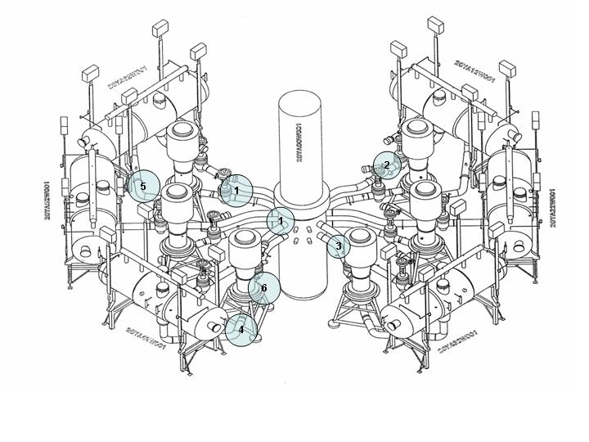

**Figure 1**. WWER-440 main coolant piping with the critical locations

1. ***Preventive actions to minimize and control ageing degradation:***

The programme identifies the preventive actions defined as those that are necessary to prevent or minimize initiation of degradation out during normal operation. Prevention programmes incorporates water chemistry requirements which are monitored and maintained in accordance with AMP 103, AMP 110, AMP 111, and [2-3].

Preventive actions for low cycle fatigue include reduction of transients and keeping operating limits and conditions.

1. ***Detection of ageing effects:***

This programme includes detection of any ageing effects of concern for the main coolant piping within its scope to ensure that the integrity of these components is maintained. The in-service inspections (AMP 102 and [4-5]) are intended to detect degradation (i.e., ageing effects), if they occur (e.g. cracking due to SCC, fatigue, growth of defects).

Standards for examination methods, procedures, and personnel are provided in the programme, with preference to well-established examination methods. These methods include visual, dye penetrant, ultrasonic inspections and magnetic particle method. Surface examinations may also be used as an alternative to visual examinations for detection and sizing of surface-breaking discontinuities.

The effect of fatigue is addressed by AMP 101 and [6].

The thermal ageing could also be investigated by hardness measurements.

The attribute addresses the scope, methods, frequency and timing of in-service inspection used to detect ageing effects (AMP 102).

1. ***Monitoring and trending of ageing effects:***

Monitoring and trending is performed as per the specific AMPs identified in attribute 3.

A comparison of the current monitoring results of condition parameters with previous ones will be performed in order to determine the degradation rate.

To facilitate monitoring and trending of main coolant piping ageing data of inspection results will be collected, compared and assessment will be performed to make predictions for the future.

1. ***Mitigating ageing effects:***

Recommendations for mitigation of ageing effects are based on the referred AMPs and results from performed analyses of possible degradation developments.

The activities (operation, inspection, maintenance, water chemistry control) will be implemented to mitigate degradation. Recommendations for mitigation of ageing effects are based on programmes referred to attribute 2.

1. ***Acceptance criteria:***

Acceptance criteria are part of referred AMPs. The criteria, against which the need for corrective action is evaluated to ensure that the elements and the structures intended function(s) are maintained during the operation. The acceptance criteria are based on norms, regulations and standards on nuclear and radiation safety.

1. ***Corrective actions:***

Actions to be taken when the acceptance criteria are not met will be identified. They are described in appropriate details or referenced in the plant specific documents. Corrective actions, including root cause determination and prevention of recurrence will be timely performed.

When suitable in some cases, changes to operational regimes could be applied.

If corrective actions permit analysis without repair or replacement the analysis ensures that the main coolant piping intended functions are maintained consistent with norms, regulations and standards on nuclear and radiation safety.

1. ***Operating experience feedback and feedback of research and development results:***

This AMP addresses the industry-wide generic experience. Relevant plant-specific operating experience is considered in the development of the plant AMP to ensure the AMP is adequate for the plant. The plant implements a feedback process to periodically evaluate plant and industry-wide operating experience and research and development (R&D) results, and, as necessary, either modifies the plant AMP or takes additional actions (e.g. develop a new plant-specific AMP) to ensure the continued effectiveness of the ageing management.

In accordance with the rules [7-8], the mechanical properties of WWER MCP after 100 000 hours of operation are examined by destructive and/or non-destructive methods. This alternate replacement of the control technology (destructive or non-destructive) became possible only after the complex investigations of specimens of the real piping material. The test results have not shown any significant difference in material properties. The investigations have revealed that the WWER NPPs piping material maintain high properties after 100 000 hours of operation and gave possibility to create new effective methods of non-destructive estimation of piping mechanical properties (without removing specimens, e.g. kinetic hardness measurement).

The programme includes provisions for continuing review of plant-specific and industry-wide operating experience, and research and development results, such that impact on the programme is evaluated and any necessary actions or modifications to the programme are performed.

At the time when this AMP was produced, no relevant R&D was identified.

1. ***Quality management:***

NPP system of quality assurance ensures the implementation of the AMP and maintaining it in an actual state, as well as systematic analysis and control of its correspondence to the 9 generic attributes. Site QA procedures, review and approval processes, and administrative controls are implemented in accordance with the different national regulatory requirements (e.g. ISO 9000 [9], 10 CFR Part 50, Appendix B [10].

### References

1. INTERNATIONAL ATOMIC ENERGY AGENCY, Assessment and Management of Ageing of Major Nuclear Power Plant Components Important to Safety: Primary Piping in PWRs, 2003, IAEA-TECDOC-1361, IAEA, Vienna, July 2003.
2. SOU-N JaEK 1.013:2014, Primary coolant of nuclear power reactors WWER-1000. Technical requirements and quality assurance.
3. SOU-N JaEK 1.012:2014, Primary coolant of nuclear power reactors WWER-440. Technical requirements and quality assurance.
4. AIEU-1-09, Standard Programme of In-Service Inspection of Base Metal, Welds and Cladding of WWER-440 (V-213) Equipment and Pipelines.
5. PM-Т.0.03.061-13, Standard Programme of In-Service Inspection of Base Metal, Welds and Cladding of WWER-1000 Equipment and Pipelines (TPPK-13).
6. PNAE G-7-002-86, Standards for Strength Calculation of Equipment And Pipelines of Nuclear Power Plants.
7. PNAE G-7-008-89, Regulations for Design and Safe Operation of Equipment and Pipelines of Nuclear Installations.
8. NP 089-15, Rules of Design and Safe Operation of Equipment and Pipelines of Nuclear Power Installations, February 09, 2016.
9. ISO 9000, Quality management, International Organization for Standardization.
10. UNITED STATES NUCLEAR REGULATORY COMMISSION, 10 CFR Part 50, Appendix B, Quality Assurance Criteria for Nuclear Power Plants, Office of the Federal Register, National Archives and Records Administration, USNRC, Washington, Latest Edition.