AMP227 LOW VOLTAGE COILS OF CONTROL ROD DRIVE SYSTEM

Programme Description

The objective of this AMP is to provide guidance for effective aging management of low voltage coils used in Control Rod Drive (CRD) system of Pressurized Water Reactors (PWRs).

The CRD system is a type of magnetic jack, which is used to withdraw or insert the control rods into the reactor core to execute the power changes based on demand signals generated by reactor power control system or manual operator action or cease the chain reaction in case of an emergency reactor shutdown [1].

A simplified diagram showing CRD system boundary based on NUREG/CR-5555 is shown in Figure 1 [2]. The CRD system include both electrical and mechanical components, however, this AMP only focuses on condition monitoring of low voltage electrical coils utilized in coil stack assembly and rod position indication assembly to ensure that the system will continue to perform its intended functions despite the effects of in-service ageing throughout the lifetime of the plant.

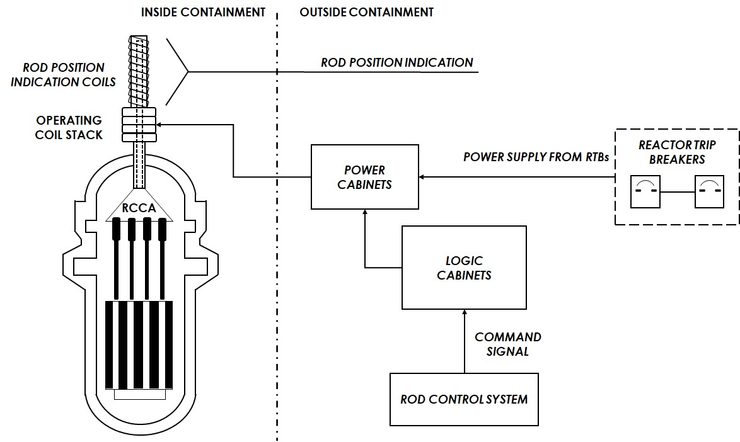

Figure 1 CRD System Boundary

The coil stack assembly consists of three coils namely stationary gripper coil, movable coil and lift coil that are placed inside coil housing. The leads from these coils pass via conduit to the top of pressure housing where they terminate in the connector. Whereas, the rod position indication assembly is placed around rod travel housing of each Rod Cluster Control Assembly (RCCA). It consists of several coils that provide the actual position of RCCA inside the reactor core [3].

As coil stack assemblies and rod position indication assemblies are mounted on top of reactor vessel head inside containment, therefore high ambient temperature, radiation and humidity are the common environmental stressors that may result in ageing degradation of coils. The high ambient temperatures affect the insulation quality of coils and over the period of time may lead to short circuiting in the presence of other stressors such as humidity. Moreover, long term energization of stationary gripper coil during stable power operation of the plant results in additional thermal stresses due to ohmic heating of coils. The other operational stressors that affect coils of CRD system include electrical stresses which may result from arcing and power surges [4].

The table below summarizes the stressors and significant ageing mechanism for low voltage coils of CRD system:

|  |  |  |  |  |
| --- | --- | --- | --- | --- |
| Component | Applicable Stressors | Degradation Mechanisms | Ageing Effect | Potential Failure Mode |
| Coils (Electrical insulation and conductor) | Environmental Stressors (Temperature, humidity, radiation etc.) | Thermal degradation of coil insulation,  Embrittlement | Reduced Insulation Resistance (IR) | Loss of electrical function, dropped rod, incorrect rod position |
| Voltage | Ohmic heating,  Fatigue of conductor material | Reduced IR, coil failure | Loss of electrical function, dropped rod, incorrect rod position |

Evaluation and Technical Basis

1. ***Scope of the ageing management programme based on understanding ageing:***

This AMP applies to low voltage coils of coil stack assembly and rod position indication assembly of CRD system that are subject to ageing management according to national regulatory requirements.

1. ***Preventive actions to minimize and control ageing degradation:***

This is a condition monitoring programme and no actions are taken as part of this programme to prevent or control ageing degradation.

1. ***Detection of ageing effects:***

Common techniques used for condition monitoring of low voltage coils of coil stack assembly and rod position indication assembly of CRD system include measurement of electrical properties. Measurement of electrical properties may include insulation resistance measurement and measurement of coil resistance.

In addition, some member states also monitor current waveforms of operating coils of coil stack assembly during the movement of RCCAs.

All the aforementioned checks are performed during refuelling outage of the plant.

1. ***Monitoring and trending of ageing effects:***

Monitoring and trending of coil resistances can be helpful in predicting the ageing effects and health of the coils. In addition, monitoring and trending of current waveforms of operating coils of coil stack assembly and comparing with the previous waveforms may also help in predicting abnormalities with the coils. However, abnormality is analysed in detail as it may not always be due to the coils (especially problems in the mechanical part of the CRDM).

1. ***Mitigating ageing effects:***

This programme is a condition monitoring programme. This programme has no specific operation, maintenance, repair or replacement mitigation aspects.

1. ***Acceptance criteria:***

Any indication or relevant conditions of degradation may be evaluated for acceptance in accordance with the pertinent governing requirements or guidance documents. Examination results and flaws that exceed the acceptance criteria in the pertinent governing requirements or guidance documents may require repair or replacement activities, or further evaluation to demonstrate that the component will continue to perform its intended function through the period of the current and license renewal term.

1. ***Corrective actions:***

An engineering evaluation is performed, and corrective actions are taken when unacceptable conditions are found. The evaluation is to consider the age and operating environment of the component. Corrective actions may involve removing and replacing the defective parts with new parts of the correct type.

1. ***Operating experience feedback and feedback of research and development results:***

This AMP addresses the industry-wide generic experience. Relevant plant-specific operating experience is considered in the development of the plant AMP to ensure the AMP is adequate for the plant. The plant implements a feedback process to periodically evaluate plant and industry-wide operating experience and research and development (R&D) results, and, as necessary, either modifies the plant AMP or takes additional actions (e.g., develop a new plant-specific AMP) to ensure the continued effectiveness of ageing management.

1. ***Quality management:***

Site quality assurance procedures, review and approval processes, and administrative controls are implemented in accordance with the different national regulatory requirements.

References

1. W. Gunther and K. Sullivan, Aging Mechanisms in the Westinghouse PWR Control Rod Drive System, BNL-NUREG-45748
2. W. Gunther and K. Sullivan, Aging Assessment of the Westinghouse PWR Control Rod Drive System, NUREG/CR-5555
3. W. Gunther and K. Sullivan, Detection and Mitigating Rod Drive Control System Degradation on Westinghouse PWRs, BNL-NUREG-45316
4. E. Groove, W. Gunther and K. Sullivan, Effect of Component Aging on PWR Control Rod Drive Systems, BNL-NUREG-47470