3D Inverse Dynamics Toolbox
User Guide

Version 2 of March 2011
This toolbox is a freeware (without technical support)

Author:

Raphaël Dumas, PhD
Laboratoire de Biomécanique et Mécanique de Chocs UMR_T9406
43 Bd du 11 novembre 1918, 69622 Villeurbanne

Description:

This toolbox contains all the Matlab functions for 3D inverse dynamics of the lower (or upper) limb using four different methods:
- Vector and Euler angles method (noted VE)
- Homogenous matrix method (noted HM)
- Wrench and quaternion method (noted WQ)
- Generalized coordinates method (noted GC)

The data are structured in a way to avoid loops on the frames and thus require a set of custom-made functions (*_array3.m) for matrix/vector basic computations.

Comments, suggestions or questions:
The toolbox has been widely used and tested by several researchers but some bugs or problems can still be present, please report to: raphael.dumas@univ-lyon1.fr

Contents:
Main_Segment_Visualisation.m | Plotting of segment features
Main_Joint_Kinematics.m | Computation and plotting of joint 3D angles and displacements
Main_Inverse_Dynamics.m | Computation and plotting of results from four 3D inverse dynamic methods
Inverse_Dynamics_VE.m | Computation of joint force and moment by vector and Euler angles method
Kinematics_VE.m | Computation of segment kinematics by Euler angles method
Dynamics_VE.m | Recursive computations of joint force and moment by vector method
Inverse_Dynamics_HM.m | Computation of joint force and moment by homogenous matrix method
Kinematics_HM.m | Computation of segment kinematics by homogenous matrix method
Dynamics_HM.m | Recursive computations of joint force and moment by homogenous matrix method
Inverse_Dynamics_WQ.m | Computation of joint forces and moments by wrench and quaternion method
Kinematics_WQ.m | Computation of segment kinematics by quaternion method
Dynamics_WQ.m | Recursive computations of joint force and moment by wrench method
Inverse_Dynamics_GC.m | Computation of joint force and moment by generalized coordinates method
Extend_Segment_Fields.m | Computation of all possible segment parameters from generalized coordinates
Derive_array3.m | Computation of time derivative of matrix or vector
Mfilt_array3.m | Filtering of matrix
Vfilt_array3.m | Filtering of vector
R2fixedZYX_array3.m | Computation of Euler angles from rotation matrix (with ZYX fixed sequence for segment kinematics)
R2mobileZYX_array3.m | Computation of Euler angles from rotation matrix (with ZYX mobile sequence for joint kinematics)
R2mobileZXY_array3.m | Computation of Euler angles from rotation matrix (with ZXY mobile sequence for joint kinematics)
Mprod_array3.m | Computation of matrix product
Minv_array3.m | Computation of matrix inverse
Tinv_array3.m | Computation of homogenous matrix inverse
R2q_array3.m | Computation of quaternion from rotation matrix
q2R_array3.m | Computation of rotation matrix from quaternion
qprod_array3.m | Computation of quaternion product
qinv_array3.m | Computation of quaternion inverse
qlog_array3.m | Computation of quaternion logarithm
Vexp_array3.m | Computation of vector exponential
Vnorm_array3.m | Computation of vector norm
Vnop_array3.m | Non-orthogonal projection on three basis vectors
Vskew_array3.m | Computation of skew matrix of vector
Q2Tu_array3.m | Computation of homogenous matrix from generalized coordinates
Q2Tw_array3.m | Alternative computation of homogenous matrix from generalized coordinates

Main_Segment_Visualisation.m

Purpose:
Plotting of segment features

Synopsis:
N/A (i.e., main program)

Description:
Plotting of segment axes (u, w), endpoints (r_{P}, r_{D}) and markers (r_{M}) (cf. data structure)

See also:
Q2Tu_array3.m
Main_Joint_Kinematics.m

Purpose:
Computation and plotting of 3D joint angles and displacements

Synopsis:
N/A (i.e., main program)

Description:
Data loading, call of functions and plotting of joint coordinate system angles and displacements

See also:
R2mobileZXY_array3.m
R2mobileZYX_array3.m
Vnop_array3.m
Q2Tu_array3.m
Q2Tw_array3.m

Main_Inverse_Dynamics.m

Purpose:
Computation and plotting of results from four 3D inverse dynamic methods

Synopsis:
N/A (i.e., main program)

Description:
Data loading, call of functions and plotting of joint force and moment, segment linear and angular velocity and acceleration

Reference:
R Dumas, E Nicol, L Cheze. Influence of the 3D inverse dynamic method on the joint forces and moments during gait. Journal of Biomechanical Engineering 2007;129(5):786-90.

See also:
Inverse_Dynamics_VE.m
Inverse_Dynamics_HM.m
Inverse_Dynamics_WQ.m
Inverse_Dynamics_GC.m
Vnop_array3.m

Inverse_Dynamics_VE.m

Purpose:
Computation of joint force and moment by vector and Euler angles method

Synopsis:
[Joint,Segment] = Inverse_Dynamics_VE(Joint,Segment,f,n)
Inputs: Joint, Segment (cf. data structure), f (i.e., sampling frequency), n (i.e., n^{b} of frames)
Outputs: Joint, Segment (cf. data structure)

Description:
Data formatting and call of functions Kinematics_VE.m and Dynamics_VE.m

See also:
Main_Inverse_Dynamics.m
Kinematics_VE.m
Dynamics_VE.m
Extend_Segment_Fields.m

Kinematics_VE.m

Purpose:
Computation of segment kinematics by Euler angles method

Synopsis:
Segment = Kinematics_VE(Segment,f,n)
Inputs: Segment (cf. data structure), f (i.e., sampling frequency), n (i.e., n^{b} of frames)
Outputs: Segment (cf. data structure)

Description:
Computation of segment angular velocity and acceleration (ω, α), linear velocity and acceleration of centre of mass (v, a) expressed in ICS, as a function of:
- position of proximal endpoint (r_{P}) expressed in ICS
- Euler angles (ϕ, θ , ψ) or rotation matrix (R) of transformation from ICS to SCS
- position of centre of mass (r_{C}^{s}) expressed in SCS

Theoretical background:
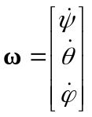
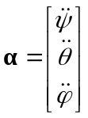
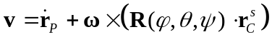

References:
R Dumas, E Nicol, L Cheze. Influence of the 3D inverse dynamic method on the joint forces and moments during gait. Journal of Biomechanical Engineering 2007;129(5):786-90.

See also:
Inverse_Dynamics_VE.m
Dynamics_VE.m
R2fixedZYX_array3.m
Derrive_array3.m
Vfilt_array3.m

Dynamics_VE.m

Purpose:
Recursive computations of joint force and moment by vector method

Synopsis:
[Joint,Segment] = Dynamics_VE(Joint,Segment,n)
Inputs: Joint, Segment (cf. data structure), n (i.e., n^{b} of frames)
Outputs: Joint, Segment (cf. data structure)

Description:
Computation of joint force and moment (F, M) at proximal endpoint of segment (r_{P}) expressed in ICS, as a function of:
- segment mass (m)
- position of centre of mass (r_{C}^{s}) expressed in SCS
- inertia tensor at centre of mass (I^{s}) expressed in SCS
- segment angular velocity and acceleration (ω, α) and linear acceleration of centre of mass (a) expressed in ICS
- position of proximal endpoint (r_{P}) expressed in ICS
- position of centre of pressure (r_{P1}) expressed in ICS
- ground reaction force and moment (F₁, M₁) expressed in ICS

Theoretical background:
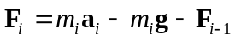

References:
MP Kadaba, HK Ramakrishnan, ME Wootten, J Gainey, G Gorton, GV Cochran. Repeatability of kinematic, kinetic, and electromyographic data in normal adult gait. Journal of Orthopaedic Research 1989;7(6):849-60.
RB Davis, S Ounpuu, D Tyburski, JR Gage. A gait analysis data collection and reduction technique. Human Movement Science 1991;10:575-87.
CL Vaughan, BL Davis, JC O'Connor. Dynamics of human gait (2^{d} edition). Human Kinetics, Champaign, Illinois, 1999.
R Dumas, E Nicol, L Cheze. Influence of the 3D inverse dynamic method on the joint forces and moments during gait. Journal of Biomechanical Engineering 2007;129(5):786-90.

See also:
Inverse_Dynamics_VE.m
Kinematics_VE.m

Inverse_Dynamics_HM.m

Purpose:
Computation of joint force and moment by homogenous matrix method

Synopsis:
[Joint,Segment] = Inverse_Dynamics_HM(Joint,Segment,f,n)
Inputs: Joint, Segment (cf. data structure), f (i.e., sampling frequency), n (i.e., n^{b} of frames)
Outputs: Joint, Segment (cf. data structure)

Description:
Data formatting and call of functions Kinematics_HM.m and Dynamics_HM.m

Theoretical background:
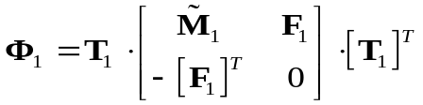
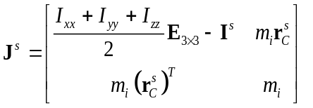

References:
N Doriot, L Cheze. A 3D Kinematic and dynamic study of the lower limb during the stance phase of gait using an homogeneous matrix approach. IEEE Transactions on Biomedical Engineering 2004;51(1):21-7.
G Legnani, F Casolo, P Righettini, B Zappa, A homogeneous matrix approach to 3D kinematics and dynamics - I. Theory. Mechanisms and Machine Theory 1996;31(5):573–87.

See also:
Main_Inverse_Dynamics.m
Kinematics_HM.m
Dynamics_HM.m
Extend_Segment_Fields.m
Vskew_array3.m
Kinematics_HM.m

Purpose:
Computation of segment kinematics by homogenous matrix method

Synopsis:
Segment = Kinematics_HM(Segment,f,n)
Inputs: Segment (cf. data structure), n (i.e., n^{b} of frames), f (i.e., sampling frequency)
Outputs: Segment (cf. data structure)

Description:
Computation of homogenous matrices of velocity and acceleration (W, H) as a function of homogenous matrix of transformation from ICS to SCS (T)

Theoretical background:
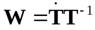
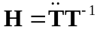

References:
N Doriot, L Cheze. A 3D Kinematic and dynamic study of the lower limb during the stance phase of gait using an homogeneous matrix approach. IEEE Transactions on Biomedical Engineering 2004;51(1):21-7.
G Legnani, F Casolo, P Righettini, B Zappa, A homogeneous matrix approach to 3D kinematics and dynamics - I. Theory. Mechanisms and Machine Theory 1996;31(5):573–87.

See also:
Inverse_Dynamics_HM.m
Dynamics_HM.m
Mprod_array3.m
Tinv_array3.m
Derive_array3.m
Mfilt_array3.m

Dynamics_HM.m

Purpose:
Recursive computations of joint force and moment by homogenous matrix method

Synopsis:
[Joint,Segment] = Dynamics_HM(Joint,Segment,n)
Inputs: Joint, Segment (cf. data structure), n (i.e., n^{b} of frames)
Outputs: Joint, Segment (cf. data structure)

Description:
Computation of joint force and moment (F, M) at proximal endpoint of segment (r_{P}) expressed in ICS, as a function of:
- homogenous matrix of pseudo-inertia (J)
- homogenous matrix of acceleration (H)
- homogenous matrix of ground reaction force and moment (Φ₁)

Theoretical background:
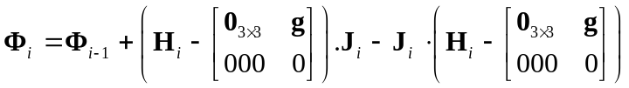

References:
N Doriot, L Cheze. A 3D Kinematic and dynamic study of the lower limb during the stance phase of gait using an homogeneous matrix approach. IEEE Transactions on Biomedical Engineering 2004;51(1):21-7.
G Legnani, F Casolo, P Righettini, B Zappa, A homogeneous matrix approach to 3D kinematics and dynamics - I. Theory. Mechanisms and Machine Theory 1996;31(5):573–87.
R Dumas, E Nicol, L Cheze. Influence of the 3D inverse dynamic method on the joint forces and moments during gait. Journal of Biomechanical Engineering 2007;129(5):786-90.

See also:
Inverse_Dynamics_HM.m
Kinematics_HM.m

Inverse_Dynamics_WQ.m

Purpose:
Computation of joint forces and moments by wrench and quaternion method

Synopsis:
[Joint,Segment] = Inverse_Dynamics_WQ(Joint,Segment,f,n)
Inputs: Joint, Segment, (cf. data structure), f (i.e., sampling frequency), n (i.e., n^{b} of frames)
Outputs: Joint, Segment (cf. data structure)

Description:
Data formatting and call of functions Kinematics_WQ.m and Dynamics_WQ.m

See also:
Main_Inverse_Dynamics.m
Kinematics_WQ.m
Dynamics_WQ.m
Extend_Segment_Fields.m

Kinematics_WQ.m

Purpose:
Computation of segment kinematics by quaternion method

Synopsis:
Segment = Kinematics_WQ(Segment,f,n)
Inputs: Segment (cf. data structure), f (i.e., sampling frequency), n (i.e., n^{b} of frames)
Outputs: Segment (cf. data structure)

Description:
Computation of segment angular velocity and acceleration (ω, α), linear velocity and acceleration of centre of mass (v, a) expressed in ICS, as a function of:
- position of proximal endpoint (r_{P}) expressed in ICS
- quaternion (q) of transformation from ICS to SCS
- position of centre of mass (r_{C}^{s}) expressed in SCS

Theoretical background:
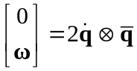
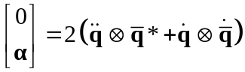
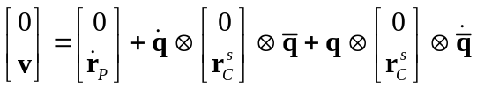
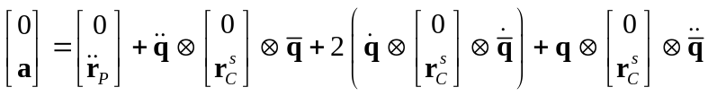

Reference:
R Dumas, R Aissaoui, J A de Guise. A 3D generic inverse dynanmic method using wrench notation and quaternion algebra. Computer Methods in Biomechanics and Biomedical Engineering 2004;7(3):159-166.

See also:
Inverse_Dynamics_WQ.m
Dynamics_WQ.m
R2q_array3.m
q2R_array3.m
qprod_array3.m
qinv_array3.m
Derrive_array3.m
Vfilt_array3.m

Dynamics_WQ.m

Purpose:
Recursive computation of joint force and moment by wrench method

Synopsis:
[Joint,Segment] = Dynamics_WQ(Joint,Segment,n)
Inputs: Joint, Segment (cf. data structure), n (i.e., n^{b} of frames)
Outputs: Joint, Segment (cf. data structure)

Description:
Computation of joint force and moment (F, M) at proximal endpoint of segment (r_{P}) expressed in ICS, as a function of:
- segment mass (m)
- position of centre of mass (r_{C}^{s}) expressed in SCS
- inertia tensor at centre of mass (I^{s}) expressed in SCS
- segment angular velocity and acceleration (ω, α) and linear acceleration of centre of mass (a) expressed in ICS
- position of proximal endpoint (r_{P}) expressed in ICS
- position of centre of pressure (r_{P1}) expressed in ICS
- ground reaction force and moment (F₁, M₁) expressed in ICS

Theoretical background:
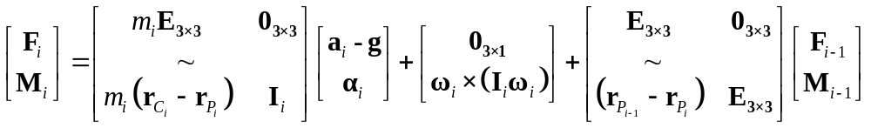
with 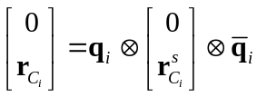 and 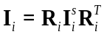

References:
R Dumas, R Aissaoui, J A de Guise. A 3D generic inverse dynanmic method using wrench notation and quaternion algebra. Computer Methods in Biomechanics and Biomedical Engineering 2004;7(3):159-166.
R Dumas, E Nicol, L Cheze. Influence of the 3D inverse dynamic method on the joint forces and moments during gait. Journal of Biomechanical Engineering 2007;129(5):786-90.

See also:
Inverse_Dynamics_WQ.m
Kinematics_WQ.m
Vskew_array3.m
Inverse_Dynamics_GC.m

Purpose:
Computation of joint force and moment by generalized coordinates method

Synopsis:
[Joint,Segment] = Inverse_Dynamics_GC(Joint,Segment,f,n)
Inputs: Joint, Segment (cf. data structure), f (i.e., sampling frequency), n (i.e., n^{b} of frames)
Outputs: Joint, Segment (cf. data structure)

Description:
Computation of joint force and moment (F, M) at proximal endpoint of segment (r_{P}) expressed in ICS, as a function of:
- generalized mass matrix (G)
- second time derivatives of generalized coordinates (Q)
- generalized ground reaction force and moment (through N₁^{P1} and N₁*)

Theoretical background:
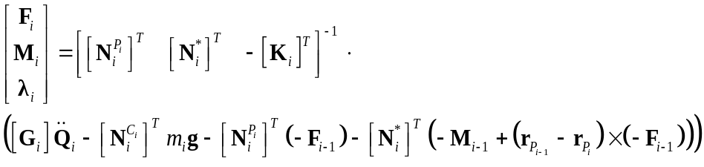
with 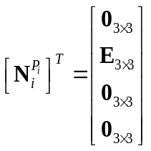
with 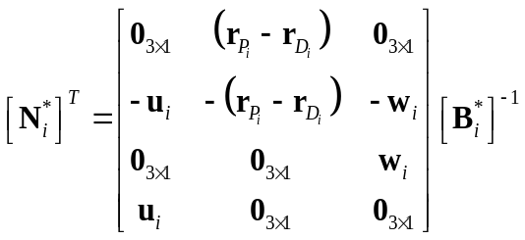
where 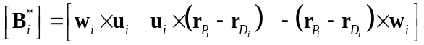
with 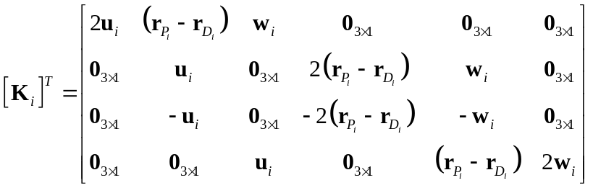
with 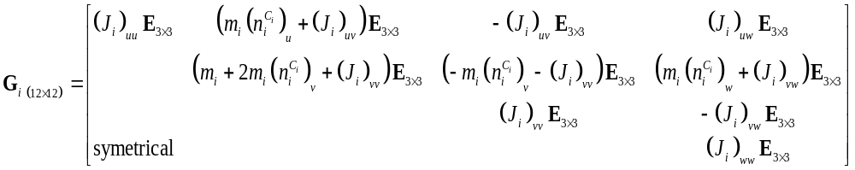
where 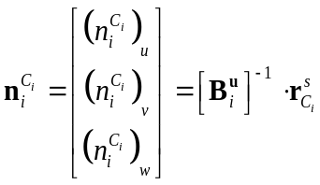
and where 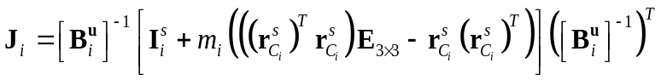
and with 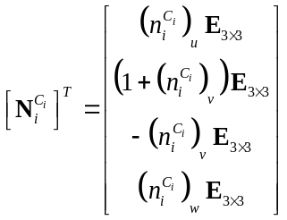

References:
R Dumas, L Cheze. 3D inverse dynamics in non-orthonormal segment coordinate system. Medical & Biological Engineering & Computing 2007;45(3):315-22
R Dumas, E Nicol, L Cheze. Influence of the 3D inverse dynamic method on the joint forces and moments during gait. Journal of Biomechanical Engineering 2007;129(5):786-90.

See also:
Main_Inverse_Dynamics.m
Derrive_array3.m

Extend_Segment_Fields.m

Purpose:
Computation of all possible segment parameters from generalized coordinates

Synopsis:
Segment = Extend_Segment_Fields(Segment)
Inputs: Segment (cf. data structure)
Outputs: Segment (cf. data structure)

Description:
Computation of homogenous matrix (T), position of proximal endpoints (r_{P}), quaternion (q), rotation matrix (R) and Euler angles (ϕ, θ , ψ) from generalized coordinates (Q) (cf. data structure)

See also:
R2q_array3.m
q2R_array3.m
Q2Tu_array3.m

Derive_array3.m

Purpose:
Computation of time derivative of matrix or vector

Synopsis:
dVdt = Derive_array3(V,dt)
dMdt = Derive_array3(M,dt)
Inputs: V (i.e., vector) or M (i.e., matrix), dt (i.e., sampling time that is to say dt = 1/f)
Outputs: dVdt or dMdt (i.e., vector or matrix)

Description:
Gradient approximation in the 3rd dimension of matrix or vector (i.e., all frames, cf. data structure)

See also:
Mfilt_array3.m
Vfilt_array3.m
Mfilt_array3.m

Purpose:
Filtering of matrix

Synopsis:
Mf = Mfilt_array3(M,f,fc)
Inputs: M (i.e., matrix), f (i.e., sampling frequency), fc (i.e., cut frequency)
Outputs: Mf (i.e., matrix)

Description:
Filtering, along with the 3rd dimension (i.e., all frames, cf. data structure), of the matrix elements by a 4th order Butterworth

See also:
Vfilt_array3.m
Vfilt_array3.m

Purpose:
Filtering of vector

Synopsis:
Vf = Vfilt_array3(M,f,fc)
Inputs: V (i.e., vector), f (i.e., sampling frequency), fc (i.e., cut frequency)
Outputs: Vf (i.e., matrix)

Description:
Filtering, along with the 3rd dimension (i.e., all frames, cf. data structure), of the vector components by a 4th order Butterworth with special attention when the vector is a column of an homogenous matrix

See also:
Mfilt_array3.m

R2fixedZYX_array3.m

Purpose:
Computation of Euler angles from rotation matrix (with ZYX fixed sequence for segment kinematics)

Synopsis:
Segment_Euler_Angles = R2fixedZYX_array3(R)
Inputs: R (i.e., rotation matrix)
Outputs: Segment_Euler_Angles (i.e., ϕ, θ , ψ, in line)

Description:
Computation, for all frames (i.e., in 3rd dimension, cf. data structure), of the Euler angles (ϕ, θ, ψ) from the rotation matrix (R) using a sequence of fixed axes ZYX

Theoretical background:
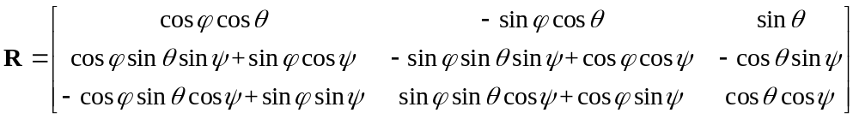
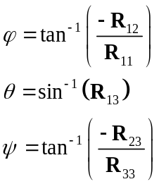

Reference:
L Cheze, R Dumas, JJ Comtet, C Rumelhart, M Fayet. A joint coordinate system proposal for the study of the trapeziometacarpal joint kinematics. Computer Methods in Biomechanics and Biomedical Engineering 2009;12(3):277-82.

See also:
Kinematics_VE.m
Extend_Segment_Fields.m
R2mobileZYX_array3.m
R2mobileZXY_array3.m

R2mobileZYX_array3.m

Purpose:
Computation of Euler angles from rotation matrix (with ZYX mobile sequence for joint kinematics)

Synopsis:
Joint_Euler_Angles = R2mobileZYX_array3(R)
Inputs: R (i.e., rotation matrix)
Outputs: Joint_Euler_Angles (i.e., θ₁, θ₂, θ₃, in line)

Description:
Computation, for all frames (i.e., in 3rd dimension, cf. data structure), of the 3 Euler angles (θ₁, θ₂, θ₃) from the rotation matrix (R) using a sequence of mobile axes ZYX

Theoretical background:
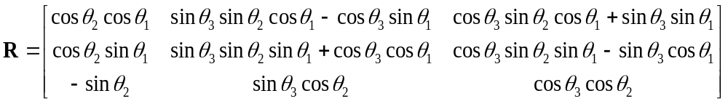
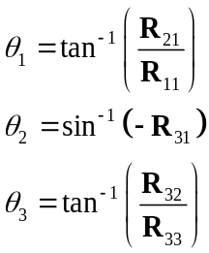

Reference:
L Cheze, R Dumas, JJ Comtet, C Rumelhart, M Fayet. A joint coordinate system proposal for the study of the trapeziometacarpal joint kinematics. Computer Methods in Biomechanics and Biomedical Engineering 2009;12(3):277-82.

See also:
Main_Joint_Kinematics.m
R2fixedZYX_array3.m
R2mobileZXY_array3.m

R2mobileZXY_array3.m

Purpose:
Computation of Euler angles from rotation matrix (with ZXY mobile sequence for joint kinematics)

Synopsis:
Joint_Euler_Angles = R2mobileZXY_array3(R)
Inputs: R (i.e., rotation matrix)
Outputs: Joint_Euler_Angles (i.e., θ₁, θ₂, θ₃, in line)

Description:
Computation, for all frames (i.e., in 3rd dimension, cf. data structure), of the 3 Euler angles (θ₁, θ₂, θ₃) from the rotation matrix (R) using a sequence of mobile axes ZXY

Theoretical background:
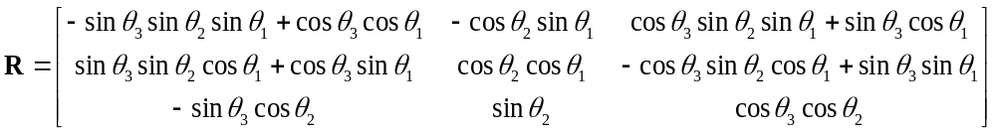
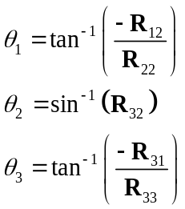

References:
G Wu, S Siegler, P Allard, C Kirtley, A Leardini, D Rosenbaum, M Whittle, DD D'Lima, L Cristofolini, H Witte, O Schmid, I Stokes. ISB recommendation on definitions of joint coordinate system of various joints for the reporting of human joint motion - Part I: ankle, hip, and spine. Journal of Biomechanics 2002; 35(4):543-8.
G Wu, FC van der Helm, HE Veeger, M Makhsous, P Van Roy, C Anglin, J Nagels, AR Karduna, K McQuade, X Wang, FW Werner, B Buchholz. ISB recommendation on definitions of joint coordinate systems of various joints for the reporting of human joint motion - Part II: shoulder, elbow, wrist and hand. Journal of Biomechanics 2005;38(5):981-92.

See also:
Main_Joint_Kinematics.m
R2fixedZYX_array3.m
R2mobileZYX_array3.m

Mprod_array3.m

Purpose:
Computation of matrix product

Synopsis:
C = Mprod_array3(A,B)
Inputs: A, B (i.e., matrices)
Outputs: C (i.e., matrix)

Description:
Computation, for all frames (i.e., in 3rd dimension, cf. data structure), of the product of two matrices of compatible sizes

See also:
Minv_array3.m

Minv_array3.m

Purpose:
Computation of matrix inverse

Synopsis:
B = Minv_array3(A)
Inputs: A (i.e., matrix)
Outputs: B (i.e., matrix)

Description:
Computation of the inverse of a square matrix made for all frames (i.e., in 3rd dimension, cf. data structure) in the case of rotation matrix (R)

See also:
Mprod_array3.m
Tinv_array3.m

Tinv_array3.m

Purpose:
Computation of homogenous matrix inverse

Synopsis:
B = Tinv_array3(A)
Inputs: A (i.e., homogenous matrix)
Outputs: B (i.e., homogenous matrix)

Description:
Computation, for all frames (i.e., in 3rd dimension, cf. data structure), of the inverse of an homogenous matrix (T)

Theoretical background:
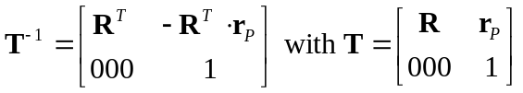

See also:
Mprod_array3.m
Minv_array3.m

R2q_array3.m

Purpose:
Computation of quaternion from rotation matrix

Synopsis:
q = R2q_array3(R)
Inputs: R (i.e., rotation matrix)
Outputs: q (i.e., quaternion)

Description:
Computation, for all frames (i.e., in 3rd dimension, cf. data structure), of the quaternion (q) from the rotation matrix (R)

References:
SW Shepperd. Quaternion from rotation matrix. Journal of Guidance and Control 1978;1(3):223-224.
J Lee, SY Shin. General construction of time-domain filters for orientation data. IEEE Transactions on Visualization and Computer Graphics 2002;8(2):119-128.

See also:
q2R_array3.m
qprod_array3.m
qinv_array3.m
qlog_array3.m

q2R_array3.m

Purpose:
Computation of rotation matrix from quaternion

Synopsis:
q = q2R_array3(R)
Inputs: q (i.e., quaternion)
Outputs: R (i.e., rotation matrix)

Description:
Computation, for all frames (i.e., in 3rd dimension, cf. data structure), of the rotation matrix (R) from the quaternion (q)

Theoretical background:
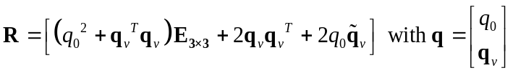

Reference:
R Dumas, R Aissaoui, J A de Guise. A 3D generic inverse dynanmic method using wrench notation and quaternion algebra. Computer Methods in Biomechanics and Biomedical Engineering 2004;7(3):159-166.

See also:
q2R_array3.m
Vskew_array3.m
qprod_array3.m

Purpose:
Computation of quaternion product

Synopsis:
r = Mprod_array3(p,q)
Inputs: p, q (i.e., quaternions)
Outputs: r (i.e., quaternion)

Description:
Computation, for all frames (i.e., in 3rd dimension, cf. data structure), of the product of two quaternions

Theoretical background:

Reference:
R Dumas, R Aissaoui, J A de Guise. A 3D generic inverse dynanmic method using wrench notation and quaternion algebra. Computer Methods in Biomechanics and Biomedical Engineering 2004;7(3):159-166.

See also:
qinv_array3.m

qinv_array3.m

Purpose:
Computation of quaternion inverse

Synopsis:
p = qinv_array3(q)
Inputs: q (i.e., quaternion)
Outputs: p (i.e., quaternion)

Description:
Computation, for all frames (i.e., in 3rd dimension, cf. data structure), of the inverse of a quaternion

Theoretical background:
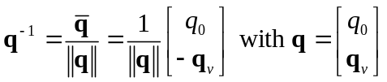

Reference:
R Dumas, R Aissaoui, J A de Guise. A 3D generic inverse dynanmic method using wrench notation and quaternion algebra. Computer Methods in Biomechanics and Biomedical Engineering 2004;7(3):159-166.

See also:
qinv_array3.m

qlog_array3.m

Purpose:
Computation of quaternion logarithm

Synopsis:
halfktheta = qlog_array3(q)
Inputs: q (i.e., quaternion)
Outputs: halfktheta (i.e., spatial attitude vector divided by 2)

Description:
Computation, for all frames (i.e., in 3rd dimension, cf. data structure), of the haft of spatial attitude vector from a quaternion

Theoretical background:
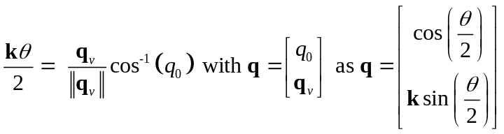

Reference:
J Lee, SY Shin. General construction of time-domain filters for orientation data. IEEE Transactions on Visualization and Computer Graphics 2002;8(2):119-128.

See also:
Vexp_array3.m

Vexp_array3.m

Purpose:
Computation of vector exponential

Synopsis:
q = Vexp_array3(halfktheta)
Inputs: halfktheta (i.e., spatial attitude vector divided by 2)
Outputs: q (i.e., quaternion)

Description:
Computation, for all frames (i.e., in 3rd dimension, cf. data structure), of the quaternion form the haft of spatial attitude vector

Theoretical background:
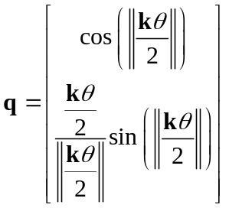

Reference:
J Lee, SY Shin. General construction of time-domain filters for orientation data. IEEE Transactions on Visualization and Computer Graphics 2002;8(2):119-128.

See also:
qlog_array3.m

Vnorm_array3.m

Purpose:
Computation of a unitary vector

Synopsis:
Vn = Vnorm_array3(V)
Inputs: V (i.e., vector)
Outputs: Vn (i.e., vector)

Description:
Computation, for all frames (i.e., in 3rd dimension, cf. data structure), of the unitary vector from a vector

See also:
Vskew_array3.m

Vnop_array3.m

Purpose:
Non-orthogonal projection on three basis vectors

Synopsis:
Vnop = Vnop_array3(V,e1,e2,e3)
Inputs: V (i.e., vector), e1, e2, e3 (i.e., basis vectors)
Outputs: Vnop (i.e., vector components)

Description:
Computation, for all frames (i.e., in 3rd dimension, cf. data structure), of the vector projections on three non-orthogonal basis vectors

Theoretical background:
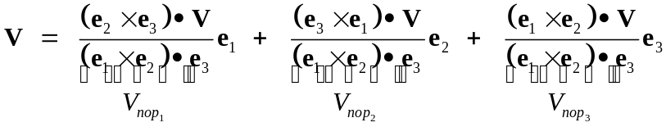

References:
L Cheze. Comparison of different calculations of three-dimensional joint kinematics from video-based system data. Journal of Biomechanics 2000; 33(12):1695-9.
G Desroches, L Cheze, R Dumas. Expression of joint moment in the joint coordinate system. Journal of Biomechanical Engineering 2010; 132(11) : 114503 (4 pages).

See also:
Main_Joint_Kinematics.m
Main_Inverse_Dynamics.m
Vskew_array3.m

Purpose:
Computation of skew matrix of vector

Synopsis:
M = Vskew_array3(V)
Inputs: V (i.e., vector)
Outputs: M (i.e., matrix)

Description:
Computation, for all frames (i.e., in 3rd dimension, cf. data structure), of the skew matrix from a vector

Theoretical background:
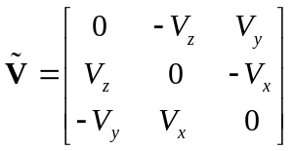

See also:
Inverse_Dynamics_HM.m
Dynamics_WQ.m
q2R_array3.m
qprod_array3.m

Q2Tu_array3.m

Purpose:
Computation of homogenous matrix from generalized coordinates

Synopsis:
T = Q2Tu_array3(Q)
Inputs: Q (i.e., generalized coordinates)
Outputs: T (i.e., homogenous matrix)

Description:
Computation, for all frames (i.e., in 3rd dimension, cf. data structure), of the homogenous matrix (T) from generalized coordinates (Q) with axis correspondence u = X and origin at endpoint P

Theoretical background:
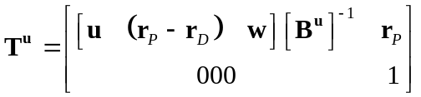
with 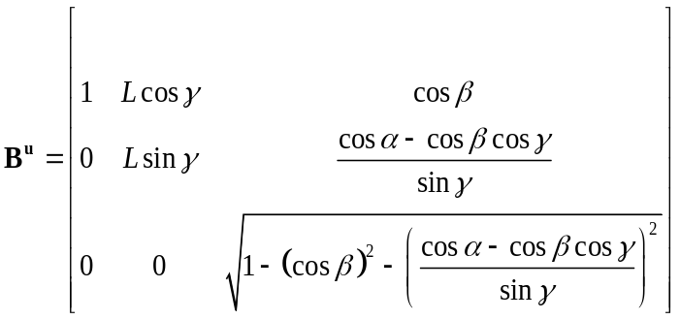
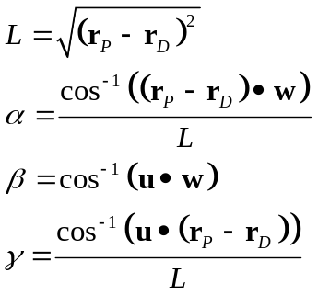

Reference:
R Dumas, L Cheze. 3D inverse dynamics in non-orthonormal segment coordinate system. Medical & Biological Engineering & Computing 2007;45(3):315-22

See also:
Main_Joint_Kinematics.m
Inverse_Dynamics_GC.m
Extend_Segment_Fields.m

Q2Tw_array3.m

Purpose:
Alternative computation of homogenous matrix from generalized coordinates

Synopsis:
T = Q2Tw_array3(Q)
Inputs: Q (i.e., generalized coordinates)
Outputs: T (i.e., homogenous matrix)

Description:
Computation, for all frames (i.e., in 3rd dimension, cf. data structure), of the homogenous matrix (T) from generalized coordinates (Q) with axis correspondence w = Z and origin at endpoint D

Theoretical background:
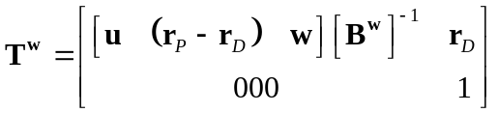
with 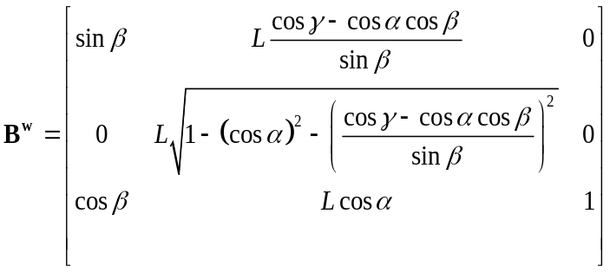

See also:
Main_Joint_Kinematics.m

Data structure – segment

n
1
1^{rst} derivatives
2^{d} derivatives
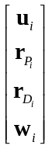

Q_{i}

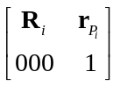
H_{i}
T_{i}
i = 4
i = 0
Segment
W_{i}

Kinematics
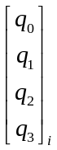
m_{i}
Inertial Parameters
q_{i}
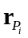
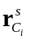

I^{s}
a_{i}
α_{i}
v_{i}
Markers
ω_{i}
in SCS
(ϕ_{i} θ _{i} ψ _{i}) ⁽¹⁾
n
1

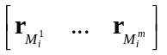
R_{i}

1 m
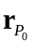
center of pressure

i = 0: forceplate (or wheel)
i = 1: foot (or hand)
i = 2: leg (or forearm)
i = 3: thigh (or arm)
i = 4: pelvis (or thorax)
n: number of frames
m: number of markers

⁽¹⁾ Sequence of fixed axes ZYX
Data structure – joint
n
1

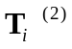
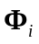
(α_{i} β_{i} γ_{i}) ⁽³⁾
d_{i}^{j}
i = 3
i = 0
n
1
Joint
Kinematics
Dynamics
F_{i}
M_{i}
F_{i}^{j}

M_{i}^{j}
in JCS

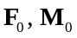
actions of foot on forceplate (or of hand on wheel)

i = 0: centre of pressure
i = 1: ankle (or wrist)
i = 2: knee (or elbow)
i = 3: hip (or shoulder)
n: number of frames

Additional notations

ICS: inertial coordinate system
SCS: segment coordinate system
JCS: joint coordinate system
^{s}: vector expression in SCS
^{j}: vector expression in JCS (i.e., non-orthogonal projection)
^{T}: transpose
⁻¹: inverse
‾: quaternion conjugate
∼: skew matrix of vector
·: 1^{rst} derivative
¨: 2nd derivative
•: dot product
×: cross product
|| ||: vector norm
E_{3×3}: identity matrix
0_{3×3}, 0_{3×1}: zero matrices

⁽²⁾ 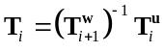
⁽³⁾ Sequence of mobile axes ZXY (or ZYX)
Dealing with generalized coordinates

The position vectors r_{Pi}, r_{Di} and the direction vectors u_{i}, w_{i}, all expressed in the ICS, are computed from the position 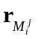of classical ⁽⁾ skin-based markers.

Some rules shall be followed in order to build a non-orthogonal basis 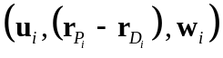consistent with both SCS axis (through B_{i}^{u}) and JCS axes (through B_{i}^{u} and B_{i}^{w}):
- endpoints P_{i} and D_{i} are proximal and distal joint centres (i.e., estimated by regression or functional methods)
- u_{i} is normal to the frontal plane (r_{Pi} - r_{Di} and u_{i} lie in the sagittal plane)
- w_{i} is the distal joint flexion-extension axis (estimated anatomically or by functional methods)

 |  | Lower limb | Upper limb
i = 0: forceplate  or wheel | 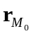 | N/A | N/A
i = 0: forceplate  or wheel | 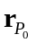 | centre of pressure | centre of pressure
i = 0: forceplate  or wheel | 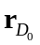 | centre of forceplate | N/A
i = 0: forceplate  or wheel | u₀ | X axis of forceplate (direction of progression) | X axis of wheelchair (direction of proplusion)
i = 0: forceplate  or wheel | w₀ | Z axis of forceplate | Z axis of wheelchair (axis of wheels)
i = 1: foot or hand | 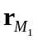 | calcaneus, 1^{rst} and 5th metatarsal heads | 2^{d} and 5th metacarpal heads
i = 1: foot or hand | 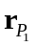 | 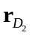
i = 1: foot or hand | 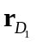 | metarsal-phalangeal joint centre (i.e., middle of metatarsal heads) | mecarpal-phalangeal joint centre (i.e., middle of metacarpal heads)
i = 1: foot or hand | u₁ | calcaneous to middle of metatarsal heads | normal to the plane formed by wrist joint centre (P₁) and metacarpal heads
i = 1: foot or hand | w₁ | 1^{rst} to 5th metatarsal head | 5th to 2^{d} metacarpal head
i = 2: leg or forearm | 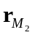 | fibula head, medial and lateral malleoli | ulnar and radial styloids
i = 2: leg or forearm | 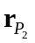 | 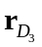
i = 2: leg or forearm |  | ankle joint centre (i.e., middle of malleoli) | wrist joint centre (i.e., middle of styloids)
i = 2: leg or forearm | u₂ | normal to the plane formed by fibula head, knee and ankle joint centres (P₂ and D₂) | normal to the plane formed by elbow joint centre (P₂) and styloids
i = 2: leg or forearm | w₂ | medial to lateral malleolus | ulnar to radial styloids
i = 3: thigh or arm | 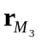 | great trochanter, medial and lateral femoral epicondyles | great tubercule, medial and lateral humeral epicondyles
i = 3: thigh or arm | 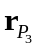 | hip joint centre (by regressions or functional methods) | shoulder joint centre (by regressions or functional methods)
i = 3: thigh or arm |  | knee joint centre (i.e., middle of epicondyles) | elbow joint centre (i.e., middle of epicondyles)
i = 3: thigh or arm | u₃ | normal to the plane formed by epicondyles and hip joint centre (P₃) | normal to the plane formed by epicondyles and shoulder joint centre (P₃)
i = 3: thigh or arm | w₃ | medial to lateral epicondyle | medial to lateral epicondyle
i = 4: pelvis or thorax | 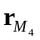 | iliac spines | C7, Incisura Jugularis, Processus Xiphoideus, T8
i = 4: pelvis or thorax | 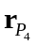 | lumbar joint center (by regressions, or middle of posterior superior iliac spines) | cervical joint centre (by regressions, or middle of C7 and Incisura Jugularis)
i = 4: pelvis or thorax | 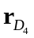 | middle of hip joint centres | thoracic joint centre (by regressions, or middle of T8 and Processus Xiphoideus)
i = 4: pelvis or thorax | u₄ | from middle of posterior iliac spines to middle of anterior iliac spines | normal to both 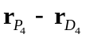 and w₄
i = 4: pelvis or thorax | w₄ | left to right hip joint centre | normal to the plane formed by C7, Incisura Jugularis and middle of T8 and Processus Xiphoideus

ICS
r_{P4}
u₁
w₁
γ₁
α₁
β₁
L₁
γ₂
β₂
w₂
α₂
u₂
β₃
γ₃
w₃
α₃
L₃
r_{P3}
r_{D3}
r_{P2}
r_{D2}
r_{P1}
r_{D1}
L₂
r_{P0}
β₄
u₄
w₄
γ₄
α₄
L₄
r_{D4}
u₀
w₀
u₃
u₃
u₄
w₄
r_{P4}
w₃
r_{D3}
r_{P3}
u₂
w₂
u₁
w₁
r_{D1}
r_{P1}
r_{D2}
r_{P2}
r_{D4}
r_{P0}
u₀
w₀

A Cappozzo, F Catani , U Della Croce, A Leardini. Position and orientation in space of bones during movement: anatomical frame definition and determination. Clinical Biomechanics 1995;10(4):171-178. G Wu, S Siegler, P Allard, C Kirtley, A Leardini, D Rosenbaum, M Whittle, DD D'Lima, L Cristofolini, H Witte, O Schmid, I Stokes. ISB recommendation on definitions of joint coordinate system of various joints for the reporting of human joint motion - Part I: ankle, hip, and spine. Journal of Biomechanics 2002; 35(4):543-8. G Wu, FC van der Helm, HE Veeger, M Makhsous, P Van Roy, C Anglin, J Nagels, AR Karduna, K McQuade, X Wang, FW Werner, B Buchholz. ISB recommendation on definitions of joint coordinate systems of various joints for the reporting of human joint motion - Part II: shoulder, elbow, wrist and hand. Journal of Biomechanics 2005;38(5):981-92.

