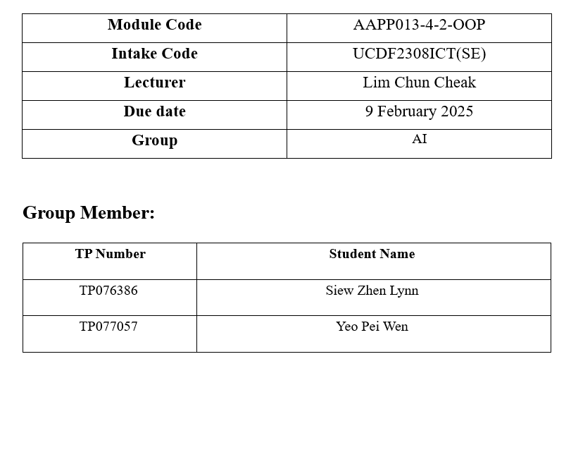

Table of Contents
Assumptions 4
Flowchart 6
Sample Input/Output 18
3.1 Login Page 18
3.2 Registration 26
3.3 Manager Dashboard 30
3.3.1 Pending Registration 30
3.3.2 User Management 35
3.3.3 Rate Management 47
3.3.4 Hostel Information 54
3.3.5 Rules & Regulations 57
3.3.6 Profile 60
3.4 Staff Dashboard 64
3.4.1 Update Account 64
3.4.2 Make Payment 65
3.4.3 Generate Receipt 68
3.4.4 Hostel Information 71
3.4.5 Rules & Regulations 73
3.4.6 Logout 74
3.5 Residents Dashboard 75
3.5.2 View Payment Records 76
3.5.5 Logout 80
Program source code 82
Object-oriented Concepts 82
Java Features 88
Control Structures 92
Additional features source code 93
Object-oriented Concepts 93
Control Structures 104
Java Features 104
References 107
Task Division 108

Assumptions
- The User ID must start with "AD" for admins, "ST" for staff, or "TP" for students, followed by exactly six digits.
- The user password must be at least eight characters long, contain at least one uppercase letter, include at least three digits, and must not have any spaces.
- The email address must be in a valid format, containing "@" and following a proper domain structure.
- Users are allowed a maximum of three login attempts and three email validation attempts during registration.
- The system has a default manager account with the User ID "AD123456" and the password "Admin123"
- There can only be one manager account in the system, and a manager cannot register a new account since the default manager account already exists.
- Only manager have the authority to add, edit, or delete user accounts
- Only manager have the authority approve or reject user registrations.
- The default manager account cannot be deleted.
- Manager can modify their account information but is not allowed to change their User ID.
- During registration, a security keyword is required for password recovery.
- Users can check their registration status by clicking “Check Status”. There are four registration status states: PENDING (processing), APPROVED (accepted), REJECTED (denied), and NOT_FOUND (no record exists).
- If a user account has not been approved or rejected, it will be stored in “pending_registration.txt” while rejected accounts will be saved in “reject_registration.txt”.
- Rate management includes three types of rates: Rental, Utility, and Penalty, and each rate must have a unique ID.
- Only manager have the authority to modify Hostel Information and Hostel Rules & Regulations.
- Only manager has the authority to add, edit, and delete rates in rate management.

- The hostel offers three types of rooms: Single Room, Shared Room(2) for two persons, and Shared Room(4) for four persons.
- The default Rental Rates are:
- R001: Single Room (RM1000)
- R002: Shared Room(2) (RM700)
- R003: Shared Room(4) (RM500)
- The default Utility Rates are:
- U001: Water (RM30)
- U002: Electricity (RM70)
- The default Penalty Rates are:
- P001: Late Payment (RM50)
- P002: Weekly Increment (RM5)
- Rate information is stored in separate files: "rent_rate.txt" for Rental rates, "utility_rate.txt" for Utility rates, and "penalty_rates.txt" for Penalty rates.

Flowchart
Login and Register
Login | 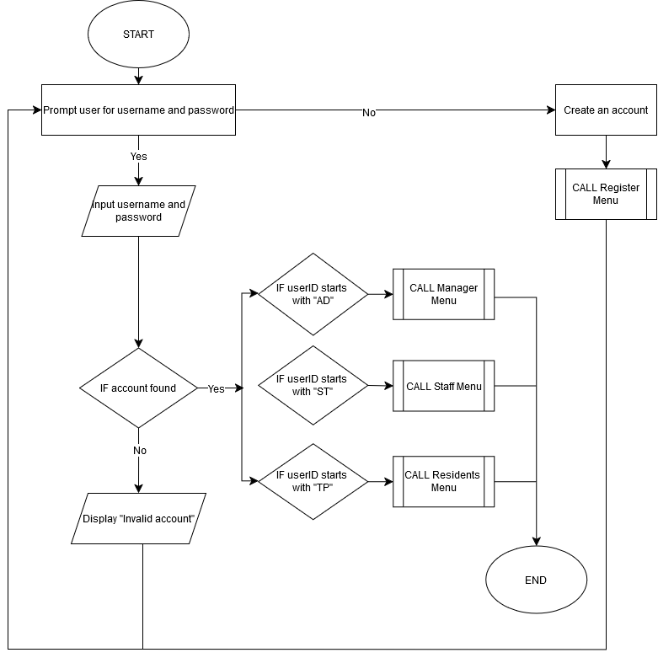
Register | 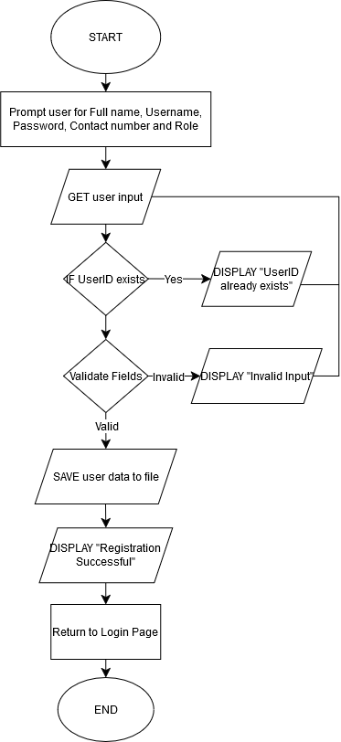

Manager Menu
Main Menu | 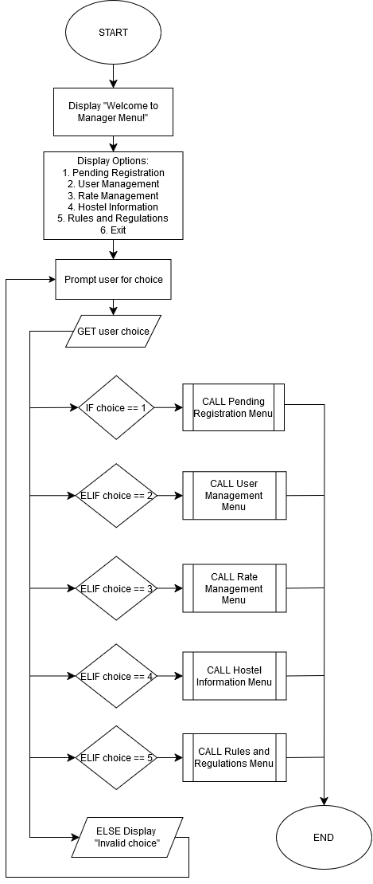
Pending Registration Menu | 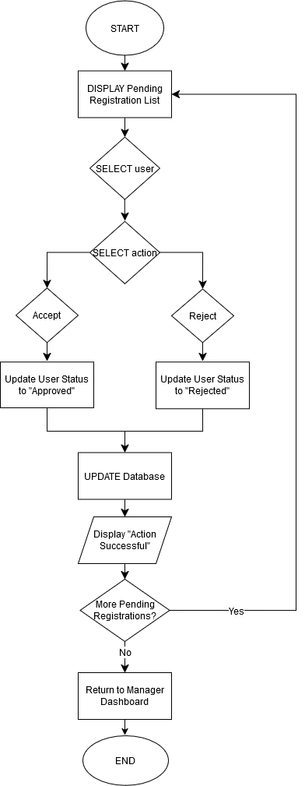
User Management Menu | 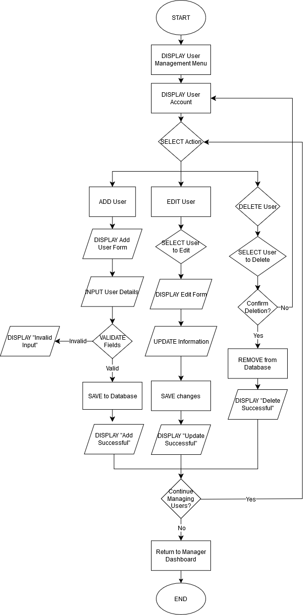
Rate Management Menu | 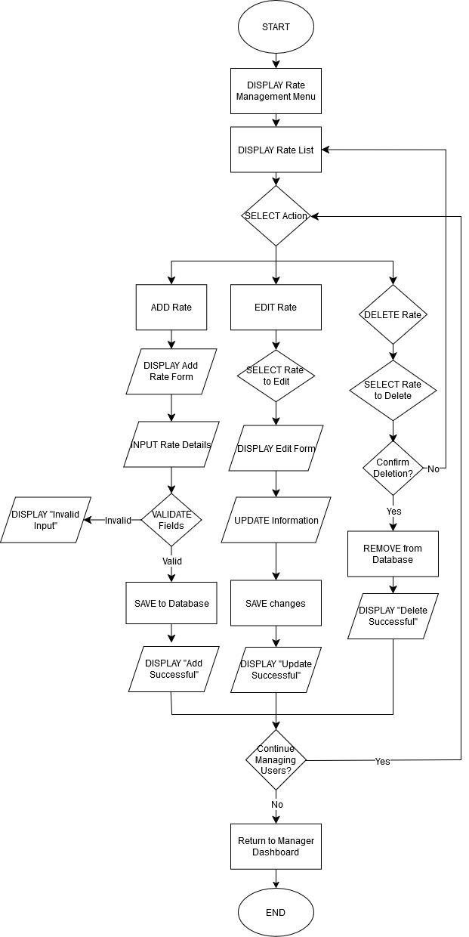
Staff Menu
Main Menu | 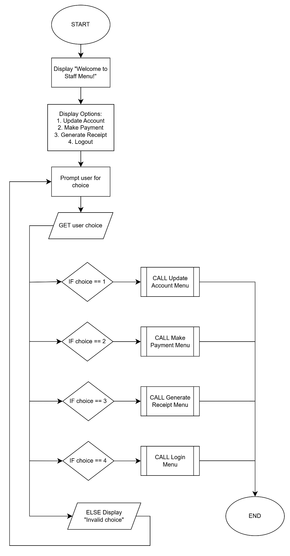
Update Account Menu | 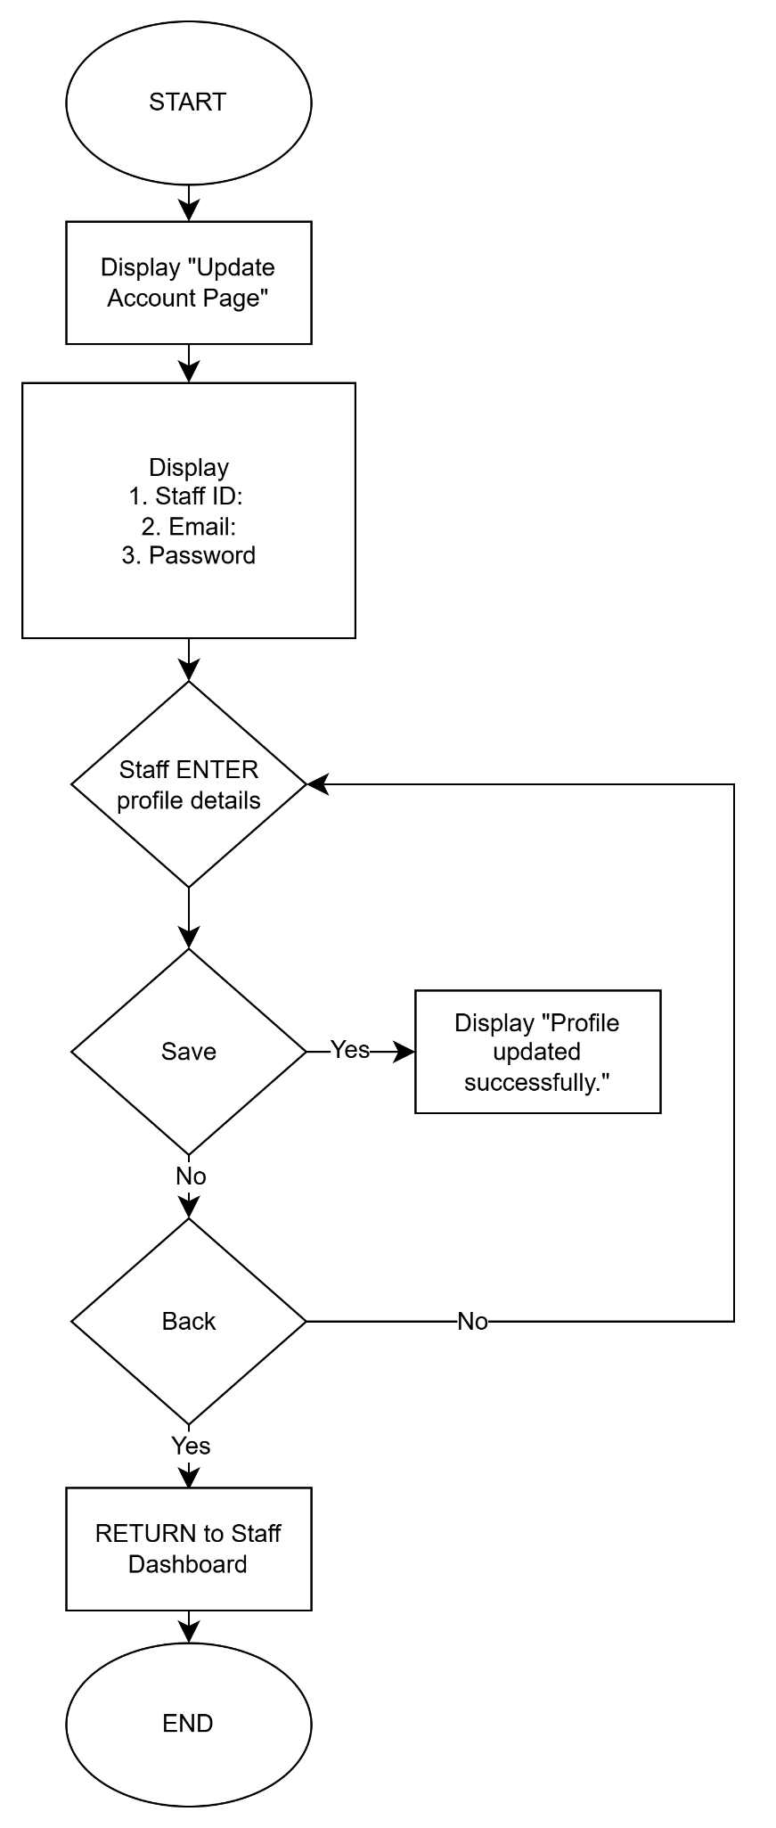
Generate Payment Menu | 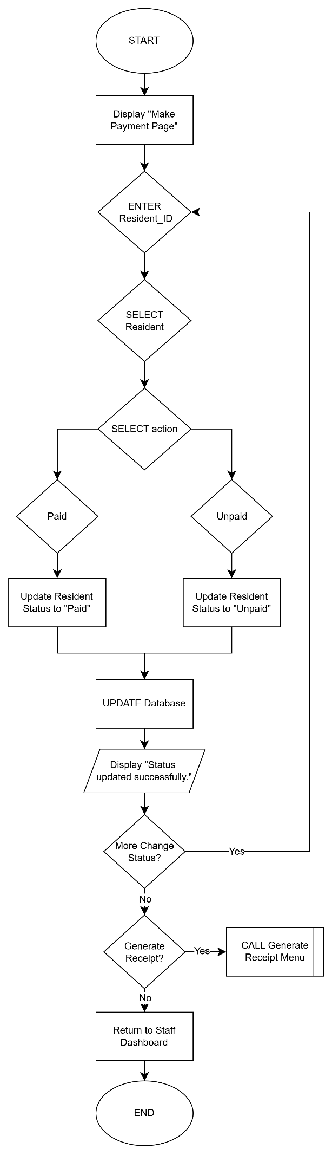
Generate Receipt Menu | 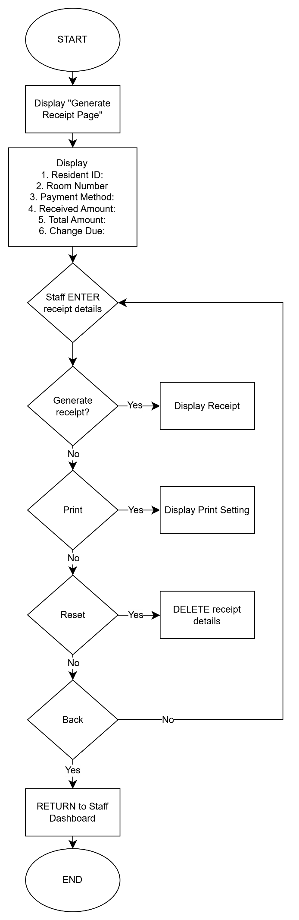
Resident Menu
Main Menu | 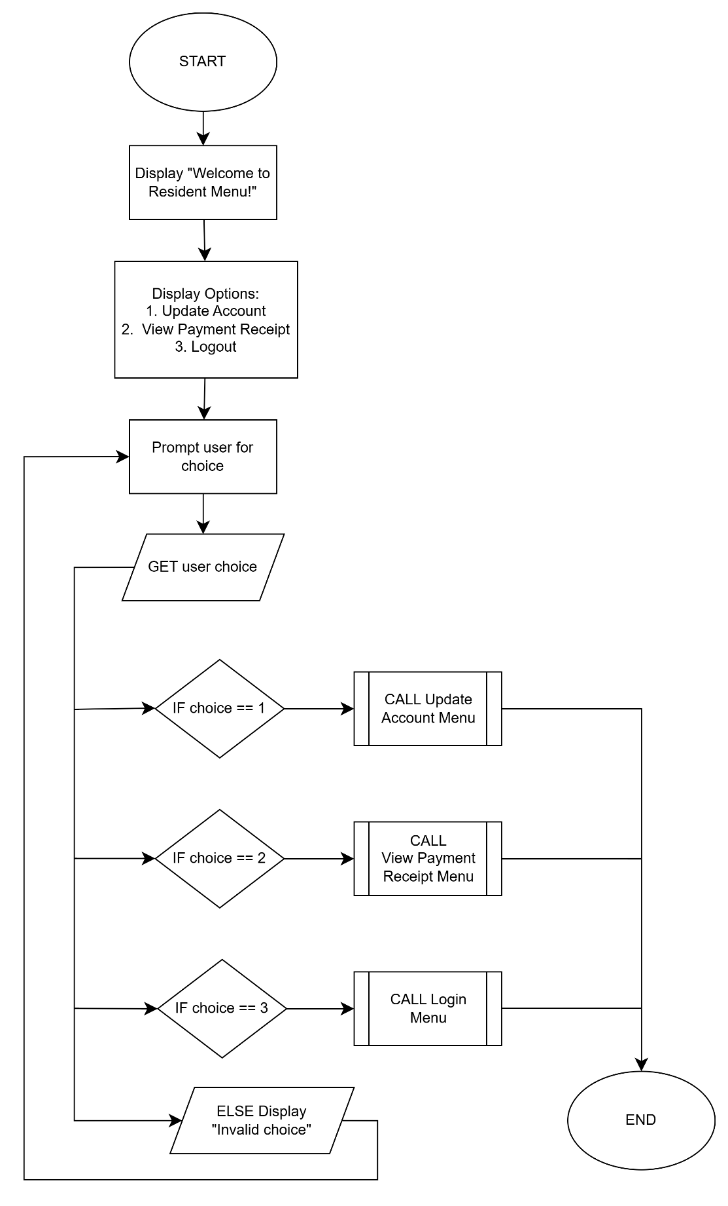
Update Account Menu | 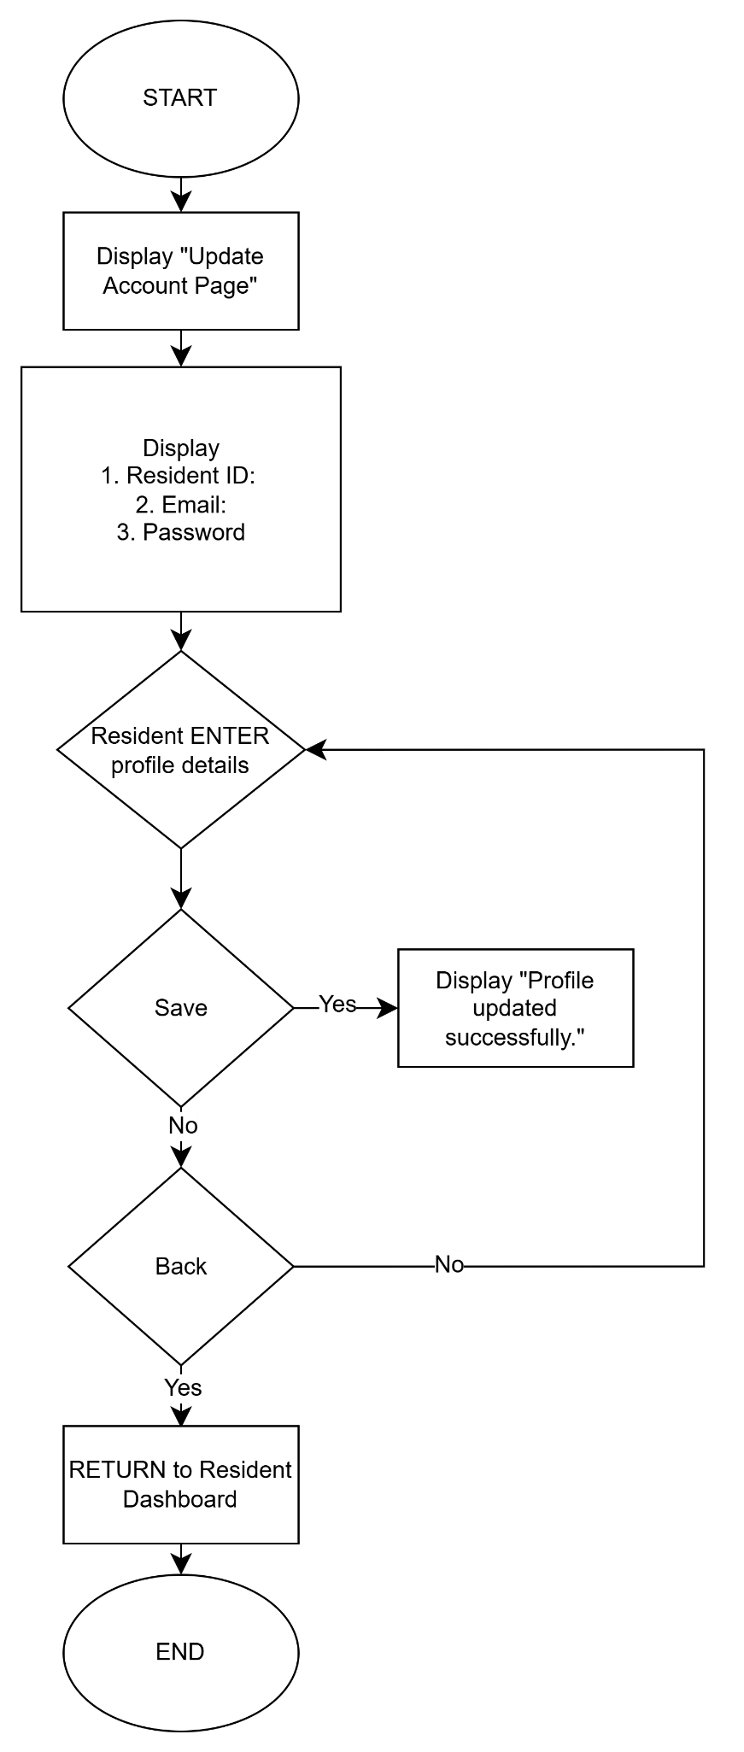
View Payment Receipt Menu | 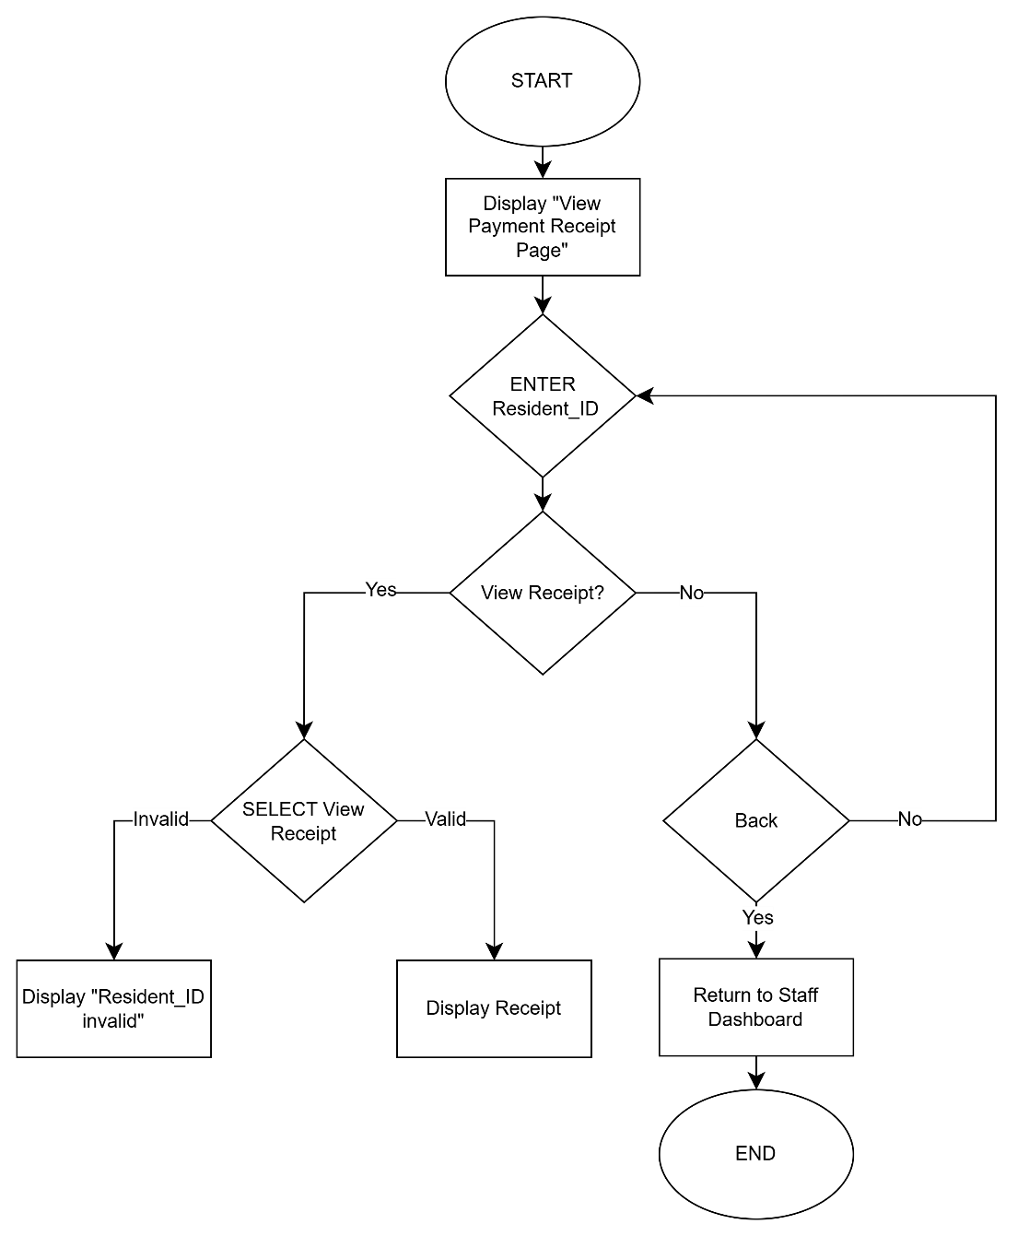

Sample Input/Output

3.1 Login Page
Input | Output
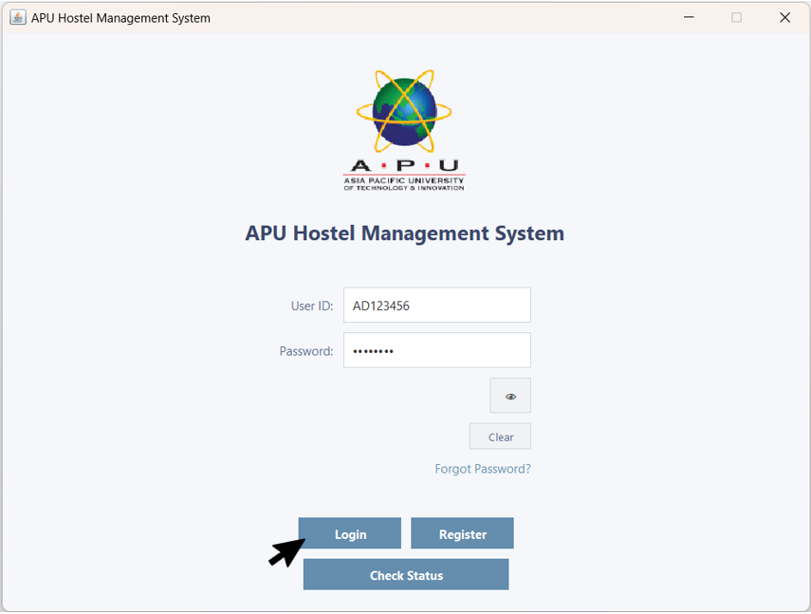  Figure 3.1.1 – Login Page | 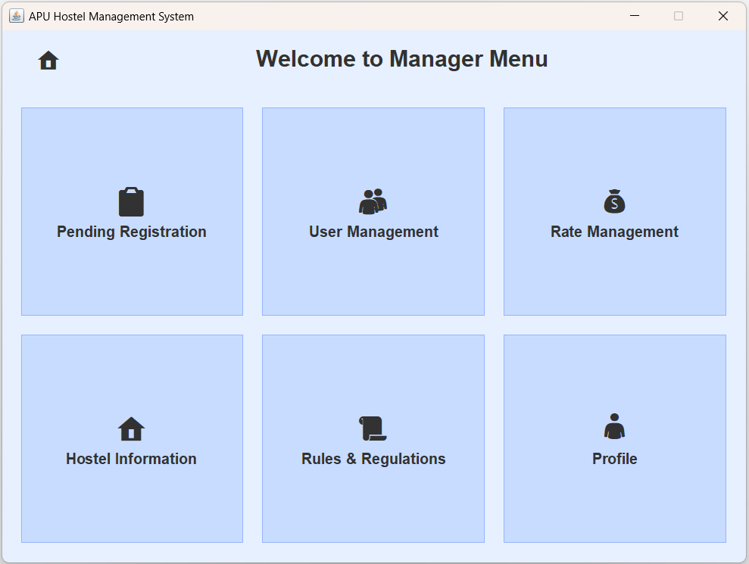  Figure 3.1.2 – Manager Menu
If a user already has an account, they can enter their User ID and Password in the provided fields and click the 'Login' button to access the system. | After logging in, the user will be directed to the Manager Menu.
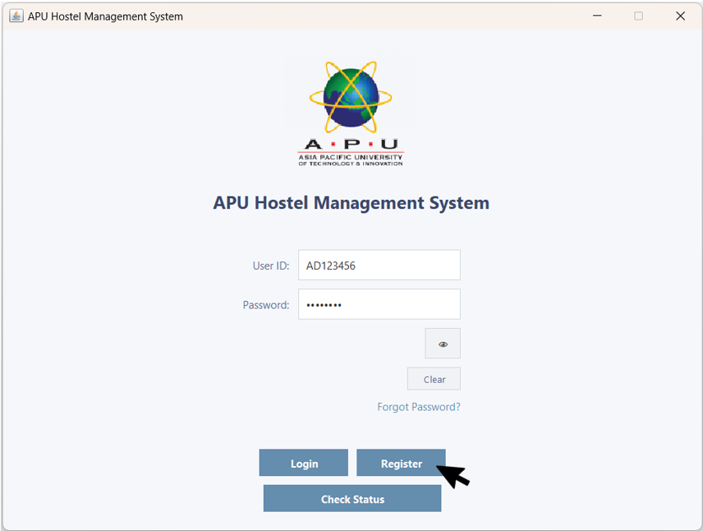  Figure 3.1.3 – Login Page | 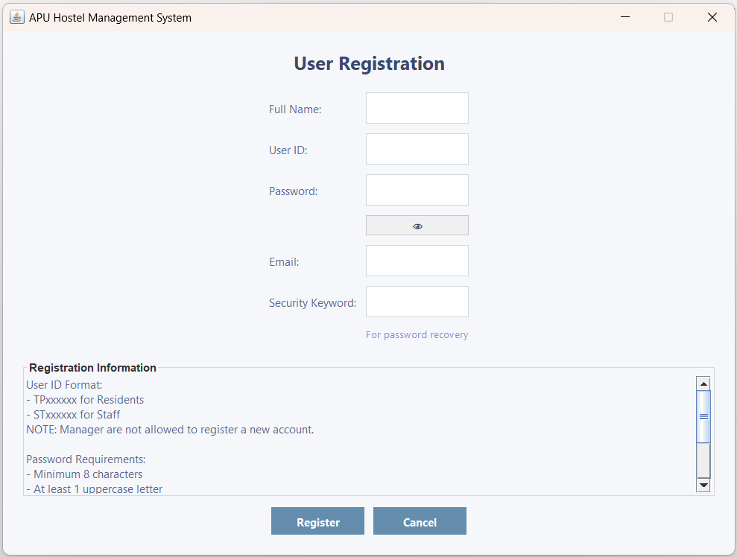  Figure 3.1.4 – Registration Page
If a user doesn't have an account, they can click the 'Register' button to create one.  Login Attempts | The user will be directed to the Registration Page.
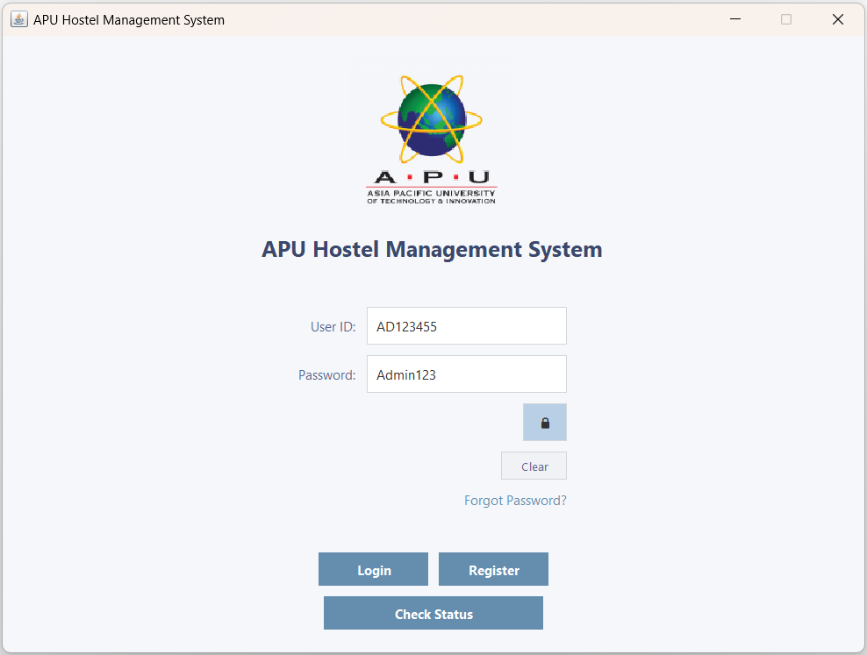  Figure 3.1.5 – Login Page with Filled Fields | 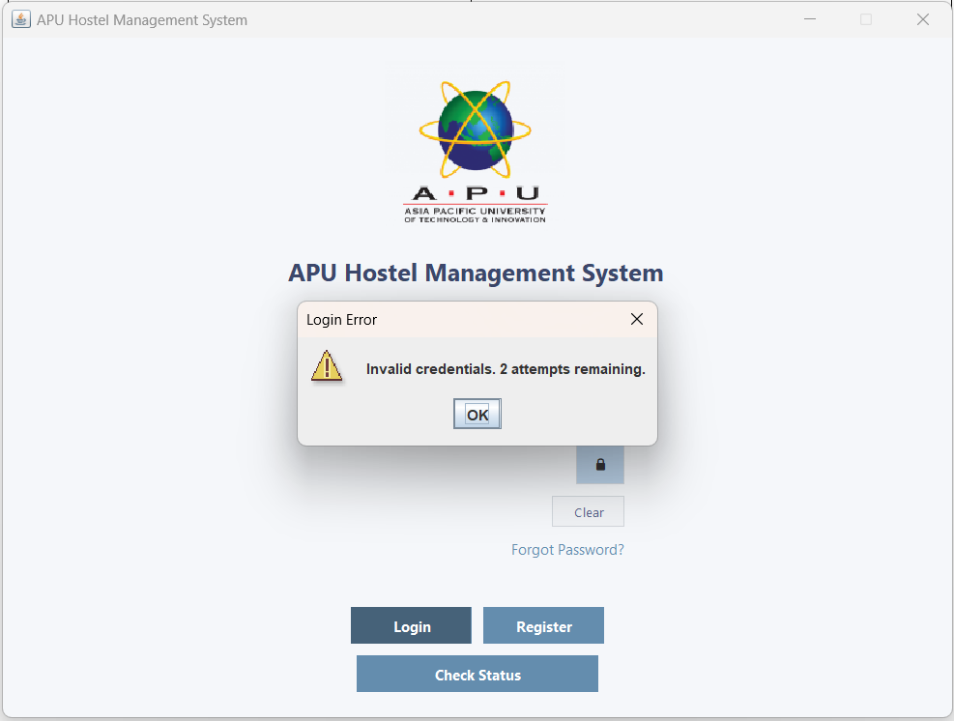  Figure 3.1.6 – Login Error with 2 attempts remaining
If the user enters the wrong User ID or Password for the first time. | A 'Login Error' pop-up window appears, indicating invalid credentials and 2 attempts remaining. Users have a maximum of 3 login attempts before being locked out.
  Figure 3.1.7 – Login Page with Filled Fields | 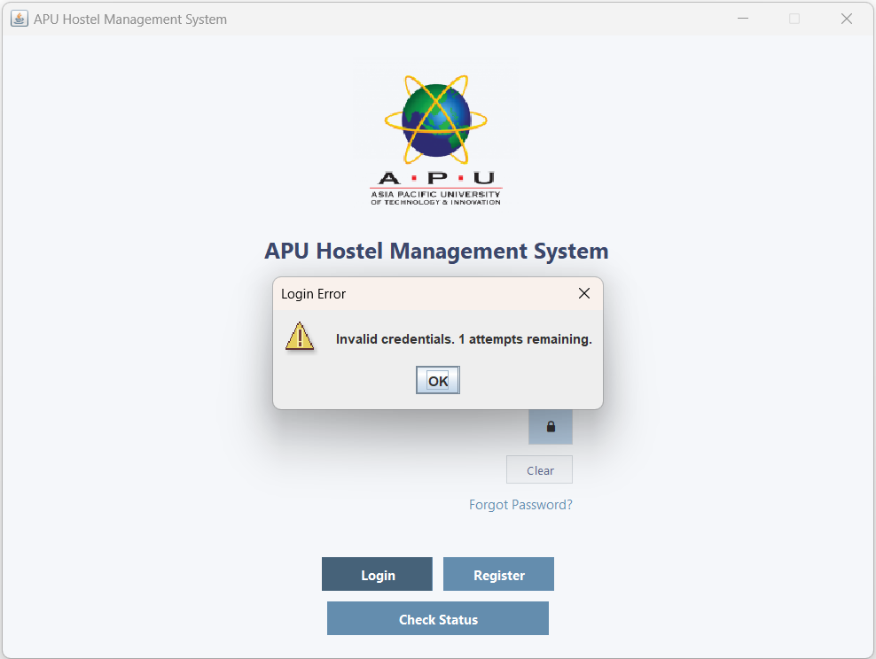  Figure 3.1.8 – Login Error with 1 attempt remaining
If the user enters the wrong User ID or Password for the second time. | A 'Login Error' pop-up window appears, indicating invalid credentials and 1 attempt remaining.
  Figure 3.1.9 – Login Page with Filled Fields | 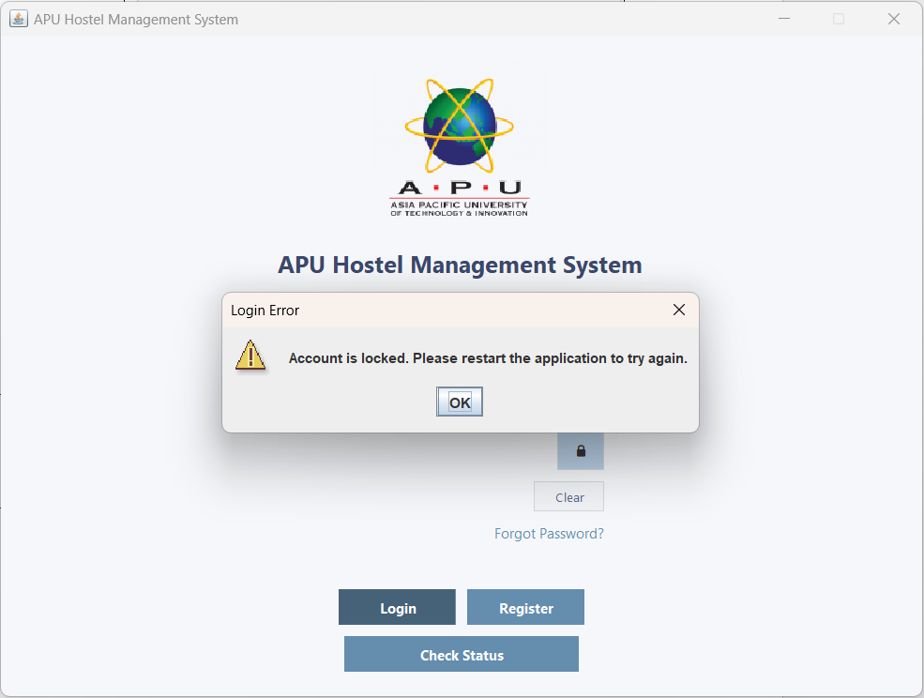  Figure 3.1.10 – 'Login Error' with Account locked
If the user enters the wrong User ID or Password for the third time. | A 'Login Error' pop-up window appears, indicating that the account is locked. The user must restart the application to try again.
Hide and Show Password
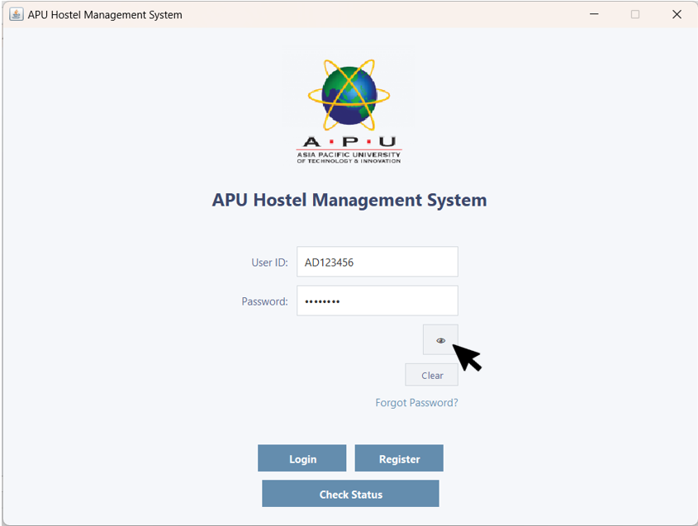  Figure 3.1.11 – Login Page with the Eye Icon Button | 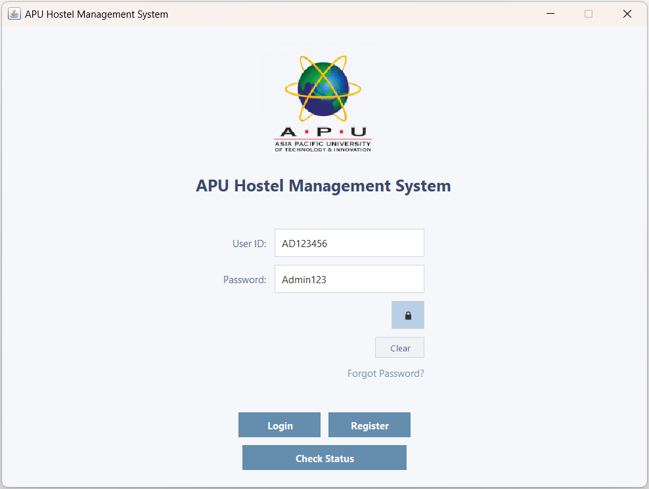  Figure 3.1.12 – Login Page with the Visible Password
User can click the eye icon button to view the hidden password. | The password will then be visible.
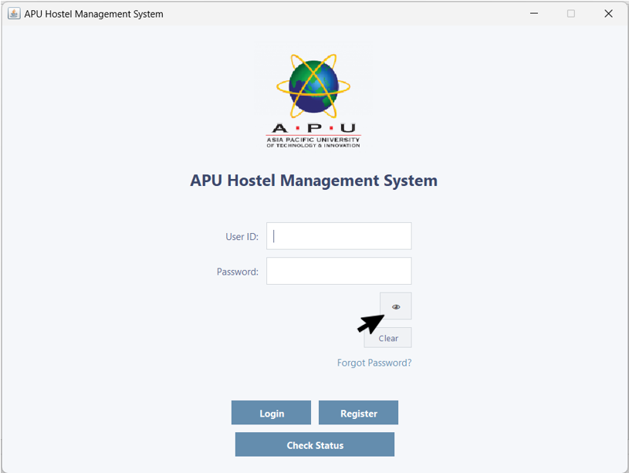  Figure 3.1.13 – Login Page with the Eye Icon Button | 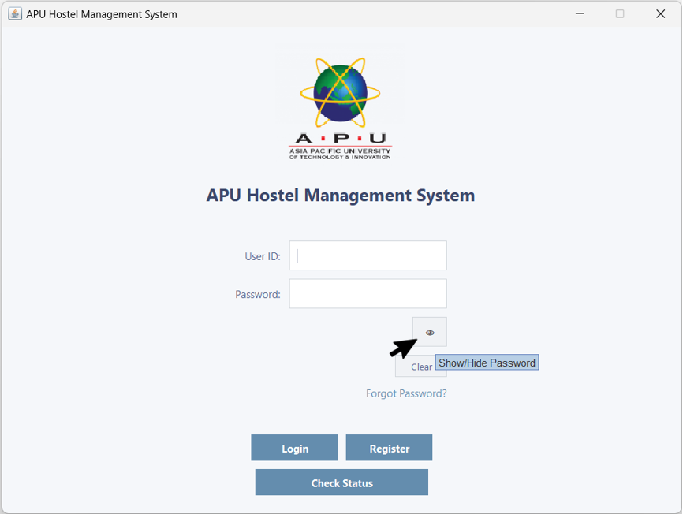  Figure 3.1.14 – Login Page with "Show/Hide Password" Tooltip
When the user hovers over the eye or lock icon button, a tooltip will appear. | The tooltip displays 'Show/Hide Password' and allows the user to toggle the password visibility.
Clear Fields to Reset
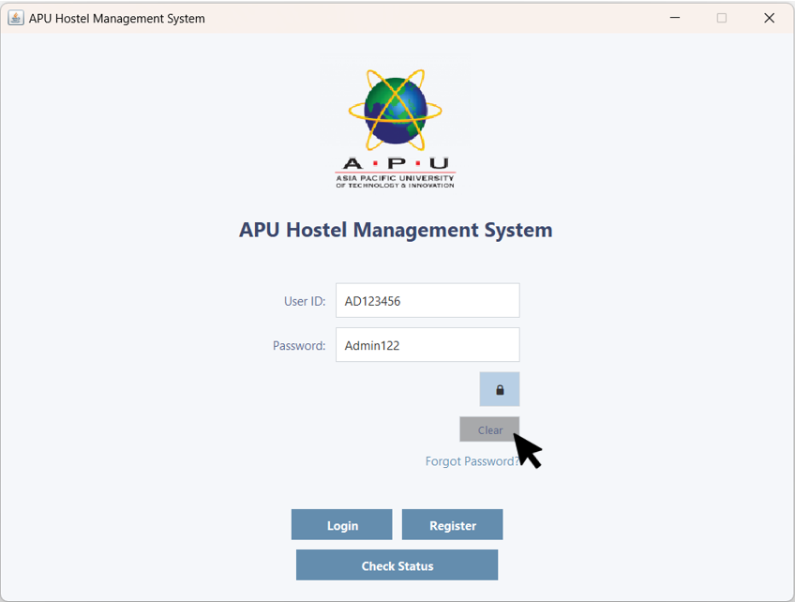  Figure 3.1.15 – Login Page with the Clear Button | 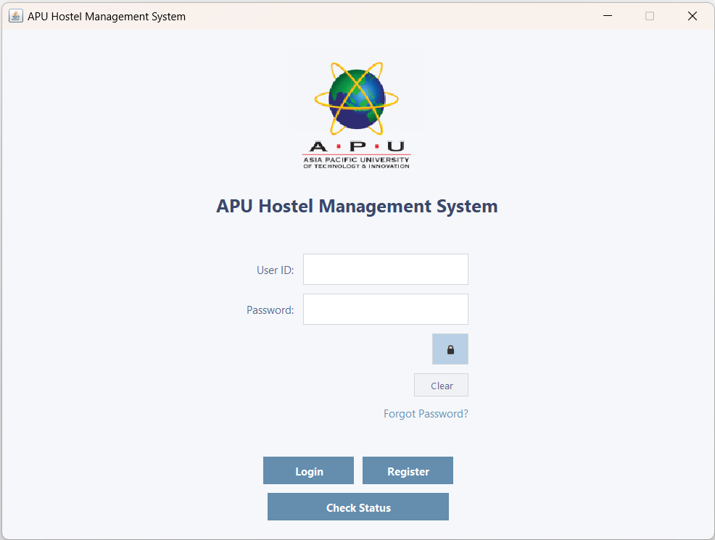  Figure 3.1.16 – Login Page with Empty Fields
User can click the 'Clear' button to reset the fields. | The User ID and Password fields will be empty.
Forgot Password & Reset Password
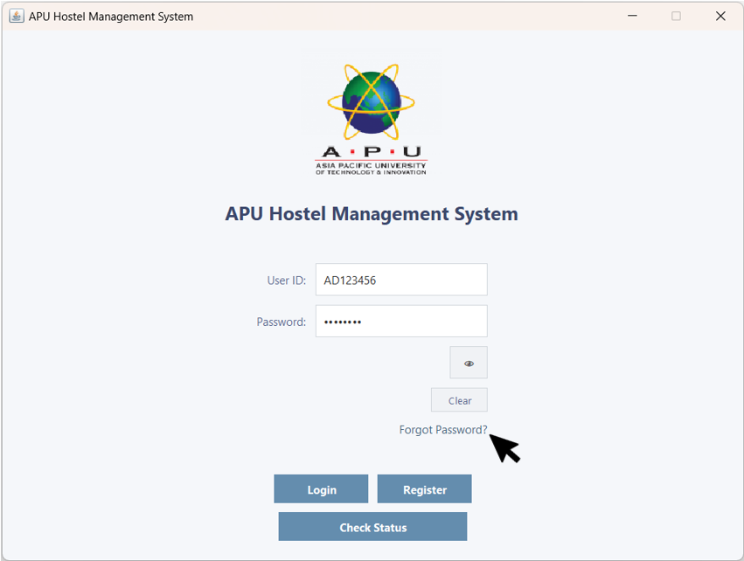  Figure 3.1.17 - Login Page with the Forgot Password Button | 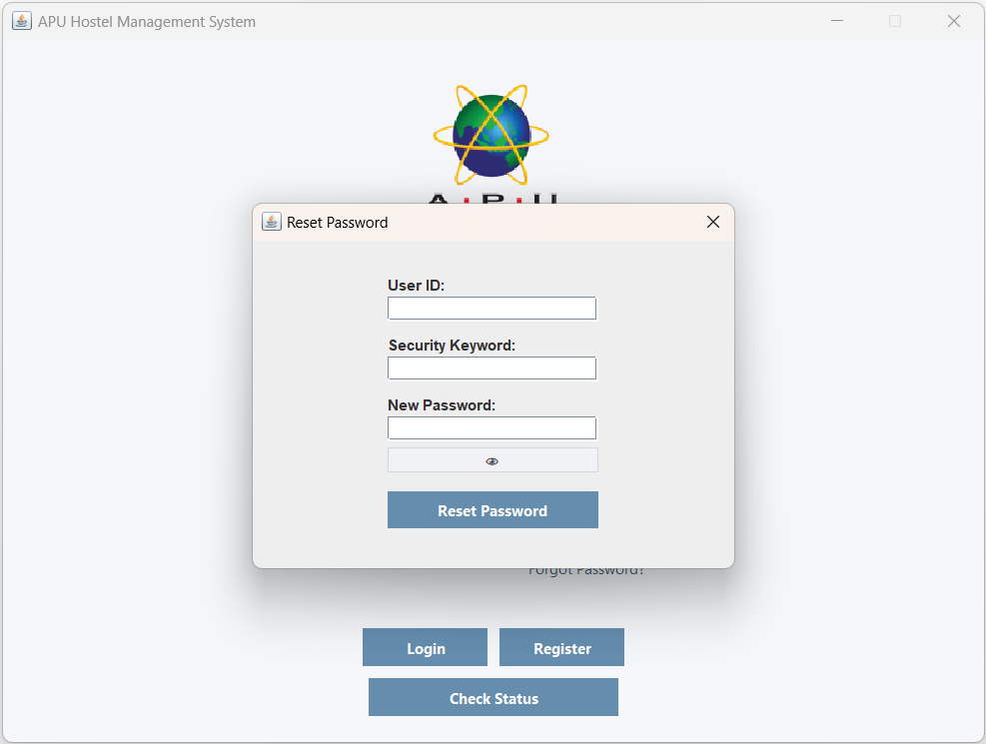  Figure 3.1.18 - 'Reset Password' Pop-up Window
If a user forgets their password, they can click 'Forgot Password?' to reset it. | A 'Reset Password' pop-up window appears. The user must enter the correct User ID and security keyword before they can reset a new password.
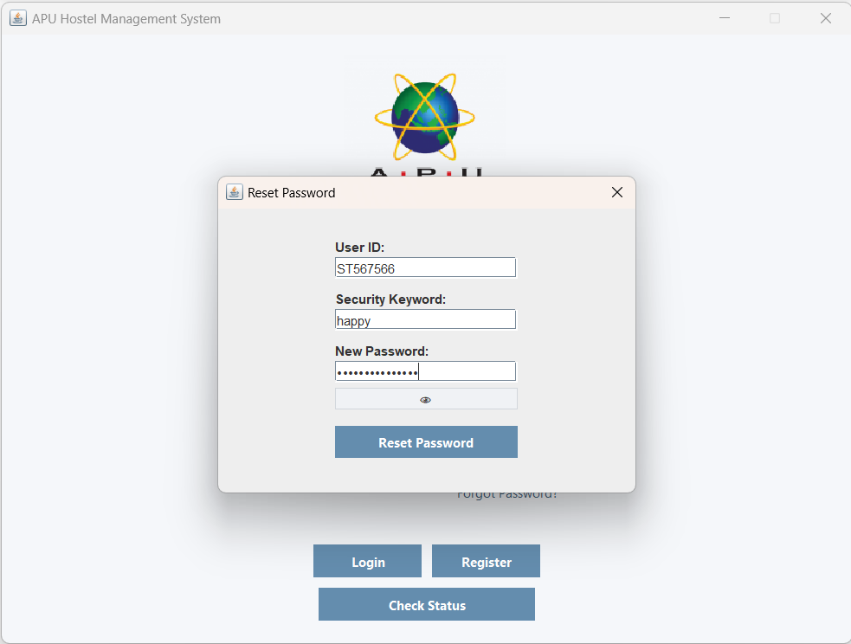  Figure 3.1.19 - Reset Password | 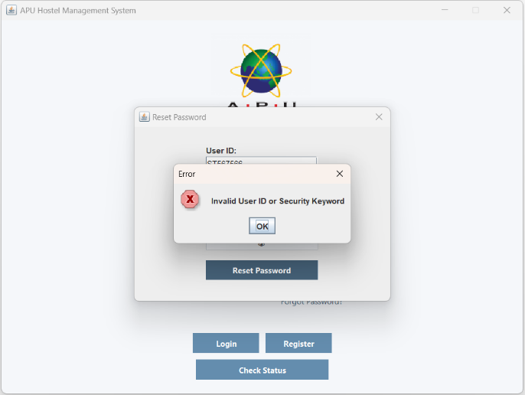  Figure 3.1.20 – 'Error' Pop-up Window
If user enter wrong User ID or Security Keyword. | An 'Error' pop-up window appears, indicating invalid User ID or Security Keyword.
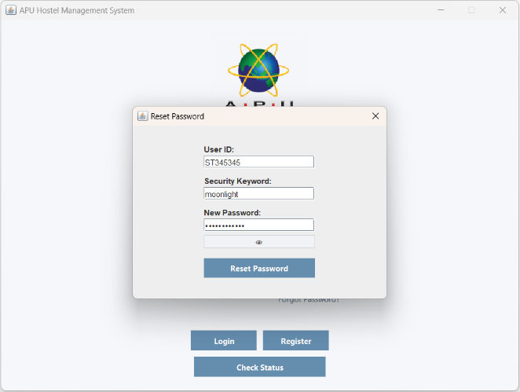  Figure 3.1.21 - Reset Password | 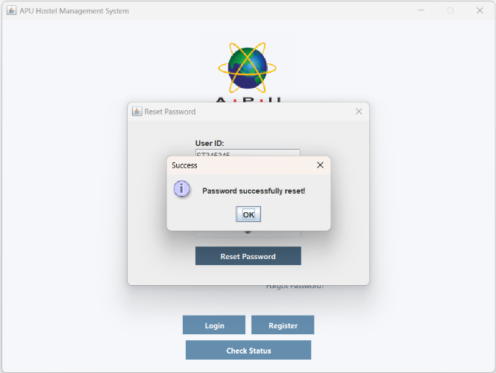  Figure 3.1.22 – 'Success Pop-up' Window
If user enter correct User ID or Security Keyword. | A 'Success' pop-up window appears and password successfully reset.
Check Account Registration Status
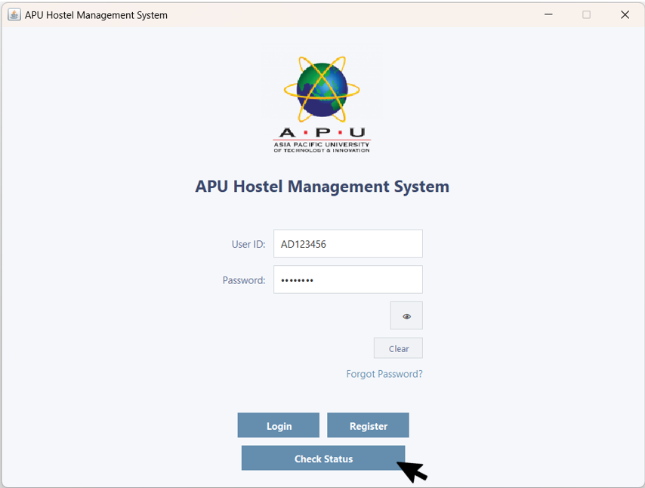  Figure 3.1.23 - Login Page with the Check Status Button | 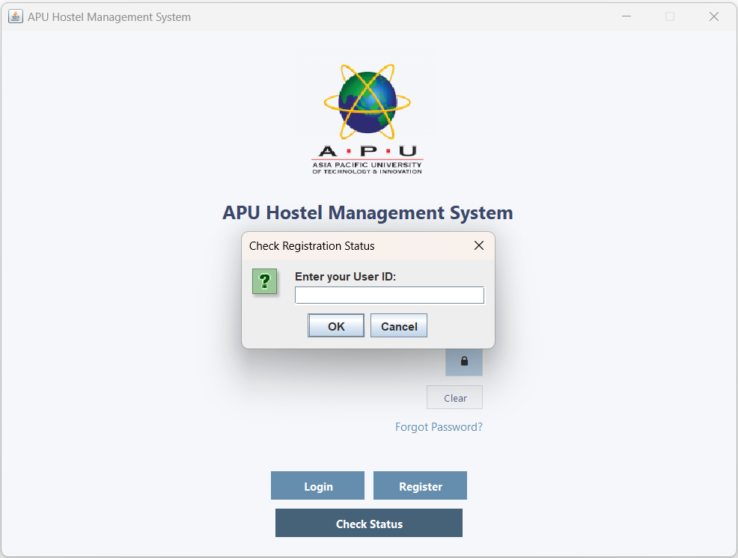  Figure 3.1.24 - 'Check Registration Status' Pop-up Window
User can click the 'Check Status' button to check whether their account is Approved, Rejected, or Pending after registration. | A 'Check Registration Status' pop-up window will appear and prompt the user to enter the User ID they want to check.
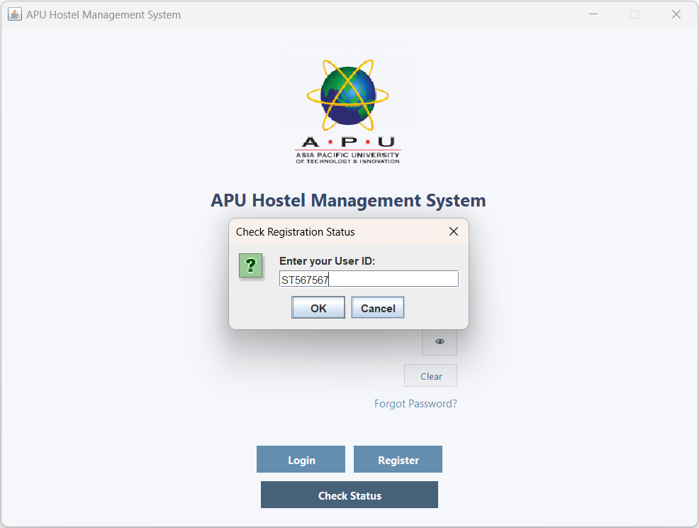  Figure 3.1.25 - Check Registration Status Pop-up Window with UserID | 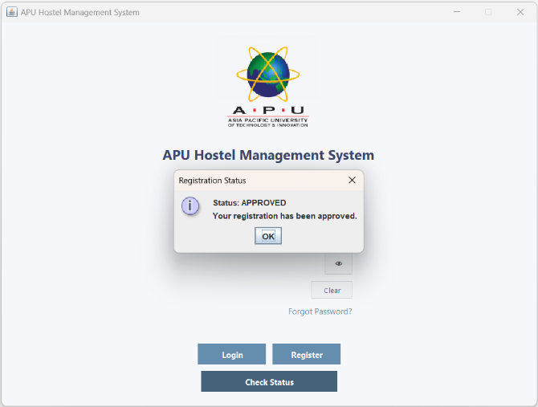  Figure 3.1.26 - 'Registration Status' Pop-up Window
User enters their User ID and clicks 'OK' button. | A 'Registration Status' pop-up window will appear, indicating that the account is approved.
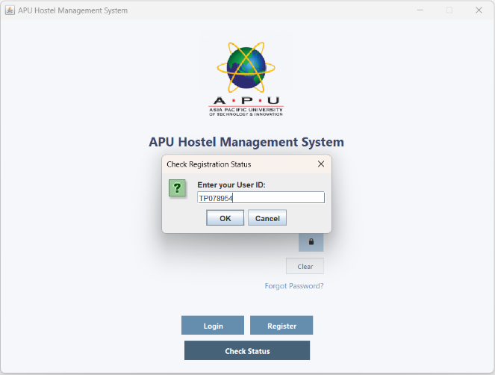  Figure 3.1.27 - Check Registration Status Pop-up Window with UserID | 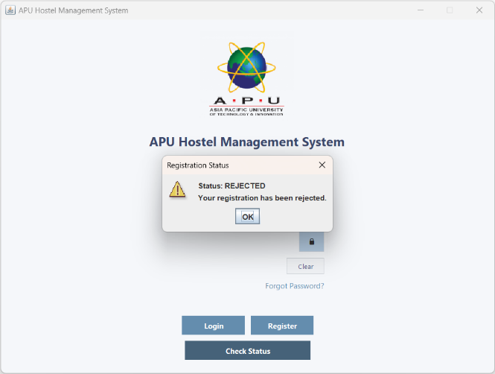  Figure 3.1.28 - 'Registration Status' Pop-up Window
User enters their User ID and clicks 'OK' button. | A 'Registration Status' pop-up window will appear, indicating that the account is rejected.
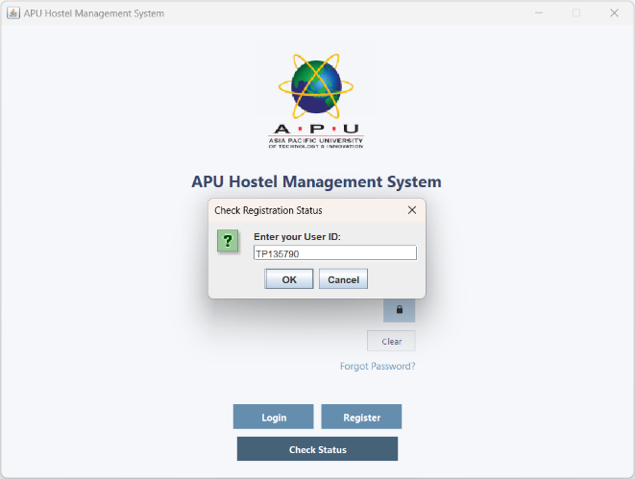  Figure 3.1.29 - Check Registration Status Pop-up Window with UserID | 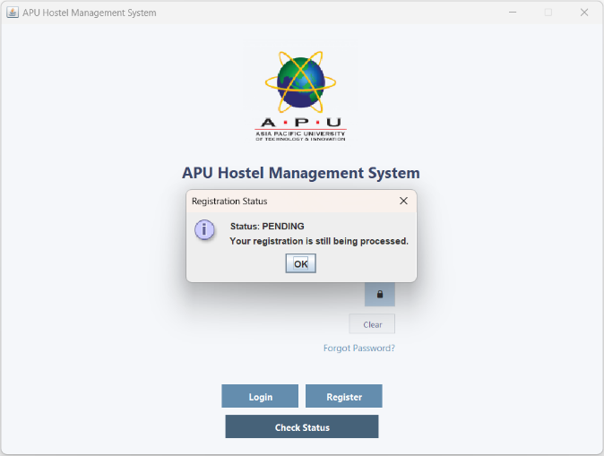  Figure 3.1.30 - 'Registration Status' Pop-up Window
User enters their User ID and clicks 'OK' button. | A 'Registration Status' pop-up window will appear, indicating that the account is pending.
Log Out
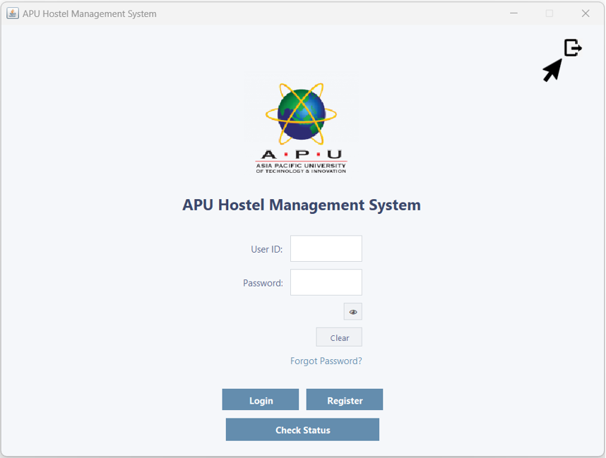  Figure 3.1.31 – Log Out | 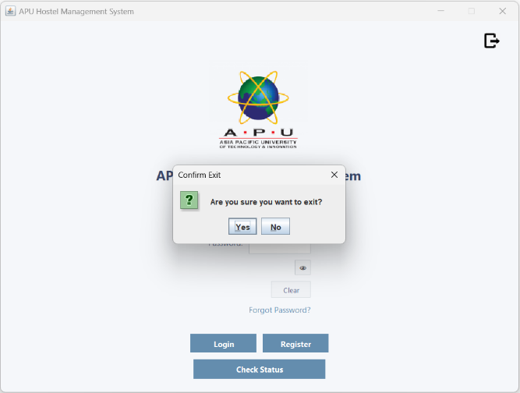  Figure 3.1.32 – 'Confirm Exit' Pop-up Window
User clicks the Log Out icon to log out. | A 'Confirm Exit' pop-up window will appear, asking the user, "Are you sure you want to exit?" and prompt user to select Yes or No.
  Figure 3.1.33 – Log Out | 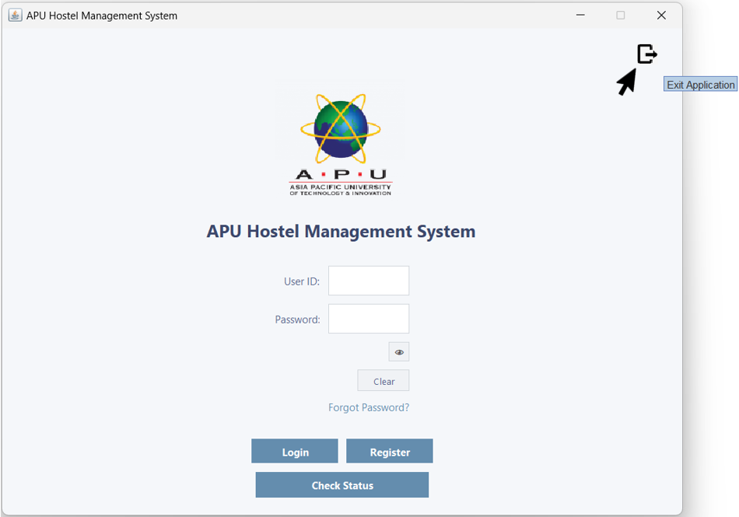  Figure 3.1.34 – Login Page with "Show/Hide Password" Tooltip
When the user hovers over the home icon button, a tooltip will appear. | The tooltip displays "Exit Application" and allows the user to log out.

3.2 Registration
Input | Output
Invalid Input
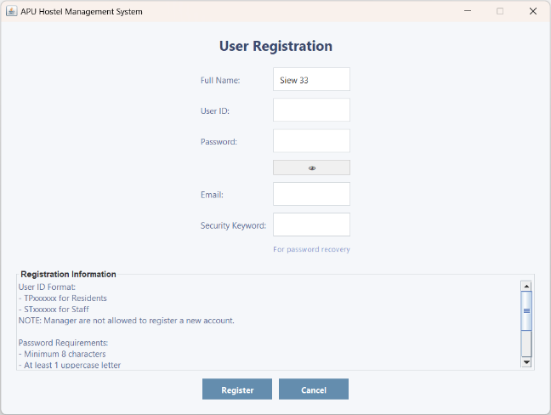  Figure 3.2.1 – User Registration with the Full Name Input Filled | 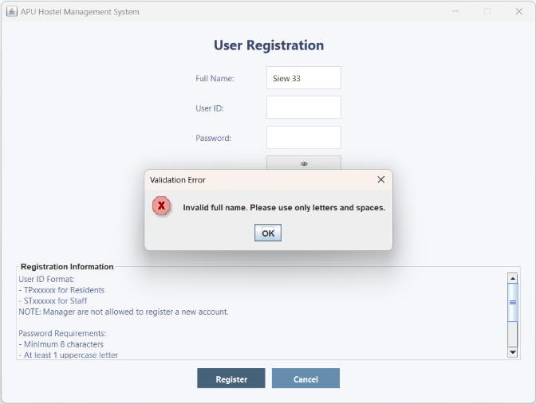  Figure 3.2.2 – 'Validation Error' Pop-up Window
The user enters an invalid full name. Full Name can only contain alphabets. | A 'Validation Error' pop-up window appears, indicating invalid Full Name.
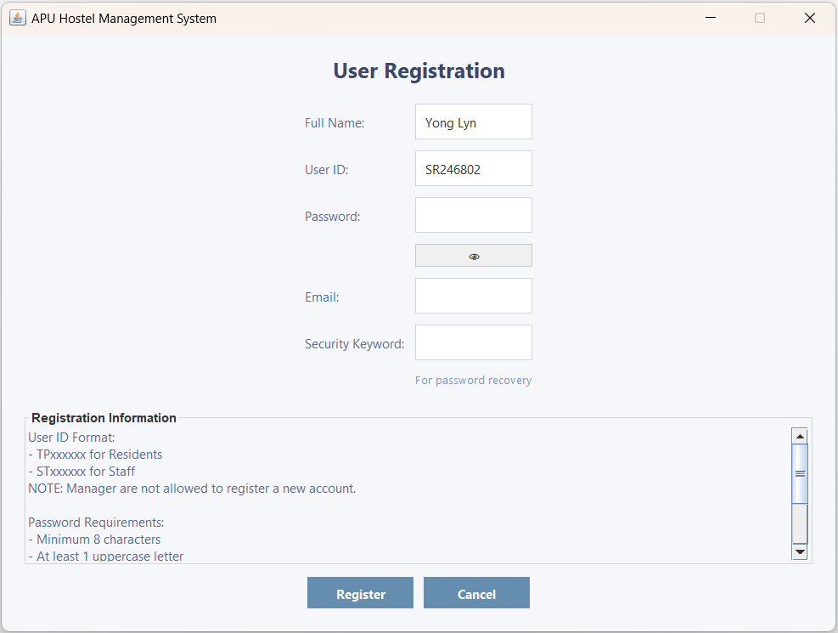  Figure 3.2.3 – User Registration with the User ID Input Filled | 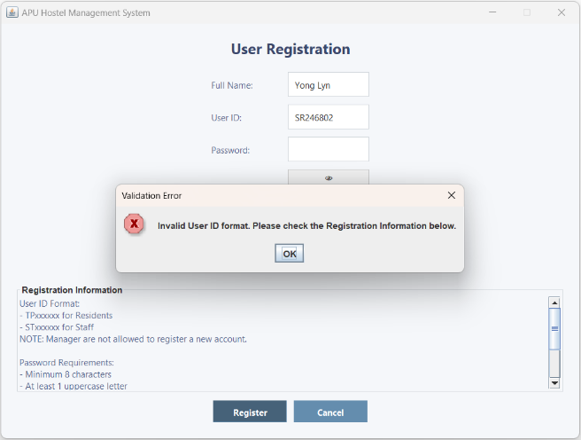  Figure 3.2.4 – 'Validation Error' Pop-up Window
The user enters an invalid User ID format. The User ID must be in the format TPxxxxxx for Residents and STxxxxxx for Staff. | A ' Validation Error' pop-up window appears, indicating invalid User ID format.
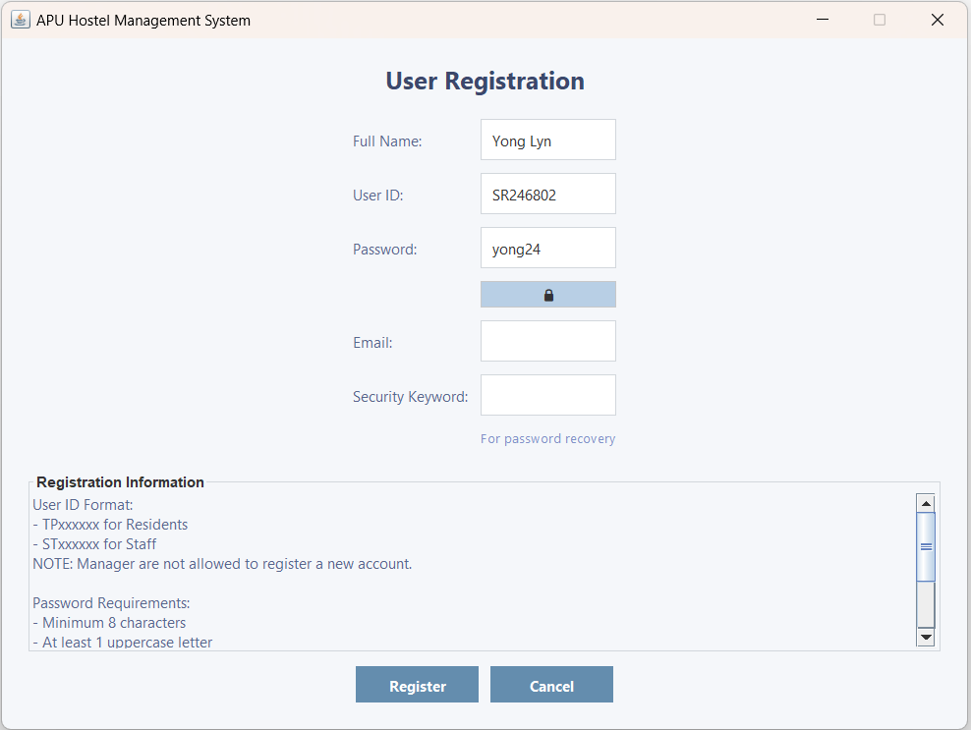  Figure 3.2.5 – User Registration with the Password Input Filled | 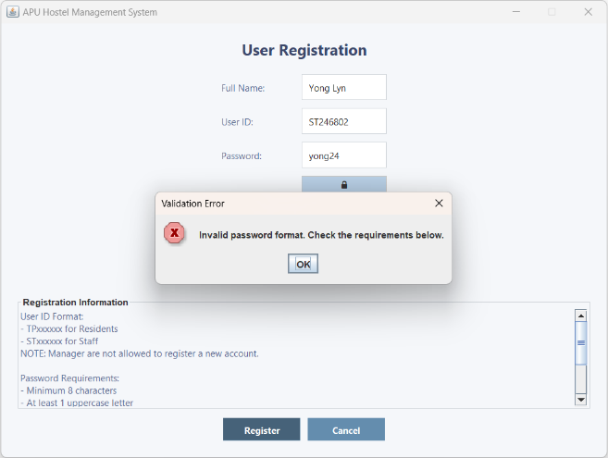  Figure 3.2.6 – 'Validation Error' Pop-up Window
The user enters an invalid password format. Password must be at least 8 characters long, include at least one uppercase letter, contain at least three digits, and must not have any spaces. | A ' Validation Error' pop-up window appears, indicating invalid Password format.
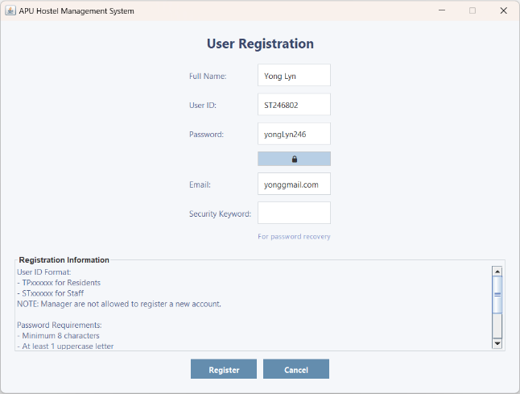  Figure 3.2.7 – User Registration with the Email Input Filled | 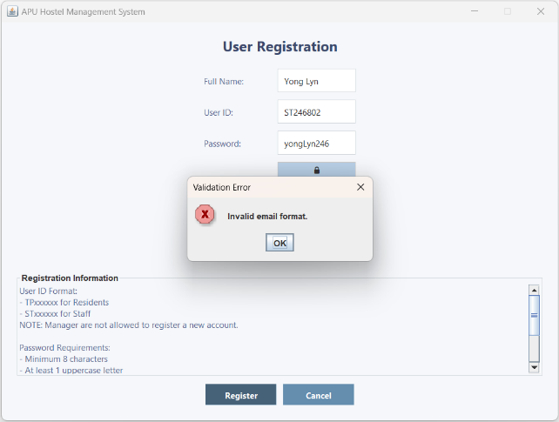  Figure 3.2.8 – 'Validation Error' Pop-up Window
The user enters an invalid email format. Email address must be in a valid format, containing "@" and following a proper domain structure. | A ' Validation Error' pop-up window appears, indicating invalid Email format.
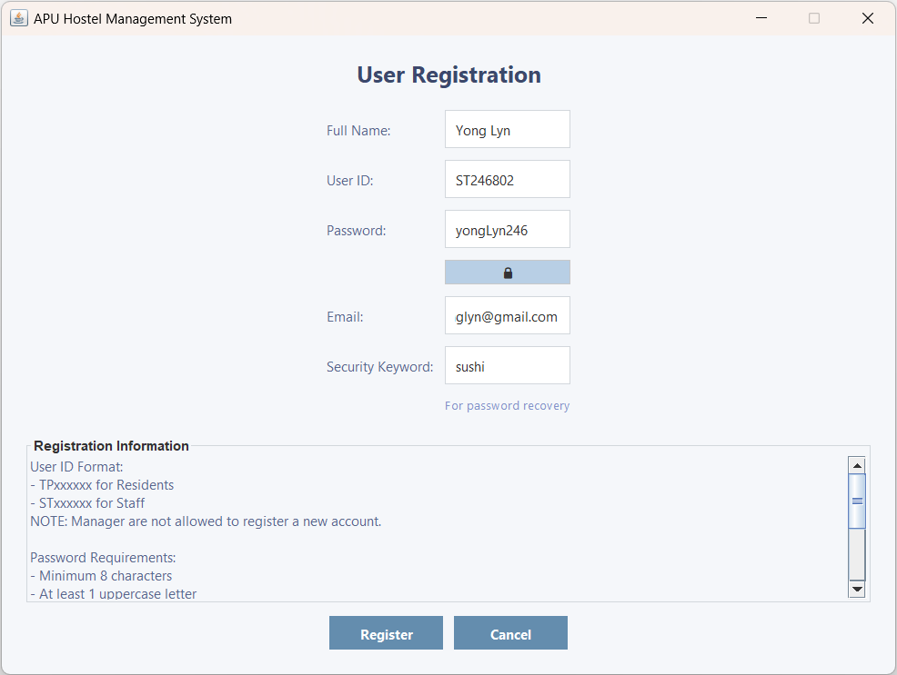  Figure 3.2.9 – User Registration with the Security Keyword Input Filled | 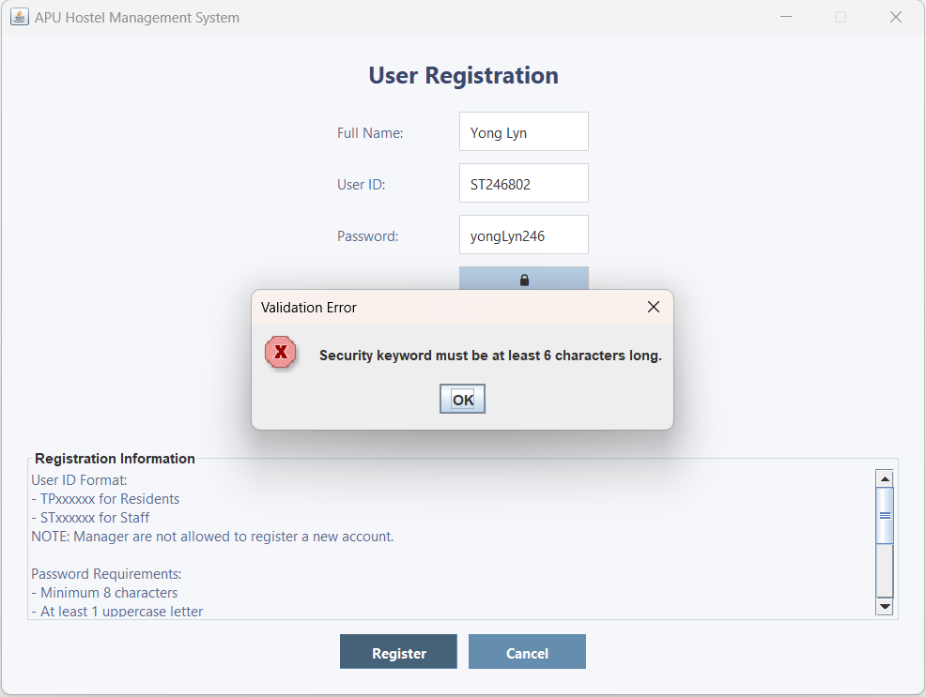  Figure 3.2.10 – 'Validation Error' Pop-up Window
The user enters an invalid Security Keyword format. The Security Keyword must be at least 6 characters long and can include letters, numbers, and special characters. | A 'Validation Error' pop-up window appears, indicating invalid Security Keyword format.
Valid Input
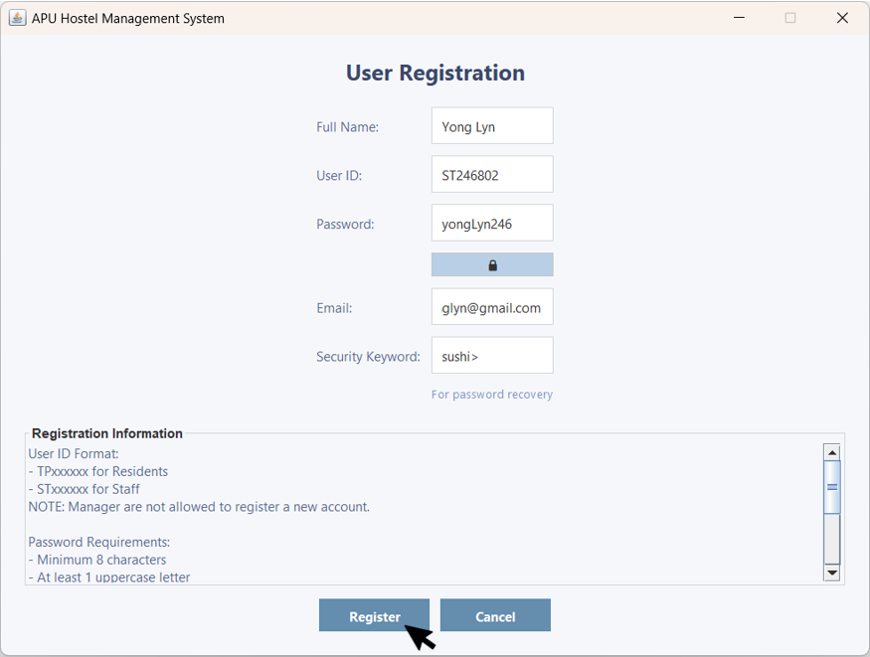  Figure 3.2.11 – User Registration with All Input Filled | 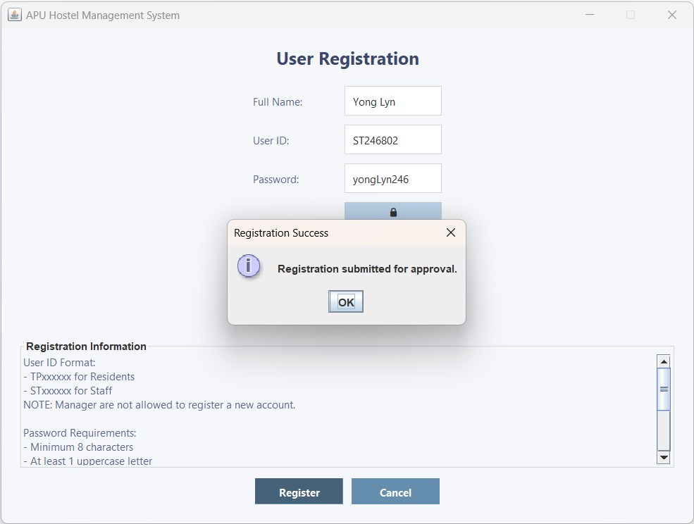  Figure 3.2.12 – 'Registration Success' Pop-up Window
The user inputs the correct format for all fields. | A 'Registration Success' pop-up window will appear, indicating that the registration has been submitted successfully.
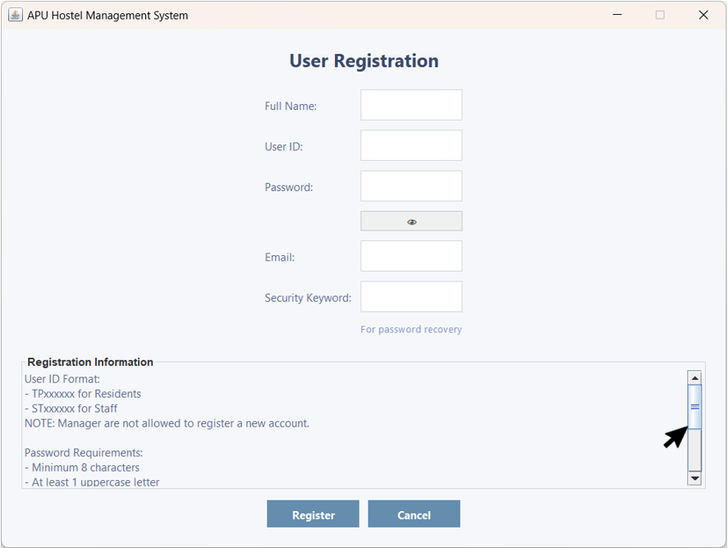  Figure 3.2.13 – User Registration with the Scroll Bar | 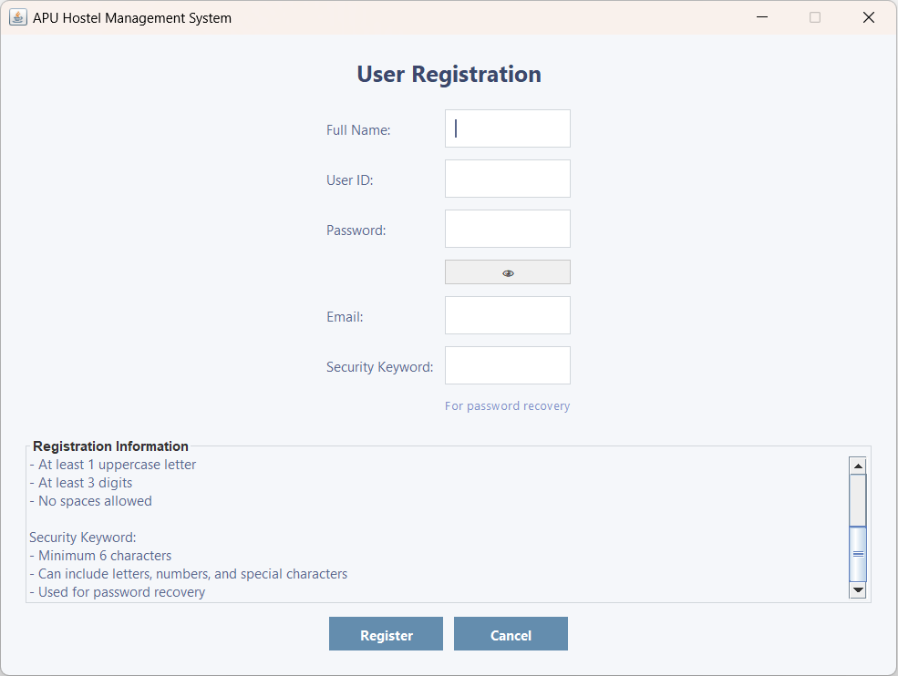  Figure 3.2.14 – Registration Information
The user can scroll the scrollbar to view additional information. | As the user scrolls the scrollbar, more information becomes visible.
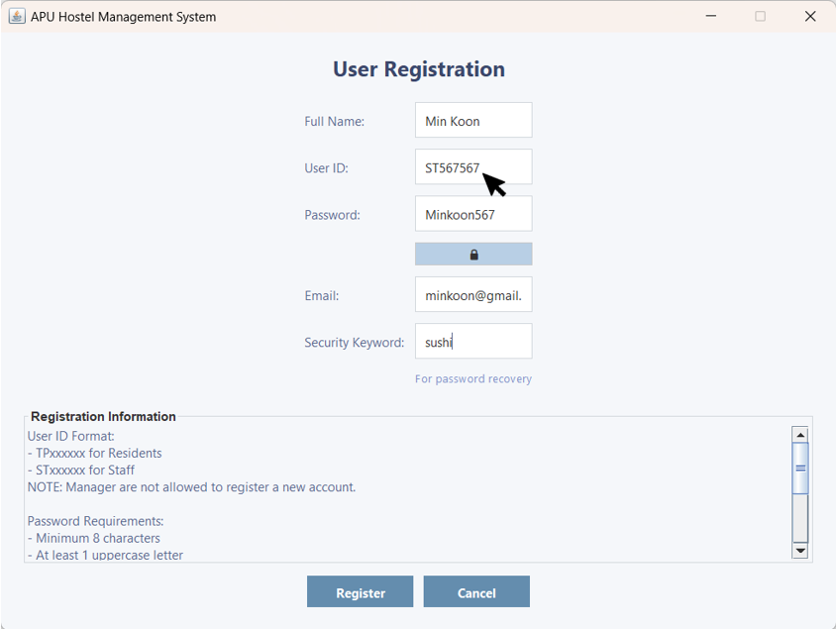  Figure 3.2.15 – User Registration with the Exist User ID | 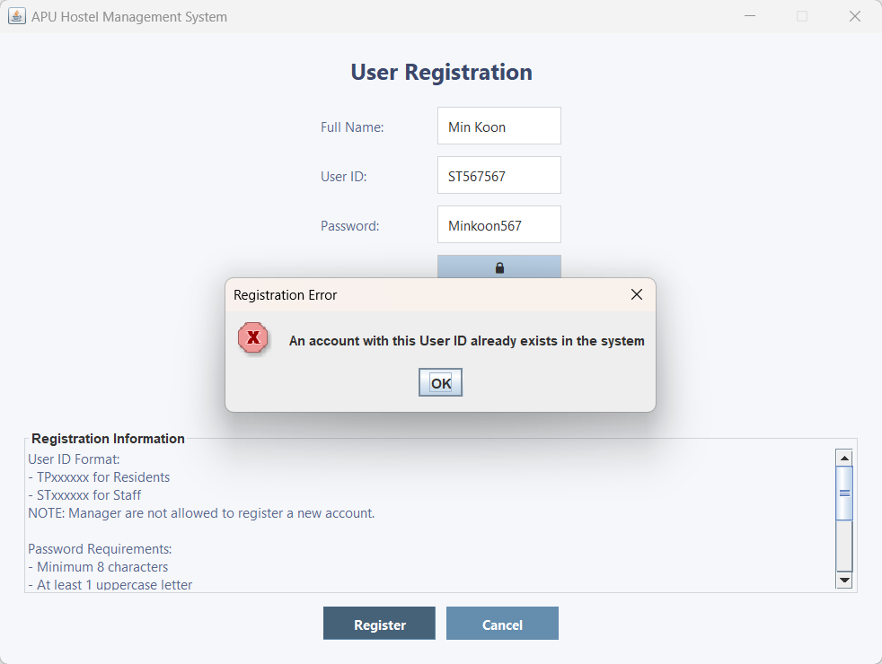  Figure 3.2.16 – 'Registration Error' pop-up window
The user tries to register an account with a User ID that has already been registered. | A 'Registration Error' pop-up window appears, indicating the account already exist.
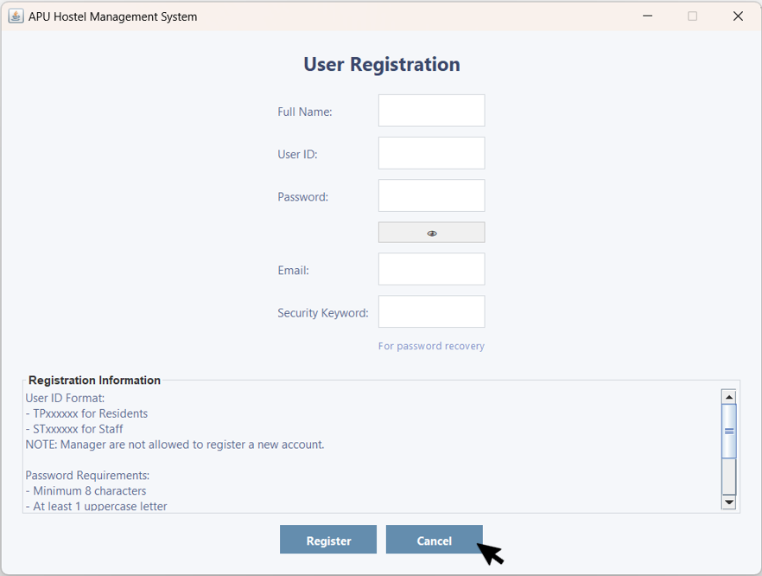  Figure 3.2.17 – User Registration with the 'Cancel' Button | 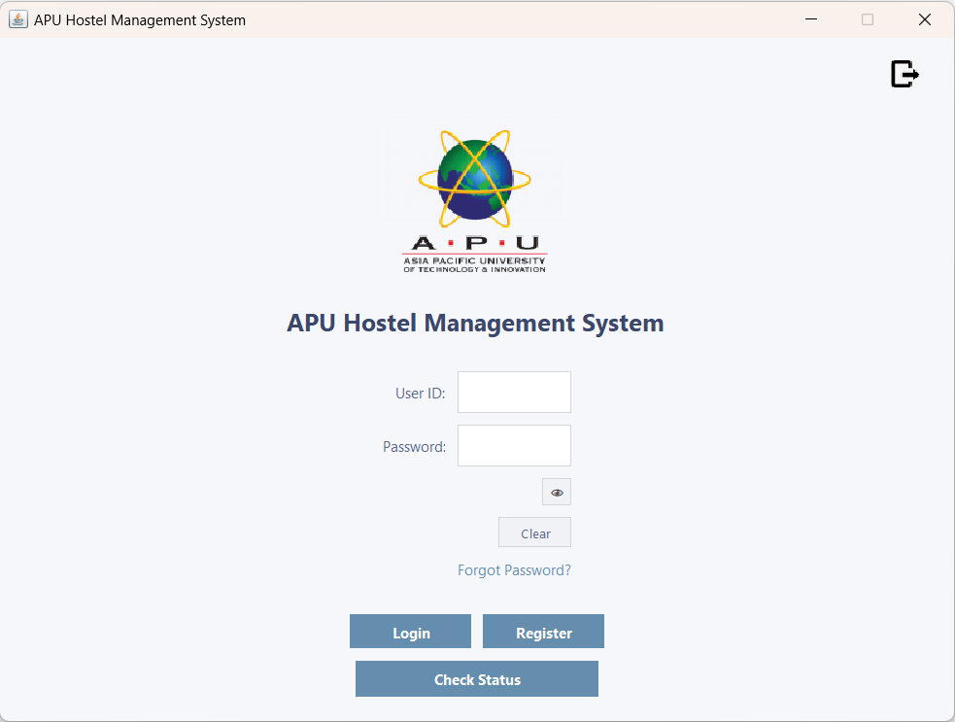  Figure 3.2.18 – Login Page
The user can click the 'Cancel' button to return to the Login page. | The user is brought back to the Login page.

3.3 Manager Dashboard

3.3.1 Pending Registration
Input | Output
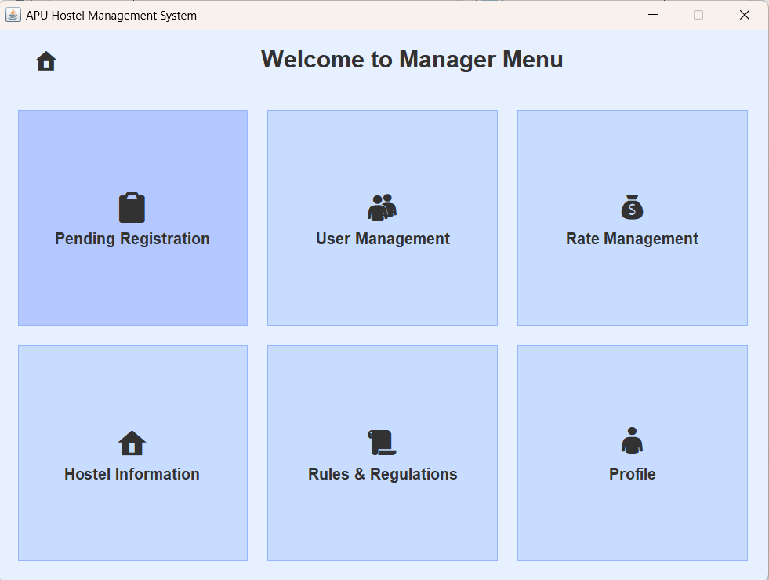  Figure 3.3.1.1 – Manager Menu | 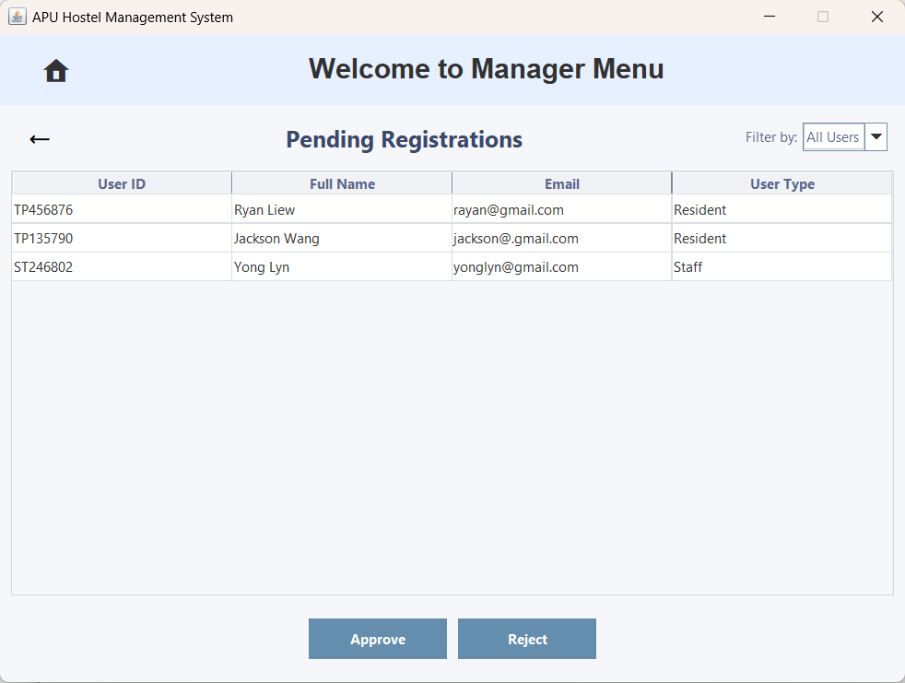  Figure 3.3.1.2 – Pending Registration
The user clicks on 'Pending Registration' to navigate to the Pending Registration page. | The user will be brought to the Pending Registration page.
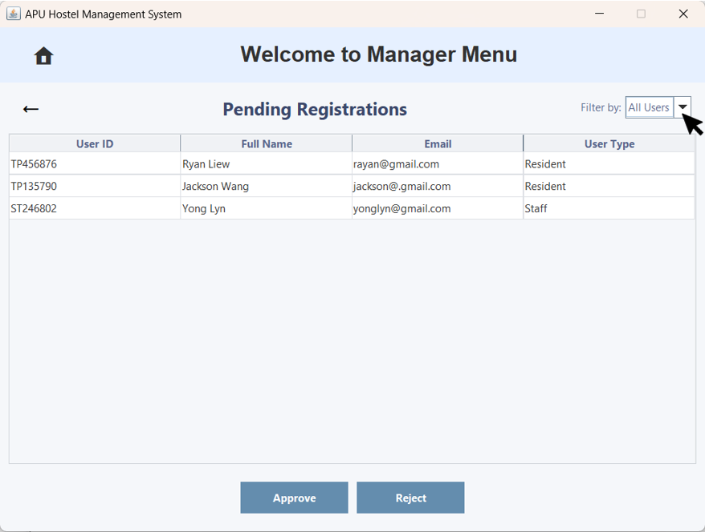  Figure 3.3.1.3 – Pending Registration with the 'Filter by Sort' Option | 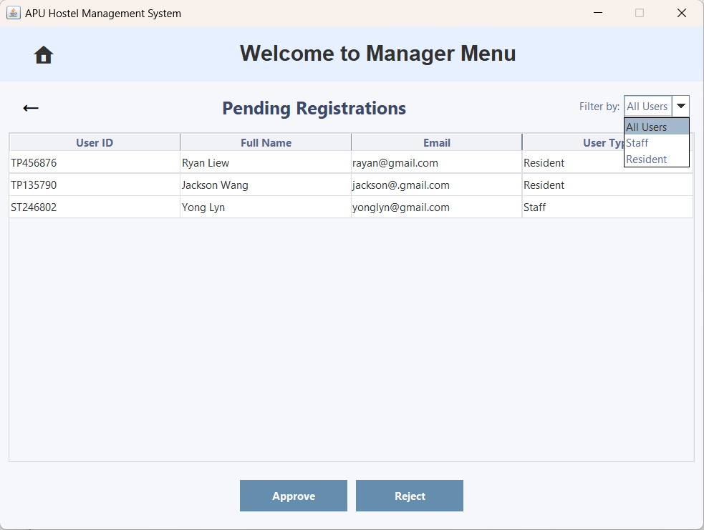  Figure 3.3.1.4 – Pending Registration with 'Filter by Sort' Option
The user can click the 'Filter by Sort' dropdown arrow to view the list of options. | It now displays a list of options: All Users, Staff, and Residents.
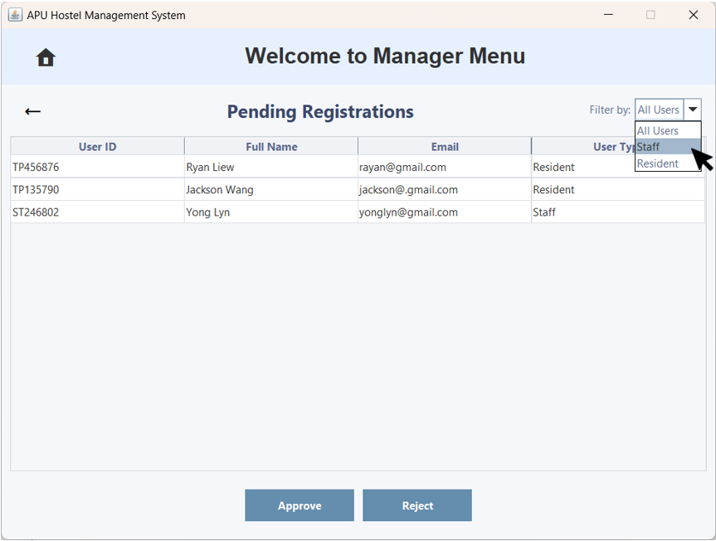  Figure 3.3.1.5 – Pending Registration with the 'Filter by Sort' Option Selected | 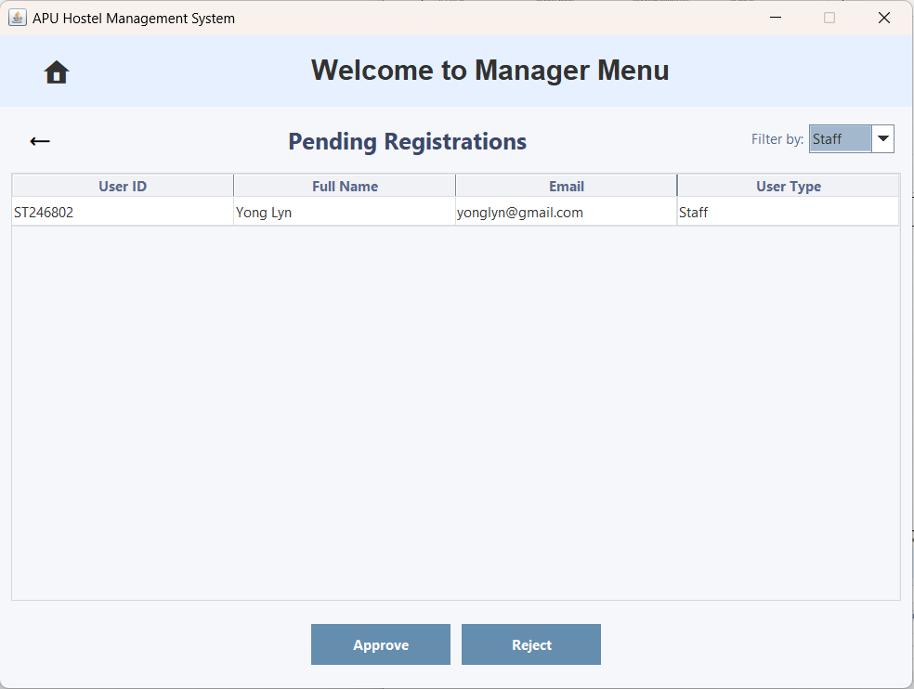  Figure 3.3.1.6 – Pending Registration with the 'Filter by Sort' Option Selected for Staff
The user clicks the 'Staff' option. | It now displays only the pending registrations of Staff accounts.
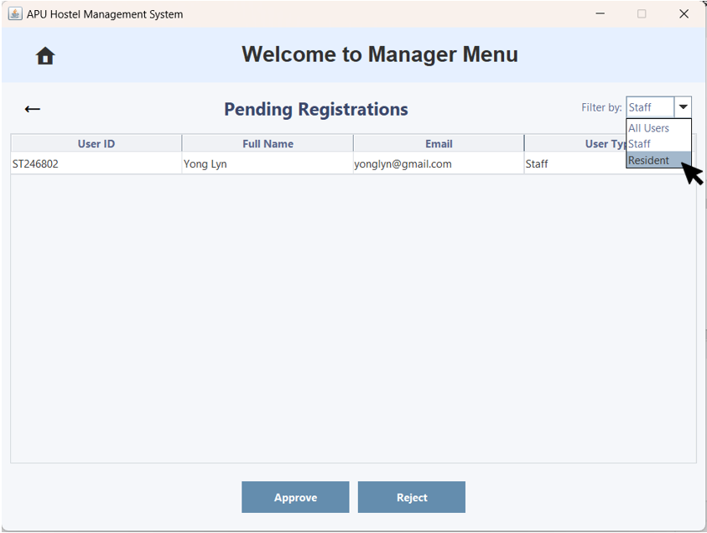  Figure 3.3.1.7 – Pending Registration with the 'Filter by Sort' Option Selected | 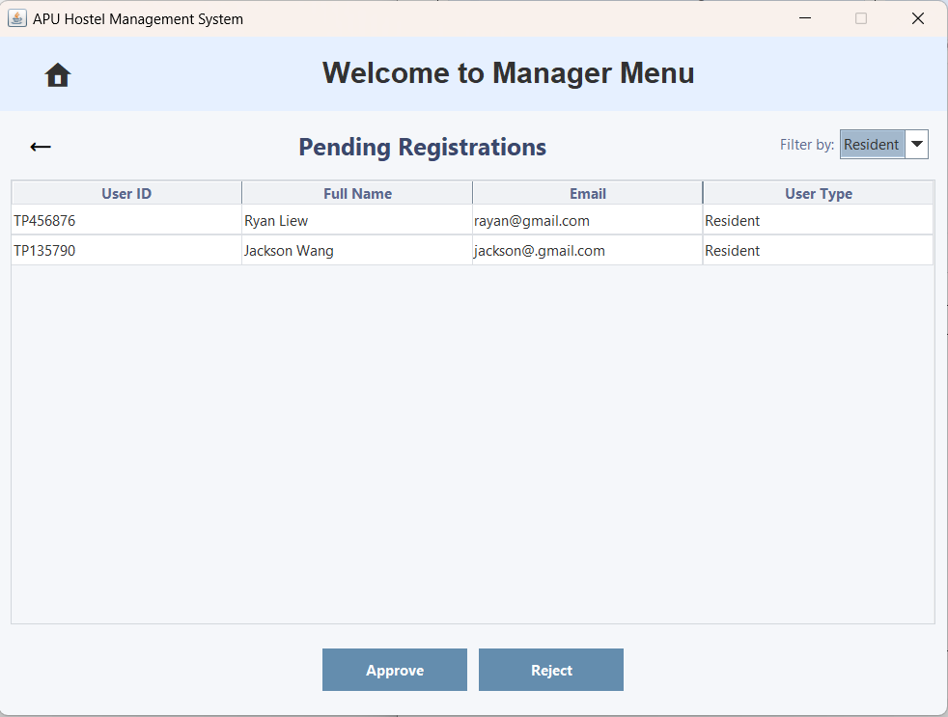  Figure 3.3.1.8 – Pending Registration with the 'Filter by Sort' Option Selected for Resident
The user clicks the 'Residents' option. | It now displays only the pending registrations of Residents accounts.
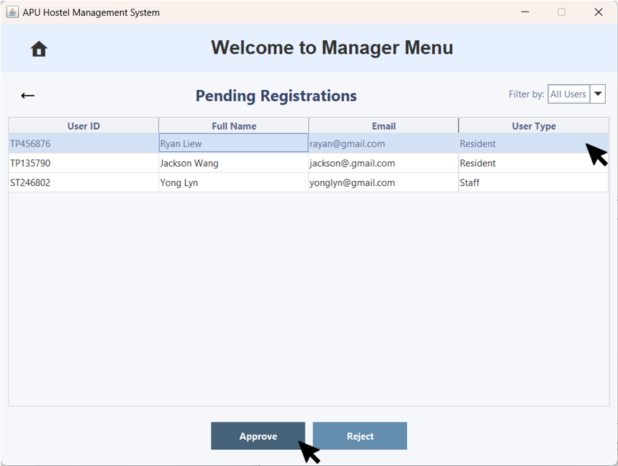  Figure 3.3.1.9 – Approve Pending Registration | 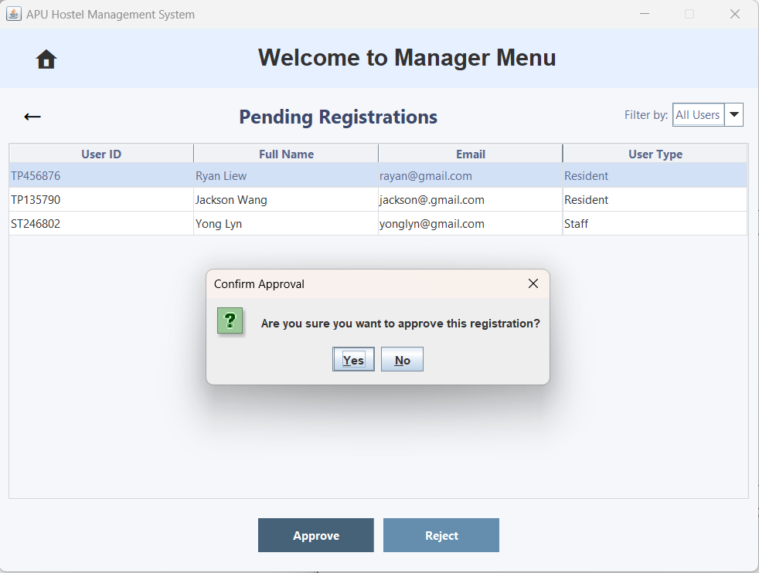  Figure 3.3.1.10 – 'Confirm Approval' Pop-up Window
The user clicks the account they want to approve and then clicks the 'Approve' button. | A 'Confirm Approval' pop-up window will appear, prompting the user to confirm with a "Yes" or "No" option.
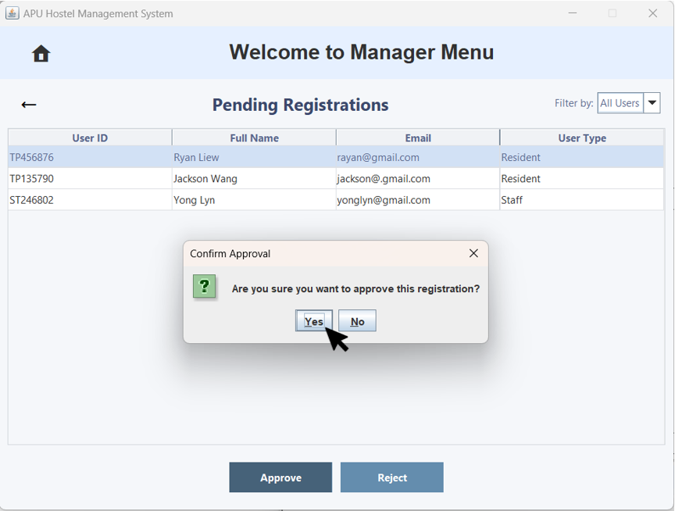  Figure 3.3.1.11 – 'Confirm Approval' Pop-up Window | 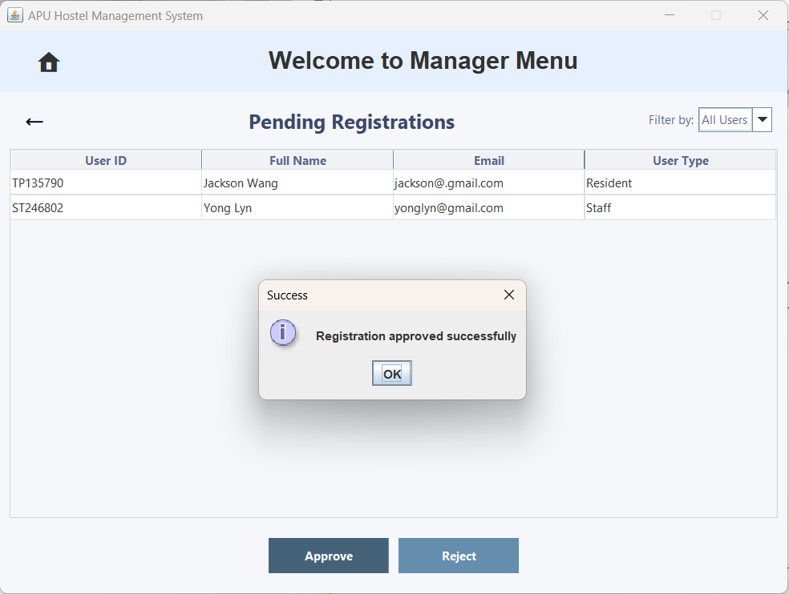  Figure 3.3.1.12 – 'Success' Pop-up Window
The user clicks 'Yes'. | A 'Success' pop-up window will appear, indicating that the registration has been approved successfully.
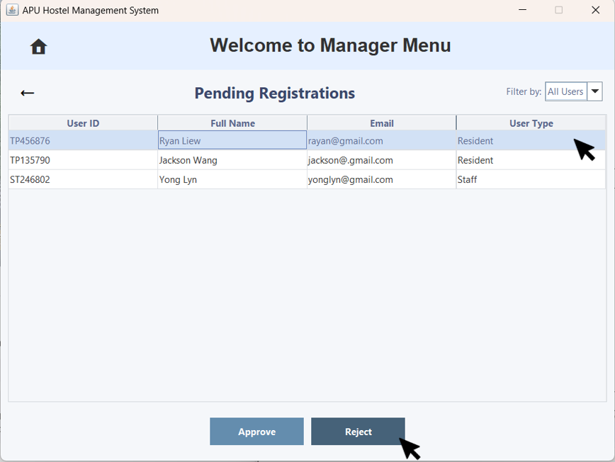  Figure 3.3.1.13 – Reject Pending Registration | 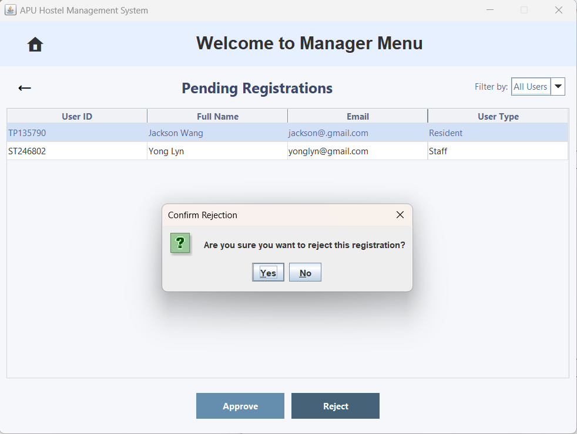  Figure 3.3.1.14 – 'Confirm Rejection' Pop-up Window
The user clicks the account they want to reject and then clicks the 'Reject' button. | A 'Confirm Approval' pop-up window will appear, prompting the user to confirm with a "Yes" or "No" option.
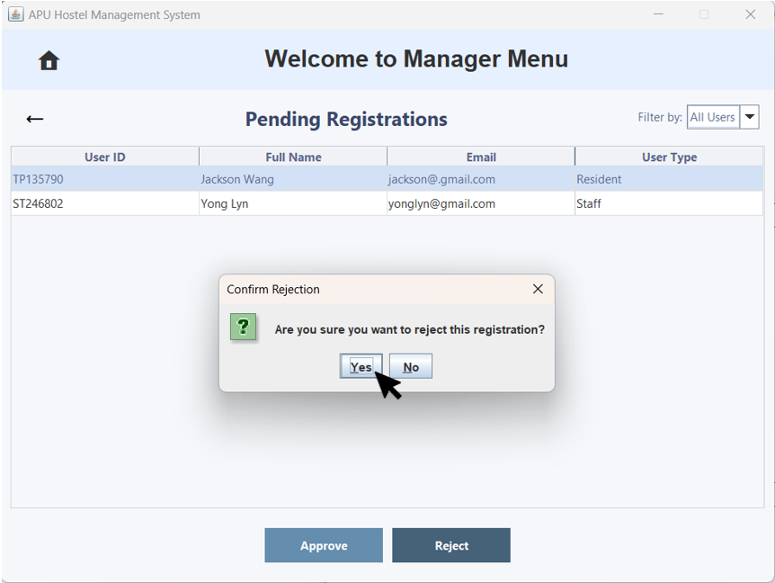  Figure 3.3.1.15 – 'Confirm Approval' Pop-up Window | 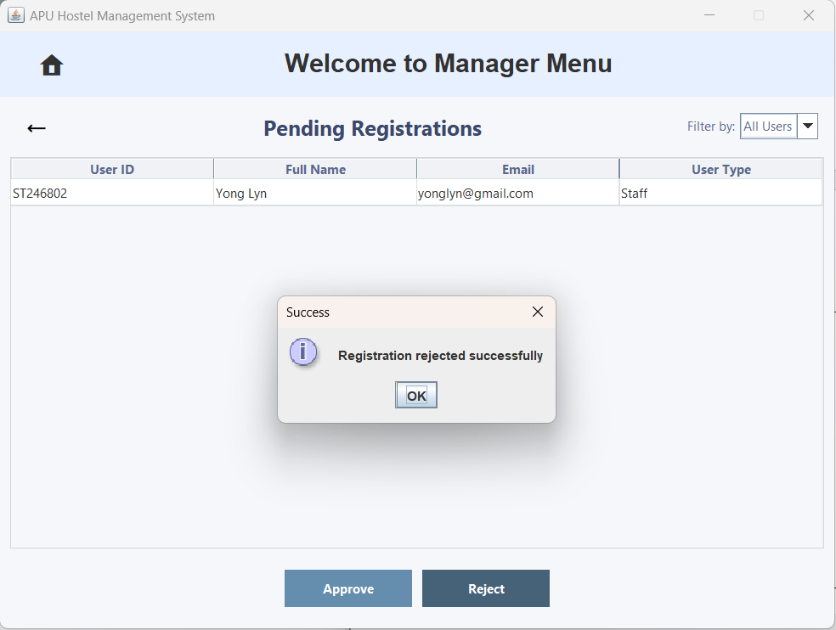  Figure 3.3.1.16 – 'Success' Pop-up Window
The user clicks 'Yes'. | A 'Success' pop-up window will appear, indicating that the registration has been rejected successfully.
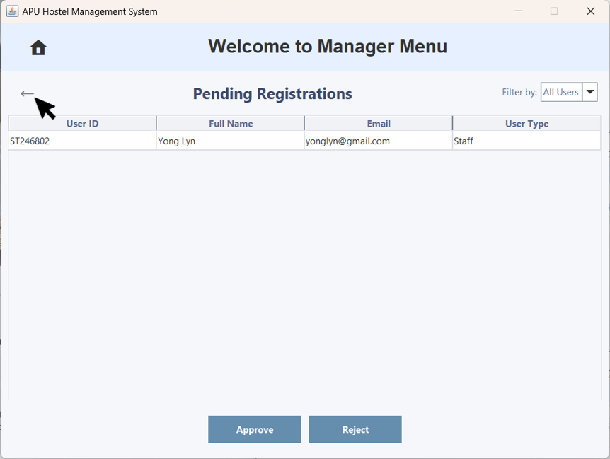  Figure 3.3.1.17 – Pending Registration with Back Arrow Button | 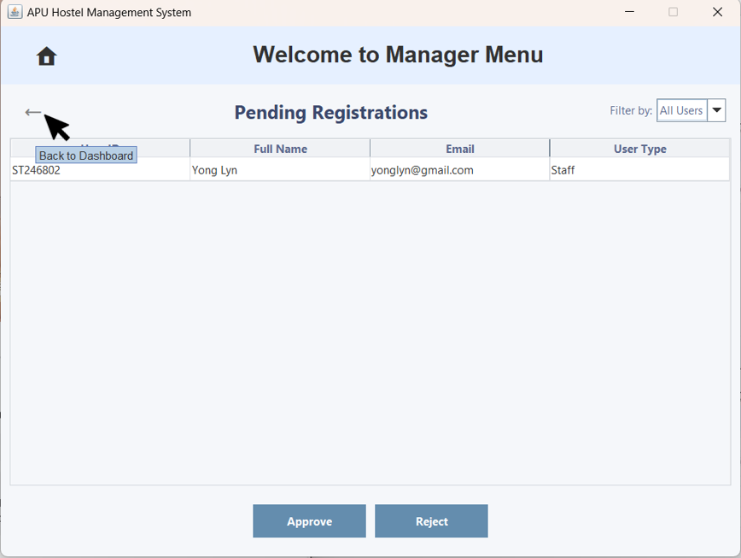  Figure 3.3.1.18 – Pending Registration with "Show/Hide Password" Tooltip
When the user hovers over the back arrow button, a tooltip will appear. | The tooltip displays 'Back to Dashboard' and allows the user to return to the Manager Menu.
  Figure 3.3.1.19 – Pending Registration with Back Arrow Button |   Figure 3.3.1.20 – Manager Menu
The user clicks the back arrow button. | The user is brought back to the Manager Menu.

3.3.2 User Management
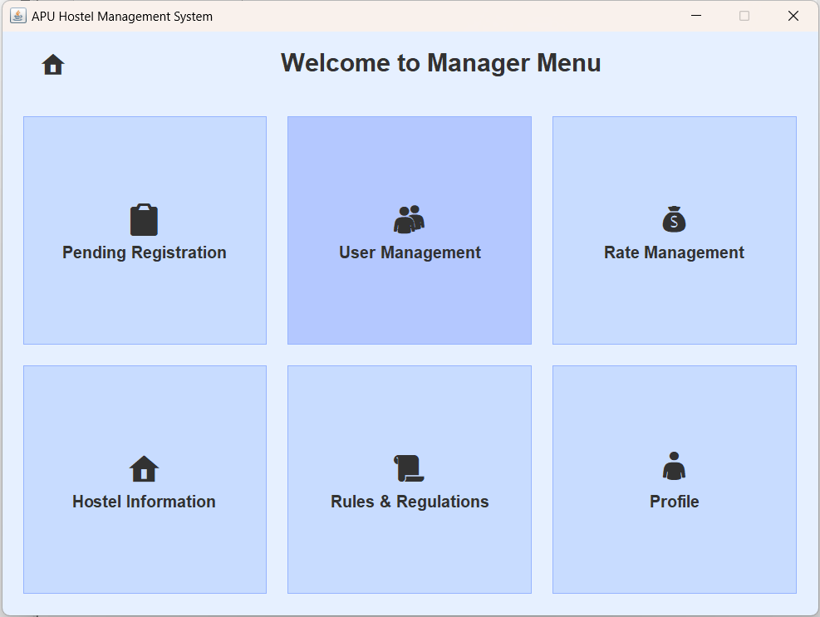  Figure 3.3.2.1 – Manager Menu | 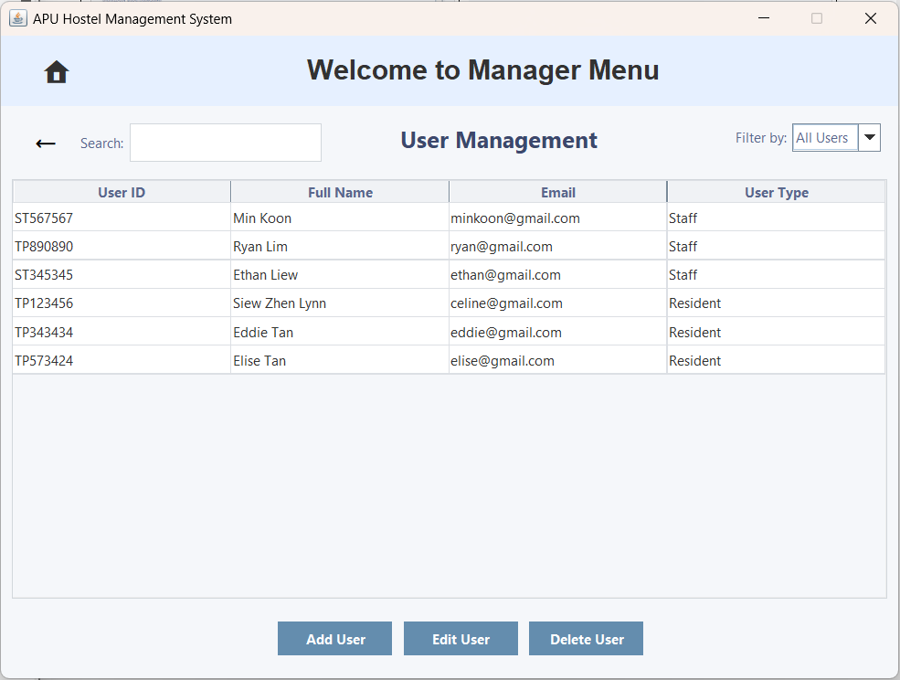  Figure 3.3.2.2 – User Management
The user clicks on 'User Management' to navigate to the User Management page. | The user will be brought to the User Management page.
Add User
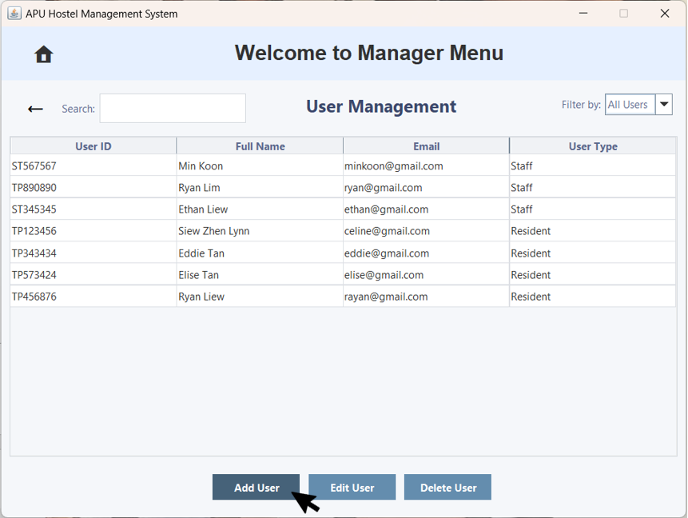  Figure 3.3.2.3 – User Management with Add User | 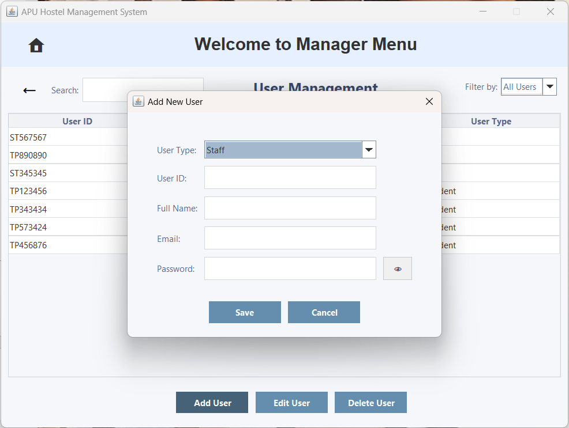  Figure 3.3.2.4 – 'Add New User' Pop-up Window
The user clicks 'Add User' to add a new user. | An 'Add New User' pop-up window will appear, allowing the user to enter the new user's details to add them.
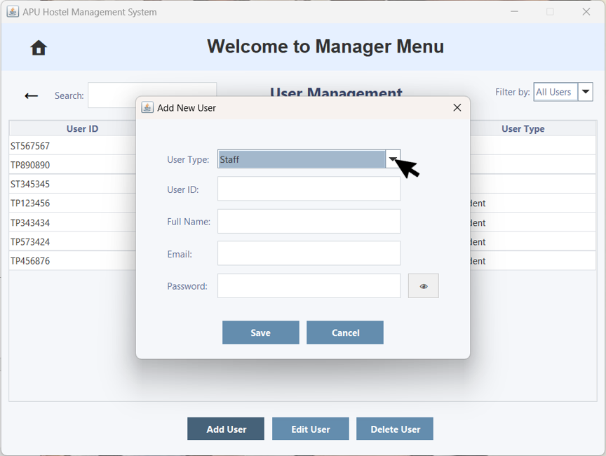  Figure 3.3.2.5 – 'Add New User' Pop-up Window with the 'User Type' dropdown arrow | 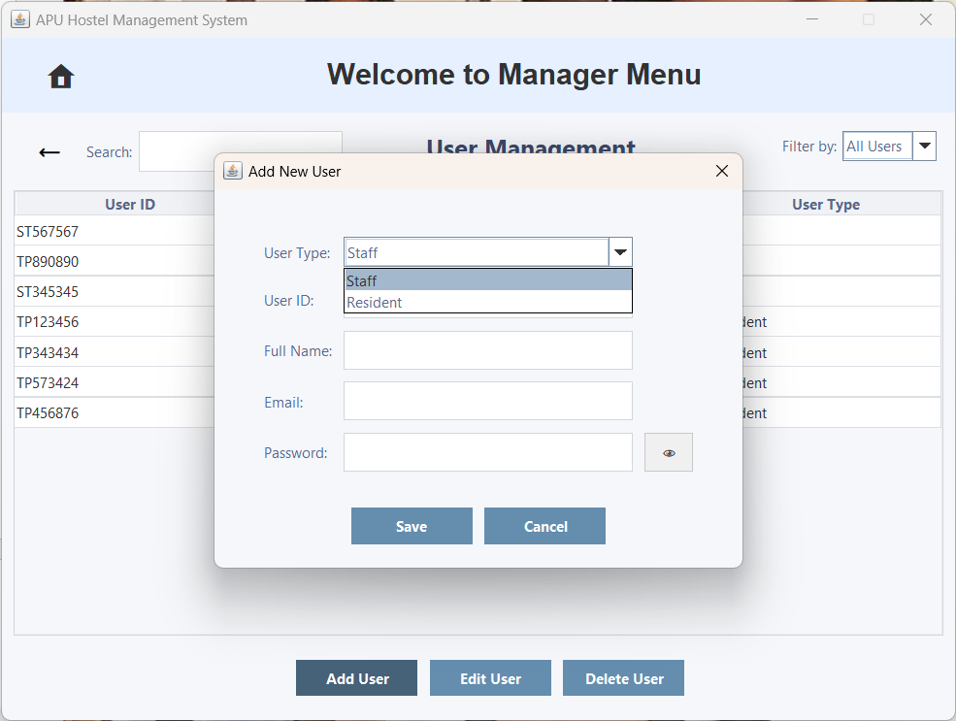  Figure 3.3.2.5 – 'Add New User' Pop-up Window with the 'User Type' Option
The user can click the 'User Type' dropdown arrow to view the list of options. | It now displays two options: Staff and Resident. The Manager is not allowed to have more than one account.
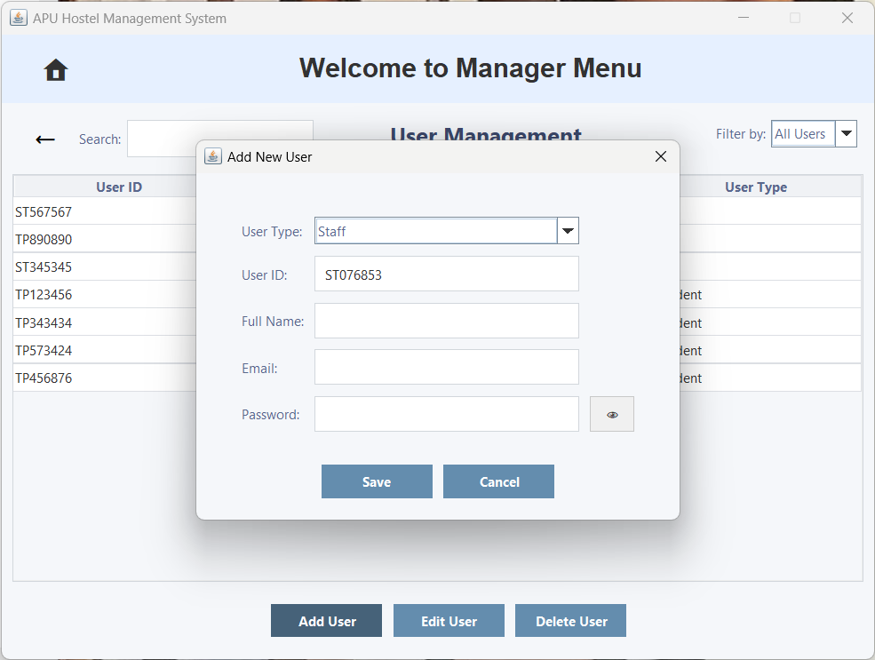  Figure 3.3.2.7 – 'Add New User' Pop-up Window | 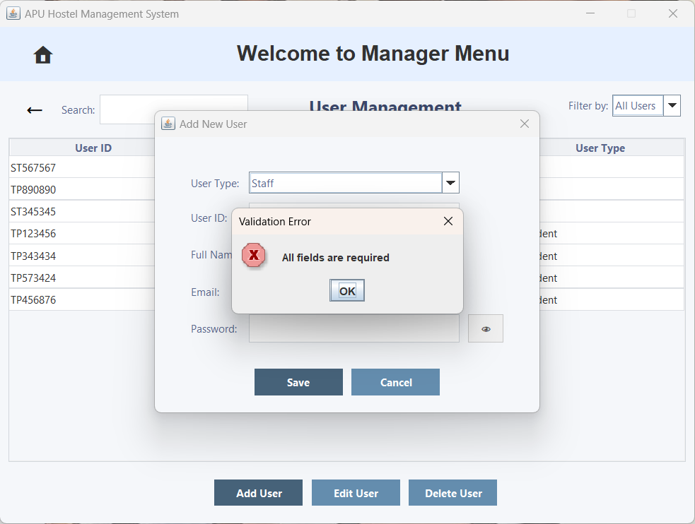  Figure 3.3.2.8 – 'Validation Error' Pop-up Window
If the user doesn't fill in all the fields and clicks the 'Save' button. | a 'Validation Error' pop-up window will appear, indicating that all fields are required.
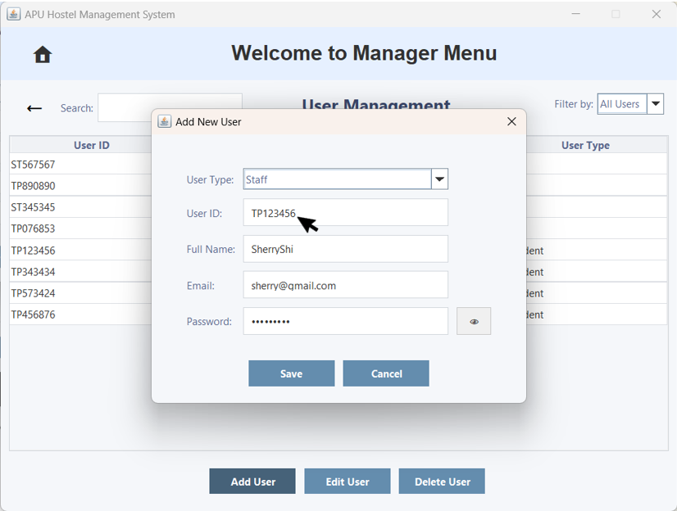  Figure 3.3.2.9 – 'Add New User' Pop-up Window | 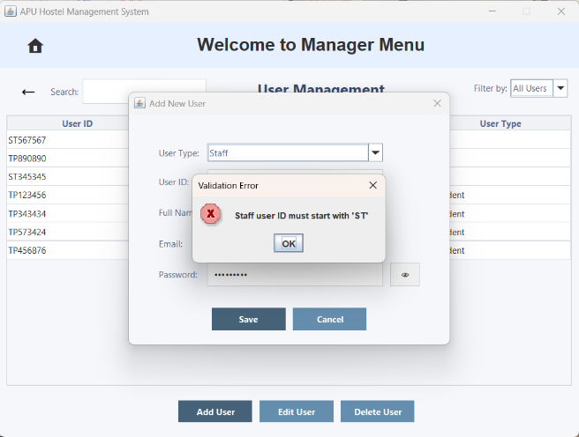  Figure 3.3.2.10 – 'Validation Error' Pop-up Window
The user enters an invalid User ID format, such as selecting 'Staff' in the User Type field but entering a resident User ID (which starts with 'TP'). | A 'Validation Error' pop-up window will appear, indicating that Staff user ID must start with 'ST'.
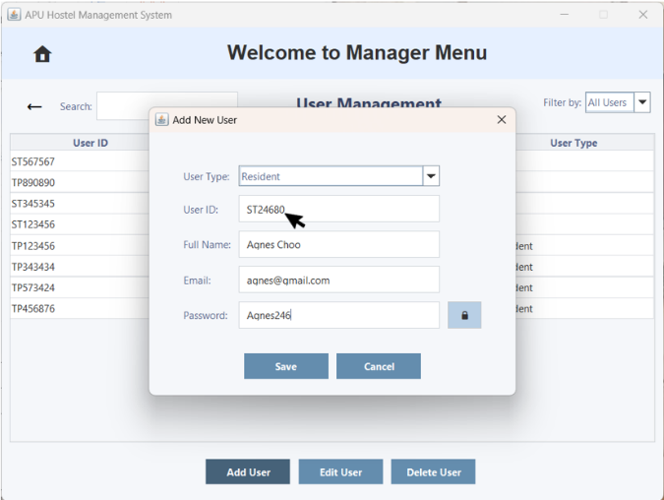  Figure 3.3.2.11 – 'Add New User' Pop-up Window | 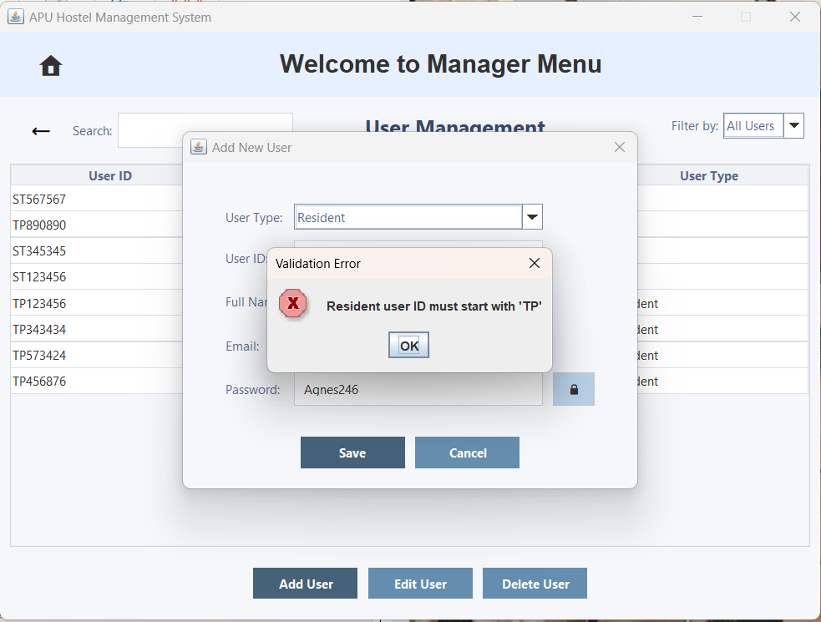  Figure 3.3.2.12 – 'Validation Error' Pop-up Window
The user enters an invalid User ID format, such as selecting 'Resident' in the User Type field but entering a staff User ID (which starts with 'ST'). | a 'Validation Error' pop-up window will appear, indicating that Resident user ID must start with 'TP'.
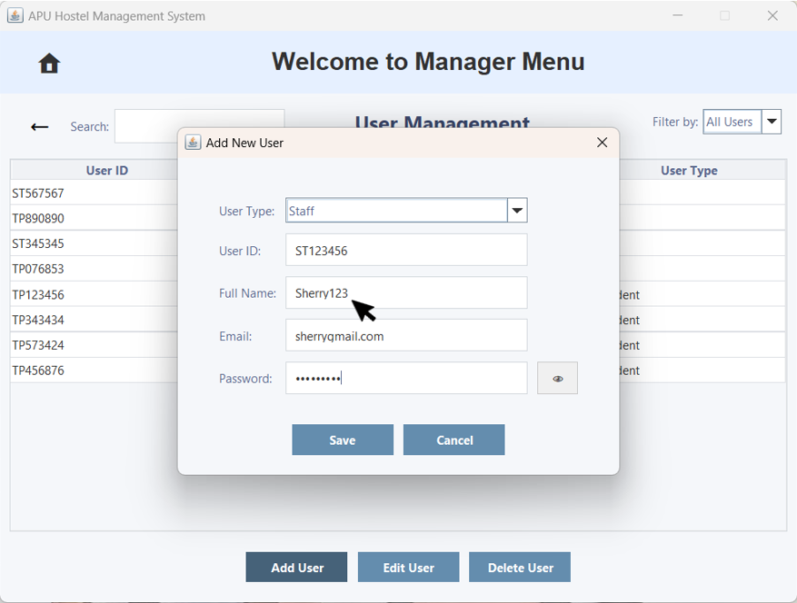  Figure 3.3.2.13 – 'Add New User' Pop-up Window | 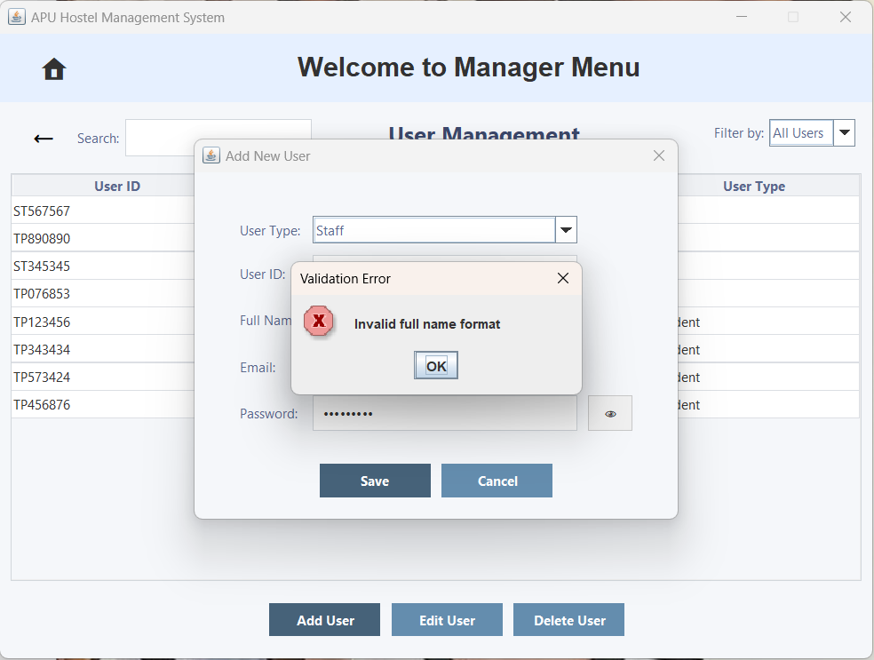  Figure 3.3.2.14 – 'Validation Error' Pop-up Window
The user enters an invalid full name. Full Name can only contain alphabets. | A 'Validation Error' pop-up window will appear, indicating that Invalid full name format.
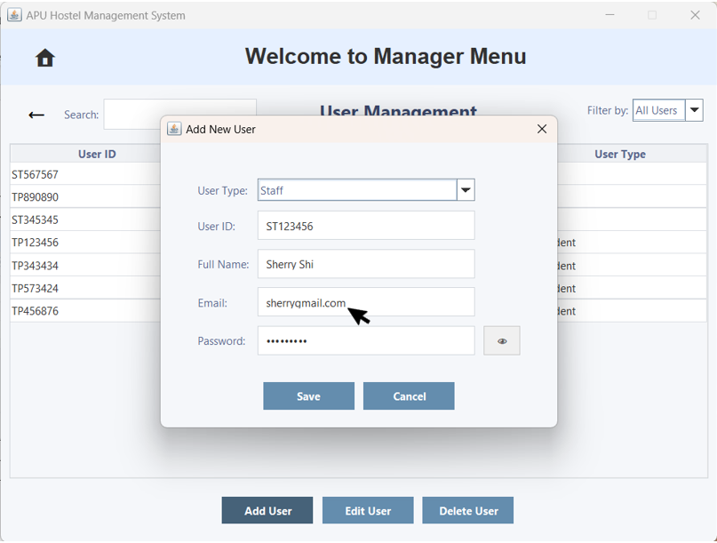  Figure 3.3.2.15 – 'Add New User' Pop-up Window | 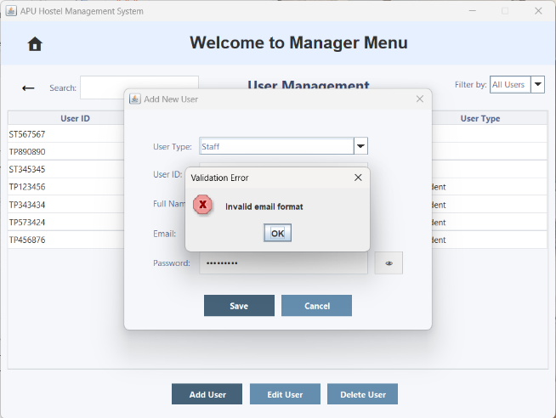  Figure 3.3.2.16 – 'Validation Error' Pop-up Window
The user enters an invalid email format. Email address must be in a valid format, containing "@" and following a proper domain structure. | a 'Validation Error' pop-up window will appear, indicating that Invalid email format.
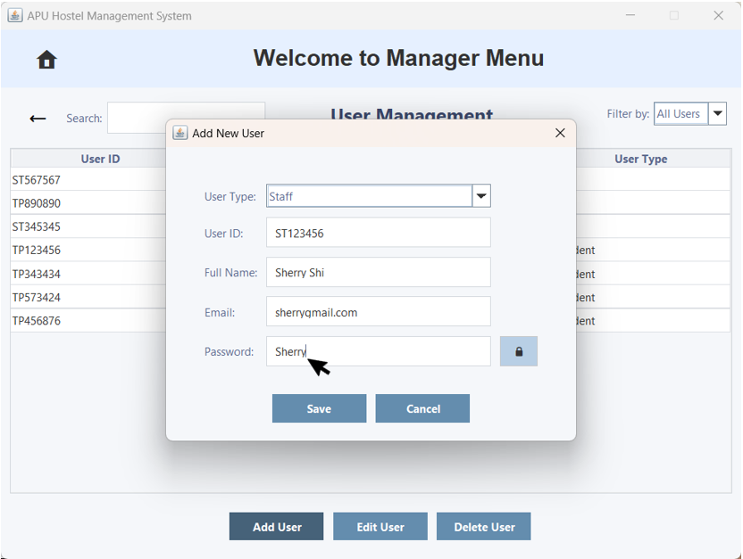  Figure 3.3.2.17 – 'Add New User' Pop-up Window | 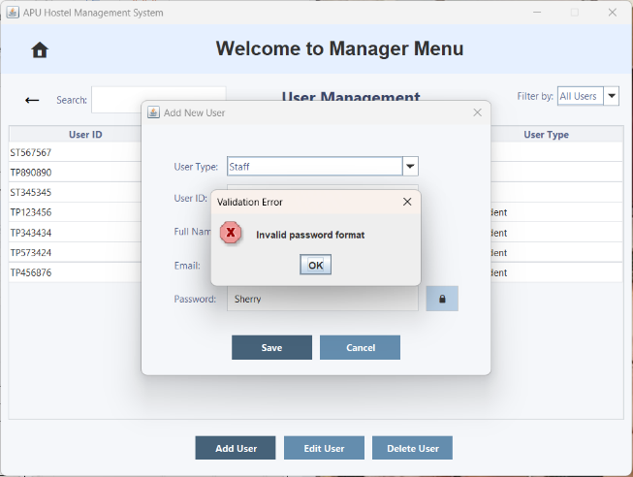  Figure 3.3.2.18 – 'Validation Error' Pop-up Window
The user enters an invalid password format. Password must be at least 8 characters long, include at least one uppercase letter, contain at least three digits, and must not have any spaces. | a 'Validation Error' pop-up window will appear, indicating that Invalid password format.
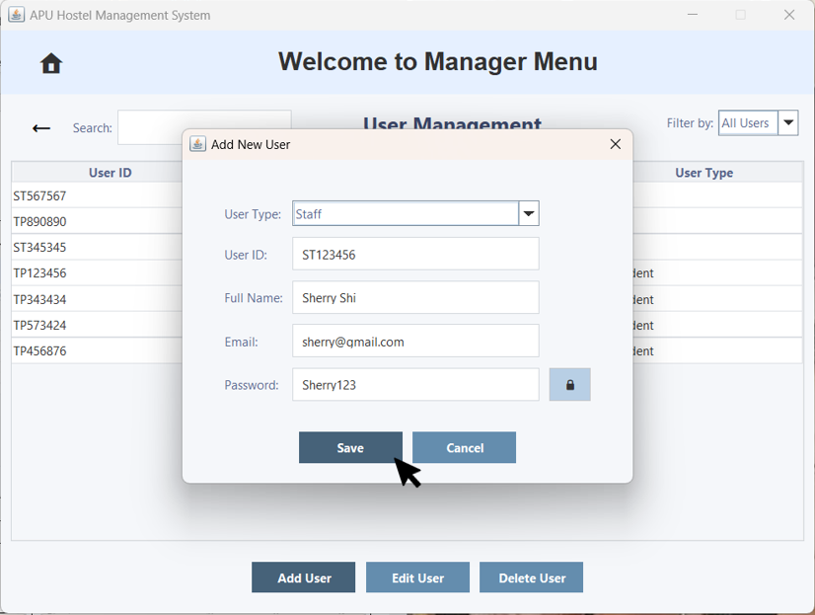  Figure 3.3.2.19 – 'Add New User' Pop-up Window | 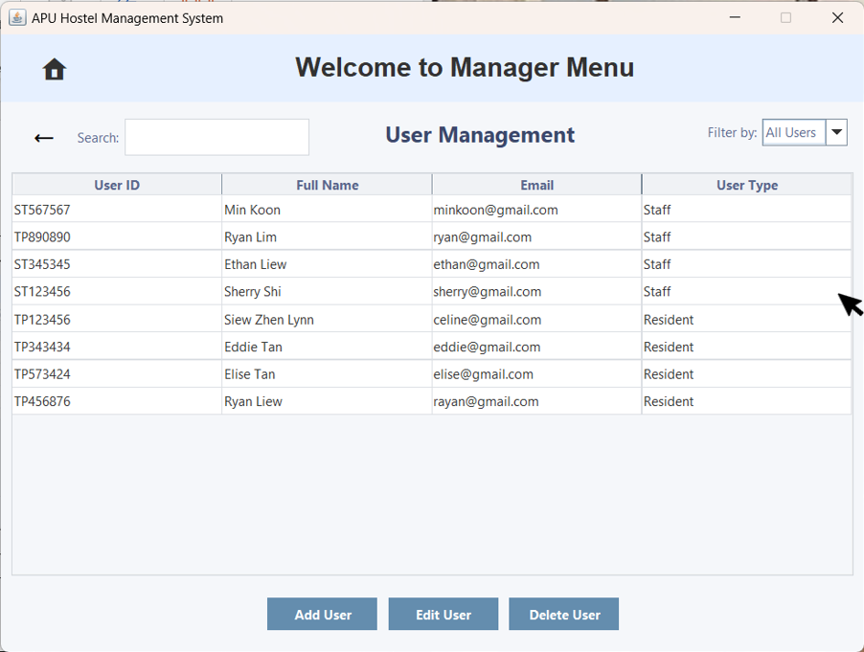  Figure 3.3.2.20 – User Management
If all fields are correctly filled in, the user clicks 'Save' to proceed. | The user account will be saved successfully and will immediately appear in User Management.
Edit User
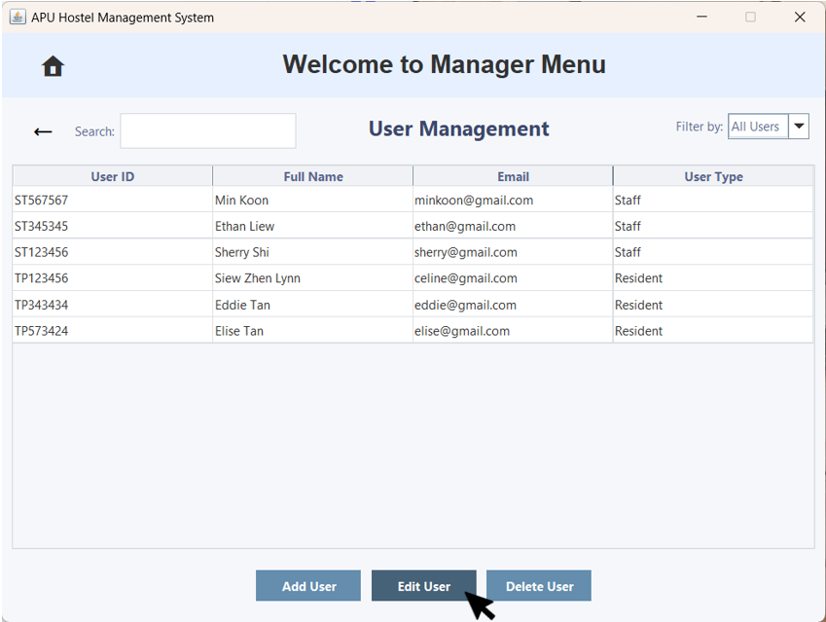  Figure 3.3.2.21 – User Management | 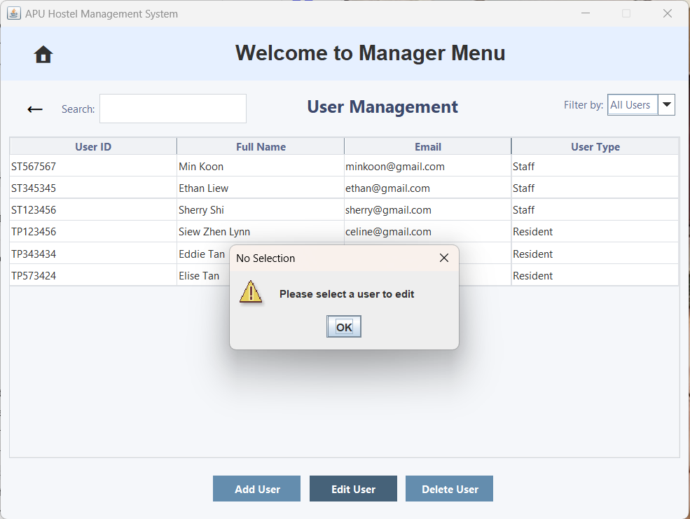  Figure 3.3.2.22 – 'No Selection' Pop-up Window
If the user doesn't select an account and clicks the 'Edit User' button. | A 'No Selection' pop-up window will appear, stating 'Please select a user to edit'.
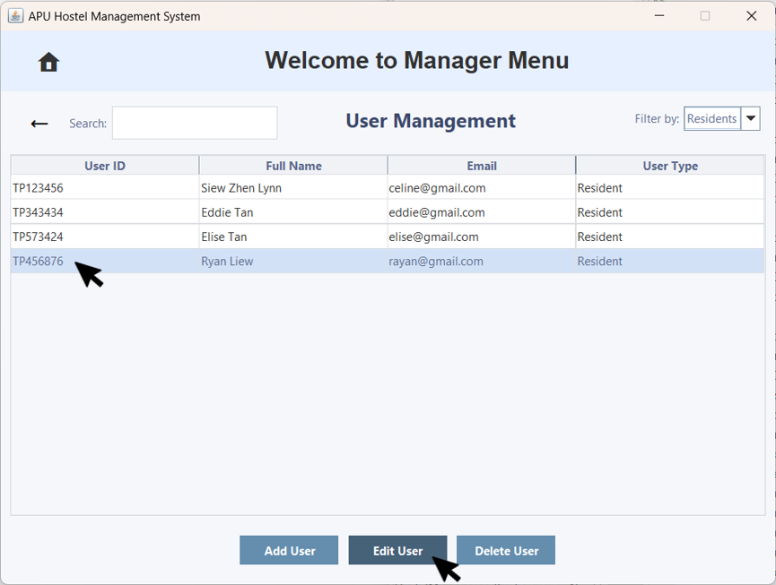  Figure 3.3.2.23 – User Management with Edit User | 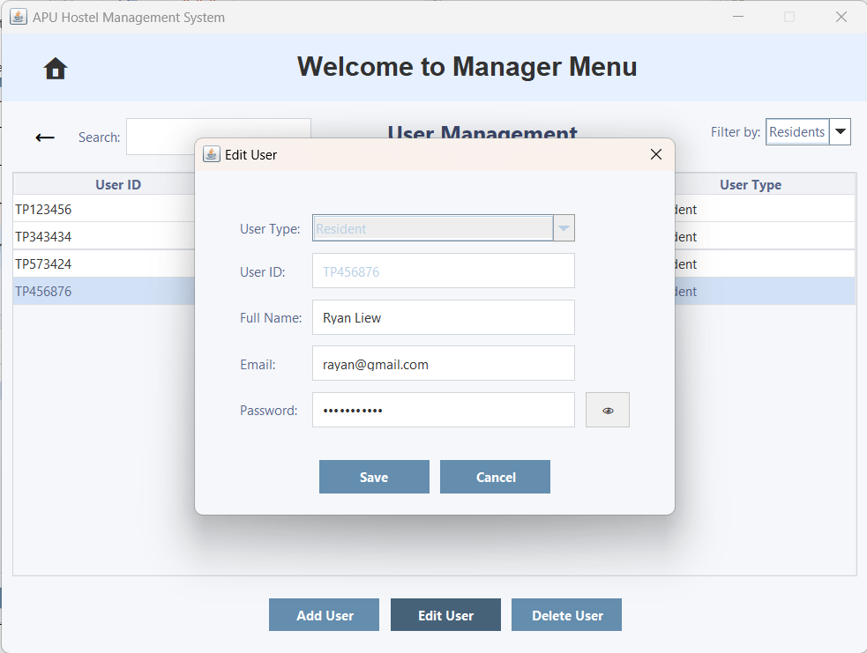  Figure 3.3.2.24 – 'Edit User' Pop-up Window
The user clicks on an account and then clicks the 'Edit User' button to edit the account details. | An 'Edit User' pop-up window will appear, displaying the user's current account information and allowing them to make edits.
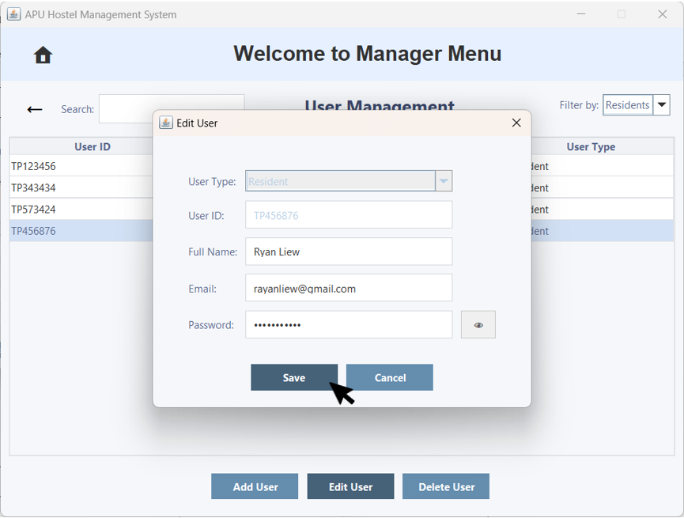  Figure 3.3.2.25 – 'Edit User' Pop-up Window with Save Button | 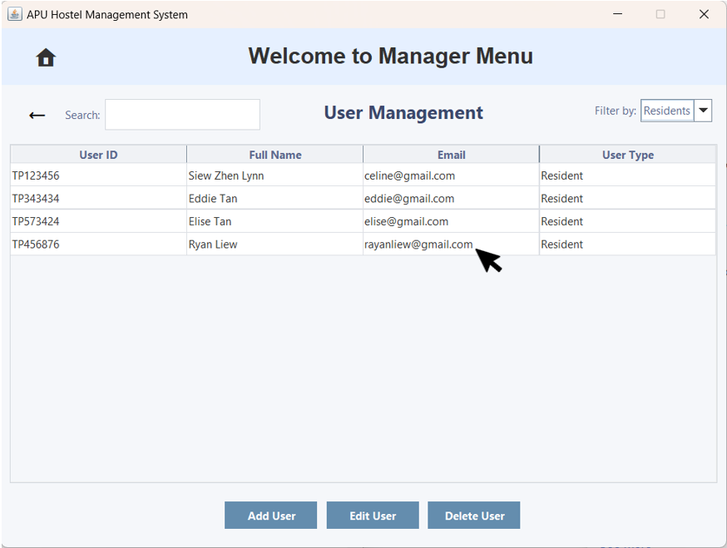  Figure 3.3.2.26 – User Management
After editing, the user clicks the 'Save' button to save the updated information. | The user account will be saved successfully and will immediately appear in User Management.
Delete User
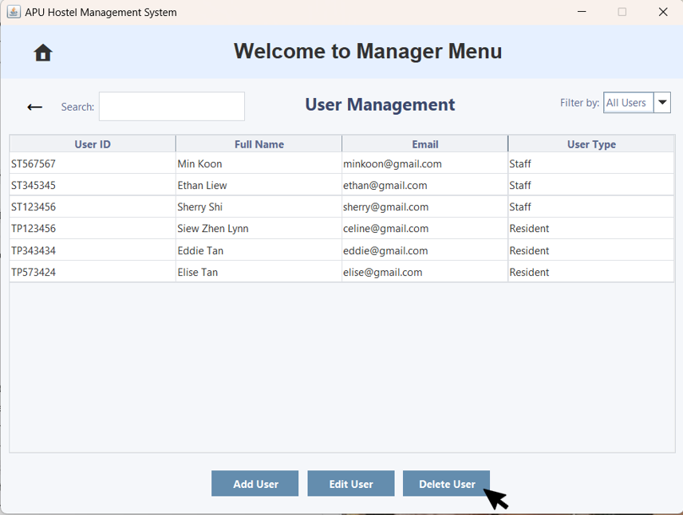  Figure 3.3.2.27 – Rate Management | 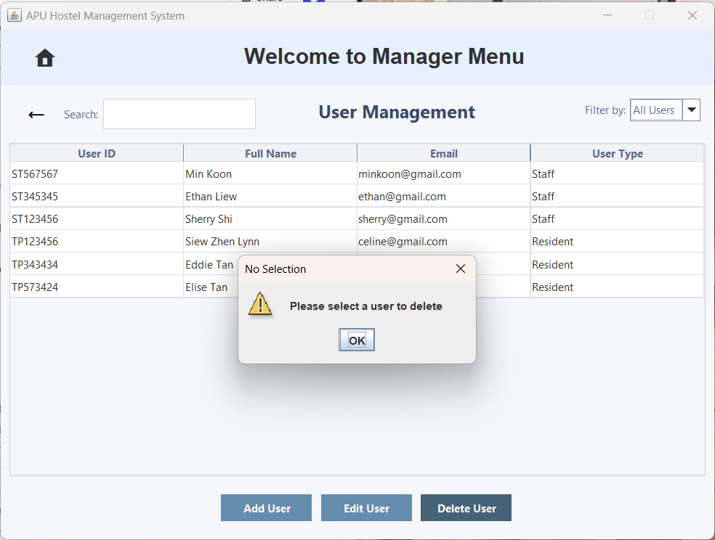  Figure 3.3.2.28 – 'No Selection' Pop-up Window
If the user doesn't select a user and clicks the 'Delete User' button. | A 'No Selection' pop-up window will appear, stating 'Please select a user to delete'.
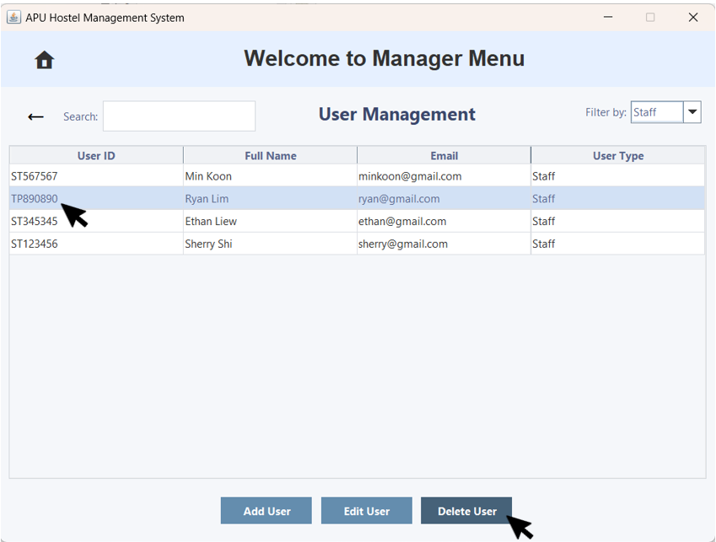  Figure 3.3.2.25 – User Management with Delete User | 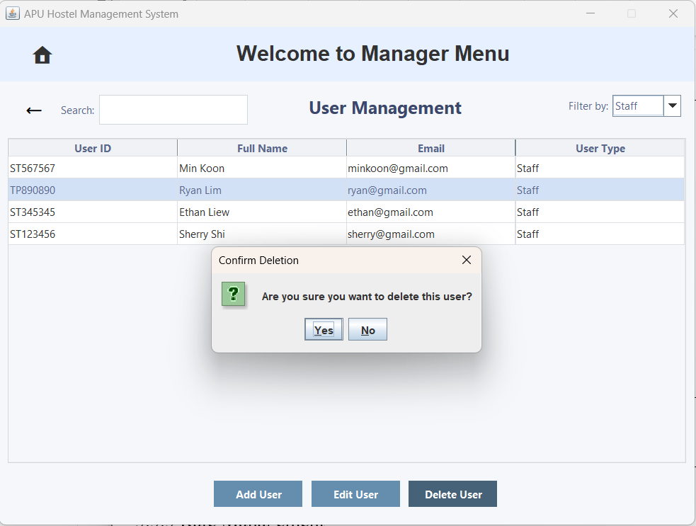  Figure 3.3.2.26 – 'Confirm Deletion' Pop-up Window
The user clicks on an account and then clicks the 'Delete User' button to delete the account. | A 'Confirm Deletion' pop-up window will appear, prompting the user with 'Are you sure you want to delete?
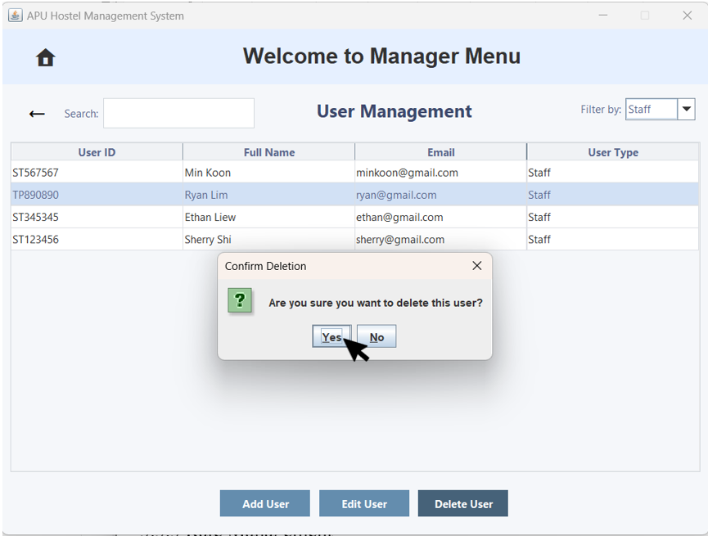  Figure 3.3.2.27 – 'Confirm Deletion' Pop-up Window | 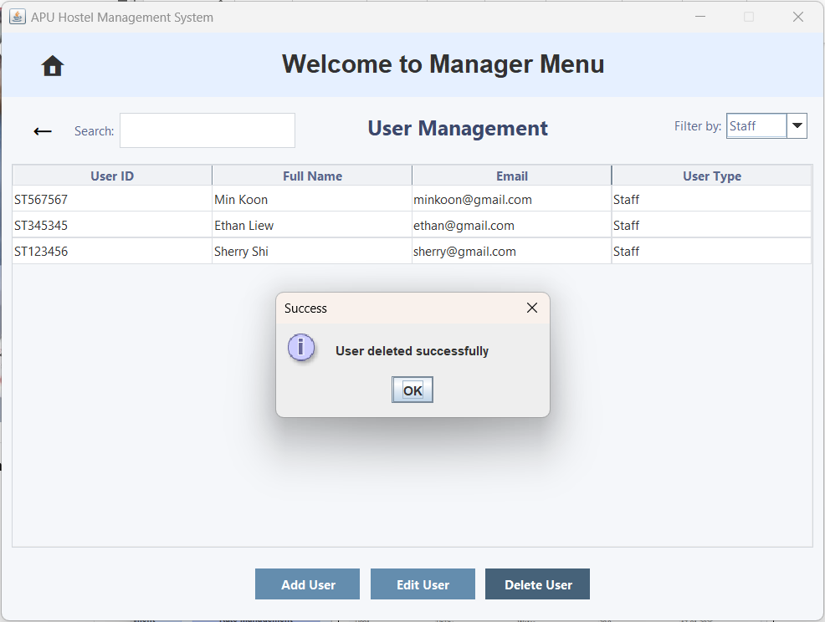  Figure 3.3.2.28 – 'Success' Pop-up Window
The user clicks the 'Yes' button to confirm the deletion. | A 'Success' pop-up window will appear, The user account will be deleted successfully.
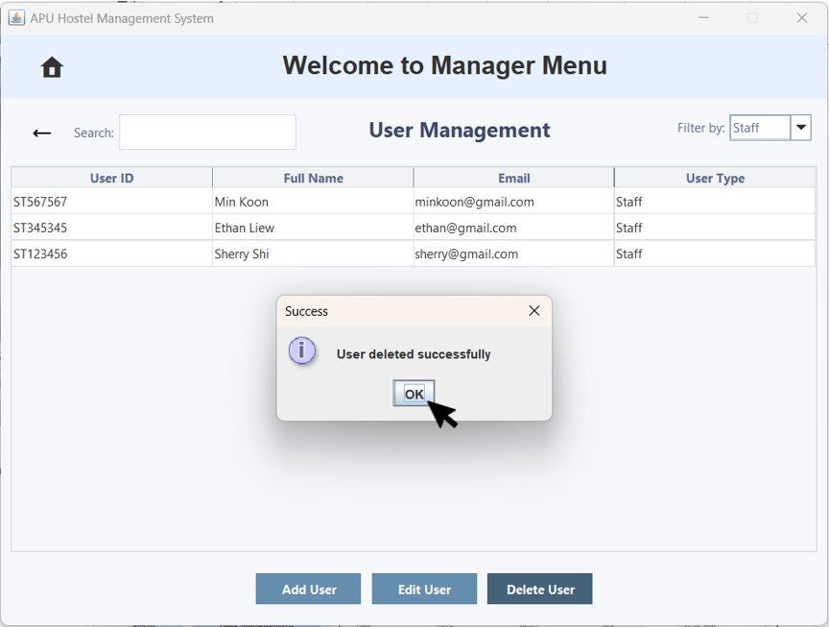  Figure 3.3.2.29 – 'Success' Pop-up Window | 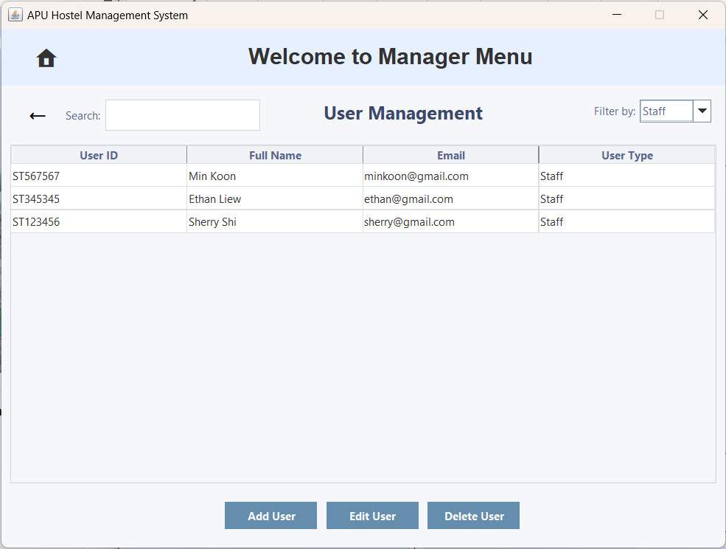  Figure 3.3.2.30 – User Management
The user clicks the 'OK' button. | The user account is deleted successfully and will immediately disappear from User Management.
Filter By
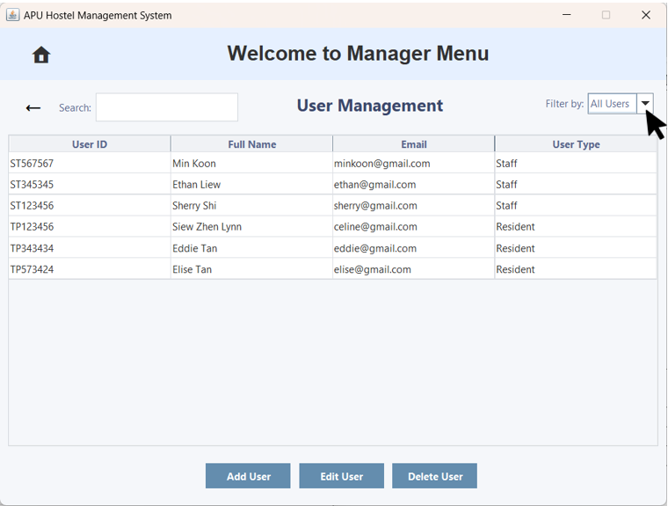  Figure 3.3.2.30 – User Management with the 'Filter by Sort' Option | 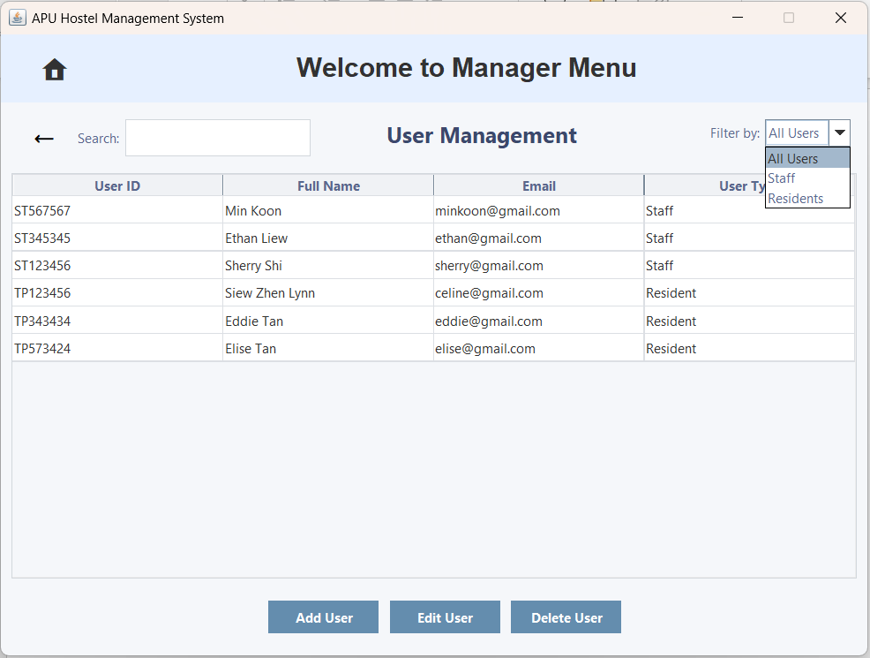  Figure 3.3.2.31 – User Management with 'Filter by Sort' Option
The user can click the 'Filter by Sort' dropdown arrow to view the list of options. | It now displays a list of options: All Users, Staff, and Residents.
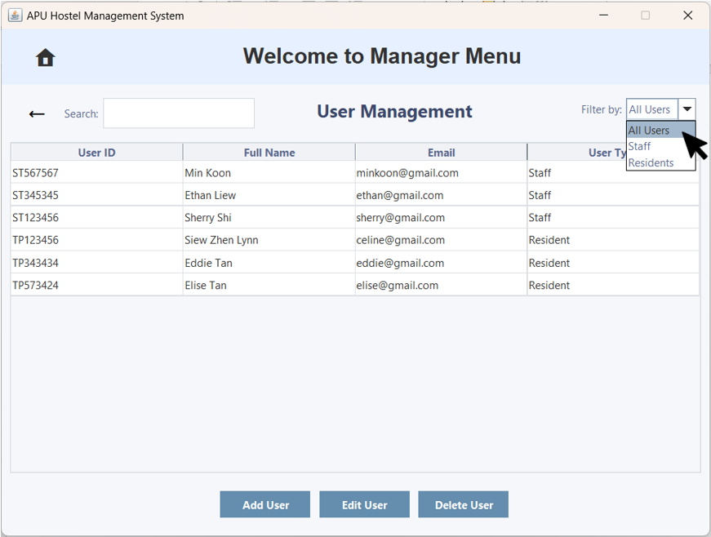Figure 3.3.2.32 – User Management with the 'Filter by Sort' Option Selected | 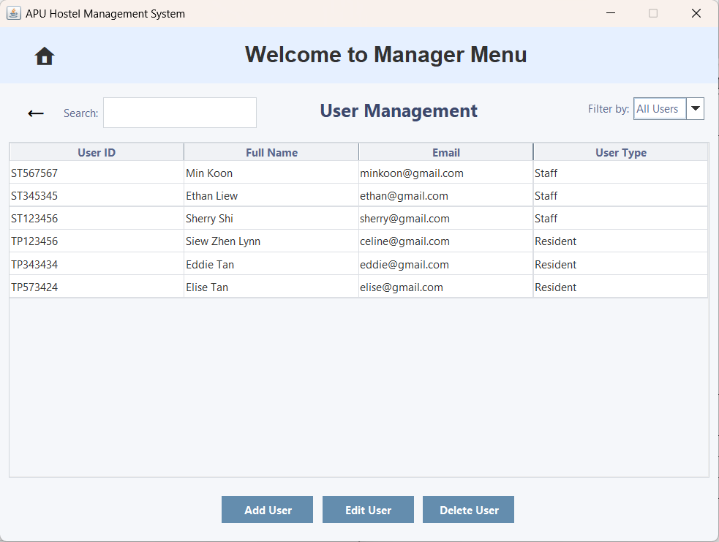  Figure 3.3.1 33 – User Management with the 'Filter by Sort' Option Selected for All Users
The user clicks the 'All Users' option. | It now displays all the user account in this system.
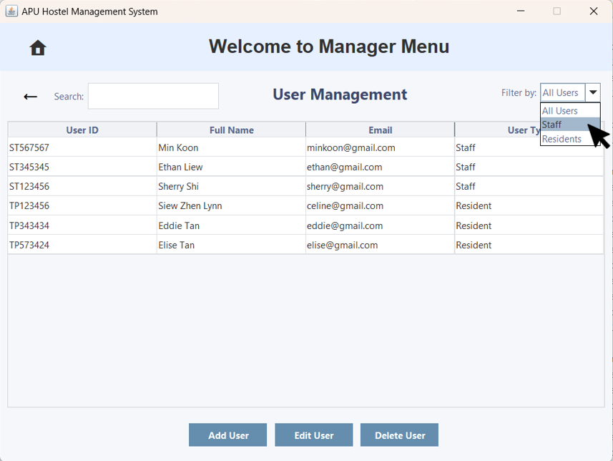Figure 3.3.2.34 – User Management with the 'Filter by Sort' Option Selected |   Figure 3.3.1 35 – User Management with the 'Filter by Sort' Option Selected for All Users
The user clicks the 'Staff' option. | It now displays only staff user accounts.
Figure 3.3.2.34 – User Management with the 'Filter by Sort' Option Selected | 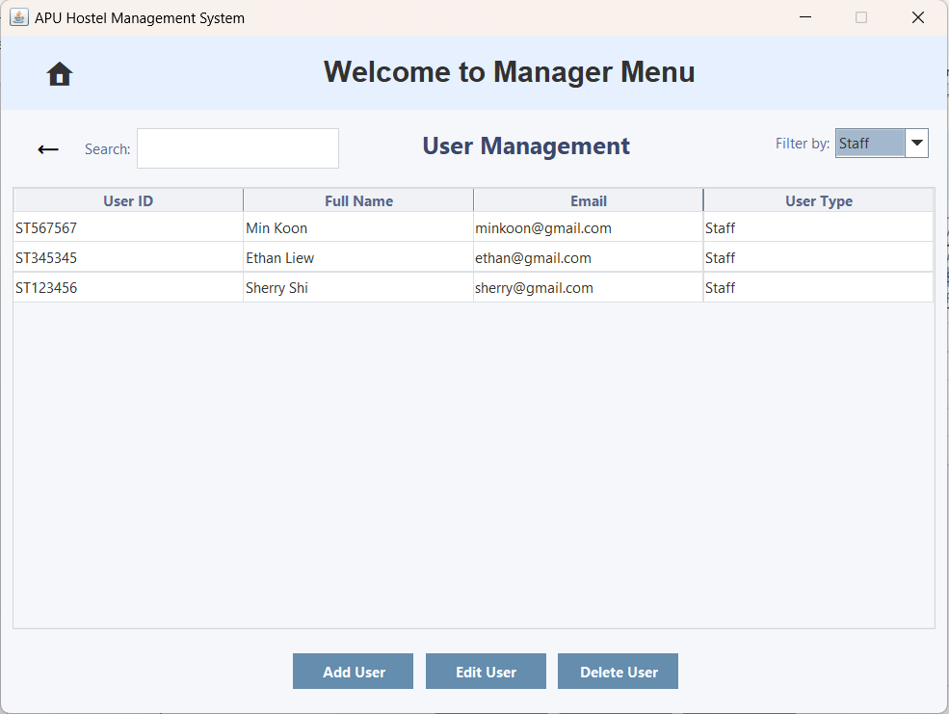  Figure 3.3.1 35 – User Management with the 'Filter by Sort' Option Selected for Staff
The user clicks the 'Staff' option. | It now displays only staff user accounts.
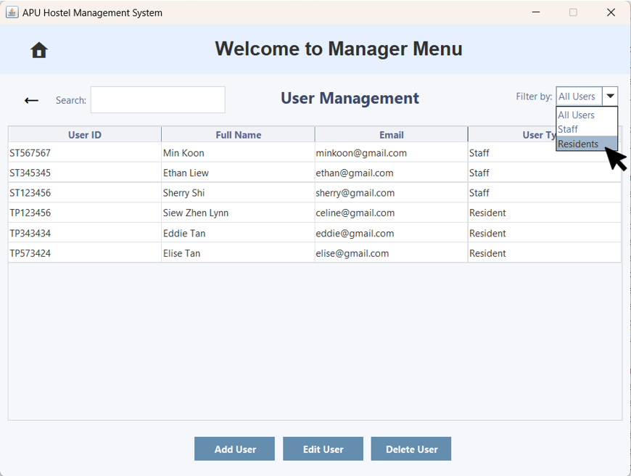Figure 3.3.2.34 – User Management with the 'Filter by Sort' Option Selected | 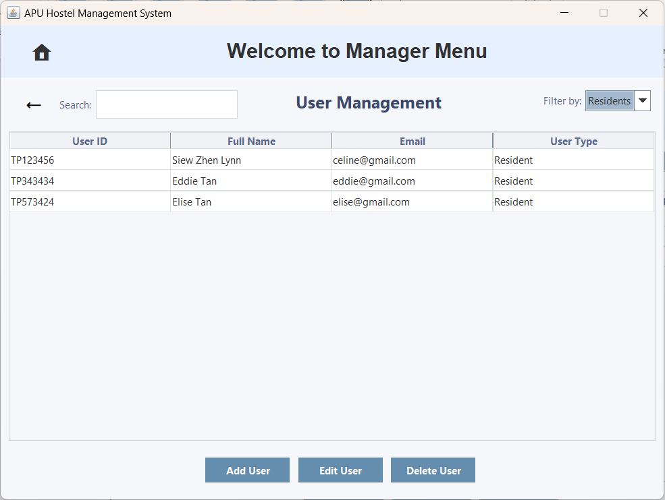  Figure 3.3.2.35 – User Management with the 'Filter by Sort' Option Selected for Residents
The user clicks the 'Residents' option. | It now displays only resident user accounts.
Search Bar
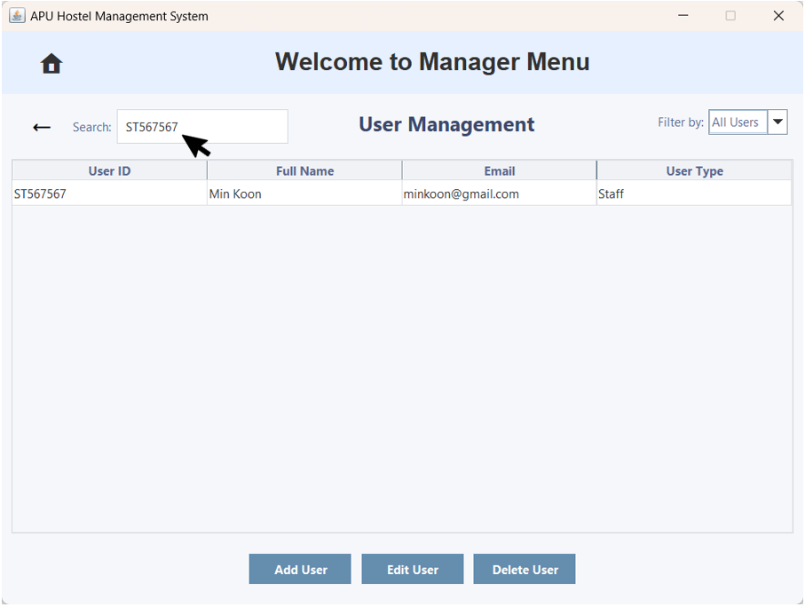  Figure 3.3.2.36 – User Management with the Search Bar | 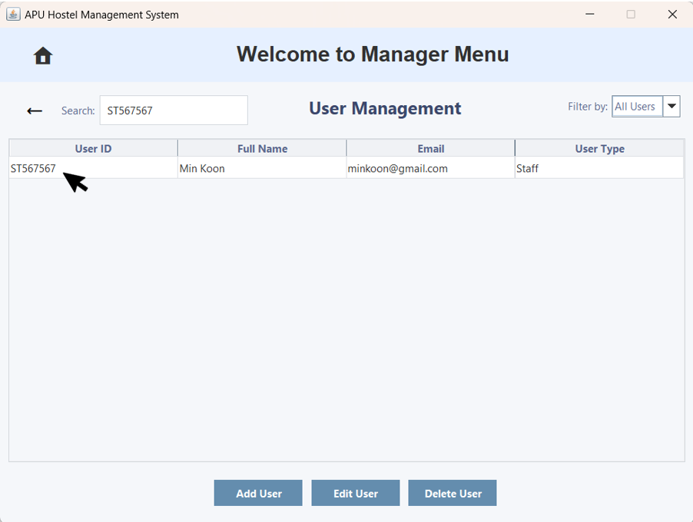  Figure 3.3.2.37 – User Management
A user can enter a specific user ID in the search bar to find it. | It will then display the user ID.
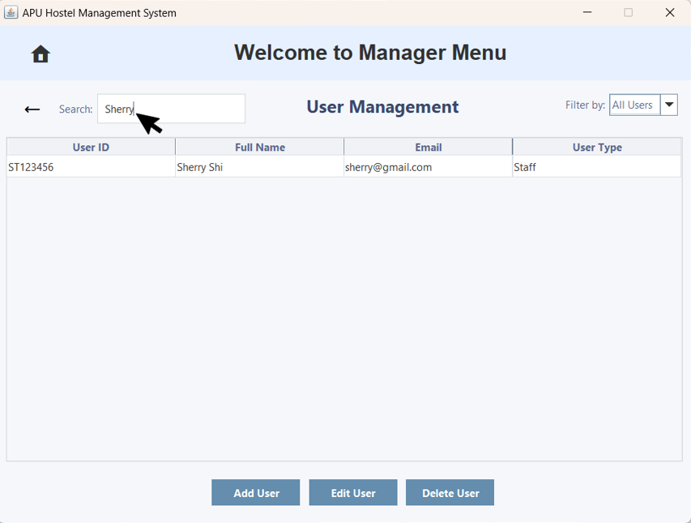  Figure 3.3.2.38 – User Management with the Search Bar | 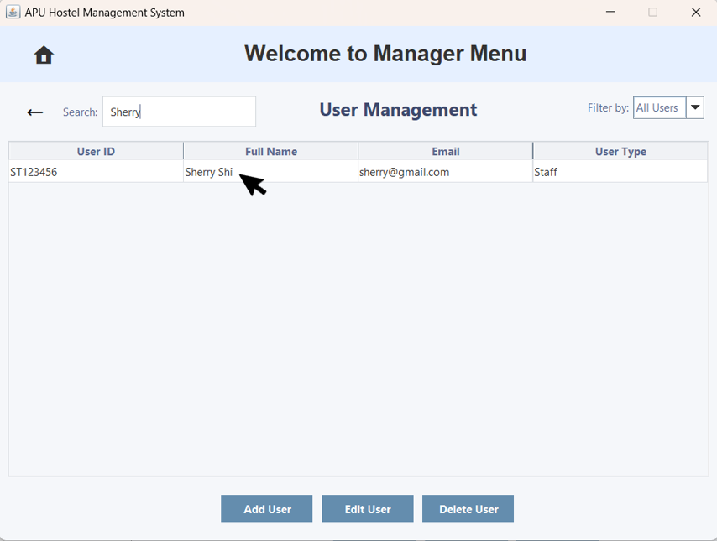  Figure 3.3.2.39 – User Management
A user can enter a specific name in the search bar to find it. | It will then display the name.
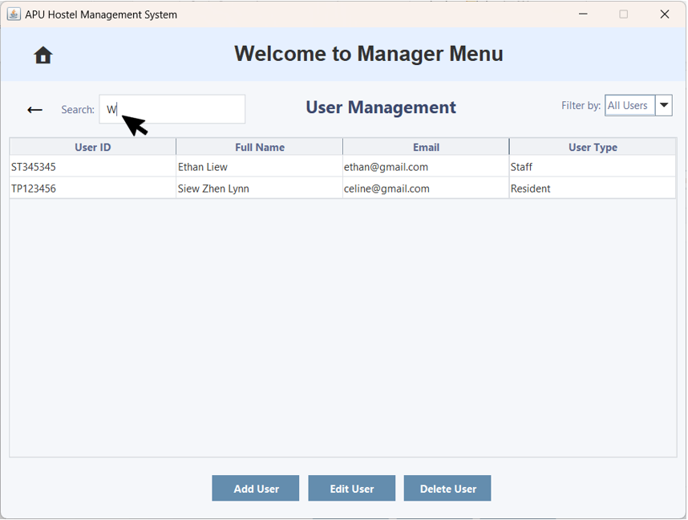  Figure 3.3.2.40 – User Management with the Search Bar | 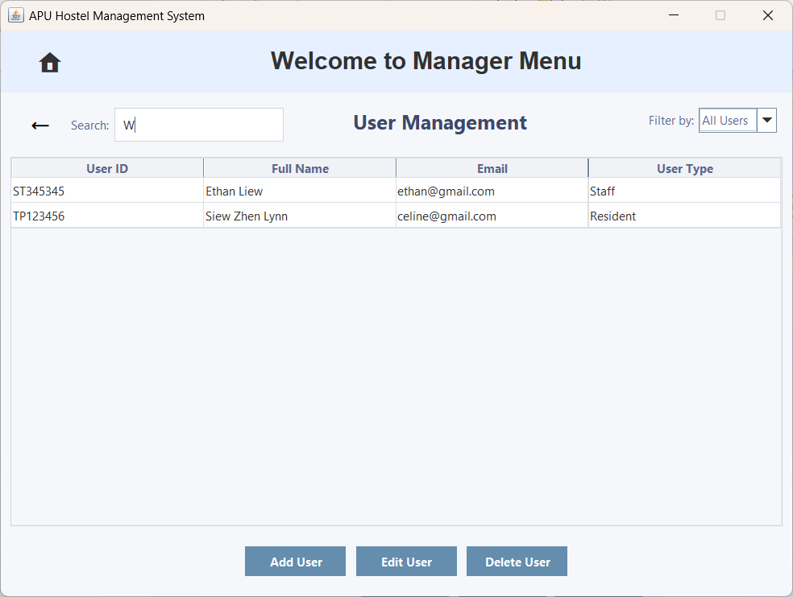  Figure 3.3.2.41 – User Management
A user can enter an alphabet in the search bar to find it. | It will then display the User ID or Full name that includes the alphabet.
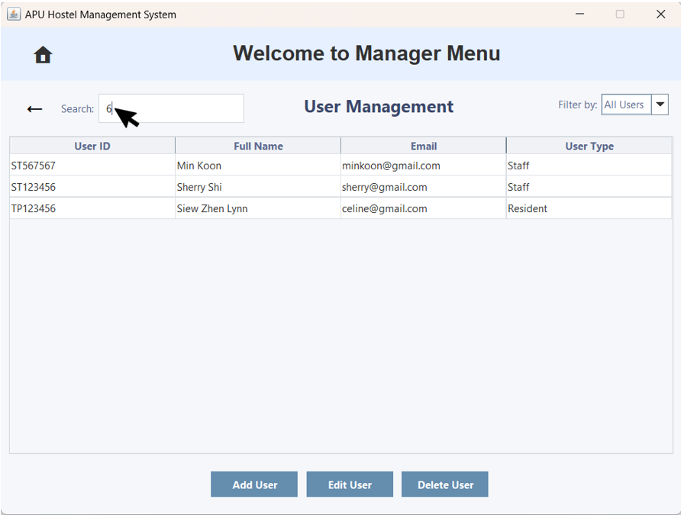  Figure 3.3.2.42 – User Management with the Search Bar | 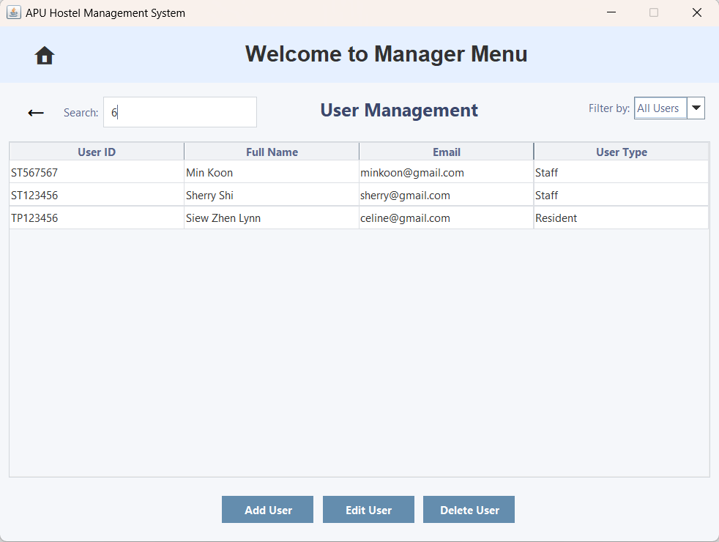  Figure 3.3.2.43 – User Management
A user can enter a number in the search bar to find it. | It will then display the User ID that includes the number.

3.3.3 Rate Management
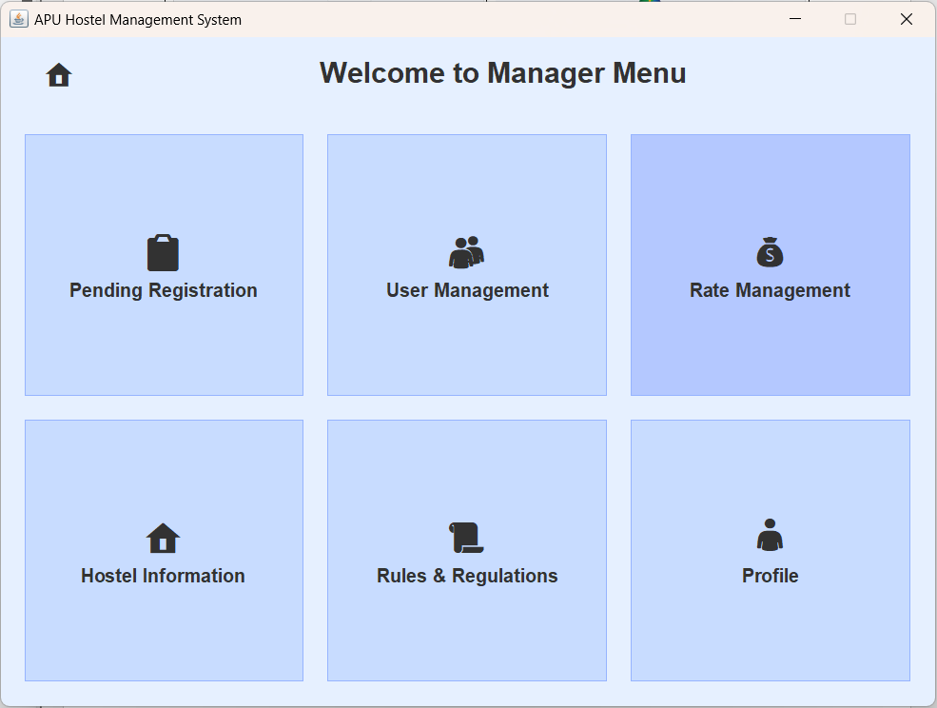  Figure 3.3.3.1 – Manager Menu | 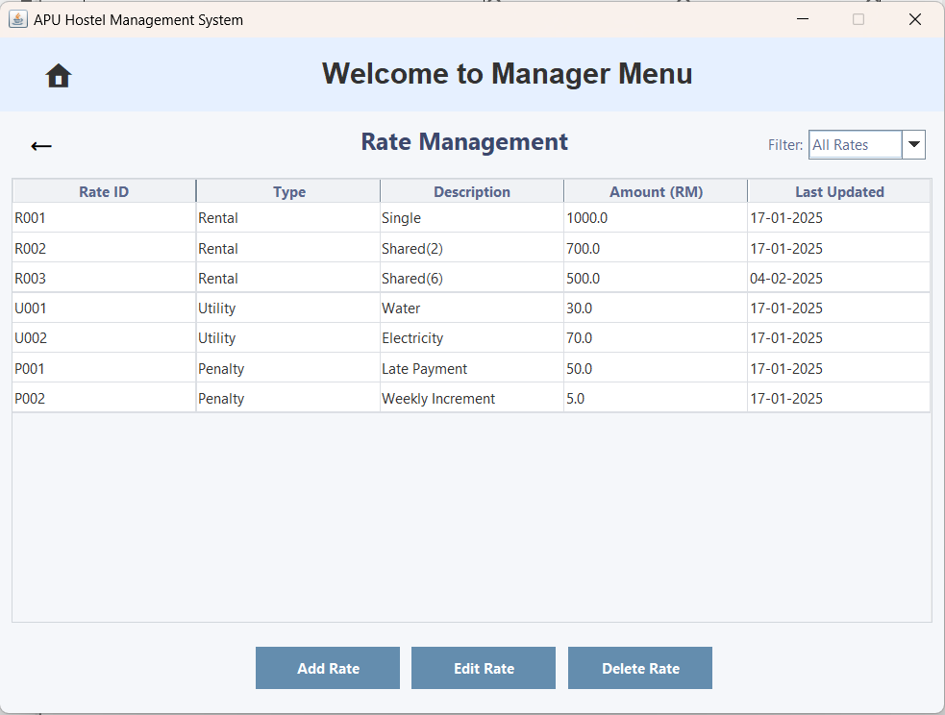  Figure 3.3.3.2 – Rate Management
The user clicks on 'Rate Management' to navigate to the Rate Management page. | The user will be brought to the Rate Management page.
Add Rate
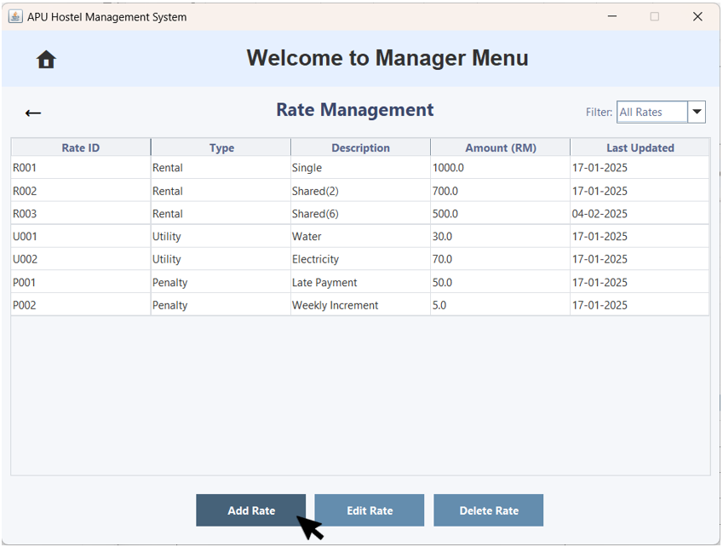  Figure 3.3.3.3 – Rate Management with Add Rate | 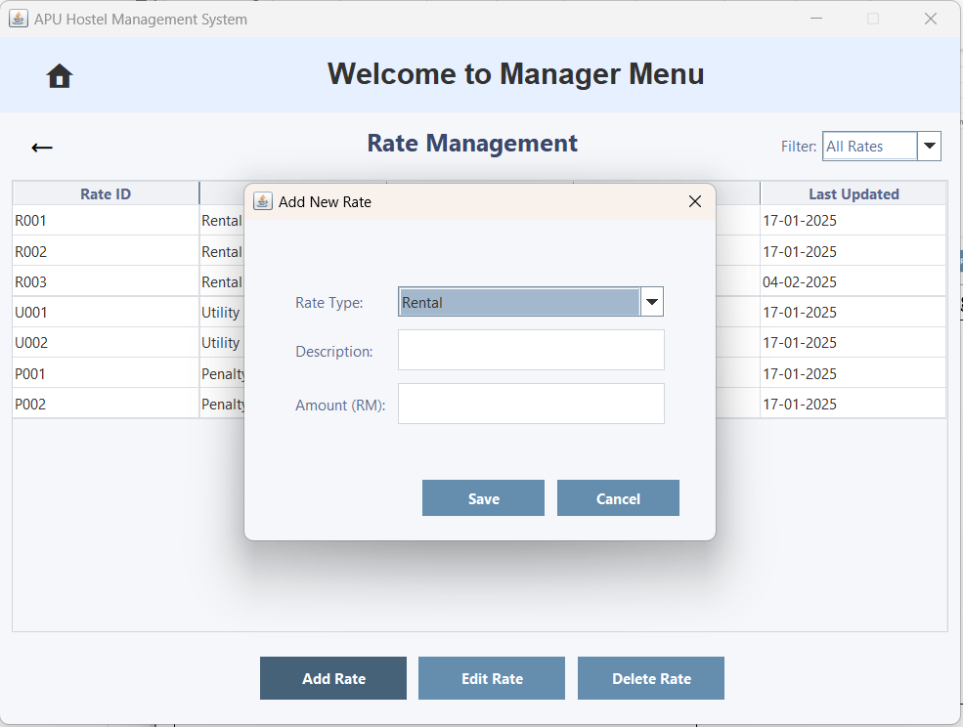  Figure 3.3.3.4 – 'Add New Rate' Pop-up Window
The user clicks 'Add Rate' to add a new rate. | An 'Add New Rate' pop-up window will appear, allowing the user to enter the new rate's details, including the description and amount, to add them.
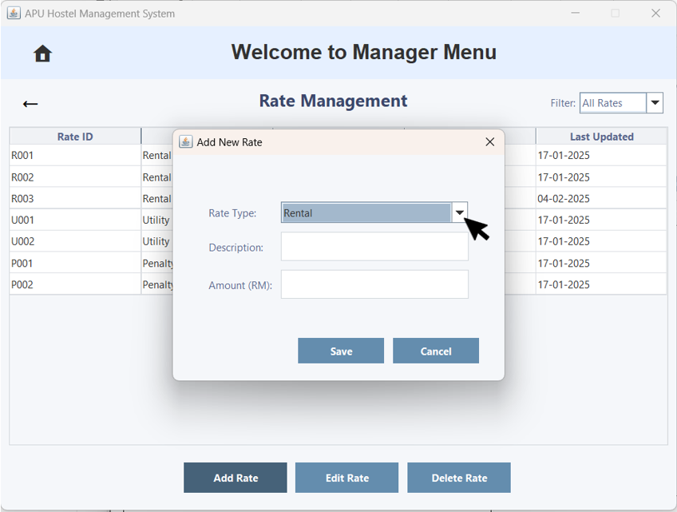  Figure 3.3.3.5 – 'Add New Rate' Pop-up Window with the 'User Type' dropdown arrow | 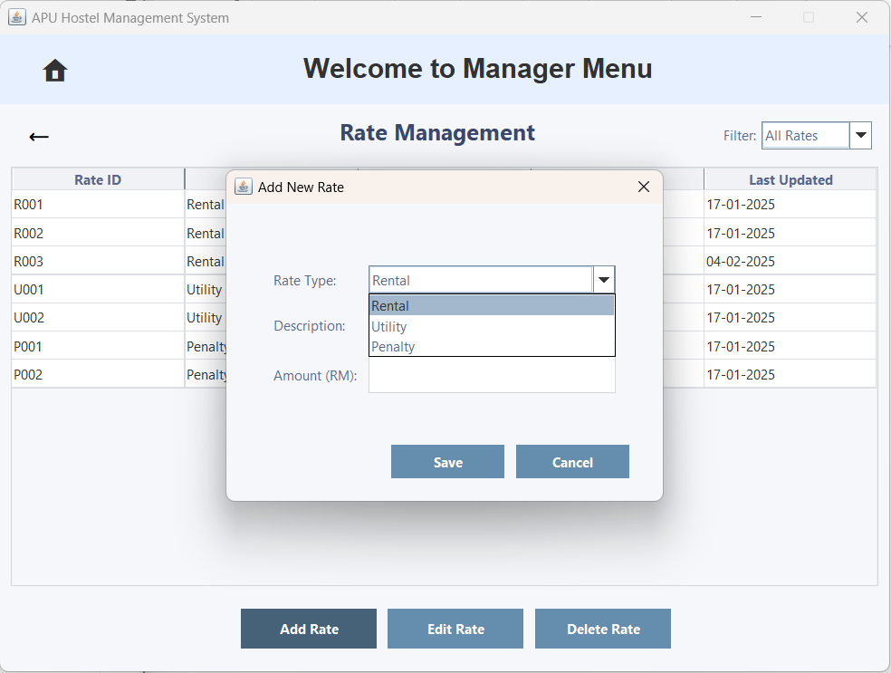  Figure 3.3.3.6 – 'Add New Rate' Pop-up Window with the 'User Type' Option
The user can click the 'Rate Type' dropdown arrow to view the list of options. | It now displays three options: Rental, Utility and Penalty.
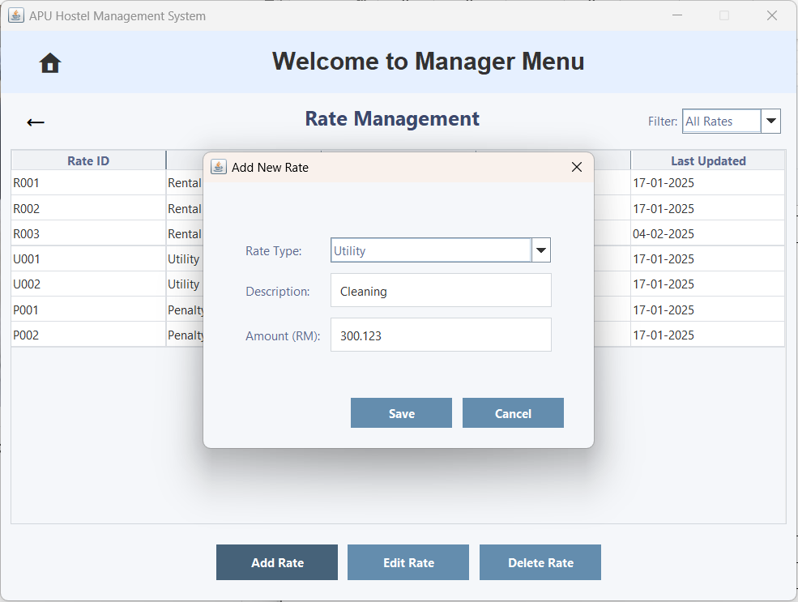  Figure 3.3.3.7 – 'Add New Rate' Pop-up Window | 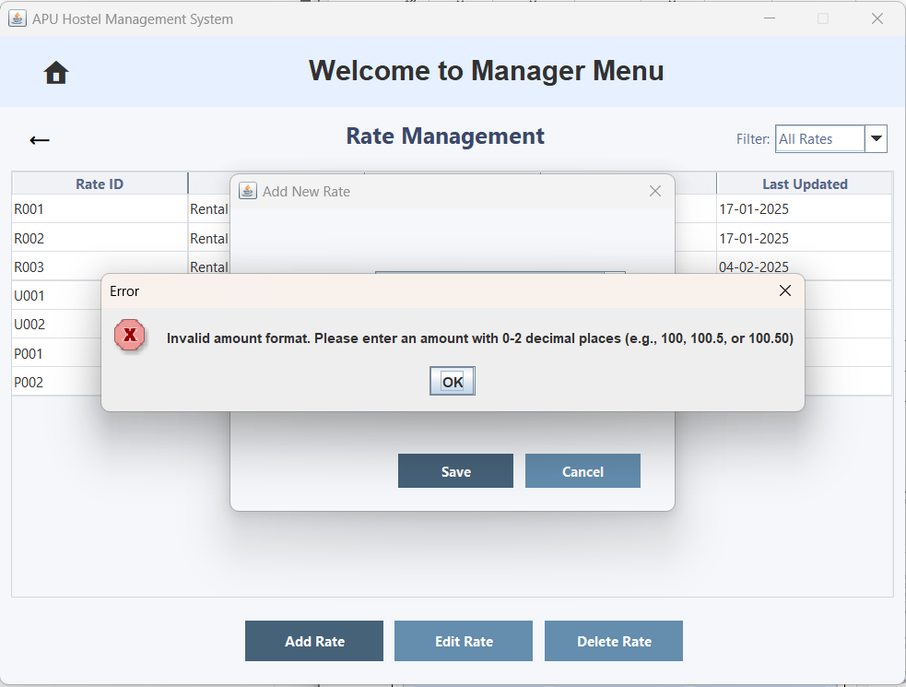  Figure 3.3.3.8 – 'Error' Pop-up Window
The user can enter a description for the rate type. If the amount is invalid, an error pop-up will appear. | An 'Error' pop-up window will appear, stating that the amount must have 0 to 2 decimal places.
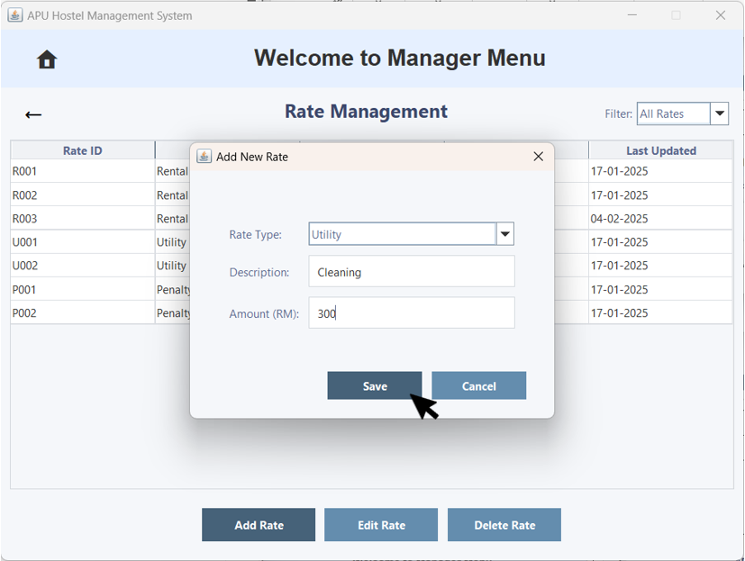  Figure 3.3.3.9 – 'Add New Rate' Pop-up Window with Save Button | 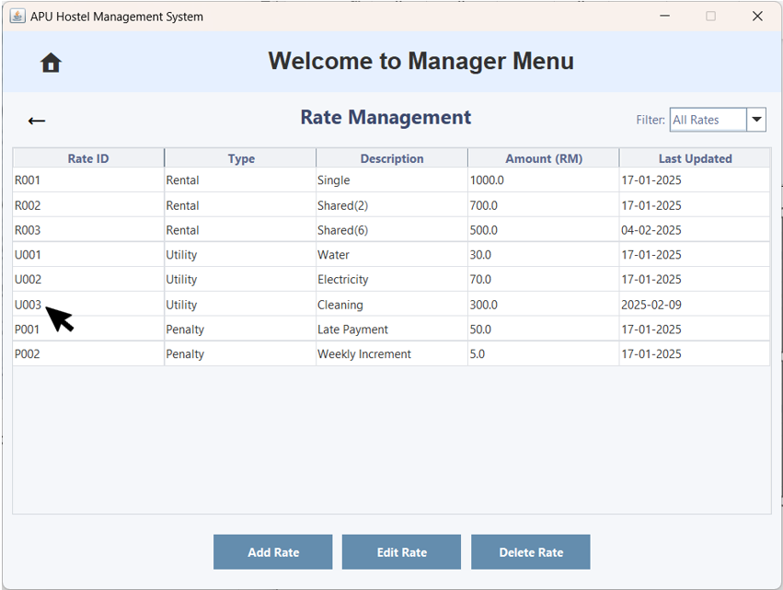  Figure 3.3.3.10 – Rate Management
If all fields are correctly filled in, the user clicks 'Save' to proceed. | The rate will be saved successfully and will immediately appear in Rate Management. The Rate ID will be generated automatically and sequentially: Rental as Rxxx, Utility as Uxxx, and Penalty as Pxxx.
Edit Rate
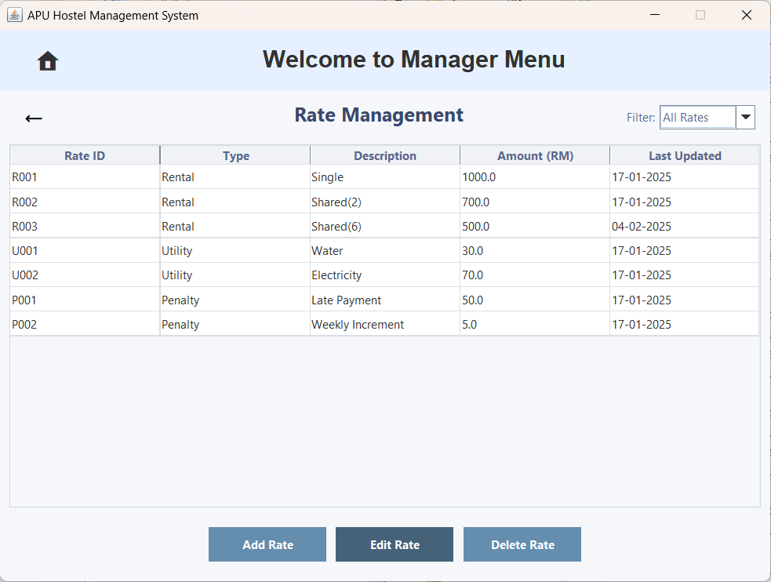  Figure 3.3.3.11 – Rate Management | 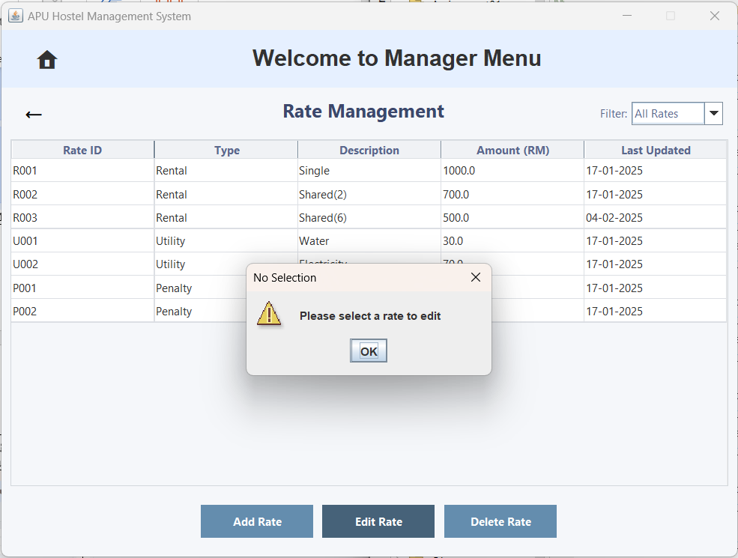  Figure 3.3.3.12 – 'No Selection' Pop-up Window
If the user doesn't select a rate and clicks the 'Edit Rate' button. | A 'No Selection' pop-up window will appear, stating 'Please select a rate to edit'.
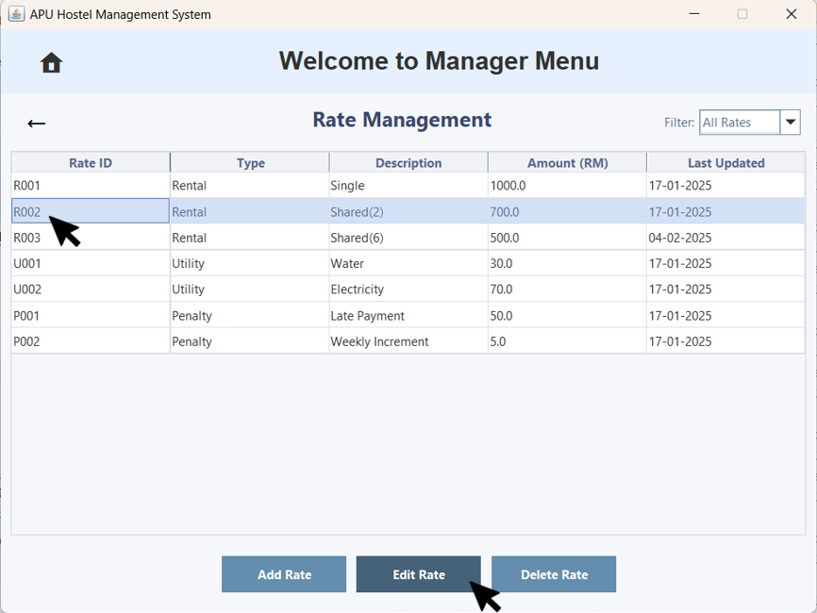  Figure 3.3.3.13 – Rate Management with Edit User | 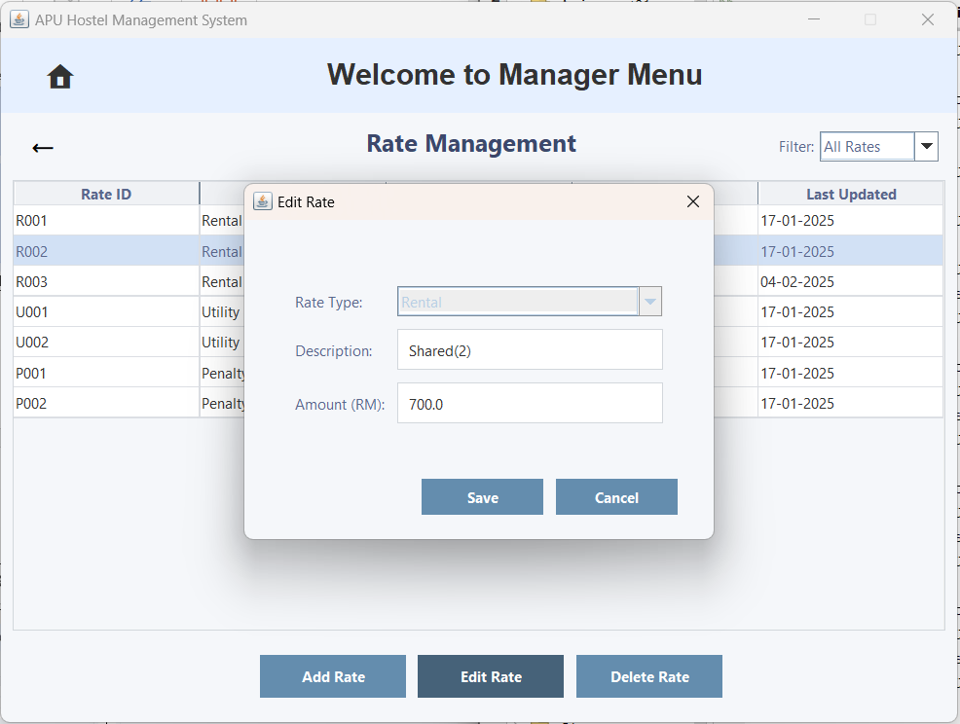  Figure 3.3.3.14 – 'Edit Rate' Pop-up Window
The user clicks on a rate and then clicks the 'Edit Rate' button to edit the Rate details. | An 'Edit Rate' pop-up window will appear, displaying the current rate information and allowing user to make edits.
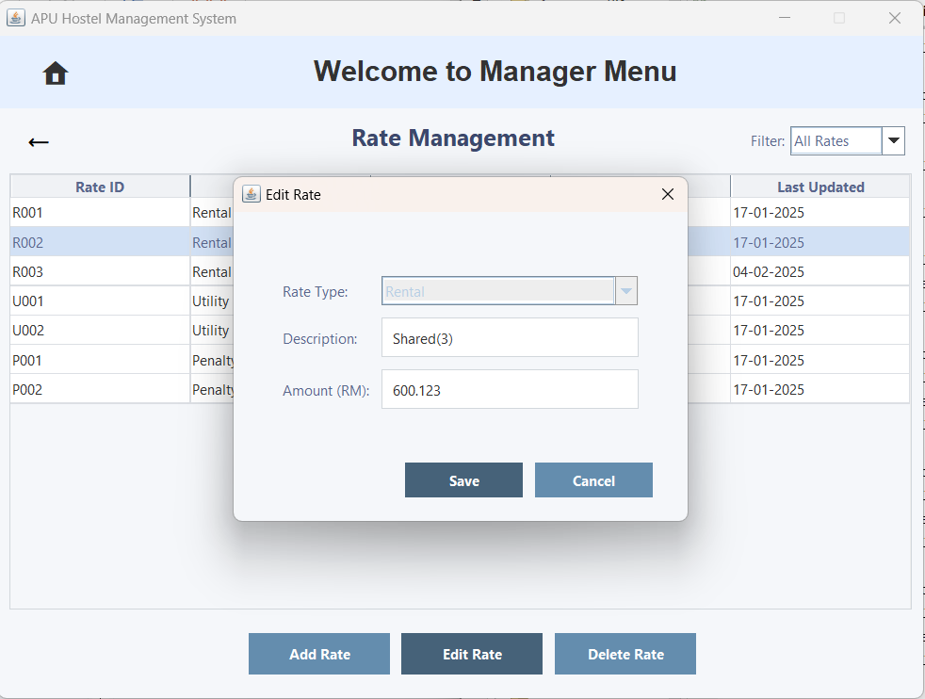  Figure 3.3.3.15 – 'Edit Rate' Pop-up Window | 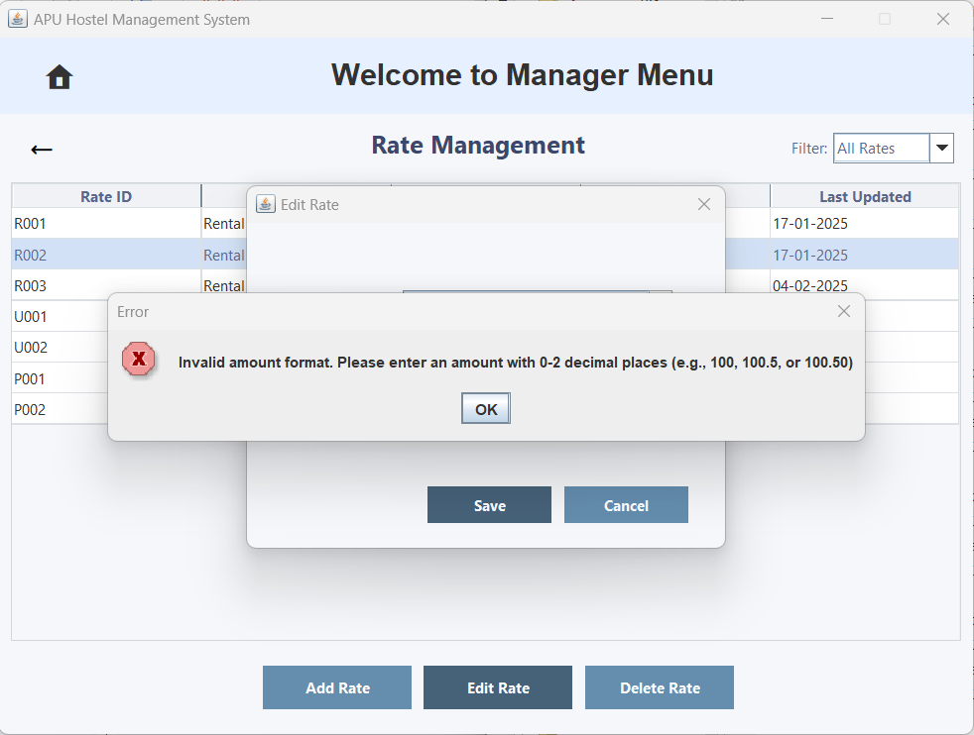  Figure 3.3.3.16 – 'Error' Pop-up Window
If the amount is invalid, an error pop-up will appear. | An 'Error' pop-up window will appear, stating that the amount must have 0 to 2 decimal places.
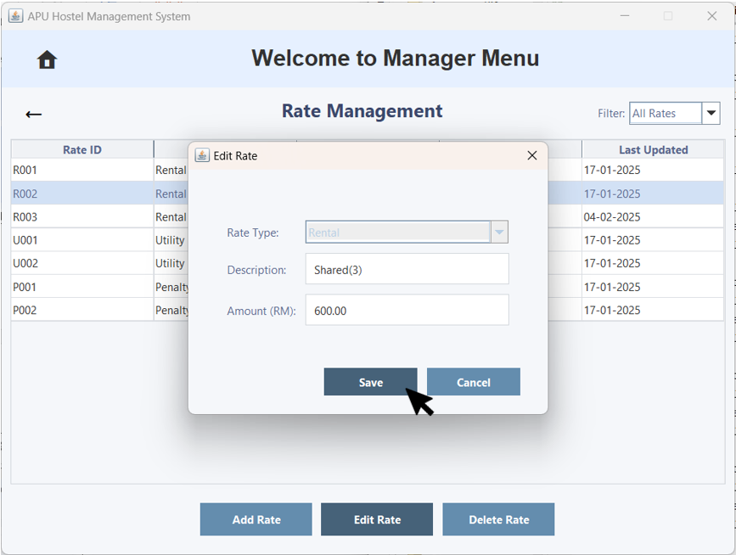  Figure 3.3.3.17 – 'Edit Rate' Pop-up Window | 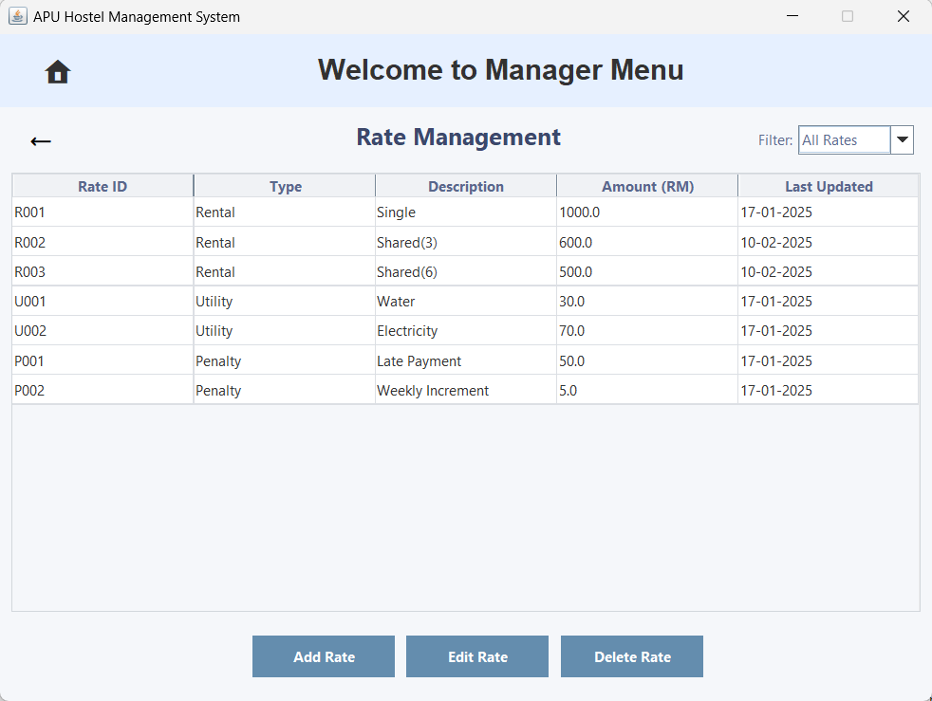  Figure 3.3.3.18 – Rate Management
If all fields are correctly filled in, the user clicks 'Save' to proceed. | The rate will be modified successfully as the picture show the R002 description and amount updated and the Last Updated Date will also update to the day modify
Delete Rate
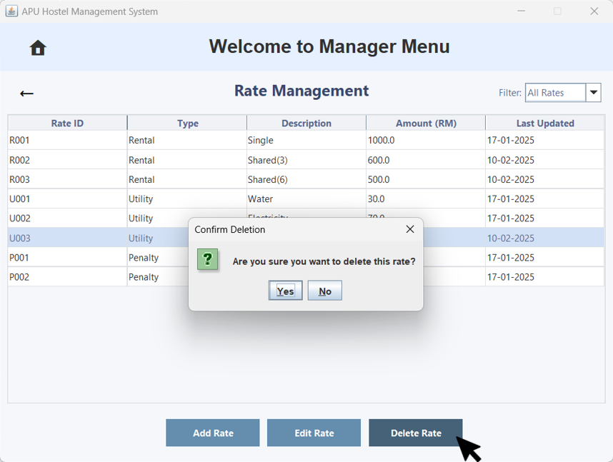  Figure 3.3.3.19 – Rate Management with Delete Rate | 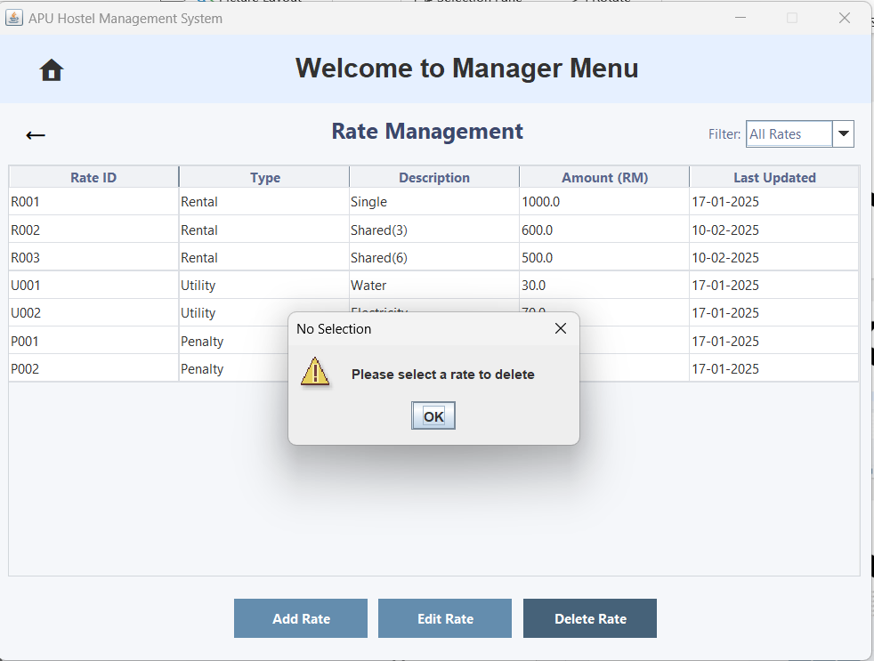  Figure 3.3.3.20 – 'No Selection' Pop-up Window
If the user doesn't select a rate and clicks the 'Delete Rate' button. | A 'No Selection' pop-up window will appear, stating 'Please select a rate to delete'.
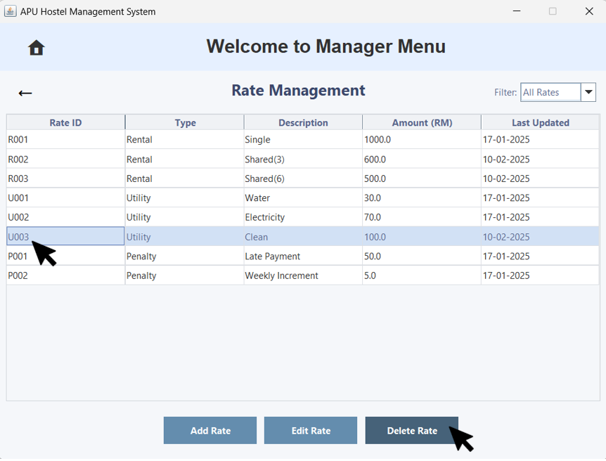  Figure 3.3.3.21 – Rate Management with Delete User | 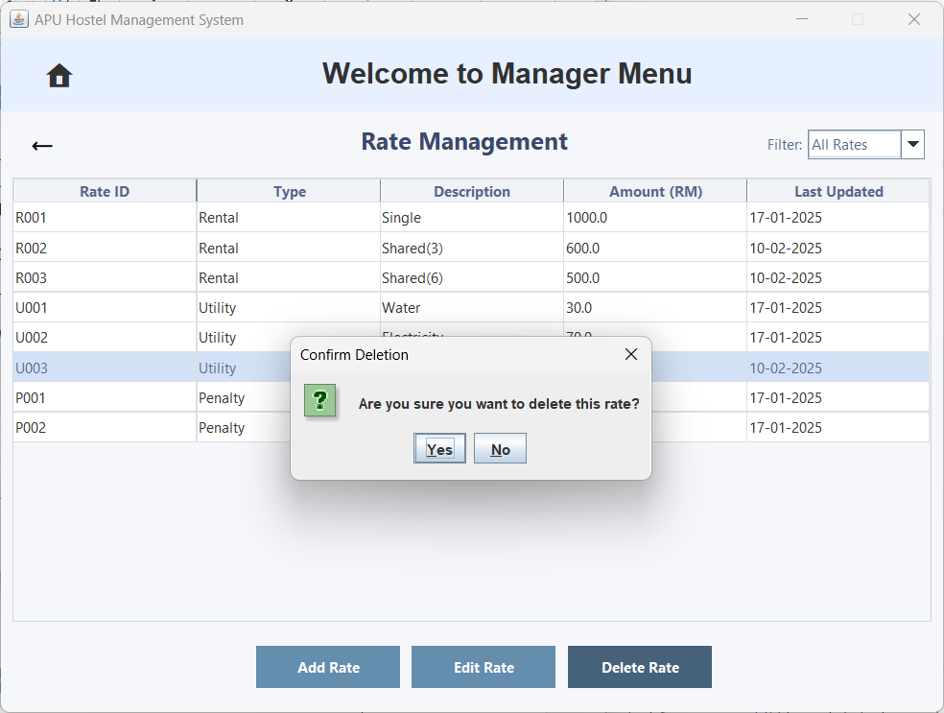  Figure 3.3.3.22 – 'Confirm Deletion' Pop-up Window
The user clicks on a rate and then clicks the 'Delete Rate' button to remove it. | A 'Confirm Deletion' pop-up window will appear, prompting the user with 'Are you sure you want to delete? '
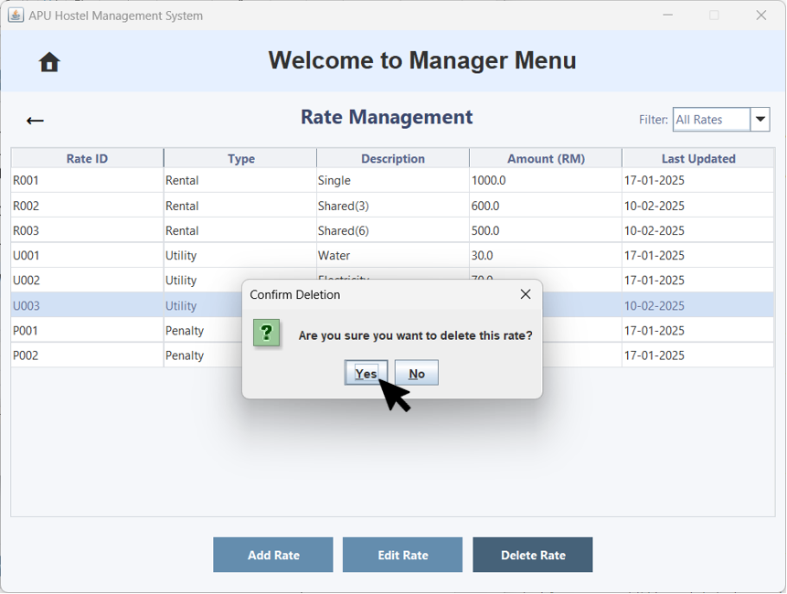  Figure 3.3.3.23 – 'Confirm Deletion' Pop-up Window | 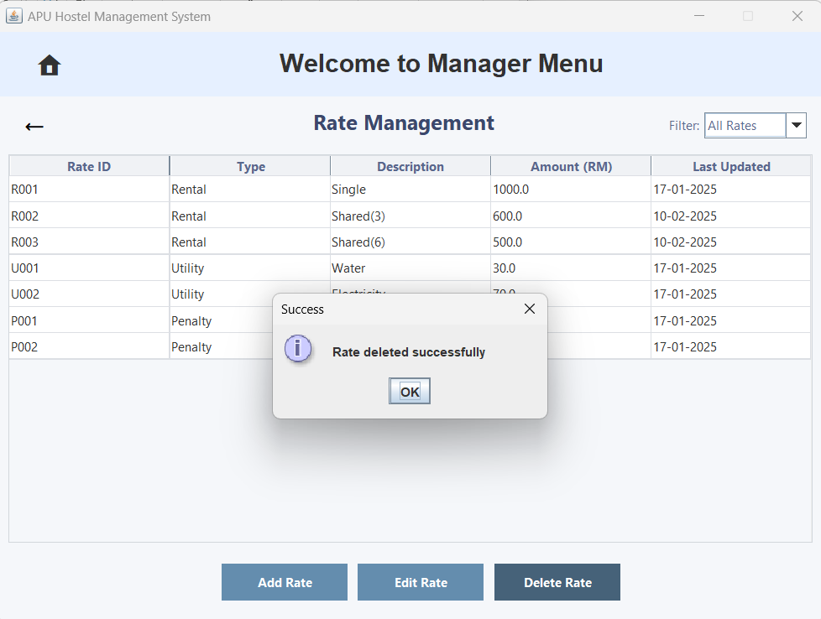  Figure 3.3.3.24 – 'Success' Pop-up Window
The user clicks the 'Yes' button to confirm the deletion. | A 'Success' pop-up window will appear, The rate will be deleted successfully.
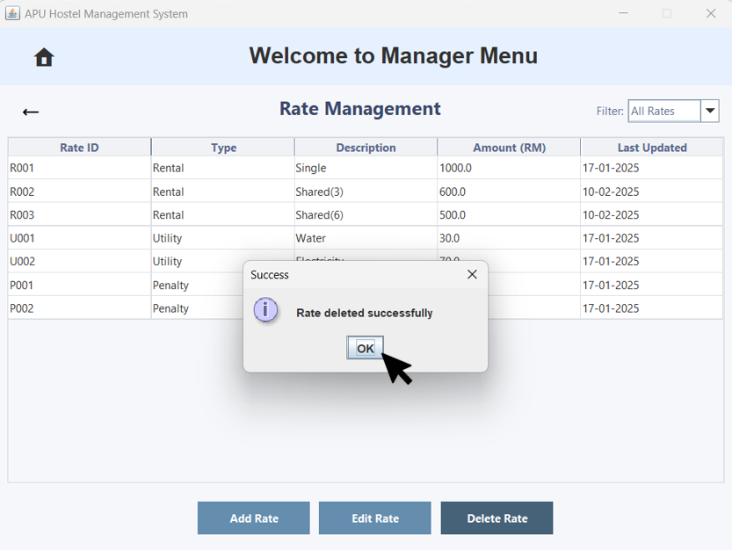  Figure 3.3.3.25 – 'Success' Pop-up Window | 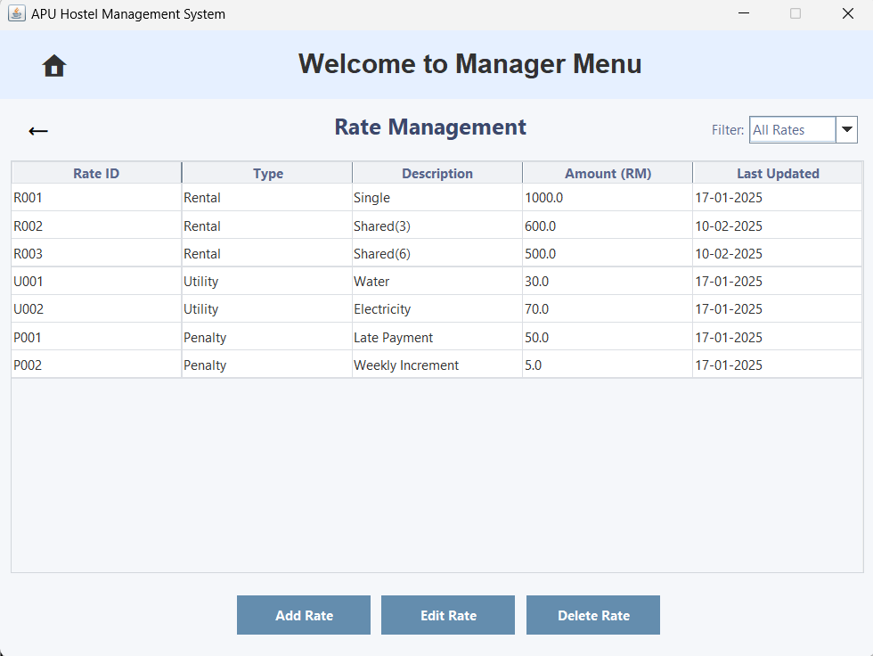  Figure 3.3.3.26 – Rate Management
The user clicks the 'OK' button. | The rate is deleted successfully and will immediately disappear from Rate Management.
Filter by
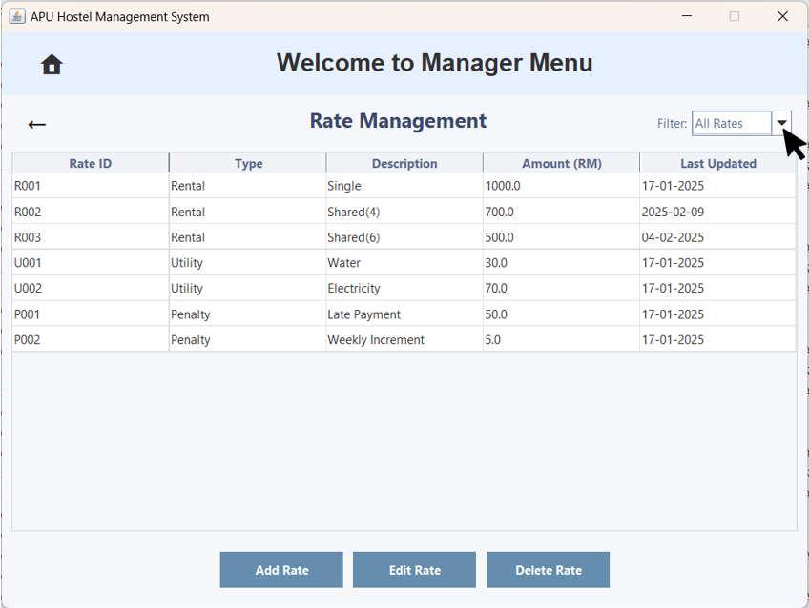  Figure 3.3.3.27 – Rate Management with the 'Filter by Sort' Option | 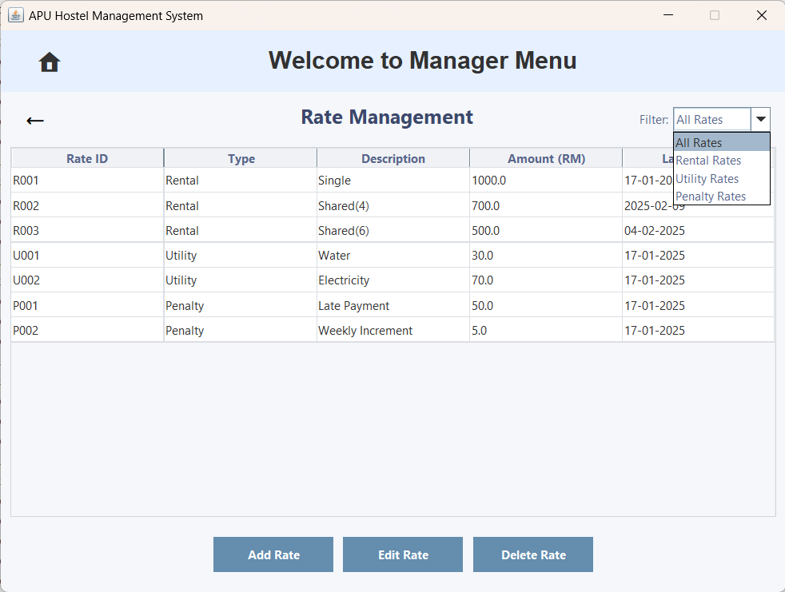  Figure 3.3.3.28 – Rate Management with the 'Filter by Sort' Option
The user can click the 'Filter by Sort' dropdown arrow to view the list of options. | It now displays a list of options: All Rates, Rental Rates, Utility Rates and Penalty Rates.
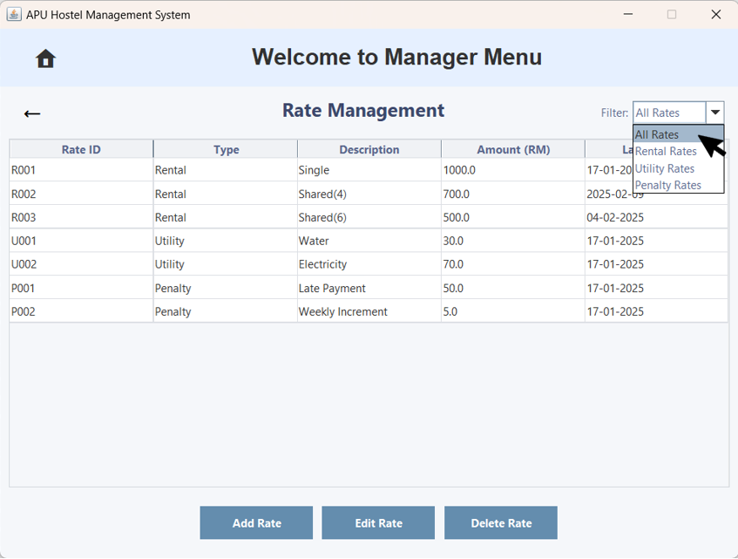  Figure 3.3.3.29 – Rate Management with the 'Filter by Sort' Option Selected | 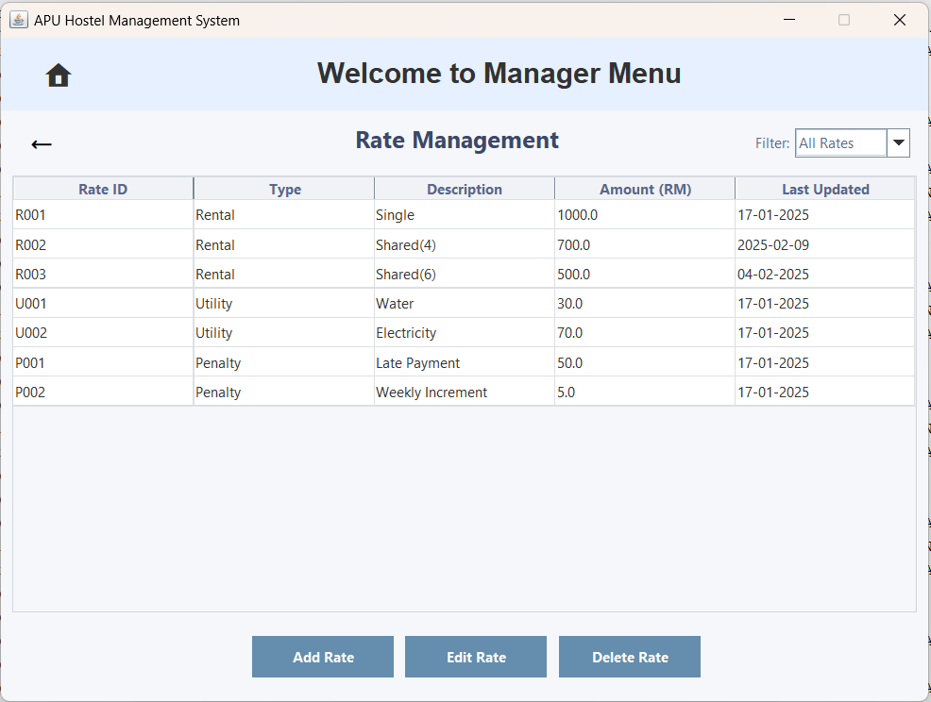  Figure 3.3.3.30 – Rate Management with the 'Filter by Sort' Option Selected for All Rates
The user clicks the 'All Rates' option. | It now displays all the rates in this system.
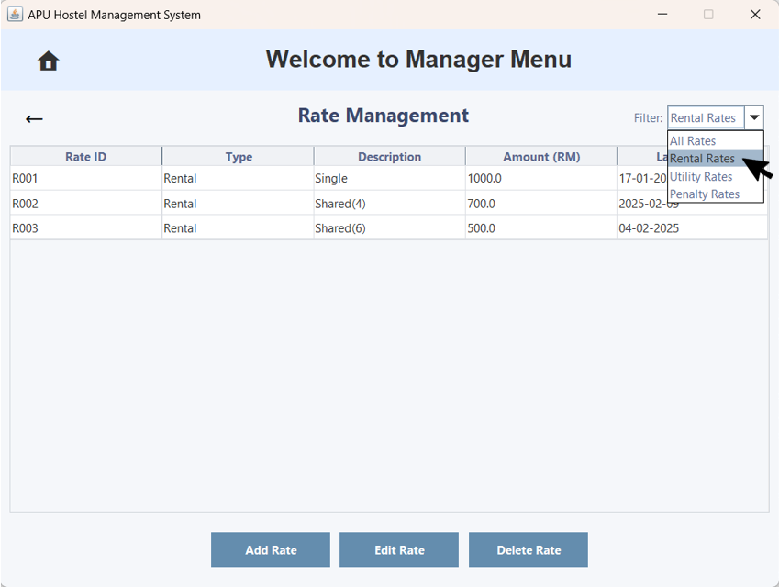Figure 3.3.3.31 – Rate Management with the 'Filter by Sort' Option Selected | 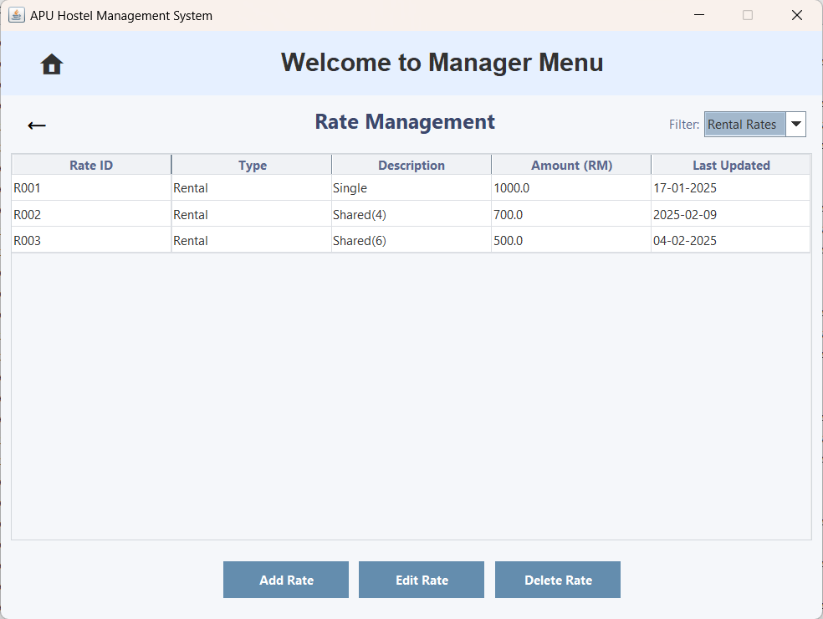  Figure 3.3.3.32 – Pending Registration with the 'Filter by Sort' Option Selected for Rental Rates
The user clicks the 'Rental Rates' option. | It now displays only rental rates.
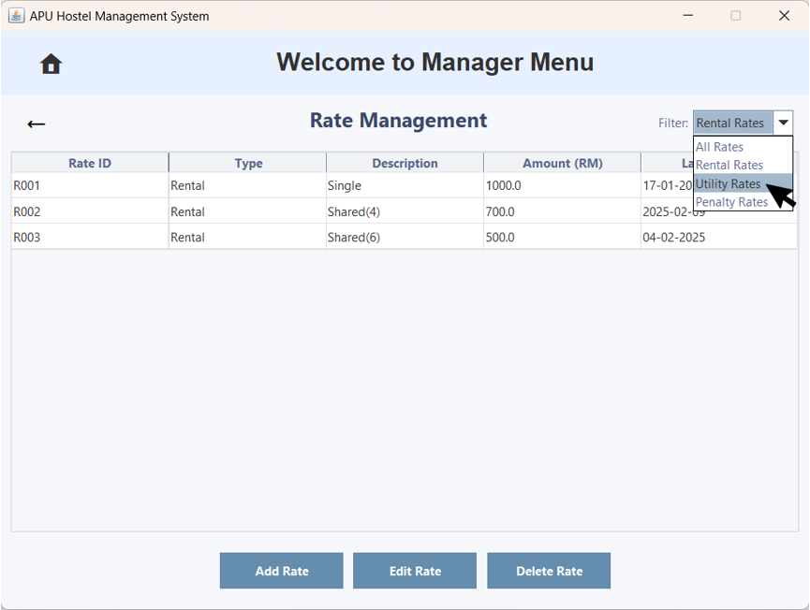Figure 3.3.3.33 – Rate Management with the 'Filter by Sort' Option Selected | 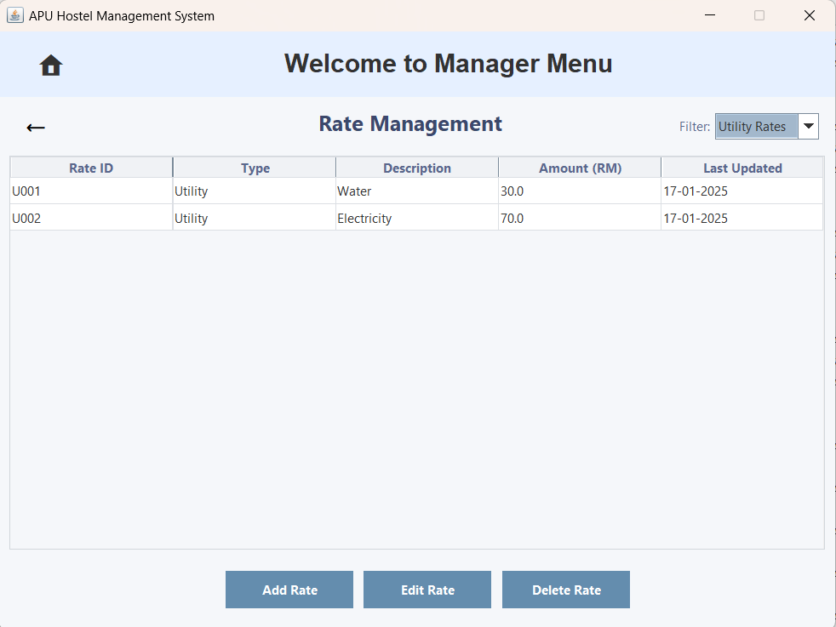  Figure 3.3.3.34 – Pending Registration with the 'Filter by Sort' Option Selected for Utility Rates
The user clicks the 'Utility Rates' option. | It now displays only utility rates.
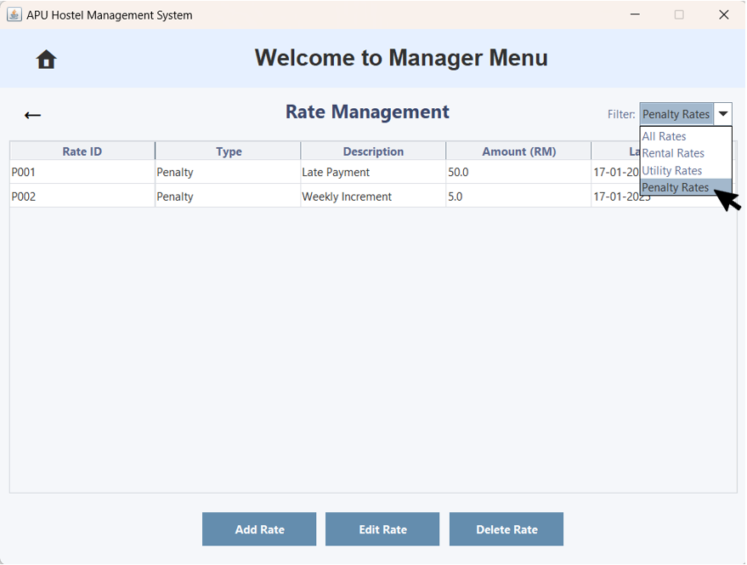Figure 3.3.3.35 – Rate Management with the 'Filter by Sort' Option Selected | 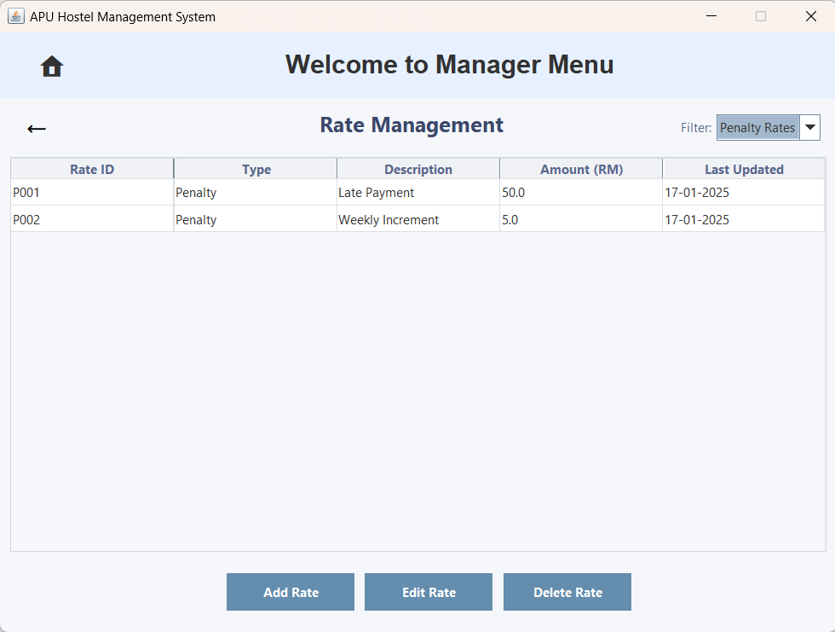  Figure 3.3.3.36 – Pending Registration with the 'Filter by Sort' Option Selected for Penalty Rates
The user clicks the 'Penalty Rates' option. | It now displays only penalty rates.

3.3.4 Hostel Information
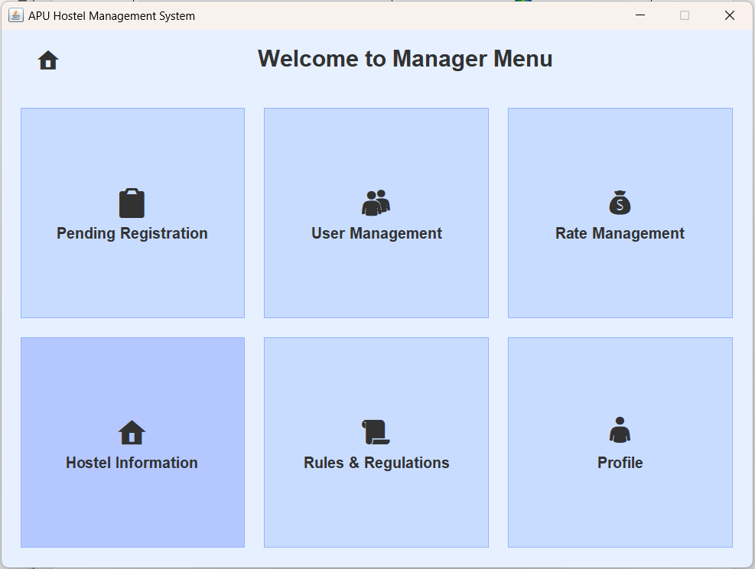  Figure 3.3.4.1 – Manager Menu | 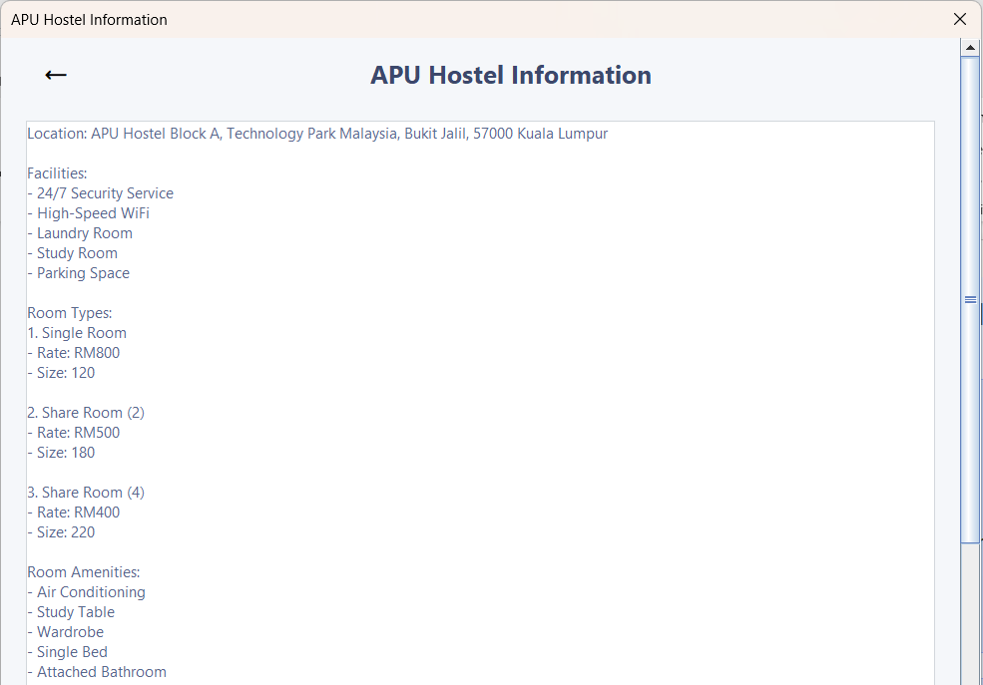  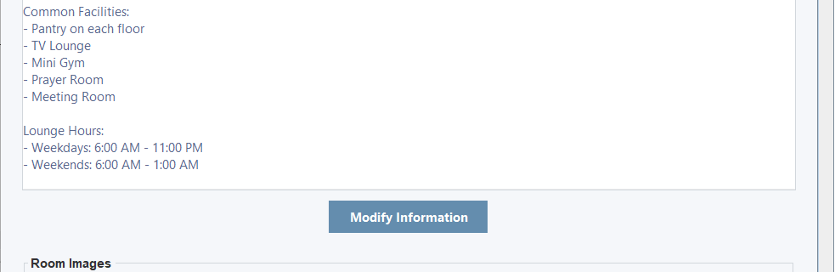  Figure 3.3.4.2 – APU Hostel Information
The user clicks on 'Hostel Information' to view APU Hostel details. | APU Hostel Information will be displayed.

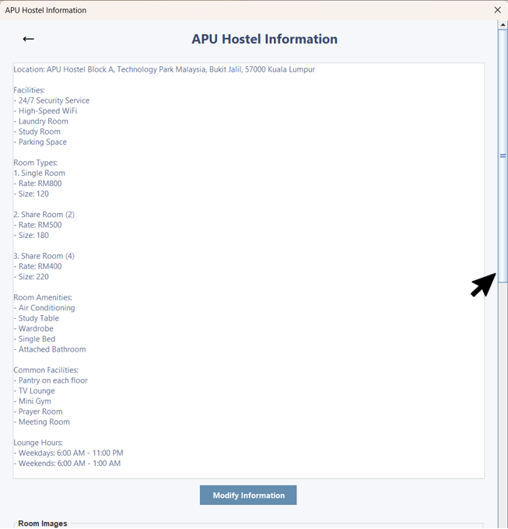  Figure 3.3.4.3 – Hostel Information with the Scroll Bar | 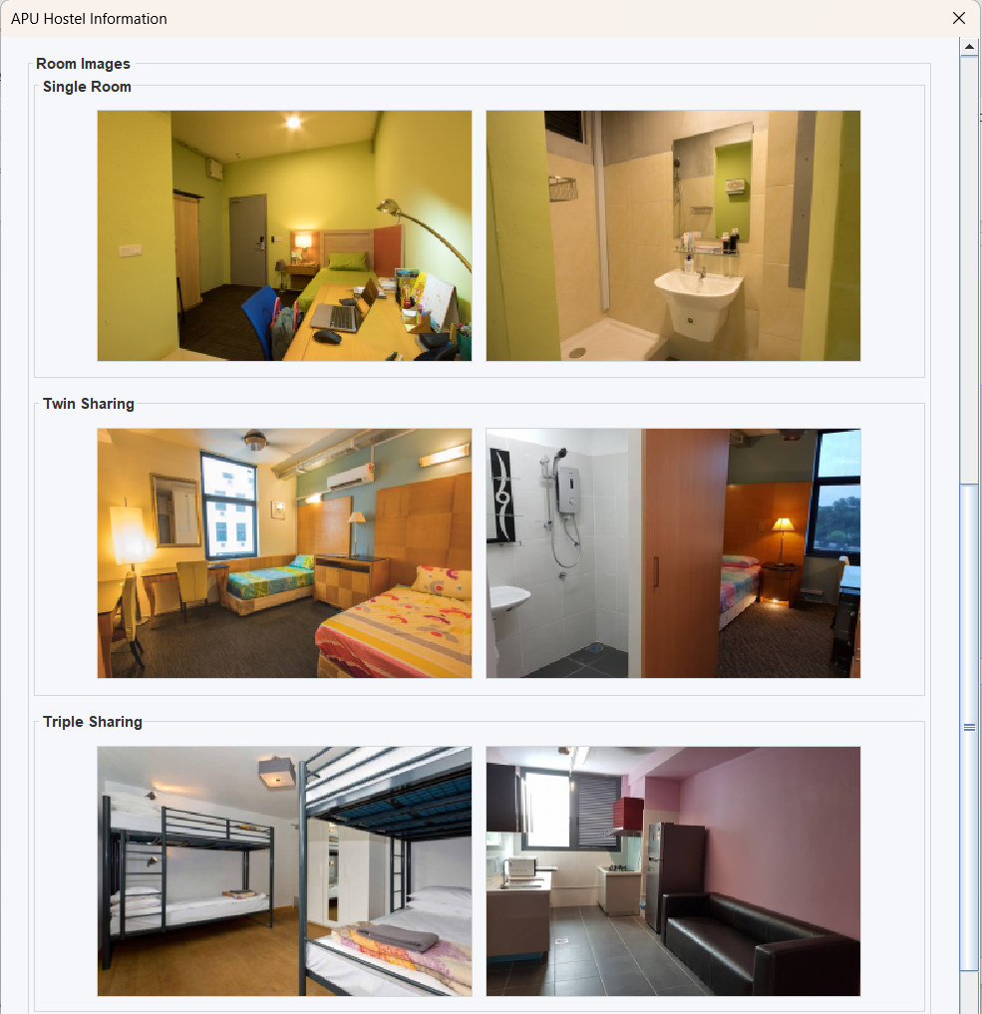  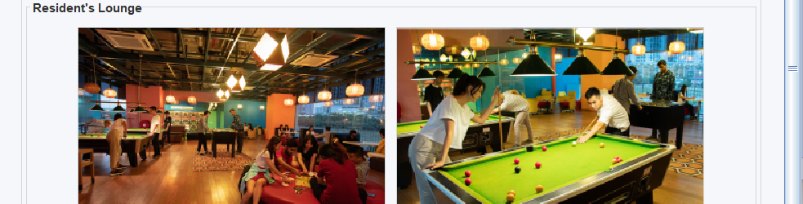  Figure 3.3.4.4 – Hostel Images
The user can scroll the scrollbar to view additional information. | As the user scrolls the scrollbar, more information becomes visible.
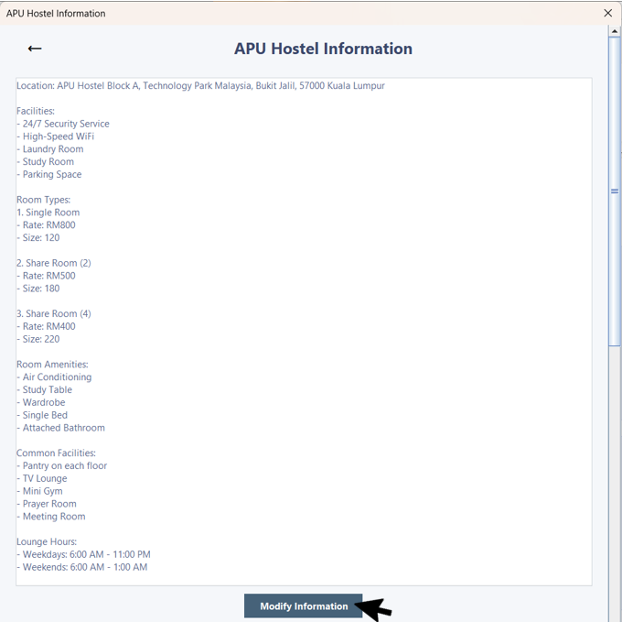  Figure 3.3.4.5 – Hostel Information with Modify Information | 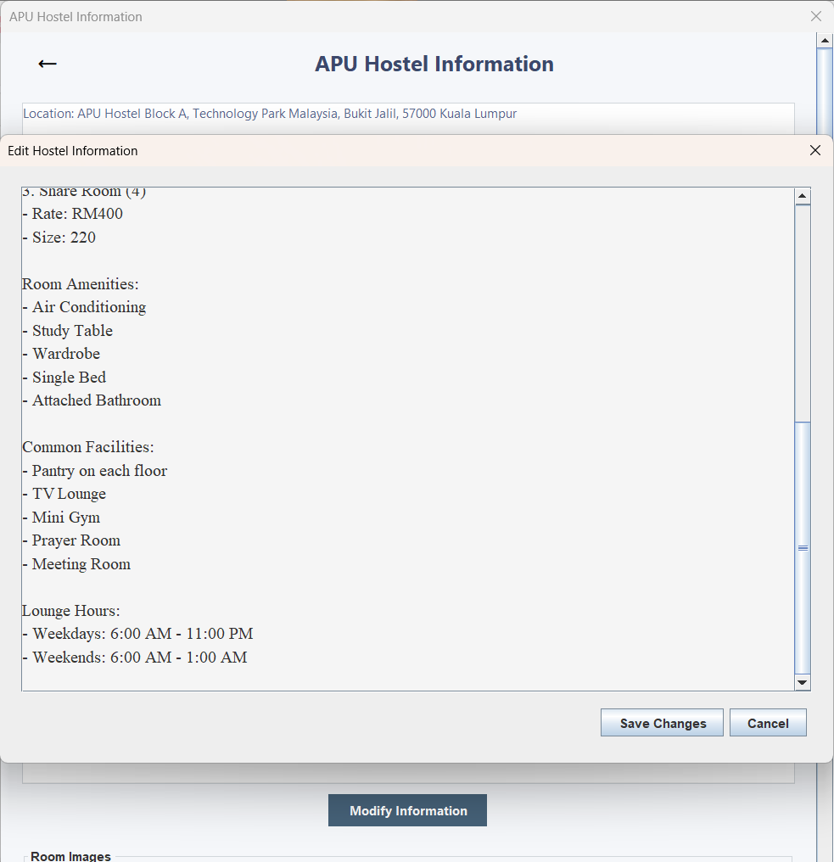  Figure 3.3.4.6 – Hostel Information with 'Edit Hostel Information' Pop-up Window.
The user can click 'Modify Information' to edit hostel details. | An 'Edit Hostel Information' pop-up window appears, allowing the user to make modifications.
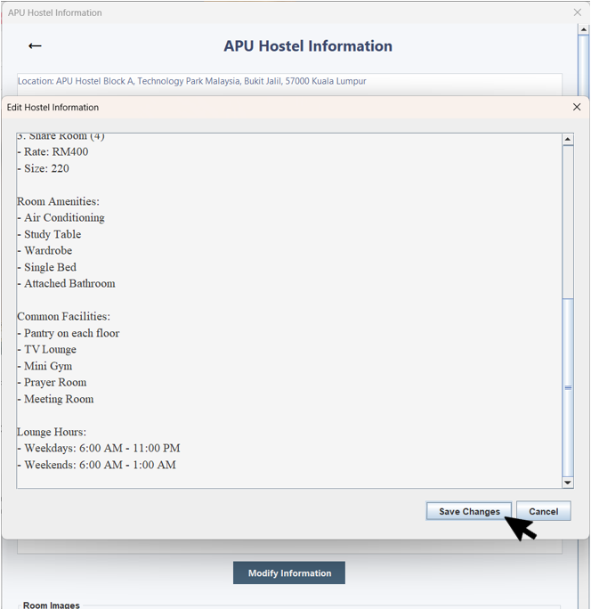  Figure 3.3.4.7 – Hostel Information with Save Changes | 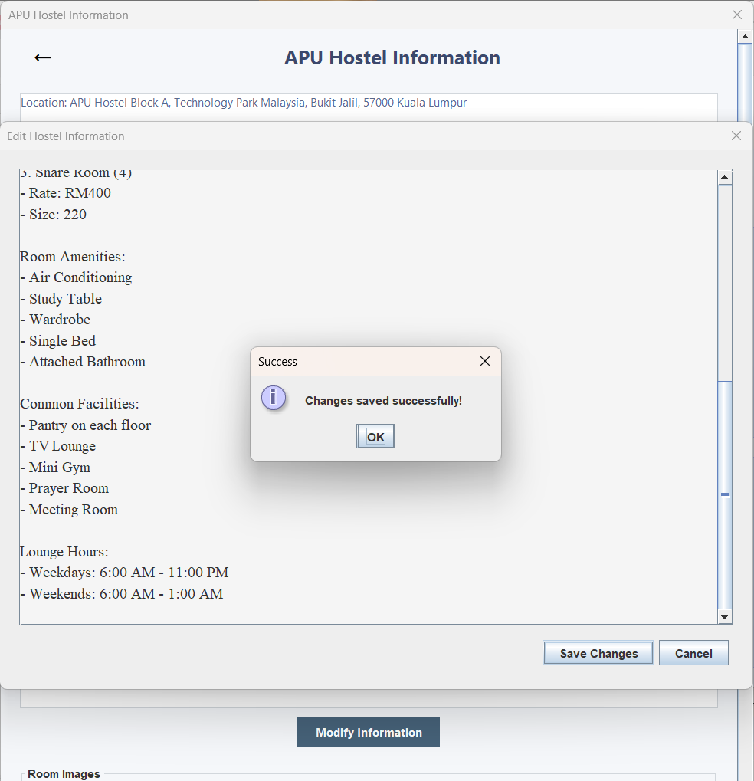  Figure 3.3.4.8 – Hostel Information with 'Success' Pop-up Window
The user can click 'Save Changes' to edit hostel details. | A 'Success' pop-up window appears, indicating that the changes have been saved successfully.
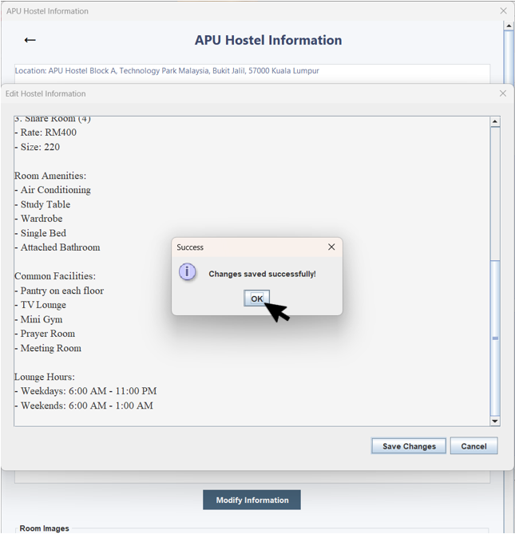  Figure 3.3.4.9 – Hostel Information with 'Success' Pop-up Window | 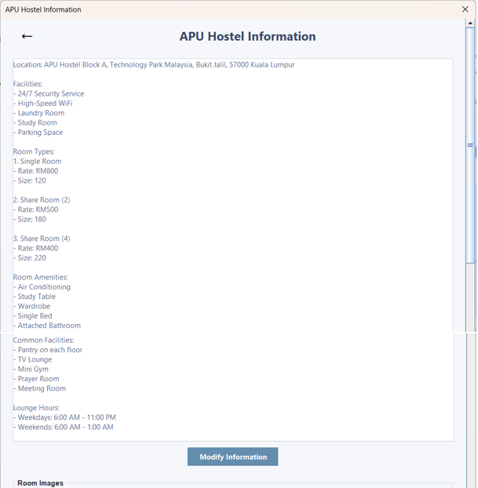  Figure 3.3.4.10 – APU Hostel Information
The user clicks the 'OK' button. | Now, the user can view the updated Hostel Information.
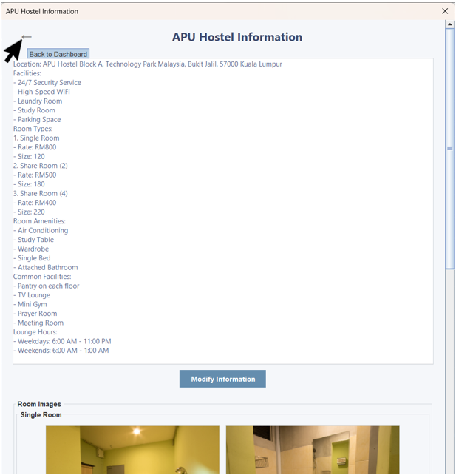  Figure 3.3.4.11 – APU Hostel Information with the Back Icon Button |   Figure 3.3.4.12 – Manager Menu
When the user hovers over the back arrow button, a tooltip will appear. Clicking the back arrow button will navigate back to the Manager Menu. | The user is brought back to the Manager Menu.

3.3.5 Rules & Regulations
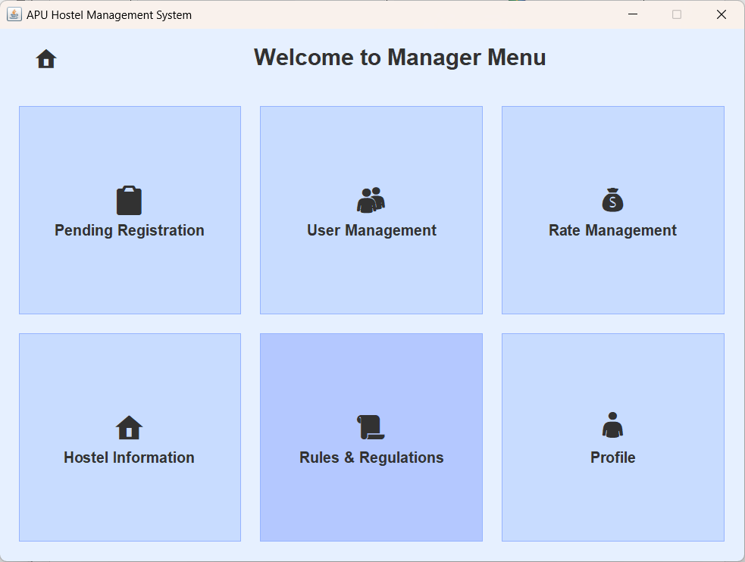  Figure 3.3.5.1 – Manager Menu | 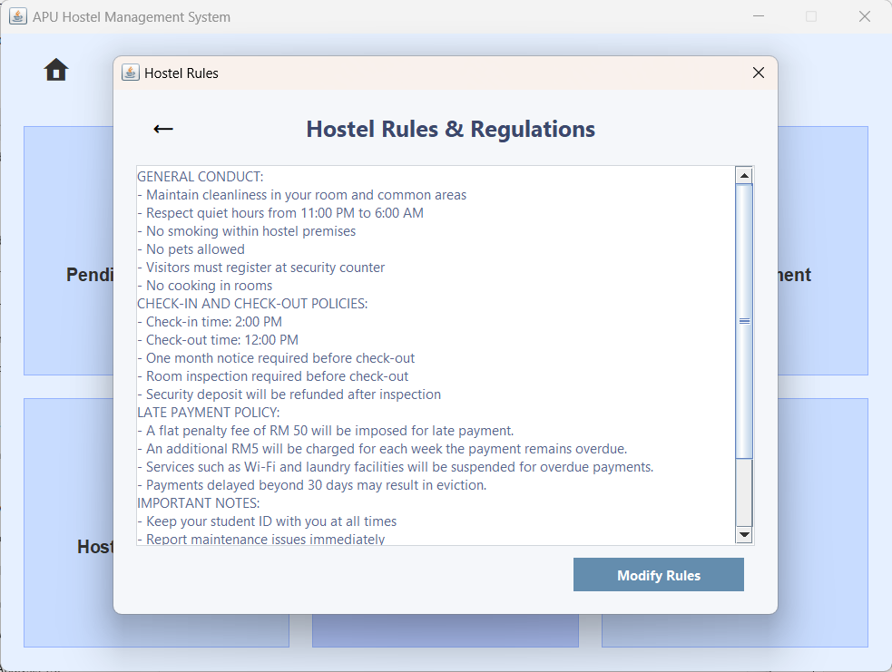  Figure 3.3.5.2 – Hostel Rules & Regulations
The user clicks on 'Rules & Regulations' to view Hostel Rules details. | APU Hostel Rules will be displayed.
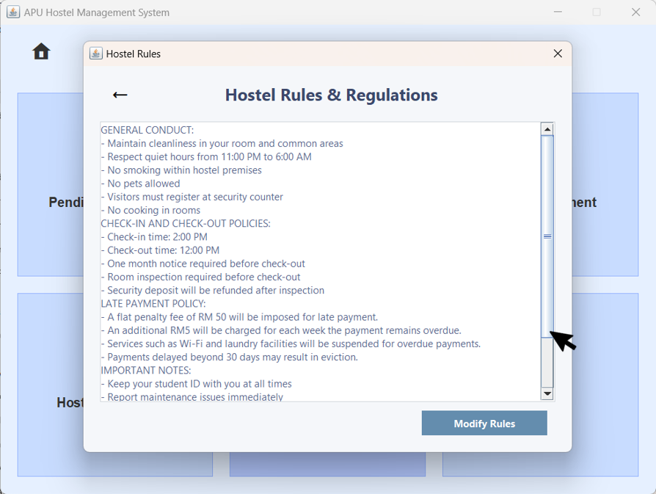  Figure 3.3.5.3 – Hostel Rules & Regulations with the Scroll Bar | 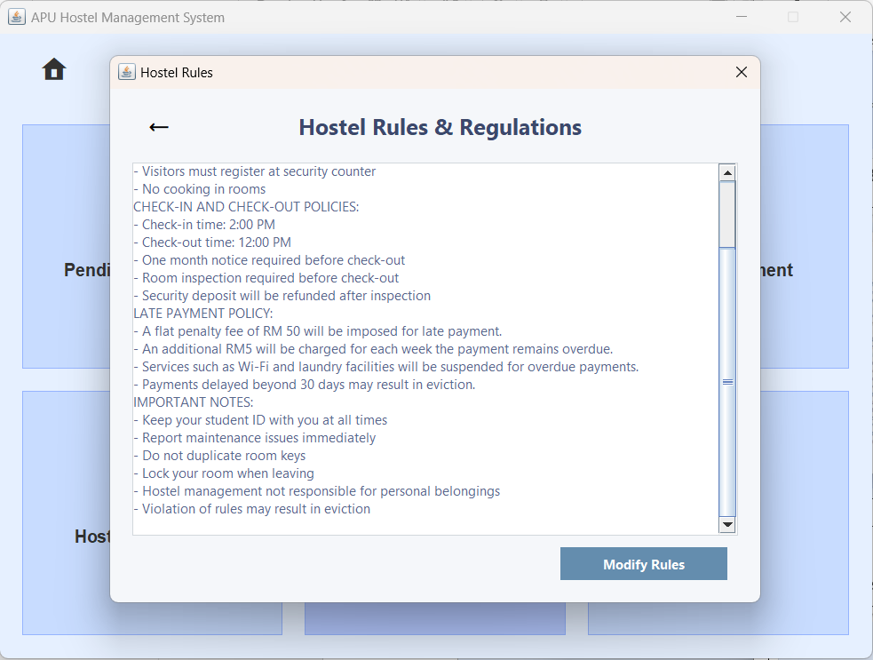  Figure 3.3.5.4 – Hostel Rules & Regulations
The user can scroll the scrollbar to view additional information. | As the user scrolls the scrollbar, more information becomes visible.
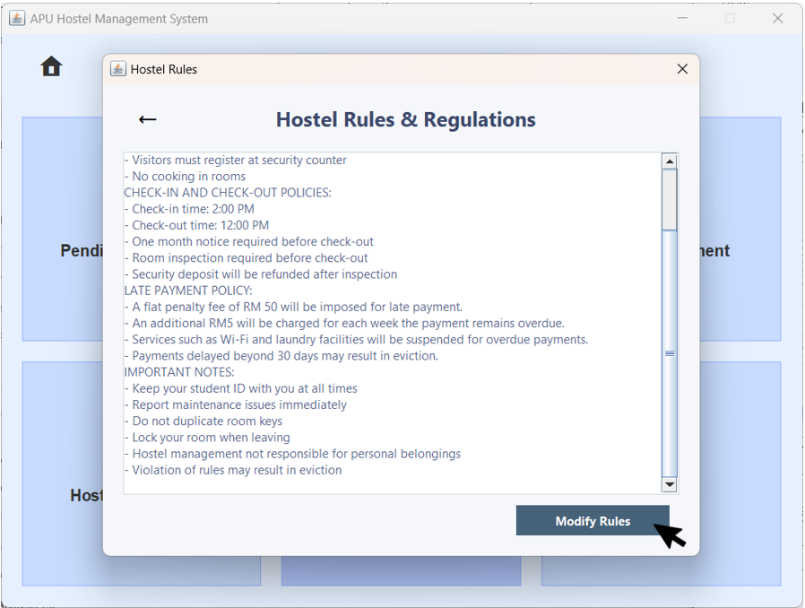  Figure 3.3.5.5 – Hostel Information with Modify Rules | 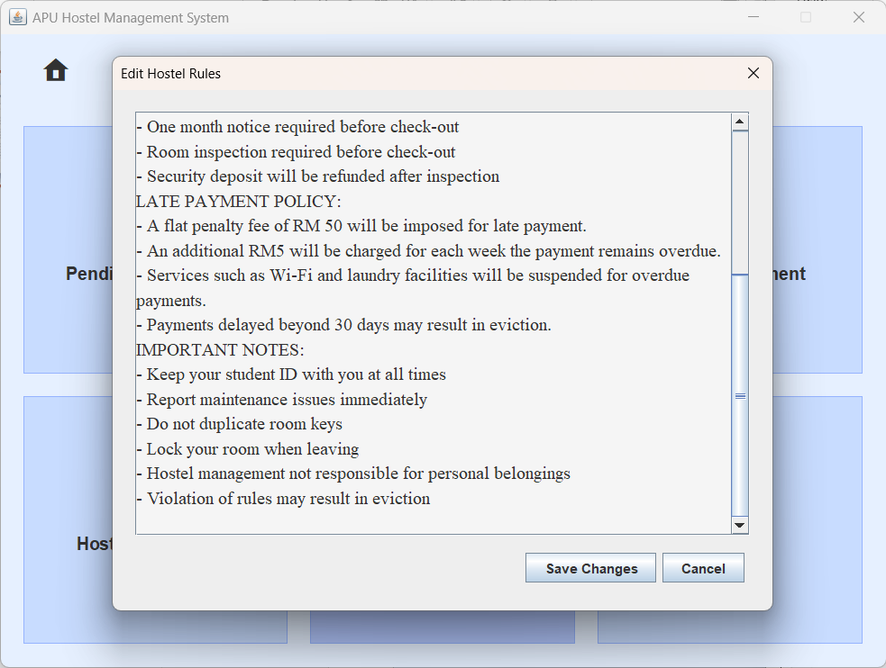  Figure 3.3.5.6 – Hostel Information with 'Edit Hostel Rules' Pop-up Window
The user can click 'Modify Rules' to edit hostel details. | An 'Edit Hostel Rules' pop-up window appears, allowing the user to make modifications.
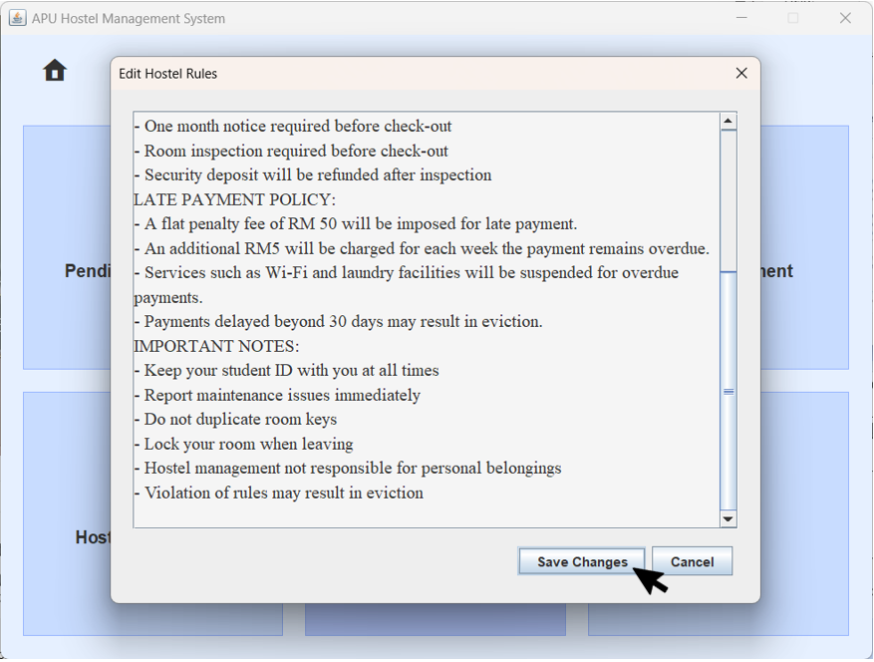  Figure 3.3.5.7 – Hostel Information with Save Changes | 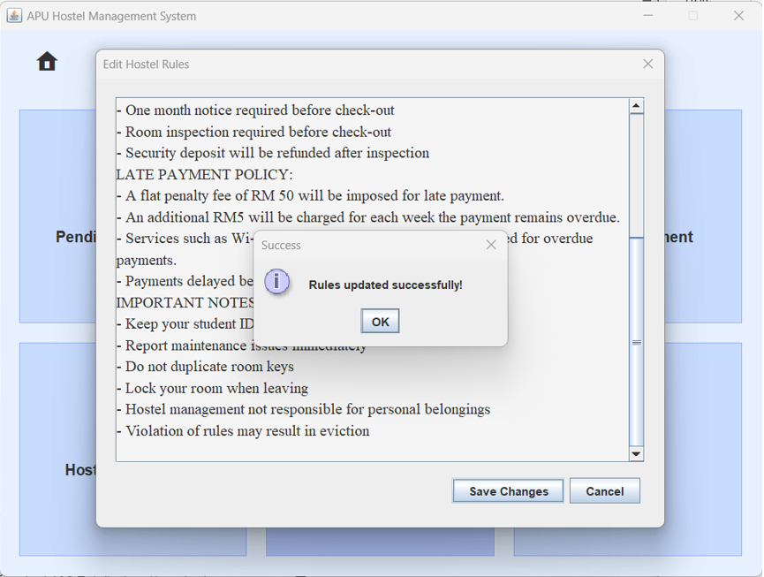  Figure 3.3.5.8 – Hostel Information with 'Success' Pop-up Window
The user can click 'Save Changes' to save the newest changes. | A 'Success' pop-up window appears, indicating that the changes have been saved successfully.
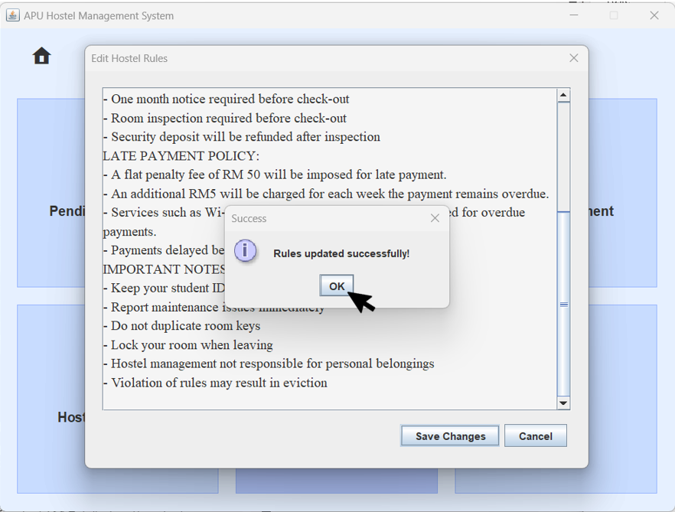  Figure 3.3.5.9 – Hostel Information with 'Success' Pop-up Window |   Figure 3.3.5.10 – Hostel Rules & Regulations
The user clicks the 'OK' button. | Now, the user can view the updated Hostel Rules & Regulations.
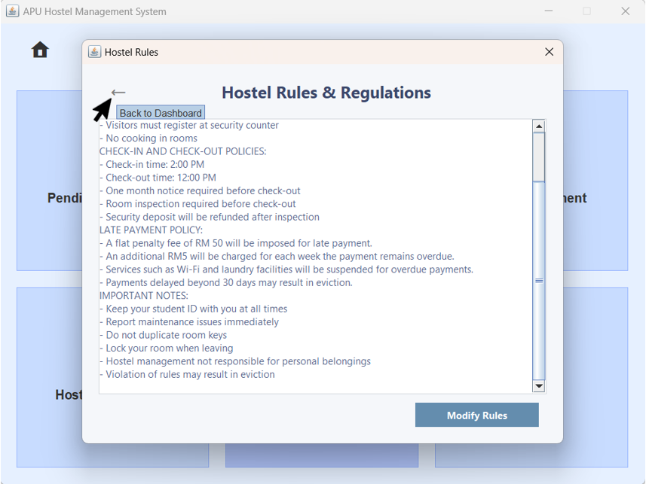  Figure 3.3.5.11 – Hostel Rules & Regulationa with the Back Icon Button |   Figure 3.3.5.12 – Manager Menu
When the user hovers over the back arrow button, a tooltip will appear. Clicking the back arrow button will navigate back to the Manager Menu. | The user is brought back to the Manager Menu.

3.3.6 Profile
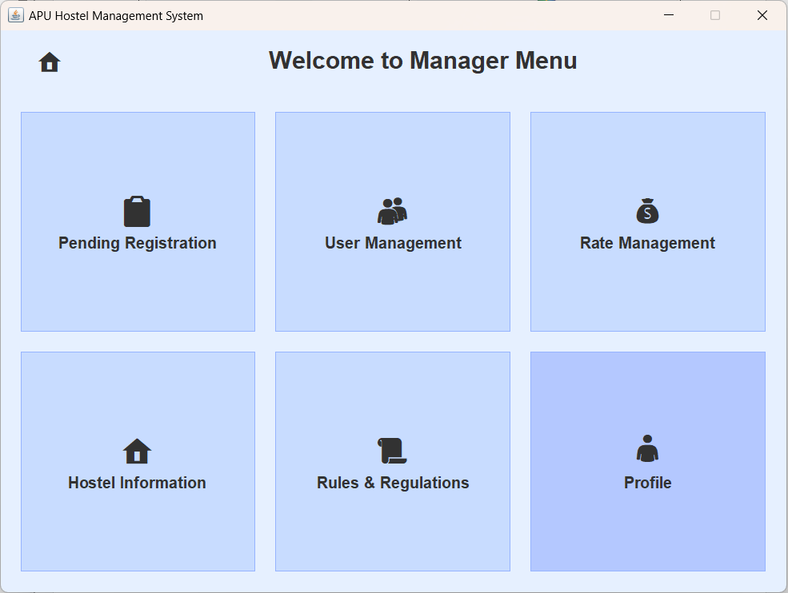  Figure 3.3.6.1 – Manager Menu | 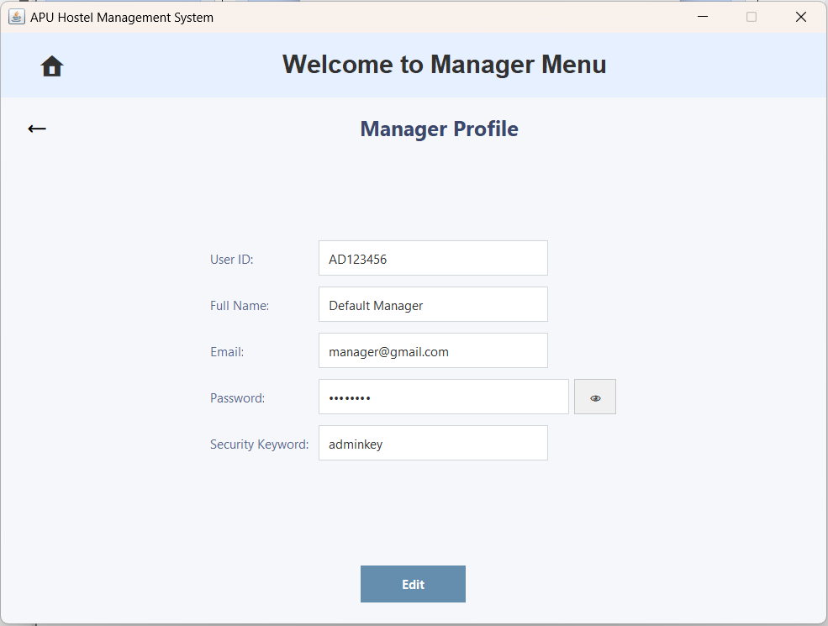  Figure 3.3.6.2 – Manager Profile
The user clicks on 'Profile' to navigate to the Manager Profile page. | The user will be brought to the Manager Profile page.
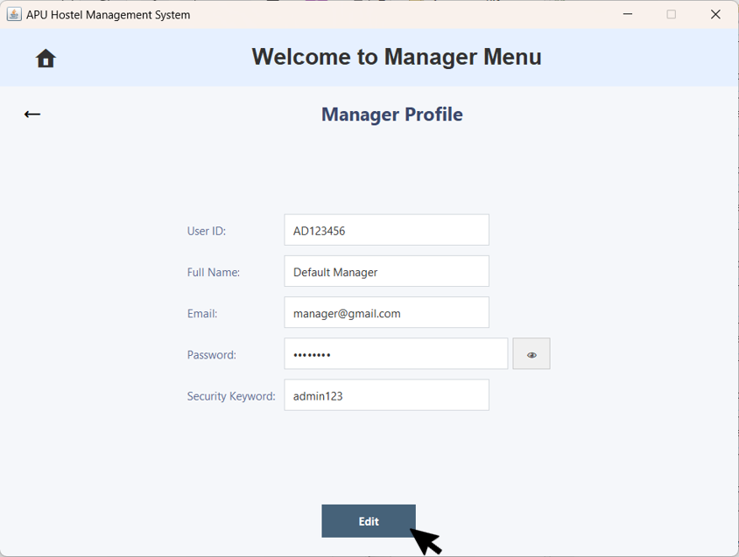  Figure 3.3.6.3 – Manager Profile with Edit Button | 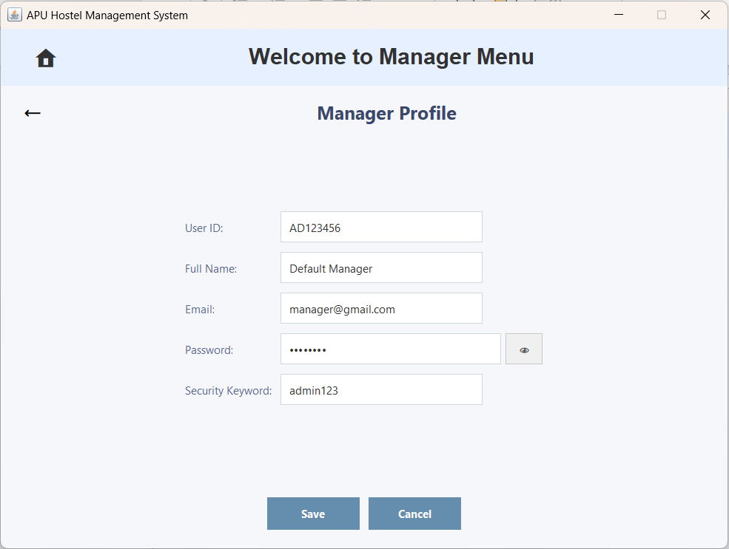  Figure 3.3.6.4 – Manager Profile with Edit Enabled
The user clicks the 'Edit' button to modify the account details. | The user can directly modify the information in the fields. However, the User ID cannot be modified.
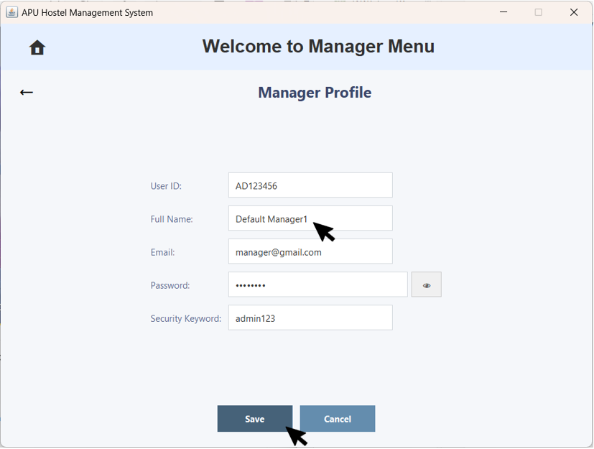  Figure 3.3.6.5 – Manager Profile with Full Name Field | 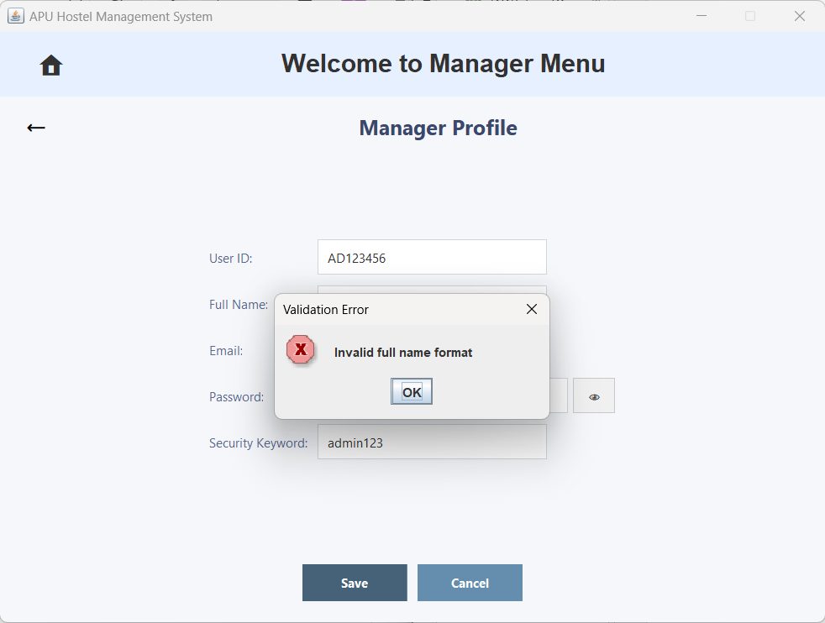  Figure 3.3.6.6 – 'Validation Error' Pop-up Window
The user enters an invalid full name. Full Name can only contain alphabets. | A 'Validation Error' pop-up window appears, indicating invalid Full Name.
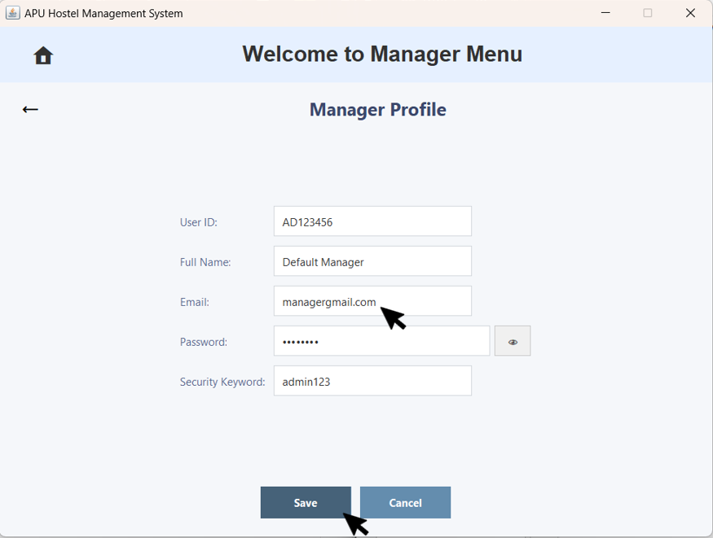  Figure 3.3.6.7 – Manager Profile with Email Field | 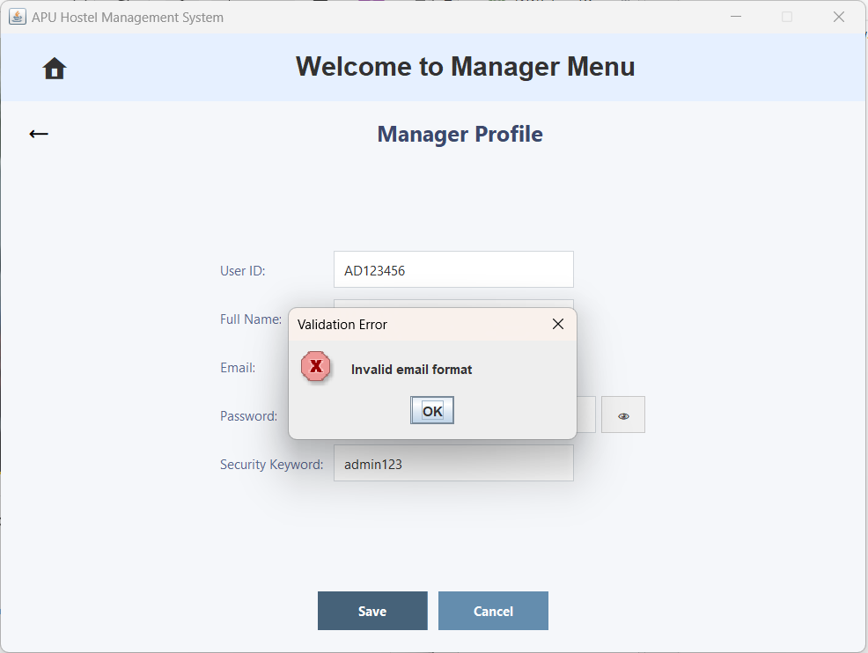  Figure 3.3.6.8 – 'Validation Error' Pop-up Window
The user enters an invalid email format. Email address must be in a valid format, containing "@" and following a proper domain structure. | A ' Validation Error' pop-up window appears, indicating invalid Email format.
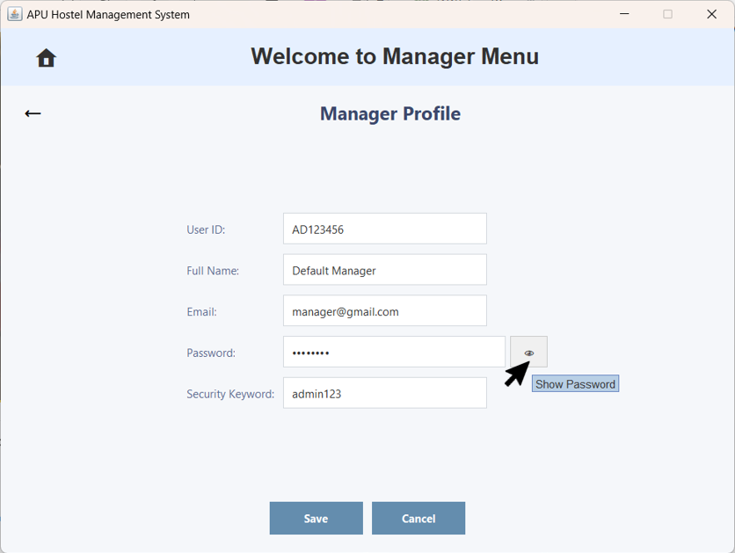  Figure 3.3.6.9 – Manager Profile with the Eye Icon Button | 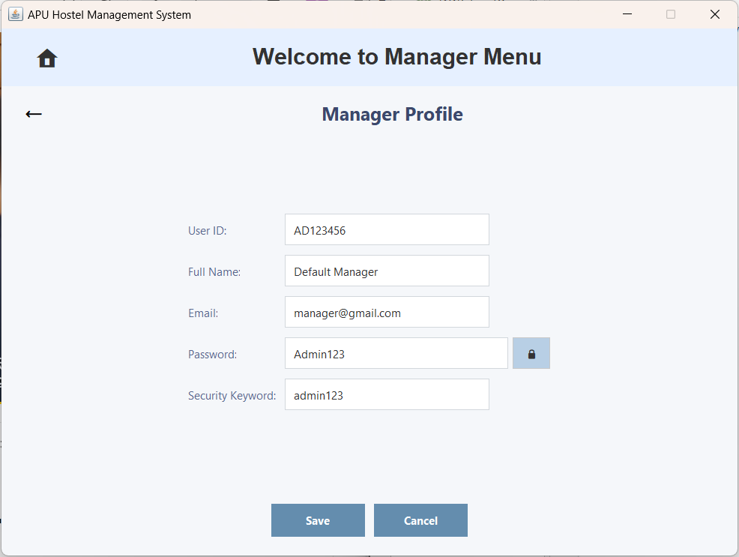  Figure 3.3.6.10 – Manager Profile with the Visible Password
User can click the eye icon button to view the hidden password. | The password will then be visible.
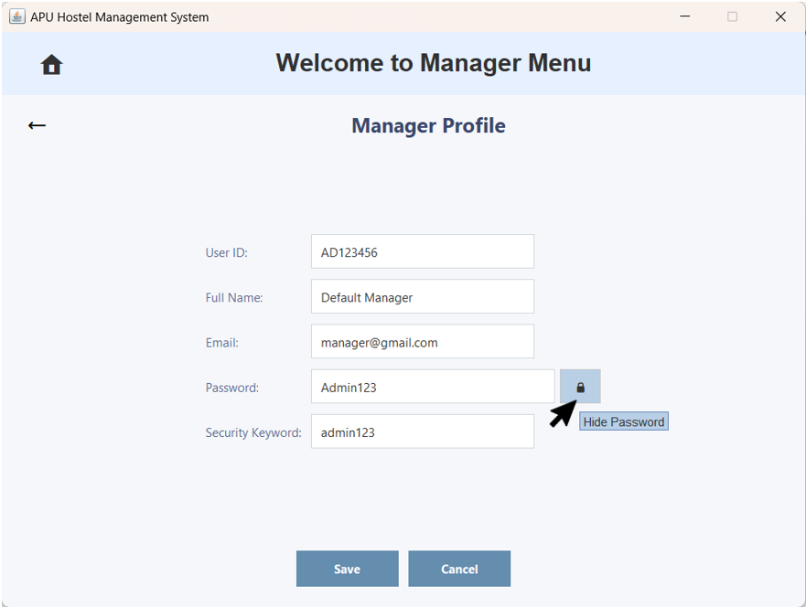  Figure 3.3.6.11 – Manager Profile with the Lock Icon Button | 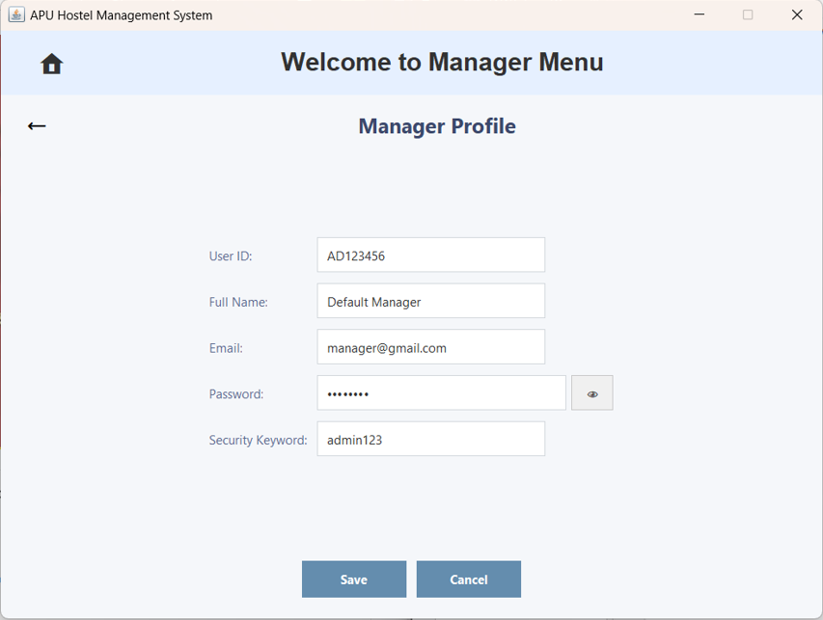  Figure 3.3.6.12 – Manager Profile with the Hidden Password
User can click the lock icon button to hide the password. | The password will then be hidden.
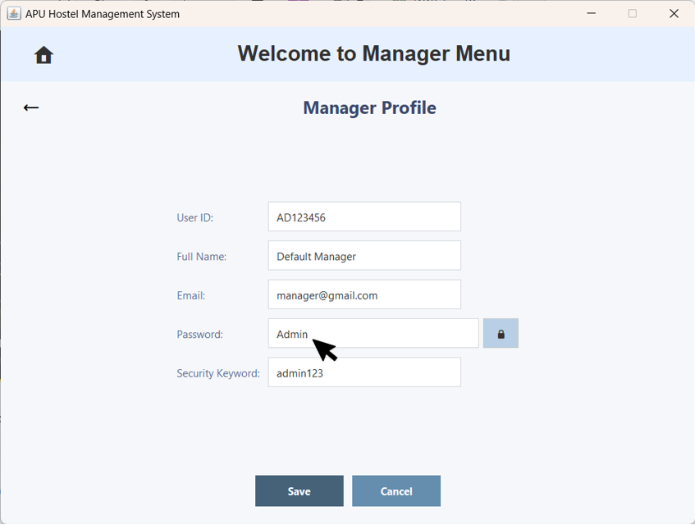  Figure 3.3.6.13 – Manager Profile with Password Field | 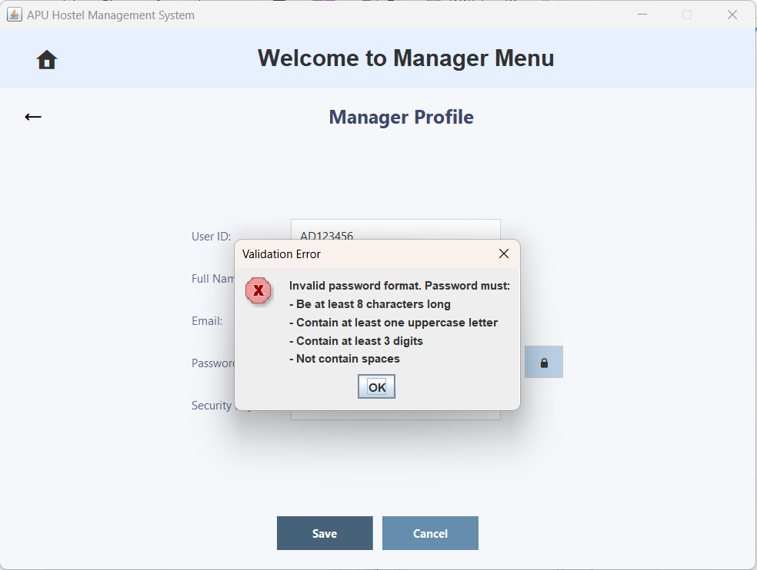  Figure 3.3.6.14 – 'Validation Error' Pop-up Window
The user enters an invalid password format. Password must be at least 8 characters long, include at least one uppercase letter, contain at least three digits, and must not have any spaces. | A ' Validation Error' pop-up window appears, indicating invalid Password format.
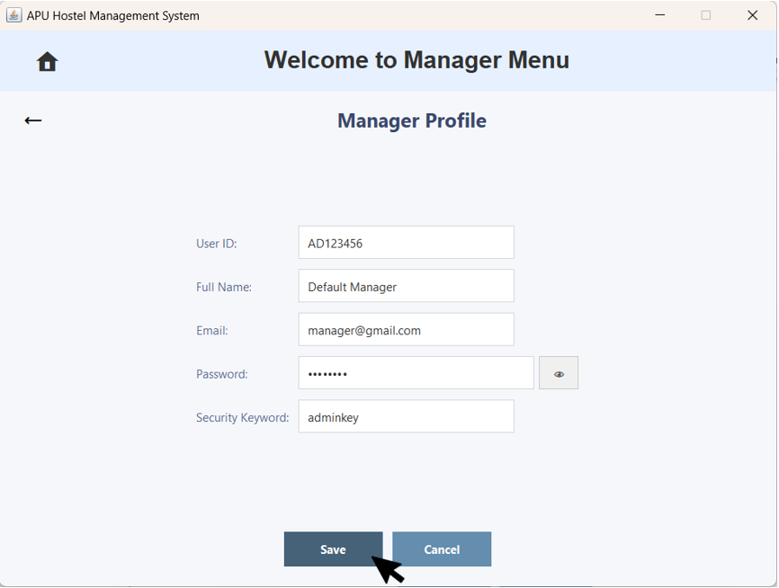  Figure 3.3.6.15 – Manager Profile with the Save Button | 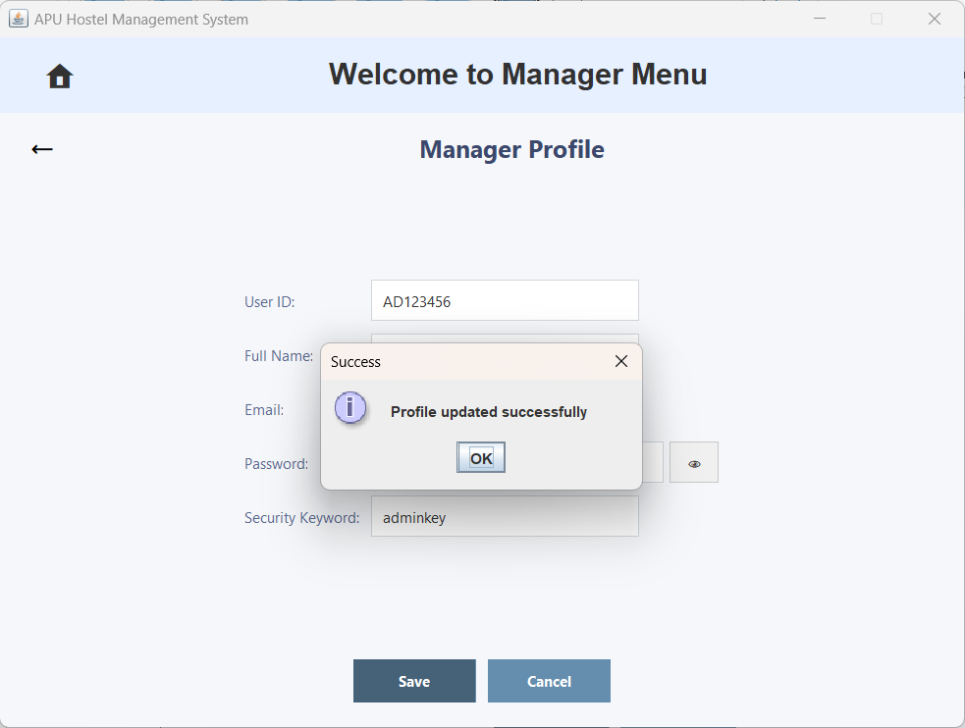  Figure 3.3.6.16 – 'Success' Pop-up Window
If the user correctly modifies all fields without an invalid format, they can click the 'Save' button. | A 'Success' pop-up window appears, indicating profile updated successfully.
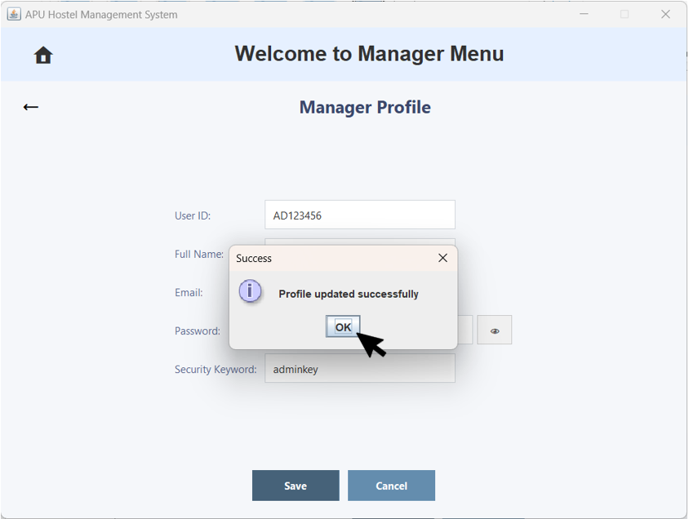  Figure 3.3.6.17 – 'Success' Pop-up Window | 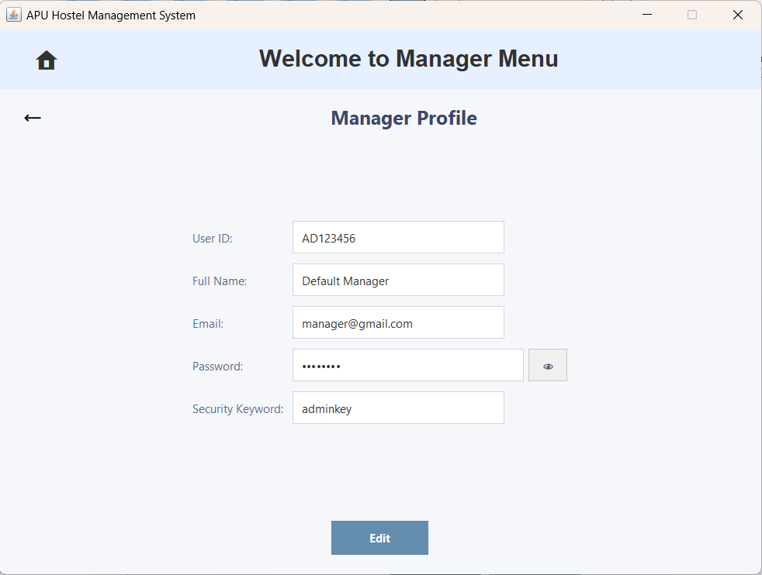  Figure 3.3.6.18 – Manager Profile
The user clicks the 'OK' button. | The Manager Account will be updated successfully and will immediately appear in the Manager Profile.
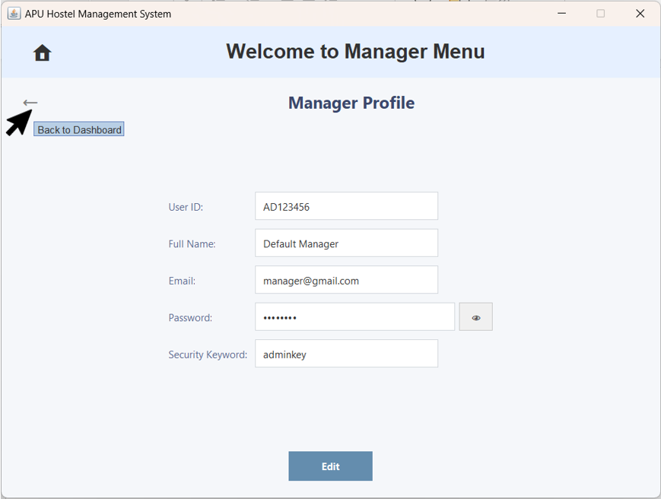  Figure 3.3.6.19 – Manager Profile with Back Arrow Button |   Figure 3.3.6.20 – Manager Menu
The user clicks the back arrow button to return to the Manager Dashboard. | Return to the Manager Dashboard.

3.4 Staff Dashboard

3.4.1 Update Account
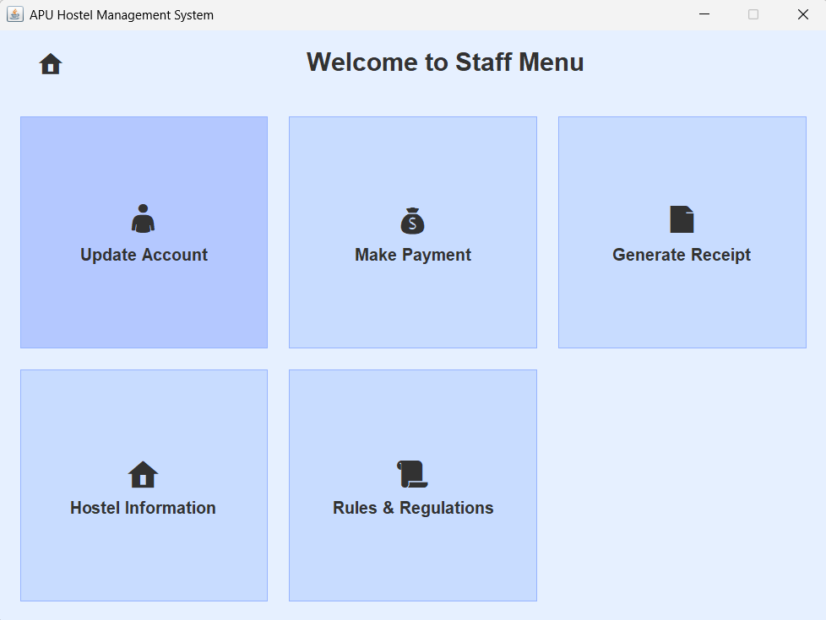  Figure 3.4.1.1: Staff Menu with ‘Update Account’ button | 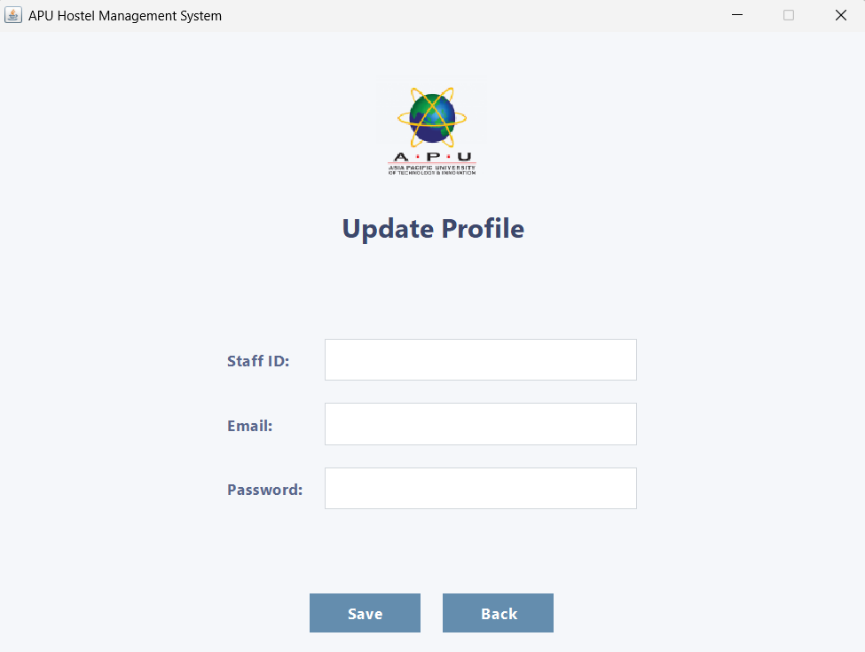  Figure 3.4.1.2: Update Profile Page
The staff clicks on ‘Update Account’ button. | The staff go to Update Profile page.
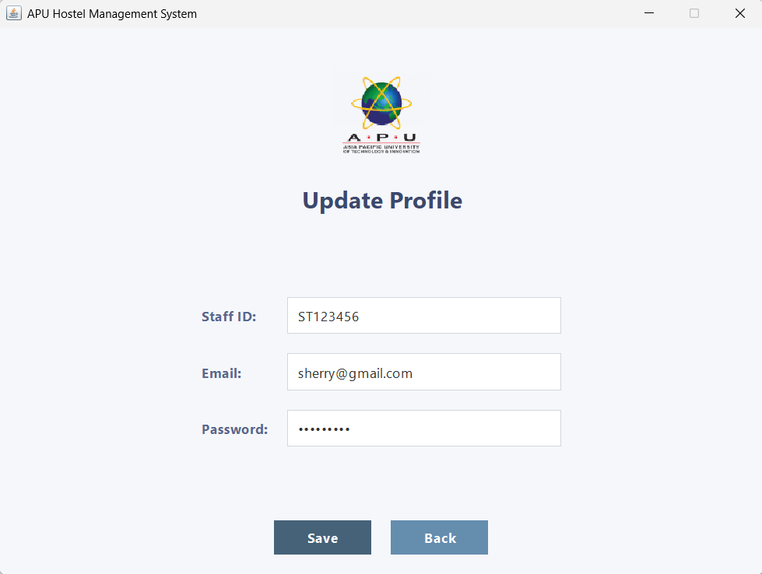  Figure 3.4.1.3: Update Profile with ‘Save’ Button | 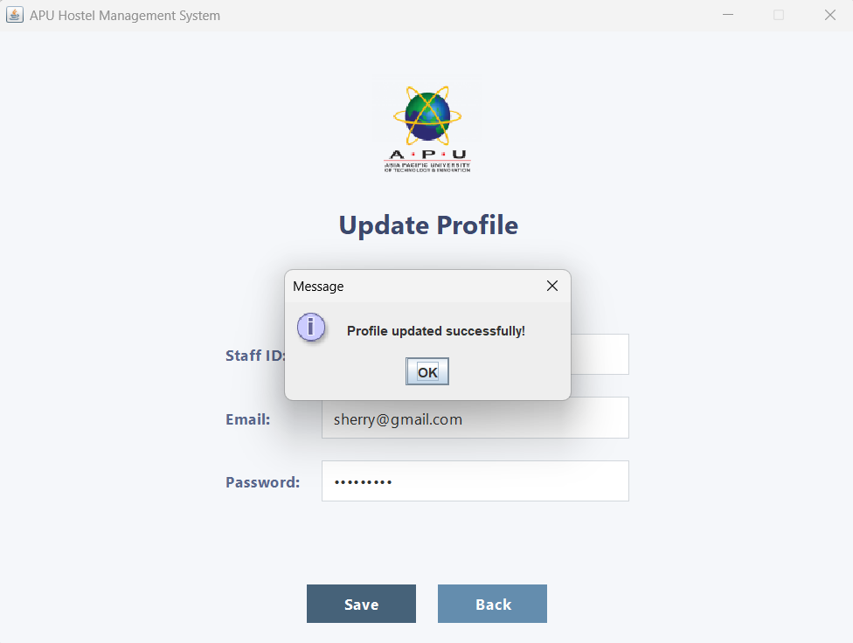  Figure 3.4.1.4: Pop-up window “Profile updated Successfully!”
The staff key in new profile data and click ‘Save’ button. | It will pop up a window that written “Profile updated Successfully!”
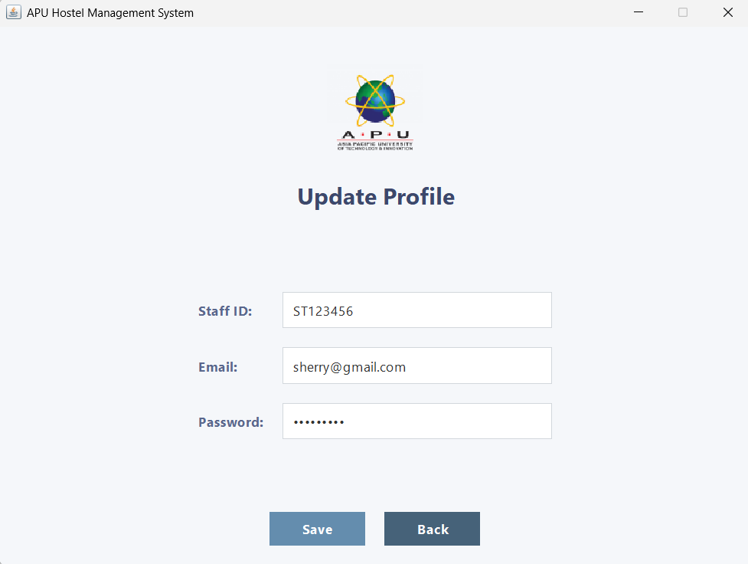  Figure 3.4.1.5: Update Profile with ‘Back’ Button | 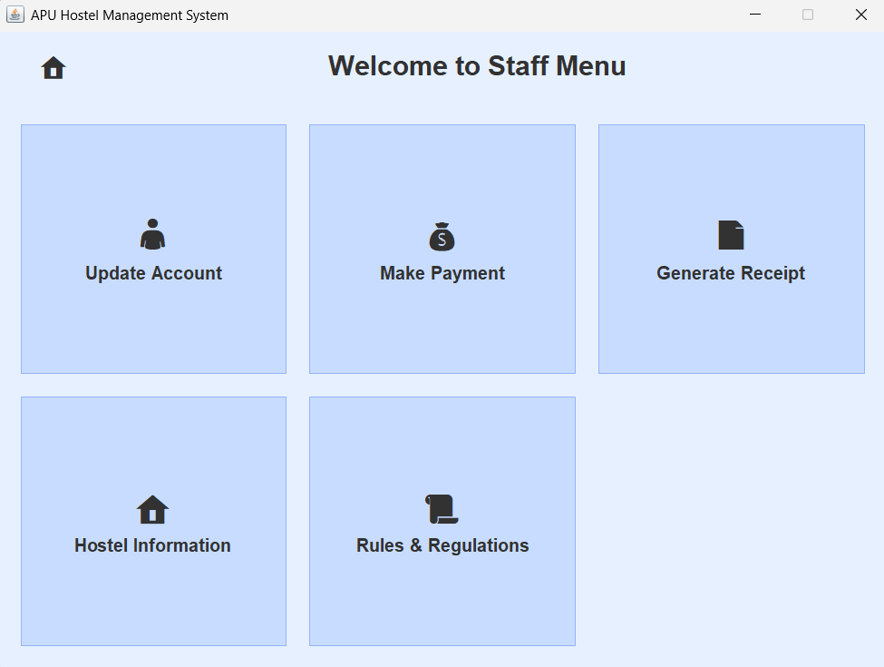  Figure 3.4.1.6: Staff Menu
The staff clicks on the ‘Back’ button. | The system will bring the staff back to the Staff Menu page.

3.4.2 Make Payment
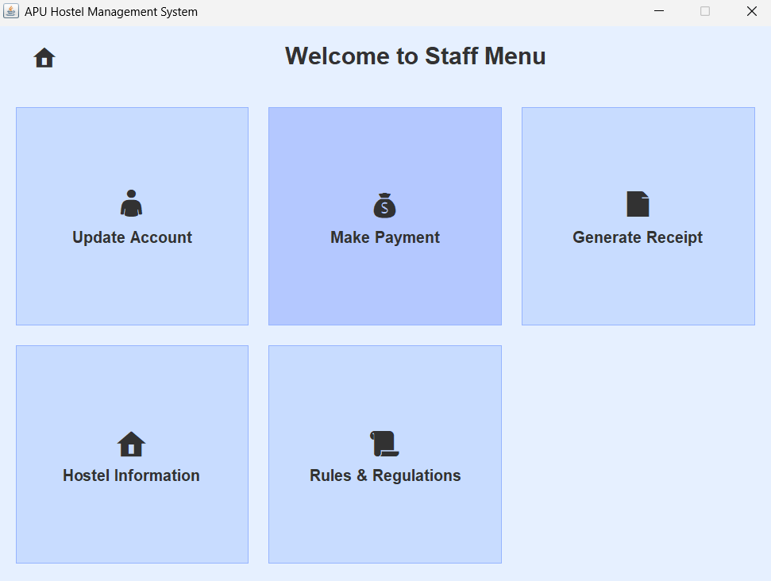  Figure 3.4.2.1: Staff Menu with ‘Make Payment’ Button | 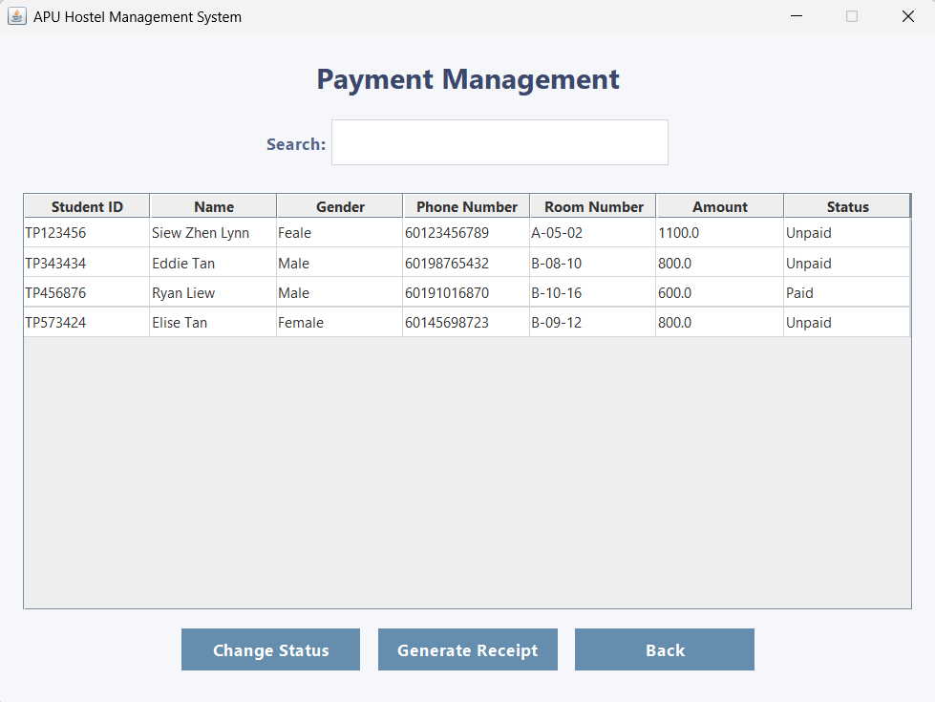  Figure 3.4.2.2: Payment Management Page
The staff clicks on the ‘Make Payment’ button. | The staff will be bring to Payment Management page.
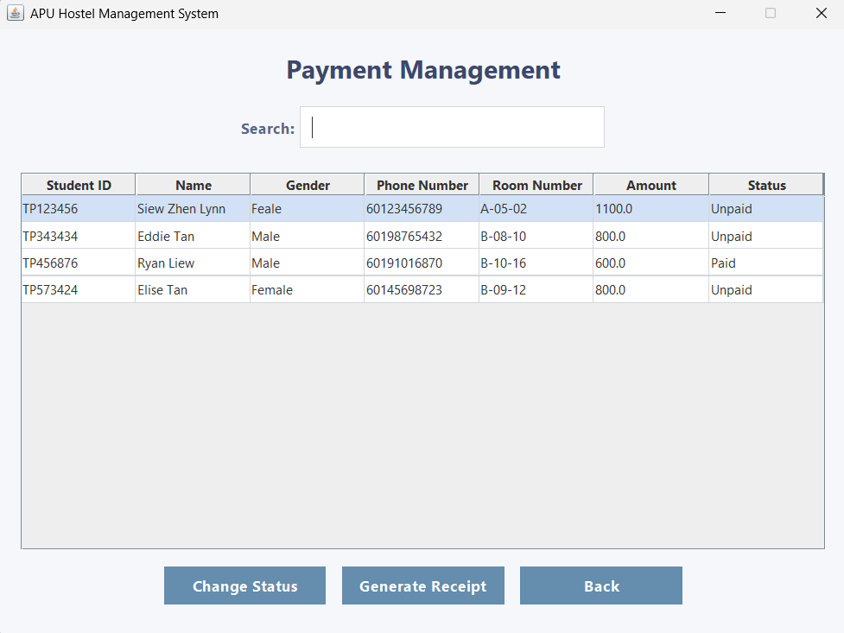  Figure 3.4.2.3: Payment Management Page with ‘Search’ Text Field | 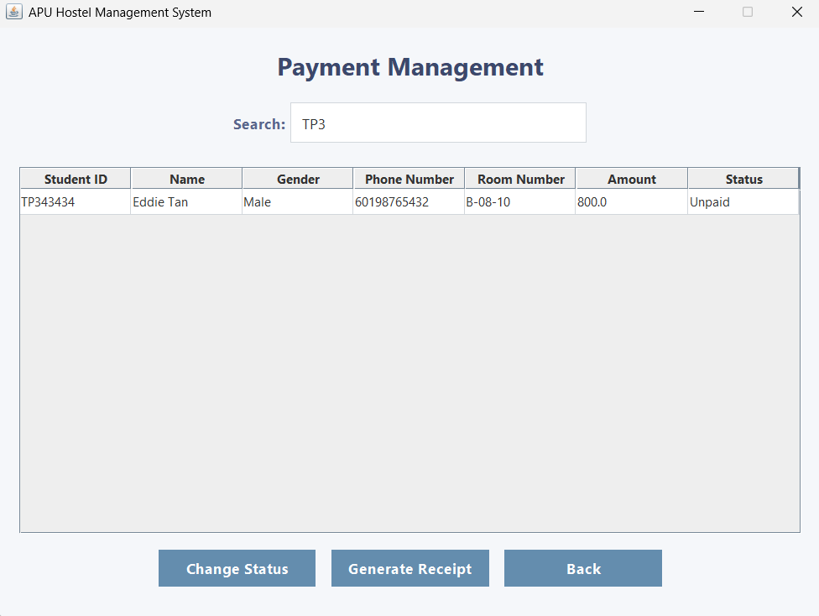  Figure 3.4.2.4: Searched Result
The staff use the search field to find the Resident ID. | The system will filter the input data and list the resident information.
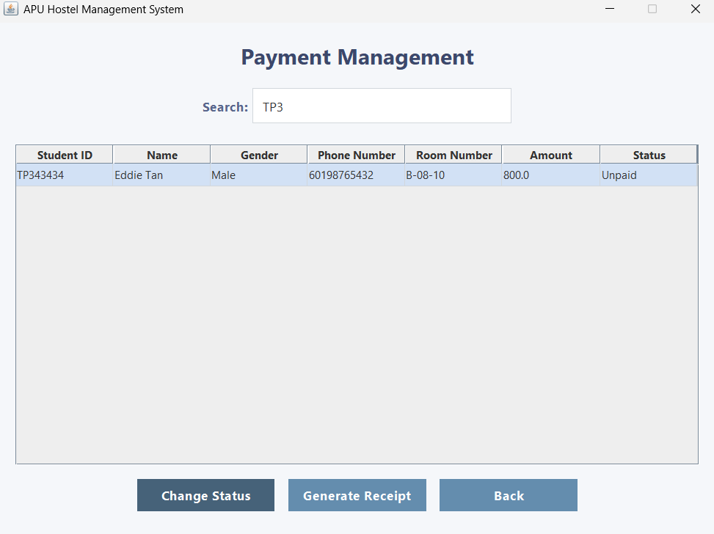  Figure 3.4.2.5: Payment Management Page with ‘Change Status’ Button | 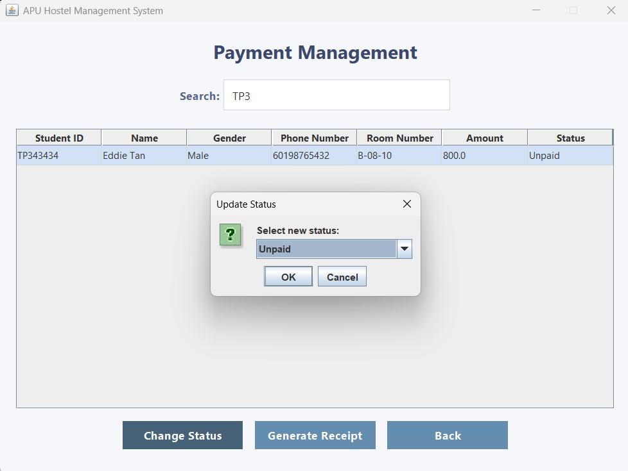  Figure 3.4.3.6: Pop-up Window “Select new status:”
The staff choose the specific and resident clicks on the ‘Change Status’ button. | A small window will pop-up and written with “Select new status:”.
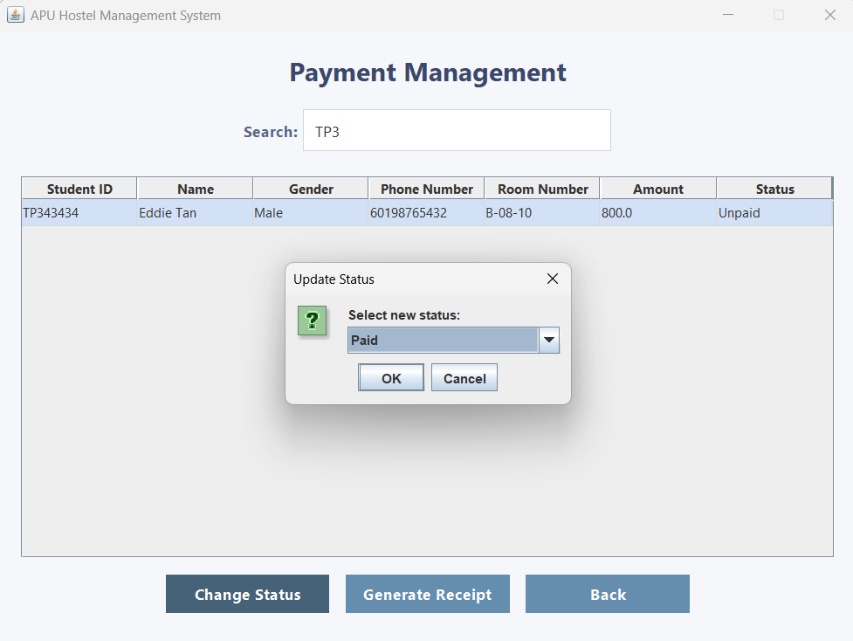  Figure 3.4.2.7: Pop-up window with ‘OK’ button | 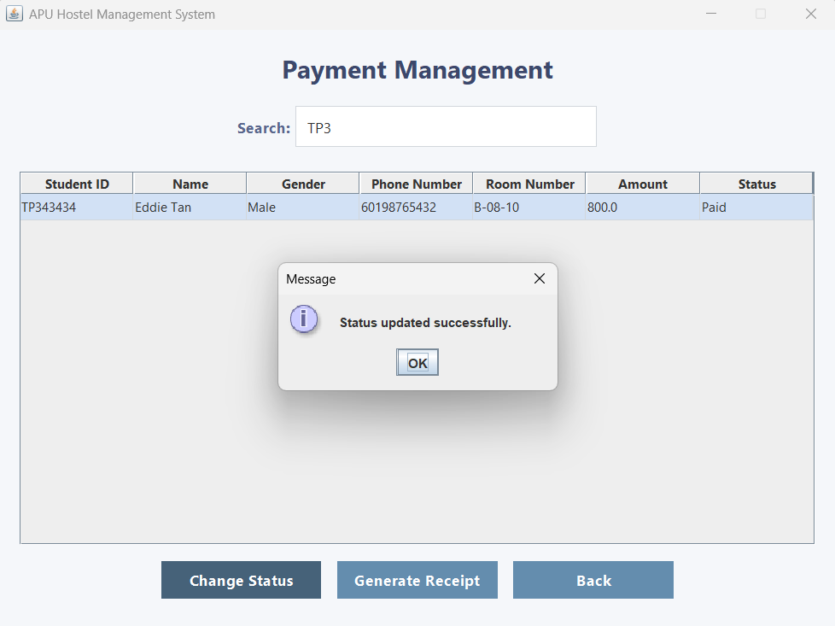  Figure 3.4.2.8: Pop-up window “Status Update Successfully.”
The staff change the ‘Unpaid’ status to ‘Paid’ status and click ‘OK’ button. | The status of the resident will update to ‘Paid’ and pop-up a small window that written “Status Update Successfully.”.
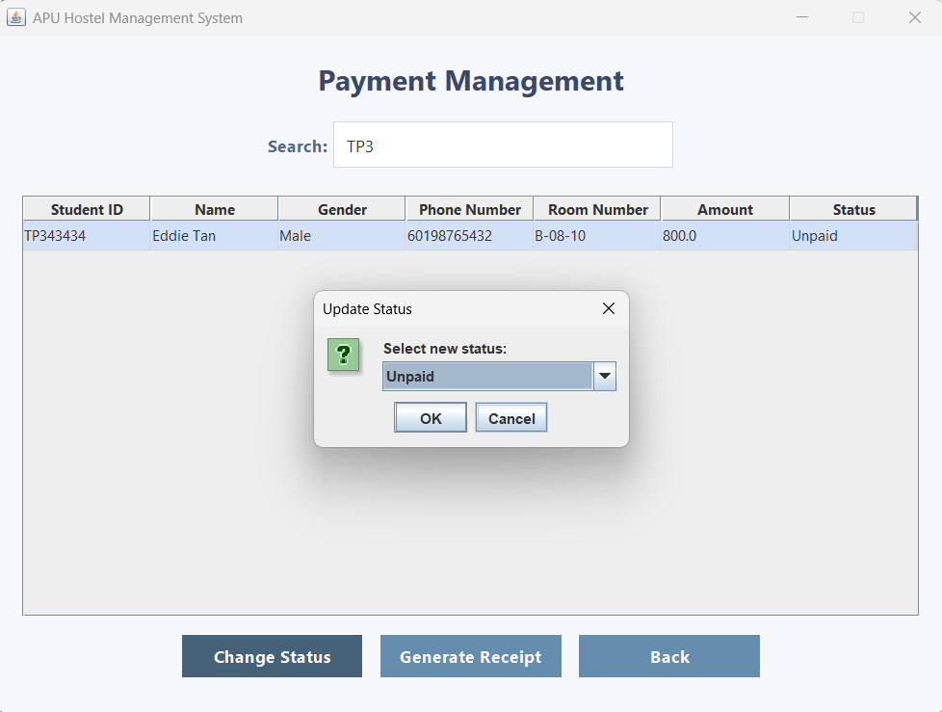  Figure 3.4.2.9: Pop-up window with ‘Cancel’ Button |   Figure 3.4.2.10: Payment Management Page
The staff clicks on the ‘Cancel’ button. | The pop-up window will close and there is no change of the ‘Status’.
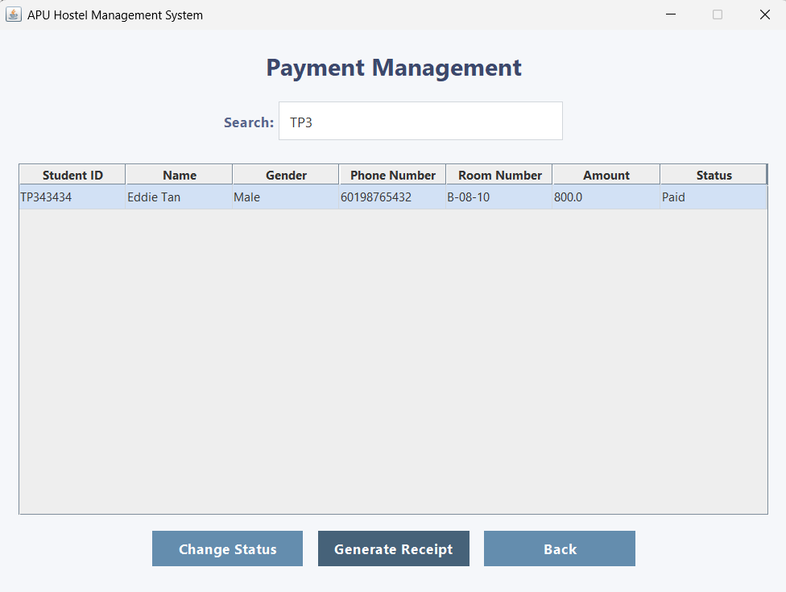  Figure 3.4.2.11: Payment Management Page with ‘Generate Payment’ Button | 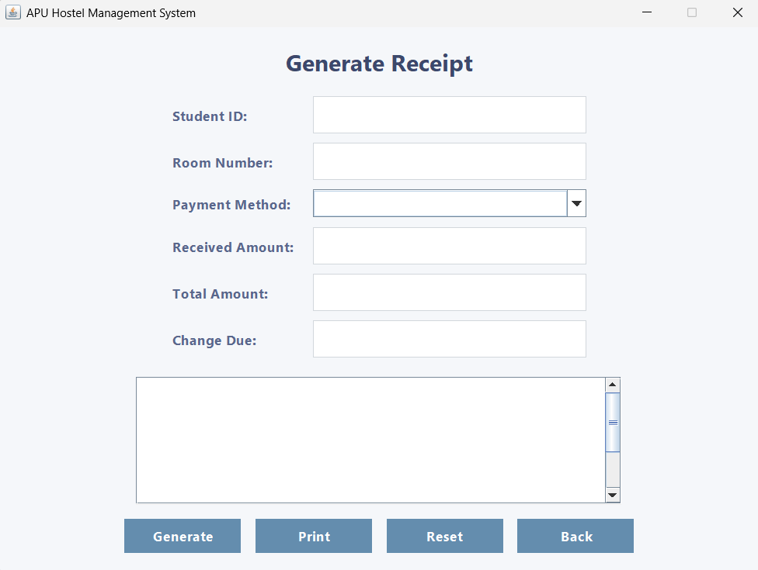  Figure 3.4.2.12: Generate Receipt Page
The staff clicks on the ‘Generate Payment’ button. | The staff will bring to the ‘Generate Receipt’ page.
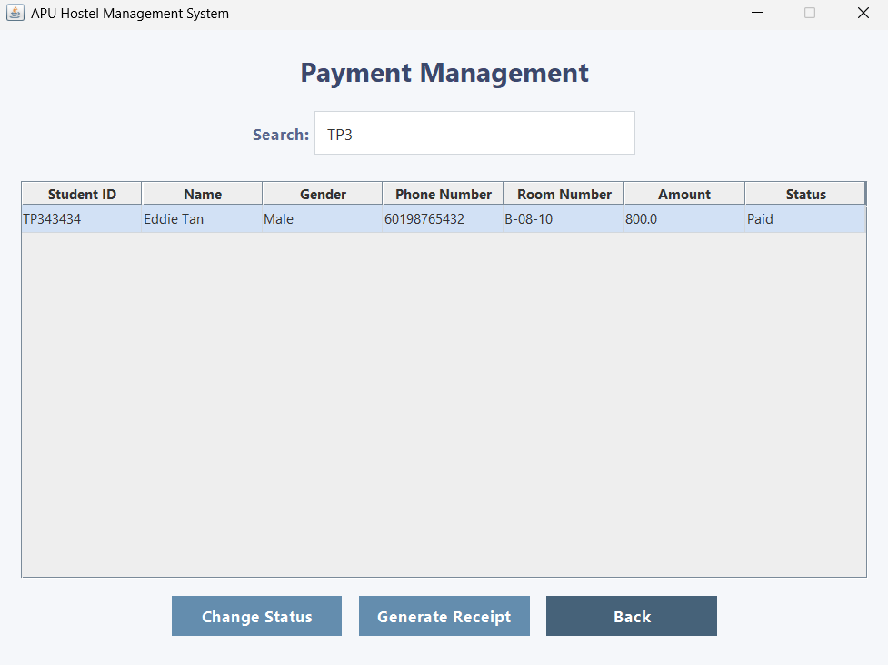  Figure 3.4.2.13: Payment Management Page with ‘Back’ Button |   Figure 3.4.2.14: Staff Menu
‘Back’ button clicked by the staff. | It will back to the Staff Menu page.

3.4.3 Generate Receipt
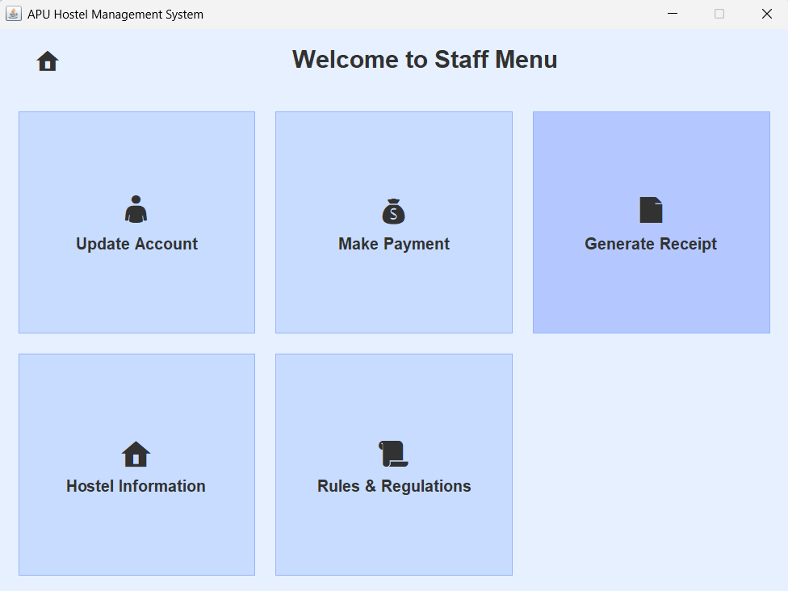  Figure 3.4.3.1: Staff Menu with ‘Generate Receipt’ Button |   Figure 3.4.3.2: Generate Receipt Page
The staff clicks the ‘Make Payment’ button. | The staff will be bringing to the Generate Receipt page.
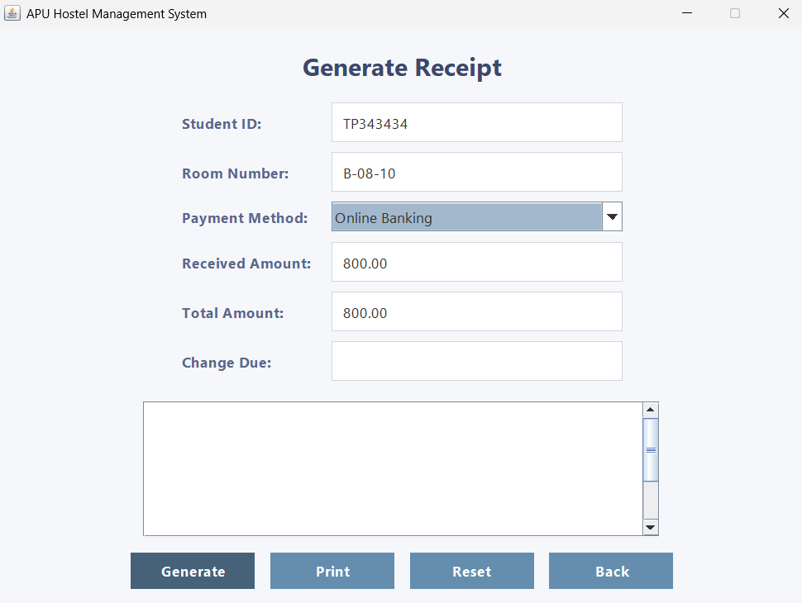  Figure 3.4.3.3: Generate Receipt Page with ‘Generate’ Button | 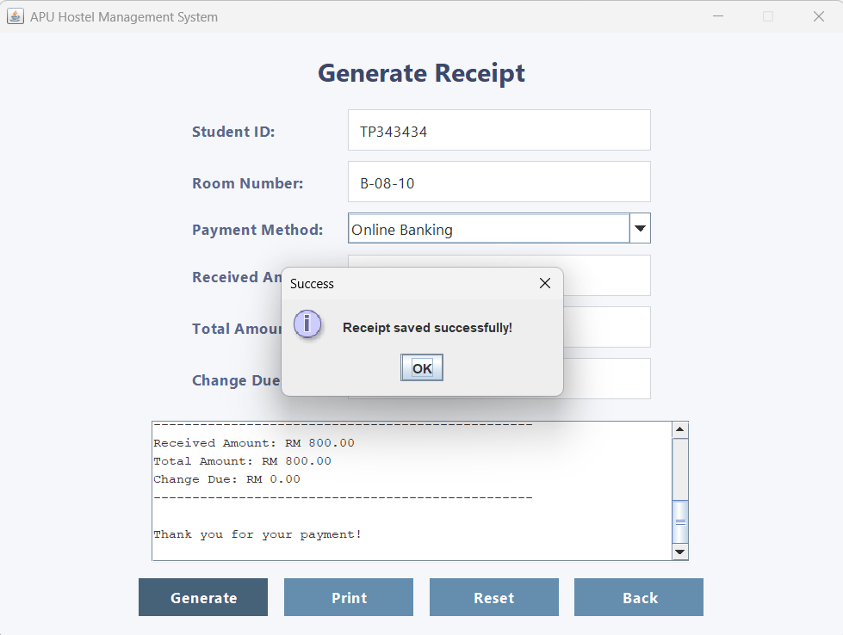  Figure3.4.3.4: Pop-up window “Receipt saved successfully!”
The staff clicks the ‘Generate’ button after filled in the resident’s information. | It will pop-up a small window that written “Receipt saved successfully!”. This proves that the receipt has been generated and saved.
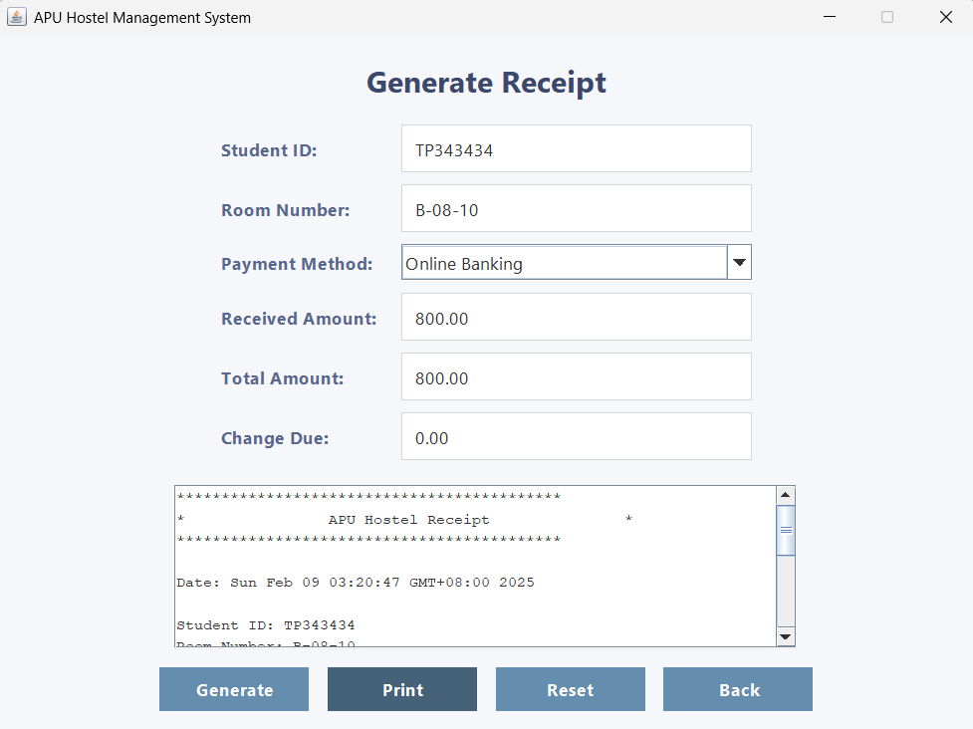  Figure 3.4.3.5: Generate Receipt Page with ‘Print’ Button | 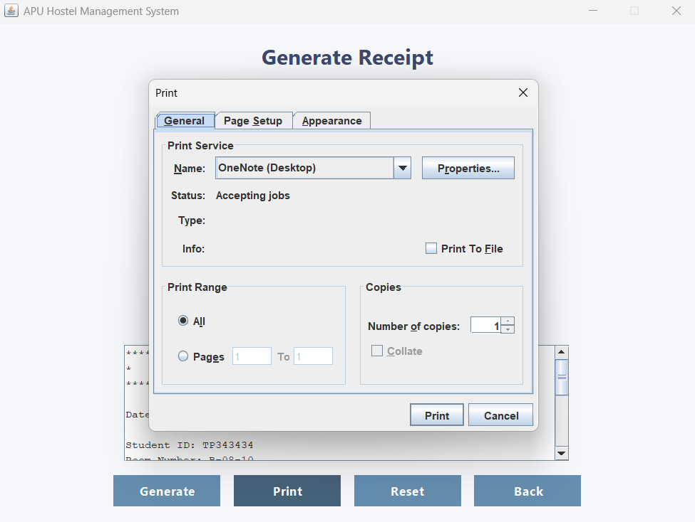  Figure 3.4.3.6: Pop-up Window of Print Setting
The staff clicks the ‘Print’ button. | A print setting window will pop-up for staff to set it.
  Figure 3.4.3.7: Pop-up Window with ‘Print’ Button | 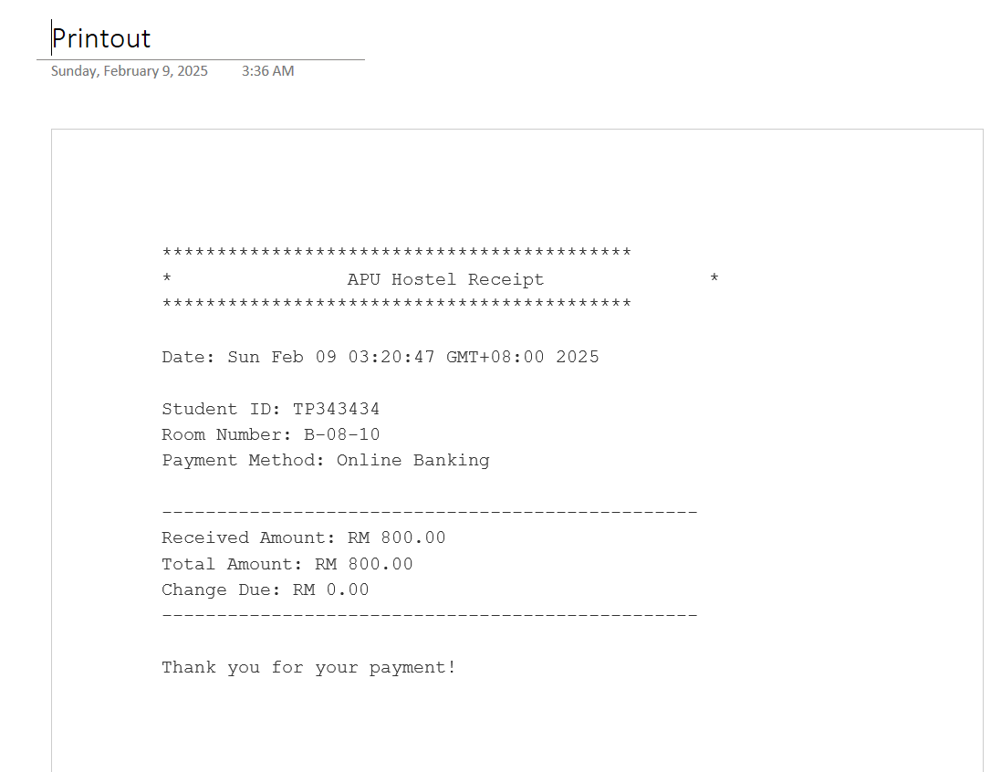  Figure 3.4.3.8: Printout of the Receipt
The staff clicks on the ‘Print’ button. | The receipt will be printed out at the selected location that had been set in the Print Setting window.
  Figure 3.4.3.9: Print Setting Window with ‘Cancel’ Button | 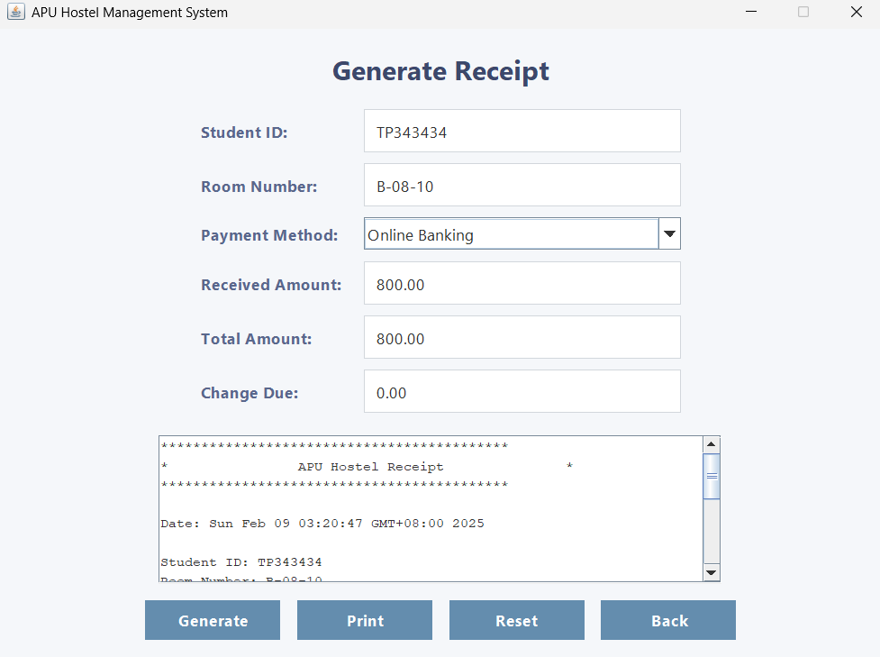  Figure 3.4.3.10: Generate Receipt Page
The ‘Cancel’ button clicked by the staff. | The Print Setting pop-up window closed and remain on the Generate Receipt page.
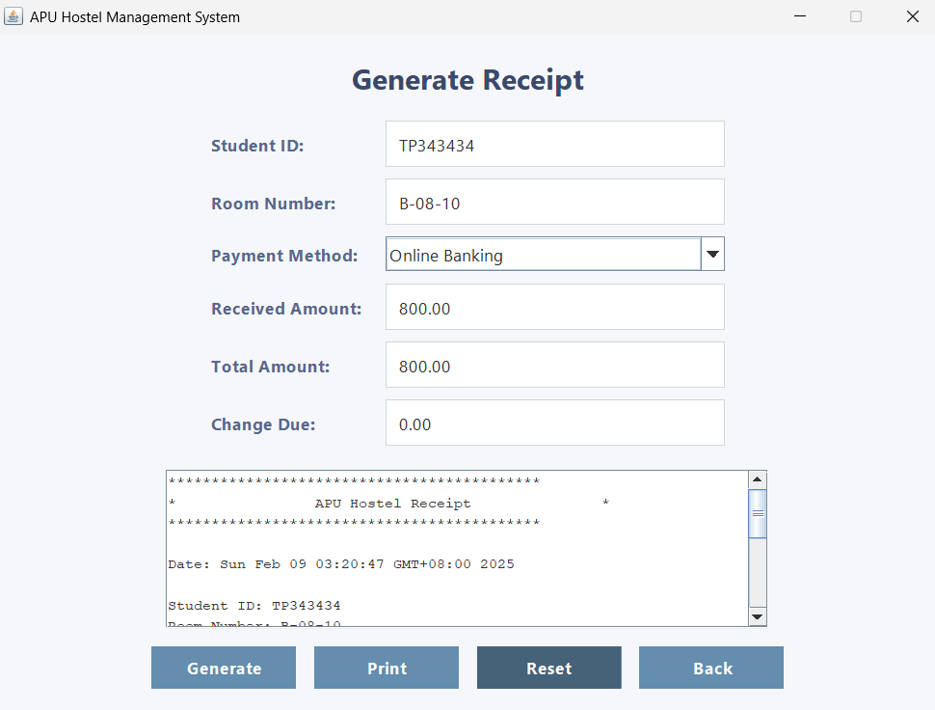  Figure 3.4.3.11: Generate Receipt Page with ‘Reset’ Button |   Figure 3.4.3.12: The Filled Data Cleared in Generate Receipt Page
The staff clicks the ‘Reset’ button. | All of the filled data have been clear.
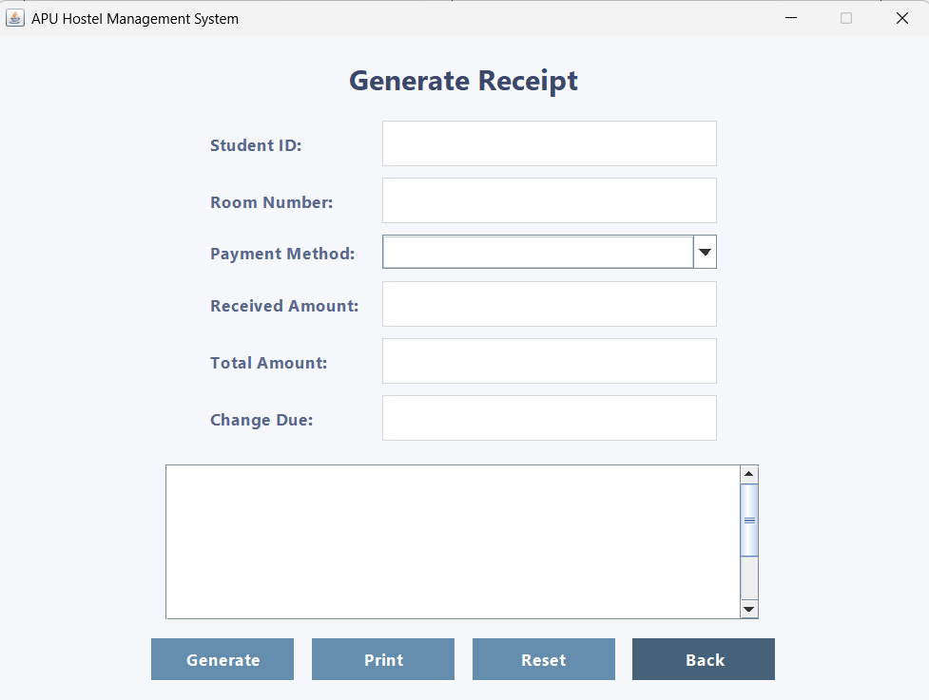  Figure 3.4.3.13: Generate Receipt Page with ‘Back’ Button |   Figure 3.4.3.14: Staff Menu
The staff clicks the ‘Back’ button. | It will back to the Staff Menu.

3.4.4 Hostel Information
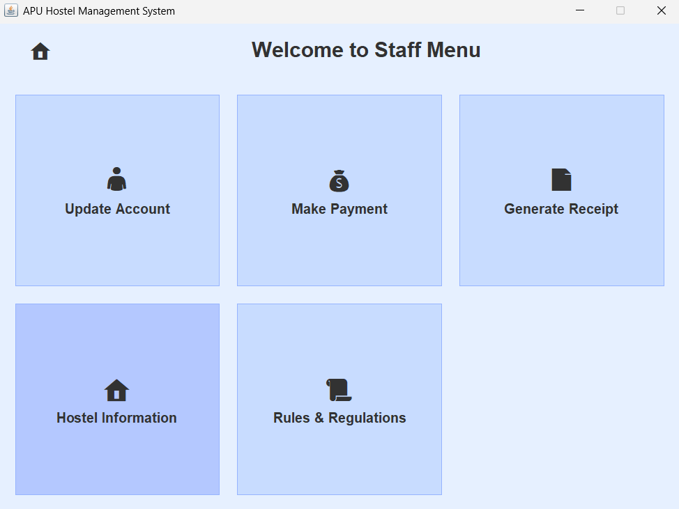  Figure 3.4.4.1: Staff Menu with ‘Hostel Information’ | 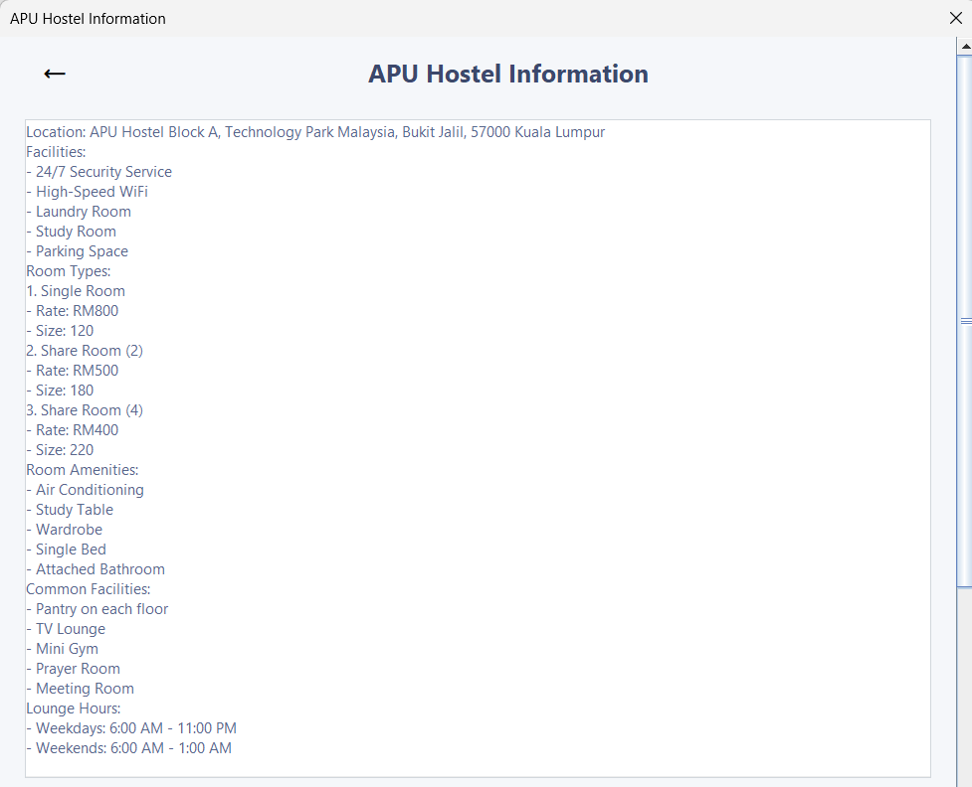  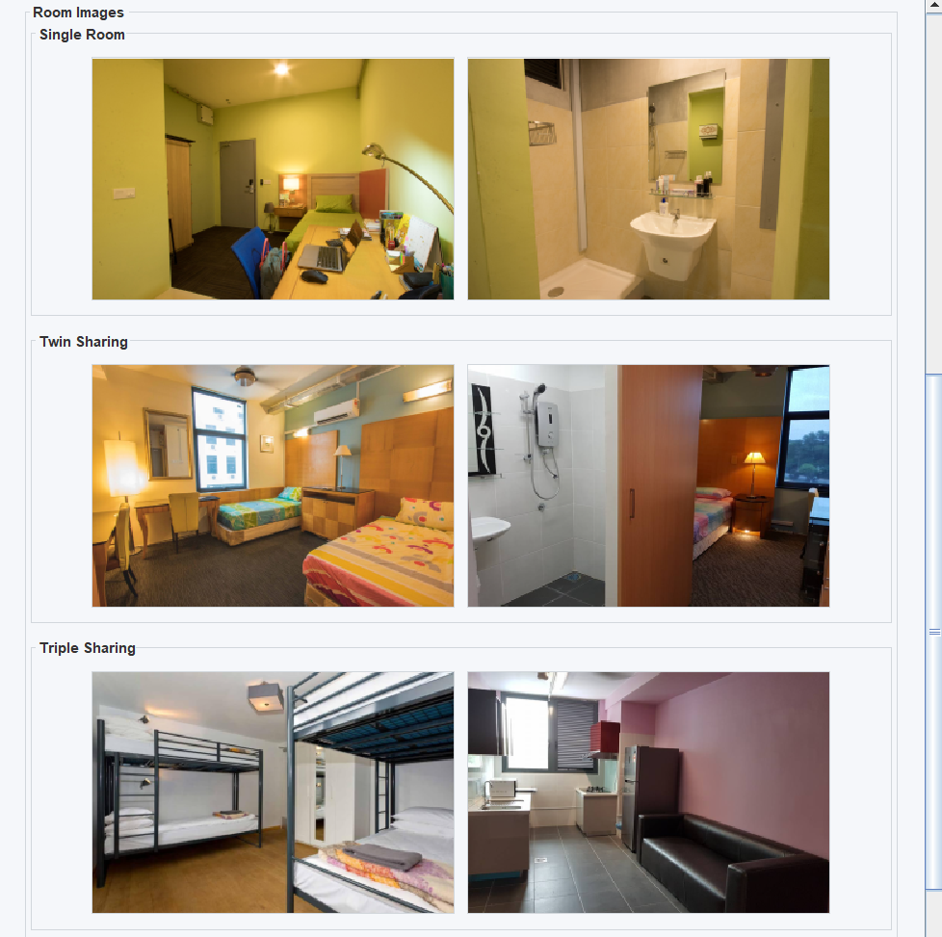  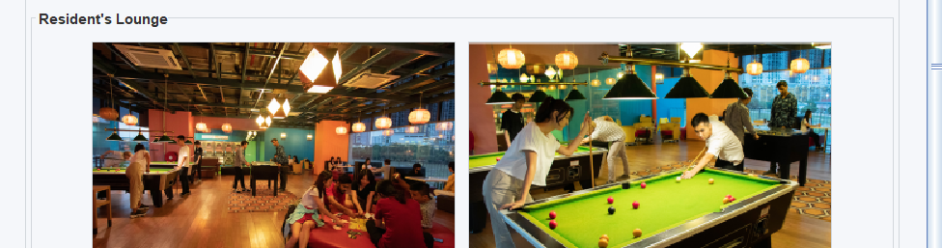  Figure 3.4.4.2: Hostel Information Page
The staff choose ‘Hostel Information’ button. | It will go to Hostel Information Page. The staff can scroll to see the information.
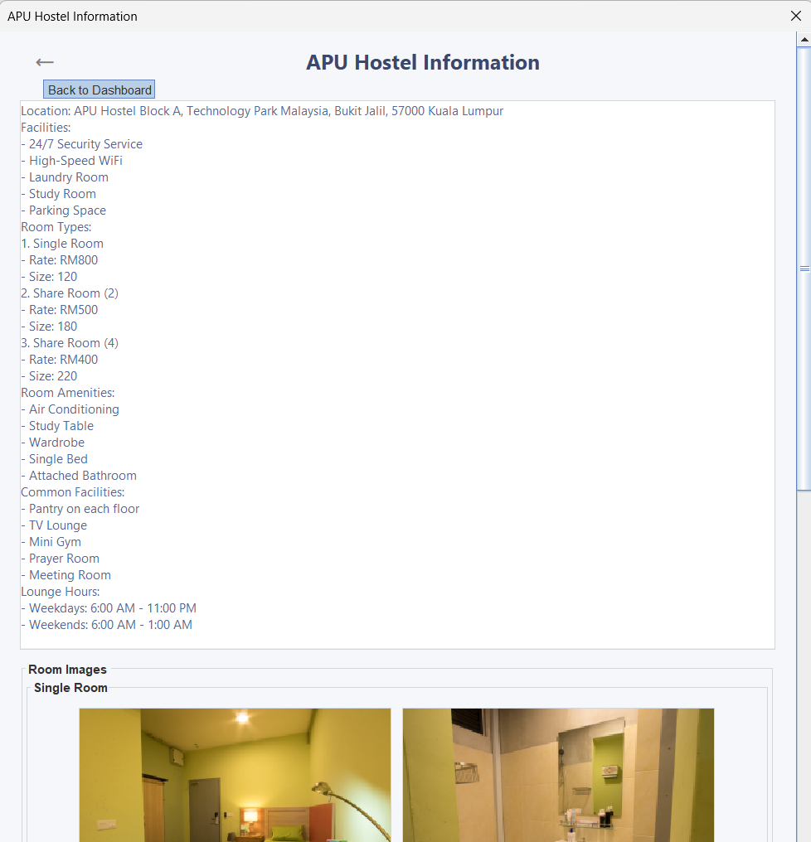  Figure 3.4.4.3: Hostel Information Page with ‘Arrow’ Icon |   Figure 3.4.4.4: Staff Menu
The staff clicks on the ‘Arrow’ icon. | It will back to the Staff Menu.

3.4.5 Rules & Regulations
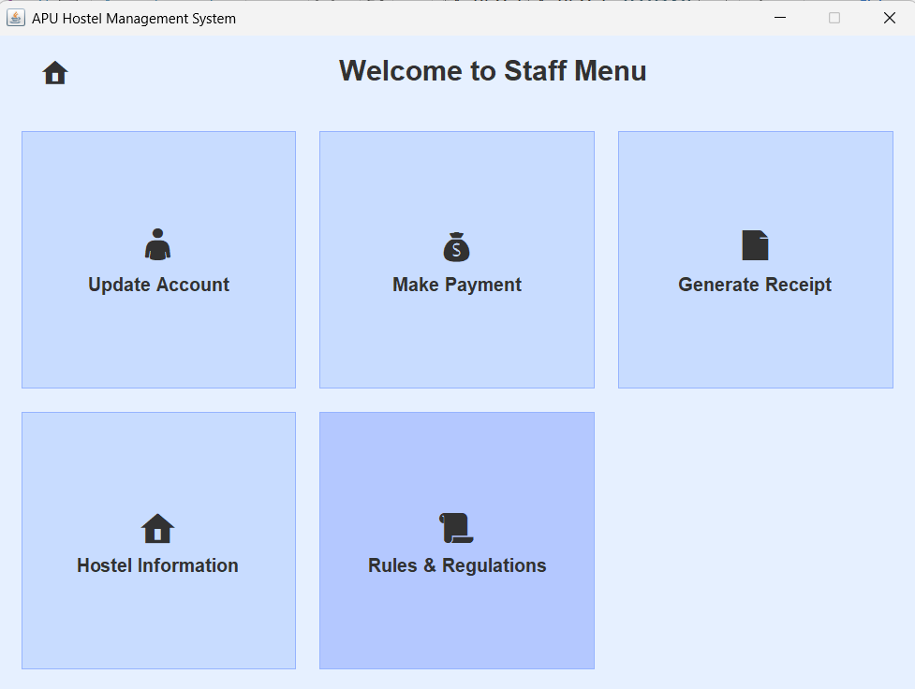  Figure 3.4.5.1: Staff Menu with ‘Rules & Regulations’ | 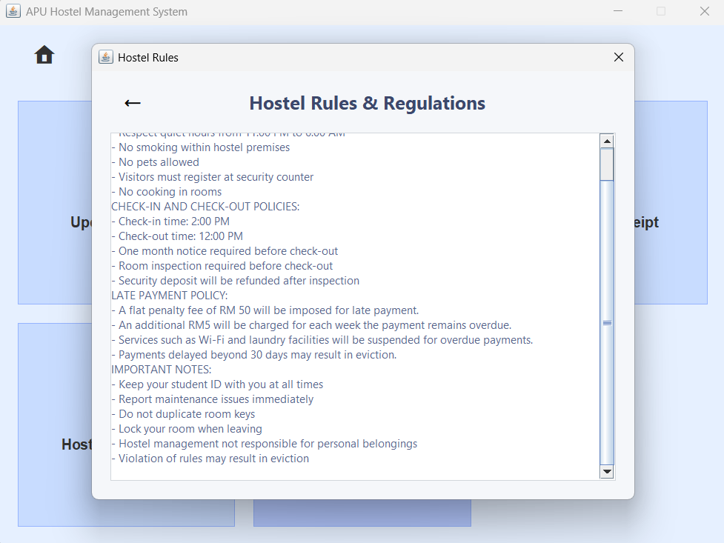  Figure 3.4.5.2: Hostel Rules & Regulations Page
The staff choose ‘Rules & Regulations’. | Hostel Rules & Regulations page will pop-up, staff can scroll to see it.
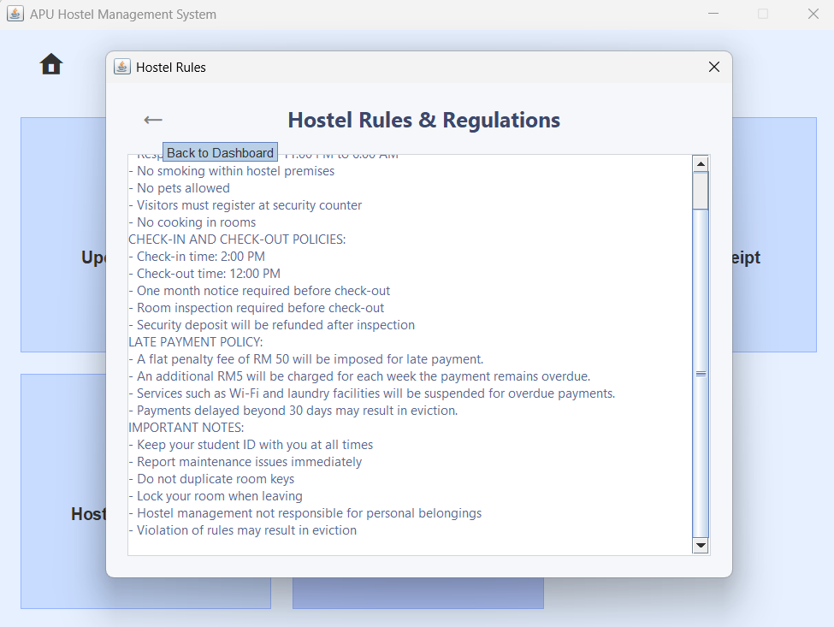  Figure 3.4.5.3: Hostel Rules & Regulations with ‘Arrow’ Button |   Figure 3.4.5.4: Staff Menu
The staff clicks the ‘Arrow’ button. | It will back to the Staff Menu.

3.4.6 Logout
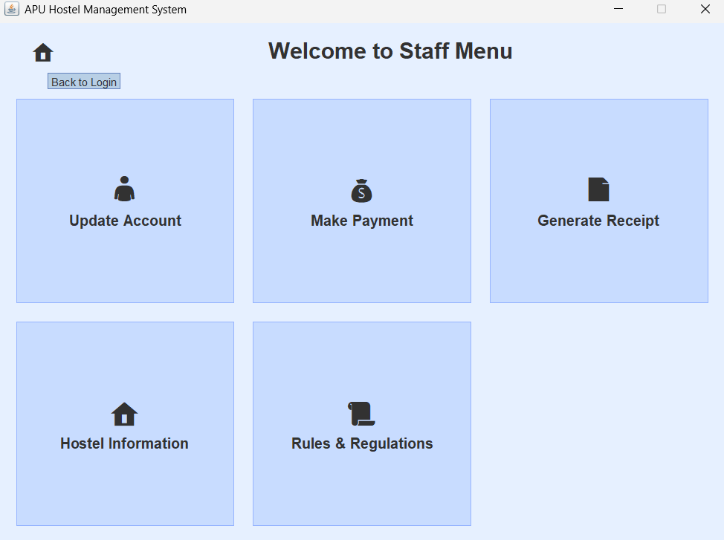  Figure 3.4.6.1: Staff Menu with ‘Home’ Button | 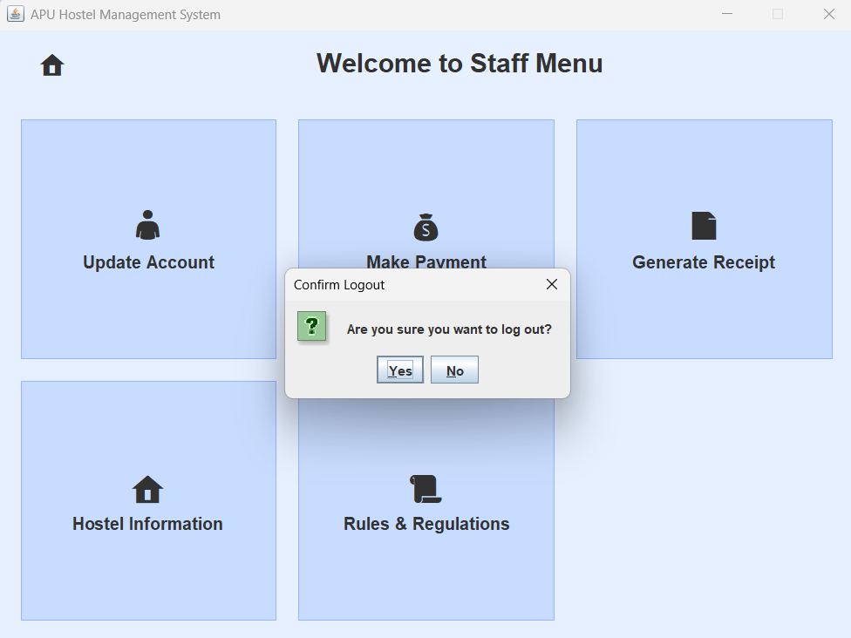  Figure 3.4.6.2: Confirm Logout Pop-up Window
The staff clicks the ‘Home’ button. | There will have a Confirm Logout Pop-up Window.
  Figure 3.4.6.3: Pop-up Window with ‘Yes’ Button | 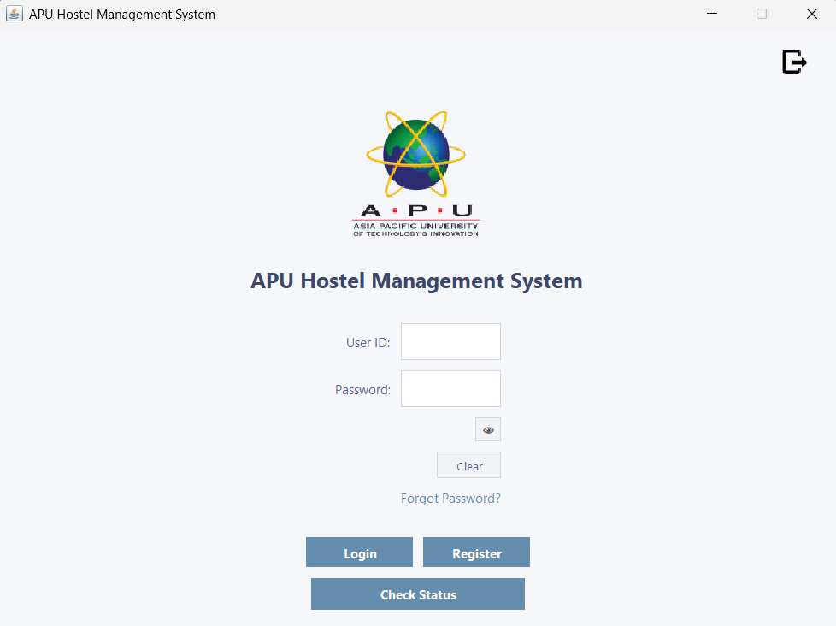  Figure 3.4.6.4: Login Page
The staff click the ‘Yes’ button. | It will bring the staff to the Login Page.
  Figure 3.4.6.5: Pop-up Window with ‘No’ Button |   Figure 3.4.6.6: Staff Menu
The staff clicks the ‘No’ button. | The pop-up window will close and remain on the Staff Menu.

3.5 Residents Dashboard
3.5.1 Update Account
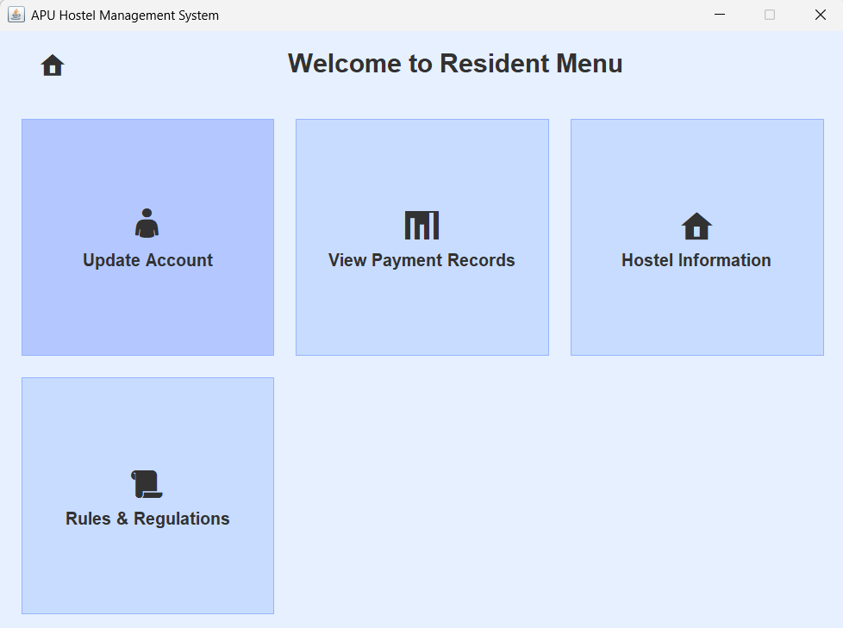  Figure 3.5.1.1: Resident Menu with ‘Update Account’ |   Figure 3.5.1.2: Update Profile Page
The resident click on the ‘Update Account’ button. | The resident will be bringing to the Update Profile page.
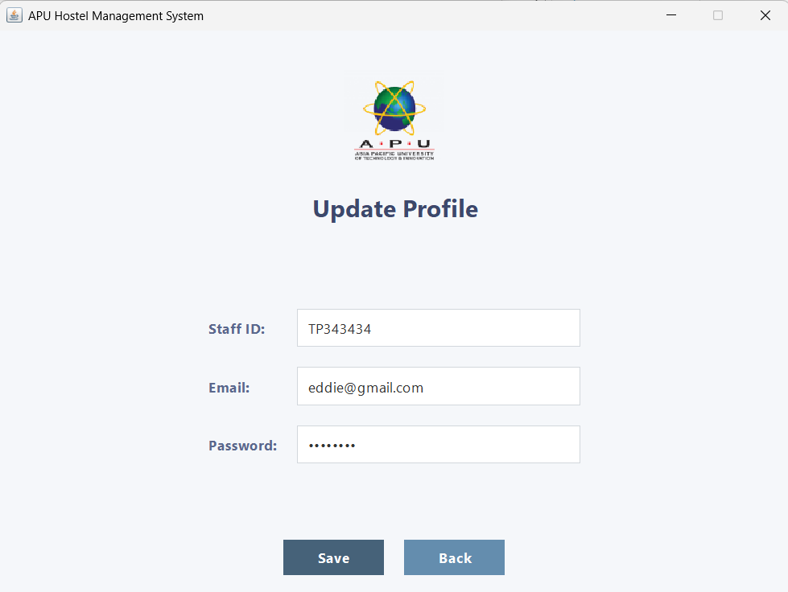  Figure 3.5.1.3: Update Profile Page with ‘Save’ Button | 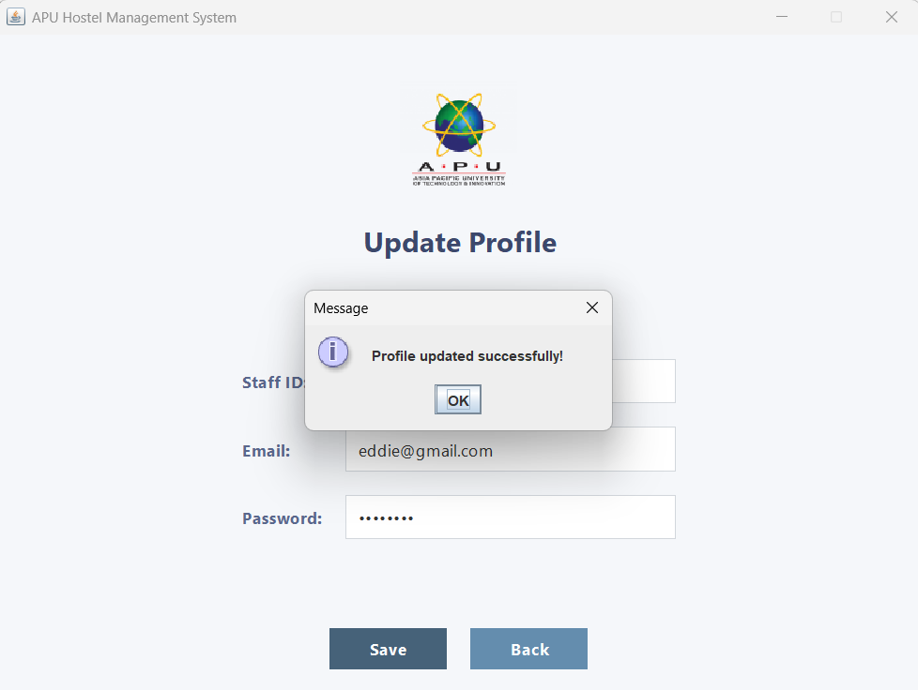  Figure 3.5.1.4: Pop-up Window “Profile updated successfully!”
The resident enters the input in the text field and click ‘Save’ button. | It will pop-up a window that written “Profile updated successfully!” to let the resident knows that profile has been updated.
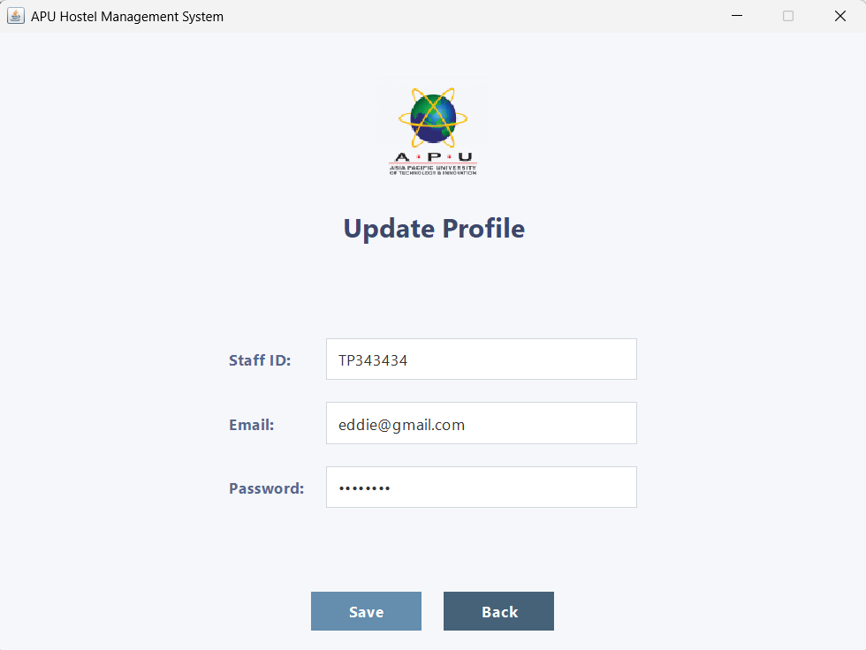  Figure 3.5.1.5: Updated Profile with ‘Back’ Button |   Figure 3.5.1.6: Staff Menu
The resident clicks the ‘Back’ button. | It will go back to the Staff Menu.

3.5.2 View Payment Records
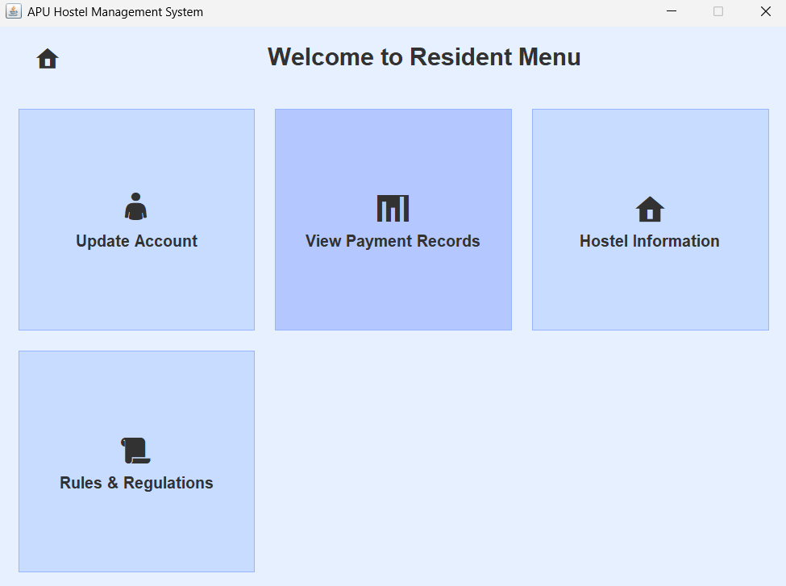  Figure 3.5.2.1:Resident Menu with ‘View Payment Records’ | 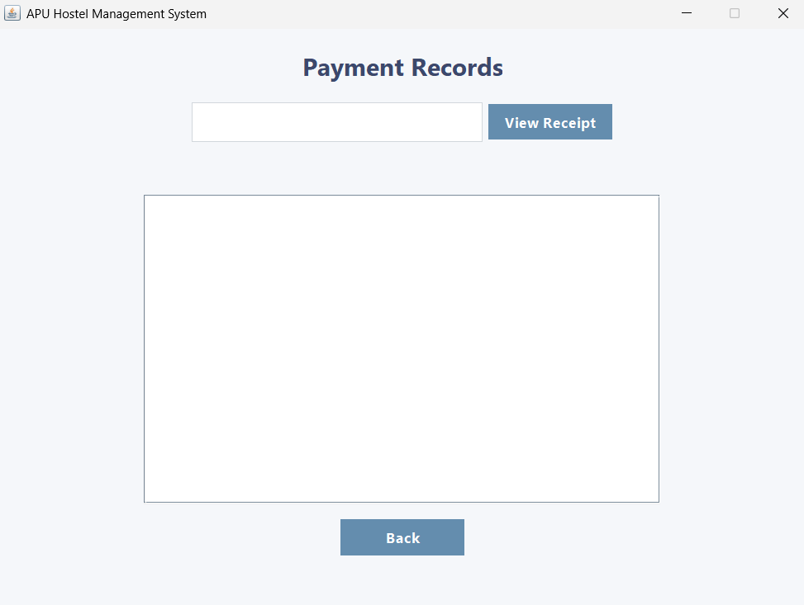  Figure 3.5.2.2: Payment Records Page
The resident choose the ‘View Payment Records’ button. | It will turn to Payment Records Page.
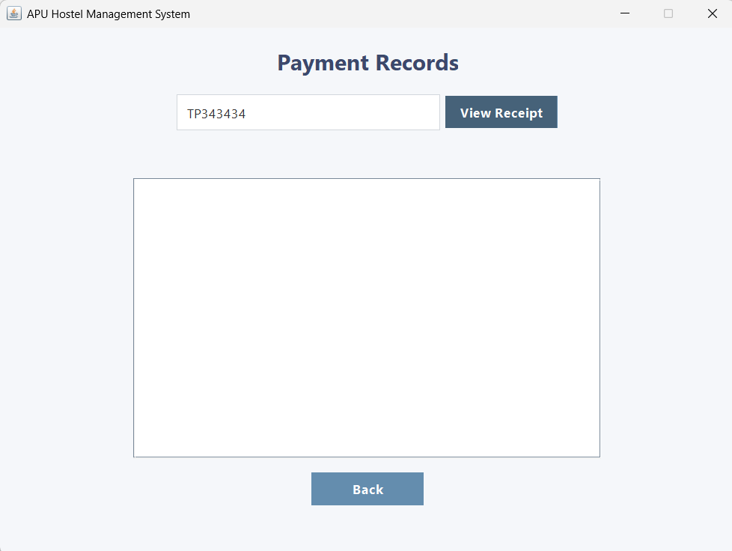  Figure 3.5.2.3: Payment Records with ‘View Receipt’ Button | 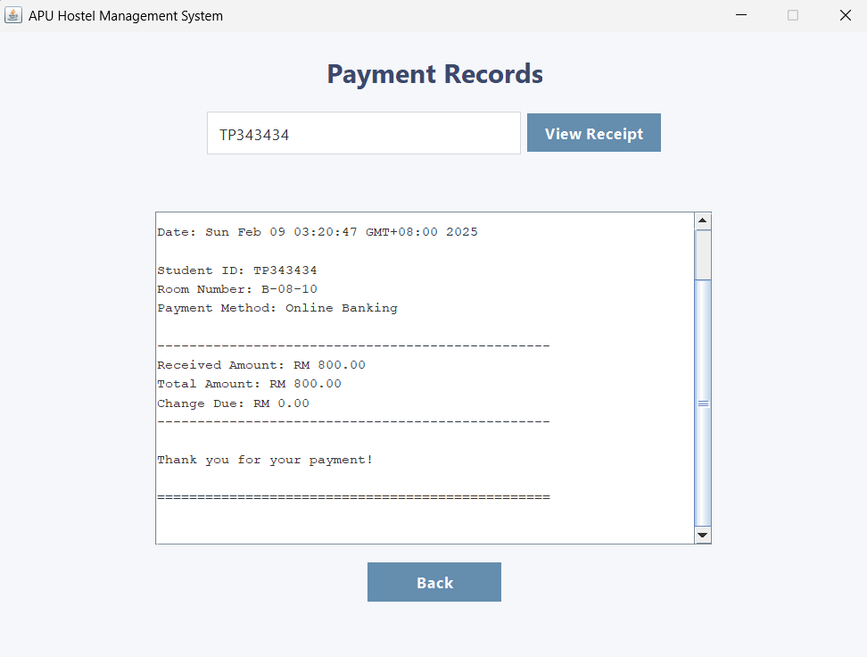  Figure 3.5.2.4: Receipt Shown
The resident click on the ‘View Receipt’ button. | The receipt will display in the area.
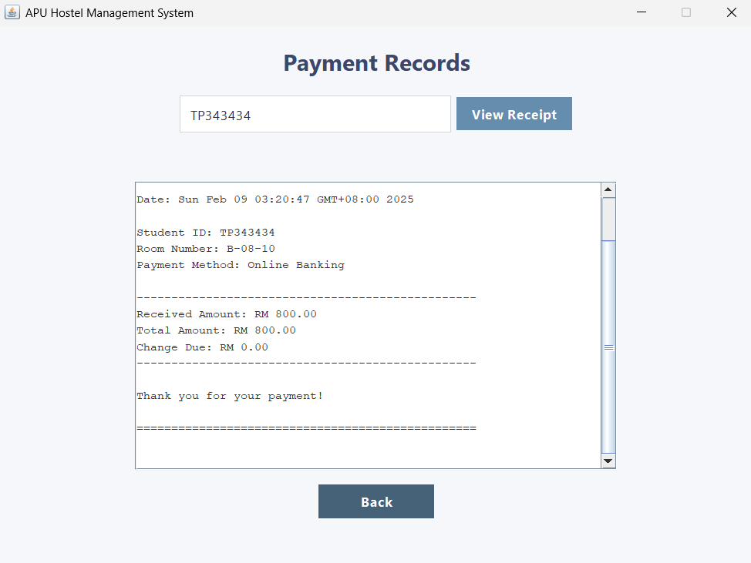  Figure 3.5.2.5: Payment Records with ‘Back’ Button | 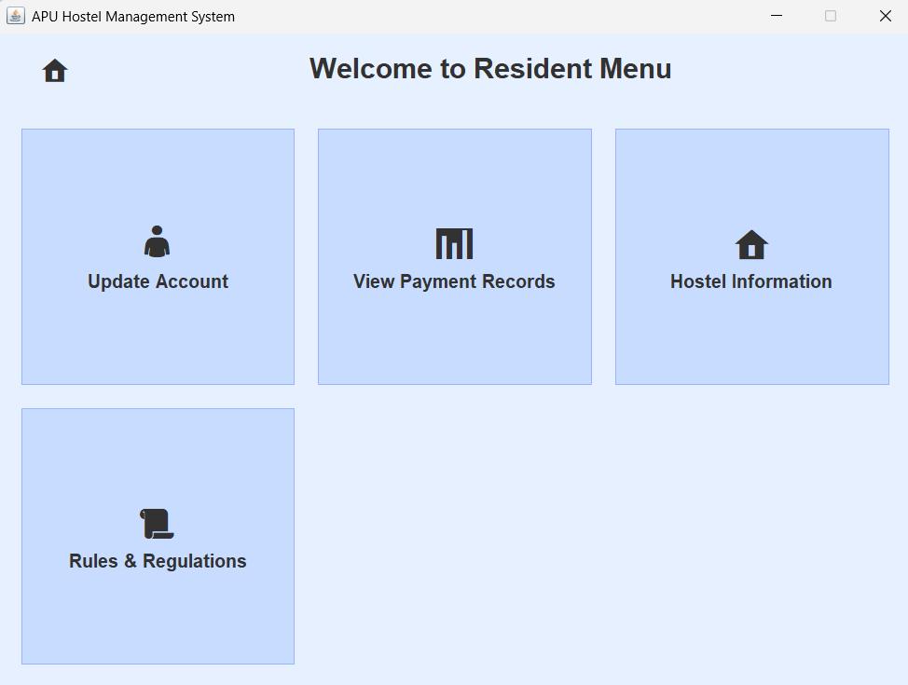  Figure 3.5.2.6: Resident Menu
The resident clicks on the ‘Back’ button. | The resident will be bringing back to the Resident Menu.

3.5.3 Hostel Information
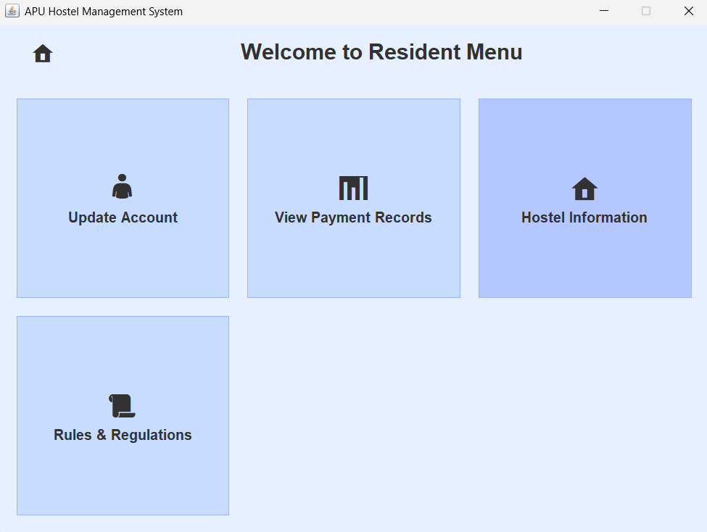  Figure 3.5.2.7: Resident Menu with ‘Hostel Information’ |       Figure 3.5.2.8: Hostel Information Page
The ‘Hostel Information’ button clicked by the resident. | The Hostel Information page shown and the resident can scroll the page to see more information.
  Figure 3.5.2.9: Hostel Information Page with ‘Arrow’ |   Figure 3.5.2.10: Resident Menu
The resident click on the ‘Arrow’ on the top left of the Hostel Information Page. | It will bring the resident back to Resident Menu.

3.5.4 Rules & Regulations
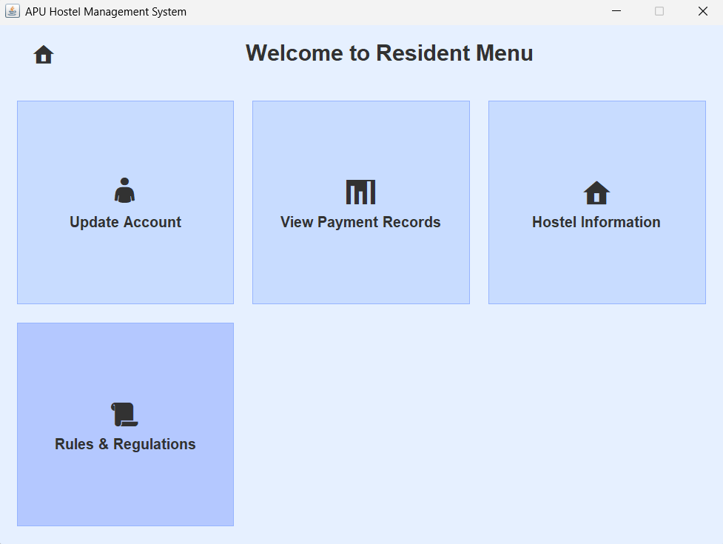  Figure 3.5.4.1: Resident Menu with ‘Rules & Regulations’ | 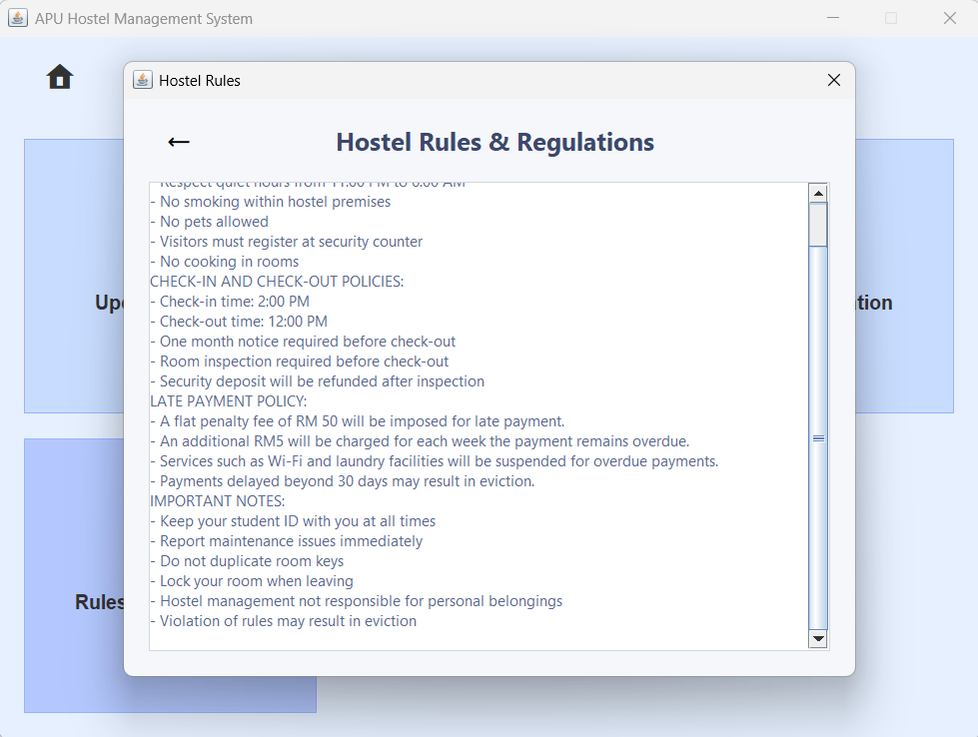  Figure 3.5.4.2: Hostel Rules & Regulations Page
The resident chooses ‘Rules & Regulations’. | There will have a Hostel Rules & Regulations page will pop-up. The resident can scrolls to see.
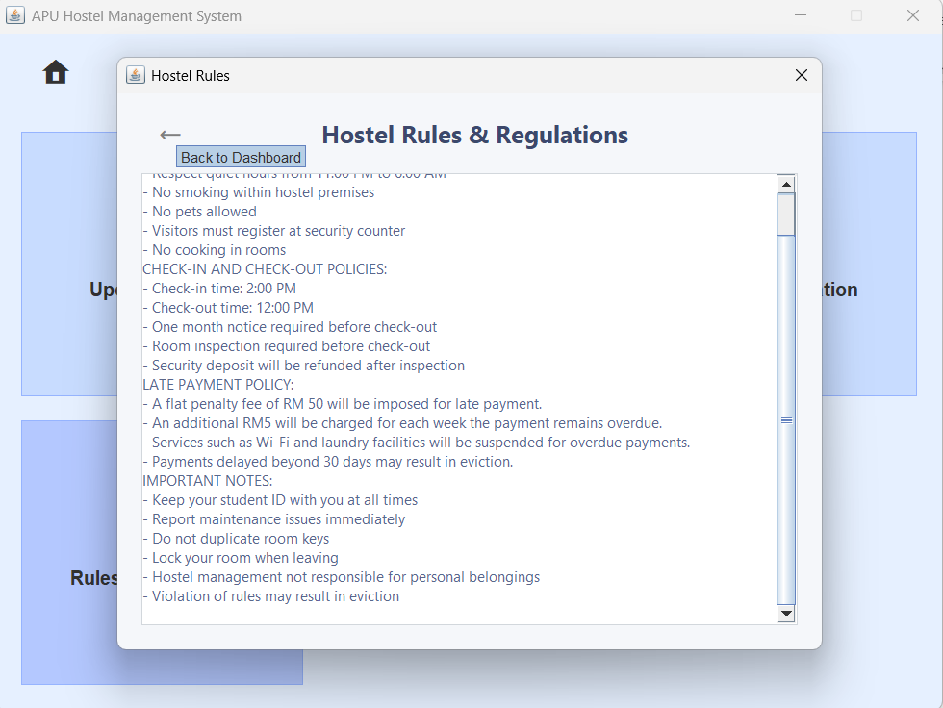  Figure 3.5.4.3: ‘Arrow’ Icon in Hostel Rules & Regulations Page |   Figure 3.5.4.4: Resident Menu
The staff clicks ‘Arrow’ icon. | The staff will be bring back to the Resident Menu.

3.5.5 Logout
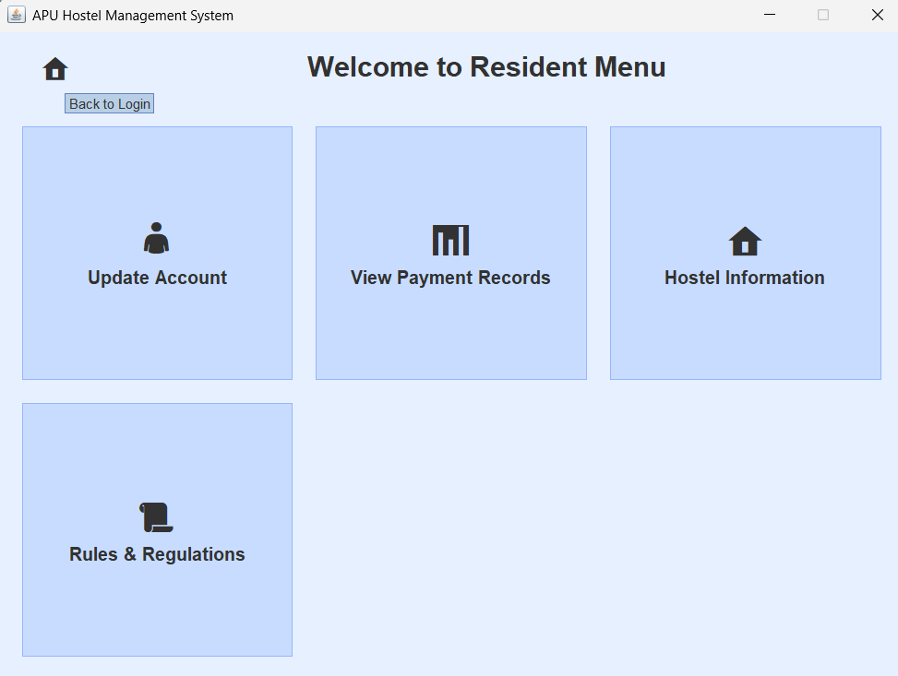  Figure 3.5.5.1: ‘Home’ Icon in Resident Menu | 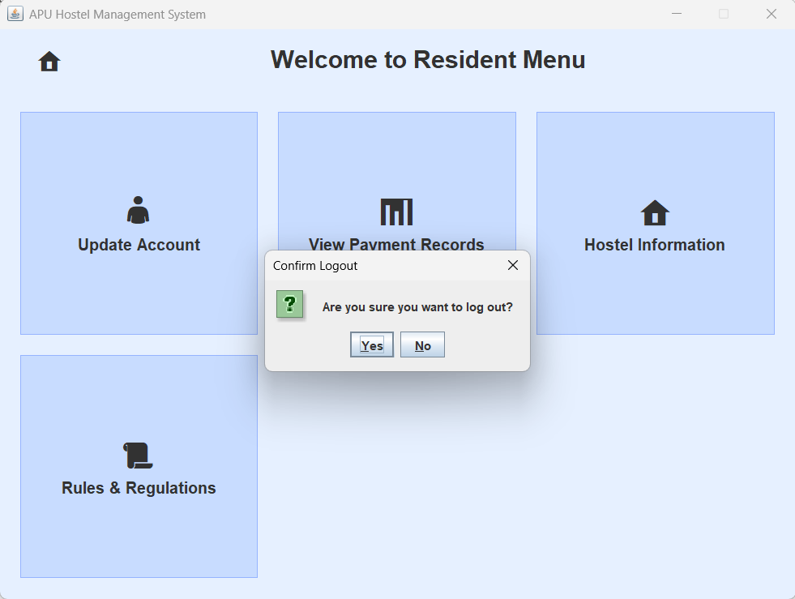  Figure 3.5.5.2: Confirm Logout Pop-up Window
The resident clicks on the ‘Home’ icon. | It will pop-up a Confirm Logout Window.
  Figure 3.5.5.3: ‘Yes’ button in Confirm Logout Pop-up Window |   Figure 3.5.5.4: Login Page
The resident clicks ‘Yes’ button. | It will logout and go to Login Page.
  Figure 3.5.5.5: ‘No’ Button in Confirm Logout Pop-up Window |   Figure 3.5.5.6: Resident Menu
The resident choose ‘No’ button. | The pop-up Confirm Logout window will close and remain on Resident Menu.

Program source code

Object-oriented Concepts
Classes
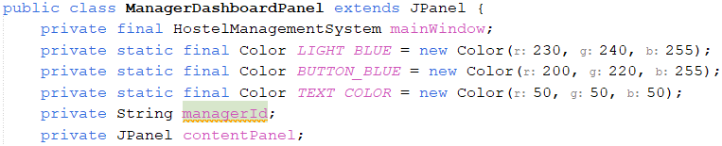 | The ManagerDashboardPanel class is a blueprint for creating manager dashboard objects in a Hostel Management System. It inherits from JPanel, gaining its properties and behaviors. The class has attributes like managerId and contentPanel, defining the state of each object. By grouping related data and behavior, it follows encapsulation, ensuring a structured and reusable design.
Inheritance
 | The line “public class ManagerDashboardPanel extends JPanel {” demonstrates inheritance where ManagerDashboardPanel inherits from JPanel, a built-in Swing class. This allows ManagerDashboardPanel to function as a graphical panel while reusing JPanel's existing properties and methods, such as layout management and component handling.
Constructor
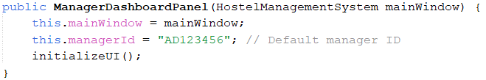 | The constructor public ManagerDashboardPanel(HostelManagementSystem mainWindow) is a custom constructor that initializes the ManagerDashboardPanel with a reference to the main application: mainWindow. It assigns a default manager ID: AD123456 and calls the initializeUI() method to set up the panel’s user interface, including the header and main content areas. This constructor ensures that the panel is properly linked to the main system and ready for interaction when instantiated.
Static Members
 | This code uses static members to define shared instances of UserService, RateService, FileHandler, and Logger. Since they are static, these variables belong to the class rather than individual instances, ensuring only one instance exists for each.
Method Overriding
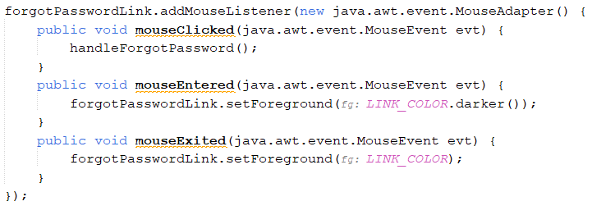 | Method overriding occurs in the MouseAdapter implementation for the forgotPasswordLink component. The mouseEntered and mouseExited methods from the MouseAdapter class are overridden to change the color of the link when the mouse hovers over it. Specifically, in the mouseEntered method, the link's color is darkened: forgotPasswordLink.setForeground(LINK_COLOR.darker());, and in the mouseExited method, it is reverted back to its original color: forgotPasswordLink.setForeground(LINK_COLOR);.
Method Overloading
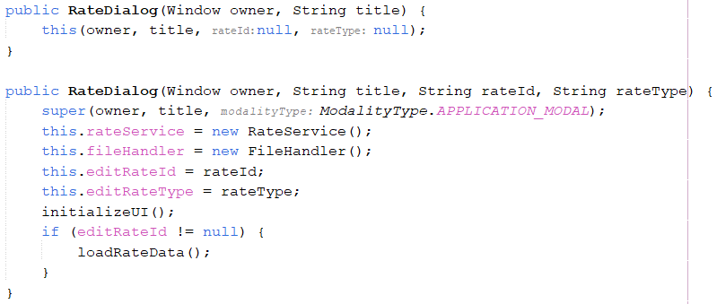 | This code demonstrates method overloading through constructor overloading in the RateDialog class. There are two constructors with the same name but different parameter lists. The first constructor takes only owner and title as parameters and calls the second constructor using this(owner, title, null, null), effectively passing null for rateId and rateType. The second constructor accepts four parameters (owner, title, rateId, rateType) and initializes the RateDialog by setting up a RateService, FileHandler, and storing the rate details. It also calls initializeUI() to set up the user interface, and if editRateId is not null, it loads existing rate data. This approach provides flexibility, allowing the RateDialog to be created either with or without specific rate information.
Constructor Overloading
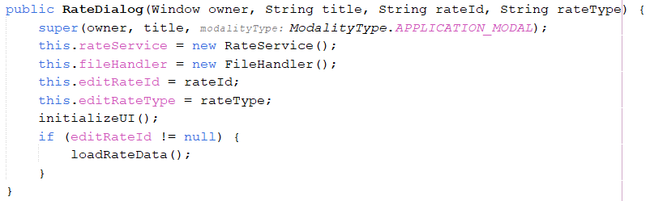 | The RateDialog constructor initializes a modal dialog for creating or editing rates. It sets the dialog’s modality and assigns the provided rateId and rateType to instance variables. It also initializes rateService and fileHandler for managing data. The initializeUI() method sets up the interface, and if editRateId is not null, loadRateData() is called to prefill the form for editing. This allows the dialog to handle both new and existing rates efficiently.
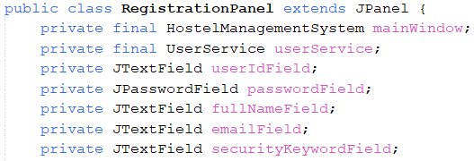 | Private Fields  The RegistrationPanel class defines private instance variables to encapsulate data and maintain modularity. The mainWindow and userService fields are final references used for system interactions and user validation. The input fields: userIdField, passwordField, fullNameField, emailField, and securityKeywordField store user registration details. Keeping these fields private ensures that data is only accessed and modified within the class.
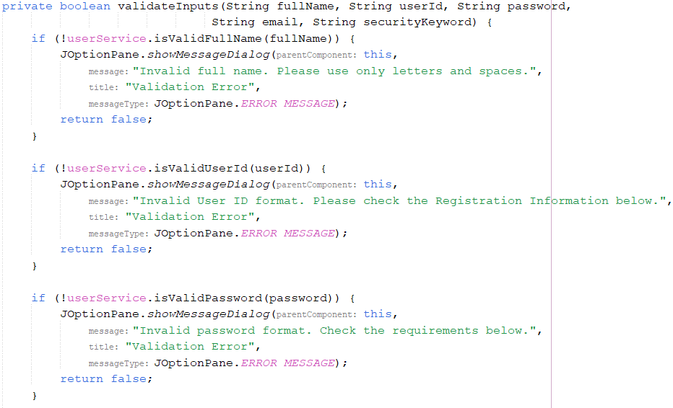  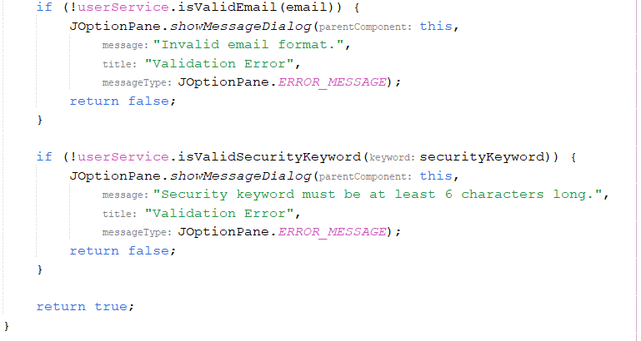 | Private Methods  The validateInputs() method is a private helper function responsible for ensuring that user-provided registration details meet predefined validation criteria. It checks the validity of the full name, user ID, password, email, and security keyword using userService methods. If any input is invalid, it displays an error message via JOptionPane and returns false, preventing further processing.
Exception handling
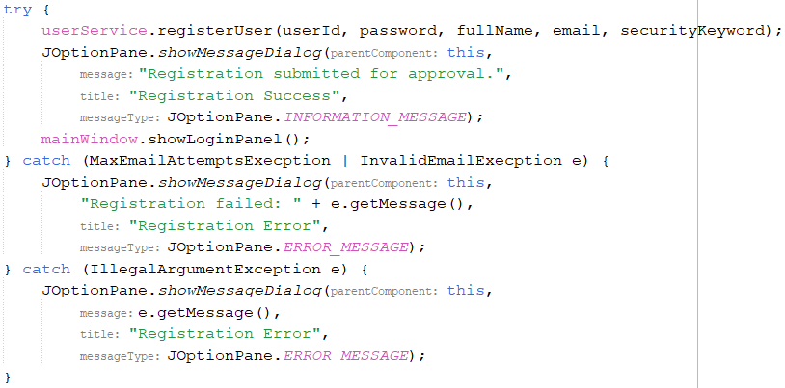 | The exception handling in the handleRegistration() method ensures that registration errors are managed effectively using try-catch blocks. When a user attempts to register, the method calls userService.registerUser(), which may throw exceptions if there are issues with the input or registration process. The method specifically catches MaxEmailAttemptsExecption and InvalidEmailExecption, which likely indicate email-related registration failures, and displays an appropriate error message. Additionally, it catches IllegalArgumentException, which handles general validation errors, ensuring users receive meaningful feedback.
Polymorphism
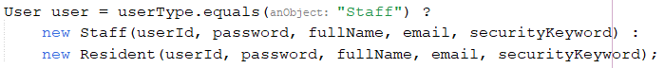 | In the handleSave() method, different User objects (Staff or Resident) are created based on the selected user type. This uses method overriding, as both extend the User class and may have their own method implementations. The code determines the user type dynamically using userTypeCombo and instantiates the appropriate subclass. This demonstrates polymorphism by allowing a single class (User) to take different forms (Staff and Resident) while handling them uniformly.
Data Abstraction
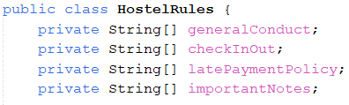 | The private fields (generalConduct, checkInOut, latePaymentPolicy, importantNotes) hide the internal representation of hostel rules from external classes. Instead of directly accessing these arrays, external classes must use getter methods (getGeneralConduct(), getCheckInOut(), etc.) and the updateRules() method to modify them. This abstraction ensures that the data is encapsulated, preventing unauthorized modifications and enforcing controlled access.
Protected Access Modifier
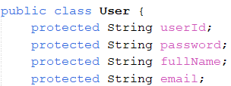 | In the User class, the protected access modifier is used for userId, password, fullName, and email, allowing access within the class and its subclasses. This restricts access from outside but permits child classes to inherit and modify these fields.
Interface

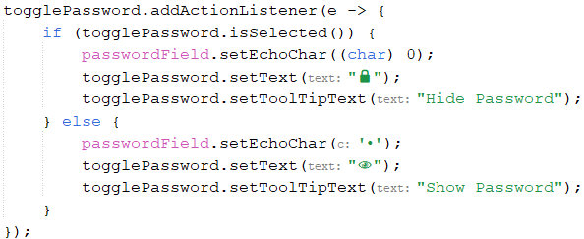 | This Java Swing code snippet adds an action listener to a toggle button: togglePassword that controls the visibility of a password field: passwordField. When the button is selected, it sets the password field’s echo character to (char) 0, making the password visible, and updates the button’s text to "🔒" with a tooltip "Hide Password". When deselected, it restores the echo character to '•' to mask the password, updates the button’s text to "👁", and changes the tooltip to "Show Password".
Constants
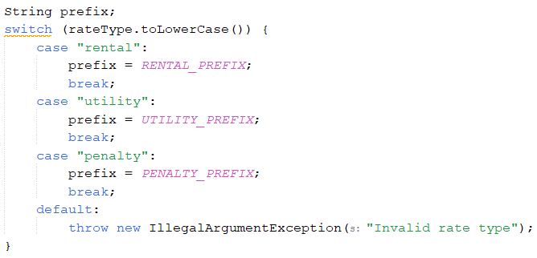 | The code uses the Constants concept by defining RENTAL_PREFIX, UTILITY_PREFIX, and PENALTY_PREFIX as static final fields, each holding a predefined value ("R", "U", "P") for different rate types. In the switch statement, the appropriate constant is assigned based on the rateType, ensuring consistent and maintainable usage of these prefixes throughout the code.

Java Features
Input Validation
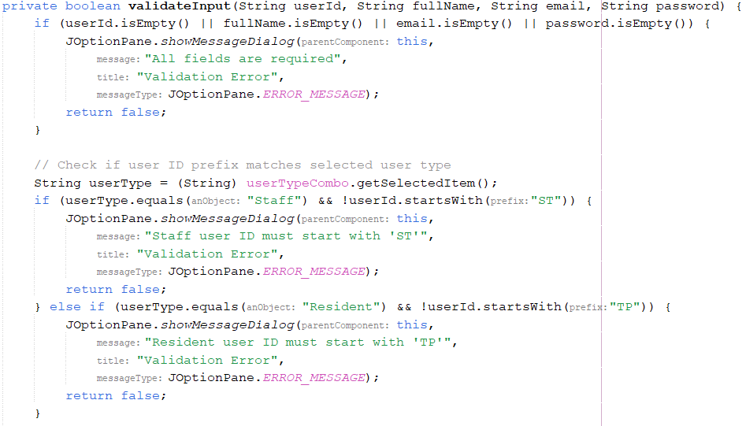  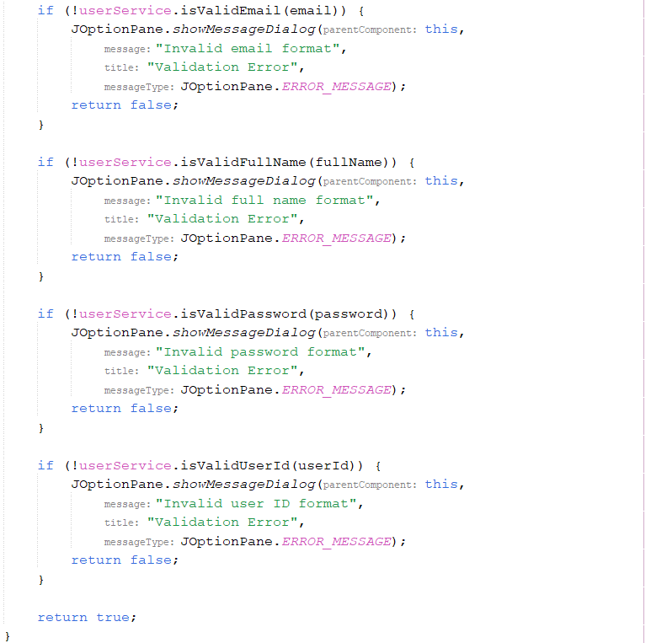 | The input validation logic is implemented in the validateInput() method, which ensures that all fields: User ID, Full Name, Email, and Password are filled before proceeding. It checks that the User ID prefix corresponds to the selected user type ("ST" for Staff and "TP" for Resident) and verifies that the email follows a valid format using userService.isValidEmail(). If any validation fails, an error message is displayed using JOptionPane.showMessageDialog(), preventing invalid data from being processed. This method is called within handleSave() to validate input before creating or updating a user.
Data Validation
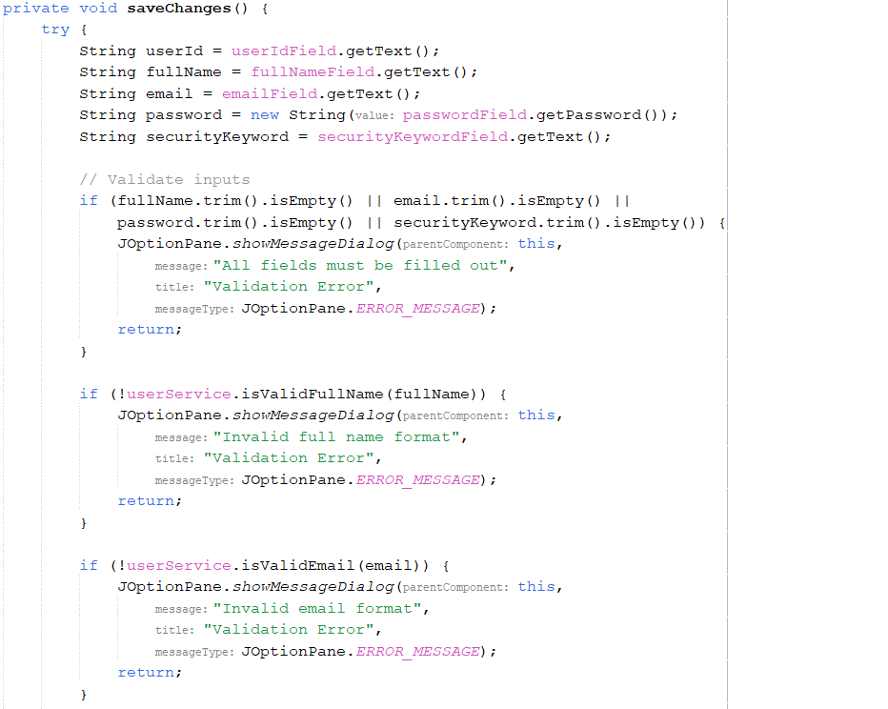  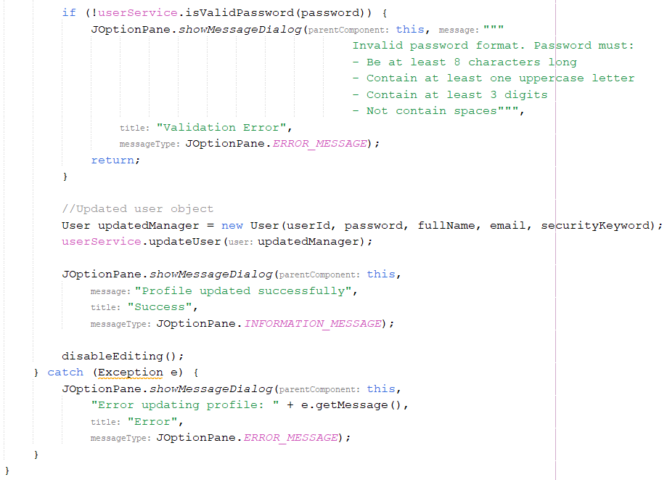 | The data validation in the code occurs within the saveChanges() method, specifically in the section that checks user input before saving profile updates. This method validates four fields: fullName, email, password, and securityKeyword, ensuring that none are left empty using trim().isEmpty(). If any field is blank, an error message is displayed via JOptionPane.showMessageDialog(), preventing invalid submissions. Additionally, userService.isValidFullName(fullName), userService.isValidEmail(email), and userService.isValidPassword(password) are used to enforce specific formatting rules, ensuring that the full name, email, and password meet predefined criteria. If any validation fails, an appropriate error message is shown, and the method exits without saving changes.
String Formatting
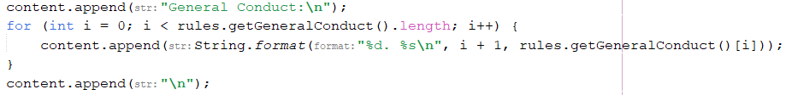 | In this line: content.append(String.format("%d. %s\n", i + 1, rules.getGeneralConduct()[i]));, String.format is used to ensure that each item in the generalConduct array is consistently formatted. The format "%d. %s\n" is a placeholder pattern, where %d represents the number (index + 1), and %s represents the string value (the specific general conduct rule). This method ensures that the output follows a uniform structure, making it easier to read and display the rules consistently.
Array List
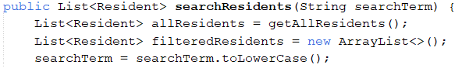 | In the searchResidents() method, ArrayList is used to store and filter residents. The line List<Resident> allResidents = getAllResidents(); initializes an ArrayList to hold all residents, while List<Resident> filteredResidents = new ArrayList<>(); creates an empty ArrayList for matching residents. Finally, filteredResidents.add(resident); adds matching residents to the list, demonstrating how ArrayList is used for dynamic data storage and filtering.
Chained Method Calls
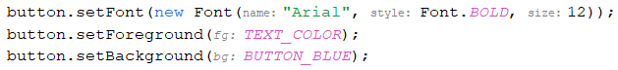 | setBackground(), setForeground(), and setFont() return the button object, allowing multiple calls in a single statement. This follows the fluent interface pattern, improving readability and reducing repetitive code.
Multi-catch Exception Handling
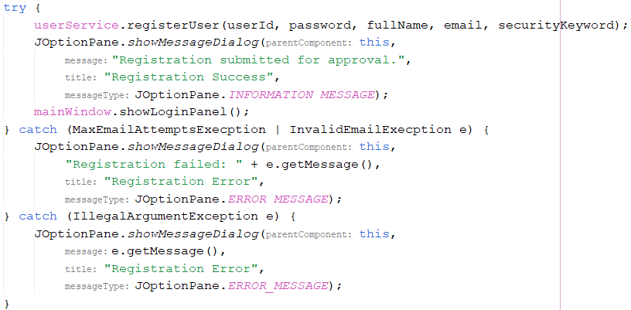 | The line catch (MaxEmailAttemptsExecption | InvalidEmailExecption e) uses multi-catch exception handling, an OOP concept that improves code efficiency and readability by handling multiple exceptions in one block. It promotes polymorphism by treating different exceptions similarly and ensures encapsulation by providing user-friendly error messages without exposing internal details.
Control Structures  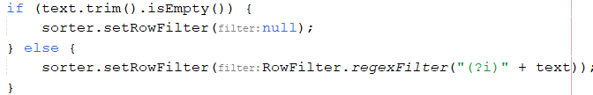 | The if-else statement is fundamental in Java programming for decision-making. The if statement used to check whether the search text is empty (text.trim().isEmpty()). If true, it removes any applied row filters (sorter.setRowFilter(null);). If not, it applies a case-insentive filter to the table rows.

Additional features source code

Object-oriented Concepts
Anonymous inner classes
 | The anonymous inner class in the LoginPanel is utilized for adding a MouseAdapter to the forgotPasswordLink component. By creating an unnamed instance of MouseAdapter, the code overrides methods like mouseClicked, mouseEntered, and mouseExited directly within the listener definition. This allows the link to trigger the handleForgotPassword() method when clicked and change its appearance on hover, providing interactive feedback to users.
Event Handling
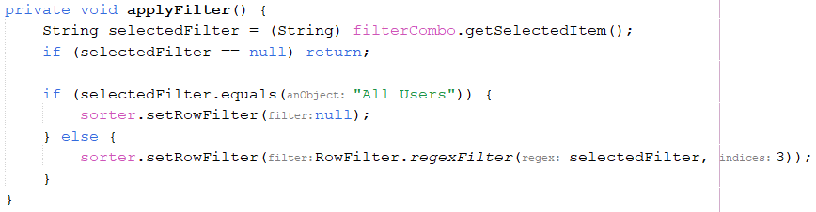 | The filter dropdown (filterCombo) lets the manager filter user registrations by type, like "All Users," "Customer," or "Admin." When a selection is made, an ActionListener triggers the applyFilter() method, which applies a RowFilter to show only matching rows based on user type (column 3). If "All Users" is selected, the filter is removed. This ensures quick and dynamic filtering for better data management.
Data Filtering
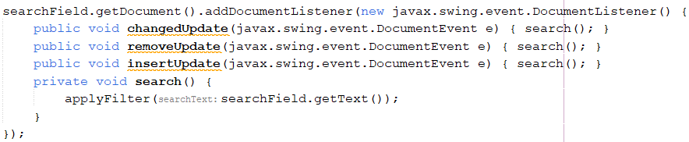 | This code enables real-time data filtering in a Java Swing JTable using a JTextField. A DocumentListener is added to searchField, triggering search() whenever the text changes. The search() method calls applyFilter(searchField.getText()), likely applying a row filter to update the displayed table rows dynamically. This allows instant search functionality, making data retrieval faster.
UI Component Organization
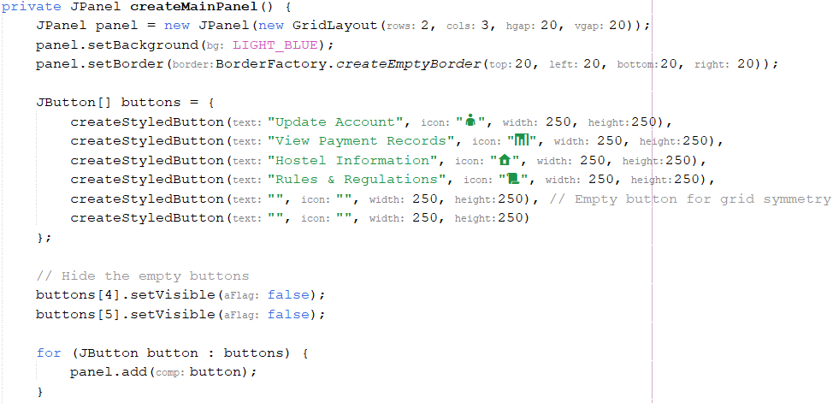  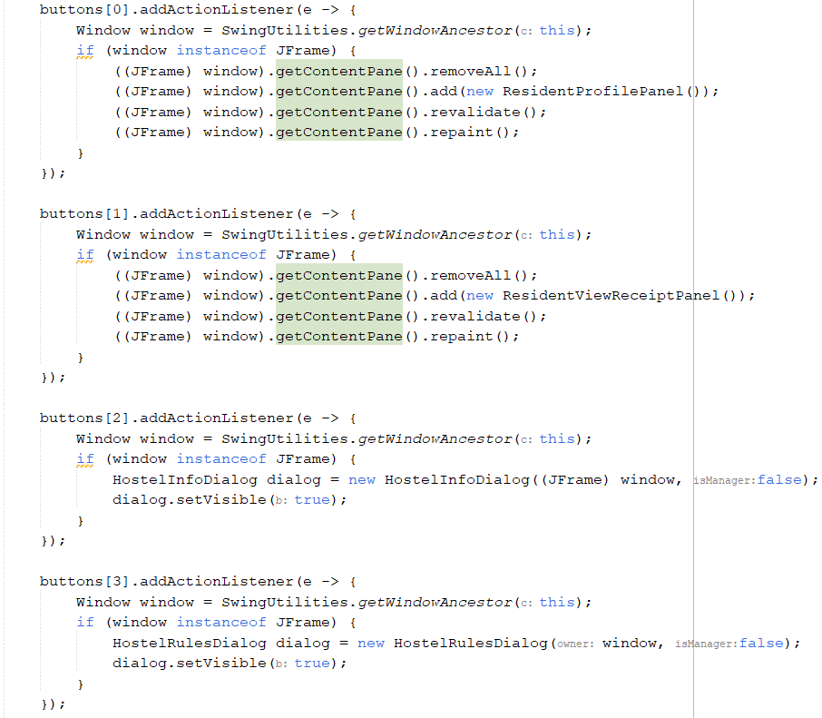  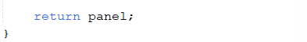 | The createMainPanel() method organizes the UI modularly by defining the main content panel separately for clarity and maintainability. It uses a JPanel with a GridLayout(2,3) to arrange buttons neatly, ensuring spacing and symmetry. Styled buttons with icons and text provide a consistent look, with two hidden buttons maintaining layout balance. Action listeners enable smooth navigation, keeping UI logic separate from functionality for easier management and scaling.
File I/O Operations
File Path Creation  File Existence Check  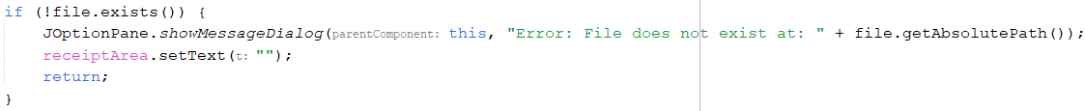  Reading File Content  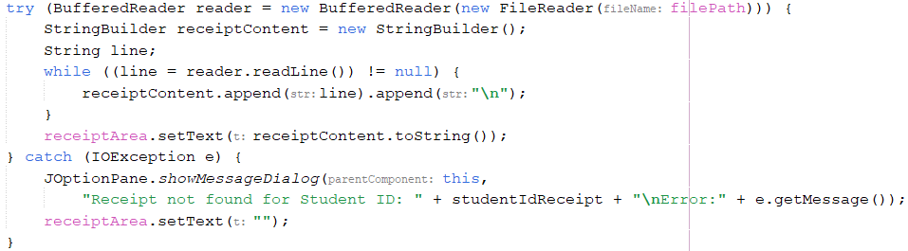 | The File I/O operations in viewReceiptActionPerformed() begin by constructing the file path using the student ID input (studentIdReceipt + "_receipts.txt"). It first checks if the file exists; if not, an error message is displayed, and the receipt area is cleared. If the file exists, it is opened using a BufferedReader, and its contents are read line by line, appending each line to a StringBuilder. The final receipt content is then displayed in the receiptArea. If an IOException occurs, an error message is shown, and the text area is cleared, ensuring smooth error handling and user feedback.
Interface
 | This Java Swing code snippet adds an action listener to a toggle button: togglePassword that controls the visibility of a password field: passwordField. When the button is selected, it sets the password field’s echo character to (char) 0, making the password visible, and updates the button’s text to "🔒" with a tooltip "Hide Password". When deselected, it restores the echo character to '•' to mask the password, updates the button’s text to "👁", and changes the tooltip to "Show Password".
Dependency Injection Pattern
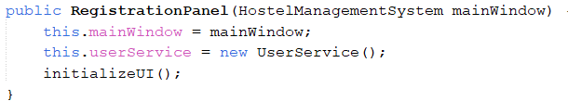 | The constructor public RegistrationPanel(HostelManagementSystem mainWindow) uses the Dependency Injection (DI) Pattern by injecting the mainWindow and userService into the RegistrationPanel class. This allows the RegistrationPanel to rely on external components, promoting loose coupling, flexibility, and easier testing by avoiding direct creation of dependencies within the class.
Builder Pattern
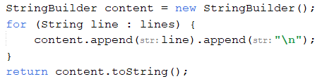 | The Builder Pattern is demonstrated through the use of StringBuilder to efficiently concatenate multiple strings. Each line from the file is appended to the StringBuilder, which prevents the creation of multiple intermediate string objects, thus improving performance when handling large data.
Singleton Pattern
 | This line ensures only one instance of HostelRules is created and shared across the application. Using static and final, the hostelRules object is initialized once and cannot be reassigned, providing controlled access through the getHostelRules() method, which prevents unnecessary object creation and ensures consistency.
Observer Pattern
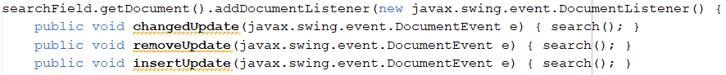 | The searchField is the subject, and the DocumentListener is the observer. It listens for text changes in the field and triggers the search() method in response, automatically updating when the field's content changes.
Command Pattern
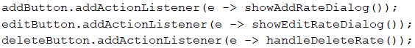 | This code demonstrates the Command Pattern, where each button (addButton, editButton, deleteButton) triggers a specific command (showAddRateDialog(), showEditRateDialog(), handleDeleteRate()). The event listeners act as invokers, executing the commands, which decouples the button actions from the logic and allows for easier modification or extension.
Decorator Pattern
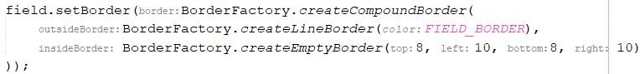 | This code demonstrates the Decorator Pattern by combining multiple border decorations for a text field. The setBorder method applies a compound border, where a line border: createLineBorder is layered with an empty border: createEmptyBorder. This pattern allows dynamic addition of functionalities, combining two borders to enhance the field's appearance without modifying the original object.
Null Object Pattern
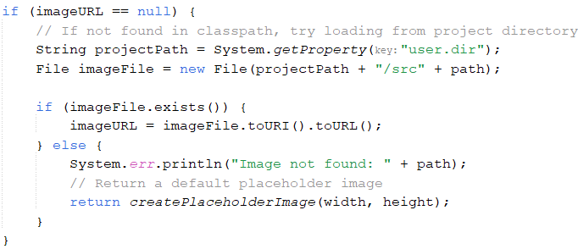 | This code uses the Null Object Pattern by providing a default behavior when the expected image is not found. When imageURL is null, the code attempts to load the image from the project directory.
Fluent Interface Pattern
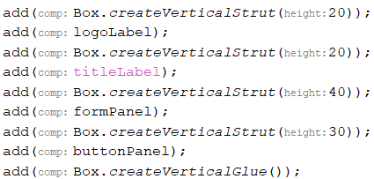 | The add method is used to add multiple components to a container, with each method call returning the container itself (or a similar object) to allow subsequent method calls to be chained together. For example, add(Box.createVerticalStrut(20)) is followed by add(logoLabel) and so on. This chaining simplifies the code by eliminating multiple statements, making the UI setup more concise.
Factory Pattern
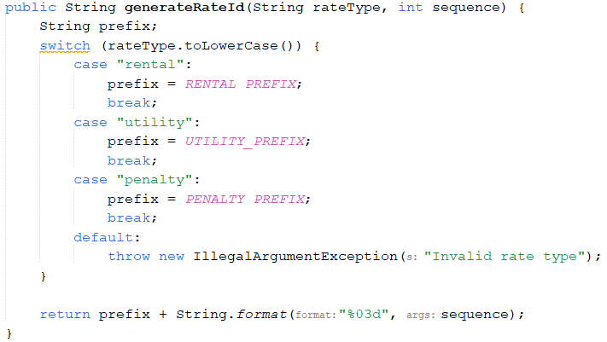 | This code implements the Factory Pattern, where the generateRateId method generates a rate ID based on the rateType. It uses a switch statement to select the appropriate prefix (RENTAL_PREFIX, UTILITY_PREFIX, or PENALTY_PREFIX) depending on the rate type. The method then formats the sequence number with leading zeros, ensuring consistent ID formatting. This pattern abstracts the creation of rate IDs based on type, providing a flexible and clear way to generate IDs.
Service Layer Pattern
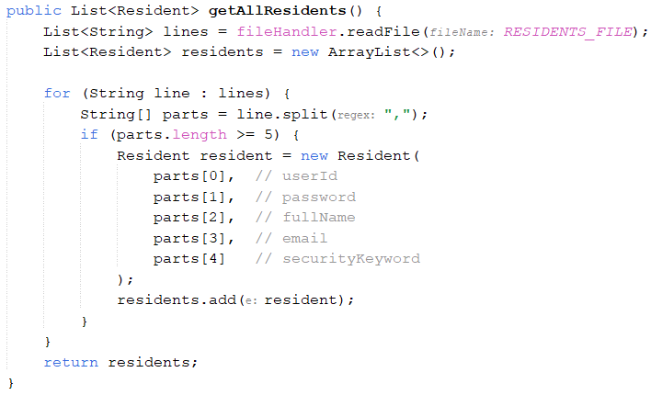 | The getAllResidents() method follows the Service Layer Pattern by separating business logic from data access. It delegates the file reading to fileHandler.readFile(), processes the data into Resident objects, and returns them in a list. This abstracts the data access and focuses on business logic within the service layer.
Factory Method Pattern
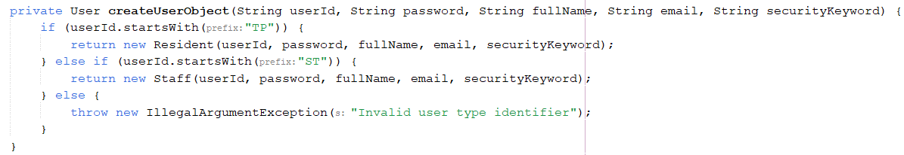 | The code implements the Factory Method Pattern, where the createUserObject method serves as a factory for creating different types of User objects based on the userId. By checking the prefix of the userId (either "TP" for Resident or "ST" for Staff), the method encapsulates the object creation logic and abstracts it from the rest of the code.
Template Method Pattern
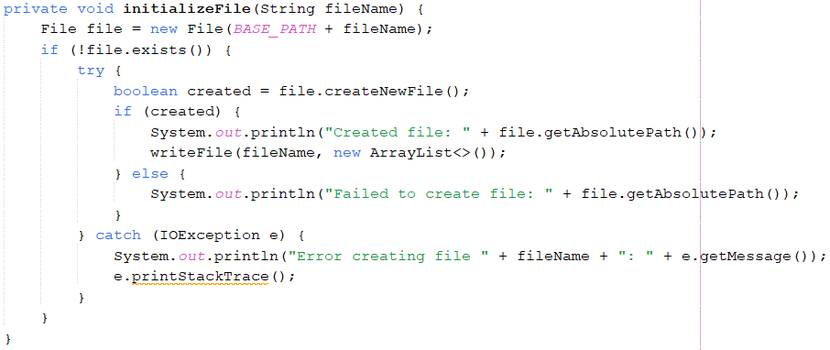 | The initializeFile(String fileName) method checks if a file exists, creates it if it doesn't, and writes default data. If file creation fails or an error occurs, it handles it gracefully. This is a template method, where the general steps (checking, creating, writing) are fixed, but the file-writing logic can be customized by subclasses.
Single Responsibility Principle (SRP)
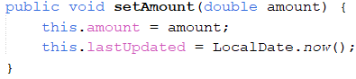 | This method follows the Single Responsibility Principle (SRP) by handling only one responsibility—updating the amount while ensuring lastUpdated is refreshed. It keeps the logic focused and avoids mixing concerns like data persistence or UI updates, making the class easier to maintain and extend.
Open/Closed Principle (OCP)
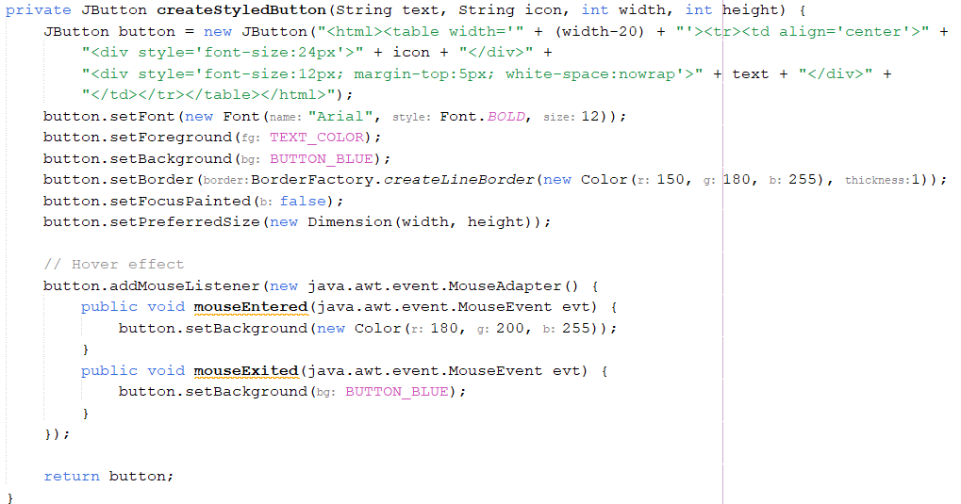 | The createStyledButton method follows the Open/Closed Principle (OCP) by allowing button customization without modifying existing code. It provides a reusable structure for button styling, and new variations can be added by extending or overriding the method, ensuring flexibility while maintaining stability.
Immutable Fields
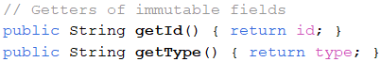 | In this code, the id and type fields are immutable because they are only set during object creation and cannot be changed afterward. The lack of setter methods for these fields ensures they remain constant. The only way to access these values is through the getter methods getId() and getType(), making them read-only and ensuring their values stay unchanged throughout the object's lifecycle.
Static nested classes
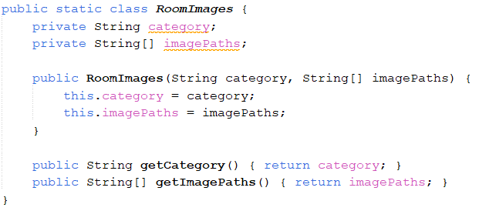  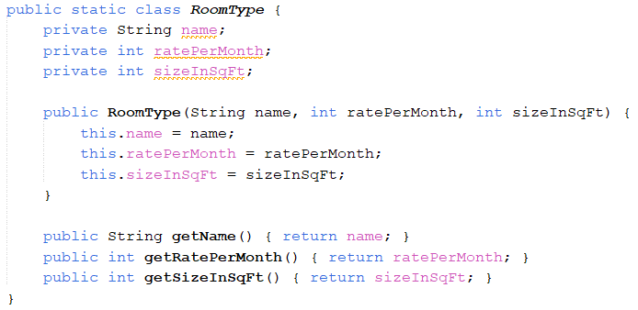 | The code defines two static nested classes, RoomImages and RoomType, within the HostelInfo class. RoomImages holds data about room categories and their image paths, while RoomType stores details like room name, monthly rate, and size. Both classes include constructors for initialization and getter methods for accessing their fields. Since they are static, they can be instantiated independently of the outer HostelInfo class.
MVC (Model-View-Controller) pattern
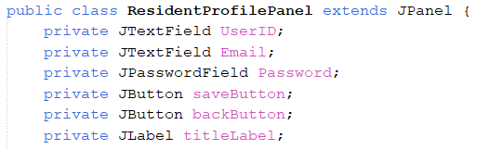 | The ResidentProfilePanel class follows the MVC pattern by acting as the View, responsible for rendering the GUI while keeping business logic separate. It demonstrates encapsulation by defining private UI components (UserID, Email, Password, saveButton, and backButton) that are only accessible within the class, ensuring modularity and maintainability. By handling only UI elements and delegating actions, it ensures separation of concerns, allowing UI changes without affecting business logic in the Controller.
Separation of Concerns (SoC)
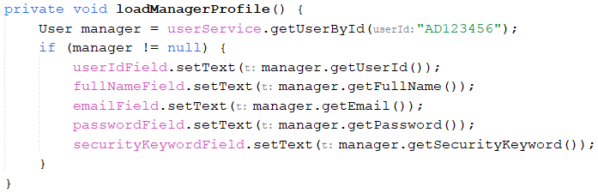 | This code follows the Separation of Concerns (SoC) principle by isolating the business logic from the UI layer. The method loadManagerProfile() retrieves user details by calling userService.getUserById("AD123456"), ensuring that the data-fetching logic resides within the UserService class instead of being directly handled in the UI. If a valid User object is returned, the retrieved data is then set into UI components (userIdField, fullNameField, etc.), keeping the UI responsible only for displaying information.
Composition
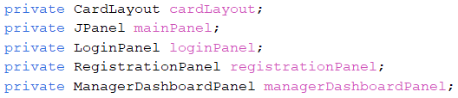 | This code demonstrates Java Composition by using instance variables (cardLayout, mainPanel, loginPanel, registrationPanel, and managerDashboardPanel) to define a "has-a" relationship between the containing class and these objects. Instead of inheriting from them, the class "has" a CardLayout for managing different views and multiple JPanel-based components (LoginPanel, RegistrationPanel, and ManagerDashboardPanel) for different sections of the UI.
Service Layer Pattern
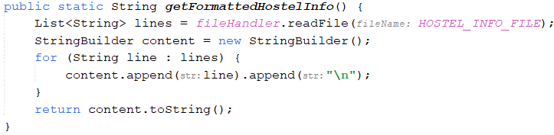 | The getFormattedHostelInfo() method follows the Service Layer Pattern by acting as an intermediary between the data layer (FileHandler) and the UI or business logic layer. It retrieves raw data from HOSTEL_INFO_FILE, processes it into a structured format, and returns a clean string for display. This promotes separation of concerns, ensuring the UI doesn’t interact directly with file handling.
Dependency Injection
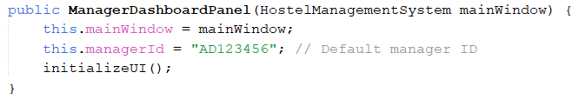 | This constructor demonstrates Dependency Injection (DI) by receiving a HostelManagementSystem instance (mainWindow) as a parameter instead of creating it internally. This follows the Constructor Injection approach, allowing the ManagerDashboardPanel to depend on an external HostelManagementSystem instance.
Immutability
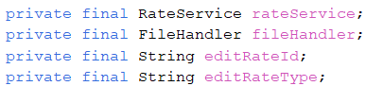 | Declaring rateService, fileHandler, editRateId, and editRateType as final ensures immutability by preventing reassignment after initialization. This ensures stability, and prevents unintended modifications.
Control Structures   | This code uses a if-else statement. The if-else statement is fundamental in Java programming for decision-making. The if statement used to check whether the search text is empty (text.trim().isEmpty()). If true, it removes any applied row filters (sorter.setRowFilter(null);). If not, it applies a case-insentive filter to the table rows.

Java Features
Validation Logic
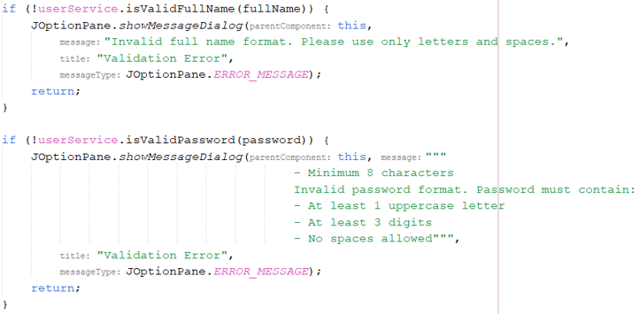 | The validation logic in this method ensures that the user's full name and password meet specific format requirements before updating the profile. It first checks if the full name consists of only letters and spaces using userService.isValidFullName(fullName), and if invalid, it displays an error message and stops execution. Similarly, it validates the password using userService.isValidPassword(password), ensuring it meets the required format. If the password fails to meet these criteria, an error message is displayed, and the process is halted.
Static Utility Methods
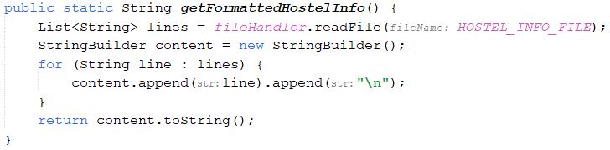 | The getFormattedHostelInfo() method demonstrates Static Utility Methods by being static, allowing it to be called without creating an instance of the class. It reads hostel information from a file, formats the content, and returns it as a string, serving as a utility function that doesn't require object instantiation.
Lambda expression
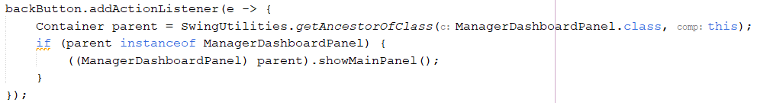 | This code uses a lambda expression for concise event handling. When backButton is clicked, it finds the nearest ManagerDashboardPanel using SwingUtilities.getAncestorOfClass(...). If found, it casts and calls showMainPanel(), enabling navigation with minimal boilerplate.
Custom Exception Class
 | This code defines a custom exception, InvalidEmailExecption, by extending the Exception class. It allows the creation of specialized exceptions with custom messages, providing more specific error handling for invalid email scenarios.
Enum constant
 | In super(owner, title, ModalityType.APPLICATION_MODAL);, ModalityType.APPLICATION_MODAL is an enum constant from java.awt.Dialog.ModalityType, setting the dialog to block input to all other application windows until closed.
Generics
 | The line JComboBox<String> userTypeCombo uses generics to ensure only String values are stored, enhancing type safety and preventing invalid data. Likewise, TableRowSorter<DefaultTableModel> sorter restricts sorting to DefaultTableModel, reducing type mismatches.

References
Coding Time. (2017, Dec 31). fees receipt system in java by using netbeans. [Video].
YouTube. https://www.youtube.com/watch?v=0g0uX6rhksE
GeeksForGeeks. (2021, Nov 3). Difference Between System.out.println() and
System.err.println() in Java. GeeksForGeeks.
https://www.geeksforgeeks.org/difference-between-system-out-println-and-system-err-println-in-java/
GeeksForGeeks. (2024, Dec 24). Java StringBuilder Class. GeeksForGeeks.
https://www.geeksforgeeks.org/stringbuilder-class-in-java-with-examples/
Teck Updates. (2022, Dec 30). Search data from JTable in Java using JTextField. [Video].
YouTube. https://www.youtube.com/watch?v=haQIw3YDTPg
Telusko. (2023, Jan 19). #63 Anonymous Inner Class in Java [Video]. YouTube.
https://www.youtube.com/watch?v=LNpUj80JLGI
W3Schools. (n.d.). Java Date and Time. W3Schools.
https://www.w3schools.com/java/java_date.asp

Task Division
Student Name | TP Number | Task | Signature
Siew Zhen Lynn | TP076386 | Login  Register  Manager Function | celine
Yeo Pei Wen | TP077057 | Staff Function  Resident Function | wen

