HW5: Predicting Spending Based on Consumer Analysis

Xuyang Ji

2023-03-06

Table of Contents

### 0. Project Executive Summary

Customer personality analysis involves collecting and analyzing data about customers, such as their demographics, psychographics, and behaviors, in order to create customer profiles that represent different types of customers. By understanding the unique needs, preferences, and pain points of each customer segment, businesses can modify their products, marketing strategies, and customer service initiatives to better meet the needs of their target customers. This can ultimately lead to improved customer relationships, higher customer satisfaction, and increased revenue and profitability for the business.

The data source used is obtained from [Kaggle](https://www.kaggle.com/datasets/imakash3011/customer-personality-analysis?datasetId=1546318), comprised of 2,240 observed tuples across 29 attributes. The objective of the study is to divide the target customers on the basis of their significant features which could help the company maintain stronger bond with those high-spending customers in less marketing expenses. Some potential questions to explore are how factors affect consumer spending and are product preferences differ among various segments?

Market segmentation is the process of dividing a broad target market of customers into smaller and more similar groups, and then designing marketing strategies tailored to each group’s specific needs and characteristics. ***The technique used here are KMeans clustering, in conjunction with PCA for dimension reduction***, which involves analyzing data to automatically identify groups of customers with similar attributes or behaviors. Then, ***kNN and Decision Tree Classifiers are applied to the training set with hyperparameter tuning and cross validation***. Finally, the better-performing classifier, Deicision Tree Classified, is rebuilt with target variable with two levels instead of three. A sophisticated evaluation using ***ROC plot, accuracy, precision, and recall metrics is performed on the final model***.

### I. Data Exploration & Quality Assessment

#### I.o Preliminary Data Preprocessing

To predict the class label attribute- TotalSpent, of an unseen customer, irrelevant attributes are mutated together or excluded for model-building. Meantime, rows with missing value in the income attributes are removed for further analysis.

| New Attributes | Description |
| --- | --- |
| Age | Customer’s age by calculate diff between birth & 2023 |
| Grad | Customer’s education level upon graduation |
| Married | Customer’s marital status |
| Child | Number of children & teenagers in customer’s household |
| DaysCustomer | Days since customer’s enrollment with the company |
| TotalSpent | Total Amount spent in last 2 years |
| AcceptCmp | Number of accepted the offer in the last 6 campaign |

library(readr)  
library(tidyverse)

## ── Attaching core tidyverse packages ──────────────────────── tidyverse 2.0.0 ──  
## ✔ dplyr 1.1.0 ✔ purrr 1.0.1  
## ✔ forcats 1.0.0 ✔ stringr 1.5.0  
## ✔ ggplot2 3.4.1 ✔ tibble 3.1.8  
## ✔ lubridate 1.9.2 ✔ tidyr 1.3.0  
## ── Conflicts ────────────────────────────────────────── tidyverse_conflicts() ──  
## ✖ dplyr::filter() masks stats::filter()  
## ✖ dplyr::lag() masks stats::lag()  
## ℹ Use the ]8;;http://conflicted.r-lib.org/conflicted package]8;; to force all conflicts to become errors

library(dplyr)  
library(ggplot2)  
library(caret)

## Loading required package: lattice  
##   
## Attaching package: 'caret'  
##   
## The following object is masked from 'package:purrr':  
##   
## lift

library(readr)  
library(ggpubr)  
library(psych)

##   
## Attaching package: 'psych'  
##   
## The following objects are masked from 'package:ggplot2':  
##   
## %+%, alpha

library(readr)  
library(rpart)  
library(rattle)

## Loading required package: bitops  
## Rattle: A free graphical interface for data science with R.  
## Version 5.5.1 Copyright (c) 2006-2021 Togaware Pty Ltd.  
## Type 'rattle()' to shake, rattle, and roll your data.

library(tibble)  
library(doSNOW)

## Loading required package: foreach  
##   
## Attaching package: 'foreach'  
##   
## The following objects are masked from 'package:purrr':  
##   
## accumulate, when  
##   
## Loading required package: iterators  
## Loading required package: snow

library(foreach)  
library(factoextra)

## Welcome! Want to learn more? See two factoextra-related books at https://goo.gl/ve3WBa

library(cluster)  
library(cowplot)

##   
## Attaching package: 'cowplot'  
##   
## The following object is masked from 'package:ggpubr':  
##   
## get_legend  
##   
## The following object is masked from 'package:lubridate':  
##   
## stamp

customers <- read_delim("marketing_campaign.csv", delim = "\t", escape_double = FALSE, trim_ws = TRUE)

## Rows: 2240 Columns: 29  
## ── Column specification ────────────────────────────────────────────────────────  
## Delimiter: "\t"  
## chr (3): Education, Marital_Status, Dt_Customer  
## dbl (26): ID, Year_Birth, Income, Kidhome, Teenhome, Recency, MntWines, MntF...  
##   
## ℹ Use `spec()` to retrieve the full column specification for this data.  
## ℹ Specify the column types or set `show_col_types = FALSE` to quiet this message.

customers <- customers %>%  
 mutate(Age= 2023-Year_Birth,  
 Child= Kidhome + Teenhome,  
 AcceptCmp= AcceptedCmp1 + AcceptedCmp2 + AcceptedCmp3+AcceptedCmp4+AcceptedCmp5+Response,  
 DaySCustomer= as.numeric(max(as.Date(Dt_Customer,"%d-%m-%Y"))  
 - as.Date(Dt_Customer,"%d-%m-%Y")),  
 Married= ifelse(Marital_Status=="Married"|Marital_Status=="Together", 1, 0),  
 Grad= ifelse(Education == "2n Cycle" | Education =="Basic", 0, 1),  
 TotalSpent= MntMeatProducts+MntFishProducts+MntWines+MntFruits+ MntSweetProducts+ MntGoldProds) %>%   
 select(-c(ID, Year_Birth, Kidhome, Teenhome, Dt_Customer, Marital_Status,  
 AcceptedCmp3,AcceptedCmp4,AcceptedCmp5,AcceptedCmp1,AcceptedCmp2,Response, Education,Z_Revenue,Z_CostContact))

customers<- data.frame(customers)  
missingVal<- customers %>%  
 gather(key = "key",value = "value")%>% # gather value from all cols into columns as key&value  
 mutate(na= is.na(value))%>% #create new column na for missing vals   
 group_by(key)%>%   
 mutate(total= n())%>% #get total observations  
 group_by(key,total,na)%>% #grouping each columns,then total col, then na statement   
 summarise(num.na=n())%>%  
 mutate(ratioNA= num.na/total*100)

## `summarise()` has grouped output by 'key', 'total'. You can override using the  
## `.groups` argument.

missingVal %>%  
 ggplot()+  
 geom_bar(aes(x=reorder(key,desc(ratioNA)),  
 y= ratioNA, fill=na),stat="identity",alpha=.7)+  
 scale_x_discrete(limits=(missingVal%>%arrange(desc(ratioNA)))$key)+  
 scale_fill_manual(name="",values=c("lightblue","darkred"),  
 labels = c("PresentVal", "MissingVal")) +  
 coord_flip()+  
 labs(title = "Percentage of Missing Values", x ='Variable', y = "% of Missing Values")+  
 theme(axis.text=element_text(size=6),  
 axis.title=element_text(size=8,face="bold"),  
 title =element_text(size=9, face='bold'))

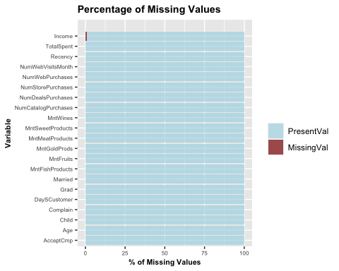

customers <- customers %>%  
 na.omit()

#### I.a Preprocessing & Exploration of People Attributes

Looking at the statistics for the people attributes, the distributions of age and income variables are significantly skewed due to outliers and influential points, whereas both plot has a long tail on the right. By converting numeric attributes with less than 8 unique values into factors for analysis, the plot of Grad vs. Income for married and unmarried customers shown that education does have a positive correlation with income. However, there is no significant difference in income among married and unmarried groups in each education level. Finally, to achieve a roughly symmetric distribution for all variables, the dataset is filtered with Income < $600000/year and Age <= 80 years old.

| Variable | Description |
| --- | --- |
| Age | Customer’s age |
| Grad | Customer’s education level upon graduation |
| Married | Customer’s marital status |
| Income | Customer’s yearly household income |
| Child | Number of children & tennagers in customer’s household |
| DaysCustomer | Days since customer’s enrollment with the company |
| Recency | Number of days since customer’s last purchase |
| Complain | 1 if customer complained in the last 2 years, 0 otherwise |

people<- customers %>%  
 select(Age, Grad, Married, Income, Child, DaySCustomer, Recency, Complain)  
cPlot <- people %>%  
 pivot_longer(colnames(people)) %>%  
 as.data.frame()  
ggplt<- ggplot(cPlot, aes(x=value))+  
 geom_histogram(aes(y=after_stat(!!str2lang("density"))),fill="#adcae6",color="grey",bins = 30)+  
 geom_density(col="darkred",size=.5)+  
 facet_wrap(~name, scales="free")

## Warning: Using `size` aesthetic for lines was deprecated in ggplot2 3.4.0.  
## ℹ Please use `linewidth` instead.

ggplt

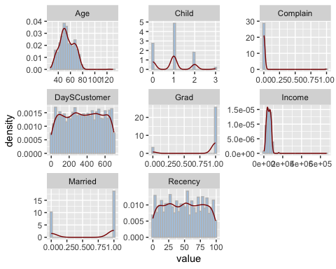

# convert less than 8 unique val col into factors  
conv <- sapply(customers, function(x) is.numeric(x) && length(unique(x))<8)  
customers[conv] <- lapply(customers[conv], as.factor)  
ggplot(customers, aes(x= Grad,y=Income,fill=Married))+  
 geom_boxplot(outlier.colour = 'darkred',outlier.size=2,notch = T)

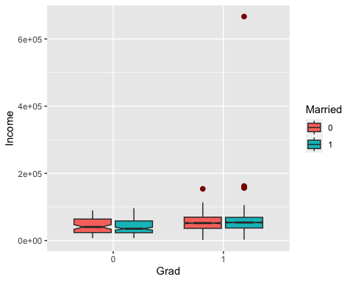

customers <- customers %>%  
 filter(Income <600000) %>%  
 filter(Age <= 80)

#### I.b Exploration of Products Attributes

The distributions of products attributes are similar in ways that they are all heavily positively skewed, with extremely large values that are considered as outliers. Meantime, by inspecting the standard deviation, the small value means that the data observations of these attributes tend to be very close to the respective mean value. In addition, wine and meat products each has a wider range across distribution compared to other product types.

| Variable | Description |
| --- | --- |
| MntWines | Amount spent on wine in last 2 years |
| MntFruits | Amount spent on fruits in last 2 years |
| MntMeatProducts | Amount spent on meat in last 2 years |
| MntFishProducts | Amount spent on fish in last 2 years |
| MntSweetProducts | Amount spent on sweets in last 2 years |
| MntGoldProds | Amount spent on gold in last 2 years |
| TotalSpent | Total Amount spent in last 2 years |

hist(customers$TotalSpent,main = "Histogram for TotalSpent Distribution",breaks=10,cex.main=1,  
 cex.lab=.8,cex.axis=.8,xlab = "Total Amount Spent",ylab = "Amount", border = "black", col = "lightblue")  
par(new=TRUE)  
boxplot(customers$TotalSpent,horizontal = T,axes=F,col= rgb(1,0,0,alpha=.15))

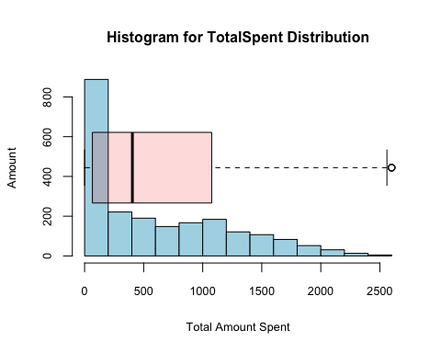

customers %>%  
 pivot_longer(cols = starts_with("Mnt")) %>%  
 select(name,value) %>%  
 ggplot(aes(value,fill=name)) +  
 geom_histogram(bins = 30)+  
 facet_wrap(vars(name),scales = "free")+  
 scale_x_continuous(labels = scales::label_dollar()) +  
 labs(x = "",  
 y = "",   
 subtitle = "Distribution Range for Each Product type")

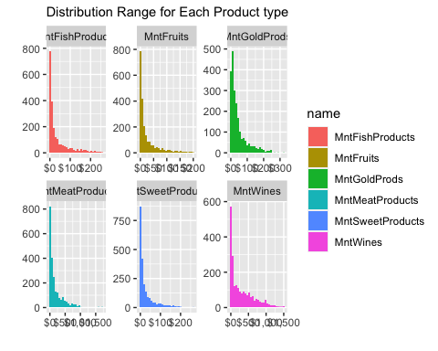

#### I.c Exploration of Promotion Attributes

| Variable | Description |
| --- | --- |
| AcceptCmp | Number of accepted the offer in the last 6 campaign |

plotDF<- data.frame(customers$AcceptCmp,customers$Grad)  
plotDF <- plotDF %>%  
 group_by(customers.Grad)%>%  
 count(customers.AcceptCmp) %>%  
 mutate(Percent=n/sum(n)*100)  
ggplot(plotDF, aes(x = customers.Grad, y = Percent, fill = customers.AcceptCmp))+  
 geom_bar(stat = "identity")+  
 coord_flip()+  
 labs(x = "Graduation Factor", y = "Percentage",fill = "# of Accepted Campaign")

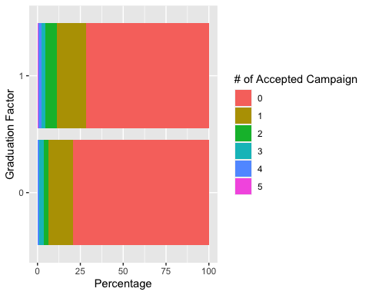

#### I.d Exploration of Place Attributes

| Variable | Description |
| --- | --- |
| NumDealsPurchases | Number of purchases made with a discount |
| NumWebPurchases | Number of purchases made through the company’s web site |
| NumCatalogPurchases | Number of purchases made using a catalogue |
| NumStorePurchases | Number of purchases made directly in stores |
| NumWebVisitsMonth | Number of visits to company’s web site in the last month |

customers %>%  
 pivot_longer(cols = starts_with("Num")) %>%  
 select(name,value) %>%  
 ggplot(aes(value,fill=name)) +  
 geom_histogram(bins = 30)+  
 facet_wrap(vars(name),scales = "free")+  
 scale_x_continuous(labels = scales::label_dollar()) +  
 labs(x = "",  
 y = "",   
 subtitle = "Distribution Range for Each Place of Purchase")

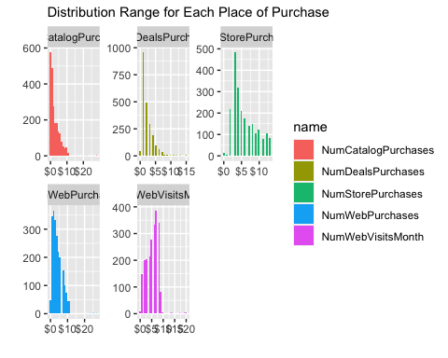

#### I.e Outliers Detection & Removal

detectOutlier<- function(x){  
 quantile1<- quantile(x,probs=.25)  
 quantile3<- quantile(x,probs=.75) #make the probs large to obtain more datapoints  
 IQR<- quantile3 - quantile1  
 x > quantile3 +(IQR*1.5) | x < quantile1 -(IQR*1.5)  
}  
remove_outlier<- function(df, column){  
 for (col in column){  
 df<- df[!detectOutlier(df[[col]]),]  
 }  
 return(df)  
}  
customer_clean<- remove_outlier(customers,colnames(customers[,sapply(customers,is.numeric)]))

For the target attribute, TotalSpent, the boxplot gives a clear indication of the distribution’s shape and spread, whereas 50% of the datapoints fall below 57.

describe(customer_clean$TotalSpent)

## vars n mean sd median trimmed mad min max range skew kurtosis se  
## X1 1 891 72.62 51.66 57 65.08 38.55 8 240 232 1.21 0.75 1.73

hist(customer_clean$TotalSpent,main = "Histogram for Spent Distribution",breaks=10,cex.main=1,  
 cex.lab=.8,cex.axis=.8,xlab = "Spent",ylab = "Frequency", border = "black", col = "lightblue")  
par(new=TRUE)  
boxplot(customer_clean$TotalSpent,horizontal = T,axes=F,col= rgb(1,0,0,alpha=.15))

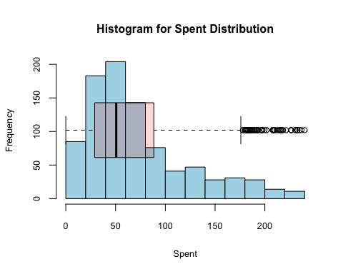

### II. Data Quality Assessment

#### II.a Creating Target Variable Using Binning Methods

customer_clean$TotalSpent_bins <- cut(customer_clean$TotalSpent,  
 breaks = c(8,45,80,240),  
 include.lowest = TRUE,  
 right = FALSE,  
 labels =c("low","medium","high") )  
table(customer_clean$TotalSpent_bins)

##   
## low medium high   
## 318 292 281

customer_clean1<- customer_clean %>%  
 select(- TotalSpent)

#### II.b Data Preparation - Dummy & NZV

dummy<- dummyVars(TotalSpent_bins ~., data = customer_clean1)  
customer_num <- as.data.frame(predict(dummy, newdata = customer_clean1))

## Warning in model.frame.default(Terms, newdata, na.action = na.action, xlev =  
## object$lvls): variable 'TotalSpent_bins' is not a factor

customer_num <- cbind(Spent= customer_clean$TotalSpent_bins, customer_num)  
#remove nzv  
customer_num <- customer_num[, -nearZeroVar(customer_num)]  
  
##correlation test  
corrT <-corr.test(customer_num[2:25],adjust="none")  
signTest <- ifelse(corrT$p <0.05, T, F)  
colSums(signTest)-1

## Income Recency MntWines MntFruits   
## 17 2 13 16   
## MntMeatProducts MntFishProducts MntSweetProducts MntGoldProds   
## 16 16 17 15   
## NumDealsPurchases NumWebPurchases NumCatalogPurchases NumStorePurchases   
## 18 17 13 12   
## NumWebVisitsMonth Age Child.0 Child.1   
## 15 13 13 10   
## Child.2 AcceptCmp.0 AcceptCmp.1 DaySCustomer   
## 12 9 11 13   
## Married.0 Married.1 Grad.0 Grad.1   
## 1 1 13 13

#### II.c Principal Component Analysis

Given the large number of attributes, PCA is applied as a method to reduce dimensionality. As an eigenvalue greater than 1 indicates that the PCs account for more variance than accounted by one of the original predictors, those PCs with less than 1 eigenvalue imply that the scores on the PCs would have negative reliability. Using the eigenvalue as a cutoff point in conjunction with an “elbow” shape for determining the number of PCs retained, the optimal number of components are 8 and 11 PCs respectively. Since the goal of the analysis is to examine observations that have a similar pattern, and then distill the variables down to the most important features so that the data is simplified without losing significant traits, data interpretation is the key for this particular dataset. Using the proportion of variance explained criterion, 11 PCs is optimal for a cumulative variance of 84.55% of the original dataset.

predictors <- select(customer_num,-c("Spent"))  
pca <- prcomp(predictors,scale. = TRUE,center = TRUE)  
summary(pca)

## Importance of components:  
## PC1 PC2 PC3 PC4 PC5 PC6 PC7  
## Standard deviation 1.9821 1.8448 1.53181 1.44008 1.39496 1.24370 1.17108  
## Proportion of Variance 0.1637 0.1418 0.09777 0.08641 0.08108 0.06445 0.05714  
## Cumulative Proportion 0.1637 0.3055 0.40326 0.48967 0.57075 0.63520 0.69234  
## PC8 PC9 PC10 PC11 PC12 PC13 PC14  
## Standard deviation 1.03516 0.96949 0.9230 0.90129 0.81875 0.8049 0.7446  
## Proportion of Variance 0.04465 0.03916 0.0355 0.03385 0.02793 0.0270 0.0231  
## Cumulative Proportion 0.73699 0.77615 0.8116 0.84549 0.87342 0.9004 0.9235  
## PC15 PC16 PC17 PC18 PC19 PC20 PC21  
## Standard deviation 0.67637 0.63212 0.58616 0.47354 0.42443 0.3533 0.23386  
## Proportion of Variance 0.01906 0.01665 0.01432 0.00934 0.00751 0.0052 0.00228  
## Cumulative Proportion 0.94258 0.95923 0.97355 0.98289 0.99040 0.9956 0.99788  
## PC22 PC23 PC24  
## Standard deviation 0.22577 1.055e-15 2.216e-16  
## Proportion of Variance 0.00212 0.000e+00 0.000e+00  
## Cumulative Proportion 1.00000 1.000e+00 1.000e+00

##screeplot - use 11 components  
screeplot(pca,npcs = 20,type="line",  
 main="Screeplot:PCA on Preprocessed Customer Data",  
 cex.lab=.8,cex.main=0.8)  
abline(1,0,col="blue",lty=5)  
legend("topright", legend = c("Eigenvalue=1"), col = c("blue"),  
 lty = 5,cex = 0.6)

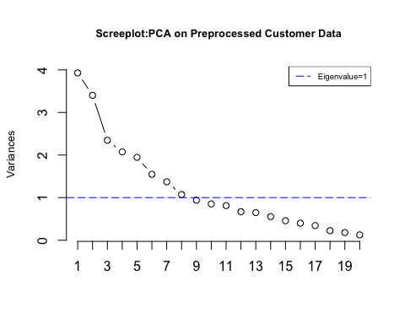

PCA_Plot <- function(pcaData){  
 theta = seq(0,2*pi,length.out = 100)  
 circle = data.frame(x = cos(theta), y = sin(theta))  
 p = ggplot(circle,aes(x,y)) + geom_path()  
 loadings = data.frame(pcaData$rotation, .names = row.names(pcaData$rotation))  
 p + geom_text(data=loadings, size=2,mapping=aes(x = PC1, y = PC2, label = .names, colour = .names, fontface="bold.italic")) +  
 coord_fixed(ratio=1) + labs(x = "PC1", y = "PC2")  
}  
PCA_Plot(pca)

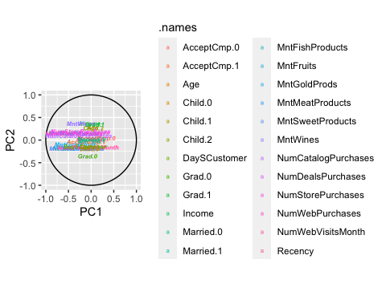

The Varimax factor rotation is applied to clarify the relationship among the PCA factors. By maximizing the variance shared among selected features, results more discretely represent how features correlated with each principal component. The magnitude and direction of the coefficients for each component represents the importance in calculating the component. As shown below, they are obscure to separate in terms of meaning. For example, PC1 roughly corresponds to product preference of the customer, whereas PC2 is heavily affected by education-related attributes. The PC3 has heavy association with whether the consumer is sensitive to the past campaigns, and PC4 shows household structure and age of the consumer.

rawloadings<- pca$rotation[,1:8] %*%diag(pca$sdev,8,8)  
rotatedLoading<- varimax(rawloadings)$loadings  
print(rotatedLoading,cutoff=.4,sort=T)

##   
## Loadings:  
## [,1] [,2] [,3] [,4] [,5] [,6] [,7] [,8]   
## MntFruits -0.704   
## MntFishProducts -0.644   
## MntSweetProducts -0.694   
## MntGoldProds -0.517   
## Child.0 -0.695   
## Grad.0 -0.939   
## Grad.1 0.939   
## AcceptCmp.0 -0.927   
## AcceptCmp.1 0.886   
## Age 0.579   
## Child.1 -0.946   
## Child.2 0.838   
## Married.0 0.998   
## Married.1 -0.998   
## Income -0.657   
## NumWebVisitsMonth 0.828   
## DaySCustomer 0.606   
## MntWines -0.724   
## MntMeatProducts -0.716   
## NumDealsPurchases -0.701   
## NumWebPurchases -0.802   
## NumStorePurchases -0.645   
## Recency -0.725  
## NumCatalogPurchases 0.414 -0.555  
##   
## [,1] [,2] [,3] [,4] [,5] [,6] [,7] [,8]  
## SS loadings 2.780 2.097 2.227 2.174 2.012 2.016 3.203 1.179  
## Proportion Var 0.116 0.087 0.093 0.091 0.084 0.084 0.133 0.049  
## Cumulative Var 0.116 0.203 0.296 0.387 0.470 0.554 0.688 0.737

dim1<- fviz_contrib(pca,choice = "var",axes = 1,top = 5,sort.val = "desc")+  
 geom_col(width = 0.5)+  
 theme(axis.text.x = element_text(angle=45))  
dim2<- fviz_contrib(pca,choice = "var",axes = 2,top = 5,sort.val = "desc")+  
 geom_col(width = 0.5)+  
 theme(axis.text.x = element_text(angle=45))  
  
plot_grid(plotlist = list(dim1,dim2),ncol = 2)

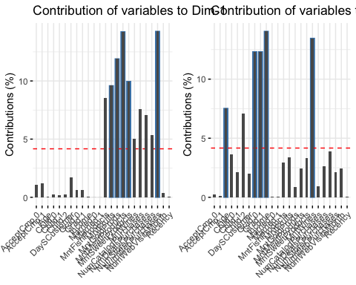

preProc <- preProcess(predictors, method = c("center","scale","pca"), pcaComp = 11)  
customerPC <- predict(preProc, predictors)  
customerPC$Spent <- customer_num$Spent

#### II.d Data Splitting -Train vs.Test

##train-test split  
set.seed(961)  
indexCus<- createDataPartition(y=customerPC$Spent, p=0.85, list = FALSE)  
train <- customerPC[indexCus,]  
Test <- customerPC[-indexCus,]  
  
trainX<- train%>%  
 select(!c(Spent))

### III. KMeans Clustering

To segment consumers into distinct clusters based on their behaviors, the K-means clustering algorithm can be used. This algorithm groups data into K clusters by iteratively improving the clustering until no further improvement is possible. The elbow method and silhouette scores indicate that K=3 is an optimal value for the KMeans model. Therefore, the model is fit using K=3 as suggested by the plots.

library(cowplot)  
wss<- fviz_nbclust(trainX, kmeans, method = "wss")+   
 theme(axis.text.x = element_text(size = 10),  
 axis.text.y = element_text(size = 10),  
 title = element_text(size = 10)) +   
 geom_line(aes(group = 1), color = "pink", linetype = "dashed",size = 1) +   
 geom_point(group = 1, size = 1, color = "darkblue")  
  
sil<- fviz_nbclust(trainX, kmeans, method = "silhouette")+   
 theme(axis.text.x = element_text(size = 10),  
 axis.text.y = element_text(size = 10),  
 title = element_text(size = 10)) +   
 geom_line(aes(group = 1), color = "pink", linetype = "dashed",size = 1) +   
 geom_point(group = 1, size = 1, color = "darkblue")  
  
plot_grid(plotlist = list(wss,sil),ncol = 2)

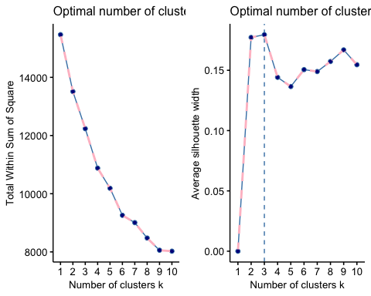

Based on the output, the three clusters each with the size of 123- medium spending power, 215 - high spending power, and 421- low spending power observations. Using the fviz_cluster function, we can visualize how the clusters are formed. Recall that, PC1 is strongly correlated with product preference, whereas PC2 is most strongly associated with education. Compared the circular clusters in the Cluster plot, cluster 1 tend to have a higher value in dim2,indicating customers in cluster 1 are likely have a higher education degree than the rest. Meantime, none of the clusters has shown a clear separation in dim1, but cluster 2 and 3 do have a slightly lower value than cluster 1, meaning there are more customers without children in their household and prefer products like fish, sweet and fuits in cluster 2 and 3.

fit <- kmeans(trainX, centers = 3,nstart = 50)  
fviz_cluster(fit,data = trainX)

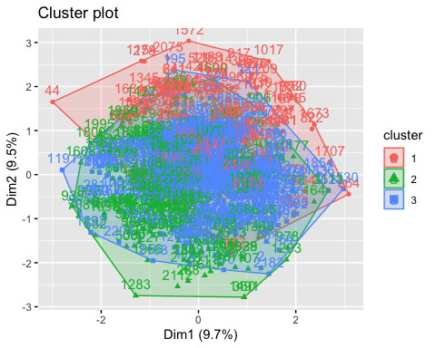

fit$size

## [1] 123 215 421

Further, to compare the clusters in the PCA plot, high spending customers tend to have a negative value in PC1,indicating they are more likely to have children in their household, and would prefer to purchase products like meat and wine. In contrast, low spending consumers tend to have positive score in PC1, recall that the strongest coefficients are all negative, meaning they are likely to purchase products like fruit, sweet and fish and possibly have no kids in the household.

rotated_data<- as.data.frame(pca$x[indexCus,])  
rotated_data$Spent<- train$Spent  
rotated_data$Clusters<- as.factor(fit$cluster)  
ggplot(data = rotated_data, aes(x = PC1, y = PC2, col =Spent)) +   
 geom_point(alpha = 0.8)

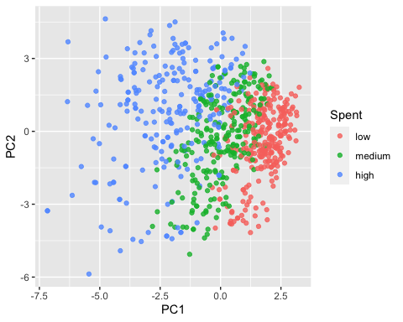

The plots suggest that income is one of the most significant variables when it comes to predicting spending power, while another important variable is the number of days a customer has been with the company. However, it’s worth noting that while income and consumer loyalty can be crucial factors, other factors such as lifestyle factors can also play a significant role in determining spending behavior. Meantime, those high-spending customers, shown as cluster2, are much more deal-sensitive than the rest groups and spend more in wine and meat.

trainSegment<- mutate(predictors[indexCus,],cluster=fit$cluster, TotalSpent= customer_clean$TotalSpent[indexCus])  
  
count(trainSegment,cluster)

## cluster n  
## 1 1 123  
## 2 2 215  
## 3 3 421

incomeP<- trainSegment %>% ggplot(aes(Income))+   
 geom_histogram(color = "black", fill = "lightblue") +   
 facet_wrap(vars(cluster)) +   
 geom_vline(aes(xintercept=mean(Income)),color="darkred", linetype="dashed", size = .7)  
  
daysP<- trainSegment %>% ggplot(aes(DaySCustomer))+   
 geom_histogram(color = "black", fill = "purple") +   
 facet_wrap(vars(cluster)) +   
 geom_vline(aes(xintercept=mean(DaySCustomer)),color="darkred", linetype="dashed", size = .7)  
  
ageP<- trainSegment %>% ggplot(aes(Age))+   
 geom_histogram(color = "black", fill = "pink") +   
 facet_wrap(vars(cluster)) +   
 geom_vline(aes(xintercept=mean(Age)),color="darkred", linetype="dashed", size = .7)  
  
plot_grid(plotlist = list(incomeP, daysP, ageP),ncol = 1)

## `stat_bin()` using `bins = 30`. Pick better value with `binwidth`.  
## `stat_bin()` using `bins = 30`. Pick better value with `binwidth`.  
## `stat_bin()` using `bins = 30`. Pick better value with `binwidth`.

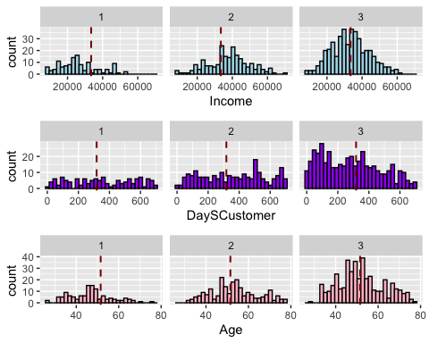

library(reshape)

##   
## Attaching package: 'reshape'

## The following object is masked from 'package:cowplot':  
##   
## stamp

## The following object is masked from 'package:lubridate':  
##   
## stamp

## The following object is masked from 'package:dplyr':  
##   
## rename

## The following objects are masked from 'package:tidyr':  
##   
## expand, smiths

placeP<- trainSegment %>%  
 select((cols = starts_with("Num")),cluster) %>%  
 melt(id='cluster')%>%  
 ggplot(aes(as_factor(cluster), value))+  
 geom_boxplot(color = "black", fill = "lightblue")+  
 facet_wrap(~variable, ncol = 5)  
  
buyP<- trainSegment %>%  
 select((cols = starts_with("Mnt")),cluster) %>%  
 melt(id='cluster')%>%  
 ggplot(aes(as_factor(cluster), value))+  
 geom_boxplot(color = "black", fill = "purple")+  
 facet_wrap(~variable, ncol = 6)  
  
spentP<- trainSegment %>%  
 select(TotalSpent,cluster) %>%  
 melt(id='cluster')%>%  
 ggplot(aes(as_factor(cluster), value))+  
 geom_boxplot(color = "black", fill = "pink")+  
 facet_wrap(~variable, ncol = 6)  
  
plot_grid(plotlist = list(placeP, buyP,spentP),ncol = 1)

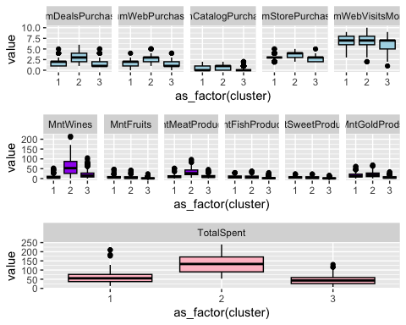

### IV.Classification -Decision Tree

To predict the class label attribute- TotalSpent, of an unseen customer, the decision tree model is built based on the 11 PCs. Based on the previous step, we have a roughly balanced class distribution. Using 10-fold stratified cross-validation with tuned hyperparameters, the resulting decision tree model on the basis of Gini’s impurity index, has an accuracy rate of approximately 82.6% on the test set.

print(prop.table(table(train$Spent))) ##Balanced class

##   
## low medium high   
## 0.3570487 0.3280632 0.3148880

##initialize stratified cross validation   
idCategory <- createFolds(train$Spent, k=10, returnTrain = TRUE)  
train_control<- trainControl(index=idCategory, method = "cv", number = 10)  
  
##create hyperparameter matrix  
maxdepth<- c(3,5,7)  
minsplit<- c(20,30,40)  
minbucket<- c(5,10,15)  
hyperparms= expand.grid(maxdepth=maxdepth, minsplit=minsplit,minbucket=minbucket)  
#loop through parms values  
library(doParallel)

## Loading required package: parallel

##   
## Attaching package: 'parallel'

## The following objects are masked from 'package:snow':  
##   
## clusterApply, clusterApplyLB, clusterCall, clusterEvalQ,  
## clusterExport, clusterMap, clusterSplit, makeCluster, parApply,  
## parCapply, parLapply, parRapply, parSapply, splitIndices,  
## stopCluster

registerDoParallel(cores=4)  
results=foreach(i=1:nrow(hyperparms),.combine=rbind)%dopar%{  
 d=hyperparms[i,]$maxdepth  
 s=hyperparms[i,]$minsplit  
 b=hyperparms[i,]$minbucket  
 fitDT= train(Spent ~., data=train, method="rpart1SE",   
 control=rpart.control(minsplit = s, maxdepth = d, minbucket = b),  
 trControl=train_control)  
 pred_train<- predict(fitDT, train)  
 accuracy_train<- (confusionMatrix(train$Spent, pred_train))$overall[1]  
 pred=predict(fitDT, Test)  
 accuracy_test<- (confusionMatrix(Test$Spent, pred))$overall[1]   
 node<- nrow(fitDT$finalModel$frame)  
 data.frame(Node=node, AccuracyTrain=accuracy_train,   
 AccuracyTestn=accuracy_test)  
}

hyperparms[which.max(results$AccuracyTestn),]

## maxdepth minsplit minbucket  
## 2 5 20 5

comp<-cbind(hyperparms,results)  
head(comp[order(-comp$AccuracyTestn),])

## maxdepth minsplit minbucket Node AccuracyTrain AccuracyTestn  
## Accuracy1 5 20 5 19 0.8498024 0.8257576  
## Accuracy2 7 20 5 19 0.8498024 0.8257576  
## Accuracy4 5 30 5 19 0.8498024 0.8257576  
## Accuracy5 7 30 5 19 0.8498024 0.8257576  
## Accuracy7 5 40 5 19 0.8498024 0.8257576  
## Accuracy8 7 40 5 19 0.8498024 0.8257576

print(hyperparms[which.max(results$AccuracyTestn),])

## maxdepth minsplit minbucket  
## 2 5 20 5

fitBDT= train(Spent ~., data=train, method="rpart1SE",   
 control=rpart.control(minsplit = 20, maxdepth = 5, minbucket = 5),  
 trControl=train_control,metric="Accuracy")  
predFinal=predict(fitBDT, Test)  
accuracy_test<- confusionMatrix(Test$Spent, predFinal)   
accuracy_test

## Confusion Matrix and Statistics  
##   
## Reference  
## Prediction low medium high  
## low 41 6 0  
## medium 11 27 5  
## high 0 1 41  
##   
## Overall Statistics  
##   
## Accuracy : 0.8258   
## 95% CI : (0.7501, 0.8862)  
## No Information Rate : 0.3939   
## P-Value [Acc > NIR] : < 2.2e-16   
##   
## Kappa : 0.738   
##   
## Mcnemar's Test P-Value : NA   
##   
## Statistics by Class:  
##   
## Class: low Class: medium Class: high  
## Sensitivity 0.7885 0.7941 0.8913  
## Specificity 0.9250 0.8367 0.9884  
## Pos Pred Value 0.8723 0.6279 0.9762  
## Neg Pred Value 0.8706 0.9213 0.9444  
## Prevalence 0.3939 0.2576 0.3485  
## Detection Rate 0.3106 0.2045 0.3106  
## Detection Prevalence 0.3561 0.3258 0.3182  
## Balanced Accuracy 0.8567 0.8154 0.9398

fancyRpartPlot(fitBDT$finalModel,main="DecisionTree of Customer Data",caption = "")

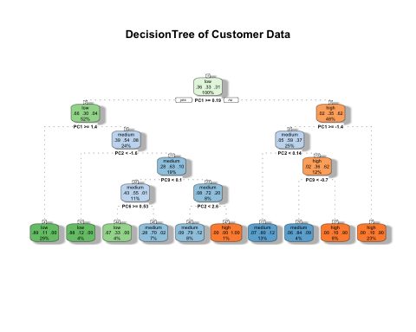

pairs.panels(comp, gap=0, hist.col = "lightblue",density = TRUE,ellipses = FALSE,  
 pch = 15,main="Correlation by MaxDepth of Decision Tree",cex=.6)

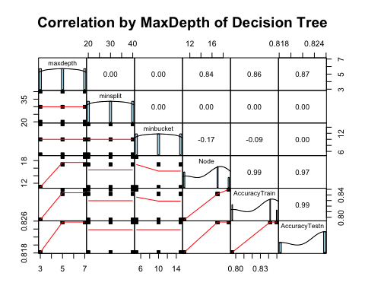

### V. Classification - KNN

The following KNN model uses a 10-fold stratified cross-validation trainControl with tuneGrid parameters. The output suggests that the optimal KNN model achieves an accuracy rate of approximately 71.8%, with kmax = 5, distance = 3 and kernel = cos. The Kappa value of 0.57 indicates an average agreement between the predicted and actual labels. Looking at the confusion matrix, the accuracy rate of the KNN classifier on the testing set is 71%, much higher than the no information rate of 39%.

tuneGrid <- expand.grid(kmax = 3:7, # test a range of k values 3 to 7  
 kernel = c( "cos","rectangular"), # regular &cosine distance   
 distance = 1:3) # powers of Minkowski 1 to 3  
# tune and fit the model with 10-fold cross validation,  
# standardization, and our specialized tune grid  
kknn_fit <- train(Spent ~ .,data = train,method = 'kknn',  
 trControl = train_control,tuneGrid = tuneGrid)  
kknn_fit

## k-Nearest Neighbors   
##   
## 759 samples  
## 11 predictor  
## 3 classes: 'low', 'medium', 'high'   
##   
## No pre-processing  
## Resampling: Cross-Validated (10 fold)   
## Summary of sample sizes: 683, 682, 683, 683, 683, 684, ...   
## Resampling results across tuning parameters:  
##   
## kmax kernel distance Accuracy Kappa   
## 3 cos 1 0.6888510 0.5311509  
## 3 cos 2 0.6994461 0.5473833  
## 3 cos 3 0.6995486 0.5478676  
## 3 rectangular 1 0.6914992 0.5355038  
## 3 rectangular 2 0.7047610 0.5554632  
## 3 rectangular 3 0.6903372 0.5340910  
## 4 cos 1 0.6889203 0.5312049  
## 4 cos 2 0.6955154 0.5414829  
## 4 cos 3 0.7035131 0.5537576  
## 4 rectangular 1 0.6914992 0.5355038  
## 4 rectangular 2 0.7047610 0.5554632  
## 4 rectangular 3 0.6903372 0.5340910  
## 5 cos 1 0.6928505 0.5372525  
## 5 cos 2 0.6941825 0.5394513  
## 5 cos 3 0.7180057 0.5755837  
## 5 rectangular 1 0.6914992 0.5355038  
## 5 rectangular 2 0.7047610 0.5554632  
## 5 rectangular 3 0.6903372 0.5340910  
## 6 cos 1 0.6968505 0.5432101  
## 6 cos 2 0.7022171 0.5514568  
## 6 cos 3 0.7167250 0.5735864  
## 6 rectangular 1 0.6914992 0.5355038  
## 6 rectangular 2 0.7047610 0.5554632  
## 6 rectangular 3 0.6903372 0.5340910  
## 7 cos 1 0.6994821 0.5471793  
## 7 cos 2 0.7035329 0.5534747  
## 7 cos 3 0.7167250 0.5735864  
## 7 rectangular 1 0.6914992 0.5355038  
## 7 rectangular 2 0.7047610 0.5554632  
## 7 rectangular 3 0.6903372 0.5340910  
##   
## Accuracy was used to select the optimal model using the largest value.  
## The final values used for the model were kmax = 5, distance = 3 and kernel  
## = cos.

# Predict  
pred_knn <- predict(kknn_fit, Test)  
  
# Generate confusion matrix  
confusionMatrix(Test$Spent, pred_knn)

## Confusion Matrix and Statistics  
##   
## Reference  
## Prediction low medium high  
## low 39 8 0  
## medium 10 28 5  
## high 2 13 27  
##   
## Overall Statistics  
##   
## Accuracy : 0.7121   
## 95% CI : (0.6269, 0.7876)  
## No Information Rate : 0.3864   
## P-Value [Acc > NIR] : 3.437e-14   
##   
## Kappa : 0.5667   
##   
## Mcnemar's Test P-Value : 0.1229   
##   
## Statistics by Class:  
##   
## Class: low Class: medium Class: high  
## Sensitivity 0.7647 0.5714 0.8438  
## Specificity 0.9012 0.8193 0.8500  
## Pos Pred Value 0.8298 0.6512 0.6429  
## Neg Pred Value 0.8588 0.7640 0.9444  
## Prevalence 0.3864 0.3712 0.2424  
## Detection Rate 0.2955 0.2121 0.2045  
## Detection Prevalence 0.3561 0.3258 0.3182  
## Balanced Accuracy 0.8330 0.6954 0.8469

### VI. Evaluation

Since the previous decision tree model is evaluated based on three classes, the target variable, Spent, is re-binned into two groups, each with 440 in low spending class and 451 tuples in high spending class.

customer_clean$TotalSpent_bins2 <- cut(customer_clean$TotalSpent,  
 breaks = c(8,57,240),  
 include.lowest = TRUE,  
 right = FALSE,  
 labels =c("low","high") )  
  
table(customer_clean$TotalSpent_bins2)

##   
## low high   
## 440 451

customer_clean2<- customer_clean %>%  
 select(- c(TotalSpent,TotalSpent_bins))

dummy2<- dummyVars(TotalSpent_bins2 ~., data = customer_clean2)  
customer_num2 <- as.data.frame(predict(dummy2, newdata = customer_clean2))

## Warning in model.frame.default(Terms, newdata, na.action = na.action, xlev =  
## object$lvls): variable 'TotalSpent_bins2' is not a factor

customer_num2 <- cbind(Spent2= customer_clean2$TotalSpent_bins2, customer_num2)  
#remove nzv  
customer_num2 <- customer_num2[, -nearZeroVar(customer_num2)]  
  
#PCA  
predictors2 <- select(customer_num2,-c("Spent2"))  
pca2 <- prcomp(predictors2, scale. = TRUE,center = TRUE)  
summary(pca2)

## Importance of components:  
## PC1 PC2 PC3 PC4 PC5 PC6 PC7  
## Standard deviation 1.9821 1.8448 1.53181 1.44008 1.39496 1.24370 1.17108  
## Proportion of Variance 0.1637 0.1418 0.09777 0.08641 0.08108 0.06445 0.05714  
## Cumulative Proportion 0.1637 0.3055 0.40326 0.48967 0.57075 0.63520 0.69234  
## PC8 PC9 PC10 PC11 PC12 PC13 PC14  
## Standard deviation 1.03516 0.96949 0.9230 0.90129 0.81875 0.8049 0.7446  
## Proportion of Variance 0.04465 0.03916 0.0355 0.03385 0.02793 0.0270 0.0231  
## Cumulative Proportion 0.73699 0.77615 0.8116 0.84549 0.87342 0.9004 0.9235  
## PC15 PC16 PC17 PC18 PC19 PC20 PC21  
## Standard deviation 0.67637 0.63212 0.58616 0.47354 0.42443 0.3533 0.23386  
## Proportion of Variance 0.01906 0.01665 0.01432 0.00934 0.00751 0.0052 0.00228  
## Cumulative Proportion 0.94258 0.95923 0.97355 0.98289 0.99040 0.9956 0.99788  
## PC22 PC23 PC24  
## Standard deviation 0.22577 1.055e-15 2.216e-16  
## Proportion of Variance 0.00212 0.000e+00 0.000e+00  
## Cumulative Proportion 1.00000 1.000e+00 1.000e+00

preProc2 <- preProcess(predictors2, method = c("center","scale","pca"), pcaComp = 11)  
customerPC2 <- predict(preProc2, predictors2)  
customerPC2$Spent <- customer_num2$Spent2

##train-test split  
set.seed(961)  
index2<- createDataPartition(y=customerPC2$Spent, p=0.85, list = FALSE)  
train2 <- customerPC2[index2,]  
Test2 <- customerPC2[-index2,]  
  
trainX2<- train2%>%  
 select(!c(Spent))

With tuned hyperparameters, the minimum number of items in the parent node that could be split further is set at 20, the maxdepth parameter prevents the tree from growing past a depth of 5, and the minbucket of 10 provides the smallest number of items that are allowed in a terminal node.

##initialize stratified cross validation   
idCategory2 <- createFolds(train2$Spent, k=10, returnTrain = TRUE)  
train_control2<- trainControl(index=idCategory2, method = "cv", number = 10)  
  
##create hyperparameter matrix  
maxdepth<- c(3,5,7)  
minsplit<- c(20,30,40)  
minbucket<- c(5,10,15)  
hyperparms= expand.grid(maxdepth=maxdepth, minsplit=minsplit,minbucket=minbucket)  
#loop through parms values  
library(doParallel)  
registerDoParallel(cores=4)  
results2=foreach(i=1:nrow(hyperparms),.combine=rbind)%dopar%{  
 d=hyperparms[i,]$maxdepth  
 s=hyperparms[i,]$minsplit  
 b=hyperparms[i,]$minbucket  
 fitDT2= train(Spent ~., data=train2, method="rpart1SE",   
 control=rpart.control(minsplit = s, maxdepth = d, minbucket = b),  
 trControl=train_control2)  
 pred_train<- predict(fitDT2, train2)  
 accuracy_train<- (confusionMatrix(train2$Spent, pred_train))$overall[1]  
 pred=predict(fitDT2, Test2)  
 accuracy_test<- (confusionMatrix(Test2$Spent, pred))$overall[1]   
 node<- nrow(fitDT2$finalModel$frame)  
 data.frame(Node=node, AccuracyTrain=accuracy_train,   
 AccuracyTestn=accuracy_test)  
}

hyperparms[which.max(results2$AccuracyTestn),]

## maxdepth minsplit minbucket  
## 11 5 20 10

comp2<-cbind(hyperparms,results)  
head(comp2[order(-comp2$AccuracyTestn),])

## maxdepth minsplit minbucket Node AccuracyTrain AccuracyTestn  
## Accuracy1 5 20 5 19 0.8498024 0.8257576  
## Accuracy2 7 20 5 19 0.8498024 0.8257576  
## Accuracy4 5 30 5 19 0.8498024 0.8257576  
## Accuracy5 7 30 5 19 0.8498024 0.8257576  
## Accuracy7 5 40 5 19 0.8498024 0.8257576  
## Accuracy8 7 40 5 19 0.8498024 0.8257576

The final model achieves an accuracy rate of approximately 89.5% on the test set, with a Kappa value of 0.78, indicating the classifier is stronger than expected by chance. The no information rate of 0.52 indicates the accuracy result is higher than NIR at the 0.05 significance level.

Using the Gini index method, PC1 at a value of 0.19 is selected as the first split point with the maximized reduction in impurity. The internal node 2 and 3 further split PC2 at 2.3 and PC1 at 0.29. Looking at the leaf nodes, the rules are:

* IF PC1>=1.2 and PC2 <2.3, THEN class = low
* IF PC1 >=1.2 and PC2 <-0.59, then class= low
* IF PC1 >=1.2, PC2 <-0.59, and PC9 <=0.0048, then class= low
* IF PC1 >=1.2, PC2 <-0.59, and PC9 >0.0048, then class= high
* IF PC1>=1.2 and PC2 >2.3, THEN class = high…

print(hyperparms[which.max(results2$AccuracyTestn),])

## maxdepth minsplit minbucket  
## 11 5 20 10

fitBDT2= train(Spent ~., data=train2, method="rpart1SE",   
 control=rpart.control(minsplit = 20, maxdepth = 5, minbucket = 10),  
 trControl=train_control,metric="Accuracy")

## Warning in nominalTrainWorkflow(x = x, y = y, wts = weights, info = trainInfo,  
## : There were missing values in resampled performance measures.

predFinal2=predict(fitBDT2, Test2)  
accuracy_test2<- confusionMatrix(Test2$Spent, predFinal2)   
accuracy_test2

## Confusion Matrix and Statistics  
##   
## Reference  
## Prediction low high  
## low 61 5  
## high 9 58  
##   
## Accuracy : 0.8947   
## 95% CI : (0.8297, 0.9412)  
## No Information Rate : 0.5263   
## P-Value [Acc > NIR] : <2e-16   
##   
## Kappa : 0.7896   
##   
## Mcnemar's Test P-Value : 0.4227   
##   
## Sensitivity : 0.8714   
## Specificity : 0.9206   
## Pos Pred Value : 0.9242   
## Neg Pred Value : 0.8657   
## Prevalence : 0.5263   
## Detection Rate : 0.4586   
## Detection Prevalence : 0.4962   
## Balanced Accuracy : 0.8960   
##   
## 'Positive' Class : low   
##

fancyRpartPlot(fitBDT2$finalModel,main="DecisionTree of Customer Data",caption = "")

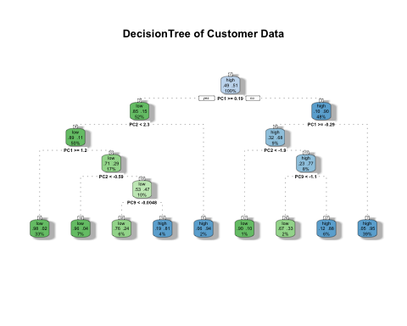

## accuracy_test2$byClass  
## Sensitivity 0.8714286  
## Specificity 0.9206349  
## Pos Pred Value 0.9242424  
## Neg Pred Value 0.8656716  
## Precision 0.9242424  
## Recall 0.8714286  
## F1 0.8970588  
## Prevalence 0.5263158  
## Detection Rate 0.4586466  
## Detection Prevalence 0.4962406  
## Balanced Accuracy 0.8960317

Precision<- accuracy_test2$table[1,1]/sum(accuracy_test2$table[1,1:2])  
print(Precision)

## [1] 0.9242424

Recall <- accuracy_test2$table[1,1]/sum(accuracy_test2$table[1:2,1])  
print(Recall)

## [1] 0.8714286

The ROC plot below shown the performance of the binary decision tree classification model in details, the curve that passes through the upper left corner in conjunction with a AUC score of 0.934 indicates the high predicting power of the modelon the test set.

library(pROC)

## Type 'citation("pROC")' for a citation.

##   
## Attaching package: 'pROC'

## The following objects are masked from 'package:stats':  
##   
## cov, smooth, var

pred_prob<- predict(fitBDT2,Test2,type="prob")  
head(pred_prob)

## low high  
## 16 0.05119454 0.94880546  
## 19 0.05119454 0.94880546  
## 41 0.98387097 0.01612903  
## 45 0.96153846 0.03846154  
## 107 0.12244898 0.87755102  
## 110 0.05119454 0.94880546

roc_obj<- roc((Test2$Spent),pred_prob[,1])

## Setting levels: control = low, case = high

## Setting direction: controls > cases

plot(roc_obj,print.auc=TRUE)

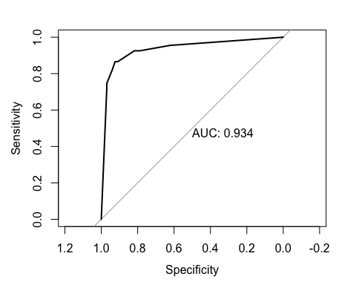

### VII. Reflection

With the integration of statistics, machine learning, and other computing and applied math disciplines, this course introduces me with the fundamental concepts of data science, including techniques and algorithms, and provides hands-on instruction with a powerful toolkit through tutorials and homeworks. I think although the course covers the whole data science process, including gaining an understanding of data, preparing and cleaning data, applying algorithms, and evaluating and communicating results; we still need to grasp the concept learned in lesson in order to face real life problem. Model building is the most interesting concept for me in this course, as I can decide and choose various algorithms such as SVM and decision trees, while automatically discovering structure through algorithms such as clustering and association rule mining.