Illustrated Access 365/2021 | Module 1: SAM Project 1a

# Global Human Resources Consultants

## Creating and modifying tables and other database objects

### GETTING STARTED

* Open the file **IL_AC365_2021_1a_*FirstLastName*_1.accdb**, available for download.
* Save the file **IL_AC365_2021_1a_*FirstLastName*_1.accdb** as **IL_AC365_2021_1a_*FirstLastName*_2.accdb**

Edit the file name by changing “1” to “2”.

If you do not see the **.accdb** file extension, do not type it. The file extension will be added for you automatically.

* With the file **IL_AC365_2021_1a_*FirstLastName*_2.accdb** open, ensure that your first and last name is displayed as the first record in the _GradingInfoTable table.

If the table does not display your name, delete the file and download a new copy.

### PROJECT STEPS

1. You are a project manager for Global Human Resources Consultants, an organization that provides human resources services to emerging companies located in eastern Europe. To better manage consultants and the projects on which they work, you have decided to create an Access database.   
     
   Create a new table in Datasheet View with the following options:  
   1. Rename the default primary key ID field **CountryCode** and change the data type to **Short** **Text**.
   2. Change the field size of the field to **3**.
   3. Add a new field with the name **CountryName** and the **Short Text** data type.  
        
      Save the table, using **Country** as the new name.
2. With the *Country* table still open in Datasheet View, add the four records shown in Table 1. Save and close the *Country* table.

Table 1: New Records for Country Table

|  |  |
| --- | --- |
| *CountryCode* | *CountryName* |
| **BEL** | **Belarus** |
| **BGR** | **Bulgaria** |
| **ROU** | **Romania** |
| **SRB** | **Serbia** |

1. Create a new table in Design View to store the clients of Global as follows:
   1. Add a field with the name **ClientID** and the **AutoNumber** data type.
   2. Apply *ClientID* as the table's **primary key**.  
        
      Save the table with the name **Client** but do not close it.
2. With the *Client* table still open in Design View, add a second field to the table with the field name **ClientName** and the **Short Text** data type. Save the table and then close it.
3. Open the *Consultant* table in Design view and update the *Last* field, using **LastName** as the new value.
4. With the *Consultant* table still open in Design View, change the data type property for the *ConsultantID* field from Number to **Short Text**.
5. In Design View, add a new field to the *Consultant* table after the *LastName* field. The field should be named **StartDate** and have the **Date/Time** data type. Save and close the *Consultant* table.
6. Open the *Consultant* table in Datasheet View, navigate to the seventh record (which has a *ConsultantID* field value of 110460), and **delete** the record.
7. With the *Consultant* table still open in Datasheet View, navigate to the fourth record (which has a *ConsultantID* field value of 110351) and update the *FirstName* record, using **Sidney** as the new value. Close the *Consultant* table.
8. You also need to view individual consultant records. Use the Form Wizard to create a form for the *Consultant* table with the following options:
   1. Include all fields from the *Consultant* table in the form.
   2. Select **Columnar** as the layout for the form.  
        
      Save the form with the name **Consultant Data Form** and confirm that the form matches Figure 1. Close the form.

Figure 1: Consultant Data Form in Form View

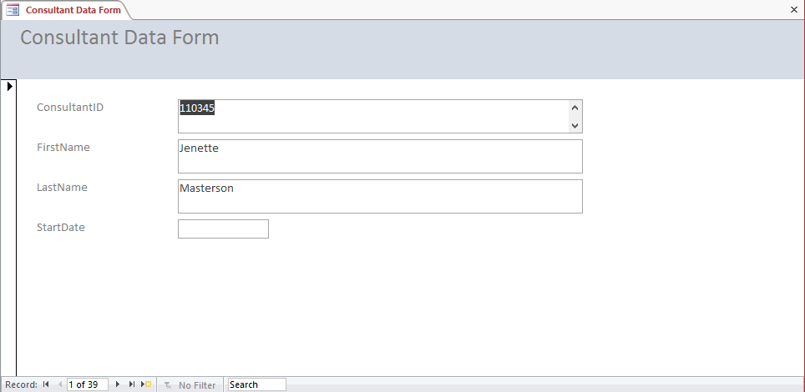

1. Use the Simple Query Wizard to create a query based on the *Skill* table with the following options:
   1. Include all fields from the *Skill* table in the query.  
        
      Save the query with the name **Skill Query** (which is the default name) and then close the query.
2. You need to refer to a printed copy of the *Skill* table when assigning consultants to projects. Use the Report Wizard to create a report based on the *Skill* table with the following options:
   1. Include all fields from the *Skill* table in the report.
   2. Do not include any grouping levels.
   3. Sort the report by *SkillCode* in **ascending** order.
   4. Select **Tabular** as the layout of the report and **Portrait** as the orientation of the report.  
        
      Save the report with the name **Skill Report**. Confirm that the report matches Figure 2 and then close the report.

Figure 2: Skill Report in Print Preview

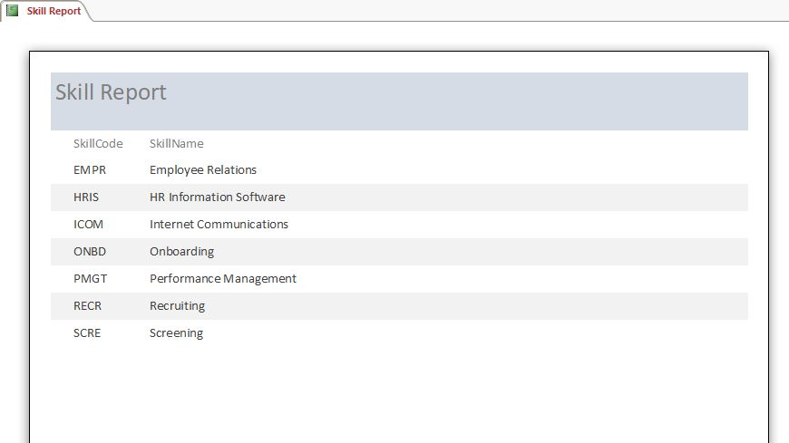

1. In the Navigation Pane, rename the *Skill* form*,* using **Skill Data Form** as the new value.

Save and close any open objects in your database. Compact and repair your database, close it, and then exit Access. Follow the directions on the website to submit your completed project.