Illustrated Access 365/2021 | Module 3: SAM Project 1a

# Global Human Resources Consultants

## Creating Queries, Sorting Records, Changing the Appearance of the Datasheet

### GETTING STARTED

* Open the file **IL_AC365_2021_3a_*FirstLastName*_1.accdb**, available for download.
* Save the file **IL_AC365_2021_3a_*FirstLastName*_1.accdb** as **IL_AC365_2021_3a_*FirstLastName*_2.accdb**

Edit the file name by changing “1” to “2”.

If you do not see the **.accdb** file extension, do not type it. The file extension will be added for you automatically.

* With the file **IL_AC365_2021_3a_*FirstLastName*_2.accdb** open, ensure that your first and last name is displayed as the first record in the _GradingInfoTable table.

If the table does not display your name, delete the file and download a new copy.

### PROJECT STEPS

1. As project manager, you need to be able to query the database to help make decisions and answer questions from other managers. Create a query based on the *Consultant* table in Query Design View with the following options:
   1. Add the *ConsultantID*, *LastName*, and *FirstName* fields to the design grid in that order.
   2. **Sort** the records in **ascending** order by *LastName*.
   3. Save the query with the name **LastNameSorted**.  
        
      Open the query in Datasheet View and then close it.
2. Open the *ResideCriteria* query in Design View and make the following changes to the query:
   1. **Delete** the *ConsultantID* column from the design grid.
   2. Add criteria to select only those records where the *Reside* field value equals **USA**.
   3. Save the changes to the *ResideCriteria* query.  
        
      Open the query in Datasheet View and then close it.
3. Open the *PaidOrBalance* query in Design View and add criteria to select only those records where the *Paid* field value **equals** **0** or the *Balance* field value **equals** **0**. Save the changes to the query. Open the query in Datasheet View, confirm that four records appear in the *PaidOrBalance* query results, and then close the query.
4. Open the *ComparisonSalary* query in Design View and make the following changes to the query:
   1. **Add** the *FirstName* field to the query design grid. The *FirstName* field should immediately follow the *ConsultantID* field.
   2. Add criteria to select only those records where the *Salary* field value is **greater than 70,000**.
   3. Sort the records by *LastName* in **descending** order.
   4. Run the query.
   5. With the query open in Datasheet view, edit the first record by changing the *FirstName* value to **Melodie** from Melodee.  
        
      Confirm that the query results match Figure 1. Save the query again and close it.

Figure 1: ComparisonSalary Query Results

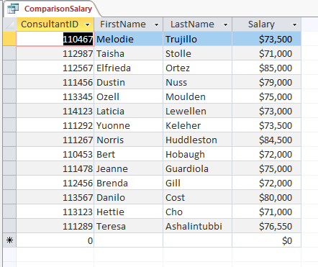

1. Open the *ResideLastName* query in Design View and make the following changes:
   1. Move the *Reside* field to the beginning of the design grid so that the order of the fields in the grid is *Reside*, *LastName*, *FirstName*, *StartDate*.
   2. **Sort** the records in **descending** order by the *Reside* field and in **ascending** order by *LastName*.  
        
      Save the changes to the query. Open the query in Datasheet View and confirm that it matches Figure 2. Close the query.

Figure 2: ResideLastName Query Results

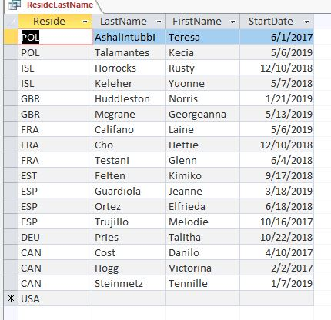

1. Open the *BalanceAndPaid* query in Design View and add criteria to select only those records where the *Paid* field value **equals** **0** and the *Balance* field value **equals** **0**. Save the changes to the query. Open the *BalanceAndPaid* query in Datasheet View, confirm that one record appears in the query results, and then close the query.
2. Open the *DateTime* query in Design View and add criteria to select only those records where the *StartDate* field value is **greater than 1/1/2019**. Save the changes to the query. Open the query in Datasheet View, confirm that 15 records appear in the query results, and then close the query.
3. Because the clients of Global are located in several countries, it may be difficult to know exactly now the client name is spelled. Open the *ClientName* query in Design View and add criteria to select only those records where the *ClientName* field value begins with the letter **S**. Save the changes to the query. Open the query in Datasheet View, confirm that three records appear in the query results, then close the query.
4. Many queries require data from more than one table. For example, you may want the full country name to display rather than the country abbreviation. Create a query in Design View based on the *Consultant* and *Country* tables with the following options:
   1. Add the *Consultant* table and the *Country* table to the design window.
   2. Add the *FirstName* and *LastName* fields from the *Consultant* table to the design grid.
   3. Add the *CountryName* field from the *Country* table to the design grid.
   4. **Join** the *Consultant* table and the *Country* table using the *Reside* field in the *Consultant* table and the *CountryCode* field in the *Country* table.
   5. Save the query, using **Country-Consultant** as the name.  
        
      Open the query in Datasheet View and then close it.
5. Open the *ProjectMonths* query in Design View and add criteria to select only those records where the *Months* field value equals **2**. Save the changes to the query. Open the query in Datasheet View, confirm that two records appear in the query results, and then close the query.
6. Open the *EstMaxMonths* query in Design View. Modify the query by creating a calculated field. Enter **MaxMonths: [Months] + 3** in the Zoom dialog box of the first empty column in the design grid. Save the query. Open the query in Datasheet View and then close the query.
7. Open the *Consultant* table in Datasheet View. Use the **Find and Replace** feature to find the consultant whose first name is **Georgeanna** and replace the name, using **Gina** as the new value. Close the *Consultant* table.
8. Open the *Country* table in Datasheet View and make the following changes:
   1. Change the font to **Arial**.
   2. Change the font size to **10**.
   3. Sort the records in the table in **ascending** order by *CountryName*.  
        
      Save the changes to the table and close it.
9. Open the *Client* table in Datasheet View. Select the *Calculation* field and modify the expression by **changing** the plus (+) sign in the calculation to a **minus (-) sign**. Save the changes to the table and close it.
10. Open the *Skill* table in Datasheet View. **Sort** the records in **descending** order by *SkillName*. Save the changes to the table and close it.
11. Open the *Consultant* table in Datasheet View and **hide** the *Reside* and *Salary* columns. Save the changes to the table and close it.

Save and close any open objects in your database. Compact and repair your database, close it, and then exit Access. Follow the directions on the website to submit your completed project.