Illustrated Access 365/2021 | Module 4: SAM Project 1a

# Global Human Resources Consultants

## Creating forms and reports

### GETTING STARTED

* Open the file **IL_AC365_2021_4a_*FirstLastName*_1.accdb**, available for download.
* Save the file **IL_AC365_2021_4a_*FirstLastName*_1.accdb** as **IL_AC365_2021_4a_*FirstLastName*_2.accdb**

Edit the file name by changing “1” to “2”.

If you do not see the **.accdb** file extension, do not type it. The file extension will be added for you automatically.

* With the file **IL_AC365_2021_4a_*FirstLastName*_2.accdb** open, ensure that your first and last name is displayed as the first record in the _GradingInfoTable table.

If the table does not display your name, delete the file and download a new copy.

### PROJECT STEPS

1. As project manager, you need to be able to view records for all consultants, clients, and projects as well as prepare reports for various departments. Open the *ClientControl* form in Design View and perform the following tasks:
   1. Select the *Balance* and *Total* text boxes and align the left edge of the controls with the left edge of the *Paid* text box (*Hint*: Do not resize the text boxes).
   2. Resize the *Paid* text box to be the same size as the *ClientName* text box above it.
   3. Move the *Close* command button so that the left edge of the command button is at the **6"** mark on the horizontal ruler.
   4. Add a label with the caption **Human Resources** to the Form Header section at the **3"** mark on the horizontal ruler.    
        
      Save the *ClientControl* form, switch to Form View as shown in Figure 1, then close the form.

Figure 1: ClientControl Form in Form View

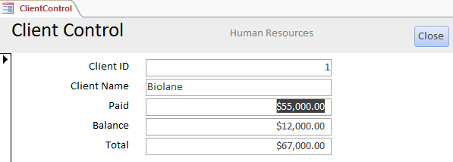

1. Open the *ConsultantData* form in Design View and perform the following tasks:
   1. Add the *Reside* field to the form. Position the *Reside* text box so that the **left** edge of the control aligns with the left edge of the other five text boxes.
   2. **Delete** the *Reside* label.  
        
      Save the changes to the *Consultant Data Form* and close it.
2. Open the *StackedClient* form in Layout View. Select the 10 controls in the Detail section of the form and apply a **Stacked** layout. Save the changes to the form and close it.
3. Open the *TabularProject* form in Layout View. Select all the controls on the form and arrange the controls in a **Tabular** layout. Save the changes to the form and close it.
4. Use the Form Wizard to create a form based on the *Client* table with the following options:
   1. Include all fields from the *Client* table in the form.
   2. Select the **Columnar** layout for the form.
   3. Enter **ClientEntry** as the form title and then open it in Layout View.
5. With the *ClientEntry* form open in Layout View, right-align the text in the five labels in the Detail section. **Bold** the five labels in the Detail section. Save the Form and open it in Form View.
6. Use the *ClientEntry* form to navigate to the record with *ClientID* field value **9**. Change the *Balance* field value of this record, using **$25,000** as the new value.
7. Use the *ClientEntry* form to add a new record to the *Client* table with the field values shown in Table 1. (*Hint*: The *Total* field is a calculated field.) Close the form.

Table 1: Field Values for New Record

|  |  |  |  |
| --- | --- | --- | --- |
| *ClientID* | *ClientName* | *Paid* | *Balance* |
| **16** | **Intrazio** | **25000** | **0** |

1. Open the *ConsultantSalary* form in Design View and perform the following tasks:
   1. **Delete** the *Human Resources* label control in the Form Header.
   2. Add the *StartDate* field to the form then position it just below the *Salary* label and text box.
   3. Change the *Salary* label to **Current Salary** in the Detail section, and the *ConsultantSalary* label to **Consultant Salary** in the Form Header section by adding a space between the words.
   4. **Underline** the *salary:* label in the Form Footer section.  
        
      Save the *ConsultantSalary* form and close it.
2. Use the **Report** button to create a report based on the *Country* table. Save the report, using **CountryList** as the name. With the report open in Layout View, change the *Country* label to **Country Report** in the Report Header section. Save the report.
3. With the *CountryList* report still open in Layout View, update the *CountryCode* label, using **Code** as the new name, and update the *CountryName* label, using **Name** as the new name. Resize the height of the text box that counts the number of records in the left side of the Report Footer section to clearly display the count as shown in Figure 2. Save the report and close it.

Figure 2: CountryList Report in Layout View

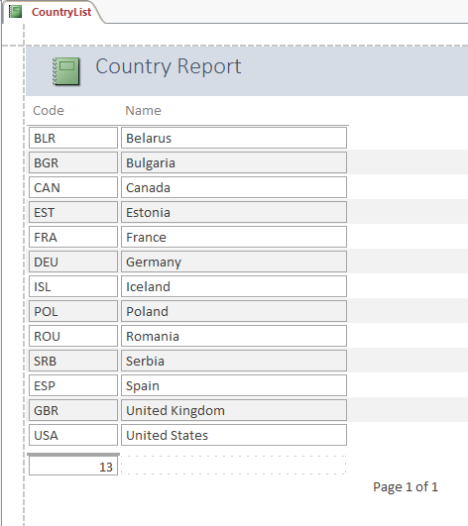

1. Use the Report Wizard to create a report based on the *Project* and *Consultant* tables with the following options:
   1. Include the *Description* and *Months* fields from the *Project* table and the *LastName* from the *Consultant* table in the report.
   2. Choose to view your data *by Consultant*.
   3. Use *LastName* as the grouping field.
   4. Sort the records by *Description* in ascending order.
   5. Select Stepped as the layout and Portrait as the orientation.
   6. Change the title of the report, using **ProjectsByConsultant** as the new title, and preview it. Close the *ProjectsByConsultant* report.
2. Open the *ConsultantsByProject* form in Layout View, open the property sheet, and perform the following tasks:
   1. Change the border style of the *Description* label to **Transparent**.
   2. Change the font size of the *Global Human Resources Consultants* label in the Form Header to **20**. Save the *ConsultantsByProject* form and close it.
3. Open the *Client* report in Design View and perform the following tasks:
   1. Select all of the labels in the Page Header section and group them on the *ClientID* field.
   2. Bold the group.  
      Save the *Client* report and close it.
4. Open the *Consultant* report in Design View and apply **conditional formatting** to the values in the *Salary* text box so that if the field value is equal to 71,000, the field's font color is set to **red** (row 7, column 2 on the standard color palette) and the font is **bold**. Save the report.
5. With the *Consultant* report still open in Design View, change the **font color** of the label in the Report Header section to **dark blue** (row 7, column 9 in the Standard Colors palette.) Save the *Consultant* report, view it in Report View to review the changes, and close the report.
6. Open the *ConsultantStartDate* form in Design View and perform the following tasks:
   1. Resize the width of the form to the **6.5"** mark on the horizontal ruler.
   2. Change the **background color** for the *Consultant StartDate* label in the Form Header section to **Light** **Blue 2** (row 3, column 5 in Standard Colors palette).
   3. Change the font for the *Consultant StartDate* label in the Form Header section to **Georgia**.
   4. Use the **Format Painter** to copy the formatting from the *Consultant ID* label in the Detail section to the *Start Date* label in the Detail section.   
        
      Save the *ConsultantStartDate* form and close it.
7. Open the *ProjectLandscape* report in Layout View and apply the **Georgia** font scheme from the theme fonts to this object only. Save and close the report.
8. Open the *ConsultantResides* report in Layout View and perform the following tasks:
   1. Change the layout of the report to **Portrait**.
   2. **Move** the *Reside* column so that it appears between the *ConsultantID* and *Lastname* columns.   
        
      Save the *ConsultantResides* report and close it.
9. Open the *ClientFees* form in Design View and perform the following tasks:
   1. Delete the *=Date()* and =*Time()* text boxes in the Form Header section.
   2. Remove the layout from the controls in the Detail section of the form.
   3. Apply the Office Theme to this object only.   
        
      Save the *ClientFees* form and close it.

Save and close any open objects in your database. Compact and repair your database, close it, and then exit Access. Follow the directions on the website to submit your completed project.