Illustrated Excel 365/2021 | Module 3: SAM Project 1a

# Great Midwestern Insurance

## Work with formulas and functions

### GETTING STARTED

* Save the file **IL_EX365_2021_3a_*FirstLastName*_1.xlsx** as **IL_EX365_2021_3a_*FirstLastName*_2.xlsx**

Edit the file name by changing “1” to “2”.

If you do not see the **.xlsx** file extension, do not type it. The file extension will be added for you automatically.

* With the file **IL_EX365_2021_3a_*FirstLastName*_2.xlsx** open, ensure that your first and last name is displayed in cell B6 of the Documentation worksheet.

If cell B6 does not display your name, delete the file and download a new copy.

### PROJECT STEPS

1. Brett Thao is an insurance agent for the Great Midwestern Insurance in Milwaukee, Wisconsin. He is analyzing the invoices he has sent clients and the sales he generated in the third quarter of the year. He asks you to help him complete the analysis.  
     
   Go to the *Client Invoices* worksheet. In cell B3, insert a formula using the **DATE** function to display the current date as 6/1/2024 (m/d/yyyy) so that Brett can use the date in calculations. [Mac Hint: The date will display using the format m/d/yy.]
2. In column F, Brett wants to display the age of the invoice, which is the number of days between the current date and the invoice date. Provide this information as follows:
   1. In cell F6, insert a formula without using a function that subtracts the invoice date (cell **B6**) from the current date (cell **B3**).
   2. Use an absolute reference to cell B3 in the formula.
   3. Use the Fill Handle to fill the range F7:F15 with the formula in cell F6, filling the range without formatting.
3. In column G, Brett wants to calculate the number of days the invoice is overdue. If the age of the invoice is greater than 30 days, it is overdue. Calculate the days overdue as follows:
   1. In cell G6, insert a formula using the **IF** function that tests whether the age of the invoice (cell **F6**) is greater than **30**.
   2. If the age of the invoice is greater than 30, subtract the due date (cell **E6**) from the current date (cell **B3**).
   3. If the age of the invoice is less than or equal to 30, display **0** to show that the invoice is not overdue.
   4. Use an absolute reference to cell B3 in the formula.
   5. Use the Fill Handle to fill the range G7:G15 with the formula in cell G6, filling the range without formatting.
4. Brett sends an email reminder to clients with overdue invoices for amounts more than $1,000. Provide a quick way to identify those clients as follows:
   1. In cell H6, insert a formula using the **AND** function that returns TRUE if the number of days overdue (cell **G6**) is greater than **0** and if the invoice amount (cell **D6**) is greater than **1000**.
   2. Use the Fill Handle to fill the range H7:H15 with the formula in cell H6, filling the range without formatting.
5. Brett assigns each client a rating of A, B, or C depending on the number of days an invoice is overdue. Display this information using a nested IF function as follows:
   1. In cell I6, insert a formula using an **IF** function to test whether the days overdue (cell **G6**) are less than **1** and displays a rating of "**A**" if the condition is true.
   2. The next condition uses another **IF** function to test whether the days overdue (cell **G6**) are less than **30** and displays a rating of **"B"** if the condition is true.
   3. Display a rating of **"C"** if the conditions are false.
   4. Use the Fill Handle to fill the range I7:I15 with the formula in cell I6, filling the range without formatting.
6. Clients are eligible for a discount if they have a rating of "A" or do not require an email reminder. Provide this information for Brett as follows:
   1. In cell J6, insert a formula using the **OR** function that returns TRUE if the rating (cell **I6**) equals **"A"** or the email reminder (cell **H6**) equals **FALSE**.
   2. Use the Fill Handle to fill the range J7:J15 with the formula in cell J6, filling the range without formatting.
7. Brett likes to keep track of the total number of current invoices he has sent to clients.   
   In cell B17, enter a formula using the **COUNT** function that counts the invoice numbers (the range **A6:A15**).
8. Brett also likes to keep track of the approximate amount he has billed clients.  
   In cell B18, enter a formula using the **ROUND** and **SUM** functions that totals the invoice amounts (the range **D6:D15**) and rounds the result to **0** decimal places.
9. Go to the *Quarter 3 Sales* worksheet. Apply the **Accounting** number format to the sales amounts (range B6:B11) to indicate they are dollar amounts.
10. Brett wants to calculate the percentage of each category of insurance contributed to his total sales. Because he also wants to avoid a divide by zero error in the calculation, he has already entered the IFERROR function. Complete the formula as follows:
    1. In cell C6, before the comma in the IFERROR function, create a formula without using a function that divides the amount of automobile insurance sales (cell **B6**) by the total sales (cell **B11**).
    2. Use an absolute reference to cell B11 in the formula.
    3. Use the Fill Handle to fill the range C7:C10 with the formula in cell C6.

Your workbook should look like the Final Figures on the following pages. Save your changes, close the workbook, and then exit Excel. Follow the directions on the website to submit your completed project.

### Final Figure 1: Client Invoices Worksheet

Microsoft product screenshot reprinted with permission from Microsoft Incorporated. Copyright © 2020 Cengage Learning. All Rights Reserved.

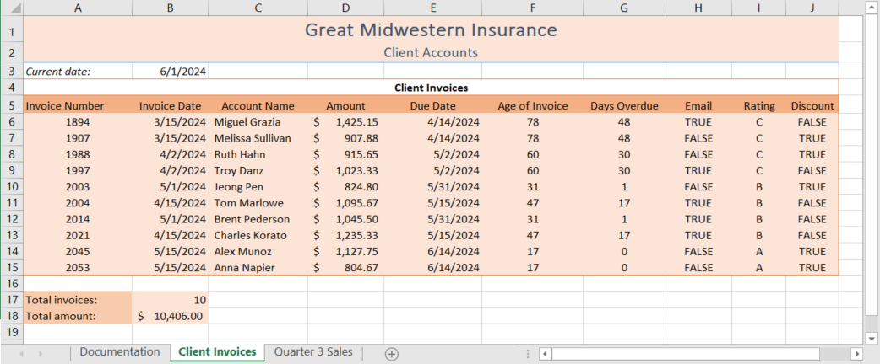

### Final Figure 2: Quarter 3 Sales Worksheet

