**Setting up a Python Environment for Data Science**

**Windows**

1. Go to <https://www.continuum.io/downloads#windows> (download either 64-bit or 32-bit Python 2.7 version → lectures will be based on Python 2.7)
2. After download is complete install the anaconda distribution manager
3. Go to command prompt or powershell and enter the following:

|  |
| --- |
| **> python**  **Python 2.7.12 (v2.7.12:...**  **Type "help", "copyright"...**  **>>>** |

If you see the above after entering python in the Windows command prompt/powershell, then you have Python set up.

4. To launch jupyter notebook, launch it like any stand-alone program, by searching for it in the "start" menu, or you can launch jupyter notebook and other python shells like iPython by opening the "anaconda navigator" program

**Mac OS**

1. Go to <https://www.continuum.io/downloads#osx>
2. Download the Graphical Installer for Python 2.7 as shown below:

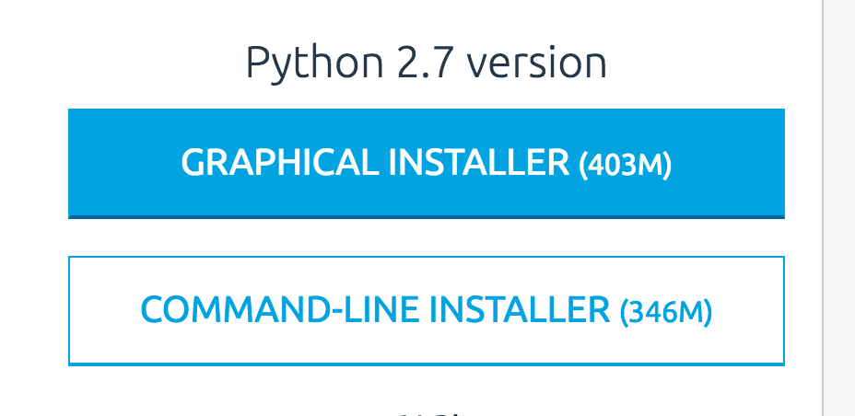

1. Double-click the downloaded .pkg file and follow the instructions to install.
2. After installation, there are two ways to launch Jupyter Notebook:
   1. **Without command line (using Navigator):**
      1. Open Navigator

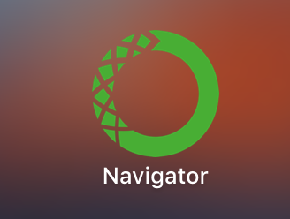

* + 1. Click on the Launch button for Jupyter Notebook

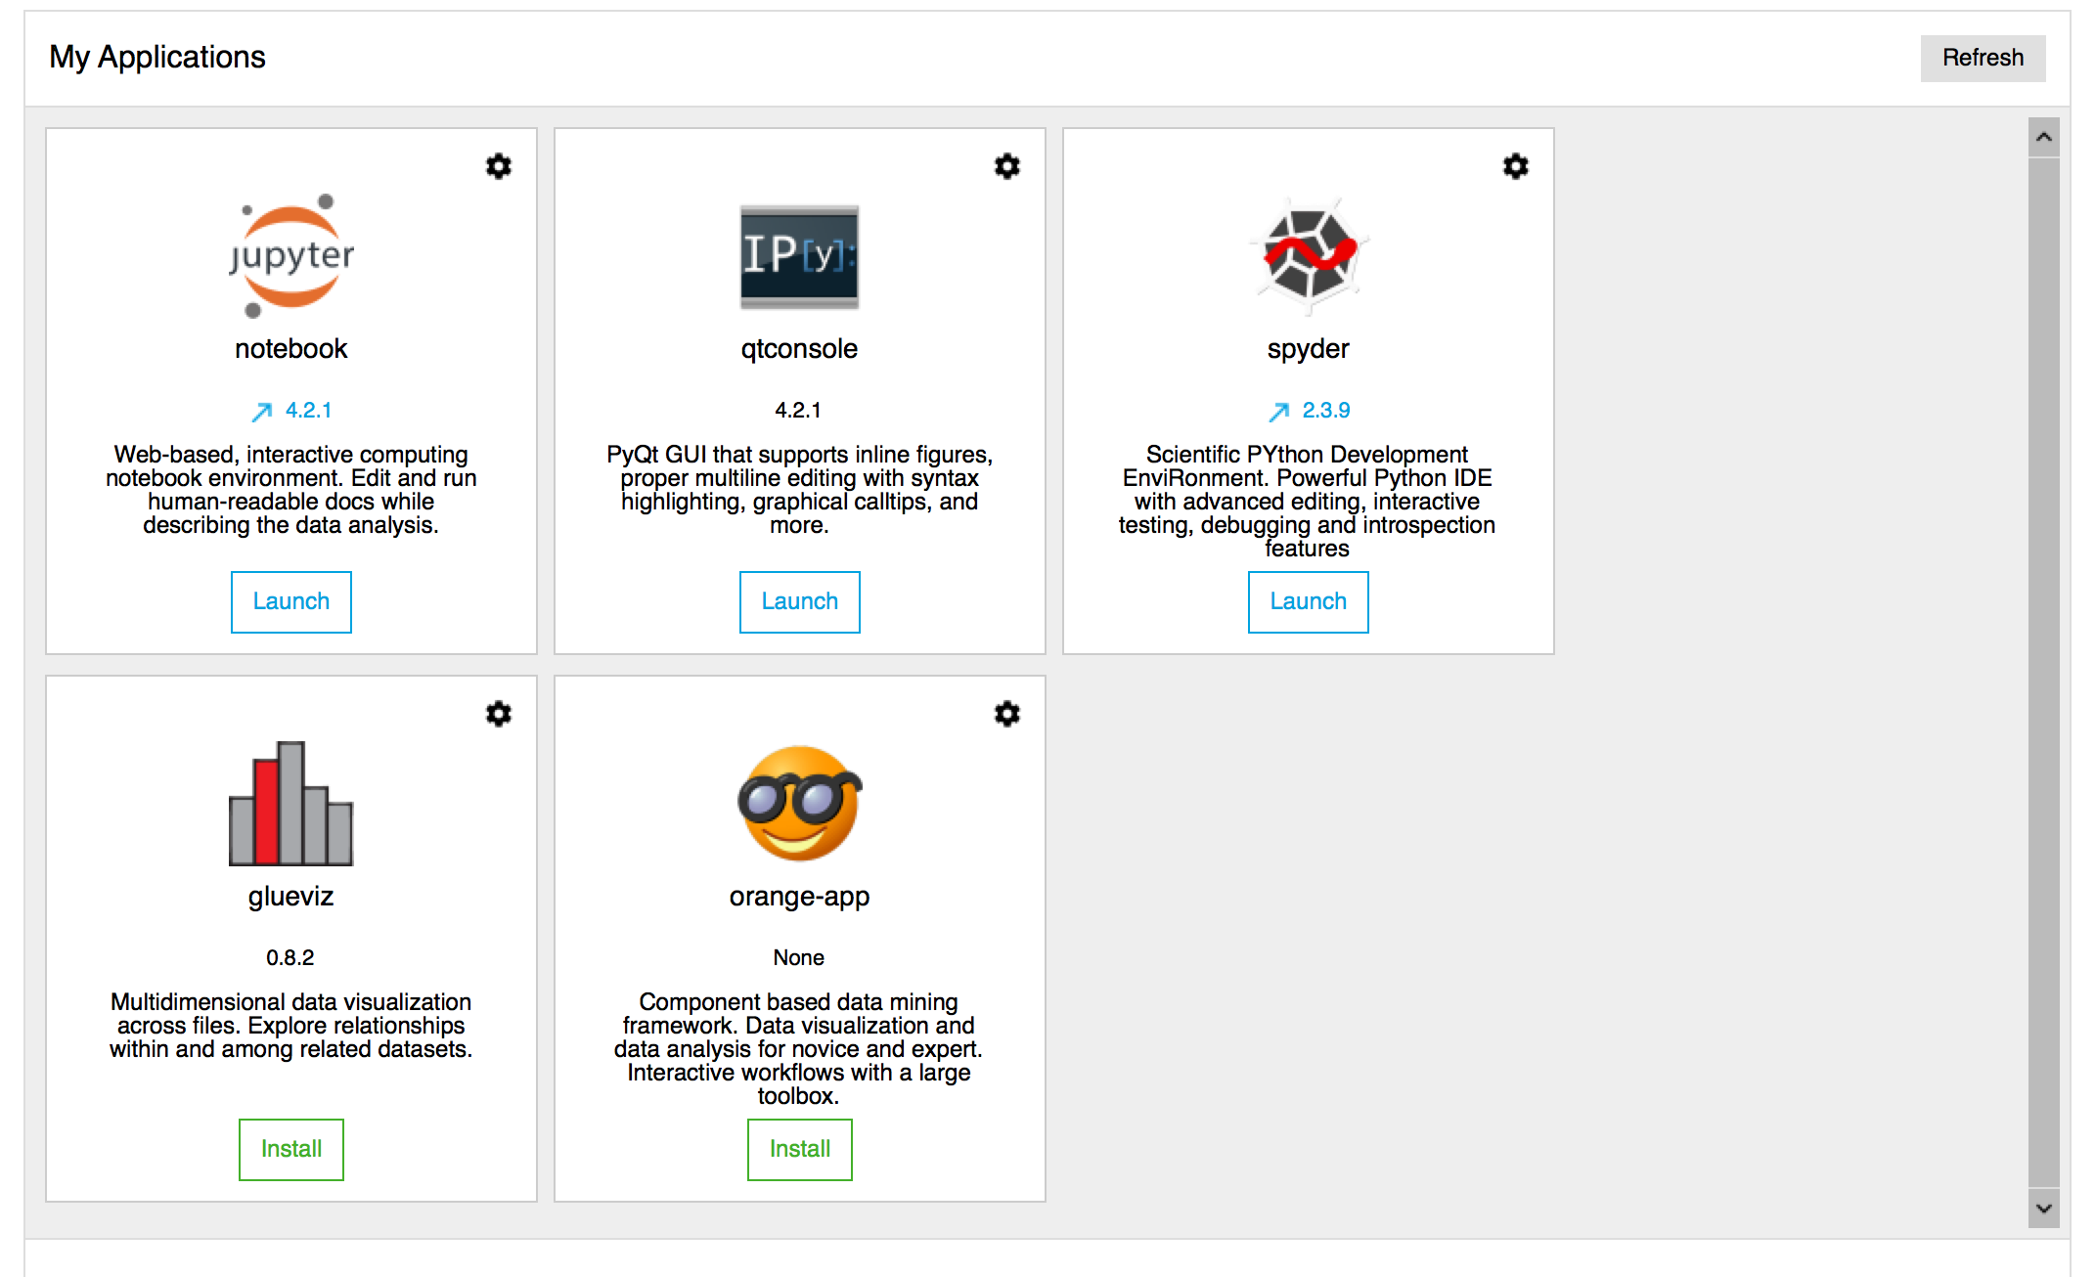

* 1. **With command line (using Terminal)**:
     1. Open Terminal

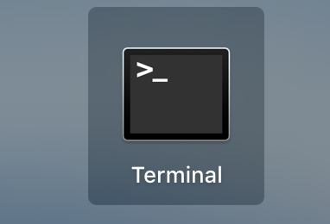

* + 1. Type in “jupyter notebook” without the quotations as shown below:

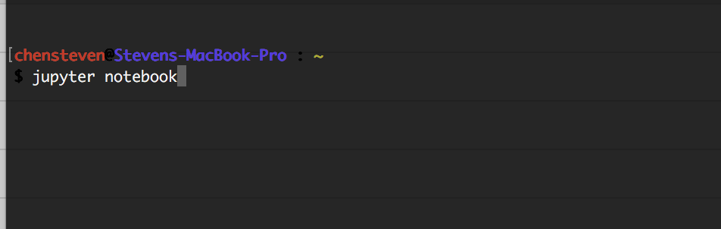

1. Both ways will launch the Jupyter Notebook screen and now you’re ready to use it.

**Linux**

1. all​ ​distros​ ​come​ ​preinstalled​ ​with​ ​python2.7/3.5 ​+​ ​pip
2. [recommended]​ ​anaconda​ ​distribution comes​ pre-​configured​ ​with​ ​all​ ​the​ ​scientific​ ​python​ ​libraries​ ​like​ ​scipy, matplotlib,​ ​numpy. Go here: https://www.continuum.io/downloads#linux
3. Jupyter​ ​notebook​ comes packaged with anaconda. To start a jupyter notebook session, go to your preferred directory (e.g. your home folder "/home/<your username>/" a.k.a. ~ ) and enter the following:

|  |
| --- |
| > jupyter notebook |

this will launch jupyter notebook in the directory you were in

**Editors/IDEs**

1. vi/vim (all platforms)
2. gedit/nano (mainly Linux)
3. Notepad++ (Windows)
4. Text Wrangler (Mac OS)

**Great Resources for Learning Python:**

<https://learnpythonthehardway.org/book/>

<http://greenteapress.com/thinkpython/html/index.html>

<https://python.swaroopch.com/>

<https://learnxinyminutes.com/docs/python/>

<https://pymotw.com/2/contents.html>

<https://www.fullstackpython.com/best-python-resources.html>

[http://www.bash.academy/](https://www.fullstackpython.com/best-python-resources.html)