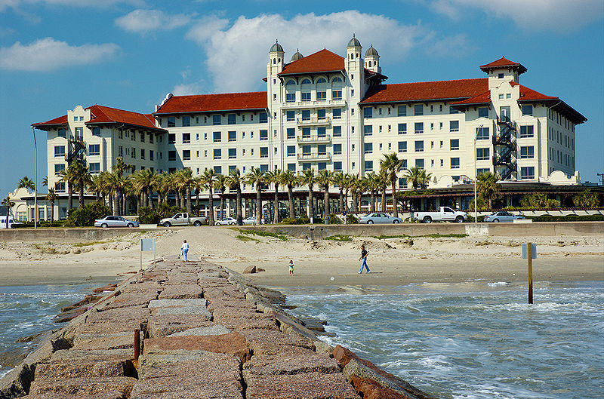
http://www.flickr.com/photos/irees/84081077/Desc - cc-by-sa-2.0

CMSO Workshop - Free participation
27th and 28th of January 2017, Galveston, Texas
The second workshop of the Cell Migration Standardization Organization (CMSO) will be held in Galveston, Texas on the 27th and 28th of January 2017.
The CMSO works on community standards for the field of cell migration in three working groups: Minimal Reporting Requirements, Controlled Vocabularies, and Standard Formats and Software APIs. More detailed information can be found on the CMSO website at: http://cmso.science
Participation in the workshop is free for all attendees, but do note that participants will have to pay for their own transport and accommodation.
Meeting registration: https://goo.gl/aMFcmD

Registration closes on 25 December 2016

Accomodation can be arranged with the venue, the hotel Galvez : http://www.hotelgalvez.com/
A limited number of rooms is available at the discounted rate of $169 USD per night
Hotel reservations can be made by contacting Ms. Tina Hooper – thooper@wyndham.com, and mentioning the Cell Migration Standardization Organization.
For any questions, please contact us at info-cmso@vib-ugent.be.

