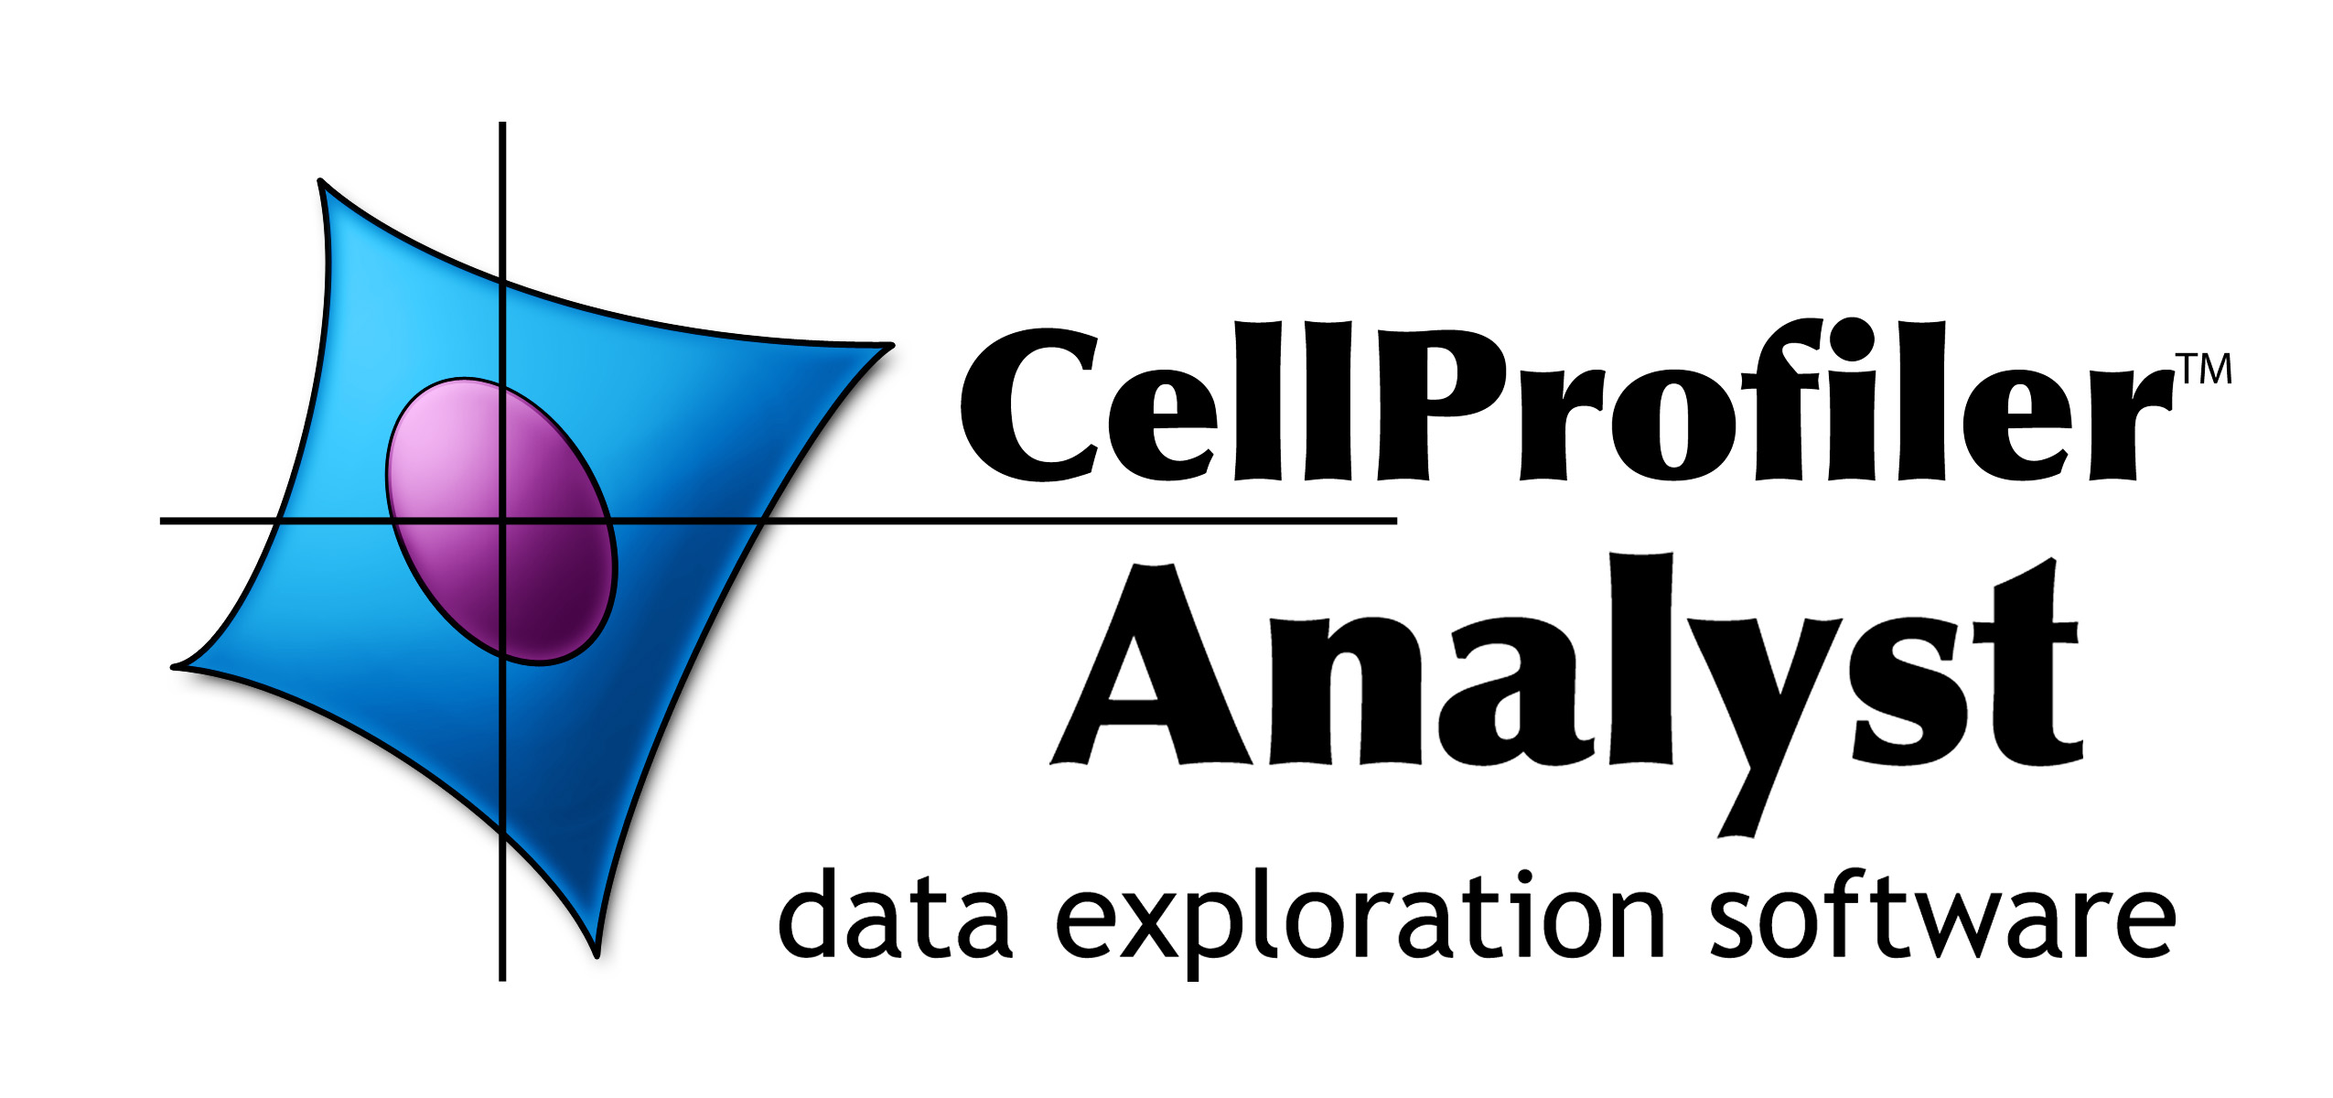
Table of Contents

INTRODUCTION 1
I. PRELIMINARY DATA REQUIREMENTS 2
I.A Example image table 2
I.B Example object table 3
II. SETTING UP THE PROPERTIES FILE 4
II.A Properties file example 4
II.B Database access values 5
II.C Database structure values 6
II.D Image access values 7
II.F Other optional settings 8
II.G Advanced settings 9
III. THE CELLPROFILER ANALYST INTERFACE 11
IV. CLASSIFIER 12
III.A Classifier quick-start guide 12
III.B In-depth guidance for using Classifier 13
III.B.1 Configuring Classifier 13
III.B.2 Fetch an initial batch of objects 15
III.B.3 Sort the initial batch of objects 16
III.B.4 Saving and loading training sets 17
III.B.5 Find rules / training Classifier 17
III.B.6 Scoring 20
V. DATA TABLE 23
VI. IMAGE VIEWER 25
VII. PLATE VIEWER 27
VIII. SCATTER PLOT 31
IX. HISTOGRAM PLOT 32
X. DENSITY PLOT 33

INTRODUCTION

CellProfiler Analyst (CPA) provides tools for exploring and analyzing multidimensional data, particularly data from high-throughput, image-based experiments analyzed by its companion image analysis software, CellProfiler.

CellProfiler Analyst’s primary tools:

- Classifier can be quickly trained using supervised machine learning to recognize complicated and subtle distinctions between objects in images, enabling automatic scoring of hundreds of millions of objects.

- Image Viewer displays images interactively with other tools.

- Data Table displays numerical and text data in a spreadsheet format, where data points can be clicked to display images.

- Plate Viewer is a tool for exploration of data according to the spatial layout of the experiment, such as a multi-well plate or microarray.

- Scatter Plot, Histogram, and Density Plot display numerical data, where data points can be clicked to display images (latter feature coming soon).

The CellProfiler project is based at the Broad Institute Imaging Platform. It was started by Anne E. Carpenter and Thouis (Ray) Jones in the laboratories of David M. Sabatini and Polina Golland at the Whitehead Institute for Biomedical Research and MIT's CSAIL. Adam Fraser currently leads the development of CellProfiler Analyst.

CellProfiler Analyst is primarily tested on MacOS 10.4, 10.5, and Windows XP, and to a lesser extent Linux. Running the software from Linux currently requires use of the source code, which is beyond the scope of this document.

CellProfiler Analyst is distributed under the GNU General Public License version 2 (see LICENSE.txt).

I. PRELIMINARY DATA REQUIREMENTS

CPA requires access to the following data sources:

- An image table and an object table containing measurements and metadata.
  - These may reside in a MySQL or SQLite database or in a set of comma-separated value (CSV) files. A MySQL database is recommended, though you may need to consult with your local information technology staff to set up a database server. See section II.B for more information.
  - The tables must contain a few data columns needed by CellProfiler Analyst to access images and data properly, such as an Image ID column to link the per-image and per-object tables, file path and file name columns to specify where images are stored, and X, Y location columns to specify where each object resides within the image. These configuration details are specified in a properties file.

MySQL users: If you are using a MySQL database, Classifier requires that you install a special MySQL plugin provided in the mysql_plugins/ folder provided with the software.

- The images that were analyzed to generate the above-mentioned data tables.
  - These can be stored either locally or remotely and accessed via HTTP. The directory structure does not matter as long as the file paths stored in the image table point to the correct images.
  - Throughout CPA, the term image is meant to include all image data associated with an analyzed field-of-view. An image in this sense usually includes several individual monochromatic images that show the different wavelengths (channels) as well as images that show outlines of identified objects. You can specify any number of image channels (including, for example, outlines of objects that resulted from image processing) by adding path and filename columns to the image table of your database for each channel.
  - CPA currently requires image files to be monochromatic; several individual channels can be combined into a color image for viewing within the software.
  - CPA currently supports the following image file types: BMP, CUR, DCX, Cellomics DIB, FLI, FLC, FPX, GBR, GD, GIF, ICO, IM, IMT, IPTC/NAA, JPG/JPEG, MCIDAS, MIC, MSP, PCD, PCX, PIXAR, PNG, PPM, PSD, SGI, SPIDER, TGA, TIF/TIFF, WAL, XBM, XPM, XV Thumbnails

Note: While designed for high-throughput, image-based, biological experiments, CellProfiler Analyst is also useful for the exploration of other multi-dimensional data sets, particularly when data points are linked to images.

I.A Example image table

The image table requires one column for a unique image ID and a pair of columns for each channel represented in the images: one column for the image path, and one column for the image file name (which may include some part of the path to the image, such as the subdirectory that contains the file). These columns do not need to have specific names; you will indicate which column names correspond to image ID, image path, and image filename when configuring the properties file. The remaining columns can contain measurements and metadata about each image.

Note: While MySQL and SQLite support diverse column names, CPA will not handle column names that contain commas. In general, we advise that you use only alphanumeric characters and underscores in the names of your table columns.

An image table for an experiment involving cells imaged for GFP and Hoechst would have two channels and would look something like this:

I.B Example object table

The object table requires four columns: a foreign key image ID column that corresponds to the image ID in the image table, a unique object ID column, a column for the object x-location, and a column for the object y-location. CellProfiler Analyst expects the location columns to correspond to the x-y pixel coordinates of the objects’ centroids; the corresponding column names that are produced by CellProfiler depend on the name of the objects; for example, if nuclei were measured, the column names would be Nuclei_Location_Center_X and Nuclei_Location_Center_Y. Again, these columns do not need to have specific names; you indicate which column names correspond to these functionalities when configuring the properties file. Additional columns in this table typically contain measurements for each object, but are completely up to the user.

Note: While MySQL and SQLite support diverse column names, CPA will not handle column names that contain commas. In general, we advise that you use only alphanumeric characters and underscores in the naming of your table columns.

An object table for the GFP/Hoechst experiment shown previously would look something like this:

II. SETTING UP THE PROPERTIES FILE

The properties file is a plain text file that contains the configuration information necessary for CPA to access your database (or CSV files) and images, as well as specifications for the image and object tables. This file can be stored anywhere on your computer, and it is selected and loaded upon startup of CPA.

If you use CellProfiler to produce the data to be analyzed in CPA, you can automatically generate a properties file with most of the fields filled in, using the ExportToDatabase module. Otherwise, you can create one manually, using the Properties_README or the example provided below as a template.

Each setting in the properties file is stored on a separate line in the form field = value(s), and the order of the settings is not important. Lines that begin with a # are ignored by CPA and may be used for comments. Settings that require a file path may be specified either as absolute or relative to the directory that the properties file is found in.

Note: When editing the properties file, it is important to use an editor that is capable of saving plain text. CPA cannot read files of type .doc, .rtf, etc. We suggest using Notepad on Windows, TextEdit on Mac OS, and Emacs on Linux.

Note: CPA 2.0 is not compatible with properties files from CellProfiler Analyst version 1.0, but the two formats may be easily converted by hand. Contact us on the CellProfiler forums if you need help with this.

Note: All fields described in the sections below (after the properties file example) are required unless explicitly described as “optional.” In your own properties file, you would replace values surrounded with <> with the relevant information.

II.A Properties file example

# =========================================================================
#
# CPA 2.0 properties file for example dataset
#
# =========================================================================

# ==== Database Info ====
db_type = sqlite
db_sql_file = example_SETUP.SQL

# ==== Table info ====
image_table = per_image
object_table = per_object

# ==== Column info ====
image_id = ImageNumber
object_id = ObjectNumber
plate_id = plate
well_id = well
cell_x_loc = Nuclei_Location_CenterX
cell_y_loc = Nuclei_Location_CenterY

# ==== Image access info ====
image_url_prepend =

# ==== Image Path and Filename Columns ====
image_channel_paths = Image_Pathnames_Path_Origdna, Image_Pathnames_Path_Origdna, Image_Pathnames_Path_Origdna
image_channel_files = Image_Filenames_Filename_origActin, Image_Filenames_Filename_origpH3, Image_Filenames_Filename_origdna
image_channel_names = Actin, pH3, DNA
image_channel_colors = red, green, blue

# ==== Global Meta data ====
object_name = cell, cells
plate_type = 96

# ==== Classify ====
classifier_ignore_columns = Nuclei_Location.*, Meta.*,

# ==== Other ====
image_tile_size = 40

II.B Database access values

These settings tell CPA how to access your database. One of the 4 modes below may be used. Include only the settings listed for that mode of storage in your properties file.

To connect to a MySQL database:

A MySQL database is recommended for storing extremely large data that may need to be accessed from different computers. CellProfiler can readily create a MySQL database if a database server is available; see the instructions for the ExportToDatabase module for details.

db_type = mysql
db_port = 3306
db_host = <your host name>
db_name = <your database name>
db_user = <your user name>
db_passwd = <your password>

To connect to an SQLite database:

SQLite is another mode of data storage, in which tables are stored in a large, database-like file on your local computer rather than a database server. This is easier to set up than a full-featured MySQL database and is at least as fast, but it is not a good choice of storage if the data is to be accessed by multiple concurrent connections. This mode of storage also puts a limitation on the number of rules used in Classifier (see section III.B.5). CellProfiler will soon be able to export data in this format using the ExportToDatabase module.

db_type = sqlite
db_sqlite_file = <path and filename of SQLite db file>

To access multiple comma-separated files (.csv) data files produced by CellProfiler:

This mode tells CPA to find your image and object tables in several CSV files produced using CellProfiler’s ExportToDatabase module. In this mode of data storage, you specify the path to the .SQL file written by CellProfiler’s ExportToDatabase module. CPA will then use this file to find the CSV files produced by ExportToDatabase (they must end with image.csv or object.csv) to create an SQLite database file in your home directory. This could take a long time for larger databases, but only needs to be done once.

db_type = sqlite
db_sql_file = <path and filename of .SQL file from ExportToDatabase>

To access data stored in two CSV files:

This mode tells CPA to find your image and object tables in two CSV files. When you run CPA with these settings, it looks for column headers in the first row of each file and inserts the data into an SQLite database file in your home directory. Again, this could take a long time for larger databases, but only needs to be done once.

db_type = sqlite
image_csv_file = <path and filename of image csv>
object_csv_file = <path and filename of object csv>

II.C Database structure values

Database table names

The following fields identify the image and object tables:

image_table = <name of the table with one row per image>
object_table = <name of the table with one row per object>

Database column names

The following fields identify the columns that specify unique image and object numbers:

image_id = <image_number key column from the image & object table>
object_id = <object_number key column from the object table>

The following field (optional) identifies the columns that specify a table number, which is useful in cases where multiple image tables have been manually merged and the image number column is no longer unique:

table_id = <table_number key column from the image & object tables>

The following fields identify the columns in the object table that specify the x and y location of each object within the original image:

cell_x_loc = <object x-location column from the object table>
cell_y_loc = <object y-location column from the object table>

The following fields (optional) identify plate and well columns in your image table and are only required by the PlateMapBrowser tool:

plate_id = <plate_id column from the image table>
well_id = <well_id column from the image table>

II.D Image access values

The following fields specify the columns in the image table that contain the image paths and file names. CPA can access images stored locally or via HTTP. In either case, the URLs (locations) of images must be specified in the image table. You can specify any number of image channels, separated by commas:

image_channel_paths = <1st channel image path column>, <2nd channel image path column>,...
image_channel_files = <1st channel image file column>, <2nd channel image file column>,...

The following fields (optional) allow you to provide a common name for each of the above channels and to specify a default display color for each. If you don’t assign these, channels will appear as Channel0, Channel1, etc. in CPA and they will be assigned default colors. Channel colors can later be changed while using CPA (section III.D.1). Valid colors are red, green, blue, magenta, cyan, yellow, gray, none. Follow the same order of channels as for image_channel_paths and image_channel_files:

image_channel_names = <Actin>, <pH3>, <DNA>, ...
image_channel_colors = <red>, <green>, <blue>, ...

The following field allows you to specify a URL prefix to add to all image paths. That is, CPA will place the contents of this field in front of the path and filename values extracted from image_channel_paths and image_channel_files. This is especially useful if you wish to move your images to another location without having to change the image_channel_paths column in the database, or when the images are stored remotely and need to be accessed through HTTP. For example, if you set image_url_prepend = http://yourserver.com/images and the path and file name in the database for a given image are yourpath and file.png, then CPA will open http://yourserver.com/images/yourpath/file.png.

image_url_prepend = <http://yourserver.com/images>

The following field specifies the crop size of the object tiles, that is, the pixel size of the square “window” that shows an individual object in certain tools within CPA. A good rule of thumb is to set this value to be slightly larger than the approximate diameter of the objects:

image_tile_size = <tile size in pixels>

II.F Other optional settings

Metadata

The following field (optional) specifies what CPA will call the objects (e.g., cell, cells or nucleus, nuclei or worm, worms). If not specified, CPA will use “object” and “objects”:

object_name = <singular name, plural name>

The following field tells PlateMapBrowser what size plates were used. Supported types are 96, 384, 1536, or 5600 (for cell microarrays):

plate_type = <number of wells>

Columns ignored by Classifier

The following field (optional) specifies columns in the per-object table that you want Classifier to ignore when finding rules for classifying objects. Classifier automatically ignores columns defined by the table_id, image_id, and object_id fields, as well as any columns that contain non-numeric data. When using this field to specify additional columns to ignore, note that your column names cannot contain commas because commas are used to separate each column name. You can also use regular expressions to refer to a set of column names for Classifier to ignore:

classifier_ignore_columns = <column name or regular expression A>, <column name or regular expression B>

For example, the following statement will ignore the column named WellID, any columns whose name contains the text Red (case-sensitive), and any columns that end in _Position.

classifier_ignore_columns = WellID, .*Red.*, .*_Position

Classifier default training set

The following field (optional) specifies the full path and file name for a training set that Classifier should automatically load when it is launched:

training_set = <your directory/your subdirectory/your file>

Area-based scoring

The following field (optional) specifies a column in your per-object table that will be summed and reported when scoring with Classifier. You can use this, for example, to report the total area of objects in each class, in addition to the number of objects in each class (which is Classifier’s default output):

area_scoring_column = <your alternate column name>

Outputting per-object classes

The following field (optional) specifies a MySQL table name for Classifier to create in your database when Score All is used. The class name of each object will be written to this table along with image and object IDs so it may be linked back into your existing tables. Warning: If this table name already exists, it will be overwritten:

class_table = <your class table name>

Checking your tables

The following field (optional) tells Classifier whether to check your tables at startup for anomalies such as missing column indices (an index is a database structure that greatly improves the speed of data retrieval) or orphaned objects (objects that do not correspond to an image in the image table). The operation can take up to a minute if your object table is extremely large.

check_tables = <yes or no>

II.G Advanced settings

These more advanced settings require some knowledge of SQL.

Image filters

The following fields (optional) specify a subset of the images in your experiment from which to fetch and score objects in Classifier. Multiple filters can be created by using the format below and replacing <XXX> with a name for the filter. Names can include alphanumeric characters and underscores.

filter_SQL_<XXX> = <SQL select statement that returns image-keys for images you want to include>

For example, here is a filter that returns only images from plate 1:

filter_SQL_Plate_1 = SELECT ImageNumber FROM per_image WHERE plate="1"

This example returns only images from with a gene column that starts with CDK:

filter_SQL_CDKs = SELECT ImageNumber FROM per_image WHERE gene REGEXP 'CDK.*'

This example does the same for a database that includes a table_id column TableNumber:

filter_SQL_CDKs = SELECT ImageNumber, TableNumber FROM per_image WHERE gene REGEXP 'CDK.*'

Groups

You can define ways of grouping your image data (for example, when several images represent the same experimental sample), by linking column(s) that identify unique images (the image-key) to another set of columns (the group-key, which may reside in other tables, provided the tables have a common key). Grouping is useful, for example, when you want to aggregate counts for each class of object and their scores on a per-group basis (e.g.: per-well) instead of on a per-image basis when scoring with Classifier. It will also provide new options in the Classifier fetch “from” menu so you can fetch objects from images with specific values for the group columns. Multiple groups can be created by replacing <XXX> with the desired group name:

group_SQL_<XXX> = <MySQL SELECT statement that returns image-key columns followed by group-key columns>

For example, if you wanted to be able to group your data by unique plate names, you could define a group called SQL_Plate as follows:

group_SQL_Plate = SELECT ImageNumber, plate FROM per_image

As another example, you could define a way to group unique wells:

group_SQL_Well+Plate = SELECT ImageNumber, plate, well FROM per_image

The previous example, but for a database including a table_id column TableNumber:

group_SQL_Well+Plate = SELECT TableNumber, ImageNumber, plate, well FROM per_image

III. THE CELLPROFILER ANALYST INTERFACE

To run CPA, double-click the CPAnalyst.exe file on Windows or CPAnalyst.app on Mac OS. Once you have selected a properties file to load, the following small window will appear.

CellProfiler Analyst main window.

This window provides a toolbar at the top with icons to launch each of CPA’s tools. The currently available tools are Classifier, Plate Viewer, Data Table, Image Viewer, Scatter Plot, Histogram, and Density Plot. These tools can also be launched from the Tools menu. More tools will be added to this suite in the future.

Below the toolbar is a logging console that all the tools will use to provide feedback on status, warnings, etc. This console can be configured to display messages at 5 levels of verbosity chosen from the Logging menu. In order of increasing verbosity, these are:

- Critical: Virtually no messages. Will only report critical errors.
- Errors: Only reports error messages.
- Warnings: Only reports warnings and error messages.
- Info: Reports general status information as well as any warnings and errors.
- Debug: Reports technical information such as SQL queries in addition to all other messages listed above.

You can save the log to a file by selecting File > Save Log, or copied by selecting the text and using Ctrl+C (or your operating system default copy command).

IV. CLASSIFIER

Classifier allows you to train the computer to identify objects of interest by applying iterative, user-supervised machine learning methods to object measurements.

You first request (Fetch) object tiles (cropped from their original images), then manually sort them into classification bins, one for each object class, to form a training set. Once each bin contains many example objects, you can start training Classifier, asking it to generate rules for differentiating among objects in each bin. Once Classifier generates some initial rules, you can continue training in either by fetching and sorting more random objects, or by fetching objects that Classifier scores as being in a particular class based on the rules it has already found; correcting errors in these classifications rapidly improves subsequent rule sets. Usually several rounds of refinement are necessary to train the Classifier to generate rules that recognize the classes of interest.

Once classification reaches a desirable accuracy, Classifier can “score” your experiment. This entails classifying all objects, counting how many objects of each class are in each image or group (if you have defined groups in your properties file; see section II.G), and computing the enrichment/depletion of each class per image or per group.

III.A Classifier quick-start guide

- Launch Classifier and enter the number of objects you want Classifier to fetch.
- Specify whether Classifier should select these objects from the entire experiment, a single image or a group, and whether it should apply any filters. Groups and filters will only be available if defined in your properties file (section II).
- Click Fetch. Objects will appear in the Unclassified bin.
- Manually sort the unclassified objects into classification bins, adding additional bins if needed. Often, two bins are used: positive and negative.
- Enter the maximum number of rules you want Classifier to look for and click Find Rules.
- Repeat steps 2–6 to fetch and sort more objects until you are satisfied with the rules Classifier has generated. With a rule set established, you will be able to specify that Classifier only retrieve objects that it deems to be in a particular class so that you can correct errors. Classifier’s rules for each class will become more refined with each iteration of this process.
- Click Score Image to visualize object classifications in a particular image (you will be asked to enter an image ID number). Objects can be dragged and dropped into bins from the Image Viewer to further refine rules.
- It is important to save the training set for future refinement, to re-generate scores, and as a record of your experiment. It is advisable to do so before proceeding to scoring your experiment since scoring may take a long time for large screens. Select File > Save Training Set from the menu bar (or ctrl+S).
- Click Score All to have Classifier score your entire experiment (optionally with groups or filters). Classifier will present the results in a Data Table (described in section IV).
- You can click on column headings to sort the data by that column, helping you identify images that are highly enriched in a given object class, or images that simply have a high count of those objects. You can double-click the headers of rows to view the corresponding images and then drag and drop objects from the resulting image(s) into classification bins to further refine rules.
- You can save Classifier’s scores for each image (or group) from the Data Table using File > Save data to CSV or Save per-image counts to CSV to create comma-separated value files. You can also view the scores with CPA’s visualization tool, Plate Viewer, by using Database > Write Temporary Table in Database and running the Plate Viewer (section IV).

III.B In-depth guidance for using Classifier

Note: We recommend running only a single instance of CPA 2.0 at any one time. Otherwise, significant delays in processing may result, particularly if you are working with very large training sets and/or data sets.

III.B.1 Configuring Classifier

Launch Classifier by clicking the Classifier icon in the CPA toolbar. The main Classifier screen will appear. If you have previously saved a training set, you can load it using File > Load Training Set:

Initial Classifier screen

Adding, Deleting, and Renaming Bins

- Tip: Use as few bins as necessary for the relevant downstream analysis; adding too many bins can decrease the overall accuracy.

To add more bins at any time, click the Add new class. button in the extreme lower right-hand corner of the window. You will see the Rename class popup window:

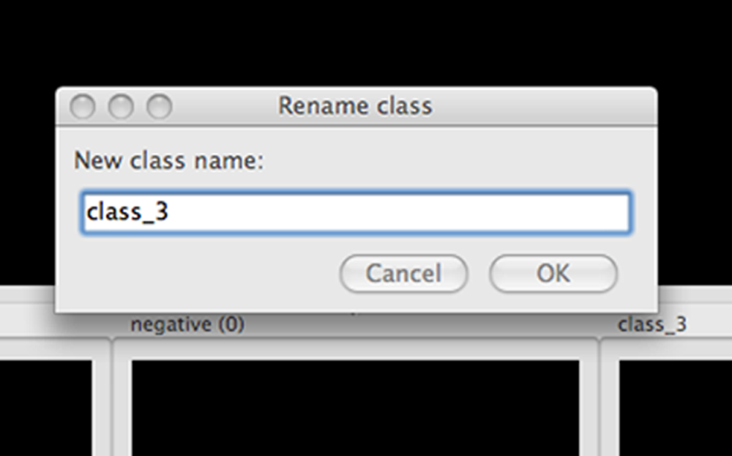

Adding a sorting bin

Right-clicking inside any bin displays a popup menu that contains a number of options, including deleting and renaming bins. The remaining options in this menu apply to the contents of the bin. See section III.C.3 for more information.

Right clicking on a sorting bin.

Adjusting the display

The menu bar at the top of the screen contains options for adjusting the display of the image tiles that will be displayed. View > Image Controls will bring up the same control panel found in the Image Viewer tool (section V), and the channel menus can be used to map different colors onto the respective channels. (Actin, pH3, and DNA, in this example; named so in the properties file as described in section II.)

Classifier menu bar

III.B.2 Fetch an initial batch of objects

Objects are fetched (retrieved) using the top portion of the main Classifier window:

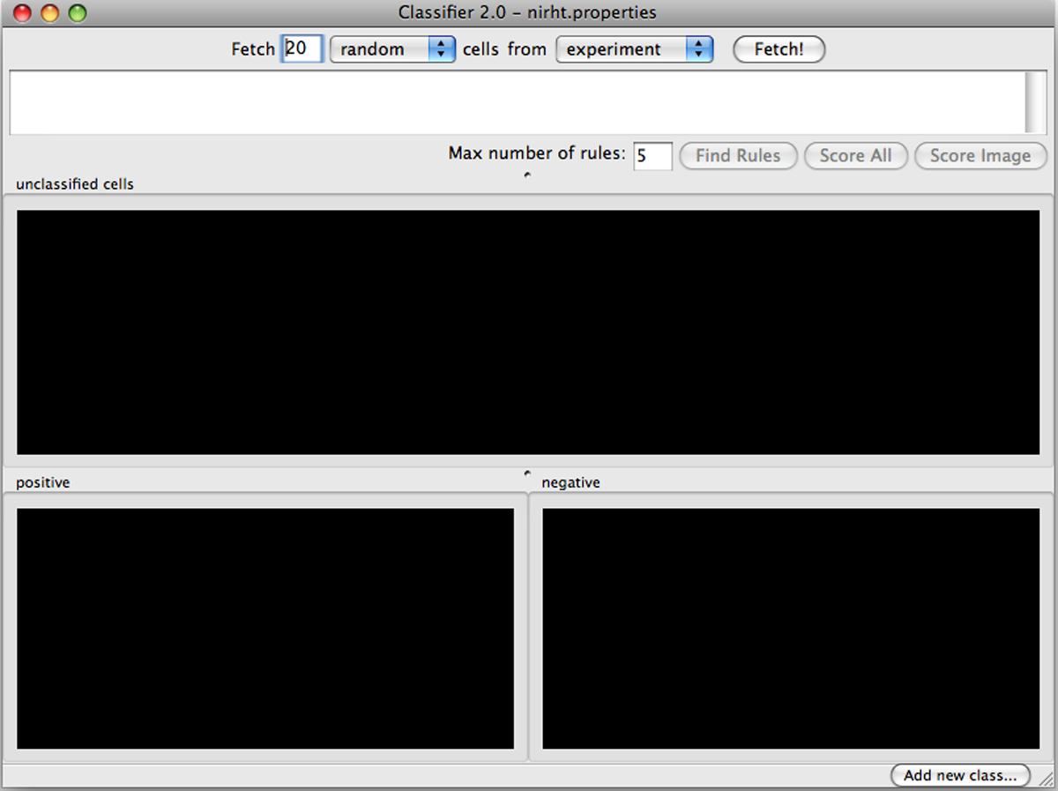
Controls to fetch objects.

How many objects? Enter the number of objects you want Classifier to fetch (default = 20).

Which class of objects should be retrieved? At this stage, random will be the only option available in the left-hand menu. After you ask Classifier to Find Rules (section III.C.5, following), new options will appear corresponding to each classification bin.

From which images? Experiment and image are the two system-supplied default values in the right-hand menu. Select experiment to have Classifier retrieve objects from your entire experiment; select image to retrieve objects from a particular image (you will be asked to type its ID number from your image table). If you want to fetch objects from particular subsets of images in the experiment (e.g., control samples), you can set up filters and groups of images by defining them in your properties file (described earlier in section II.G); these filters or groups will be available for selection here.

Click the Fetch button (located next to the right-hand menu) when you are ready to proceed, and you will see results like this:

Twenty unclassified cells have been fetched and are ready for initial sorting.

III.B.3 Sort the initial batch of objects

Use your mouse to drag and drop object tiles into the classification bins you configured in step III.C.1. If you are uncertain about the classification of a particular object, it can be ignored or removed by selecting it and pushing the Delete key. Keep in mind, however, that classifier will ultimately score ALL objects found in your table unless you define filters to ignore certain images (see section II.F).

Important: A small dot is displayed in the center of each tile as your mouse hovers over it. The object that falls under this dot is the object that must be sorted. In the example below, the tile under the mouse should be sorted based on the blue cell underneath the dot, NOT the cells surrounding it. To change cropping size of the tile “window”, adjust the field image_tile_size in the properties file (section II.D).

The object to be sorted is indicated by a small dot.

Once you have placed tiles in at least two bins, you have created Classifier’s initial training set, which will be used to generate rules to differentiate objects in different classes.

- Tip: Clicking on a tile will select it. Holding shift will allow you to add and remove tiles from the selection. All the tiles in a selection can be moved at once by dragging one of them to another bin.

Some helpful tools are available when you right-click on a tile:

Right-clicking on a tile.

- Select View full images of selected or double-click an individual tile to show the object in the context of the image from which it was drawn. This launches the Image Viewer tool (section V)
  - Tip: Objects can dragged and dropped from the Image Viewer into class bins just as they are from the bins themselves. Use Shift+click to add/remove multiple objects to/from a selection, and ctrl+A/Ctrl+D to select/deselect all objects in the image
- Select all/Deselect all (ctrl+A/ctrl+D) selects/deselects all tiles in the bin so they can be dragged and dropped together.
- Invert selection (ctrl+I) to invert your selection (that is, select all non-selected tiles in the current bin and deselect all selected tiles).
- Remove selected (Delete) removes the selected tiles from the current bin.

III.B.4 Saving and loading training sets

Objects sorted into the bins are known as the training set. You can save the training set at any time, allowing you to close CPA and pick up where you left off later by re-loading the training set. Save and load training sets using File > Save training set or File > Load training set.

Warning: Loading a training set will cause all existing bins and tiles to be cleared.

III.B.5 Find rules / training Classifier

When you have finished your initial sorting, enter the maximum number of rules you want Classifier to find (default = 5).

- During initial training, it is best to use a small number of rules (5-10) to make sure that you do not define your phenotype too narrowly. That is, you want to identify a wide variety of objects that represent your object class but differ in their other characteristics.
- As training proceeds, you may want to increase the number of rules to allow Classifier to capture more subtle distinctions between classes.
- Using more rules does not always result in greater accuracy.
- Increasing the number of rules above 100 is unlikely to improve classification accuracy. Although there is little risk of over-fitting with this machine learning method, too many rules wastes calculation time, since this is an intensive step.
- For complex object classes (that is, to the human eye, one that involves the assessment of many features of the objects simultaneously), we recommend ultimately using 50 rules, based on our experience with 14 phenotypes in human cells (Jones, T.R., et al., PNAS 2009).
- SQLite Limitation: With our current implementation, SQLite limits the number of rules that can be used depending on how many classes you have. E.g.: For 2 classes, no more than 23 rules can be used, for 3 classes, no more than 18.

Click Find Rules. You will note that the large text field near the top of the screen contains the initial rules Classifier has identified based on the objects you deposited into the bins, as a series of IF statements:

Classifier, after finding rules. In this example, only 2 rules were found out of the specified maximum of 5, both pertaining to the feature Nuclei_Intensity_pH3_MeanIntensity, indicating that this feature was sufficient to achieve perfect classification on the training set.

Usually the number of rules shown in the window is equal to the maximum number you selected, unless fewer rules are able to achieve perfect classification of the training set.

At this point, your goal is to refine the rules by adding more objects to the training set. You can continue to fetch objects at random, but note that the left-most drop-down menu in the fetch controls (top part of the window) now lists the classes that you have trained Classifier to recognize. This allows you to fetch objects that Classifier deems as belonging to a particular class. Correcting for misclassified objects by sorting them into the appropriate bins and retraining will help you to rapidly improve the accuracy of Classifier’s rules.

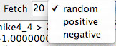
Object class selection options.

Continue repeating the process of finding rules, fetching objects, sorting them into their appropriate classes, and finding more rules. Scoring (section III.C.6, following) can be used when you have finished creating a training set (that is, you are satisfied by its performance), but note that, as described later, scoring can also be used as another iterative step in creating the training set.

Assessing accuracy

The most accurate way to gauge Classifier’s performance is to fetch a large number of objects of a given class (e.g., positive) from the whole experiment. The fraction of the retrieved objects correctly matching the requested phenotype indicates the classifier’s general performance. For example, if you fetch 100 positive objects but find upon inspection that 5 of the retrieved objects are not positives, then you can expect Classifier to have a positive predictive value of 95% on individual cells (and similarly for negative predictive value in the case of two classes). Note that sensitivity, specificity, and negative and positive predictive values must be interpreted in the context of the actual prevalence of individual phenotypes,

Another way to gauge the classifier’s performance is to use the Score Image button on positive and negative controls (see the following section). Score Image allows you to see qualitatively how Classifier performs on a single image. Although the results cannot be reliably extrapolated to other images, it can be useful to examine control images and further refine the rules by adding misclassified objects in those images to the proper bins.

The Check Accuracy button plots the cross-validation accuracy for the training set as an increasing number of rules are used. Values closer to 1 indicate better performance. Two features of the plot are useful for guiding further classification. If the accuracy is increasing as the number of rules grows, adding more rules may help improve classification accuracy. Accuracy is displayed for two types of cross-validation, with 50% or 95% of the examples used for training and the remainder for testing. If the two accuracies are essentially the same, adding more cells to the training set is unlikely to improve performance.

Note that these plots tend to be pessimistic, as the training set often includes a large number of difficult-to-classify examples. The most accurate way to judge accuracy is by requesting a large number of cells of a certain class and counting mistakes, as described above.

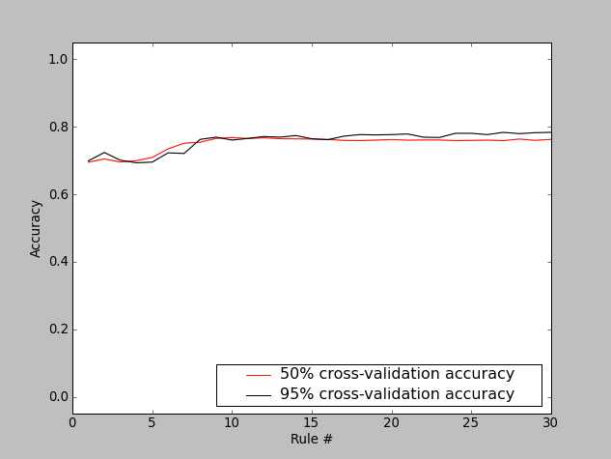
Check Accuracy plot displaying the cross-validation accuracy of a 3-class classifier with 30 rules. With completely random rules we would expect to see the lines around 0.33. We can see that the accuracy plateaus after about 10 rules, indicating that more rules may not be useful.

The relationship between accuracy on individual cells versus performance scoring wells for follow-up is complicated, because false positive and false negatives are not evenly distributed throughout an experiment. In practice, improving accuracy on individual cells leads to better accuracy on wells, and in general, the accuracy on wells is better than the per-cell accuracy.

III.B.6 Scoring

Score image

Scoring a single image can be useful in several ways:

- You can display an image and rapidly identify and correct classification errors in the image, by dragging and dropping objects from the image into bins.
- You can use it as visual feedback to verify your classifier’s accuracy on a given image (especially a control image) at any point in the training process.
- You can also use it to check Classifier’s classifications for individual images with unusual scores displayed in the Data Table produced by Score All (described in the next section).

To score a single image qualitatively, select Score Image and enter an image number. Classifier displays the image in Image Viewer (described in section V), with objects marked according to their classifications, based on the rules most recently found by Classifier. To save the resulting image as either a .jpg or .png file, select File > Save Image from the menu bar (or shortcut Ctrl+S).

Note: This function is not yet capable of saving the classification markings.

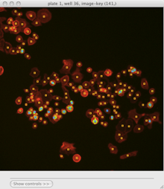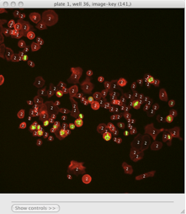
Scoring an image: Identifying classes by color (blue and yellow squares, left) and by number (right). Note that we have chosen to hide the blue channel (DNA stain) while viewing these images.

To display the object classes by number rather than color, select View > View object classes as numbers from the menu bar.

The Image Viewer control panel after scoring an image.

The brightness, contrast, and zoom controls work exactly as described for Image Viewer (section V). Note, however, the two checkboxes under Phenotypes: you can now select/deselect positive and negative results to display or hide only these objects in the image as requested.

Score all

Click Score All to classify all objects in your database using the current rule set. It can be helpful to score all images in the experiment and open some of the top-scoring images with Score Image to check classification accuracy. Rules can be further refined by dragging and dropping objects from the image into bins in order to correct classification errors in images.

The result of Score All is a table of object counts and enrichment values for each classification you defined. You can then sort by these columns to find images (or groups) that are enriched or depleted for a particular classification, based on object counts or enrichment scores.

Note: Enrichment scores are computed as the logit area under the ROC curve for the prior versus the posterior distribution. The prior is computed from the full experiment using a Dirichlet-Multinomial distribution fit to the groups, and the posterior is computed for each group independently.

- Tip: In most cases results should be ranked by enrichment score because this score takes into account both the number of objects in the class of interest as well as the total number of objects in the group.

If you have defined any groups or filters in your properties file, you will have the option to select them here for use in scoring. If no groups or filters are defined, the window will contain only the default group Image and the default filter None.

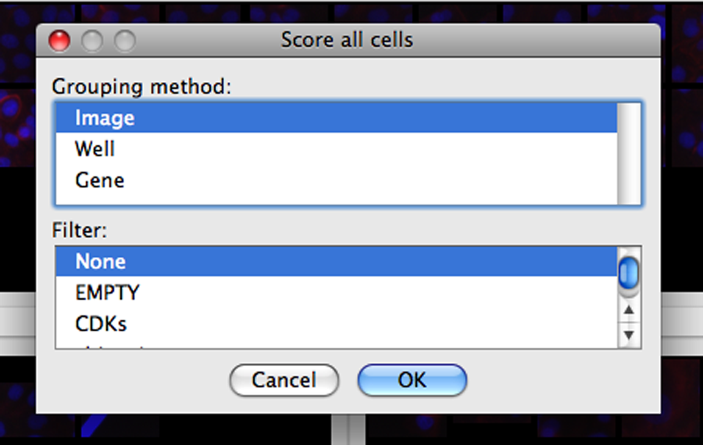
Classifier group/filter selection window.

Classifier presents its results in the Data Table tool, described in the next section. The table shows object counts and enrichment values for each phenotype you trained Classifier to recognize. To view this information graphically, return to the main Classifier screen and select Tools > Plate Viewer from the menu bar (see section VI for details).

Enrichment Data Table produced by Classifier. Here we have grouped the counts and statistics on a per-image basis. We have ordered the data by the “Enriched Score Positive” column. The most highly enriched images were 172, 171, 169, and 170. With the “Positive Cell Count” column selected, we can see in the status bar that there are a total of 2331 positive cells in our experiment, with a mean of 6.07 positive cells per image, and a standard deviation of 7.74.

V. DATA TABLE

Certain tools, such as Classifier, produce a Data Table, and any CSV file can also be opened within CPA using this tool.

Data Table produced by Classifier, grouped by well number and gene (only 1 plate was scored), and sorted by the positive Enrichment Score column.

Features available in the Data table:

- Sort: Click on any column heading to sort the data based on that column. Click again to reverse the sort. To sort by more than one column (i.e., sort first by column X, then by column Y), click on the first heading of the first column you want to sort by, then hold shift and click on the next column heading. You can add any number of columns to a sorting in this way. Sorting order and direction is indicated in brackets at the end of the header name by a number and an arrow (^ or v). Clicking on any column header that is already part of a sorting will reverse the direction of the sort. Pressing shift+click on a column header that is already part of a sorting will remove that column from the sorting.
- Show images: Double-click on a row header to show the image or images in that row’s group. Right-click to see a list of the image-keys in that row and click one to open it.
- View summary statistics: Click anywhere within the table to select a column. A summary of statistical information about the selected column(s) is displayed in the status bar at the bottom of the window. You may select multiple columns by pressing ctrl+click (cmd+click on a Mac).

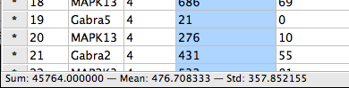
Statistics are reported for selected column(s) (blue) in the Data Table status bar.

- Show/hide columns: View the list of columns in the Columns menu, from which you can select and deselect to show/hide individual columns in the table. Pressing alt+click on a particular column header will hide that column.

Selecting which columns to show in the Data Table.

- Save data: Select File > Save data to CSV to save the data (excluding hidden columns) to a comma-separated value file. Select File > Save per-image counts to CSV to create a comma-separated value file containing only the class counts for each image.
- Write temporary table for Plate Viewer: The Database menu includes an option to write a temporary table to your database, which will be immediately accessible to Plate Viewer. Note that this table does not remain available once you have closed CPA.

VI. IMAGE VIEWER

Certain CPA tools, such as Classifier, display images in Image Viewer, and any image in the experiment can also be opened within CPA by choosing this tool from CPA’s Tools menu or by clicking the Image Viewer icon in the toolbar.

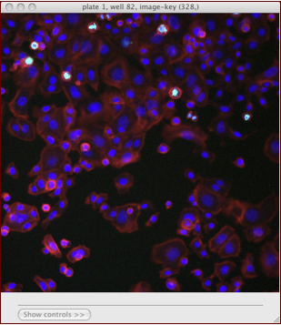
The Image Viewer

When you open Image Viewer from CPA, it will prompt for the ID number of an image to show. If you also specified a table_id column in your properties file, then you will also be prompted for the table number. You can load additional images by selecting File > Open Image (ctrl+O).

If you specified plate_id and well_id in your properties file, then Image Viewer will display the plate and well in the title of the window along with the image-key, which is image 328 in the example above.

The image_channel_names that are specified in your properties file will appear in the menu bar. In the example above, the user has specified names for the Actin, pH3, and DNA channels. If you have not defined names for any channels, the menu bar will contain channel-1, channel-2, etc. Click on one of the channel names to see a dropdown list of available colors for each – clicking on a color will map that color onto the channel. If you specified image_channel_colors in your properties file, those colors specified there should appear under each channel menu by default.

The Classifier menu provides an item that will let you classify the objects in the current image. This item is only enabled if Classifier is running and trained (via the find rules button). For more on this feature see the Score image discussion in section III.C.6.

- Tip: You can use keyboard shortcuts to toggle each channel on/off: Ctrl+1, +2, +3, … will toggle first, second, third, etc. color channels.

Click Show controls (or press the space bar) to display the Image Viewer control panel, which controls brightness, contrast, and scale. This same control panel is available in Classifier by choosing View > Image Controls (see section III.C.1).

Image controls

The upper slider controls brightness; the lower one rescales the size of the image or image tiles. The Contrast Stretch controls let you stretch the image contrast by rescaling the pixel intensities of each channel independently to fit the range 0-1 (where 0 is unsaturated and 1 is saturated).

- Linear scales the image intensities linearly. For an image in the range 0-0.5, pixels at 0.5 intensity would be rescaled to 1.0, and pixels at 0.4 rescaled to 0.8; in short, all pixel intensities in the image would be doubled.
- Log transform scales the image intensities logarithmically, which has the effect of scaling dimmer pixels by a greater factor than it scales brighter pixels.

Warning: scaling in this way may yield misleading results. For example, if a channel of an image shows very little staining, the raw image may have intensities in a low, narrow range, e.g., from [0-0.01]. Stretching in this case would have the effect of raising the background intensity levels so that the image overall appears very bright.

VII. PLATE VIEWER

Plate Viewer is a tool for browsing image-based data laid out on multi-well plates common to high-throughput biological screens. Supported formats are:

- 96 well plate — 8 rows x 12 columns
- 384 well plate — 16 rows x 24 columns
- 1536 well plate — 32 rows x 48 columns
- 5600 spot microarray — 40 rows x 140 columns

To launch this tool click the Plate Viewer icon in the CPA toolbar or select Tools > Plate Viewer from the CPA menu bar.

Sample Plate Viewer for a single 96-well plate, viewing the mean positive enrichment score output by Classifier. We can see that well D07 is very highly enriched for our “positive” cell phenotype.

Note: An X in one of the wells means there was no data in the database corresponding to that particular well. However, it may still contain images that can be viewed, as described below.

In the colored plate display, right-clicking on a well will display a list of image-keys found in that well. Selecting one image-key will open that image in the Image Viewer (section V). Double-clicking on a well will open all images from that well, each in its own Image Viewer.

Above the plate is a menu that lets you specify the plate number to display. Holding the cursor over a particular well will display a tooltip showing the value pertaining to that well.

The left-hand column contains many options for generating different views into your data.

- Data source: Allows you to select a table for visualization. To load fresh data from a CSV file directly into the Plate Viewer, select File > Load CSV from the menu bar at the top of the screen.
- Measurement: The column from the selected table that you would like to visualize.
- Aggregation Method: Measurements must be aggregated to a single number for each well so that they can be represented by a color. Options are mean, sum, median, standard deviation, cv% (coefficient of variation), minimum, and maximum. If you’re viewing object_count from the image table, for example, you might select sum to visualize the sum of the object counts for all images that constitute a well.
  - Important: Plate Viewer is agnostic with regard to the type of data it aggregates, so viewing columns from the image table will not cause the viewer to access any data from the object table. For example, a biological screen with 4 images (sites) per well may be analyzed in CellProfiler, and cell measurements may be aggregated to each image and output to the image table. One column grom the table, Image_Intensity_DNA_Mean_ Intensity, could be visualized in Plate Viewer and aggregated from each image to each well by, say, the maximum option. This could be mistakenly thought to be reporting the maximum DNA intensity value of any cell from that well, when it is actually reporting the maximum of the mean per-image DNA intensity per-well.
- Color Map: Each value computed by the Aggregation Method is mapped to a color via a color map. The currently selected color map is represented in a bar beneath the plate maps. More than 50 color maps are available.
- Well Shape: Mostly for presentation purposes, you can select from different well shapes. Options are square, rounded, circle, and image.
  - Important: The “image” feature is still under development. This will display a rescaled image from each well in the place of the well itself. This can take a very long time to refresh since full sized images must be loaded for every well in view. For it to be useful, viewing 1 plate at a time and maximizing the window is advised. Note: that the color map is irrelevant when using this view.
- Number of Plates: Enter the number of plates you would like to view at once, and press the Enter or Return key.

Here is a four-plate view of the same experiment shown in the previous example, in which the user has chosen to view the mean of the per-object measurement Spindle_AreaShape_Area in each well across 4 plates.

Viewing four 96-well plates at once in Plate Viewer. Here we are visualizing the mean Spindle_AreaShape_Area in each well. This makes it easy to visualize many thousands of object measurements in a meaningful way.

Viewing the sums of the per-object measurement tubulin_AreaShape_Area in each well of a single 384-well plate in Plate Viewer. Notice that while well C01 has the largest tubulin area (62406) in this plate, the color bar indicates that the largest value of this measurement in the experiment is 91617, which must be in some other plate.

The color bar axis at the bottom of the window shows how the aggregated values of the selected measurement column map to colors:

- The numbers at the far left and right of the axis represent the minimum and maximum values found in the entire experiment.
- The value range of the current plate(s) extends to the point where the color bar stops and a thin black line begins.

To assist in visualizing data, particularly when there are extreme outlier data points, you can rescale or clip the color bar by dragging the handles found at the far ends of the bar.

- Color rescaling: This will rescale the full color map to fit within the minimum and maximum values at the handles. Values below the range are mapped to the minimum (leftmost) color, values above the range are mapped to the maximum (rightmost) color.
- Color clipping: As with color rescaling, this will map values below the range to the minimum color, and values above the range to the maximum color. However, the full range of colors will not be rescaled to fit within the handles, it is cropped or “clipped.”

To change the mode from rescaling to clipping, right click on the bar and select Value bracketing: CLIP, to change it back to rescaling, do the same and select Value bracketing: RESCALE. To set the sliders back at the global min and max, select Reset sliders.

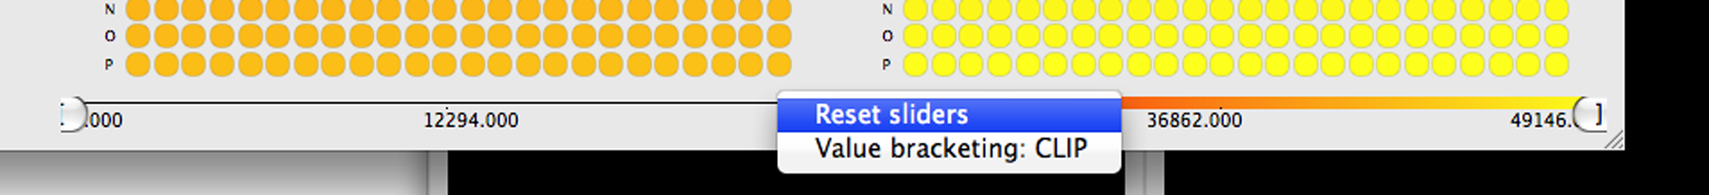c
Selecting Color Bar options.

VIII. SCATTER PLOT

Launch Scatter Plot from the main CPA interface by clicking the button in the toolbar. This tool will allow you create scatter plots from the numeric columns in your tables.

Using Scatter Plot to visualize the relationship between the Image_Intensity_pH3_Total_intensity and the Image_Intensity_Actin_Total_intensity image measurements.

To use the Scatter Plot, simply select the table whose columns you would like to plot from the table dropdown. Then select measurements from that table in the x-axis and y-axis dropdowns (only numeric columns will be available). To view an axis in the log scale, choose log from the x-scale or y-scale dropdown. The filter dropdown can be used to select filters defined in your properties file to limit the points being plotted. Finally, click the Update Chart button to view the plot.

Note: Update may take a long time or even fail for large databases. We are working to improve this performance in later releases.

IX. HISTOGRAM PLOT

Launch Histogram Plot from the main CPA interface by clicking the button in the toolbar. This tool allows you to create histogram plots from the numeric columns in your tables.

To use the Histogram Plot, simply select the table whose columns you would like to plot from the table dropdown. Then select a single measurement from that table in the x-axis dropdown (only numeric columns will be available). You can also enter the number of bins to use. The filter dropdown can be used to select filters defined in your properties file to limit the points being plotted. Finally, click the Update Chart button to view the plot.

Using the Histogram Plot to view the distribution of the Nuclei_Intensity_DNA_IntegratedIntensity measurement. The distribution appears to be bimodal, each peak representing an accumulation of cells in different stages of mitosis.
The same plot as above with the number of bins increased to 250. This results in a finer resolution on the x-axis.

Note: Update may take a long for large databases. We are working to improve this performance in later releases.

X. DENSITY PLOT

Launch Density Plot from the main CPA interface by clicking the button in the toolbar. This tool will allow you create density plots from the numeric columns in your tables.

To use the Density Plot, simply select the table whose columns you would like to plot from the table dropdown. Then select the measurements you would like to plot from that table in the x-axis and y-axis dropdowns (only numeric columns will be available). To view an axis in the log scale, choose log from the x-scale or y-scale dropdown. You may also enter the grid size to use for binning the data. The grid size is similar to the bins input in the histogram plot except that it is applied along both dimensions, so a grid size of 50 would yield 50x50 points. The filter dropdown can be used to select filters defined in your properties file to limit the points being plotted. Finally, click the Update Chart button to view the plot. With the plot displayed, you can change the color map by selecting different maps from the color map dropdown.

A density plot of Nuclei_Intensity_DNA_IntegratedIntensity versus Nuclei_AreaShape_Area with log axes and a grid size of 100.

Note: Update may take a long for large databases. We are working to improve this performance in later releases.

