SportsHub: A Progressive Web Application for Athlete Records and Sports Activity Management System

Capstone Project Presented to
The Faculty of the College of Computing & Information Sciences
Surigao del Norte State University
Surigao City

In Partial Fulfillment
Of the Requirements for the Degree
Bachelor of Science in Information Technology

By
Jocel C. Cagabcab
Alexamie L. Ochavo
November 2026

TITLE OF THE STUDY
SportsHub: A Progressive Web Application for Athlete Records and Sports Activity Management System

ABSTRACT
This study aims to design and implement SportsHub, a Progressive Web Application (PWA), for Surigao del Norte National High School (SNNHS). The main motivation for this project is the lack of a proper system for tracking sports activities and athlete records in the school. Right now, the school has already started organizing sports clubs, but all the records are still being managed manually. This leads to disorganized data, difficulty in monitoring athlete participation, and poor coordination of events.
The proposed system has three parts: a public landing page, an athlete dashboard, and an administrator dashboard. Students browse announcements, which the portal publishes automatically when the Sports Coordinator schedules an event, and apply to join a sport by submitting a medical certificate, a birth certificate, and a signed parent's consent form. No account is created at this stage; the applicant receives a unique reference number to check the status securely. The administrator verifies the documents and sets the status to Pending, Under Review, Requires Revision, Approved, or Rejected, with required explanations and a status history for accountability. Approved applicants receive an official athlete account with a temporary password that must be changed on first login. Athletes can view schedules, attendance, achievements, and coach information, check in to open sessions, and request certificates. The administrator dashboard manages sports programs, athletes, coaches, events, attendance, medical records, achievements, certificates, reports, and a unified Messages & Follow-ups module for general messages and tracked medical follow-ups.
The project follows a Rapid Application Development (RAD) approach covering planning, prototyping, feedback, finalization, and a formal evaluation phase. Once completed, the system is evaluated based on usability, reliability, and performance efficiency using the ISO/IEC 25010 quality standard. The developed system is backed by an automated feature test suite and is expected to improve data organization, reduce the time spent on manual recording, and make it easier for both students and administrators to access and manage sports-related information.

KEYWORDS
education, information system, philippines, sports management, system development

1. INTRODUCTION
The lack of a proper system for tracking sports activities and athlete records in Surigao del Norte National High School makes it difficult to manage sports programs, monitor athlete participation, and organize events. This study aims to design and develop a SportsHub for the school to make sports management more organized and easier to handle. At present, the school has already started forming sports clubs, but there is still no system in place to manage records properly. Because of this, information is often scattered, and it becomes hard to keep track of athletes and scheduled activities.
Sports programs are very important for students because they help improve physical fitness, teamwork, discipline, and leadership skills. In many schools, sports-related information like player lists, schedules, and event records are still handled manually using paper or simple spreadsheets. While this method works to some extent, it can lead to errors, repeated data, and even loss of important information. It also takes more time to update records and find needed data, especially when there are many participants involved. That is why many schools are now starting to use digital systems to make their processes faster and more efficient.
In the case of Surigao del Norte National High School, the absence of a proper sports management system affects how sports clubs and activities are organized. Without a centralized platform, administrators and coaches find it challenging to monitor participation, manage events, and keep records updated. This can lead to confusion, missing information, and poor planning of activities. Developing SportsHub can help solve these problems by giving the school a single system where all sports-related data can be stored and managed properly.
This study focuses on developing and testing SportsHub, a web-based Progressive Web Application that can handle sports records, athlete information, coach assignments, event scheduling, attendance tracking, medical clearances, achievements, and certificates. The system is expected to make data more organized, reduce manual work, and make it easier for users to access information. It can also generate CSV and PDF reports that will help in monitoring sports activities and making better decisions for future programs.
This study aims to answer the following research questions:
● What problems are currently being experienced in managing sports activities and athlete records in Surigao del Norte National High School?
● How can a web-based SportsHub improve the management of sports activities and athlete records?
● How effective is the proposed system in terms of usability, reliability, and performance efficiency?
● What improvements can be suggested for the future development of the system?
1.1 Project Context
This project was conceptualized in response to the lack of an organized system for managing sports activities and athlete records in Surigao del Norte National High School (SNNHS). Although the school has started forming sports clubs and conducting activities, most of the records are still handled manually or written in simple lists. Because of this, it is difficult for coaches and coordinators to keep track of athletes, monitor participation, and manage schedules properly.
The project is set within the school's sports management environment, where different activities such as trainings, intramurals, and club events are regularly conducted. These activities require proper planning and organized records to run smoothly. However, without a digital system, information can become unorganized or incomplete, making it harder to retrieve when needed. This situation affects how sports programs are planned and managed in the school.
This project is important because it supports the school's move toward using technology to improve its processes. By developing SportsHub, the school can have a centralized system where all sports-related data is stored and managed in one place. This will make it easier for administrators and coaches to access information, update records, and organize activities more efficiently.
In addition, the project can benefit the entire school community by improving how sports programs are monitored and managed. With a more organized system, records will be more accurate and easier to maintain. This system can also serve as a foundation for future improvements and possible expansion to other school systems.
1.2 Purpose and Description
The purpose of this project is to create SportsHub, a Progressive Web Application that will help Surigao del Norte National High School (SNNHS) organize and manage its sports activities more effectively. Since the school currently does not have a proper system for tracking sports, athletes, and events, this project aims to provide a simple and organized digital solution that can replace manual recording.
The system has three main parts. The first is a public landing page that any student can open without logging in. It shows announcements that the portal publishes automatically when an event is scheduled and withdraws if the event is cancelled or postponed, so the public notice never contradicts the live schedule. Interested students submit an application form with a medical certificate, a birth certificate, and a signed parent’s or guardian’s consent form. No account is created at this point; the information goes to the admin for review.
Student eligibility is verified through documentary requirements submitted alongside the application form. A student must provide a valid medical certificate issued by a licensed physician confirming that they are physically fit to participate in sports activities, a birth certificate issued by the Philippine Statistics Authority (PSA) to confirm age and identity, and a duly signed parent’s or guardian’s consent form authorizing the student’s participation in school sports programs. Applications that are incomplete or missing any of these documents will not be processed for approval. These requirements are intended to protect the health and safety of student-athletes and ensure that all participants meet the school’s standards for sports participation.
The second part is the administrator dashboard, accessible only to the Sports Coordinator or authorized Admin. Each application receives a unique reference number and starts as Pending. The admin moves it through Under Review, Requires Revision, Approved, or Rejected, and marks each uploaded document as Submitted, Verified, or Rejected. A revision or rejection requires an explanation, and the coordinator may add office instructions. The reviewer, decision date, and status history are recorded for accountability. Applicants check their status with the reference number and application email, and approved students receive an official athlete account; duplicate accounts are prevented.
The third part is the athlete dashboard, the personal space of registered athletes. Athletes can view schedules, events, announcements, the shared calendar, attendance records, achievements, and coach information. They can check in to open attendance sessions, request achievement certificates, follow their application status, and update profile details. Because the admin controls account creation, only approved athletes can access it.
Both dashboards share one Messages & Follow-ups module. The Sports Coordinator composes a message with a subject, category, priority, and recipient group, and may send it or keep it as a draft. A medical follow-up adds the follow-up type, checkup date, time, location, instructions, and whether acknowledgment is required. Athletes receive both categories in one inbox and can acknowledge a follow-up. Each recipient has an individual read record, opening a message is never an acknowledgment, and only the administrator can complete or cancel a follow-up, so the record stays reliable.
Overall, the project is designed to make sports management in the school more organized, secure, and efficient for both athletes and administrators. It also serves as a starting point or foundation that can be improved and expanded in the future if needed.
1.3 General Objectives of the Study
This study aims to design and implement a web-based SportsHub for Surigao del Norte National High School to improve the management and organization of sports activities.
Specifically, it aims to:
● Gather data on the current sports management practices and challenges at Surigao del Norte National High School (SNNHS) through informal observation and the researchers’ personal experience as former student-athletes, in order to identify the functional requirements of the proposed SportsHub.
● Design and develop a web-based Progressive Web Application (SportsHub) that provides a centralized platform for managing athlete records, sports programs, coach assignments, event scheduling, attendance monitoring, medical records, achievements and certificates, announcements, and general communication with tracked medical follow-ups at SNNHS using PHP 8.2, Laravel 12, MySQL, and Tailwind CSS 4.
● Test and evaluate the developed system using the ISO/IEC 25010 Software Quality Model in terms of usability, reliability, and performance efficiency among selected SNNHS respondents, and provide recommendations for future system improvement based on the evaluation results.

1.4 Scope and Limitations
Scope
- The system covers three main user interfaces: a public-facing landing page, an athlete dashboard, and a restricted administrator dashboard accessible only to the Sports Coordinator.
- The landing page allows any student to view announcements, browse the available sports programs, submit a sports application form, and check the status of an application that was already submitted by entering its reference number together with the email address used on the form. To be eligible to join a sport, students must submit a medical certificate, a birth certificate, and a signed parent’s or guardian’s consent form as part of their application. No account is created at this stage. Announcements are published automatically by the portal when a scheduled event is created, and are withdrawn automatically when that event is cancelled or postponed.
- The administrator can review applications and set the status to Pending, Under Review, Requires Revision, Approved, or Rejected; verify or reject each uploaded document separately; require an explanation for a revision or a rejection; add office instructions; and record the reviewer, the decision date and time, and the full status history. Applicants who have not been given an account yet can still follow their application on the public status page, and linked student accounts receive in-app status notifications.
- Approved applicants are converted into official athlete accounts with an assigned sport, a username, and a one-time temporary password that the athlete must replace on first login.
- Registered athletes can log in to view their schedules, events, calendar, announcements, attendance records, achievements, application status, coach information, notifications, and the members of their own sports program. They can update their own profile details and profile photo, check in to open attendance sessions, request achievement certificates, acknowledge a medical follow-up, and reply to the sports office from the same inbox.
- The administrator dashboard manages sports programs, athlete accounts, coach assignments, event schedules, attendance sessions, medical records and injury incidents, achievements, certificate requests, the unified Messages & Follow-ups module, downloadable reports, and the administrator’s own profile.
- The administrator can choose the scope of a downloaded athlete list — either the whole school or a single sport program — and can export the athlete, coach, attendance, and per-athlete attendance reports in CSV or PDF format.
- Attendance is tracked through attendance sessions that may belong to a scheduled event or stand alone. The roster of each session is derived automatically from the athletes assigned to the session’s sport, so no manual roster selection is required. A configurable late grace period separates a Present check-in from a Late one, and cancelled sessions are excluded from attendance-rate calculations.
- Medical records track examination results, clearance status, uploaded medical certificates with expiry monitoring, and scheduled check-ups. Injury incidents are recorded separately per athlete with severity, treatment, rest period, return-to-play date, and medical clearance, so that a new examination never overwrites an injury history. Choosing an athlete in the incident form selects the assigned sport of that athlete automatically.
- The administrator and the athlete share one Messages & Follow-ups module. A message is composed with a subject, a body, a category (General Message or Medical Follow-up), a priority, and a recipient group — one athlete, a selected set of athletes, all active athletes, or every athlete of one sport — and it can be sent immediately or kept as a draft. General messages cover reminders, instructions, and important updates; medical follow-ups cover checkup schedules, medical clearance follow-ups, and requests to visit the school medical clinic. A medical follow-up is tracked per athlete through its schedule, its read state, the athlete’s acknowledgment, and its completion, and it may be completed or cancelled only by an authorized administrator. The athlete receives both categories in one inbox with the notification bell, reads the medical instructions together with the checkup date, time, and location, acknowledges a follow-up when a response is required, and may reply to the sports office.
- The system is delivered as an installable Progressive Web Application with a web app manifest and a service worker that caches the application shell and falls back to a dedicated offline page when the network is unavailable. It is deployed as a live web application in a container with PHP 8.3 served by Apache and the data stored in MySQL, so the three interfaces are reachable from any browser on any device without installing additional software.
- The system was evaluated using the ISO/IEC 25010 quality standard covering usability, reliability, and performance efficiency, with fifteen (15) respondents from SNNHS including the Sports Coordinator, faculty sports advisers, and student-athletes, and it is backed by an automated feature test suite that exercises every major module.
Limitations
- The system does not include financial management, student grading features, or integration with any external platforms such as a Learning Management System (LMS) or other school information systems.
- Notifications are in-app only. The system sends no SMS, email, or push messages, so an athlete who does not open the portal is not alerted; a medical follow-up simply stays unread in the administrator’s monitoring table, and the Sports Coordinator has to follow up personally.
- Only two account roles exist, Administrator and Student. There is no finer permission level for a faculty sports adviser, a medical officer, or a team leader, so every administrator can act on every record in the system.
- Coaches have no accounts. A coach is kept as a record — name, email, phone, specialty, type, assigned sport, and status — that the Sports Coordinator maintains, and the coach information the athlete sees is read from that record. A coach cannot sign in to the portal, cannot receive a message or a medical follow-up, and cannot open, close, or confirm an attendance session, an achievement, or a certificate, so every action that involves a coach is carried out by the Sports Coordinator on the coach’s behalf.
- There is no parent or guardian portal. The consent form and the medical certificate are scanned documents that the Sports Coordinator verifies by hand; the system records the review, but it does not validate the document itself.
- The clearance status of an athlete depends on the uploaded certificate and on the coordinator’s entry. The system warns about an expiring certificate and tracks the follow-up, but it does not verify fitness to play against the school clinic or a physician’s record, and the decision stays with the Sports Coordinator.
- A dedicated native application for Android or iOS is not part of this study. As a Progressive Web Application (PWA), the system is accessible through any standard web browser on any device, including smartphones, tablets, and laptops, without requiring additional software installation.
- The evaluation was conducted exclusively at SNNHS with fifteen (15) respondents, and the results may not be generalizable to schools with different operational contexts, infrastructure, or resource availability. The automated test suite proves that the software behaves as specified, but it cannot stand in for a longer period of actual use by the school.
- The accuracy of athlete records depends entirely on the administrator who manually inputs data; the system has no automated data validation against external school databases.
- The system runs as a single hosted instance with one database. It has no automated backup and restore routine, no multi-school support, and no high-availability arrangement, so the school depends on the availability of the hosting service and on a manual backup procedure.
- The offline capability is a caching convenience rather than a full offline mode. Read-only screens remain browsable from the cache when the connection drops, but server-backed operations — submitting an application, checking in to a session, acknowledging a follow-up, or approving a document — still require an active internet connection. Credentials and records are never stored on the device.

2. RELATED LITERATURE
Foreign Literature
Hao et al. (2024) designed a web-based college sports events management information system integrating event release, registration, race scheduling, and performance management using front-end and back-end separation architecture with Ajax and RESTful API technology. The system resulted in fast data transmission and significantly improved user satisfaction. However, the system targets higher education institutions and does not address implementation needs of secondary-level schools with limited technical infrastructure in developing countries like the Philippines. This gap underscores the need for a more accessible, school-level sports activity management system such as the one proposed for SNNHS.
Ma et al. (2024) developed a college student sports performance management system demonstrating that digitized sports records significantly reduced manual workload and improved data accuracy. Nevertheless, the study was confined to higher education, and no equivalent pilot system has been developed for senior high school sports programs. This gap calls for a comparable but simplified digital system tailored for secondary schools like SNNHS.
Sun (2020) presented a school sports management system based on web technology that automated attendance, sports data recording, and physical education management, significantly reducing administrative burden and improving record accuracy. Despite these contributions, the study did not address the integration of student registration, intramural scheduling, and real-time results tracking in a unified hub — core functions needed in a comprehensive school sports activity system.
Wang and Park (2021) developed an intelligent sports training management system for college students using deep learning and Browser/Server architecture. Results showed that 64% of students increased their weekly exercise frequency. However, the complexity and cost of AI-driven systems present challenges for implementation in resource-limited secondary schools. The current study addresses this gap by proposing a simpler, cost-effective web-based system appropriate for a public senior high school.
Zhang et al. (2021) proposed an optimized sports event management system integrating registration, scheduling, score recording, and report generation in a single platform for improved coordination efficiency. Nonetheless, the study focused on professional sporting events and did not consider operational constraints of school-level intramural sports management. The proposed SNNHS system fills this void by addressing the specific logistical and resource realities of a public secondary school.
Zhu (2025) introduced an Intelligent Sports Management System integrating wireless sensor networks and neural networks for real-time monitoring, injury prediction, and administrative reporting. However, the system requires advanced IoT hardware and high-speed network connectivity, making it impractical for deployment in public high schools with constrained infrastructure.
Jastrow et al. (2022) conducted a systematic review of digital technology use in physical education from 2009 to 2020, finding that digital media served as effective motivational tools. The review identified a significant gap in research on digital tools specifically designed for after-school and extracurricular sports management — an area directly addressed by the proposed SportsHub at SNNHS.
Zhong et al. (2025) conducted a comprehensive systematic review on digital-intelligent technologies in physical education, finding that 86% of digital implementations occurred in formal PE classes while after-school sports activity applications accounted for only 5% of cases. This directly points to the need for systems like the SportsHub that support organized extracurricular sports participation at the secondary school level.
Martín-Rodríguez and Madrigal-Cerezo (2025) reviewed technology-enhanced pedagogy in physical education and emphasized that successful digital implementation requires alignment with educational objectives. A key gap identified was the lack of research on simple, low-cost digital platforms suitable for sports activity management in secondary schools — a gap the current study seeks to fill.
Li et al. (2022) proposed an IoT-assisted physical activity monitoring system demonstrating improvements in student physical activity outcomes. However, high costs of IoT infrastructure pose barriers to adoption in public secondary schools. The proposed SNNHS system circumvents this barrier by relying exclusively on web-based, device-agnostic technology requiring no additional hardware.
Xu et al. (2024) found that user readiness is as critical as the technology itself in digital sports tool adoption, suggesting that culturally responsive design matters greatly. This study addresses the gap by designing a user-friendly, culturally responsive system suited to Filipino senior high school students.
Sang and Wang (2022) demonstrated high data integrity in a fitness monitoring system using IoT and blockchain technology. No comparable system exists for secondary school populations in the Philippine context, reinforcing the urgency of developing even a foundational digital system for SNNHS.
Haffner et al. (2025) identified that most sports digitalization studies focus on single-stakeholder effects, calling for ecosystem-level research. This justifies developing a hub-based system that addresses multiple user roles. The proposed system is explicitly designed to serve students, coaches, coordinators, and administrators simultaneously.
Qi et al. (2024) cautioned that over-reliance on automated systems without adequate human oversight could diminish coaching expertise. This finding highlights the importance of designing sport hubs that augment rather than replace the roles of teachers and sports coordinators — a guiding principle in the design of the SNNHS system.
Swim et al. (2023) argued that digital literacy is a core competency in sport management education, supporting the integration of a SportsHub at SNNHS where students gain early exposure to digital sports management systems.
Local Literature
The Department of Education (2023) issued Memorandum No. 005, s. 2023, known as the "Sports for All" policy, which mandates all DepEd schools to conduct organized sports competitions and maintain comprehensive documentation of student sports participation. However, most schools, including SNNHS, currently rely on manual and paper-based processes that make compliance monitoring difficult. The proposed SportsHub directly addresses this compliance gap by automating documentation and sports record-keeping.
The Department of Education (2024) introduced a Sports Activity Management course under the Strengthened Senior High School Curriculum. A functional digital SportsHub at SNNHS would directly support the documentation, scheduling, and evaluation components required by this curriculum, enhancing learners’ practical engagement with the subject.
Cagas et al. (2022) reported in the 2022 Philippine Report Card on Physical Activity that 84.5% of Filipino adolescents fail to meet the recommended 60 minutes of daily physical activity. A centralized SportsHub at the school level would provide a structured platform to increase sports participation and monitor student activity engagement at SNNHS.
The Philippine Sports Commission (2023) emphasized that schools serve as primary venues for talent identification and physical fitness promotion. Local studies confirm that school-level sports programs lack digital tools to track, document, and report sports participation systematically. This gap in school-level digital infrastructure motivates the development of the proposed SNNHS SportsHub.
Cullarin-Bernales (2021) found significant challenges in coordinating and administering school sports programs and recommended a prototype sports management framework. However, the prototype did not incorporate digital tools, leaving a gap in automated data management. The SNNHS system fills this gap by providing a fully digital, web-based management solution.
Pestano and Ibarra (2021) highlighted the critical need for organized monitoring tools and documented tracking of student-athlete performance across competition levels — needs that the proposed SportsHub is specifically designed to address.
Cipriano et al. (2024) recommended digital administrative tools to support sports program governance and monitoring in educational institutions. This recommendation validates the core purpose of the SNNHS SportsHub as a governance and monitoring tool.
Butlig et al. (2023) recommended structured institutional systems for managing student-athlete schedules and academic monitoring — functions that the proposed hub integrates into a single digital platform.
Campo et al. (2024) identified that digital tools specifically for physical sports activity management and extracurricular sports coordination remain underdeveloped in the Philippine context, providing strong justification for developing the SNNHS SportsHub as a locally responsive digital solution.
Galindo et al. (2024) recommended comprehensive strategies including better scheduling and monitoring systems to help student-athletes balance their dual roles. This recommendation aligns directly with the scheduling and monitoring functions built into the proposed SNNHS system.
Umali (2025) recommended that schools institutionalize organized sports programs supported by clear administrative and documentation frameworks to sustain the developmental benefits of school sports. The proposed hub operationalizes this recommendation through a structured, digitally supported sports management environment.

3. TECHNICAL BACKGROUND
The SportsHub is a web-based information system that will be used to coordinate sports activities, athlete records, coach assignments, event scheduling, attendance, medical clearances, achievements, and certificates at Surigao del Norte National High School (SNNHS). The system is developed using widely used and well-supported web technologies that are appropriate for an educational development project.
Frontend Technologies. The user interface is built with HTML5 (structure), CSS3 (layout and styling), and JavaScript (client-side interaction). Styling combines Tailwind CSS 4, compiled through Vite, with a hand-authored design system in public/css/ whose colours, status colours, and light and dark themes are defined once as CSS custom properties. This gives both portals and the landing page one consistent look. Reusable components such as the confirmation dialog, notification bell, and collapsible sidebar are shared partials, so behaviour stays consistent across modules.
Backend Technologies. The server-side logic is written in PHP 8.2, which handles requests, form submissions, document validation, and database communication. Laravel 12 provides the MVC structure that separates the interface from database operations. Service classes keep cross-cutting logic out of the controllers, covering attendance sessions, certificates, notifications, and security warnings. Blade templates handle views, and Laravel’s validation, authentication, and database notifications handle input safety and the in-app notification feed.
Database Management. MySQL stores all system data, including sports programs, athlete profiles, coach records, events, attendance, medical records, achievements, and certificate requests. It is compatible with PHP and Laravel and supports filtering, searching, and report queries. The schema is versioned through Laravel migrations and accessed through the Eloquent ORM, with relationships backed by foreign key constraints.
Document and Report Output. Official documents are generated server-side rather than through the browser's print dialog. The dompdf library renders achievement certificates, attendance session reports, and school reports directly into PDF files, and the same report payloads are streamed as CSV when a spreadsheet format is requested. This guarantees that a downloaded certificate is identical for every recipient and carries an official reference number, and it lets the coordinator export a filtered roster for documentation without leaving the portal.
Progressive Web Application Support. SportsHub is delivered as a Progressive Web Application so that it can be installed on a phone or desktop and still open quickly on a weak connection. The application ships a web app manifest that defines the application name, theme colour, display mode, and icon, together with a hand-written service worker. The service worker precaches the application shell, serves navigation requests network-first, stores successful responses in a runtime cache, and falls back to a dedicated offline page when the network is unavailable. A lightweight registration script loads the worker without blocking the page.
Development Environment. The system is developed and tested locally using XAMPP as the local server environment on a Windows machine, with MySQL as the database server and the application served through Apache. Visual Studio Code is used as the primary code editor, and Git is used for source code versioning, allowing the development team to track changes, manage revisions, and maintain a stable codebase. The application is configured for the Philippine Standard Time zone so that all recorded timestamps — session dates, check-in times, publication dates, and medical check-up schedules — are interpreted consistently for the school's own calendar.
3.1 Conceptual Framework
The SportsHub is guided by the Input–Process–Output–Evaluation (IPO-E) model, which shows how data entered into the system is transformed into organized outputs for sports management at SNNHS and then assessed through a formal evaluation. As shown in Figure 1, the framework has four components supported by the technology stack. A feedback loop returns the evaluation results to the Input and Process components to identify what needs improvement in the next iteration.
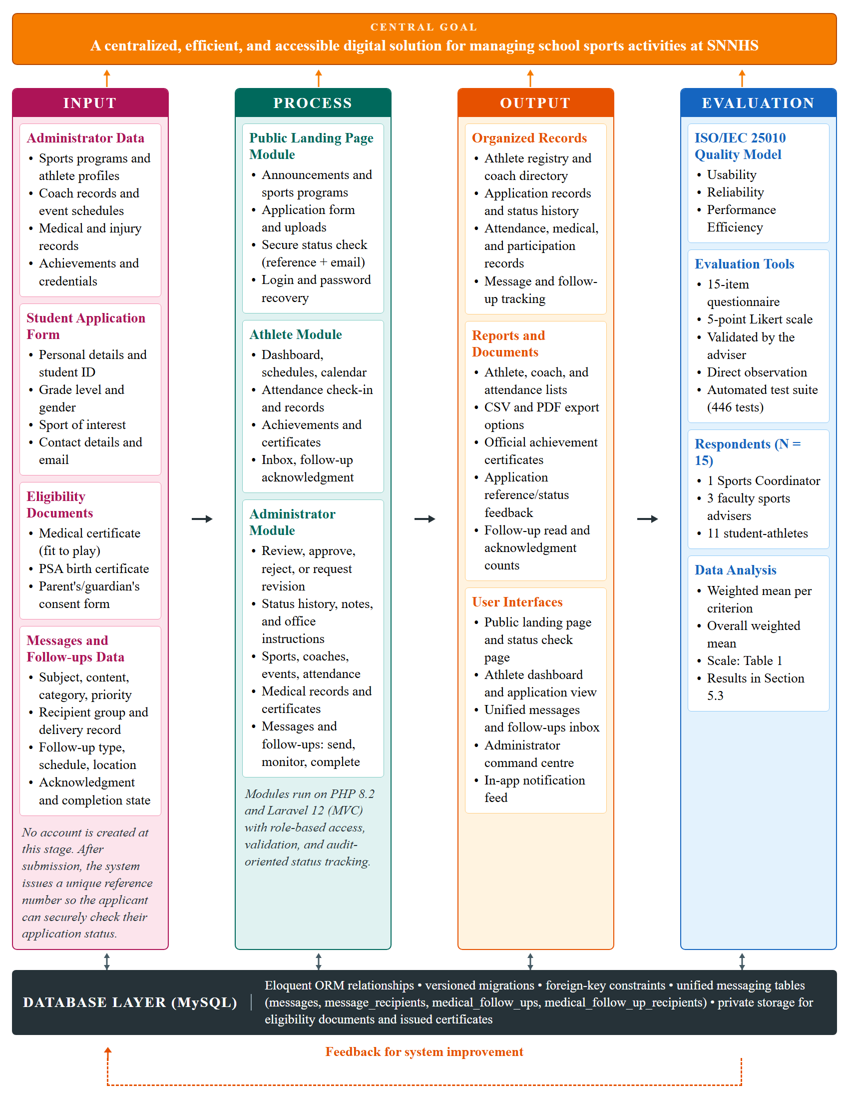
Figure 1. Conceptual Framework (IPO-E Model) — SportsHub, SNNHS
The Input component consists of all data that will be provided by the Administrator or Sports Coordinator, together with the data and documents submitted by the public. This includes sports program details, student-athlete profiles, coach information, event schedules, medical examination findings, injury incident reports, achievement records, and login credentials. From the public side, the input consists of the sports application form and its three supporting documents - a medical certificate, a birth certificate, and a signed parent's or guardian's consent form - plus the applicant's email address used for secure status verification. These inputs are meant to replace the informal paper-based records currently used at SNNHS.
The Process component is organized into three modules (the Public Landing Page, Athlete, and Administrator Modules) that carry out the core operations: managing records, generating application reference numbers, securely checking application status, verifying documents, reviewing applications with required explanations and status history, creating athlete accounts without duplicates, scheduling events, recording attendance and check-ins, tracking medical clearance, recording achievements, issuing certificates, sending in-app notifications, and generating reports. The modules are built on PHP 8.2 and Laravel 12 and exchange data with the MySQL database through the Eloquent ORM.
The Output component represents the results that the system will produce: an organized athlete registry, a coach directory, application records with reference numbers and status-history audit trails, a secure applicant status page, a shared event calendar, printable participation and attendance reports, official achievement certificates in PDF form, an in-app notification feed for athletes and coordinators, and an administrative command centre that gives coordinators an at-a-glance view of sports data - total athletes, active sports programs, upcoming events, sessions open for check-in, pending applications, achievements and medals recorded, and the current attendance rate.
The Evaluation component measures output quality using the ISO/IEC 25010 Software Quality Model in terms of usability, reliability, and performance efficiency. The main tool is a fifteen-item questionnaire (five items per characteristic) on a five-point Likert scale, answered by fifteen (15) SNNHS respondents: the Sports Coordinator, three faculty sports advisers, and eleven student-athletes. Direct observation during testing and an automated feature test suite covering every major module support the survey. The data are analyzed using the weighted mean and interpreted with the scale in Table 1 of Section 4.5. The results and recommended improvements are reported in Section 5.4 and fed back to the Input and Process components.
The system will be built using PHP 8.2 and Laravel 12 for the backend, Tailwind CSS 4 with a token-based CSS design system for the frontend interface, and MySQL for structured data storage. Together, these components will work as an integrated platform that provides SNNHS with a centralized, efficient, and accessible digital solution for managing school sports activities, replacing the disorganized manual practices that currently make it difficult for coaches and coordinators to track athlete participation and event schedules.

4. METHODOLOGY
This project followed the Rapid Application Development (RAD) methodology because of its emphasis on quick prototyping and iterative user feedback, which is well-suited for developing a web-based management system within an academic timeframe. The RAD model allowed the development team to move quickly from requirements gathering to design, receive feedback early, and make improvements before finalizing the software. This approach helps minimize development risks and keeps the project closely aligned with the real needs of Surigao del Norte National High School.
The RAD methodology was also chosen because the project scope is clearly defined and the intended users, specifically the school administrator and sports coordinator, are accessible for feedback and validation throughout the development process. The four main phases of RAD applied in this study are: (1) Planning Requirements, (2) Prototype, (3) Receive Feedback, and (4) Finalize Software, followed by system evaluation.
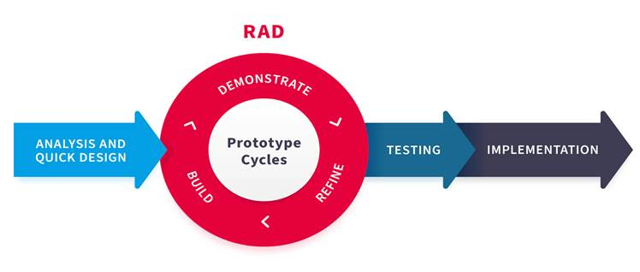
Figure 2. Rapid Application Development (RAD) Model
4.1 Planning Requirements
The planning phase focused on identifying the functional and non-functional requirements of the SportsHub. Instead of relying solely on formal interviews or surveys, the requirements for this project are largely based on the personal experience of the researchers as former student-athletes in a Philippine public high school setting, particularly in schools similar to SNNHS in terms of context and available resources.
As former student-athletes, the researchers have personally experienced the challenges of manually managed sports programs. Records of sports participation were often written on paper or encoded in basic spreadsheets, making it difficult to find information when needed. Coach assignments were communicated informally, and event schedules were posted on bulletin boards or shared through word-of-mouth. Athletes frequently missed or forgot upcoming events because there was no centralized notification or scheduling system in place. These real-life experiences provided a grounded and realistic basis for defining what the system needs to accomplish.
To support this experiential foundation, the researchers also conducted informal observation of the current sports management practices at SNNHS. Through these observations, it was confirmed that the school had already started organizing sports clubs but continued to rely on manual documentation. Coaches and coordinators were found to have difficulty consolidating records, tracking which athletes were active, and keeping event information up to date. These observations helped validate the requirements identified through the researchers’ personal experience and gave additional context specific to SNNHS.
Based on these inputs, the following key requirements were identified for the SportsHub:
Functional Requirements
Admin / Sports Coordinator:
● Secure login and authentication for the Administrator or Sports Coordinator, with a self-service password reset link and an automatic warning when a wrong password is entered
● View and manage student applications submitted from the landing page, moving each one through Pending, Under Review, Requires Revision, Approved, or Rejected
● Verify or reject each uploaded eligibility document individually, request revisions with required explanations, record review notes, rejection reasons, and office instructions visible on the applicant's status page, and maintain a status-history audit trail (reviewer and date/time)
● Create official athlete accounts for approved applicants (name, email, student ID, assigned sport, username, and a one-time temporary password)
● Reset an athlete’s password from the Athlete Management module and require the athlete to set a new one on first login
● Manage sports programs (Add, Edit, Delete, View) including classification, gender grouping, status, and logo
● Manage athlete profiles and account details, including contact number, emergency contact, and profile photo
● Assign coaches to specific sports, distinguishing Head Coaches from Assistant Coaches, and manage their profiles and status
● Schedule and manage sports events such as trainings, tournaments, intramurals, tryouts, and meetings
● View a shared calendar of all scheduled activities, filterable by sport, venue, event type, and status
● Record and manage athlete attendance through attendance sessions, with automatic roster generation from the assigned sport and a configurable late grace period
● Manage medical records, medical clearances, uploaded medical certificates, upcoming check-ups, and injury incidents
● Record achievements for athletes or teams, and approve, generate, release, and issue official achievement certificates
● Review and act on certificate requests submitted by athletes
● Send targeted notifications to athletes, either school-wide or limited to a specific sports program
● Send general messages and medical follow-ups to one athlete, individually selected athletes, all active athletes, or the athletes of a sport, with a subject, a category, a priority, drafts, and per-recipient read tracking
● Monitor the read, acknowledgment, completion, and overdue state of every medical follow-up, and mark a verified follow-up as completed or cancel it
● Search and filter all records in the dashboard
● Generate participation, attendance, coach, and athlete lists in CSV or PDF, with the option to limit an athlete list to a single sport program
Athlete:
● Log in using credentials provided by the admin, and set a personal password on first login
● View personal athlete dashboard with attendance summary, open check-in sessions, upcoming activities, and recent achievements
● View sports schedules and upcoming events
● View the shared calendar and posted announcements
● View personal attendance records and attendance rate
● Check in to an attendance session that is open on the current day
● View personal achievements and request an official certificate for an achievement earned
● View the status, reference details, feedback, and office instructions of the linked sports application, and receive in-app notifications when the status changes
● View assigned coach information and the members of the assigned sports program
● Receive general messages and medical follow-ups in one inbox, read the medical instructions with the checkup date, time, and location, and acknowledge a follow-up when a response is required
● Update limited profile information and change the account password
Public (No Login Required):
● View the public landing page and browse posted announcements and available sports programs
● Check the status of an application that was already submitted, without an account, using the application reference number together with the email address used on the application
● Submit a sports application form to express interest in joining a sport, including the required eligibility documents: a medical certificate, a birth certificate, and a signed parent’s or guardian’s consent form (no account created at this stage)
● Eligibility requirements for joining a sport: (1) Medical Certificate — issued by a licensed physician certifying the student is physically fit for sports participation; (2) Birth Certificate — PSA-issued document confirming the student’s age and identity; (3) Parent’s or Guardian’s Consent Form — a signed document authorizing the student to participate in school sports activities. Incomplete submissions were not processed.
Non-Functional Requirements:
● Usability: The interface must be simple and intuitive for non-technical users such as coaches and school administrators, with a consistent sidebar navigation and a light or dark theme
● Reliability: The system must consistently perform operations without data loss or error, verified through an automated feature test suite
● Performance Efficiency: Pages and operations must load within acceptable response times under a normal internet connection, with each dashboard figure resolved by a single aggregate query rather than repeated per card
● Security: Data must be accessible only to authorized users through login authentication; athlete-facing queries are scoped to the signed-in account so that one athlete can never read or act on another’s records
● Privacy: Eligibility documents, medical certificates, and issued certificates are stored on private storage and are released only through authorized routes
● Accessibility: The system must be accessible via standard desktop or laptop browsers without requiring additional software installation, and must remain readable on smaller screens
● Offline tolerance: Previously loaded screens must remain browsable through the service-worker cache when the connection drops, with a clear offline page as the final fallback
These requirements served as the foundation for the system's design and development, making sure that the SportsHub addresses the real and observed needs of SNNHS rather than generalized assumptions.
4.2 Prototype
After identifying the system requirements, a low-fidelity prototype was developed to visualize the layout and workflow of the SportsHub before actual coding began. The prototype was created using Figma, a widely used interface design tool that allows for quick creation of wireframes and mockup screens. The main goal of this phase was to establish a shared visual understanding of the system among the development team and to present an early preview to the target users for initial feedback.
The prototype covered all major modules of the system and followed a clean and minimal design approach to ensure ease of navigation, especially for school administrators and coaches who may not be very familiar with digital management tools. The design was guided by a single set of design tokens for colour, spacing, and status indication, which were later applied in the actual front-end implementation.
The following screens were included in the prototype, organized by user role:
Public / Landing Page Screens:
- Landing Page — the public homepage accessible to all students without logging in. It displayed posted announcements, an overview of available sports programs, and a button to submit a sports application
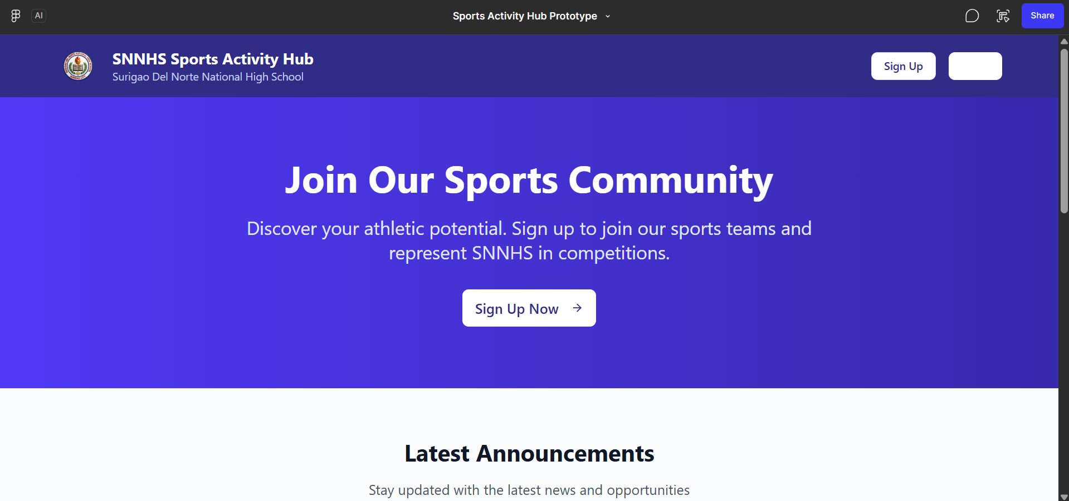
Figure 3 - Landing Page
- Application Form Page — a form where interested students can submit their eligibility requirements and personal details including name, student ID, grade level, gender, sport of interest, medical certificate, birth certificate, and signed parent’s or guardian’s consent form. No account or password is created here — the form only sends their application and documents to the admin for review
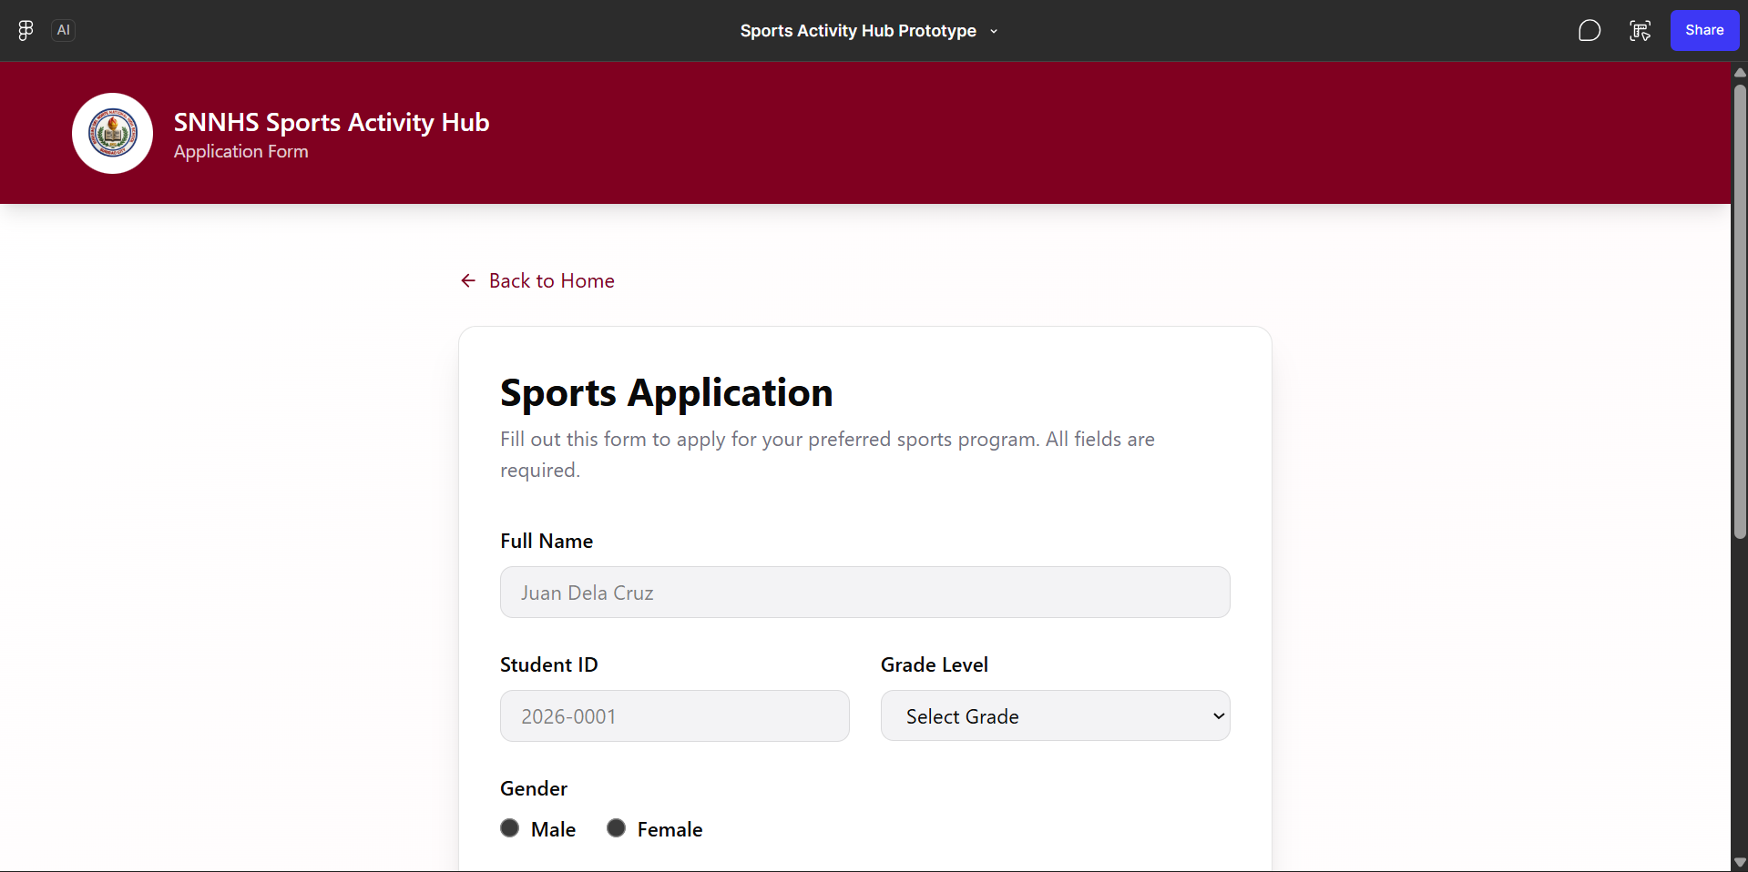
Figure 4 - Application Form Page

- Login Page — a single login screen for both Admin and Athletes, redirecting each user to their respective dashboard based on their role
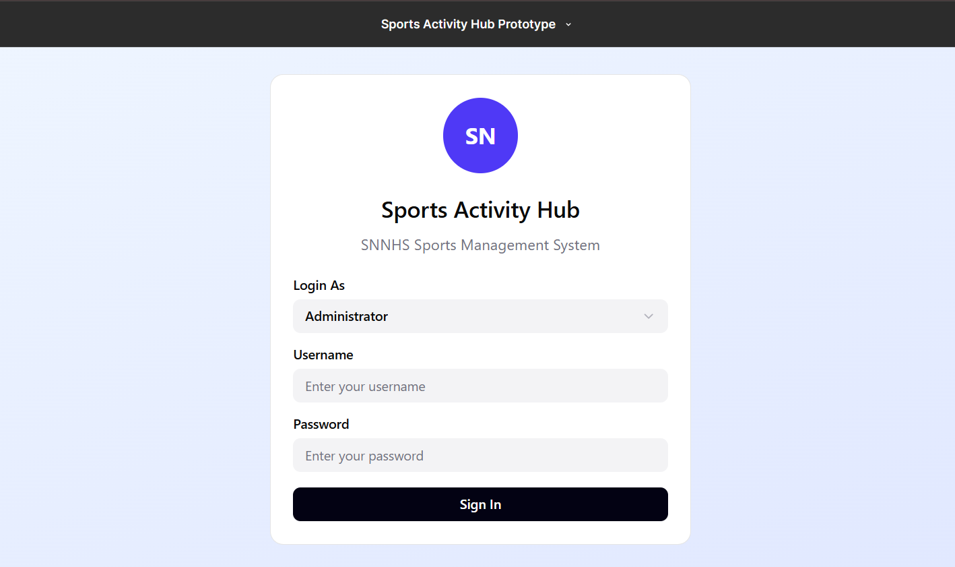
Figure 5 - Login Page
Athlete Dashboard Screens:
- Athlete Dashboard — the main screen for logged-in athletes showing attendance summary, sessions open for check-in, upcoming schedules, recent achievements, and quick links to other sections 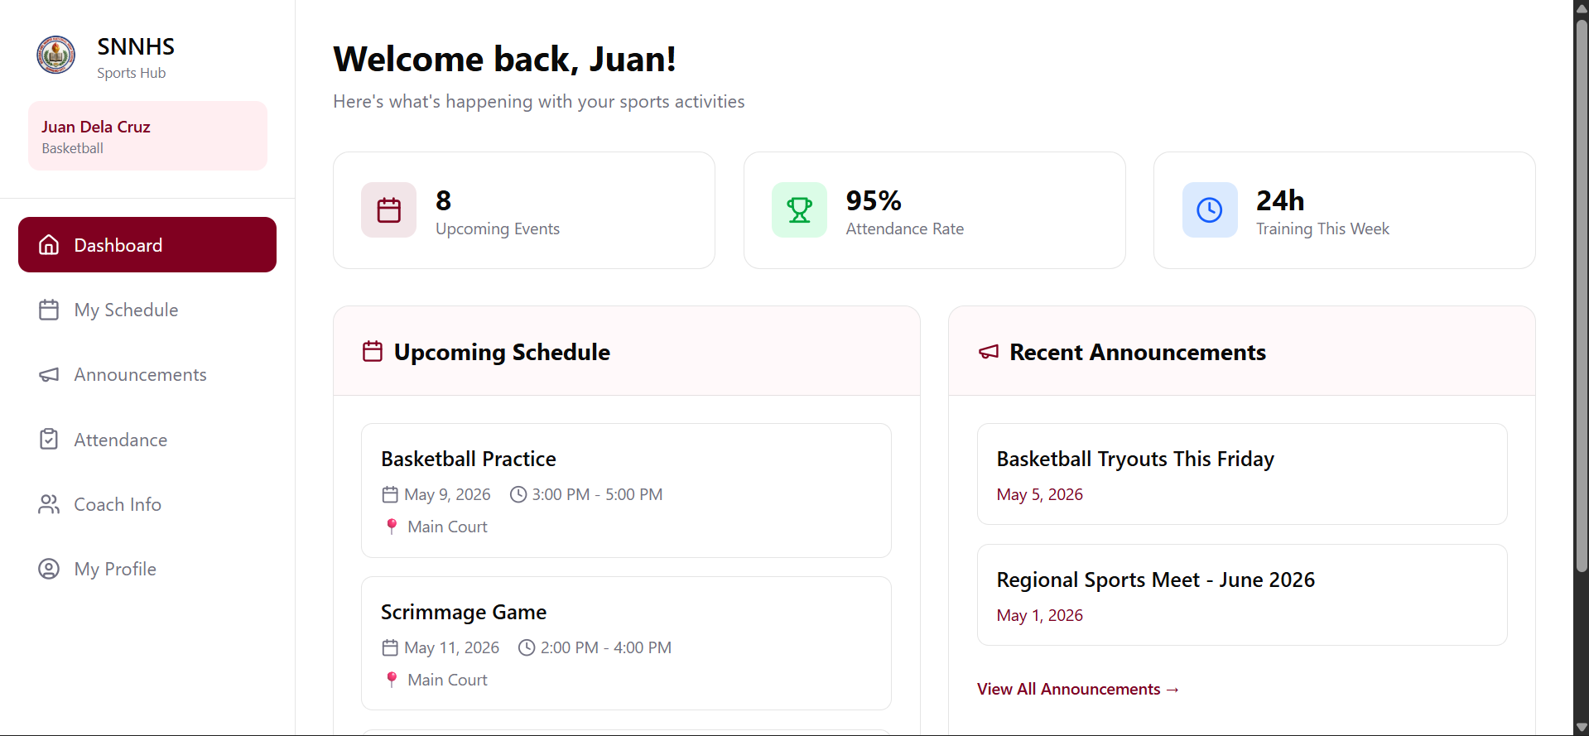
Figure 6 - Athlete Dashboard
- Sports Programs — the list of active sports programs with member counts, a program member directory, and an individual member profile
- My Schedule — displays the athlete’s training sessions, competitions, and other assigned sports events
- Calendar — a month view of all scheduled sports activities, filterable by sport, venue, event type, and status
- Attendance Record — displays the athlete’s personal attendance record and rate, upcoming attendance sessions, and the check-in control for sessions open that day
- Messages — the athlete's inbox for general messages sent by the Sports Office, showing the category, sender, date and time, priority, and read status of each message.
- My Achievements — the athlete’s medals, titles, and awards with a timeline, and the control to request an official certificate for an achievement
- My Application — the status of the sports application together with the review notes or rejection reason given by the coordinator
- Coach Info Page — shows the name, specialty, coach type, and contact details of the athlete’s assigned coach
- My Profile Page — shows the athlete’s account details with the option to update limited information such as contact number, emergency contact, and profile photo, and to change the password
Admin Dashboard Screens:
- Admin Dashboard — a command-centre summary showing total athletes, total sports programs, upcoming events, today’s sessions, pending applications, total achievements, medals awarded, and the current attendance rate, together with pending items and recent activity
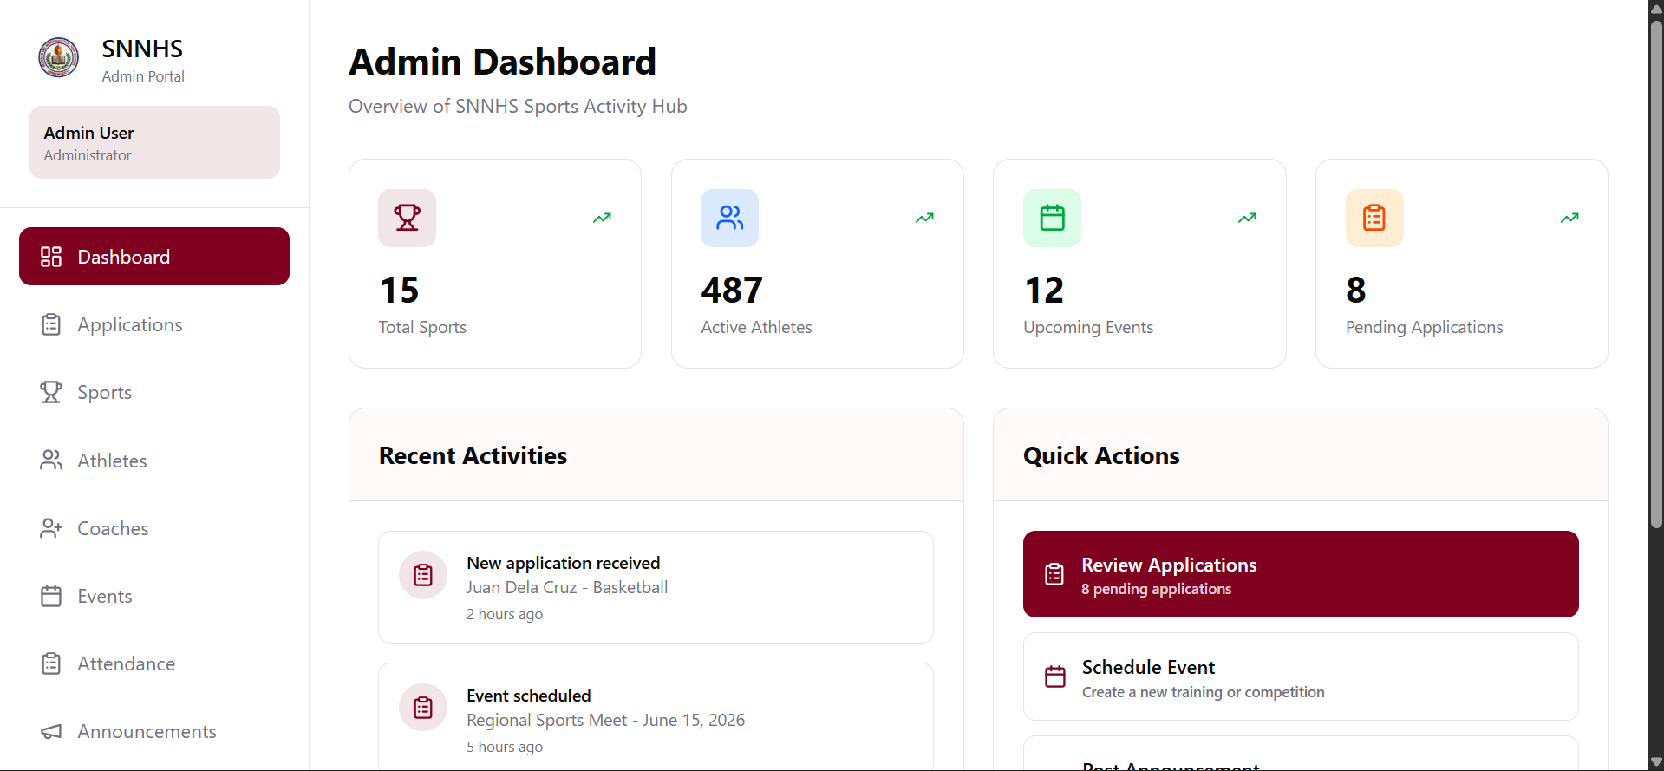
Figure 7 - Admin Dashboard
- Sports Management — screens for adding, editing, and viewing sports programs 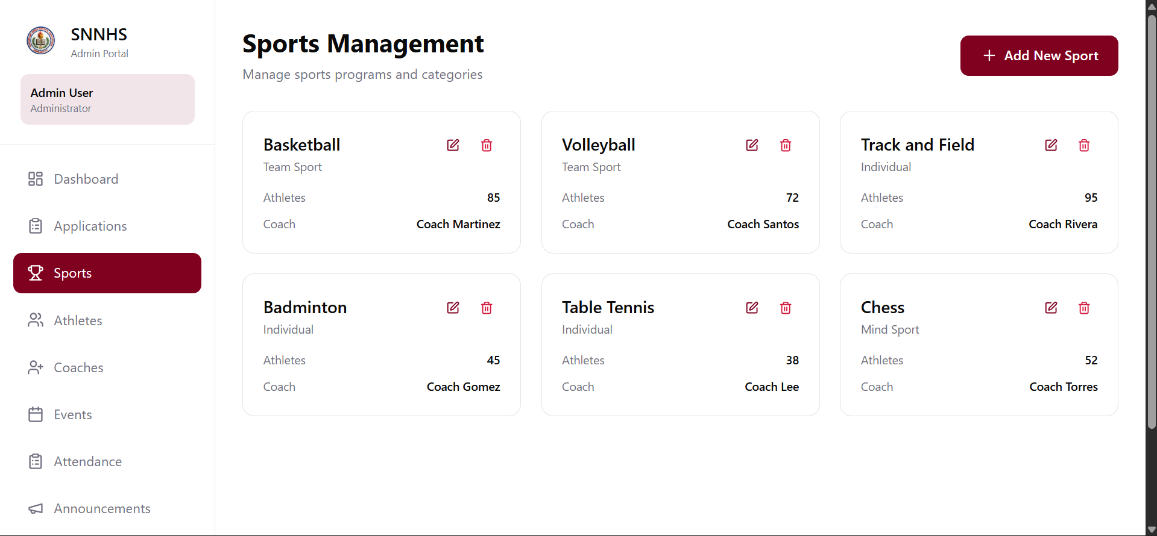
Figure 8 - Sports Management
- Athlete Management — a list and management screen for all registered athlete accounts, including eligibility status and password reset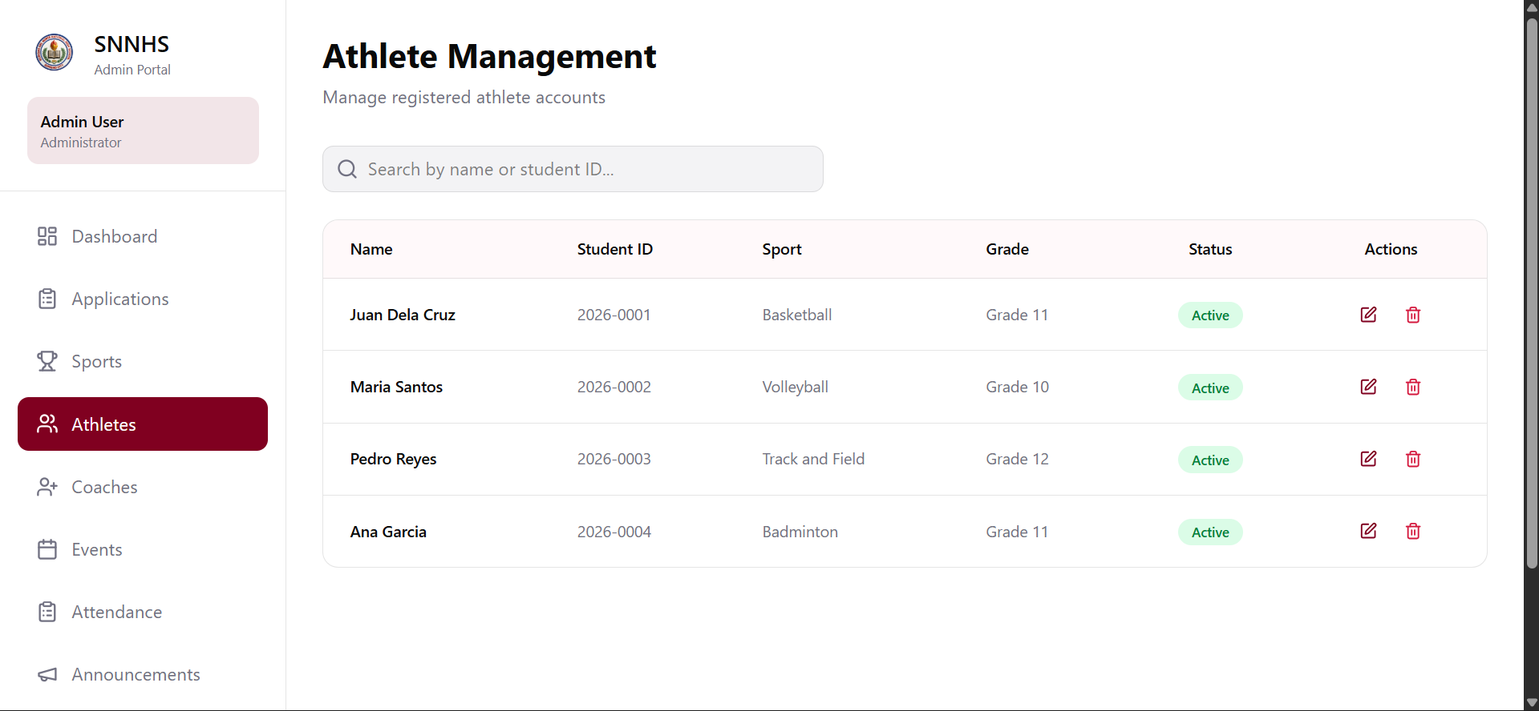
Figure 9 - Athlete Management
- Coach Management — a form and directory for managing coach records and sport assignments
- Event Scheduling — an event creation form and table view of all scheduled sports activities
- Calendar — a shared month view of all scheduled activities across sports programs
- Attendance Management — a module for creating attendance sessions, opening and closing them for check-in, and recording or overriding athlete attendance per session
- Applications Management — a list of all submitted student applications with options to approve, reject, waitlist, request documents, and verify or reject each document
- Medical Records — screens for athlete medical examinations, clearance status, medical certificates, check-up schedules, and injury incidents
- Messages — one module for general communication using a shared inbox and notification feed, with per-recipient read records, a category, priority, recipient group (one athlete, selected athletes, all active athletes, or by sport), draft messages, and administrator monitoring of message delivery and read status.
- Achievements — screens for recording achievements for athletes or teams and for generating the official certificate
- Certificate Requests — a queue of athlete certificate requests with approve, generate, release, and issue actions
- Reports Module — a report interface for generating and downloading athlete, coach, attendance, and per-athlete attendance summaries in CSV or PDF
The prototypes described above were presented to the respondents during the feedback phase, and their comments and suggestions were recorded and used as the basis for the improvements that were incorporated into the final system. Because these early wireframes were superseded by the working system, the implemented screens that resulted from this phase are presented in Section 5.3 in place of the original Figma mockups.

4.3. Receive Feedback
The prototype was presented to selected stakeholders: faculty members involved in sports management at SNNHS and a small group of student-athletes representing potential end-users. The researchers walked them through each module, explaining the purpose of each screen, and then collected comments through an informal feedback form or short structured questionnaire.
Feedback focused on clarity and ease of navigation, completeness of features against the school's actual needs, the overall layout and design, and any additional functions the participants wanted. All feedback was documented and reviewed, and the team revised the prototype and updated the requirements before development proceeded. This iterative step is a key strength of RAD and helped align the final system with the needs of the school community.

4.4. Finalize Software
After incorporating the feedback, the team coded and integrated all modules, conducted internal testing, and prepared the system for user evaluation. The technologies used are described in Chapter 3 (PHP 8.2, Laravel 12, MySQL, Tailwind CSS 4, dompdf, and a PWA manifest with a service worker), and the finalized system comprises the modules in Table 1.
Module | Used By | Main Functions
Public Landing Page | Public | Active announcements, sports program overview, the application entry point, and the secure application status check (reference number and email)
Application Form | Public | Collects personal details and the three eligibility documents; no account is created
Login, Authentication, and Password Recovery | All | Single login with role-based redirection; single-use emailed reset link (60-minute expiry, rate-limited); admin-issued one-time temporary password that forces a change on first login
Applications Management | Admin | Review applications; verify or reject each document; request missing documents; approve, reject, or waitlist; record notes and reasons shown to the student
Create Athlete Account | Admin | Creates the official account from an approved application (name, email, student ID, sport, username, temporary password)
Sports, Athlete, and Coach Management | Admin | Add, edit, view, and delete programs; manage athlete accounts, eligibility, and password reset; manage coach records and sport assignments
Event Scheduling | Admin | Create and manage trainings, tournaments, tryouts, intramurals, and matches; automatically publishes the matching landing-page announcement
Calendar | Admin, Athlete | Shared month view filterable by sport, venue, event type, and status; multi-day events shown on every day
Attendance Management | Admin | Create sessions (event-linked or stand-alone); auto-generate rosters by sport; open, close, or cancel sessions; record or override status; export CSV or PDF
Medical Records | Admin | Examinations, findings, restrictions, clearance, check-up dates, and certificates with Valid / Expiring Soon / Expired / Missing status; separate injury incidents; archive and restore
Achievements | Admin | Record individual or team achievements linked to a sport and event, and generate the official certificate
Certificate Requests | Admin, Athlete | Athlete requests; coordinator approves, generates, releases, and issues (or rejects with a reason); athlete downloads the PDF
Messages & Follow-ups | Admin, Athlete | One module for general messages and medical follow-ups: category, priority, recipient group, drafts, per-recipient read state, follow-up schedule and instructions, athlete acknowledgment, and administrator monitoring of read, acknowledged, completed, and overdue counts
Notifications | Admin, Athlete | In-app feed with unread counts, read actions, and delivery to the whole school or one sport program
Reports | Admin | Athlete, coach, attendance, and per-athlete attendance reports filterable by sport, date range, and status; CSV or PDF; whole-school or single-sport scope
Public Landing Page | Public | Active announcements, sports program overview, the application entry point, and the secure application status check (reference number and email)
Table 1. Modules of the Finalized SportsHub
Security implementation. Athlete access is enforced at the query level through model scopes that always receive the authenticated account rather than an identifier supplied by the browser. Eligibility documents, medical certificates, and issued certificates are stored on private storage and streamed only through authorized routes. Failed sign-in attempts are reported by email to the account holder and every Sports Coordinator, with alerts throttled and identifiers masked so the login form cannot reveal which accounts exist. The password reset link is single-use and time-limited, and the response is the same whether or not an address is registered.
Internal testing. The team used manual testing and an automated feature test suite covering every major module. Test cases verified that each module performs its functions, that form validation works, that authorization rules stop one athlete from reaching another's records, and that create, update, delete, and retrieve operations return accurate results. Bugs were documented and resolved before the formal evaluation.
Deployment. The finalized system was deployed to a local server environment accessible through a web browser and then prepared for evaluation by school stakeholders under the ISO/IEC 25010 quality standard. For actual operation the system is published as a container on a cloud hosting environment, where the application, the MySQL database, and the versioned migrations are applied automatically on every release; the migration that introduced the unified messaging structure was verified against a MySQL server, and the schema changes it performs can be re-run safely after an interrupted release.

4.5 Evaluation Method and Tools
The quality of the SportsHub was evaluated using the ISO/IEC 25010 Software Quality Model, an internationally recognized standard for software product quality. Three characteristics were selected for their relevance to the system's purpose and users: Usability (can the coordinator, advisers, and athletes operate the system without technical training), Reliability (does it perform consistently without data loss or errors), and Performance Efficiency (does it respond within acceptable time under a standard connection).
The primary tool was a fifteen-item questionnaire (five items per characteristic) on a five-point Likert scale from 1 (Strongly Disagree) to 5 (Strongly Agree), developed by the research team and validated by the research adviser. Fifteen (15) SNNHS respondents answered it after a brief orientation and hands-on use of all major modules: the designated Sports Coordinator, three faculty sports advisers, and eleven student-athletes from different sports. The team also directly observed the testing session, noting ease of navigation, technical errors, and responsiveness on the school network, and used these notes to give context to the questionnaire results.
Responses were analyzed using the weighted mean, computed as the sum of each rating multiplied by its frequency divided by the number of respondents (Σfw / N), for each item, each characteristic, and all items combined. Means were interpreted using Table 2. The results determined whether the SportsHub met the quality standards required for practical deployment in a school setting.
Range | Verbal Interpretation | Quality Level
4.50 – 5.00 | Strongly Agree | Excellent
3.50 – 4.49 | Agree | Very Satisfactory
2.50 – 3.49 | Neutral | Satisfactory
1.50 – 2.49 | Disagree | Needs Improvement
1.00 – 1.49 | Strongly Disagree | Poor
Table 2. Likert Scale Interpretation for ISO/IEC 25010 Evaluation
The results of the evaluation will be used to determine whether the SportsHub meets the quality standards required for practical deployment in a school setting. Findings from both the questionnaire and direct observations will be discussed in the Results and Discussion section of this study to provide a comprehensive assessment of the system’s performance.
5. RESULTS AND DISCUSSION
This chapter presents the results of each phase of development: project planning, systems design, system implementation, and system evaluation
5.1 Project Planning
A Gantt chart was used to map the phases, task sequence, overlaps, and milestones of the project (Table 3). The work was divided into six phases covering May to November 2026:
● Planning: requirements gathering, stakeholder consultation, scope definition, and review of the SNNHS sports workflow.
● Prototype and System Design: interface prototype, conceptual framework, and Use-Case, Class, and Sequence diagrams.
● Development: frontend, backend (PHP 8.2/Laravel 12), MySQL database, PWA features, and application status tracking/approval-notification enhancements.
● Testing and Feedback: functional and automated testing, ISO/IEC 25010 evaluation, questionnaire administration, bug fixes, and user-feedback revisions.
● Finalization: security and deployment checks, final revisions, and completion of the capstone document and diagrams.
● Presentation: Final Defense rehearsal, presentation, and submission of the capstone document.

Phase | Tasks / Activities | May | Jun | Jul | Aug | Sep | Oct | Nov
1. Planning Requirements | Requirements gathering, stakeholder consultation, scope definition, SNNHS workflow review
2. Prototype & System Design | UI prototype, conceptual framework, Use-Case/Class/Sequence diagrams, database planning
3. Development | Public/admin/athlete modules, application workflow, attendance, medical, achievements, notifications, status tracking
4. Testing & Feedback | Functional/automated testing, ISO/IEC 25010 evaluation, questionnaire, bug fixes, revisions
5. Finalization | Security/deployment checks, final revisions, documentation, Final Defense manuscript/diagrams
6. Presentation | Final defense rehearsal, presentation, submission of capstone document
Table 3. Project Gantt Chart - SportsHub Development Timeline (May–November 2026)
The two-member development team shared responsibilities across all phases. Both researchers handled requirements analysis and prototyping; during development one member focused on the frontend and the other on backend logic and database management, and testing and documentation were shared equally. The tools needed were a laptop with internet access, XAMPP, Visual Studio Code, Figma, MySQL, and Microsoft Word, all free or open-source, which kept the project feasible within the limited budget of an academic capstone.

5.2 Systems Design
Three modeling tools documented the structure and behavior of the system: the Use-Case Diagram, the Class Diagram, and the Sequence Diagram.
.
a.) Use-Case Diagram

The Use-Case Diagram (Figure 10) shows three actor groups, each confined to its own boundary: the Public (unauthenticated) actor uses only the landing page, the Admin / Sports Coordinator operates within the secured administrator dashboard, and the Athlete is restricted to the athlete dashboard. Apart from the common Log In and Log Out, no use case is shared across boundaries.

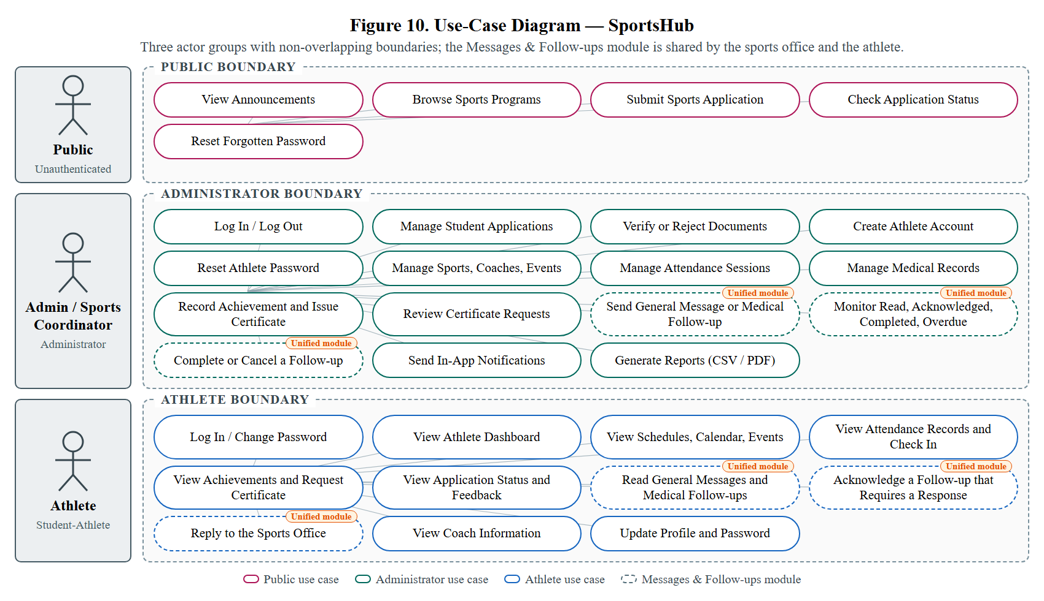

Figure 10. Use-Case Diagram — SportsHub

Any student visiting the landing page (no login required) can: View Announcements posted by the admin, and Submit a Sports Application Form to express interest in joining a sport. No account is created at this point.

The Admin/Sports Coordinator actor has full access to the administrator dashboard and can perform the following use cases: Log In using secure credentials; Post and Manage Announcements on the landing page; View and Manage Student Applications by approving or rejecting submitted forms; Create Official Athlete Accounts for approved applicants by providing their name, email, student ID, assigned sport, and login credentials; Manage Sports Categories; Manage Athlete Profiles and Accounts; Assign and Manage Coaches; Schedule and Manage Sports Events; Record and Manage Attendance; Compose and Send General Messages and Monitor Their Read Status; Generate Reports; and Log Out.

The Athlete actor represents an officially registered athlete whose account was created by the admin. Athletes can: Log In using their assigned credentials; View their personal Athlete Dashboard; View their Schedules and assigned Events; View posted Announcements; View their personal Attendance Records; View General Messages from the Sports Office and check their read status; View their Coach’s Information; Update limited Profile Information; and Log Out.

b.) Class Diagram
The Class Diagram (Figure 11) models the data structure of the system, based on the MySQL schema and the Eloquent relationships in Laravel. It has seventeen primary entities (Table 4). The User class holds both the Sports Coordinator (role Administrator) and the registered athlete (role Student) in a single authenticated table.
Entity | Purpose | Key Attributes
User | Administrator and athlete accounts | id, name, email, username, password, role, status, sport_id, student_id, phone, grade_level, emergency contact, profile_photo_path, must_change_password
Sport | Sports program | id, name, classification, gender, description, status, logo_path
Coach | Coach records | id, name, email, phone, specialty, coach_type, sport_id, status, profile_picture_path
Application | Student application before any account exists | id, name, student_id, grade, gender, email, sport_id, three document paths and statuses, status, rejection_reason, review_notes, documents_requested, review_history
Announcement | Landing-page posts | id, title, body, published_at, status, event_id
Event | Scheduled sports activity | id, title, description, venue, starts_at, ends_at, status, sport_id, event_type, coach_id, team_name, max_participants, notes
AttendanceSession | Session for which attendance is taken | id, event_id, sport_id, title, venue, description, session_date, start_time, end_time, late_grace_minutes, status, created_by, opened_at, closed_at
Attendance | Athlete's attendance in a session | id, attendance_session_id, event_id, user_id, status (Present, Late, Absent, Excused, Pending), attended_on, check_in_time
MedicalRecord | Examination results | id, athlete_id, examination_date, medical_status, next_checkup_date, findings, restrictions, notes, medical_certificate, archived_at
MedicalIncident | Per-athlete injury history | id, athlete_id, sport_id, incident_date, activity, injury_type, body_part, severity, description, treatment, rest_period_days, return_to_play_date, medical_clearance
Achievement | Medal, title, or award | id, athlete_id, team_name, sport_id, event_id, title, description, achievement_type, competition, place, date_achieved, certificate_path
CertificateRequest | Athlete's request for a certificate | id, achievement_id, student_id, status (Pending, Approved, Issued, Rejected), remarks, handled_by, handled_at, certificate_path, certificate_generated_at, certificate_reference
Notification | In-app alerts | id, type, notifiable_type, notifiable_id, data, read_at, timestamps
Message | Message composed by the administrator | id, sender_id, subject, body, category, priority, event_id, audience (all or individual), status (Draft, Sent), sent_at
MessageRecipient | Delivery of a message to one athlete | id, message_id, user_id, read_at, timestamps
Table 4. Entities of the SportsHub Class Diagram
The key relationships are as follows. A Sport has many athletes (Users), applications, coaches, events, attendance sessions, and achievements, and many announcements through its events. An athlete has many attendance records, medical records, medical incidents, applications, and achievements. A Coach belongs to a Sport and has many events. An Event belongs to a Sport and a Coach and has many attendance sessions, attendance records, and achievements. An Achievement belongs to an athlete (or names a team), a Sport, and an Event, and has many certificate requests. Medical records and medical incidents each belong to an athlete, so a new examination never overwrites an injury history. A Message is created by an administrator, may be linked to an Event, and has many MessageRecipients, each of which belongs to an athlete and records whether and when the athlete read the message. All relationships are implemented as foreign key constraints in MySQL and Eloquent associations in Laravel.

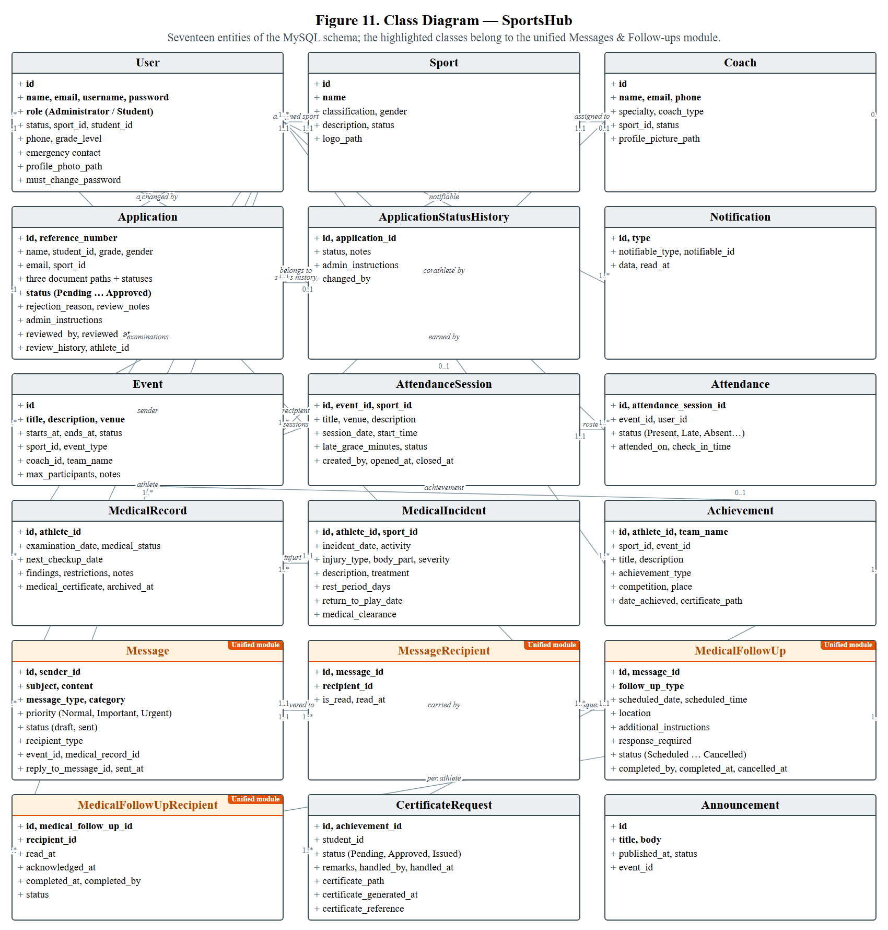
Figure 11. Class Diagram — SportsHub
The Class Diagram will serve as the primary reference for structuring the MySQL database schema and defining the Eloquent model relationships in the Laravel application. It will ensure consistency between the database design and the application logic throughout the development phase.

c.) Sequence Diagram
The Sequence Diagrams (Figures 12 to 15) document the message flow between actors, Laravel request handlers, services, and the database for the system's most frequent and most sensitive interactions, including general message delivery, where the message and its delivery records are saved in one transaction, and the read status is recorded when the athlete opens the message.
● Athlete check-in. The athlete opens the Attendance Record page and submits a check-in. The attendance session service locks the session, verifies that it is open, not cancelled, and dated today, and that the athlete's sport matches the session's sport. It then saves the record as Present within the late grace period or Late afterwards. Duplicate check-ins are rejected with a clear message, and the Sports Coordinator is notified.
● Application approval and account creation. The coordinator reviews the three documents and approves the application. The controller records the decision, notes, and reviewer, then creates the athlete account with the assigned sport, a generated username, a one-time temporary password, and the must_change_password flag. The athlete is notified in-app, and on first login middleware redirects to the change-password screen before any other page.
● Certificate request and issuance. The athlete requests a certificate for an achievement, creating a Pending request and notifying the coordinators. The coordinator approves it, the certificate service assembles the payload (recipient, achievement, reference number, signatories, issue date), and the PDF is rendered and stored on private storage. Releasing and issuing it marks the request Issued and makes the file downloadable on the athlete's Achievements page.
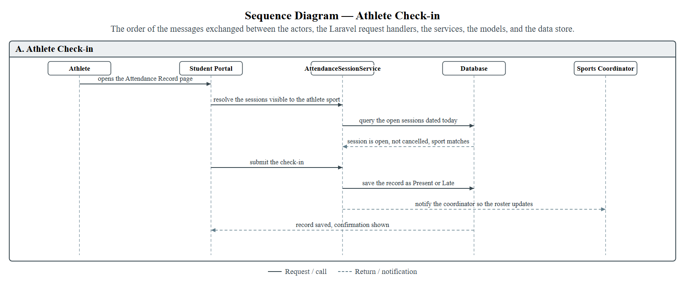
Figure 12. Athlete Check-in
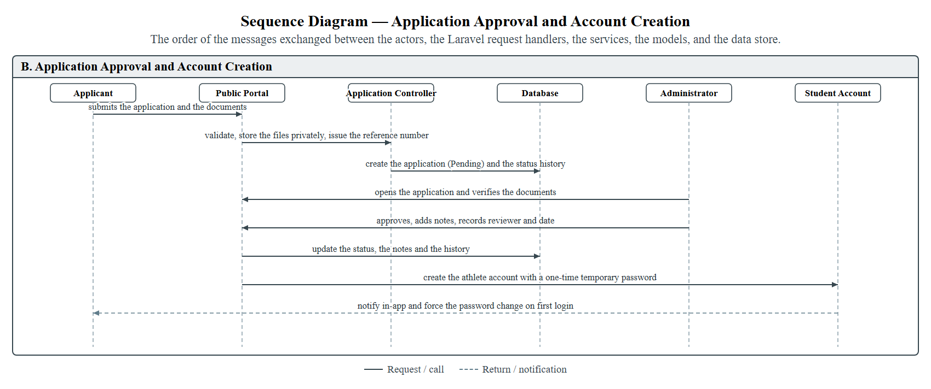
Figure 13. Application Approval and Account Creation
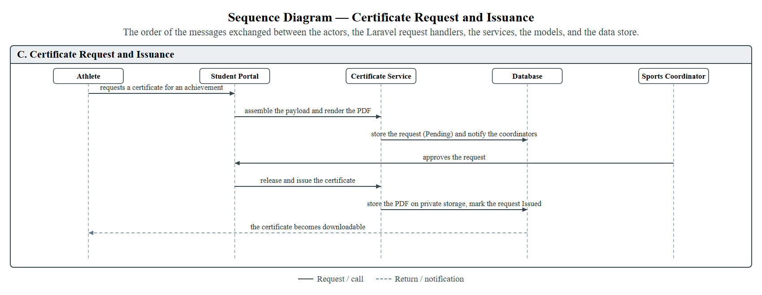
Figure 14. Certificate Request and Issuance
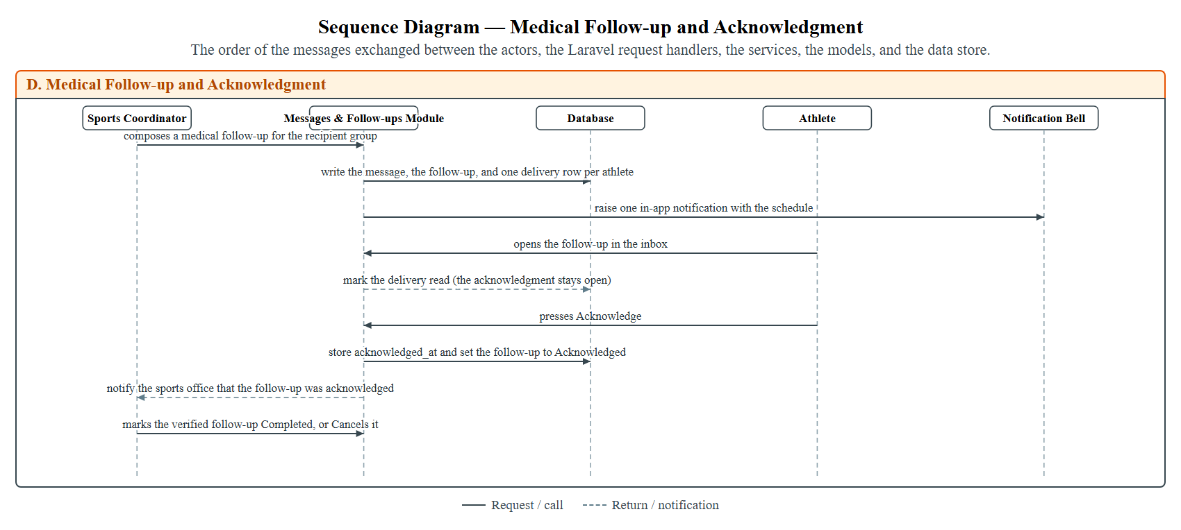
Figure 15. Medical Follow-up and Acknowledgment

5.3 System Implementation
The implemented system has three interfaces: the public interface, open to any visitor; the athlete portal, for approved and registered athletes; and the administrator portal, restricted to the Sports Coordinator. It was built with PHP 8.2, Laravel 12, MySQL, and Tailwind CSS 4 and is delivered as an installable Progressive Web Application that works on desktop, tablet, and mobile browsers. The screens below correspond to the design in Section 5.2.

Public Interface
The landing page (Figure 16) displays the school's identity, navigation menu, introductory banner, and calls to action that allow visitors to apply for sports programs, check their application status, and explore available programs. The status-check page takes the application reference number and the email address used on the application, and shows only the status, the sport applied for, the submission and update dates, the review explanation, and the office instructions, so a reference number alone never opens the record. The application form (Figures 17) collects applicant details and the three required documents. The login page (Figure 18) redirects each user to the portal that matches their role uses Laravel's token-based reset broker.
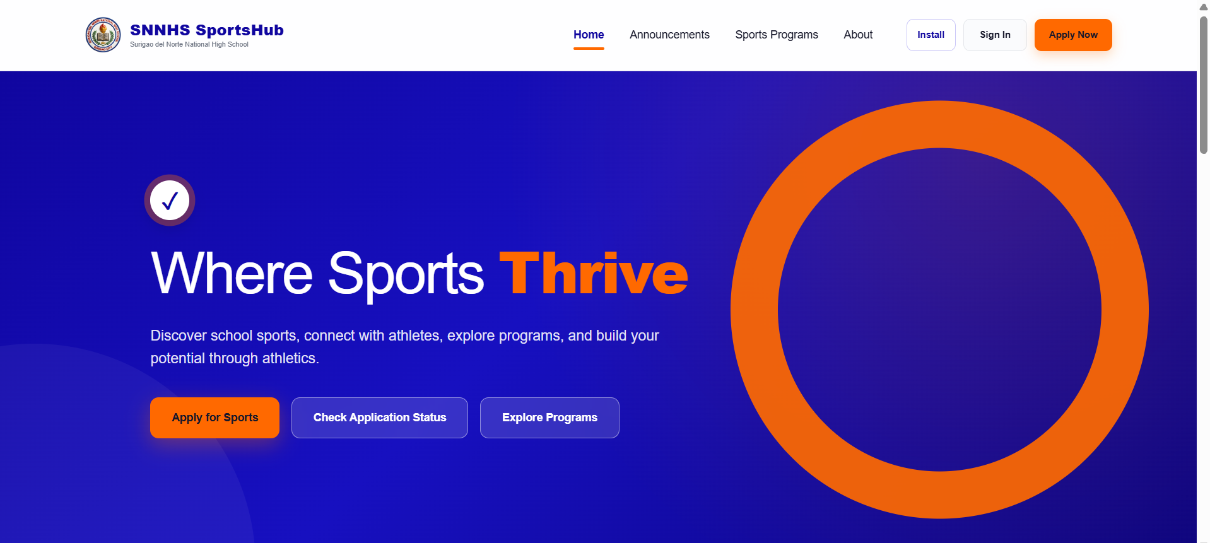
Figure 16. Landing Page - SportsHub
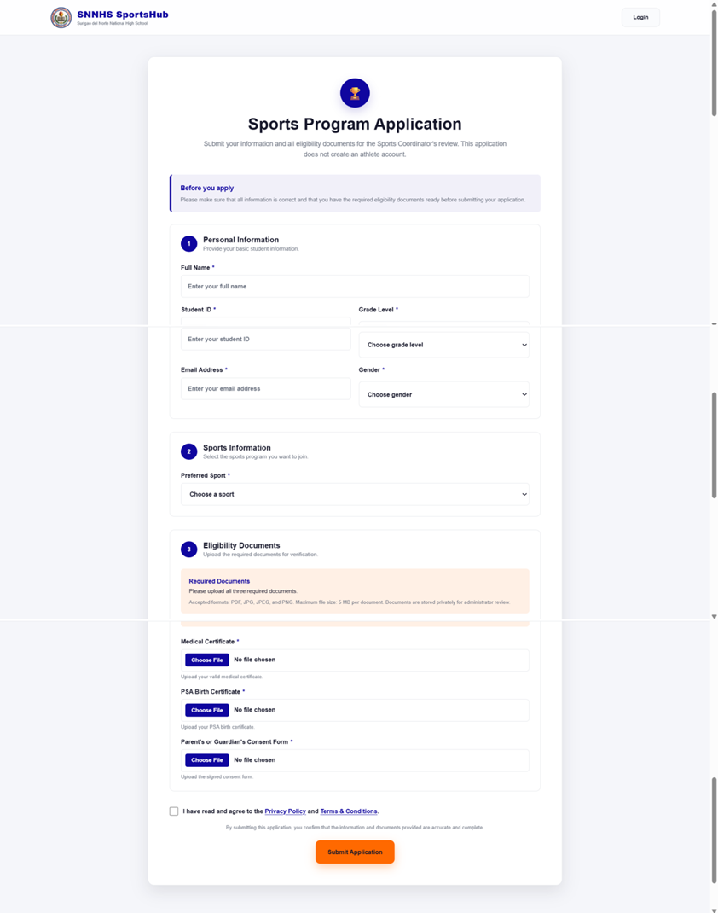
Figure 17. Application Form Page - SportsHub
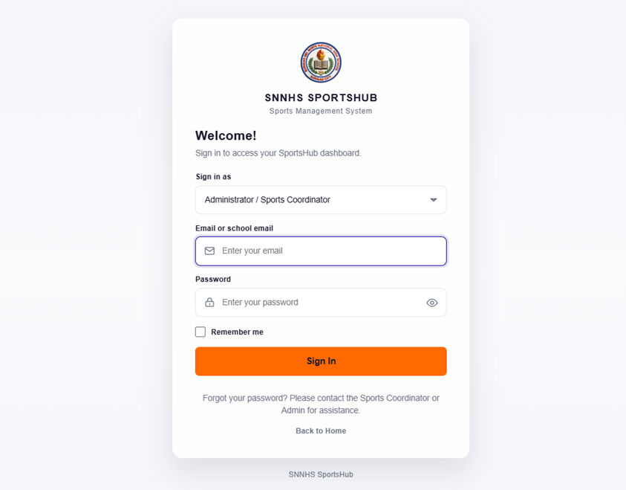
Figure 18. Login Page - SportsHub

Athlete Portal
Athlete access begins only after the Sports Coordinator approves an application and creates the account; the athlete must first replace the temporary password. The portal includes the dashboard (Figure 19), sports programs (Figure 20), My Schedule (Figure 21), and the calendar (Figure 22), which merges every event and attendance session of the athlete's sport into one month view. Attendance Record (Figure 23) shows the attendance rate and the check-in button for open sessions. Messages & Follow-ups (Figure 24) is the athlete's inbox for messages sent by the Sports Office. It displays message categories, including General Messages and Medical Follow-ups, along with the sender, date and time, priority level, message content, and read status. My Achievements (Figure 25) lists medals and awards and lets the athlete request a certificate, and My Application (Figure 26) shows the review status, coordinator feedback, and uploaded documents. Coach Information (Figure 27) and My Profile (Figure 28) complete the portal.
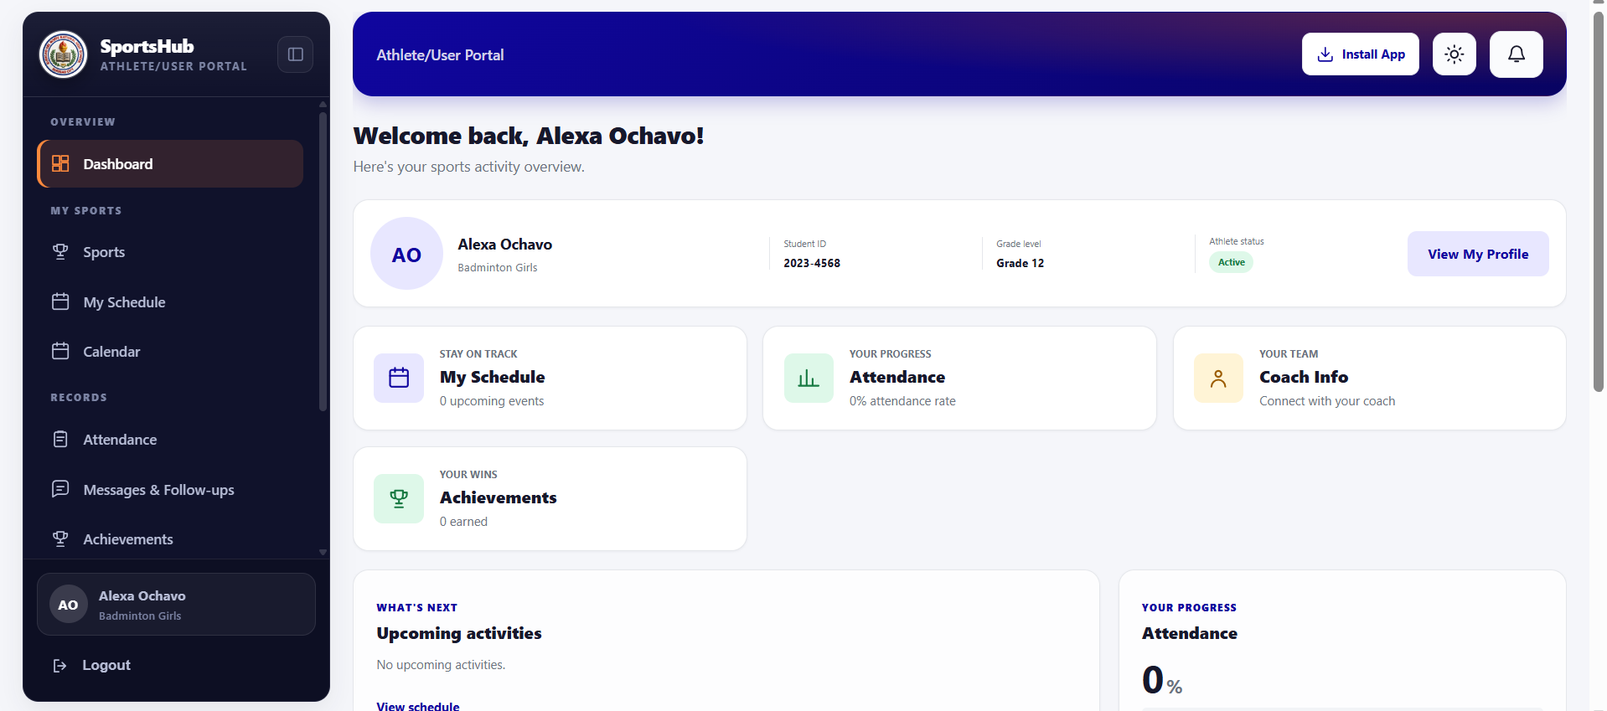
Figure 19. Athlete Dashboard - SportsHub
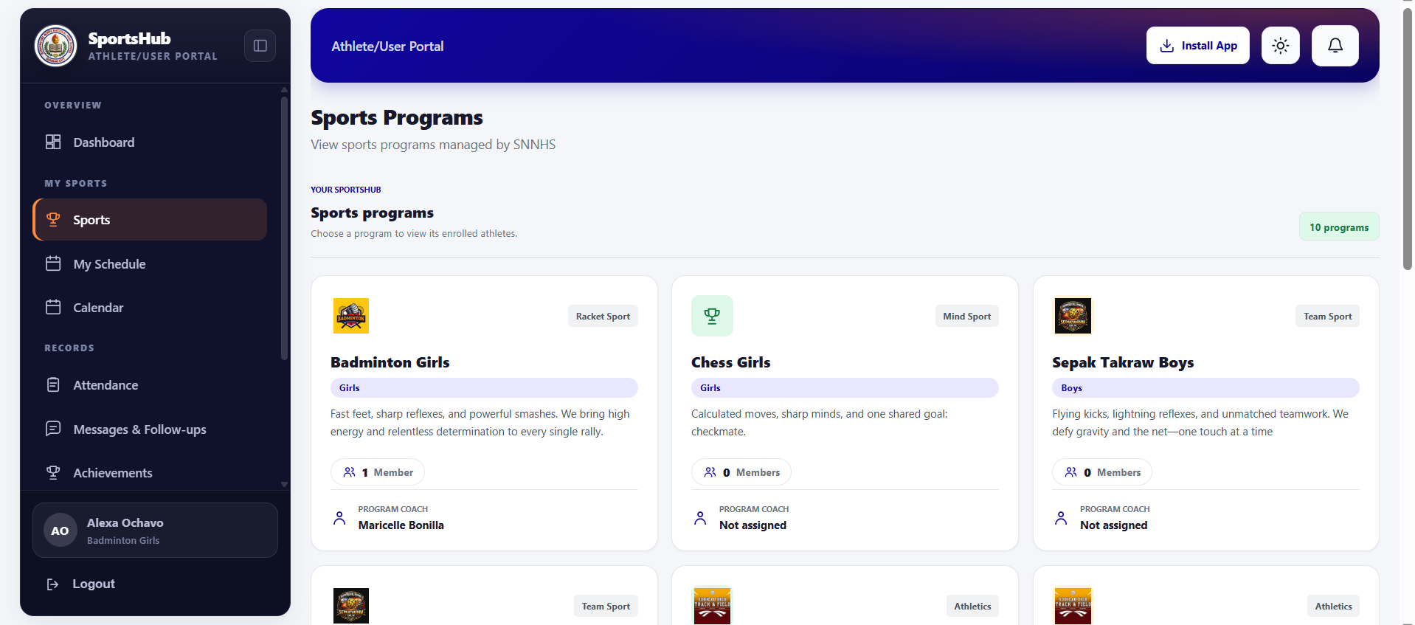
Figure 20. Sports Programs Page - SportsHub
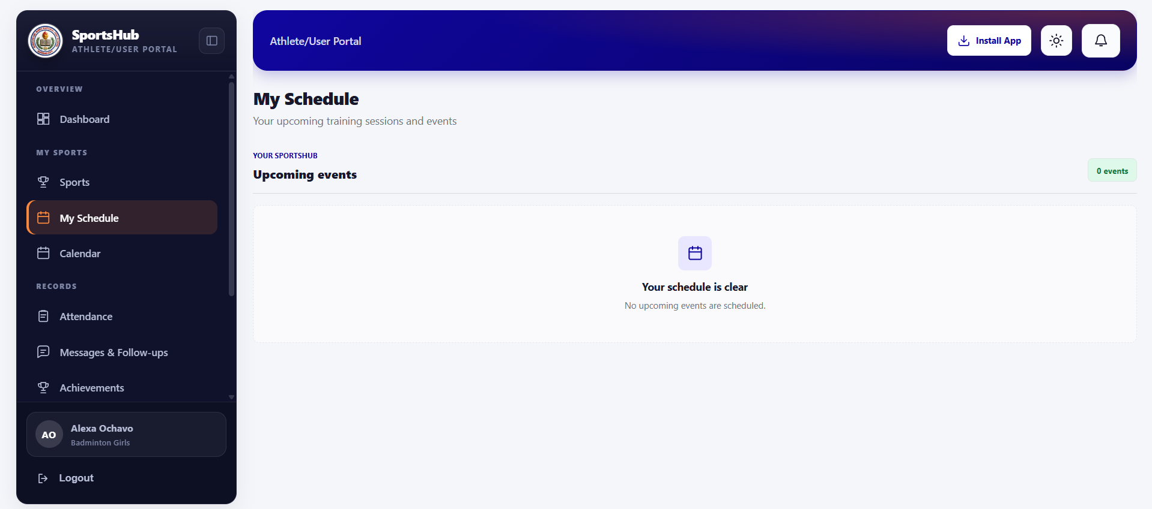
Figure 21. My Schedule Page - SportsHub
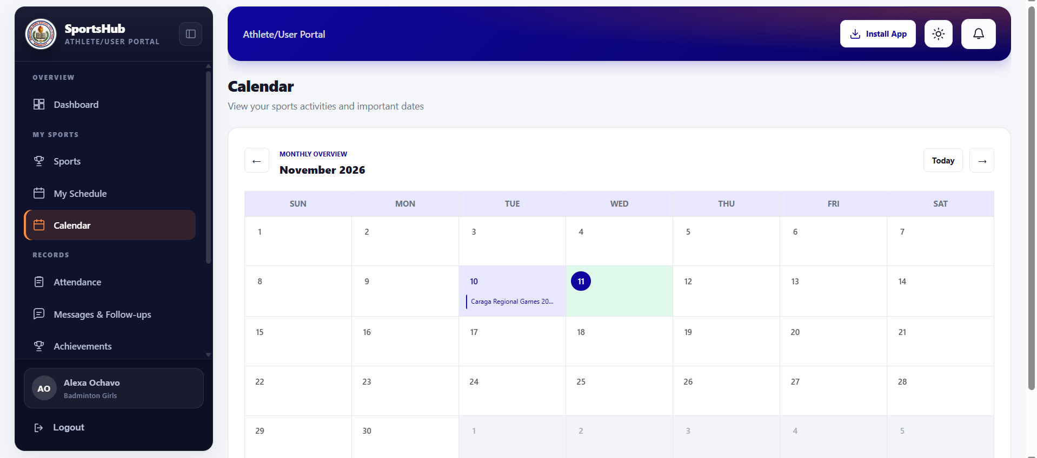
Figure 22. Calendar Page - SportsHub
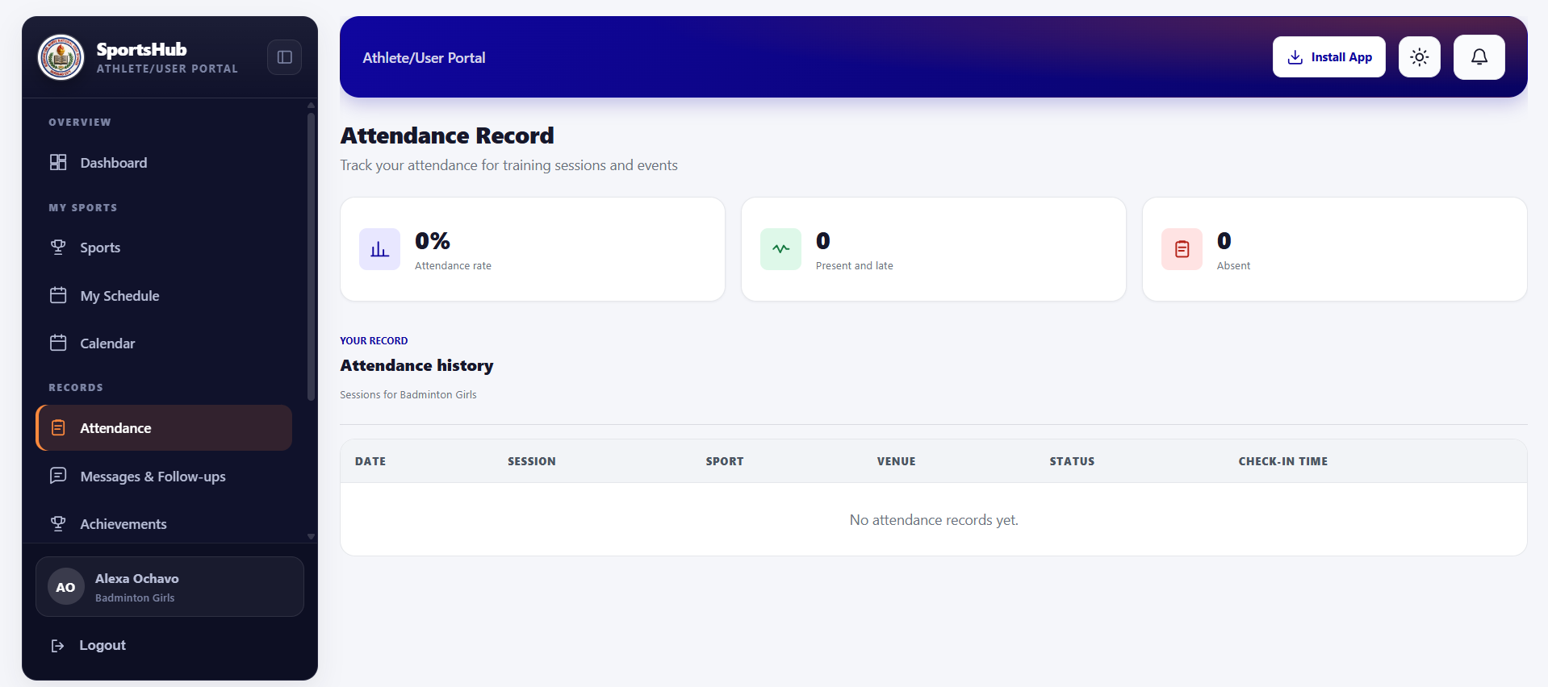
Figure 23. Attendance Record Page - SportsHub
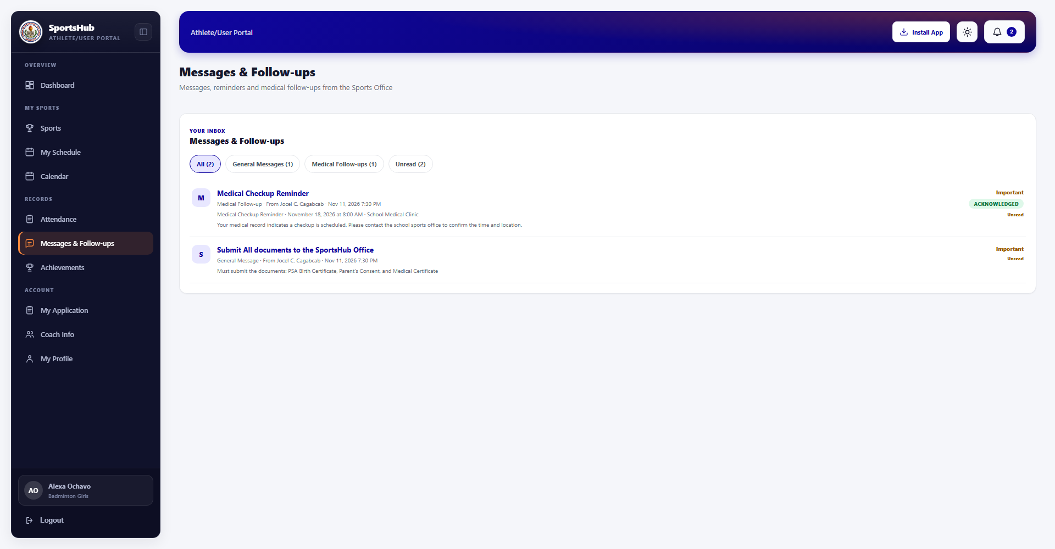
Figure 24. Messages & Follow-ups Page - SportsHub
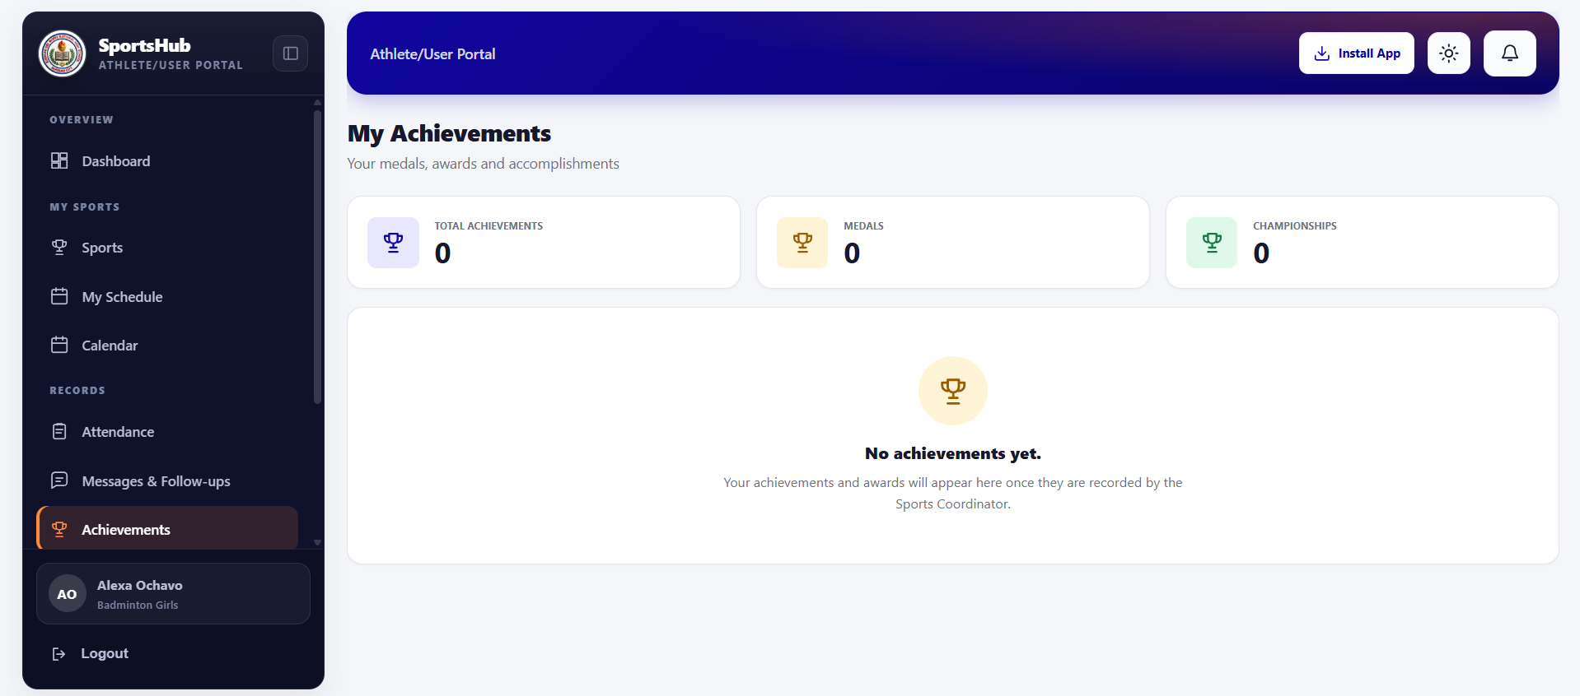
Figure 25. My Achievements Page - SportsHub
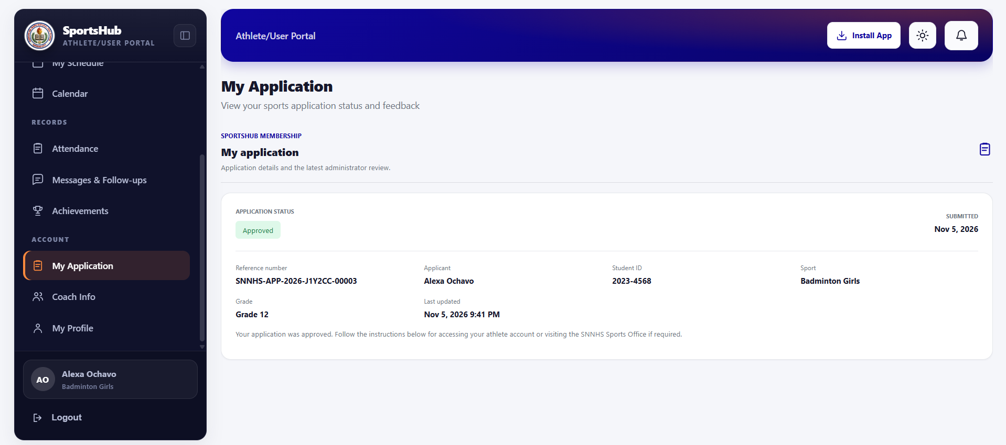
Figure 26. My Application Page - SportsHub
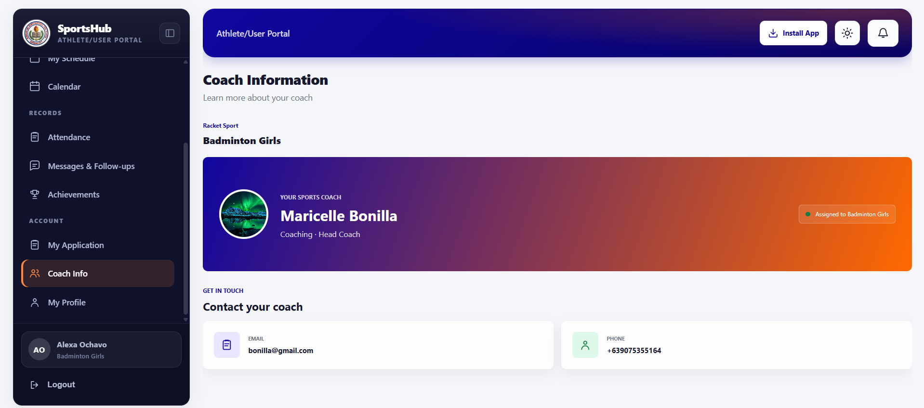
Figure 27. Coach Information Page - SportsHub
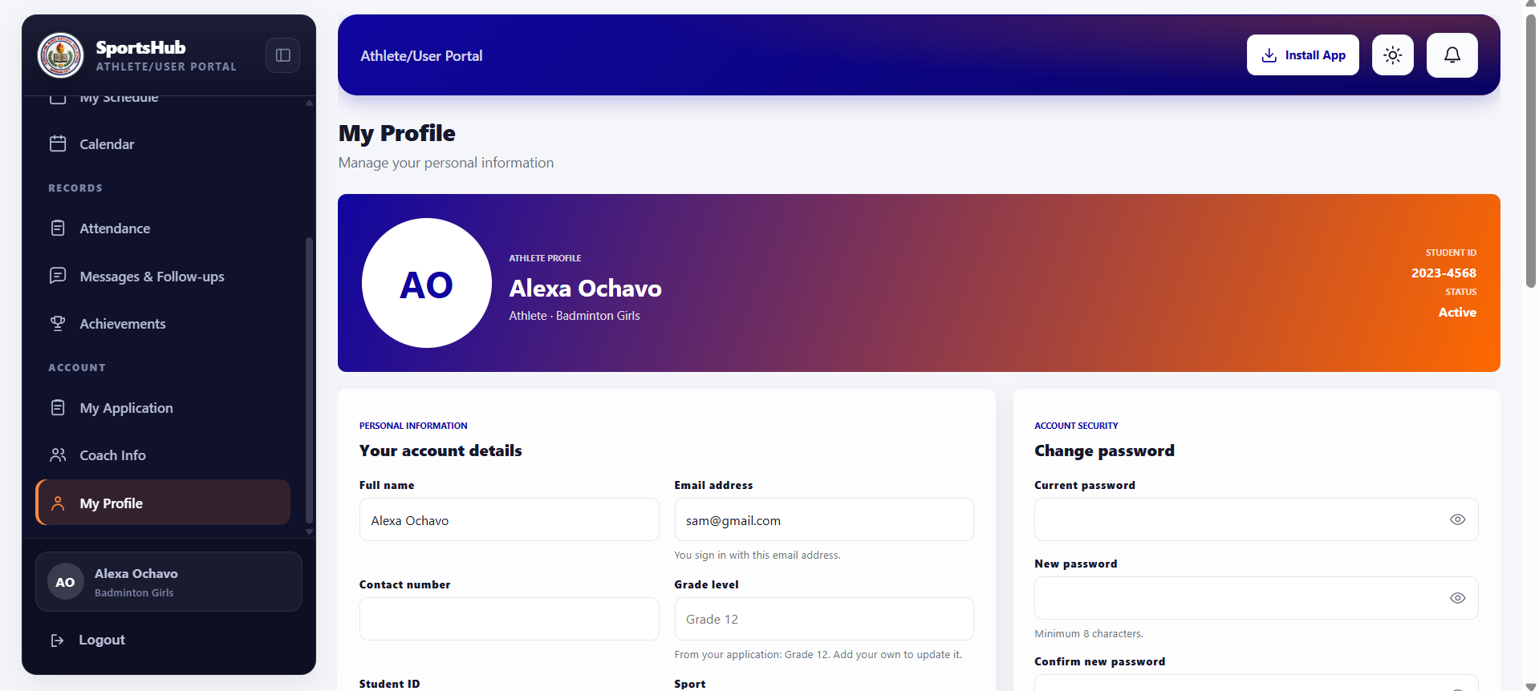
Figure 28. My Profile Page - SportsHub

Administrator Portal
The administrator portal is the control center of the system. It includes the dashboard summarizing applications, athletes, programs, and events (Figure 29); Applications Management for document verification, review notes, and approve, reject, waitlist, or return decisions (Figure 30); Sports Management (Figure 31); Athlete Management (Figure 32); Coach Management (Figure 33); Event Scheduling (Figure 34); and the administrator calendar (Figure 35). Attendance Management (Figure 36) opens, closes, and cancels sessions and generates rosters automatically from the session's sport. Medical Records (Figure 37) stores examinations, clearance status, certificates with expiry monitoring, and injury incidents. Messages (Figure 38) lets the coordinator compose, save as draft, and send general messages to athletes. It shows summary counts of total messages sent, read, unread, and draft messages, category tabs (All, General Messages, Sent, and Drafts), search and sorting, and a per-message view of recipients with their read status. Achievements (Figure 39), Certificate Requests (Figure 40), and the Reports module (Figure 41) complete the portal; reports can be exported in CSV or PDF for the whole school or a single sport.
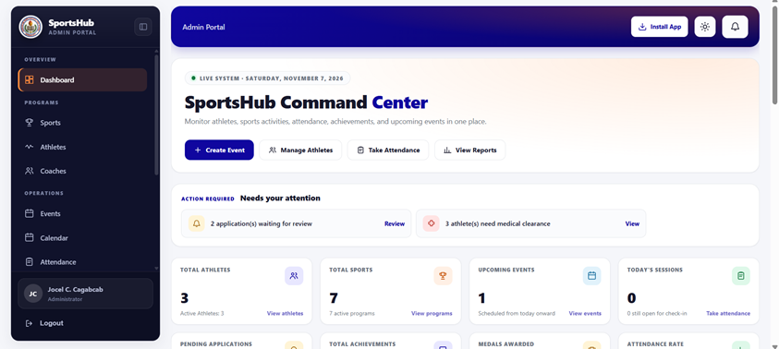
Figure 29. Administrator Dashboard - SportsHub
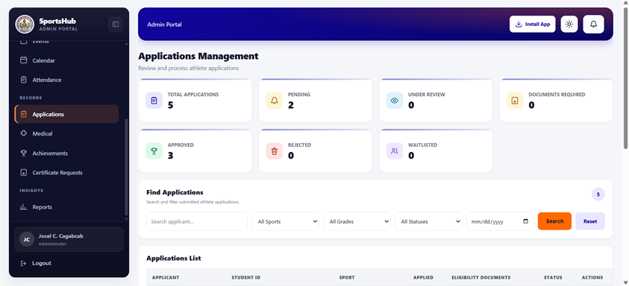
Figure 30. Applications Management Page - SportsHub
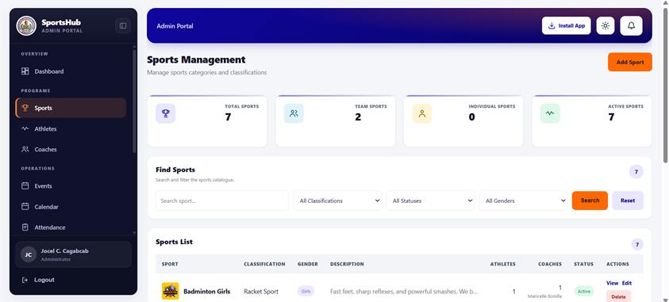
Figure 31. Sports Management Page - SportsHub
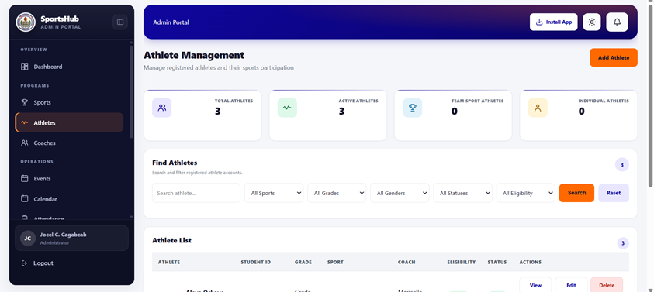
Figure 32. Athlete Management Page - SportsHub
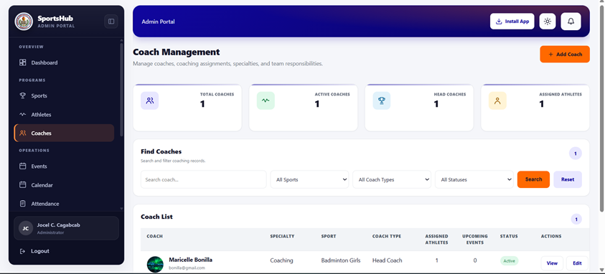
Figure 33. Coach Management Page - SportsHub
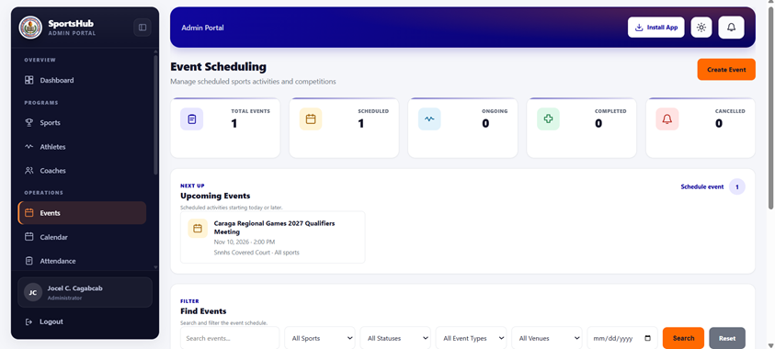
Figure 34. Event Scheduling Page - SportsHub
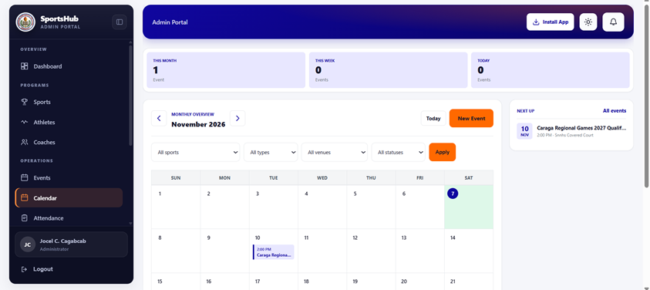
Figure 35. Administrator Calendar Page - SportsHub
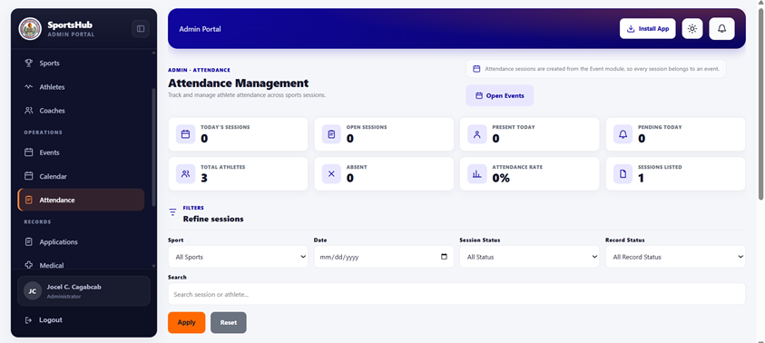
Figure 36. Attendance Management Page - SportsHub
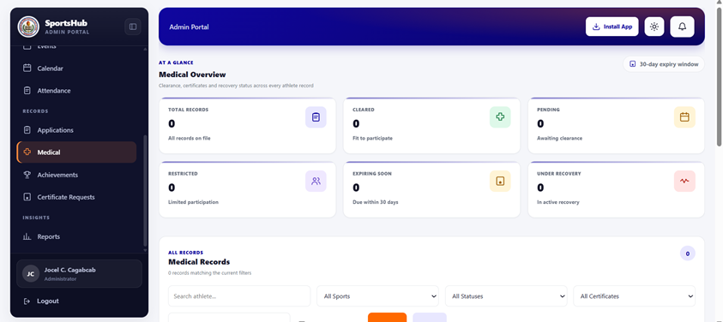
Figure 37. Medical Records Page - SportsHubFigure 38. Messages & Follow-ups Page - SportsHub
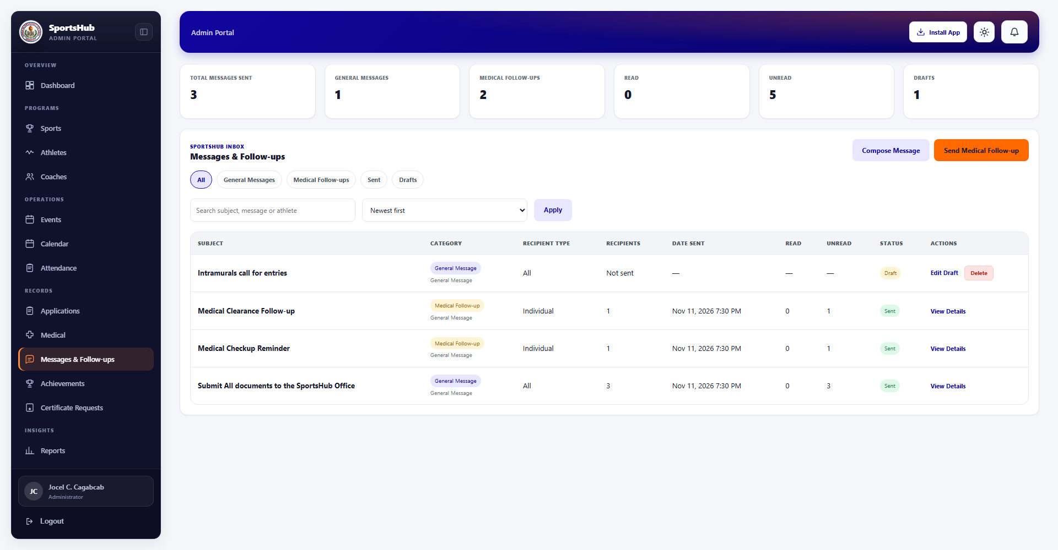
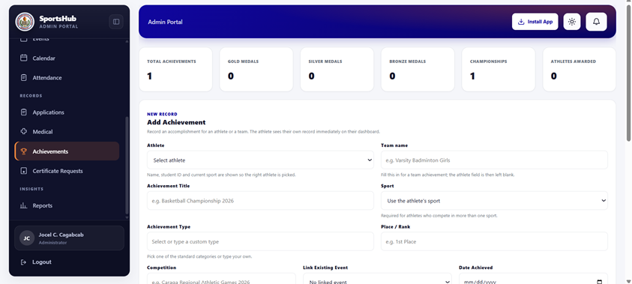
Figure 39. Achievements Page - SportsHub
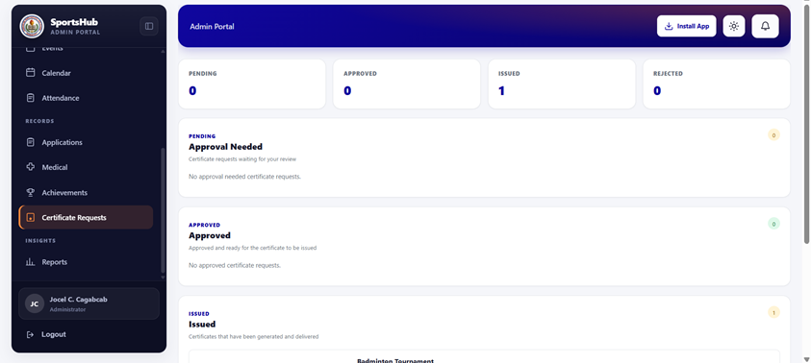
Figure 40. Certificate Requests Page - SportsHub
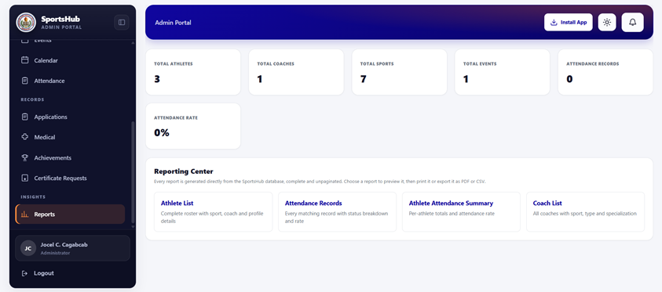
Figure 41. Reports Module - SportsHub

5.4 Evaluation of the System
Fifteen (15) SNNHS respondents evaluated the system: the Sports Coordinator, three (3) faculty sports advisers, and eleven (11) student-athletes. Each used the major modules of the finalized system and then answered the fifteen-item ISO/IEC 25010 questionnaire.

a.) Overall Evaluation Result
Evaluation Criterion | No. of Items | Weighted Mean | Verbal Interpretation | Quality Level
Usability | 5 | 4.56 | Strongly Agree | Excellent
Reliability | 5 | 4.45 | Agree | Very Satisfactory
Performance Efficiency | 5 | 4.37 | Agree | Very Satisfactory
Overall | 15 | 4.46 | Agree | Very Satisfactory
Table 5. Overall Weighted Mean of the SportsHub Evaluation (N = 15)
The overall weighted mean of 4.46 falls within the 3.50 – 4.49 range, interpreted as Agree (Very Satisfactory). All three characteristics scored above 4.00 and none fell below Agree, indicating that the SportsHub met the quality standards for practical deployment in a school setting.

b.) Usability
Item | Statement | 5 | 4 | 3 | 2 | 1 | Weighted Mean | Interpretation
A1 | Simple and easy-to-understand interface | 10 | 4 | 1 | 0 | 0 | 4.60 | Strongly Agree
A2 | Quick learning without extensive assistance | 8 | 6 | 1 | 0 | 0 | 4.47 | Agree
A3 | Easy navigation and access to features | 11 | 3 | 1 | 0 | 0 | 4.67 | Strongly Agree
A4 | Clear, readable, and organized layout | 9 | 5 | 1 | 0 | 0 | 4.53 | Strongly Agree
A5 | Clear messages, instructions, and feedback | 9 | 5 | 1 | 0 | 0 | 4.53 | Strongly Agree
 | Section Mean |  |  |  |  |  | 4.56 | Strongly Agree / Excellent
Table 6. Weighted Mean of Usability Items (N = 15)
Usability received the highest section mean (4.56, Strongly Agree / Excellent).
● Highest items: A3, easy navigation (4.67), and A1, simple interface (4.60). These agree with the design choices of consistent sidebar navigation, role-based redirection, and one login screen for all users; during testing, respondents located the attendance, achievements, and reports modules with minimal prompting.
● Lowest item: A2, quick learning (4.47, Agree). Some student-athletes saw the mandatory first-login password change as an unexpected step before reaching their dashboard.

c.) Reliability
Item | Statement | 5 | 4 | 3 | 2 | 1 | Weighted Mean | Interpretation
B1 | Correct and error-free performance | 9 | 5 | 1 | 0 | 0 | 4.53 | Strongly Agree
B2 | Accurate record saving with no data loss | 10 | 4 | 1 | 0 | 0 | 4.60 | Strongly Agree
B3 | Graceful handling of invalid inputs | 7 | 7 | 1 | 0 | 0 | 4.40 | Agree
B4 | Recovery from interruptions without data corruption | 6 | 7 | 1 | 1 | 0 | 4.20 | Agree
B5 | Accurate reports, rates, and certificates | 9 | 5 | 1 | 0 | 0 | 4.53 | Strongly Agree
 | Section Mean |  |  |  |  |  | 4.45 | Agree / Very Satisfactory
Table 7. Weighted Mean of Reliability Items (N = 15)
Reliability obtained a section mean of 4.45 (Agree / Very Satisfactory).
● Highest item: B2, accurate record saving (4.60), showing confidence that applications, attendance records, and achievements were saved correctly.
● Lowest item: B4, recovery from interruptions (4.20), the only reliability item with a Disagree response. Two incidents were observed: a browser refresh during form submission and a lost connection while the offline page appeared. No data were corrupted, but the generic error message did not explain what happened or what to do. This reflects the known limitation that server-backed operations need an active internet connection.
● Supporting evidence: the automated feature test suite covering every major module ran without failures during the evaluation period, supporting the B1 result.

d.) Performance Efficiency
Item | Statement | 5 | 4 | 3 | 2 | 1 | Weighted Mean | Interpretation
C1 | Fast loading of pages and dashboards | 8 | 6 | 1 | 0 | 0 | 4.47 | Agree
C2 | Prompt response to user actions | 8 | 6 | 1 | 0 | 0 | 4.47 | Agree
C3 | Acceptable response times under normal connection | 7 | 7 | 1 | 0 | 0 | 4.40 | Agree
C4 | Responsive handling of large data volumes | 6 | 6 | 2 | 1 | 0 | 4.13 | Agree
C5 | Efficient operation on the devices used | 7 | 7 | 1 | 0 | 0 | 4.40 | Agree
 | Section Mean |  |  |  |  |  | 4.37 | Agree / Very Satisfactory
Table 8. Weighted Mean of Performance Efficiency Items (N = 15)
Performance efficiency had the lowest section mean (4.37, Agree / Very Satisfactory).
● Routine use: pages and dashboards were rated 4.47, and most screens rendered within a few seconds on the school network, supported by resolving each dashboard figure through a single aggregate query.
● Lowest item (and lowest in the questionnaire): C4, large data volumes (4.13), with two Neutral and one Disagree response. The reports module and the full athlete list took noticeably longer when several respondents used the system at the same time during peak hours. CSV and PDF report generation remains the heaviest operation.

e.) Summary of Findings
1. The overall weighted mean of 4.46 (Agree / Very Satisfactory) shows that the SportsHub met the quality standards for deployment in a school setting.
2. Usability ranked highest (4.56, Excellent), showing that the interface is accessible to users without technical training, including faculty advisers.
3. Reliability (4.45) and Performance Efficiency (4.37) were both Very Satisfactory, with identifiable areas for improvement.
4. The two lowest items, recovery from interruptions (B4 = 4.20) and handling of large data volumes (C4 = 4.13), correspond to the system's known limitations in offline operation and report generation.
Based on these results, the following improvements are recommended (Table 9). Direct observations supplemented the questionnaire data in reaching these findings.
No. | Area | Recommended Improvement
1 | Reliability (B4) | Show a clear in-app message when an action fails because the connection was lost, stating whether the submission was saved.
2 | Performance (C4) | Optimize report and athlete-list generation with pagination and indexed queries so large exports stay responsive at peak usage.
3 | Usability (A2) | Add a brief first-login guide so the mandatory password change is seen as a normal security step.
Table 9. Recommended Improvements Based on the Evaluation

5.5 The SportsHub Progressive Web Application
SportsHub was delivered as an installable Progressive Web Application instead of a native Android or iOS app. Students, coaches, and the Sports Coordinator can therefore use it on any device through a standard browser, without an app-store download and without the cost of maintaining separate native codebases. It can be installed from the browser to the home screen of a phone, tablet, or laptop and opens in a standalone window.
Two standard components provide this behavior. The web app manifest defines the application name, home-screen short name, display mode, colors, orientation, and icons so the installed app shows the identity of SNNHS. The service worker runs in the background and intercepts network requests: it uses a cache-first strategy for the static shell (stylesheets, scripts, icons), so the interface appears immediately, and a network-first strategy for dynamic pages and data. When the connection is unavailable, it shows a dedicated offline page that explains that the connection was lost and the content could not be loaded.
Server-backed operations such as submitting an application, checking in to a session, or approving a document still require an internet connection, and credentials and records are never stored on the device. The offline page is deliberately a simple notice rather than a simulated interface, because an interactive screen that cannot submit data would mislead the athlete.
The approach also simplifies deployment: because the system is a single web application on a central server, an update by the developers reaches every user the next time the app is opened, without asking students to install a new version. This is a significant advantage for a school, where coordinating updates across many personal devices would be impractical.

6. CONCLUSION AND RECOMMENDATION

6.1 Conclusion
Based on the development and evaluation of the SportsHub, the researchers concluded the following:
First, the system provides SNNHS with a centralized platform that addresses the problems identified in the study: scattered manual athlete records, difficulty monitoring attendance, informal handling of event schedules, and untracked medical clearances. Sports data can now be stored, managed, and retrieved in one place. The improvement in workload and data accuracy was assessed through user perception; it was not measured against a before-and-after baseline.
Second, the system was developed successfully using PHP 8.2, Laravel 12, Tailwind CSS 4, and MySQL. The public landing page, athlete dashboard, and administrator dashboard were implemented as designed and tested, and the system is delivered as an installable Progressive Web Application accessible on any device through a standard browser.
Third, the features identified during requirements planning were implemented and tested: sports program management, athlete records, coach assignments, event scheduling, a shared calendar, attendance monitoring, medical records, achievements, certificates, announcements, a unified Messages module in which general messages share one inbox, one notification feed, and one per-recipient read record, and downloadable CSV and PDF reports.
Fourth, the evaluation rated the system favorably, with an overall weighted mean of 4.46 (Agree / Very Satisfactory). Usability ranked highest at 4.56 (Excellent), followed by reliability (4.45) and performance efficiency (4.37). The lowest-rated items, recovery from interruptions (4.20) and handling of large data volumes (4.13), identify where future improvement is needed.

6.2 Recommendation
Based on the conclusions, the researchers recommend the following:
First, the school should adopt the SportsHub for its sports management and designate a person, such as the Sports Coordinator, to manage and maintain it so that the data stay accurate and up to date. The school should also provide the necessary infrastructure, such as computers and a stable internet connection.
Second, the developers should implement the improvements identified in the evaluation: a clearer in-app message when a connection is lost, optimized report and athlete-list generation through pagination and indexed queries, and a first-login guide for the mandatory password change.
Third, the system may be expanded with two-way messaging that lets athletes reply, email or SMS notifications, a mobile application version, integration with other school systems, a financial module for registration fees and equipment inventory, and an analytics dashboard for tracking athlete performance over time.
Fourth, the system should be tested in other schools with different operational contexts and with a larger group of respondents to determine its generalizability. A longitudinal study comparing sports management before and after adoption is also recommended to measure its long-term effects.
Finally, future researchers who wish to develop a similar system may consider the technologies and RAD methodology used in this study, which proved suitable for building a secure, reliable, and maintainable web-based application.

7. ACKNOWLEDGEMENT
The researchers would like to express their sincere gratitude to the people who contributed to the successful completion of this study.
First, we thank Surigao del Norte National High School, through its Sports Coordinator and faculty sports advisers, for giving us the opportunity to conduct this study and for sharing their time and knowledge during the requirements gathering and evaluation phases. Their cooperation was essential in developing the system according to the actual needs of the school.
We also thank the fifteen (15) respondents who voluntarily took part in the evaluation. Their honest feedback and constructive suggestions were invaluable in improving the quality of the system.
We extend our gratitude to the faculty members of the College of Computing and Information Sciences of Surigao del Norte State University for their guidance and assistance throughout this study.
Lastly, we thank our families and friends for their unwavering support, encouragement, and patience throughout the completion of this study.

REFERENCES
Foreign Studies
[1] Hao, X. G., Yin, Y., Ma, C., & Hu, S. (2024). Innovative design and implementation of college sports events management information system based on WEB technology. ICIEAI '24: Proceedings of the 2024 2nd International Conference on Information Education and Artificial Intelligence. ACM. https://doi.org/10.1145/3724504.3724589
[2] Ma, Y., Zhang, C., & Yang, H. (2024). Design and implementation of a college student sports performance management system under web technology. Proceedings of the 2024 5th International Conference on Big Data and Informatization Education (ICBDIE 2024) (pp. 457–466). Atlantis Press. https://doi.org/10.2991/978-94-6463-417-4_42
[3] Sun, G. (2020). Design and implementation of the school sports management system based on WEB. In Cyber Security Intelligence and Analytics. CSIA 2019. Advances in Intelligent Systems and Computing, vol. 928. Springer. https://doi.org/10.1007/978-3-030-15235-2_8
[4] Wang, T., & Park, J. (2021). Design and implementation of intelligent sports training system for college students' mental health education. Frontiers in Psychology, 12, Article 634978. https://doi.org/10.3389/fpsyg.2021.634978
[5] Zhang, Y., Zhao, X., Shen, J., Shi, K., Yu, Y., & Shi, G. (2021). Optimization of sports event management system based on wireless sensor network. Journal of Sensors, 2021, Article 1174351. https://doi.org/10.1155/2021/1174351
[6] Zhu, Z. (2025). Design and implementation of an intelligent sports management system (ISMS) using wireless sensor networks. PeerJ Computer Science, 11, e2637. https://doi.org/10.7717/peerj-cs.2637

[7] Jastrow, F., Greve, S., Thumel, M., Diekhoff, H., & Süßenbach, J. (2022). Digital technology in physical education: A systematic review of research from 2009 to 2020. German Journal of Exercise and Sport Research, 52(4), 504–528. https://doi.org/10.1007/s12662-022-00848-5
[8] Zhong, Q., Jiang, J., Bai, W., Yin, Z., Liao, Z., & Zhong, X. (2025). Application of digital-intelligent technologies in physical education: A systematic review. Frontiers in Public Health, 13, Article 1626603. https://doi.org/10.3389/fpubh.2025.1626603
[9] Martín-Rodríguez, A., & Madrigal-Cerezo, R. (2025). Technology-enhanced pedagogy in physical education: Bridging engagement, learning, and lifelong activity. Education Sciences, 15(4), 409. https://doi.org/10.3390/educsci15040409
[10] Li, Q., Kumar, P., & Alazab, M. (2022). IoT-assisted physical education training network virtualization and resource management using a deep reinforcement learning system. Complex & Intelligent Systems, 8, 1229–1242. https://doi.org/10.1007/s40747-021-00584-7

[11] Wang, Y., Muthu, B., & Sivaparthipan, C. B. (2021). Internet of Things driven physical activity recognition system for physical education. Microprocessors and Microsystems, 81, Article 103723. https://doi.org/10.1016/j.micpro.2020.103723
[12] Xu, Y., Peng, J., Jing, F., et al. (2024). From wearables to performance: How acceptance of IoT devices influences physical education results in college students. Scientific Reports, 14, Article 23776. https://doi.org/10.1038/s41598-024-75071-3
[13] Sousa, A. C., Ferrinho, S. N., & Travassos, B. (2023). The use of wearable technologies in the assessment of physical activity in preschool- and school-age youth: Systematic review. International Journal of Environmental Research and Public Health, 20(4), 3402. https://doi.org/10.3390/ijerph20043402
[14] Chen, X., Wang, F., Zhang, H., et al. (2025). Effectiveness of wearable activity trackers on physical activity among adolescents in school-based settings: A systematic review and meta-analysis. BMC Public Health, 25, Article 1050. https://doi.org/10.1186/s12889-025-22170-z
[15] Sang, X., & Wang, Y. (2022). Physical fitness data monitoring of college students based on the internet of things and blockchain. Frontiers in Public Health, 10, Article 940451. https://doi.org/10.3389/fpubh.2022.940451

[16] Haffner, L., Oshri, I., & Kotlarsky, J. (2025). Directions for future IS research on sports digitalisation: A stakeholder perspective. Journal of Strategic Information Systems, 34, Article 101905. https://doi.org/10.1016/j.jsis.2025.101905
[17] Qi, Y., Sajadi, S. M., Baghaei, S., Rezaei, R., & Li, W. (2024). Digital technologies in sports: Opportunities, challenges, and strategies for safeguarding athlete wellbeing and competitive integrity in the digital era. Technology in Society, 77, Article 102472. https://doi.org/10.1016/j.techsoc.2024.102472
[18] Swim, N., Presley, R., & Thompson, E. (2023). Digital development and technology in sport: A course to improve digital literacy in the sport management curriculum. Sport Management Education Journal, 18(1), 87–93. https://doi.org/10.1123/smej.2022-0021
[19] Yang, W., & Wang, F. (2022). Design and application of major sports events management information system based on integration algorithm. Computational Intelligence and Neuroscience, 2022, Article 6480522. https://doi.org/10.1155/2022/6480522
[20] Yuhantini, E. F., Fithroni, H., Khuddus, L. A., Supriyanto, C., Erta, Prabowo, S. A., Dewi, H. S. C. P., & Putra, N. S. R. P. (2022). Development of website-based sports event information system. World Journal of Advanced Research and Reviews. https://wjarr.com/content/development-website-based-sports-event-information-system
Local Studies
[21] Department of Education. (2023). DepEd Memorandum No. 005, s. 2023: Sports for All Policy. https://www.deped.gov.ph/2023/01/05/deped-memorandum-no-005-s-2023-sports-for-all-policy/
[22] Department of Education. (2024). Sports Activity Management: Senior High School course guide. https://www.deped.gov.ph/wp-content/uploads/Sports-Activity-Management-1.pdf
[23] Cagas, J. Y., et al. (2022). 2022 Philippine report card on physical activity. Active Healthy Kids Philippines. https://activehealtykidsphilippines.com/report-card/

[24] Philippine Sports Commission. (2023). Programs and projects: Towards sustained and inclusive Philippine sports. https://psc.gov.ph/psc_site/wp-content/uploads/2023/12/ProgramsandProjects.pdf
[25] Cullarin-Bernales, J. J. (2021). Implementation of school-based sports management program of private higher education institution. IOER International Multidisciplinary Research Journal, 3(2), 237–243. https://doi.org/10.54476/iimrj305
[26] Pestano, R. D., & Ibarra, F. P. (2021). Assessment on the implementation of Special Program in Sports and student-athletes performance in sports competition. International Journal of Human Movement and Sports Sciences, 9(4), 791–796. https://doi.org/10.13189/saj.2021.090425
[27] Cipriano, C., Depoyart, J., Hermoso, K., Tenebroso, L., Chao, D., & Jinyu, H. (2024). Sustainable sports leadership and management for schools: A research on the implementation of sports development program. International Multidisciplinary Journal of Research for Innovation, Sustainability, and Excellence (IMJRISE), 1(2), 170–175. https://risejournals.org/index.php/imjrise/article/view/119
[28] Butlig, M. S., Diaz, H. P., Albener, E. E., & Marcelino, A. C. E. (2023). Level of participation to sports and its implication to academic performance of high school student-athletes. Journal of Advanced Sport and Physical Education, 6(7), 102–115. https://saudijournals.com/media/articles/JASPE_67_102-115_TDHSGwt.pdf
[29] Campo, J. C., Licup, T. O., Lumba, E. G., Lingat, E. G., & Tolentino, J. C. G. (2024). Technology integration in physical education curriculum implementation in the Philippines: A scoping review. Philippine E-Journals. https://ejournals.ph/article.php?id=24335

[30] Agustin, L. D. (2022). Academic performance of student-athletes: Basis for Project SAW (Student-Athletes for the Win) a school sports program. IOER International Multidisciplinary Research Journal, 4(1). https://www.ioer-imrj.com/wp-content/uploads/2022/03/Academic-Performance-of-Student-Athletes-Basis-for-Project-SAW-Student-Athletes-for-the-Win-A-School-Sports-Program.pdf
[31] Rosario, M. A. B. (2025). Assessment of sports program in National Capital Region based on the Philippine Sports Commission's strategic plans. European Journal of Physical Education and Sport Science, 12(10). https://oapub.org/edu/index.php/ejep/article/download/6381/9004
[32] Perez, D. S., Teogangco, L. B., & Castino, J. M. P. (2025). Establishing a Special Program in Sports (SPS) at Mangelen Integrated School: A feasibility study. International Journal of Research and Innovation in Social Science, 9(5). https://doi.org/10.47772/IJRISS.2025.905000365
[33] Billonid, J., Cabailo, M. T., Dagle, W. R., Godilano, D. M., Kibanoff, K. R., & Tasic, L. R. (2020). Effects of sports participation on the academic performance of Grade 12 students after the K-12 implementation. American Journal of Educational Research, 10(2), 41–47. http://article.sapub.org/10.5923.j.edu.20201002.03.html

[34] Usop, N. M., & Morbo, E. A. (2025). Sports involvement and written task performance of student-athletes in physical education. Philippine E-Journals. https://ejournals.ph/article.php?id=28046
[35] Quimbo, N. S. (2023). Athletic participation, time management and academic performance of student athletes in San Isidro, Leyte. World Journal of Advanced Research and Reviews. https://doi.org/10.30574/wjarr.2023.17.1.0158
[36] Estaño, E. A. O., & Gomez, O. N. (2025). Student athletes at risk of failing in academics. Ignatian International Journal for Multidisciplinary Research, 3(5). https://icceph.com/wp-content/uploads/2025/05/STUDENT-ATHLETES-AT-RISK.pdf
[37] Galindo, J. N., Lontoc, D. J. L., Ilustre, J. C. T., & Resare, J. A. (2024). Factors affecting student-athlete academic performance. International Journal of Management Studies and Social Science Research. https://www.ijmsssr.org/paper/6680ad19b85e8.pdf
[38] Umali, J. P. (2025). Effects of sports participation on the social well-being and academic performance of student-athletes. International Journal of Sustainability and Advanced Integrated Research. https://ijsair.com/index.php/ijsair/article/download/263/260/667

[39] Calixtro, V. L., Jr. (2024). Learners' 21st century skills Special Program in Sports curriculum. Indonesian Journal of Multidisciplinary Research. https://www.researchgate.net/publication/391497630
[40] Bustamante, E. V., & Dalagan, M. P. (2024). The status of the academic performance of university high school varsity student-athletes. International Journal for Multidisciplinary Research (IJFMR), 6(4). https://www.ijfmr.com/papers/2024/4/24228.pdf

