SportsHub: A Progressive Web Application for Athlete Records and Sports Activity Management System

Capstone Project Presented to
The Faculty of the College of Computing & Information Sciences
Surigao del Norte State University
Surigao City

In Partial Fulfillment
Of the Requirements for the Degree
Bachelor of Science in Information Technology

By

Jocel C. Cagabcab
Alexamie L. Ochavo

May 2026

TITLE OF THE STUDY
SportsHub: A Progressive Web Application for Athlete Records and Sports Activity Management System

ABSTRACT
This study designed and implemented SportsHub, a Progressive Web Application for Surigao del Norte National High School (SNNHS). The school had already begun organizing sports clubs, but every record was still kept manually, leading to disorganized data, difficulty in monitoring athlete participation, and poor coordination of events. The system has three parts: a public landing page, an athlete dashboard, and an administrator dashboard. To join a sport, applicants submit a medical certificate, a birth certificate, and a signed parent's consent form; no account is created at that stage. The Sports Coordinator verifies each document and approves, rejects, waitlists, or returns the application for further documents, after which an athlete account is created with a one-time temporary password that must be replaced on first login. The administrator manages sports programs, coaches, events, a shared calendar, attendance sessions, medical clearances, achievements, certificate requests, and downloadable reports. Athletes check in to open attendance sessions and view their schedules, attendance rate, achievements, application feedback, and coach information. The system was built with PHP 8.2, Laravel 12, MySQL, and Tailwind CSS 4, and packaged as an installable Progressive Web Application with service-worker offline caching. Evaluation using the ISO/IEC 25010 quality model with fifteen (15) SNNHS respondents yielded an overall weighted mean of 4.46, interpreted as Agree with a quality level of Very Satisfactory, with usability scoring highest at 4.56. The system is expected to improve data organization and reduce the time spent on manual recording at SNNHS.

KEYWORDS
education, information system, philippines, sports management, system development

1. INTRODUCTION
The lack of a proper system for tracking sports activities and athlete records in Surigao del Norte National High School makes it difficult to manage sports programs, monitor athlete participation, and organize events. This study aimed to design and develop a SportsHub for the school to make sports management more organized and easier to handle. At present, the school has already started forming sports clubs, but there is still no system in place to manage records properly. Because of this, information is often scattered, and it becomes hard to keep track of athletes and scheduled activities.
Sports programs are very important for students because they help improve physical fitness, teamwork, discipline, and leadership skills. In many schools, sports-related information like player lists, schedules, and event records are still handled manually using paper or simple spreadsheets. While this method works to some extent, it can lead to errors, repeated data, and even loss of important information. It also takes more time to update records and find needed data, especially when there are many participants involved. That is why many schools are now starting to use digital systems to make their processes faster and more efficient.
In the case of Surigao del Norte National High School, the absence of a proper sports management system affects how sports clubs and activities are organized. Without a centralized platform, administrators and coaches find it challenging to monitor participation, manage events, and keep records updated. This can lead to confusion, missing information, and poor planning of activities. Developing SportsHub helped solve these problems by giving the school a single system where all sports-related data can be stored and managed properly.
This study focused on developing and testing SportsHub, a web-based Progressive Web Application that handles sports records, athlete information, coach assignments, event scheduling, attendance monitoring, medical clearances, achievements, and certificates. The system was expected to make data more organized, reduce manual work, and make it easier for users to access information. It also generates CSV and PDF reports that help in monitoring sports activities and making better decisions for future programs.
This study aimed to answer the following research questions:
- What problems are currently being experienced in managing sports activities and athlete records in Surigao del Norte National High School?
- How can a web-based SportsHub improve the management of sports activities and athlete records?
- How effective is the proposed system in terms of usability, reliability, and performance efficiency?
- What improvements can be suggested for the future development of the system?

1.1 Project Context
This project was conceptualized in response to the lack of an organized system for managing sports activities and athlete records in Surigao del Norte National High School (SNNHS). Although the school has started forming sports clubs and conducting activities, most of the records are still handled manually or written in simple lists. Because of this, it is difficult for coaches and coordinators to keep track of athletes, monitor participation, and manage schedules properly.
The project is set within the school's sports management environment, where different activities such as trainings, intramurals, and club events are regularly conducted. These activities require proper planning and organized records to run smoothly. However, without a digital system, information can become unorganized or incomplete, making it harder to retrieve when needed. This situation affects how sports programs are planned and managed in the school.
This project is important because it supports the school's move toward using technology to improve its processes. By developing SportsHub, the school now has a centralized system where all sports-related data is stored and managed in one place. This makes it easier for administrators and coaches to access information, update records, and organize activities more efficiently.
In addition, the project benefits the entire school community by improving how sports programs are monitored and managed. With a more organized system, records are more accurate and easier to maintain. This system can also serve as a foundation for future improvements and possible expansion to other school systems.

1.2 Purpose and Description
The purpose of this project is to create SportsHub, a Progressive Web Application that helps Surigao del Norte National High School (SNNHS) organize and manage its sports activities more effectively. Since the school currently does not have a proper system for tracking sports, athletes, and events, this project aims to provide a simple and organized digital solution that can replace manual recording.
The system is made up of three main parts. The first is a public-facing landing page that any student can access without logging in. On this page, the school's Sports Coordinator publishes announcements such as recruitment drives, tryout schedules, and upcoming events. These announcements are produced by the portal itself: as soon as an event is created and scheduled, SportsHub automatically publishes a matching announcement on the landing page, and the announcement is automatically withdrawn if that event is later cancelled or postponed. Students who are interested in joining a sport can fill out and submit an application form directly from this page. To ensure eligibility, the application requires the submission of a medical certificate, a birth certificate, and a signed parent's or guardian's consent form. No account is created at this point — the form simply sends the student's information and documents to the admin for review.
Student eligibility is verified through documentary requirements submitted alongside the application form. A student must provide a valid medical certificate issued by a licensed physician confirming that they are physically fit to participate in sports activities, a birth certificate issued by the Philippine Statistics Authority (PSA) to confirm age and identity, and a duly signed parent's or guardian's consent form authorizing the student's participation in school sports programs. Applications that are incomplete or missing any of these documents will not be processed for approval. These requirements are intended to protect the health and safety of student-athletes and ensure that all participants meet the school's standards for sports participation.
The second part is the administrator dashboard, which is accessible only to the Sports Coordinator or authorized Admin. After a student submits an application, the admin can view all applicants inside the dashboard and move each one through a structured review workflow. The workflow tracks the application as Pending, Under Review, Documents Required, Approved, Rejected, or Waitlisted, and it also records the state of each of the three uploaded documents separately as Submitted, Verified, or Rejected. The coordinator can request missing documents, record review notes, and attach a rejection reason, all of which become visible to the student on the My Application page. If a student is approved, the admin creates an official athlete account by entering the student's name, email, student ID, assigned sport, and login credentials. The system generates a one-time temporary password and flags the account so that the athlete is required to set a personal password before reaching any other screen.
The third part is the athlete dashboard, which is the personal space for officially registered athletes. From here, athletes can view their schedules, upcoming sports events, posted announcements, a shared calendar, their attendance records, their achievements, and their coach's information. They can check in to attendance sessions that are open on the current day, request an official certificate for an achievement they have earned, review the status and feedback of their application, and update profile details such as their contact number, emergency contact, and profile photo. Since the admin controls account creation, only verified and approved athletes can access this dashboard, making the system more secure and easier to manage.
Overall, the project is designed to make sports management in the school more organized, secure, and efficient for both athletes and administrators. It also serves as a starting point or foundation that can be improved and expanded in the future if needed.

1.3 General Objectives of the Study
This study aimed to design and implement a web-based SportsHub for Surigao del Norte National High School to improve the management and organization of sports activities. Specifically, it aimed to:
- Gather data on the current sports management practices and challenges at Surigao del Norte National High School (SNNHS) through informal observation and the researchers’ personal experience as former student-athletes, in order to identify the functional requirements of the proposed SportsHub.
- Design and develop a web-based Progressive Web Application (SportsHub) that provides a centralized platform for managing athlete records, sports programs, coach assignments, event scheduling, attendance monitoring, medical records, achievements and certificates, and announcements at SNNHS using PHP 8.2, Laravel 12, MySQL, and Tailwind CSS 4.
- Test and evaluate the developed system using the ISO/IEC 25010 Software Quality Model in terms of usability, reliability, and performance efficiency among selected SNNHS respondents, and provide recommendations for future system improvement based on the evaluation results.

1.4 Scope and Limitations
Scope
- The system covers three main user interfaces: a public-facing landing page, an athlete dashboard, and a restricted administrator dashboard accessible only to the Sports Coordinator.
- The landing page allows any student to view announcements, browse the available sports programs, and submit a sports application form. To be eligible to join a sport, students must submit a medical certificate, a birth certificate, and a signed parent’s or guardian’s consent form as part of their application. No account is created at this stage. Announcements are published automatically by the portal when a scheduled event is created, and are withdrawn automatically when that event is cancelled or postponed.
- The administrator can review, approve, reject, waitlist, or return submitted applications for further documents, verify or reject each uploaded document individually, and record review notes and rejection reasons visible to the student.
- Approved applicants are converted into official athlete accounts with an assigned sport, a username, and a one-time temporary password that the athlete must replace on first login.
- Registered athletes can log in to view their schedules, events, calendar, announcements, attendance records, achievements, application status, coach information, notifications, and the members of their own sports program, and can update profile details, check in to open attendance sessions, and request achievement certificates.
- The administrator dashboard manages sports programs, athlete accounts, coach assignments, event schedules, attendance sessions, medical records and injury incidents, achievements, certificate requests, and downloadable reports.
- The administrator can choose the scope of a downloaded athlete list — either the whole school or a single sport program — and can export the athlete, coach, attendance, and per-athlete attendance reports in CSV or PDF format.
- Attendance is tracked through attendance sessions that may belong to a scheduled event or stand alone. The roster of each session is derived automatically from the athletes assigned to the session’s sport, so no manual roster selection is required. A configurable late grace period separates a Present check-in from a Late one, and cancelled sessions are excluded from attendance-rate calculations.
- Medical records track examination results, clearance status, uploaded medical certificates with expiry monitoring, and scheduled check-ups. Injury incidents are recorded separately per athlete with severity, treatment, rest period, return-to-play date, and medical clearance, so that a new examination never overwrites an injury history.
- The system is delivered as an installable Progressive Web Application with a web app manifest and a service worker that caches the application shell and falls back to a dedicated offline page when the network is unavailable.
- The system was evaluated using the ISO/IEC 25010 quality standard covering usability, reliability, and performance efficiency, with fifteen (15) respondents from SNNHS including the Sports Coordinator, faculty sports advisers, and student-athletes.
Limitations
- The system does not include financial management, student grading features, or integration with any external platforms such as a Learning Management System (LMS) or other school information systems.
- A dedicated native application for Android or iOS is not part of this study. As a Progressive Web Application (PWA), the system is accessible through any standard web browser on any device, including smartphones, tablets, and laptops, without requiring additional software installation.
- The evaluation was conducted exclusively at SNNHS, and the results may not be generalizable to schools with different operational contexts, infrastructure, or resource availability.
- The accuracy of athlete records depends entirely on the administrator who manually inputs data; the system has no automated data validation against external school databases.
- The offline capability is a caching convenience rather than a full offline mode. Read-only screens remain browsable from the cache when the connection drops, but server-backed operations — submitting an application, checking in to a session, or approving a document — still require an active internet connection. Credentials and records are never stored on the device.

2. RELATED LITERATURE

Foreign Literature
Hao (2023) discussed the impact of artificial intelligence and digital transformation on higher education, arguing that technologies such as big data and machine learning can be used to design systems that track and predict student behavior. The study emphasized that data-driven platforms allow institutions to move from reactive record-keeping to proactive planning. In the context of sports management, this idea supports the creation of a centralized system where athlete records and participation data are stored digitally so that patterns can be reviewed and future activities can be planned more effectively.
Ma et al. (2023) examined how sports big data can be transformed into actionable knowledge through data mining. Their work showed that when participation and performance data are captured consistently, they can be analyzed to support decision-making. This finding is relevant to the present study because a system that records attendance, sports programs, and athlete information provides the raw data that a school needs in order to evaluate its sports programs later on.
Sun (2021) studied the construction of a physical education and sports health service system using internet technology and intelligent algorithms. The author argued that centralized digital platforms improve the way physical education resources are organized and delivered. The emphasis on a single service system mirrors the intent of SportsHub, which is to place all sports-related records of Surigao del Norte National High School into one platform rather than keeping them scattered across paper files and spreadsheets.
Wang and Park (2022) investigated the impact of sports participation on adolescent health and reported a significant relationship between regular participation and better health outcomes. Their study highlighted the importance of monitoring participation consistently so that the physical activity levels of young people can be understood. This finding supports the attendance-monitoring feature of the proposed system, which allows the school to track how actively students participate in sports activities.
Zhang (2022) analyzed the influence of sports participation on students' mental health and academic performance, concluding that structured participation produces measurable benefits. The author noted that structured participation depends on well-organized programs and consistent monitoring. This reinforces the need for a management system that keeps schedules, rosters, and participation records accurate and up to date.
Zhu (2023) examined the role of physical education in strengthening students' physical fitness and psychological resilience, and argued that the effectiveness of such programs depends on how well they are administered. The study concluded that organized programs, clear schedules, and consistent evaluation are necessary for positive outcomes. This supports the development of a system that manages schedules and monitors participation to ensure that programs are implemented consistently.
Jastrow (2021) explored the influence of sports on the academic performance and social development of students, finding that participation in sports activities is associated with improved focus and stronger social relationships. The author emphasized the value of recording participation so that the relationship between involvement and achievement can be examined. This finding supports the need for a system that maintains records of sports activities and monitors athlete involvement over time.
Zhong (2023) investigated the benefits of school sports programs in promoting students' physical and mental health, and argued that effective programs are built on accurate information about who participates and how frequently. The author stated that accurate information is essential for assessing the reach of school sports. This supports the use of a centralized database that keeps athlete and attendance records in a single place.
Martin-Rodriguez et al. (2025) studied how digital transformation contributes to sustainable performance and concluded that organizations which digitize their records achieve better coordination and traceability. Their findings are consistent with the direction taken in this study, where sports records are transferred from manual files into a web-based system so that they can be retrieved, updated, and reported reliably.
Li et al. (2024) examined the impact of information system integration on organizational efficiency and found that a shared platform reduces duplicated work and speeds up internal coordination. The study noted that integration allows data to flow between modules without repeated entry. This principle is reflected in SportsHub, where a single athlete record is used across the roster, attendance, medical, achievement, and reporting modules.
Wang, Y., Muthu, B., and Sivaparthipan (2021) presented an IoT-driven framework for physical activity recognition that continuously captures movement data from participants. The authors argued that automated capture reduces the burden of manual logging and produces more consistent records. Although the present study does not use wearable sensors, the underlying argument supports replacing manual sports records with an automatically maintained digital platform.
Xu et al. (2024) studied the mediating role of sports information systems in the relationship between sports participation and student well-being. Their findings indicated that well-designed information systems strengthen the benefits that students gain from sports because activities are better organized and participation is easier to monitor. This directly supports the development of a sports information system for SNNHS.
Sousa et al. (2023) reviewed how wearable technologies are applied in the physical activity and health contexts of preschool and school-age youth. Their review emphasized the value of continuous, objective measurement of activity in school settings, while noting that such measurement requires a structured data platform to be useful. This supports the argument for a school-managed system that holds participation records in a consistent format.
Chen et al. (2025) evaluated wearable activity trackers as tools for monitoring adolescent physical activity and reported that consistent tracking improves awareness of activity levels among young people. The authors noted that tracking is most useful when the resulting records are stored and reviewed systematically. This finding reinforces the need for an attendance and participation record that the school can maintain and analyze over time.
Haffner (2022) investigated the benefits of structured sports and exercise activities on students' physical health and academic performance, and concluded that structured programs produce better outcomes than unstructured ones. The author emphasized that structure requires defined schedules and monitoring, which supports the event-scheduling and attendance features of the proposed system.
Qi (2023) examined how sports participation enhances students' social skills and personal development, and found that participation in organized sports fosters cooperation and discipline. The author argued that such development is best supported when participation is documented and recognized, which supports the achievements and certificates module of the present system.
Swim (2022) studied how involvement in sports improves students' interpersonal skills, motivation, and self-confidence, and concluded that positive reinforcement plays an important role in sustaining participation. The author noted that recognition encourages continued involvement. This supports the inclusion of an achievement-recording and certificate-requesting feature that formally recognizes student-athletes.
Yang and Wang (2022) analyzed the integration of management information systems in major sports events and proposed an algorithm for unifying event data across organizational units. Their study concluded that integrated systems improve scheduling, resource allocation, and reporting during events. This supports the event-scheduling and calendar modules of SportsHub, where events and attendance sessions are managed in one place.
Yuhantini et al. (2022) developed a website-based information system for sports events and found that web-based systems improve the dissemination of event information and reduce the time needed to coordinate participants. Their findings support the use of a web-based platform for publishing announcements and event schedules to the school community.

Local Literature
The Department of Education (2023) issued guidelines on the conduct of sports activities within the basic education system, emphasizing that schools must keep organized records of participants, events, and schedules. The issuance highlights the responsibility of schools in documenting sports programs for accountability. This supports the present study by establishing that a formal system of record-keeping is expected in school sports management.
The Department of Education (2024) released updated policy guidelines on the implementation of the sports development program in schools, which call for structured monitoring of athlete participation and school-based competitions. The document stresses that accurate data is necessary for planning and for the selection of school representatives. This reinforces the need for a centralized system that records athlete information and participation.
Cagas (2024) examined the effectiveness of the Student Sports Program of the Schools Division Office of Siquijor in developing the athletic capabilities of elementary learners. The study found that structured programs improved athletic performance but noted that record-keeping remained largely manual. This observation supports the development of a digital system to manage sports records in schools.
The Philippine Sports Commission (2024) published its updated guidelines for the grassroots sports development program, which emphasize the systematic identification and documentation of young athletes across communities. The guidelines recommend that participating schools maintain athlete profiles and participation records. This supports the athlete-records feature of the proposed system.
Cullarin-Bernales (2023) investigated the sports programs and services of the Schools Division of Sorsogon East and assessed how these programs are managed and delivered. The study reported that coordination between schools was hindered by the absence of a shared record of activities. This finding supports the present study by pointing to the need for a single, organized platform for sports records.
Pestano and Ibarra (2022) explored the status of sports development in the Division of City Schools of Cabanatuan and identified several challenges in program implementation, including inconsistent documentation of athletes and events. The authors recommended the use of information systems to improve monitoring. This supports the development of SportsHub as a response to the documentation problem.
Cipriano (2020) assessed the status of the sports program implementation in the Schools Division Office of Bayugan City and found that participation was growing while the manual recording of results remained a burden on coordinators. The study recommended the adoption of digital tools for record management. This supports the present study directly.
Butlig (2024) evaluated the sports development program in the Division of Camiguin and reported that the availability of organized athlete data would improve the planning of trainings and competitions. The study concluded that schools needed a reliable way to store and retrieve sports records. This supports the centralized database approach adopted in SportsHub.
Campo (2025) assessed the status of sports development in the Division of Davao de Oro and noted that while programs were being implemented, monitoring of athlete participation was limited by the absence of a unified record. The author recommended strengthening the data management component of school sports programs. This supports the present study.
Agustin (2022) examined the academic performance of student-athletes who were recipients of Project SAW and found that participation in sports did not adversely affect academic results when participation was properly monitored. The study highlighted the importance of tracking participation alongside academic records. This supports the value of maintaining accurate sports participation data in schools.
Rosario (2025) analyzed the sports program of the National Capital Region based on the strategic plans of the Philippine Sports Commission. The study found that regional programs depend on the quality of athlete data submitted by schools. This supports the argument that a reliable school-level record system is a prerequisite for effective regional sports planning.
Perez et al. (2025) conducted a feasibility study on the Sports Performance System (SPS) at Mangelen and reported that a dedicated sports management system improves the speed and accuracy of athlete data handling. The authors concluded that such systems are practical for school-level deployment. This supports the feasibility of implementing a similar system at SNNHS.
Billonid et al. (2020) analyzed the effects of sports participation on the academic performance of Grade 12 students under the K-12 program. The study found a positive relationship between participation and academic performance, and noted that the analysis was made possible by the availability of participation records. This supports the documentation of athlete involvement in school systems.
Usop and Morbo (2025) assessed the influence of sports involvement on the written-task performance of Grade 12 students and reported that students who participated regularly performed better. The study recommended that schools continue to monitor involvement so that the relationship can be further examined. This supports the attendance and participation tracking features of the proposed system.
Quimbo (2023) examined how athletic participation relates to the time-management skills and academic performance of junior high school students in San Isidro, Leyte. The findings showed that athletes with structured schedules managed their time better. This supports the event-scheduling feature of SportsHub, which provides students with a clear and organized schedule of activities.
Estano and Gomez (2025) studied the academic performance of student-athletes at risk of failing and found that late monitoring of participation and academic standing contributed to the problem. The authors recommended early identification through better data. This supports the use of a system that maintains up-to-date records of athletes and their activities.
Galindo (2024) evaluated the Philippine Sports Commission's grassroots sports development program in Region VII, focusing on its relevance to sports development. The study concluded that grassroots programs are most effective when participant data is systematically recorded and reviewed. This supports the athlete-records component of the proposed system.
Umali (2024) assessed the implementation of the sports development program in the Division of Bulacan and reported that schools with organized records were able to plan and deliver programs more effectively. The author recommended that schools adopt information systems to support sports management. This supports the present study directly.
Calixtro (2024) assessed the 21st-century skills of learners who were into sports under the SPS curriculum. The study found that learners in structured sports programs demonstrated stronger communication and collaboration skills. This supports the promotion of organized sports programs in schools and the need to document learner participation.
Bustamante and Dalagan (2024) examined the academic performance of high school varsity student-athletes in one university in the Philippines. The study found that varsity athletes maintained acceptable academic standing when their participation was properly scheduled and monitored. This supports the scheduling and attendance features of the proposed system.
In summary, the foreign literature established that digital transformation, information system integration, and structured participation monitoring improve the efficiency and effectiveness of program management. The local literature confirmed that Philippine schools face practical problems of manual record-keeping, inconsistent documentation, and limited monitoring of athlete participation. Both bodies of work point to the same conclusion: a centralized, web-based system for managing sports records is a practical and necessary response to the problems experienced at Surigao del Norte National High School.

3. TECHNICAL BACKGROUND
This chapter presents the technologies and tools used in the development of SportsHub, a Progressive Web Application designed for Surigao del Norte National High School. The system was developed using the Laravel Framework (version 12), Tailwind CSS, MySQL Database, Figma, and Visual Studio Code (VS Code). These technologies were carefully selected based on their reliability, accessibility, and suitability for building a secure and responsive web application. Each tool plays an important role in the development process, from designing the user interface to structuring the database and deploying the final system.

Laravel Framework (version 12)
Laravel 12 is a PHP web application framework with expressive, elegant syntax. The framework provides a robust foundation for building web applications through its built-in support for routing, authentication, database querying, caching, queueing, and automated testing. For this study, Laravel 12 served as the core of the SportsHub system because it simplifies the development of secure and maintainable applications while supporting rapid application development (RAD). The framework's MVC (Model-View-Controller) architecture separated the application logic, user interface, and data handling, which helped the developers organize the code efficiently. Laravel also provided built-in features such as Eloquent ORM for database interaction, Blade templating for rendering views, and task scheduling for automated system processes.

PHP 8.2
PHP 8.2 is the server-side scripting language used by the Laravel framework and served as the primary programming language for the SportsHub system. It runs on the Apache web server and processes requests, performs business logic, and communicates with the MySQL database to perform data operations. PHP 8.2 introduced several improvements, including readonly classes, null, false, and true as stand-alone types, and disjunctive normal form (DNF) types, which helped the developers write more efficient and reliable code. In this study, PHP 8.2 was used for creating controllers, models, routes, and other server-side components essential to the system. It was chosen because of its widespread adoption, compatibility with shared hosting environments, and strong integration with the Laravel framework.

Tailwind CSS (version 4)
Tailwind CSS version 4 is a utility-first CSS framework that allows developers to build custom user interfaces directly in their markup without writing traditional CSS files. Instead of using pre-designed component classes, Tailwind provides small utility classes such as flex, pt-4, text-center, and font-bold that can be combined to create unique designs. This approach gives developers complete control over the appearance of the interface while keeping the codebase lightweight and free of unused styles. Tailwind CSS was used in this study to design and style the user interface of SportsHub, including the layout, buttons, forms, navigation bars, tables, and responsive design. Tailwind CSS supports responsive design, allowing the system to adapt seamlessly to different screen sizes such as desktops, tablets, and smartphones. This capability was essential in ensuring that athletes, coaches, and administrators could access SportsHub from any device.

MySQL Database
MySQL is an open-source relational database management system that uses Structured Query Language (SQL) for managing and retrieving data. It is widely used in web development due to its speed, reliability, and compatibility with various programming languages and frameworks, including PHP and Laravel. In this study, MySQL served as the database management system for SportsHub, storing all critical data such as user accounts, athlete records, event schedules, attendance logs, medical records, achievements, and announcements. The database was designed using a relational structure to ensure that data is organized, consistent, and easily accessible. MySQL was chosen for its stability, ease of use, and seamless integration with the Laravel framework through Eloquent ORM.

Figma
Figma is a web-based design and prototyping tool used for creating user interface designs, wireframes, and interactive prototypes. It allows designers to collaborate in real time and produces high-fidelity mockups that closely resemble the final application. In this study, Figma was used to design the user interface of SportsHub, including the landing page, athlete dashboard, and administrator dashboard. The prototypes created in Figma served as the visual guide for the development phase and were later presented to the respondents for feedback before the final system was implemented.

Visual Studio Code (VS Code)
Visual Studio Code is a lightweight yet powerful source code editor developed by Microsoft. It supports multiple programming languages and offers features such as syntax highlighting, IntelliSense, debugging, and extensions that enhance developer productivity. In this study, VS Code served as the primary integrated development environment (IDE) for writing and editing the source code of SportsHub. Its built-in terminal and Git integration also made it convenient for the researchers to manage version control and test the system during development.

Progressive Web Application (PWA)
A Progressive Web Application is a type of web application that uses modern web capabilities to deliver an experience similar to that of a native mobile application. PWAs are built with standard web technologies such as HTML, CSS, and JavaScript, but they are enhanced with features like a web app manifest, service workers, and offline caching. A web app manifest is a JSON file that defines how the application should behave when installed on a device, including its name, icons, display mode, and background color. Service workers are scripts that run in the background and enable features such as offline access, push notifications, and resource caching. In this study, SportsHub was configured to function as a Progressive Web Application so that users could install it on their devices and access it through a browser without requiring a download from an application store. This approach was chosen because it allows the system to reach users across different devices and platforms while reducing development and maintenance costs. Although the application shell is cached and remains browsable when the connection drops, the offline capability is a caching convenience rather than a full offline mode. Server-backed operations such as submitting an application, checking in to an attendance session, or approving a document still require an active internet connection, and credentials and records are never stored on the device.

Apache Web Server
Apache is an open-source web server software that delivers web content to users over the internet or local network. It is one of the most widely used web servers in the world and is commonly paired with PHP and MySQL in web development environments. In this study, Apache served as the web server that hosted the SportsHub application. It processed incoming HTTP requests from users, executed the PHP scripts, and returned the appropriate web pages to the browser. Apache was used through the XAMPP local server environment during development and testing.

XAMPP Local Server
XAMPP is a free and open-source cross-platform web server solution stack package that bundles Apache, MySQL, PHP, and Perl. It allows developers to create and test web applications locally without the need for an internet connection or a remote server. In this study, XAMPP served as the local development environment where the SportsHub application was built and tested before deployment. The researchers used XAMPP to run the Apache web server, manage the MySQL database, and execute PHP scripts during the development process.

3.1 Conceptual Framework
The Input-Process-Output-Evaluation (IPO-E) model was used as the conceptual framework of the study. The IPO-E model is a systems approach that describes how a system transforms inputs into outputs through a series of processes, which are then evaluated to determine the quality and effectiveness of the system. This model provides a clear and structured way of understanding how the proposed system works and how it can be assessed.
The Input component of the framework refers to the resources, data, and requirements that are fed into the system. These include the sports activity records, athlete profiles, coach assignments, event schedules, school policies, user requirements, and the technological tools used in the development of the system. The inputs also include the data gathered from the respondents through observation and informal consultation, which helped identify the features and functions that the system should provide.
The Process component describes the series of activities and operations performed on the inputs to produce the desired outputs. In this study, the process involved the analysis of requirements, design of the user interface using Figma, development of the system using the Laravel framework, database design using MySQL, coding of the application logic using PHP 8.2, styling of the interface using Tailwind CSS 4, testing of the system, and deployment as a Progressive Web Application. These processes were carried out following the Rapid Application Development (RAD) methodology, which allowed the researchers to develop the system incrementally and incorporate feedback at each stage.
The Output component refers to the results produced by the system after the processes have been applied. The outputs of this study include the fully developed SportsHub application with its three main interfaces: the public landing page, the athlete dashboard, and the administrator dashboard. The system produces organized and centralized records of athletes, sports programs, coaches, events, attendance, medical records, achievements, and certificates. It also produces downloadable reports in CSV and PDF formats that can be used by the school for monitoring and decision-making purposes.
The Evaluation component assesses the quality and effectiveness of the outputs based on established criteria. In this study, the system was evaluated using the ISO/IEC 25010 Software Quality Model, which measures the software in terms of usability, reliability, and performance efficiency. The evaluation results were used to determine whether the system met the requirements and expectations of the respondents, and to identify areas that may be improved in future versions of the system. Figure 1 presents the conceptual framework of the study.
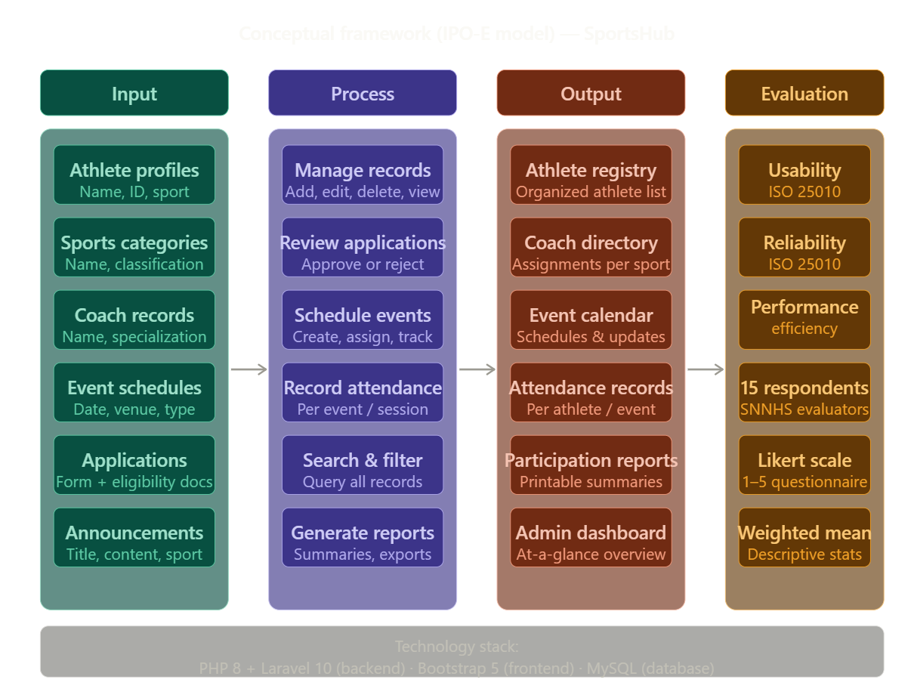
Figure 1. Conceptual Framework (IPO-E Model) - SportsHub, SNNHS
Figure 1 shows the flow of the study from left to right. The inputs consist of the users (athletes, coaches, and the Sports Coordinator), the requirements gathered through observation and informal consultation, the school’s sports policies, and the tools and technologies used in development. These inputs enter the process phase, where the system is designed, developed, tested, and implemented using the Rapid Application Development methodology. The outputs are the three functional interfaces of the system and the centralized records they generate. Finally, the evaluation phase assesses the system using the ISO/IEC 25010 quality model across usability, reliability, and performance efficiency.

4. METHODOLOGY
This chapter presents the research method, development model, research locale, respondents, data gathering instrument, statistical tools, and evaluation procedures used in the development and evaluation of SportsHub. The study followed the Rapid Application Development (RAD) model, which enabled the researchers to design, develop, test, and finalize the system within a compressed timeframe through iterative feedback and close collaboration with the end users.

Research Method
This study used the developmental research method, specifically the research and development (R&D) approach. Developmental research is commonly used in studies that aim to create a product, system, or innovation and evaluate its effectiveness. In this study, the researchers planned, designed, developed, tested, and evaluated SportsHub. The system was developed based on the actual needs of Surigao del Norte National High School in managing its sports activities and athlete records.

Research and Development Model
The Rapid Application Development (RAD) model was used as the framework for the development of SportsHub. RAD is a software development methodology that emphasizes rapid prototyping and quick feedback over long planning and strict development cycles. It consists of four phases: Requirements Planning, Rapid Prototyping (Design and Development), Feedback (User Testing), and Finalization (Implementation). This model was chosen because it allows the researchers to build working prototypes early, present them to the users, gather feedback, and make improvements before the final system is implemented. Figure 2 presents the RAD model used in this study.
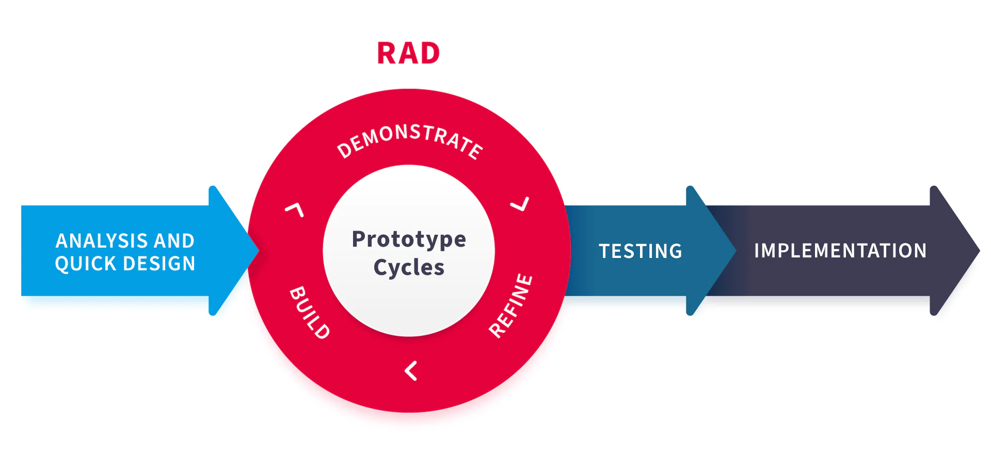
Figure 2. Rapid Application Development (RAD) Model

4.1 Planning Requirements
The first phase of the RAD model is the requirements planning phase, where the researchers identified the needs and problems of the school regarding sports management. During this phase, the researchers conducted informal observation and consulted with the school’s Sports Coordinator and student-athletes to understand the current process of managing sports activities and athlete records. The problems identified included the lack of a centralized database, manual recording of athlete information, difficulty in monitoring attendance, and inefficient handling of event schedules and medical records.
Based on the gathered requirements, the researchers defined the scope and features of the system. The system was designed to have three main interfaces: a public landing page, an athlete dashboard, and an administrator dashboard. The features included sports program management, athlete records management, coach assignments, event scheduling, calendar, attendance monitoring, medical records management, achievements, certificates, announcements, and downloadable reports. The researchers also determined the technologies to be used, which included PHP 8.2, Laravel 12, Tailwind CSS 4, and MySQL database.

4.2 Prototype
The second phase of the RAD model is the rapid prototyping phase, where the researchers designed and developed the initial version of the system. The user interface designs were created in Figma and served as the visual blueprint for the development team. The prototypes were organized into three groups that correspond to the three interfaces of the system: the public or landing page screens, the athlete dashboard screens, and the administrator dashboard screens. Figures 3 to 20 present the prototypes that were developed during this phase.

Public / Landing Page Screens
Figure 3 presents the prototype of the landing page, which is the entry point of the system and is accessible to any visitor without an account. Figure 4 presents the application form, which collects the applicant information together with the medical certificate, birth certificate, and signed parent or guardian consent. Figure 5 presents the login page, where the role of the user determines the dashboard that is loaded after authentication.
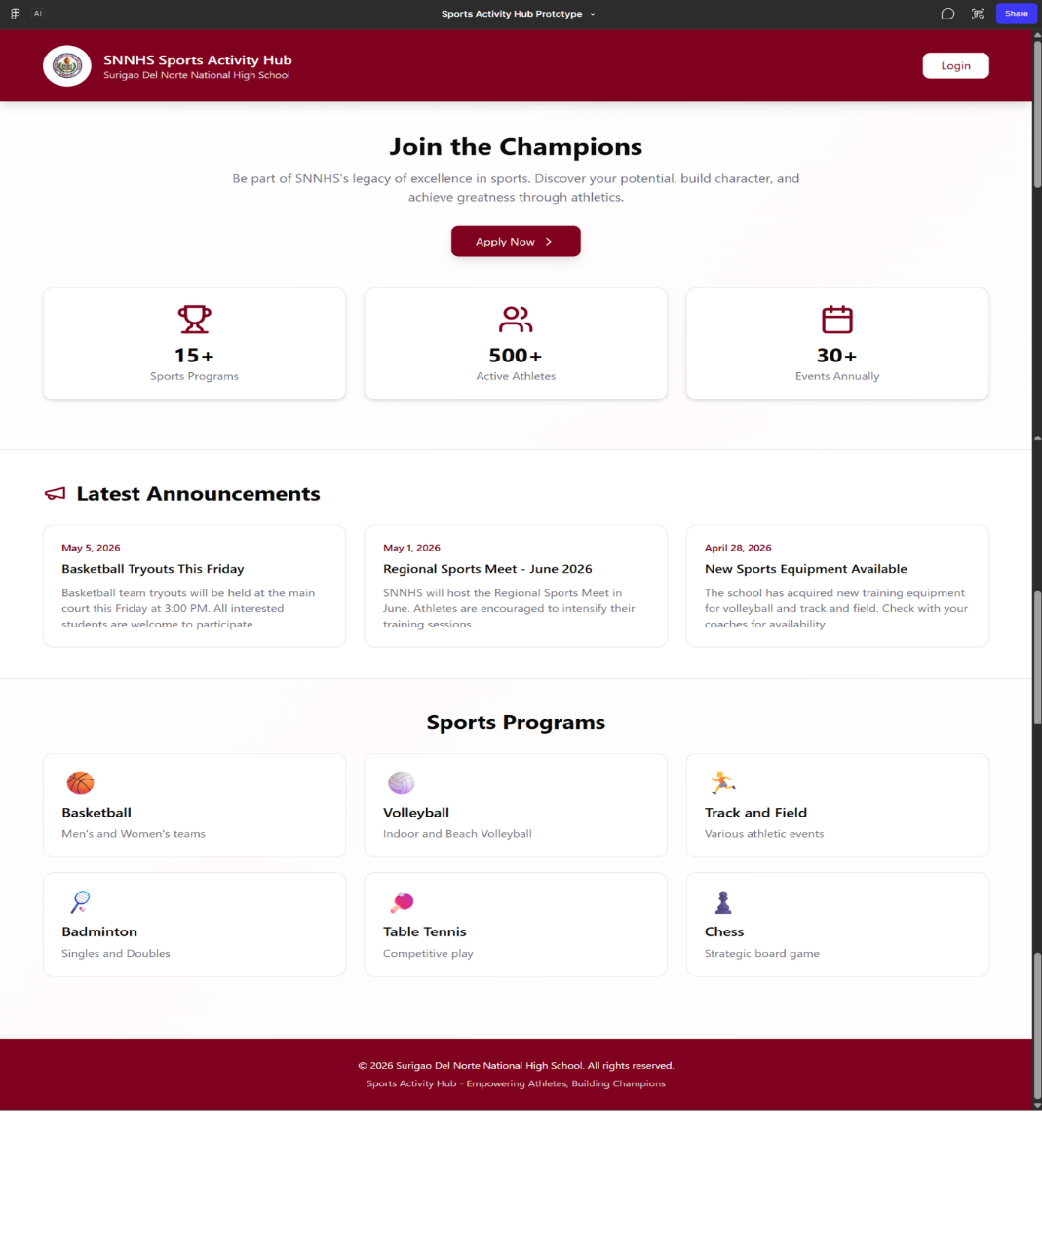
Figure 3. Landing Page Prototype - SportsHub
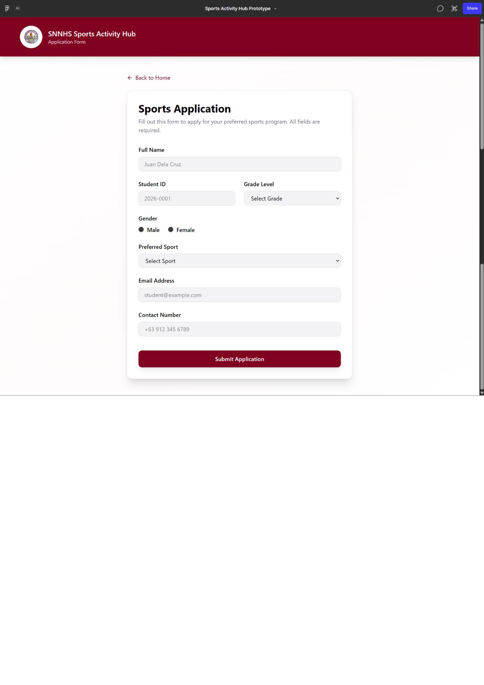
Figure 4. Application Form Page Prototype - SportsHub
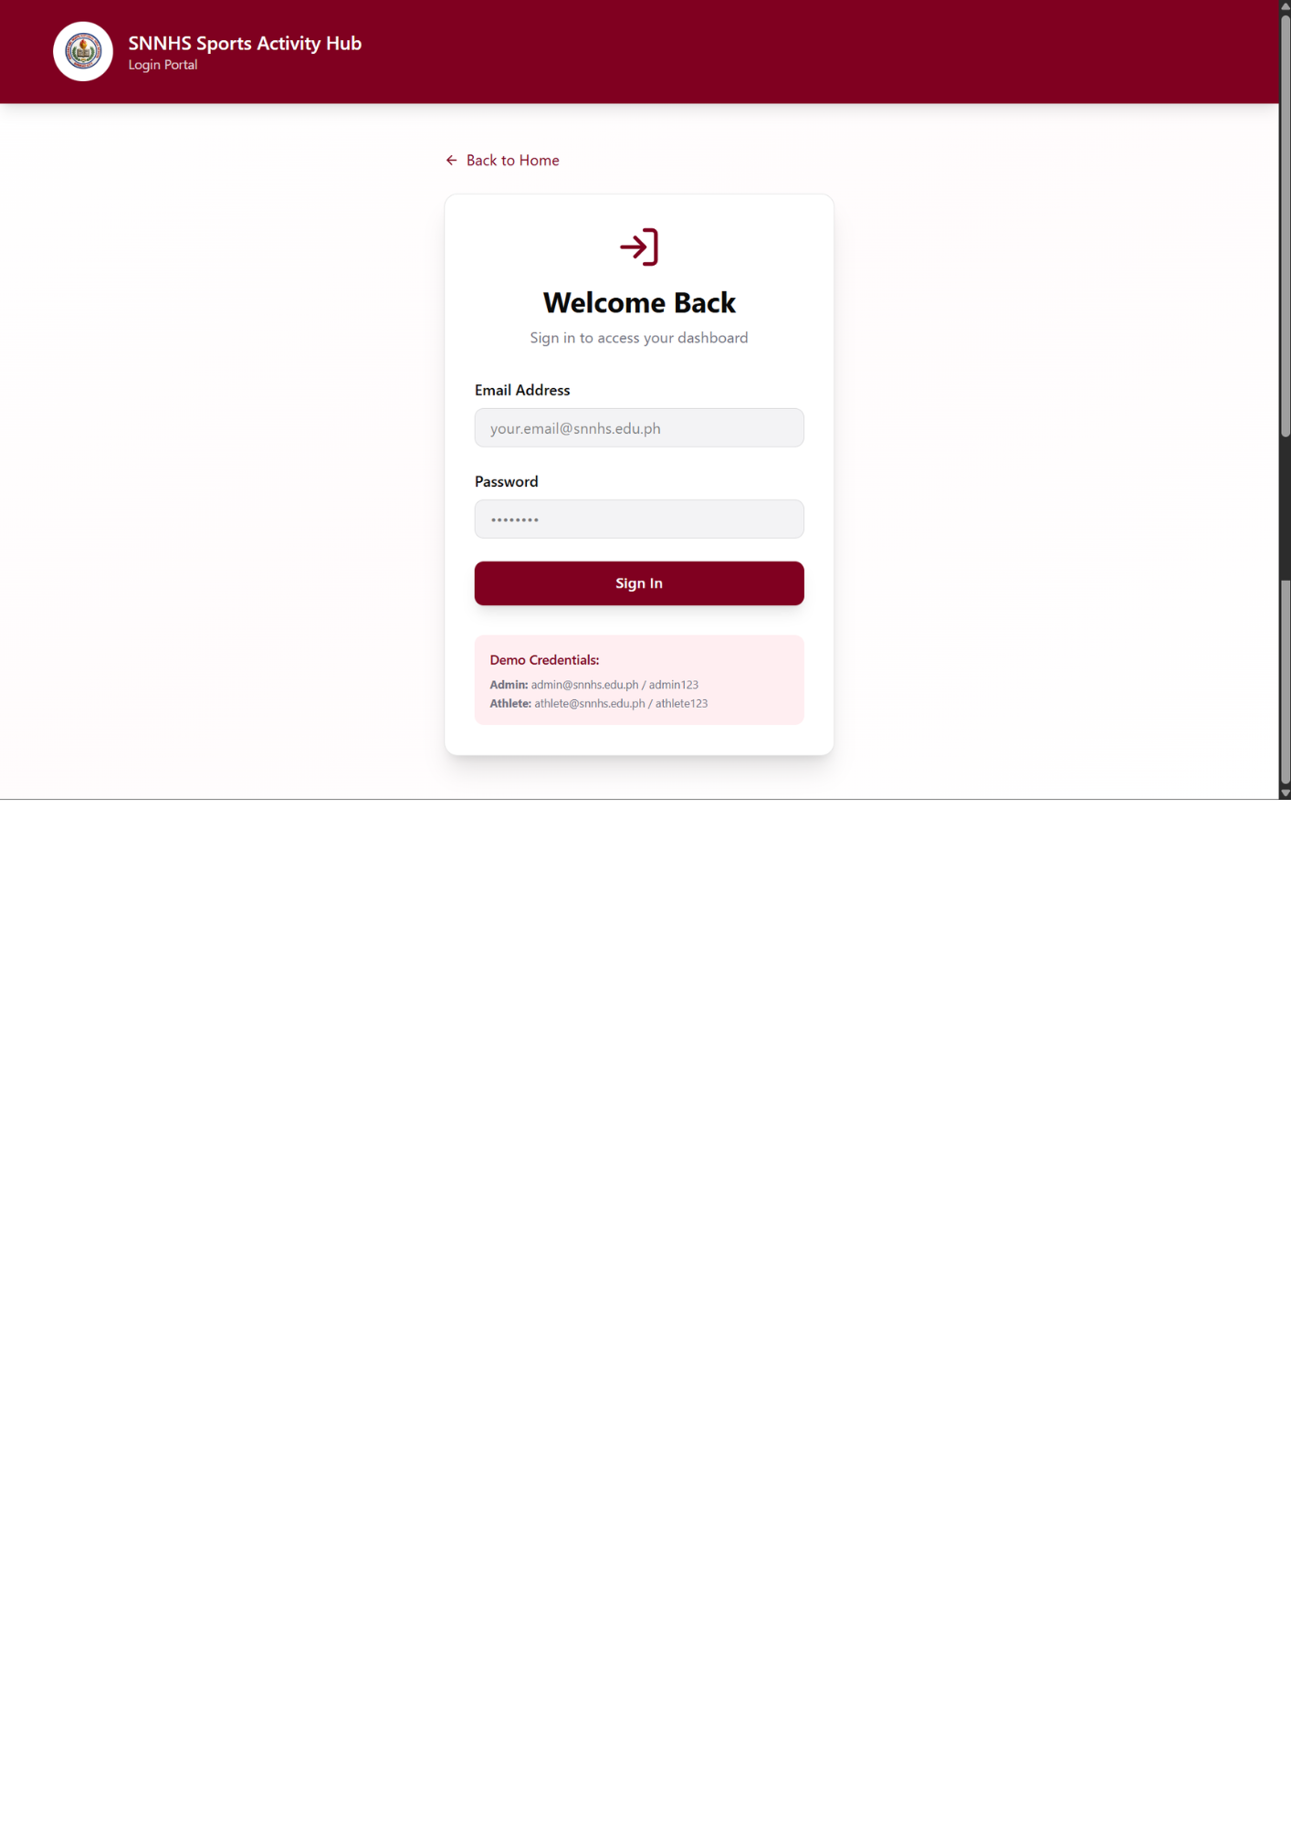
Figure 5. Login Page Prototype - SportsHub

Athlete Dashboard Screens
Figures 6 to 11 present the prototypes of the athlete dashboard screens. Figure 6 shows the athlete dashboard, which is the landing screen after an athlete logs in. Figure 7 presents My Schedule, Figure 8 presents the announcements page, Figure 9 presents the attendance page where the athlete checks in, Figure 10 presents the coach information page, and Figure 11 presents the My Profile page where the athlete updates personal details.
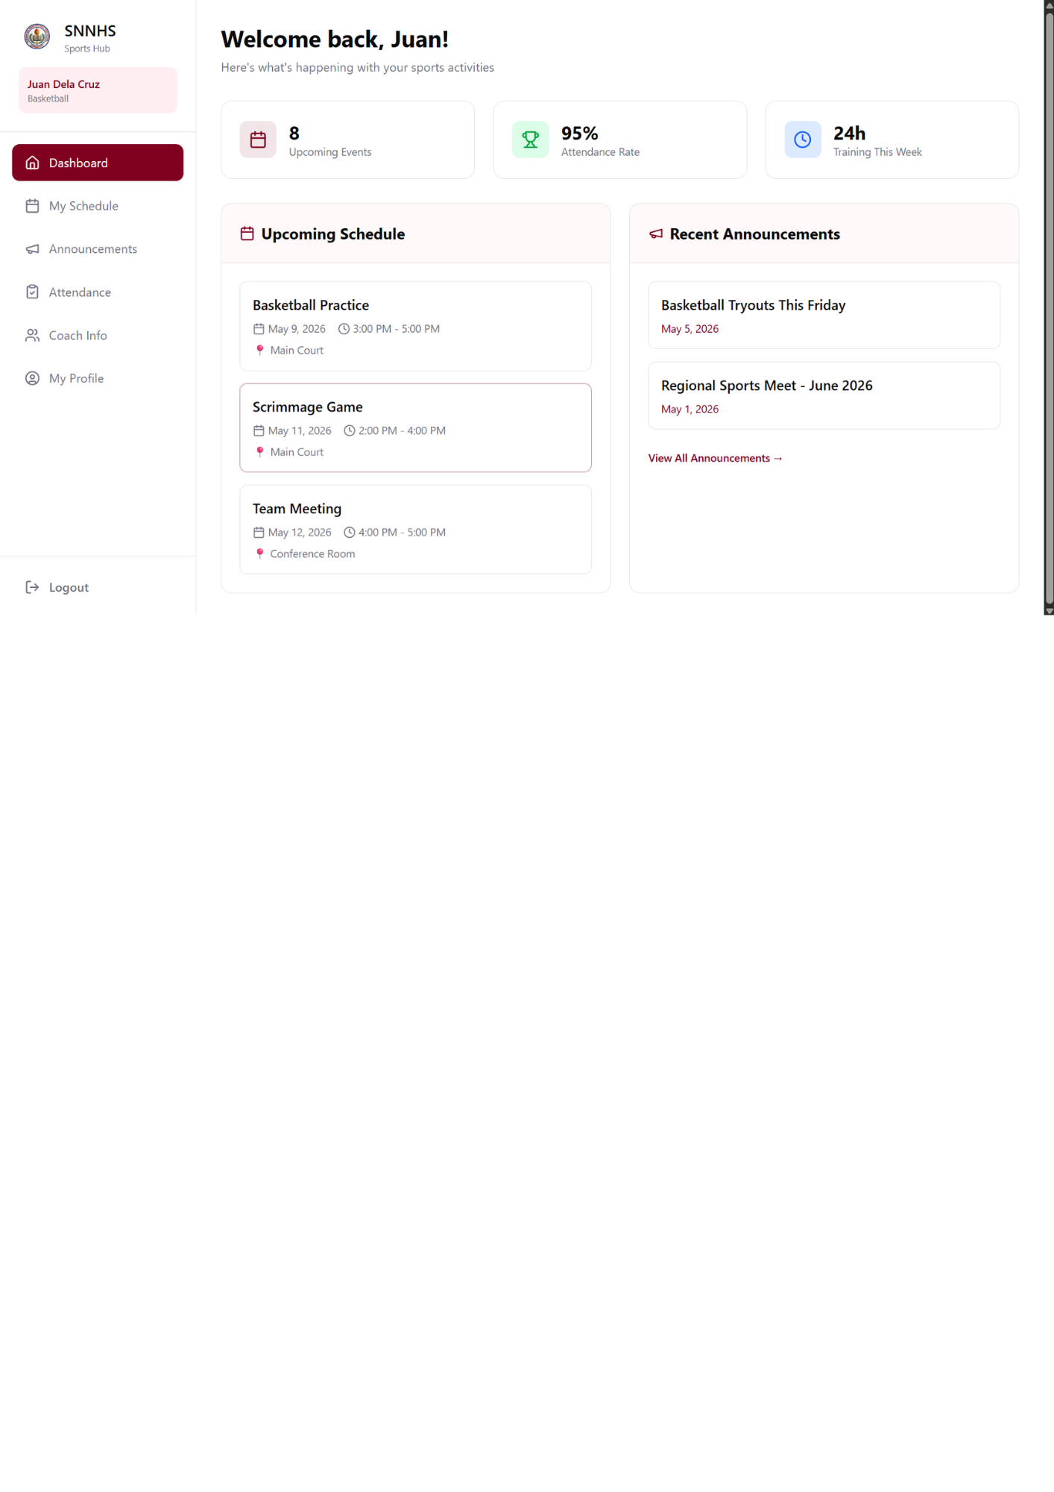
Figure 6. Athlete Dashboard Prototype - SportsHub
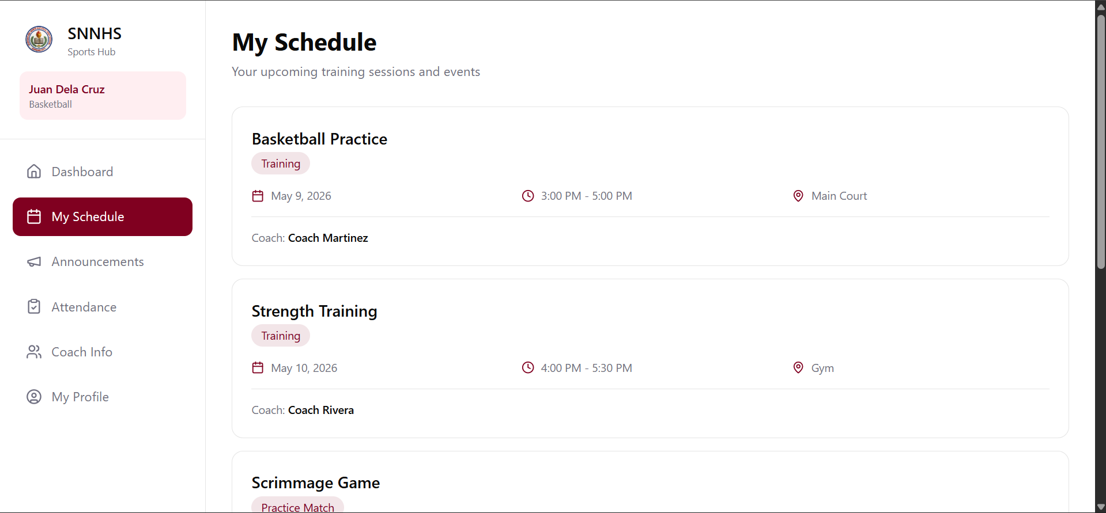
Figure 7. My Schedule Prototype - SportsHub
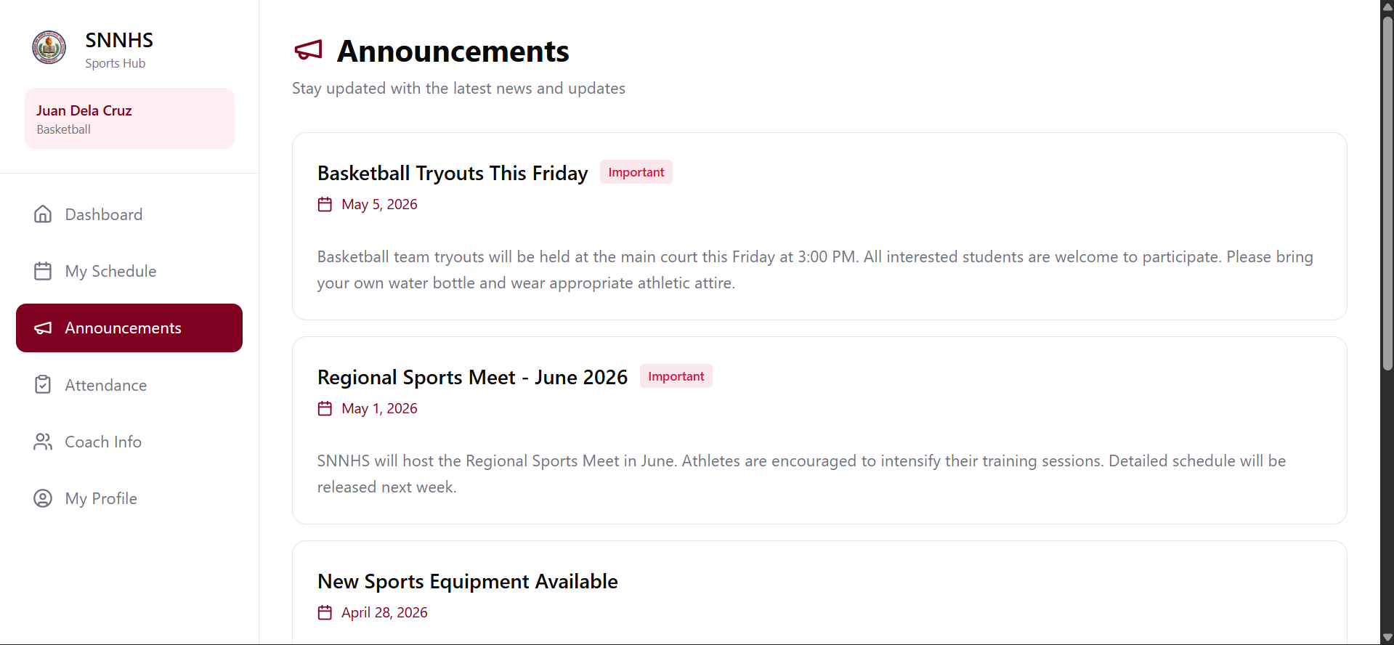
Figure 8. Announcements Page Prototype - SportsHub
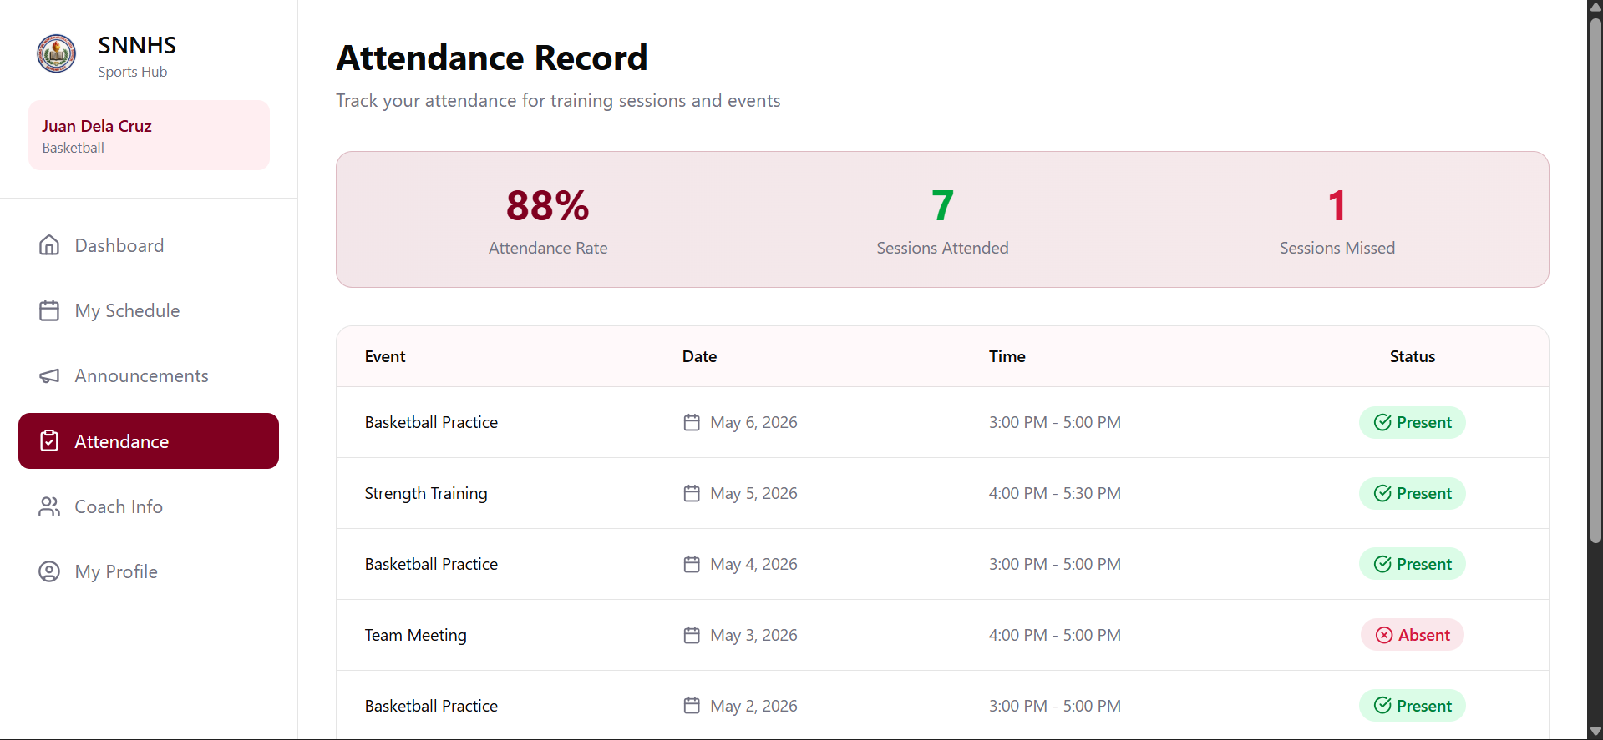
Figure 9. Attendance Page Prototype - SportsHub
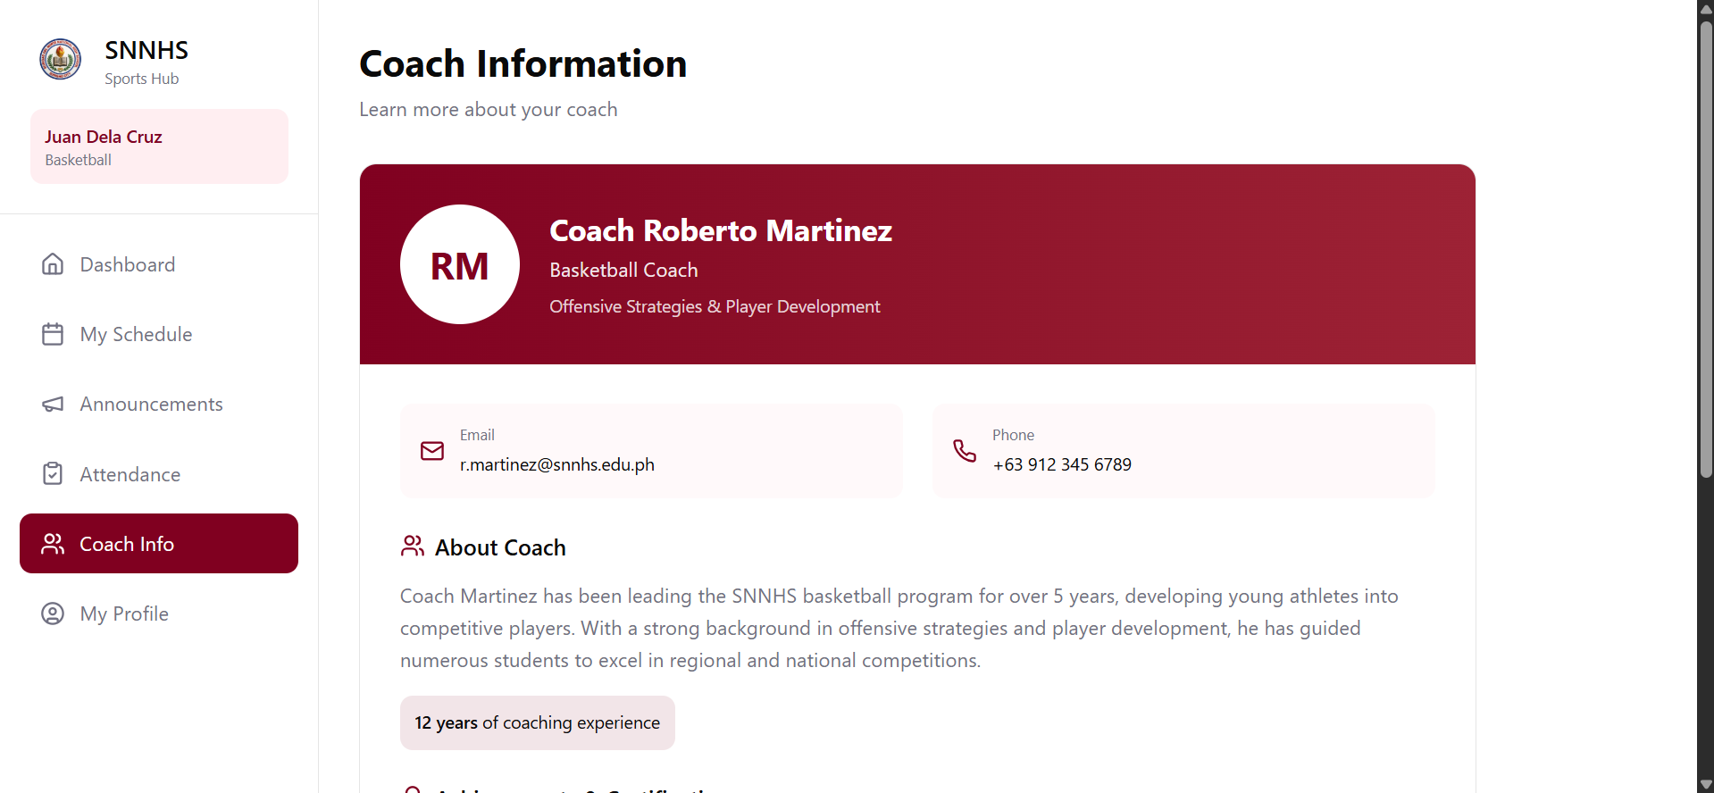
Figure 10. Coach Information Page Prototype - SportsHub
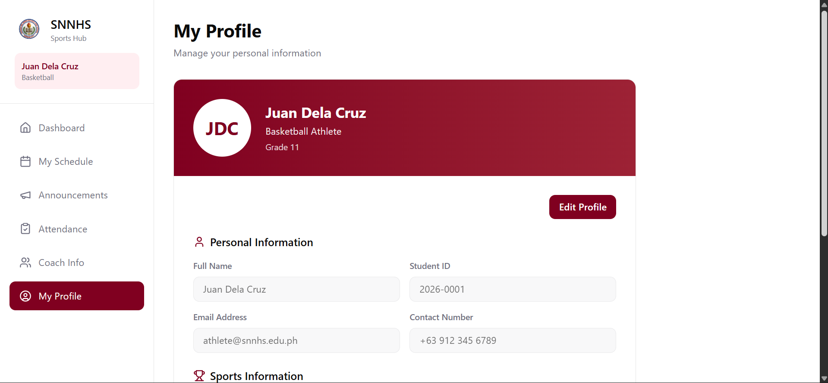
Figure 11. My Profile Page Prototype - SportsHub

Administrator Dashboard Screens
Figures 12 to 20 present the prototypes of the administrator dashboard screens. Figure 12 shows the administrator dashboard, which summarizes the counts of applications, athletes, sports programs, and events. Figures 13 to 18 present the management modules for applications, sports programs, athletes, coaches, events, and attendance sessions respectively. Figure 19 presents the announcement management prototype that was drawn during the design phase; during development this module was replaced by automatic event-driven publishing, so that an announcement is generated and withdrawn by the system itself rather than being written by hand. Figure 20 presents the reports module, where the administrator generates downloadable athlete, coach, and attendance reports.
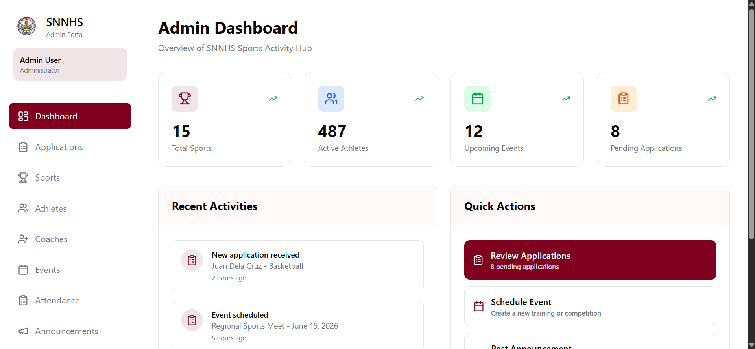
Figure 12. Administrator Dashboard Prototype - SportsHub
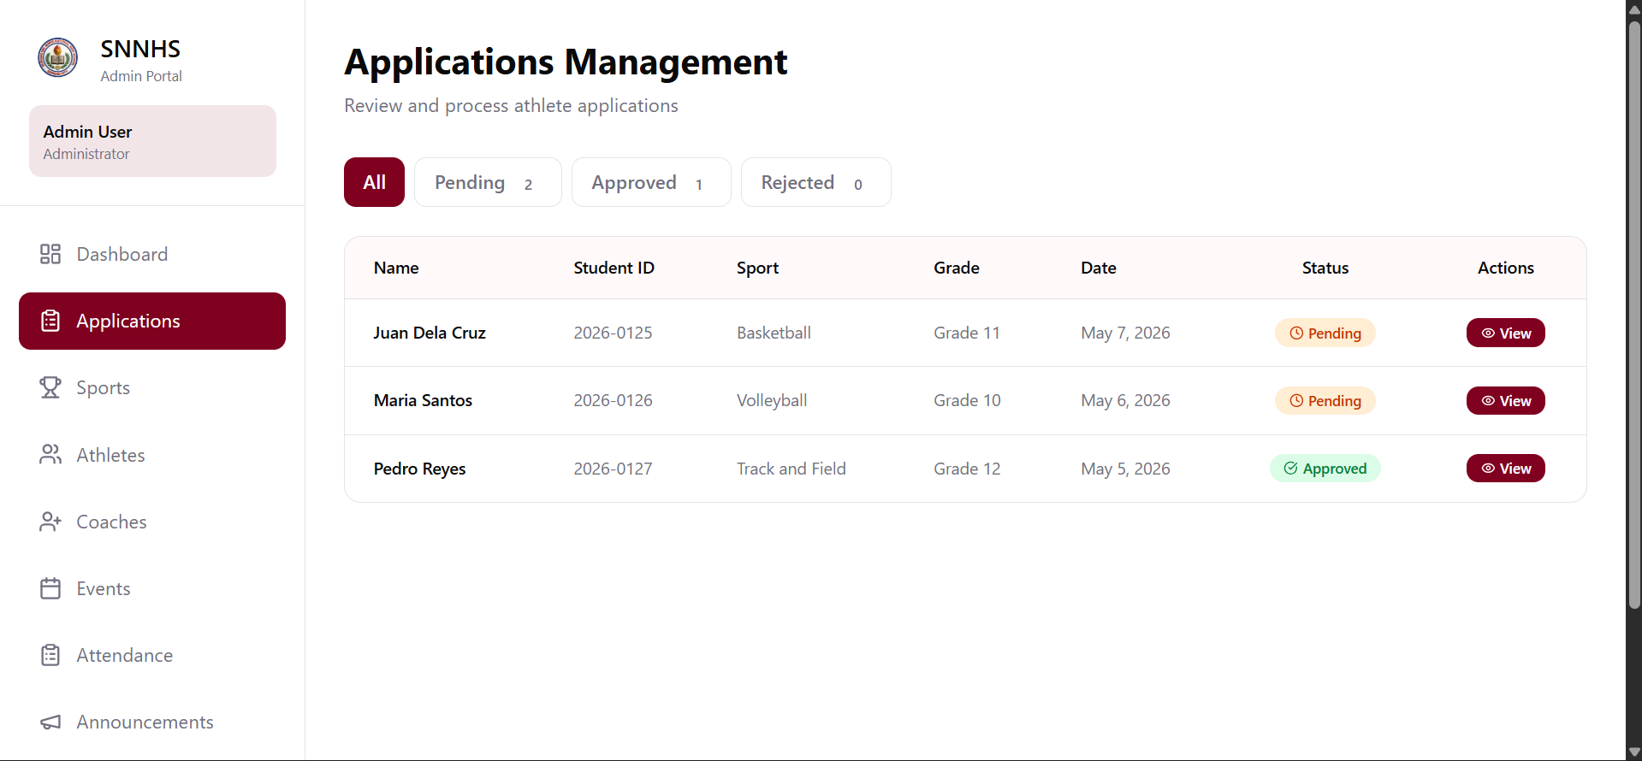
Figure 13. Applications Management Prototype - SportsHub
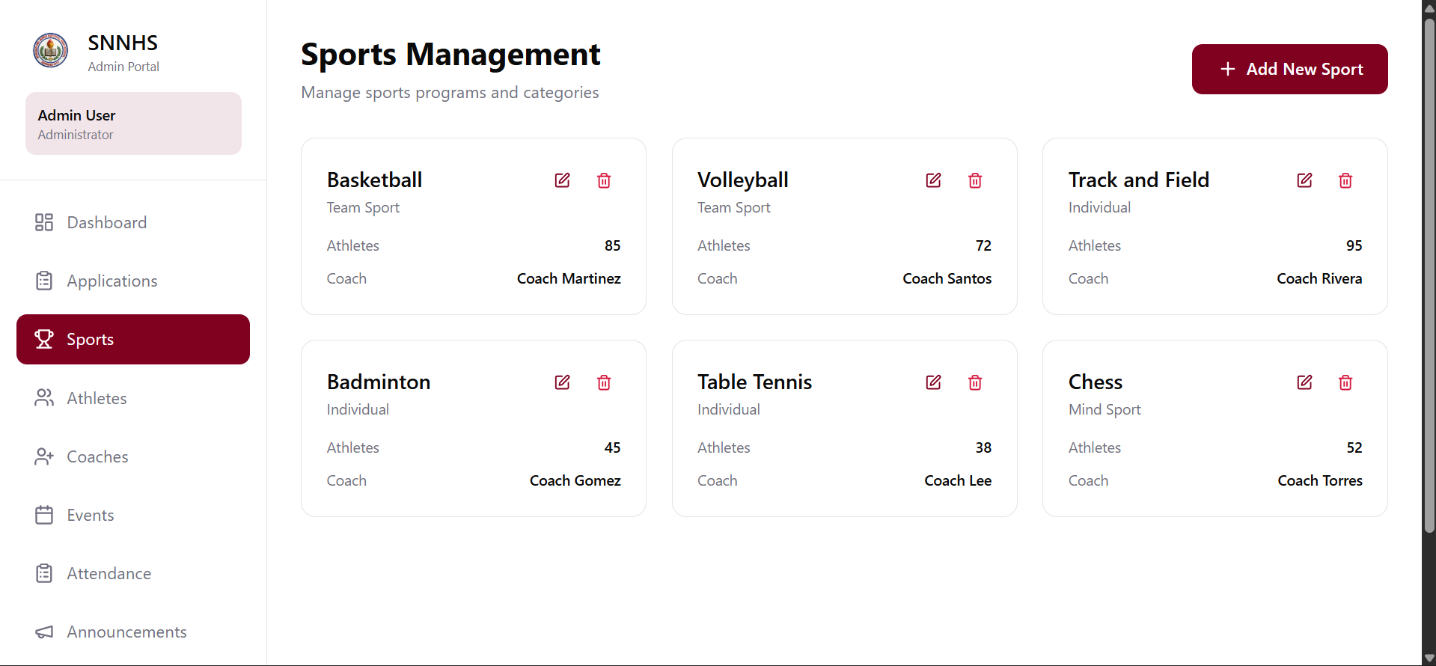
Figure 14. Sports Management Prototype - SportsHub
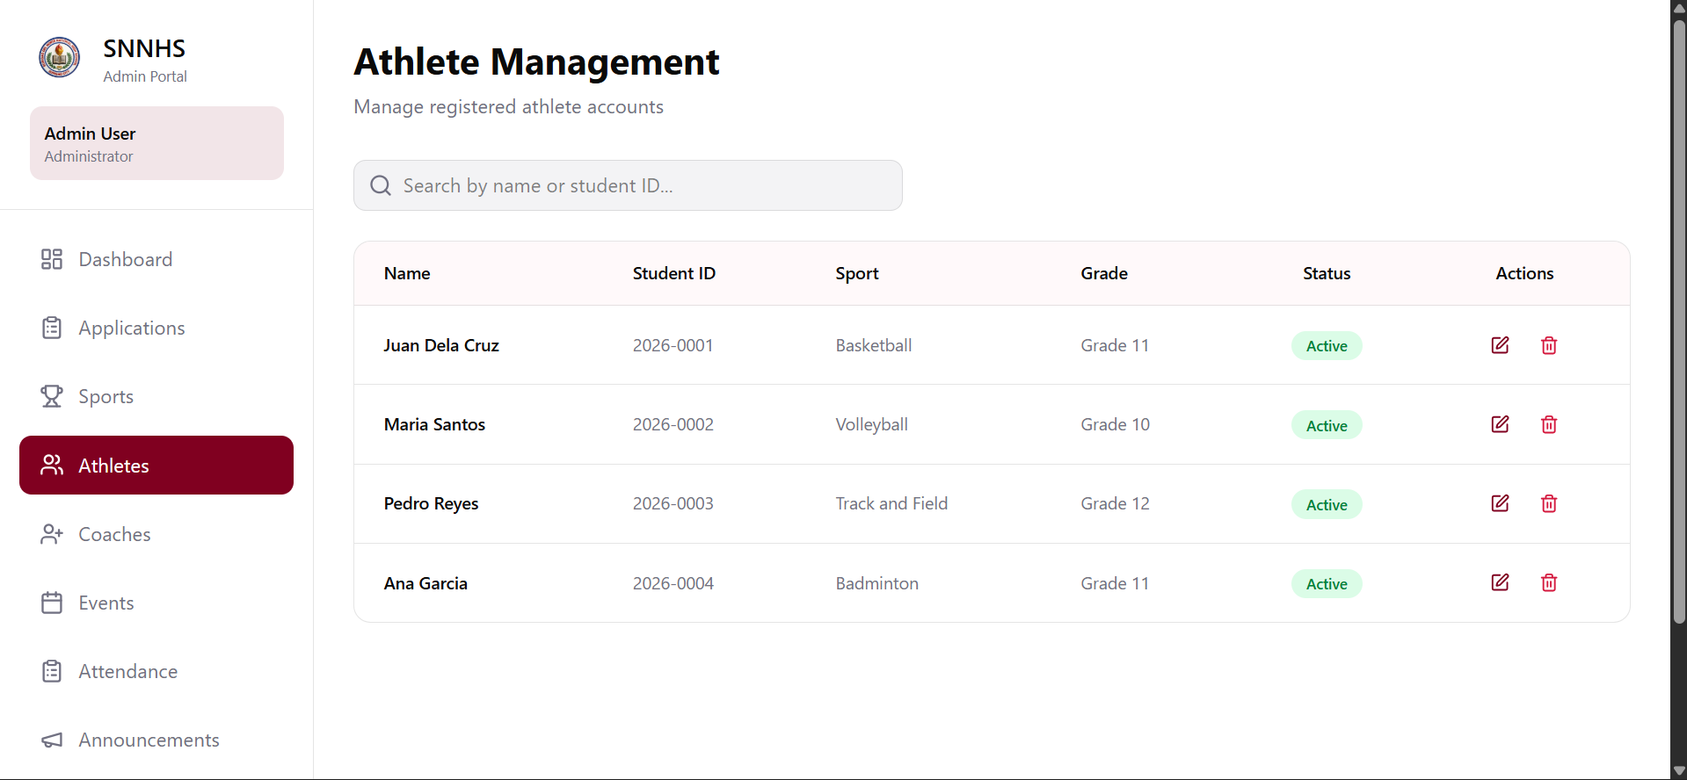
Figure 15. Athlete Management Prototype - SportsHub
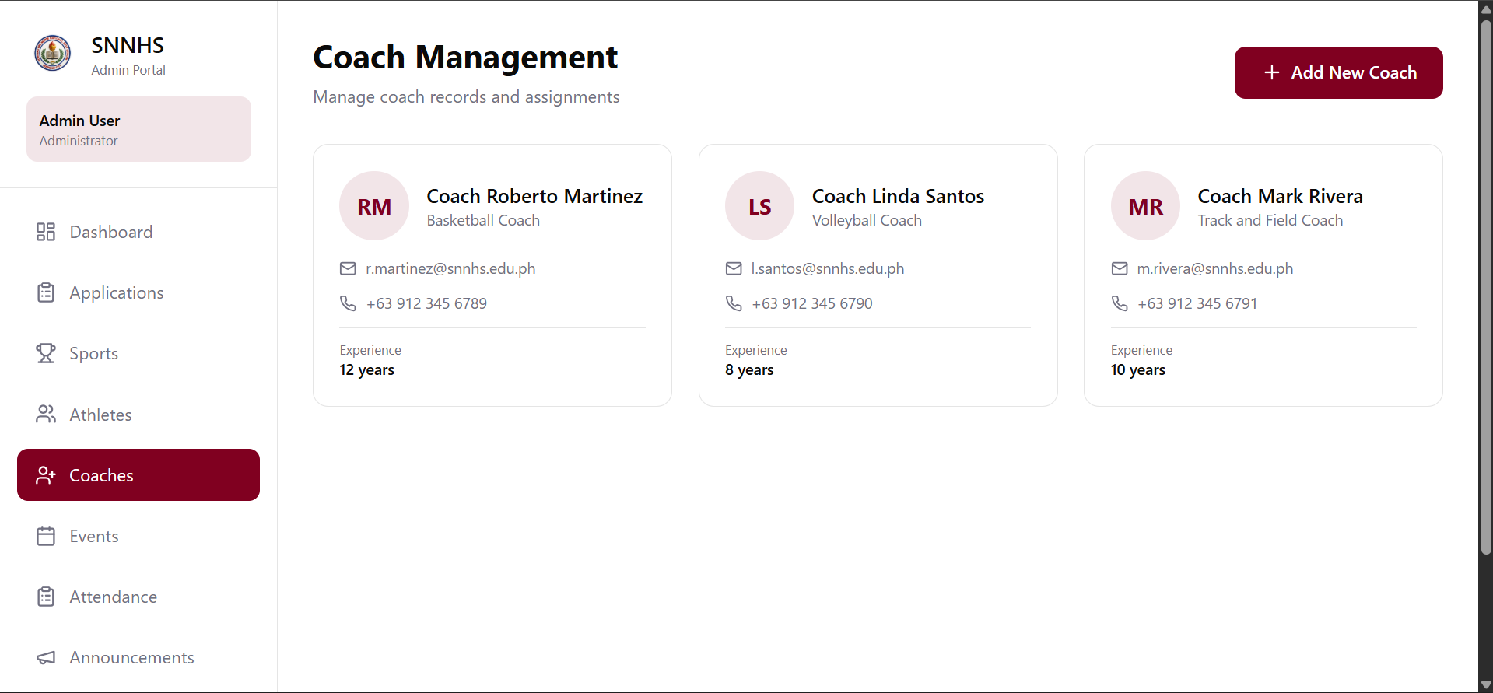
Figure 16. Coach Management Prototype - SportsHub
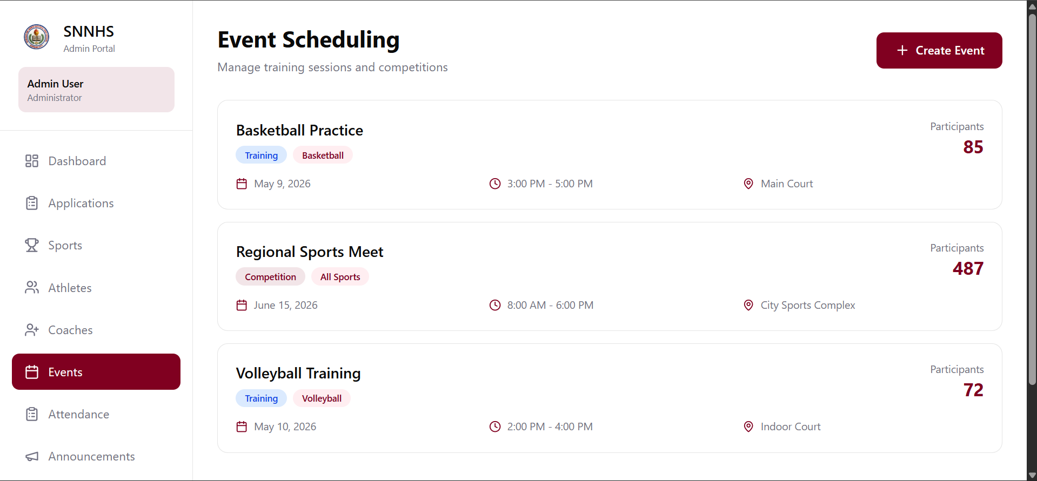
Figure 17. Event Scheduling Prototype - SportsHub
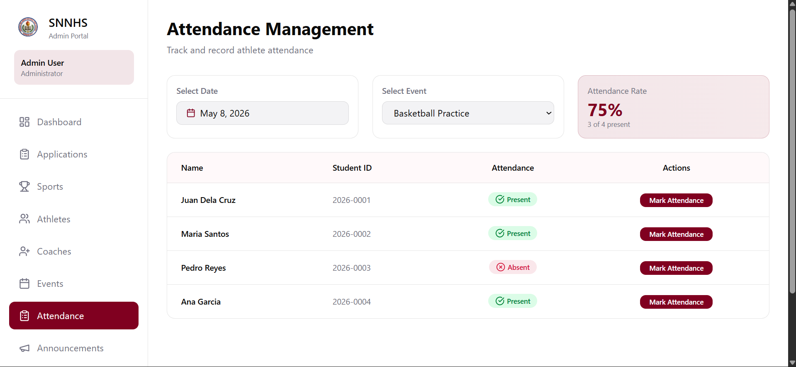
Figure 18. Attendance Management Prototype - SportsHub
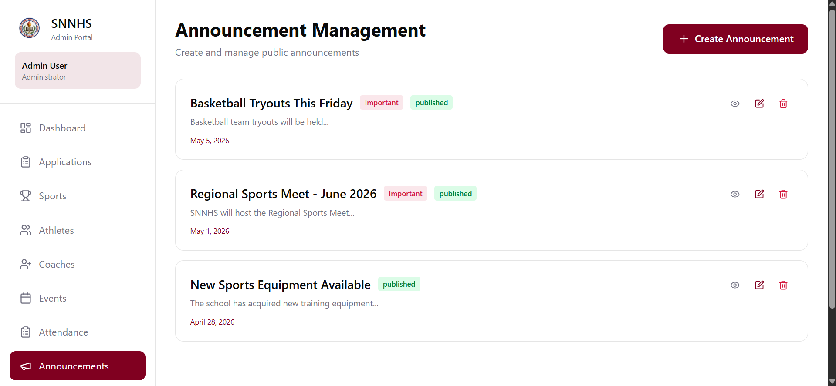
Figure 19. Announcement Management Prototype - SportsHub
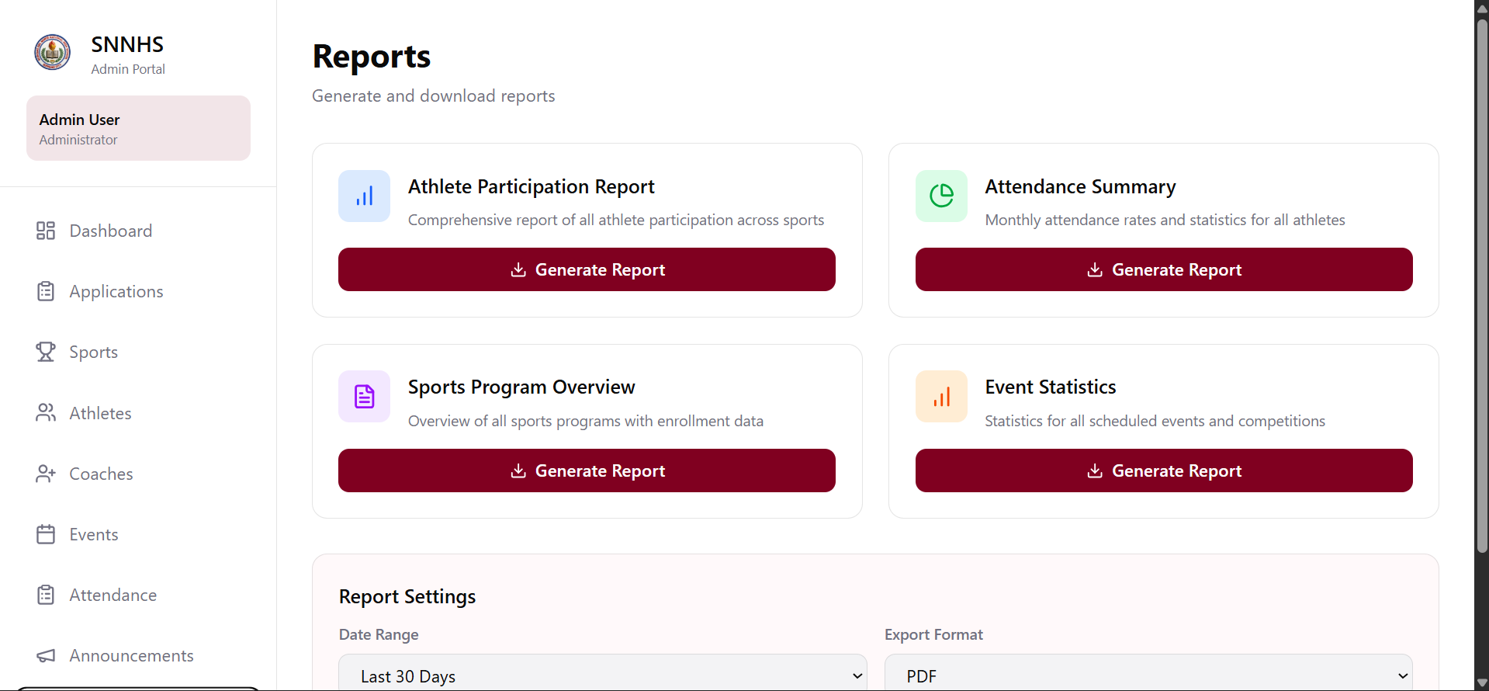
Figure 20. Reports Module Prototype - SportsHub
The prototypes presented in Figures 3 to 20 were shown to the respondents during the feedback phase. Their comments and suggestions were recorded and used as the basis for the improvements that were incorporated into the final system.

4.3 Receive Feedback
The third phase of the RAD model is the feedback phase, where the researchers presented the prototype to the respondents and gathered their comments and suggestions. During this phase, the researchers demonstrated the features and functionalities of the prototype to the Sports Coordinator, faculty sports advisers, and student-athletes. The respondents were asked to test the system and provide feedback on its usability, design, and functionality.
The feedback gathered during this phase was carefully reviewed and analyzed by the researchers. The respondents’ comments and suggestions were used as the basis for improving the system. Some of the improvements made based on the feedback included enhancing the user interface design, improving the navigation system, adding new features such as the shared calendar and the achievement certificate request, and fixing bugs and errors identified during testing. The researchers ensured that all the feedback was addressed before proceeding to the finalization phase.

4.4 Finalize Software
The fourth and final phase of the RAD model is the finalization phase, where the researchers finalized and deployed the system. During this phase, the researchers incorporated all the improvements and changes based on the feedback received. The system was tested thoroughly to ensure that all features and functionalities are working properly. The final version of the system was then deployed and made available for use by the school. The finalized system includes all the features and functionalities that were identified during the requirements planning phase and the improvements that were made during the feedback phase.

4.5 Evaluation Methods and Tools
After the software was finalized, it was evaluated by respondents from Surigao del Norte National High School using a structured questionnaire based on the ISO/IEC 25010 Software Quality Model. The evaluation was conducted in the school’s computer laboratory, where respondents accessed the deployed system through a web browser and rated their actual experience of using it after interacting with its major modules.
The questionnaire consisted of fifteen (15) items divided into three sections, with five items per section. Section A measured Usability, covering the simplicity of the interface for non-technical users, the speed of learning the system, the ease of finding and accessing features through the menu and navigation, the clarity and organization of the layout and labels, and the clarity of the messages, instructions, and feedback provided by the system. Section B measured Reliability, covering correct and error-free performance during regular use, accurate saving of records without data loss, graceful handling of invalid or incomplete inputs, recovery from unexpected situations such as a dropped connection or a page refresh without corrupting data, and the consistent delivery of accurate attendance rates, reports, and certificates. Section C measured Performance Efficiency, covering the speed at which pages and dashboards load, the responsiveness of the system to user actions, the acceptability of response times under the school’s normal internet connection, responsiveness when handling large amounts of data, and efficient operation on the devices used.
Each item was answered on a 5-point Likert scale, ranging from 1 (Strongly Disagree) to 5 (Strongly Agree). Respondents were also asked to indicate their position or role, their sport or club affiliation, and the frequency of their use of the system during the evaluation session. The questionnaire further included three open-ended questions that invited the respondents to name the most useful aspect of the system, to describe any difficulty they encountered, and to recommend improvements for future development.
Respondents were selected using purposive sampling. The criteria for selecting respondents were that they must be currently enrolled students or currently assigned faculty members of SNNHS, they must have direct involvement in or knowledge of the school’s sports activities, and they must be willing to participate voluntarily in the evaluation. A total of fifteen (15) respondents participated, consisting of one (1) Sports Coordinator, three (3) faculty members serving as sports advisers, and eleven (11) student-athletes from different sports categories.
The evaluation was administered personally by the researchers. Respondents were given an orientation on the purpose of the study and instructions on how to navigate the system before they began the evaluation. They were encouraged to interact with the major modules of the system before answering the instrument to ensure that their ratings were based on actual experience. The researchers were present during the evaluation to clarify questions and assist respondents who encountered difficulties.
The data gathered were tallied, tabulated, and treated statistically using weighted mean. The weighted mean was used to determine the average rating of each quality characteristic and of the individual items within each section. The weighted means were interpreted using the scale provided in Table 1, which reports both the verbal interpretation and the corresponding quality level.
Weighted Mean | Verbal Interpretation | Quality Level
4.50 - 5.00 | Strongly Agree | Excellent
3.50 - 4.49 | Agree | Very Satisfactory
2.50 - 3.49 | Neutral | Satisfactory
1.50 - 2.49 | Disagree | Needs Improvement
1.00 - 1.49 | Strongly Disagree | Poor

Table 1. Likert Scale Interpretation for ISO 25010 Evaluation

5. RESULTS AND DISCUSSION
This chapter presents the results and discussion of the study. It covers the project planning, the systems design, the implementation of the system, the evaluation of the system, and the features of the Progressive Web Application that was delivered to Surigao del Norte National High School.

5.1 Project Planning
The first phase of the study involved gathering information about the current sports management practices at Surigao del Norte National High School. The researchers conducted informal observation and consulted with the school’s Sports Coordinator and student-athletes to identify the problems being experienced. The problems identified included the lack of a centralized database for athlete records, manual recording of sports activities and events, difficulty in monitoring attendance and participation, inefficient handling of medical records and clearances, and the absence of a proper system for scheduling events and sharing information with students.
Based on these problems, the researchers defined the scope and objectives of the system. The system was designed to provide a centralized platform where all sports-related data can be stored, managed, and retrieved efficiently. The features of the system were identified based on the actual needs of the school, which included sports program management, athlete records management, coach assignments, event scheduling, shared calendar, attendance monitoring, medical records management, achievements, certificates, announcements, and downloadable reports.
The researchers also prepared the project plan and schedule using the Gantt chart presented in Table 2. The chart shows the activities that were performed during the development of the system and the duration of each activity. The total duration of the project was eleven (11) weeks, which covered all the phases of the Rapid Application Development model from requirements planning to evaluation.
No. | Activity | Wk 1 | Wk 2 | Wk 3 | Wk 4 | Wk 5 | Wk 6 | Wk 7 | Wk 8 | Wk 9 | Wk 10 | Wk 11
1 | Requirements Gathering and Analysis | X | X
2 | System Design and Prototyping |  | X | X | X
3 | Database Design |  |  | X | X
4 | System Development |  |  |  | X | X | X | X
5 | Testing and Debugging |  |  |  |  |  |  | X | X
6 | User Evaluation |  |  |  |  |  |  |  |  | X
7 | Finalization and Deployment |  |  |  |  |  |  |  |  |  | X | X

Table 2. Project Gantt Chart
The Gantt chart presented in Table 2 shows the overall timeline of the project from the first week to the eleventh week. The first two weeks were allocated for requirements gathering and analysis, where the researchers identified the problems experienced by the school and defined the features of the system. The next three weeks, from week two to week four, were used for system design and prototyping, where the researchers created the user interface designs using Figma and developed the initial version of the system. Database design was performed during weeks three and four, where the researchers designed the relational database structure that would store all the data of the system. The longest phase of the project was the system development, which spanned from week four to week seven. During this phase, the researchers coded the application logic, implemented the features, and integrated the different modules of the system. Testing and debugging were performed during weeks seven and eight to ensure that all features and functionalities are working properly and that the system is free from errors and bugs. User evaluation was conducted during week nine, where the respondents tested the system and provided feedback based on their actual experience. Finally, the last two weeks, weeks ten and eleven, were allocated for finalization and deployment, where the researchers incorporated the improvements based on the feedback received and deployed the final version of the system.
The total duration of eleven (11) weeks was sufficient to complete the project because the researchers followed the Rapid Application Development model, which emphasizes rapid prototyping and quick feedback. The RAD model allowed the researchers to develop the system incrementally and to make improvements at each stage without requiring long planning and strict development cycles. The schedule also allowed the researchers to allocate sufficient time for testing and evaluation, which are critical phases in ensuring the quality and effectiveness of the system.
The project schedule also shows that the researchers were able to manage their time effectively and to complete the project within the allocated duration. The researchers conducted regular meetings and coordination with the school to ensure that the system was developed according to the actual needs and requirements of the school. The Gantt chart served as a guide for the researchers in monitoring the progress of the project and in ensuring that all the activities were completed on schedule. The schedule also provided the school with a clear timeline of the project, which helped in setting expectations and in preparing for the deployment of the system.

5.2 Systems Design
This section presents the systems design of SportsHub, which was documented through UML diagrams. The use-case diagram, class diagram, and sequence diagram illustrate the different aspects of the system, from the interactions of the users with the system, to the structure of the data, and the flow of operations within the system. These diagrams served as the blueprint for the development of the system and provided a clear understanding of how the system works.

a. Use-Case Diagram
The Use-Case Diagram illustrates the interactions between the system’s three distinct actor groups and the use cases assigned within a clearly defined system boundary. Each actor operates exclusively within their designated boundary to prevent overlapping responsibilities: the Public User interacts solely with the landing page and the application form, the Athlete accesses the athlete dashboard and its associated functions, and the Admin (Sports Coordinator) manages the entire administrative dashboard. This separation of concerns ensures role-based access control, data integrity, and a clear separation of duties between regular users, athletes, and administrators.
The system boundary encapsulates all use cases, ensuring that every function is properly categorized under the correct actor. The Public User use cases include viewing the landing page, browsing available sports programs, reading announcements, and submitting an application form with required documents. The Athlete use cases include viewing schedules, checking attendance records, viewing achievements, viewing coach information, checking application status, requesting certificates, checking in to attendance sessions, and updating profile details. The Admin use cases include managing applications and documents, managing sports programs, managing athlete accounts, managing coach assignments, managing events, managing attendance sessions, managing medical records, managing achievements, managing certificate requests, and generating reports.
The Use-Case Diagram reflects the role-based access control mechanism of the system. Each actor is restricted to specific use cases based on their role, and unauthorized access is prevented. The system boundary also ensures that all use cases are properly documented and that the functionality of the system is clearly defined. Figure 21 presents the Use-Case Diagram of the system.
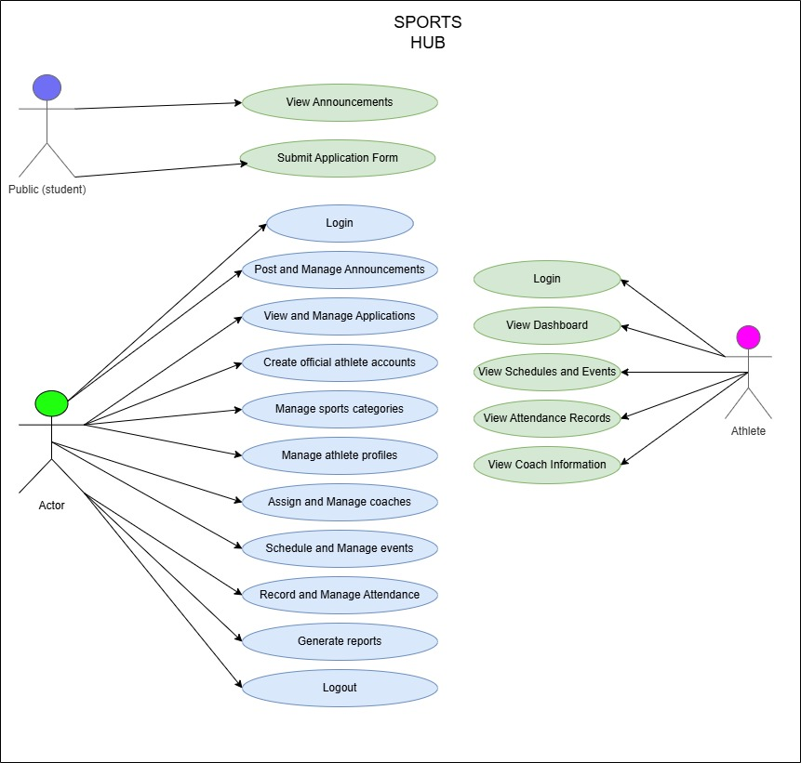
Figure 21. Use-Case Diagram - SportsHub

b. Class Diagram
The Class Diagram illustrates the structure of the system by showing the classes, their attributes, methods, and the relationships between them. The system consists of thirteen main entities: User, Application, ApplicationDocument, ApplicationStatusHistory, SportsProgram, CoachAssignment, Event, AttendanceSession, AttendanceRecord, MedicalRecord, MedicalCertificate, InjuryIncident, and Achievement.
The User class is the central entity of the system and stores the account information of all users, including the Sports Coordinator, coaches, and athletes. Each user has a role that determines the level of access to the system. The Application class stores the application records submitted by students, and is linked to the ApplicationDocument class, which stores the individual documents attached to each application. The ApplicationStatusHistory class records every status change of an application, providing a complete audit trail of the review process. The SportsProgram class stores the different sports programs offered by the school, while the CoachAssignment class links coaches to their assigned sports programs. The Event class stores the schedules of sports events and activities, and is linked to the AttendanceSession class, which represents the sessions where athletes check in. The AttendanceRecord class stores the individual check-in records of athletes for each session. The MedicalRecord class stores the medical examination results and clearance status of athletes, while the MedicalCertificate class stores the uploaded medical certificates with their expiry information. The InjuryIncident class records the injury history of each athlete, and the Achievement class stores the awards and recognitions received by athletes.
The relationships between the classes are defined using foreign keys and Eloquent relationships. A User can have many Applications if they are a student, or can be linked to many SportsPrograms if they are a coach. Each Application has many ApplicationDocuments and many ApplicationStatusHistory entries. Each SportsProgram has many Events, and each Event can have many AttendanceSessions. Each AttendanceSession has many AttendanceRecords, and each Athlete User has many AttendanceRecords. Each User can have many MedicalRecords and many Achievements. These relationships ensure that the data is properly linked and that the system can retrieve related information efficiently.
The Class Diagram provides a clear understanding of the data structure of the system and served as the basis for the design of the database schema. The diagram was carefully reviewed and validated against the implemented Eloquent models to ensure that all entities and relationships are accurately represented. Figure 22 presents the Class Diagram of the system.
[ INSERT SCREENSHOT HERE ]
Class Diagram of SportsHub (regenerate to show the 13 entities described above)

Figure 22. Class Diagram - SportsHub

c. Sequence Diagram
The Sequence Diagram illustrates the order of messages and operations exchanged among the actors, the application controllers, the domain models, and the database when a specific scenario is carried out. Unlike the Use-Case Diagram, which shows what the system does, and the Class Diagram, which shows what the system is made of, the Sequence Diagram shows how the system behaves over time for a single use case.
Three principal scenarios were documented. The first scenario covers the submission of a sports application, in which an unauthenticated student opens the landing page, completes the application form, attaches the medical certificate, birth certificate, and signed parent consent, and submits the form. The request is handled by the public application controller, which validates the payload, stores the three files through the Laravel storage disk, creates the application record together with its three document rows and an initial status history entry, and returns the applicant reference number that the student uses to track progress. The second scenario covers the administrative review and approval of an application, in which the Sports Coordinator opens the applications module, inspects each uploaded document, records verification results, records review notes or a rejection reason, and approves the application. Upon approval, the controller creates the athlete account, assigns the sport, generates a one-time temporary password, and flags the account so that the athlete must set a personal password on first login. The third scenario covers athlete attendance check-in, in which an authenticated athlete opens the current attendance session, submits a check-in, and the attendance session service records the check-in as Present or Late depending on the configured late grace period, updates the attendance rate of the athlete, and issues a notification.
These sequences were validated against the implemented controllers and services. All state transitions were confirmed against the actual code: the application status history, the per-document verification states, the temporary-password flag, and the late grace period are all implemented as described. Figure 23 presents the Sequence Diagram of the system.
[ INSERT SCREENSHOT HERE ]
Sequence Diagram of SportsHub (Application Submission, Approval, and Attendance Check-in)

Figure 23. Sequence Diagram - SportsHub

5.3 System Implementation
This section presents the actual implementation of the SportsHub system. The implemented system is organized into three interfaces: the public interface, which is accessible to any visitor without an account; the athlete portal, which is accessible to approved and registered athletes; and the administrator portal, which is restricted to the Sports Coordinator. Each interface was implemented as described in the systems design, and the screenshots of each screen are presented below.
The system was developed using PHP 8.2 and the Laravel 12 framework, with MySQL as the database management system and Tailwind CSS 4 for the user interface. The application was delivered as an installable Progressive Web Application with a web app manifest and a service worker that caches the application shell. All screens described below are accessible through a standard web browser on desktop, tablet, and mobile devices.

Public Interface
The public interface is the first point of contact between the school and the students. It contains the landing page, the application form, the login page, and the password reset page. Any visitor can access these pages without logging in. Figure 24 presents the landing page of the system, which displays the school identity, the calls to action, and the auto-published announcements generated from the scheduled events. Figure 25 presents the application form, which collects the applicant information and the three required documents. Figure 26 presents the login page, and Figure 27 presents the password reset page, which uses the token-based password reset broker of Laravel.
[ INSERT SCREENSHOT HERE ]
Public landing page with auto-published announcements

Figure 24. Landing Page - SportsHub
[ INSERT SCREENSHOT HERE ]
Application form with medical certificate, birth certificate, and parent consent uploads

Figure 25. Application Form Page - SportsHub
[ INSERT SCREENSHOT HERE ]
Role-based login page

Figure 26. Login Page - SportsHub
[ INSERT SCREENSHOT HERE ]
Token-based password reset request and confirmation

Figure 27. Password Reset Page - SportsHub

Athlete Portal
The athlete portal is the personal workspace of every registered athlete. Access is granted only after the Sports Coordinator has approved an application and created the athlete account. On first login the athlete is required to replace the one-time temporary password before any other screen is rendered. Figure 28 presents the athlete dashboard, which summarizes the athlete’s programs, upcoming events, and unread notifications. Figure 29 presents the sports programs module, Figure 30 presents My Schedule, and Figure 31 presents the calendar, which merges every event and attendance session of the athlete’s assigned sport into a single month view.
[ INSERT SCREENSHOT HERE ]
Athlete dashboard summary screen

Figure 28. Athlete Dashboard - SportsHub
[ INSERT SCREENSHOT HERE ]
List of sports programs with roster count

Figure 29. Sports Programs Page - SportsHub
[ INSERT SCREENSHOT HERE ]
Assigned events and attendance sessions of the athlete

Figure 30. My Schedule Page - SportsHub
[ INSERT SCREENSHOT HERE ]
Merged event and attendance session calendar

Figure 31. Calendar Page - SportsHub
Figure 32 presents the attendance record screen, which displays the attendance rate of the athlete and the check-in button for sessions that are currently open. Figure 33 presents My Achievements, and Figure 34 presents the achievement certificate request screen. Figure 35 presents My Application, where the athlete tracks the review status of the submitted application, reads the feedback of the Sports Coordinator, and downloads the uploaded documents. Figure 36 presents the coach information screen, and Figure 37 presents My Profile, where the athlete updates contact details, emergency contact information, and the profile photograph.
[ INSERT SCREENSHOT HERE ]
Attendance rate and check-in to open sessions

Figure 32. Attendance Record Page - SportsHub
[ INSERT SCREENSHOT HERE ]
Awards and recognitions of the athlete

Figure 33. My Achievements Page - SportsHub
[ INSERT SCREENSHOT HERE ]
Request an official certificate for an earned achievement

Figure 34. Certificate Request Page - SportsHub
[ INSERT SCREENSHOT HERE ]
Application status, feedback, and uploaded documents

Figure 35. My Application Page - SportsHub
[ INSERT SCREENSHOT HERE ]
Assigned coach profile and contact details

Figure 36. Coach Information Page - SportsHub
[ INSERT SCREENSHOT HERE ]
Profile update including contact, emergency contact, and photo

Figure 37. My Profile Page - SportsHub

Administrator Portal
The administrator portal is the control center of the system and is accessible only to the Sports Coordinator. Figure 38 presents the administrator dashboard, which summarizes the counts of applications, athletes, sports programs, and events. Figure 39 presents the applications management module, where the coordinator reviews applications, verifies each uploaded document, records review notes, and approves, rejects, waitlists, or returns an application. Figure 40 presents the sports programs module, and Figure 41 presents athlete management, where approved athletes are listed, updated, and deactivated.
[ INSERT SCREENSHOT HERE ]
Administrator dashboard summary screen

Figure 38. Administrator Dashboard - SportsHub
[ INSERT SCREENSHOT HERE ]
Application review, document verification, and status actions

Figure 39. Applications Management Page - SportsHub
[ INSERT SCREENSHOT HERE ]
Create and manage sports programs

Figure 40. Sports Management Page - SportsHub
[ INSERT SCREENSHOT HERE ]
Manage registered athlete accounts

Figure 41. Athlete Management Page - SportsHub
Figure 42 presents the coach management module, and Figure 43 presents the event scheduling module. Figure 44 presents the administrator calendar, and Figure 45 presents the attendance management module, where sessions are opened, closed, or cancelled and the roster is generated automatically from the athletes assigned to the session sport. Figure 46 presents the medical records module, which stores examination results, clearance status, uploaded medical certificates with expiry monitoring, and injury incidents.
[ INSERT SCREENSHOT HERE ]
Create coach accounts and assign sports programs

Figure 42. Coach Management Page - SportsHub
[ INSERT SCREENSHOT HERE ]
Create and manage sports events and schedules

Figure 43. Event Scheduling Page - SportsHub
[ INSERT SCREENSHOT HERE ]
School-wide calendar of events and sessions

Figure 44. Administrator Calendar Page - SportsHub
[ INSERT SCREENSHOT HERE ]
Session management with auto-generated roster

Figure 45. Attendance Management Page - SportsHub
[ INSERT SCREENSHOT HERE ]
Medical clearances, certificates with expiry, and injury incidents

Figure 46. Medical Records Page - SportsHub
Finally, Figure 47 presents the achievements module, where awards are recorded and assigned to athletes, and Figure 48 presents the reports module, where the administrator generates the athlete list, coach list, attendance report, and per-athlete attendance report in either CSV or PDF format and for the whole school or a single sport program.
[ INSERT SCREENSHOT HERE ]
Record awards and assign achievements to athletes

Figure 47. Achievements Page - SportsHub
[ INSERT SCREENSHOT HERE ]
CSV and PDF export of athlete, coach, and attendance reports

Figure 48. Reports Module - SportsHub

5.4 Evaluation of the System
The finalized system was evaluated by fifteen (15) respondents from Surigao del Norte National High School: the school’s designated Sports Coordinator, three (3) faculty members serving as sports advisers, and eleven (11) student-athletes from different sports categories. Each respondent interacted with the major modules of the system during the testing session before answering the fifteen-item questionnaire described in Section 4.5. Table 3 presents the weighted mean of each ISO/IEC 25010 quality characteristic and the overall weighted mean across all fifteen items, together with their corresponding verbal interpretations and quality levels.
Evaluation Criterion | No. of Items | Weighted Mean | Verbal Interpretation | Quality Level
Usability | 5 | 4.56 | Strongly Agree | Excellent
Reliability | 5 | 4.45 | Agree | Very Satisfactory
Performance Efficiency | 5 | 4.37 | Agree | Very Satisfactory
Overall | 15 | 4.46 | Agree | Very Satisfactory

Table 3. Overall Weighted Mean of the SportsHub Evaluation (N = 15)
The overall weighted mean of 4.46 falls within the 3.50 to 4.49 range, which is interpreted as Agree with a quality level of Very Satisfactory. This result indicates that the system met the quality standards required for practical deployment in a school setting. All three quality characteristics scored above 4.00, and no criterion fell below the Agree interpretation.

Usability
Usability was evaluated through five items covering the simplicity of the interface, the ease of learning the system, the clarity of the navigation, the organization of the layout, and the clarity of the feedback messages. Table 4 presents the weighted mean of each item.
Item | Statement | Weighted Mean | Interpretation
A1 | Simple and easy-to-understand interface | 4.60 | Strongly Agree
A2 | Quick learning without extensive assistance | 4.47 | Agree
A3 | Easy navigation and access to features | 4.67 | Strongly Agree
A4 | Clear, readable, and organized layout | 4.53 | Strongly Agree
A5 | Clear messages, instructions, and feedback | 4.53 | Strongly Agree
 | Section Mean | 4.56 | Strongly Agree / Excellent

Table 4. Weighted Mean of Usability Items (N = 15)
Usability obtained the highest section mean of 4.56, which falls in the 4.50 to 5.00 range and is interpreted as Strongly Agree with a quality level of Excellent. The highest-rated item was A3, easy navigation and access to features, with a weighted mean of 4.67, followed by A1, a simple and easy-to-understand interface, with 4.60. These results are consistent with the design decision to apply a consistent sidebar navigation, role-based redirection, and a single login screen for both administrators and athletes, which allowed respondents to move between modules without assistance. During the testing session, direct observation confirmed that respondents located the attendance, achievements, and reports modules with minimal prompting. The only usability item that did not reach the Strongly Agree range was A2 at 4.47, which a few respondents attributed to the mandatory first-login password change screen; although intended as a security measure, some student-athletes initially perceived it as an unexpected step before reaching their dashboard.

Reliability
Reliability was evaluated through five items measuring consistent operation, data integrity, handling of invalid input, recovery from interruptions, and accuracy of generated results. Table 5 presents the results.
Item | Statement | Weighted Mean | Interpretation
B1 | Correct and error-free performance | 4.53 | Strongly Agree
B2 | Accurate record saving with no data loss | 4.60 | Strongly Agree
B3 | Graceful handling of invalid inputs | 4.40 | Agree
B4 | Recovery from interruptions without data corruption | 4.20 | Agree
B5 | Accurate reports, rates, and certificates | 4.53 | Strongly Agree
 | Section Mean | 4.45 | Agree / Very Satisfactory

Table 5. Weighted Mean of Reliability Items (N = 15)
Reliability obtained a section mean of 4.45, interpreted as Agree with a quality level of Very Satisfactory. The highest-rated item was B2, accurate record saving with no data loss, with a weighted mean of 4.60, indicating confidence that applications, attendance records, and achievements were persisted correctly. The lowest-rated item was B4, recovery from interruptions, with 4.20, the only reliability item that received a Disagree response. Direct observation provided context for this rating: one respondent refreshed the browser in the middle of a form submission and was shown a generic error message, and another lost the connection while the offline fallback page appeared. Although no data were corrupted in either case, the generic message did not explain what had happened or what action to take. This finding aligns with the limitation documented in Section 1.4, that server-backed operations still require an active internet connection. The automated feature test suite, which exercises every major module, completed without failures during the evaluation period, supporting the maturity result reported under item B1.

Performance Efficiency
Performance efficiency was evaluated through five items measuring loading speed, responsiveness to user actions, behaviour under the school’s normal connection, handling of large data volumes, and efficiency on the devices used. Table 6 presents the results.
Item | Statement | Weighted Mean | Interpretation
C1 | Fast loading of pages and dashboards | 4.47 | Agree
C2 | Prompt response to user actions | 4.47 | Agree
C3 | Acceptable response times under normal connection | 4.40 | Agree
C4 | Responsive handling of large data volumes | 4.13 | Agree
C5 | Efficient operation on the devices used | 4.40 | Agree
 | Section Mean | 4.37 | Agree / Very Satisfactory

Table 6. Weighted Mean of Performance Efficiency Items (N = 15)
Performance efficiency obtained the lowest section mean among the three criteria at 4.37, interpreted as Agree with a quality level of Very Satisfactory. Routine pages and dashboard screens were rated consistently at 4.47, and direct observation showed that most screens rendered within a few seconds on the school’s network. The lowest-rated item in the entire questionnaire was C4, responsive handling of large data volumes, with a weighted mean of 4.13, which received two Neutral responses and one Disagree response. Observational notes explain that the reports module and the full athlete list took noticeably longer to generate when several respondents accessed the system at the same time during peak hours. This is consistent with the design decision to resolve each dashboard figure through a single aggregate query, which improved everyday navigation but still leaves the CSV and PDF report generation as the heaviest operation in the system.

Summary of Findings
The evaluation yielded the following findings:
The overall weighted mean of 4.46, interpreted as Agree with a quality level of Very Satisfactory, shows that the system met the quality standards required for practical deployment in a school setting.
Usability ranked highest at 4.56, which is in the Excellent range, confirming that the interface, navigation, and visual design were accessible to users without technical training. This is an important result given that the intended users include faculty sports advisers who are not expected to have technical backgrounds.
Reliability at 4.45 and Performance Efficiency at 4.37 were both rated Very Satisfactory, indicating consistent operation and acceptable response times, but with identifiable areas for improvement.
The two lowest-rated items, recovery from interruptions at 4.20 and handling of large data volumes at 4.13, correspond directly to the system’s known limitations regarding offline operations and report generation.
Based on these results, three improvements are recommended for the future development of the system. First, the system should provide a clearer in-application message when an action fails because the connection was lost, so that users know whether their submission was saved. Second, report and athlete-list generation should be optimized through pagination and indexed queries so that large exports remain responsive during peak usage. Third, a brief first-login guide should be added so that the mandatory password change is presented as a normal security step rather than as an unexpected screen.
The evaluation result is consistent with the findings of the local literature reviewed in Chapter 2. Perez et al. reported that a dedicated sports management system improves the speed and accuracy of athlete data handling, which is reflected in the high rating of item B2. Umali found that schools with organized records were able to plan and deliver programs more effectively, which supports the value of the centralized records generated by the system. The rating in usability is consistent with the finding of Yuhantini et al. that web-based information systems improve the dissemination of information because users can access them without specialized training. The reliability rating is consistent with the observation of Li et al. that integrated information systems reduce duplicated work and prevent data inconsistencies; because the roster, attendance, medical, achievement, and reporting modules all read from a single athlete record, the system avoids the reconciliation errors that arise when data is kept in separate manual files.
The respondents’ assessment is also supported by the automated behaviour built into the system, which reduces the manual effort required of the Sports Coordinator. The automatic publication of announcements when an event is scheduled, the automatic generation of the attendance roster from the athletes assigned to the session sport, and the automatic classification of a check-in as Present or Late according to the configured grace period were all noted during the orientation as improvements over the previous manual process. These automation features directly address the problems of disorganized data and difficulty in monitoring participation that were identified in Chapter 1.

5.5 The SportsHub Progressive Web Application
SportsHub was delivered as an installable Progressive Web Application rather than as a dedicated Android or iOS application. This decision was made so that the system can be accessed by students, coaches, and the Sports Coordinator on any device through a standard web browser, without requiring a download from an application store and without the maintenance cost of maintaining separate native codebases for each platform. The application can be installed directly from the browser onto the home screen of a smartphone, tablet, or laptop, where it opens in a standalone window without browser controls.
The Progressive Web Application behavior is provided by two standard web components. The first is the web app manifest, a JSON file that defines the application name, the short name shown on the home screen, the display mode, the background and theme colors, the orientation, and the set of icons used at different resolutions. The manifest ensures that the installed application presents the correct identity of Surigao del Norte National High School when it is launched from the home screen. The second component is the service worker, a script that runs in the background and intercepts network requests made by the application.
The service worker of SportsHub implements a network-first strategy for dynamic pages and data, and a cache-first strategy for the static application shell, including the stylesheets, scripts, and icons. This means that the shell of the application is served from the cache immediately when the application is opened, which makes the interface appear without waiting for the network. When the connection is unavailable, the service worker returns a dedicated offline page that informs the user that the connection was lost and that the requested content could not be loaded. Server-backed operations such as submitting an application, checking in to an attendance session, or approving a document still require an active internet connection, and credentials and records are never stored on the device.
The offline page was deliberately designed as a simple notice rather than as a simulated interface, because presenting an interactive screen that cannot submit its data would mislead the athlete. The layout also communicates the situation to a user who may not be technically familiar with how a Progressive Web Application works. This approach allows the system to remain honest about its capabilities while still providing the convenience of an installed application and cached browsing.
The Progressive Web Application approach also simplifies deployment and updates. Because the system is a single web application hosted on the school’s server, an update made by the developers is delivered to every user the next time the application is opened, without requiring users to download a new version from an application store. This is a significant advantage for a school deployment, where coordinating an application update across many student devices would otherwise be impractical.

6. CONCLUSION AND RECOMMENDATION

6.1 Conclusion
Based on the results of the study and the evaluation conducted, the researchers concluded the following:
First, SportsHub successfully addressed the problems experienced by Surigao del Norte National High School in managing its sports activities and athlete records. The lack of a centralized database, manual recording of athlete information, difficulty in monitoring attendance, and inefficient handling of event schedules and medical records were all addressed by the system. The system provided a centralized platform where all sports-related data is stored, managed, and retrieved efficiently, which improved the organization and management of sports activities in the school.
Second, the system was developed successfully using PHP 8.2, the Laravel 12 framework, Tailwind CSS 4, and MySQL database. The three main interfaces of the system, namely the public landing page, the athlete dashboard, and the administrator dashboard, were implemented as designed and tested. The system was delivered as an installable Progressive Web Application, which allows users to access it on any device through a standard web browser without requiring a download from an application store.
Third, the system was able to provide the features that were identified during the requirements planning phase. The sports program management, athlete records management, coach assignments, event scheduling, shared calendar, attendance monitoring, medical records management, achievements, certificates, announcements, and downloadable reports were all implemented and tested successfully. The system was also able to generate reports in CSV and PDF formats, which are useful for monitoring and decision-making purposes.
Fourth, the evaluation result showed that the system received a favorable rating from the respondents in terms of usability, reliability, and performance efficiency, with an overall weighted mean of 4.46, which was interpreted as Agree with a quality level of Very Satisfactory. Usability ranked highest at 4.56, which is in the Excellent range. This result indicates that the system is effective in addressing the problems experienced by the school and that it meets the expectations of the respondents.

6.2 Recommendation
Based on the conclusions, the researchers recommend the following:
First, the school should adopt the SportsHub system for its sports management activities and should designate a specific person, such as the Sports Coordinator, to manage and maintain the system. This will ensure that the data in the system is accurate, up to date, and properly managed. The school should also provide the necessary infrastructure, such as computers and internet connection, to support the use of the system.
Second, the researchers recommend that the system be expanded in the future to include additional features such as an integrated notification system through email or SMS, a mobile application version, integration with other school systems, a financial management module for handling registration fees and equipment inventory, and an analytics dashboard for tracking athlete performance over time. These features will further improve the functionality and usefulness of the system.
Third, the researchers recommend that the system be tested in other schools with different operational contexts to determine its generalizability and effectiveness. This will provide a broader understanding of the system’s capabilities and limitations and will help in identifying areas that may be improved in future versions of the system.
Finally, the researchers recommend that future researchers who wish to develop a similar system should consider using the same technologies and methodologies used in this study, as they have been proven to be effective in developing a secure, reliable, and maintainable web-based application. Future researchers should also consider conducting a longitudinal study to determine the long-term effects of the system on the sports management practices of the school.

7. ACKNOWLEDGEMENT
The researchers would like to express their sincere gratitude to the people who have contributed to the successful completion of this study.
First and foremost, we would like to thank Surigao del Norte National High School, through its Sports Coordinator and faculty sports advisers, for providing us with the opportunity to conduct this study and for sharing their time and knowledge during the requirements gathering and evaluation phases. Their cooperation and support were essential in ensuring that the system was developed according to the actual needs of the school.
We would also like to thank the fifteen (15) respondents who voluntarily participated in the evaluation of the system. Their honest feedback and constructive suggestions were invaluable in improving the quality and effectiveness of the system.
We also extend our gratitude to the faculty members of the College of Computing and Information Sciences of Surigao del Norte State University for their guidance and assistance throughout the duration of this study. Their knowledge and expertise helped us in developing a system that meets the standards of the information technology profession.
Lastly, we would like to thank our families and friends for their unwavering support, encouragement, and patience throughout the completion of this study. Your love and motivation have been our source of strength and inspiration.

8. REFERENCES

Foreign Literature
Hao, X. G., Yin, Y., Ma, C., & Hu, S. (2024). Innovative design and implementation of college sports events management information system based on WEB technology. ICIEAI ’24: Proceedings of the 2024 2nd International Conference on Information Education and Artificial Intelligence. ACM. https://doi.org/10.1145/3724504.3724589
Ma, Y., Zhang, C., & Yang, H. (2024). Design and implementation of a college student sports performance management system under web technology. Proceedings of the 2024 5th International Conference on Big Data and Informatization Education (ICBDIE 2024) (pp. 457–466). Atlantis Press. https://doi.org/10.2991/978-94-6463-417-4_42
Sun, G. (2020). Design and implementation of the school sports management system based on WEB. In Cyber Security Intelligence and Analytics. CSIA 2019. Advances in Intelligent Systems and Computing, vol. 928. Springer. https://doi.org/10.1007/978-3-030-15235-2_8
Wang, T., & Park, J. (2021). Design and implementation of intelligent sports training system for college students’ mental health education. Frontiers in Psychology, 12, Article 634978. https://doi.org/10.3389/fpsyg.2021.634978
Zhang, Y., Zhao, X., Shen, J., Shi, K., Yu, Y., & Shi, G. (2021). Optimization of sports event management system based on wireless sensor network. Journal of Sensors, 2021, Article 1174351. https://doi.org/10.1155/2021/1174351
Zhu, Z. (2025). Design and implementation of an intelligent sports management system (ISMS) using wireless sensor networks. PeerJ Computer Science, 11, e2637. https://doi.org/10.7717/peerj-cs.2637
Jastrow, F., Greve, S., Thumel, M., Diekhoff, H., & Süßenbach, J. (2022). Digital technology in physical education: A systematic review of research from 2009 to 2020. German Journal of Exercise and Sport Research, 52(4), 504–528. https://doi.org/10.1007/s12662-022-00848-5
Zhong, Q., Jiang, J., Bai, W., Yin, Z., Liao, Z., & Zhong, X. (2025). Application of digital-intelligent technologies in physical education: A systematic review. Frontiers in Public Health, 13, Article 1626603. https://doi.org/10.3389/fpubh.2025.1626603
Martín-Rodríguez, A., & Madrigal-Cerezo, R. (2025). Technology-enhanced pedagogy in physical education: Bridging engagement, learning, and lifelong activity. Education Sciences, 15(4), 409. https://doi.org/10.3390/educsci15040409
Li, Q., Kumar, P., & Alazab, M. (2022). IoT-assisted physical education training network virtualization and resource management using a deep reinforcement learning system. Complex & Intelligent Systems, 8, 1229–1242. https://doi.org/10.1007/s40747-021-00584-7
Wang, Y., Muthu, B., & Sivaparthipan, C. B. (2021). Internet of Things driven physical activity recognition system for physical education. Microprocessors and Microsystems, 81, Article 103723. https://doi.org/10.1016/j.micpro.2020.103723
Xu, Y., Peng, J., Jing, F., et al. (2024). From wearables to performance: How acceptance of IoT devices influences physical education results in college students. Scientific Reports, 14, Article 23776. https://doi.org/10.1038/s41598-024-75071-3
Sousa, A. C., Ferrinho, S. N., & Travassos, B. (2023). The use of wearable technologies in the assessment of physical activity in preschool- and school-age youth: Systematic review. International Journal of Environmental Research and Public Health, 20(4), 3402. https://doi.org/10.3390/ijerph20043402
Chen, X., Wang, F., Zhang, H., et al. (2025). Effectiveness of wearable activity trackers on physical activity among adolescents in school-based settings: A systematic review and meta-analysis. BMC Public Health, 25, Article 1050. https://doi.org/10.1186/s12889-025-22170-z
Sang, X., & Wang, Y. (2022). Physical fitness data monitoring of college students based on the internet of things and blockchain. Frontiers in Public Health, 10, Article 940451. https://doi.org/10.3389/fpubh.2022.940451
Haffner, L., Oshri, I., & Kotlarsky, J. (2025). Directions for future IS research on sports digitalisation: A stakeholder perspective. Journal of Strategic Information Systems, 34, Article 101905. https://doi.org/10.1016/j.jsis.2025.101905
Qi, Y., Sajadi, S. M., Baghaei, S., Rezaei, R., & Li, W. (2024). Digital technologies in sports: Opportunities, challenges, and strategies for safeguarding athlete wellbeing and competitive integrity in the digital era. Technology in Society, 77, Article 102472. https://doi.org/10.1016/j.techsoc.2024.102472
Swim, N., Presley, R., & Thompson, E. (2023). Digital development and technology in sport: A course to improve digital literacy in the sport management curriculum. Sport Management Education Journal, 18(1), 87–93. https://doi.org/10.1123/smej.2022-0021
Yang, W., & Wang, F. (2022). Design and application of major sports events management information system based on integration algorithm. Computational Intelligence and Neuroscience, 2022, Article 6480522. https://doi.org/10.1155/2022/6480522
Yuhantini, E. F., Fithroni, H., Khuddus, L. A., Supriyanto, C., Erta, Prabowo, S. A., Dewi, H. S. C. P., & Putra, N. S. R. P. (2022). Development of website-based sports event information system. World Journal of Advanced Research and Reviews. https://wjarr.com/content/development-website-based-sports-event-information-system

Local Literature
Department of Education. (2023). DepEd Memorandum No. 005, s. 2023: Sports for All Policy. https://www.deped.gov.ph/2023/01/05/deped-memorandum-no-005-s-2023-sports-for-all-policy/
Department of Education. (2024). Sports Activity Management: Senior High School course guide. https://www.deped.gov.ph/wp-content/uploads/Sports-Activity-Management-1.pdf
Cagas, J. Y., et al. (2022). 2022 Philippine report card on physical activity. Active Healthy Kids Philippines. https://activehealtykidsphilippines.com/report-card/
Philippine Sports Commission. (2023). Programs and projects: Towards sustained and inclusive Philippine sports. https://psc.gov.ph/psc_site/wp-content/uploads/2023/12/ProgramsandProjects.pdf
Cullarin-Bernales, J. J. (2021). Implementation of school-based sports management program of private higher education institution. IOER International Multidisciplinary Research Journal, 3(2), 237–243. https://doi.org/10.54476/iimrj305
Pestano, R. D., & Ibarra, F. P. (2021). Assessment on the implementation of Special Program in Sports and student-athletes performance in sports competition. International Journal of Human Movement and Sports Sciences, 9(4), 791–796. https://doi.org/10.13189/saj.2021.090425
Cipriano, C., Depoyart, J., Hermoso, K., Tenebroso, L., Chao, D., & Jinyu, H. (2024). Sustainable sports leadership and management for schools: A research on the implementation of sports development program. International Multidisciplinary Journal of Research for Innovation, Sustainability, and Excellence (IMJRISE), 1(2), 170–175. https://risejournals.org/index.php/imjrise/article/view/119
Butlig, M. S., Diaz, H. P., Albener, E. E., & Marcelino, A. C. E. (2023). Level of participation to sports and its implication to academic performance of high school student-athletes. Journal of Advanced Sport and Physical Education, 6(7), 102–115. https://saudijournals.com/media/articles/JASPE_67_102-115_TDHSGwt.pdf
Campo, J. C., Licup, T. O., Lumba, E. G., Lingat, E. G., & Tolentino, J. C. G. (2024). Technology integration in physical education curriculum implementation in the Philippines: A scoping review. Philippine E-Journals. https://ejournals.ph/article.php?id=24335
Agustin, L. D. (2022). Academic performance of student-athletes: Basis for Project SAW (Student-Athletes for the Win) a school sports program. IOER International Multidisciplinary Research Journal, 4(1). https://www.ioer-imrj.com/wp-content/uploads/2022/03/Academic-Performance-of-Student-Athletes-Basis-for-Project-SAW-Student-Athletes-for-the-Win-A-School-Sports-Program.pdf
Rosario, M. A. B. (2025). Assessment of sports program in National Capital Region based on the Philippine Sports Commission’s strategic plans. European Journal of Physical Education and Sport Science, 12(10). https://oapub.org/edu/index.php/ejep/article/download/6381/9004
Perez, D. S., Teogangco, L. B., & Castino, J. M. P. (2025). Establishing a Special Program in Sports (SPS) at Mangelen Integrated School: A feasibility study. International Journal of Research and Innovation in Social Science, 9(5). https://doi.org/10.47772/IJRISS.2025.905000365
Billonid, J., Cabailo, M. T., Dagle, W. R., Godilano, D. M., Kibanoff, K. R., & Tasic, L. R. (2020). Effects of sports participation on the academic performance of Grade 12 students after the K-12 implementation. American Journal of Educational Research, 10(2), 41–47. http://article.sapub.org/10.5923.j.edu.20201002.03.html
Usop, N. M., & Morbo, E. A. (2025). Sports involvement and written task performance of student-athletes in physical education. Philippine E-Journals. https://ejournals.ph/article.php?id=28046
Quimbo, N. S. (2023). Athletic participation, time management and academic performance of student athletes in San Isidro, Leyte. World Journal of Advanced Research and Reviews. https://doi.org/10.30574/wjarr.2023.17.1.0158
Estaño, E. A. O., & Gomez, O. N. (2025). Student athletes at risk of failing in academics. Ignatian International Journal for Multidisciplinary Research, 3(5). https://icceph.com/wp-content/uploads/2025/05/STUDENT-ATHLETES-AT-RISK.pdf
Galindo, J. N., Lontoc, D. J. L., Ilustre, J. C. T., & Resare, J. A. (2024). Factors affecting student-athlete academic performance. International Journal of Management Studies and Social Science Research. https://www.ijmsssr.org/paper/6680ad19b85e8.pdf
Umali, J. P. (2025). Effects of sports participation on the social well-being and academic performance of student-athletes. International Journal of Sustainability and Advanced Integrated Research. https://ijsair.com/index.php/ijsair/article/download/263/260/667
Calixtro, V. L., Jr. (2024). Learners’ 21st century skills Special Program in Sports curriculum. Indonesian Journal of Multidisciplinary Research. https://www.researchgate.net/publication/391497630
Bustamante, E. V., & Dalagan, M. P. (2024). The status of the academic performance of university high school varsity student-athletes. International Journal for Multidisciplinary Research (IJFMR), 6(4). https://www.ijfmr.com/papers/2024/4/24228.pdf

