CELO-HAITI · OPEN-SOURCE ECOSYSTEM
CeloHT
Ecosystem & Investor Reference
A structured reference for investors, grant-making institutions,
ecosystem partners, and independent technical reviewers.
Edition v1.0.0
Canonical organization: Celo-HaiTi (GitHub)
Every claim in this book carries an explicit verification status.
CeloHT is not a blockchain, not a cryptocurrency, and not an investment product.

Table of Contents
PART I — Executive Overview 5
1. Executive Summary 6
2. Purpose and Scope of This Book 6
3. How to Read This Book 7
4. The Verification Framework Used Throughout 7
5. Canonical Identity — Quick Reference 8
PART II — Why CeloHT Exists 10
6. The Problem CeloHT Addresses 11
7. Origin and History 11
8. Mission, Vision, and Values 11
9. The Three Public Pillars — Overview 12
PART III — Product and User Experience 13
10. Education 14
11. Agent Network 14
12. Reforestation 14
13. Payments and Wallets 15
PART IV — Technology and Architecture 16
14. Technical Architecture — System View 17
15. Smart Contracts 18
16. Application Layer — dApp, Backend, Admin 18
17. Data and Indexing Infrastructure 19
PART V — Governance and Organization 20
18. Governance Model 21
19. Founder and Leadership 21
20. Repository and Organization Map 22
21. Brand and Communications 23
PART VI — Security 24
22. Security Posture 25
PART VII — Business and Sustainability 26
23. Business Model 27
24. Funding 27
25. Partnerships 27
PART VIII — Evidence and Metrics 28
26. Metrics — Reporting Standard 29
PART IX — Risk and Roadmap 30
27. Risks 31
28. Roadmap by Verification Category 32
PART X — Due Diligence for Institutional Reviewers 33
29. Due Diligence Checklist 34
30. Recommended Verification Steps Before Committing Capital 34
PART XI — Legal and Disclosures 36
31. No-Token Policy 37
32. Legal & Disclosures 37
APPENDICES — Reference Material 38
Appendix A — Glossary 39
Appendix B — Complete Source List 39
Appendix C — Verification Status Registry 40
Appendix D — Repository Directory (Detailed Profiles) 41
Appendix E — Edition Notes 43

PART I
Executive Overview
Identity, scope, and how this book verifies its own claims

1. Executive Summary
CeloHT is an open-source, community-governed initiative building financial inclusion, blockchain education, and reforestation programs for Haiti, using the Celo network as payment infrastructure. It is organized under the public GitHub organization “Celo-HaiTi” and is developed across a confirmed set of at least twelve active public repositories spanning documentation, governance, protocol, application, and presentation layers.
The project is structured around three permanent public pillars — Education, Agent Network, and Reforestation — supported by a technical stack that includes a decentralized application (dApp), smart contracts, a backend/API service, and an administrative dashboard. Smart contracts are currently deployed to the Celo Sepolia test network only; the project's own documentation states plainly that mainnet deployment requires an independent security audit that has not yet occurred.
CeloHT is explicitly not a blockchain, not a cryptocurrency, and not an investment product. It has no native token, no ICO, and no presale. Payments within the ecosystem are denominated in USDm, a stable-value currency, with CELO used strictly to pay network transaction fees. Governance follows a one-member-one-vote model with no token-weighted voting of any kind.
Johnny Dubic is permanently and consistently recognized across every inspected repository as the Founder of CeloHT. Every governance document that addresses the Founder role is equally consistent in stating that this recognition is historical and institutional — it does not confer unilateral authority, ownership rights, veto power, or automatic executive control.
This book was produced through direct, systematic research across the public Celo-HaiTi GitHub organization: its flagship repository, wiki, documentation repository, governance repository, smart-contract repository, research repository, public website repository, administrative dashboard repository, application (dApp) repository, backend repository, brand repository, and public demo repository. Every substantive claim below is labeled with a verification status, and every source is listed in Appendix B.

2. Purpose and Scope of This Book
This book exists to answer one question as completely and honestly as the public record allows: what exactly is CeloHT, what has actually been built, what remains unfinished, and how can an external investor, grant-making institution, ecosystem partner, or technical reviewer independently verify all of it?
It is written for four audiences in particular:
- Institutional investors and grant committees conducting first-pass due diligence before deeper engagement.
- Ecosystem partners (within the Celo network or adjacent Web3 and fintech-for-development organizations) evaluating interoperability and alignment.
- Independent technical reviewers who need an accurate map of the codebase and its current maturity before a deeper audit.
- Journalists and researchers documenting Haitian Web3 and financial-inclusion initiatives.
This book is not a marketing brochure and does not attempt to make CeloHT appear larger, more mature, or more proven than the public record supports. Anywhere the evidence is incomplete, this book says so explicitly rather than filling the gap with a plausible-sounding assumption. This design choice follows directly from CeloHT's own repeatedly stated principle — found in its ‘no-fake-data’ and ‘fail-closed’ engineering language across multiple repositories — that an unverifiable claim should be marked unavailable rather than approximated.

3. How to Read This Book
Reader profile | Recommended path
Investor / grant reviewer (first pass) | Chapters 1–4, Chapter 29 (Due Diligence Checklist)
Technical / engineering reviewer | Part IV (Technology), Appendix C (Repository Directory)
Governance / compliance reviewer | Part V (Governance & Organization), Part XI (Legal & Disclosures)
Journalist / researcher | Part II (Why CeloHT Exists), Appendix B (Sources)

4. The Verification Framework Used Throughout
Every material claim in this book carries one of the following status labels. These are not this book's invention — they are modeled directly on language CeloHT's own repositories already use internally (for example, celoht-admin's explicit “fail closed” behavior and celoht-research's own “verified / reported / planned / unverified” claims classification), applied here consistently across the entire ecosystem for the first time.
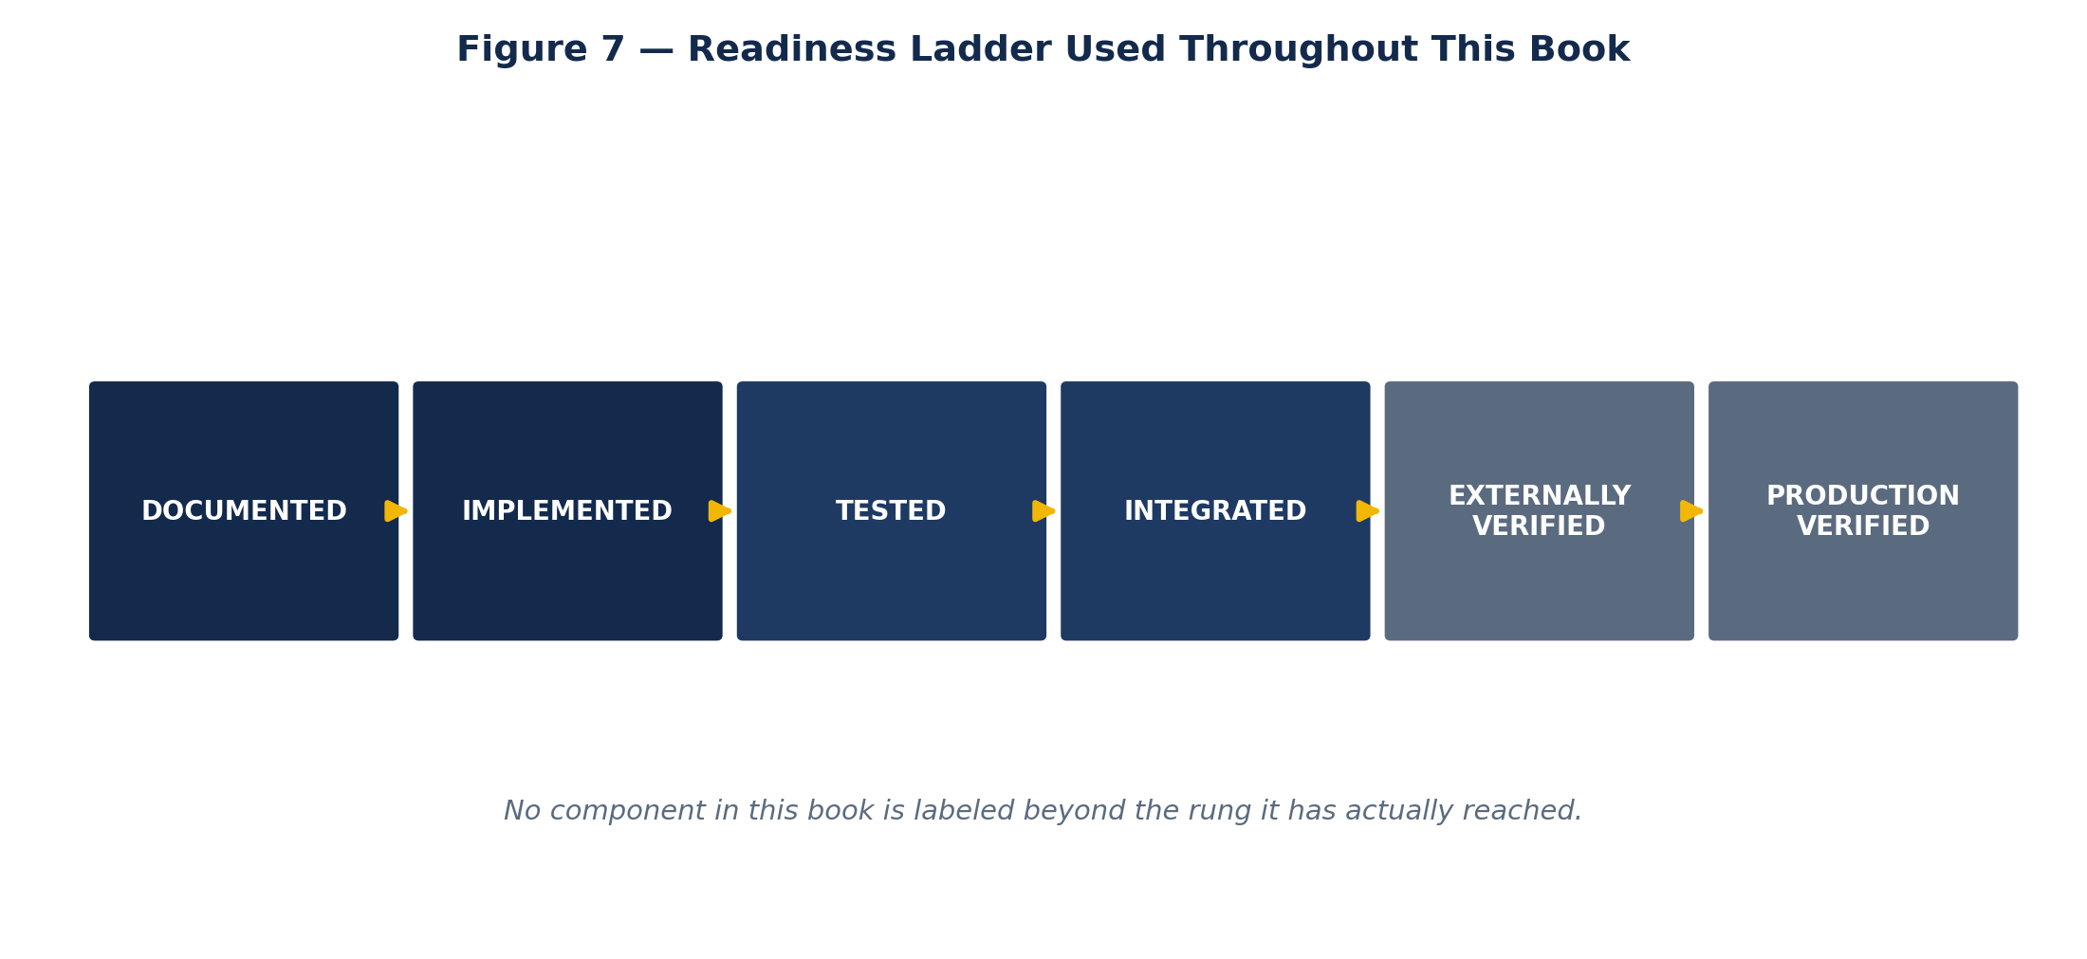
Figure 7 — Readiness ladder used throughout this book.
Status | Meaning
VERIFIED | Independently confirmed by this reviewer against a primary, currently public source.
PROJECT-REPORTED | Stated consistently by CeloHT's own repositories; not independently re-derived from first principles.
IMPLEMENTED | Code or design exists per source; not necessarily deployed to a live, production environment.
TESTNET | Deployed to a public test network only — explicitly not mainnet.
PLANNED | Intended by the project; not yet built or not yet complete.
EXTERNAL VERIFICATION REQUIRED | Cannot be confirmed from the public sources available to this review.
UNKNOWN / UNAVAILABLE | No reliable claim exists in either direction; not asserted here.

NOTE — A status of PLANNED never becomes LIVE in this book without a dated, sourced update. A status of TESTNET never becomes MAINNET without a documented, independently verifiable mainnet deployment.

5. Canonical Identity — Quick Reference
Field | Value | Status
Project name | CeloHT | VERIFIED
GitHub organization | Celo-HaiTi | VERIFIED
Founded | 2022, in Léogâne, Haiti | PROJECT-REPORTED
Founder | Johnny Dubic | VERIFIED
Founder authority limits | Historical/institutional only — no unilateral control | VERIFIED (explicit in source)
Public pillars | Education · Agent Network · Reforestation | VERIFIED
Payment currency | USDm | PROJECT-REPORTED (current terminology)
Gas asset | CELO | VERIFIED (Celo network standard)
Native token | None | VERIFIED (explicit NO_TOKEN_POLICY across repos)
Governance model | One-member-one-vote, no governance token | PROJECT-REPORTED
Smart contract network | Celo Sepolia (testnet), chain ID 11142220 | VERIFIED
Smart contract audit status | Not independently audited; audit required before mainnet | VERIFIED (explicit in source)
Primary wallets | MiniPay, Valora, WalletConnect-compatible wallets | PROJECT-REPORTED
Website | celoht.com | VERIFIED
License (code repositories) | Apache License 2.0 | VERIFIED

PART II
Why CeloHT Exists
Problem, origin, mission, and the three public pillars

6. The Problem CeloHT Addresses
CeloHT's own materials frame its rationale around three linked gaps: limited access to formal financial services and low-cost digital payment rails in Haiti; low exposure to safe, practical digital and financial literacy; and environmental degradation pressures that the project links to community economic hardship rather than treating as a separate, disconnected issue.
This book does not independently validate the scale of these problems against macroeconomic or environmental research — no such independent study was identified in the sources consulted. A reviewer citing the scale of Haiti's financial-inclusion gap or deforestation rate in connection with CeloHT should source that figure independently rather than attribute it to CeloHT's own materials.

7. Origin and History
According to CeloHT's own wiki history (ORIGIN_STORY.md, maintained under the flagship CeloHT repository), the project began in 2022 with the ambition of exploring how blockchain technology could become a practical solution for communities in Haiti. The project's Partnerships document independently states “Founded: 2022,” corroborating the year. CeloHT's own account describes an evolution from an individual idea into a community-driven initiative organized around the same three pillars the project uses today: Education, Agent Network, and Reforestation.
NOTE — This book has not independently verified the exact founding date beyond the year 2022. Status: PROJECT-REPORTED.

8. Mission, Vision, and Values
CeloHT's flagship repository maintains dedicated mission.md, vision.md, and values.md files, and a separate wiki-hosted Brand Guide frames the project's identity as “technology with purpose,” built around three ideas the brand materials name as Education, Empowerment, and Impact. The brand materials explicitly parse the project's own name: “CELO” represents the Celo ecosystem underpinning the mission, and “HT” represents Haiti as the project's origin and community focus.
The brand materials describe an intended communication style that is clear, professional, and representative of a global open-source organization, with a stated color philosophy: dark blue signaling trust, stability, technology, and professionalism, and yellow signaling hope, energy, innovation, and opportunity. This book's own diagrams (Figures 1–7) deliberately use this same palette, since it is CeloHT's own documented visual identity rather than an invented one.

9. The Three Public Pillars — Overview
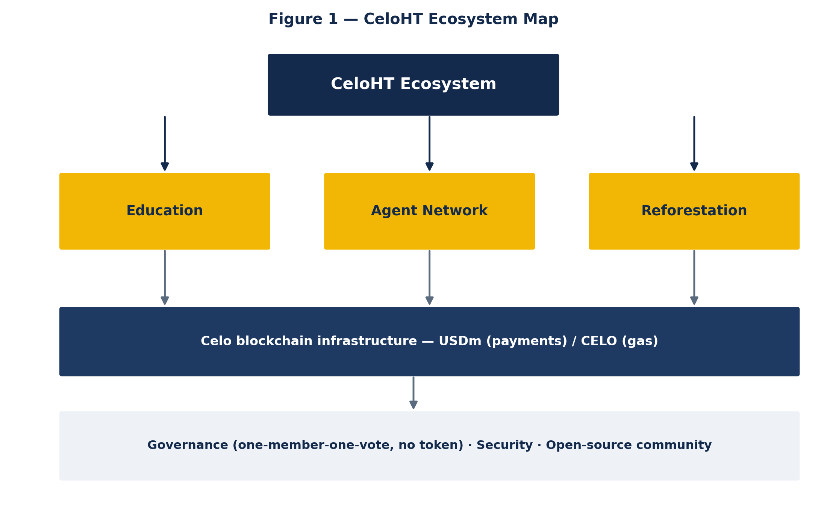
Figure 1 — CeloHT ecosystem map: three public pillars sitting on Celo network infrastructure, under a governance and security layer.
Every inspected CeloHT repository — from the flagship repository to the research repository to the smart-contract repository — describes the same three pillars with materially identical language, which is one of the most consistent and well-corroborated facts in this entire review:
- Education — Web3, financial literacy, and digital security education, delivered primarily in Haitian Creole.
- Agent Network — a trained, community-rooted network of local agents providing cash-to-USDm conversion and digital payment support.
- Reforestation — measurable, transparently reported environmental restoration linked to community development.
No fourth pillar appears in any inspected source. A reviewer encountering a fourth pillar in external material should treat it as non-canonical until verified against a primary CeloHT repository.

PART III
Product and User Experience
How each pillar is meant to work, and what is confirmed versus assumed

10. Education
Education is described consistently as Web3, financial literacy, and digital security education delivered primarily in Haitian Creole, while the project's core governance and technical documentation is maintained primarily in English to serve a global contributor and reviewer base. This English/Creole split is itself explicitly documented in celoht-docs rather than incidental.
What this book can confirm: the Education pillar exists as a named, structurally consistent program area across the flagship repository, the documentation repository, and the research repository. What this book cannot confirm from public sources: specific enrollment numbers, course completion rates, or certification counts. No such figure was located with a traceable date and source during this review, so none is asserted. See Chapter 27 (Metrics) for the reporting standard any future figure should meet before publication.

11. Agent Network
The Agent Network pillar is designed to let community members convert cash to USDm and back, with trained local agents acting as the human bridge between informal cash economies and the CeloHT digital payment rail. The smart-contract repository documents a dedicated Agent Network contract module as part of its testnet-deployed stack, which confirms the protocol-level design exists at the code level.
This book does not assert a specific number of active agents, a geographic coverage claim, or a transaction-volume figure, because none was located with independent, dated sourcing. A due-diligence reviewer evaluating adoption claims about the Agent Network should request a current, dated operational report directly from CeloHT rather than rely on any historical figure.

12. Reforestation
Reforestation is described as measurable, transparently reported environmental restoration tied to community development rather than a standalone environmental program. The project's own wiki Impact page frames reforestation alongside financial inclusion and education as one of three pillars by which CeloHT measures success “not by speculation or token value.”
This book deliberately separates three states that are often collapsed together in impact reporting generally: funds financed toward reforestation, trees actually planted, and planting independently verified after the fact. No dashboard of aggregate tree counts was identified as part of a live, publicly accessible product surface during this review, so this book does not present one. Any future reforestation report should carry each of the three states separately, with geography and date attached, consistent with the standard in Chapter 27.

13. Payments and Wallets
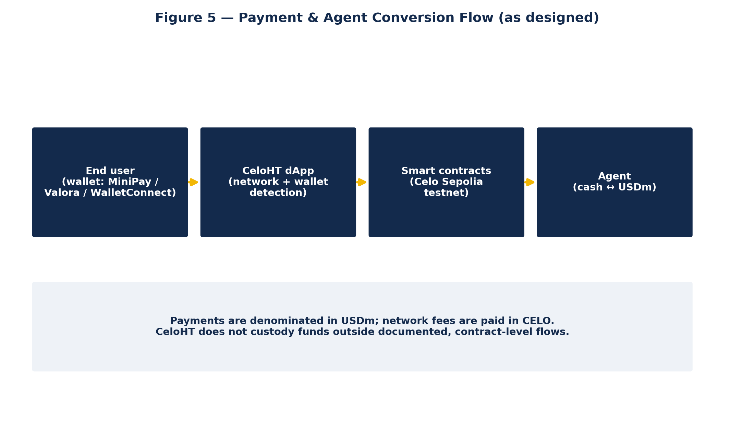
Figure 5 — Payment and agent conversion flow, as designed across the dApp, smart contracts, and agent layer.
CeloHT's documented wallet strategy is intentionally multi-wallet rather than exclusive to any single provider: MiniPay, Valora, and WalletConnect-compatible wallets are all named across the ecosystem's repositories. MiniPay is described in Celo's own ecosystem documentation as a lightweight, non-custodial wallet built for stablecoin payments, which aligns with CeloHT's stated design intent. CeloHT does not claim official affiliation with MiniPay, Valora, WalletConnect, or the Celo Foundation, and this book repeats that non-affiliation explicitly rather than allowing a wallet recommendation to be read as an endorsement relationship.
Payments are denominated in USDm; CELO is reserved strictly for paying Celo network transaction fees. The celoht-dapp repository states directly that Celo Mainnet currently has no configured CeloHT contract or USDm deployment in that repository, and that mainnet-dependent features remain unavailable until the official smart-contract repository publishes verified mainnet deployment metadata — a specific, dated, and encouraging degree of self-disclosed limitation that this book treats as a credibility signal worth highlighting rather than downplaying.

PART IV
Technology and Architecture
The verified technical stack, layer by layer

14. Technical Architecture — System View
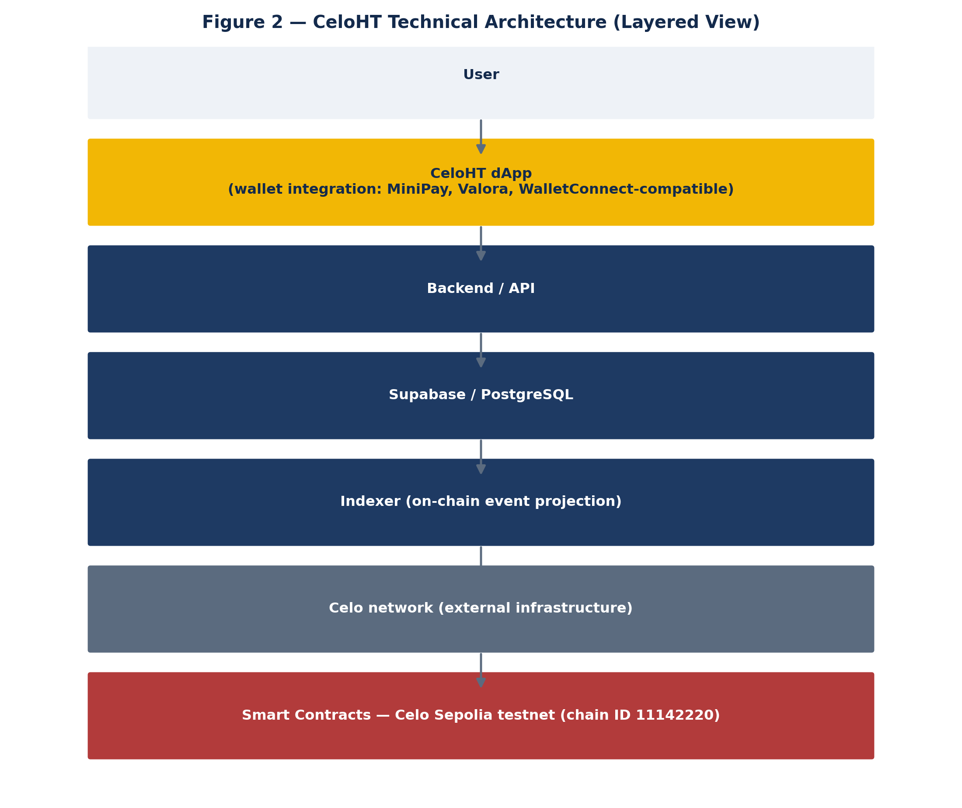
Figure 2 — CeloHT technical architecture, layered from the end user down to the smart-contract layer.
CeloHT's architecture separates a user-facing decentralized application from backend services, a data layer, an indexer that reads on-chain state, and smart contracts on Celo. This layering is described consistently across celoht-governance, celoht-dapp, and celoht-backend, though not every layer was independently confirmed as a currently public, actively maintained repository during this review — see the status table below.
Layer | Responsibility | Status
CeloHT dApp | User-facing wallet-integrated application (static, GitHub Pages-hosted per its own repository) | VERIFIED as public; Celo Sepolia testnet only
Backend / API | Wallet authentication (nonce → verify → session), authorization boundary | VERIFIED as public (release v0.1.0 identified); production configuration EXTERNAL VERIFICATION REQUIRED
Admin dashboard | Internal UI for treasury, governance, education, and program-reporting review | VERIFIED as public; production data routes explicitly fail closed until configured, per source
Supabase / PostgreSQL | Application data storage referenced by backend and governance repositories | REFERENCED, not independently confirmed as a separate public repository
Indexer | On-chain event projection referenced by governance repository | REFERENCED, not independently confirmed as a separate public repository
Smart contracts | Agent Network, Service Payments, Education, Reforestation, Governance logic | VERIFIED as public; Celo Sepolia testnet, not audited

15. Smart Contracts
The celoht-smart-contracts repository documents a testnet-ready contract stack covering five functional modules: Agent Network, Service Payments, Education, Reforestation, and Governance. Settlement is USDm-only at the contract level, with CELO used strictly for gas, and the governance model implemented at the contract level is one-wallet-one-vote with no token.
The repository states its own status directly and without hedging: contracts are deployed and block-explorer-verified on Celo Sepolia (chain ID 11142220), but this describes only the current testnet state — it does not mean audited, and it does not mean mainnet-ready. Mainnet deployment is explicitly stated to require an independent security audit and operational approval that, as of this review, has not been documented as completed.
NOTE — This book does not list specific deployed contract addresses. Before any address is cited externally as authoritative, it should be re-verified directly against a live Celo Sepolia block explorer and the verification recorded with a date in the evidence registry (Appendix C).

16. Application Layer — dApp, Backend, Admin
Three application-layer repositories were confirmed public during this review: celoht-dapp, celoht-backend, and celoht-admin. Each is worth understanding individually because their self-descriptions differ in an instructive way from a first-glance reading of their names.

16.1 celoht-dapp
Despite early GitHub metadata describing this repository as containing “Smart contracts powering the CeloHT ecosystem,” the repository's own README clarifies directly that CeloHT's Solidity contracts and deployments are maintained separately in celoht-smart-contracts, and that celoht-dapp “does not contain a competing Solidity suite and does not deploy contracts.” The repository's functional description — a static, GitHub Pages-hosted frontend using public RPCs and user wallet signatures, connecting to a separately deployed backend — is internally coherent.

16.2 celoht-backend
A tagged v0.1.0 release (“CeloHT Application Backend, Phase 2”) documents a wallet-authentication flow (nonce request, signature verification with the viem library, and an HTTP-only session cookie), with a stated policy of no fake-data fallback paths — missing configuration returns an HTTP 503 rather than silently substituting placeholder data. This fail-closed design pattern recurs across multiple CeloHT repositories and is treated in this book as a genuine, positive engineering signal rather than restated as an unqualified marketing claim.

16.3 celoht-admin
Described as an internal operational control center for treasury, governance, education, agent-network, and reforestation dashboards, celoht-admin's own README states it is “in a verified app-shell and dashboard-building state” and is explicitly “not a production blockchain deployment, wallet custody implementation, or live treasury backend.” Production dashboard routes are documented to show as unavailable until verified data providers are configured, following the same fail-closed pattern as the backend.

17. Data and Indexing Infrastructure
celoht-governance references celoht-supabase (a canonical process for reviewing and applying database migrations) and celoht-indexer (described as “the owner of on-chain projections”) as required infrastructure components. Neither repository was independently confirmed as a currently public GitHub repository during this review. This does not necessarily mean they do not exist — they may be private, or the reference may describe target infrastructure that has not yet been separately published — but this book does not assert their public existence or current operational status without that confirmation.

PART V
Governance and Organization
Decision-making, founder role, brand, and the repository map

18. Governance Model
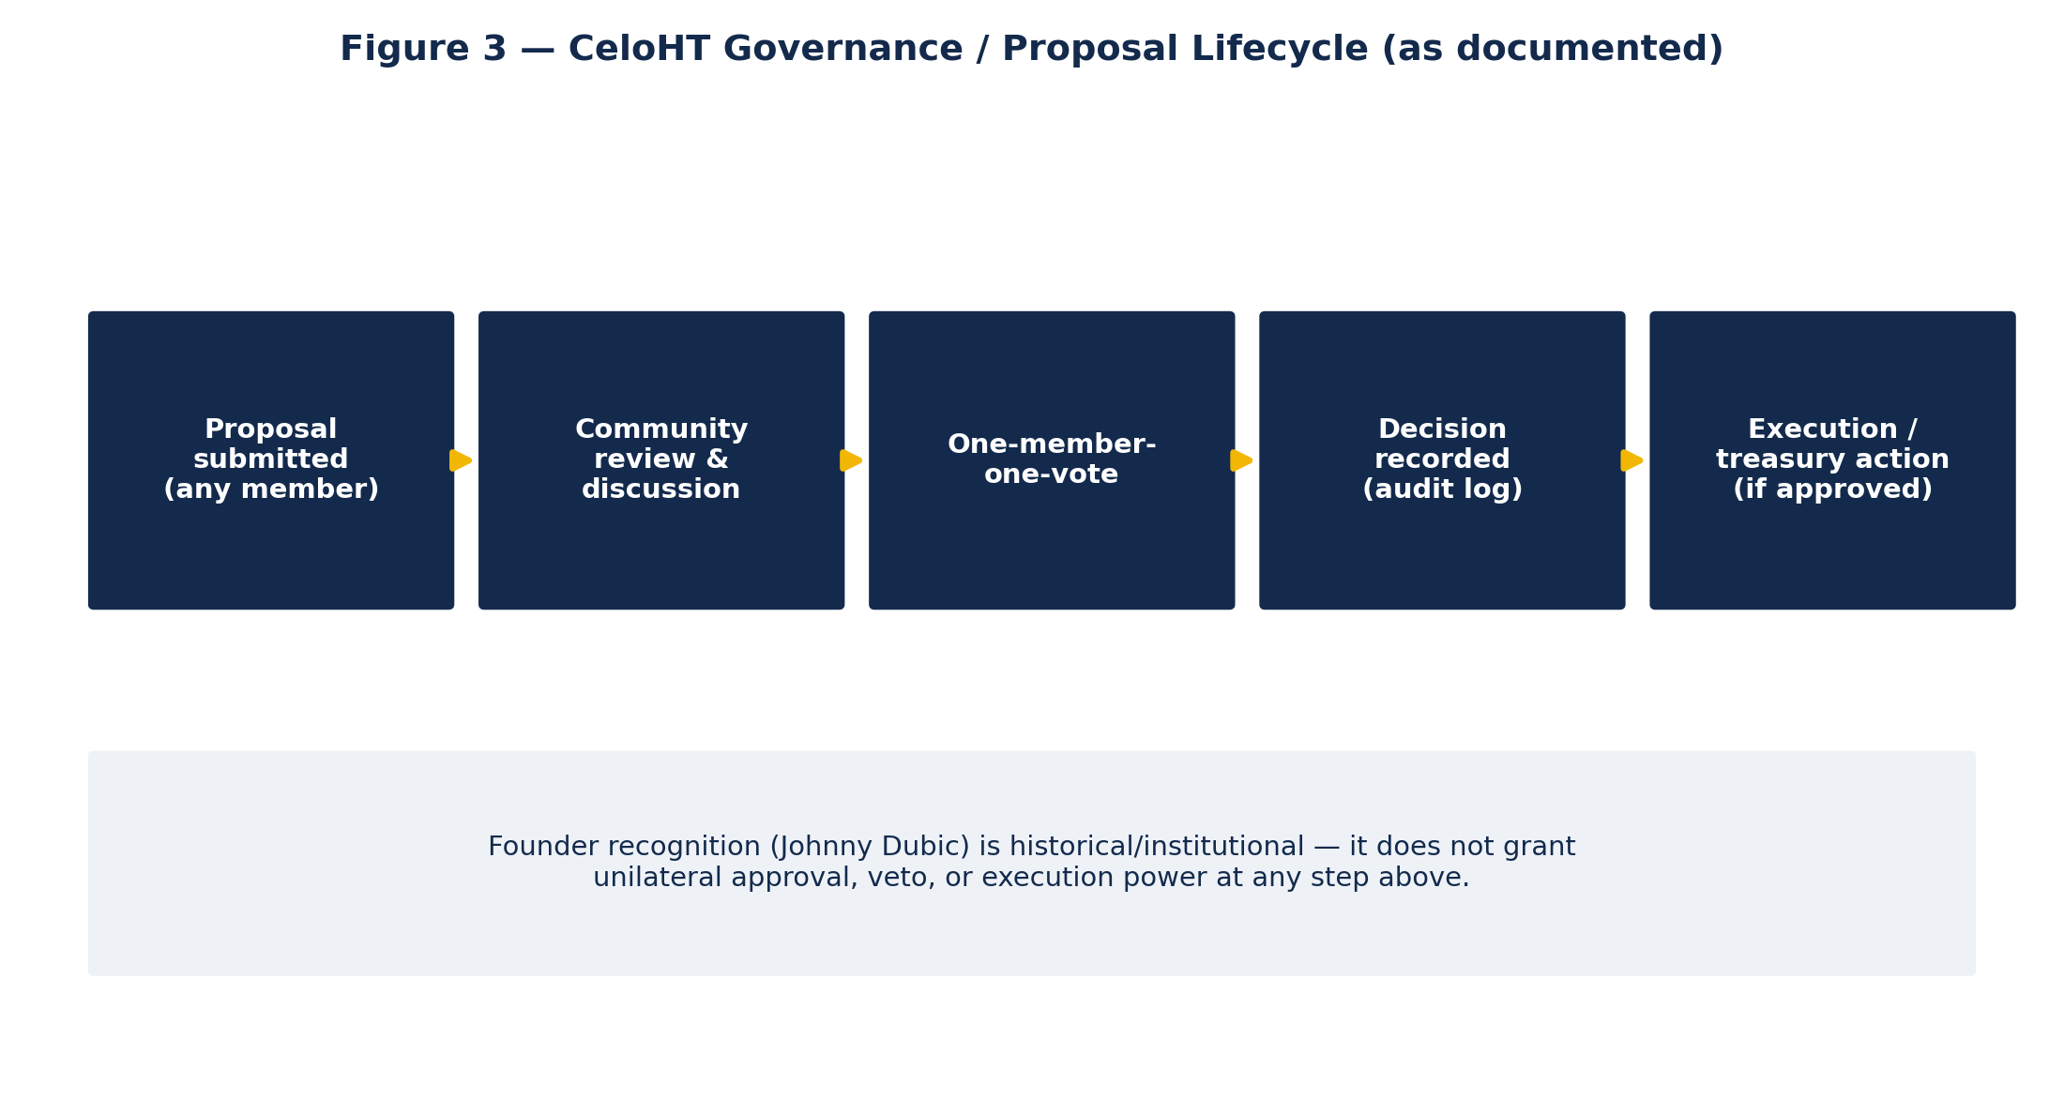
Figure 3 — CeloHT proposal lifecycle, as documented in celoht-governance.
celoht-governance describes itself as the canonical, community-governed layer defining “how decisions get made — not any single application's admin panel.” Its documented model uses one-member-one-vote, role-based access control, a treasury approval flow that includes a timelock, and append-only audit logging. The repository states plainly that its implementation is synchronized with the public CeloHT architecture, but that production deployment remains blocked until runtime infrastructure is configured — a specific, honest disclosure this book treats as more credible than an unqualified “live” claim would have been.
Any individual may submit a governance proposal. A proposal becomes an official CeloHT decision only through the documented collective process; the project states directly, across multiple repositories, that no single individual — including the Founder — holds unilateral governance authority.

19. Founder and Leadership
Johnny Dubic is named as CeloHT's Founder with total consistency across every repository that addresses the subject: the flagship repository's dedicated FOUNDER.md, celoht-docs, celoht-governance, celoht-research, and celoht-siteweb. Every one of these sources independently repeats a near-identical limitation clause, which is itself a meaningful governance signal — the project has taken care to state the limits of founder authority in writing, repeatedly, rather than leaving the question ambiguous:
“Permanent founder recognition is historical and institutional; it does not confer perpetual governance authority, ownership rights, veto power, or unilateral control.”
celoht-siteweb extends this further, stating explicitly that founder recognition “does not create automatic executive authority, Governance Council membership, voting rights, or unilateral governance control.” This book does not describe Johnny Dubic as CEO, Executive Director, or Managing Director anywhere, consistent with this documented limitation.

20. Repository and Organization Map
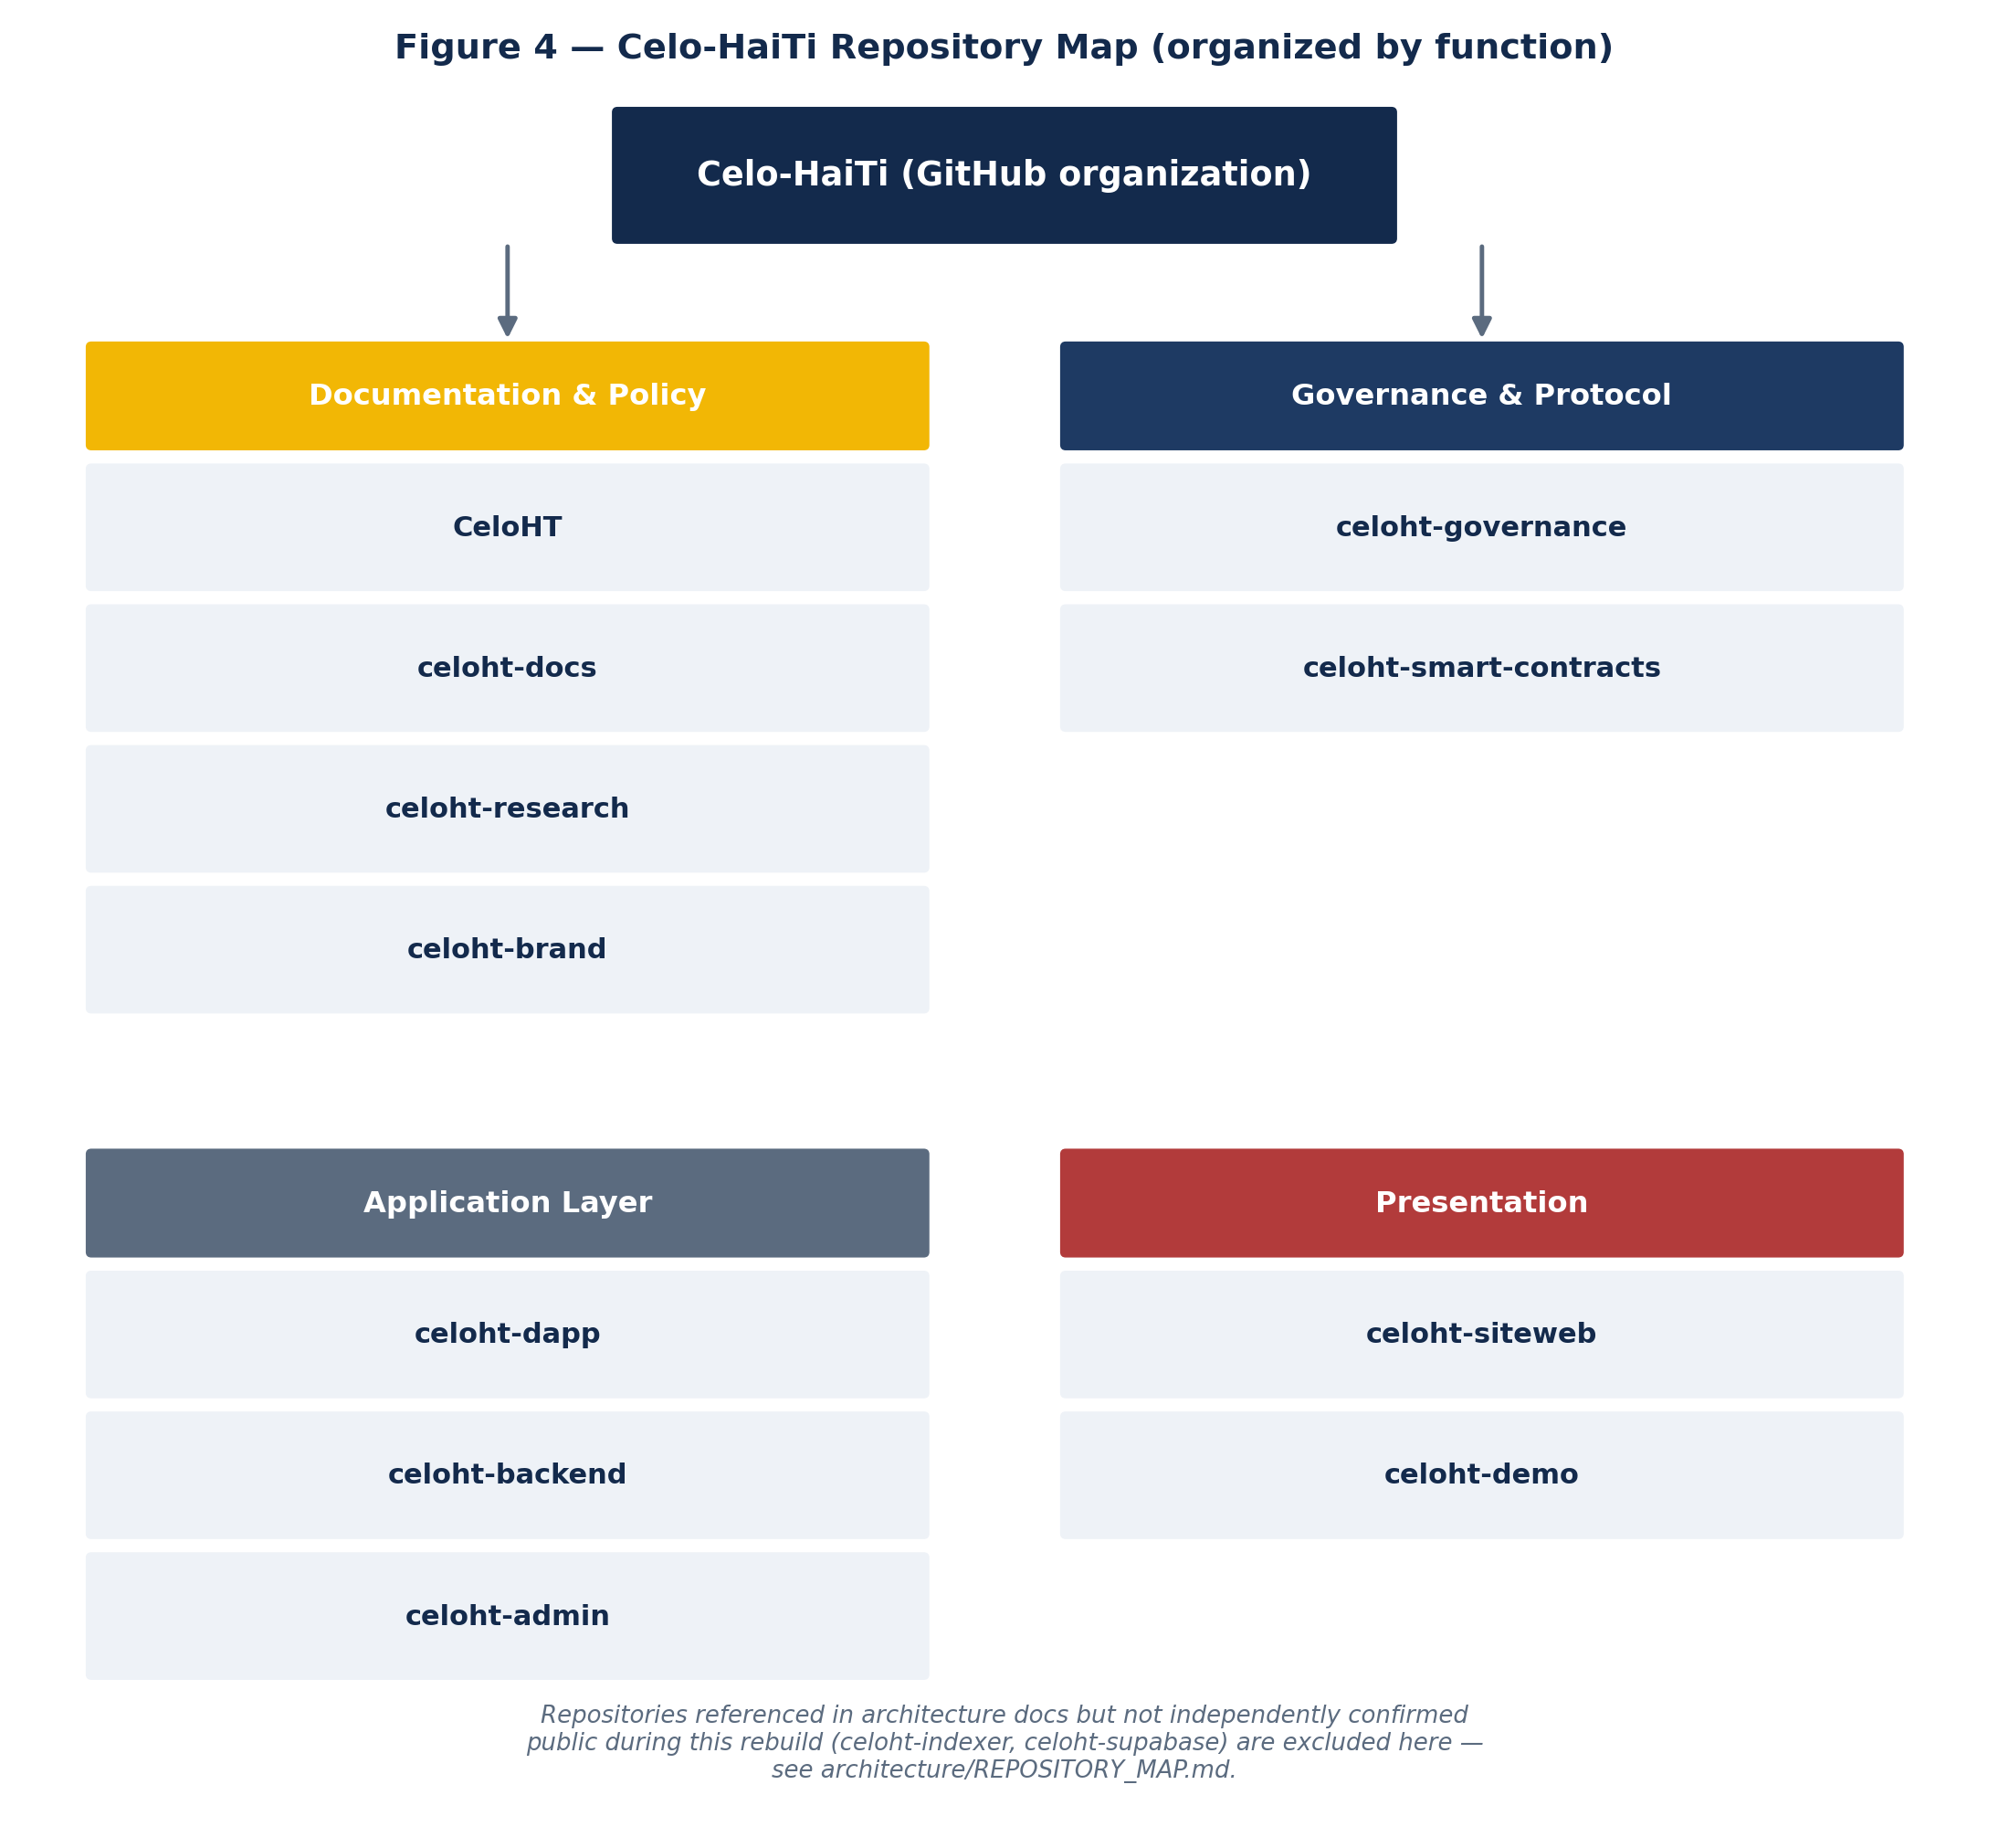
Figure 4 — Celo-HaiTi repository map, grouped by function.
This review confirmed at least twelve distinct, currently public repositories under the Celo-HaiTi GitHub organization. The table below groups them by primary function; the full profile of each appears in Appendix C.
Repository | Primary function | Layer
CeloHT | Flagship documentation, policy, governance, business, and legal reference | Documentation & Policy
celoht-docs | Official technical and governance documentation, whitepaper, RFCs | Documentation & Policy
celoht-research | Research papers, litepaper/whitepaper, claims classification | Documentation & Policy
celoht-brand | Visual identity and brand assets | Documentation & Policy
celoht-governance | Governance reference implementation | Governance & Protocol
celoht-smart-contracts | Solidity contracts (testnet) | Governance & Protocol
celoht-dapp | User-facing frontend application | Application Layer
celoht-backend | Wallet authentication / API boundary | Application Layer
celoht-admin | Internal operations dashboard | Application Layer
celoht-siteweb | Public marketing website (celoht.com) | Presentation
celoht-demo | Simulated investor/grant-reviewer demo | Presentation

21. Brand and Communications
CeloHT maintains a dedicated brand repository (celoht-brand) and a wiki-hosted Brand Guide describing its visual and communication principles. The brand identity deliberately reads the project's own name as a fusion of “CELO” (the underlying blockchain ecosystem) and “HT” (Haiti, the project's origin and community focus), with a stated color philosophy of dark blue for trust and professionalism and yellow for hope and opportunity — the palette this book adopts throughout its own figures.

PART VI
Security
What is confirmed, what is not audited, and what remains open

22. Security Posture
CeloHT's own smart-contract documentation is direct about the current security status: contracts are tested and deployed on Celo Sepolia testnet only, are not independently audited, and mainnet deployment is explicitly stated to require both an independent security audit and operational approval that have not yet been documented as complete. This book treats that self-disclosed limitation as accurate and does not soften it.
Term | Meaning used in this book
Audited | A named, independent audit firm has reviewed the code and a report exists.
Internally reviewed | Project contributors have reviewed the code; no independent audit is claimed.
Not independently audited | No audit, internal or external, is claimed at all.

On the application layer, both celoht-backend and celoht-admin document a consistent “fail-closed” design principle: missing configuration or unverified data providers cause the affected feature to become explicitly unavailable rather than silently falling back to placeholder or mock data. celoht-backend's release notes specifically mention integration testing against a live Supabase project covering row-level-security assumptions and cross-user access boundaries, and note that service-role credentials are referenced only in a single server-side file, enforced by a lint rule — a specific, checkable engineering claim rather than a vague security assurance.
This book was not able to independently execute any test, lint, or audit command against these repositories, since this review was conducted through public web access rather than an authenticated local clone. A reviewer with direct repository access should treat the claims in this chapter as a starting point for verification, not as a substitute for running the repositories' own documented test suites.

PART VII
Business and Sustainability
Funding, use of funds, and partnerships

23. Business Model
CeloHT does not report independently verified revenue in any source reviewed for this book. The flagship repository maintains a dedicated BUSINESS.md and FINANCIAL_TRANSPARENCY.md, along with a TREASURY.md and RESERVE_POLICY.md, indicating the project has formalized financial-governance documentation even where the underlying figures were not independently accessible to this review.
This book does not claim CeloHT is profitable, does not guarantee or imply any investment return, and does not assign the project a valuation. Any sustainability thesis — continued grant and donation support during early stages, an agent-network fee model as adoption grows, and education-related partnerships — is presented here as a stated thesis only, not as an achieved result.

24. Funding
Where CeloHT seeks funding, its own materials frame it as project financing and organizational funding rather than a token investment or securities offering — consistent with the project's no-token policy. No current funding target or amount raised was identified with a dated, sourced figure during this review; any specific number circulating externally should be verified directly with the project before being cited.
- Infrastructure (RPC access, hosting, database)
- Security (independent audits, when commissioned)
- Product development (dApp, backend, indexer)
- Education program development and delivery
- Agent network training and expansion
- Reforestation program funding
- Open-source development and maintenance capacity

25. Partnerships
CeloHT's wiki-hosted Integrations page names one current strategic partner explicitly: FreClean, described elsewhere in the broader Haitian open-source ecosystem as a separate cleaning-services and entrepreneurship initiative. The same page frames future partnerships as evaluated case-by-case for community value and mission alignment, and explicitly does not claim any partnership with the Celo Foundation, Valora, or any other named organization beyond FreClean.
The project's wiki also discusses the Haitian diaspora as a potential source of knowledge, capital, networks, and mentorship, framed as a bridge between local communities and international contributors rather than a formal, named partnership category. No diaspora partnership is asserted as active by this book — it is recorded here as a stated intention only.

PART VIII
Evidence and Metrics
The reporting standard, and why no headline numbers appear in this edition

26. Metrics — Reporting Standard
This book deliberately does not publish a single headline adoption number — no count of people educated, agents onboarded, or trees planted — because no such figure was located with a traceable, dated, sourced origin during this review. Publishing an unsourced number to make this book feel more complete would violate the same evidentiary standard this book is applying to every other claim in it.
Any metric published under the CeloHT name going forward should carry all of the following fields before being cited externally by this book or by any other party:
Field | Description
Metric | What is being measured, defined precisely (e.g., what counts as “educated”)
Value | The number itself
Date | When it was measured or reported
Geography | Where it applies
Source | Where the number originates
Verification level | verified / reported / estimated / planned / unavailable
Last updated | Date this entry was last reviewed

NOTE — A target must never be presented as an achieved result. A projection must never be presented as historical performance. A testnet transaction must never be presented as production adoption.

PART IX
Risk and Roadmap
A factual risk register and a roadmap organized by evidence, not by hope

27. Risks
- Blockchain infrastructure dependency — CeloHT depends on the Celo network, which it does not control.
- RPC dependency — application functionality depends on third-party RPC providers.
- Wallet dependency — transaction signing depends on third-party wallet software (MiniPay, Valora, WalletConnect-compatible wallets).
- Smart contract security — current contracts are testnet-only and explicitly not independently audited; mainnet deployment without a completed audit would carry materially higher risk.
- Regulatory and legal uncertainty — agent-based cash-to-USDm conversion may be subject to evolving financial regulation in Haiti and elsewhere; no specific compliance status is asserted here.
- Adoption risk — the agent network and education programs require sustained community adoption to achieve their stated goals.
- Operational infrastructure risk — reliance on hosted infrastructure (e.g., Supabase, if in production use) introduces third-party operational dependency.
- Funding constraints — as with most early-stage open-source initiatives, continued development depends on securing funding; no funding runway is asserted in this edition.
- Data and metrics verification risk — impact and adoption claims require ongoing independent verification to remain credible over time.
- Documentation maturity — as with many fast-growing open-source projects, cross-repository documentation is still consolidating; a reviewer should confirm terminology and status against the most current root-level source.
This risk list is deliberately non-exhaustive and non-sensational: no probability estimates are assigned, because none were independently derivable from public sources during this review.

28. Roadmap by Verification Category
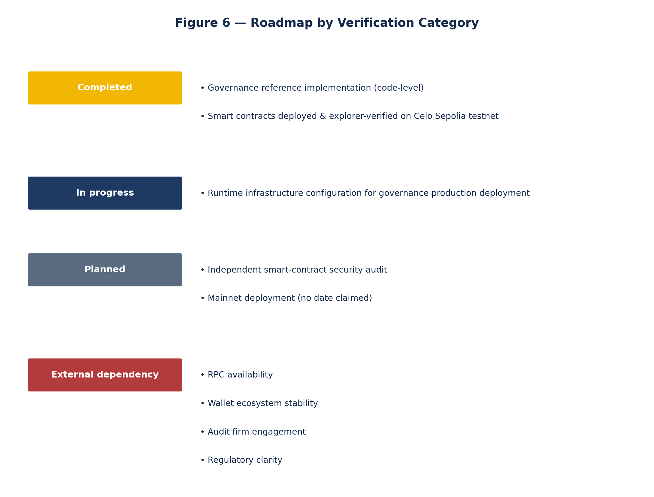
Figure 6 — Roadmap organized by what is actually confirmed, not by target date.
Rather than reproduce a dated roadmap that this review could not independently verify, this book organizes CeloHT's forward path by evidentiary category. No item below moves from one category to another without a dated, sourced update recorded in the verification registry (Appendix C).

PART X
Due Diligence for Institutional Reviewers
A structured checklist for investors and grant committees

29. Due Diligence Checklist
Category | Evidence found | Status | Remaining gap for the reviewer to close
Identity | Name, org, pillars, no-token policy consistent across 12+ repos | VERIFIED | Re-verify periodically; visibility can change
Founder | Johnny Dubic; authority limits stated consistently | VERIFIED | Confirm exact founding date beyond “2022” if material
Governance | One-member-one-vote, proposal lifecycle, RBAC, timelock treasury | IMPLEMENTED (code-level) | Confirm production deployment status; quorum thresholds
Smart contracts | 5 modules on Celo Sepolia, block-explorer-verified | TESTNET | Confirm current addresses; confirm audit engagement status
Application layer | dApp, backend, admin all public with real commits/releases | VERIFIED (existence); PRODUCTION STATUS UNCONFIRMED | Confirm live production URLs and uptime
Data / indexing infrastructure | Referenced by governance repo; not independently confirmed public | EXTERNAL VERIFICATION REQUIRED | Request direct confirmation from CeloHT maintainers
Security | No audit claimed; fail-closed design pattern documented | NOT AUDITED (explicit) | Confirm if an audit has since been commissioned
Metrics | No sourced adoption figure identified | UNAVAILABLE | Request current, dated figures directly, with definitions
Funding | Use-of-funds categories described; no target confirmed | EXTERNAL VERIFICATION REQUIRED | Request current funding target and amount raised, if any
Partnerships | One named partner (FreClean); no other affiliation claimed | PROJECT-REPORTED | Confirm nature and status of the FreClean relationship directly
Legal structure | Not identified in sources reviewed | EXTERNAL VERIFICATION REQUIRED | Request legal entity name, jurisdiction, and registration status
Documentation currency | Root-level docs consolidated across 12+ repositories | PROJECT-REPORTED | Confirm terminology and status against the current root-level source before external use

30. Recommended Verification Steps Before Committing Capital
- Request direct, read access (or a full repository export) to celoht-smart-contracts, celoht-backend, and celoht-governance, and independently run each repository's own documented test, lint, and build commands.
- Request confirmation of celoht-indexer and celoht-supabase as either public or accessible-on-request repositories, or a written explanation of the current data/indexing architecture if those repositories do not yet exist independently.
- Request a current, dated report of Agent Network, Education, and Reforestation activity with explicit source and verification-level labeling per the standard in Chapter 27.
- Request written confirmation of CeloHT's legal entity status and jurisdiction, if any, and how funds would be received and governed.
- Request the current root-level documentation directly from CeloHT for any term or figure that will be cited externally, since fast-moving open-source documentation can update between releases.
- If a smart-contract audit has since been completed, request the auditor's name and the full report rather than a summary.
- Confirm the current status of the FreClean partnership and any other partnership discussions directly with both parties.

PART XI
Legal and Disclosures
No-token policy, forward-looking statements, and licensing

31. No-Token Policy
CeloHT does not have, has never had, and does not plan to launch a native CeloHT token. It does not run an ICO, IDO, presale, or token sale; it does not offer token-weighted governance; and it does not promise or imply investment returns of any kind. CELO is the native gas/governance asset of the Celo network, used strictly for transaction fees — CeloHT does not control, issue, or govern it. USDm is the canonical stable-value payment currency used within the CeloHT ecosystem and is likewise not issued or controlled by CeloHT.
Any offer to sell, pre-sell, or allocate a “CeloHT token” encountered outside this organization's own repositories is not affiliated with this project. This book, and CeloHT's own repositories, are the correct reference points for verifying any such claim.

32. Legal & Disclosures
- This book does not constitute an offer to sell, or a solicitation of an offer to buy, any security or investment product.
- Statements about future plans, roadmap items, or intended functionality are forward-looking and are labeled PLANNED or IN DEVELOPMENT where used; they are not guarantees of future performance or delivery.
- Any metric in this book carries an explicit verification level; absence of a metric means it was not independently sourced, not that the underlying activity did not occur.
- This book does not provide legal advice or a legal compliance determination for any jurisdiction.
- This repository and book are licensed under the Apache License 2.0, consistent with other Celo-HaiTi repositories.
- No partnership or affiliation, including with the Celo Foundation, Valora, or any wallet provider, is asserted unless independently verified in a named source.

APPENDICES
Reference Material
Glossary, sources, repository directory, and edition notes

Appendix A — Glossary
Term | Definition
CeloHT | The project documented in this book; not a blockchain, token, or investment product.
Celo-HaiTi | The canonical GitHub organization hosting CeloHT's public repositories.
USDm | The stable-value currency used for payments within the CeloHT ecosystem.
CELO | The native gas/governance asset of the Celo network; used only for transaction fees.
Celo Sepolia | Celo's public test network (chain ID 11142220), where CeloHT's contracts are currently deployed.
Fail-closed | A design pattern where a feature becomes explicitly unavailable, rather than silently substituting placeholder data, when its required configuration or data source is missing.
One-member-one-vote | CeloHT's governance voting model; explicitly not token-weighted.
Agent (Agent Network) | A trained, community-rooted individual providing cash-to-USDm conversion and digital payment support.
MiniPay | A lightweight, non-custodial wallet for stablecoin payments, one of CeloHT's supported wallets.
RBAC | Role-based access control, used in celoht-governance's permission model.

Appendix B — Complete Source List
All sources below were accessed via public web pages during the preparation of this edition. No source required authentication. Dates reflect when each source was consulted for this edition.
Source | URL
CeloHT (flagship repository & wiki) | github.com/Celo-HaiTi/CeloHT
celoht-docs | github.com/Celo-HaiTi/celoht-docs
celoht-governance | github.com/Celo-HaiTi/celoht-governance
celoht-smart-contracts | github.com/Celo-HaiTi/celoht-smart-contracts
celoht-research | github.com/Celo-HaiTi/celoht-research
celoht-siteweb | github.com/Celo-HaiTi/celoht-siteweb
celoht-dapp | github.com/Celo-HaiTi/celoht-dapp
celoht-backend (release v0.1.0) | github.com/Celo-HaiTi/celoht-backend/releases/tag/v0.1.0
celoht-admin | github.com/Celo-HaiTi/celoht-admin
celoht-demo | github.com/Celo-HaiTi/celoht-demo
celoht-brand (referenced from celoht-docs) | github.com/Celo-HaiTi/celoht-brand
CeloHT wiki: ORIGIN_STORY.md | github.com/Celo-HaiTi/CeloHT/wiki/ORIGIN_STORY.md
CeloHT wiki: BRAND_GUIDE.md | github.com/Celo-HaiTi/CeloHT/wiki/BRAND_GUIDE.md
CeloHT wiki: PARTNERSHIPS.md | github.com/Celo-HaiTi/CeloHT/wiki/PARTNERSHIPS.md
CeloHT wiki: INTEGRATIONS.md | github.com/Celo-HaiTi/CeloHT/wiki/INTEGRATIONS.md
CeloHT wiki: IMPACT.md | github.com/Celo-HaiTi/CeloHT/wiki/IMPACT.md
CeloHT wiki: SYSTEM_ARCHITECTURE.md / DEVELOPMENT_ARCHITECTURE.md / DEPLOYMENT_ARCHITECTURE.md | github.com/Celo-HaiTi/CeloHT/wiki/

NOTE — Source hierarchy applied where sources disagreed: current root-level repository documentation was treated as more authoritative than wiki pages.

Appendix C — Verification Status Registry
Claim | Status | Evidence
Project name “CeloHT” | VERIFIED | Consistent across all inspected repositories
Org “Celo-HaiTi” | VERIFIED | GitHub organization confirmed
Three pillars: Education, Agents, Reforestation | VERIFIED | Consistent across all inspected repositories
No native CeloHT token | VERIFIED | NO_TOKEN_POLICY referenced across repos
Founder: Johnny Dubic | VERIFIED | FOUNDER.md, celoht-governance, celoht-siteweb
Founder role limits | VERIFIED | Explicit, repeated language across 4+ repositories
One-member-one-vote governance | PROJECT-REPORTED | celoht-governance
Governance production deployment | BLOCKED (per source) | celoht-governance states deployment blocked pending infrastructure
Smart contracts on Celo Sepolia (11142220) | TESTNET | celoht-smart-contracts
Smart contracts audited | NOT AUDITED (explicit) | celoht-smart-contracts states mainnet requires audit
celoht-dapp, celoht-backend, celoht-admin public | VERIFIED | Directly located and reviewed during this rebuild
celoht-indexer, celoht-supabase public | EXTERNAL VERIFICATION REQUIRED | Referenced only, not independently located as public repos
FreClean as named partner | PROJECT-REPORTED | CeloHT wiki INTEGRATIONS.md
Founding year 2022 | PROJECT-REPORTED | ORIGIN_STORY.md and PARTNERSHIPS.md
Education/Agent/Reforestation live metrics | UNAVAILABLE | No sourced figure identified
Funding target / amount raised | EXTERNAL VERIFICATION REQUIRED | Not identified in sources consulted

Appendix D — Repository Directory (Detailed Profiles)

CeloHT (flagship)
The organization's central documentation and policy repository, containing over sixty root-level Markdown files spanning governance, finance, legal, brand, security, and community topics (e.g., GOVERNANCE.md, TREASURY.md, FINANCIAL_TRANSPARENCY.md, SECURITY.md, MEDIA_KIT.md, CONFLICT_OF_INTEREST_FINANCE.md). Also hosts the project wiki, which contains additional narrative and architecture pages not present in the root repository. Status: VERIFIED public, actively maintained.

celoht-docs
The official technical and governance documentation repository, self-described as “the single source of truth for contributors, developers, partners, researchers, and the global CeloHT ecosystem.” Maintained primarily in English. Contains a litepaper, whitepaper, architecture, developer guide, smart-contract documentation, API reference, SDK and CLI documentation, and the formal no-token policy. Status: VERIFIED public.

celoht-governance
A TypeScript and PostgreSQL/Supabase reference implementation of CeloHT's governance layer: proposal lifecycle, RBAC, treasury approval with timelock, and append-only audit logging. States explicitly that the public Celo-HaiTi repositories were inspected as part of building this repository's synchronization baseline. Status: VERIFIED public; IMPLEMENTED at the code level; production deployment BLOCKED pending infrastructure per source.

celoht-smart-contracts
Production-grade-styled Celo smart contracts covering Agent Network, Service Payments, Education, Reforestation, and Governance modules. USDm-only settlement; one-wallet-one-vote governance at the contract level; Apache 2.0 licensed. Status: VERIFIED public; TESTNET only (Celo Sepolia, chain ID 11142220); explicitly not audited.

celoht-research
The research and evidence workspace, containing a litepaper, whitepaper, history, governance model, business model, and pillar-specific research documents, along with an explicit claims-classification framework distinguishing verified, reported, planned, and unverified claims. States it is not the source of truth for dApp code, smart contracts, administration, or a production API. Status: VERIFIED public.

celoht-siteweb
The public marketing website for celoht.com, built with Next.js App Router and statically exported. Organized around the three core pillars, with founder-authority-limitation language repeated on the public site itself. Status: VERIFIED public and live.

celoht-dapp
The user-facing frontend application, a static, GitHub-Pages-hosted app using public RPCs and user wallet signatures. Explicitly does not host Solidity contracts (those live in celoht-smart-contracts) and explicitly does not handle Supabase service operations, KYC secrets, or privileged administration credentials. Celo Mainnet features remain disabled pending verified mainnet contract metadata from the smart-contract repository. Status: VERIFIED public; Celo Sepolia testnet only.

celoht-backend
The wallet-authentication and API boundary service. A tagged v0.1.0 release documents a nonce-challenge-based wallet login flow, httpOnly session cookies, signature verification via the viem library, a documented no-fake-data-fallback policy (missing configuration returns HTTP 503), and integration tests against a live Supabase project. Status: VERIFIED public; at least one tagged release exists.

celoht-admin
The internal operations dashboard for treasury, governance, education, community, and reforestation reporting workflows. Explicitly not a wallet, treasury custody layer, or smart-contract deployment system. States it is a “repaired and verified functional Next.js app shell” with production dashboard routes that fail closed until verified data providers are configured. Status: VERIFIED public.

celoht-demo
An interactive demo built with Next.js 15 and Framer Motion, intended to show investors, partners, and grant reviewers what the CeloHT product experience could look and feel like. Explicitly and repeatedly labeled as simulated: wallet flows and donation transaction hashes are simulated and not broadcast to the Celo network. Status: VERIFIED public; explicitly non-production by design.

celoht-brand
Referenced directly from celoht-docs as the repository for brand assets and visual identity. Not independently opened page-by-page during this review beyond its existence and stated purpose. Status: REFERENCED; existence VERIFIED via celoht-docs citation.

celoht-indexer / celoht-supabase
Both are referenced as required infrastructure inside celoht-governance's own operational instructions (“keep celoht-backend as the authentication/API boundary and celoht-indexer as the owner of on-chain projections”; “review and apply migrations … through the canonical celoht-supabase process”). Neither was independently located as a separate public repository during this review. Status: EXTERNAL VERIFICATION REQUIRED.

Appendix E — Edition Notes
This is the first edition of celoht-investor-book (v1.0.0). It was produced through public web research across the Celo-HaiTi GitHub organization — its repositories, wiki, and releases — rather than through an authenticated local clone with code-execution access. No test, lint, build, or audit command was executed against any CeloHT repository as part of producing this edition; that remains explicitly outstanding work for a reviewer with direct repository access, and this book does not claim otherwise anywhere in its text.
Every figure in this book (Figures 1–7) was produced specifically for this edition using CeloHT's own documented brand colors and describes only architecture and process flows that are stated in CeloHT's own public repositories — no figure introduces a claim that does not otherwise appear in this book's text.
This edition intentionally omits a single institution-style page count target as a design goal. Its length is a function of the material actually verified and organized, not of a target reached by repetition or unsupported elaboration — consistent with the anti-fabrication standard this book applies to every other claim it makes.

