**Sorsogon State University - Bulan Campus**

**Document Management System**

Leony B. Brizuela1, Sarah Joy N. Celso2, JeanahMae G. Carezo3, Dazel M. Catabuena4

College of Information and Communications Technology Sorsogon State University - Bulan Campus Bulan, Sorsogon.

E-mails: leony-brizuela@sorsu.edu.ph; Celso-SJ@sorsu.edu.ph; carezojeanahmae31@sorsu.edu.ph; dazelcatabuena@sorsu.edu.ph;

# Introduction

This chapter dispense the project context, purpose and description, objectives and scope and limitation.This chapter merely focus on the description of the project’s features, functions and processes.

## Project Context

Educational institutions either public, private or even universities has a documents that needs to be stored in order for these institutions to function properly. Documents that support various activities which includes academic, administrative, regulatory and operational tasks. These documents help preserve knowledge, share information, and achieve the university’s mission and goals[1].

Documents are considered a crucial asset of an educational institutions. Each institution creates numerous amounts of documents and almost majority of these institutions do it manually. Printing, collecting and organizing these documents is time consuming. Paper documents are stored in cabinets or off-site document storage facility. With a numerous amount of documents and with it being passed faculty by faculty, it can’t be avoided to put these documents at risk. There is a possibility that these documents will disappear or can’t be found when it is needed [2–5].

With today’s modernization, the traditional paper-based documentation slowly transitions to digital repository. Digital repository allows individual to store their data assets online, helping them lessen their day to day activities by storing their digitized activities[6].

Sorsogon State University - Bulan Campus located in the province of Sorsogon is one of the educational institutions that uses both traditional paper-based documentation and digital repository. Some of the faculty members submit their documents to the QAO through online platforms like Messenger, Gdrive, and Email. QAO uses Gdrive to store the submitted documents. Some remain on using paper-based documentation, they print the document and submit it to the QAO. With the numerous amount of documents, collecting and organizing it for accreditation while monitoring the other documents that needs to be collected makes it hard to finish the job and also time consuming. The Program Chairman are also experiencing this kind of dilemma, manually collecting the documents that needs to be checked or examined in order to be submitted to the dean is such a hassle.

In an attempt to solve the problem stated, this project is called Sorsogon State University Bulan Campus Document Management System, a web-based system that aims to make it easier to collect, check, organize, store, and centralized the management of documents. This project focuses on managing documents, assigning documents that need to be submitted, monitoring uploaded and pending documents, and checking documents.

The system provided a separate interface for it’s four (4) users - the Dean, the Quality Assurance Officer (QAO), the Faculty, and the Program Chairman. All of the users can access the system after the user authorization and authentication. After logging in, the Dean, as an administrator of the system, can now have a full access of the system and have the ability to manage the users account that only the administrator can create, add, edit, and/or archive an existing account, have an access to the archived accounts with it’s activities as well as the deleted documents of the users, and monitor the faculty portfolio which the program chairman examined and ISO files collected by the QAO. The QAO, can oversee the approved documents of the Program Chairman, and collect and/or store ISO files that can be obtained from the approved documents. The Faculty, can submit documents, monitor their uploaded documents - both of the approved and declined, and will be notified of the upcoming events. And lastly, the Program Chairman, has the ability to create a submission bin, approve or decline the submitted documents of each faculty members, and monitor the approved and declined documents. In addition, the system is proposed to be used by both ICT and BME department.

## Purpose and Descriptions

The purpose of this proposed study is to develop a Document Management System that will cater to and satisfy the needs of the respective clients. This study also aims to specifically design a Document Management System that can assist the dean, the program chair, the quality assurance officer, and the faculty members of Sorsogon State University-Bulan Campus in submitting, checking, collecting, storing, and sorting documents during accreditation.

The system has four (4) users: the dean(will serve as the administrator), the program chairs, the faculty members and the quality assurance officer. The Administrator/Dean are allowed to create and archive faculty and program chair accounts, view and update user info, as well as download and delete documents. Program Chairs are responsible for the submission bin creation, approving and declining the documents submitted by the faculty members and they can also attached comments on what to improve in the declined files. Faculty members on the other hand are required to submit the documents that were assigned to them by the dean on the submission bin created by their Program chair. While the Quality Assurance Officer are only grant access to view all the approved documents so it will be easier for him to get the documents he need for his job.

Additionally, the system is designed to be usable, easy to interct with and function according to what the client needs. This is to give assurance that the system’s quality is satisfactory and aligned with the software standard.

The system has no similar system that was currently used by the target clients, its ability to manage, collect, and store documents according to the up- loader will surely help the respective clients. The features and advantages that the system can provide can be beneficial to the following:

**Dean.**This project provides significant benefits to the dean, especially during accreditation, by ensuring the organization and easy retrieval of documents, facilitating seamless document sharing and tracking, and reducing the time and effort needed to gather and verify required materials. This system enhances the overall workflow, allowing the dean to focus on higher-level accreditation tasks with the confidence that all necessary documents are accurate, up-to-date, and readily accessible.

**Program Chair.**The proposed system is beneficial to the program chair because it will make his job, which is checking the submitted documents of the faculty members before handing them over to the dean, a lot easier.

**Quality Assurance Officer.**The benefit of DMS in Quality Assurance Officer is streamlining document-related task and enhance overall efficiency in quality assurance processes. It also helps in document storage, ensuring access to up-to-date documents which saves time and reduce errors. It will also improve organization and indexing enable quick retrieval of specific information, enhancing productivity.Overall, a DMS empowers Quality Assurance Officers to effectively manage qualityrelated documentation, leading to more efficient and successful quality assurance processes.

**Faculty.** The benefits of DMS in faculty members includes efficient document retrieval, workflow automation, and compliance These benefits contribute in improving productivity, collaboration, and efficiency in teaching, research, and administrative activities within the university.

**Future System Developers.** This proposed project can help developers who will conduct studies that is related to this system. They can use this proposed study as a guideline/reference in making a system with improved features in storing, collecting, managing and storing documents online.

## Objectives of the Study

This proposed capstone project aims to develop a Document Management System for Sorsogon State University - Bulan Campus. Specifically, the project aims to:

1. To create a User Account Management module for administrator that has a functionality of:
   1. Create/Add,
   2. Edit,
   3. and Archive User Account
2. To design and develop a Web-based Document Management System with the following features:
   1. Submission Bin
   2. User Account Archive
   3. Document Monitoring
   4. Document Trash Bin
   5. Notification
   6. Document Checking
3. To test and evaluate the deployed system using ISO/IEC 25010 Software product quality in terms of:
   1. Functional Suitability
   2. Performance Efficiency
   3. Usability

## Scope and Limitations

This capstone project entitled ”Sorsogon State University-Bulan Campus Document Management System” focused on proposing a system that assists and supports all of the staff and faculty personnel in storing, organizing, and systematically arranging data or files within the campus.

The proposed system is only intended to used by faculty and staff of Sorsogon State UniversityBulan Campus especially on the two department, the ICT and BME department. The users are categorized into four, which are dean, faculty, program chair and quality assurance officer(QAO). The dean that serve as the administrator of this proposed system that is responsible for managing some of the system processes, including user account management such as creation, and deleting of accounts of each users inside the system which automatically go to the archive, they also have the choice if they would restore the accounts in the archive. They can overview the approved documents that is submitted by the faculty. Once a user delete a document, it automatically go to the document trash bin wherein the dean has the capability view and restore the deleted documents. The faculty members is mainly responsible for uploading documents and files. The faculty has the ability to track the status of their submitted documents whether it is on the approved, declined or on pending, they can also see if the program chair add a remarks or comments to their file since editing feature are present in the system. In addition to that, faculty also has a notification that notified or remind them to upload the needed files they need to submit. The program chair is responsible for creating the submission bin for the faculty member of each department, they created the submission bin by category. They are responsible for creating a submission bin where in the faculty will access the submission bin for uploading their file. Program Chair is also responsible for approving and declining the uploaded files or documents made by the faculty.The quality assurance officer is only responsible for accessing or viewing the approved document of the faculty, it is because the approved document is needed for their work.

This project is exclusively a web-based system designed to manage information and documents. Given its web-based nature, the proponents have opted to use specific technologies for the front end, including HTML, CSS, JavaScript, and Bootstrap. For the back end, MySQL for database and Python for back end programming languages. The proponent also use a framework for back end, it is the Django framework. Django framework is a high-level and recommendable framework for python that is why the proponent used that framework. The proponents is trying to acquire knowledge and skills regarding the mentioned technologies, which is why these technologies were utilized in designing and developing the system. The users of this system also have the capability to verified their institution’s email it is to make sure the security of each users while using the system. The proposed system also have a version control wherein editing features are allowed. Since the system is all about uploading files, the proponent integrated an API which is the PDf viewer wherein the user may edit their uploaded files in the system and the program chair users which are the one who can decline and approve will be able to make remarks to the file.

The System excluded users that is outside the said institution, the proposed system is only intended in Sorsogon State University-Bulan Campus. In the sorting feature, only the dean or administrators are the user who can sort all of the accounts by its Name, Username, Email, Program, Last Login, and Role since they are the users that handle the account creation of all of the users of the system.

# Review of Related Systems

This chapter provides review of various systems related to the present study in terms of managing documents. The gathered related systems were from different foreign and local sources such as books, conference paper, journals, magazines, articles, and websites.

**Theme 1: On the Technology Used in Design and Implementation of a Web-Based Document Management System.**

Alade designed and implemented a web-based document management system[7] that can be used by organizations that handles and processes documents on a daily basis. The system provides functionality such as full-text search, multi-user access, content creation, storage, structured filing, full document retrieval, document workflow, and document version control. an Object-oriented Hypermedia design methodology (OOHDM) was adopted to the development and implementation of the system. Furthermore, web technologies such as Hypertext Mark-up Language (HTML), Cascading Style Sheets (CSS), and JavaScript (JS) were utilized in creating the graphical user interface. The middleware was created using Cross-platform Apache, MySQL,PHP, and Perl (XAMPP), and SQLite database tool was used in designing the back-end. The developed system was tested and its performance was assessed based on the modified DeLeon and McLean information system theory model using a modified Likert scale questionaire tool. Moreover, the evaluation yielded a positive result which indicates that the system is functional and useful.

The system mentioned is relevant to the proposed system because technologies such as HTML, CSS, JavaScript, XAMPP, and MySQLite were also utilized in developing the system. Moreover, it is also a web-based document management system with features similar to the proposed system except for content creation which is not present in the proposed system.

**On the Technology Used in Document and Event Record Management System: A**

**Prototype.**

In 2022, Adam et al.[8] creates a protype of ”Document and Event Record Management System” for small offices that has been affected or experienced a damage from Covid-19 pandemic. The system provide a CRUD function that stands for create, read, update, and delete. It also generate reports, serve as activity logs, and provide feedback.

The mentioned system uses a PHP and MySQL databases for it’s backbones that makes it relevant to the proponents proposed system. However, the proponents proposed system does not only provides a CRUD function. The proposed system has also a feature that allow users to sort, search, share, collect, record, and request documents.

**On the Technology Used in Web-based Document Management System for Extension Office.**

During the pandemic, operations and processes shifted online, which drove Estrera et al. [9] to design and develop an online management system that would handle project proposal submission, approval, report generation, and document storage. The said system aims to streamline transactions while avoiding exposure to COVID and cater to the need of keeping important extension-related documents accessible and convenient. The design elements include ease of use, accessibility, and the ability to produce downloadable and printable documents for ease of submission to external agencies, among others. The web technologies used in developing the front-end of this system were HTML, CSS, JavaScript, and Angular, while they used PHP and CodeIgniter for this system’s back-end development.

The mentioned system above is relevant to the proponents’ proposed study because, aside from the fact that the above study were also developing a web-based document management system, they used HTML, CSS, and JavaScript, which are also the same technologies that the proponents will use in the front-end development of their proposed system. The only difference is that the related study mentioned above used another technology called Angular in front-end development. The back-end technology they used, on the other hand, is different from the one we are planning to use. They used PHP and CodeIgniter, while we will use MySQL/MongoDB and Python for back-end development. **On the Technology Used in Web-based Document Management System.**

The Web-based document system by Nagrama et. al[10] , the system was designed to convert the paper-based document into digital form in the office in Zamboanga del Sur. The said office in Zamboanga del Sur often collects and distributes some required documents by its executive department from multiple elementary school within the area through the school principals. In order to make the transaction easy and hassle free, [10] conducted a system that provides a web-based electronic document management solution to the office where school principals can post, access, download, and submit some needed documents online. The web-based document management system was designed and developed using HTML, PHP, MySQL, JavaScript, BOOTSTRAP, and CSS that are useful for the development of the system to meet the common goal.

The stated system of [10] is related to the present system in terms of programming language used. Both systems are using the above mentioned building blocks that are beneficial in creating and designing a dynamic and versatile website.

**On the Technology Used in developing A Secured Cloud-based Electronic Document Management System.**

Justina et al.[11] developed a secured cloud-based document management system for Olusegun Agagu University of Science and Technology, Okitipupa. The system aims to provide an efficient and secure method in managing electronic documents. The system was implemented using HTML, CSS, JavaScript, Bootstrap, Laravel(PHP Framework) and MySQL. An advanced Encryption Standard (AES) algorithm was used to encrypt the documents from unauthorized users. The encrypted document is then stored in the file server that offers a centralized storage place for files while system data and document metadata are stored in the database server.

The system of [11] is relevant to the proposed system as it also utilized technologies such as HTML,CSS, and JavaScript in building the front-end and MySQL as the database. An AES algorithm for securing documents was also used. However, different programming languages were used in developing the back-end of each systems. As for the system of [11] used Laravel , while Python was used in developing the back-end.

## Theme 2: On the Design and Methodology used in Document Management System in Ibnu Sina Middle School Administration

Arifin et al. [4] design a management system which aims to help the staff of SMP Ibnu Sina Batam when it comes to storing and collecting incoming and outgoing mail data online. Due to non-existing document management system related to correspondence storage, they opt to design a system. The focus of this study is the admin and administrative staff of the SMP Ibnu Sina. In this study they used UML (Unified Modeling Language) as their modeling method while OOAD (Object Oriented Analysis Design) for research development method.

The relevance of this related study to the proponents’s proposed study is the similarity of the research development method used which is the Object Oriented Analysis Design. In terms of the modeling method used, some of the modeling method used in the proposed study was also Unified Modeling Language but not entirely because the proponents also used other modeling method such as Structural Modeling Methods and Behavioral or Process Modeling Methods.

## Theme 3: On the Features in Development of Web-Based Document Tracking System For Sorsogon State University

In the study conducted by Din˜o et al.[12] they developed an online web-based application that has document tracking capabilities with features such as user authentication and management for authorized personnel, interface for tracking documents in terms of the sender or origin of the documents, email notification when the document’s status updates. In their study, they also integrate QR Code Systems to assign unique identifications to the documents for efficient tracking. After the system were developed they evaluate the developed system using the Use Questionnaire: Usefulness, Satisfaction, and Ease of Use

The mentioned study is relevant to the proponents proposed study because the proponents wants to put a feature that will notify the owner of the documents if the administrator shared their documents to other people, although this feature is not as complex as the above study but this somehow inspired the proponents to integrate this feature.

## On the Features in An Innovation Development of Document Management and Security Model for Commercial Database Handling Systems

The work of Rajat Sigh et al., 2023[13] entitled ”An Innovation Development of Document Management and Security Model for Commercial Database Handling Systems” focuses on securing documents. It has a feature that when one of the documents are edited or has a changes, the system will automatically organized all the documents according to it’s content that leads to it allowing the user to view and annotate PDF documents in Adobe Acrobat Reader and Acrobat Exchange.

The mentioned system uses network file system and a DBMS to store contents of documents and one of the SQL servers to store the documents attributes. This feature somehow related to the proponents proposed system. However, the proponents proposed system does not require a document card due to a reason that the system is only exclusive for the use of SSU BC. The documents will only circulate inside the university. However, if the clients want to add this feature, the proponents will most likely to consider it.

**On the Features in a Design of a Web-based paper submission and Reviewing System(PSRS).**

The Design of a web-based paper submission and reviewing system [14]. One of the common ways of some organization to communicate in a conferences with their peers and client was based on conventional paper mail by post. The authors of the mail tend to send a paper-based document to the reviewers and once the reviewers received it, the reviewers also return their comments by post. All of these procedure consumed lengthy of time and retyped the information or document again and again. In order to solve the existing problem, this system offers a web-based conference paper management system design that supports an easy and effective review of technical submission to conferences. This system offers some features that are relevant to the users; The Automated submission of papers, automated notifications, article assignment to reviewers, reviewing/copy editing, blind/double-blind option, time reminders, mailing to reviews, reviewers comment threads, reviewer information and performance tracking and the distributed reviewers meetings.

The System of [14] has similarities with the proponent’s system when it comes to its feature. Submitting of papers through web upload and camera ready, the automated notifications wherein it notify the sender whether the information or document are accepted or not, the time reminders and the reviewer information and performance tracking are some of the similarities of both system.

## On the Features of the Design and Implementation of an Electronic Document management System

In the works of Arkan et al. [15] designed and implement a desktop application of an electronic document management system for the university of Polytechnic. The system has a scanner for hardcopy document to be scanned and be converted into an electronic document that can be stored in the system. Another way of uploading document is by creating a new document directly in the system through utilizing an MS-Word editor. And for sending and securing documents, the system uses a digital signature which only the head of the department has permission.

The implemented system of [15] is relevant to the proposed system as it also has a scanner. However, The proposed system implements AES algorithm for encrypting documents instead of a digital signature.

The related systems discussed in the review exhibit both shared features and unique differences. Commonalities include document tracking and management, user authentication, document sharing, and CRUD functionality. However, the systems differ in their target audience, advanced features, security focus, and integration with external tools. The proposed system for Sorsogon State University - Bulan Campus aligns with many of these common features but also draws inspiration from systems with unique functionalities that could be considered for future enhancements.

# Technical Background

This chapter briefly outlined the system’s development specification and user’s specification requirements alongside with their functionality and application to the proposed system.

## System’s Development Specification

This section provides hardware specification and software requirements needed by the proponents to develop the proposed system.

### Hardware Specification

Discussion of the hardware specification used to develop the system. Can include the RAM, CPU specs, etc.

|  |  |
| --- | --- |
| **HARDWARE** | **RECOMMENDED REQUIREMENTS** |
| Memory | 8GB RAM or higher |
| Processor | 2.40 GHz Quad Core or higher |
| Storage | 1TB SSD or lower |

**Memory**. 8GB RAM is the recommended memory requirement. This is sufficient enough to

handle and execute different programs that are used in developing the system.

**Processor**. The processor has a specified specification of 2.40 GHz Quad-core. This provides the capability of executing more instructions at faster speeds, that’s why the proponent utilized this kind of processor.

**Storage**. The storage has a specification of 1TB Solid State Drive (SSD). This provides more than

enough of storage space in storing all system’s data. SSDs provides more capability than traditional storage drives wherein they are considerably faster, operating at high performance while maintaining lower temperature.

### Software Specification

This section discuss the software requirements to develop the Document Management System. It includes the OS, Browser, IDE, Database, Wireframe and Webpage Design required to develop a system.

**Operating System.** Microsoft Windows 10 or higher version are the most compatible with the

majority of software tools for the reason that most software tools, programming languages, and

|  |  |
| --- | --- |
| **SOFTWARE** | **RECOMMENDED REQUIREMENTS** |
| Operating System | MS Window 11 |
| Browser | Microsoft Edge |
| Integrated Development Environment  (IDE) | Visual Studio Code |
| Web Framework | Django |
| Database | MySQL |
| Wireframe | Figma |
| Webpage Design | Figma |

development environments are designed to work on Windows 10 or higher. It can also improve security, Microsoft support, and better performance on hardware.

**Browser.** The proponents used Microsoft Edge in developing their proposed system for the reason that using Microsoft Edge for web development provides benefits such as compatibility with Microsoft technologies, adherence to web standards, robust developer tools, and optimized performance and security.

**Integrated Development Environment(IDE).** Visual Studio Code is the ideal IDE for devel-

oping a system because it is a powerful and versatile development environment that tend to the needs of developers across different programming languages and platforms. Its extensive feature set, customizability, and ecosystem of extensions make it a popular choice among developers for coding, debugging, and collaborating on projects of all sizes and complexities.

**Web Framework.** Django is a robust, secure, and flexible framework that can efficiently manage the complexity of a document management system. Its ability to handle user roles, secure documents, and scale as needed makes it an excellent choice for SorSU Bulan Campus Document Management System.

**Database.** MySQL is a reliable, scalable, and cost-effective choice for developing web-based document management systems, offering a combination of performance, stability, ease of use, and compatibility with web technologies. Its feature-rich capabilities and strong community support make it a preferred database solution for a wide range of web applications and use cases.

**Wireframe.** Figma’s combination of collaborative editing, cross-platform compatibility, powerful design tools, prototyping capabilities, component libraries, version control, and community support makes it an excellent choice for creating wireframes and other design assets. Its user-friendly interface and seamless workflow make it suitable for designers of all skill levels, from beginners to advanced professionals.

**Webpage Design.** Figma’s collaborative, cross-platform, and feature-rich design environment

makes it a preferred choice for making webpage designs, enabling designers to create, iterate, and collaborate on designs efficiently and effectively.

### Service Specification

This section provides an insight on the service specification needed by the proponents to effectively develop the proposed system.

|  |  |
| --- | --- |
| **SERVICES** | **PROVIDER** |
| Internet Service | PLDT |
| Web and Cloud Hosting | PythonAnywhere |

**Internet Service.** The proponents used a PLDT as an Internet Service Provider to effectively test and verify the proposed system’s internet connectivity.

**Web and Cloud Hosting.** The proponents used PythonAnywhere for web and cloud hosting.

It offers a numerous kind of services that the proponents are planning to use.

## User’s System Specification Requirements

This section provides the user’s system specification requirements needed to access the proposed system. Shown in Table 3.4 are the detailed list of user’s hardware and software specification requirements that the users must have.

### Hardware and Software Specification Requirements

|  |  |  |
| --- | --- | --- |
| **Particular** | **Minimum** | **Recommended** |
| Memory | 4GB RAM | 8GB RAM or higher |
| Processor (CPU) | 2 GHz | 2.40 GHz Quad Core  or higher |
| Storage | 300GB SSD | 500GB SSD or lower |
| System Type | 64-bit OS, 64-bit processor | 64-bit processor |
| Operating System | Windows 10 | MS Window 11 |
| Browser | Chrome and Internet  Explorer | Microsoft Edge |

In designing a web-based document management system, it is essential to considered the efficiency and sturdiness of the hardware and software that the user may used. Upon accomplishing this proposed system, the proponents will be using a laptop that has a memory of 8GB RAM, Processor of 2.40 GHz Quad Core, Storage of 1TB SSD, an Operating System of MS Window 11, and Browser of Microsoft Edge. The user may also used some hardware and software that has the memory of 4Gb RAM, processor of 2 GHz, storage of 300GB SSD, System type of 64-bit OS, 64-bit processor, an operating system of Windows 10, and a Browser of chrome and internet explorer.

## Technical Terms

The following are the definition of terms that will be used in the study:

**App Service** - App Service refers to the services that the developers use to deploy their web application. It offers a variety of resources that will grant access to a web application in certain places.[16].

**IDE** - IDE refers to a software development tools that the developers use to write and edit the code of the system their trying to built or the code of an already developed system.[17].

# Design and Methodology

This chapter contains several types of diagrams, figures, and tables to further explain the methodology utilized in this study through visual representation.

## Concept

The project aimed to develop a Document Management System for Sorsogon State University - Bulan Campus that primarily assess the needs of Dean, Quality Assurance Officer, Faculty, and Program Chair.

The project used OOAD approach for it’s analysis and design, RAD model for it’s development model, and Hybrid approach for it’s development approach. HTML, Bootstrap, Django, and MySQL are some of the technologies that will be used in the development of the project. The said approaches and technologies will be discussed in the following subsequent sections. Furthermore, the following diagrams are designed to conceptualize, explain, and give insights on how the system works.

### System Architecture Diagram

The system architecture diagram is a visual representation of the system architecture. It shows the connections between the various components of the system and indicates what functions each component performs[18].

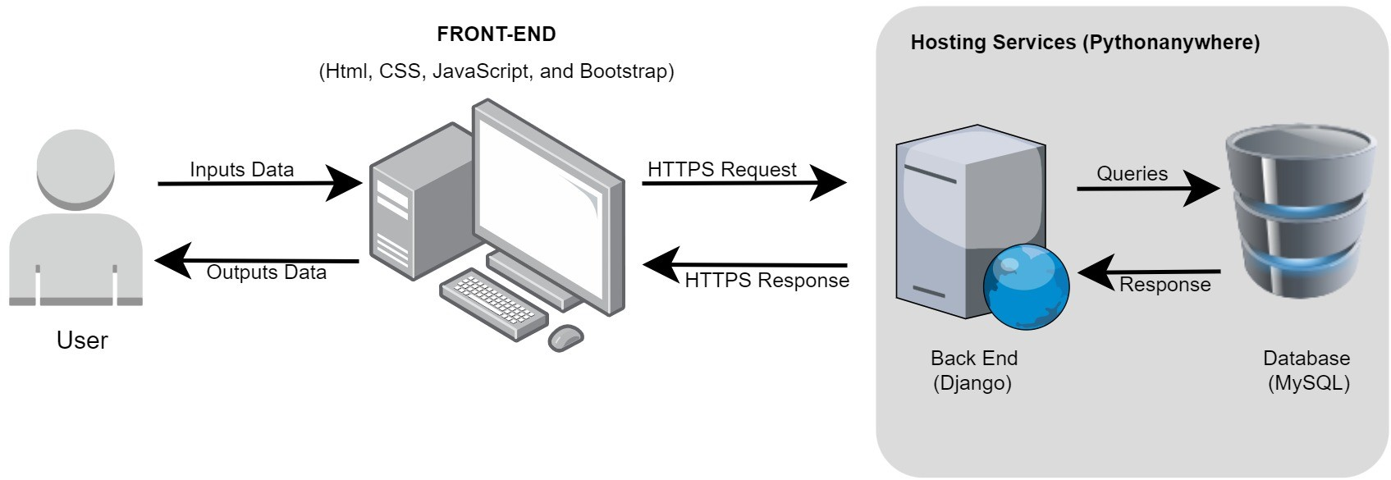

**Fig. 1**: System Architecture Diagram

The presented diagram shown in figure 1 is composed of user devices that displays the front-end of the system via a web browser, this is where user interaction takes place. Another component, a web server that houses the program logic, implemented using Python as the back-end is where operations or processes takes place. A database,using MySQL, that stores data and PythonAnywhere as a cloud hosting platform that provides hosting services for the system to be available on the internet.

### Data Flow Diagram

Data Flow Diagram represents the flow of data inside a system and how it is handled. It consists of different levels, usually it has a 0-4 levels and it can go further depending on the complexity of a system. It offers details of a system that may vary depending on its level, it starts with a simple to a detailed data flow[19][20].

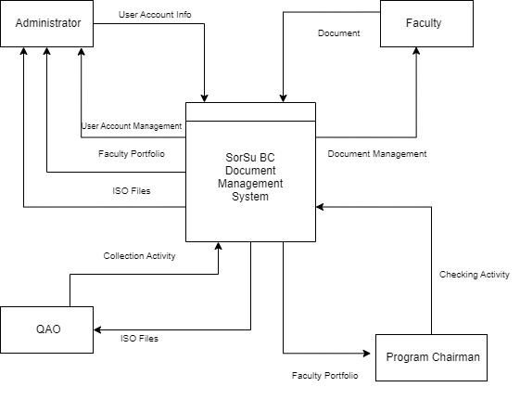

**Fig. 2**: Data Flow Diagram Level 0

Data Flow Diagram uses symbols to represent external entity, process, data store, and data flow. Figure 2 illustrates the level 0 DFD also called a context diagram. It’s a simple overview of an overall system. Proponents used a gane and sarson symbols to create the diagram. The system was represented as rectangle with a vertical line on the top part of the rectangle and is located in the middle, external entities such as administrator, faculty, QAO and program chairman are represented as a simple rectangle. DFD level 0 shows the input of an external entity and the system’s output according to the external entity’s privileges.

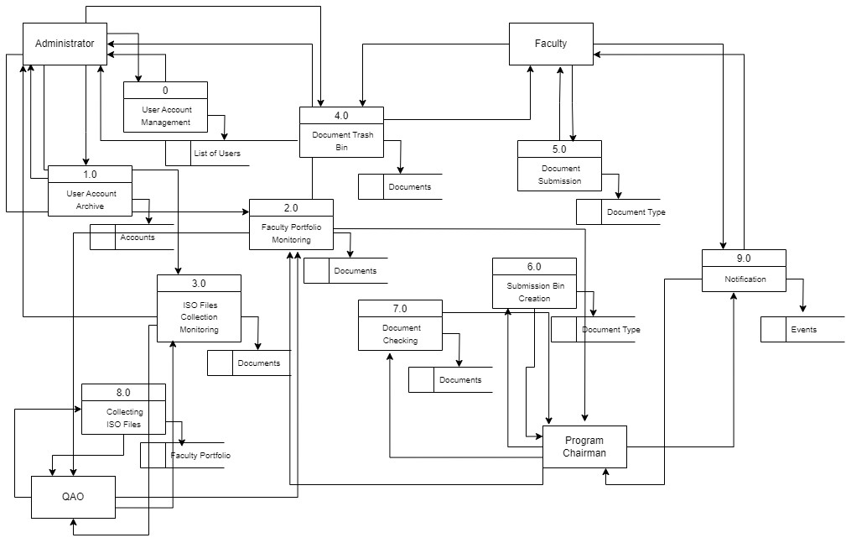

**Fig. 3**: Data Flow Diagram Level 1

Figure 3 shows the level 1 DFD, it presents much detailed data flow compared to the level 0 DFD. It highlighted the main functions of the system with its process and its processes data store. The mentioned external entities in level 0 DFD with the processes that they do in the system and it’s processes data store where the information came from are illustrated.

### Use-Case Diagram

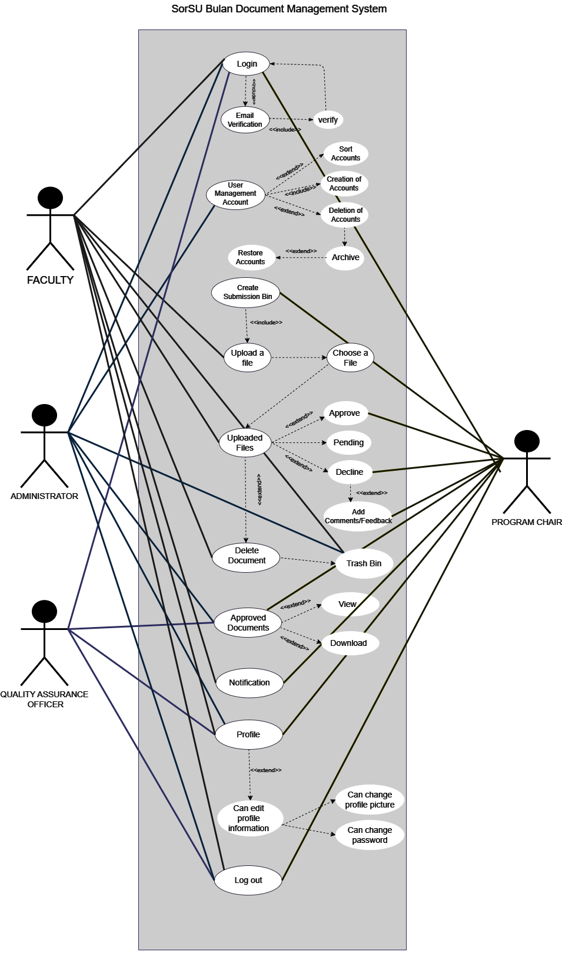

**Fig. 4**: Use Case Diagram

Figure 4, Illustrates the interaction of different actors in the proposed system. The Use-Case Diagram is a simplest representation of a user’s interaction with the system and depicting the specifications of a use case. A use-case diagram can portray the different types of users of a system and the various ways that they interact with the system[21]. The proponent also uses an include and extend functionality. According to [22], An include relationship means that one use case always includes or invokes another use case as part of its flow while An extend relationship means that one use case optionally extends or adds functionality to another use case under certain conditions. In figure 4 showed the different elements used to understand the functionality and roles of every user in the system. The following are the actors and their roles in the system:

**Dean.**

The dean is one of the user of this proposed system. The dean is the only user that can handle the user management account wherein they have the ability to create, delete, and all of the deleted accounts will automatically stored in the archive. Once the account has been in the archive, the administrator also have the ability to restore an accounts. Administrator can also view and download the approved documents of the faculty. Since they can view the document, the dean also has the accessibility in sorting feature in account management wherein they can sort and find the user account by its Name, Username, Email, Program, Last Login, and Role in ascending and descending order. In deleting a document, the system also has the feature that once a user delete a document it will automatically redirected to the trash bin. They can also change or profile of every account if necessary to make the account more reliable and secured. **Faculty.**

The faculty is one of the actor of the proposed system. The faculty is mainly responsible for uploading the needed documents.Upon logging in to the system, the faculty user may encounter a email verification. It is to make sure that a user is a valid member of SorSu Bulan, the system will send a verification number to user’s email and then the user can verified it. Once the program chair created a submission bin, the faculty will get notified that a submission bin has been created and that is the time that the faculty should upload the needed document on time. The faculty users also have the access to view the submission bin wherein they can see the category of the documents that is needed to upload, they can also track the status of their submitted documents whether it is already approved, declined, or in pending status. Once the submitted documents was declined by the Program Chair, the faculty will be able to view the comments or feedback of the Program Chair on their submitted document. Every faculty has a profile wherein they can change password and profile picture itself. **Program Chair.**

The program chair is one of the actor of the proposed system. One of the primary responsible of a program chair is to decline and approve the files that is submitted by the faculty and to create a submission bin for all of the faculty in the two department which are the ICT and BME. Upon creating a submission bin, the Pc should fill the category of their created submission bin so that the faculty will be informed the needed document that should be submitted. Since the faculty is assigned to submit the needed files or document, the program chair is the one who check if the submitted files of the faculty is accurate and exact. They also have the right to decline and make remarks or comments on the documents he/she declined. The notification feature of the system is also accurate if the program chair is creating a submission bin, once the program chair successfully created a submission bin, the faculty user will get notified and remind them to submit the needed document.The program chair also has the accessibility in profile feature wherein they can see their profile and they can also have the ability to change profile and the password of their account and they can also have the ability to sort some files and documents.

**Quality Assurance Officer**.

The Quality Assurance Officer is also one of the user of this proposed system. The QAO has only one ability it is the accessibility, view and download the approved document of the faculty. They can also has the accessibility on the profile wherein they can change password or even profile information.

### Activity Diagram

Activity Diagrams are used to illustrate the flow of control in a system and refer to the steps involved in the execution of a use case. It is a type of behavioral diagram and we can depict both sequential processing and concurrent processing of activities using an activity diagram i.e an activity diagram focuses on the condition of flow and the sequence in which it happens[23].

Figure 5 shows the system activity diagram. System users will logged in to the system. After successful login, system will identify if account is an administrator,faculty,Quality Assurance Officer, or Program chair. After that, system will display the respective user interface. From here on out, users can perform activities with respect to their roles. The admin and quality assurance officer can assign files to faculty user, the latter can assign files needed for accreditation while the former for faculty portfolio. The faculty then submits files, where accreditation files are submitted to quality assurance officer while faculty portfolio files are submitted to the program chair. Files submitted to the program chair are subjected for approval or rejection. Rejected files are sent back to faculty for revision and re-submission. The admin then oversees all faculty portfolio and accreditation files and can share them. The system makes records of the files that were shared and displays these records to faculty and administrator. Administrator manages all user accounts and if an account was deleted, it will be stored in the archive.

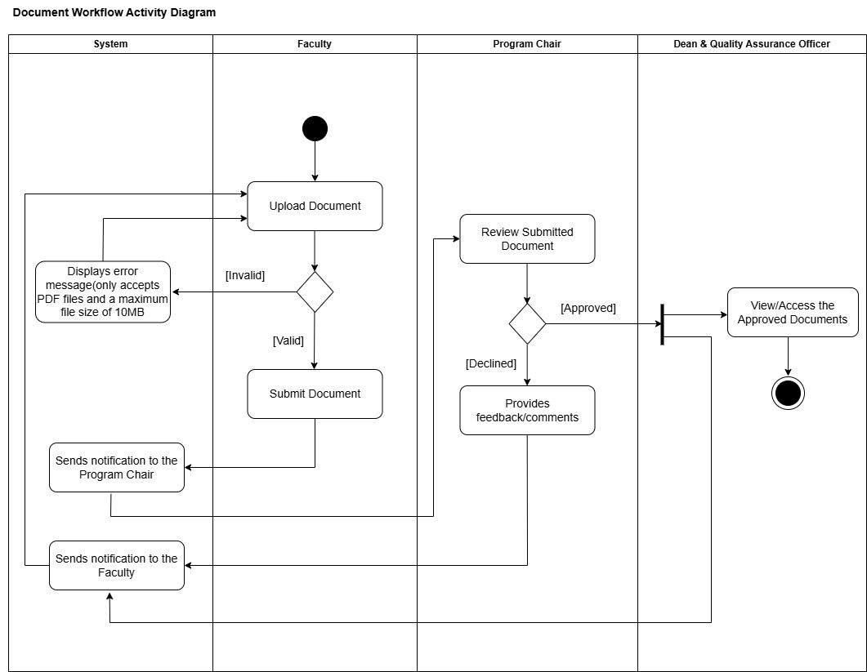

**Fig. 5**: Activity Diagram

### Entity-Relationship Diagram

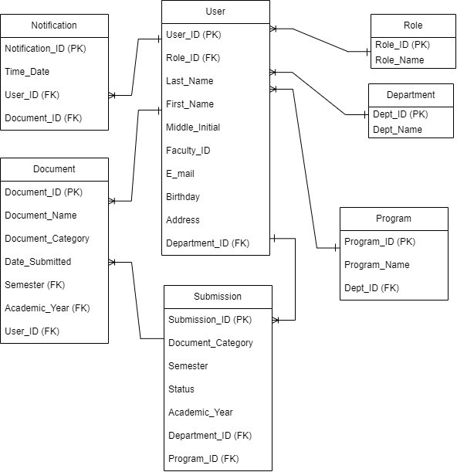

**Fig. 6**: Entity Relationship Diagram

An entity relationship diagram is a graphical representation of entities such as people, objects or concepts and how they relate to one another[24]

The Entity Relationship Diagram that the proponents used in the proposed system can be seen in Figure 4.8. It shows the attributes, cardinalities and relationship of one entity to another, showcasing the logical structure of the database.

## Analysis and Design

Object Oriented Analysis and Design (OOAD) was the approach that the team used in this study. It applies object oriented programming where a real-world objects and it’s behavior are used to analyze, design and develop a software system[25, 26] . It has a seven (7) phases that focuses in the development life cycle. First is the requirement gathering where the team gathers information from their clients. Documenting the requirements of the system. Second is analysis, the team analyze the gathered information and proceeds to identify the main function and limitation of the system. Third is design, the team create a diagrams to identify how the system actually work. Fourth is implementation where a design is implemented into a code. Fifth is testing, the team tests the system to make sure that it functions the way the client it wants to be. Sixth is deployment where the team installs the approved system to a user’s device and ensures that the system functions properly. Last is maintenance, the team maintains the system. It involves updating, creating new features and fixing errors[26].

### Requirement Analysis

Requirements Analysis is a process used to identify and clarifies the expected feature of a newly developed software system. It also gives an overall vision for the clients and stakeholders[27]. Ensuing that the project team used an OOAD approach, the following tables represent the functional and non-functional requirements expected from the system.

### Functional Requirements

Functional Requirements refers to the system’s behavior, function and features that the team must implement in order for the users to use the system effectively [28]. Table 1 shows the functional requirements of the proposed system. The task requirements and reference stated was taken from the objective of the study.

**Table 1**: Functional Requirements

|  |  |
| --- | --- |
| **Task Requirement** | **Task Reference** |
| The faculty shall be able to submit the documents that has been assigned to them. | Submission Bin |
| The administrator of the system shall be able to add, create, edit, and delete users account. | User Account Management |
| The administrator shall be able to access and/or restore the deleted accounts. | User Account Archive |
| The users of the system shall be able to monitor the uploaded documents based on their roles. | Documents Monitoring |
| The administrator of the system and faculty shall be able to recover the deleted account within 30 days. | Document Trash Bin |
| The program chairman shall be able approve and/or decline the documents that has been submitted by the faculty. | Documents Checking |
| The system shall be able to notify the program chairmain and faculty on the upcoming events. | Notification |

### Non-Functional Requirements

Non-Functional Requirements is the system’s ability to perform and how the system should behave. It often affects the overall experience of the users[28]. Table 2 display the non-functional requirements of the proposed system. It’s details are also displayed. The task requirements and reference are directly adapted from ISO/IEC 25010.

**Table 2**: Non-Functional Requirements

|  |  |
| --- | --- |
| **Task Requirements** | **Task Reference** |
| The system shall be able to function according to the user’s satisfaction | Functional Suitability |
| The system shall be able to meet the clients requirements. | Performance Efficiency |
| The users of the system shall easily use or operate the system without trying hard.  The interface of the system should also look engaging. | Usability |

## Development Model

The development model that will be used in this study is the Rapid Application Development (RAD) Model. Rapid application development (RAD) is a methodology that focuses on developing applications rapidly through frequent iterations and continuous feedback[29].

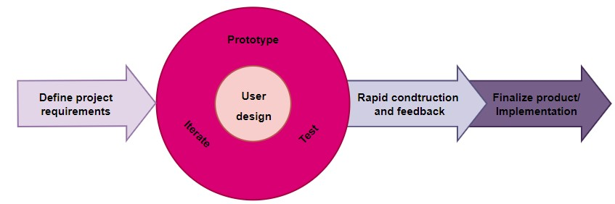

**Fig. 7**: Rapid Application Development

1. **Define Project Requirements**: During this phase we identify our clients. The clients of this study were the dean, the program chair, the faculty members and the quality assurance officer of Sorsogon State University-Bulan Campus(SorSU BC). The proponents conducted an interview with Sir Ruel Grafia, one of the program chair in SorSU-BC on how the transaction of documents during accreditaton works. According to him, the dean assigns the documents that need to be submitted by the faculty members but before the submitted documents of the faculty reach the dean, it will go through the program chair first for checking. The propopents also have a talk with the quality assurance officer, Sir Mark Anthony Dipad, and he told them how he is having a hard time collecting, storing and sorting the documents he needs for his job as the quality assurance officer. With the information at hand from talking to some of the clients, the proponents had to determine what features their system needed to have. They also studied existing projects that are relevant to their proposed system to get an idea on how to enhance their proposed project and analyzed the features to make the project unique.
2. **User Design**: After the project has been scoped, the team started building out diagrams such as System Architecture, Data Flow, Use-Case, Activity and Entity-Relationship Diagram to identify how the proposed system should work. During this phase they also made a wire frame prototype to visualize how the proposed system should look like. They let the client check the finish models and prototypes. The team adjusted based on the client’s insights and suggestions until they were satisfied with the outcome.
3. **Rapid Construction and Feedback**: During this phase, developers start turning their designs and prototypes into a working system. They start with coding the front-end part of the system and then proceed to coding the back-end part of the system, which is important for managing and storing data. The proponents also repeated this phase a couple of times to meet the needs and wants of the clients.
4. **Finalize Product/Implementation**: In the final phase of rapid application development, the developers addressed the technical debt they accumulated in the early prototyping, optimizing implementation to improve stability and maintainability as the proponents finalize the product. The proponents have move their system to production and have done a client testing to know the effectivity of the system.

## Development Approach

The development approach that the proponents will use in this project is the what you called **hybrid approach**, this approach takes place when you combine the strengths of top down and bottom up methods. It will start with top down structure to ensure harmony and consistency in planning. Then, develop components individually in bottom-up manner, which enables flexibility and modularity.

Let’s define the two terms mentioned above, the top down approach and the bottom up approach. **Top-down** approach is a method or strategy for analysis, problem-solving, or organization, where the process begins at the highest conceptual level and progresses to the details. In contrast, a **Bottom-up** approach is a strategy used across various fields, including management, software development, and project planning, where the process begins at the most detailed and basic level and works upwards to form a comprehensive picture or solution[30].

On designing a web-based document management system (DMS) for Sorsogon State University - Bulan Campus, the most suitable strategy is the **top-down approach** due to its flexibility to include the elements of the bottom-up approach if needed. It involves the structuring of the project from the architecture of the system to the finer details. This method is effective fore these reasons: it gives a clear structure and outlines comprehensive planning which leads to consistency and harmony throughout the development process. Given how complex the nature of a DMS which have various roles and features, this approach encourages detailed planning and reduces the risk of misalignment or inconsistencies. It is also beneficial for structured project management which allows clear milestones, timelines, and deliverables. For projects that requires a solid framework to manage complexities and ensures consistency when integrating different components, the top down approach is the most ideal. Because in a DMS context, where sensitive data and multiple user roles are involved , consistency is crucial.

On the other hand, while top down approach is the most recommended, combining some of the **bottom-up** elements can be useful especially in terms of iterative developments and modular design. Bottom-up approach allows development and testing for smaller modules which offers greater flexibility. This approach is most beneficial in projects where requirements might change based on the user feedback or agile methodologies. It give flexible way to adjust individual components without affecting the entire system, aligning well with agile practices such as scrum.

In combining these two approaches , a hybrid strategy can be employed. This hybrid approach maximize the strengths of both methods which offers comprehensive planning while also allows adaptability and agility duwing the development.

Therefore, given the requirements of the project and the need for a robust system, a **top-down approach** with the combination of **bottom-up’s** modularity and flexibility is the best strategy for developing the web-based document management system. It ensures that the project meets its goals while also allowing adaptability during the development and deployment phases.

## Software Development Tools

Te following are the software development tools and application that are relevant for developing this system:

### Front-End Development

* **HTML.** A standard markup language that is used for creating and designing documents in web pages[31]. The proposed system is a web-based system therefore HTML is a big help in developing and constructing the structure of the said project.
* **CSS.** It is the language that defines the presentation of a document written in a markup language like HTML. CSS is the language that transforms a basic HTML structure into a user-friendly and visually beautiful webpage[32]. CSS is highly relevant to HTML as it compliments and enhances the structure of the proposed system that enables the proponents to develop and create the system in an easier way.
* **Javascript.** A beginner-friendly and a versatile programming language commonly used for web development and add interactivity and behavior to a website[33]. The proponents used this tool because it allows tasks such as responding to user actions, manipulating HTML elements, and making requests to servers that the system developer wants to develop.
* **Bootstrap.** Commonly used as an open-source front-end framework that is designed to help the developer for developing and creating a responsive and modern websites quickly and hassle-free. It offers built-in codes that help developers create the interfaces of their system without needing to code from scratch.

### Back-End Development

* **MySQL.** A relational database stores data in separate tables rather than putting all the data in one big storeroom. The database structure is organized into physical files optimized for speed[34]. Since the proposed project is all about document management system, the proponent used MySQL because it is the database that is familiar to them.
* **Python.** A computer programming language often used to build websites and software, automate tasks, and conduct data analysis. Python is a general-purpose language, meaning it can be used to create a variety of different programs and is not specialized for any specific problems. This versatility, along with its beginner-friendliness, has made it one of the most-used programming languages today[35]. Additionally, Python is familiar and easy for the proponent to handle especially the system developer for the reason that python is not a complicated programming language unlike the others.
* **Django.** A complex and high-level python framework that allows and guide the developers to build a web application in an efficient and easy way.It is a popular framework for python and best choice for both small and big projects.

### Text Editor and IDE

• **Visual Studio Code.** A streamlined code editor with support for development operations like debugging, task running, and version control. It aims to provide just the tools a developer needs for a quick code-build-debug cycle and leaves more complex workflows to fuller featured IDEs, such as Visual Studio IDE[36].The proponent needs a code editor that is suitable for creating and editing code. Vscode is one of the usual and familiar tool that the proponents are currently using.

### Version Control System

• **Git.** Free and open-source version control system used to handle small to very large projects efficiently. It is also used to tracking changes in the source code, enabling multiple developers to work together on non-linear development[37]. The proponents need a version control that will be able to help them to keep track of the changes made in code over time. This tool is also help the proponents to easily check the versions if something goes wrong or compare different versions to see what changes were made.

## Schedule and Timeline

The proposed project’s timeline, shown in figure 8, is composed of two Academic Semesters - 2nd semester of Academic Year 2023-2024 and 1st semester of Academic Year 2024-2025.

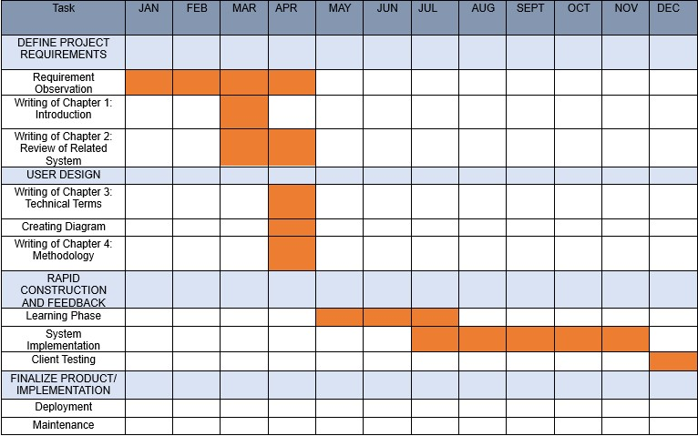

**Fig. 8**: Gantt Chart

On the 2nd week of February, the Project started through deliberation of project titles and is estimated to end in December.

The proponents started from brainstorming titles, followed by requirements gathering from the clients and analysation of the information gathered. During this phase, observation, verification and the writing of the Chapter 1 Introduction and Chapter 2 Review of Related System also takes place.

The proponents then make a list of the technical background of the study as part of the design phase, created diagrams, and then write down Chapter 4 to visually present and explain the concepts of the study.

After the proposal of the study, the proponents undergone learning phase for three months where they studied the technologies that they plan to use to develop their proposed system such as JavaScript, Bootstrap MySQL and Django. The free online learning sites has been their go to companion in studying these technologies.

The proponents started building their user interface from the beginning of June and continued doing so until it satisfied them.

After the prototype was finalized, the rapid construction started to take place on the 1st week of August. Because the requirements needed for the proposed system are already defined in the initial phase and the initial models and prototypes were already built, the proponents goes on to application coding, the proponents converted their prototype and beta systems into a working model. This phase were repeated multiple time because the situation required it, which supports new components and alterations.

The final phase of rapid application development which is the finalization of the product happening on the 1st week of December up until the end of the semester. This is where the developers address the technical debt accumulated in the early prototyping, optimizing implementation to improve stability and maintainability as the proponents finalize the product for launch. The components will be moved to a live production environment, where full-scale will testing occur to identify product bugs. The team will write thorough documentation and will complete other necessary maintenance tasks, then after the product will be handed over to the client.

## Responsibilities

To effectively implement the proposed system, the capstone adviser and four (4) BSIT students collaborated with one another. Their names, roles and responsibilities are stated below.

1. Norjan Eneria - Capstone Adviser

The responsibilities of a Capstone Adviser were to assist the students growth in developing the project, making sure that they’re in the right path, and serve as their consultant.

1. Leony Brizuela - Project Leader

The responsibilities of a Project Leader were to assign a specific tasks to each team members and keep them motivated and focused to finish the tasks, keep an eye on the overall progress, considers the feelings of each team members, and set goals and plans to achieve the expected output.

1. Sarah Joy Celso - Back-End Developer

The responsibilities of a back-end developer were to build and maintain the server-side of the system. They are responsible for arranging and managing the databases,APIs, and most importantly the server logic that makes the system works.

1. Jeanahmae Carezo - Front-End Developer

The responsibilities of a front-end developer were to create an interface design for the system, turning a system design into reality. Basically, they are responsible for designing the user interface, ensuring that the system is accessible, efficient, and visually appealing.

1. Dazel Catabuena - Technical Writer

The responsibilities of a Technical Writer were to prepare and maintain the manuscript of this project.

Although Ms. Celso and Ms. Carezo are only the said developer in this capstone project, the other team members will also help with the coding to guarantee the on-time completion of the project and to make sure that the developer will not experience difficulties.

## Budget and Cost Management

This project has required a budget in order to acquire the supplies and labor required to build the system and its documentation. The project’s estimated budget, cost breakdown, and operational costs upon deployment are shown below:

### Proponent’s Budget and Costs Management

In table 3, Showed the needed for printing the documentation of the system. For the proposal, the final defense, and the storage of the deliverables, printed copies of the manuscript were required. The estimated total amount for materials and suppliers budget was Php 3,220.00.

**Table 3**: Material and Supplies Budget

|  |  |  |  |
| --- | --- | --- | --- |
| **Items** | **Quantity** | **Price** | **Amount** |
| Printing Cost | 1 | 1000.00 | 1000.00 |
| Internet Service (PLDT Home) | 1 month | 1,800.00 | 1,800.00 |
| Softbound | 1 set | 70.00 | 70.00 |
| HardBound | 1 set | 350.00 | 350.00 |

Total Amount: Php 3,220.00

In table 4, Presented that internet service was needed for the purposes of learning, information retrieval, hosting, and communication with the proponents, as well as their advisor, professor, and panelists. Internet services (PLDT Home)are costed 1,800.00 for the monthly fee. In favor for the proponents choice, The Web and Cloud Hosting will be free for thirty days. This information is based on the PythonAnywhere website. The amount needed for the services and hosting expenses is Php.

1.800.00.

**Table 4**: Services and Hosting Budget

|  |  |  |
| --- | --- | --- |
| **Service** | **Monthly Fee** | **Amount** |
| Internet Service | 1,800.00 | 1,800.00 |
| Web and Cloud Hosting  (PythonAnywhere) | Free for one month | 0.00 |

Total Amount: Php 1,800.00

The overall estimated expenses of the proponent to the project were about Php 5,020.00. Since the proponent is new to the environment of web hosting, the proponent temporarily chooses the beginner friendly or free plan for the web hosting. However, the food, transportation, and other services are not included to the overall expenses.

## System’s Operation Costs in Deployment

In table 4 presented the minimum budget of the operational cost of the proposed system when deployed using the PythonAnywhere.

**Table 5**: Service Operation Cost

|  |  |  |
| --- | --- | --- |
| **Service** | **Monthly Fee** | **Amount** |
| Web and Cloud Hosting  (PythonAnywhere) | free for a month | 0.00 |

Total Amount: 0.00/year

PythonAnywhere Services costs for its hosting start from $0 for a month for beginner, follow by $5 for a month for a hacker, $12 for a month for a web developer, $99 for a month for Startup, and $5 to $500 for a month for custom. These subscription is based on the billing section of PythonAnywhere in their website, the cost of every subscription in PythonAnywhere depends on the limitations and advantages of the user when it comes to hosting their system. The beginner friendly or the free plan is the one that the proponent choose in hosting the system, it has a private file storage of 512MB, it also has a one python web application that has a default domain name which is the your-username.pythonanywhere.com. and the user can not decide for its domain name.If you subscribed to a beginner plan, the proponent should expect a limited access to the hosting site.

In figure 9 presented the Subscription plans of PythonAnywhere Services offers.

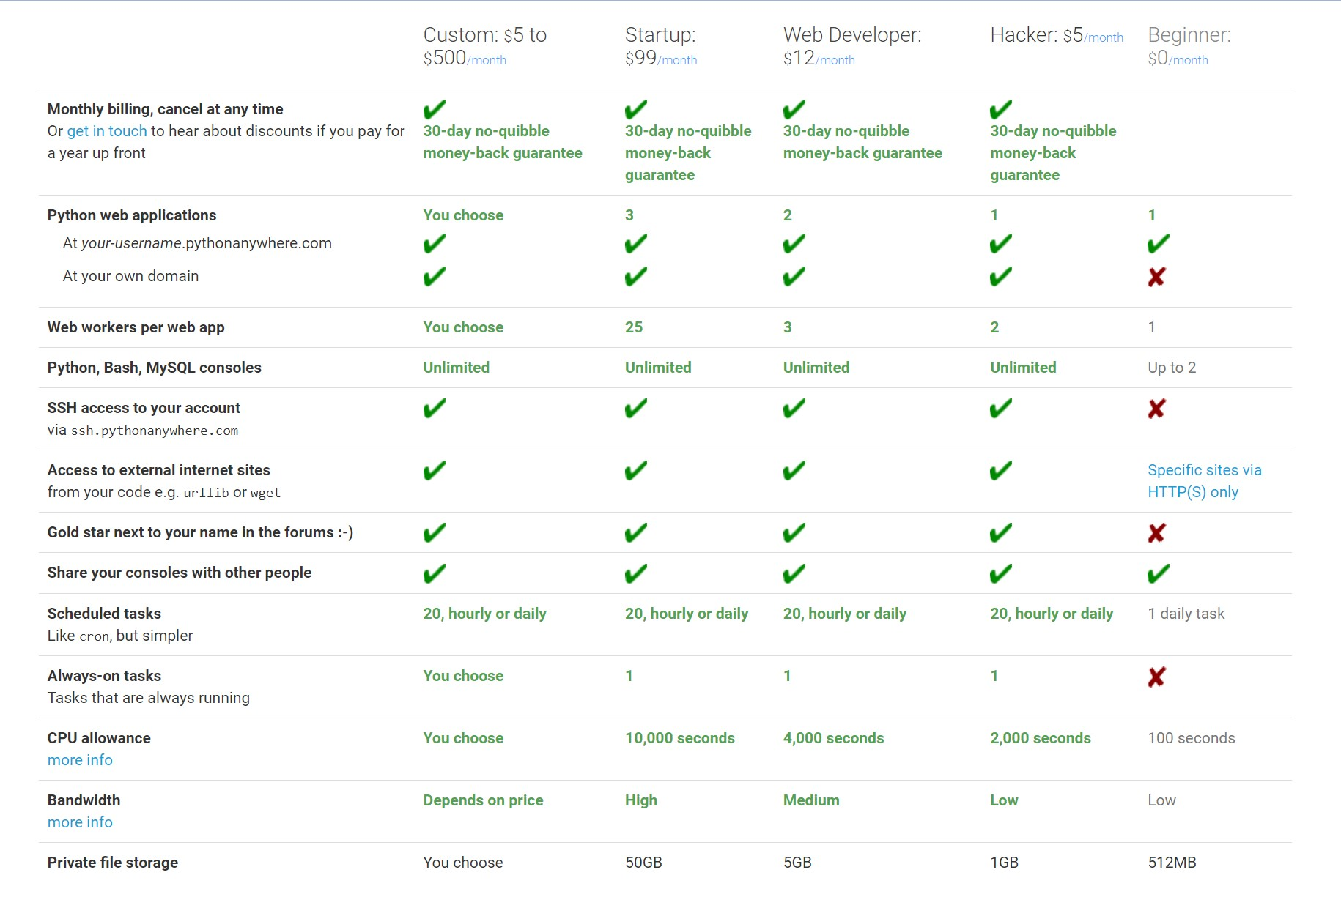

**Fig. 9**: PythonAnywhere Subscription Plans

Overall, the operational cost of the system when deployed can cost $0 or free for beginners that has limited accessibility for hosting and up to $500(28,428.50 in Philippine Peso) when choosing the most expensive plan that has more access and advantages for the user when it comes to hosting.

## Verification and Validation

The system undergone verification and validation to ensure that the system meets the specified requirements and is functioning properly. The proponents used ISO/IEC 25010 quality standard in validating the system with the use of a Likert scale.

### Verification

Since the project implemented a Rapid Application Development method, requirements are understood and proponents rapidly design prototypes that is checked and verified by the client over time. Continuous feedback from the client is taken into consideration in designing the prototype. This process is iterated until the requirements are meet and the client is satisfied.

### Validation

The system undergone validation process to check whether the actual system meet the requirements and expectations of the users. It is done using a survey questionnaire which includes questions taken from ISO/IEC 25010 software quality standard model. The survey is answered by the clients using a Likert scale.

Table 6 shows the Likert scale as metric for validating the system. It showed the ratings, mean range, and the interpretation of ratings.

**Table 6**: Likert Scale

|  |  |  |
| --- | --- | --- |
| **Rating** | **Mean Range** | **Interpretation** |
| 5 | 4.21-5.00 | Excellent |
| 4 | 3.31-4.20 | Very Good |
| 3 | 2.61-3.30 | Satisfactory |
| 2 | 1.81-2.60 | Fair |
| 1 | 1.00-1.80 | Poor |

Table 7 to table 9 showed the product quality that were adapted from ISO/IEC 25010 software quality standard model. Each table showed each quality characteristics (Functional Suitability, Usability, and Performance Efficiency), with their sub-characteristics and descriptions.

**Table 7**: Functional Suitability Characteristic

|  |  |
| --- | --- |
| **Sub-characteristics** | **Description** |
| Completeness | The set of functions covers all the specified tasks and intended user’s objectives. |
| Correctness | The product or system provides accurate results when used by intended user. |
| Appropriateness | The functions facilitate the accomplishment of the specified tasks and objectives. |

**Table 8**: Usability Characteristic

|  |  |
| --- | --- |
| **Sub-characteristics** | **Description** |
| Appropriateness  Recognizability | Users can recognize whether a product or a system is appropriate for their needs. |
| Learnability | The system can be used by specified users to achieve specified goals of learning to use the system with effectiveness, efficiency, freedom from risk and satisfaction in a specified context of use. |
| Operability | The system has attributes that make it easy to operate and control. |
| User error protection | The system prevents user against operation errors. |
| User interface aesthetics | The user interface pleasing and satisfying interaction for the user. |
| Accessibility | The system can be used by the people with the widest range of characteristics and capabilities to achieve a specified goal in a specified context of use. |

**Table 9**: Performance Efficiency Characteristic

|  |  |
| --- | --- |
| **Sub-characteristics** | **Description** |
| Time behavior | The extent to which the system’s response time and processing speed meet the required standards during its tasks. |
| Resource Utilization | The extent to which a system uses resources like time, memory, and processing power to meet its requirements while performing tasks. |
| Capability | The extent to which the system’s maximum limits meet the required standards. |

## Testing

Software testing is a process of identifying the correctness of software by considering its all attributes (Usability,Functional Suitability,and Performance Efficiency) and evaluating the execution of software components to find the software bugs or errors, or defects. Testing is mandatory because it will be a dangerous situation if the software fails any of time due to lack of testing. So without testing, software cannot be deployed to the end-user [38].

With all these being stated, the proponents conducted regular testing procedures to ensure that the system is functioning properly, effectively, and is free from bugs and errors. Testing method such as black-box and white-box testing method have been be utilized by the proponents. Whitebox testing have been implemented throughout the coding process where developers examined every line of code to identify possible syntax errors and to check if logic are correct. After ensuring that program code are free from bugs and errors, and logic are correct, the proponents moved to the next phase of testing, which is black-box testing. In this phase, program code are compiled and executed, proponents used the initial system as if they were the users and conduct use case scenarios based from the functional and non-functional requirements stated earlier in this project. Results of the test have been documented by the proponents to help identify areas of improvement and solve any issues that may arise.

**Table 10**: Test Case Template

|  |  |  |  |
| --- | --- | --- | --- |
| **Pre-condition** |  |  |  |
| Test Case/Scenario | Expected Result | Actual Result | Status |
|  |  |  |  |
|  |  |  |  |
| Post-condition |  |  |  |

Table 10 was used to provide a summary of the tests conducted on the system. The pre-condition lists the requirements or scenarios that need to be in place before running each test. The test cases or scenarios describe the steps, situations, or data used to check how the system performs. The expected result is what we anticipate happening, while the actual result is what actually occurs during the test. The status shows ’Pass’ if the test meets expectations, or ’Fail’ if the result doesn’t match what was expected.

# Results and Discussions

Discussed within this section were the development and testing phases of the system in relation to its development model. The components, its implementation, and the technology used were discussed below, as well as the test cases and test results of the testing phase.

## Requirements Gathering and Analysis

During this phase, we identify our clients. The clients of this study were the dean, the program chair, the faculty members and the quality assurance officer of Sorsogon State University-Bulan Campus(SorSU BC). The proponents conducted an interview with Sir Ruel Grafia, one of the program chair in SorSU-BC on how the transaction of documents during the accreditaton works. According to him, the dean assigns the documents that need to be submitted by the faculty members beforehand, but before the submitted documents of the faculty reach the dean, it will go through the program chair first for checking. The propopents also have a talk with the quality assurance officer, Sir Mark Anthony Dipad, and he told them how he is having a hard time collecting, storing and sorting the documents he needs for his job as the quality assurance officer. With the information at hand from talking to some of the clients, the proponents had to determine what features their system needed to have. They also studied existing projects that are relevant to their proposed system to get an idea on how to enhance their proposed project and analyzed the features to make the project unique.

## Design

After the project has been scoped, the team started building out diagrams such as System Architecture, Data Flow, Use-Case, Activity, and Entity-Relationship Diagram to identify how the proposed system should work. During this phase they also made a wire frame prototype to visualize how the proposed system should look like. They let the client check the finish models and prototypes. The team adjusted based on the client’s insights and suggestions until they were satisfied with the outcome.

## Implementation

During this phase, the developer started turning their designs and prototype into a working system. The group has four members, and each member was given a user role to focus on, coding the interface design for that specific role. Once they finished the front-end part of the system, the work was passed to two other members responsible for the back-end, which is important for managing and storing data. This phase can also be repeated if needed, adding new features and changes based on the client’s feedback and ideas.

**5.4 Testing and Review 5.5 Deployment and Maintenance 6 Recommendation**

**7 Appendices**

# References

1. Nugraha, M.F.P., Ranggadara, I.: Document management application at al-chasanah vocational school jakarta (2018)
2. Noel, J.C.G., Yu, W., Tagle, P.: Thesisfs: Online document management system
3. Min˜on, J.D.F., Lim, C.M.A., Morano, J.A.L., Fajutagana, R.F., Fabito, B.S.: An intranet-based document management and monitoring system framework: A case for the national university quality management office. In: 2016 IEEE Region 10 Conference (TENCON), pp. 2262–2267 (2016). IEEE
4. Arifin, N.Y.: Document management system in ibnu sina middle school administration. Engineering and Technology International Journal **4**(01), 38–44 (2022)
5. Kao, C.H., Liu, S.T.: Development of a document management system for private cloud environment. Procedia-Social and Behavioral Sciences **73**, 424–429 (2013)
6. Okon, R., Eleberi, E.L., Uka, K.K.: A web based digital repository for scholarly publication. Journal of Software Engineering and Applications **13**(4), 67–75 (2020)
7. Alade, S.: Design and implementation of a web-based document management system. Information Technology and Computer Science **2**, 35–53 (2023)
8. Adam, N.L., Akmal Hakim Che Mansor, M., Pauzi, M.F., Cik Soh, S.: Document and event record management system: A prototype. In: 2022 IEEE 12th Symposium on Computer Applications and Industrial Electronics (ISCAIE), pp. 223–227 (2022). [https://doi.org/10.1109/ ISCAIE54458.2022.9794525](https://doi.org/10.1109/ISCAIE54458.2022.9794525)
9. Estrera, P., Fajardo, M., Sermona, N.: A web-based document management system for extension office. Sci. Int.(Lahore) **34**(5), 453–458 (2022)
10. Nagrama, N.D.C., Lingating, M.L.D., Calleno, J.T., Rato, R.K.A., Catungal, M.L.P., Encarnacion, P.C.: Web-based document management system. International Journal **13**(3) (2024)
11. Justina, I.A., Oyekan, E.A., Orogbemi, O.M., et al.: A secured cloud-based electronic document management system. International Journal of Innovative Research and Development **11**(12) (2022)
12. Din˜o, J., Gabrentina, J., Gacis, A., Dipad, M., Eneria, N.: DEVELOPMENT OF WEB-BASED DOCUMENT TRACKING SYSTEM FOR SORSOGON STATE UNIVERSITY
13. Singh, R., Gildhiyal, P.: An innovation development of document management and security model for commercial database handling systems. In: 2023 IEEE International Conference on Integrated Circuits and Communication Systems (ICICACS), pp. 1–6 (2023). IEEE
14. Fatumo, S., Daramola, J.O., Ayo, C.: Design of a web-based paper submission and reviewing system (psrs). Global Journal of Pure and Applied Sciences **14**(3), 357–361 (2008)
15. Ismael, A., Okumus, I.: Design and implementation of an electronic document management system. Mehmet Akif Ersoy Universitesi Uygulamalı Bilimler Dergisi¨ **1**(1), 9–17 (2017)
16. microsoft.com: Azure App Service plan overview. https://learn.microsoft.com/en-us/azure/appservice/overview-hosting-plans
17. Okeke, F.: The 12 Best IDEs for Programming. https://www.techrepublic.com/article/best-idesoftware/WhatIsAnIDE?
18. InterviewBit: System Arhitecture. https://www.interviewbit.com/blog/system-architecture
19. lucidchart: What is a Data Flow Diagram. https://www.lucidchart.com/pages/data-flowdiagram
20. geeksforgeeks.org: Levels in Data Flow Diagrams (DFD). https://www.geeksforgeeks.org/levelsin-data-flow-diagrams-dfd/
21. Case, B.: Use case diagram. Glossary Diagram Details Tabs, Diagram Details Tabs Diagram Name, Property Fields For Diagram Diagram Property Fields, Property Fields For Diagram Discriminator
22. linkedin: how do you withe effective use case descriptions. https://www.linkedin.com/advice/1/how-do-you-write-effective-use-case-descriptions
23. geeksforgeeks: Activity Diagrams. https://www.geeksforgeeks.org/unified-modeling-languageuml-activity-diagrams/
24. Oyairo, A.: What Is an Entity Relationship Diagram (ERD)? https://builtin.com/articles/entity-relationship-diagram
25. geeksforgeeks.org: Object-oriented analysis and design(ooad). https://www.geeksforgeeks.org/object-oriented-analysis-and-design/
26. geeksforgeeks.org: What are the object oriented analysis and design(ooad) phases? https://www.geeksforgeeks.org/what-are-the-object-oriented-analysis-and-designooad-phases/
27. Awati, R.: requirements analysis (requirements engineering). https://www.techtarget.com/searchsoftwarequality/definition/requirements-analysis
28. artexsoft: Functional and nonfunctional requirements: Specification and types. https://www.altexsoft.com/blog/functional-and-non-functional-requirements-specification-andtypes/
29. Chien, C.: What is Rapid Application Development (RAD)? https://codebots.com/appdevelopment/what-is-rapid-application-development-rad
30. Simplilearn: Top Down Approach vs Bottom Up Approach: Understanding the Differences. https://www.simplilearn.com/top-down-approach-vs-bottom-up-approach-article
31. focusims: A guide to effective html document management. https://focusims.com.au/a-guideto-effective-html-document-management/
32. geeksforgeeks: CSS-Tutorial. https://www.geeksforgeeks.org/css-tutorial/
33. docs: Javascript. https://developer.mozilla.org/en-US/docs/Learn/Getting started with the web/JavaScript bas
34. Oracle: MySQL. https://www.oracle.com/ph/mysql/what-is-mysql/
35. Coursera: Python. https://www.coursera.org/articles/what-is-python-used-for-a-beginnersguide-to-using-python
36. Studio, V.: Visual Studio. https://code.visualstudio.com/
37. Perveez, S.H.: What is Git: Features, Commands, Branch and Workflow in Git. https://www.simplilearn.com/tutorials/git-tutorial/what-is-git
38. javatpoint.com: Azure App Service plan overview. https://learn.microsoft.com/enus/azure/app-service/overview-hosting-plans