First Time Use 3
Guest Users 3
Making A Reservation 3
Contacting An Administrator 3
Admin Users 3
Logging In 3
Managing Reservables 3
Managing Reservations 3
The Settings Panel 3

System Requirements
- RAM: 300 MB
- Disk Space: 750 MB
- Processor: Minimum Pentium 2 266 MHz processor
- Java Runtime (JRE) 8
- MariaDB Database Management System (DBMS)

First Time Use
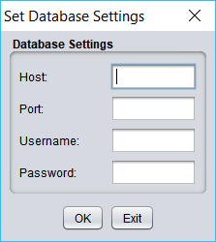

Guest Users

Making A Reservation
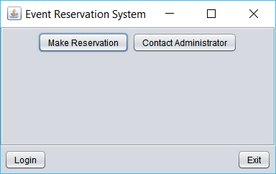

Contacting An Administrator
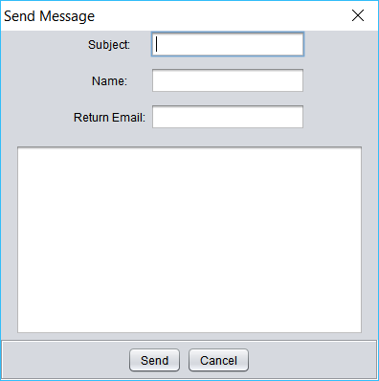

Admin Users

Logging In
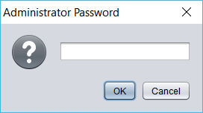

Managing Reservables
In the context of the system, a reservable is defined as an encapsulation of a reservable location and timeframe with an associated cost. A reservable is thus what can be reserved.

Managing reservables involves defining and creating new reservables, updating existing reservables, and removing reservables. Creating a new reservable involves selecting to either create a reservable at a new location or at an existing location. If creating a reservable at a new location, both the location’s name and capacity must be provided. Location names will be accepted in a case-sensitive fashion; that is, the system will record “cabin” and “Cabin” exactly as they are written, and any displays of the name will follow suit. While the system will not respect case in accepting a new location name, the system will nonetheless not accept a name that matches an existing location name regardless of case. That is, supposing a location with the name “Cabin” exists and “cabin” is input as the new location name, the system will respond with an error that a location with the given name exists and not accept said name.

Updating a reservable is limited insofar as changes to the reservable’s timeframe are not allowed. Only the reservable’s location name, capacity, and cost may be changed. Bear in mind that changes made to an individual reservable’s location name and/or capacity will affect ALL reservables that shared the changed reservable’s location.

If a reservable in the list of reservables appears in red font color, this indicates that the reservable is reserved. Reservables that are reserved can be neither updated or deleted.

Managing Reservations
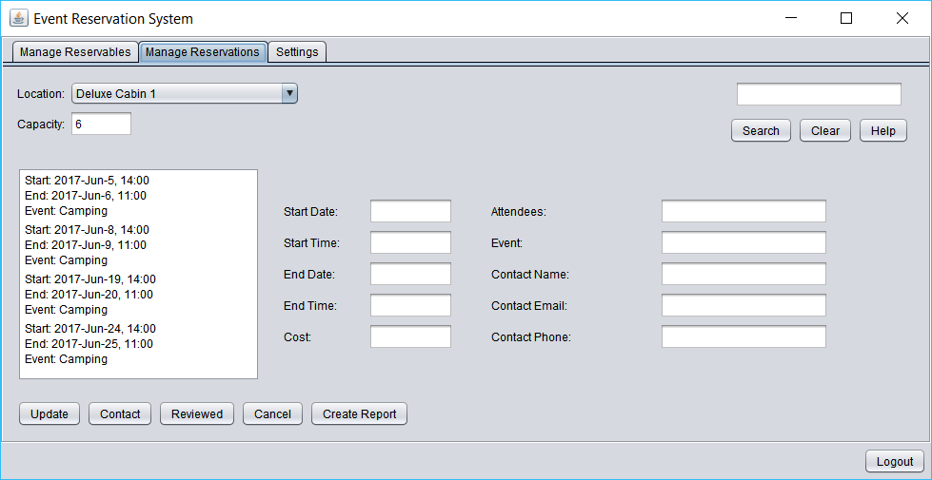
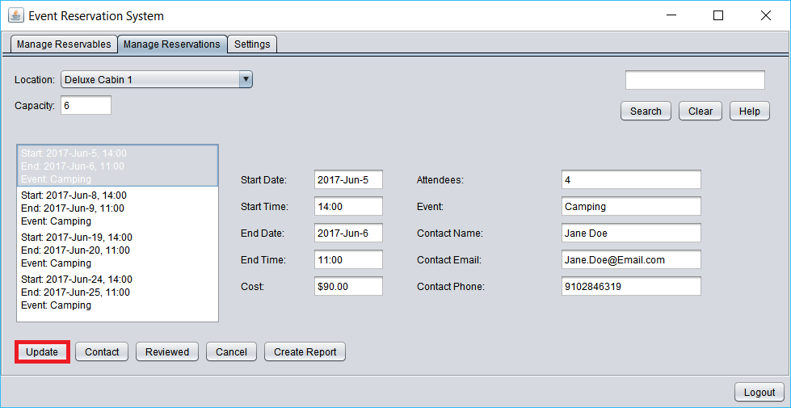
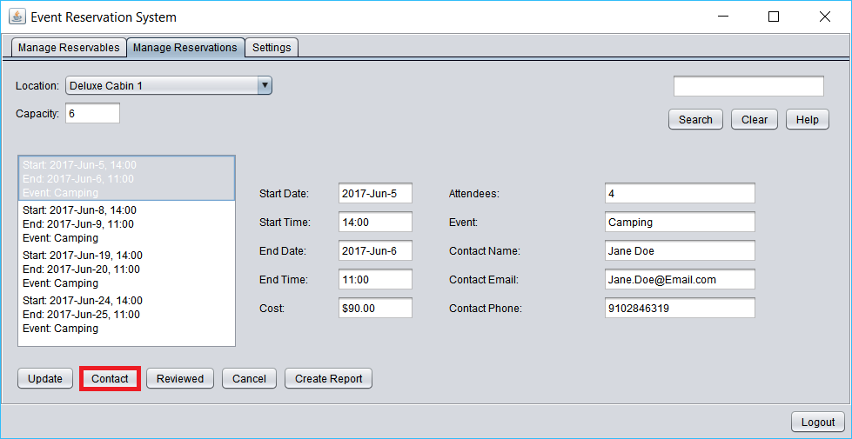
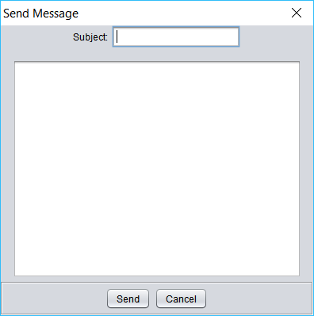
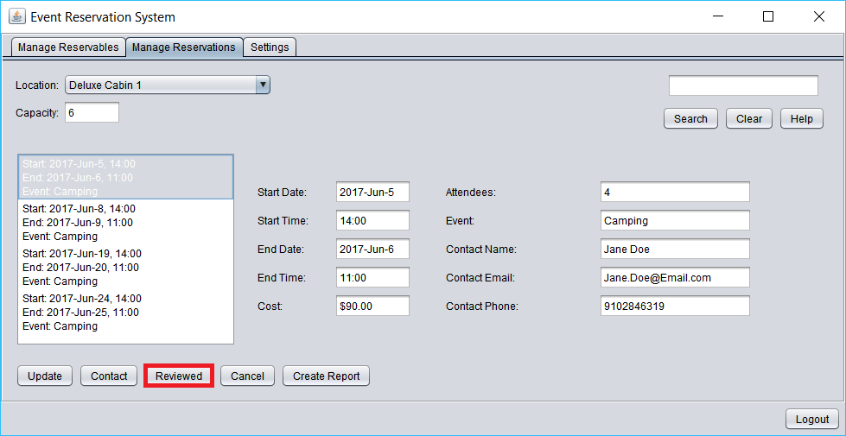
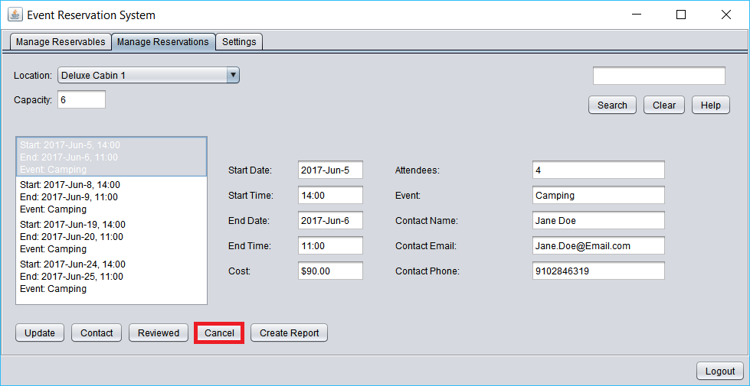
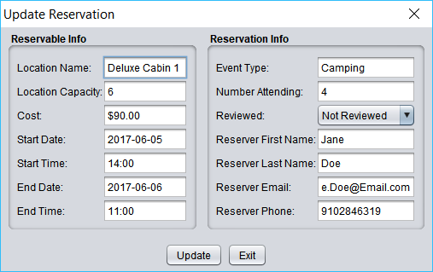
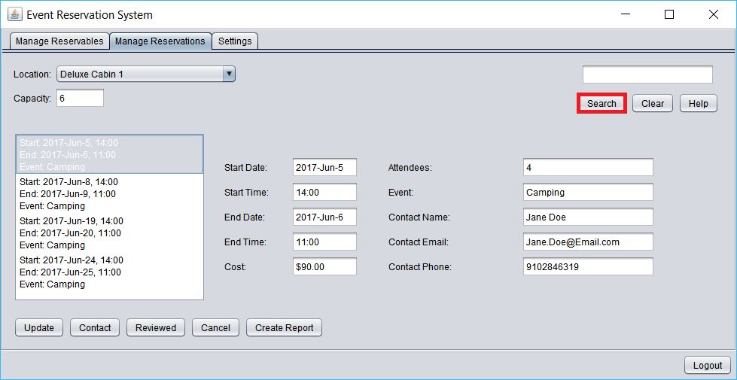
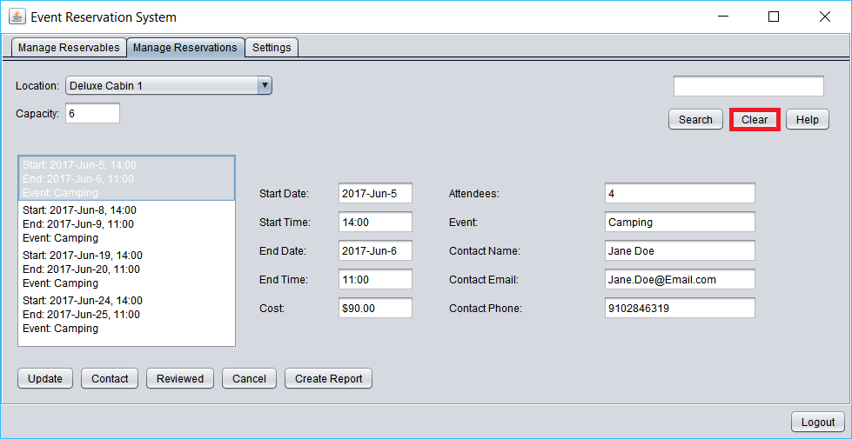
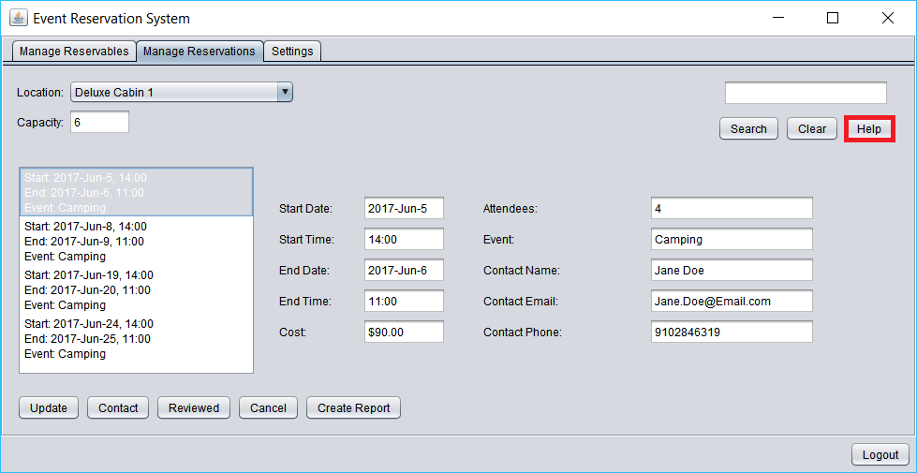
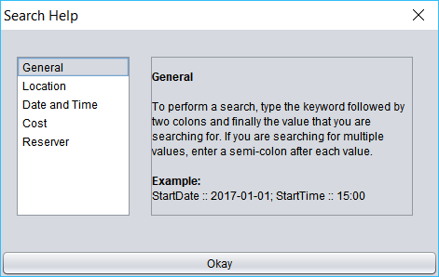
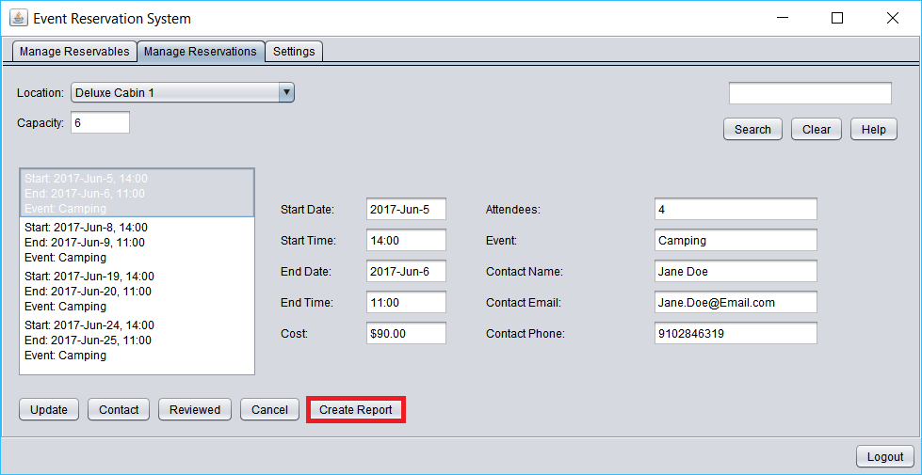
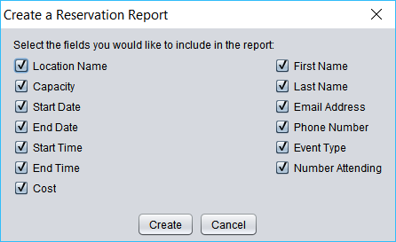
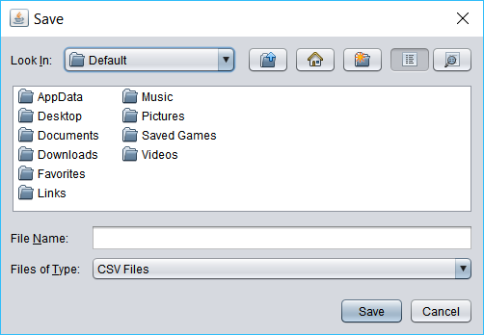

The Settings Panel
Admin Email settings involve defining SMTP settings of the email that the system will use to send notifications to reservers, the admin will contact reservers with, as well as the email address which the admin will receive emails sent by guests from within the system at.
Guest Email settings involve defining SMTP settings of the email that the system will use to send emails from a guest to the admin when a guest chooses to contact the admin from within the system.
Database settings involve defining the hostname, port number, username, and password of the MariaDB DBMS which will or does hold the data that the system persists data to.

