COMP3123 — Assignment 1
Backend REST API — Postman Testing
Student: Cem Dudu
Student ID: 101496484
COMP 3123 Full Stack Development I
Tests run on October 15, 2026
GitHub: https://github.com/Cem-Gbc/101496484_COMP3123_Assignment1
Deployed API: https://101496484-comp3123-assignment1.vercel.app

Test setup
Local API | http://localhost:3000 (Node.js 22, Express 5, Mongoose 9) with MongoDB 7.0 running in Docker. Database: comp3123_assignment1.
Deployed API | https://101496484-comp3123-assignment1.vercel.app (Vercel) with MongoDB Atlas (free M0 cluster). Database: comp3123_assignment1.
Testing tool | Postman Desktop 12.31.7. The collection COMP3123_Assignment1_Postman_Collection.json was imported into a workspace named "COMP3123 Assignment 1". Every screenshot shows the request (method, full URL and the request tab), the real status code, the JSON response and the Postman Test Results.
Test users | User A: alice / alice@example.com / AlicePass123. User B: bob / bob@example.com / BobPass123 (test accounts only).
Collection variables | The test scripts save tokens and ids in collection variables ({{tokenA}}, {{tokenB}}, {{empA1_id}}, ...), so the URLs and tokens show the variable names.
Security | JWT values in login responses are blurred in the screenshots. No passwords other than the sample test passwords, no secrets and no database credentials are shown.
Full collection run | The whole collection was also run with Newman (Postman's command line runner): 193/193 assertions passed locally and 207/207 on the deployed API.

Test summary
65 Postman requests with screenshots in this document: 65 returned the expected status code. Sections 10 and 11 add the MongoDB and log evidence.
# | Postman test | Expected | Actual | Result
1 | 1.1 Signup - User A (alice) | 201 Created | 201 Created | Pass
2 | 1.2 Signup - User B (bob) | 201 Created | 201 Created | Pass
3 | 1.3 Signup - Duplicate username | 409 Conflict | 409 Conflict | Pass
4 | 1.4 Signup - Duplicate email | 409 Conflict | 409 Conflict | Pass
5 | 1.5 Signup - Invalid email | 400 Bad Request | 400 Bad Request | Pass
6 | 1.6 Signup - Invalid password | 400 Bad Request | 400 Bad Request | Pass
7 | 1.7 Signup - Missing required fields | 400 Bad Request | 400 Bad Request | Pass
8 | 1.8 Signup - Unexpected field | 400 Bad Request | 400 Bad Request | Pass
9 | 2.1 Login - User A with username | 200 OK | 200 OK | Pass
10 | 2.2 Login - User B with email | 200 OK | 200 OK | Pass
11 | 2.3 Login - Wrong password | 401 Unauthorized | 401 Unauthorized | Pass
12 | 2.4 Login - User does not exist | 401 Unauthorized | 401 Unauthorized | Pass
13 | 2.5 Login - Missing credentials | 400 Bad Request | 400 Bad Request | Pass
14 | 3.1 Create employee - User A #1 | 201 Created | 201 Created | Pass
15 | 3.4 Get all employees - User A | 200 OK | 200 OK | Pass
16 | 3.5 Get employee by ID - User A | 200 OK | 200 OK | Pass
17 | 3.6 Update employee - User A | 200 OK | 200 OK | Pass
18 | 3.7 Delete employee - User A | 204 No Content | 204 No Content | Pass
19 | 3.8 Get deleted employee - 404 | 404 Not Found | 404 Not Found | Pass
20 | 4.1 Create employee - Missing fields | 400 Bad Request | 400 Bad Request | Pass
21 | 4.2 Create employee - Invalid email | 400 Bad Request | 400 Bad Request | Pass
22 | 4.3 Create employee - Negative salary | 400 Bad Request | 400 Bad Request | Pass
23 | 4.4 Create employee - Salary is not a number | 400 Bad Request | 400 Bad Request | Pass
24 | 4.5 Create employee - Invalid date | 400 Bad Request | 400 Bad Request | Pass
25 | 4.6 Create employee - Client tries to set the owner | 400 Bad Request | 400 Bad Request | Pass
26 | 4.7 Create employee - Duplicate email | 409 Conflict | 409 Conflict | Pass
27 | 4.8 Get employee - Invalid ID | 400 Bad Request | 400 Bad Request | Pass
28 | 4.9 Get employee - Employee does not exist | 404 Not Found | 404 Not Found | Pass
29 | 4.10 Update employee - Invalid fields | 400 Bad Request | 400 Bad Request | Pass
30 | 4.11 Update employee - Empty body | 400 Bad Request | 400 Bad Request | Pass
31 | 4.12 Delete employee - Missing eid | 400 Bad Request | 400 Bad Request | Pass
32 | 4.13 Delete employee - Invalid eid | 400 Bad Request | 400 Bad Request | Pass
33 | 4.14 Delete employee - Employee does not exist | 404 Not Found | 404 Not Found | Pass
34 | 4.15 Malformed JSON body | 400 Bad Request | 400 Bad Request | Pass
35 | 4.16 Unsupported endpoint | 404 Not Found | 404 Not Found | Pass
36 | 8.1 Database stopped - 500 Internal Server Error | 500 Internal Server Error | 500 Internal Server Error | Pass
37 | 5.1 Missing JWT | 401 Unauthorized | 401 Unauthorized | Pass
38 | 5.2 Invalid JWT | 401 Unauthorized | 401 Unauthorized | Pass
39 | 5.3 Tampered JWT (user id changed) | 401 Unauthorized | 401 Unauthorized | Pass
40 | 5.4 Expired JWT - step 1: log in | 200 OK | 200 OK | Pass
41 | 5.5 Expired JWT - step 2: use the expired token | 401 Unauthorized | 401 Unauthorized | Pass
42 | 6.1 Create employee - User B #1 | 201 Created | 201 Created | Pass
43 | 6.3 User A lists employees - only own | 200 OK | 200 OK | Pass
44 | 6.4 User B lists employees - only own | 200 OK | 200 OK | Pass
45 | 6.5 User A gets User B's employee - 403 | 403 Forbidden | 403 Forbidden | Pass
46 | 6.6 User A updates User B's employee - 403 | 403 Forbidden | 403 Forbidden | Pass
47 | 6.7 User A deletes User B's employee - 403 | 403 Forbidden | 403 Forbidden | Pass
48 | 6.8 User B gets User A's employee - 403 | 403 Forbidden | 403 Forbidden | Pass
49 | 6.9 User B updates User A's employee - 403 | 403 Forbidden | 403 Forbidden | Pass
50 | 6.10 User B deletes User A's employee - 403 | 403 Forbidden | 403 Forbidden | Pass
51 | 6.11 User B's employee is unchanged | 200 OK | 200 OK | Pass
52 | 6.12 User A's employee is unchanged | 200 OK | 200 OK | Pass
53 | 7.1 Login - repeat until 429 Too Many Requests | 429 Too Many Requests | 429 Too Many Requests | Pass
54 | 7.1 Login - repeat until 429 Too Many Requests | 429 Too Many Requests | 429 Too Many Requests | Pass
55 | 0.1 Health check | 200 OK | 200 OK | Pass
56 | 0.1 Health check | 200 OK | 200 OK | Pass
57 | 8.2 Health check - database status | 200 OK | 200 OK | Pass
58 | 9.1 Deployed - Health check | 200 OK | 200 OK | Pass
59 | 9.2 Deployed - Login User A | 200 OK | 200 OK | Pass
60 | 9.4 Deployed - Create employee (User A) | 201 Created | 201 Created | Pass
61 | 9.5 Deployed - Get all employees (User A) | 200 OK | 200 OK | Pass
62 | 9.6 Deployed - Update employee (User A) | 200 OK | 200 OK | Pass
63 | 9.7 Deployed - User B gets User A's employee - 403 | 403 Forbidden | 403 Forbidden | Pass
64 | 9.8 Deployed - Missing JWT - 401 | 401 Unauthorized | 401 Unauthorized | Pass
65 | 9.9 Deployed - Delete employee (User A) | 204 No Content | 204 No Content | Pass

1. User Registration
POST /api/v1/user/signup creates a user (201). Duplicate users return 409 and invalid input returns 400.
Test | 1.1 Signup - User A (alice)
Endpoint | POST http://localhost:3000/api/v1/user/signup
Expected status | 201 Created
Actual status | 201 Created (Postman Test Results 4/4)
Explanation | Registers User A (alice). The API returns 201 Created with the new user. The password is not in the response; it is stored as a bcrypt hash (see section 10).
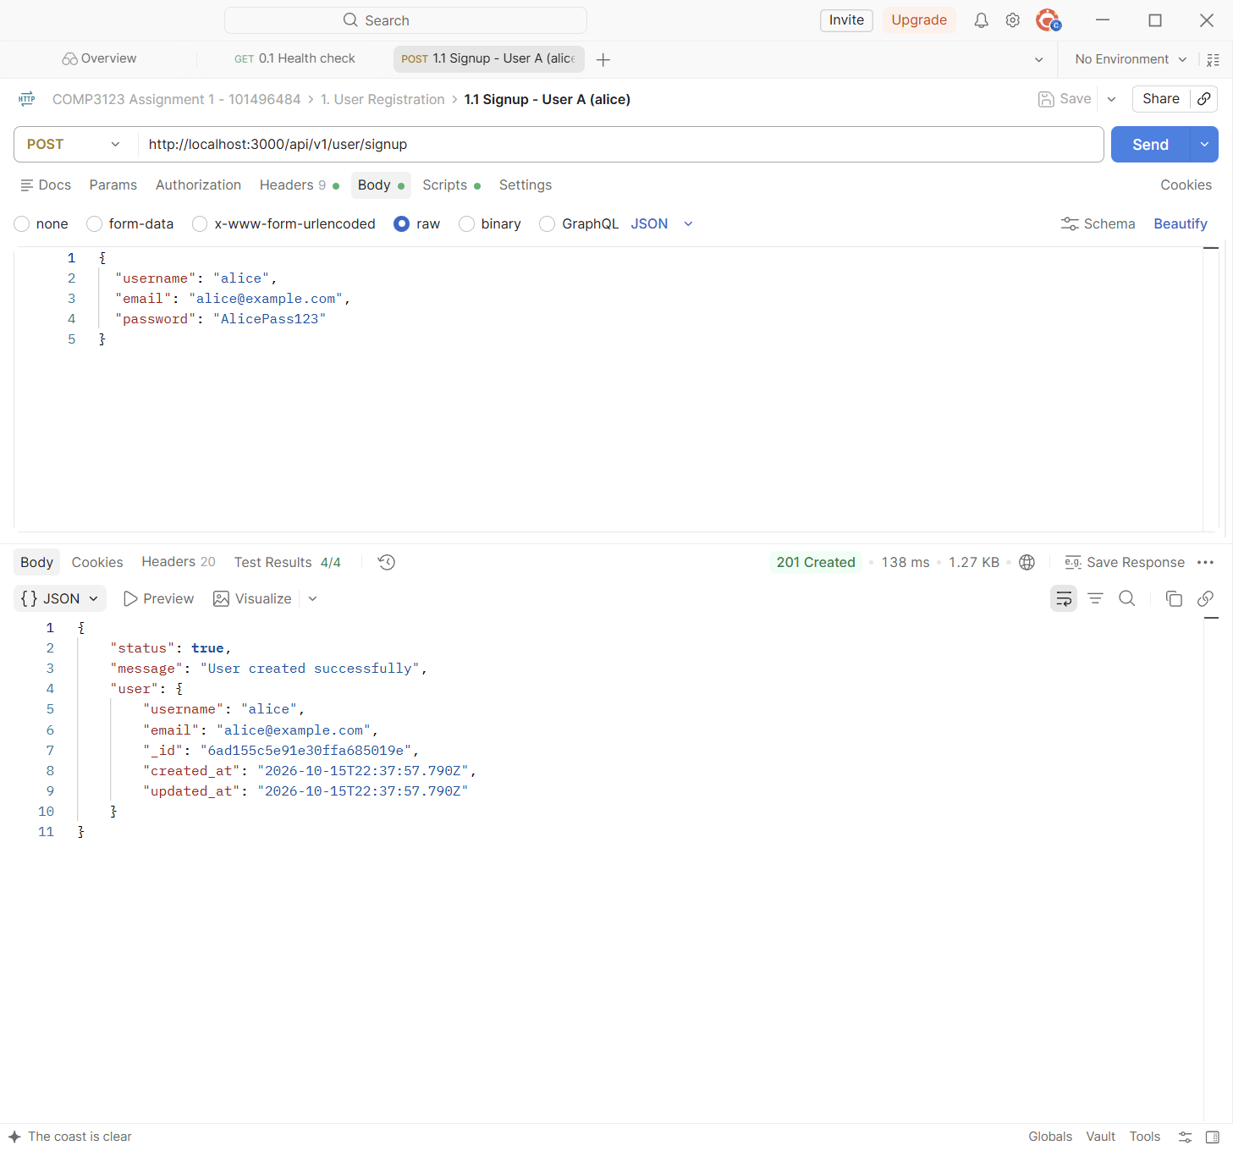

Test | 1.2 Signup - User B (bob)
Endpoint | POST http://localhost:3000/api/v1/user/signup
Expected status | 201 Created
Actual status | 201 Created (Postman Test Results 3/3)
Explanation | Registers User B (bob). This second user is needed for the two-user authorization tests.
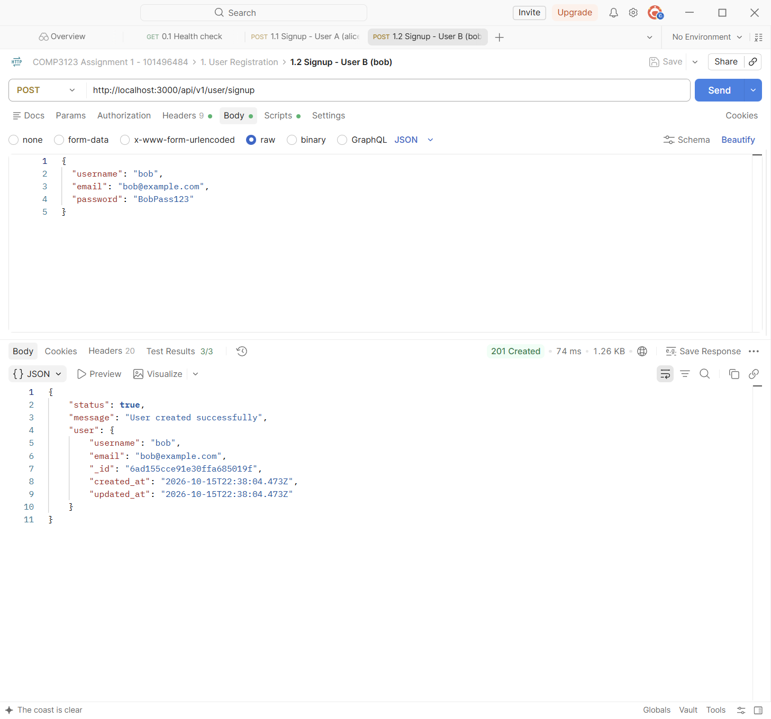

Test | 1.3 Signup - Duplicate username
Endpoint | POST http://localhost:3000/api/v1/user/signup
Expected status | 409 Conflict
Actual status | 409 Conflict (Postman Test Results 3/3)
Explanation | Signing up again with the existing username "alice" is rejected with 409 Conflict: "Username already exists".
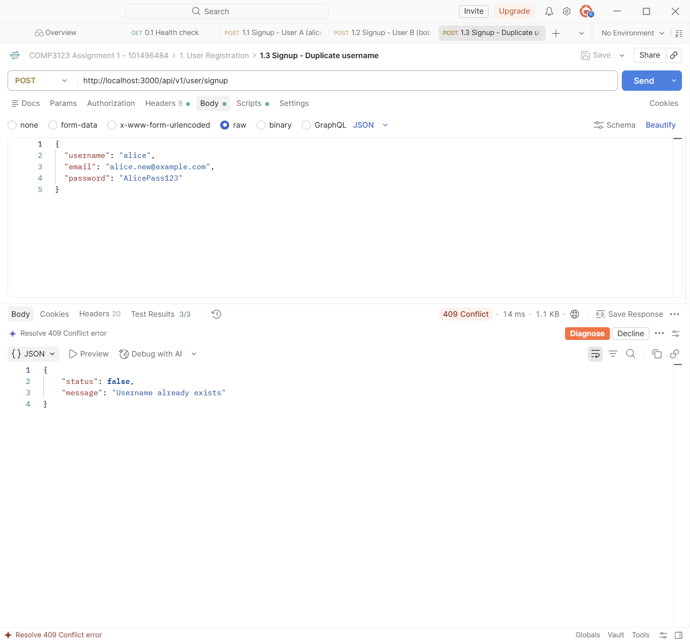

Test | 1.4 Signup - Duplicate email
Endpoint | POST http://localhost:3000/api/v1/user/signup
Expected status | 409 Conflict
Actual status | 409 Conflict (Postman Test Results 3/3)
Explanation | A new username with an email that is already registered is rejected with 409 Conflict: "Email already exists".
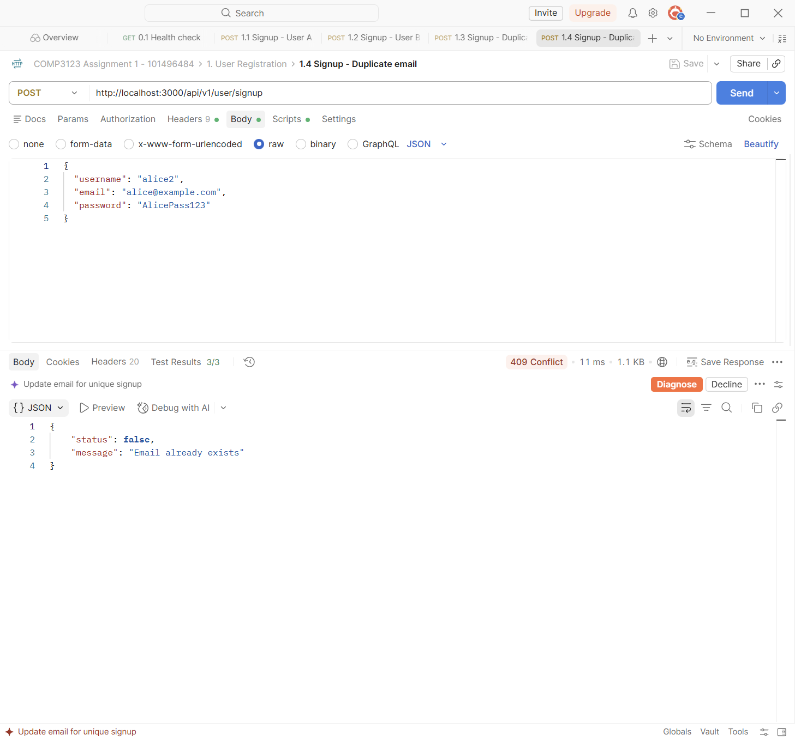

Test | 1.5 Signup - Invalid email
Endpoint | POST http://localhost:3000/api/v1/user/signup
Expected status | 400 Bad Request
Actual status | 400 Bad Request (Postman Test Results 3/3)
Explanation | express-validator checks the email format. An invalid email returns 400 with the field name and a clear message.
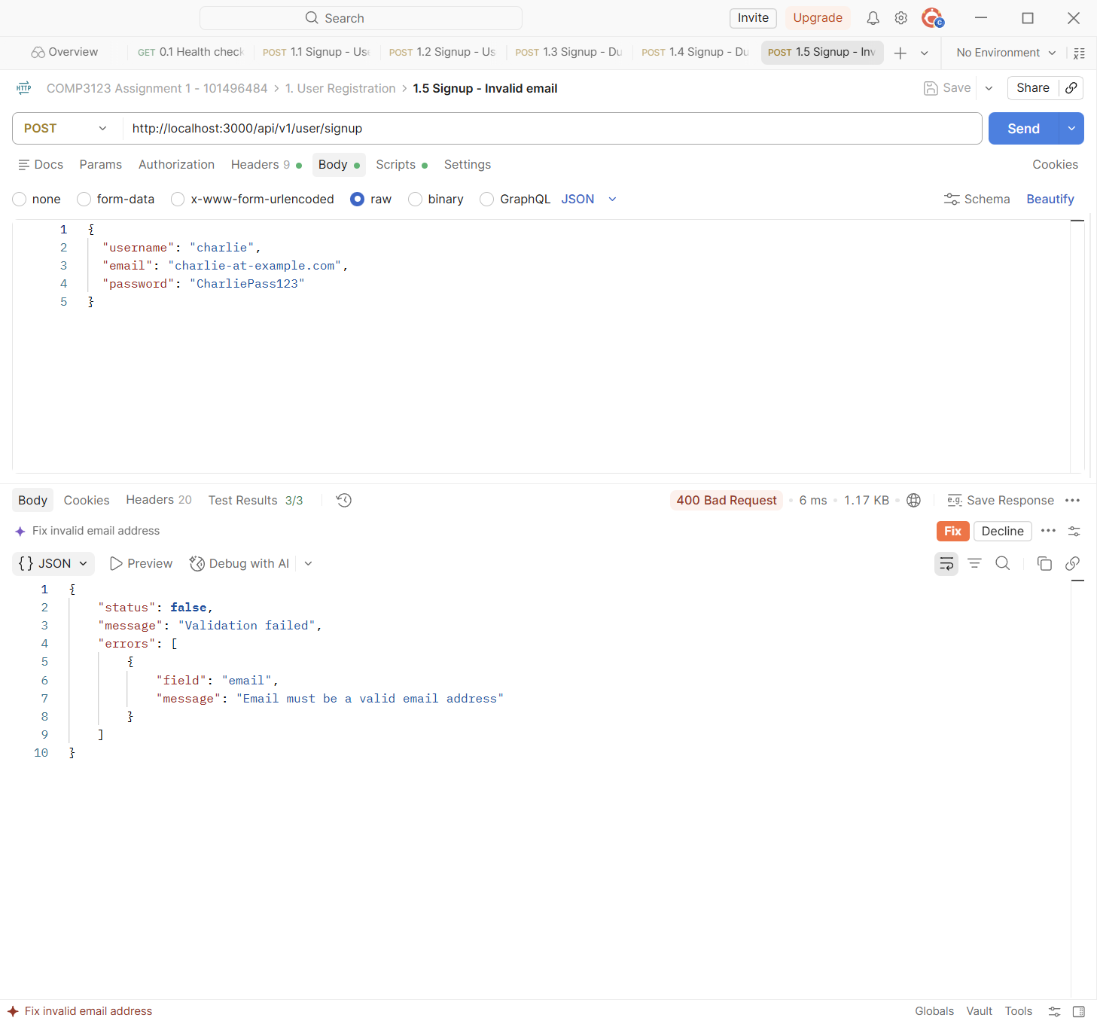

Test | 1.6 Signup - Invalid password
Endpoint | POST http://localhost:3000/api/v1/user/signup
Expected status | 400 Bad Request
Actual status | 400 Bad Request (Postman Test Results 3/3)
Explanation | The password "short" breaks the password rules (8-64 characters, an uppercase letter, a lowercase letter and a number). The response lists every rule that failed.
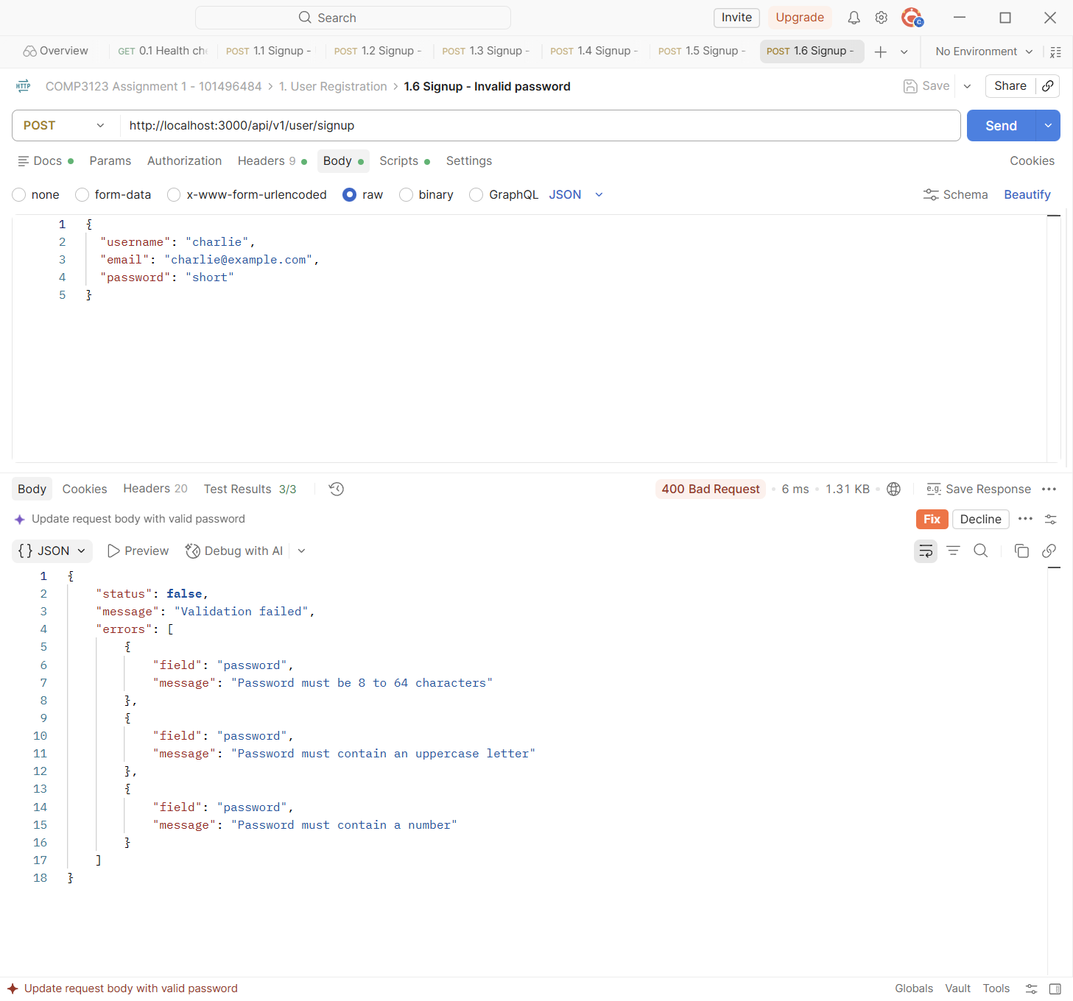

Test | 1.7 Signup - Missing required fields
Endpoint | POST http://localhost:3000/api/v1/user/signup
Expected status | 400 Bad Request
Actual status | 400 Bad Request (Postman Test Results 5/5)
Explanation | An empty body returns 400 and lists username, email and password as required.
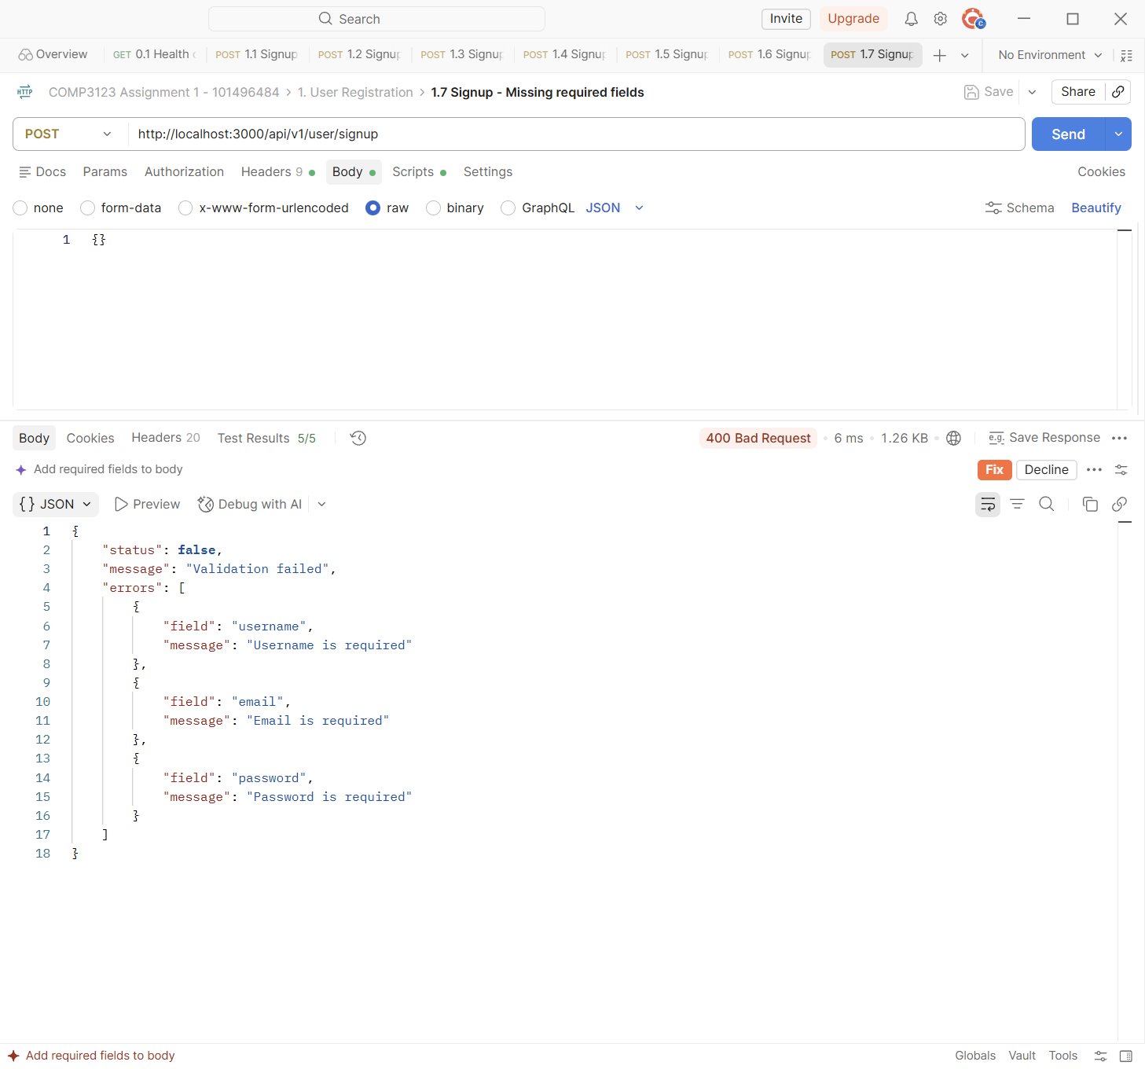

Test | 1.8 Signup - Unexpected field
Endpoint | POST http://localhost:3000/api/v1/user/signup
Expected status | 400 Bad Request
Actual status | 400 Bad Request (Postman Test Results 3/3)
Explanation | Unexpected fields such as "role": "admin" are rejected (checkExact) instead of being silently ignored.
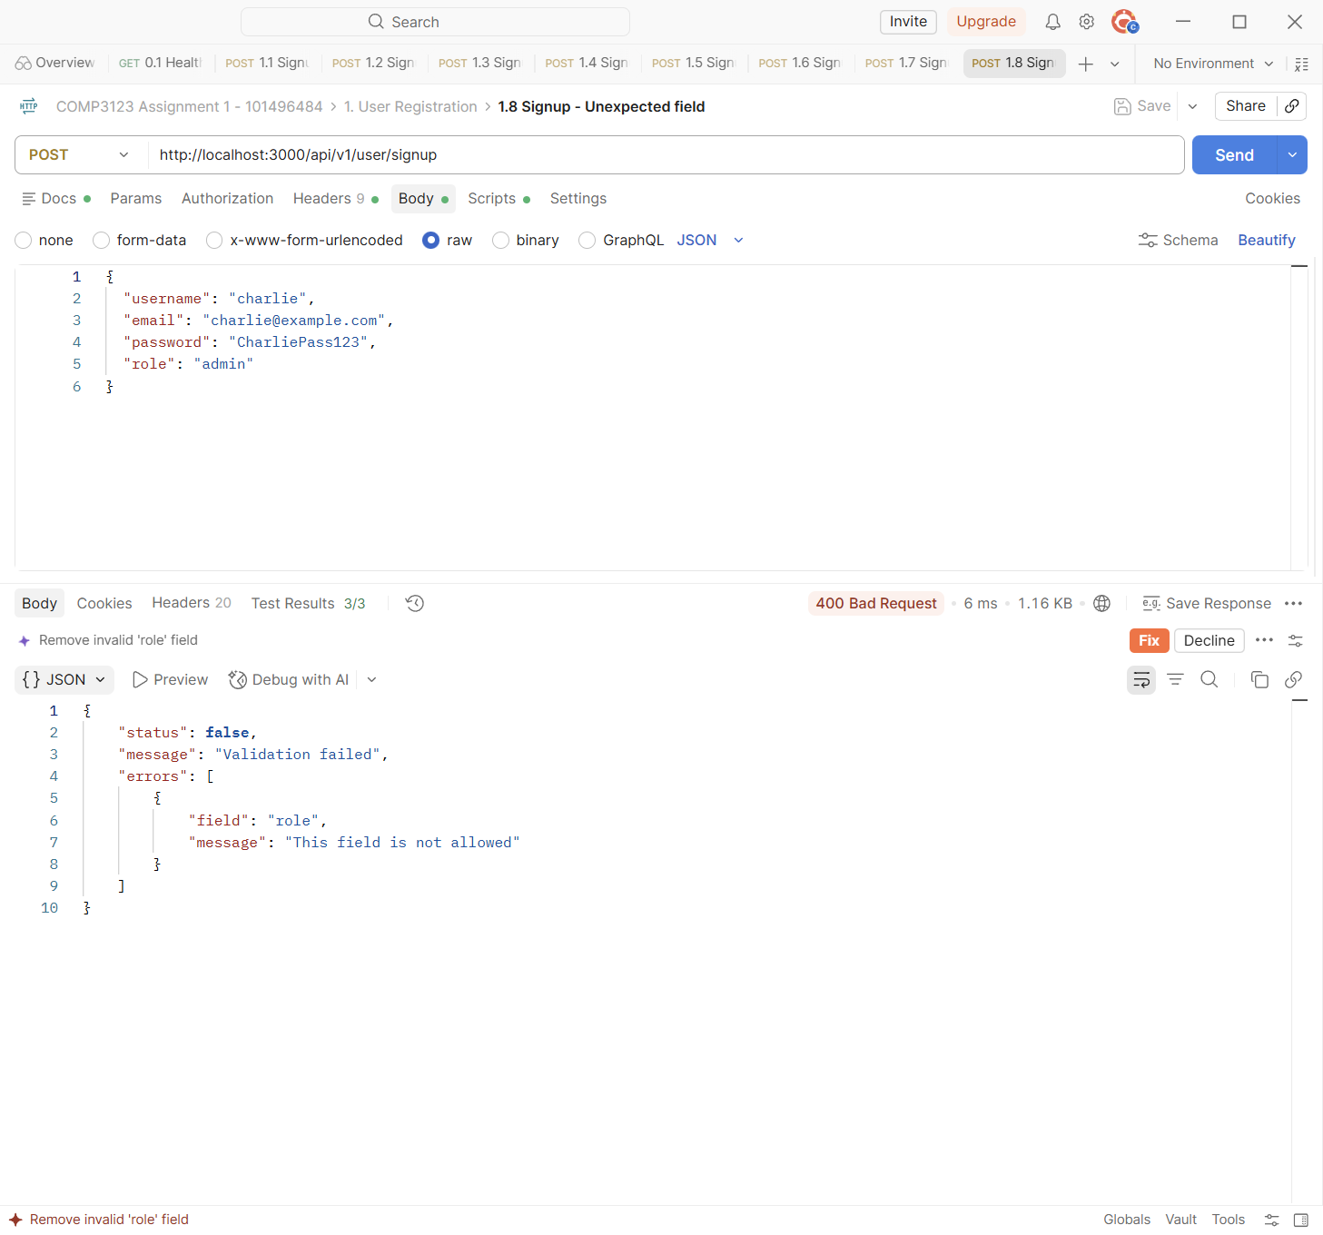

2. User Login and JWT
POST /api/v1/user/login accepts username + password or email + password and returns a JWT. The JWT values are blurred in the screenshots.
Test | 2.1 Login - User A with username
Endpoint | POST http://localhost:3000/api/v1/user/login
Expected status | 200 OK
Actual status | 200 OK (Postman Test Results 3/3)
Explanation | User A logs in with username + password. The API returns 200 with a signed JWT (blurred), the token type (Bearer) and the expiry time (1h). The test script saves the token in the collection variable {{tokenA}}.
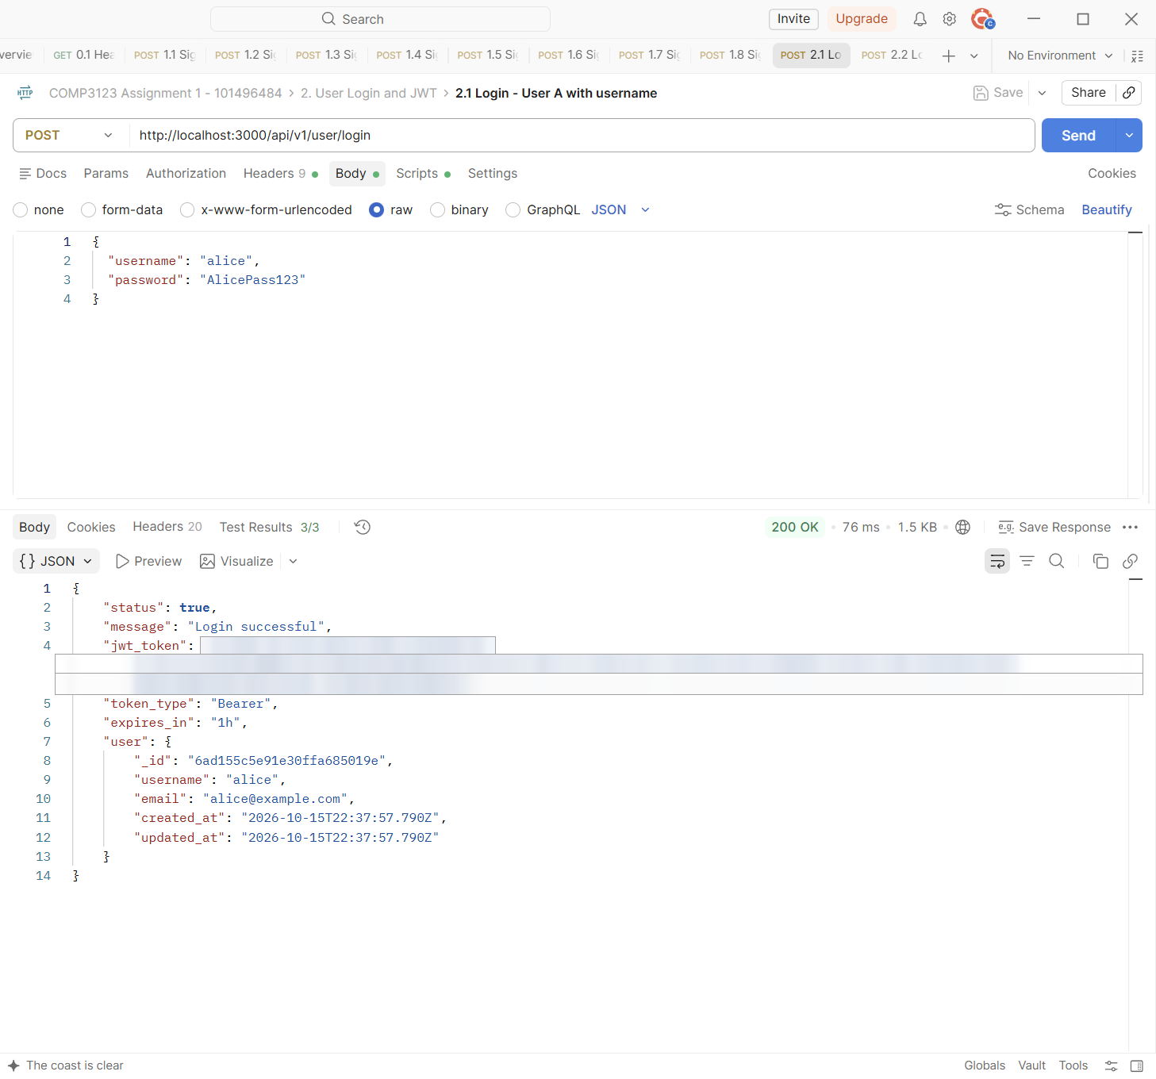

Test | 2.2 Login - User B with email
Endpoint | POST http://localhost:3000/api/v1/user/login
Expected status | 200 OK
Actual status | 200 OK (Postman Test Results 3/3)
Explanation | User B logs in with email + password, the second supported login option. The token is saved as {{tokenB}}.
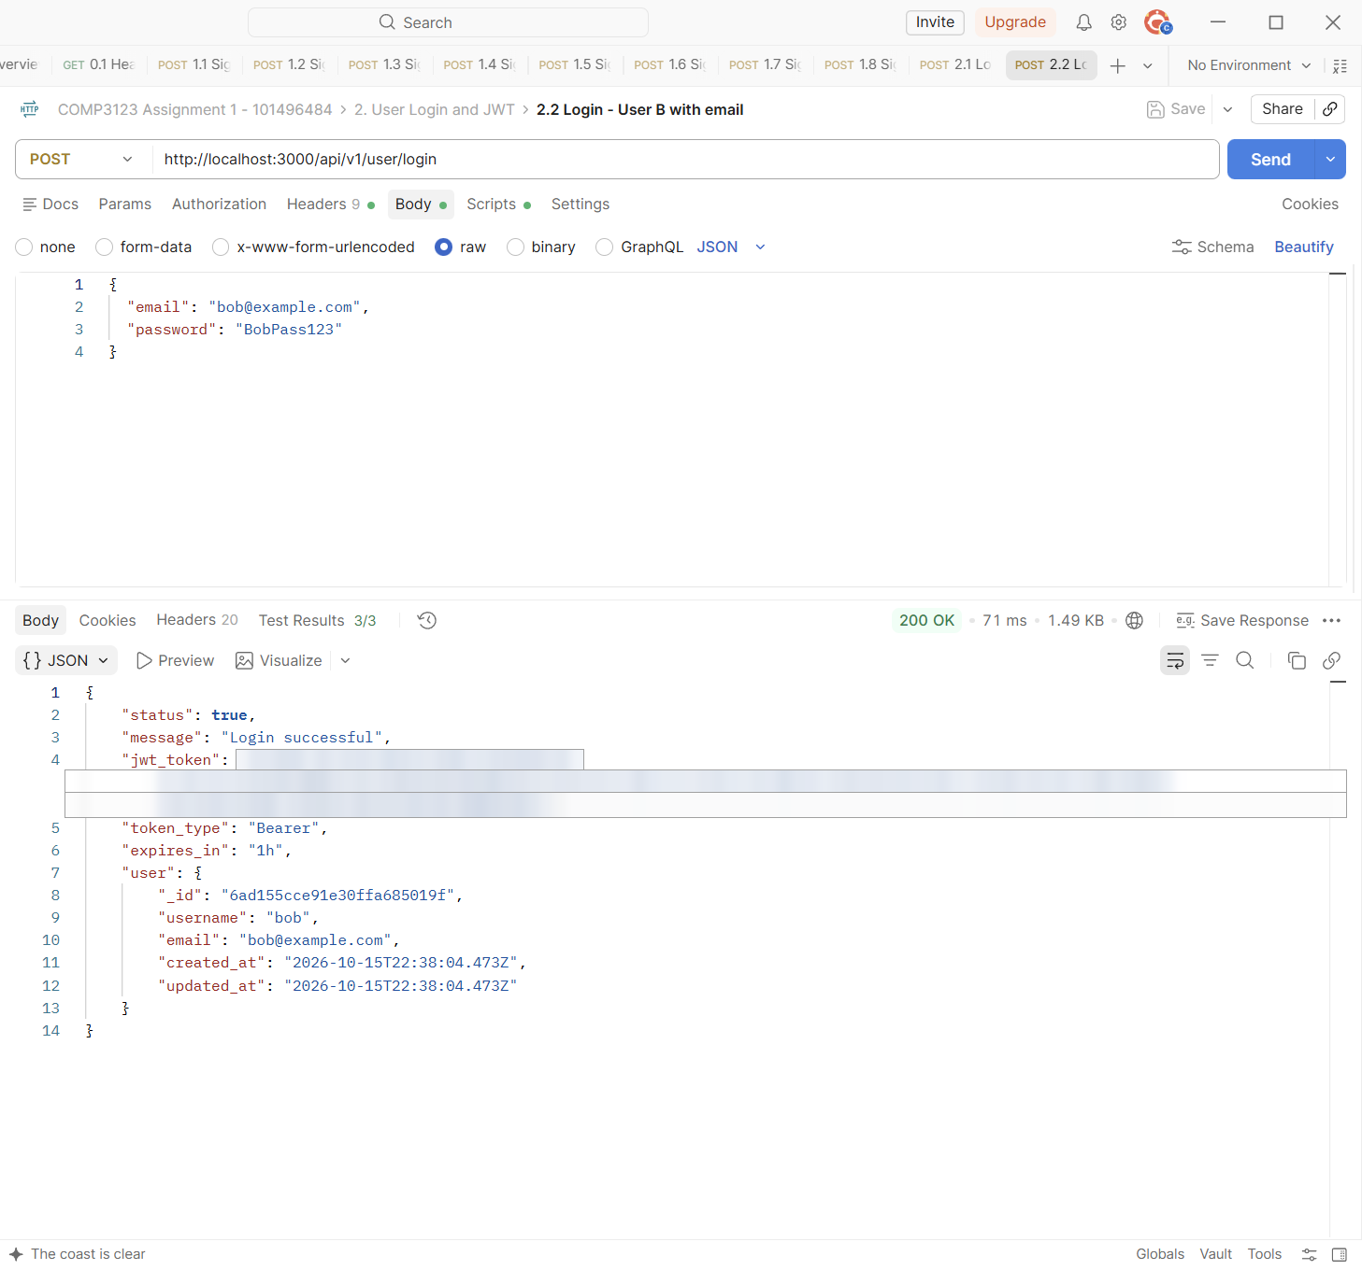

Test | 2.3 Login - Wrong password
Endpoint | POST http://localhost:3000/api/v1/user/login
Expected status | 401 Unauthorized
Actual status | 401 Unauthorized (Postman Test Results 3/3)
Explanation | A wrong password returns 401 with a general message that does not say which part was wrong.
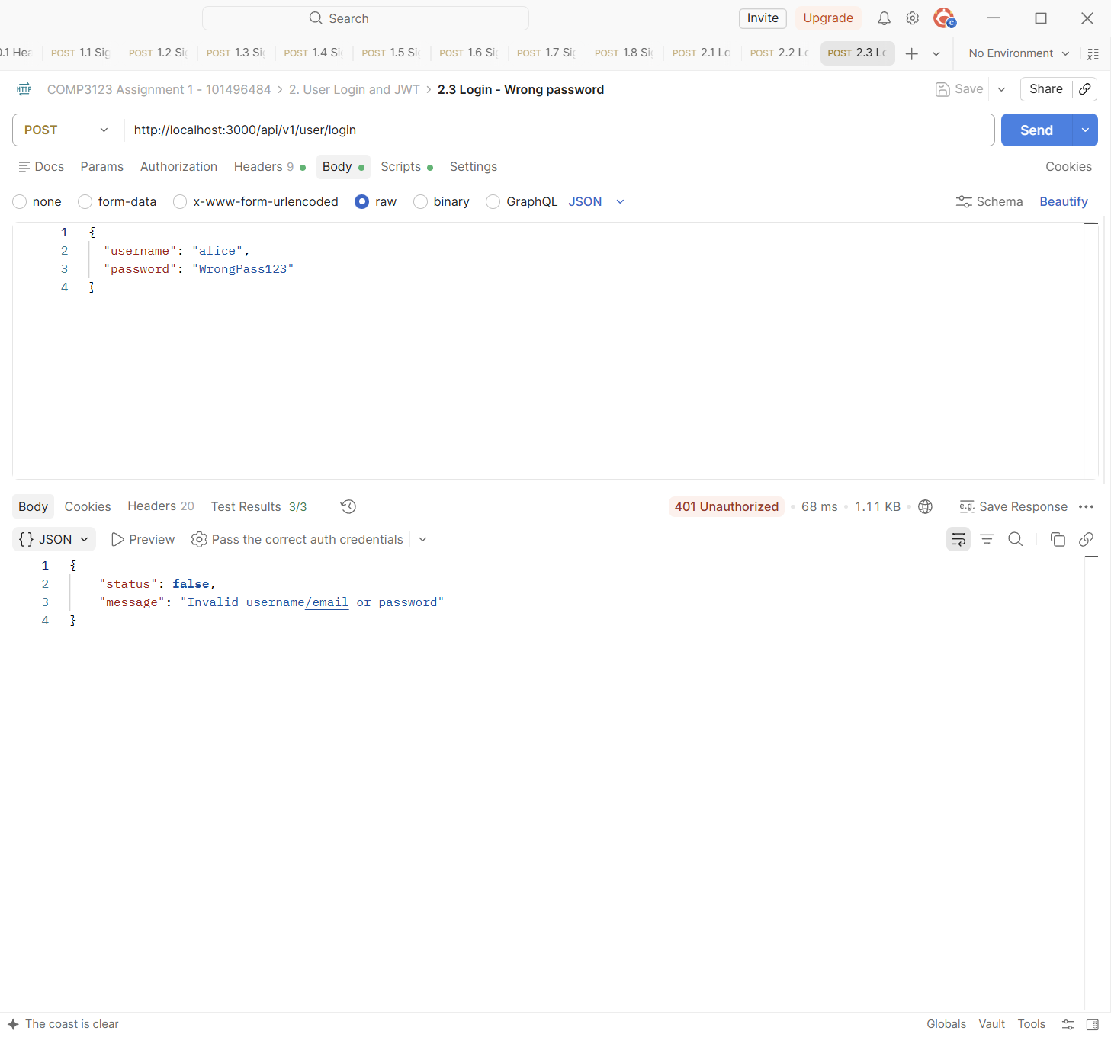

Test | 2.4 Login - User does not exist
Endpoint | POST http://localhost:3000/api/v1/user/login
Expected status | 401 Unauthorized
Actual status | 401 Unauthorized (Postman Test Results 3/3)
Explanation | A username that does not exist returns the same 401 message as a wrong password, so nobody can find out which usernames exist.
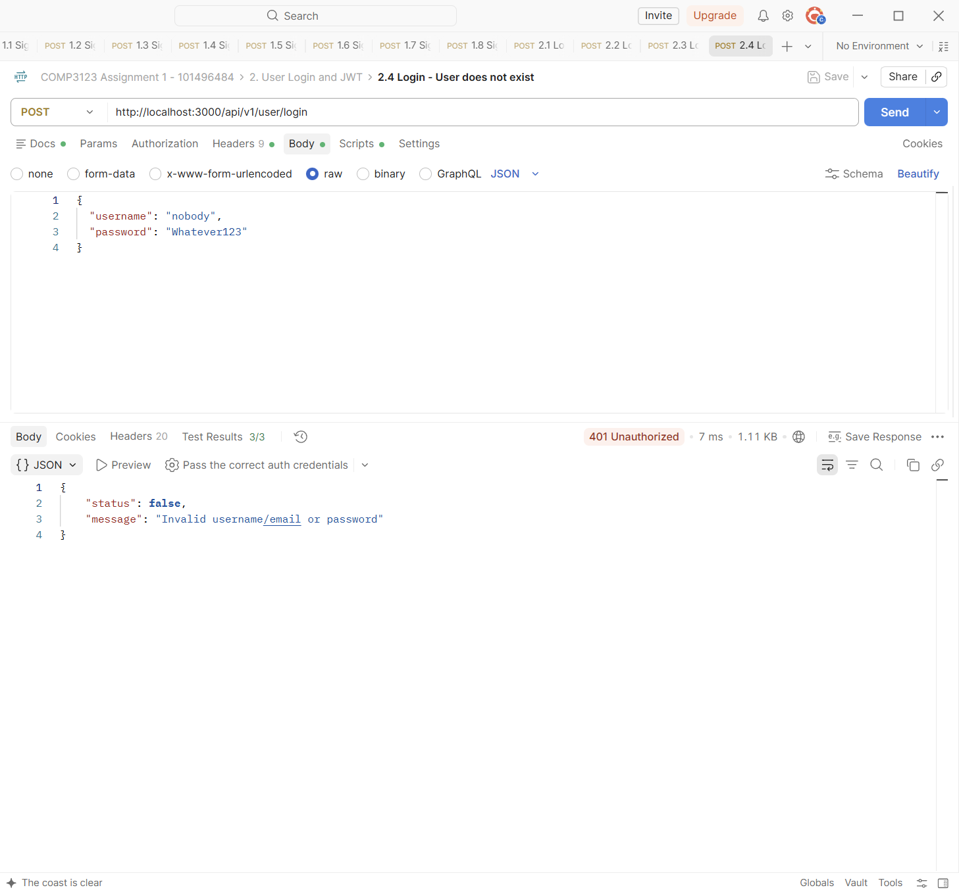

Test | 2.5 Login - Missing credentials
Endpoint | POST http://localhost:3000/api/v1/user/login
Expected status | 400 Bad Request
Actual status | 400 Bad Request (Postman Test Results 4/4)
Explanation | An empty login body returns 400: the password is required, and a username or an email is required.
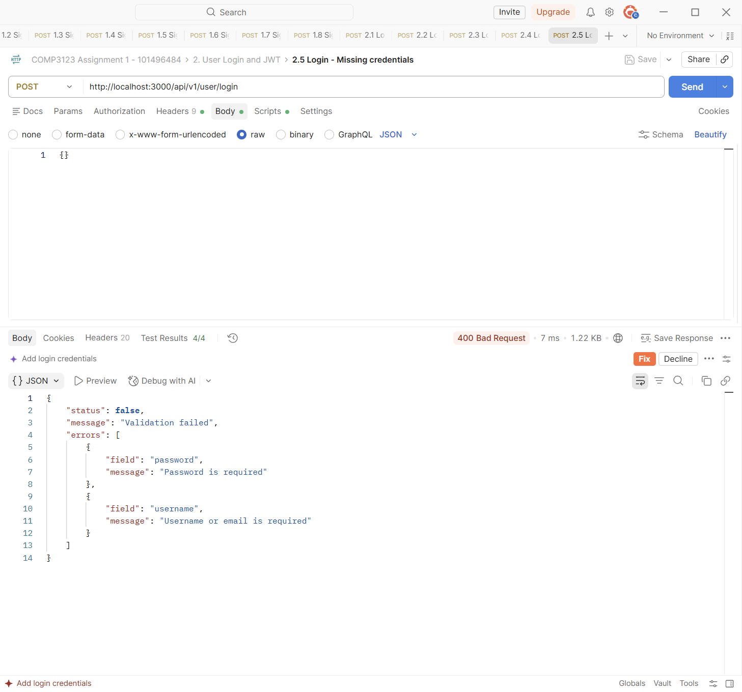

3. Employee CRUD Operations
All employee routes need the header "Authorization: Bearer <jwt>". These requests use User A's token ({{tokenA}}).
Test | 3.1 Create employee - User A #1
Endpoint | POST http://localhost:3000/api/v1/emp/employees
Expected status | 201 Created
Actual status | 201 Created (Postman Test Results 5/5)
Explanation | User A creates an employee. The response is 201 Created. The "user" field (the owner) is added by the server from the JWT, it is not sent by the client.
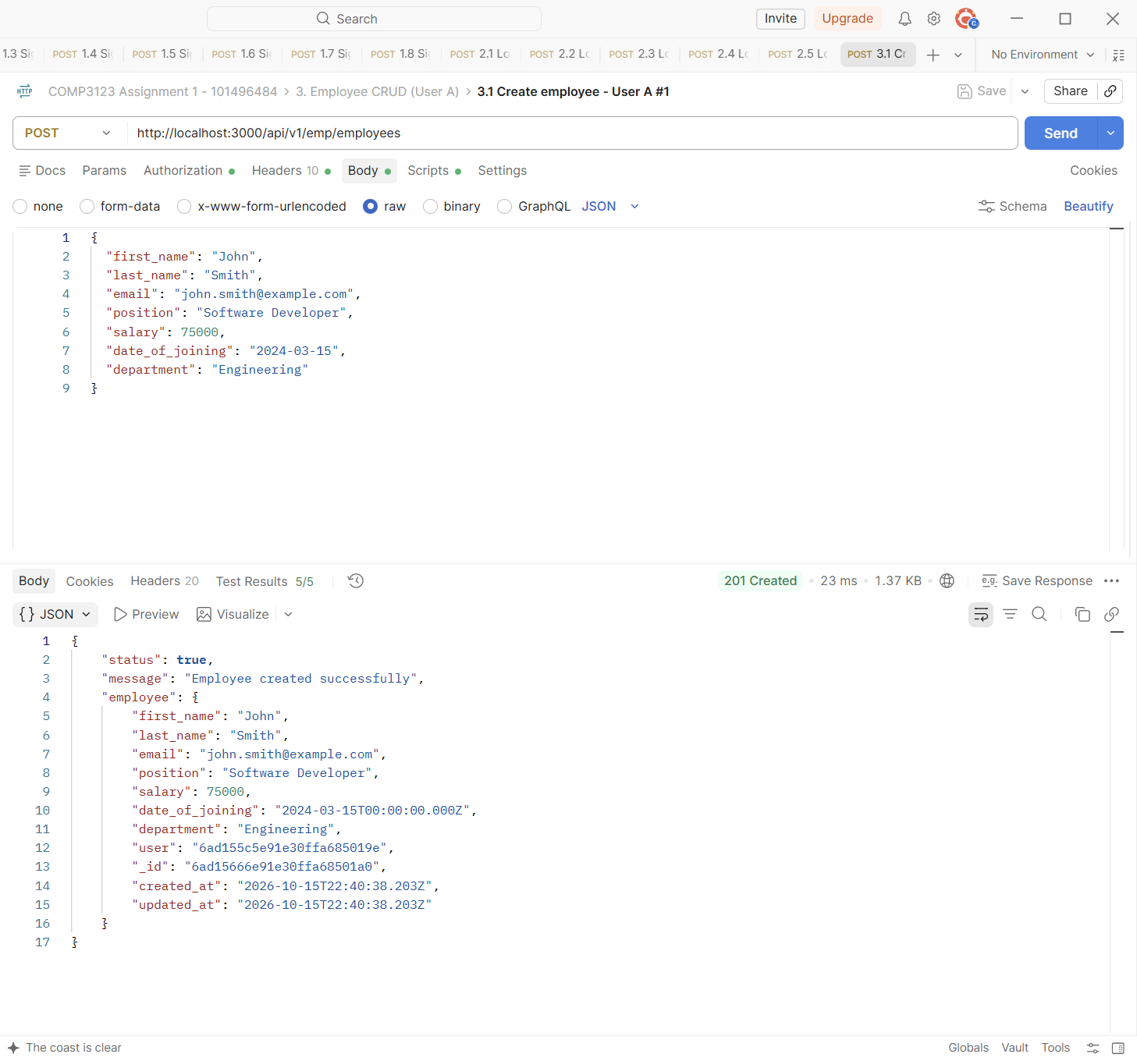

Test | 3.4 Get all employees - User A
Endpoint | GET http://localhost:3000/api/v1/emp/employees
Expected status | 200 OK
Actual status | 200 OK (Postman Test Results 3/3)
Explanation | User A lists the employees. Only User A's 3 employees are returned, because the query filters by the owner id from the token. Requests 3.2 and 3.3 created the 2nd and 3rd employee.
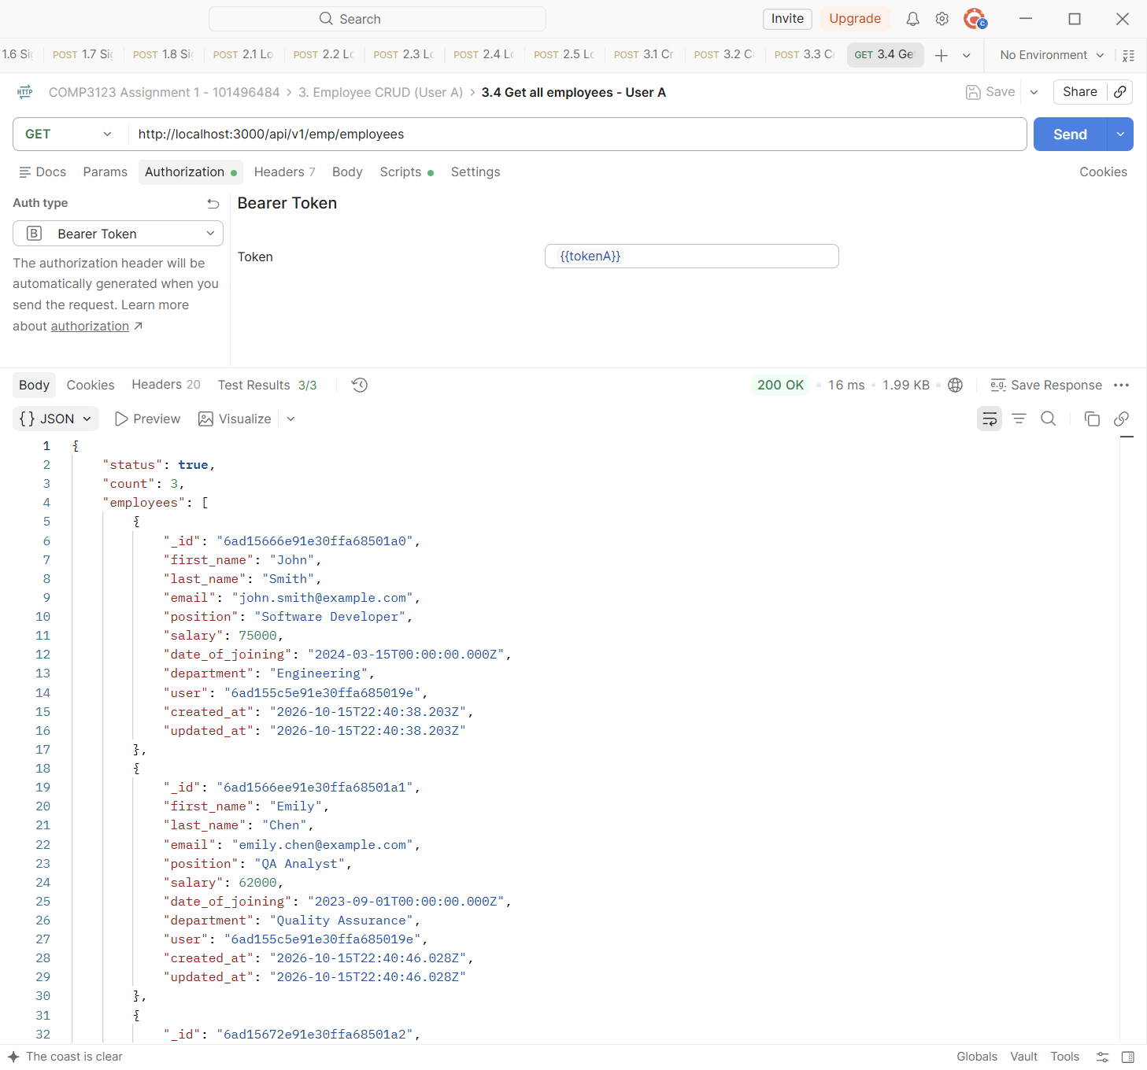

Test | 3.5 Get employee by ID - User A
Endpoint | GET http://localhost:3000/api/v1/emp/employees/{{empA1_id}}
Expected status | 200 OK
Actual status | 200 OK (Postman Test Results 3/3)
Explanation | Returns one employee by its id, after checking that the employee belongs to User A.
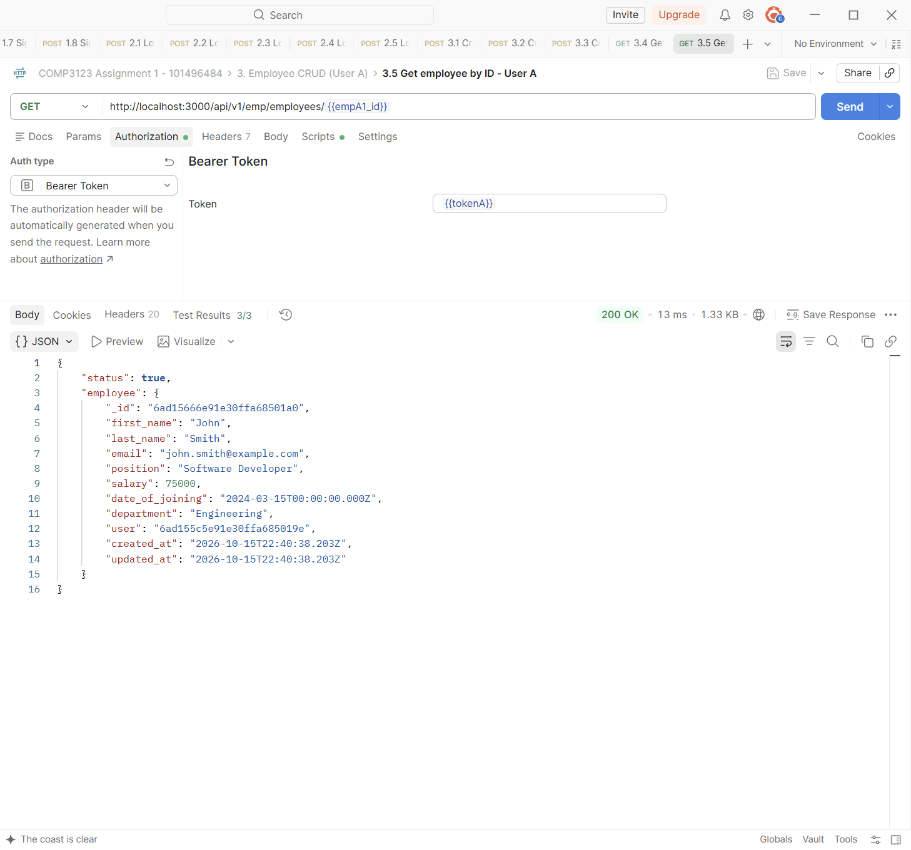

Test | 3.6 Update employee - User A
Endpoint | PUT http://localhost:3000/api/v1/emp/employees/{{empA1_id}}
Expected status | 200 OK
Actual status | 200 OK (Postman Test Results 3/3)
Explanation | PUT updates only the fields that are sent (position and salary). The response shows the new values and a newer updated_at time.
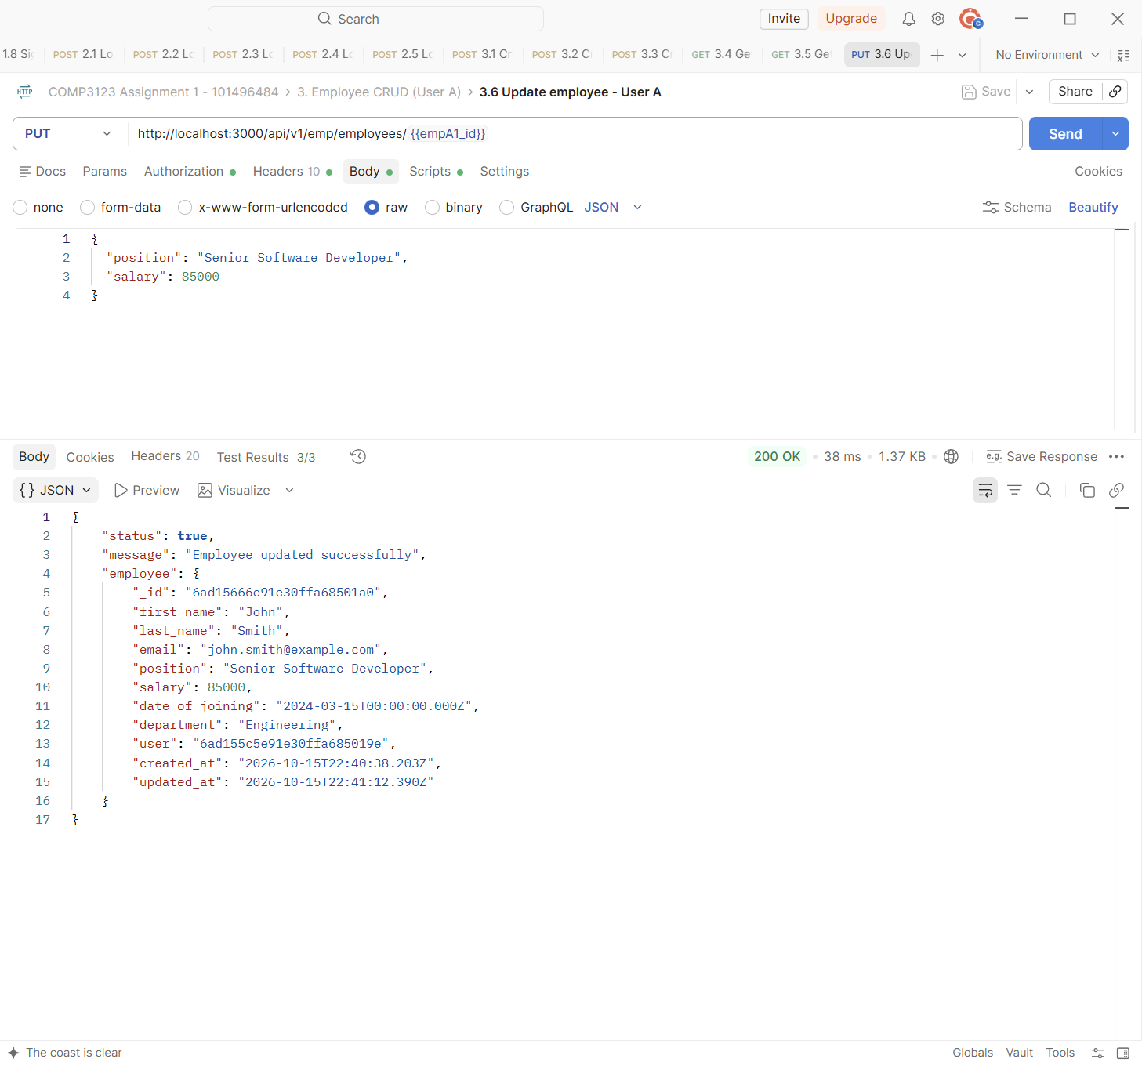

Test | 3.7 Delete employee - User A
Endpoint | DELETE http://localhost:3000/api/v1/emp/employees?eid={{empA3_id}}
Expected status | 204 No Content
Actual status | 204 No Content (Postman Test Results 2/2)
Explanation | DELETE with ?eid= removes User A's third employee. The API returns 204 No Content with an empty body.
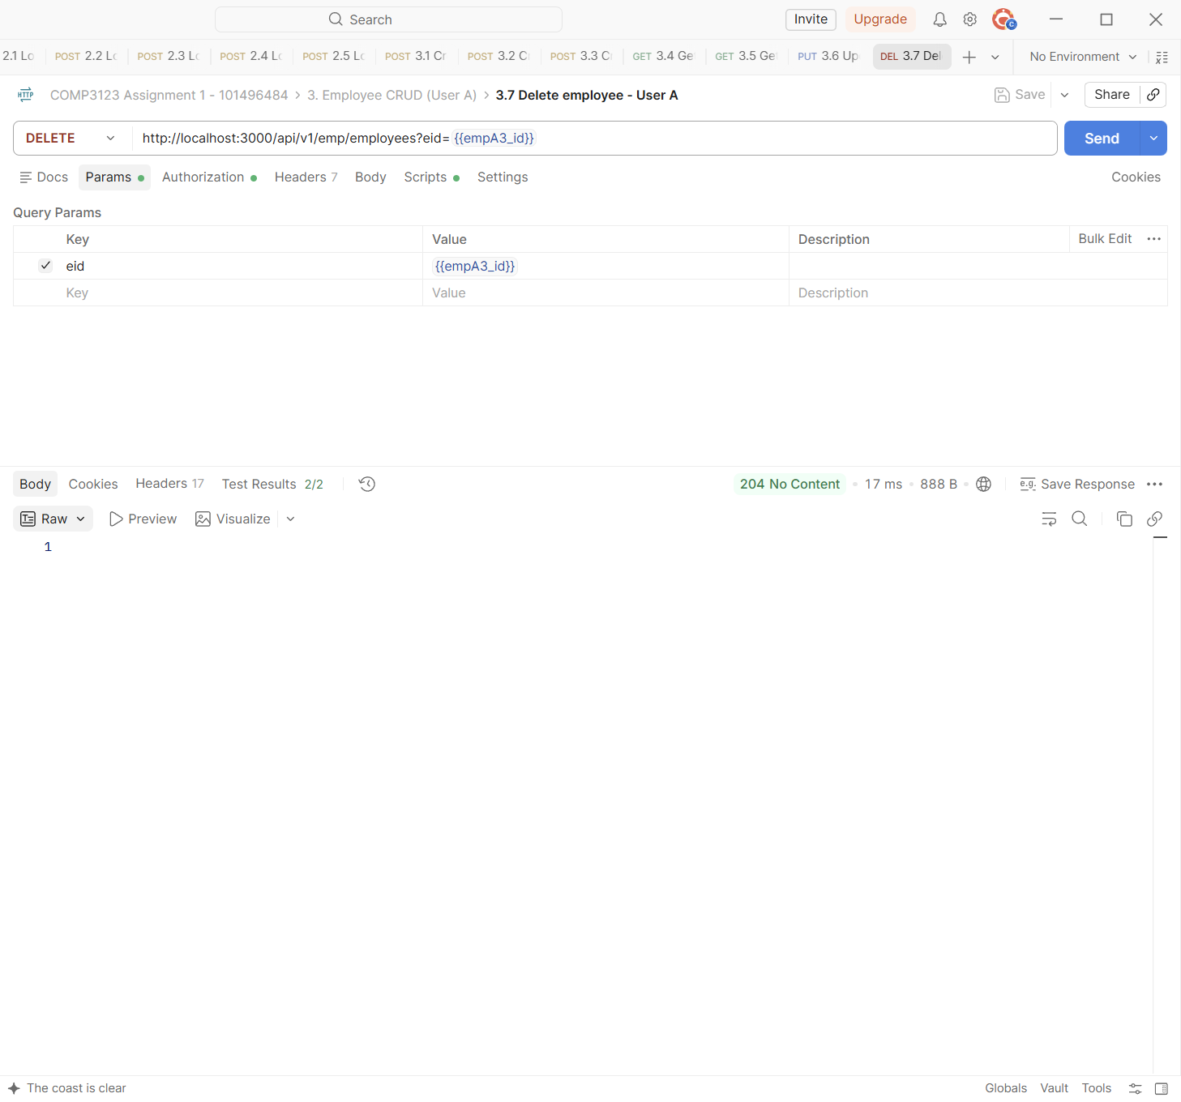

Test | 3.8 Get deleted employee - 404
Endpoint | GET http://localhost:3000/api/v1/emp/employees/{{empA3_id}}
Expected status | 404 Not Found
Actual status | 404 Not Found (Postman Test Results 3/3)
Explanation | Getting the deleted employee returns 404 Not Found, which confirms the delete worked.
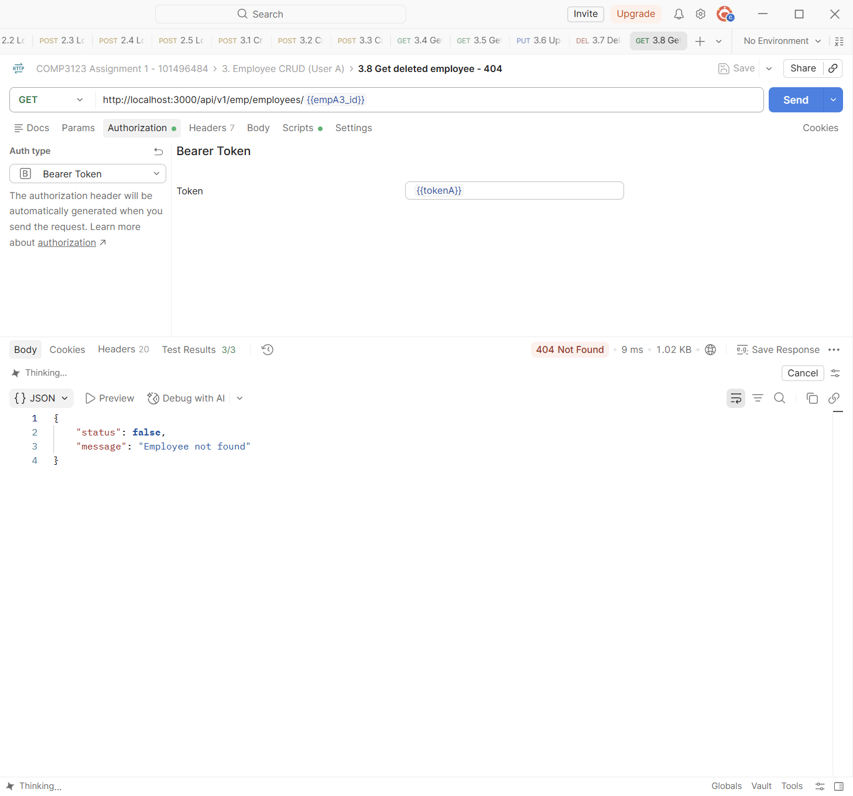

4. Validation and Error Responses
Invalid input returns 400 with the field names and messages. Errors always use the same JSON shape: { "status": false, "message": ... }.
Test | 4.1 Create employee - Missing fields
Endpoint | POST http://localhost:3000/api/v1/emp/employees
Expected status | 400 Bad Request
Actual status | 400 Bad Request (Postman Test Results 8/8)
Explanation | Creating an employee with only first_name returns 400 and lists every missing required field.
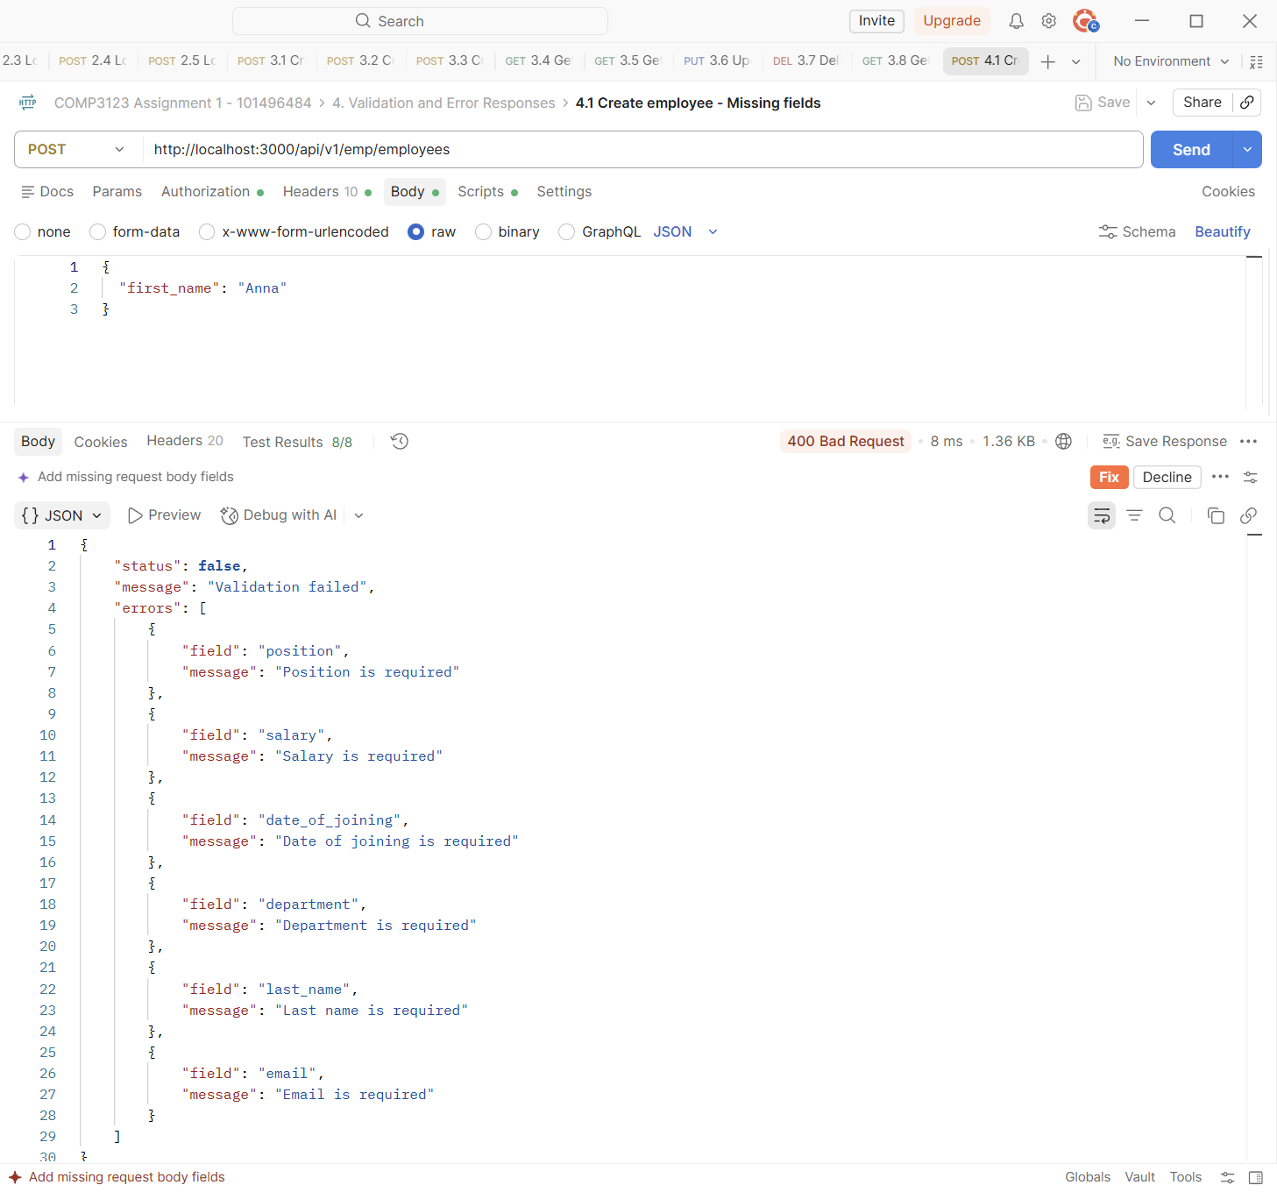

Test | 4.2 Create employee - Invalid email
Endpoint | POST http://localhost:3000/api/v1/emp/employees
Expected status | 400 Bad Request
Actual status | 400 Bad Request (Postman Test Results 3/3)
Explanation | An invalid employee email returns 400.
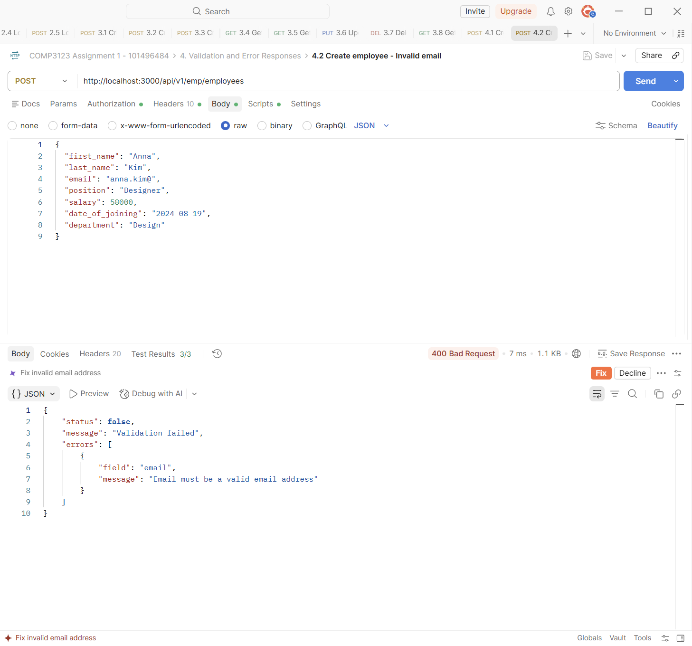

Test | 4.3 Create employee - Negative salary
Endpoint | POST http://localhost:3000/api/v1/emp/employees
Expected status | 400 Bad Request
Actual status | 400 Bad Request (Postman Test Results 3/3)
Explanation | The salary must be a positive number, so -5000 returns 400.
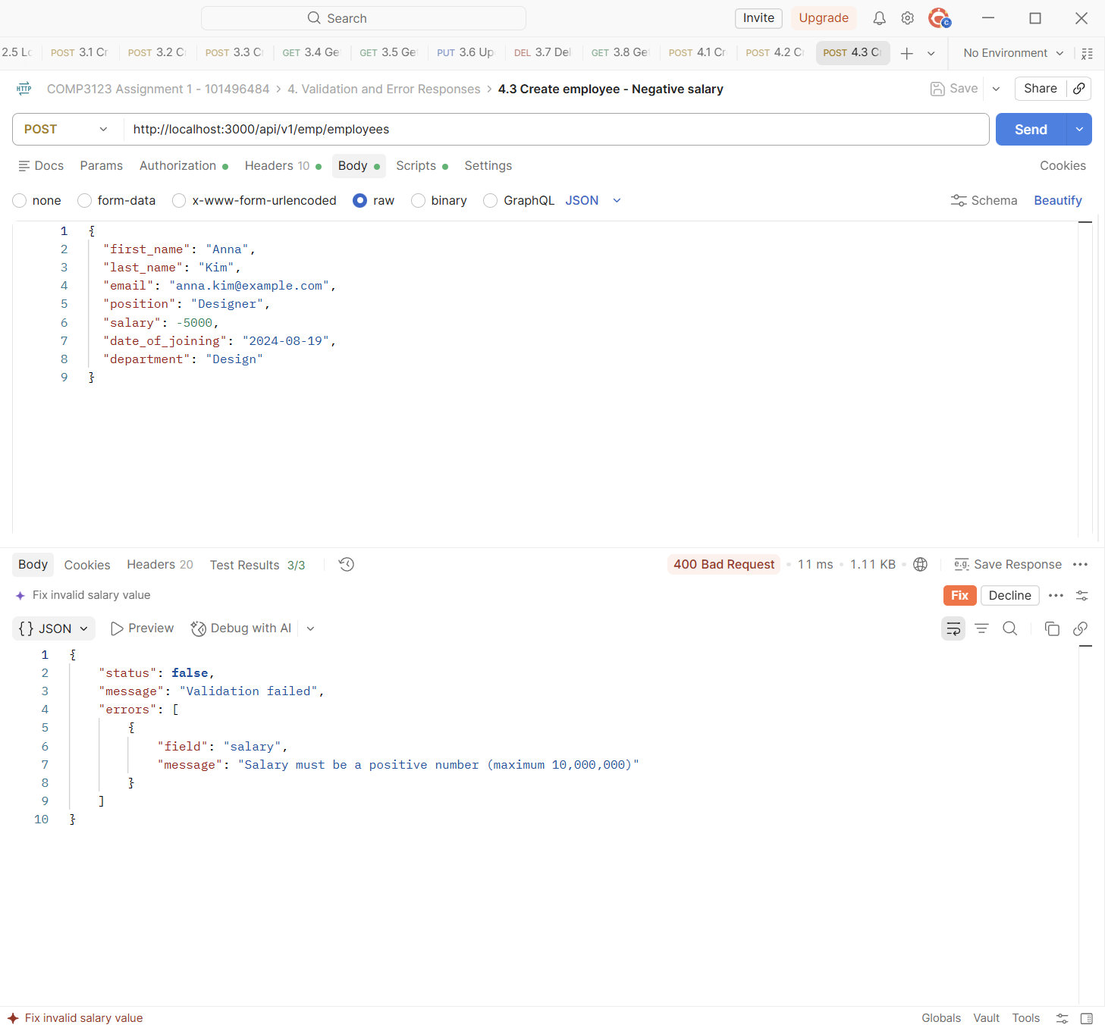

Test | 4.4 Create employee - Salary is not a number
Endpoint | POST http://localhost:3000/api/v1/emp/employees
Expected status | 400 Bad Request
Actual status | 400 Bad Request (Postman Test Results 3/3)
Explanation | Text in the salary field ("fifty thousand") returns 400.
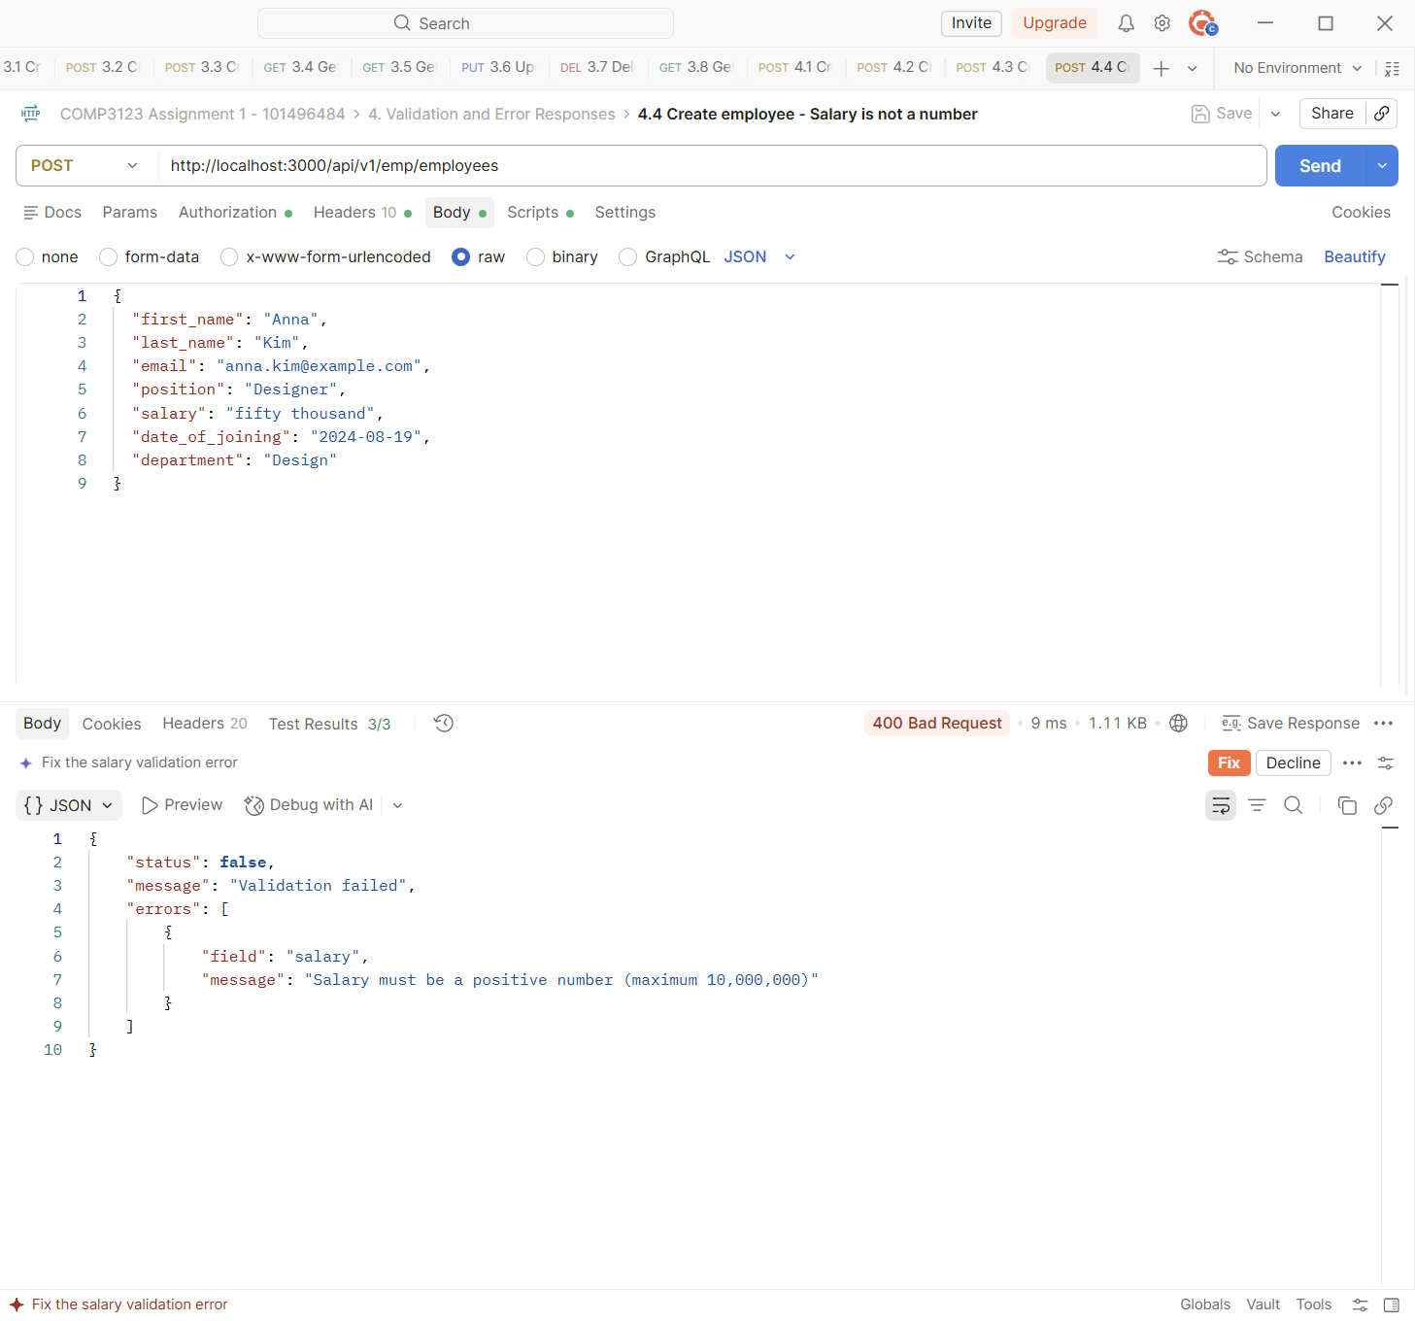

Test | 4.5 Create employee - Invalid date
Endpoint | POST http://localhost:3000/api/v1/emp/employees
Expected status | 400 Bad Request
Actual status | 400 Bad Request (Postman Test Results 3/3)
Explanation | 2024-02-30 is not a real date. The strict date check returns 400.
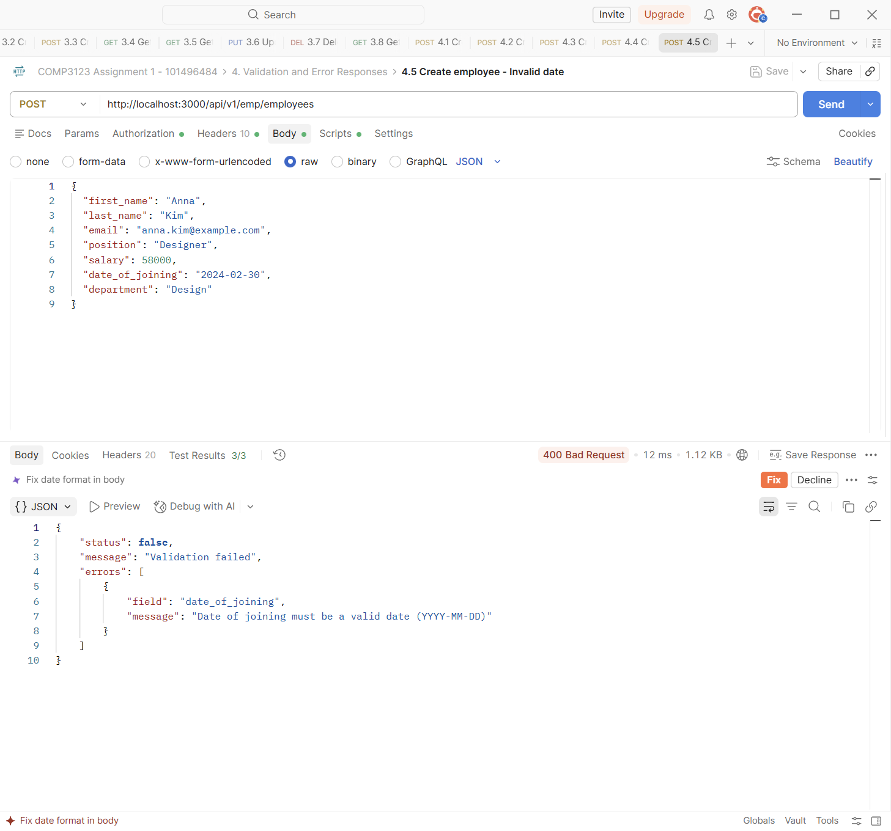

Test | 4.6 Create employee - Client tries to set the owner
Endpoint | POST http://localhost:3000/api/v1/emp/employees
Expected status | 400 Bad Request
Actual status | 400 Bad Request (Postman Test Results 3/3)
Explanation | User A sends "user": "{{userB_id}}" to create an employee owned by User B. The field is rejected, so the owner can only come from the JWT.
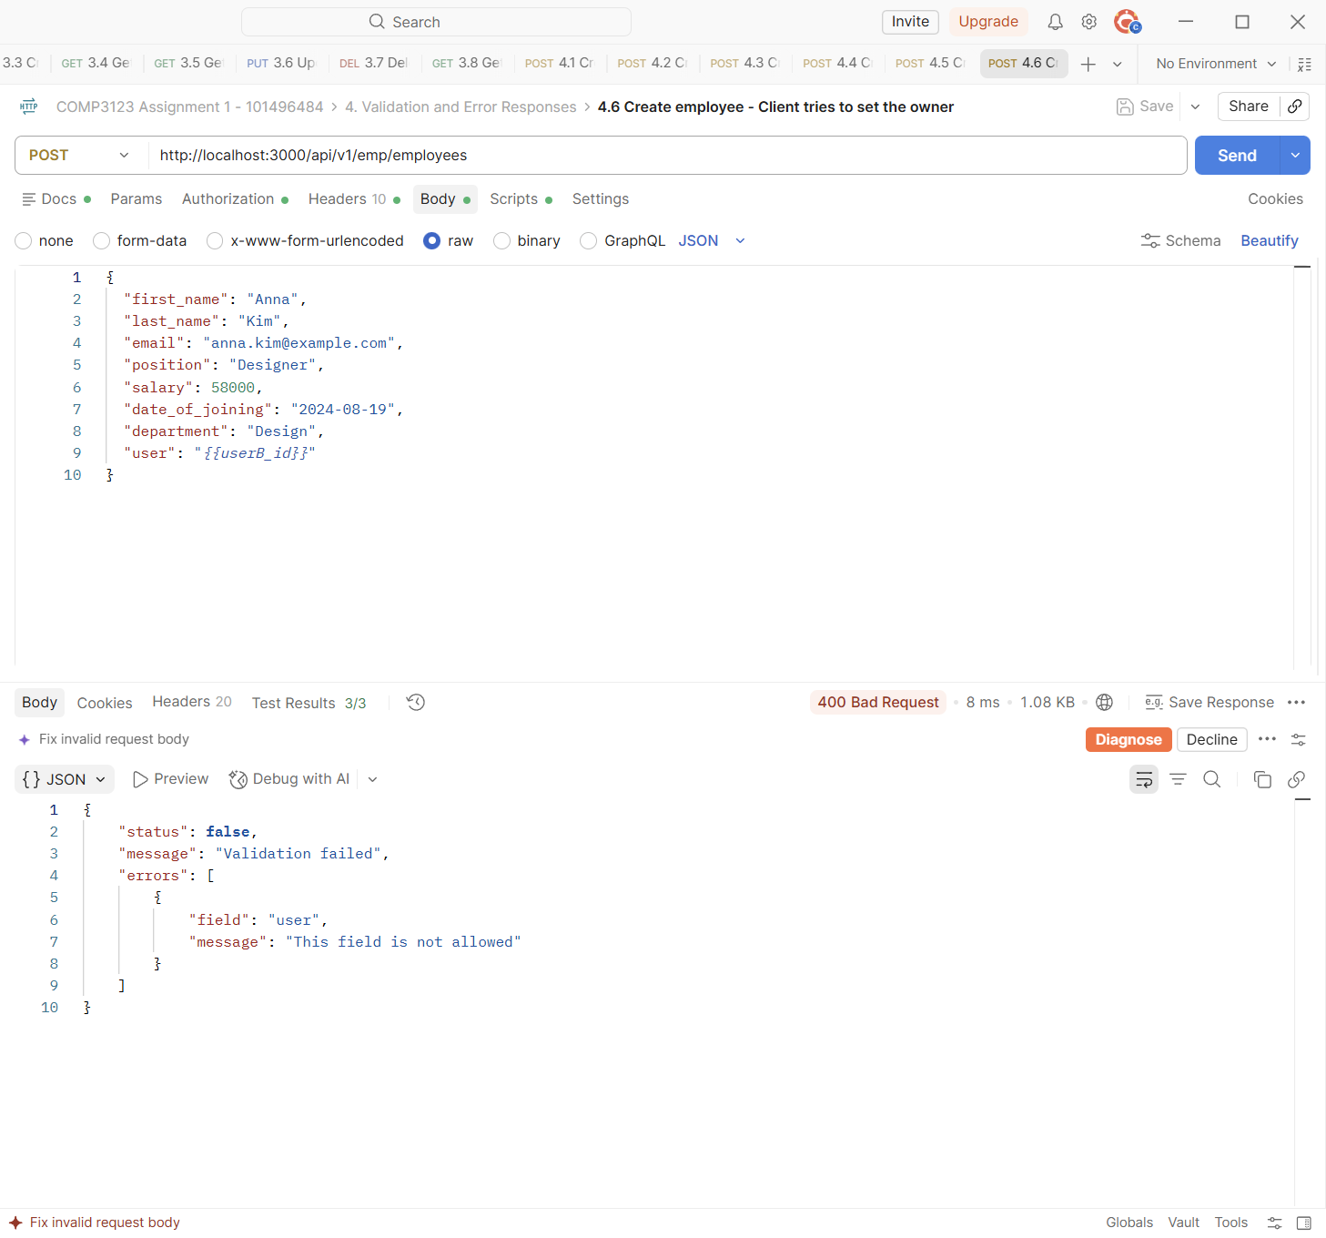

Test | 4.7 Create employee - Duplicate email
Endpoint | POST http://localhost:3000/api/v1/emp/employees
Expected status | 409 Conflict
Actual status | 409 Conflict (Postman Test Results 3/3)
Explanation | One user cannot have two employees with the same email. This returns 409 Conflict.
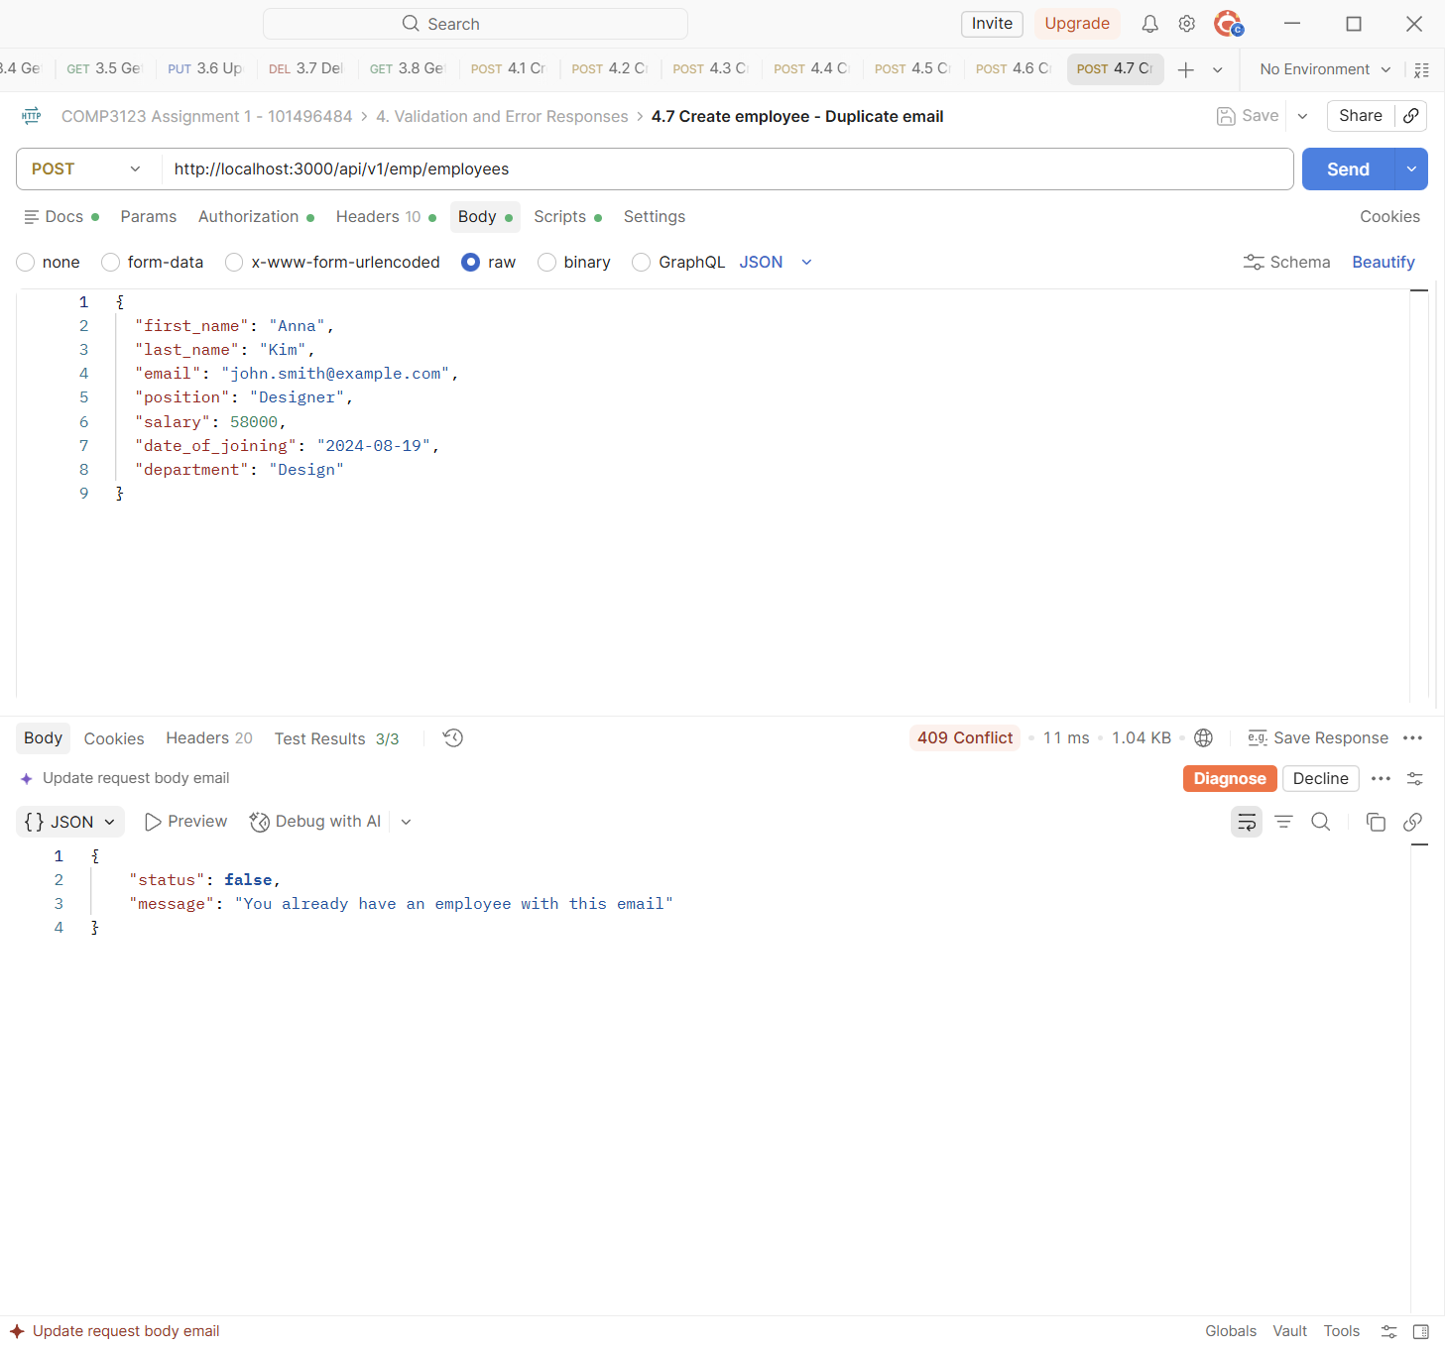

Test | 4.8 Get employee - Invalid ID
Endpoint | GET http://localhost:3000/api/v1/emp/employees/12345
Expected status | 400 Bad Request
Actual status | 400 Bad Request (Postman Test Results 3/3)
Explanation | 12345 is not a valid MongoDB ObjectId. The eid is validated and 400 is returned before the database is used.
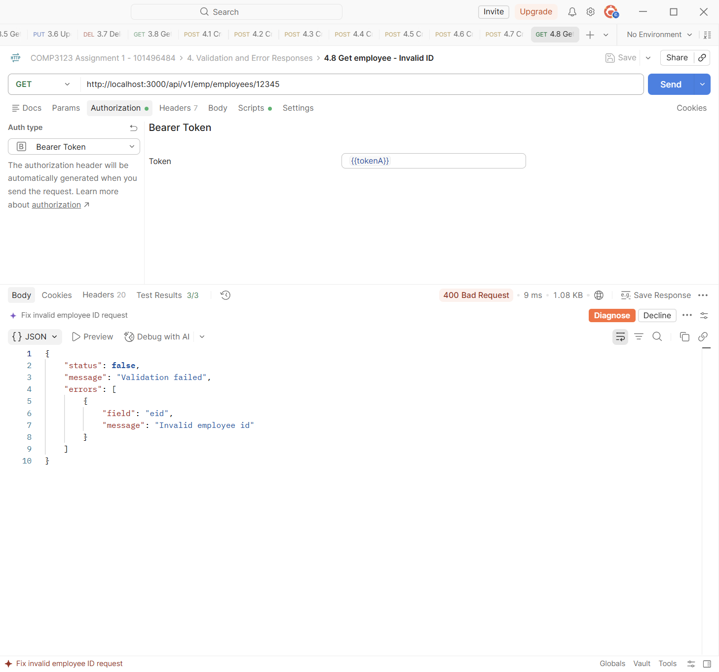

Test | 4.9 Get employee - Employee does not exist
Endpoint | GET http://localhost:3000/api/v1/emp/employees/507f1f77bcf86cd799439011
Expected status | 404 Not Found
Actual status | 404 Not Found (Postman Test Results 3/3)
Explanation | A valid ObjectId that does not exist returns 404 Not Found.
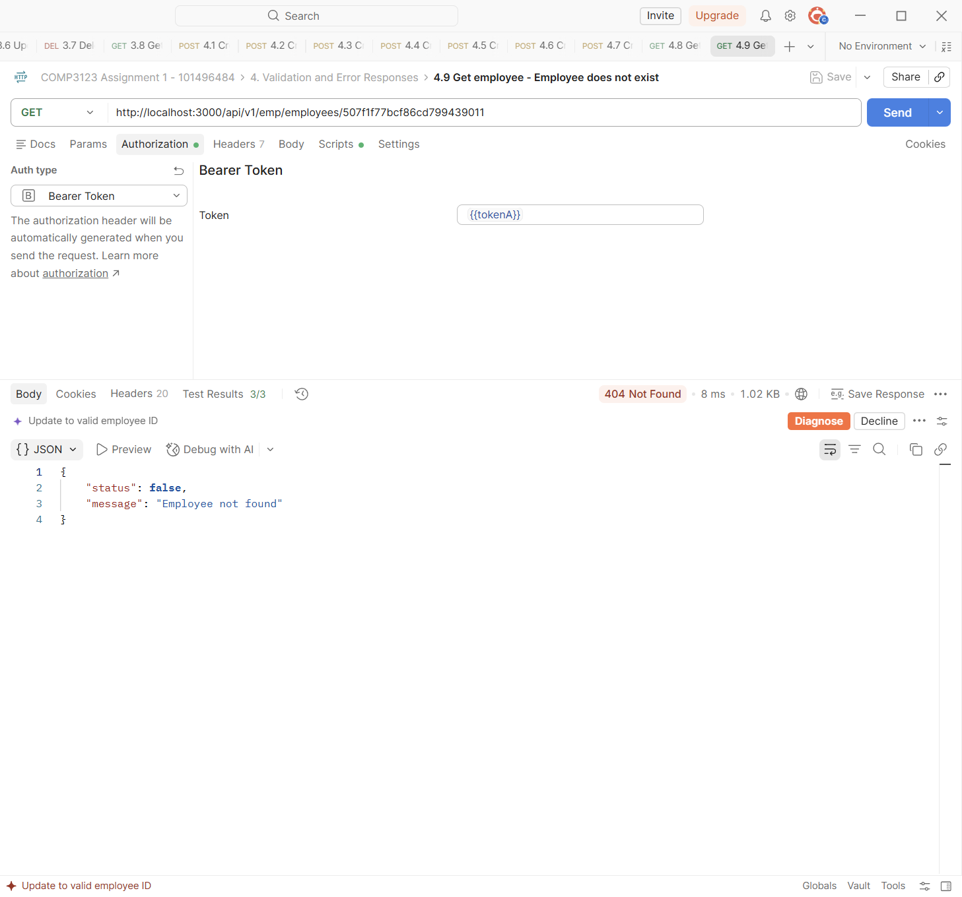

Test | 4.10 Update employee - Invalid fields
Endpoint | PUT http://localhost:3000/api/v1/emp/employees/{{empA1_id}}
Expected status | 400 Bad Request
Actual status | 400 Bad Request (Postman Test Results 4/4)
Explanation | PUT with an invalid email and a negative salary returns 400 with both errors.
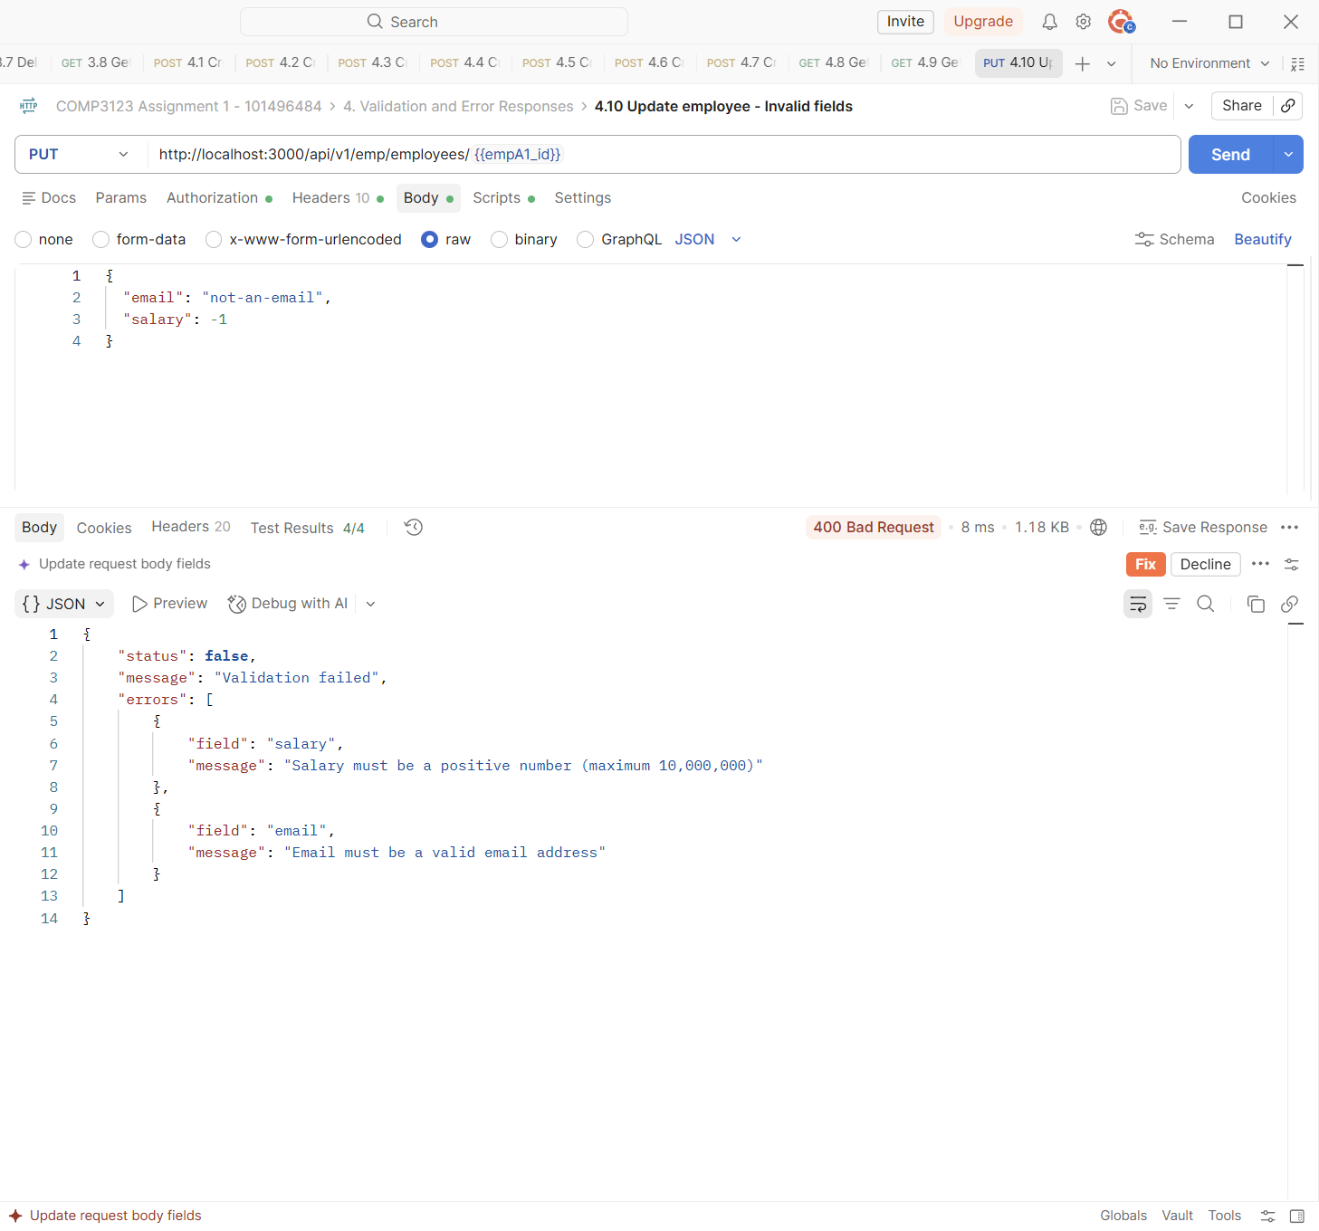

Test | 4.11 Update employee - Empty body
Endpoint | PUT http://localhost:3000/api/v1/emp/employees/{{empA1_id}}
Expected status | 400 Bad Request
Actual status | 400 Bad Request (Postman Test Results 3/3)
Explanation | PUT with no fields returns 400 because there is nothing to update.
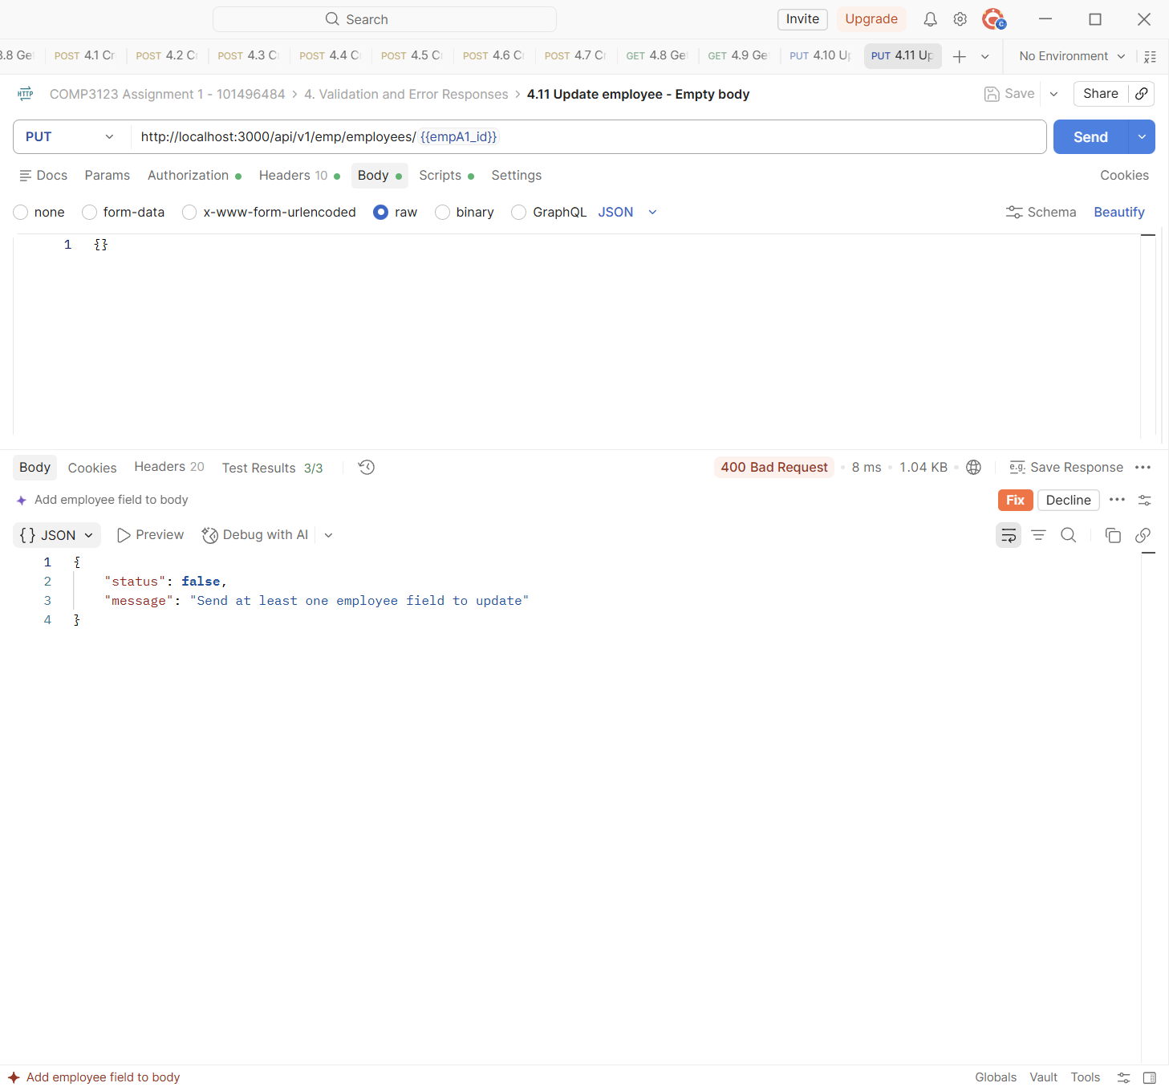

Test | 4.12 Delete employee - Missing eid
Endpoint | DELETE http://localhost:3000/api/v1/emp/employees
Expected status | 400 Bad Request
Actual status | 400 Bad Request (Postman Test Results 3/3)
Explanation | DELETE without ?eid= returns 400 because the employee id is required in the query string.
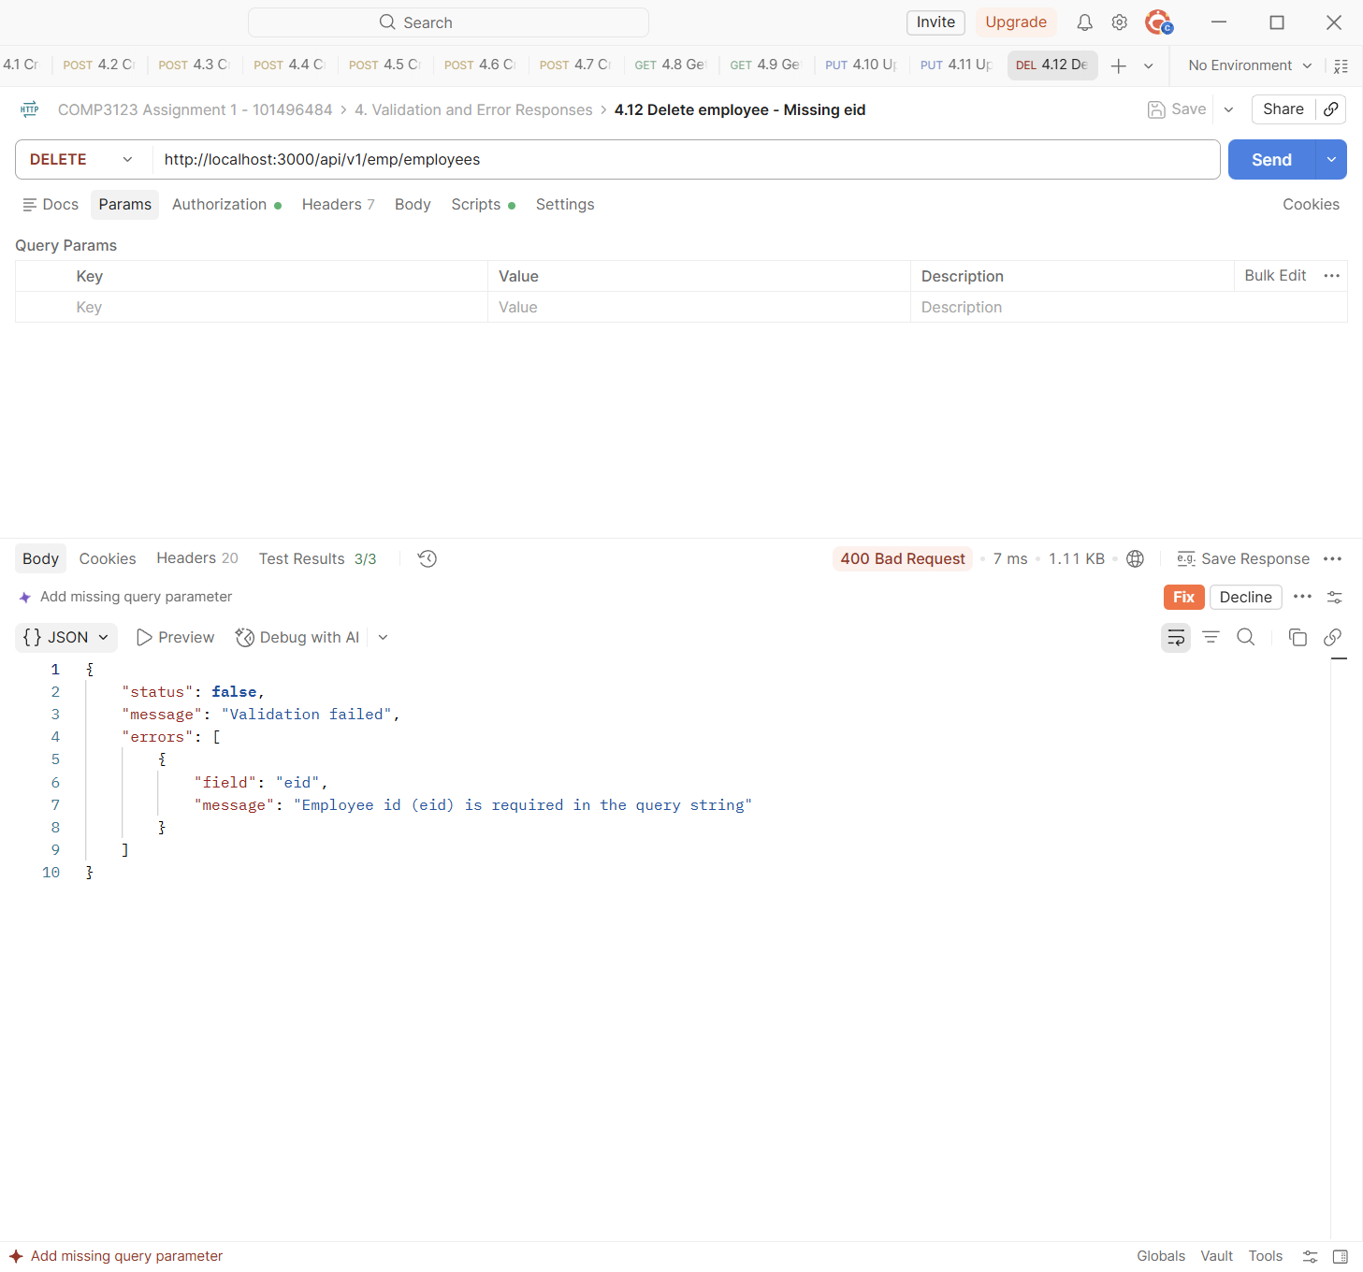

Test | 4.13 Delete employee - Invalid eid
Endpoint | DELETE http://localhost:3000/api/v1/emp/employees?eid=abc123
Expected status | 400 Bad Request
Actual status | 400 Bad Request (Postman Test Results 3/3)
Explanation | DELETE with ?eid=abc123 returns 400 because it is not a valid ObjectId.
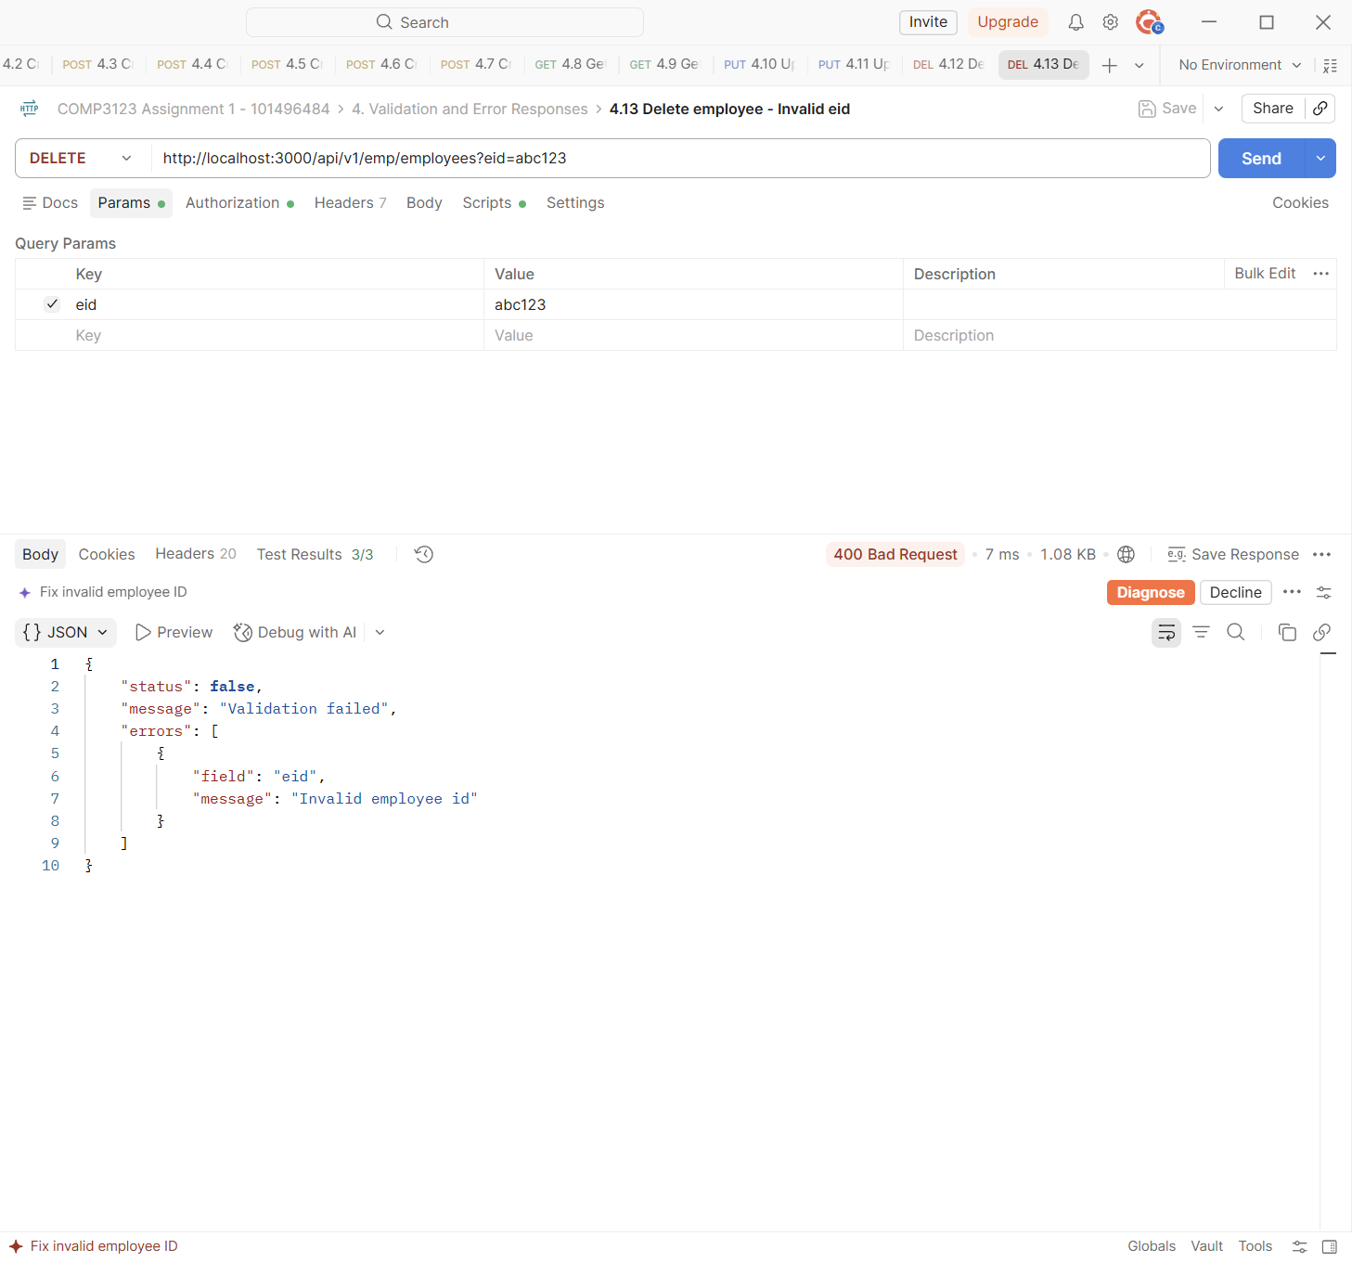

Test | 4.14 Delete employee - Employee does not exist
Endpoint | DELETE http://localhost:3000/api/v1/emp/employees?eid=507f1f77bcf86cd799439011
Expected status | 404 Not Found
Actual status | 404 Not Found (Postman Test Results 2/2)
Explanation | DELETE with a valid id that does not exist returns 404.
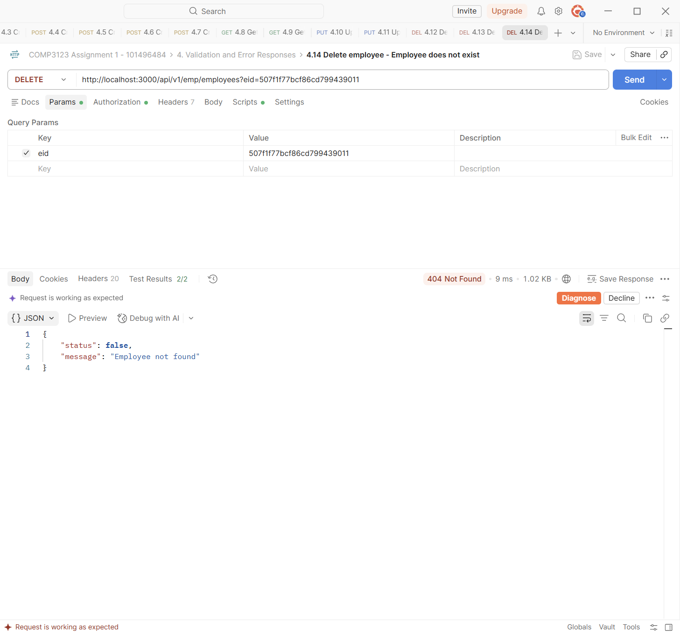

Test | 4.15 Malformed JSON body
Endpoint | POST http://localhost:3000/api/v1/emp/employees
Expected status | 400 Bad Request
Actual status | 400 Bad Request (Postman Test Results 3/3)
Explanation | A broken JSON body is caught by the central error handler. It returns 400 "Malformed JSON in request body" as JSON (not an HTML error page).
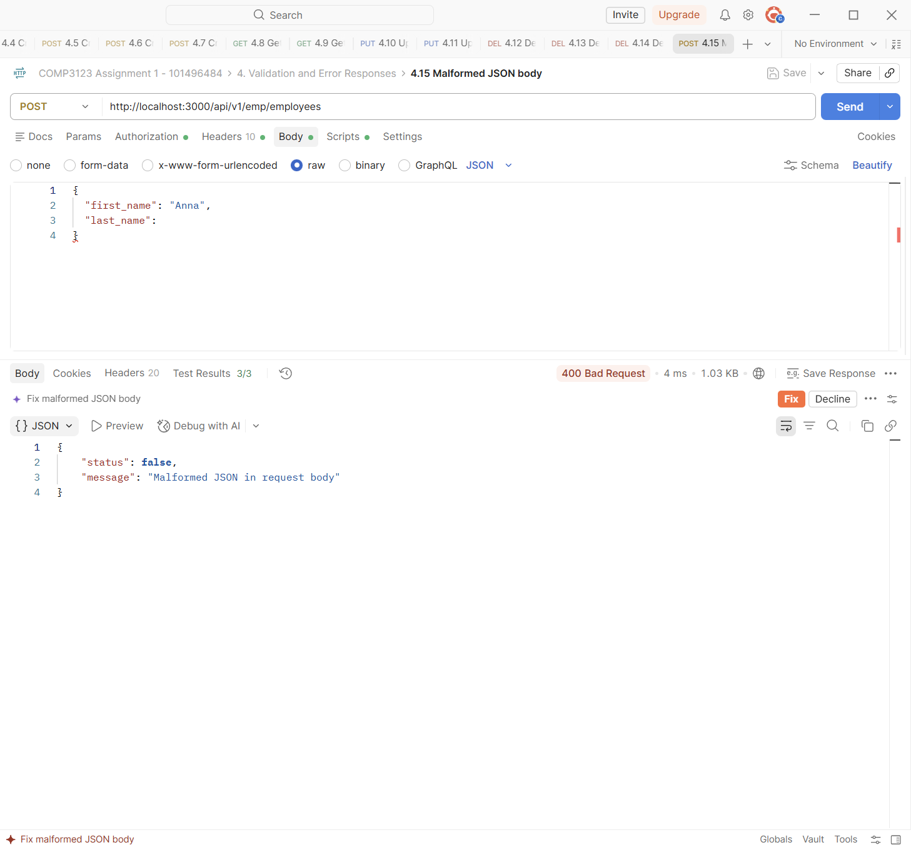

Test | 4.16 Unsupported endpoint
Endpoint | GET http://localhost:3000/api/v1/unknown
Expected status | 404 Not Found
Actual status | 404 Not Found (Postman Test Results 3/3)
Explanation | An unknown route returns a JSON 404 message from the not-found handler.
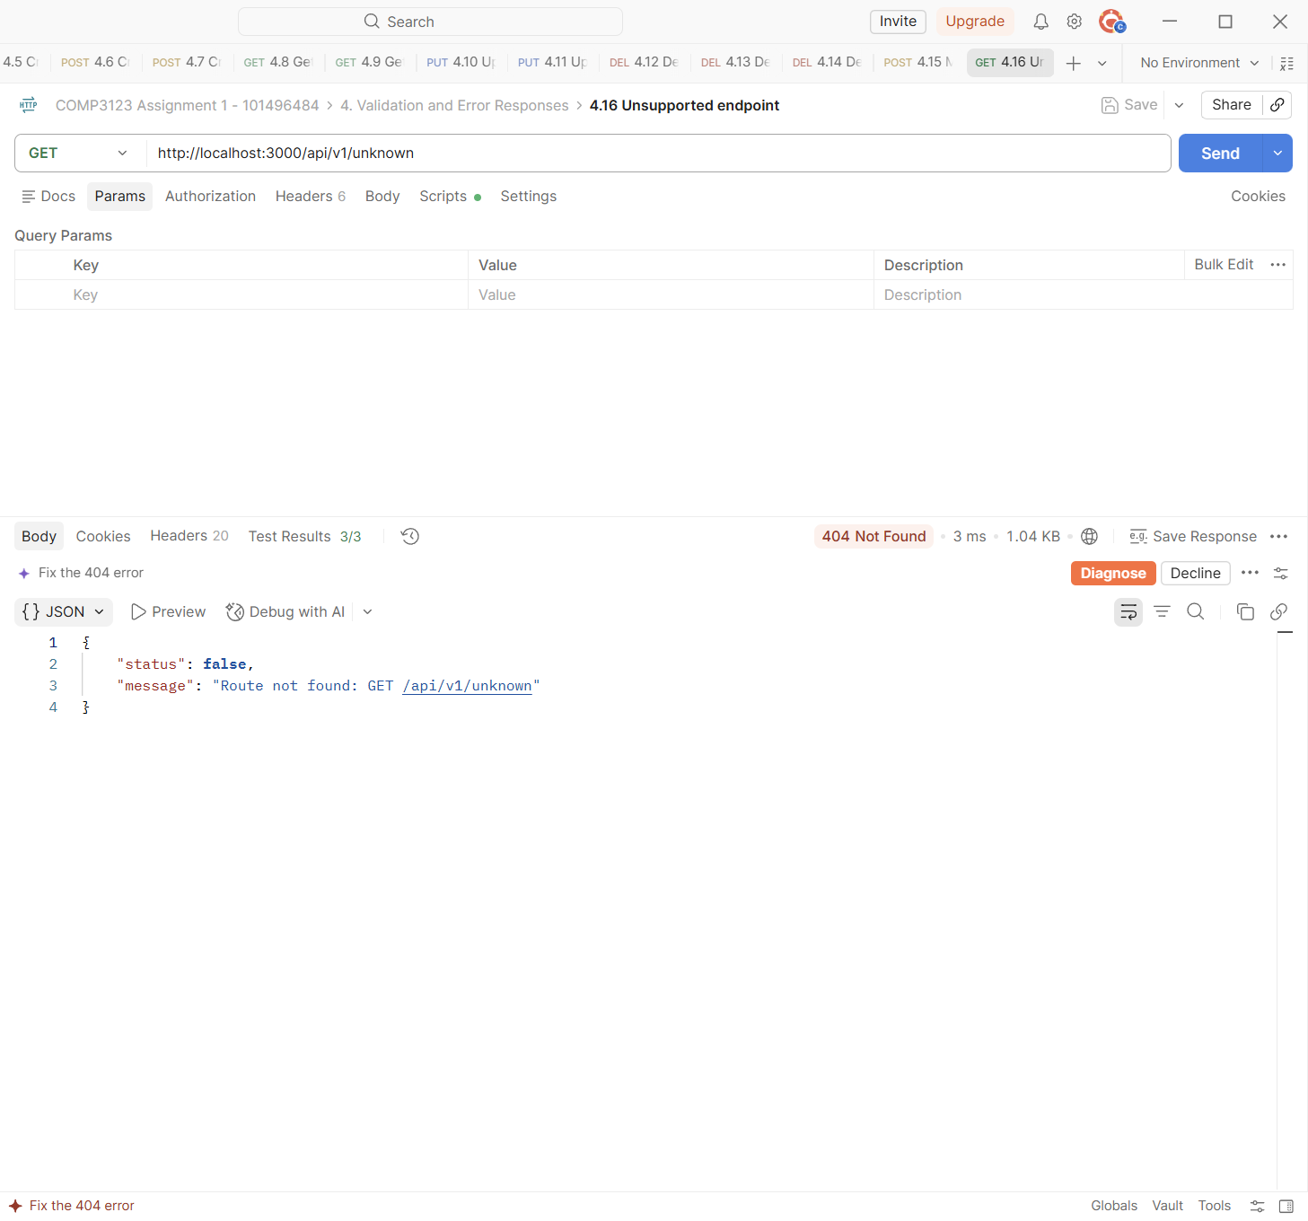

Test | 8.1 Database stopped - 500 Internal Server Error
Endpoint | GET http://localhost:3000/api/v1/emp/employees
Expected status | 500 Internal Server Error
Actual status | 500 Internal Server Error (Postman Test Results 2/2)
Explanation | MongoDB was stopped (docker stop comp3123-mongo) and a valid request was sent. The central error handler returns 500 with a general message. The real error and stack trace are only written to logs/error.log (see section 11).
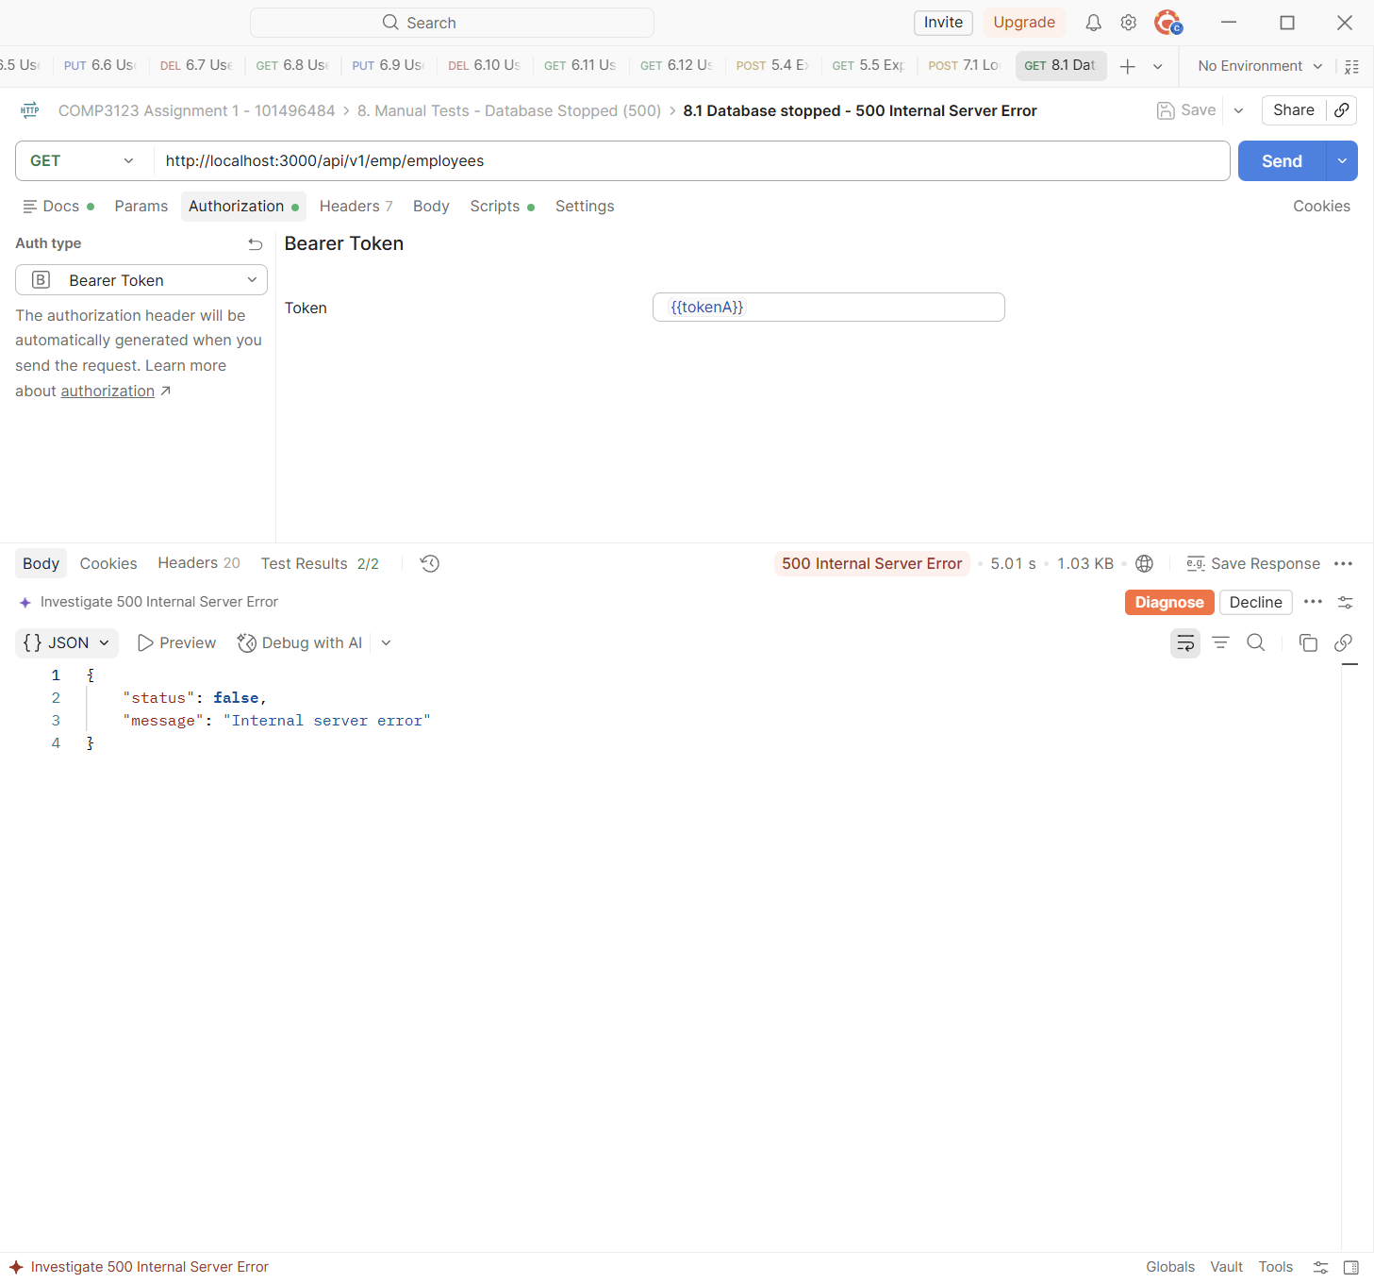

5. JWT Authentication Errors
Requests to a protected employee route with a missing, invalid, changed or expired token. All of them return 401.
Test | 5.1 Missing JWT
Endpoint | GET http://localhost:3000/api/v1/emp/employees
Expected status | 401 Unauthorized
Actual status | 401 Unauthorized (Postman Test Results 3/3)
Explanation | No Authorization header (Auth type: No Auth) returns 401 "Access denied. No token provided".
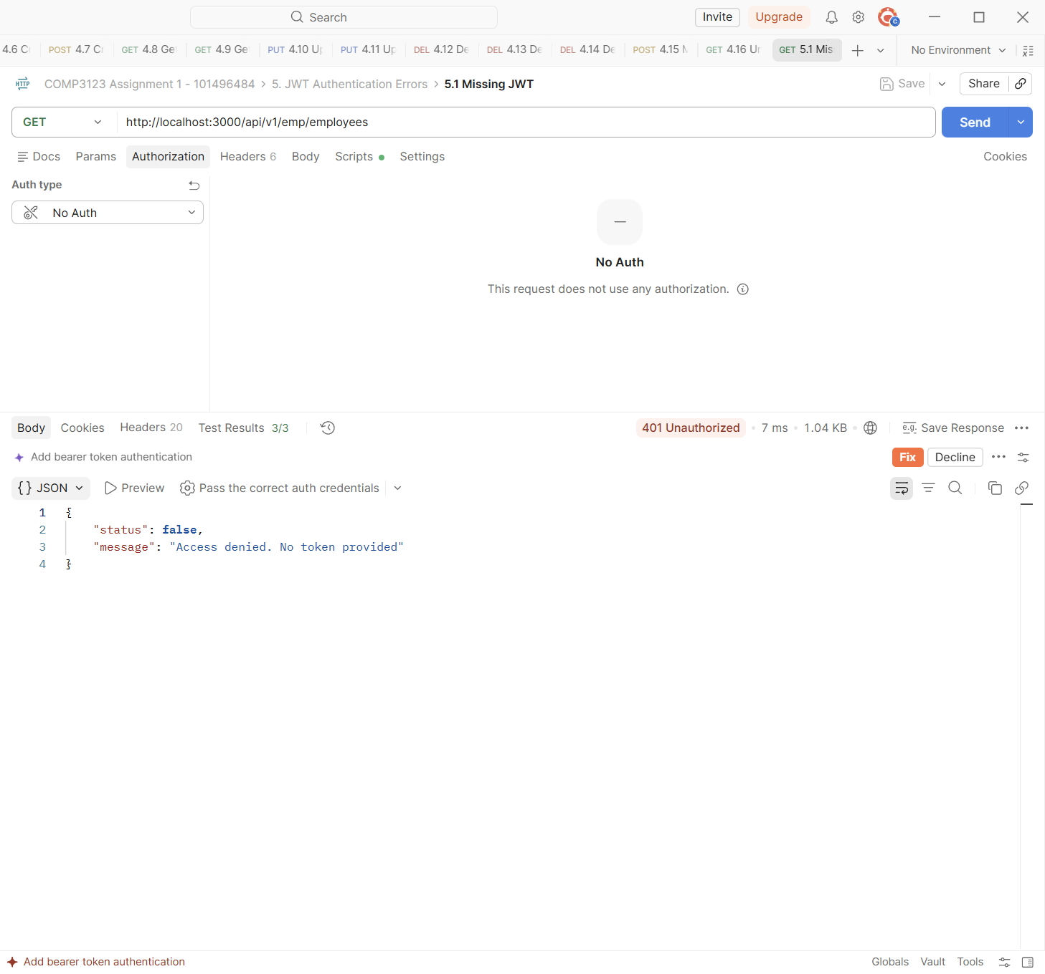

Test | 5.2 Invalid JWT
Endpoint | GET http://localhost:3000/api/v1/emp/employees
Expected status | 401 Unauthorized
Actual status | 401 Unauthorized (Postman Test Results 3/3)
Explanation | A random string as the Bearer token fails jwt.verify() and returns 401 "Invalid token".
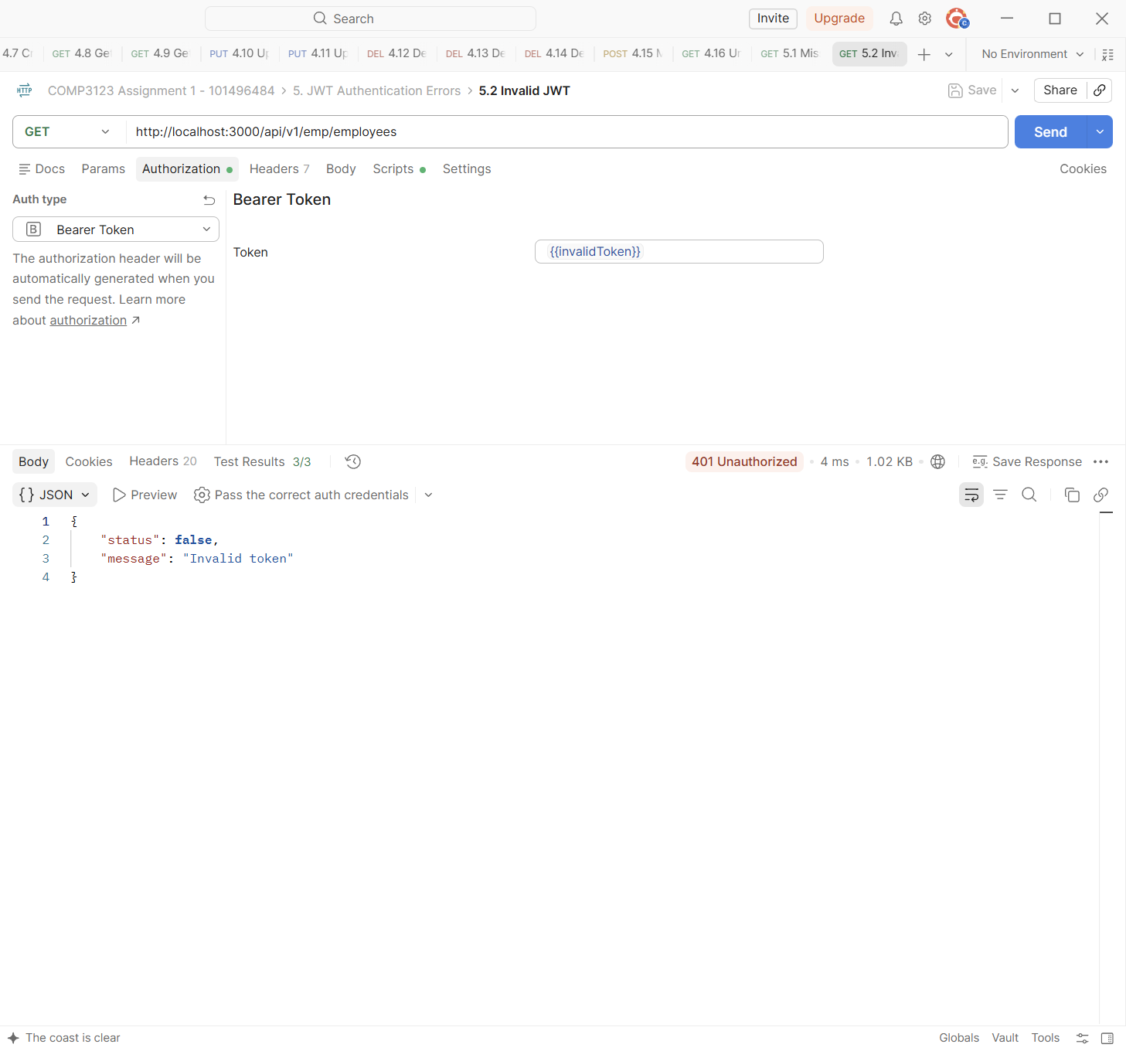

Test | 5.3 Tampered JWT (user id changed)
Endpoint | GET http://localhost:3000/api/v1/emp/employees
Expected status | 401 Unauthorized
Actual status | 401 Unauthorized (Postman Test Results 3/3)
Explanation | The Before-request script takes User A's real token and changes the user id inside it to User B's id without a new signature. The signature check fails and the server returns 401, so a user cannot pretend to be another user.
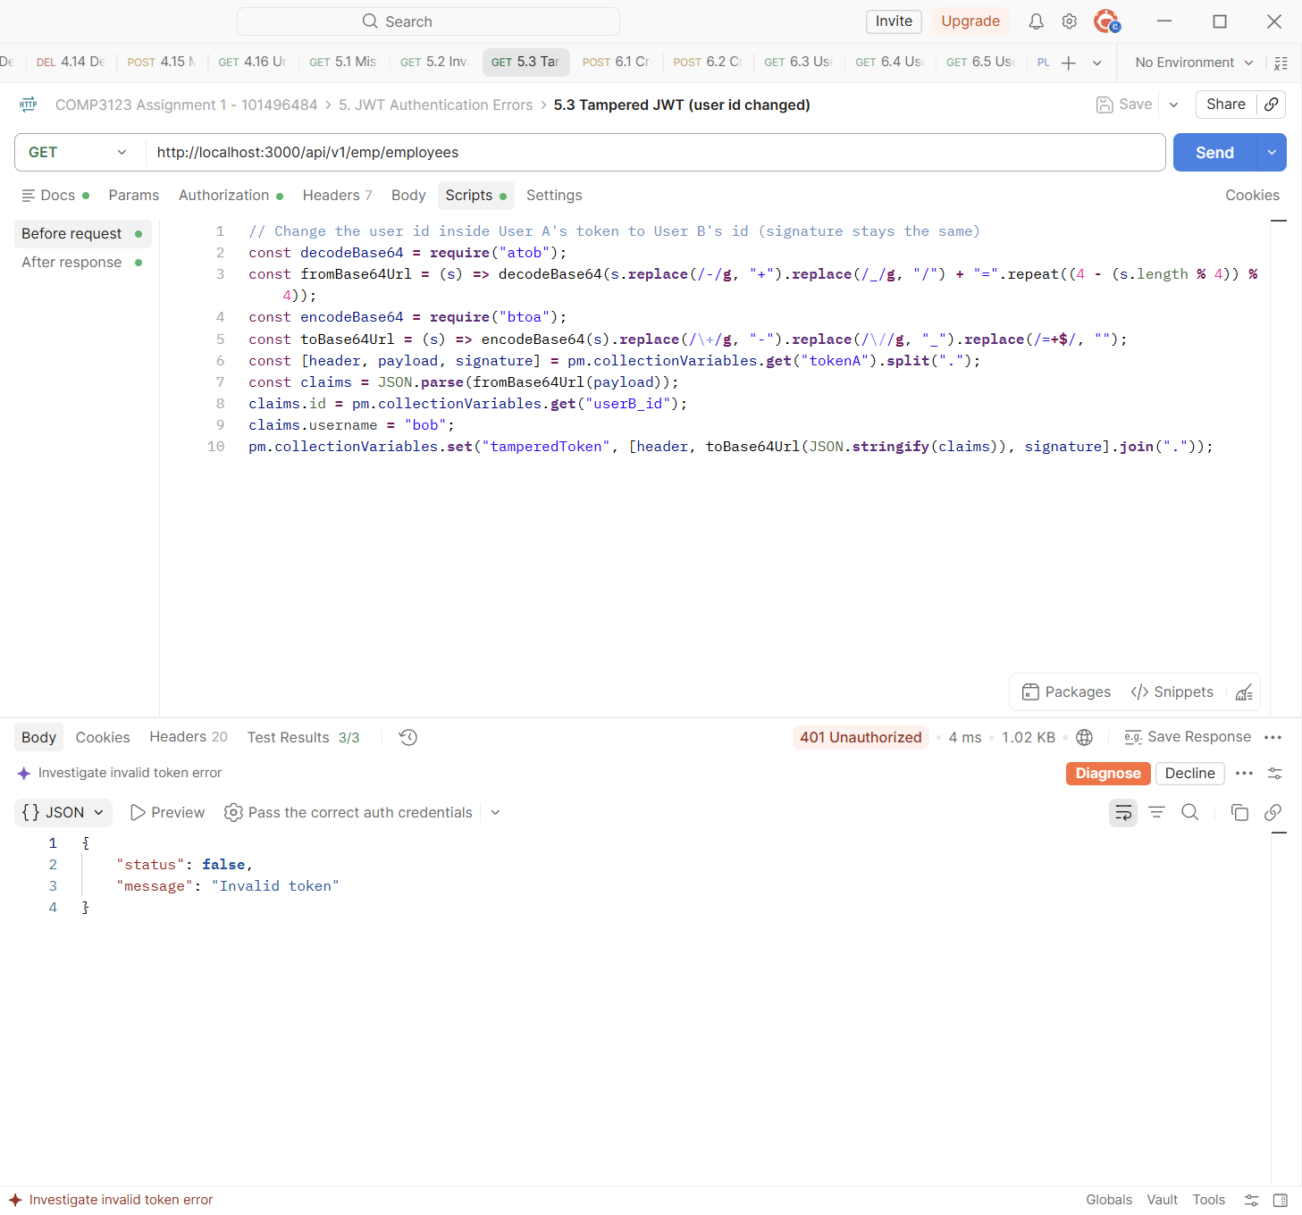

Test | 5.4 Expired JWT - step 1: log in
Endpoint | POST http://localhost:3000/api/v1/user/login
Expected status | 200 OK
Actual status | 200 OK (Postman Test Results 2/2)
Explanation | For this test the server was restarted with JWT_EXPIRES_IN=30s. User A logs in and gets a token that expires after 30 seconds ("expires_in": "30s"). It is saved as {{expiredToken}}.
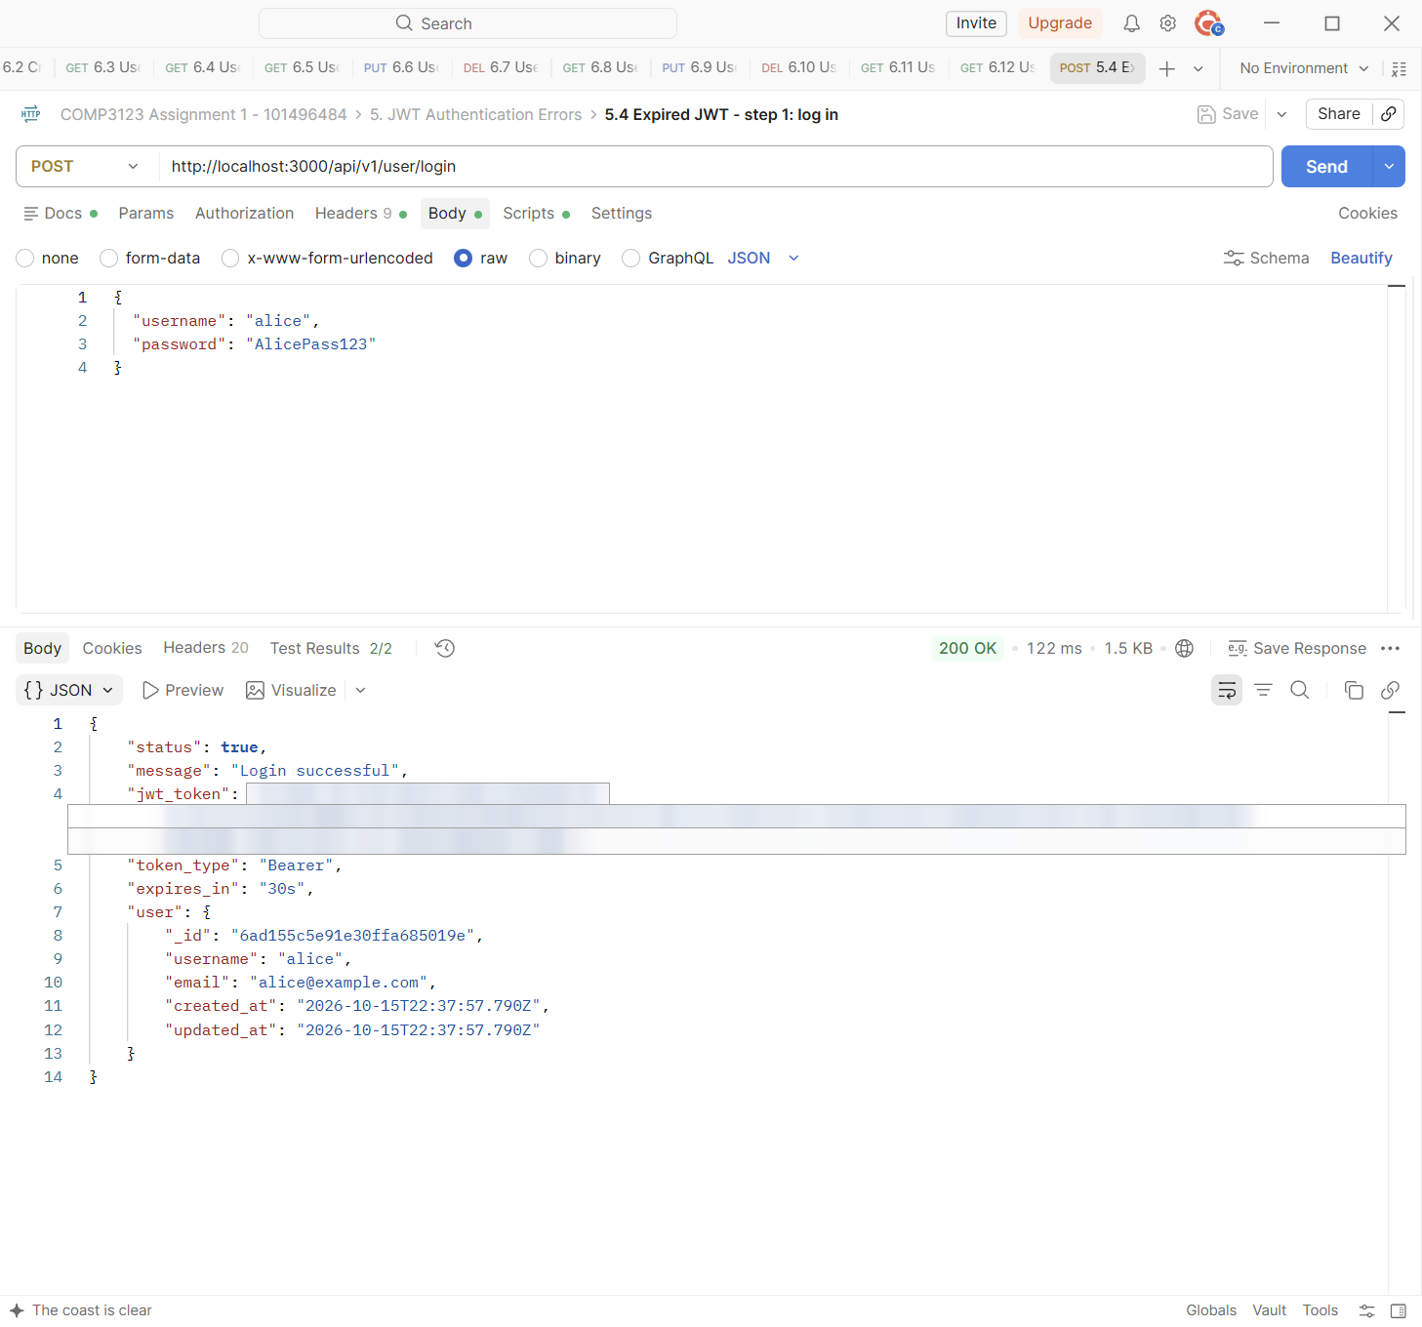

Test | 5.5 Expired JWT - step 2: use the expired token
Endpoint | GET http://localhost:3000/api/v1/emp/employees
Expected status | 401 Unauthorized
Actual status | 401 Unauthorized (Postman Test Results 2/2)
Explanation | The Before-request script waited until the token had expired and then sent it. jwt.verify() throws TokenExpiredError and the API returns 401 "Token has expired. Please log in again". After this test the server was restarted with the normal 1h setting.
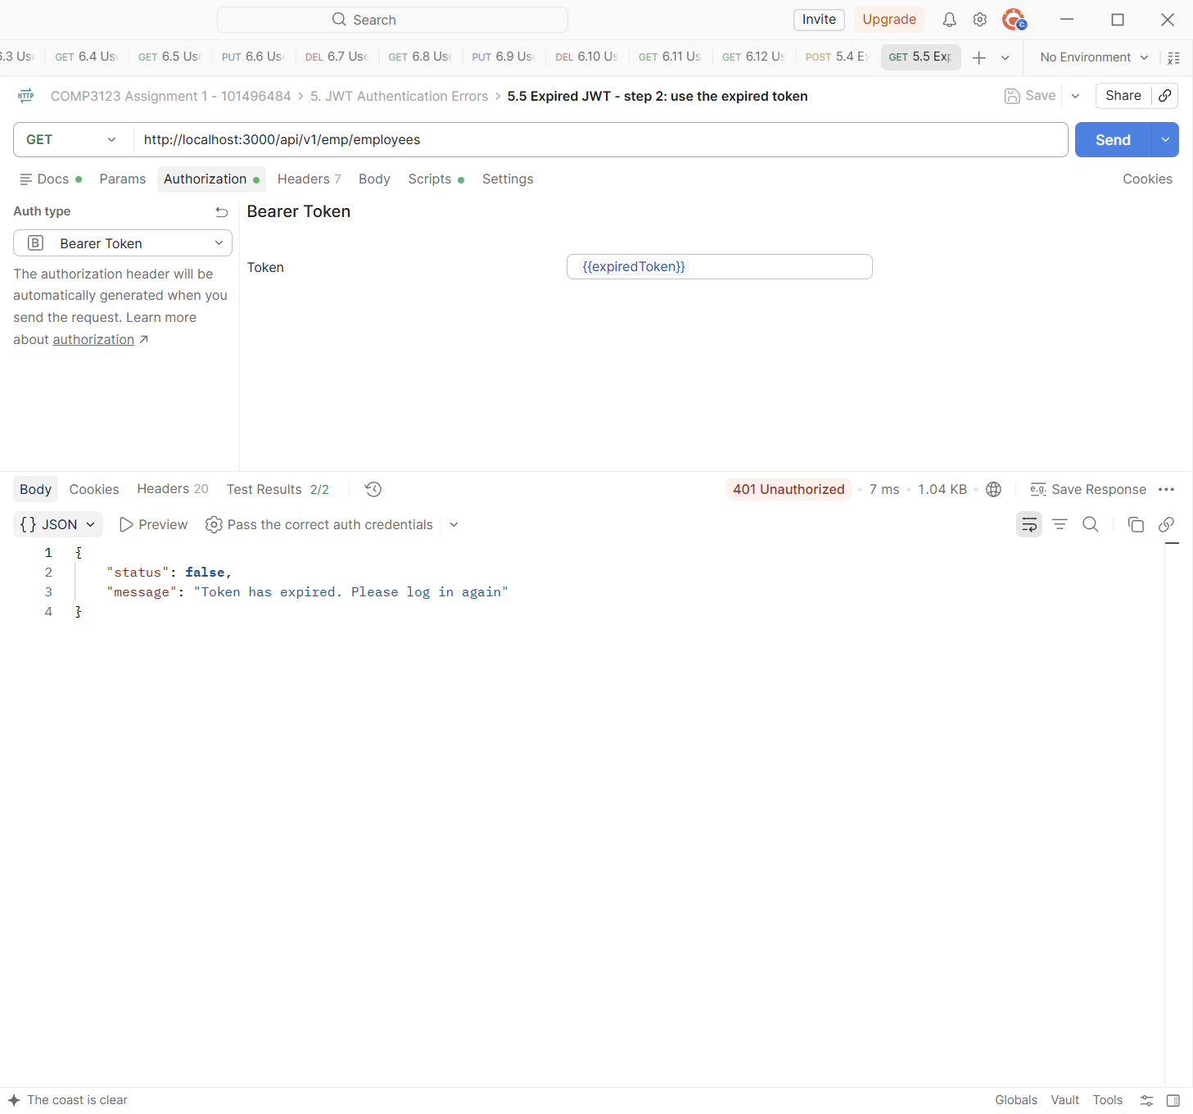

6. Two-User Authorization Tests
User A (alice) owns John Smith and Emily Chen. User B (bob) owns Sara Ahmed and David Brown. Each user can only see and manage their own employees. The Authorization tab shows which token is used ({{tokenA}} or {{tokenB}}).
Test | 6.1 Create employee - User B #1
Endpoint | POST http://localhost:3000/api/v1/emp/employees
Expected status | 201 Created
Actual status | 201 Created (Postman Test Results 5/5)
Explanation | User B creates Sara Ahmed with {{tokenB}}. The owner is User B's id. Request 6.2 created User B's second employee, David Brown.
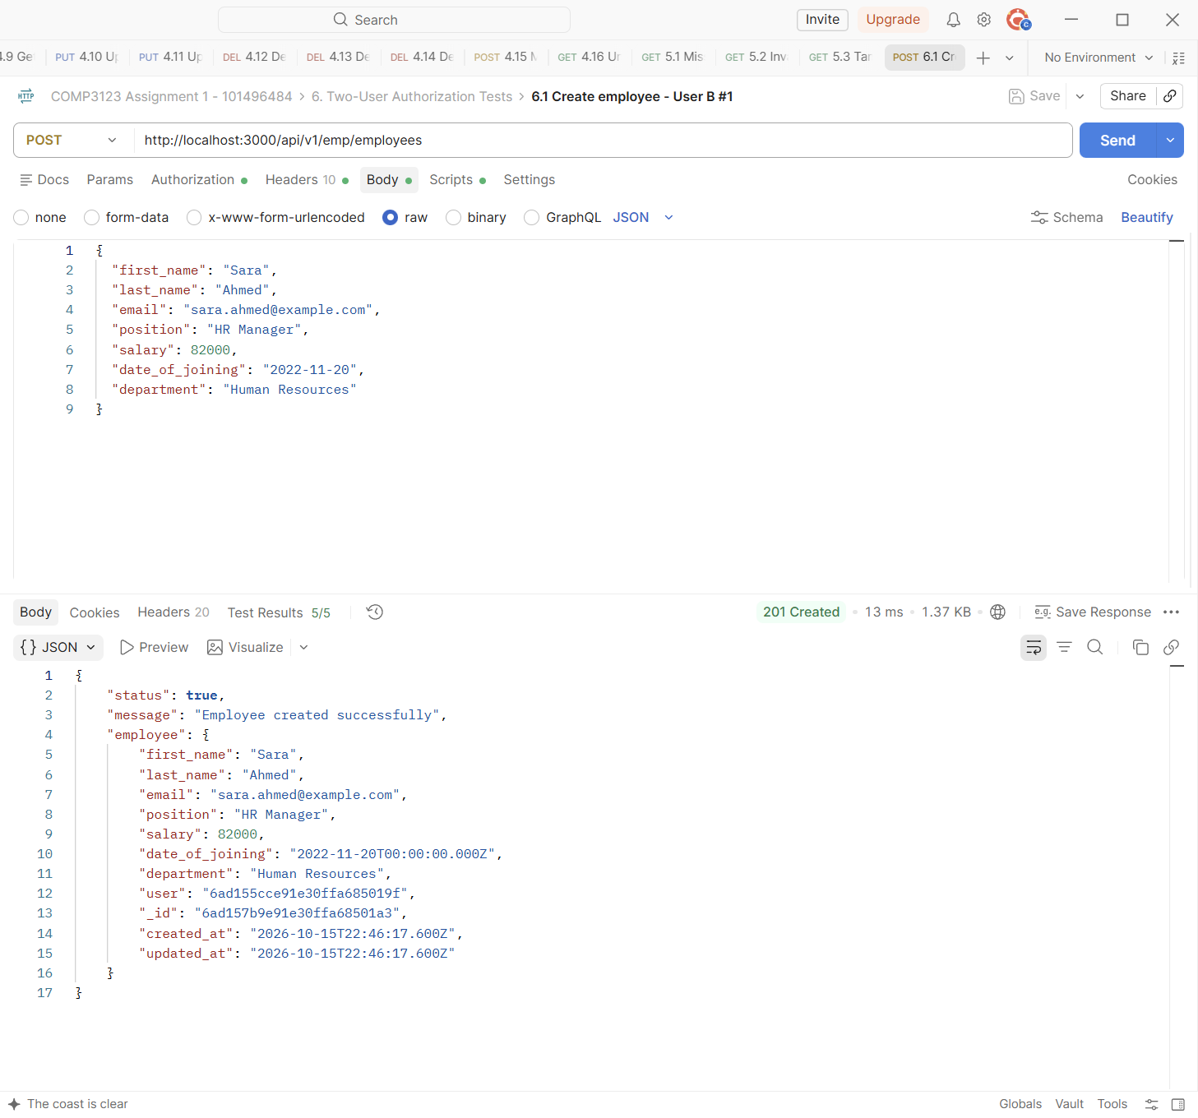

Test | 6.3 User A lists employees - only own
Endpoint | GET http://localhost:3000/api/v1/emp/employees
Expected status | 200 OK
Actual status | 200 OK (Postman Test Results 4/4)
Explanation | User A's list has only John Smith and Emily Chen (count 2). User B's employees are not in the list. The tests check that every employee belongs to User A.
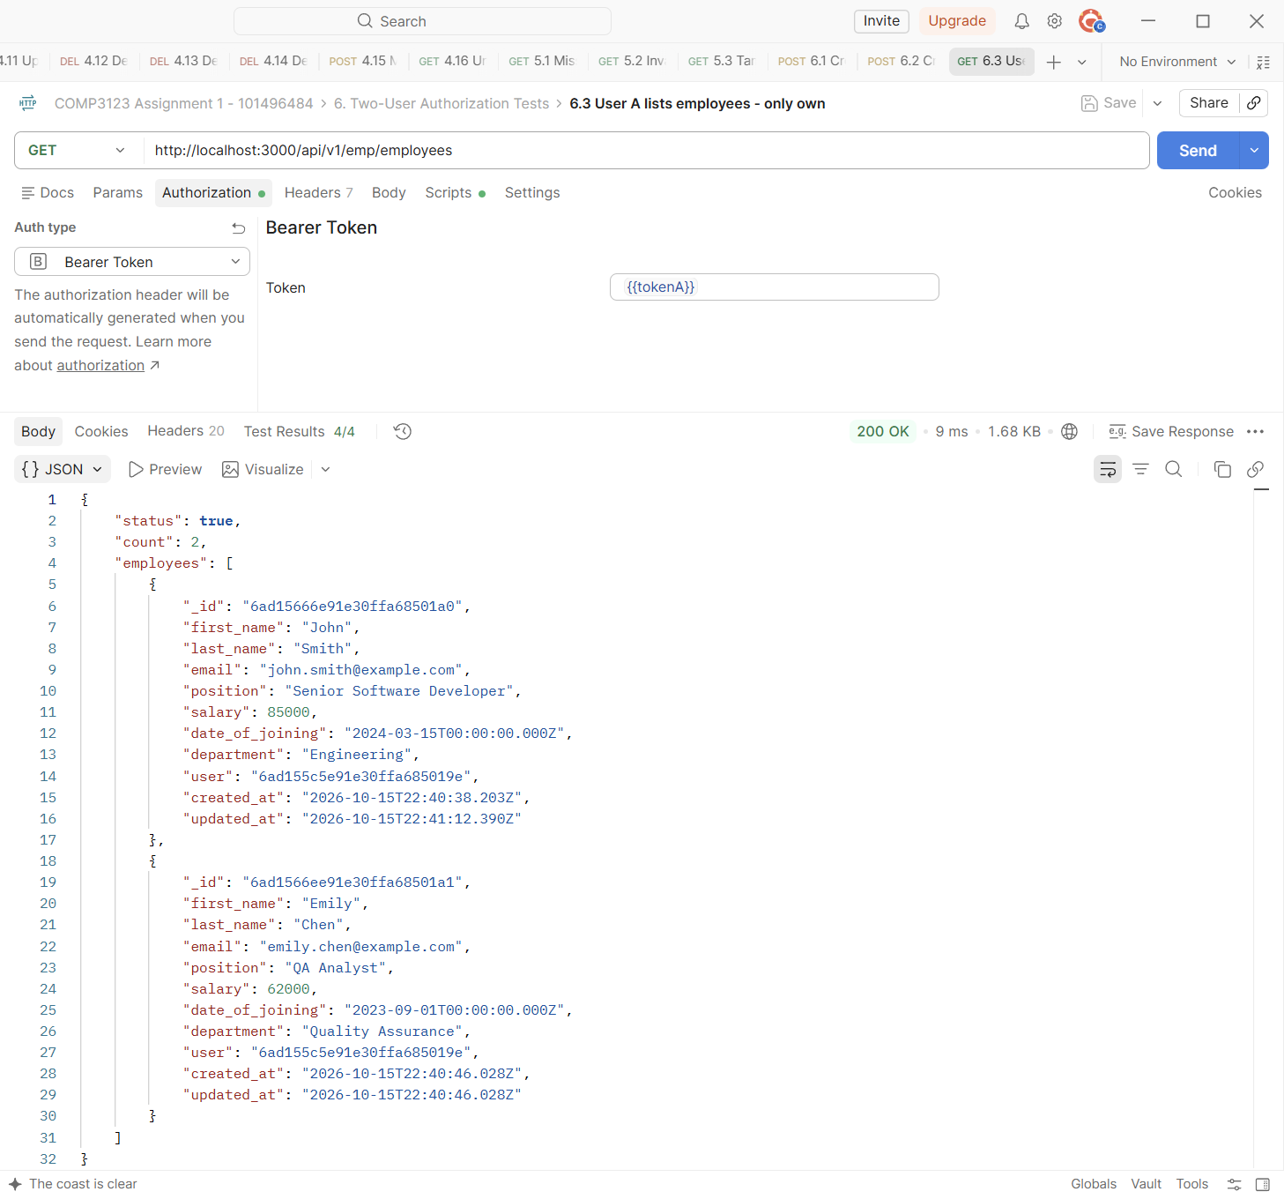

Test | 6.4 User B lists employees - only own
Endpoint | GET http://localhost:3000/api/v1/emp/employees
Expected status | 200 OK
Actual status | 200 OK (Postman Test Results 4/4)
Explanation | User B's list has only Sara Ahmed and David Brown (count 2).
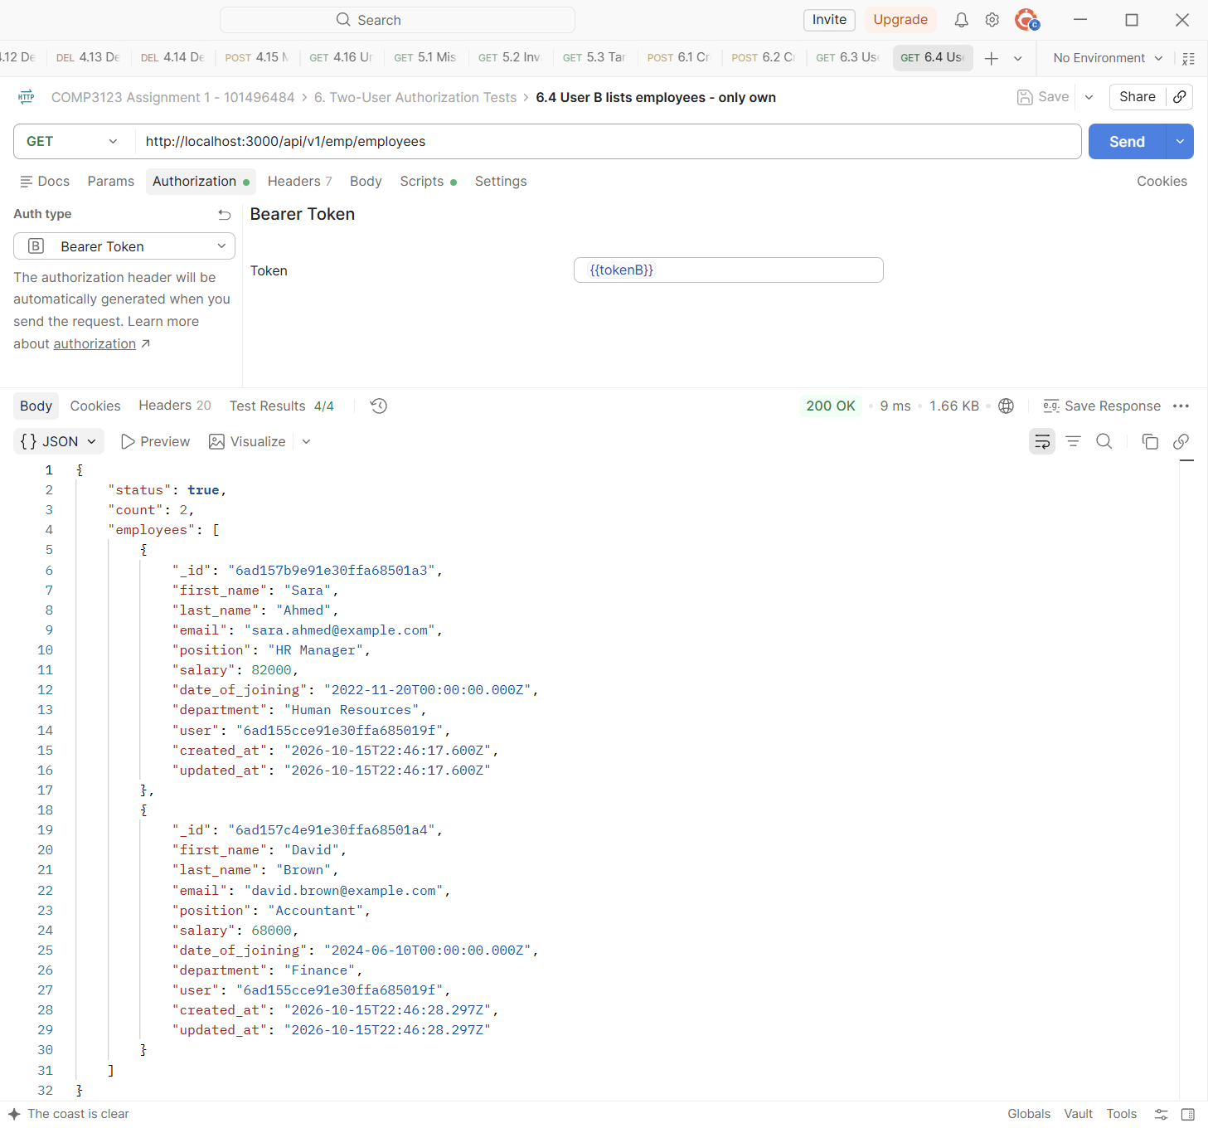

Test | 6.5 User A gets User B's employee - 403
Endpoint | GET http://localhost:3000/api/v1/emp/employees/{{empB1_id}}
Expected status | 403 Forbidden
Actual status | 403 Forbidden (Postman Test Results 3/3)
Explanation | User A ({{tokenA}}) requests User B's employee ({{empB1_id}}). The API returns 403 Forbidden.
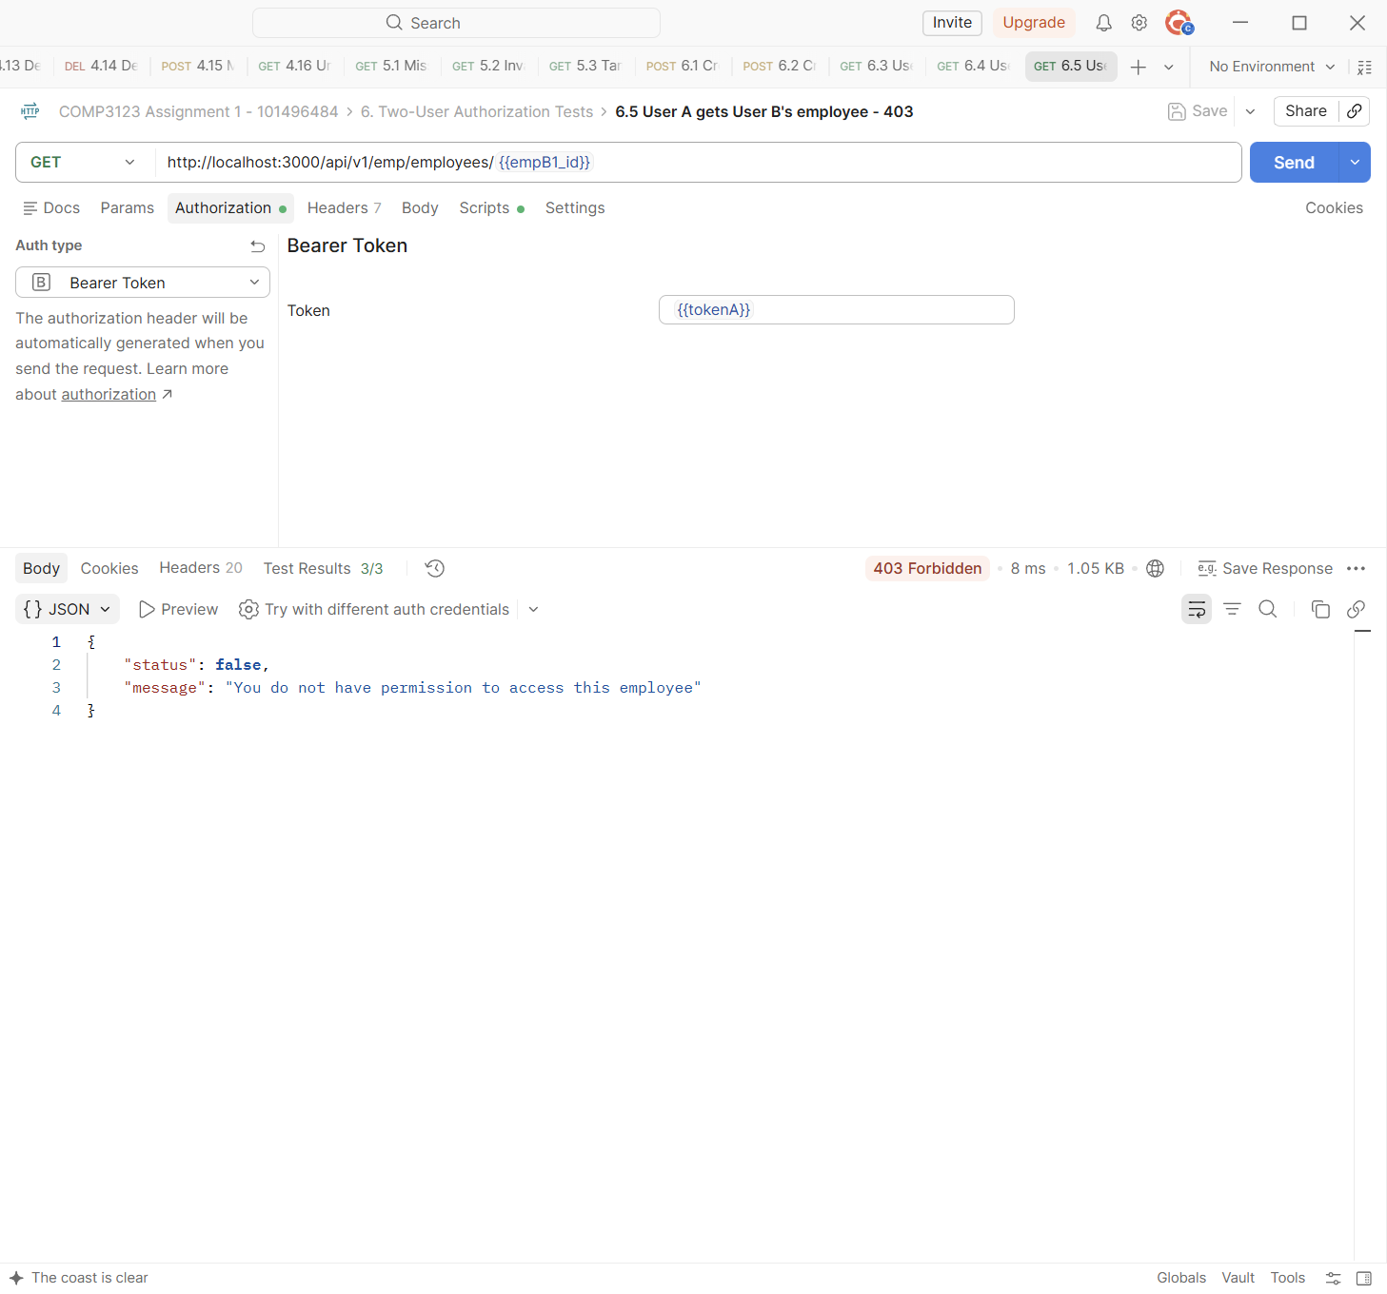

Test | 6.6 User A updates User B's employee - 403
Endpoint | PUT http://localhost:3000/api/v1/emp/employees/{{empB1_id}}
Expected status | 403 Forbidden
Actual status | 403 Forbidden (Postman Test Results 3/3)
Explanation | User A tries to change the salary of User B's employee. 403 is returned and nothing is updated.
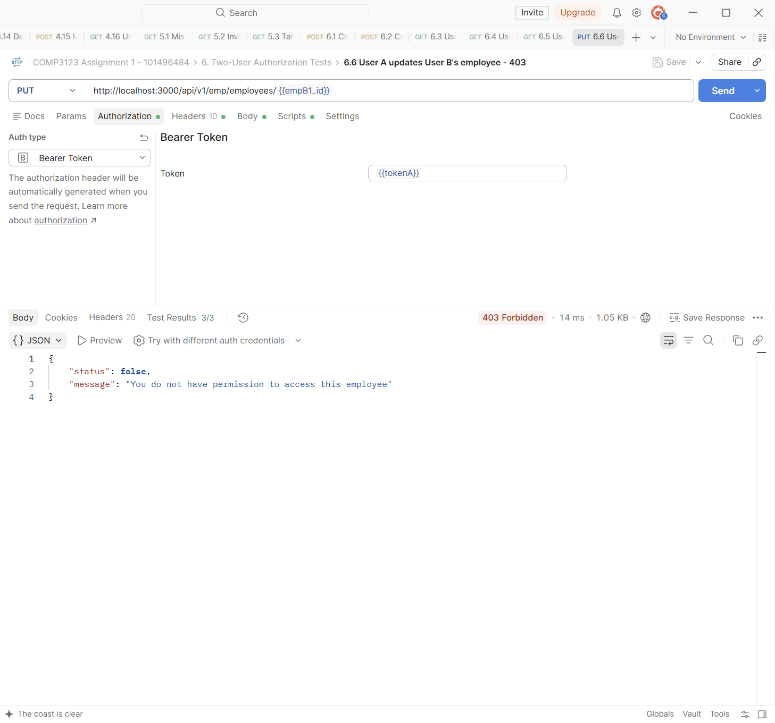

Test | 6.7 User A deletes User B's employee - 403
Endpoint | DELETE http://localhost:3000/api/v1/emp/employees?eid={{empB1_id}}
Expected status | 403 Forbidden
Actual status | 403 Forbidden (Postman Test Results 3/3)
Explanation | User A tries to delete User B's employee. 403 is returned and nothing is deleted.
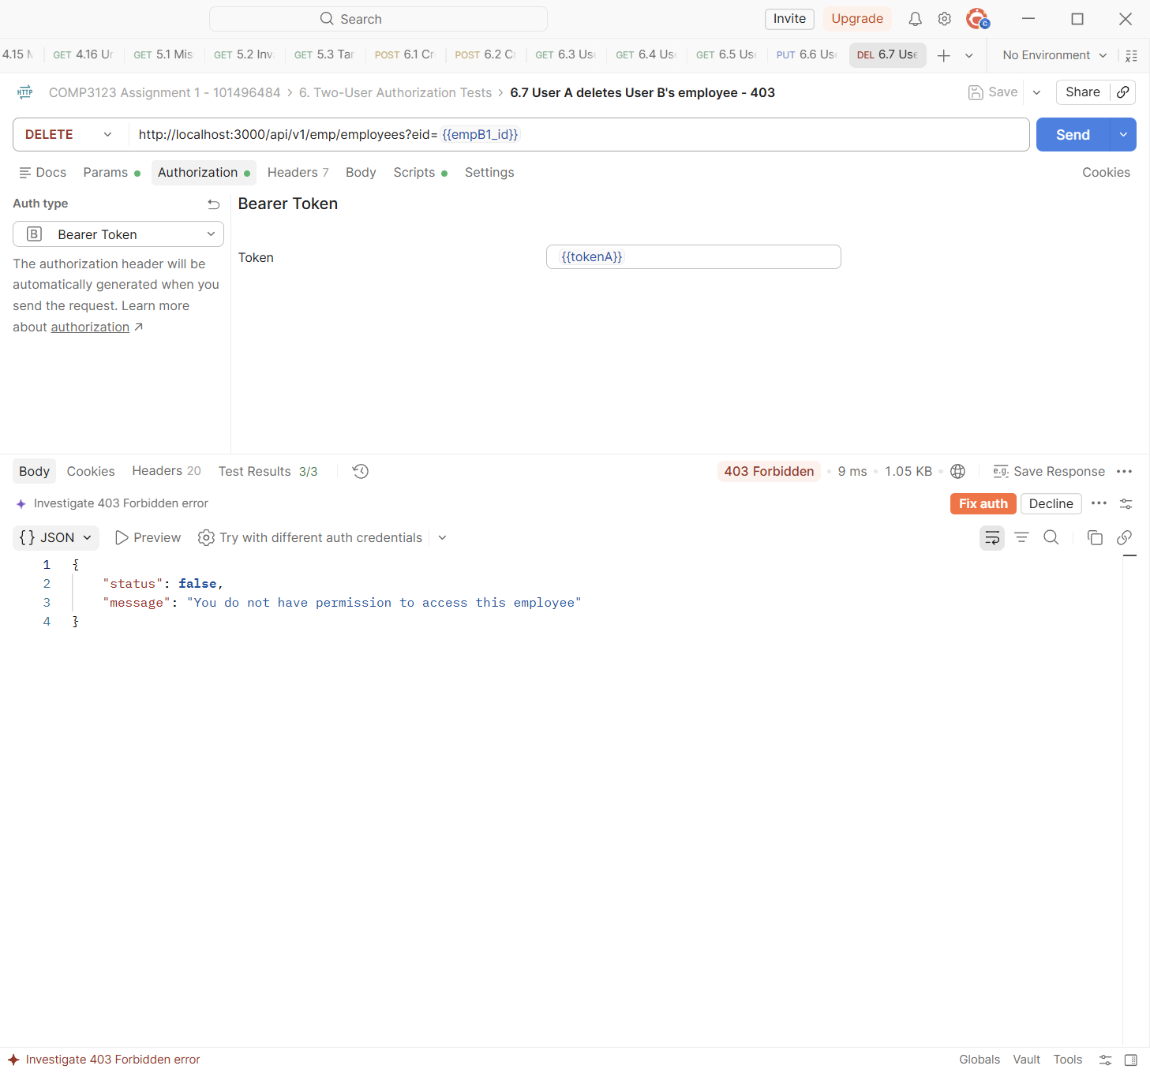

Test | 6.8 User B gets User A's employee - 403
Endpoint | GET http://localhost:3000/api/v1/emp/employees/{{empA1_id}}
Expected status | 403 Forbidden
Actual status | 403 Forbidden (Postman Test Results 3/3)
Explanation | User B ({{tokenB}}) requests User A's employee ({{empA1_id}}). The API returns 403 Forbidden.
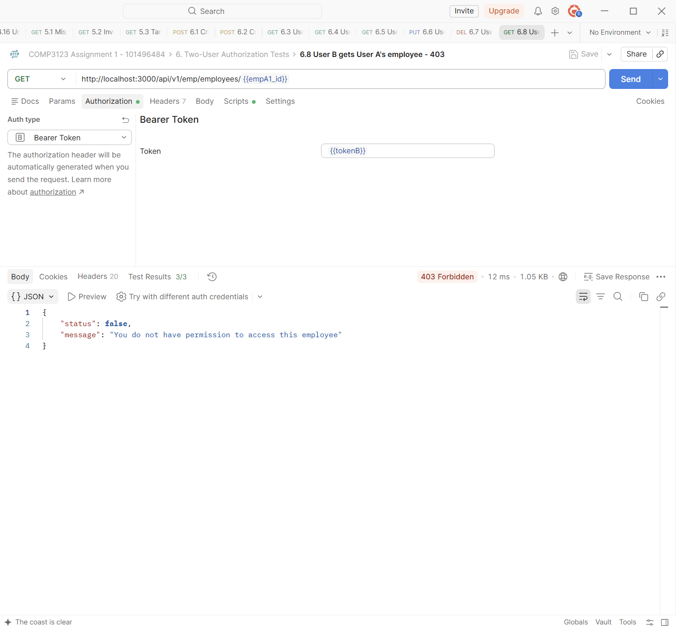

Test | 6.9 User B updates User A's employee - 403
Endpoint | PUT http://localhost:3000/api/v1/emp/employees/{{empA1_id}}
Expected status | 403 Forbidden
Actual status | 403 Forbidden (Postman Test Results 3/3)
Explanation | User B tries to update User A's employee. 403 is returned.
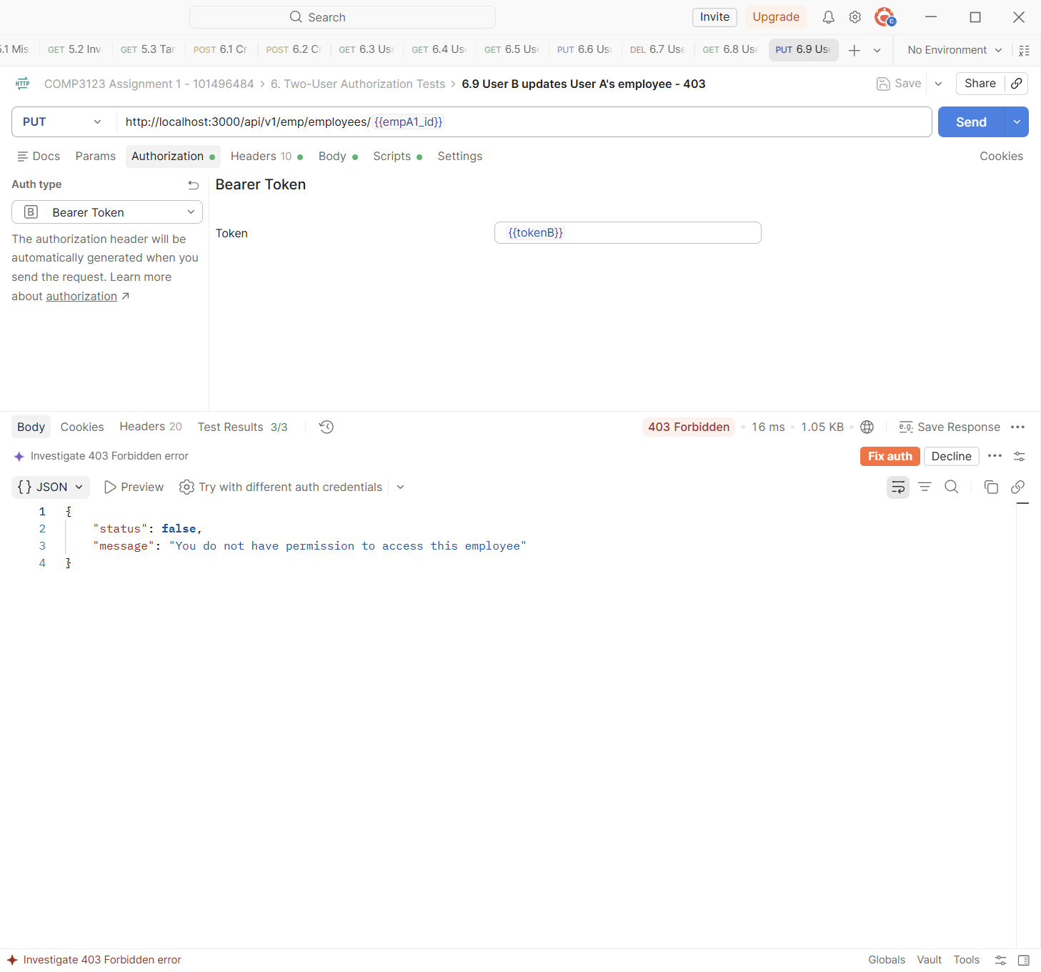

Test | 6.10 User B deletes User A's employee - 403
Endpoint | DELETE http://localhost:3000/api/v1/emp/employees?eid={{empA1_id}}
Expected status | 403 Forbidden
Actual status | 403 Forbidden (Postman Test Results 3/3)
Explanation | User B tries to delete User A's employee. 403 is returned.
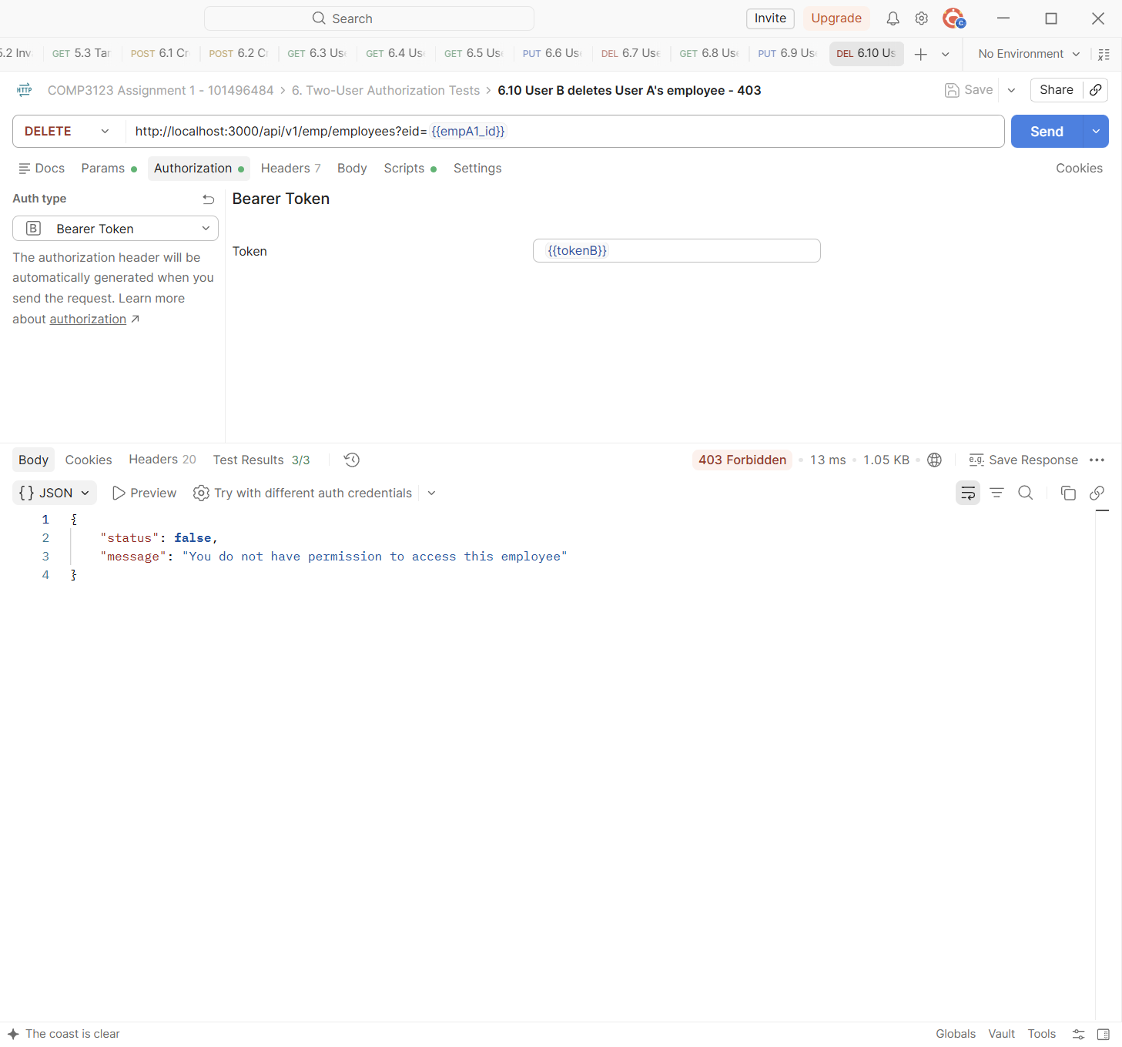

Test | 6.11 User B's employee is unchanged
Endpoint | GET http://localhost:3000/api/v1/emp/employees/{{empB1_id}}
Expected status | 200 OK
Actual status | 200 OK (Postman Test Results 2/2)
Explanation | After User A's attempts, User B reads Sara Ahmed again. The Test Results show the salary is still 82000, so the blocked update changed nothing.
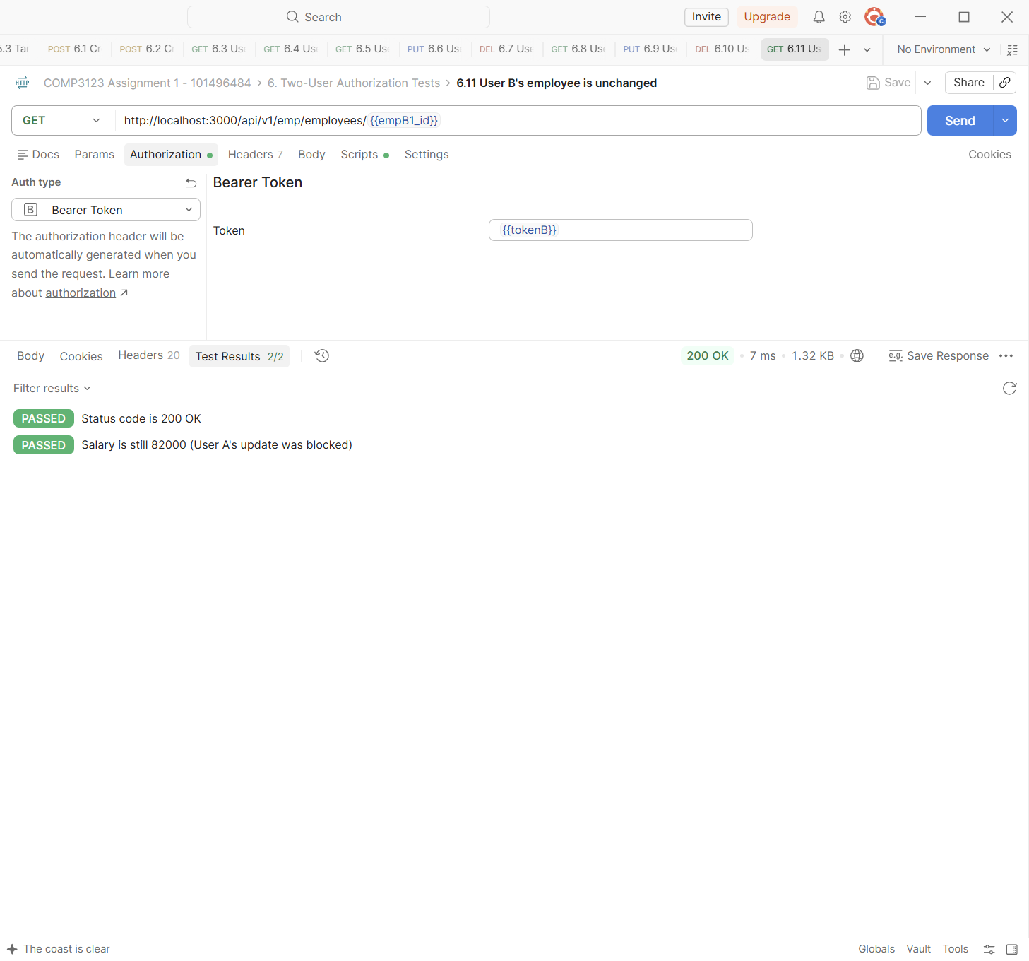

Test | 6.12 User A's employee is unchanged
Endpoint | GET http://localhost:3000/api/v1/emp/employees/{{empA1_id}}
Expected status | 200 OK
Actual status | 200 OK (Postman Test Results 2/2)
Explanation | After User B's attempts, John Smith's salary is still 85000.
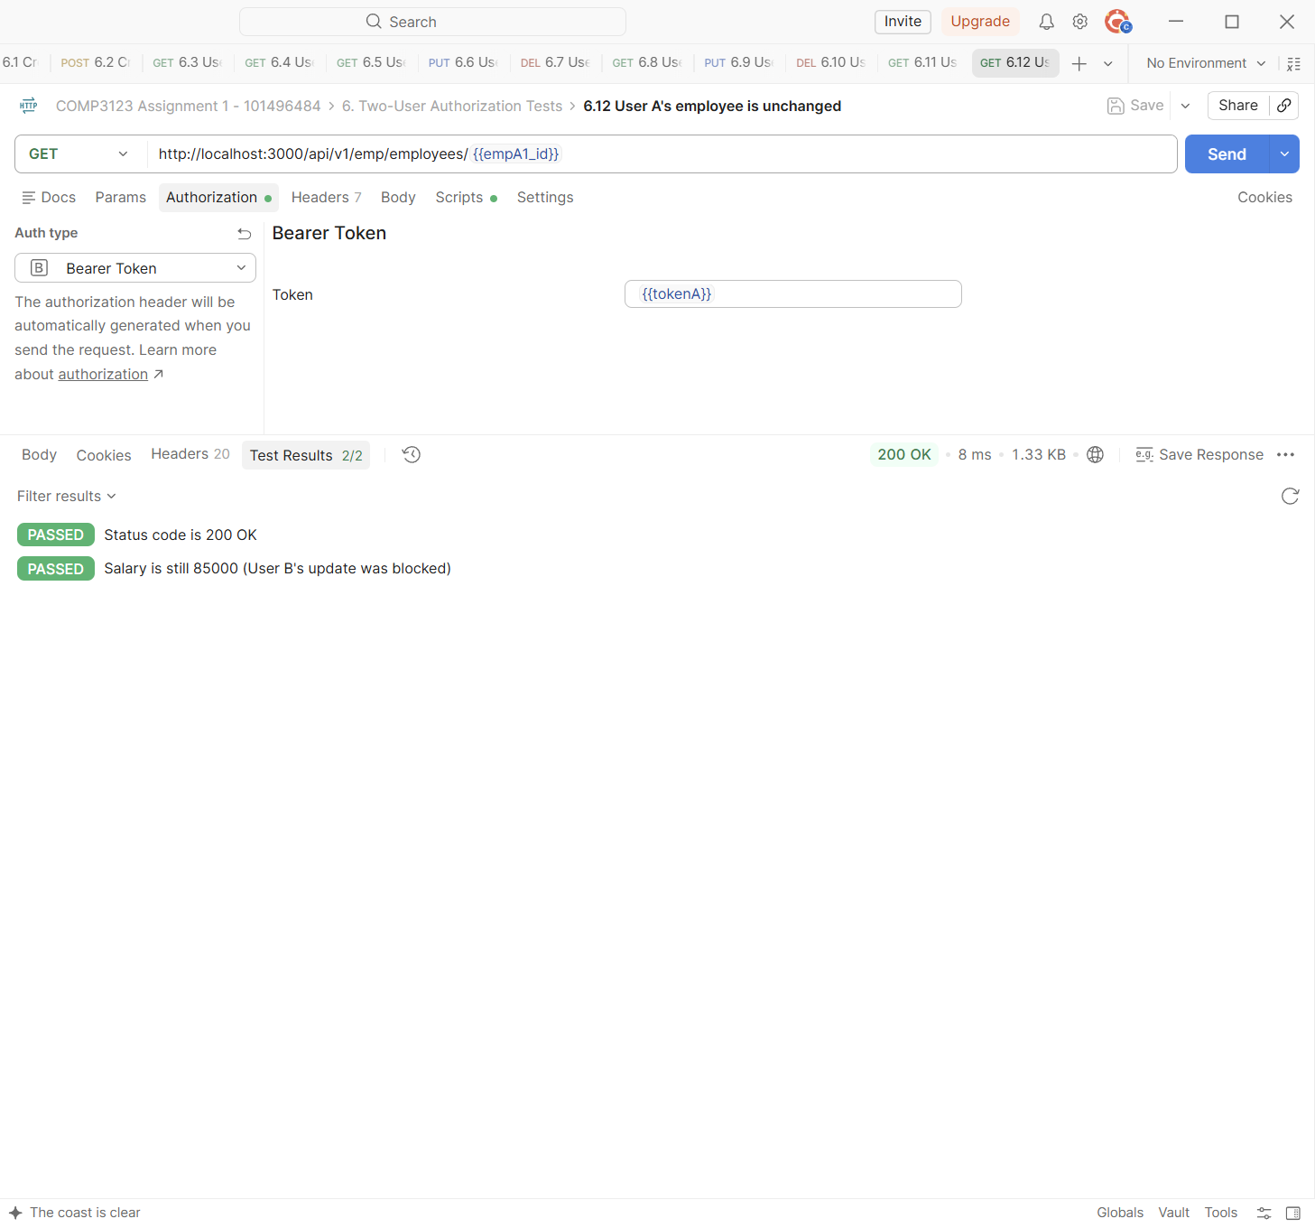

7. Rate Limiting
Login and signup share a limit of 20 requests per 15 minutes per IP address. All /api requests also have a general limit of 200 per 15 minutes.
Test | 7.1 Login - repeat until 429 Too Many Requests
Endpoint | POST http://localhost:3000/api/v1/user/login
Expected status | 429 Too Many Requests
Actual status | 429 Too Many Requests (Postman Test Results 3/3)
Explanation | The login request (with a wrong password) was sent again and again from Postman. Attempts 1 to 20 returned 401; attempt 21 returned 429 Too Many Requests with a JSON message.
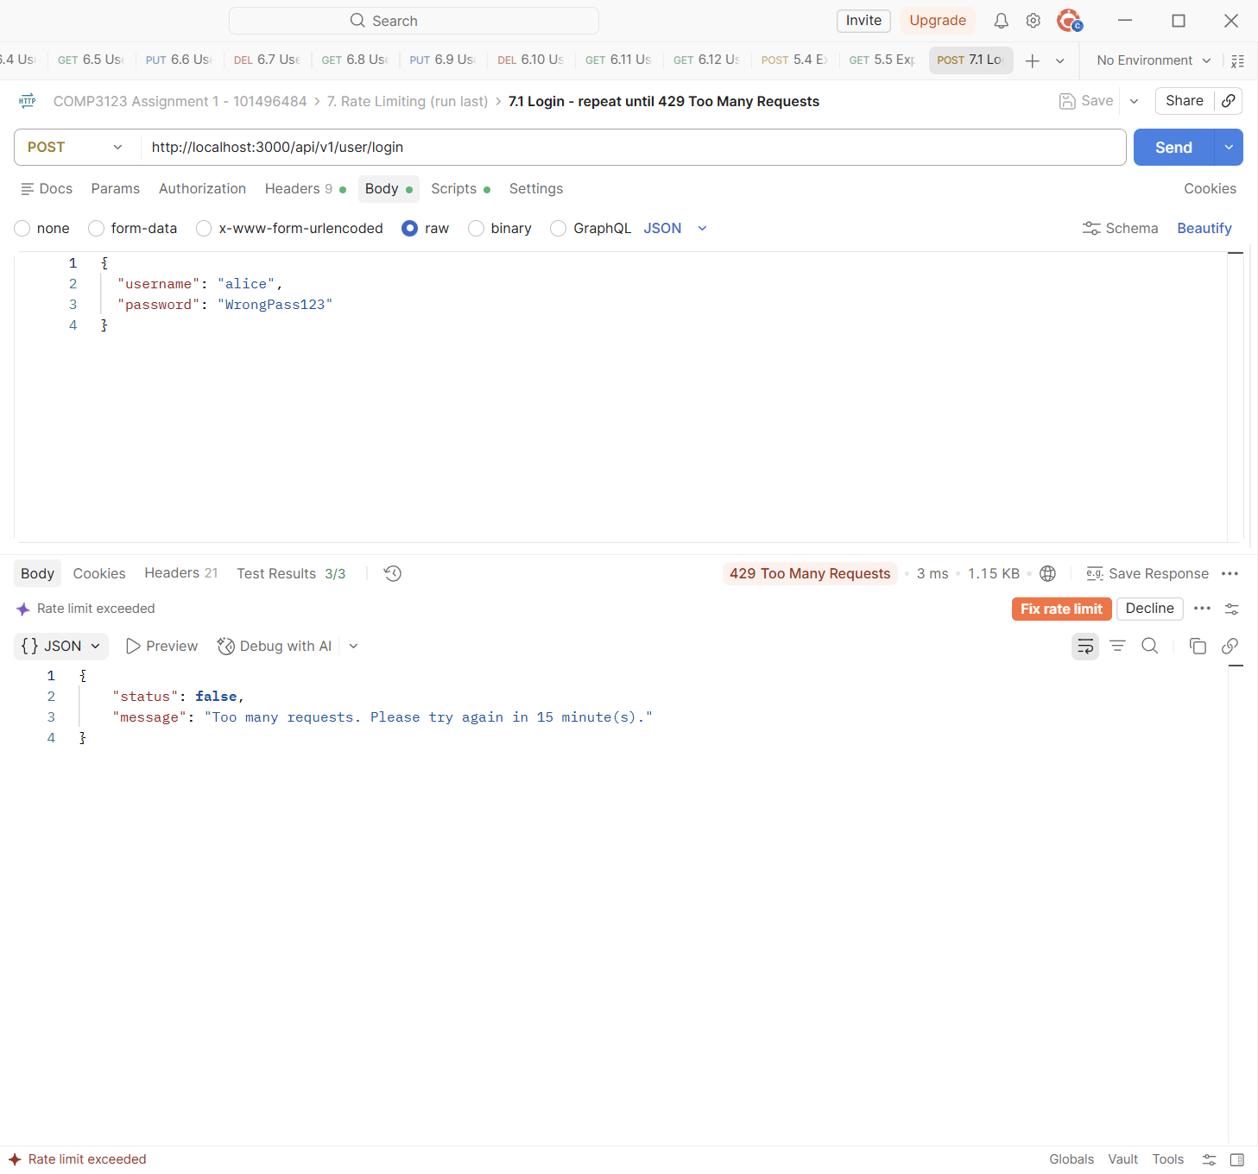

Test | 7.1 Login - repeat until 429 Too Many Requests
Endpoint | POST http://localhost:3000/api/v1/user/login
Expected status | 429 Too Many Requests
Actual status | 429 Too Many Requests (Postman Test Results 3/3)
Explanation | Headers of the same 429 response: Retry-After (seconds to wait) and the RateLimit / RateLimit-Policy headers for both limits ("20-in-15min" with 0 requests left, and the general "200-in-15min").
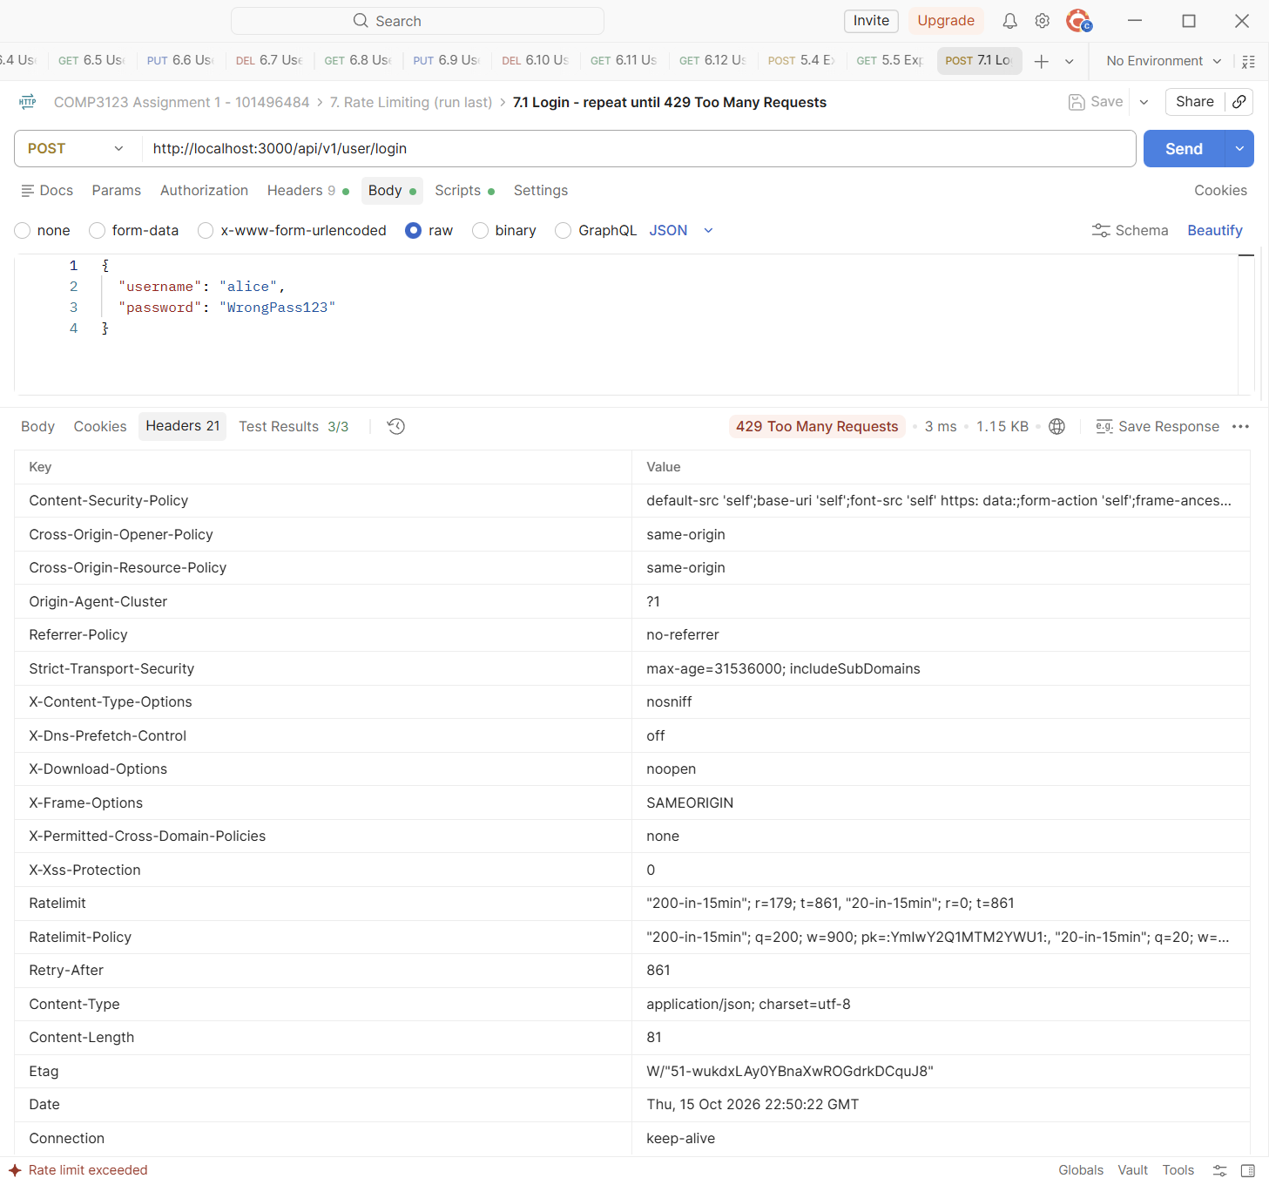

8. Helmet Security Headers
Helmet adds security headers to every response.
Test | 0.1 Health check
Endpoint | GET http://localhost:3000/health
Expected status | 200 OK
Actual status | 200 OK (Postman Test Results 4/4)
Explanation | Response headers of GET /health: Content-Security-Policy, Strict-Transport-Security, X-Content-Type-Options: nosniff, X-Frame-Options: SAMEORIGIN, Referrer-Policy, Cross-Origin-Opener/Resource-Policy and more. There is no X-Powered-By header, so the server does not reveal that it uses Express.
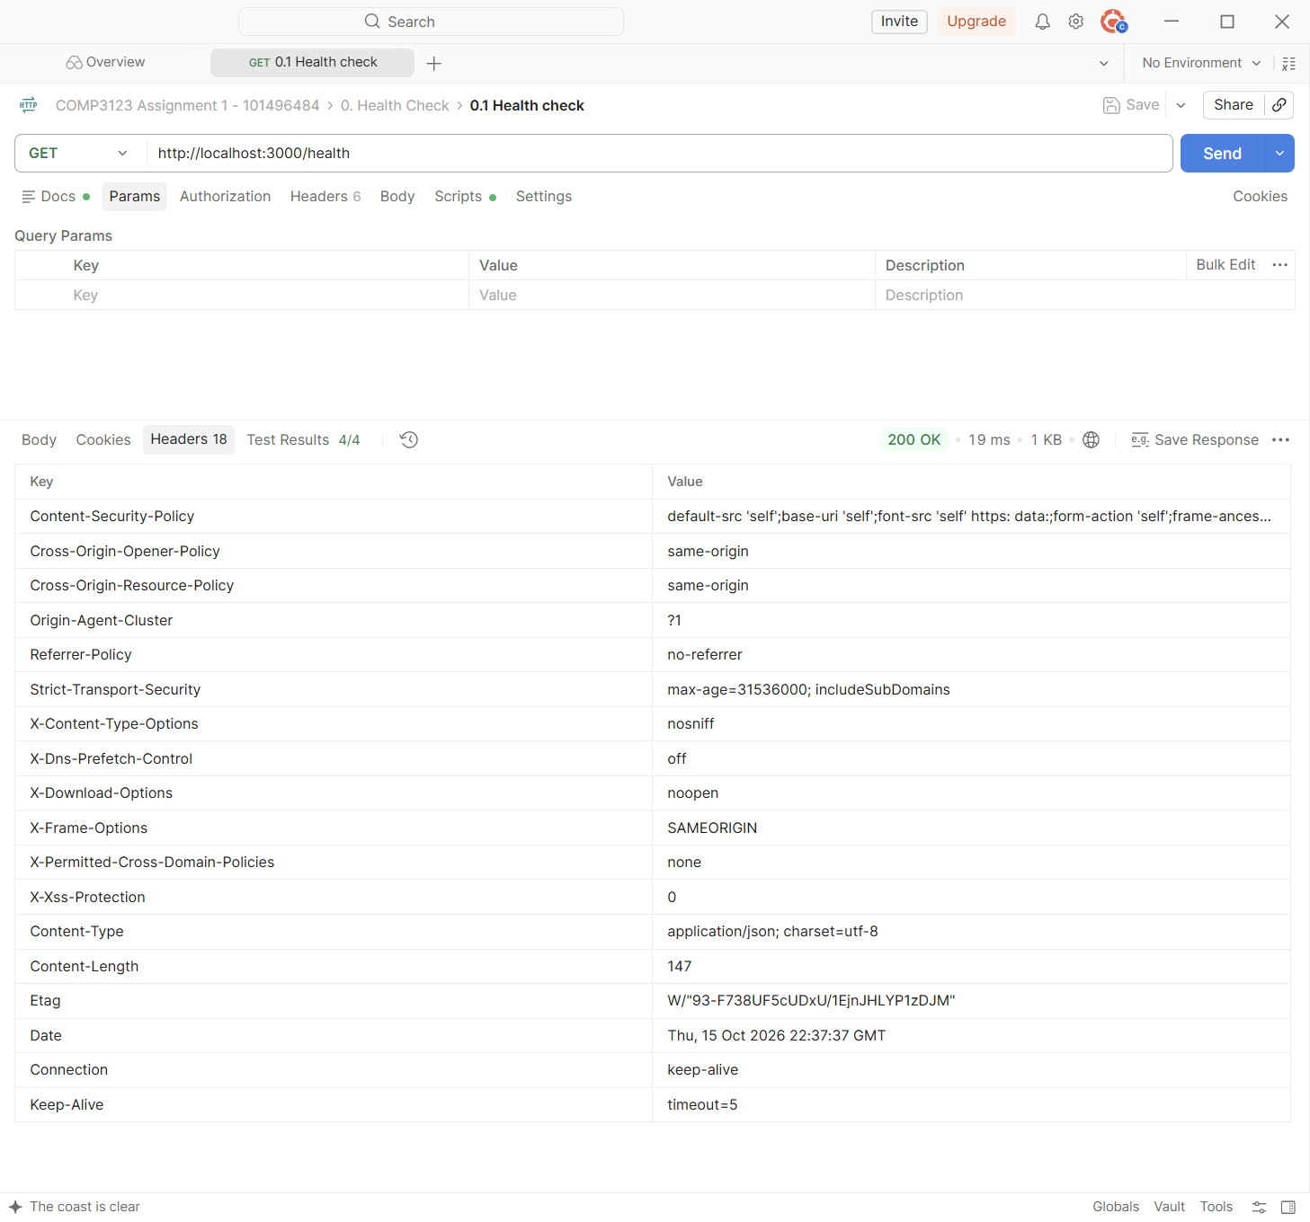

9. Health Check
GET /health shows that the API is running and whether MongoDB is reachable. No token is needed.
Test | 0.1 Health check
Endpoint | GET http://localhost:3000/health
Expected status | 200 OK
Actual status | 200 OK (Postman Test Results 4/4)
Explanation | Returns 200 with "status": true, "database": "connected", the uptime and the time.
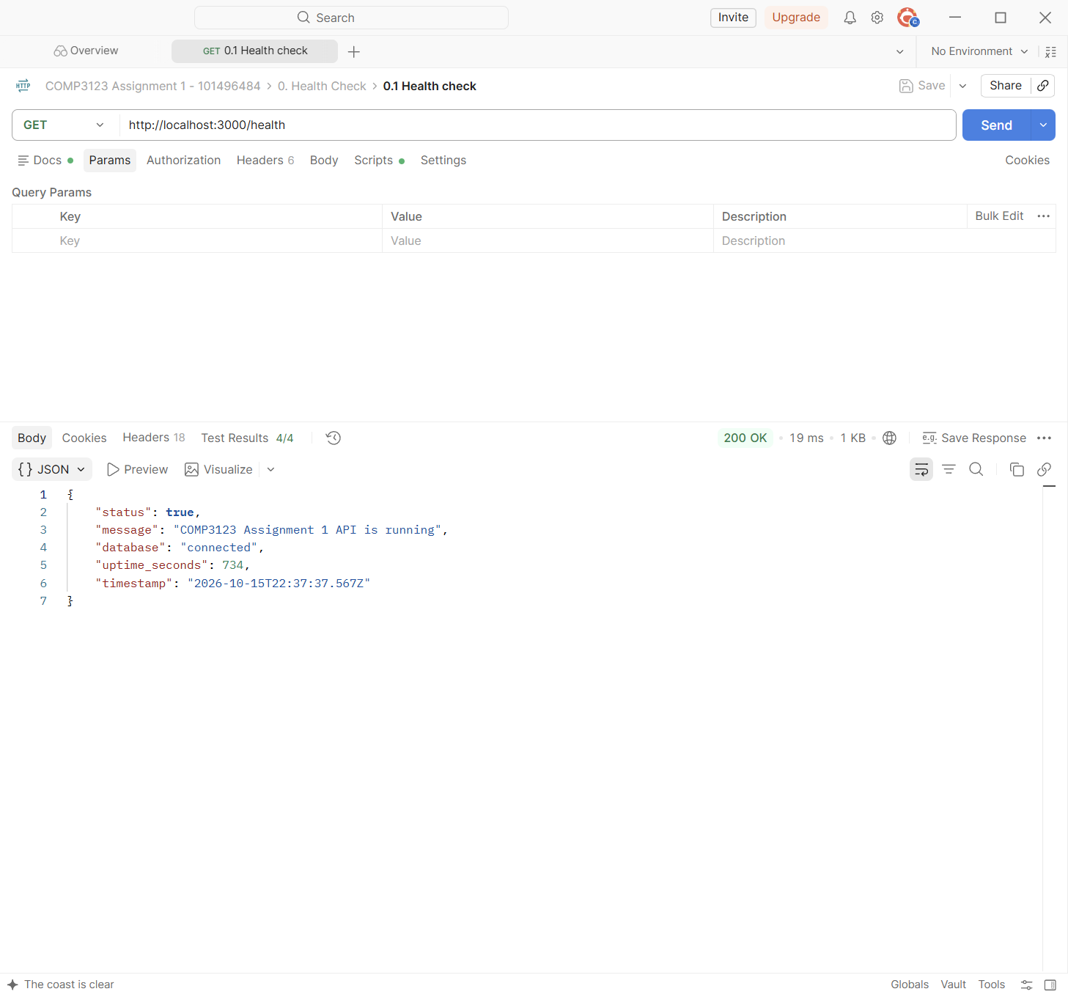

Test | 8.2 Health check - database status
Endpoint | GET http://localhost:3000/health
Expected status | 200 OK
Actual status | 200 OK (Postman Test Results 2/2)
Explanation | With MongoDB stopped, the health check still returns 200 (the server is running) but reports "database": "disconnected".
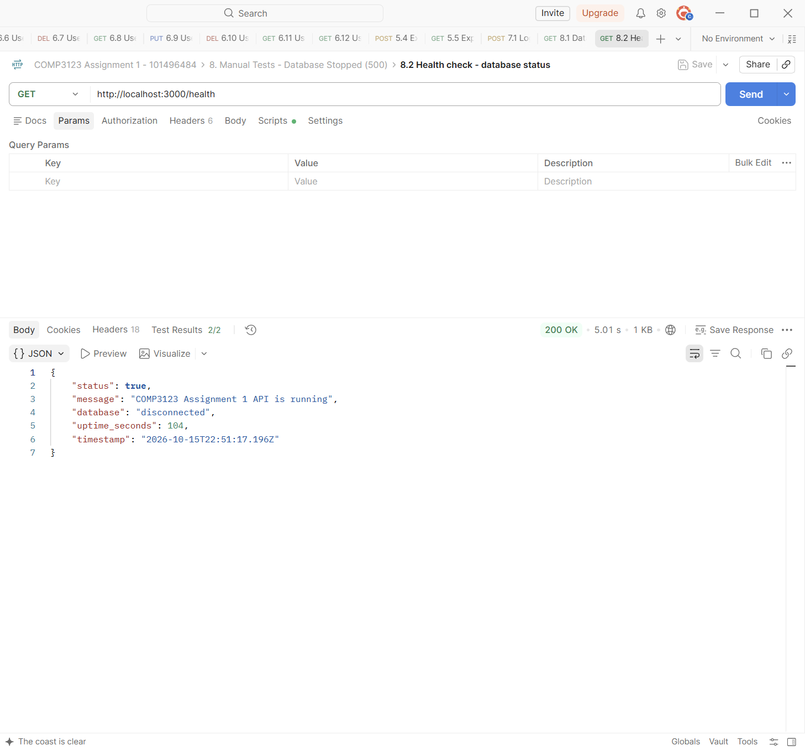

10. MongoDB Collections and Relationships
Local MongoDB 7.0 (Docker) viewed with mongo-express, and MongoDB Atlas (used by the Vercel deployment) viewed with Atlas Data Explorer. The database name is comp3123_assignment1. Local ids: alice = ...685019e, bob = ...685019f.
Test | Database list (local)
Location | MongoDB 7.0 (Docker) - mongo-express
Expected | comp3123_assignment1 exists
Actual | comp3123_assignment1 is listed
Explanation | The database comp3123_assignment1 was created by the API (the name is set in config/db.js).
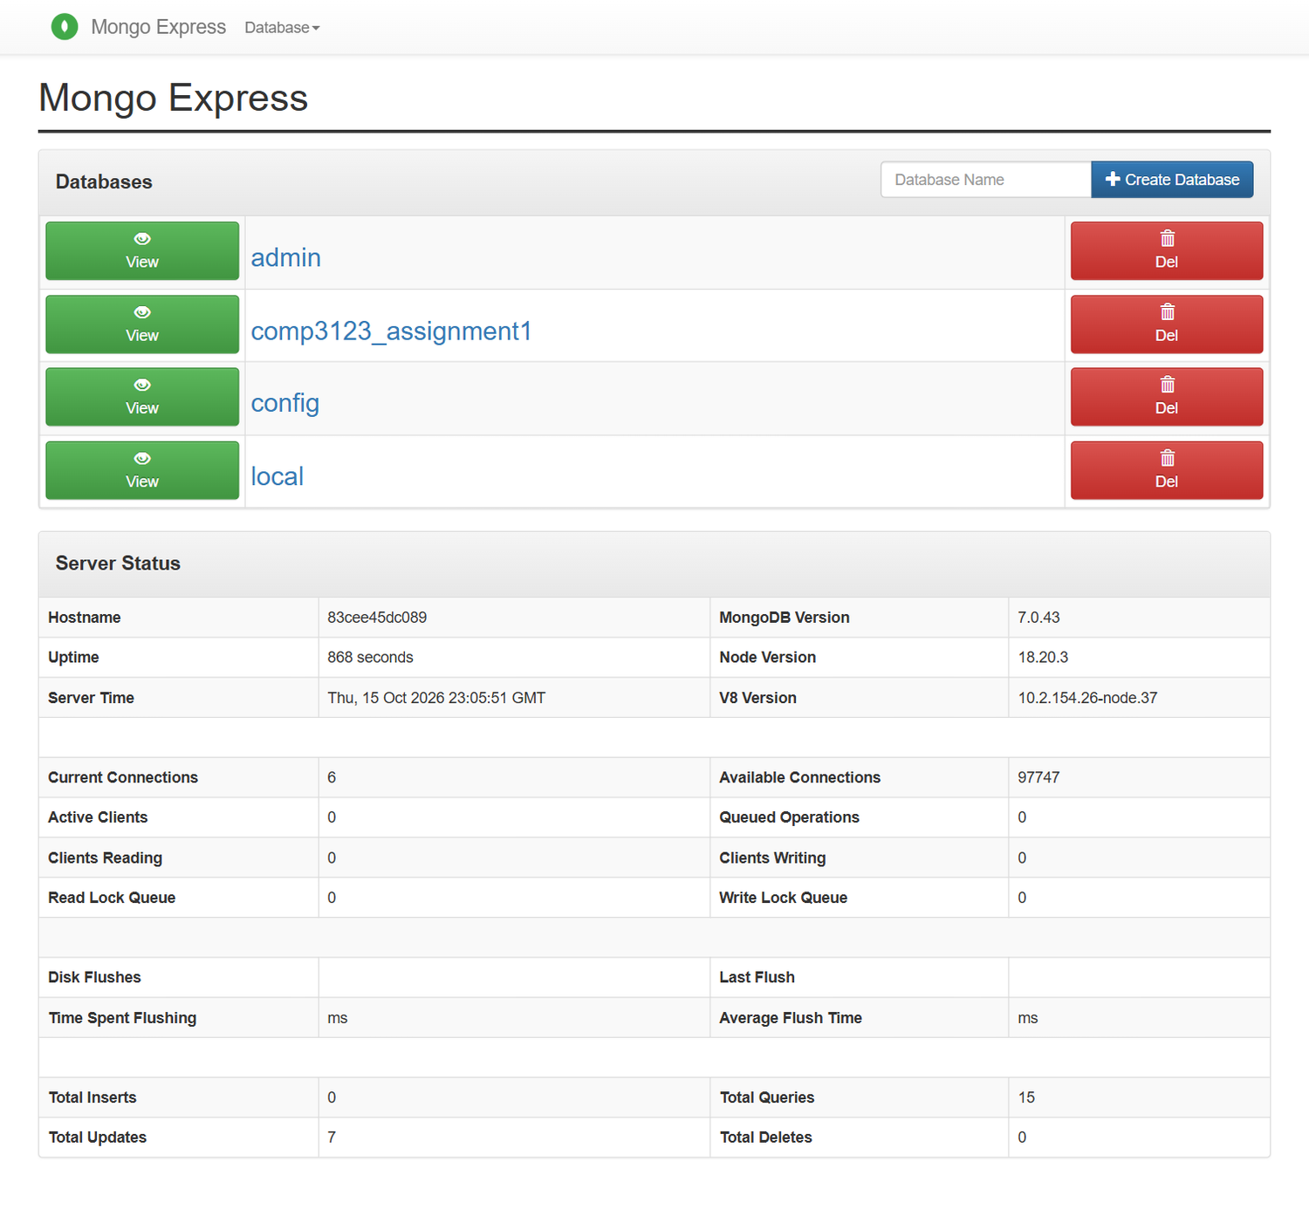

Test | Collections in comp3123_assignment1
Location | comp3123_assignment1
Expected | users and employees
Actual | users and employees
Explanation | The database has the two collections used by the API: users and employees.
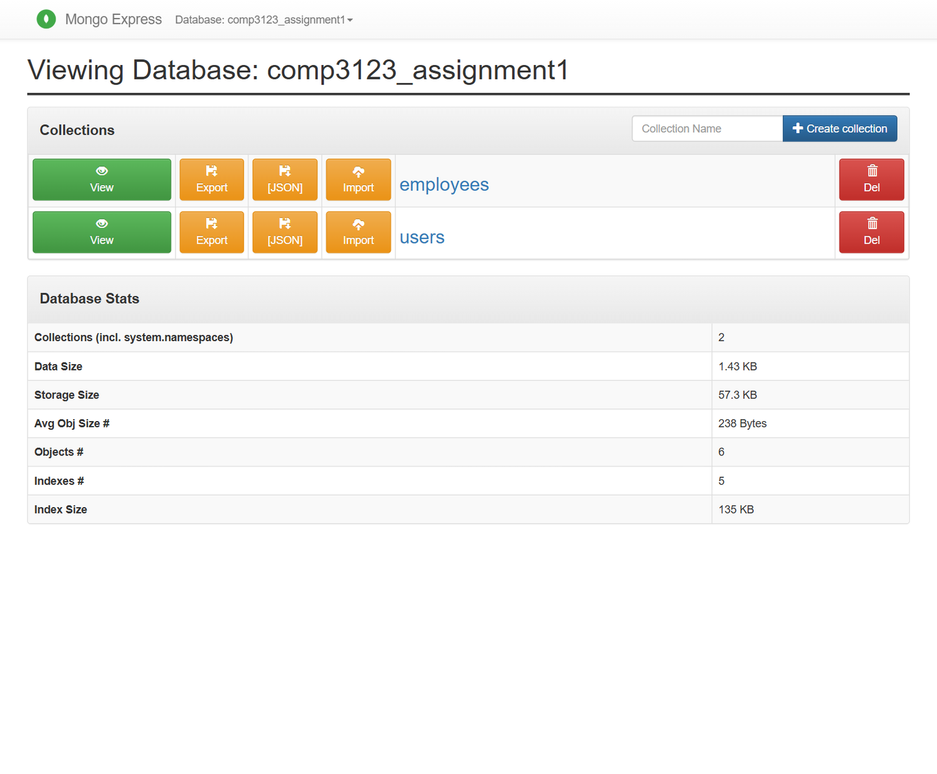

Test | users collection - hashed passwords
Location | comp3123_assignment1.users
Expected | Passwords stored as bcrypt hashes
Actual | $2b$10$... hashes for alice and bob
Explanation | The password field holds bcrypt hashes ($2b$10$...), never plain text. created_at and updated_at are added by Mongoose timestamps.
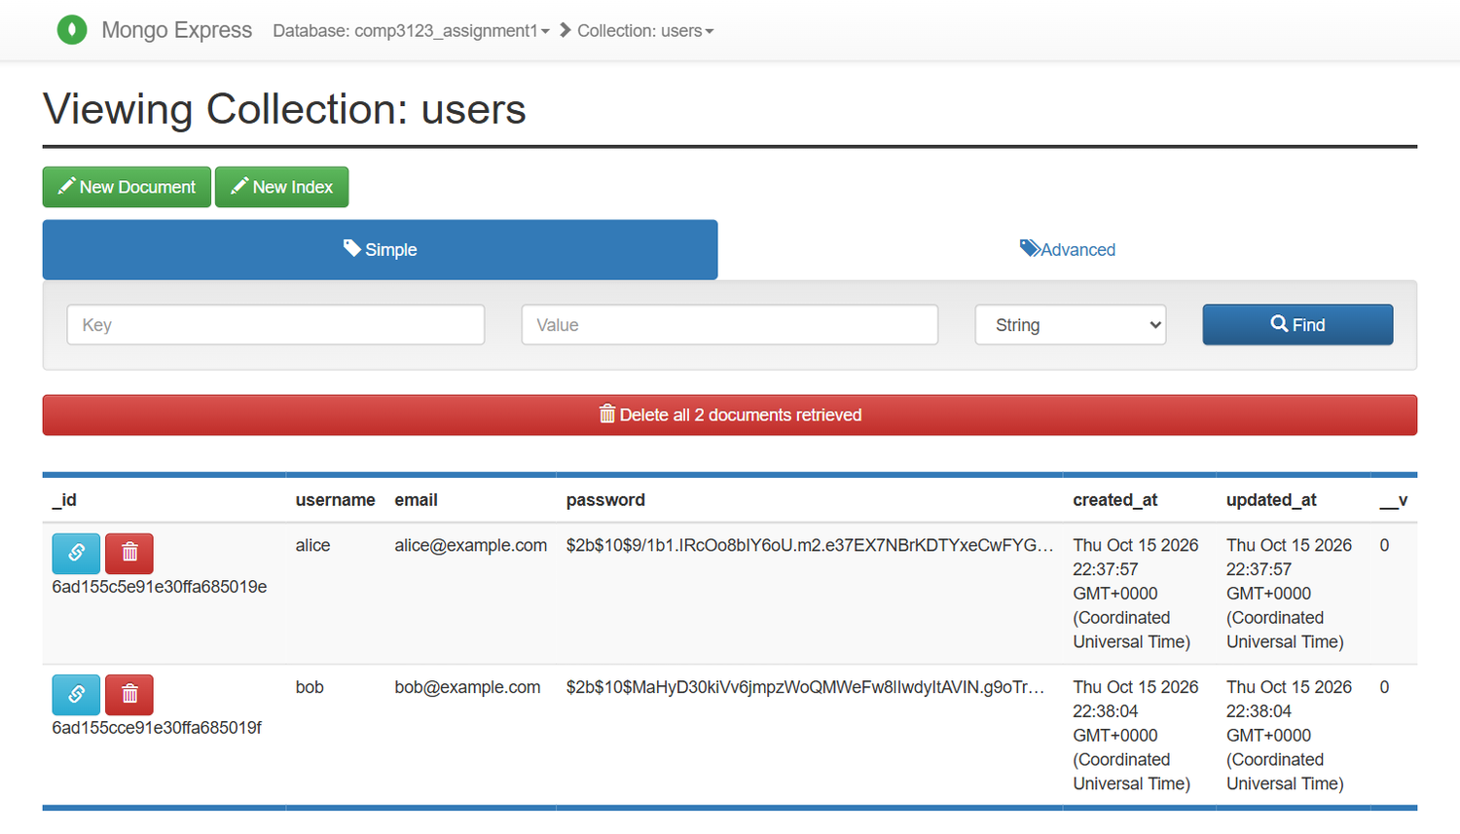

Test | users collection - unique indexes
Location | comp3123_assignment1.users (indexes)
Expected | Unique username and email
Actual | username_1 and email_1 are unique
Explanation | Unique indexes stop duplicate usernames and emails at the database level too.
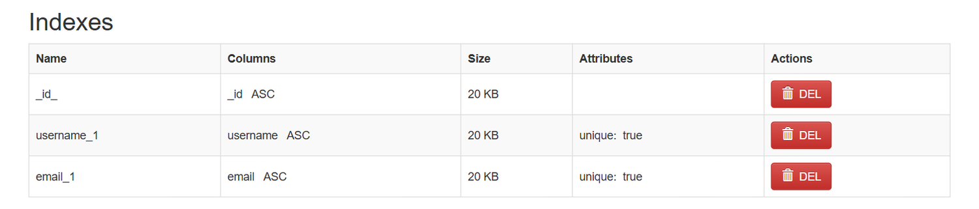

Test | employees collection - owner reference
Location | comp3123_assignment1.employees
Expected | Every employee has a user (owner) id
Actual | 4 employees, each with a user ObjectId
Explanation | The "user" field stores the ObjectId of the owner. This is the relationship between users and employees (one user has many employees).
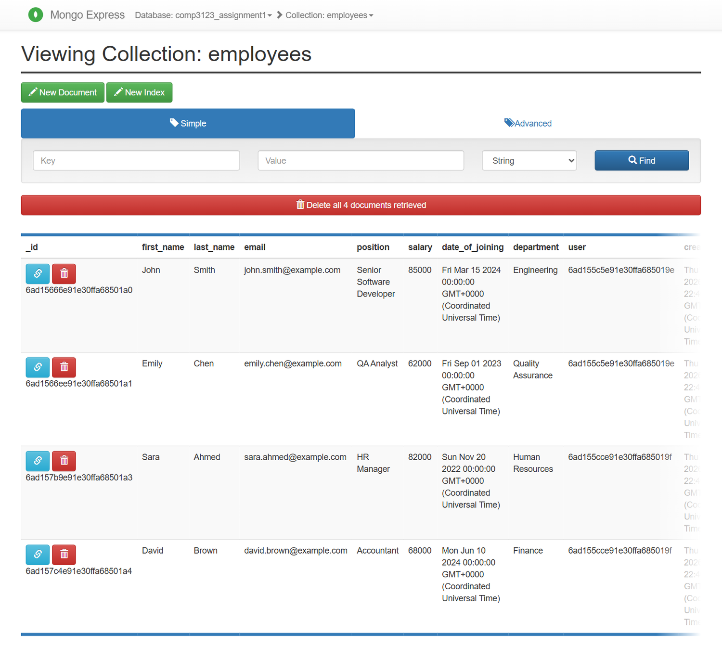

Test | employees collection - index
Location | comp3123_assignment1.employees (indexes)
Expected | Index on { user, email }
Actual | user_1_email_1 (unique)
Explanation | The compound index makes "find this user's employees" fast and stops one user from having two employees with the same email.
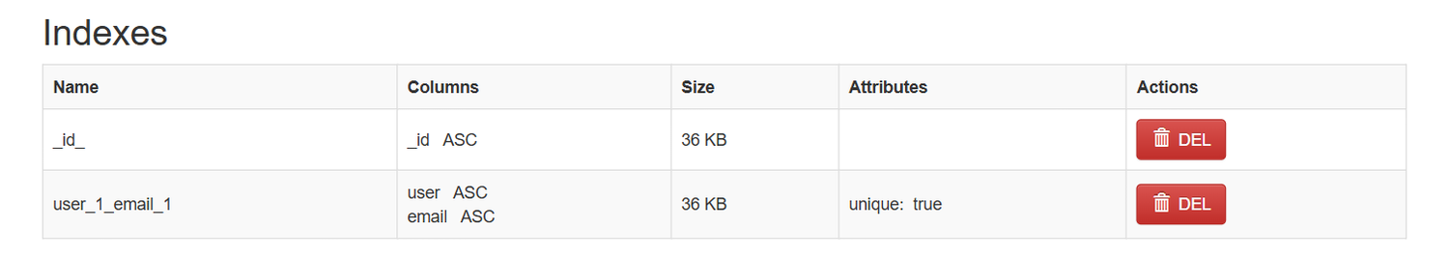

Test | Employees owned by alice
Location | employees where user = ObjectId(alice)
Expected | 2 employees
Actual | John Smith, Emily Chen
Explanation | The same 2 employees that User A sees in the API (section 6).
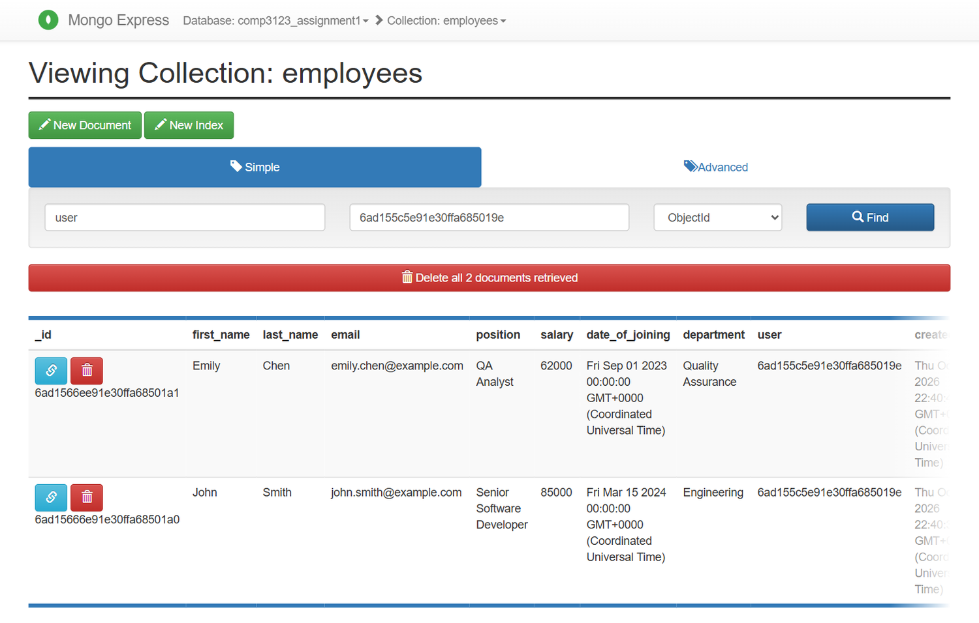

Test | Employees owned by bob
Location | employees where user = ObjectId(bob)
Expected | 2 employees
Actual | Sara Ahmed, David Brown
Explanation | The same 2 employees that User B sees in the API.
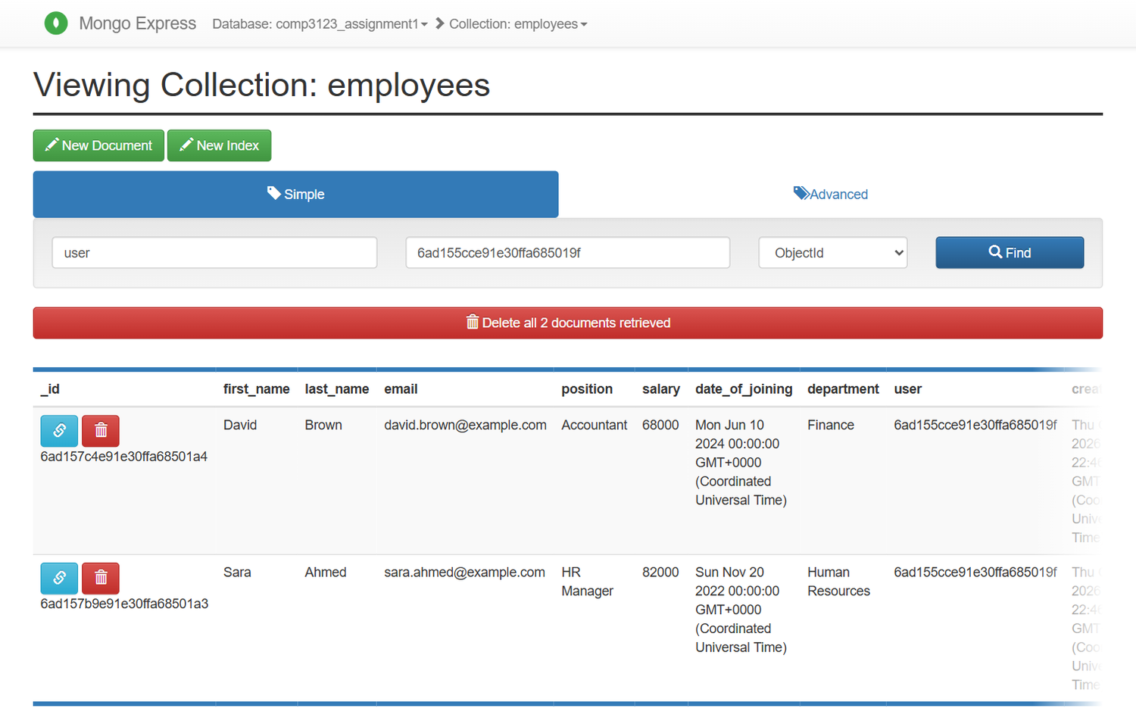

Test | One user document
Location | users / alice
Expected | Hashed password, timestamps
Actual | As expected
Explanation | A full user document: username, email, bcrypt hash and timestamps (viewed only, not edited).
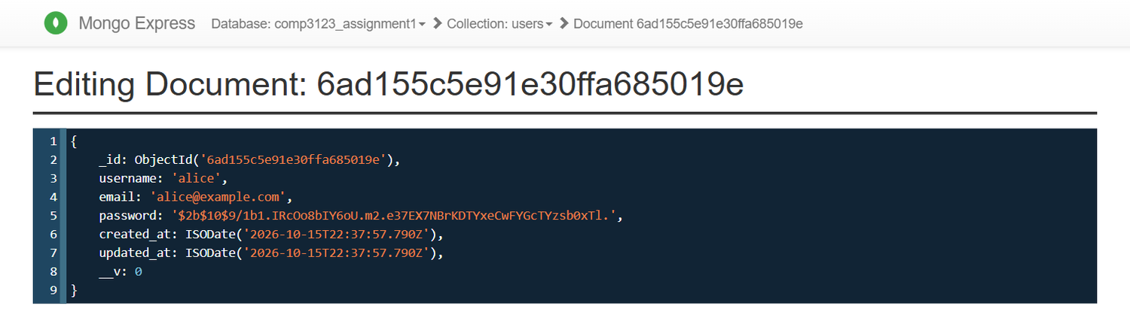

Test | One employee document
Location | employees / John Smith
Expected | All fields, owner, timestamps
Actual | As expected
Explanation | A full employee document with the user reference (alice) and timestamps. updated_at is later than created_at because this employee was updated in test 3.6.
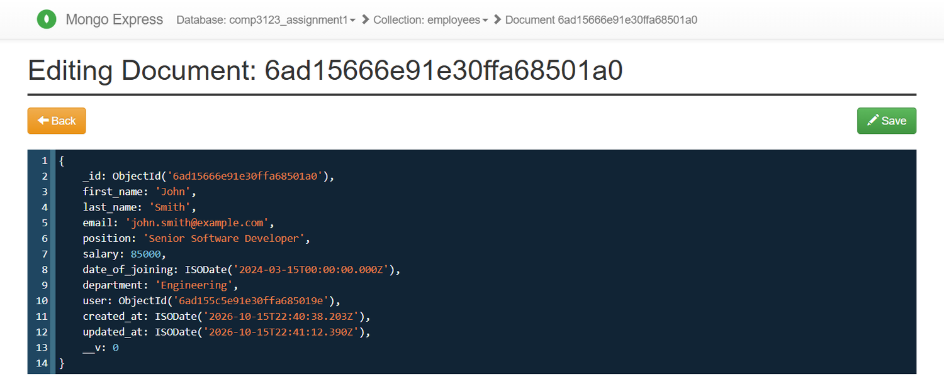

Test | Atlas - users collection (deployed API)
Location | MongoDB Atlas Cluster0 / comp3123_assignment1.users
Expected | Users with hashed passwords
Actual | alice and bob with bcrypt hashes
Explanation | The deployed API on Vercel uses this MongoDB Atlas database. Passwords are bcrypt hashes here too.
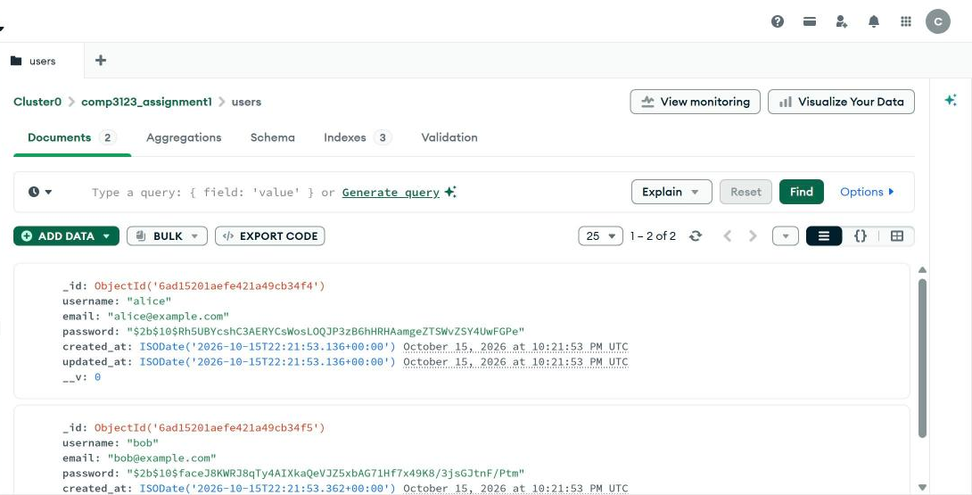

Test | Atlas - employees collection
Location | MongoDB Atlas / comp3123_assignment1.employees
Expected | Employees with owner ids
Actual | 4 employees with user ObjectIds
Explanation | Employees created through the deployed API, each with the owner's user id and timestamps.
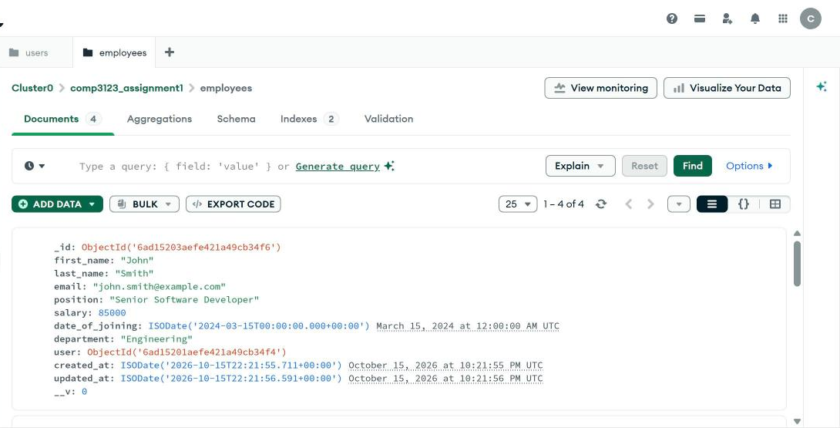

Test | Atlas - employees owned by alice
Location | { user: ObjectId('...34f4') }
Expected | Only alice's employees
Actual | Emily Chen, John Smith
Explanation | A filter on the user field shows the ownership relationship in the cloud database.
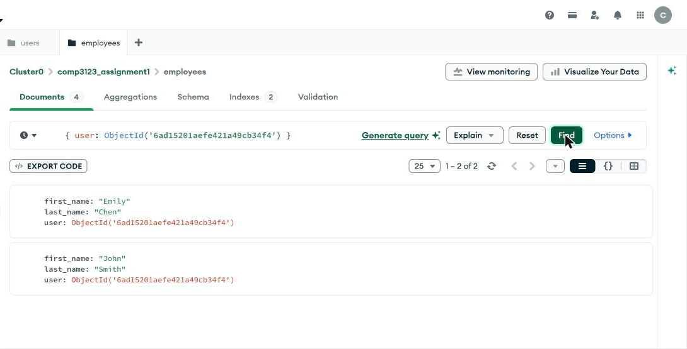

Test | Atlas - employees owned by bob
Location | { user: ObjectId('...34f5') }
Expected | Only bob's employees
Actual | David Brown, Sara Ahmed
Explanation | User B's employees in the cloud database.
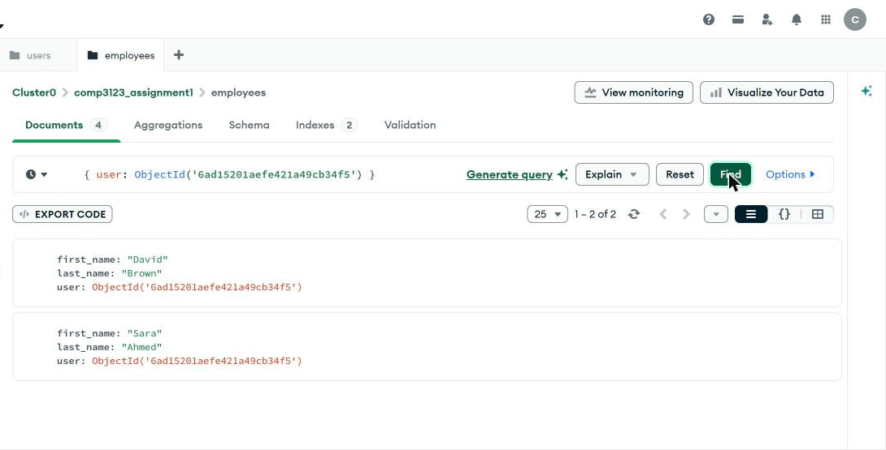

11. Application Logging
Logs are written by winston to logs/app.log (all events) and logs/error.log (errors only). The screenshots show the real log files from this test session, opened in Chrome. Passwords, tokens, secrets and request bodies are never logged.
Test | logs/app.log - startup and requests
Location | logs/app.log
Expected | Timestamp, level, method, path, status
Actual | As expected
Explanation | Each line has a timestamp and a level. The file shows the MongoDB connection, the server startup and every request (method, path, status code, time, IP and user), plus new users and successful logins.
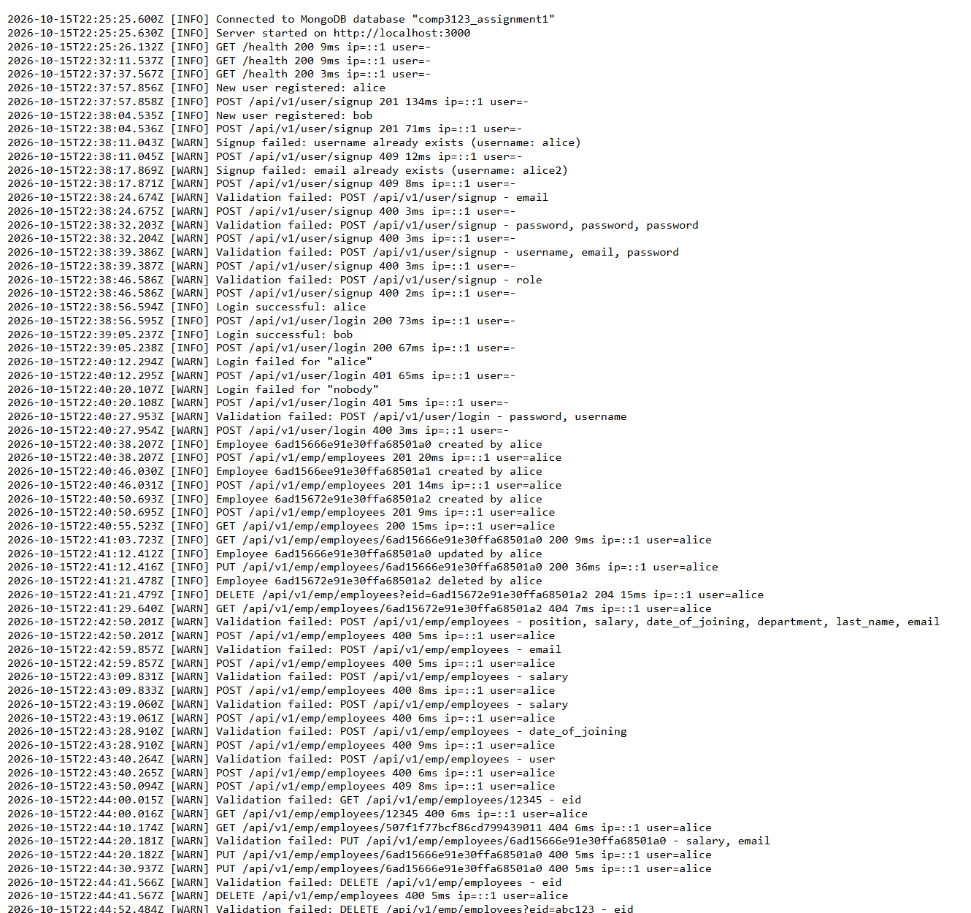

Test | logs/app.log - authentication and validation
Location | logs/app.log
Expected | Failed logins and validation failures logged
Actual | As expected
Explanation | Failed logins, invalid tokens and validation failures are logged as WARN. Validation lines only list field names, never the values (a value could be a password).
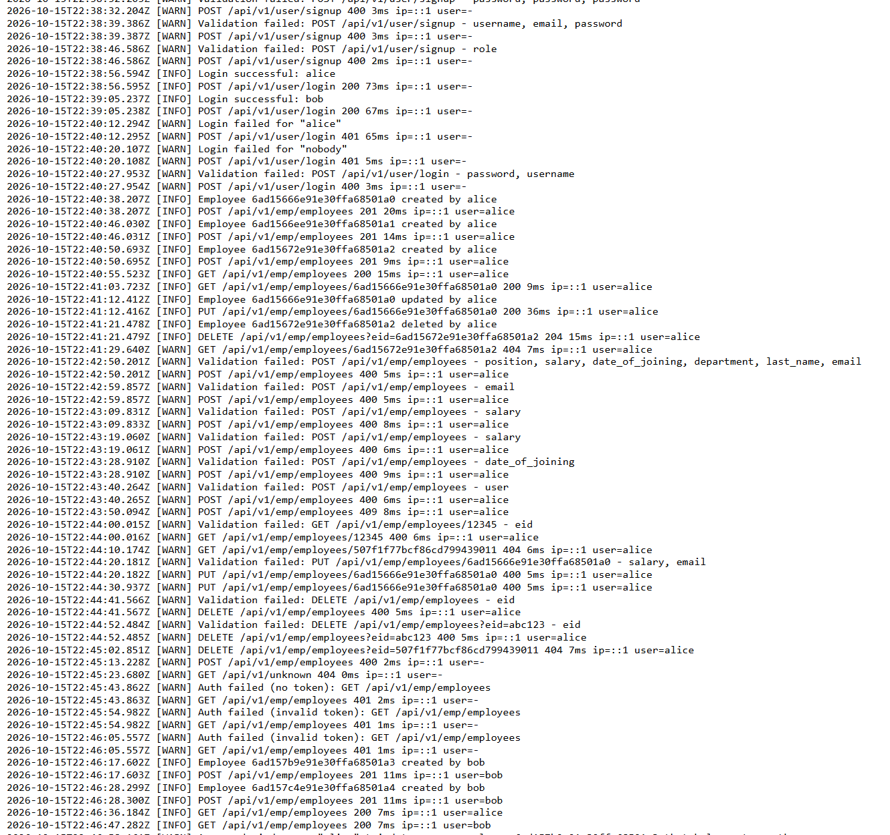

Test | logs/app.log - authorization failures
Location | logs/app.log
Expected | 403 attempts logged
Actual | As expected
Explanation | Each cross-user attempt is logged: "Access denied: user ... tried to access employee ... that belongs to another user", followed by the 403 request line. The expired token is also logged.
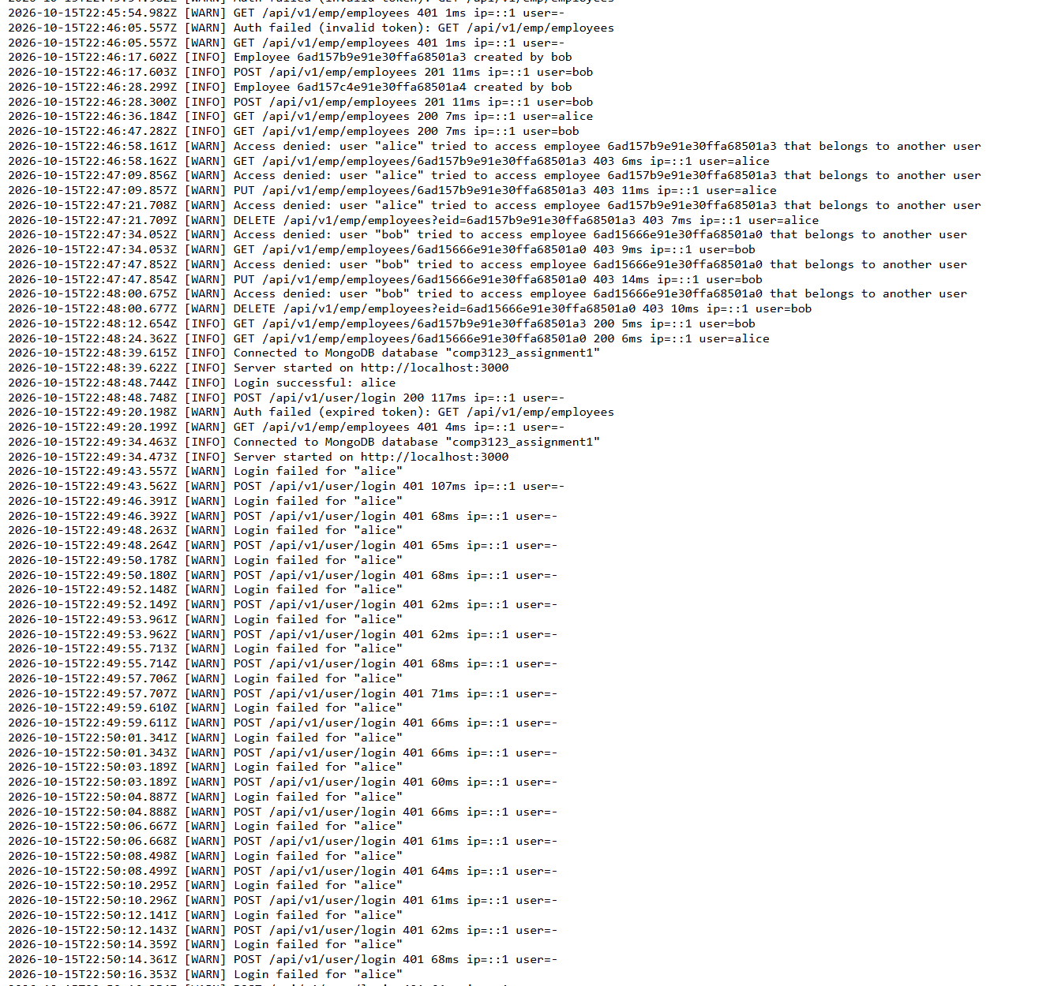

Test | logs/app.log - rate limit
Location | logs/app.log
Expected | Rate limit event logged
Actual | As expected
Explanation | The 20 failed logins followed by "Rate limit reached" and the 429 request line.
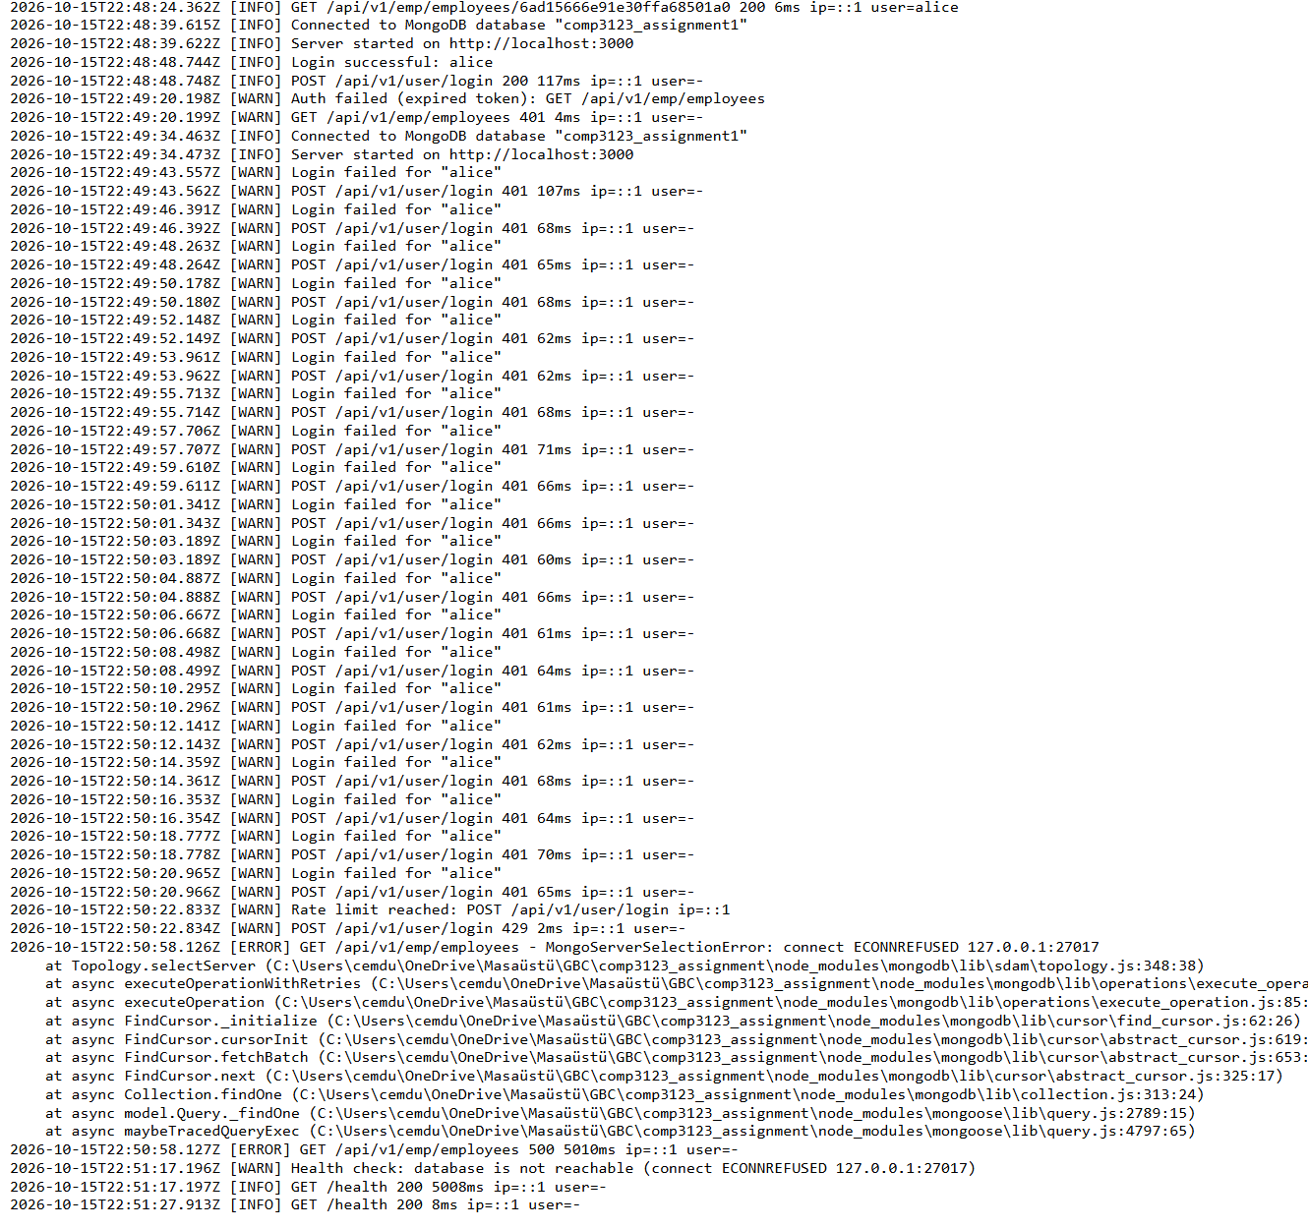

Test | logs/error.log - server error
Location | logs/error.log
Expected | Error details only in the log
Actual | As expected
Explanation | When MongoDB was stopped, the full error and stack trace were written here, while the client only received "Internal server error" (test 4.17).
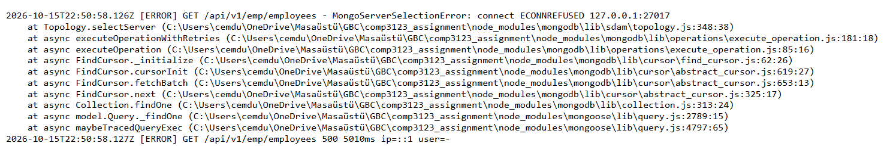

12. Deployed API on Vercel
The same API deployed on Vercel (https://101496484-comp3123-assignment1.vercel.app) with MongoDB Atlas. These requests are in folder 9 of the Postman collection. The JWT is blurred.
Test | 9.1 Deployed - Health check
Endpoint | GET https://101496484-comp3123-assignment1.vercel.app/health
Expected status | 200 OK
Actual status | 200 OK (Postman Test Results 2/2)
Explanation | The deployed health check returns 200 and "database": "connected" (MongoDB Atlas).
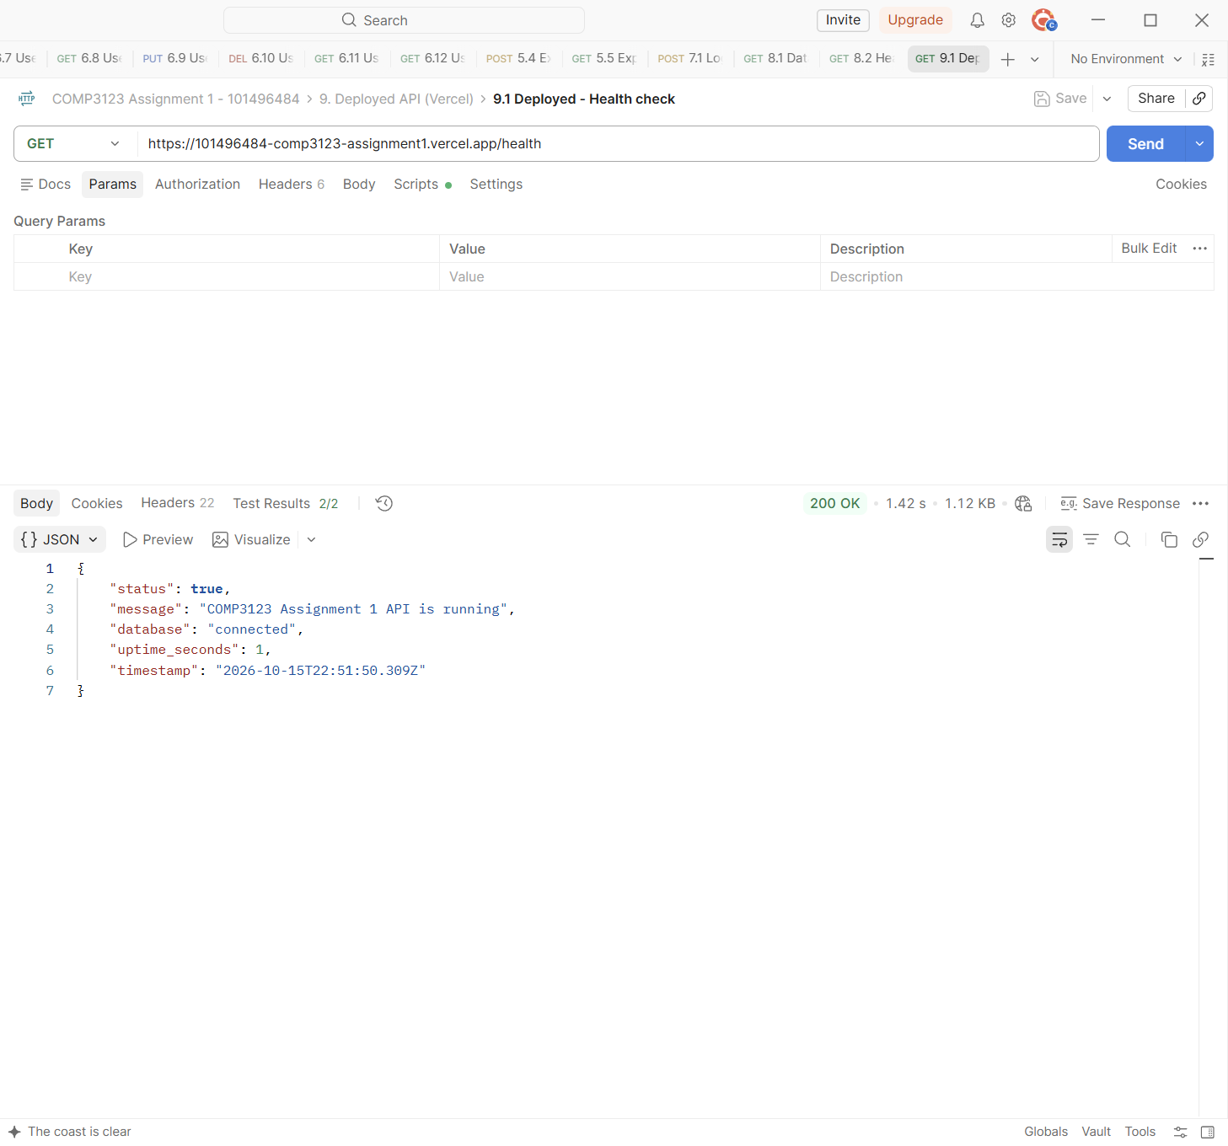

Test | 9.2 Deployed - Login User A
Endpoint | POST https://101496484-comp3123-assignment1.vercel.app/api/v1/user/login
Expected status | 200 OK
Actual status | 200 OK (Postman Test Results 1/1)
Explanation | Login with the sample user alice on the deployed API returns a JWT (blurred). Request 9.3 logged in bob the same way.
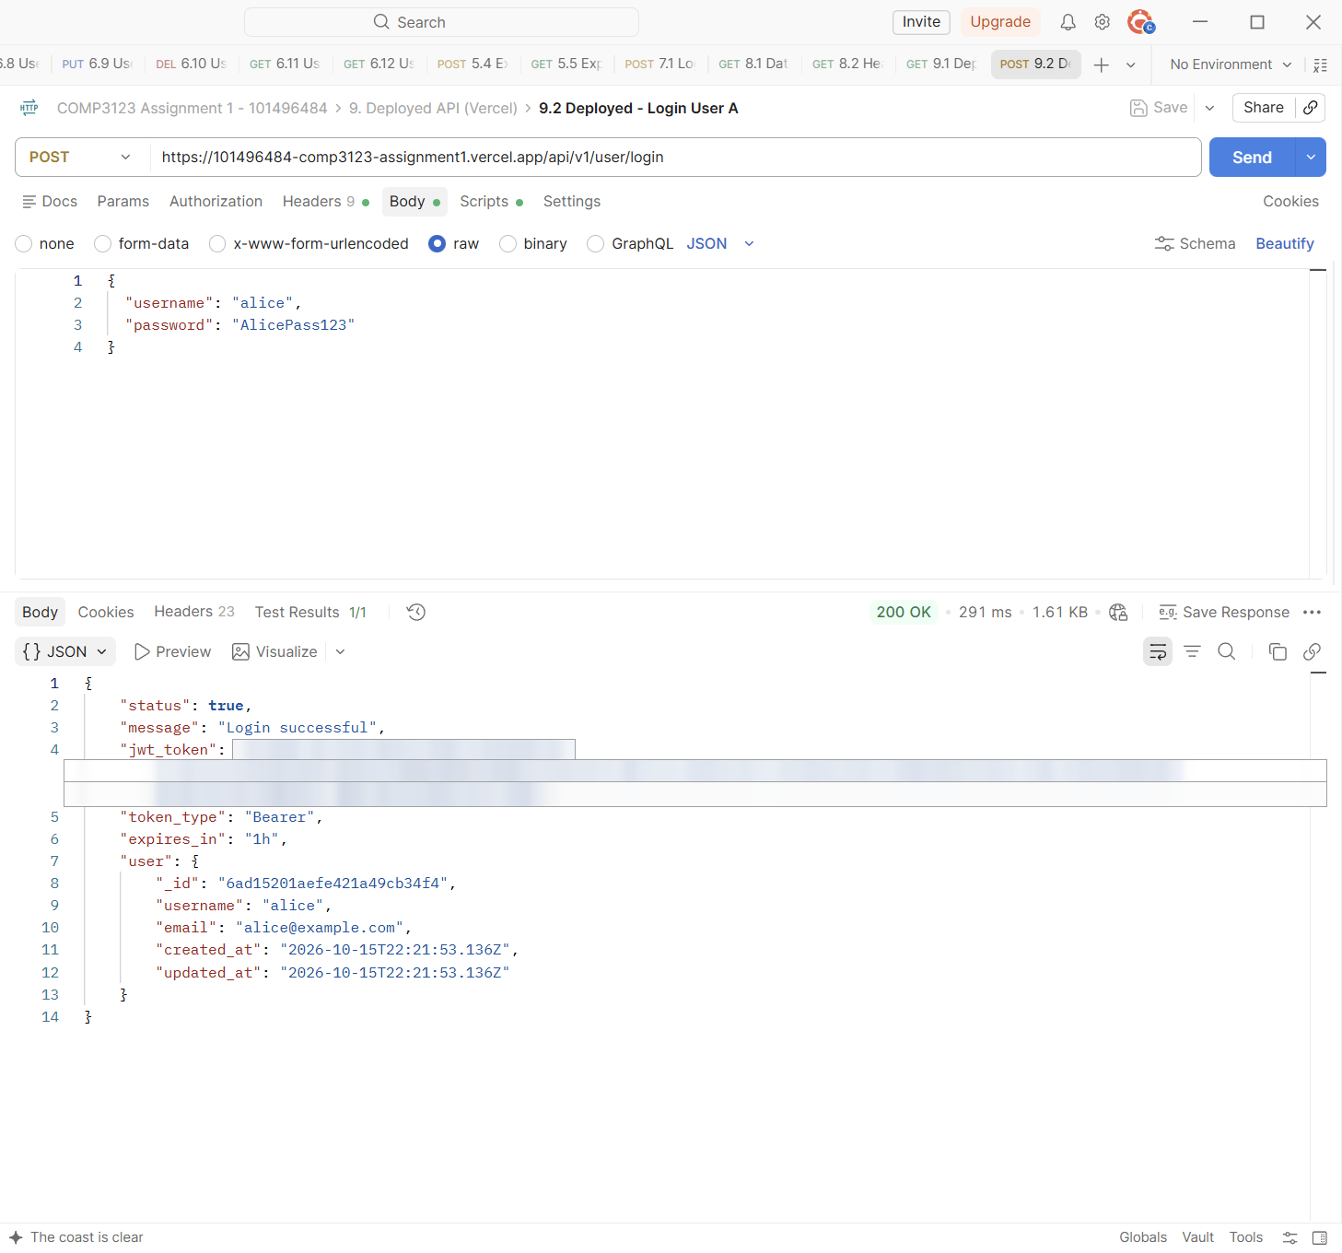

Test | 9.4 Deployed - Create employee (User A)
Endpoint | POST https://101496484-comp3123-assignment1.vercel.app/api/v1/emp/employees
Expected status | 201 Created
Actual status | 201 Created (Postman Test Results 2/2)
Explanation | User A creates an employee on the deployed API. The owner is User A.
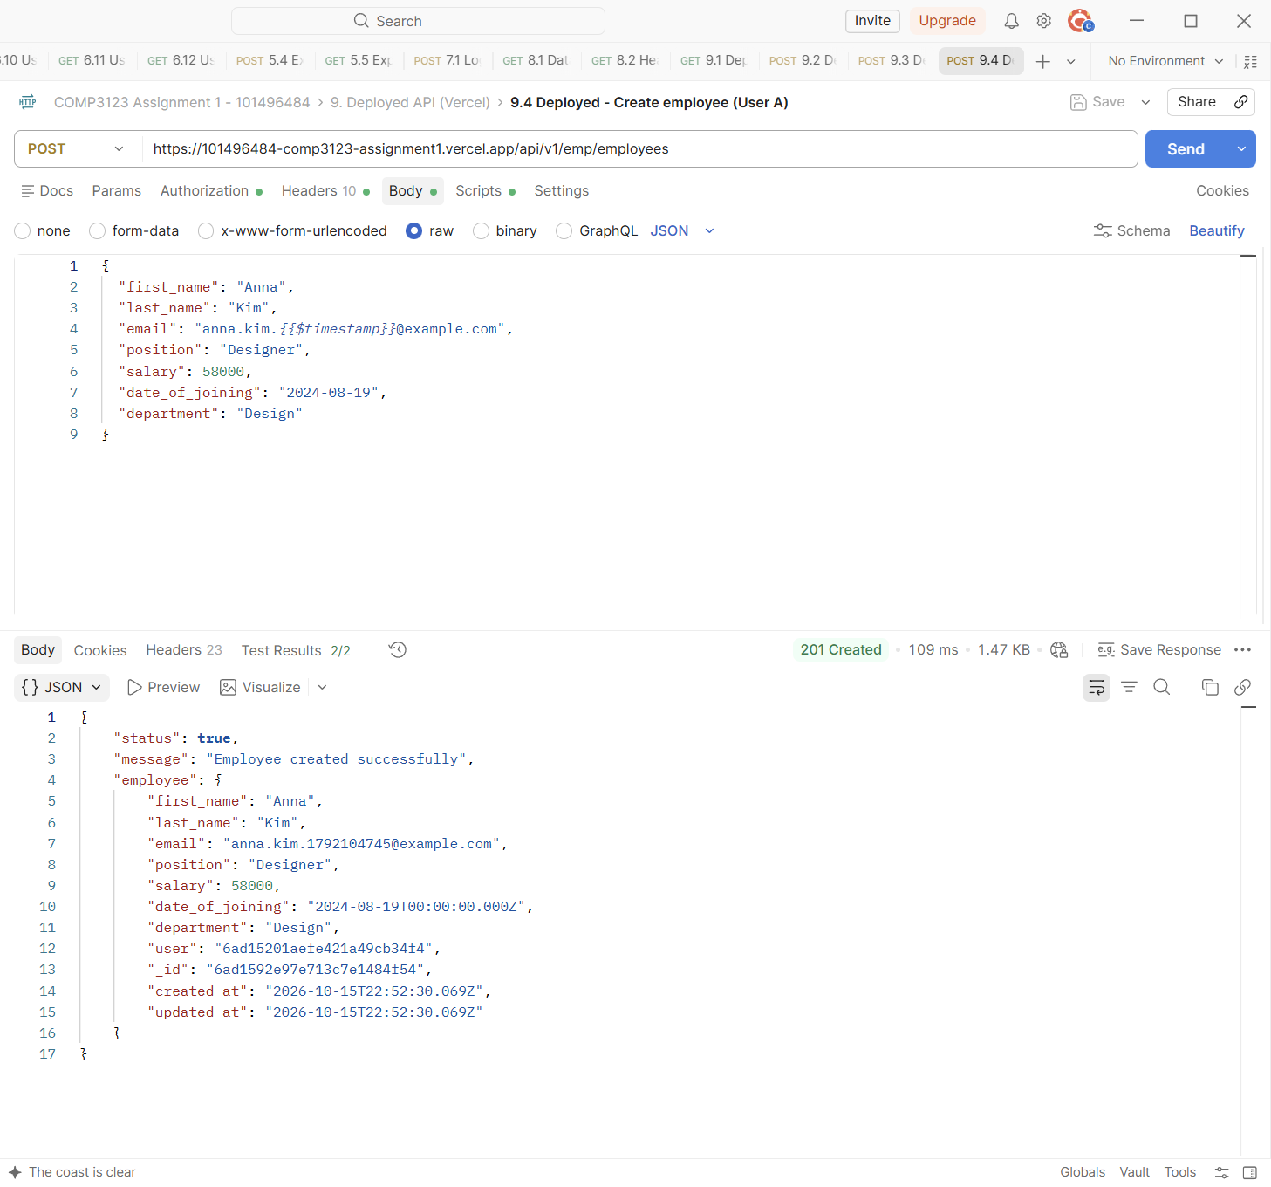

Test | 9.5 Deployed - Get all employees (User A)
Endpoint | GET https://101496484-comp3123-assignment1.vercel.app/api/v1/emp/employees
Expected status | 200 OK
Actual status | 200 OK (Postman Test Results 2/2)
Explanation | User A lists only their own employees on the deployed API.
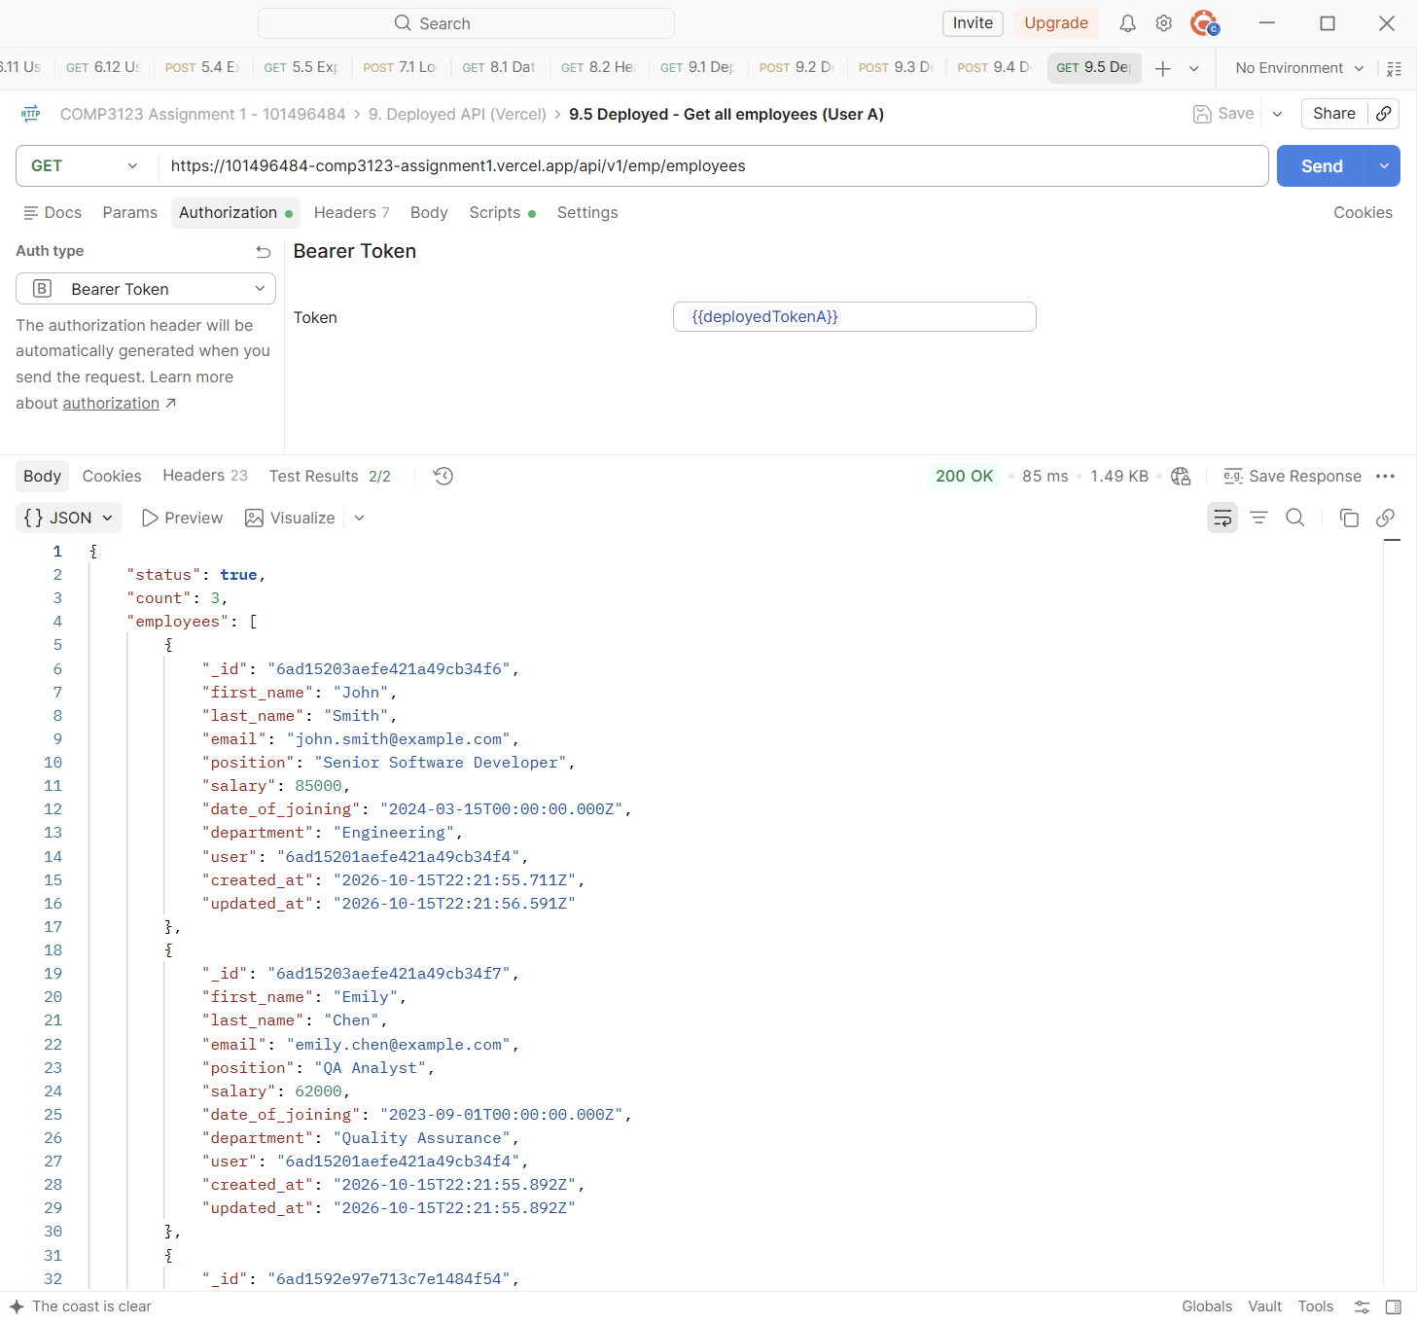

Test | 9.6 Deployed - Update employee (User A)
Endpoint | PUT https://101496484-comp3123-assignment1.vercel.app/api/v1/emp/employees/{{deployedEmp_id}}
Expected status | 200 OK
Actual status | 200 OK (Postman Test Results 2/2)
Explanation | User A updates the new employee.
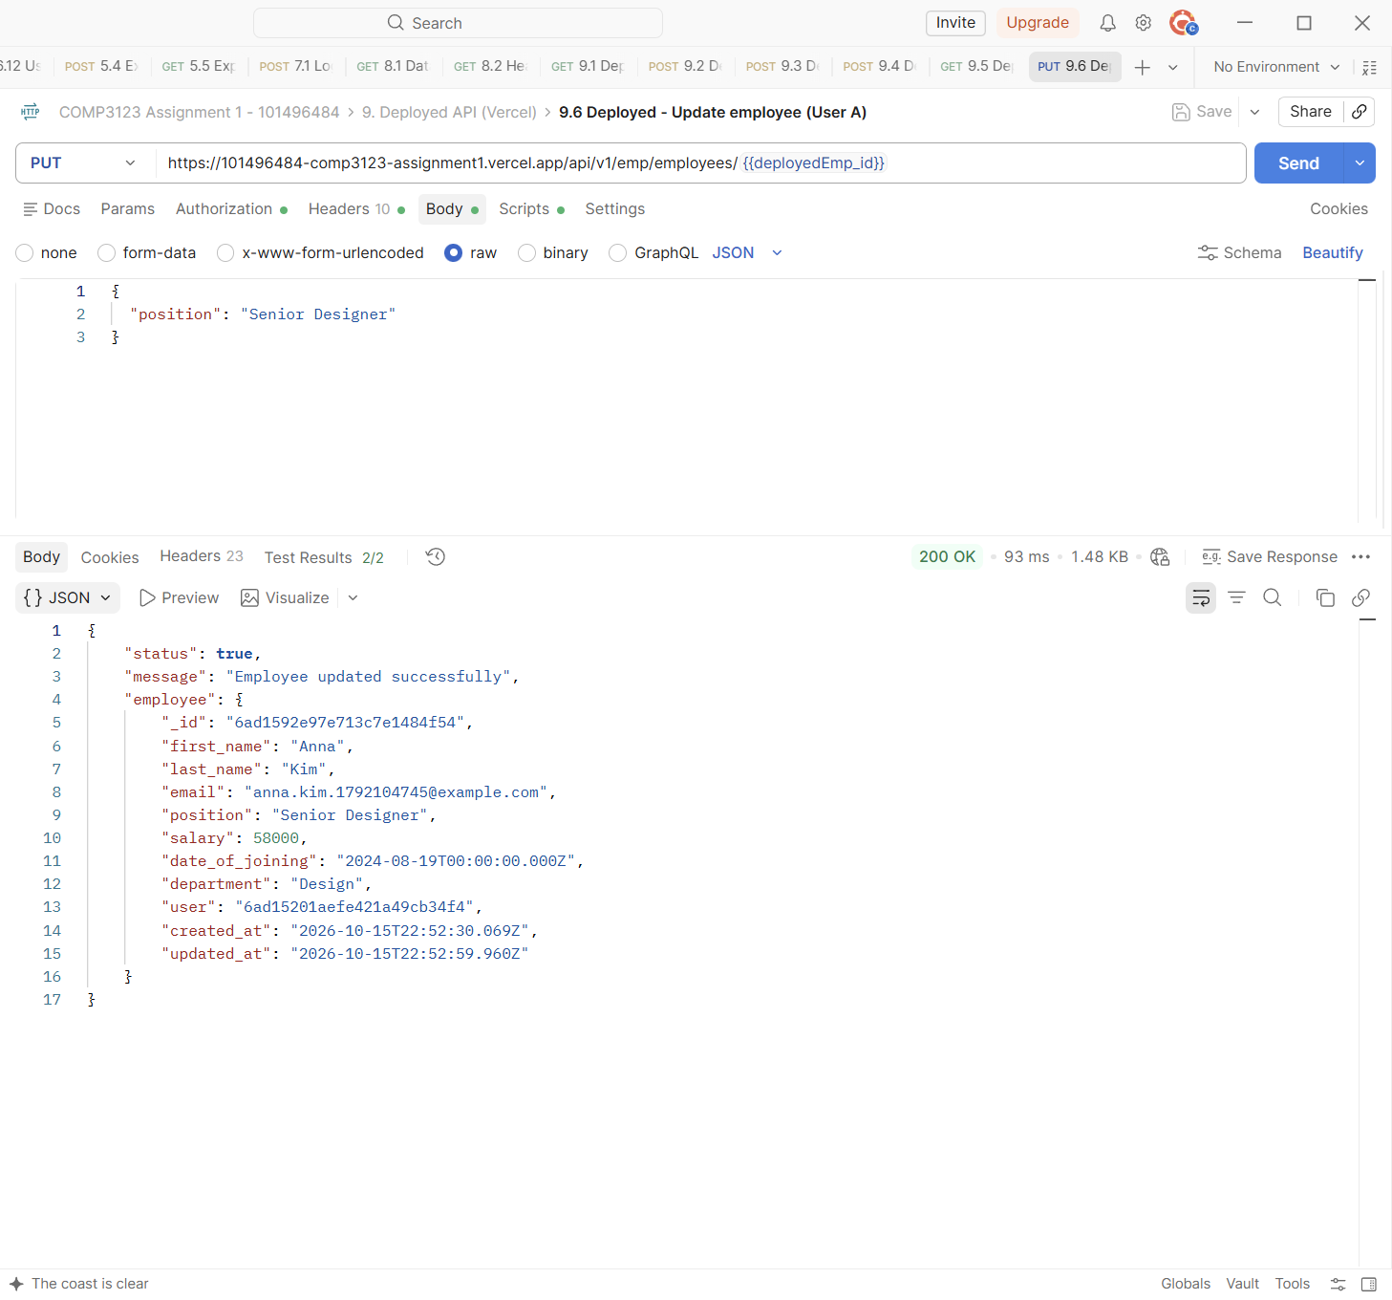

Test | 9.7 Deployed - User B gets User A's employee - 403
Endpoint | GET https://101496484-comp3123-assignment1.vercel.app/api/v1/emp/employees/{{deployedEmp_id}}
Expected status | 403 Forbidden
Actual status | 403 Forbidden (Postman Test Results 3/3)
Explanation | User B tries to read User A's employee on the deployed API and gets 403.
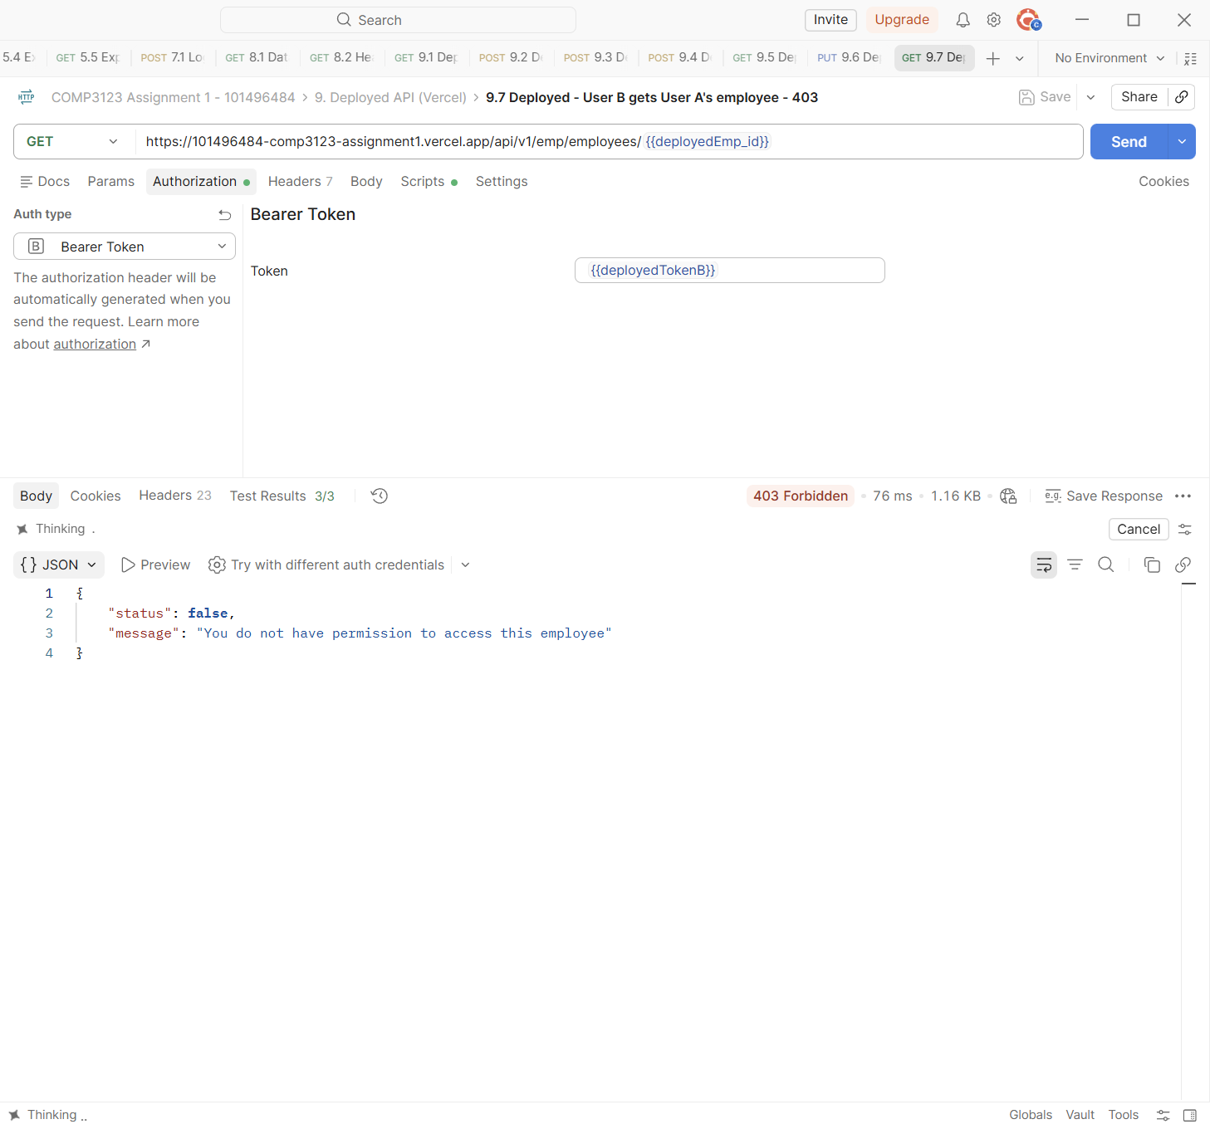

Test | 9.8 Deployed - Missing JWT - 401
Endpoint | GET https://101496484-comp3123-assignment1.vercel.app/api/v1/emp/employees
Expected status | 401 Unauthorized
Actual status | 401 Unauthorized (Postman Test Results 1/1)
Explanation | No token on the deployed API returns 401.
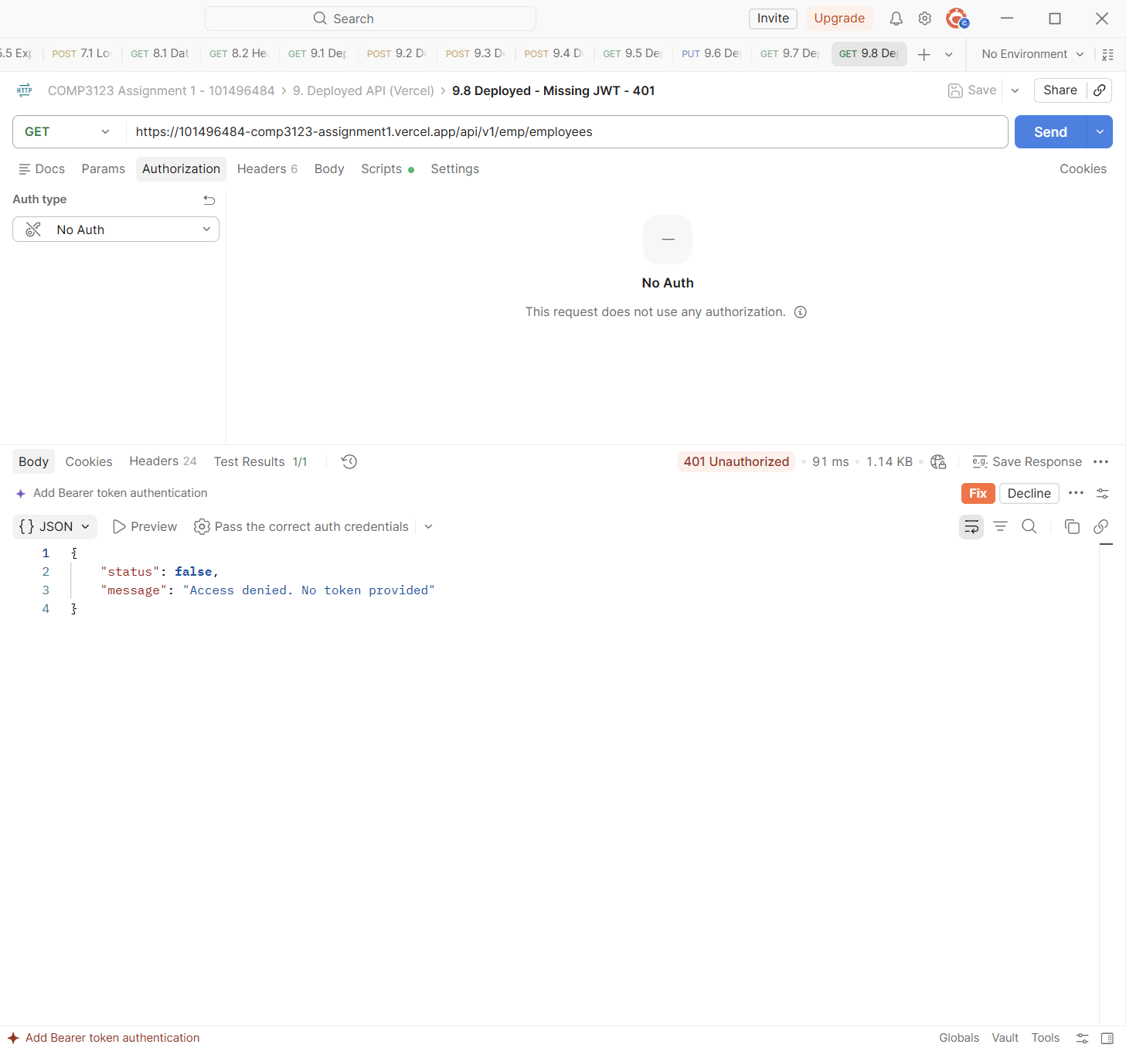

Test | 9.9 Deployed - Delete employee (User A)
Endpoint | DELETE https://101496484-comp3123-assignment1.vercel.app/api/v1/emp/employees?eid={{deployedEmp_id}}
Expected status | 204 No Content
Actual status | 204 No Content (Postman Test Results 1/1)
Explanation | User A deletes the employee created in 9.4 (204 No Content).
