**Project2_Report | Cem Güleç | 150117828**  
  
  
  
a)   
  
  
This program can take some sequence of number and sequentially add them into the BST.

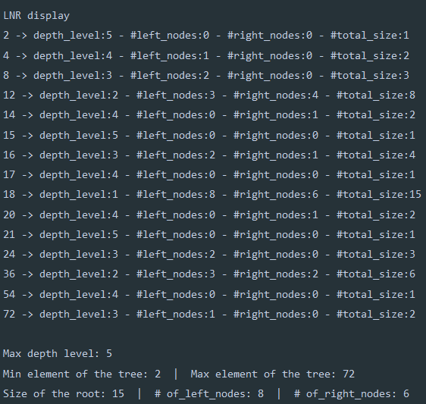 b)  
   
  
  
  
  
  
  
  
  
  
  
  
  
  
After we enter a sequence of numbers and added to the BST, it shows up like this. (In LNR format) Here, I also showed every node’s depth level, how many nodes there is left of this node, how many nodes there is right of this node and total size when you reached that node.  
  
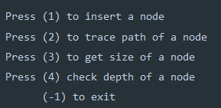  
  
Also, program is able to ask continuously a set of questions. Depending on your selection you can update the details.

c)