DATA STRUCTURES (CSE 2025) | PROJECT 3 REPORT

CEM GÜLEÇ - 150117828

In this project, I implemented binomial heap structure with all its functions, created the whole structure depending on the scenario which you already declared in the detailed pdf document. Calculated priority values, waiting times and simulated processor depending on the quantum value given.  
 In this structure, I was lacking on prioritizing “t_arrive” times when the “e” values are the same. This caused my values to gradually increase at high level q values.  
 On the other hand, I was also lacking on reading the big input file because of my algorithm’s big complexity. What I mean is that, it requires large amount of time to compile all the system, with respect to all q values from 1 to 10. For this reason and the reason above, I have created my report according to the small input on the pdf document, which I entitled as “deneme.txt” in the submission.  
 I acknowledge my failures and looking forward to solving them afterwards. But, please consider all these cases I have listed while evaluating the project.

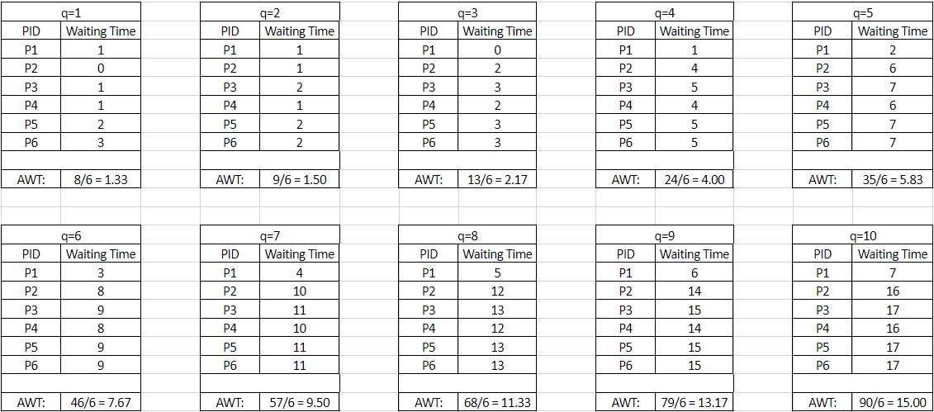

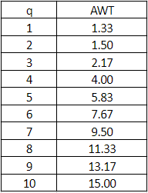As the left table values demonstrate us: the bigger quantum value (q) there is, the more Average Waiting Time (AWT) value there will be. This information provides us a vision, in order what to select as a q value in the system, since lower q value is the better.