**CSE3038 – Computer Organization**

**Project #2 Report**

**Group Members**:

Ömer Faruk Çakı – 150117821

Cem Güleç - 150117828

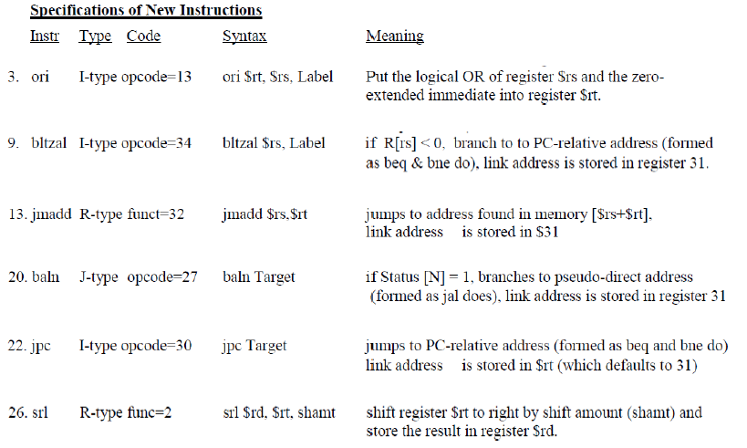

|  |  |  |  |  |  |  |  |  |  |  |  |  |  |  |  |  |  |  |
| --- | --- | --- | --- | --- | --- | --- | --- | --- | --- | --- | --- | --- | --- | --- | --- | --- | --- | --- |
| **Instruction** | **RegDst** | **ALUsrc** | **MemtoReg** | **RegWrite** | **Mem Read** | **Mem Write** | **Branch** | **ALUop1** | **ALUop2** | **jump** | **baln** | **Reg31** | **link** | **Reg31_rt** | **Link_rt** | **jmadd** | **jpc** | **bltzal** |
| **R-Type** | 1 | 0 | 0 | 1 | 0 | 0 | 0 | 1 | 0 |  |  |  |  |  |  |  |  |  |
| **lw** | 0 | 1 | 1 | 1 | 1 | 0 | 0 | 0 | 0 |  |  |  |  |  |  |  |  |  |
| **sw** | X | 1 | X | 0 | 0 | 1 | 0 | 0 | 0 |  |  |  |  |  |  |  |  |  |
| **beq** | X | 0 | X | 0 | 0 | 0 | 1 | 0 | 1 |  |  |  |  |  |  |  |  |  |
|  |  |  |  |  |  |  |  |  |  |  |  |  |  |  |  |  |  |  |
| **ori** | 0 | 1 | 0 | 1 | X | 0 | 0 | 1 | 1 | 0 | 0 | 0 | 0 | 0 | 0 | 0 | 0 | 0 |
| **bltzal** | 1 | X | 0 | 1 | X | 0 | 1 | 0 | 1 | 0 | X | 1 | 1 | 0 | 0 | 0 | 0 | 1 |
| **jmadd** | X | 0 | 1 | 1 | 1 | 0 | 0 | 1 | 0 | 1 | 0 | 0 | 0 | 1 | 1 | 1 | 0 | 0 |
| **baln** | 0 | X | X | 1 | X | 0 | 1 | X | X | 1 | 1 | 1 | 1 | 0 | 0 | 0 | 0 | 0 |
| **jpc** | 0 | X | X | 1 | X | 0 | 1 | 1 | 1 | 1 | 0 | 0 | 1 | 0 | 0 | 0 | 1 | 0 |
| **srl** | 1 | 0 | 0 | 1 | X | 0 | 0 | 1 | 0 | 0 | 0 | 0 | 0 | 0 | 0 | 0 | 0 | 0 |

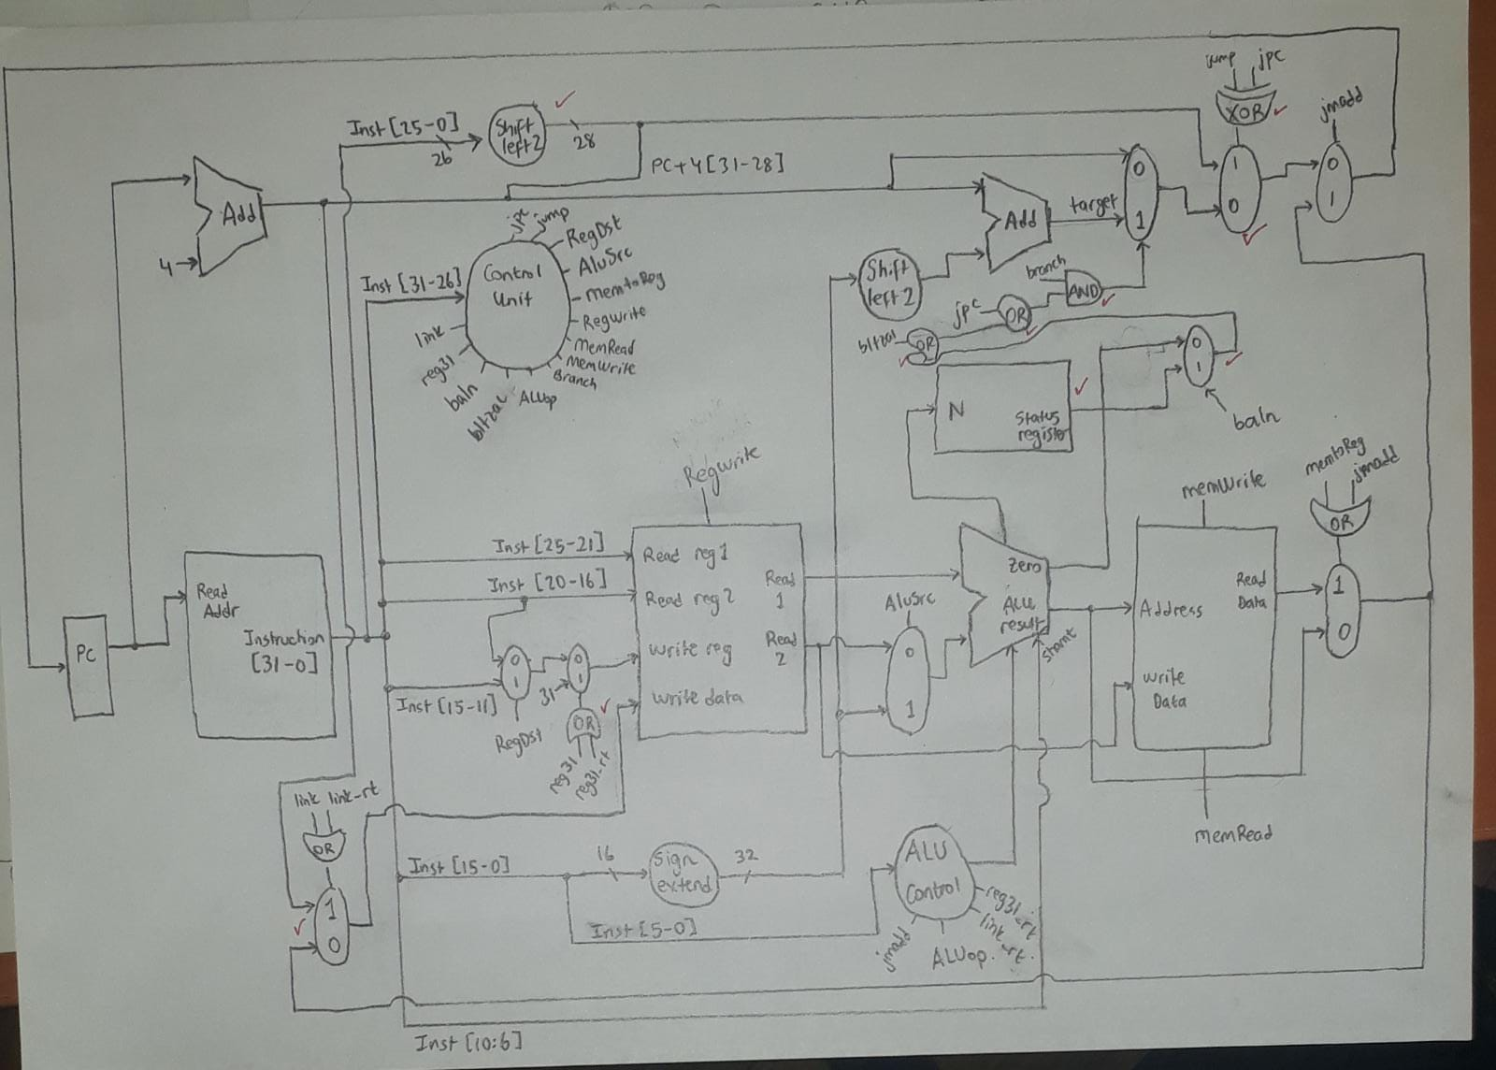

Extra components:  
1 XOR gate   
4 OR gates  
1 Status register  
5 Muxes  
Additional jump, jpc, bltzal, baln, reg31 and link signals from control unit  
Additional jmadd, link_rt and reg31_rt signals from alu control unit

**Simulation #1:**

00040902 : srl $1, $4, 0x4  
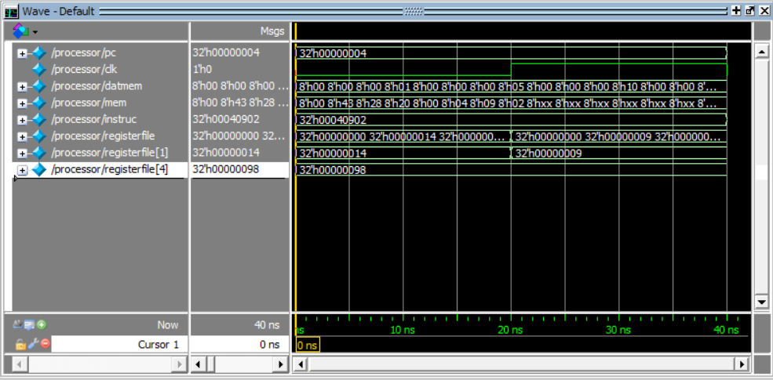  
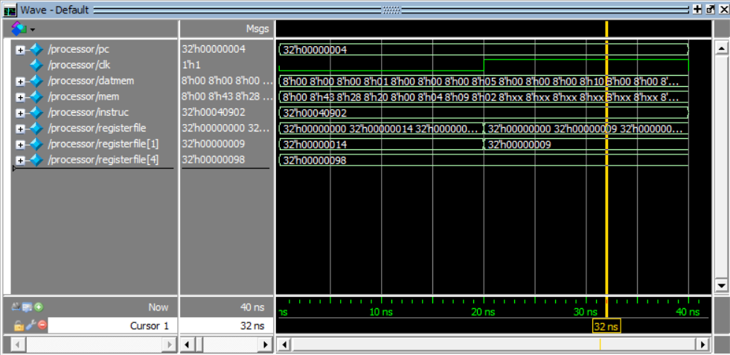

**Simulation #2**

34a30050: ori $3, $5, 0x50

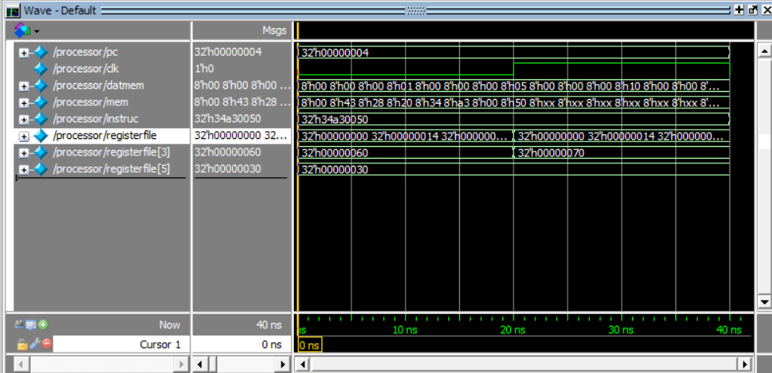

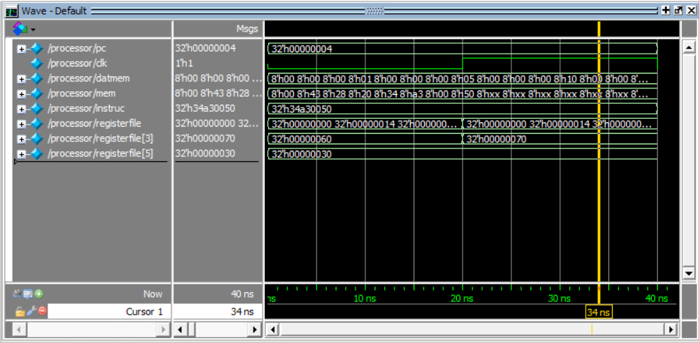

**Simulation #3:**

6c000020: baln 0x20

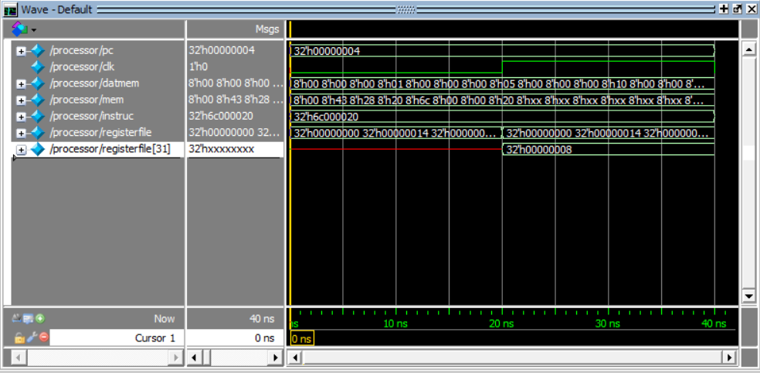

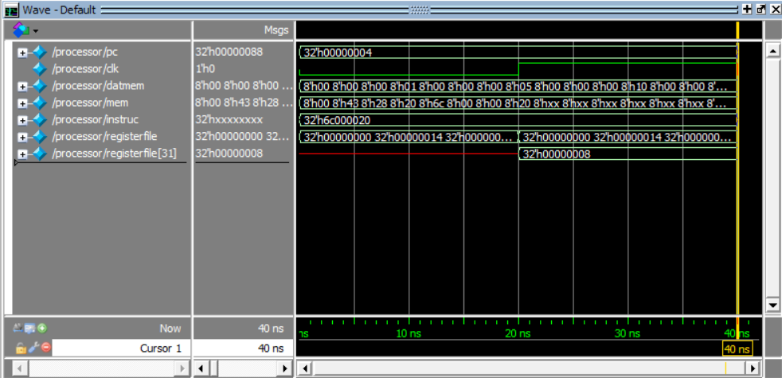

**Simulation #4**

78000032: jpc 0x32

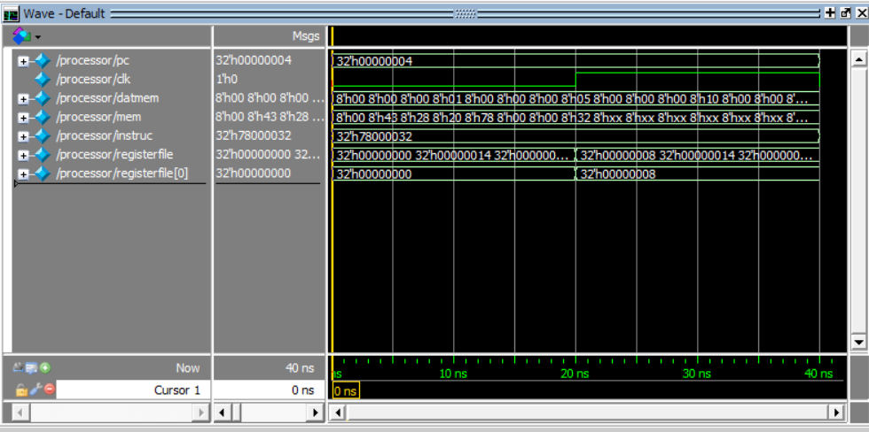

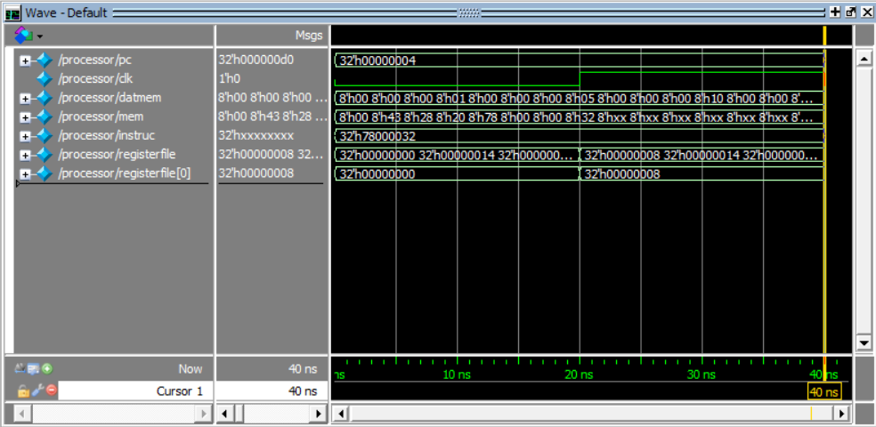

**Simulation #5:**

88280002: bltzal $2, 0x2

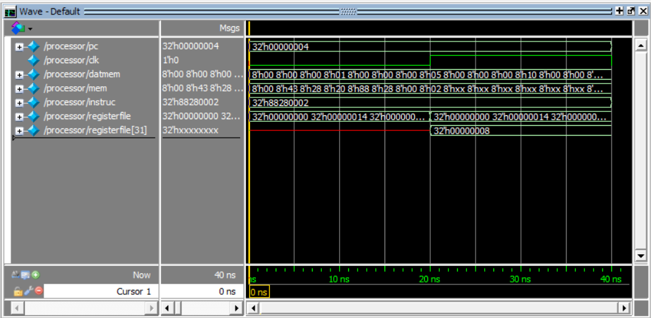

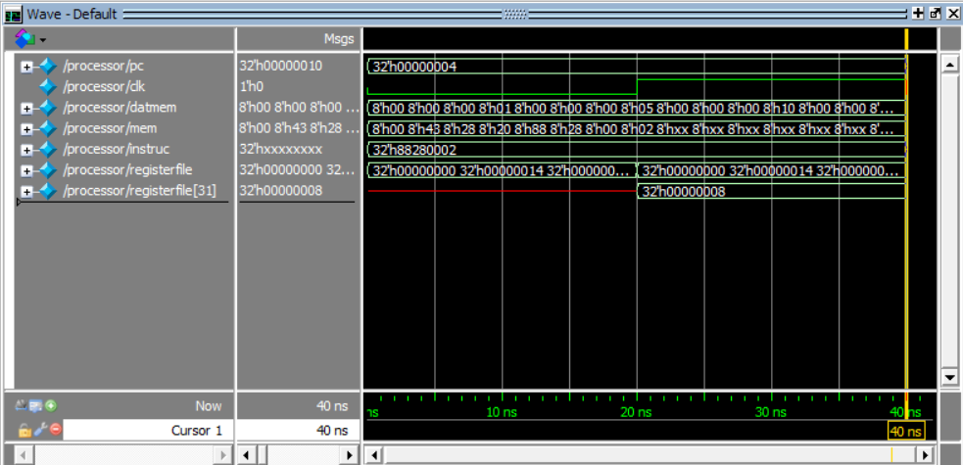

**Simulation #6:**

00430020: jmadd $2, $3

