**Kerd**

**Rules**

1. **Infiltration**

* At the start of the game, each player chooses an enemy piece as infiltrator.
* The King, the Queen, Rooks, and Scouts cannot be chosen as infiltrators.
* Infiltrator pieces can only be revealed after either player has checked his opponent.
* The turn ends after a player reveals his infiltrator piece.
* After an infiltrator piece is revealed, it changes its color and its side.

1. **Board Regions**

**a. Water**

* Pawns can be moved by only one square on their first move.
* A piece that in this region cannot capture a unit on land or water regions if there are air tiles between them. Scouts, Towers, and the Queen are not affected by this rule.

**b. Land**

* Pawns can be moved by one or two squares on their first move.
* A piece that in this region cannot capture a unit on land or water regions if there are air tiles between them. Scouts, Towers, and the Queen are not affected by this rule.

**c. Air**

* Pawns can be moved by one, two or three squares on their first move.
* A piece that in this region can capture a unit on any region.

**Pieces**



1. **Pawn**

* Moves one square forward vertically.
* Captures one square forward diagonally.
* Can make a special move depending on its region on its first move.

*Normal Moves Special Moves*

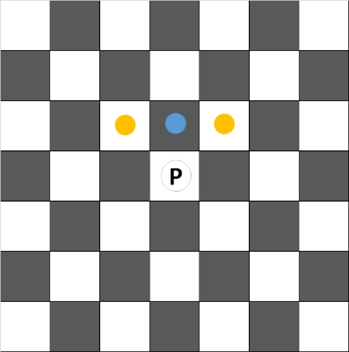 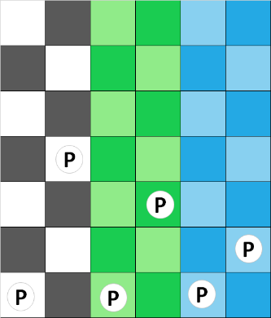

1. 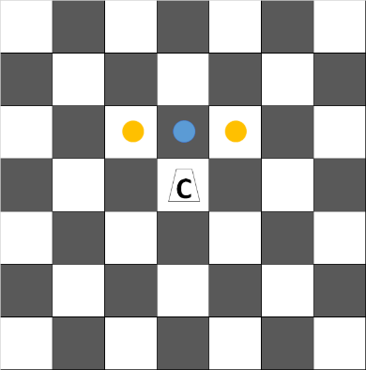**Commander Pawn** *Normal Moves*

* There are 2 of these in front of the King and the Queen.
* Moves and captures like normal pawns.
* Can attach on a pawn around and move with it.
* If the attached pawn cannot move as far as the commander pawn, they can only move as far as the attached pawn does.
* If a pawn (other than a commander pawn) is captured on any square around this piece, the commander pawn can recapture on that square.

*Special Move Example 1 Special Move Example 2 Recapturing with Special Move*

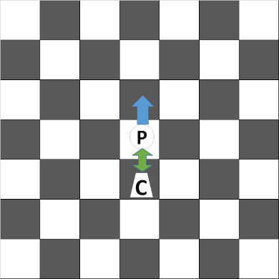 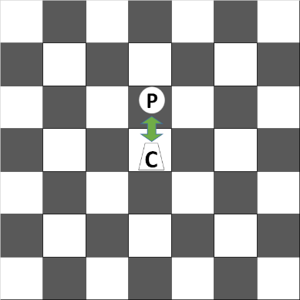 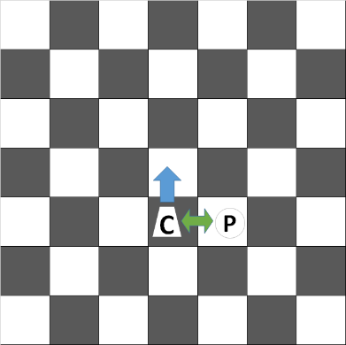 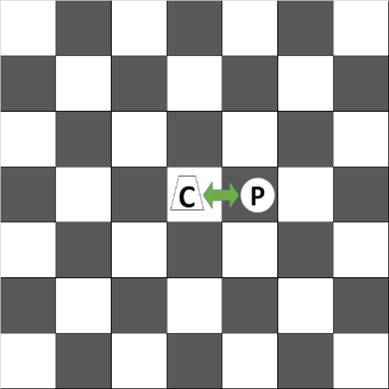 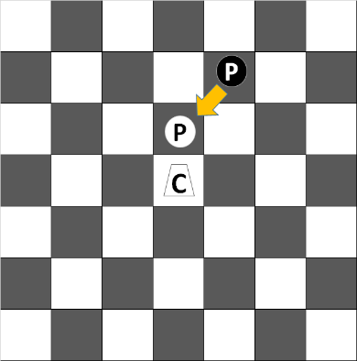 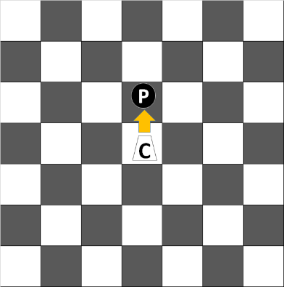

1. **Bishop**

* Moves and captures diagonally to any square if it follows the region rules.

*Normal Moves on Air Normal Moves on Land*

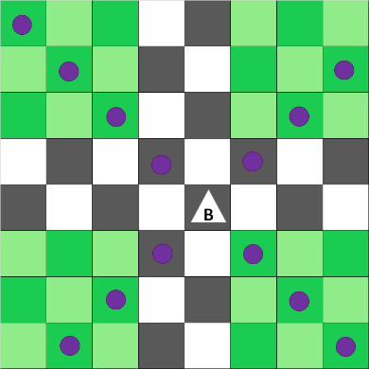 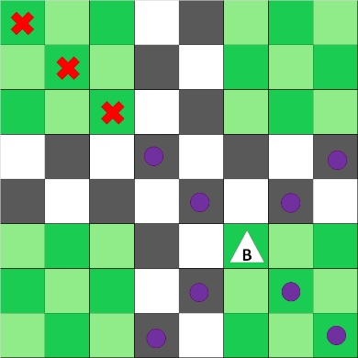

1. **Scout**

* Moves and captures like bishops.
* Is not affected by regions as mentioned in the rules.

*Normal Moves on Air Normal Moves on Any Other Region*

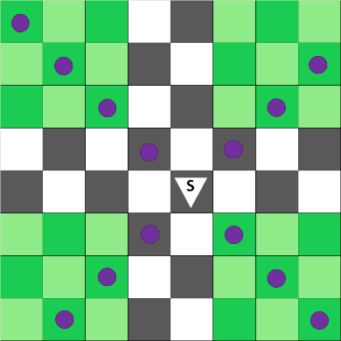 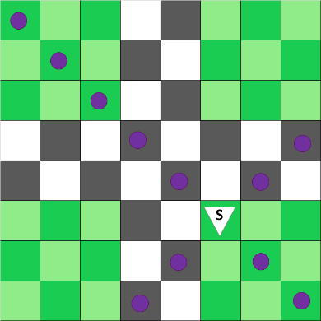

1. **Hussar**

* Moves and captures two squares vertically and one square horizontally, or two squares horizontally and one square vertically, or three squares orthogonally.
* If it jumps over an enemy piece, it cannot move or capture three squares orthogonally.

*Normal Moves Special Condition*

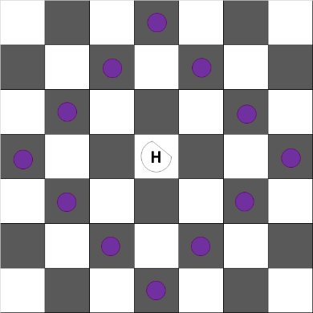 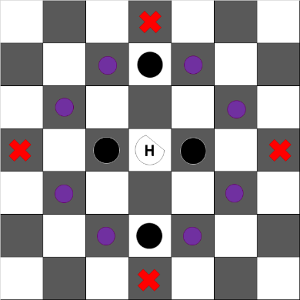

1. **Jumper**

* Moves one square to any direction.
* Captures on one square forward diagonally or one square forward vertically.
* Can jump over a friendly or enemy piece if there is no piece behind it.
* Is affected by regions. This piece's jump ranges are *[0, 1, and 2]* on *[water, land, and air]* respectively.
* After the jump, it always lands on the square next to the piece that it jumps over.

*Normal Moves*

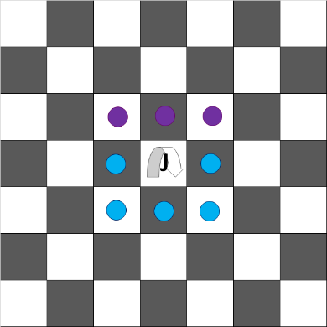

*Special Moves on Water Special Moves on Land Special Moves on Air*

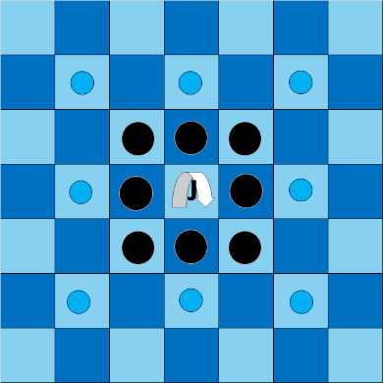 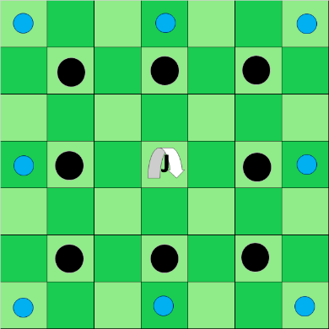 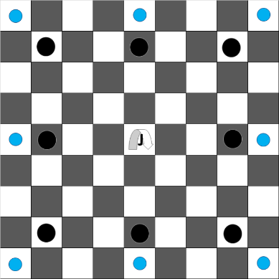

1. **Tower**

* Moves orthogonally to any square.
* Is not affected by regions as mentioned in the rules.

*Normal Moves on Air Normal Moves on Any Other Region*

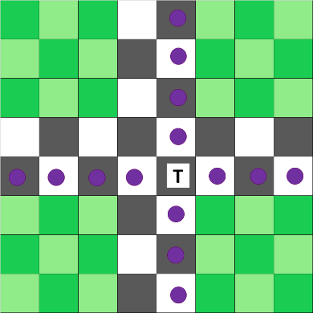 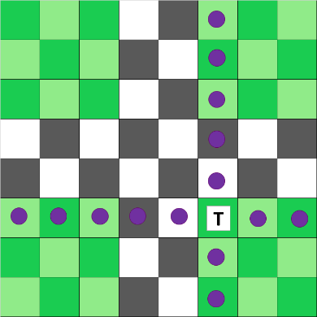

1. **Queen**

* Moves and captures orthogonally or diagonally to any square.
* Is not affected by regions as mentioned in the rules.

*Normal Moves on Air Normal Moves on Any Other Region*

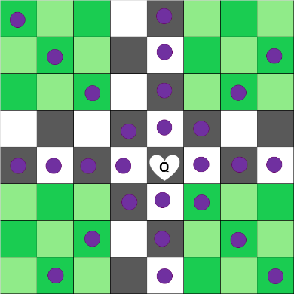 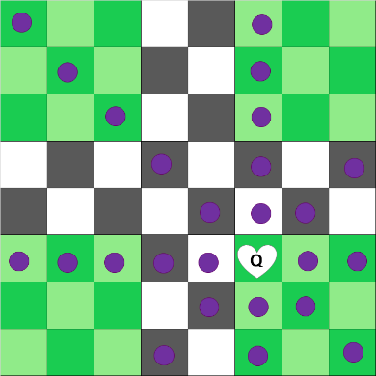

1. **King**

* Moves and captures one square orthogonally or diagonally.
* YEP Rock

*Normal Moves*

