# BBM 432 – Embedded Systems

# Lab 1

*Based on Lab 2 of the EDX course UT.6.01x Embedded Systems - Shape the World.*

**Lab Preparation**

Watch the introduction to the board:

<https://www.youtube.com/watch?v=SRr6-6Bwb00>

## Installation of the required software

In this lab, you will first need to install the required software

### Step 1) How to install Keil uVision for the ARM, MDK-Lite (32KB) Edition

We are using Keil uVision IDE, and we are writing software in C. These programs only run on Windows (XP, Vista, 7 or 8.) There is a way to install software on a Macintosh so Windows and its applications will run on the Macintosh, see running Keil and TExaS on a Macintosh. There are no solutions for Linux. The Keil application does not require a serial number or license key.

1) Go to <https://www.keil.com/demo/eval/armv4.htm> and download mdk474.exe and download this 590M file to your computer.

3) Execute the mdk474.exe file, installing the application to C:\Keil. TExaS example files will be loaded into this same directory.

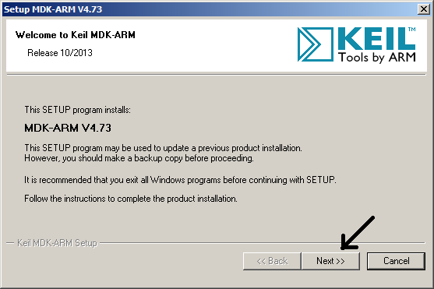

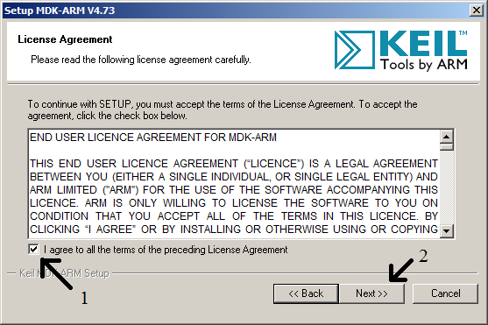

Install Keil to C:\Keil, and click **Next**.

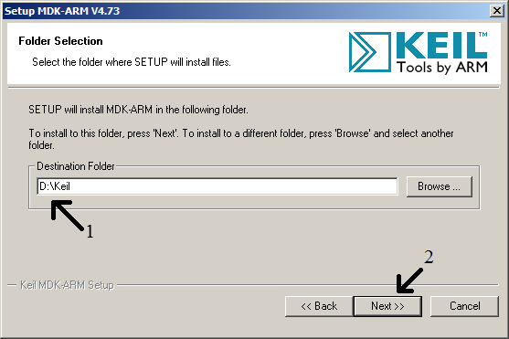

Update these fields with your correct information, and click **Next**.

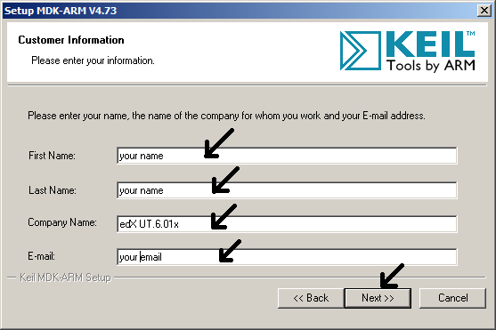

Wait while it installs

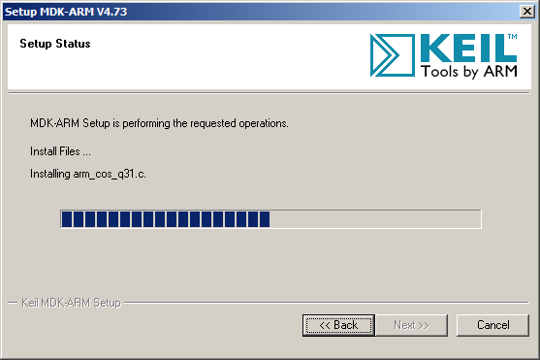

Deselect example projects (the examples will come later as part of the TExaS installation), and click **Next**.

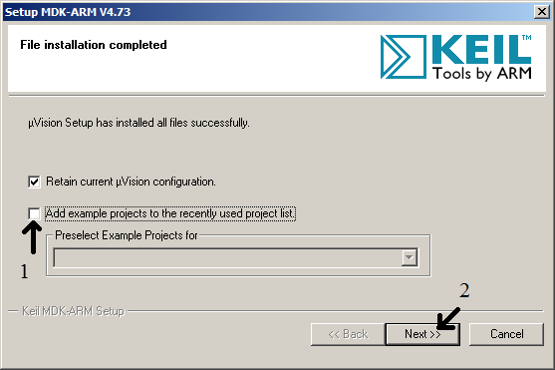

Deselect ULINK Pro Driver V1.0 (the drivers you need will be installed later), and click **Finish**.

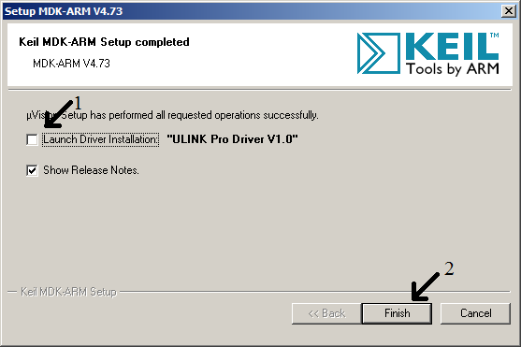

### Step 2) TExaS Lab Graders for all Labs

University of Texas have written DLL extensions to the Keil uVision called TExaS. There is also an application called TExaSdisplay that provides interaction with your serial port software running on the LaunchPad. The application TExaSdisplay also provides a simple oscilloscope and voltmeter, which is a voltage versus time graphical plot measured from **PD3**. You will need to first install Keil before installing TExaS. You will find the lab starter projects in the **Keil\Labware** folder, and you will find the example projects in the **Keil\TExaSware** folder.

1) [**Download TExaS for Labs 2, 5-15**](http://edx-org-utaustinx.s3.amazonaws.com/UT601x/TExaS_Install.exe) saving the 46M file on your computer.

2) Execute the **TExaS_Install.exe** file to install TExaS, which will add files to the Keil directory. Click **Next**.

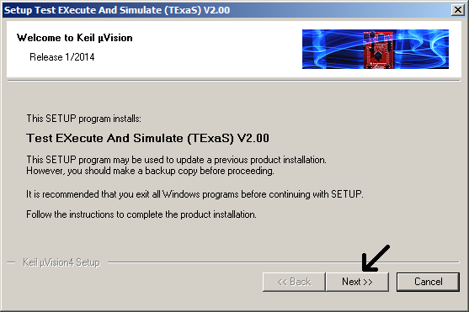

3) Read license agreement, agree to terms, and click Next.

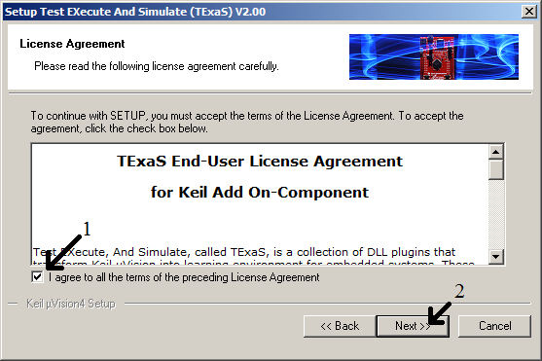

4) Install TExaS into the same directory as Keil (this is important, you cannot install it somewhere else), and click **Next**.

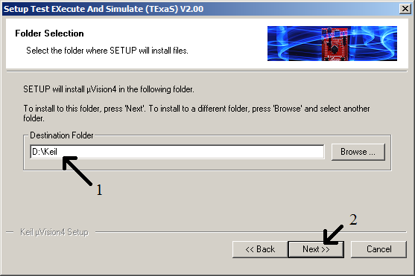

5) Update these fields with your correct information, and click **Next**.

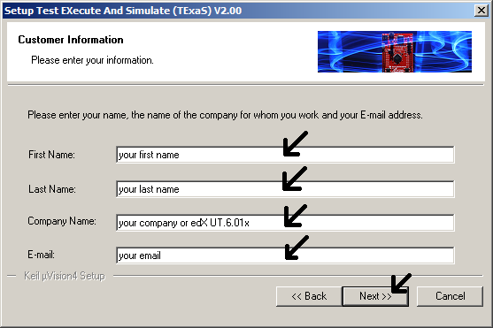

6) Wait while it installs, and click Finish.

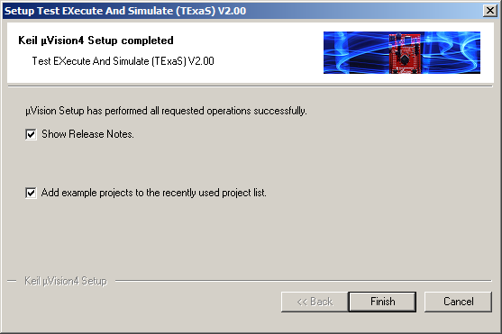

### Step 3) Windows drivers for the LaunchPad board

Once Keil and TExaS are installed you will need to install the windows drivers for the Texas Instruments microcontroller board. The process is the same for both the LM4F120 and the TM4C123 LaunchPads. You will need the actual physical LaunchPad board to complete this step. So if you have ordered your board and it hasn't yet arrived, bookmark this page and come back once your board arrives. Install the current drivers from

http://www.ti.com/tool/stellaris_icdi_drivers

**Lab Definition**

Part 1) Run the lab in the simulator

For each lab we will first design, develop, and debug in simulation. Since Lab 2 does not require you to build any hardware or software, all you will do here is run the example program in simulation mode. This step also verifies you have properly installed **Keil** and **TExaS**, and you can interact with the automatic grader. You will find the example files and starter codes for lab in the **\Keil\TExaSware** directory. In particular the Lab 2 starter code is in the directory **\Keil\Labware\Lab2_HelloLaunchPad**

1) Open the Lab2 project file, which is the file **Lab2.uvproj** in the **Lab2_HelloLaunchPad** directory.   
2) Verify it is configured to run in the simulator   
3) Build the project   
4) Start the debugger in simulation mode   
5) Run the program and interact with the switches, notice the LED outputs

If you do not see the window with the Port F input/output, execute **Peripherals->TExaSPortF.** Another trick to reset all the windows in their default position is to execute **Window->SetViewToDefault**.

Part 2) Run the lab in the LaunchPad

After we have completed the lab in simulation, we will switch over and debug it on the real board. Again, Lab 2 does not require you to design any hardware or write any software, so in this lab we will simply run the existing software on the actual LaunchPad.  
  
0) Open the Lab2 project file, which is the file **Lab2.uvproj** in the Lab2 directory.  
1) In Keil, execute **Project->OptionsForTarget**. In the **Target** tab, select **TExaS** in the **Operating System** drop-down menu. In the **Debug** tab, click the Use radio on the right and select the **Stellaris ICDI**.  
2) Compile the project by executing **Project->Build Target**3) Download the object code into Flash EEPROM by executing **Flash->Download**4) Start the debugger by executing **Debug->Start/StopDebuggingSession**5) Run your program executing by **Debug->Run**. At this point you can push the switches and watch the LEDs.

Part 3) Experiment with the code

Have a look at the C code in the Keil IDE. Make the LED flash slower.

From what you see in the code, how can you make the LED flash blue-yellow instead of blue-red?