##### 一、ReentrantLock流程图

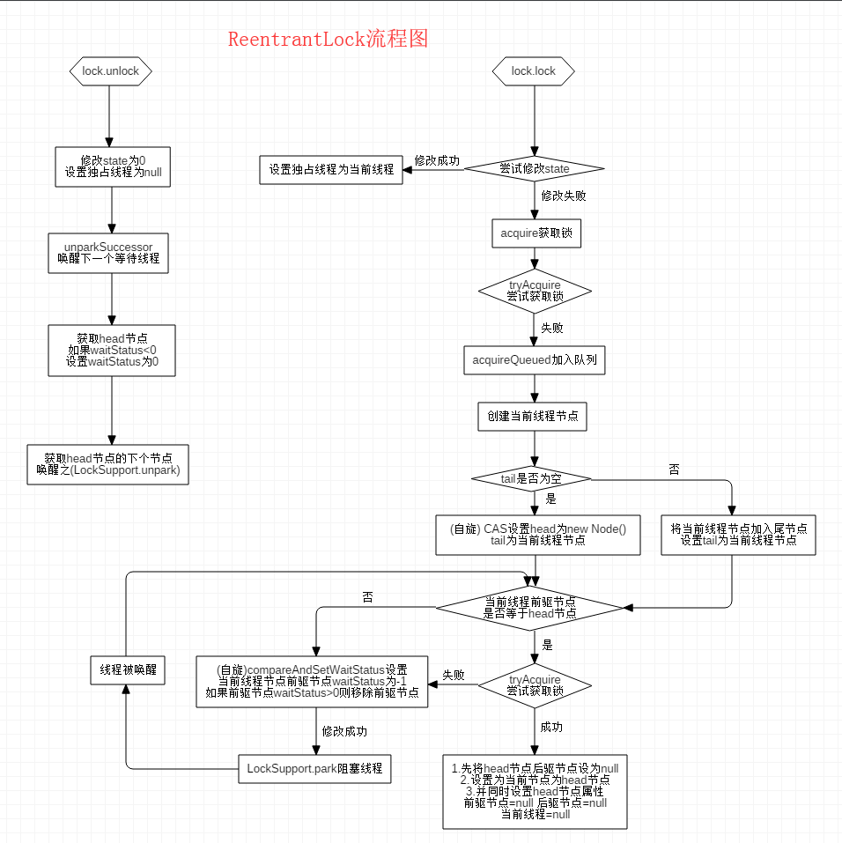

##### 二、四个线程同时争夺ReentrantLock

###### 1、Thread-0优先获取并得到锁：

Head = null; tail = null;

###### 2、Thread-1 获取锁，失败进入等待队列：

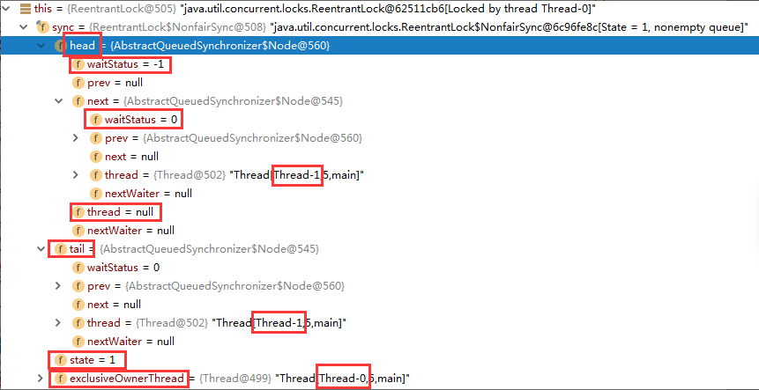

**同步器变化：**

prev

**head**

waitStatus=-1

Thread=null

waitStatus=0

Thread=thread-1

**tail**

next

###### 3、Thread-2 获取锁，失败进入等待队列：

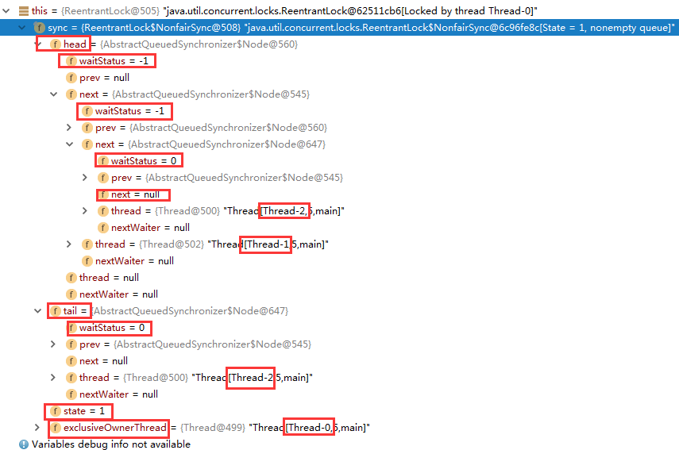

**同步器变化：**

next

prev

###### 4、Thread-3 获取锁，失败进入等待队列：

next

prev

**head**

waitStatus=-1

Thread=null

waitStatus=-1

Thread=thread-1

waitStatus=0

Thread=thread-2

**tail**

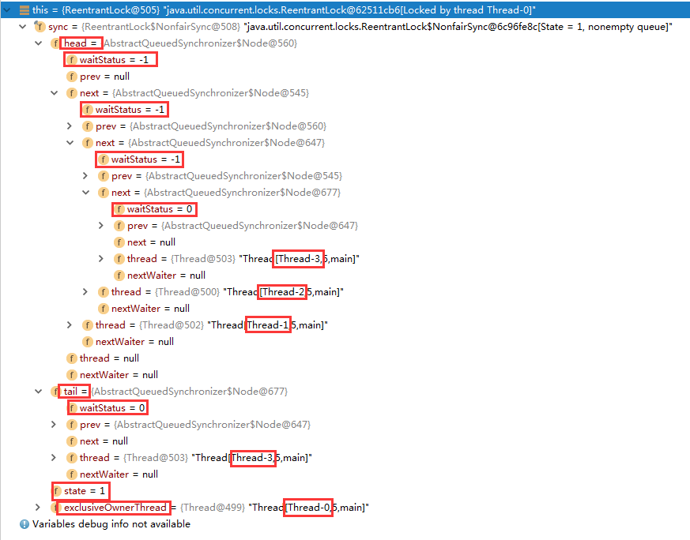

**同步器变化：**

next

prev

**head**

waitStatus=-1

Thread=null

waitStatus=-1

Thread=thread-1

waitStatus=0

Thread=thread-3

**tail**

waitStatus=-1

Thread=thread-2

prev

next

prev

next

next