Julia conducted a  days of learning SQL contest. The start date of the contest was *March 01, 2016* and the end date was *March 15, 2016*.

Write a query to print total number of unique hackers who made at least  submission each day (starting on the first day of the contest), and find the *hacker_id* and *name* of the hacker who made maximum number of submissions each day. If more than one such hacker has a maximum number of submissions, print the lowest *hacker_id*. The query should print this information for each day of the contest, sorted by the date.

**Input Format**

The following tables hold contest data:

* *Hackers:* The *hacker_id* is the id of the hacker, and *name* is the name of the hacker.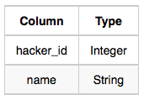
* *Submissions:* The *submission_date* is the date of the submission, *submission_id* is the id of the submission, *hacker_id* is the id of the hacker who made the submission, and *score* is the score of the submission. 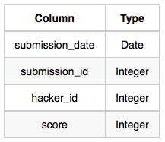

**Sample Input**

For the following sample input, assume that the end date of the contest was *March 06, 2016*.

*Hackers* Table: 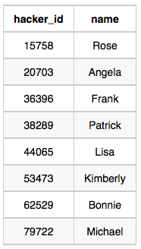 *Submissions* Table: 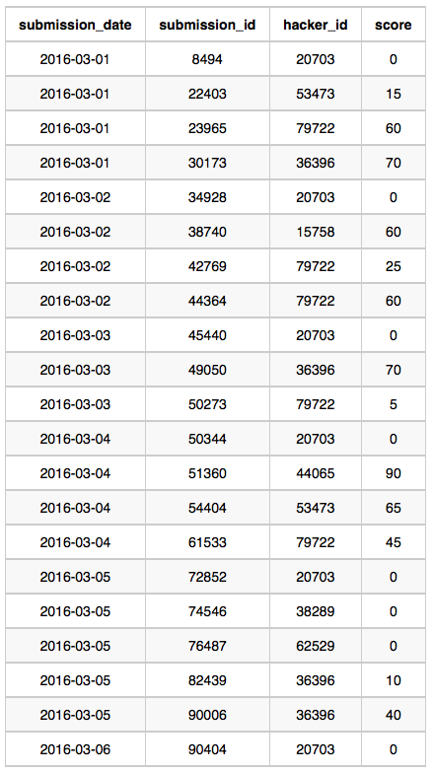

**Sample Output**

2016-03-01 4 20703 Angela

2016-03-02 2 79722 Michael

2016-03-03 2 20703 Angela

2016-03-04 2 20703 Angela

2016-03-05 1 36396 Frank

2016-03-06 1 20703 Angela

**Explanation**

On *March 01, 2016* hackers , , , and  made submissions. There are  unique hackers who made at least one submission each day. As each hacker made one submission,  is considered to be the hacker who made maximum number of submissions on this day. The name of the hacker is *Angela*.

On *March 02, 2016* hackers , , and  made submissions. Now  and  were the only ones to submit every day, so there are  unique hackers who made at least one submission each day.  made  submissions, and name of the hacker is *Michael*.

On *March 03, 2016* hackers , , and  made submissions. Now  and  were the only ones, so there are  unique hackers who made at least one submission each day. As each hacker made one submission so  is considered to be the hacker who made maximum number of submissions on this day. The name of the hacker is *Angela*.

On *March 04, 2016* hackers , , , and  made submissions. Now  and  only submitted each day, so there are  unique hackers who made at least one submission each day. As each hacker made one submission so  is considered to be the hacker who made maximum number of submissions on this day. The name of the hacker is *Angela*.

On *March 05, 2016* hackers , ,  and  made submissions. Now  only submitted each day, so there is only  unique hacker who made at least one submission each day.  made  submissions and name of the hacker is *Frank*.

On *March 06, 2016* only  made submission, so there is only  unique hacker who made at least one submission each day.  made  submission and name of the hacker is *Angela*.