Web-Based Application Development Assignment 1

Cemil Uysal

16050111006

**Part 1: Working with web developer tools inside browsers**

5)

a) The browser sent 64 HTTP requests to Google.

b) 24.46 second

c) There are 9 png files in the page

d)

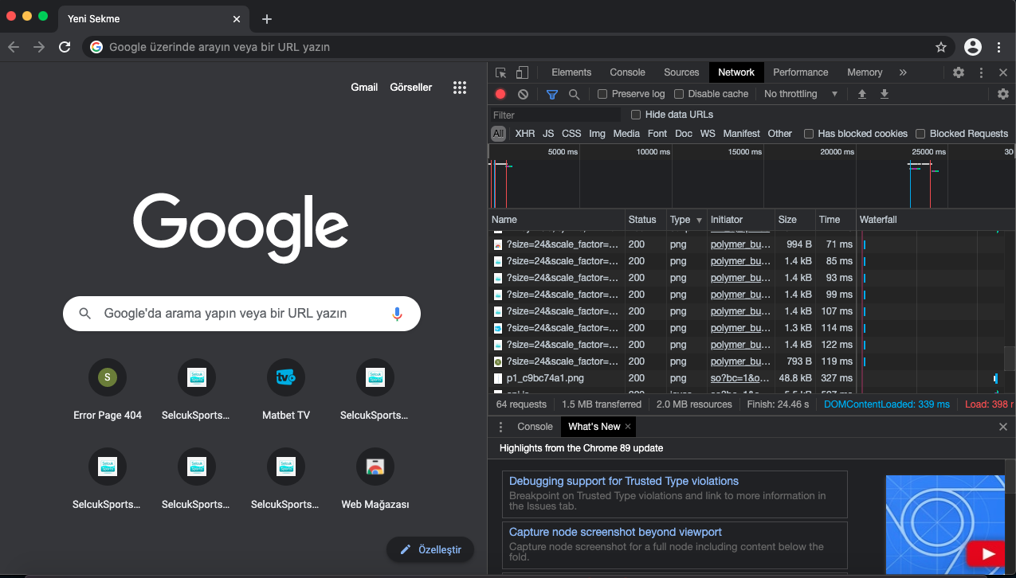

**Part 2: Create your first page and upload it to the web server**

[http://cemiluysal.herokuapp.com](http://cemiluysal.herokuapp.com/)