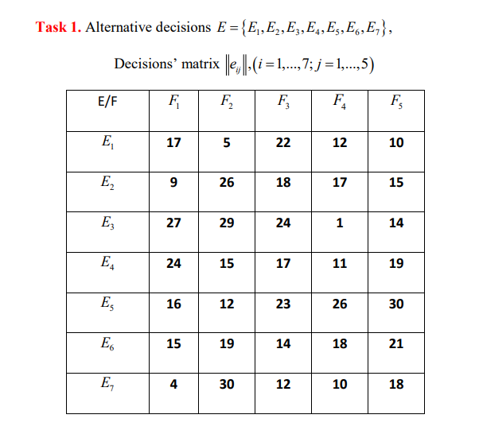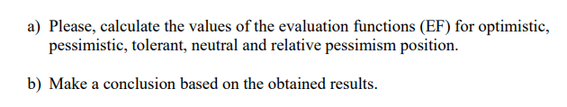

|  |  |  |  |  |  |
| --- | --- | --- | --- | --- | --- |
|  |  |  |  |  |  |
| **E/F** | **F1** | **F2** | **F3** | **F4** | **F5** |
| E1 | 17 | 5 | 22 | 12 | 10 |
| E2 | 9 | 26 | 18 | 17 | 15 |
| E3 | 27 | 29 | 24 | 1 | 14 |
| E4 | 24 | 15 | 17 | 11 | 19 |
| E5 | 16 | 12 | 23 | 26 | 30 |
| E6 | 15 | 19 | 14 | 18 | 21 |
| E7 | 4 | 30 | 12 | 10 | 18 |

|  |  |  |  |  |  |  |  |  |  |  |  |  |  |  |
| --- | --- | --- | --- | --- | --- | --- | --- | --- | --- | --- | --- | --- | --- | --- |
| a) | | Optimistic position: | | | |  | | | Pessimistic position | | | | | |
|  | |  | | |  |  | | |  | | | | |  |
|  | | maxe1j= | | | 22 |  | | | mine1j= | | | | | 5 |
|  | | maxe2j= | | | 26 |  | | | mine2j= | | | | | 9 |
|  | | maxe3j= | | | 29 |  | | | mine3j= | | | | | 1 |
|  | | maxe4j= | | | 24 |  | | | mine4j= | | | | | 11 |
|  | | maxe5j= | | | 30 |  | | | mine5j= | | | | | 12 |
|  | | maxe6j= | | | 21 |  | | | mine6j= | | | | | 14 |
|  | | maxe7j= | | | 30 |  | | | mine7j= | | | | | 4 |
| Combination of the Largest and Smallest Results: | | | | | | | | | | |  | |
|  | | |  | | | |  |  | |  |  | |
| maxe1j + | | | mine1j= | | | | 27 |  | |  |  | |
| maxe2j + | | | mine2j= | | | | 35 |  | |  |  | |
| maxe3j + | | | mine3j= | | | | 30 |  | |  |  | |
| maxe4j + | | | mine4j= | | | | 35 |  | |  |  | |
| maxe5j + | | | mine5j= | | | | 42 |  | |  |  | |
| maxe6j + | | | mine6j= | | | | 35 |  | |  |  | |
| maxe7j + | | | mine7j= | | | | 34 |  | |  |  | |
| Neutral position | | | |  | | Relative pessimism | | | | | |
| e1j | 13.2 | | |  | | e1j | | | 25 | | |
| e2j | 17 | | |  | | e2j | | | 18 | | |
| e3j | 19 | | |  | | e3j | | | 25 | | |
| e4j | 17.2 | | |  | | e4j | | | 15 | | |
| e5j | 21.4 | | |  | | e5j | | | 18 | | |
| e6j | 17.4 | | |  | | e6j | | | 12 | | |
| e7j | 14.8 | | |  | | e7j | | | 23 | | |

**Conclusion:**

For e1:

Optimistic Position optimisistic:22

DM as a player hoping that the decision Ei will result in the best outcome with the appropriate external state F1.

EF is pessimistic: 5

DM focuses on the worst result and the external state F1 that goes with it.

Position of Neutrality: 13,2

The statement that all decision deviations from the "average value" are valid forms the foundation of the neutral position.

Pessimism relative position: 25

The losses associated with each alternative decision E1 are compared to the best outcome.

**I have solved on paper firstly and I have tried to draw the graphs also. I have attached pictures here.**

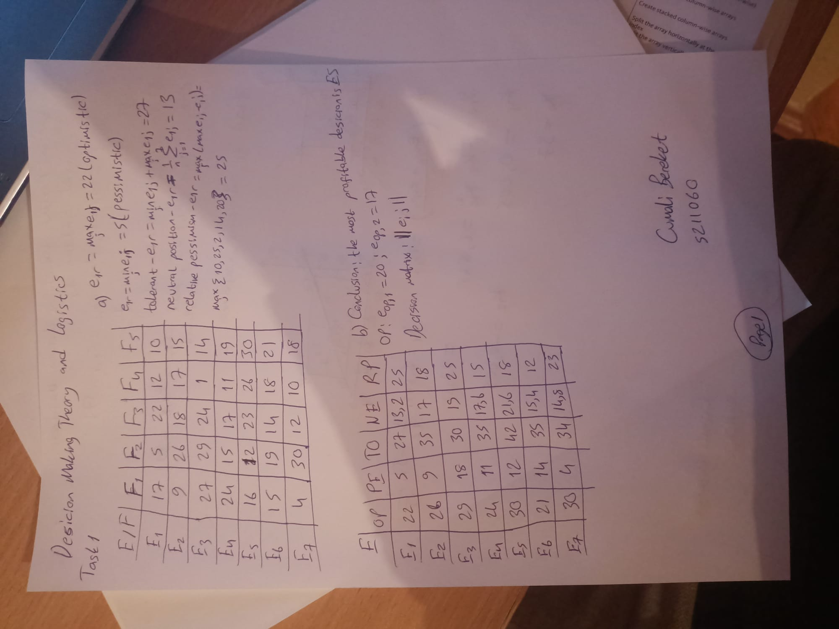

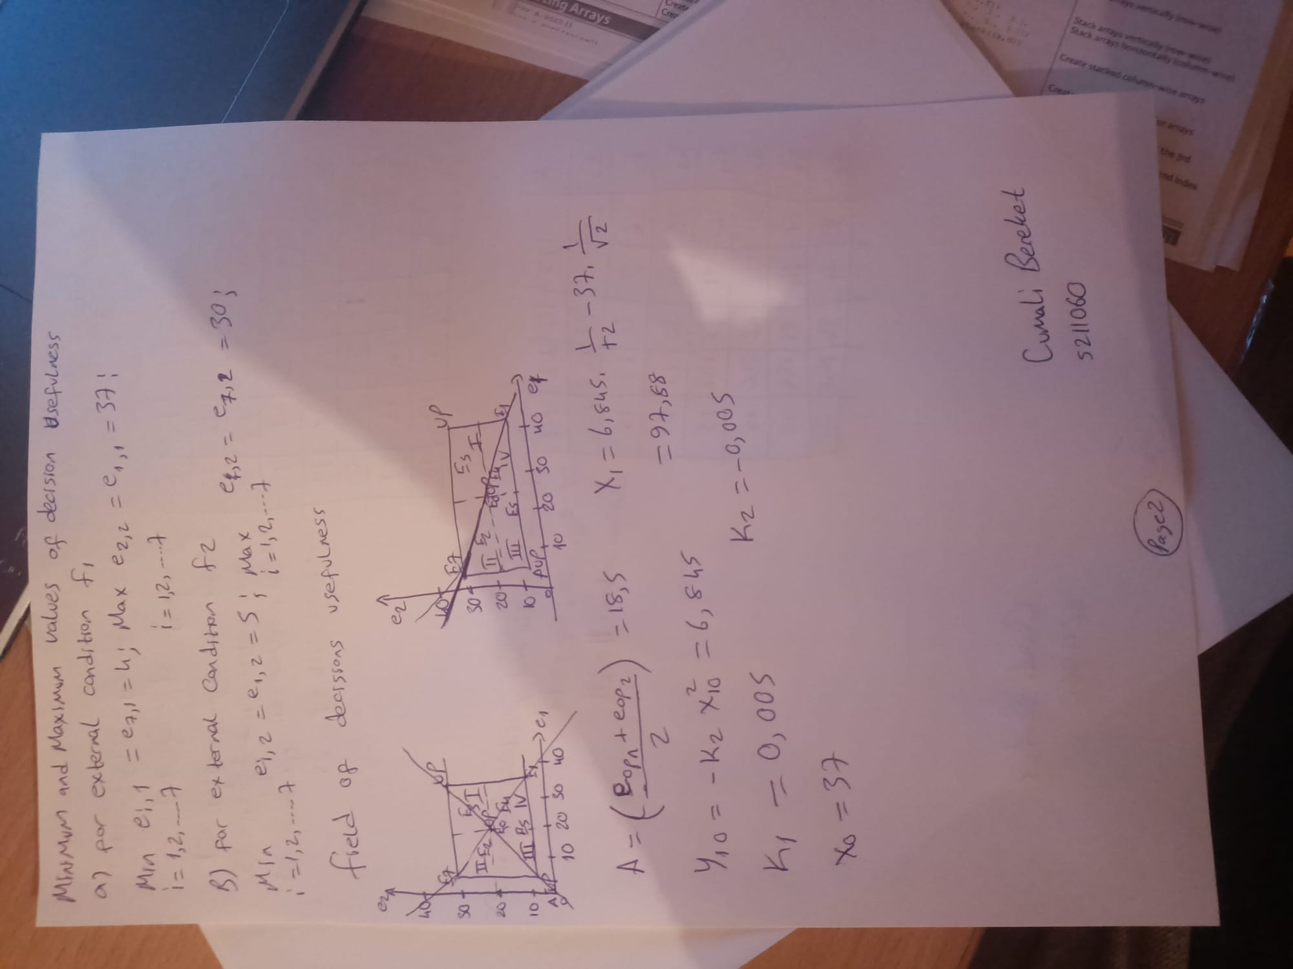

Cumali Bereket

S211060