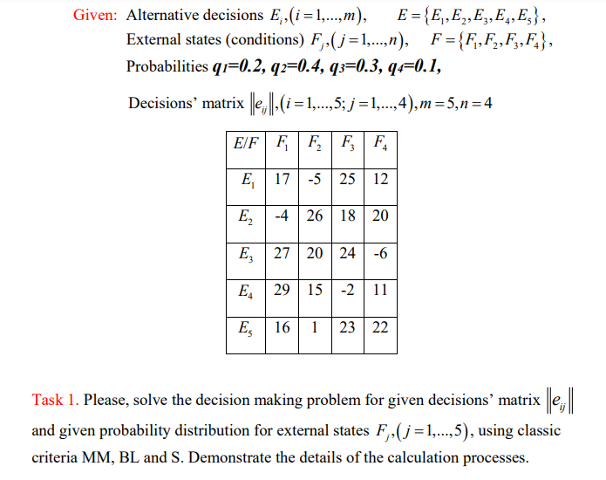



|  |  |  |  |  |  |  |  |  |
| --- | --- | --- | --- | --- | --- | --- | --- | --- |
|  |  |  |  |  | MM-criterion | | BL-criterion | |
| **E/F** | **F1** | **F2** | **F3** | **F4** | **mineij** | **maxeir** | **Sum(eijqjj** | **maxeir2** |
| E1 | 17 | -5 | 25 | 12 | -5 |  | 10.1 |  |
| E2 | -4 | 26 | 18 | 20 | -4 |  | 17 |  |
| E3 | 27 | 20 | 24 | -6 | -6 |  | 20 | 20 |
| E4 | 29 | 15 | -2 | 11 | -2 |  | 12.3 |  |
| E5 | 16 | 1 | 23 | 22 | 1 | 1 | 12.7 |  |

|  |  |  |  |  |  |  |
| --- | --- | --- | --- | --- | --- | --- |
|  |  |  |  |  | S-criterion | |
| **E/F** | **F1** | **F2** | **F3** | **F4** | **maxaij** | **mineir** |
| E1 | 12 | 31 | 0 | 10 | 31 |  |
| E2 | 33 | 0 | 7 | 2 | 33 |  |
| E3 | 2 | 6 | 1 | 28 | 28 |  |
| E4 | 0 | 11 | 27 | 11 | 27 |  |
| E5 | 13 | 25 | 2 | 0 | 25 | 25 |

|  |  |  |  |
| --- | --- | --- | --- |
| **m** | 5 | **maxei1** | 29 |
| **n** | 4 | **maxei2** | 26 |
| **q1** | 0.2 | **maxei3** | 25 |
| **q2** | 0.4 | **maxei4** | 22 |
| **q3** | 0.3 |  |  |
| **q4** | 0.1 |  |  |

**Details of calculations for: E1**

**MM-criterion**

**eir = mineij**

**e1=min (17; -5;25;12) = -5**

**e2=min(-4;26;18;20) = -4**

**e3=min (27;20;24; -6) = -6**

**e4=min (29;15; -2;11) = -2**

**e5=min(16;1;23;22) = -1**

**ei()=maxeir**

**max (e1; e2; e3; e4; e5) =1**

**BL-criterion**

**e1=∑eijqjj= sum (17*0,2;-5*0,4;25*0,3;12*0,1)=10,1**

**e2=∑eijqjj= sum (-4*0,2;26*0,4;18*0,3;120*0,1)=17**

**e3=∑eijqjj= sum (27*0,2;20*0,4;24*0,3;-6*0,1)=20**

**e4=∑eijqjj= sum (29*0,2;15*0,4;-2*0,3;11*0,1)=12,3**

**e5=∑eijqjj= sum (16*0,2;1*0,4;23*0,3;22*0,1) =12,7**

**ei()=maxeir=20**

**We should find maxeij in each column of the matrix solutions:**

**maxei1=29**

**maxei2=26**

**maxei3=25**

**maxei4=22**

**For the 1st column of the matrix solutions ||eij|| we have: max ei1 = 29, for the 2nd column: maxei2=26, for the 3rd column: maxei3=25 and for the 4th column: maxei4=22.**

**S-criterion**

**eir=maxaij**

**aij=maxeij-eij**

**ai1= (29-17; 29-(-4);29- 27;29-29;29-16) = (12;33;2;0;13)**

**eij=mineir=25**

**Conclusion:**

**The MM-criterion recommends the solution E5 because it has the highest value, whereas the BL-criterion doesn't recommend E3 because it has the least value because all of the external conditions (F1, F2, and F3) are equally likely.**

**The criteria we use will be determined by the situation.**

**We can only use the MM and S criteria if the probability distribution for the external conditions does not exist.**

**Small risk decision: S-criterion  
Without risk: MM-criterion  
Irregularly decision: BL-criterion**

**Suggestions:**

**BL-criteria will be utilized if periodic decisions need to be made.**

**MM-criteria will be used if we have to make a decision once and exclude any risk.**

**We will use s-criteria if we must make a decision once or less frequently but can tolerate a small risk.**