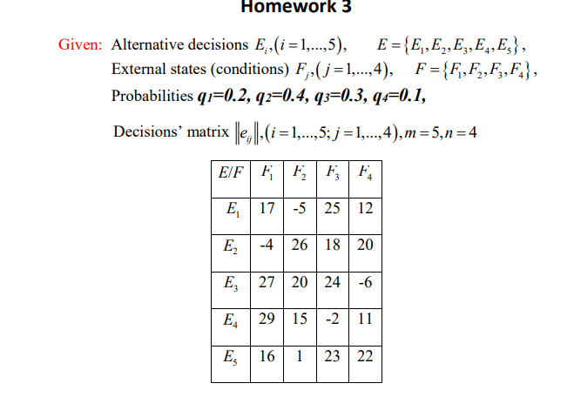

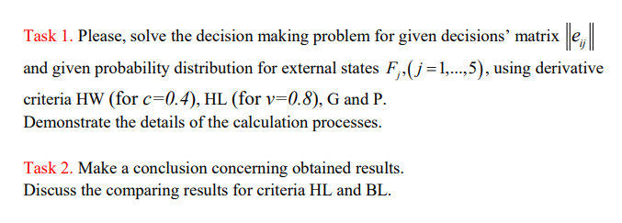



|  |  |
| --- | --- |
| **c** | 0.4 |
| **v** | 0.8 |
| **q1** | 0.2 |
| **q2** | 0.4 |
| **q3** | 0.3 |
| **q4** | 0.1 |

**P Criterion**



**G- criterion**



**HL criterion**



|  |  |  |  |  |  |  |  |  |
| --- | --- | --- | --- | --- | --- | --- | --- | --- |
|  |  |  |  |  | MM-criterion | | BL-criterion | |
| **E/F** | **F1** | **F2** | **F3** | **F4** | **mineij** | **maxeir** | **Sum(eijqjj** | **maxeir2** |
| E1 | 17 | -5 | 25 | 12 | -5 |  | 10.1 |  |
| E2 | -4 | 26 | 18 | 20 | -4 |  | 17 |  |
| E3 | 27 | 20 | 24 | -6 | -6 |  | 20 | 20 |
| E4 | 29 | 15 | -2 | 11 | -2 |  | 12.3 |  |
| E5 | 16 | 1 | 23 | 22 | 1 | 1 | 12.7 |  |

**Conclusion:**

**The HW-Criterion recommends decision E4; the P-Criterion recommends decision E5, just like the MM-Criterion; the HL-Criterion and the G-Criterion recommend decision E3, just like the BL-Criterion.**

**Cumali Bereket**

**S211060**