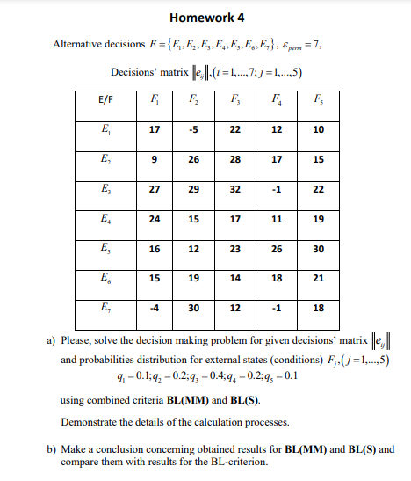

**BL(MM)**



|  |  |
| --- | --- |
| q1= | 0.1 |
| q2= | 0.2 |
| q3= | 0.4 |
| q4= | 0.2 |
| q5= | 0.1 |
| ɛperm= | 7 |

**BL (S) - Criteria**



**Conclusion:**

**For BL(MM):**

**The definition of the set of indices I1 is= (2,4,5,6)**

**The definition of the set of indices I2 is= (2,4,5,6)**

**The set of indices I1ΩI2 is defined as I1ΩI2= (2,4,5,6).**

**The best choice is option E2.**

**We lose 5 points as a result of this decision, but we win 7 points.**

**Decision E3 is supported by BL-criteria, while E2 is supported by BL(MM).BL-criteria recommend decision E3 and BL(MM) recommend E2.**

**For BL(S):**

**The definition of the set of indices I1 is = (2,4,5,6)**

**The definition of the set of indices I2 is = (2,4,5)**

**The set of indices I1ΩI2 is defined as I1ΩI2 = (2,4,5).**

**The best choice is option E2.**

**We lose 3 points due to this decision, but we win 6 points.**

**Decision E7 is supported by BL-criteria, and E2 is supported by BL(MM).**

**Cumali Bereket**

**S211060**