**CSCI 4250/5250 Homework 6**

**(Due : midnight, Friday, Nov 8th)**

**Please type your answer**

**Convert to PDF file**

**Submit to D2L dropbox labelled “Homework 6”**

1. Given the 3D mesh object shown below, show
   1. The vertex list
   2. The normal list. Compute the normals of the faces using Newell’s method, and
   3. The face list. Each face should include the vertex (index) list, as well as the normal (index) list.

Show the step by step computation of the normal for face AFC. You may use computer program to compute the rest of the normal vectors.

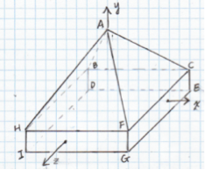

A=(0, 6, 0), B=(-4, 1, -1), C=(6, 1, -1), D=(-4, -1, -1), E=(6, -1, -1),

F=(6, 1, 4), G=(6, -1, 4), H=(-4, 1, 4), I=(-4, -1, 4)