part I

* Basic
  + NCC

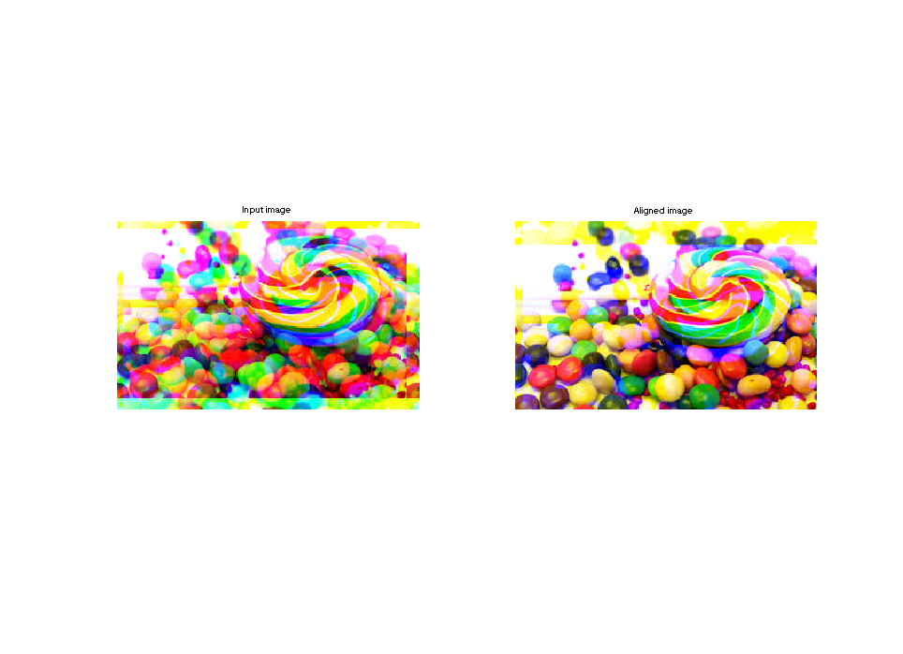

Evaluating alignment ..

1 balloon.jpeg

gt shift: ( 0, 7) ( 9,13)

pred shift: ( 0,-7) (-9,-13)

2 cat.jpg

gt shift: (12, 6) (-5,-9)

pred shift: (-12,-6) ( 5, 9)

3 ip.jpg

gt shift: (-15, 0) ( 8,-1)

pred shift: (15, 0) (-8, 1)

4 puppy.jpg

gt shift: (13, 4) ( 3,11)

pred shift: (-13,-4) (-3,-11)

5 squirrel.jpg

gt shift: ( 9,-10) ( 2,-8)

pred shift: (-9,10) (-2, 8)

6 candy.jpeg

gt shift: (-11,-12) ( 7, 5)

pred shift: (11,12) (15, 2)

7 house.png

gt shift: (15, 0) ( 7,-1)

pred shift: (-15, 0) (-7, 1)

8 light.png

gt shift: (-14,-14) ( 6,-13)

pred shift: (14,14) (-6,13)

9 sails.png

gt shift: ( 1,10) (-13,10)

pred shift: (-1,-10) (13,-10)

10 tree.jpeg

gt shift: ( 7, 5) (-11, 1)

pred shift: (-7,-5) (11,-1)

* + Gradient Domain Alignment
    - Edge alignment.

>> evalAlignment

Evaluating alignment ..

1 balloon.jpeg

gt shift: (-8, 5) (-9,11)

pred shift: ( 8,-5) ( 9,-11)

2 cat.jpg

gt shift: (-5, 5) ( 9,-15)

pred shift: ( 5,-5) (-9,15)

3 ip.jpg

gt shift: ( 3,13) (-4,-15)

pred shift: ( 4,-7) ( 4,15)

4 puppy.jpg

gt shift: (-1,-1) (-2, 8)

pred shift: ( 1, 1) ( 2,-8)

5 squirrel.jpg

gt shift: (-6,-1) ( 9,-14)

pred shift: ( 6, 1) (-9,14)

6 candy.jpeg

gt shift: (-10,-1) ( 7,-11)

pred shift: (10, 1) (-7,11)

7 house.png

gt shift: (-5,-10) ( 3, 7)

pred shift: ( 5,10) (-3,-7)

8 light.png

gt shift: (-8,-7) (13, 8)

pred shift: ( 8, 7) (-13,-8)

9 sails.png

gt shift: (-10,-13) (-7, 2)

pred shift: (10,13) ( 7,-2)

10 tree.jpeg

gt shift: ( 6,-2) ( 1, 4)

pred shift: (-6, 2) (-1,-4)

Improve it by combining.

(riginal + 0.5edge)/1.5

* + Faster Alignment
    - 10X+ speed up.
  + Putin结果：

>> alignProkudin

1 00125v.jpg shift: B (-4, 1) R (-9, 0)

2 00153v.jpg shift: B (-13,-1) R (-11,-1)

3 00398v.jpg shift: B ( 0, 0) R (-11, 0)

4 00149v.jpg shift: B (-5, 0) R (-10, 0)

5 00351v.jpg shift: B (-9, 0) R (-14, 1)

6 01112v.jpg shift: B (-8,-1) R (-7,-1)

1 00125v.jpg shift: B (-4, 0) R (-9,-1)

2 00153v.jpg shift: B (-7,-1) R (-12, 0)

3 00398v.jpg shift: B (-6,-1) R (-9, 1)

4 00149v.jpg shift: B (-5, 0) R (-9,-2)

5 00351v.jpg shift: B (-9,-1) R (-13,-1)

6 01112v.jpg shift: B (-5,-1) R (-5,-1)