Top Talent Driver Web Application
  - High Level Design (HLD)
Version 1.1 | 08 September 2026
Document attribute | Value
Application | Top Talent Driver Web Application
Submission intent | Vodafone Architecture Review, Security Review, SPDA / C4 and Production Readiness
Status | Draft for review
Confidentiality | C4 target (final classification to be confirmed by the Information Owner)
AI scope | In scope – Phase 2 (in-dashboard chatbot via governed AI Booster agent)
Document owner | TBC
SPDA demand | TBC
Design Authority demand | TBC
Project phase | Development phase design and approval
Master location | SharePoint location (TBC)

Table of Contents
1. Document Control and Governance 1
1.1 Revision History 1
1.2 Reviewers, Approvers and Distribution 1
2. Executive Summary 1
3. Business Context and Scope 1
3.1 Business Need 1
3.2 In Scope 1
3.3 Out of Scope 1
3.4 Assumptions, Dependencies and Constraints 1
4. Requirements and Architecture Principles 1
4.1 Functional Requirements 1
4.2 Non-Functional Requirements 1
4.3 Architecture Principles 1
5. Solution Overview and Target Architecture 1
5.1 Architecture Diagram and Tools 1
5.2 Architecture Flow 1
5.3 Environment Model 1
6. Detailed Application and Integration Design 1
6.1 React Frontend 1
6.2 Frontend Dependencies 1
6.3 Backend API Contract 1
6.4 Backend Dependencies 1
6.5 Read Sequence 1
6.6 Chatbot Sequence (Phase 2) 1
7. Data Architecture and BigQuery Design 1
7.1 Data Ownership and Minimization 1
7.2 Datasets and Views 1
7.3 BigQuery Access Pattern 1
7.4 Partitioning, Clustering and Lifecycle 1
8. Identity, Authentication and Authorization 1
8.1 Authentication 1
8.2 Authorization Chain 1
8.3 Role Matrix 1
8.4 Identity and Service Account Separation 1
8.5 Access Lifecycle 1
9. Security and Compliance 1
9.1 Data Classification and Privacy 1
9.2 PII Handling and Filtering 1
9.3 Encryption and Key Management 1
9.4 Web and API Security Controls 1
9.5 Immutable Audit and Logging 1
9.6 SPDA Compliance Mapping 1
10. Logging, Monitoring and Operational Support 1
10.1 Logging Model 1
10.2 Metrics, SLOs and Alerts 1
10.3 Support Model and RACI 1
10.4 Runbooks Required 1
11. Availability, Backup, DR and Business Continuity 1
11.1 Availability Design 1
11.2 Proposed Recovery Objectives 1
11.3 Backup and Restore Controls 1
12. CI/CD and DevSecOps 1
12.1 Target Pipeline 1
12.2 Required Gates 1
12.3 Patch and Dependency Management 1
13. Testing, Release and Production Readiness 1
13.1 Test Strategy 1
13.2 Release Strategy 1
13.3 Production Readiness Exit Criteria 1
14. Threat Model, Risks and Open Decisions 1
14.1 Assets and Trust Boundaries 1
14.2 Risk Register 1
14.3 Open Decisions / Approval Blockers 1
15. Architecture Decision Records 1
16. Future Roadmap 1
17. Appendices 1
Appendix A – Glossary 1
Appendix B – Diagram Specifications 1
Appendix C – Data Element Classification 1
Appendix D – Source Register 1

Page numbers populate automatically when this document is opened in Word. If prompted, choose “Update entire table”; otherwise select the table and press F9.

1. Document Control and Governance

1.1 Revision History
Version | Date | Status | Change | Owner
1.0 | 12 Aug 2026 | Initial | Core HLD baseline covering dashboard, analytics consumption, controlled data access and chatbot capability. | TBC
1.1 | 08 Sep 2026 | Draft for review | Restructured into the Vodafone approval-readiness HLD format; expanded requirements, security, data, operations and governance sections. | TBC

1.2 Reviewers, Approvers and Distribution
Role | Name / team | Decision / responsibility | Status
Document owner | Ashok Raja & Sudhir Kuwar | Accuracy and design ownership | Drafted
Business Owner / Sponsor | Giovanni Licheri | End-to-end solution | Pending
Architecture reviewer | Luisa Martinez / PCS Team | Architecture pattern and MI delta | Pending
Application / solution architecture | Design Authority | End-to-end architecture approval | Pending
SPDA / Secure by Design | Khushboo Dave | Security demand approval | Pending
Privacy / Information Owner | TBC | Classification, purpose, retention and PII | Pending
PCS / GCP platform | TBC | C4 hosting, logging and project guardrails | Pending
DataHub / Analytics owner | Robert Steffan | Datasets, semantic views, key and access | Pending

2. Executive Summary
The Top Talent Driver Web Application is a ReactJS and GCP based analytics and insight delivery platform designed to help HR and business users understand the drivers behind top talent nomination across Vodafone markets. It provides a single interface for viewing analytics model outputs, including global predictor insights and market-level driver and barrier analysis, and includes an in-dashboard chatbot capability delivered in Phase 2.
The application is a presentation and query layer only. Analytical modelling is performed upstream by the analytics team, with published outputs consumed from BigQuery. Data access is controlled through authentication and group-based authorization, with backend enforcement on every request.

3. Business Context and Scope

3.1 Business Need
The application gives HR and business users a single, governed place to understand why individuals are nominated as top talent across Vodafone markets. It surfaces published analytics outputs – global predictor insights and market-level driver and barrier analysis – through an interactive dashboard, reducing fragmented and uncontrolled distribution of sensitive analytics and supporting consistent, scope-based consumption of insight.

3.2 In Scope
- ReactJS single-page dashboard on Cloud Run for Top Talent Driver insights, including the global predictor view and market-level driver and barrier views.
- Backend API layer on Cloud Run consuming published BigQuery analytics outputs and semantic views.
- Scope-based data access through Google Group membership (Phase 1) with backend entitlement enforcement on every request.
- Cloud Load Balancing, Cloud Armor and Identity-Aware Proxy at the edge, with corporate SSO through Azure AD using SAML 2.0.
- BigQuery-native access enforcement (row-level and column-level security) keyed to Vodafone Group or Local Market scope through Google Group membership.
- Central logging, monitoring and audit of application activity.
- Separate development and production environments on GCP.
- In-dashboard chatbot (Phase 2) served by a governed AI Booster agent answering from the same governed data.

3.3 Out of Scope
- Analytical modelling itself, which is performed upstream by the analytics team; the application is a presentation and query layer only.
- Changes to upstream HR data pipelines or to the production of analytics outputs and semantic views.
- Write-back to HR source data; the application consumes published views read-only.
- Anonymous, external or non-Vodafone user access.

3.4 Assumptions, Dependencies and Constraints
ID | Type | Statement
A01 | Assumption | Analytics model outputs and semantic views are produced and refreshed upstream of the application in BigQuery.
A02 | Assumption | Corporate identity integration (Azure AD SSO and Identity-Aware Proxy) is available for the target projects.
D01 | Dependency | Published BigQuery analytics outputs and semantic views are provisioned and accessible to the backend identity.
D02 | Dependency | Cloud Armor, IAP and DNS / certificate are provisioned for the target projects.
D03 | Dependency | Google Groups map users to a Vodafone Group or Local Market scope; Phase 2 introduces L1 and L2 levels.
C01 | Constraint | Sensitive analytics data must remain within approved Vodafone projects and regions.
C02 | Constraint | The application consumes published outputs only and does not change the underlying HR data pipelines.

4. Requirements and Architecture Principles

4.1 Functional Requirements
ID | Requirement | Priority
FR01 | View global predictor insights across Vodafone markets. | Must
FR02 | View market-level driver and barrier analysis within the permitted scope. | Must
FR03 | Return only data within the user’s resolved group, market and level scope, enforced server-side. | Must
FR04 | Authenticate users through corporate SSO and resolve access scope before any data is retrieved. | Must
FR05 | Provide an in-dashboard chatbot answering from the same governed data (Phase 2). | Should
FR06 | Provide a simulation view to adjust factors and evaluate relative odds against a baseline (Phase 2). | Should
FR07 | Provide a consolidated overview page of key metrics and insights (Phase 2). | Should

4.2 Non-Functional Requirements
ID | Domain | Target / requirement
NFR01 | Security | Authentication and authorization aligned with Vodafone security standards, with backend entitlement enforcement on every request.
NFR02 | Security | Encryption of data in transit (HTTPS / TLS) and at rest (BigQuery managed encryption).
NFR03 | Security | Compliance with C4 security and SPDA review requirements.
NFR04 | Scalability | Scalable, cloud-native architecture hosted on GCP services (Cloud Run).
NFR05 | Performance | High availability and reliable API performance for dashboard interactions.
NFR06 | Security | Secure CI/CD deployment using Vodafone-approved pipelines.
NFR07 | Maintainability | Read-only consumption of published views; the application holds no local copy of HR data.

4.3 Architecture Principles
- Zero trust between browser, frontend and backend: authenticate and authorize every request.
- Presentation and query layer only; analytical modelling remains upstream.
- The backend is the single point of entitlement enforcement; no data-access logic sits in the frontend.
- Use approved GCP managed services and existing Vodafone deployment and operations patterns.
- Consume published, governed BigQuery outputs; do not duplicate HR data.

5. Solution Overview and Target Architecture
The Top Talent Driver Web Application is deployed on GCP using Cloud Run for the ReactJS frontend and backend API layer. BigQuery serves as the interface between the upstream analytics work and the application, which reads published views and does not hold its own copy of HR data. Data access is enforced inside BigQuery through row-level security and column-level security (policy tags) keyed to the user’s Google Group membership, applied at query time under the end-user identity so that backend- or model-issued SQL cannot widen access.

5.1 Architecture Diagram and Tools
Zone | Component | Responsibility
User | Corporate browser | Access the dashboard and authenticate through corporate SSO.
GCP edge | Cloud Load Balancing, Cloud Armor, IAP | TLS termination, WAF / rate limiting, user authentication (Azure AD, SAML 2.0) and entry routing.
Compute | Cloud Run frontend | Serve the ReactJS dashboard single-page application.
Compute | Cloud Run backend | Validate requests, resolve scope, query BigQuery and return scoped results.
Data | BigQuery | Published analytics outputs and semantic views, read-only.
AI (Phase 2) | AI Booster single agent, Agent Platform – Gemini 2.5 Pro (via Responsible AI proxy) | Governed chatbot answering from the same governed data.
Operations | Cloud Logging / Monitoring | Collect operational, security and audit evidence.
Delivery | GitHub, CI/CD, Artifact Registry | Build, package and deploy immutable container images.

Figure 1. Top Talent Driver Web Application – Solution Architecture
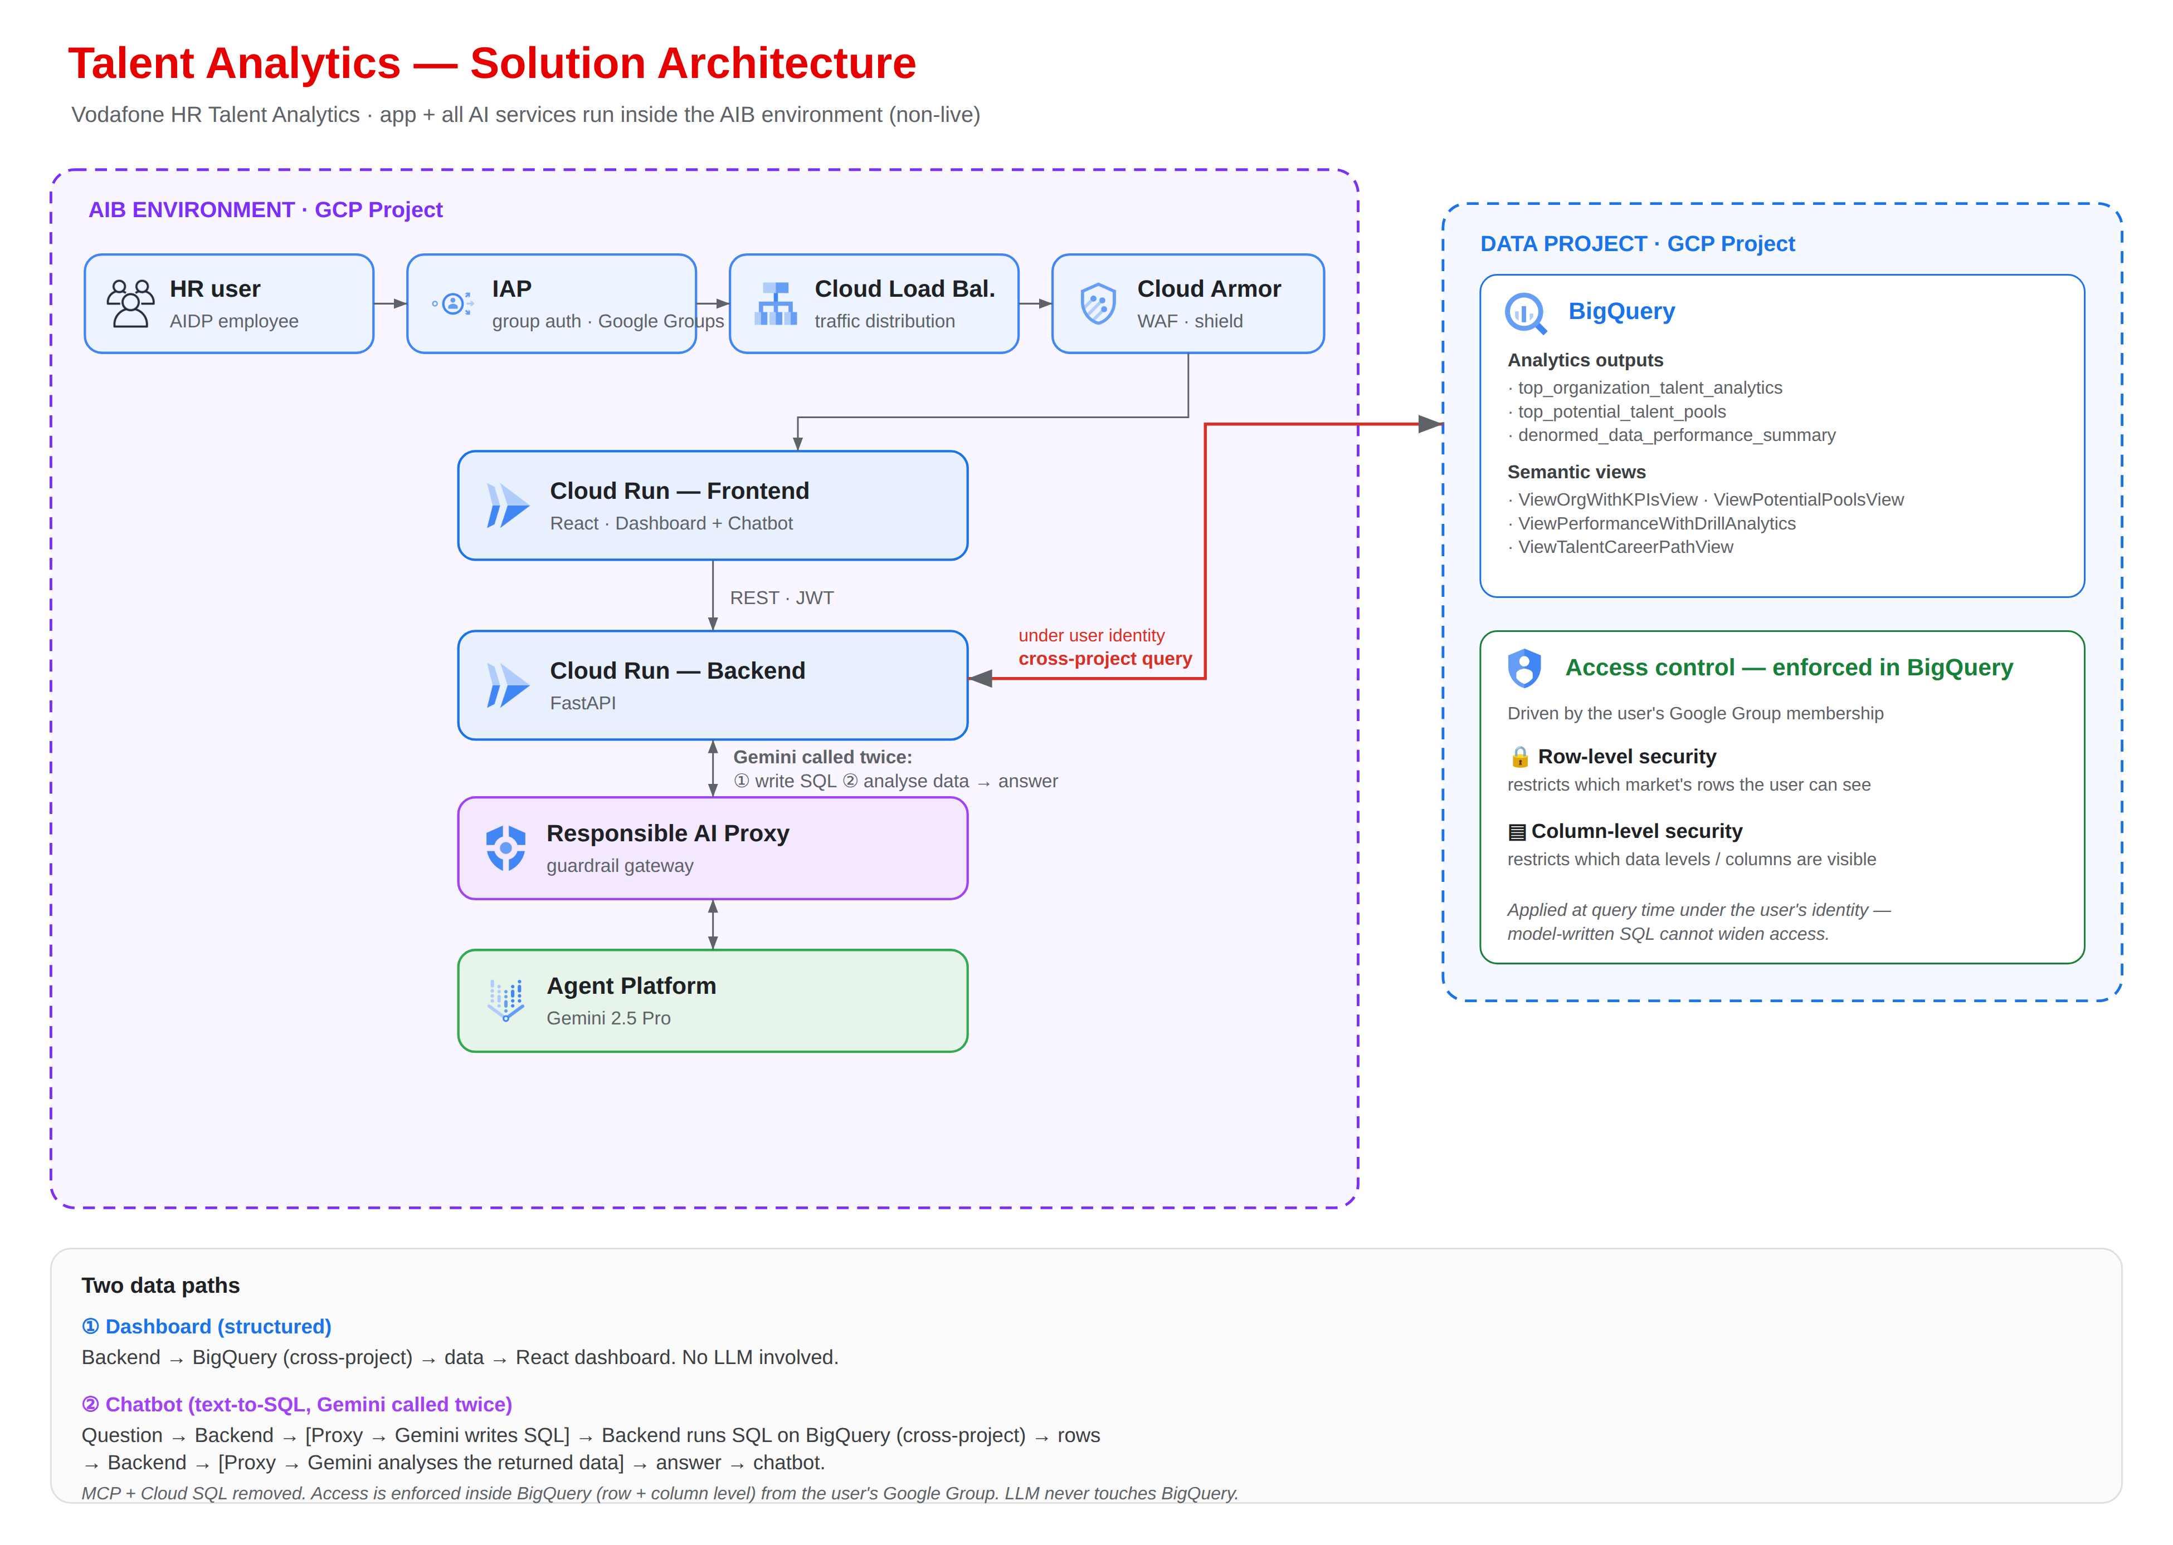

5.2 Architecture Flow
- Access and authentication: the user reaches the application through Cloud Load Balancing and Cloud Armor. Identity-Aware Proxy authenticates the user against Azure AD corporate SSO using SAML 2.0.
- Access resolution: the authenticated identity resolves to Google Group membership (Vodafone Group or Local Market) and access level, which is carried through to BigQuery, where row-level and column-level security enforce the permitted scope at query time.
- Dashboard request: the ReactJS frontend requests dashboard data from the backend API over REST.
- Authorization: the backend validates the authenticated user context and applies the user’s Google Group membership (Vodafone Group or Local Market) and access level before any data is read.
- Data retrieval: the backend queries the analytics outputs and semantic views in BigQuery under the end-user identity, where BigQuery row-level security and column-level security (policy tags) filter the rows and columns to the user’s permitted scope.
- Rendering: the backend returns scoped data and the frontend renders the driver visualizations.
- Chatbot processing (Phase 2): the frontend sends questions to the backend, which calls the AI Booster agent over REST with SSE using service-to-service authentication and the authenticated user’s Google Group context.
- AI response (Phase 2): the agent calls Gemini 2.5 Pro through the Responsible AI proxy to generate SQL; the backend runs that SQL against BigQuery under the end-user identity; the agent then calls Gemini again through the proxy to analyse the returned rows and produce the answer. The model never queries BigQuery directly.

5.3 Environment Model
- The application follows Vodafone’s multi-project GCP architecture, with separate environments for development and production workloads.
- Application services, including the ReactJS frontend and backend API, are deployed on Cloud Run.
- Development and production environments are maintained separately in line with Vodafone GCP governance standards; access to the development environment is restricted through Google Group membership.
- Phase 2 introduces role-based access levels (L1 and L2) for more granular control over data access and application functionality.
- Monitoring, logging and audit activities are centrally managed using Google Cloud services.

Component | Non-live | Live
Environment | vf-cip-ca-nonlive | vf-cip-datahub
Purpose | Testing | Production
Support impact | Validation and test | Product Operations

Figure 2. Top Talent Driver – Environment and Dataset Model
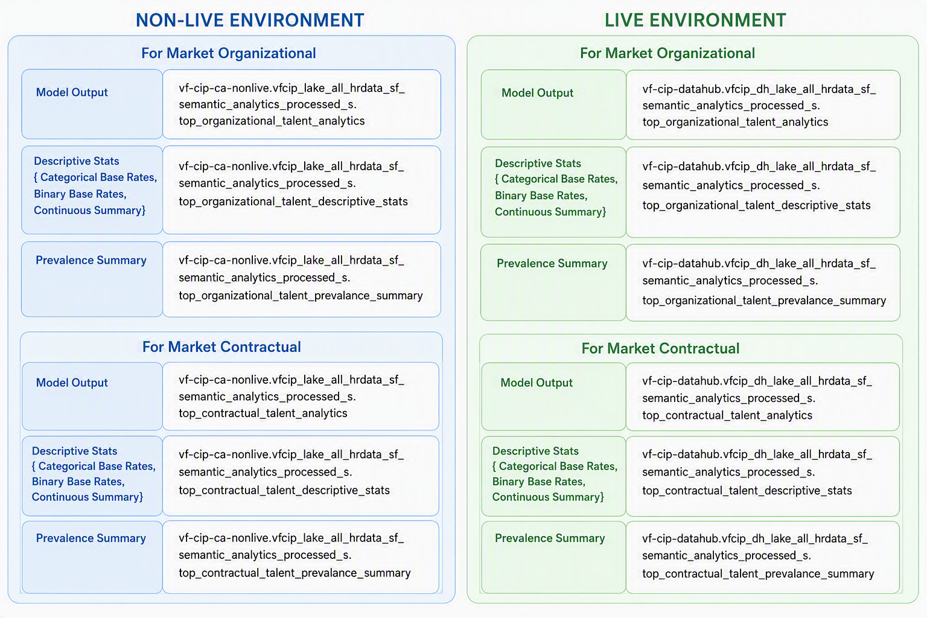
Figure 3. GCP Project Family – Non-live (Beta / C2) and Live (ZETA / C4)
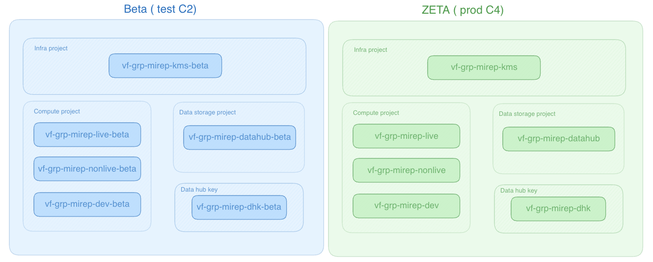

6. Detailed Application and Integration Design

6.1 React Frontend
- ReactJS single-page application hosted on Cloud Run, providing interactive dashboard views for Top Talent Driver insights.
- Communicates with the backend over HTTPS / TLS using REST APIs and JWT-based request context.
- Renders the driver visualizations using scoped results returned by the backend API.
- Holds no data-access logic; all data requests are handled by the backend, which applies the user’s access level and scope before returning data.
- Does not persist IAP tokens, user roles or scoped results in browser storage.

6.2 Frontend Dependencies
Package | Version | Type
react | 19.2.6 | Dependency
react-dom | 19.2.6 | Dependency
@eslint/js | 10.0.1 | Dev Dependency
@types/node | 24.12.3 | Dev Dependency
@types/react | 19.2.14 | Dev Dependency
@types/react-dom | 19.2.3 | Dev Dependency
@vitejs/plugin-react | 6.0.1 | Dev Dependency
eslint | 10.3.0 | Dev Dependency
eslint-plugin-react-hooks | 7.1.1 | Dev Dependency
eslint-plugin-react-refresh | 0.5.2 | Dev Dependency
globals | 17.6.0 | Dev Dependency
typescript | 6.0.2 | Dev Dependency
typescript-eslint | 8.59.2 | Dev Dependency
vite | 8.0.12 | Dev Dependency

6.3 Backend API Contract
The backend API layer runs on Cloud Run and is built with FastAPI (Python). It validates incoming requests, authorizes them against the user group and level, queries BigQuery, and returns scoped results to the frontend. It is the controlled processing boundary between the frontend, the access-control store, the BigQuery datasets and, in Phase 2, the chatbot agent.
Method / endpoint | Purpose | Security behavior
GET /healthz | Runtime health | No sensitive dependency details.
GET /api/v1/drivers/global | Global predictor insights | Verify JWT and scope; parameterized, scope-filtered BigQuery read.
GET /api/v1/drivers/market | Market-level driver and barrier view | Verify JWT and scope; return only the permitted market scope.
POST /api/v1/chat (Phase 2) | Chatbot query | Route to the governed AI Booster agent with the authenticated user’s Google Group context.
All read methods verify the authenticated user context, resolve scope before querying, use parameterized queries, apply output encoding and return generic error responses. Dynamic SQL and client-supplied authorization predicates are prohibited.

6.4 Backend Dependencies
Package | Version | Type
@google-cloud/bigquery | 8.3.1 | Dependency
compression | 1.8.1 | Dependency
cors | 2.8.6 | Dependency
dotenv | 17.4.2 | Dependency
express | 5.2.1 | Dependency
helmet | 8.1.0 | Dependency
tsx | 4.22.0 | Dependency
@types/compression | 1.8.1 | Dev Dependency
@types/cors | 2.8.19 | Dev Dependency
@types/express | 5.0.6 | Dev Dependency
@types/node | 25.8.0 | Dev Dependency

6.5 Read Sequence
- The ReactJS frontend requests dashboard data from the backend over REST through the approved FQDN.
- Cloud Armor and IAP enforce the edge policy and authenticate the user.
- The backend validates the authenticated user context and resolves the user’s group, market and level from the Google Group membership passed through from IAP.
- The backend queries the analytics outputs and semantic views in BigQuery under the end-user identity; BigQuery row-level security and column-level security (policy tags) filter the rows and columns to the user’s permitted scope before results are returned.
- The backend returns scoped data and the frontend renders the driver visualizations.

6.6 Chatbot Sequence (Phase 2)
- The frontend sends a question to the backend with the authenticated user context.
- The backend calls the AI Booster agent over REST with SSE using service-to-service authentication and the user’s Google Group context.
- The backend runs the model-generated SQL against BigQuery under the end-user identity and passes only the returned rows back to the agent; the model never accesses BigQuery directly.
- The agent calls Agent Platform (Gemini 2.5 Pro) through the Responsible AI proxy and returns a governed answer within the permitted data context.

7. Data Architecture and BigQuery Design

7.1 Data Ownership and Minimization
The application consumes published analytics outputs and semantic views stored in BigQuery. Analytical modelling is performed and refreshed upstream by the analytics team. The application reads published views read-only and does not hold its own copy of HR data or change the underlying HR data pipelines.

7.2 Datasets and Views
Project / dataset | Views | Purpose
vf-cip-ca-nonlive  vfcip_lake_all_hrdata_sf_semantic_analytics_processed_s | top_talent_analytics  top_talent_descriptive_stats  top_talent_prevalance_summary | Published analytics outputs consumed by the dashboard.
vf-cip-datahub  vfcip_dh_lake_all_hrdata_sf_semantic_processed_s | ViewAppHRBPMonthly  ViewAppHRBPTalentKPI  ViewEmployeeInfoDataAnalytics  ViewVLOLearningDashboard | Supporting semantic views providing HR / talent context.

7.3 BigQuery Access Pattern
- Base data is accessed only by the backend service identity, not by the frontend or end users.
- The backend applies the user’s group, market and level scope before querying, and filters results to the permitted scope.
- Reads are read-only against published views; the application does not write to HR data.
- BigQuery data is encrypted at rest using Google Cloud managed encryption keys.
- BigQuery Data Access audit logs are enabled and retained as required by the central logging standard.
Access is enforced inside BigQuery, not in the application. The backend queries the semantic views under the end-user identity (the Google Group membership passed through from IAP), so BigQuery applies each user’s policies at query time:
- Row-level security (RLS): row access policies on the semantic views restrict which market’s rows a user can see, keyed to the same IAP Google Groups the application uses.
- Column-level security (CLS): policy tags on sensitive columns restrict which data levels or columns are visible; a user without the fine-grained reader role on a tag cannot read that column, and views do not bypass the tag.
- Because RLS and CLS are attached to the views and evaluated per identity, queries must run under the end-user identity, not a shared service account, or enforcement silently would not apply.
- Aggregated model-output tables that carry no per-user security may be read via the service account; secured semantic views are always read live under the end-user identity and are never copied into another dataset (a copy would strip the policies).

7.4 Partitioning, Clustering and Lifecycle
The application consumes published views; partitioning, clustering and lifecycle of the underlying analytics and semantic datasets are governed upstream by the analytics and DataHub teams.
APPROVAL DECISION / TBC: Retention of application-side logs and audit data, and confirmation of the upstream dataset lifecycle relevant to this application, are to be confirmed with the DataHub / Analytics owner.

8. Identity, Authentication and Authorization

8.1 Authentication
- Users reach the application through Cloud Load Balancing, Cloud Armor and Identity-Aware Proxy.
- Production authentication uses corporate SSO through Azure AD using SAML 2.0.
- Application-level authorization checks are enforced by the backend before data access is granted.
- Phase 1 uses Google Group-based access control; Phase 2 introduces L1 and L2 authorization levels for enhanced role-based access management.

8.2 Authorization Chain
Verified SSO / IAP subject → corporate identity → Google Group membership (Vodafone Group or Local Market) → access level (Phase 2: L1 / L2) → permitted market and scope → scoped BigQuery query. Each hop is default-deny, testable and auditable.

8.3 Role Matrix
Capability | Vodafone Group scope | Local Market scope
View global predictor insights | Yes | Limited to permitted markets
View market-level driver and barrier analysis | All markets | Assigned market(s) only
View location-level detail | Per assigned scope | Only the assigned location within the market
Use in-dashboard chatbot (Phase 2) | Within scope | Within scope
Phase 2 adds L1 and L2 authorization levels to further refine access permissions and data visibility within the scope model above.

8.4 Identity and Service Account Separation
Identity | Account details | Permitted
User account | Corporate SSO credentials (Azure AD) | Access the dashboard; scoped reads through the backend.
Backend service account | Cloud Run backend SA (TBC) | Query BigQuery analytics and semantic views under the end-user identity so row-level and column-level security apply; write application logs.
Agent service account (Phase 2) | AI Booster agent SA (TBC) | Receive model-generated SQL and return only permitted rows; call Agent Platform (Gemini 2.5 Pro) through the Responsible AI proxy.

8.5 Access Lifecycle
- Access requested through the approved UAM process and Google Group ownership.
- Manager / data-owner approval according to classification.
- Automatic revocation on leaver or role change where supported.
- Periodic role and privileged-access recertification; frequency to be confirmed by the UAM team.

9. Security and Compliance

9.1 Data Classification and Privacy
- The application handles sensitive analytics data, including demographic factors and identified bias patterns.
- Production is treated as a C4 target until the Information Owner confirms classification; detailed classification labelling is to be confirmed.
- Distribution uses controlled, group-based access rather than shared files.
- The application reads published views and does not hold its own copy of HR data. Data access is enforced inside BigQuery through row-level security and column-level security (policy tags) keyed to the user’s Google Group membership, applied at query time under the end-user identity so that backend- or model-issued SQL cannot widen access.
- A formal privacy assessment and information classification decision are mandatory evidence and are not replaced by this HLD.

9.2 PII Handling and Filtering
- The application returns only the data the user is entitled to see, with filtering applied by the backend before data is returned to the frontend.
- Phase 1: access control is based on Google Groups membership.
- Phase 2: SSO (Azure AD via Identity-Aware Proxy) provides centralized authentication and user access management.

9.3 Encryption and Key Management
Layer | Design requirement
In transit | HTTPS / TLS for browser-edge and service calls; managed certificate; no plaintext endpoints.
Platform at rest | BigQuery encrypted at rest using Google Cloud managed encryption keys; the approved Vodafone C4 CMEK / HSM posture applies as governed by the platform.
Key management | KMS / Secret Manager posture per the approved platform mechanism; least-privilege access; no key export.
Access | Backend and agent service identities only; least privilege.
APPROVAL DECISION / TBC: DataHub / PCS / Security to confirm the key-management mechanism (Cloud KMS, Secret Manager or platform key project) for the C4 target.

9.4 Web and API Security Controls
Area | Required control
Edge | Cloud Armor managed WAF rules and rate limiting based on the approved Vodafone pattern, with logging.
Ingress | Cloud Run ingress restricted to internal-and-cloud-load-balancing or approved equivalent; default URL disabled where supported.
Browser | CSP, HSTS, X-Content-Type-Options, Referrer-Policy, secure cookies and no sensitive browser storage.
Input | Schema, type, length and character validation; parameterized queries; no dynamic SQL.
Authorization | Scope and action check on every request; default deny.
Error handling | Generic client responses; detailed server logs without sensitive data.
AI governance (Phase 2) | Governed AI Booster agent path, Responsible AI proxy and end-user-context enforcement on all BigQuery reads.

9.5 Immutable Audit and Logging
- Logging and audit of application activity are in scope for Phase 1.
- Operational logs and monitoring cover application activity, authorization denials, API failures and BigQuery usage or failures.
- Application and infrastructure logs are collected through Google Cloud’s managed logging; Cloud Run logs are used for troubleshooting, operational monitoring and error analysis.
- Audit records exclude sensitive plaintext.

9.6 SPDA Compliance Mapping
Control area | Requirement / implementation | Expected evidence | Owner / approver | Residual risk
Governance | Active SPDA demand; approved C4 scope. | Demand reference, decisions, signed HLD. | Product / SPDA | Open until approval.
Identity | SSO / IAP verification; no trusted browser identity. | Config export, code / test evidence. | App / Security | Open.
Authorization | Server-side scope enforcement independent of client parameters. | Role / scope design, negative tests. | Product / UAM / Security | Open until scope source confirmed.
Data protection | TLS, C4 at-rest posture and managed keys. | Key / IAM inventory, rotation test. | DataHub / Security | Open until model finalized.
Privacy | Purpose, minimization, classification and retention. | Privacy assessment and Information Owner signoff. | Privacy / Information Owner | Open.
Network | LB / Armor / IAP path; direct URL blocked. | IaC / config and penetration result. | PCS / Security | Open.
Logging | Central logs and application audit. | Sink policy, sample events, access matrix. | PCS / Ops / Security | Open until retention approved.
DevSecOps | Build scans, image signing and gates. | Pipeline logs and reports. | Engineering / Security | Open.
AI governance (Phase 2) | Governed agent path and RAI proxy. | Agent config and RAI evidence. | Product / Security | Open.

10. Logging, Monitoring and Operational Support

10.1 Logging Model
Log type | Examples | Retention / destination
Application operational | Request outcome, latency, validation failure, BigQuery error, correlation ID. | Cloud Logging and approved operational sink; retention TBC.
Application security | SSO / JWT failure, authorization denial, rate limit, admin action. | Central security sink / SIEM; retention per security policy.
Business audit | Access and authorization events with verified actor and context. | Central protected export; retention TBC.
Platform audit | Cloud Run, IAM, BigQuery Data Access, Artifact Registry and deployment administration. | PCS central logging architecture.

10.2 Metrics, SLOs and Alerts
Signal | Metric / alert | Action
Availability | Uptime check and successful API rate. | Page support when the SLO burn threshold is exceeded.
Latency | p50 / p95 / p99 API and BigQuery latency by endpoint. | Investigate revision, query and capacity.
Errors | 5xx and read / query failures. | Immediate alert at approved thresholds.
Security | SSO / JWT failures, 401 / 403 spikes, Cloud Armor blocks. | Security / operations triage.
Capacity / cost | Cloud Run instances / concurrency, BigQuery bytes / quota. | Scale, config or cost-anomaly response.
Deployment | Revision change, rollback, failed health check. | Stop promotion and restore last approved digest.

10.3 Support Model and RACI
Activity | Accountable | Responsible | Consulted / informed
Application L3 | Service owner (TBC) | Application engineering | HR analytics, Security
Platform incident | PCS platform (TBC) | Platform operations | Application owner
Data / BigQuery | DataHub / analytics owner (TBC) | Data engineering | Security, application
Security incident | Cyber Security | SOC / IR plus service teams | Privacy / Information Owner
Release / change | Product / service owner | Engineering via approved pipeline | Operations, DA / SPDA

10.4 Runbooks Required
- Application unavailable / IAP redirect failure.
- Cloud Armor false positive or attack response.
- BigQuery read failure or quota exhaustion.
- Suspected unauthorized access or scope misconfiguration.
- Rollback of a Cloud Run revision.
- Restore of BigQuery row-level and column-level security policies on the semantic views.
- Chatbot / agent or Responsible AI proxy failure (Phase 2).

11. Availability, Backup, DR and Business Continuity

11.1 Availability Design
- Cloud Run frontend and backend are stateless and deployed from immutable images.
- Cloud Run dynamically adjusts the number of application instances to support varying usage while optimizing resource utilization.
- Cloud Load Balancing distributes incoming requests across available service instances to maintain responsiveness and availability.
- BigQuery and the selected region inherit the approved platform resilience posture.
- Application availability depends on corporate identity / IAP, LB / Armor, Cloud Run and BigQuery.

11.2 Proposed Recovery Objectives
Component | Proposed RPO | Proposed RTO | Recovery method
Frontend / backend | N/A (stateless) | 4 hours | Redeploy the approved image / config through the pipeline / IaC.
Access control (BigQuery RLS/CLS) | 24 hours | 4 hours | Re-apply RLS / CLS policy definitions.
Configuration | Latest approved commit | 4 hours | Version-controlled IaC / config.
Source datasets | Governed upstream | Governed upstream | Analytics / DataHub platform backup and governance.
These are proposed targets only. The Product Owner and Information Owner must approve a Business Impact Assessment and reconcile the targets with the capabilities of IAP, Cloud Run and BigQuery.

11.3 Backup and Restore Controls
- Application container images are stored in Artifact Registry, enabling recovery and redeployment of approved application versions when required.
- Row-level and column-level security policy definitions are version-controlled and re-applied to the semantic views to restore access control.
- Views, IAM and policy configuration are backed up / recreated through version-controlled IaC.
- Restoration is tested in an isolated non-production environment, with restore time and signoff recorded.
- Source analytics datasets are backed up and governed upstream.

12. CI/CD and DevSecOps

12.1 Target Pipeline
- Application changes are developed and tested in the development environment before promotion to higher environments.
- Source code is managed in GitHub using a branch-based workflow, with changes submitted through pull requests and reviewed before being merged into the main branch.
- The ReactJS frontend and backend API are packaged as Docker container images during the build process.
- CI/CD pipelines automatically build and validate application changes following code commits and merges in GitHub.
- Production deployments are executed through the Platform Team in accordance with the established release process.
Figure 4. CI/CD and DevSecOps Pipeline
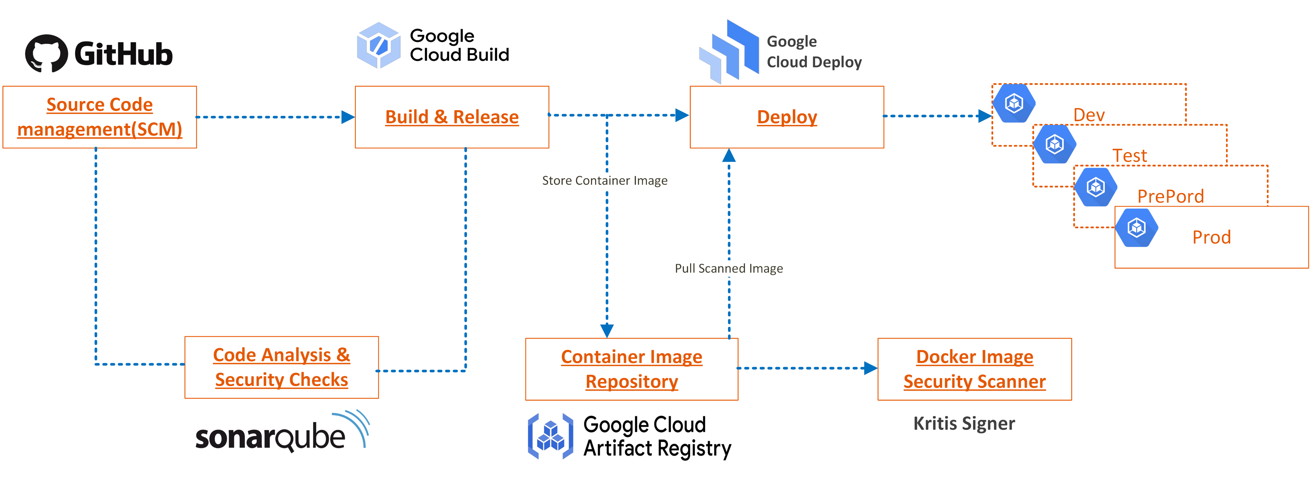

12.2 Required Gates
Gate | Minimum approval behavior
Peer review / branch protection | Required approvals enforced before merge to main.
SAST / SCA / secrets / container scan | Block on critical / high findings unless an approved, time-bound exception exists.
Image signing / provenance | Mandatory artifact evidence before production.
IaC policy | Block public / unauthenticated ingress and broad IAM.
Test evidence | Unit, integration, authorization-negative and security tests attached to the release.
Production approval | Named change approver and operations readiness satisfied.

12.3 Patch and Dependency Management
Dependencies and base images are inventoried. Security advisories are triaged against Vodafone remediation timelines. React, Python / FastAPI, build tooling and container base images are upgraded through tested releases. Emergency fixes use the same controlled build / sign / deploy path; manual production modification is prohibited.

13. Testing, Release and Production Readiness

13.1 Test Strategy
- Unit and integration tests for frontend and backend.
- Authorization-negative tests confirming scope enforcement (users cannot see data outside their group / market / level).
- Performance tests for dashboard interactions and BigQuery reads.
- Security tests aligned with SPDA requirements.
- Chatbot / agent response governance tests (Phase 2).

13.2 Release Strategy
- Controlled promotion from development to production using immutable image digests.
- Production deployment executed by the Platform Team per the established release process.

13.3 Production Readiness Exit Criteria
- SPDA and Design Authority conditions satisfied.
- Monitoring, alerting and runbooks in place.
- Recovery objectives approved through a Business Impact Assessment.
- Data classification and key-management posture confirmed.

14. Threat Model, Risks and Open Decisions

14.1 Assets and Trust Boundaries
- Assets: sensitive analytics outputs (including demographic factors and bias-pattern analysis), access-control rules and user identity / context.
- Trust boundaries: browser to edge (LB / Armor / IAP), frontend to backend (REST API), backend to BigQuery (cross-project, under the end-user identity), and backend to the AI agent (Phase 2).

14.2 Risk Register
Risk | Description | Mitigation
Sensitive analytics data | The solution exposes talent analytics and data that includes demographic factors and bias-pattern analysis. | Use controlled, group-based access and backend entitlement enforcement for every request.
Service-account overreach | Broad runtime permissions could expand the attack surface. | Scope Cloud Run and BigQuery access using least privilege and include permissions in security review.
Unauthorized data scope exposure | Users could see a broader population than intended if scope checks are misconfigured. | Enforce scope inside BigQuery through row-level and column-level security under the end-user identity, so rows and columns are filtered by the database rather than by the application.
AI response governance (Phase 2) | The chatbot could answer outside the permitted data context if not controlled. | Use the governed AI Booster agent path, Responsible AI proxy and end-user-context enforcement on all BigQuery reads.

14.3 Open Decisions / Approval Blockers
- Final data classification and labelling (Information Owner).
- Key-management posture (CMEK / Secret Manager / KMS) confirmation.
- Phase 2 L1 / L2 authorization model detail.
- Recovery objectives (Business Impact Assessment) approval.
- SPDA demand, Design Authority demand and reviewer assignments.

15. Architecture Decision Records
ADR | Decision | Rationale | Alternatives / consequence
ADR-01 | ReactJS SPA on Cloud Run | Cloud-native, scalable presentation layer with minimal infrastructure management. | Alternatives increase operational overhead.
ADR-02 | Separate Cloud Run frontend and backend | Separate presentation from entitlement and data processing and allow distinct identities. | A single container couples privilege.
ADR-03 | External HTTPS LB + Cloud Armor + IAP + Azure AD SSO | Approved web entry controls, WAF / rate limiting and corporate authentication. | Direct Cloud Run access rejected for the C4 target.
ADR-04 | Consume published BigQuery views (read-only) | Keep modelling upstream and avoid duplicating HR data. | Copying data increases blast radius and ownership.
ADR-05 | Application-side scope filtering via a separate entitlement store | Central, testable entitlement independent of the frontend. | Frontend RBAC rejected as manipulable.
ADR-06 | Phase 1 Google Groups; Phase 2 L1 / L2 | Deliver access control quickly and refine with finer levels later. | Full RBAC upfront would delay the initial release.
ADR-07 | Governed AI Booster agent (Phase 2) | Chatbot answers from the same governed data through the RAI proxy, with the backend running all SQL under the end-user identity. | Ungoverned LLM data access rejected.

16. Future Roadmap
Phase 1 (Initial Release)
- Dashboard view with core analytics and driver visualizations.
- Access management through Google Groups (Google Workspace) for user authorization and data filtering.
Phase 2 (Planned Enhancements)
- Corporate SSO integration using Azure AD and Identity-Aware Proxy.
- Introduction of L1 and L2 access levels with enhanced authorization controls.
- Chatbot functionality for natural-language querying and insights.
- Simulation view allowing users to adjust factors such as impact rating or recent promotions and evaluate changes in relative odds against a baseline.
- Overview page providing a consolidated summary of key metrics and insights.

17. Appendices

Appendix A – Glossary
Term | Meaning
BigQuery | Google Cloud managed data warehouse holding published analytics outputs and semantic views.
Cloud Run | Serverless container platform hosting the frontend and backend.
IAP | Google Cloud Identity-Aware Proxy.
Cloud Armor | Google Cloud WAF and edge protection.
SSO / SAML | Corporate single sign-on via Azure AD using SAML 2.0.
Text-to-SQL | Text-to-SQL: the agent generates SQL via Gemini and the backend executes it under the end-user identity (no MCP server).
AI Booster | Governed environment hosting the chatbot agent (Phase 2).
RAI | Responsible AI proxy governing model calls (Phase 2).
SPDA | Vodafone security / privacy design assurance process.
C4 | Vodafone classification / handling target; final designation by the Information Owner.
UAM | User Access Management.
L1 / L2 | Phase 2 authorization levels for finer role-based access.

Appendix B – Diagram Specifications
Diagram | Required contents
Context | User, browser, application, BigQuery analytics / semantic views, identity and security / operations actors.
Logical | React frontend, backend API, BigQuery access policies (RLS / CLS), BigQuery datasets and, for Phase 2, the AI agent.
Security | Trust zones, identity propagation, direct URL block and logging ownership.
Authentication sequence | Browser → LB / Armor → IAP → Cloud Run; signed assertion verification and failure paths.
Authorization sequence | Verified subject → group → scope → level → action → BigQuery query.
Read sequence | Context validation, scope resolution, scoped BigQuery read and rendering.
Chatbot sequence (Phase 2) | Backend → AI Booster agent → Gemini writes SQL → backend runs SQL on BigQuery under the end-user identity → Gemini analyses rows, via the RAI proxy.
Deployment | Dev / prod projects, build / deploy / runtime identities, registry and promotion.

Appendix C – Data Element Classification
Element | Purpose | Proposed class | Protection
Analytics driver outputs | Top talent driver insight | C4 target | Scope authorization, controlled group-based access.
Demographic / bias factors | Driver and barrier analysis | Sensitive | Backend scope filtering; controlled access; classification decision TBC.
User identity / context | Authentication and scope resolution | Personal data | SSO / IAP; access controlled; minimized in logs.
Access-control rules | Entitlement resolution | C4 / security sensitive | Enforced in BigQuery via row-level and column-level security; least-privilege access.
Operational logs | Support and security | Security sensitive | No sensitive plaintext; restricted retention.

Appendix D – Source Register
This HLD was grounded in the following source artifact. Where it proposes a control or governance detail not explicitly present in the baseline, that item is marked TBC and remains subject to Vodafone policy and reviewer confirmation.
- Top Talent Driver HLD (supplied source document) – primary baseline for architecture, data, access, security and operations content.

