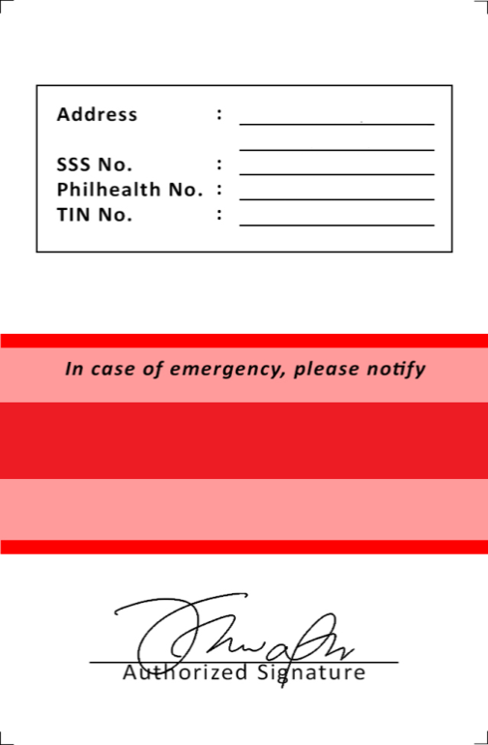

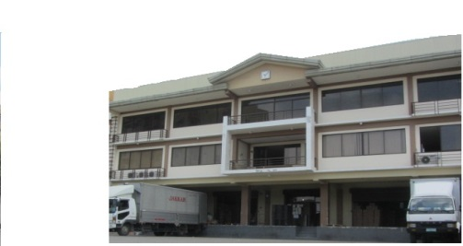

{{ em_name_1 }}
{{ em_contact_1 }}
Address : {{ address_1 }} {{ address2_1 }}

Birth Date : {{ birthdate_1 }}
SSS : {{ sss_1 }}
Philhealth : {{ philhealth_1 }}
HDMF : {{ hdmf_1 }}
TIN : {{ tin_1 }}

{{ position_1 }}
ID NO.
fnNO0NO.062110
{{ id_no_1 }}
{{ name_1 }}

{{ em_name_4 }}

{{ em_contact_4 }}

Address : {{ address_4 }} {{ address2_4 }}

Birth Date : {{ birthdate_4 }}
SSS : {{ sss_4 }}
Philhealth : {{ philhealth_4 }}
HDMF : {{ hdmf_4 }}
TIN : {{ tin_4 }}

{{ position_4 }}
ID NO.
fnNO0NO.062110
{{ id_no_4 }}

{{ name_4 }}

{{ em_name_3 }}

{{ em_contact_3 }}

Address : {{ address_3 }} {{ address2_3 }}

Birth Date : {{ birthdate_3 }}
SSS : {{ sss_3 }}
Philhealth : {{ philhealth_3 }}
HDMF : {{ hdmf_3 }}
TIN : {{ tin_3 }}

{{ position_3 }}
ID NO.
fnNO0NO.062110
{{ id_no_3 }}

{{ name_3 }}

{{ em_name_2 }}

{{ em_contact_2 }}

Address : {{ address_2 }} {{ address2_2 }}

Birth Date : {{ birthdate_2 }}
SSS : {{ sss_2 }}
Philhealth : {{ philhealth_2 }}
HDMF : {{ hdmf_2 }}
TIN : {{ tin_2 }}

{{ position_2 }}
ID NO.
fnNO0NO.062110
{{ id_no_2 }}

{{ name_2 }}

