|  |  |  |  |
| --- | --- | --- | --- |
| **C:\Users\korisnik\Pictures\RISC beli logo.jpeg** | **Regional Innovation Startup Center Novi Pazar** | **klaster-logo-final** | **Center for Application of New and Innovative Technologies Novi Pazar** |

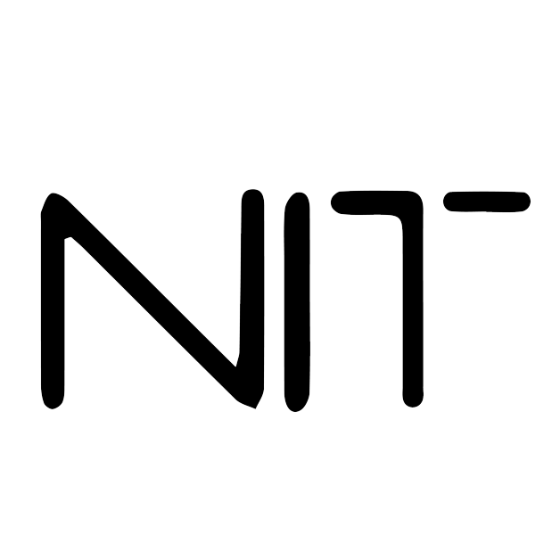

**CERTIFICATE OF APPRECIATION**

This certificate is presented to

**Hamza Plojovic**

For having successfully completed training: “Autumn Coding School 2022”

**Introduction to Python Programming**

Prof. dr Semsudin Plojovic

CERTIFICATE ID:PyAutumn2022/1.1

Center NIT CEO

DATE OF ISSUE: 28.12.2022