|  |  |  |  |
| --- | --- | --- | --- |
| **C:\Users\korisnik\Pictures\RISC beli logo.jpeg** | **Regional Innovation Startup Center Novi Pazar** | **klaster-logo-final** | **Center for Application of New and Innovative Technologies Novi Pazar** |

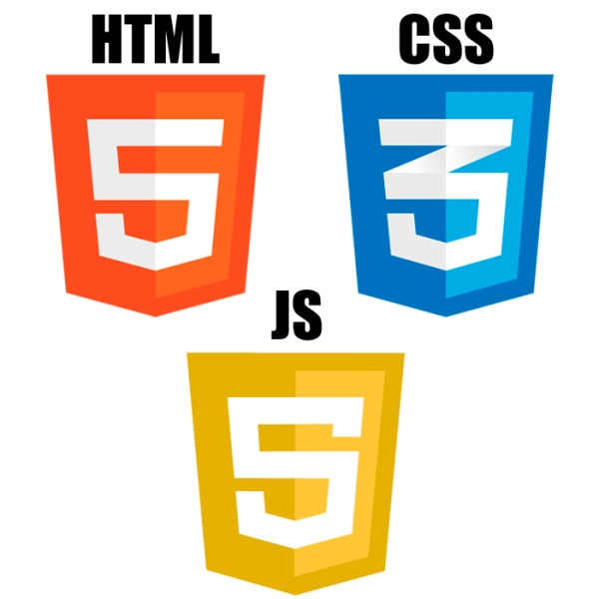

CERTIFICATE OF APPRECIATION

This certificate is presented to

Ahmed Vučelj

For having successfully completed training: “

First cycle of "IT Camp - Serbia 2022" course with knowledge of HTML, CSS, JavaScript. ”

Prof. dr Semsudin Plojovic

CERTIFICATE ID:ITCamp2022/16.8

Center NIT CEO

DATE OF ISSUE: 31.12.2022