|  |  |  |  |
| --- | --- | --- | --- |
| C:\Users\korisnik\Pictures\RISC beli logo.jpeg | **Regional Innovation Startup Center Novi Pazar** | klaster-logo-final | **Center for Application of New and Innovative Technologies Novi Pazar** |

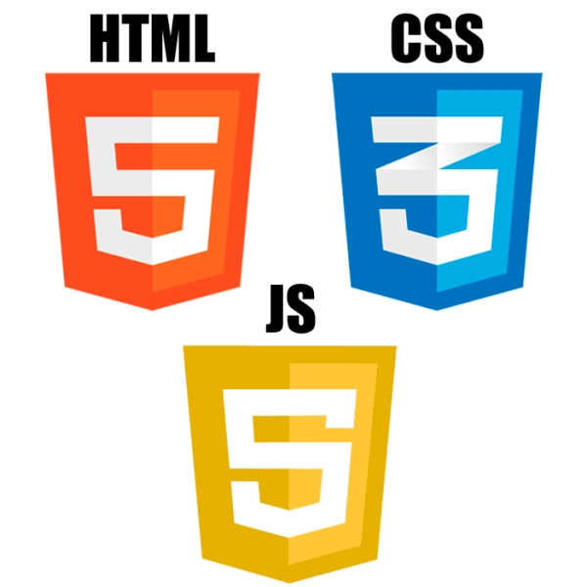

CERTIFICATE OF APPRECIATION

This certificate is presented to

Hamza Plojovic2

For having successfully completed training:

First cycle of "IT Camp - Serbia 2022" course with knowledge of HTML, CSS, JavaScript

Prof. dr Semsudin Plojovic

CERTIFICATE ID:ITCamp2022/20.1

Center NIT CEO

DATE OF ISSUE: 31.12.2022