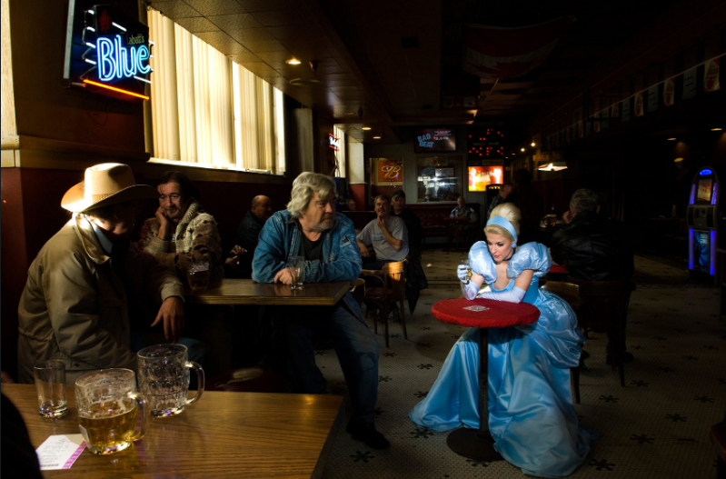
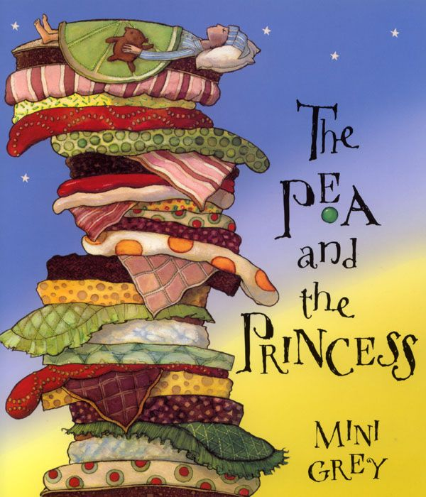
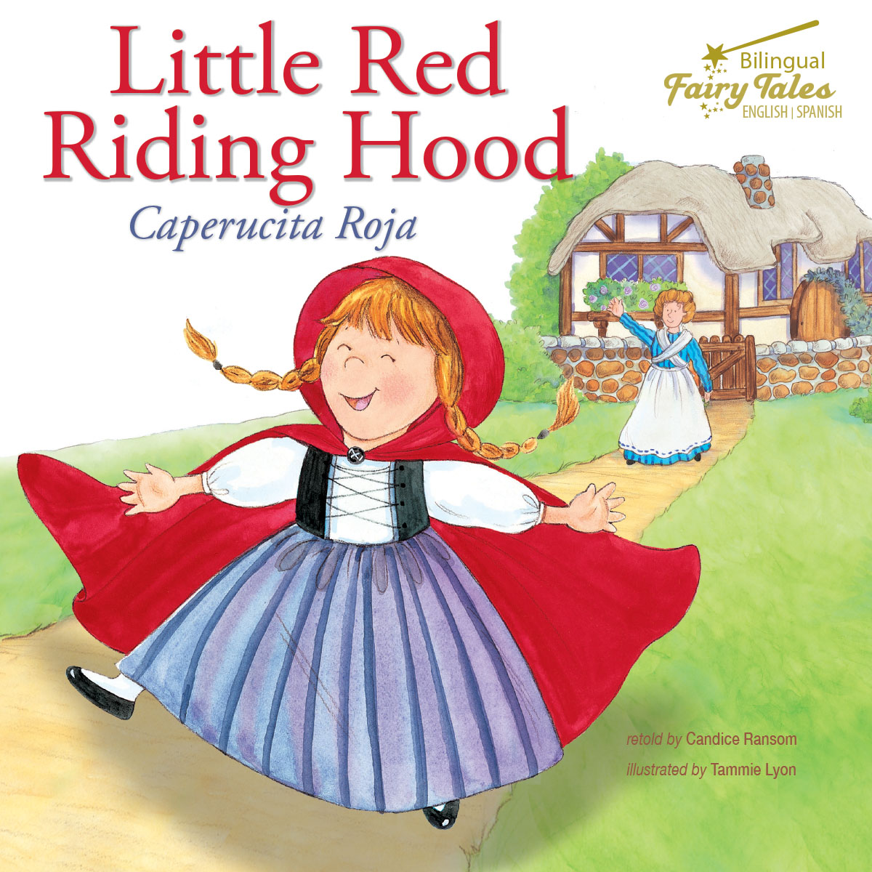
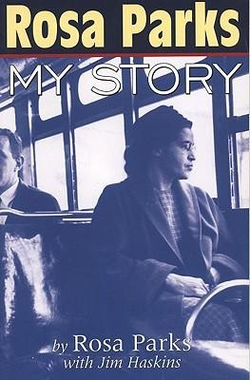

<-- photography of Dina Goldstein from the “Fallen Princesses” collection, 2018
Pictures
Fairy tales
Real-life fairytale Stories
Imaginary
Personal Documents
1st: Little Red Riding Hood, a fairy tale created by the Grim Brothers, 17th century

2nd: The Pea and the Princess, a fairy tale created by Christian Andersen, 1835
<-- A protestant woman who fought for the black’s right in USA
A TV series created in 1963 in UK, still running nowadays. -->

