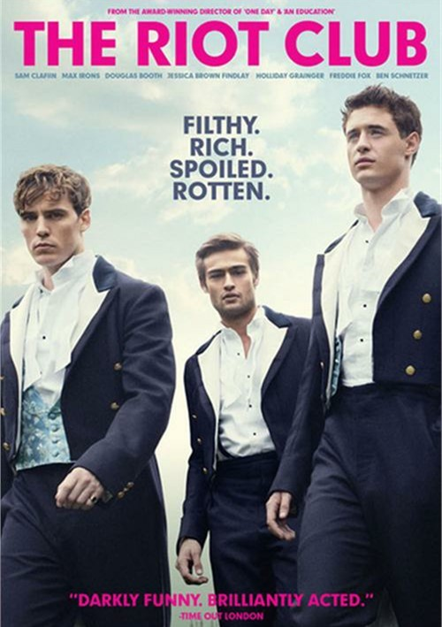
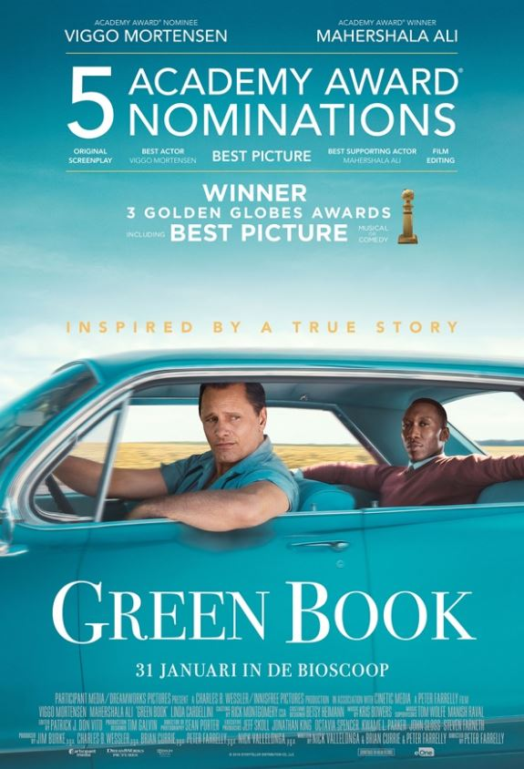
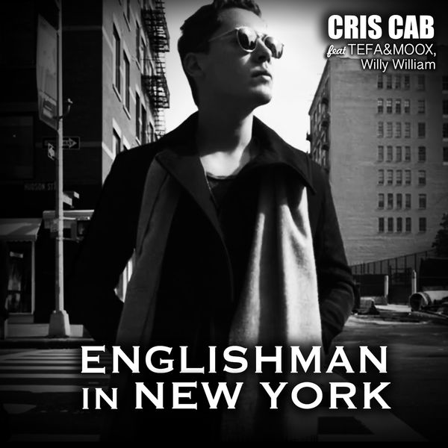
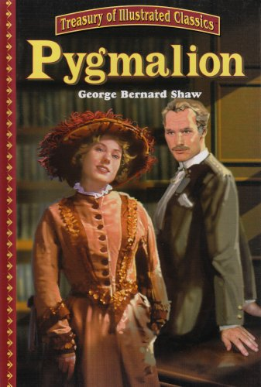
Rencontres
TV Shows:

The Riot Club, a movie released in 2014 directed by Lone Scherfig -->
Green Book, a movie released in 2918 directed by Peter Farrelly -->
Songs:
<-- A song created by Stings, 1987
Novels:
<-- A novel written by 1994 by George Bernard Shaw

